**Cu-decorating on N, P-Codoped porous carbon derived from wheat straw as advanced catalysts for N-alkylation of amines with alcohols**

Dong Zhanga, JingjingTiana, Yunyun Yana, Lina Zhanga*,Hongyu Hub*

1. *Shaanxi Key Laboratory of Phytochemistry and College of Chemistry and Chemical Engineering, Baoji University of Arts and Sciences, Baoji, 721013, China.*
2. *Xingzhi College,Zhejiang Normal University, Lanxi,321004,China*

E-mails*: feimengxia_123@163.com,* *huhongyu22@126.com*

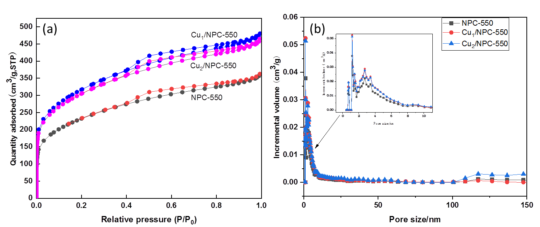

Fig. S1. Nitrogen adsorption/desorption isotherms (a) and the corresponding pore size distribution (b)

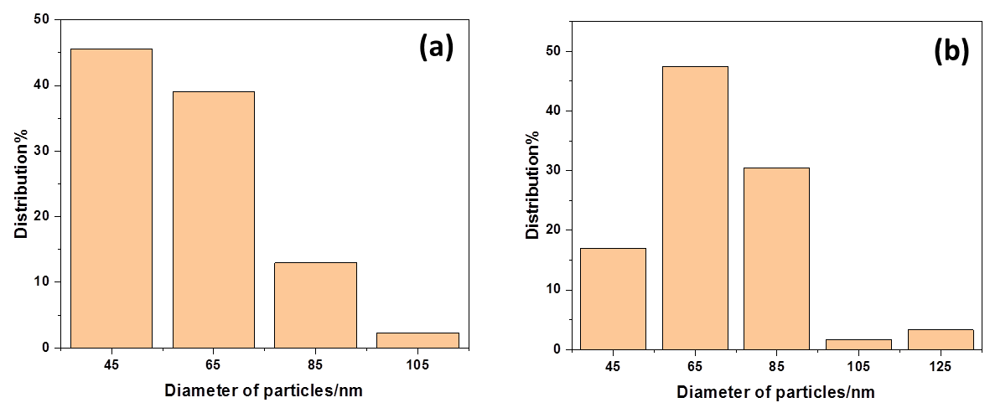

Fig. S2. Cu particle size distribution of (a) Cu1/NPC-550 and (b) Cu3/NPC-550

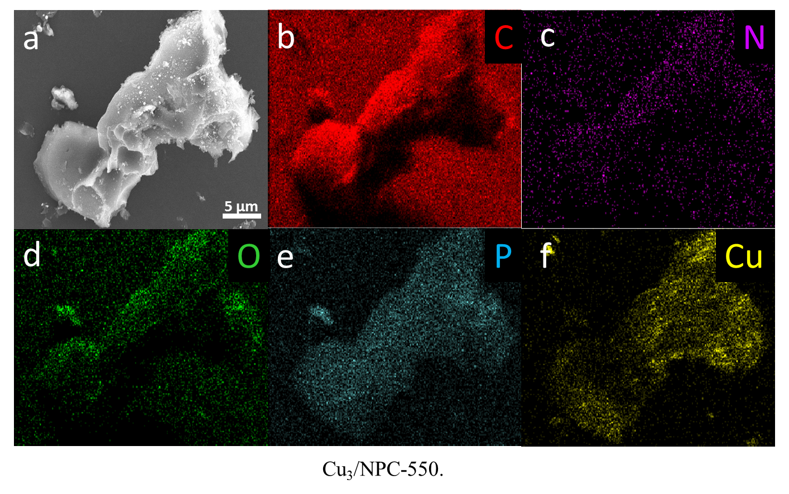

Fig. S3. Elemental mapping disclosing the elemental distribution of C, N, P, O and Cu on the surface of Cu3/NPC-550.

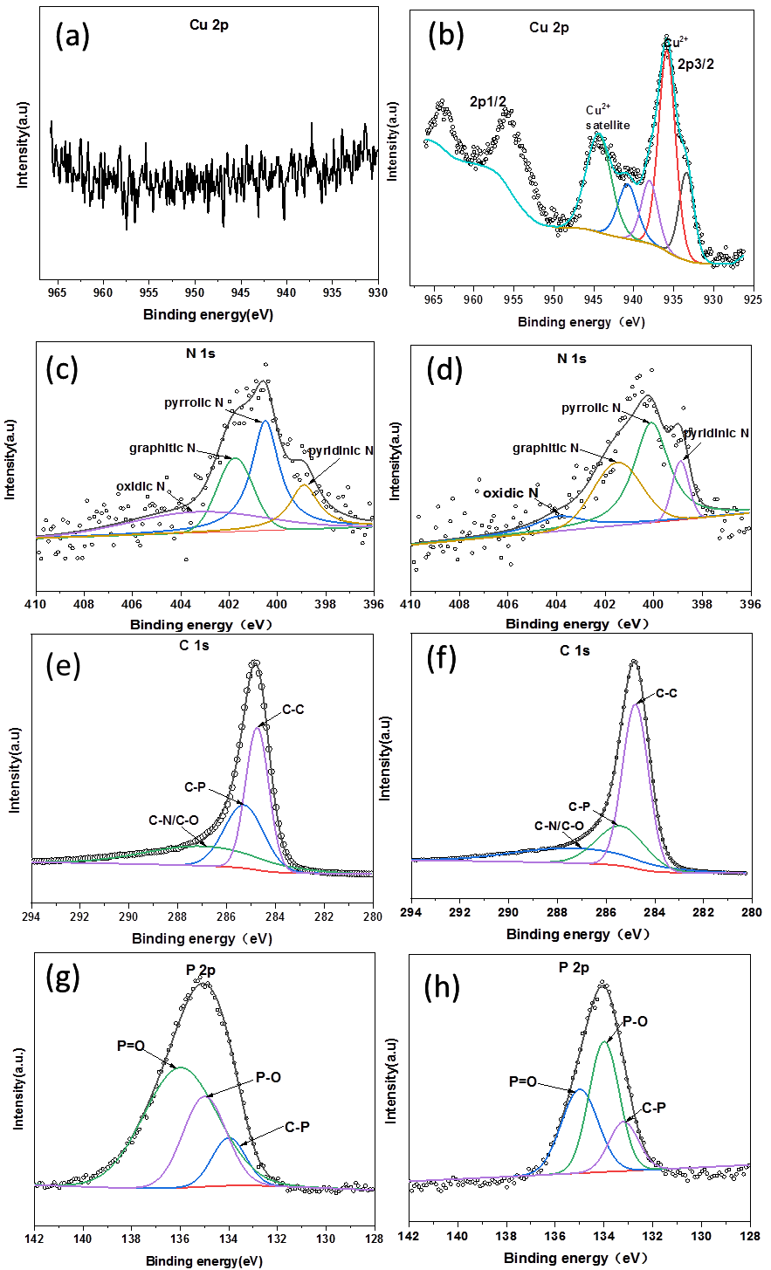

Fig. S4. XPS spectra of NPC-500 (a,c,e,g) and Cu3/NPC-550(b,d,f,h) for Cu 2p, N 1s, C 1s, P 2p

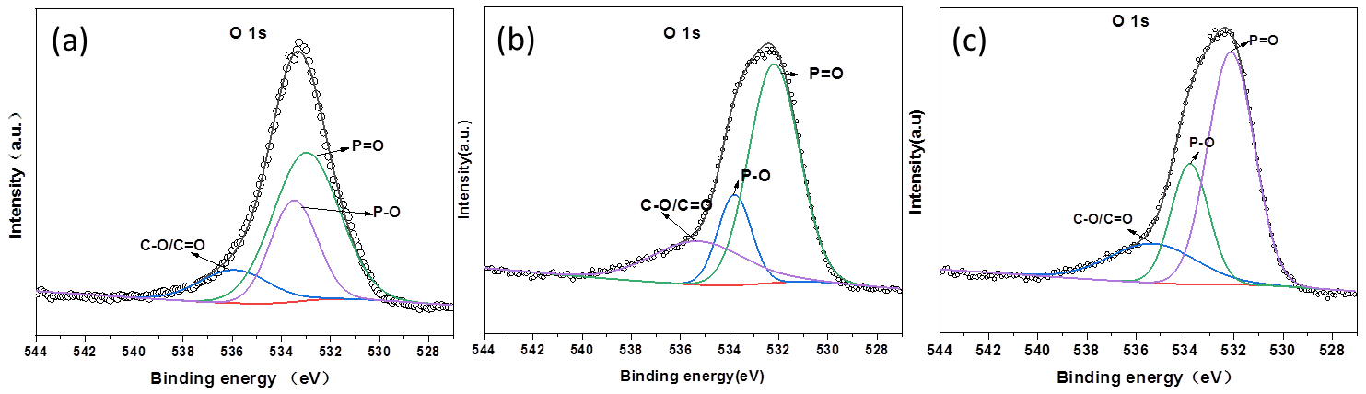

Fig. S5. XPS spectra of NPC-500 (a) , Cu2/NPC-550 (b) and Cu3/NPC-550(c) for O 1s

**Characterization data of isolated products**



**N-benzylaniline(Vellakkaran et al., 2017)**(isolated yield :87%, 3a, Table 3), colorless liquid. 1H NMR (400 MHz, CDCl3) δ 7.52 – 7.43 (m, 4H), 7.39 (d, *J*= 6.0 Hz, 1H), 7.34 – 7.27 (m, 2H), 6.89 – 6.82 (m, 1H), 6.78 – 6.71 (m, 2H), 4.41 (s, 2H).13C NMR (100 MHz, CDCl3) δ 148.27, 139.60, 129.38, 128.74, 127.61, 127.32, 117.67, 113.00, 48.40.



**N-(4-methoxybenzyl)aniline(Vellakkaran et al., 2017)**(isolated yield :85%, 3b, Table 3).colorless liquid. 1H NMR (400 MHz, CDCl3) δ 7.36 – 7.29 (m, 2H), 7.25 – 7.17 (m, 2H), 6.95 – 6.88 (m, 2H), 6.75 (tt, *J* = 7.4, 1.0 Hz, 1H), 6.70 – 6.63 (m, 2H), 4.27 (s, 2H), 3.82 (s, 3H).13C NMR (100 MHz, CDCl3) δ158.89, 148.21, 131.43, 129.26, 128.81, 117.53, 114.05, 112.89, 55.30, 47.83.



**N-(4-methylbenzyl)aniline(Vellakkaran et al., 2017)**(isolated yield :86%, 3c, Table 3),colorless liquid.1H NMR (400 MHz, CDCl3) δ 7.35 – 7.30 (m,2H), 7.24 (tt, *J* = 7.8, 3.3 Hz, 4H), 6.78 (tt, *J* = 7.4, 1.0 Hz, 1H), 6.73 – 6.66 (m, 2H), 4.33 (s, 2H), 2.41 (s, 3H).13C NMR (100 MHz, CDCl3) δ 148.25, 136.88, 136.42, 129.35, 129.29, 127.56, 117.55, 112.91, 48.14, 21.15.



**N-benzyl-4-methylaniline(Vellakkaran et al., 2017)**(isolated yield :79%, 3d, Table 3),colorless liquid.1H NMR (400 MHz, CDCl3) δ 7.46 – 7.36 (m, 4H), 7.31 (t, *J* = 6.9 Hz, 1H), 7.04 (dd, *J* = 8.5, 0.5 Hz, 2H), 6.62 (t, *J* = 5.4 Hz, 2H), 4.34 (s, 2H), 2.29 (s, 3H).13C NMR (100 MHz, CDCl3) δ 145.91, 139.68, 129.77, 128.61, 127.53, 127.17, 126.80, 113.09, 48.70, 20.43.



**4-methyl-N-(4-methylbenzyl)aniline**(Tan et al., 2016)(isolated yield :91%, 3e, Table 3),white solid; mp50-52℃

1H NMR (400 MHz, CDCl3) δ 7.31 (d, *J* = 7.1 Hz, 2H), 7.20 (d, *J* = 7.3 Hz, 2H), 7.04 (d, *J* = 7.3 Hz, 2H), 6.61 (dd, *J* = 8.3, 1.2 Hz, 2H), 4.30 (s, 2H), 2.40 (s, 3H), 2.30 (s, 3H).13C NMR (100 MHz, CDCl3) δ 146.05, 136.77, 136.65, 129.76, 129.29, 127.53, 126.66, 113.04, 48.44, 21.13, 20.43.



**N-(4-methoxybenzyl)-4-methylaniline(Singh et al., 2021)**(isolated yield :89%, 3f, Table 3)white solid; mp67-68℃

1H NMR (400 MHz, CDCl3) δ 7.40 – 7.30 (m, 2H), 7.10 – 7.01 (m, 2H), 6.99 – 6.88 (m, 2H), 6.70 – 6.57 (m, 2H), 4.27 (s, 2H), 3.84 (s, 3H), 2.30 (s, 3H).13C NMR (100 MHz, CDCl3) δ 158.86, 146.02, 131.71, 129.76, 128.81, 126.69, 114.04, 113.08, 55.30, 48.17, 20.44.



**N-benzyl-4-methoxyaniline(Vellakkaran et al., 2017)**(isolated yield :58%, 3g, Table 3), colorless liquid.1H NMR (400 MHz, CDCl3) δ 7.39 – 7.30 (m, 4H), 7.30 – 7.21 (m, 1H), 6.80 – 6.74 (m, 2H), 6.70 – 6.61 (m, 2H), 4.28 (s, 2H), 3.73 (s, 3H).13C NMR (100 MHz, CDCl3) δ 152.60, 141.58, 139.12, 128.56, 127.71, 127.25, 114.89, 114.70, 55.77, 49.60.



**4-methoxy-N-(4-methylbenzyl)aniline(Tan et al., 2016)**(isolated yield :70%, 3h, Table 3)white solid; Mp67-69℃1HNMR (400 MHz, CDCl3) δ=7.24 (d, *J* = 7.8 Hz, 2H), 7.13 (d, J = 7.8 Hz, 2H), 6.82 – 6.72 (m, 2H), 6.67 – 6.55 (m, 2H), 4.22 (s, 2H), 3.73 (s, 3H),2.33 (s, 3H).13C NMR (100 MHz, CDCl3) δ =152.37, 142.03, 136.82, 136.26, 129.22, 127.61, 114.88, 114.42, 55.78, 49.20, 21.06.



**4-methoxy-N-(4-methoxybenzyl)aniline(Zhang et al., 2014)**(isolated yield :72%, 3i, Table 3)White solid; mp 93-94℃. 1H NMR (400 MHz, CDCl3) δ 7.32 – 7.26 (m, 2H), 6.91 – 6.85 (m, 2H), 6.81 – 6.76 (m, 2H), 6.65 – 6.57 (m, 2H), 4.20 (s, 2H), 3.79 (s, 3H), 3.74 (s, 3H).13C NMR (100 MHz, CDDl3) δ 158.81, 152.20, 142.43, 131.62, 128.81, 114.90, 114.18, 113.97, 55.80, 55.27, 48.76.



**N-benzyl-4-ethylaniline(Fertig et al., 2018)**(isolated yield :85%, 3j, Table 3)colorless liquid.1H NMR (400 MHz, CDCl3) δ 7.47 – 7.38 (m, 4H), 7.38 – 7.30 (m, 1H), 7.15 – 7.07 (m, 2H), 6.66 (dd, *J* = 8.8, 2.4 Hz, 2H), 4.37 (s, 2H), 2.63 (q, *J* = 7.6 Hz, 2H), 1.28 (t, *J* = 7.6 Hz, 3H).13C NMR (100 MHz, CDCl3) δ 146.19, 139.75, 133.48, 128.65, 128.63, 127.59, 127.21, 113.08, 48.73, 28.02, 16.03.



**4-ethyl-N-(4-methylbenzyl)aniline**(isolated yield :81%, 3k, Table 3)white solid; mp 43-44℃. 1H NMR (400 MHz, CDCl3) δ 7.32 (d, *J* = 7.8 Hz, 2H), 7.22 (t, *J* = 7.9 Hz, 2H), 7.08 (d, *J* = 8.1 Hz, 2H), 6.65 (d, *J* = 8.5 Hz, 2H), 4.32 (s, 2H), 3.78(s, 1H), 2.62 (q, *J* = 7.6 Hz, 2H), 2.41 (s, 3H), 1.27 (td, *J* = 7.6, 1.6 Hz, 3H).13C NMR (100 MHz, CDCl3) δ 146.18, 136.80, 136.61, 133.44, 129.31, 128.59, 127.59, 113.11, 48.51, 28.01, 21.14, 16.01.HRMS (ESI-TOF, M/Z) for C16H19N [M+H]+: calc.: 226.1590. Found:226.1591.



**4-ethyl-N-(4-methoxybenzyl)aniline(Satyanarayana et al., 2013)**(isolated yield :80%, 3l, Table 3)1H NMR (400 MHz, CDCl3) δ 7.36 – 7.27 (m, 2H), 7.07 – 6.99 (m, 2H), 6.95 – 6.85 (m, 2H), 6.65 – 6.56 (m, 2H), 4.24 (s, 2H), 3.81 (s, 3H), 2.56 (q, *J* = 7.6 Hz, 2H), 1.21 (t, *J* = 7.6 Hz, 3H).13C NMR (100 MHz, CDCl3) δ 158.82, 146.21, 133.35, 131.67, 128.79, 128.53, 113.99, 112.98, 55.28, 48.13, 27.94, 15.95.



**4-butyl-N-(4-methylbenzyl)aniline(Chung and Chung 2018)**,(isolated yield :91%, 3m, Table 3),white solid,mp51-53℃.1H NMR (400 MHz, CDCl3) δ 7.32 (d, *J* = 7.9 Hz, 2H), 7.29 – 7.23 (m, 2H), 7.21 (d, *J* = 7.8 Hz, 2H), 6.71 – 6.62 (m, 2H), 4.31 (s, 2H), 2.41 (s, 3H), 1.35 (dd, *J* = 2.5, 1.0 Hz, 9H).13C NMR (100 MHz, CDCl3) δ 145.94, 140.30, 136.80, 136.66, 129.30, 127.60, 126.04, 112.64, 48.45, 33.90, 31.62, 21.15.



**4-(tert-butyl)-N-(4-methoxybenzyl)aniline(Yoshinaga et al., 2020)**(isolated yield :80%, 3n, Table 3), white solid,mp96-98ºC.1H NMR (400 MHz, CDCl3) δ 7.39 – 7.33 (m, 2H), 7.31 – 7.24 (m, 2H), 6.98 – 6.92 (m, 2H), 6.71 – 6.63 (m, 2H), 4.29 (s, 2H), 3.85 (s, 3H), 1.36 (s, 9H).13C NMR (100 MHz, CDCl3) δ 158.89, 145.94, 140.31, 131.74, 128.88, 126.04, 114.05, 112.67, 55.30, 48.16, 33.91, 31.63.



**N-benzyl-3-methylaniline(Minakawa et al., 2015)**(isolated yield :85%, 3o, Table 3)light yellow oil. 1H NMR (400 MHz, CDCl3) δ 7.48 – 7.31 (m, 5H), 7.14 (t, *J* = 7.7 Hz, 1H), 6.66 – 6.60 (m, 1H), 6.56 – 6.49 (m, 2H), 4.37 (s, 2H), 2.35 (s, 3H).13C NMR (100 MHz, CDCl3) δ 148.27, 139.63, 139.06, 129.20, 128.66, 127.58, 127.24, 118.61, 113.74, 110.06, 48.42, 21.70.



**3-methyl-N-(4-methylbenzyl)aniline(Midya et al., 2018)**(isolated yield :86%, 3p, Table 3)colorless liquid.1H NMR (400 MHz, CDCl3) δ 7.34 (d, *J* = 8.0 Hz, 2H), 7.24 (d, *J* = 7.8 Hz, 2H), 7.17 (d, *J* = 7.7 Hz, 1H), 6.65 (d, *J* = 8.6 Hz, 1H), 6.54 (dd, *J* = 11.0, 3.1 Hz, 2H), 4.34 (s, 2H), 2.44 (s, 3H), 2.37 (s, 3H).13C NMR (100 MHz, CDCl3) δ 148.26, 139.04, 136.87, 136.50, 129.36, 129.21, 127.64, 118.64, 113.83, 110.16, 48.25, 21.71, 21.18.



**N-(4-methoxybenzyl)-3-methylaniline**(Nirmala et al., 2017)(isolated yield :66%, 3q, Table 3)Colorless liquid 1H NMR (400 MHz, CDCl3) δ 7.37 – 7.27 (m, 2H), 7.10 (t, *J* = 7.7 Hz, 1H), 6.95 – 6.86 (m, 2H), 6.58 (dd, *J* = 7.5, 0.6 Hz, 1H), 6.53 – 6.44 (m, 2H), 4.26 (s, 2H), 3.82 (s, 3H), 2.31 (s, 3H).13C NMR (100 MHz, CDCl3) δ 158.86, 148.30, 139.00, 131.58, 129.13, 128.82, 118.47, 114.03, 113.66, 110.00, 55.29, 47.85, 21.64.



**N-benzyl-2-methylaniline(Huang et al., 2019)**(isolated yield:78%, 3r, Table 3)lightyellow oil; 1H NMR (400 MHz, CDCl3) δ 7.49 – 7.37 (m, 4H), 7.38 – 7.31 (m, 1H), 7.21 – 7.11 (m, 2H), 6.74 (td, *J* = 7.4, 1.0 Hz, 1H), 6.68 (d, *J* = 8.0 Hz, 1H), 4.43 (s, 2H), 2.22 (s, 3H).13C NMR (100 MHz, CDCl3) δ 146.08, 139.54, 130.11, 128.69, 127.57, 127.28, 127.20, 121.97, 117.25, 110.07, 48.37, 17.58.



**N-(4-methoxybenzyl)-2-methylaniline(Panda et al., 2020)**(isolated yield:70%, 3s, Table 3)white solid; mp51-52℃. 1H NMR (400 MHz, CDCl3) δ 7.37 – 7.29 (m, 2H), 7.17 – 7.06 (m, 2H), 6.95 – 6.88 (m, 2H), 6.74 – 6.63 (m, 2H), 4.31 (s, 2H), 3.82 (s, 3H), 2.17 (s, 3H).13C NMR (100 MHz, CDCl3) δ 158.90, 146.07, 131.44, 130.04, 128.85, 127.14, 121.94, 117.17, 114.06, 110.03, 55.29, 47.84, 17.52.



**N-benzyl-4-chloroaniline(Vellakkaran et al., 2017)**(isolated yield:79%, 3t, Table 3),colorless liquid.1H NMR (400 MHz, CDCl3) δ 7.43 – 7.35 (m, 4H), 7.34-7.31 (m, 1H), 7.16-7.12 (m, 2H), 6.61 – 6.53 (m, 2H), 4.31 (s, 2H).13C NMR (100 MHz, CDCl3) δ 146.61, 138.93, 129.09, 128.72, 127.45, 117.93, 114.03, 113.22, 48.39.



**4-chloro-N-(4-methoxybenzyl)aniline(Singh et al., 2021)**(isolated yield:71%, 3u, Table 3)white solid,mp 75-77℃1H NMR (400 MHz, CDCl3) δ 7.29 – 7.22 (m, 2H), 7.14 – 7.07 (m, 2H), 6.91 – 6.85 (m, 2H), 6.58 – 6.51 (m, 2H), 4.21 (s, 2H), 3.79 (s, 3H).13C NMR (100 MHz, CDCl3) δ 158.95, 146.59, 130.82, 129.02, 128.72, 122.09, 114.07, 113.96, 55.28, 47.87.



**N-benzyl-4-fluoroaniline(Huang et al., 2019),**(isolated yield:70%, 3v, Table 3)Colorless oil. 1H NMR (400 MHz, CDCl3) δ7.37 (dd, *J* = 8.1, 5.6 Hz, 4H), 7.32 (dd, *J* = 12.2, 8.6 Hz, 1H), 6.90 (t, *J* = 8.7 Hz, 2H), 6.64 – 6.55 (m, 2H), 4.29 (s, 2H), 3.80 (s, 1H). 13C NMR (100 MHz, CDCl3) δ =157.11, 154.77, 144.40, 139.20, 128.67, 127.51, 127.32, 115.78, 115.55, 113.79, 113.72, 48.97.



**4-fluoro-N-(4-methylbenzyl)aniline(Gour et al., 2019)**(isolated yield:75%, 3w, Table 3)White solid; mp 71-73℃1H NMR (400 MHz, CDCl3) δ 7.28 (d, *J* = 8.0 Hz, 2H), 7.19 (d, *J* = 7.8 Hz, 2H), 6.95 – 6.87 (m, 2H), 6.63 – 6.55 (m, 2H), 4.26 (s, 2H), 2.38 (s, 3H).13C NMR (100 MHz, CDCl3) δ157.13, 154.79, 144.38, 136.99, 136.06, 129.35, 127.54, 115.77, 115.54, 113.86, 113.79, 48.80, 21.10.



**4-fluoro-N-(4-methoxybenzyl)aniline(Santoro et al., 2014)**(isolated yield:71%, 3x, Table 3)White solid; mp 72-74℃1H NMR (400 MHz, CDCl3) δ 7.35–7.22 (m, 2H), 6.93 – 6.83 (m, 4H), 6.62 – 6.52 (m, 2H), 4.20 (s, 2H), 3.80 (s, 3H).13C NMR (100 MHz, CDCl3) δ 158.91, 157.04, 154.71, 144.47, 131.15, 128.77, 115.72, 115.50, 114.04, 113.73, 113.66, 55.27, 48.44.



**N-benzyl-3,4-dimethylaniline(Dai et al., 2015)**(isolated yield:80%, 3y, Table 3)Yellow oil. 1H NMR (400 MHz, CDCl3) δ 7.41 – 7.30 (m, 4H), 7.31 – 7.23 (m, 1H), 6.93 (d, *J* = 8.1 Hz, 1H), 6.49 (d, *J* = 2.4 Hz, 1H), 6.41 (dd, *J* = 8.1, 2.5 Hz, 1H), 4.30 (s, 2H), 2.18 (s, 3H), 2.15 (s, 3H).13C NMR (100 MHz, CDCl3) δ 146.15, 139.62, 137.28, 130.25, 128.54, 127.52, 127.10, 125.71, 114.84, 110.39, 48.74, 19.99, 18.65.



**3,4-dimethyl-N-(4-methylbenzyl)aniline**(isolated yield:90%, 3z, Table 3)light yellow oil1H NMR (400 MHz, CDCl3) δ 7.34 (d, *J* = 8.0 Hz, 2H), 7.23 (d, *J* = 7.8 Hz, 2H), 7.02 (d, *J* = 8.1 Hz, 1H), 6.56 (d, *J* = 2.4 Hz, 1H), 6.48 (dd, *J* = 8.1, 2.6 Hz, 1H), 4.32 (s, 2H), 2.43 (s, 3H), 2.28 (s, 3H), 2.25 (s, 3H). 13C NMR (100 MHz, CDCl3) δ 146.53, 137.29, 136.80, 136.75, 130.35, 129.31, 127.58, 125.51, 114.83, 110.35, 48.48, 21.16, 20.10, 18.76.HRMS (ESI-TOF, M/Z) for C16H19N [M+H]+: calc.: 226.1590. Found:226.1579.



**N-benzylnaphthalen-2-amine(Vellakkaran et al., 2017)**(isolated yield:86%, 3aa, Table 3),Yellow oil.1H NMR (400 MHz, CDCl3) δ 7.88 (dd, *J* = 8.9, 7.6 Hz, 2H), 7.57 – 7.46 (m, 4H), 7.46 – 7.32 (m, 5H), 6.74 (d, *J* = 8.3 Hz, 1H), 4.54 (s, 2H).13C NMR (100 MHz, CDCl3) δ 142.43, 138.59, 134.37, 128.75, 127.99, 127.56, 126.57, 125.87, 124.99, 123.66, 120.11, 118.45, 106.01, 49.06.



**N-(4-methylbenzyl)naphthalen-2-amine(Guo et al., 2018)**(isolated yield:90%, 3ab, Table 3)Yellow oil. 1H NMR (400 MHz, CDCl3) δ 7.89 (dd, *J* = 11.2, 8.3 Hz, 2H), 7.58 – 7.46 (m, 2H), 7.44 – 7.33 (m, 4H), 7.23 (d, *J* = 7.4 Hz, 2H), 6.78 (d, *J* = 6.7 Hz, 1H), 4.50 (s, 2H), 2.42 (s, 3H).13C NMR (100 MHz, CDCl3) δ 142.24, 137.27, 135.34, 134.38, 129.43, 128.74, 128.09, 126.56, 125.88, 125.02, 123.72, 120.18, 118.62, 106.35, 49.00, 21.21.



**N-(4-methoxybenzyl)naphthalen-2-amine(Li et al., 2014)**(isolated yield:85%, 3ac, Table 3)brown oil.1H NMR (400 MHz, CDCl3) δ 7.92 – 7.78 (m, 2H), 7.56 – 7.38 (m, 5H), 7.34 (d, *J* = 8.2 Hz, 1H), 7.01 – 6.94 (m, 2H), 6.71 (d, *J* = 7.5 Hz, 1H), 4.45 (s, 2H), 3.85 (s, 3H).13C NMR (100 MHz, CDCl3) δ 159.08, 143.31, 134.38, 131.12, 129.11, 128.74, 126.71, 125.80, 124.78, 123.49, 120.03, 117.67, 114.19, 104.86, 55.35, 48.16.

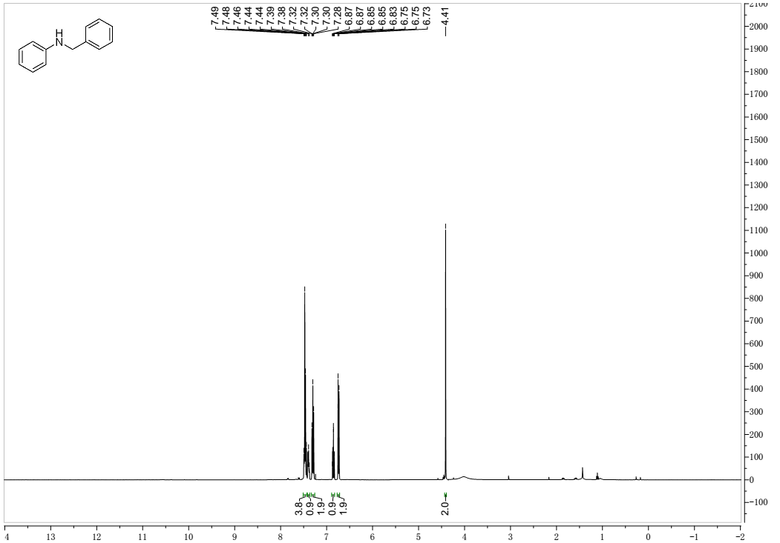

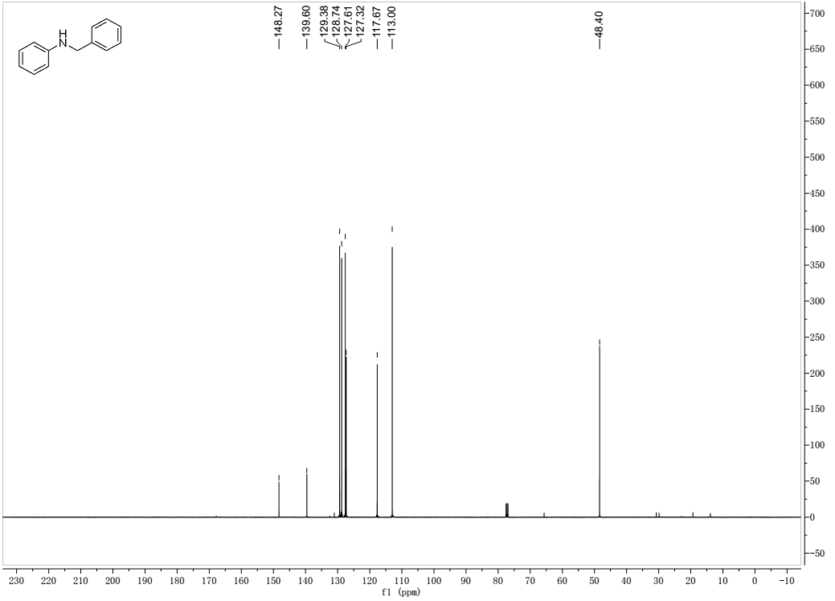

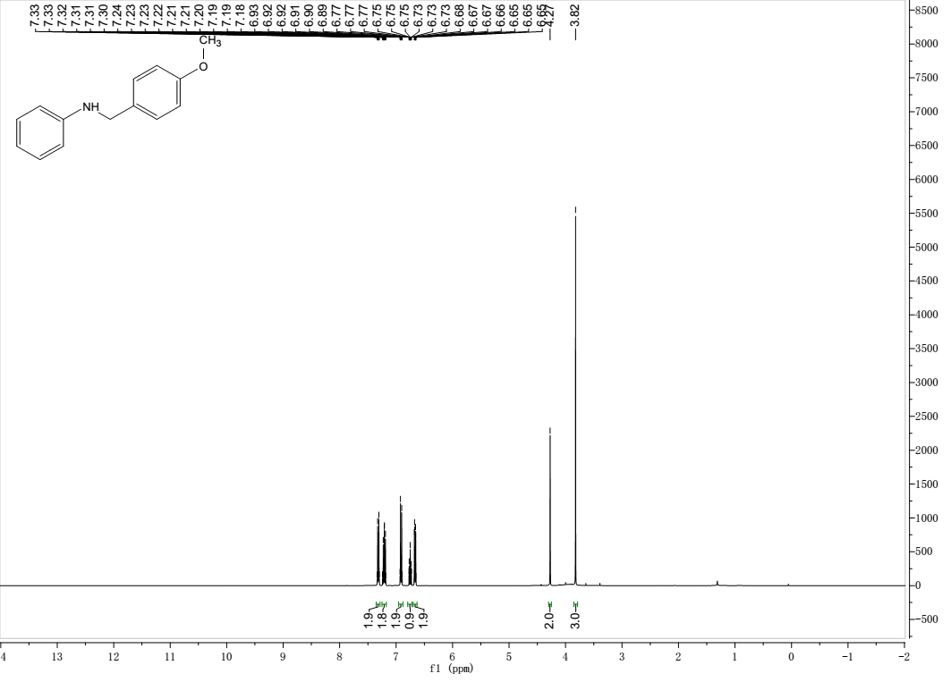

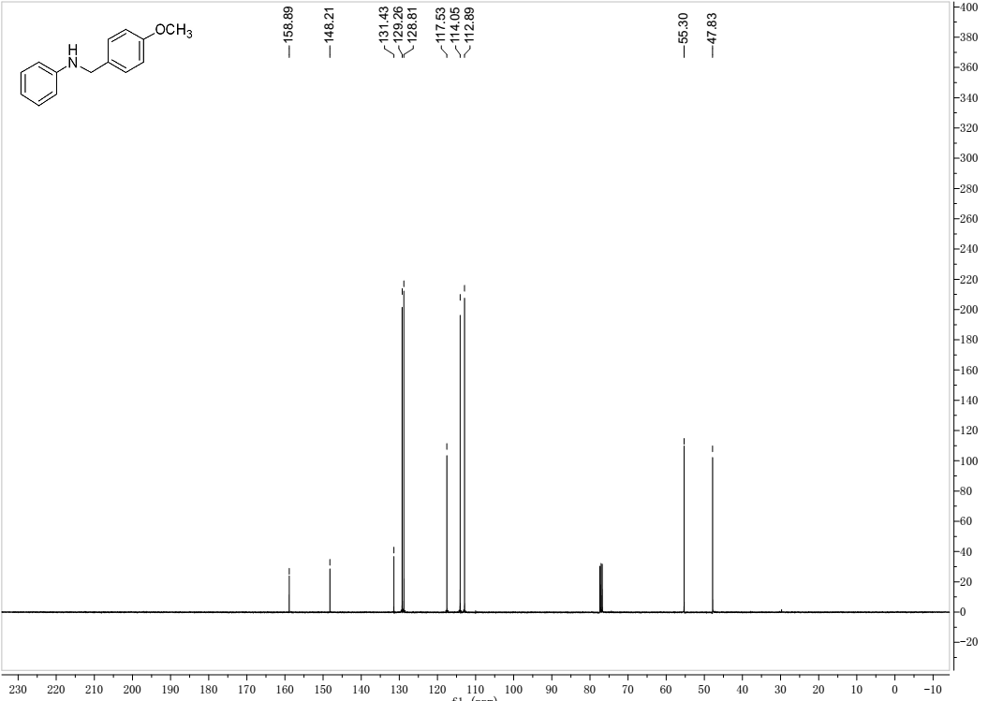

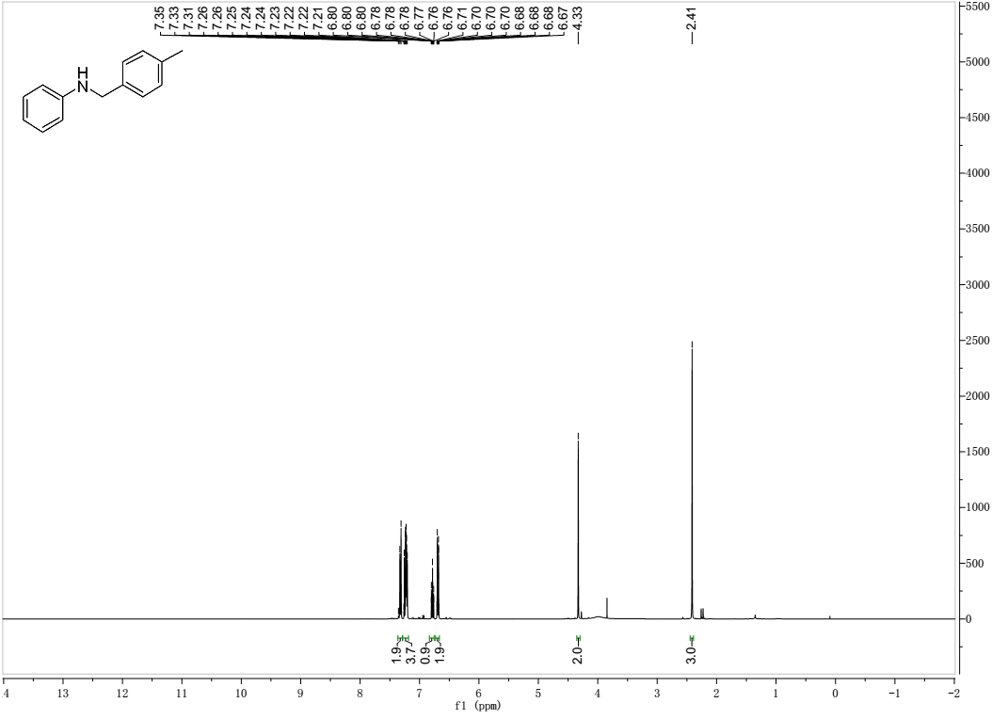

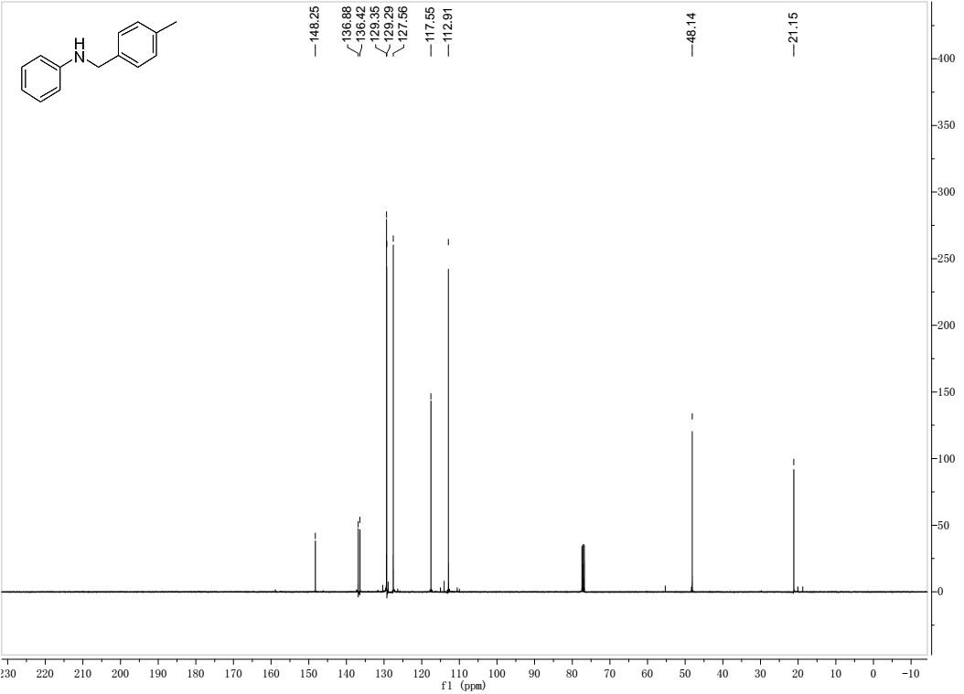

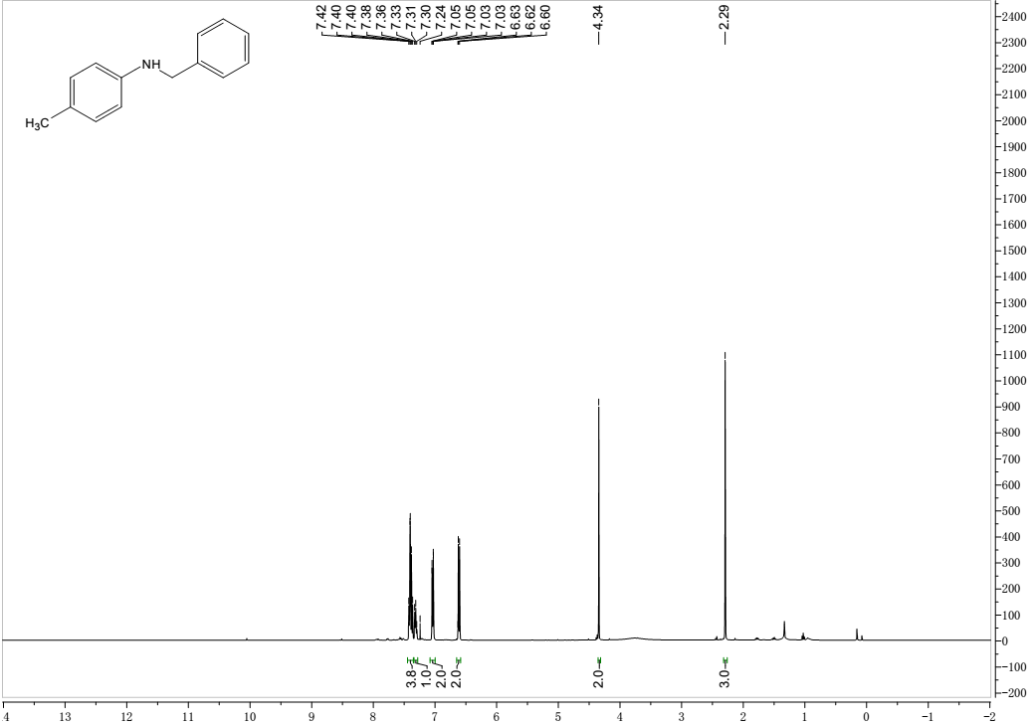

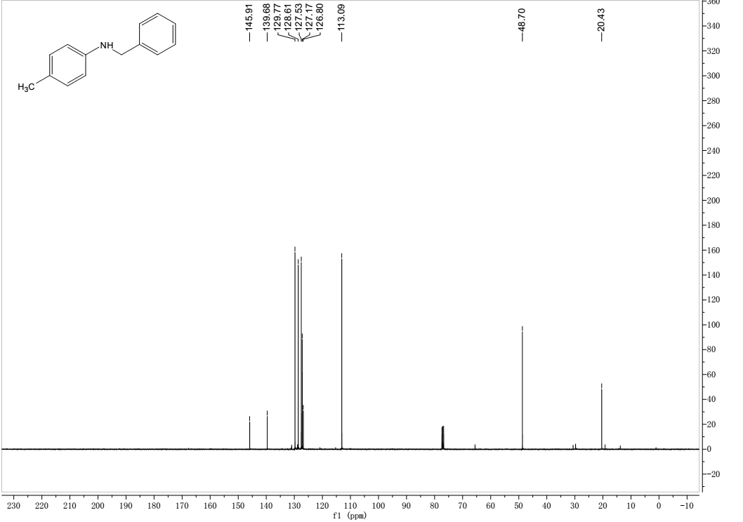

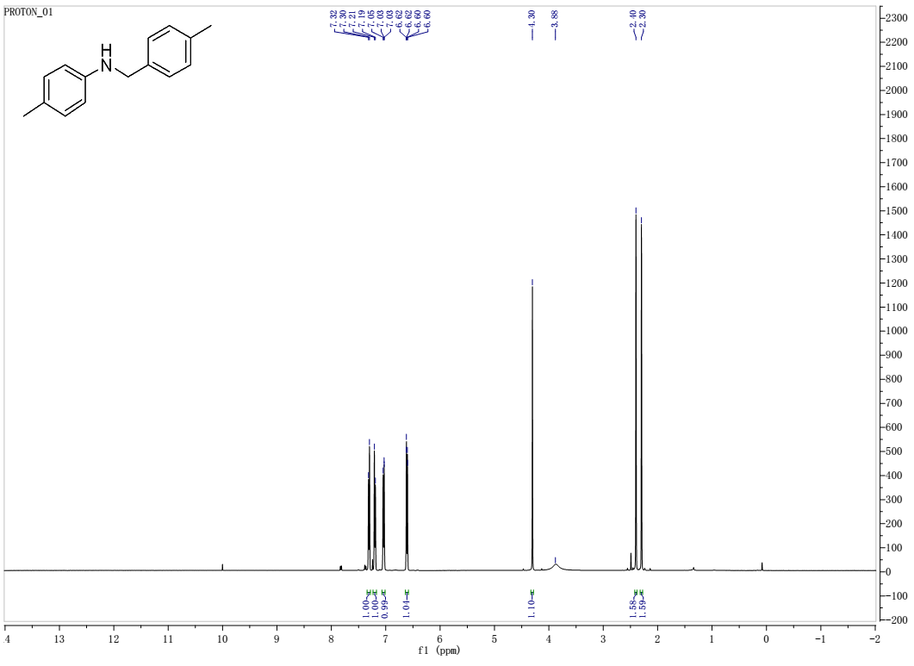

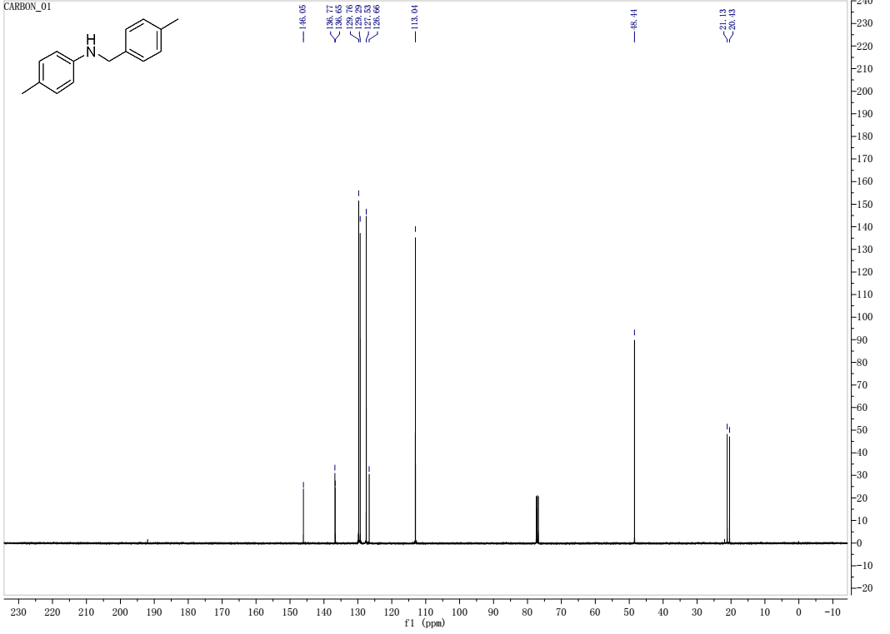

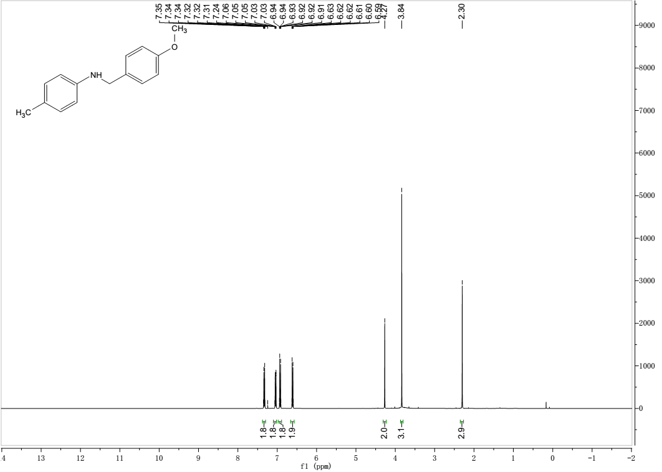

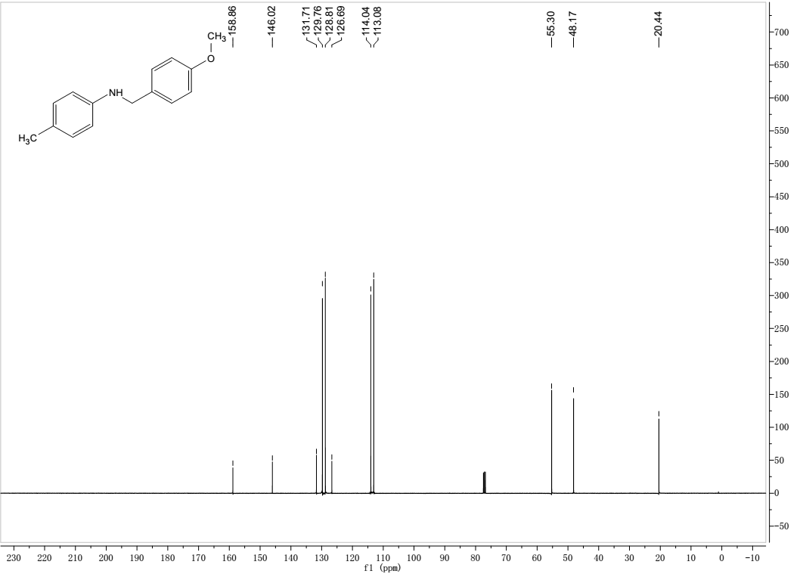

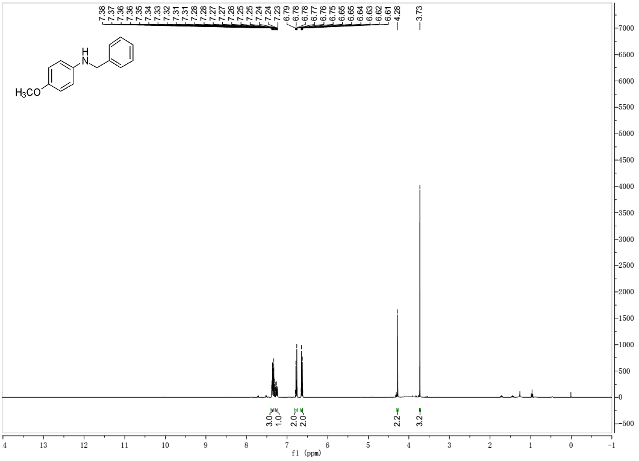

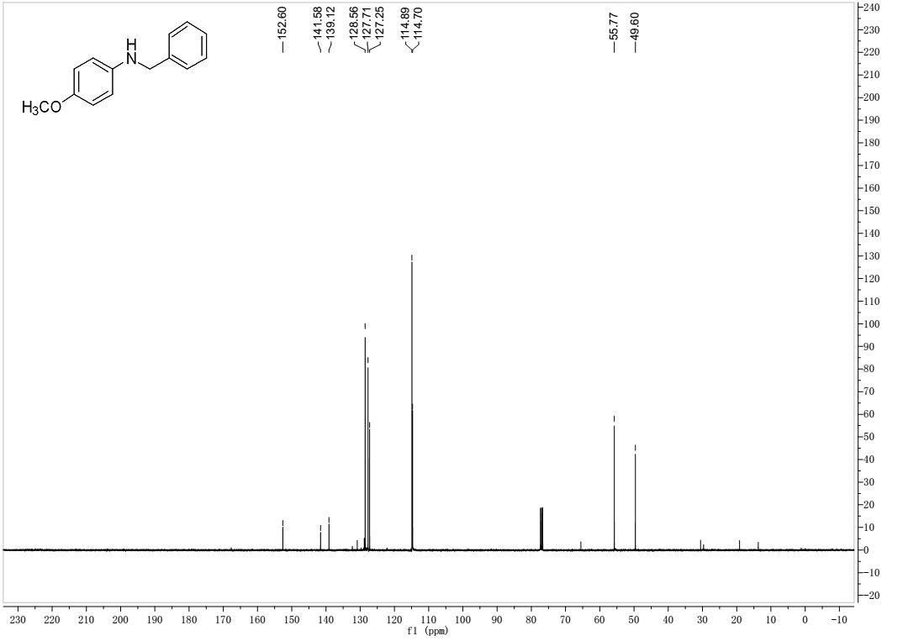

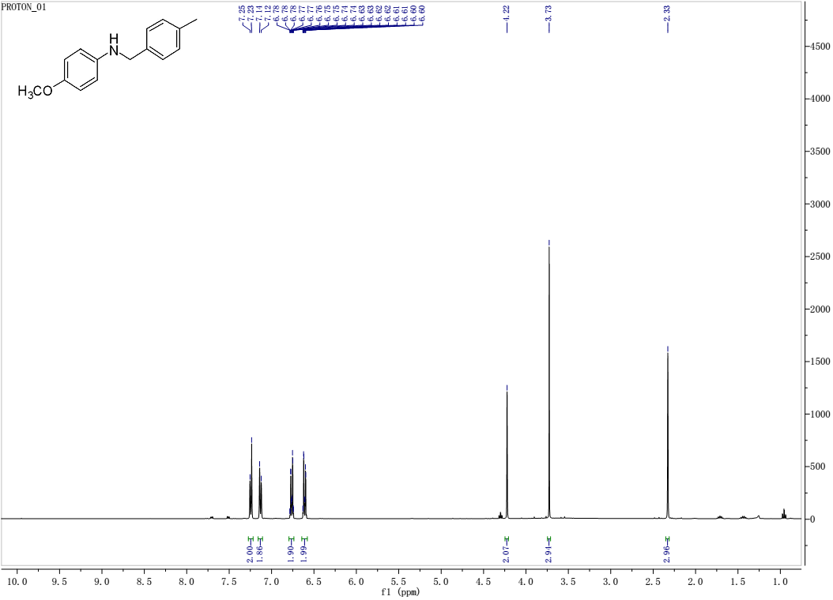

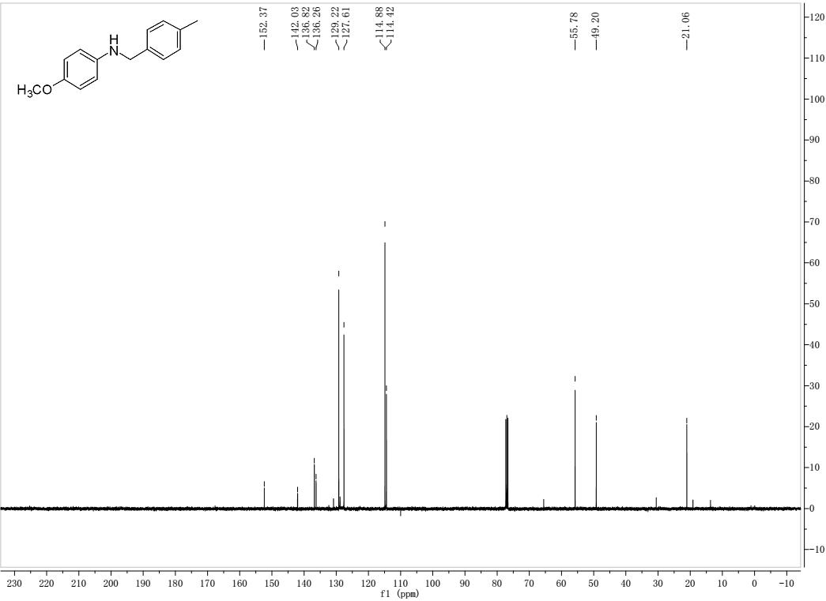

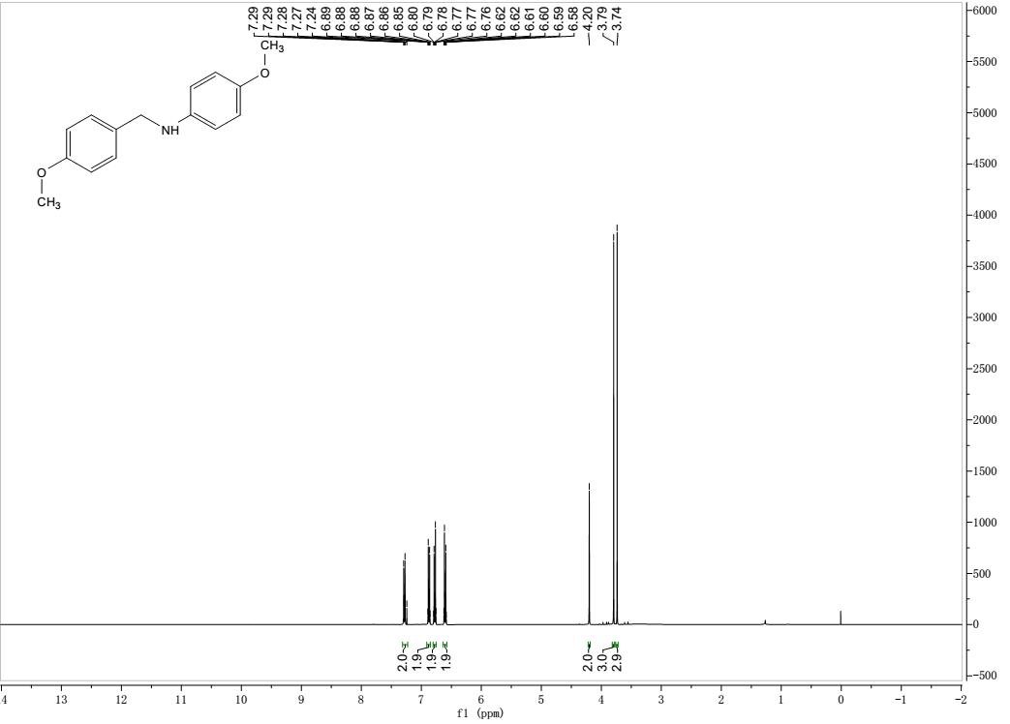

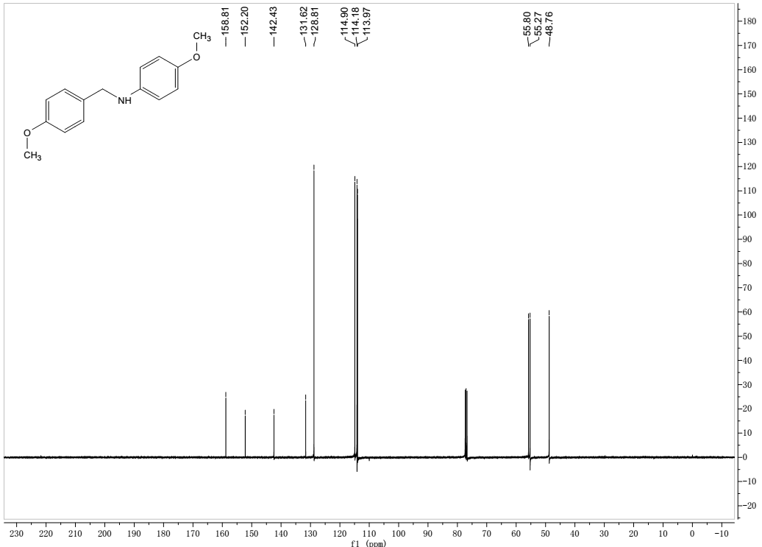

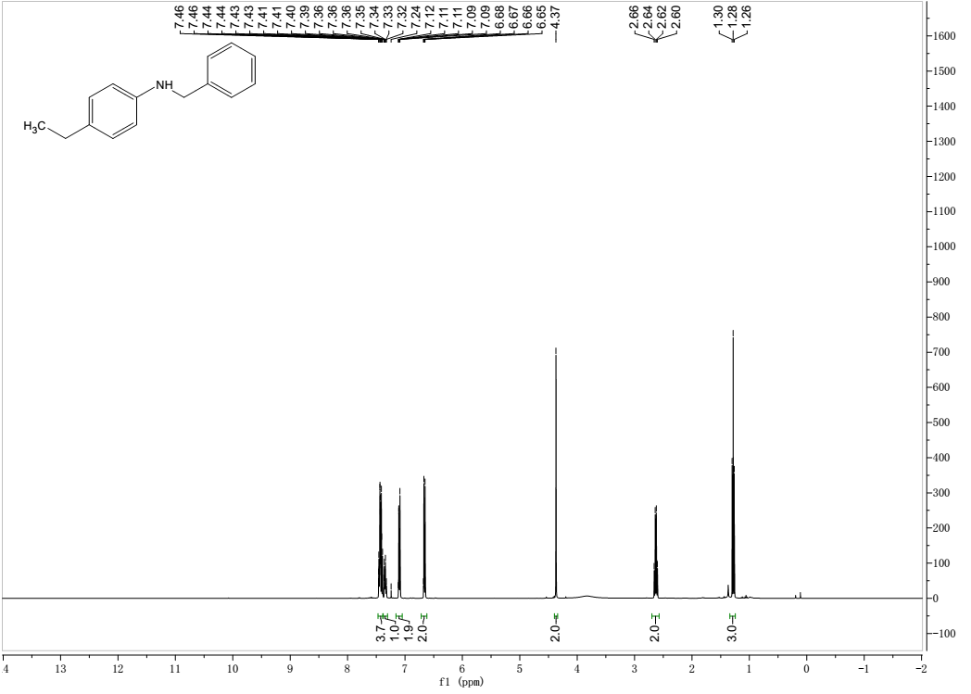

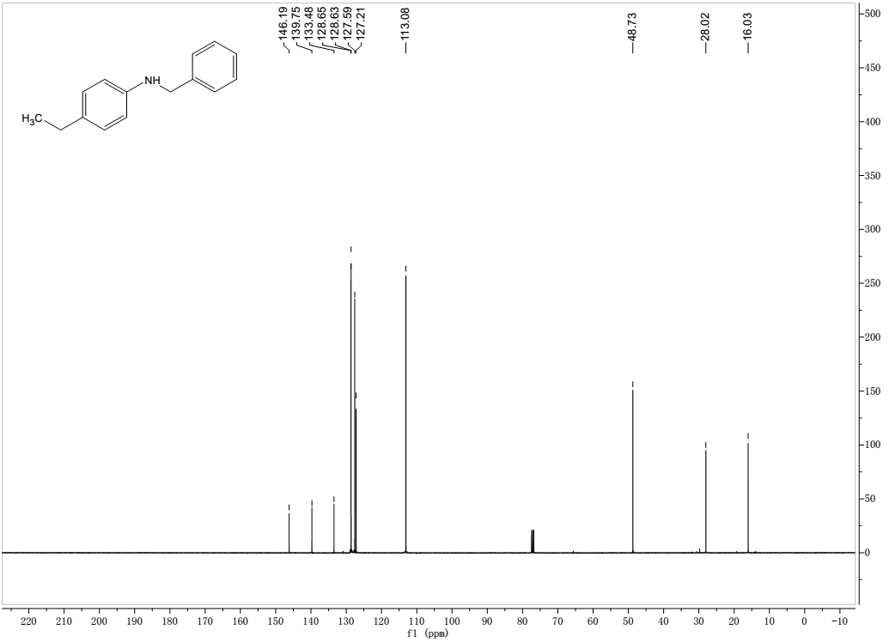

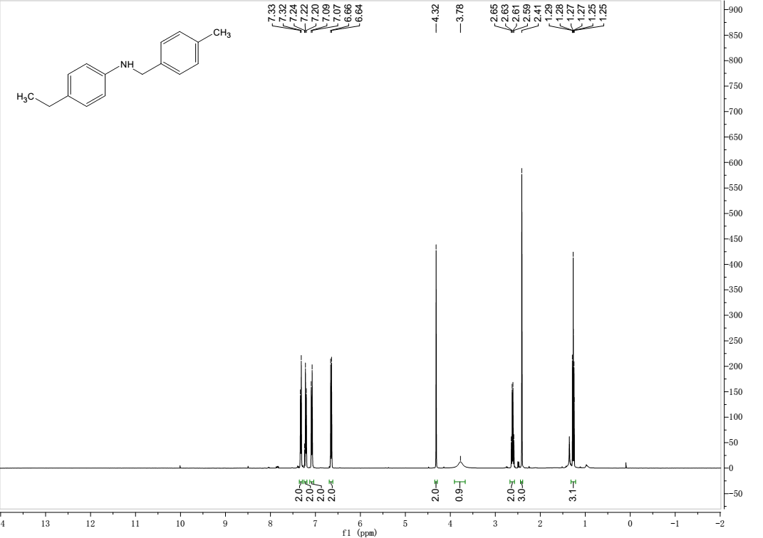

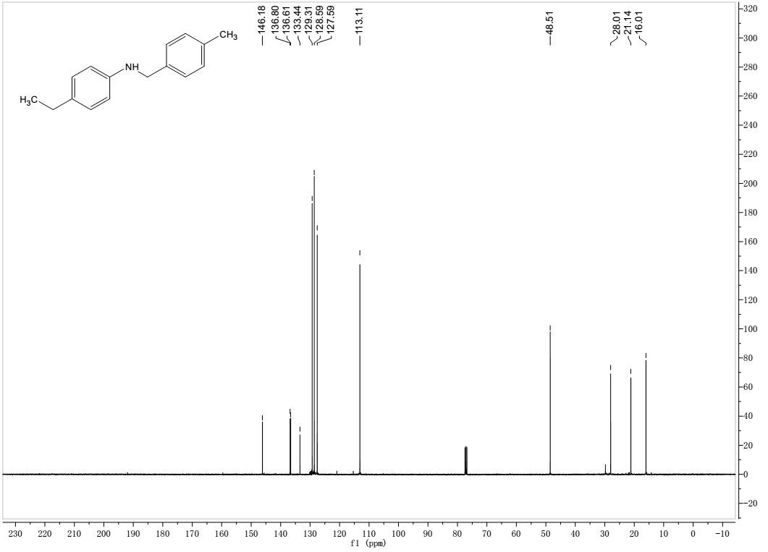

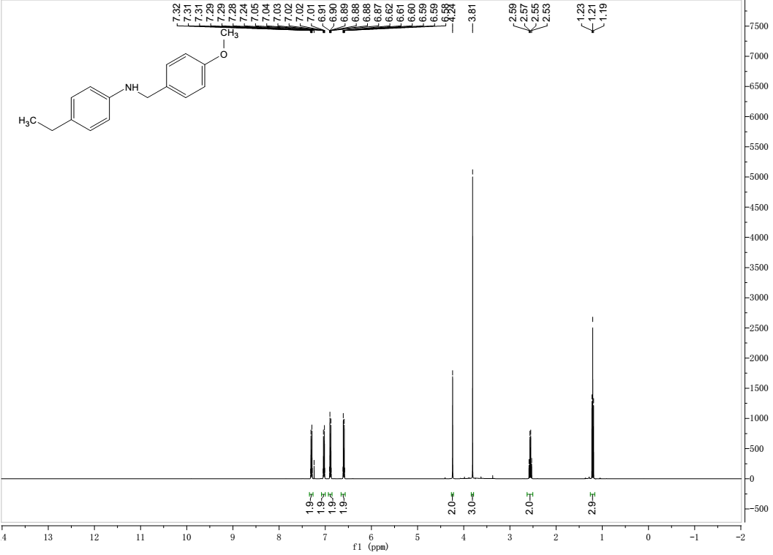

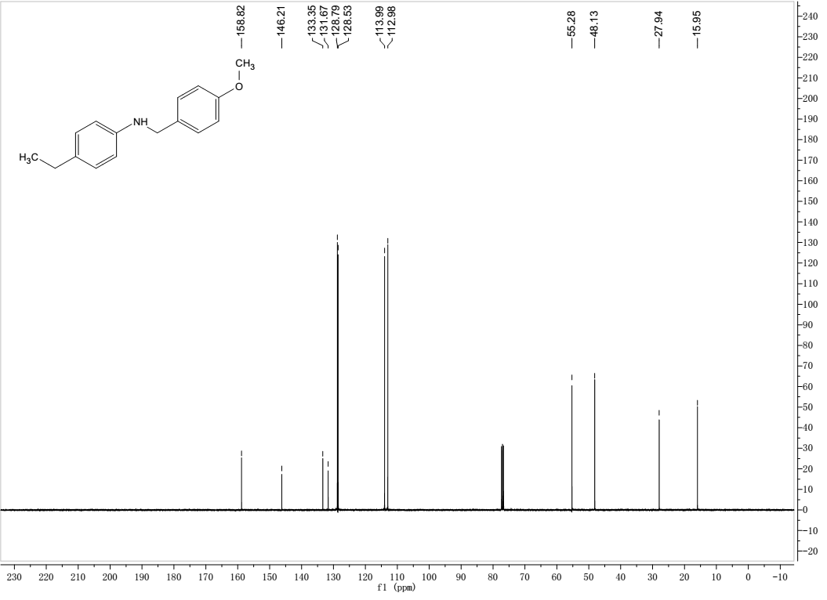

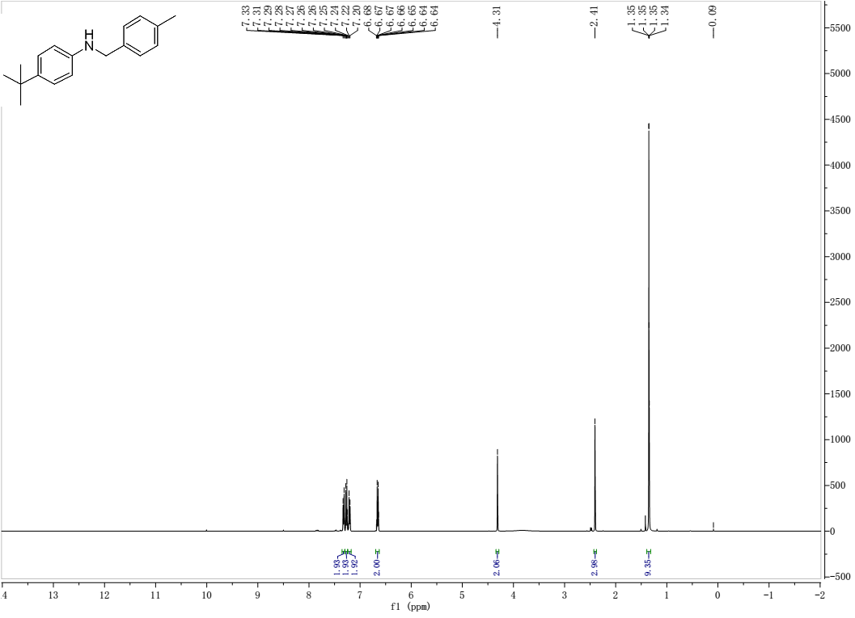

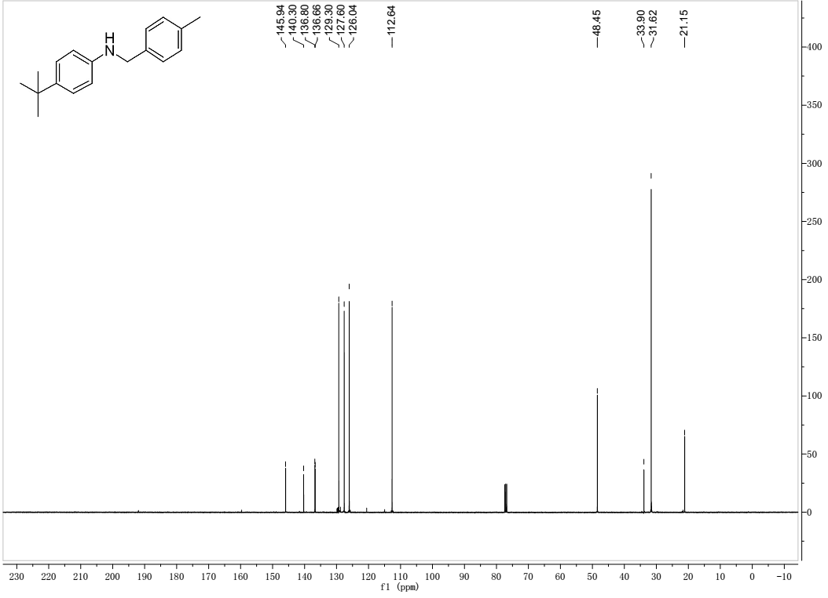

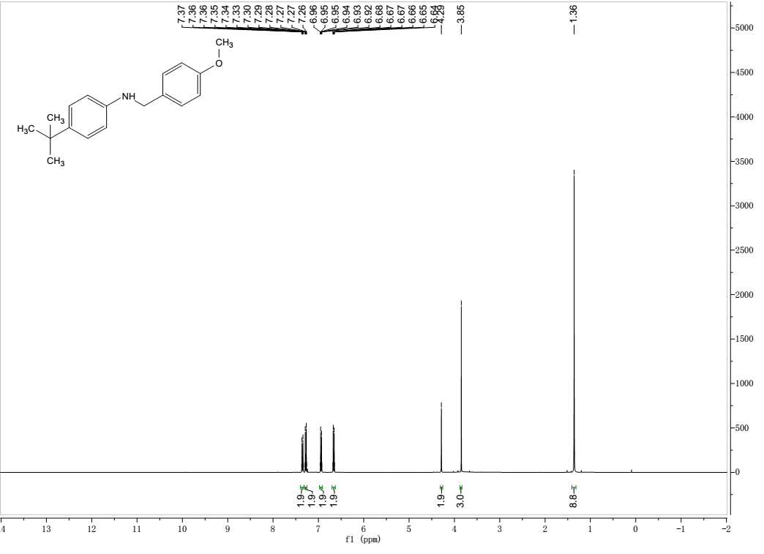

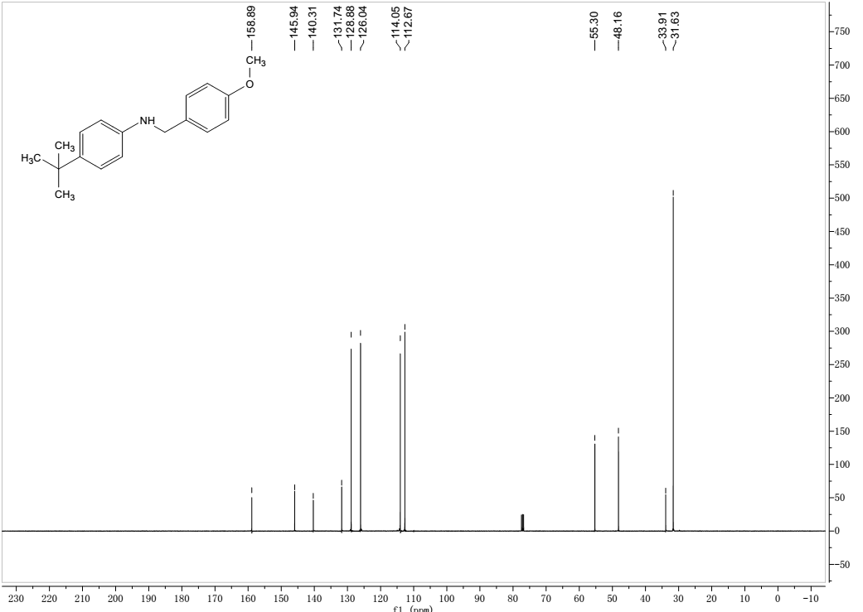

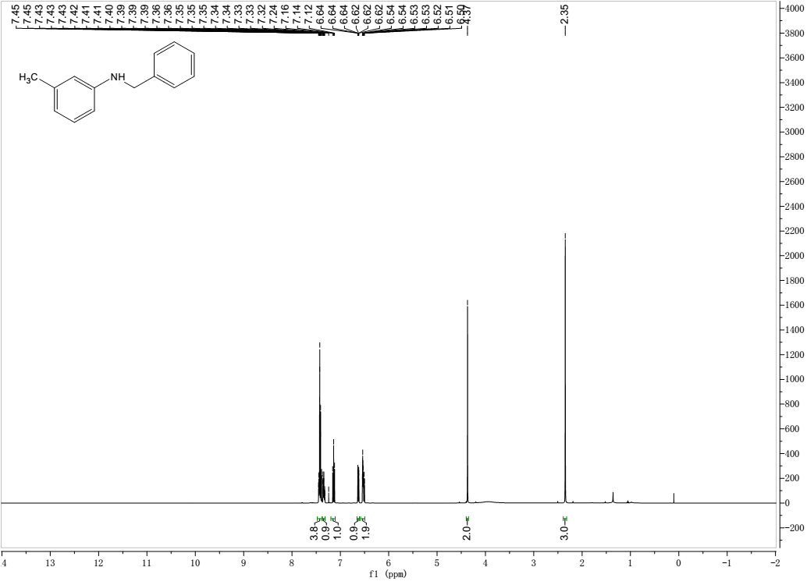

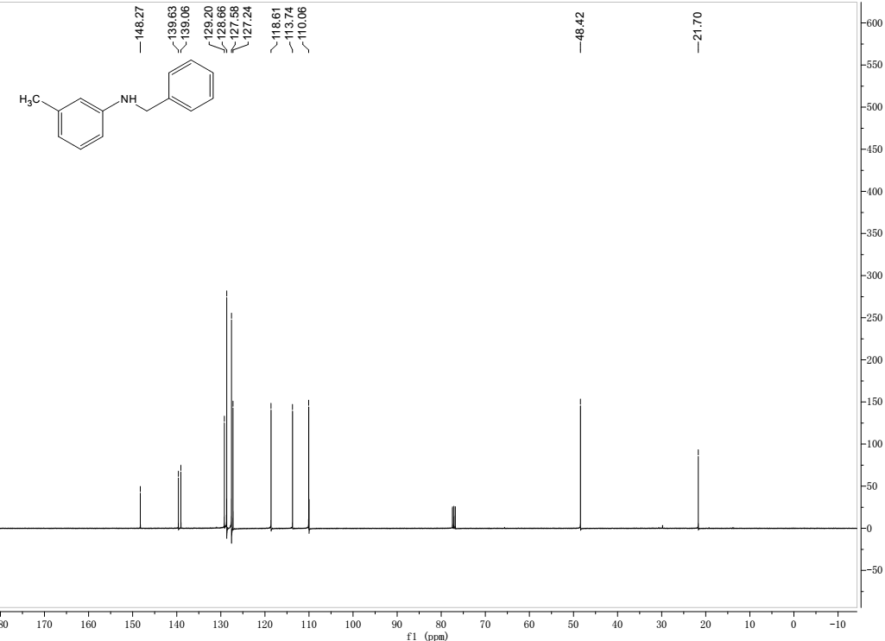

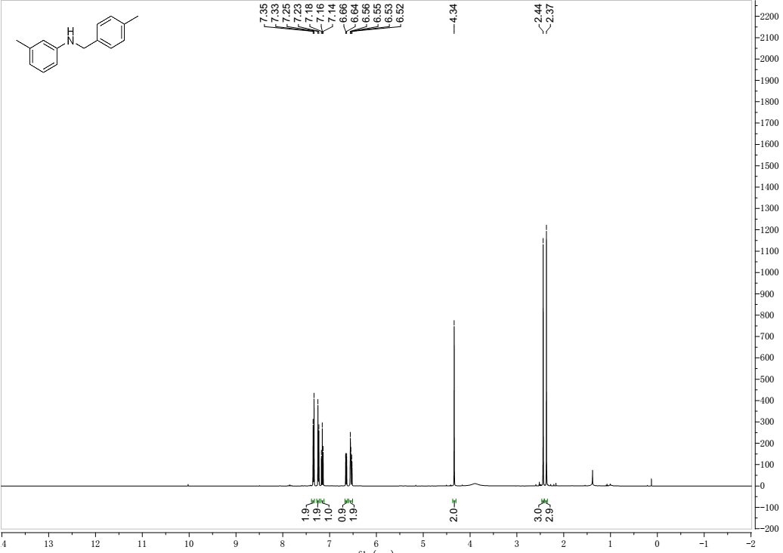

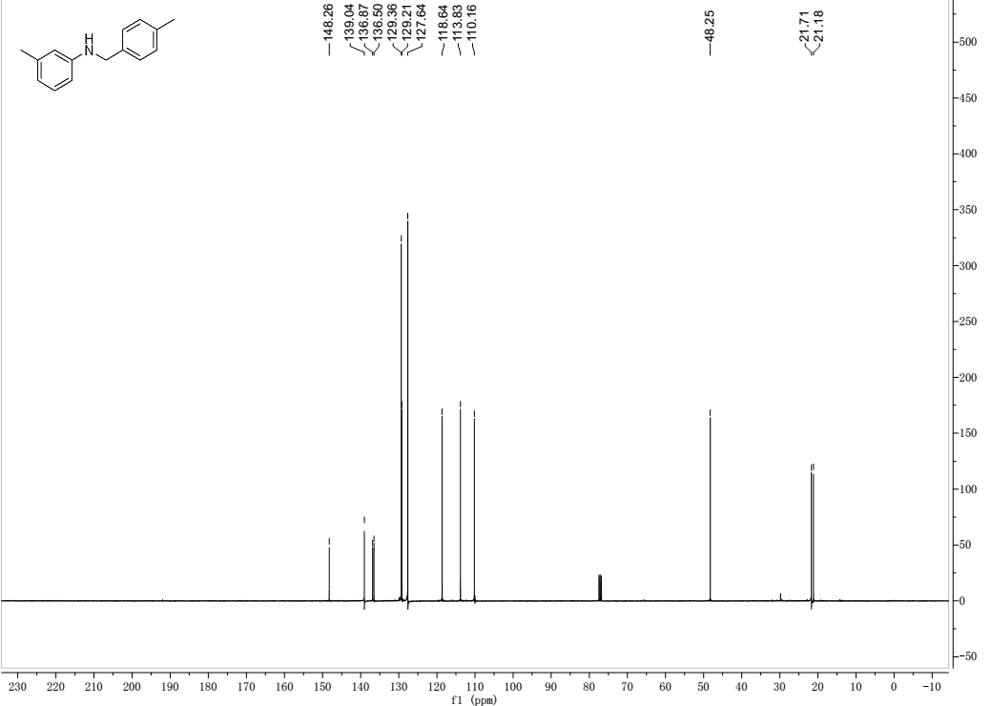

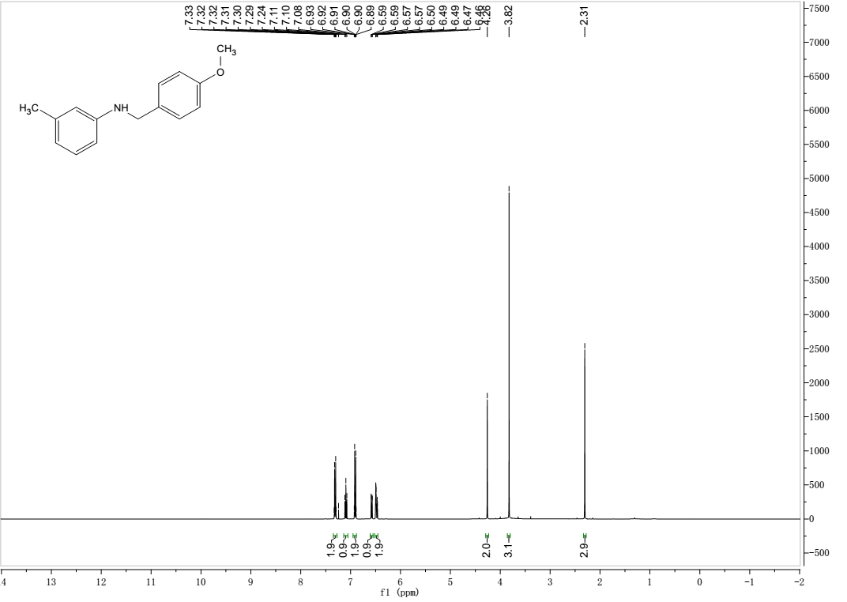

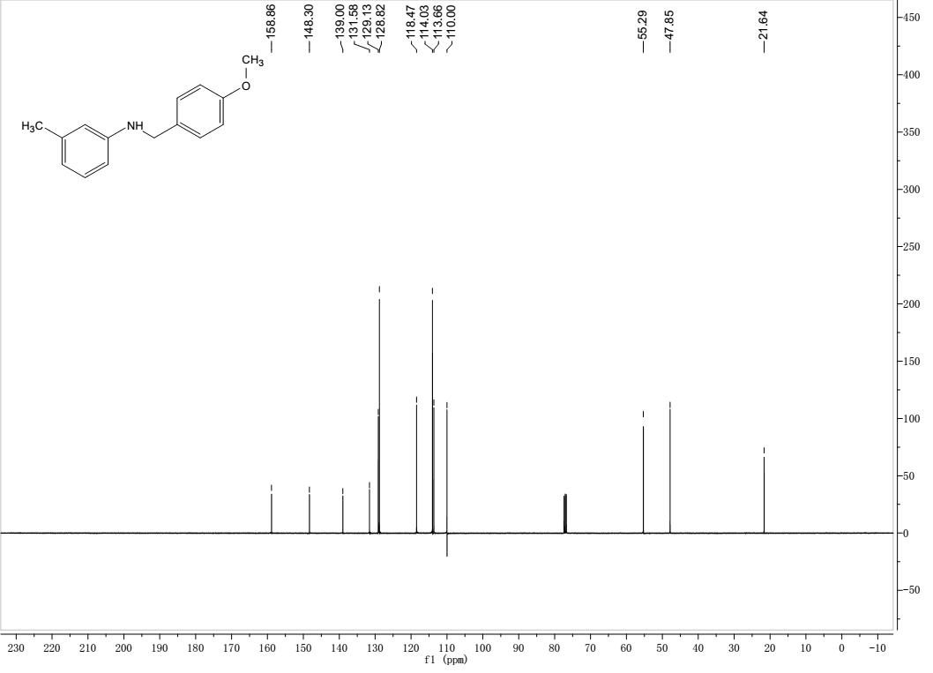

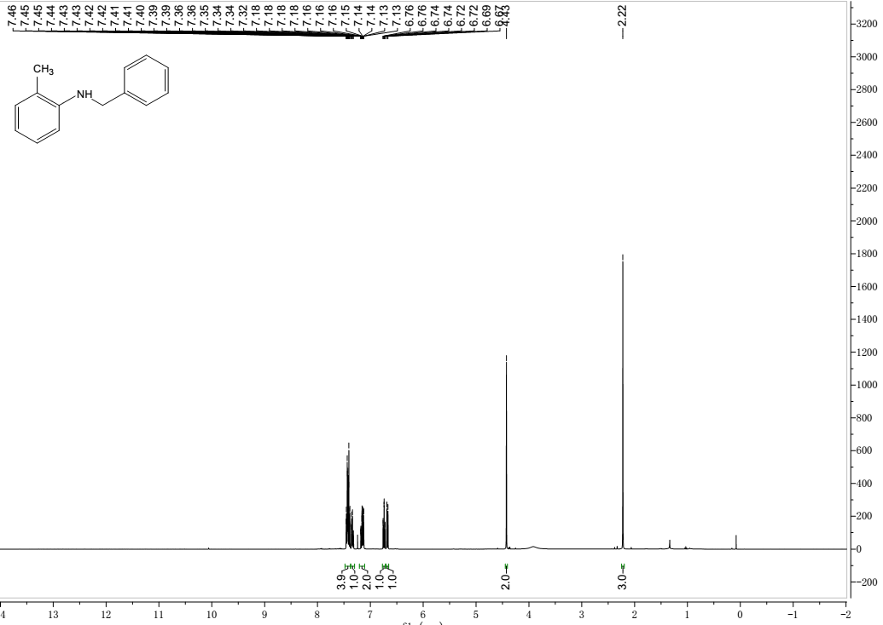

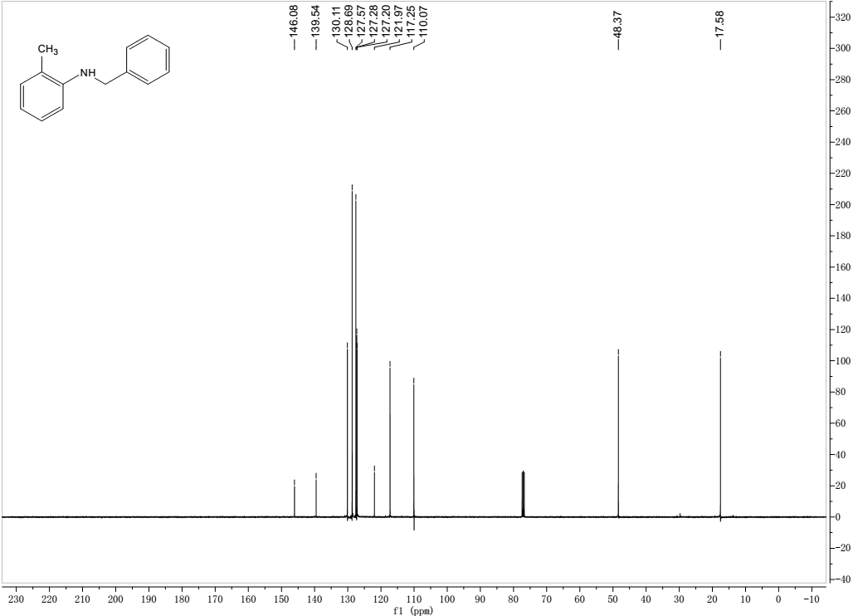

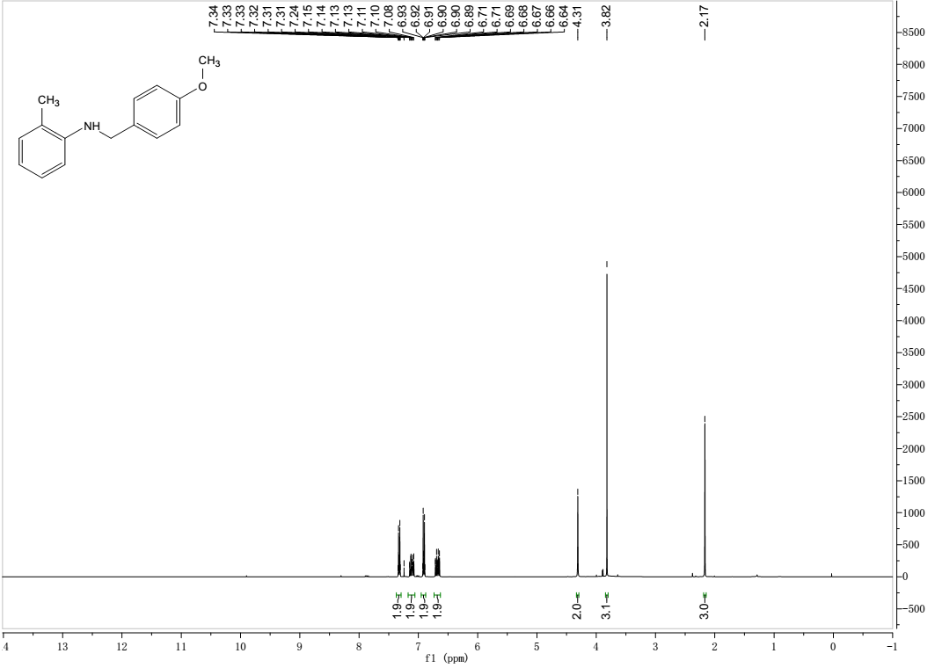

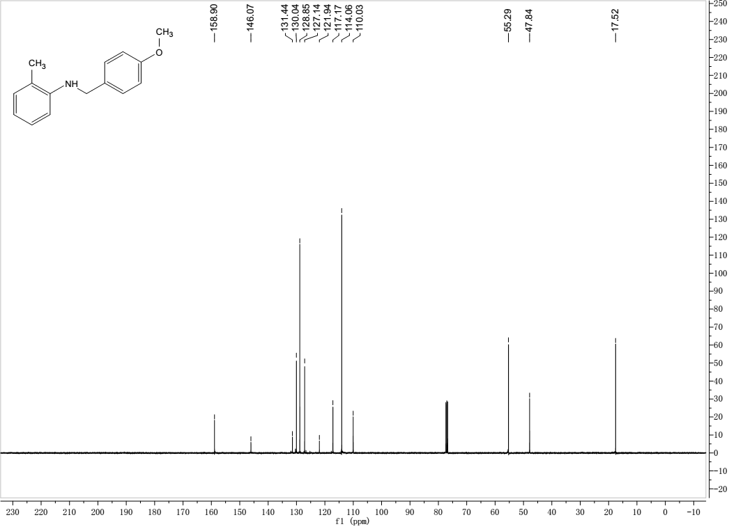

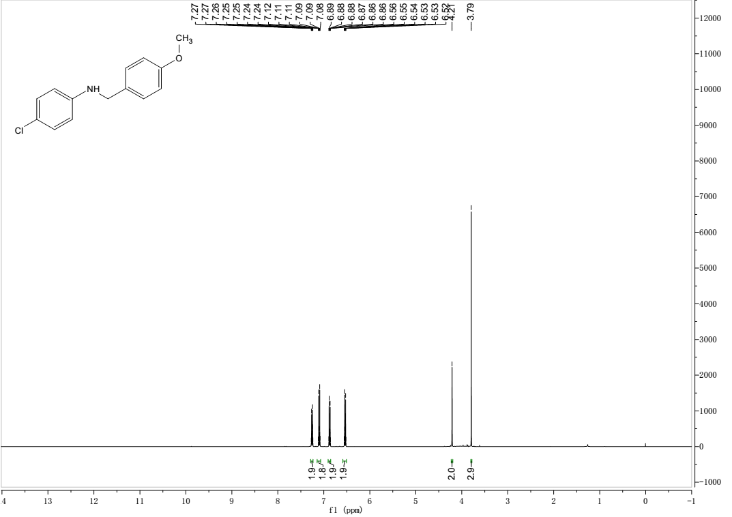

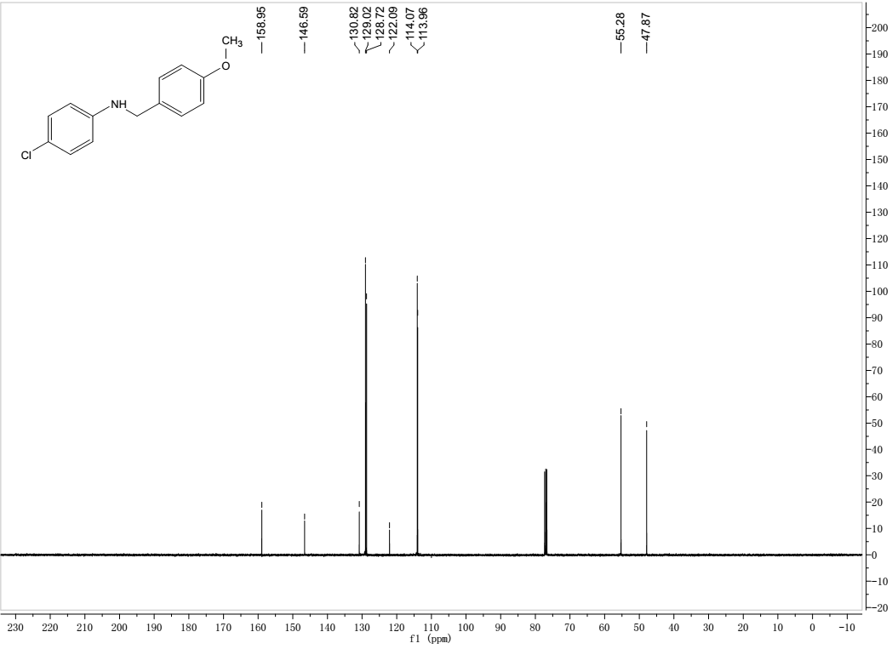

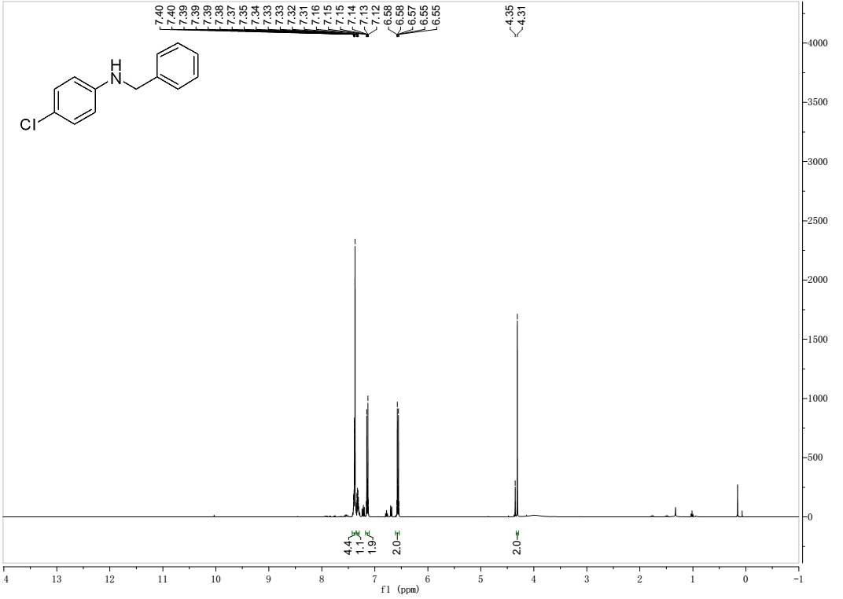

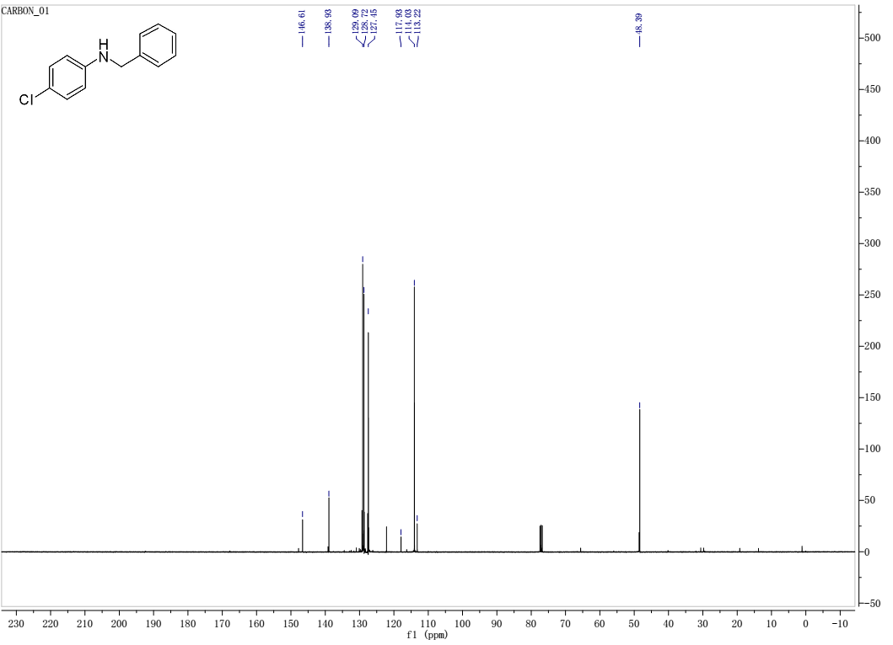

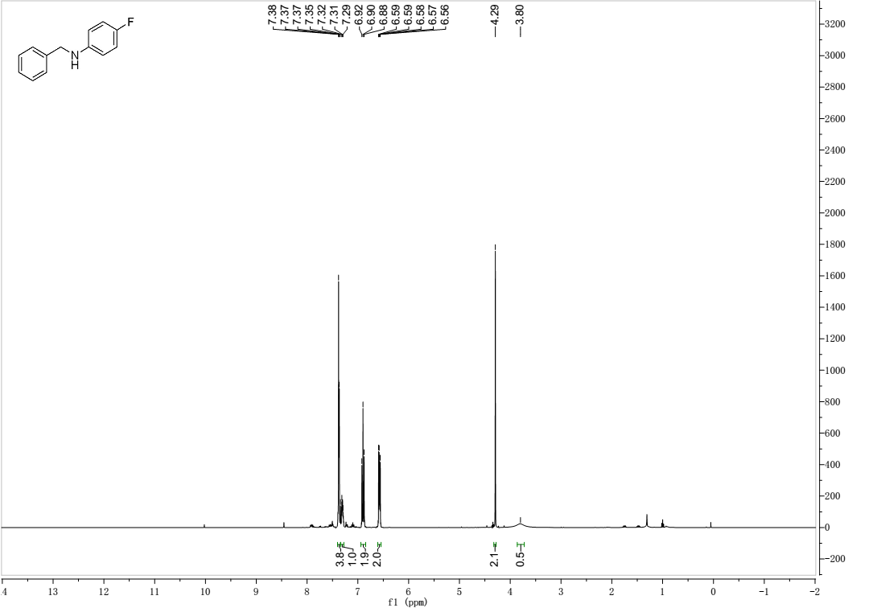

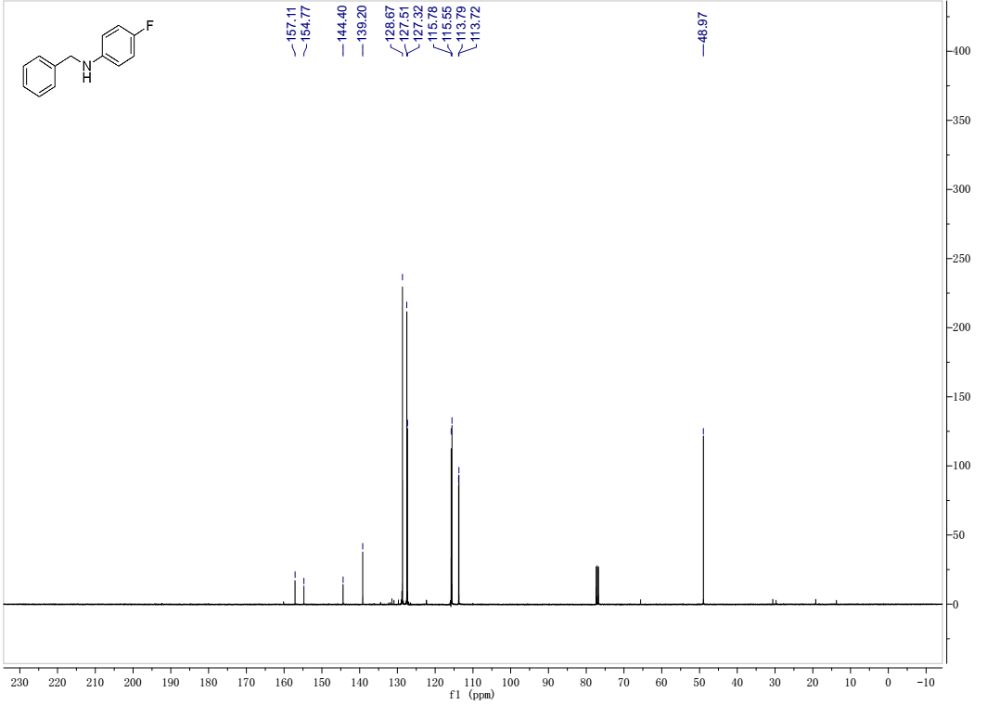

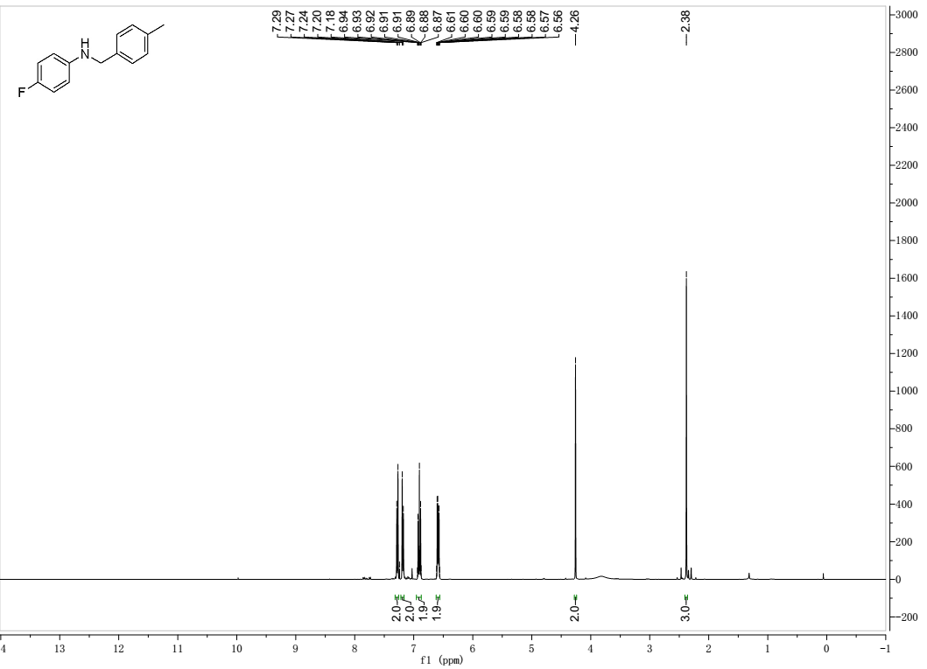

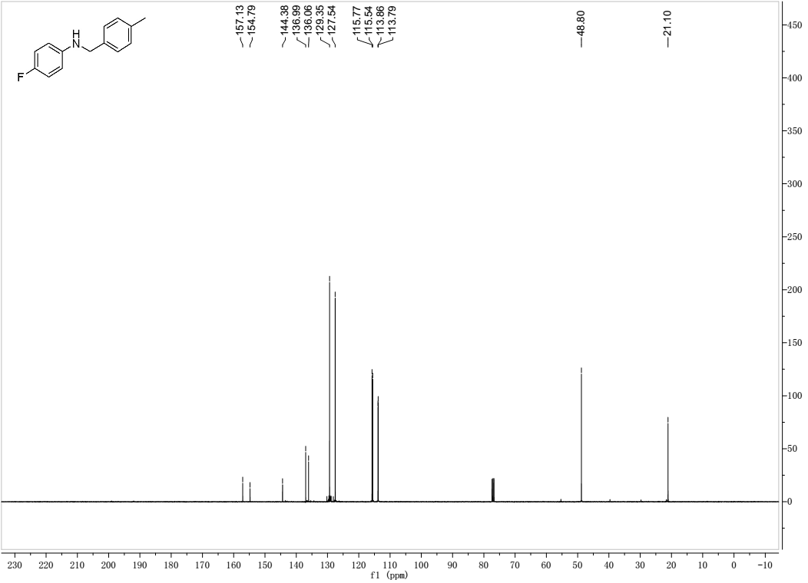

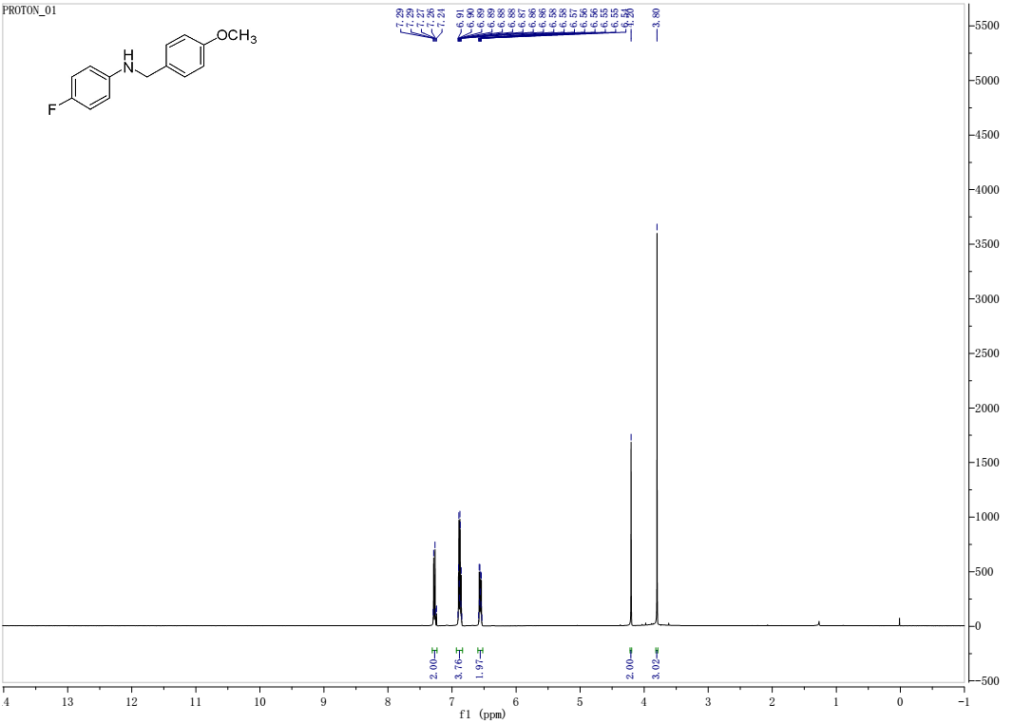

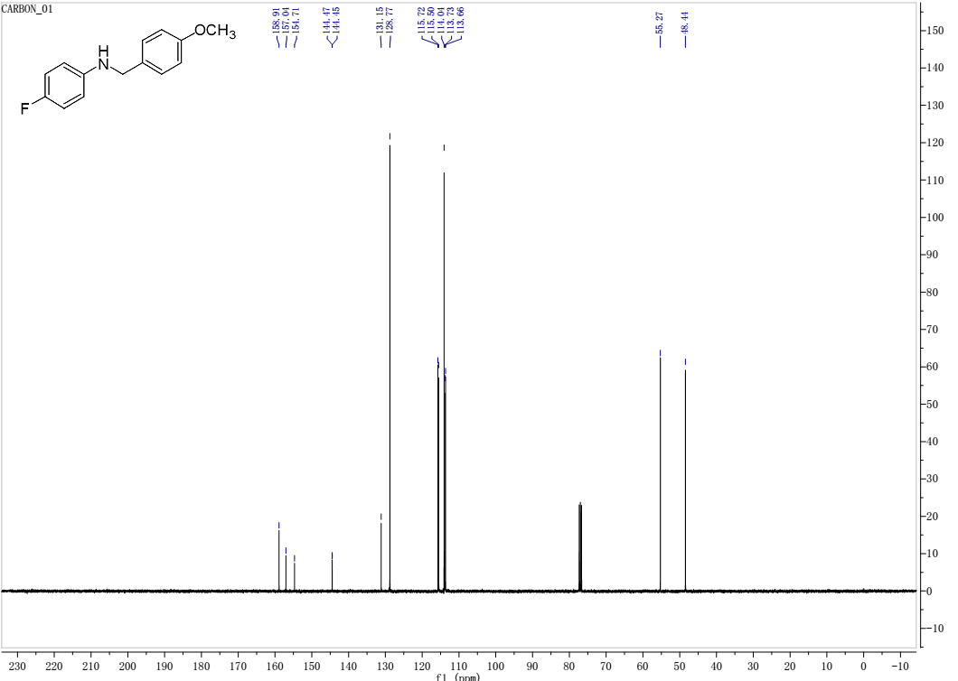

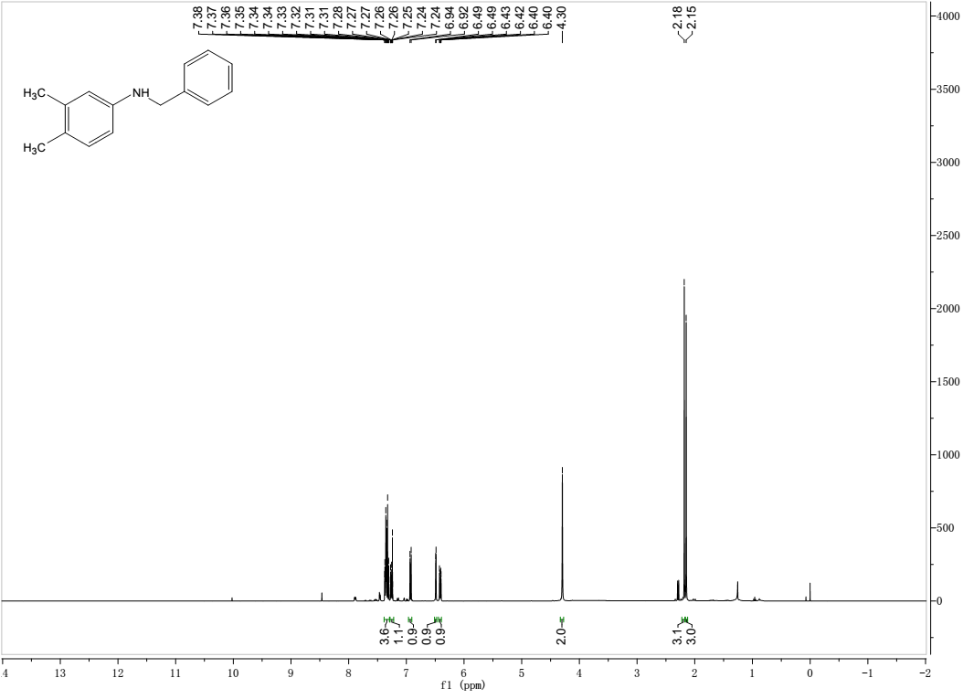

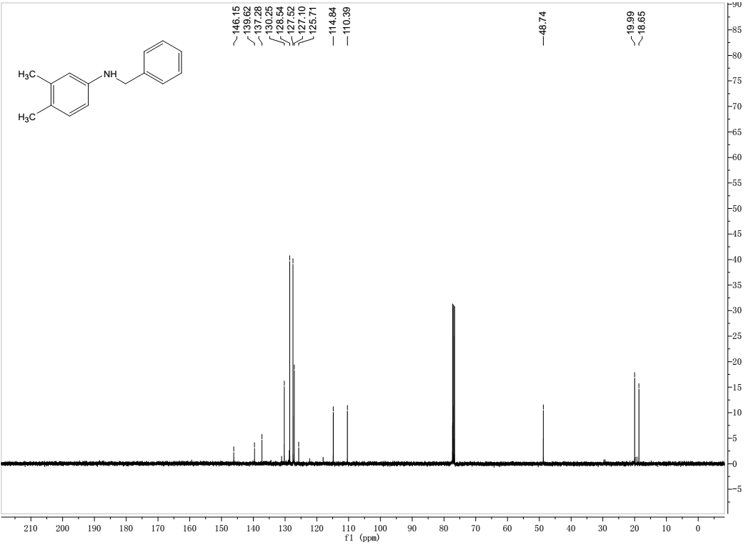

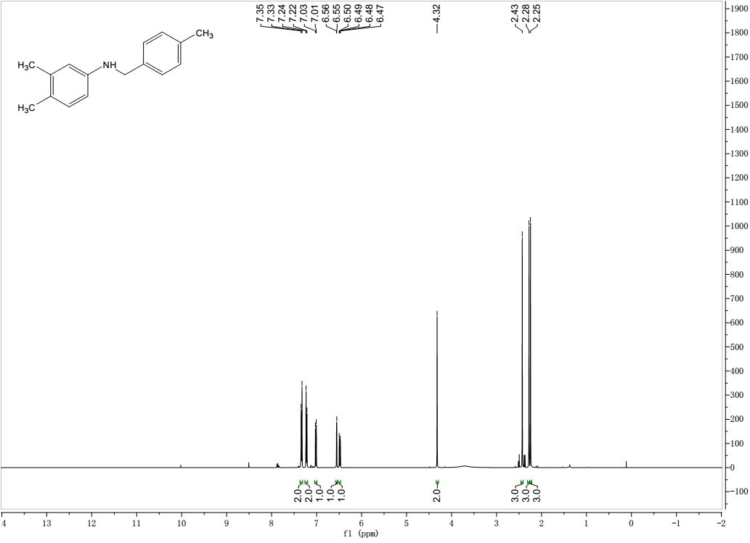

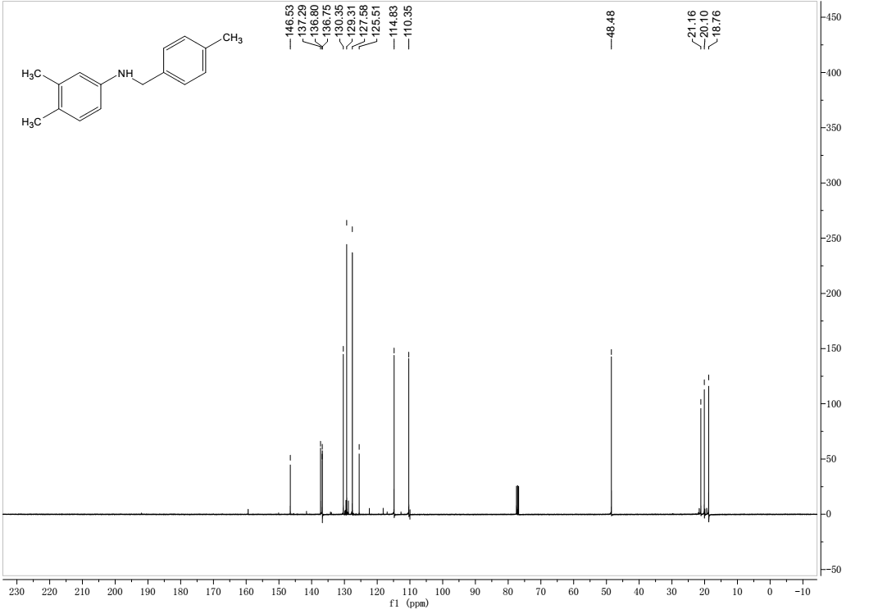

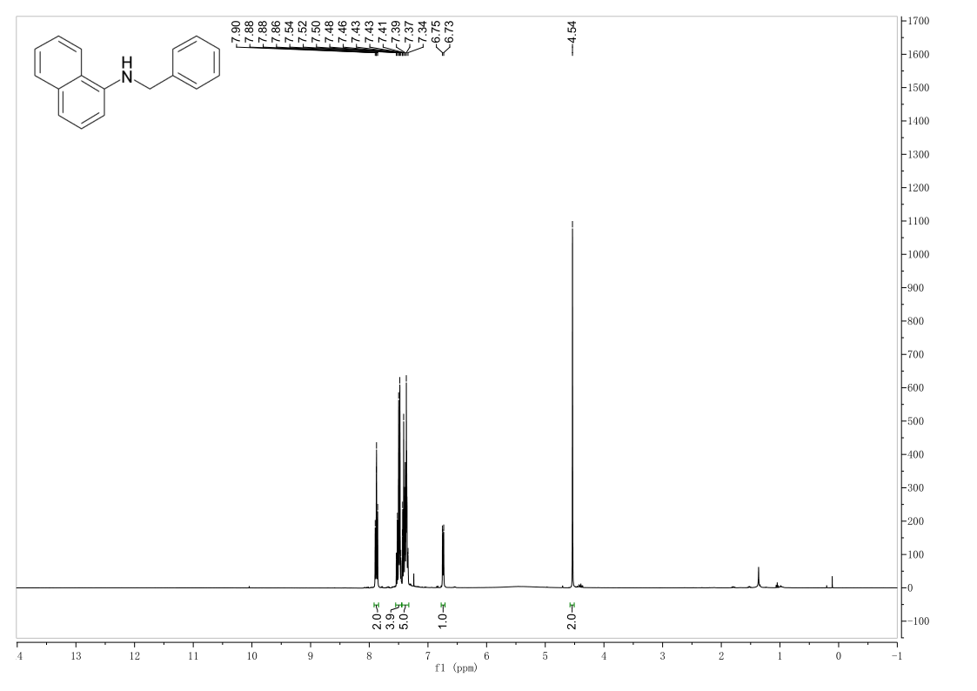

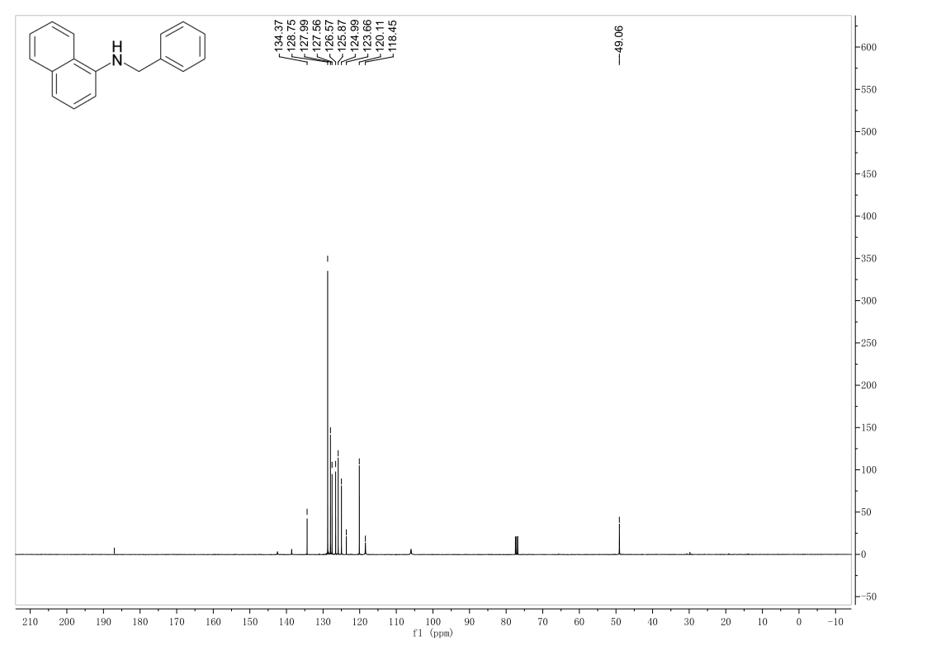

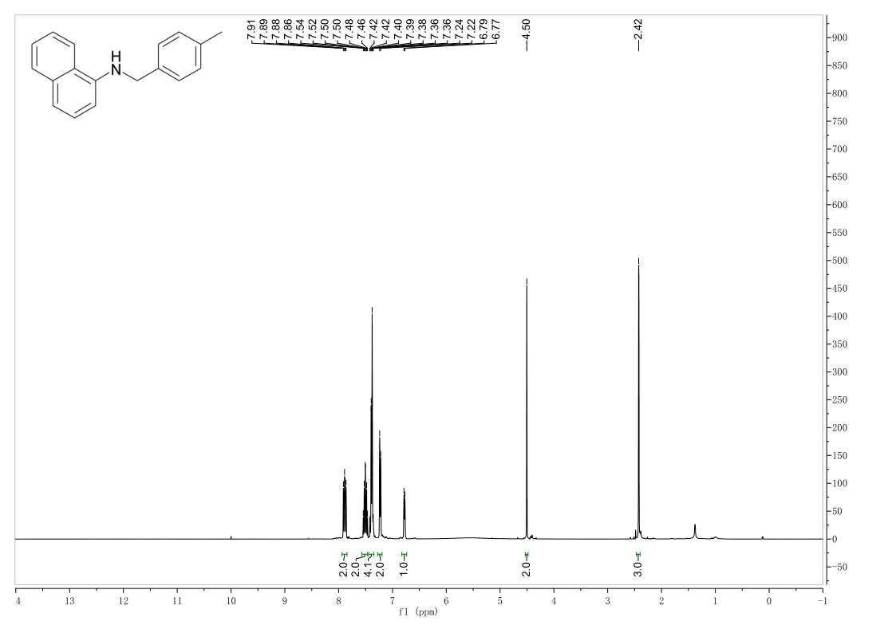

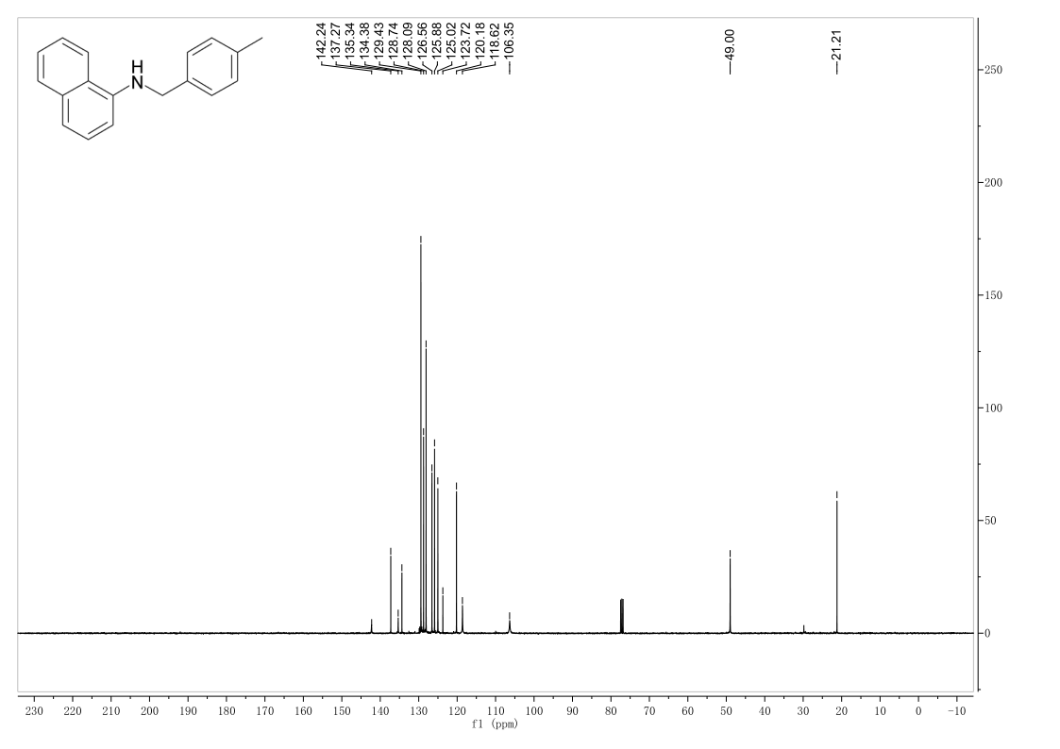

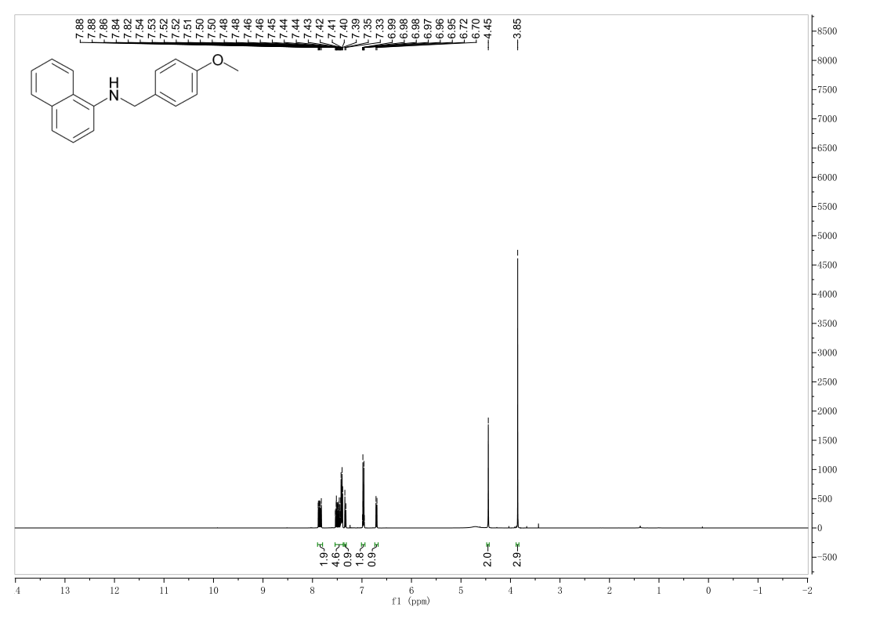

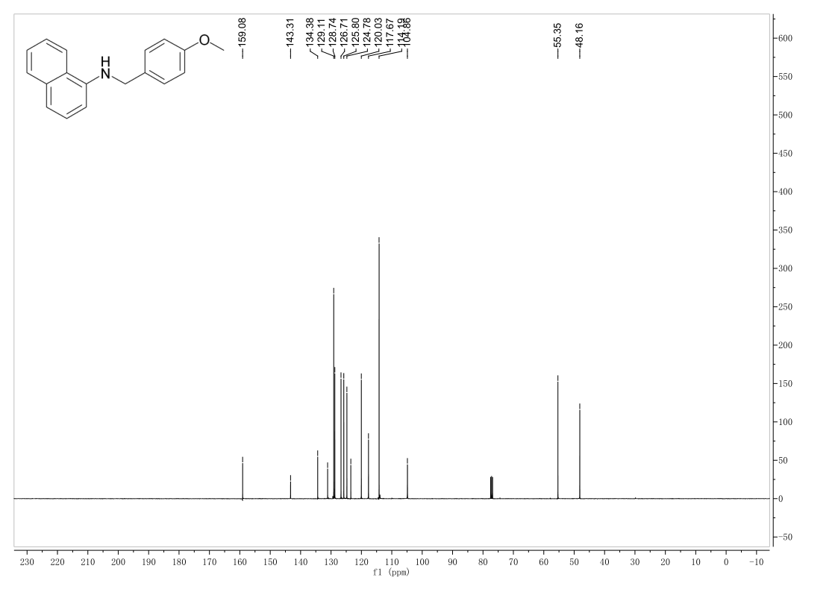

Chung, H. and Y. K. Chung, 2018. Cobalt-Rhodium Heterobimetallic Nanoparticle-Catalyzed N-Alkylation of Amines with Alcohols to Secondary and Tertiary Amines. J Org Chem. 83, 8533-8542. https://doi.org/10.1021/acs.joc.8b01109

Dai, X., X. Cui, Y. Deng, et al., 2015. A conjugated ketone as a catalyst in alcohol amination reactions under transition-metal and hetero-atom free conditions. RSC Advances. 5, 43589-43593. https://doi.org/10.1039/C5RA07681A

Fertig, R., T. Irrgang, F. Freitag, et al., 2018. Manganese-Catalyzed and Base-Switchable Synthesis of Amines or Imines via Borrowing Hydrogen or Dehydrogenative Condensation. ACS Catalysis. 8, 8525-8530. https://doi.org/10.1021/acscatal.8b02530

Gour, J., S. Gatadi, S. Malasala, et al., 2019. A Microwave-Assisted SmI2-Catalyzed Direct N-Alkylation of Anilines with Alcohols. The Journal of Organic Chemistry. 84, 7488-7494. https://doi.org/10.1021/acs.joc.9b00717

Guo, B., H.-X. Li, S.-Q. Zhang, et al., 2018. C-N Bond Formation Catalyzed by Ruthenium Nanoparticles Supported on N-Doped Carbon via Acceptorless Dehydrogenation to Secondary Amines, Imines, Benzimidazoles and Quinoxalines. ChemCatChem. 10, 5627-5636. https://doi.org/10.1002/cctc.201801525

Huang, M., Y. Li, J. Liu, et al., 2019. A bifunctional strategy for N-heterocyclic carbene-stabilized iridium complex-catalyzed N-alkylation of amines with alcohols in aqueous media. Green Chemistry. 21, 219-224. https://doi.org/10.1039/c8gc02298d

Li, T., X. Cui, L. Sun, et al., 2014. Economical and efficient aqueous reductions of high melting-point imines and nitroarenes to amines: promotion effects of granular PTFE. RSC Advances. 4, 33599-33606. https://doi.org/10.1039/C4RA04528A

Midya, S. P., J. Pitchaimani, V. G. Landge, et al., 2018. Direct access to N-alkylated amines and imines via acceptorless dehydrogenative coupling catalyzed by a cobalt(ii)-NNN pincer complex. Catalysis Science & Technology. 8, 3469-3473. https://doi.org/10.1039/C8CY00859K

Minakawa, M., M. Okubo and M. Kawatsura, 2015. Selective Direct N-Alkylation of Amines with Alcohols using Iron(III) Phthalocyanine Chloride under Solvent-Free Conditions. Bulletin of the Chemical Society of Japan. 88, 1680-1682. https://doi.org/10.1246/bcsj.20150217

Nirmala, M., G. Saranya, P. Viswanathamurthi, et al., 2017. Organonickel complexes encumbering bis-imidazolylidene carbene ligands: Synthesis, X-ray structure and catalytic insights on Buchwald-Hartwig amination reactions. Journal of Organometallic Chemistry. 831, 1-10. https://doi.org/10.1016/j.jorganchem.2016.12.029

Panda, T. K., I. Banerjee and S. Sagar, 2020. Alkali Metal–Promoted Facile Synthesis of Secondary Amines from Imines and Carbodiimides. Applied Organometallic Chemistry. 34, e5765. https://doi.org/10.1002/aoc.5765

Santoro, F., R. Psaro, N. Ravasio, et al., 2014. N-Alkylation of amines through hydrogen borrowing over a heterogeneous Cu catalyst. RSC Advances. 4, 2596-2600. https://doi.org/10.1039/C3RA44364G

Satyanarayana, P., G. M. Reddy, H. Maheswaran, et al., 2013. Tris(acetylacetonato)rhodium(III)-Catalyzed α-Alkylation of Ketones, β-Alkylation of Secondary Alcohols and Alkylation of Amines with Primary Alcohols. Advanced Synthesis & Catalysis. 355, 1859-1867. https://doi.org/10.1002/adsc.201300061

Singh, A., A. Maji, M. Joshi, et al., 2021. Designed pincer ligand supported Co(ii)-based catalysts for dehydrogenative activation of alcohols: Studies on N-alkylation of amines, α-alkylation of ketones and synthesis of quinolines. Dalton Transactions. 50, 8567-8587. https://doi.org/10.1039/D0DT03748F

Tan, D.-W., H.-X. Li, D. J. Young, et al., 2016. Phosphine ligand-free RuCl3-catalyzed reductive N-alkylation of aryl nitro compounds. Tetrahedron. 72, 4169-4176. https://doi.org/10.1016/j.tet.2016.05.036

Vellakkaran, M., K. Singh and D. Banerjee, 2017. An Efficient and Selective Nickel-Catalyzed Direct N-Alkylation of Anilines with Alcohols. ACS Catalysis. 7, 8152-8158. https://doi.org/10.1021/acscatal.7b02817

Yoshinaga, T., T. Iwata and M. Shindo, 2020. Mild Environment-friendly Oxidative Debenzylation of N-Benzylanilines Using DMSO as an Oxidant. Chemistry Letters. 49, 191-194. https://doi.org/10.1246/cl.190854

Zhang, C., Z. Zhan, M. Lei, et al., 2014. Ullmann-type C–N coupling reaction catalyzed by CuI/metformin. Tetrahedron. 70, 8817-8821. https://doi.org/10.1016/j.tet.2014.10.014