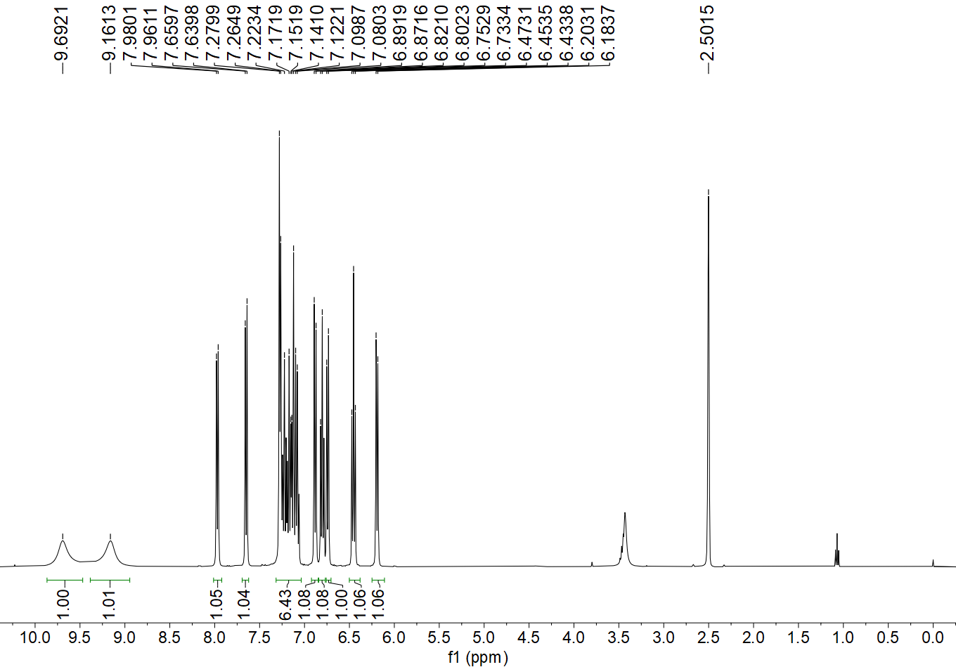
Fig. S1 ¹H NMR spectrum of H₂L

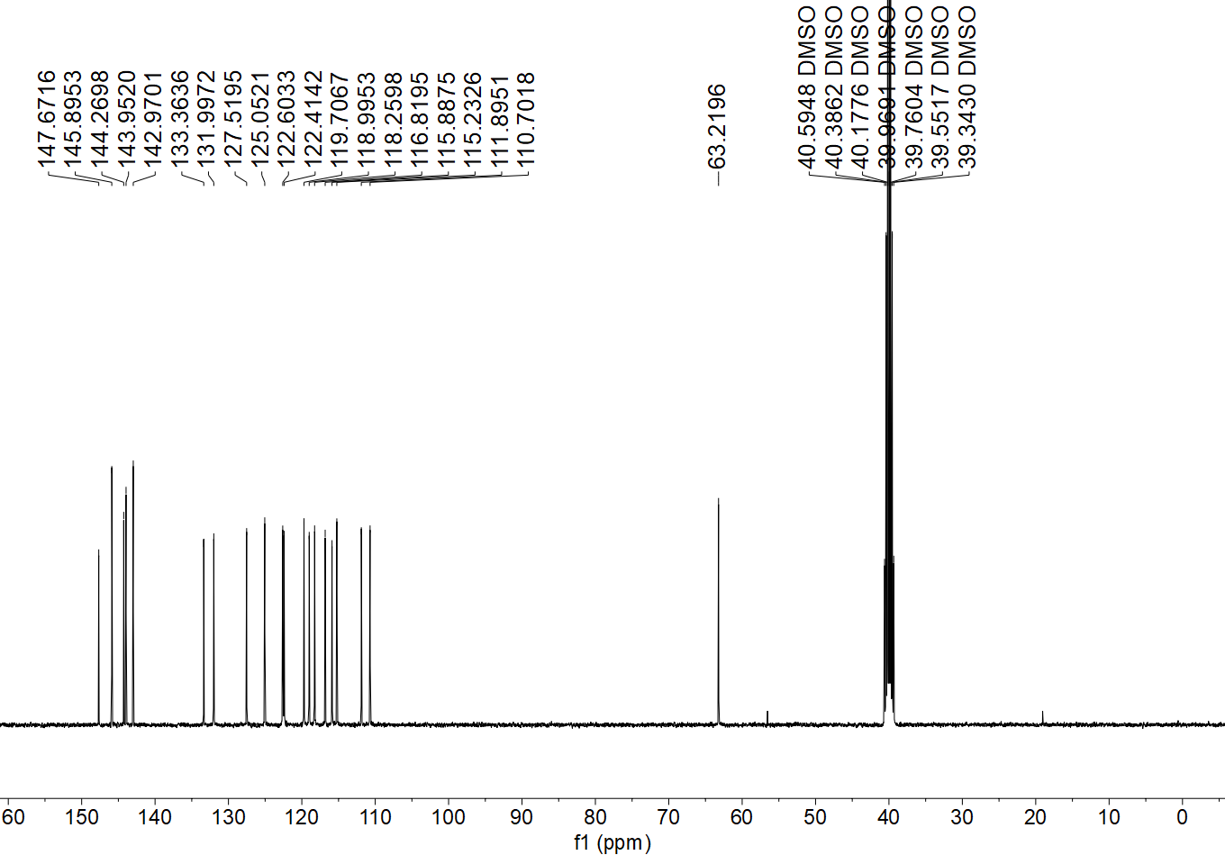
Fig. S2 ¹³C NMR spectrum of H₂L

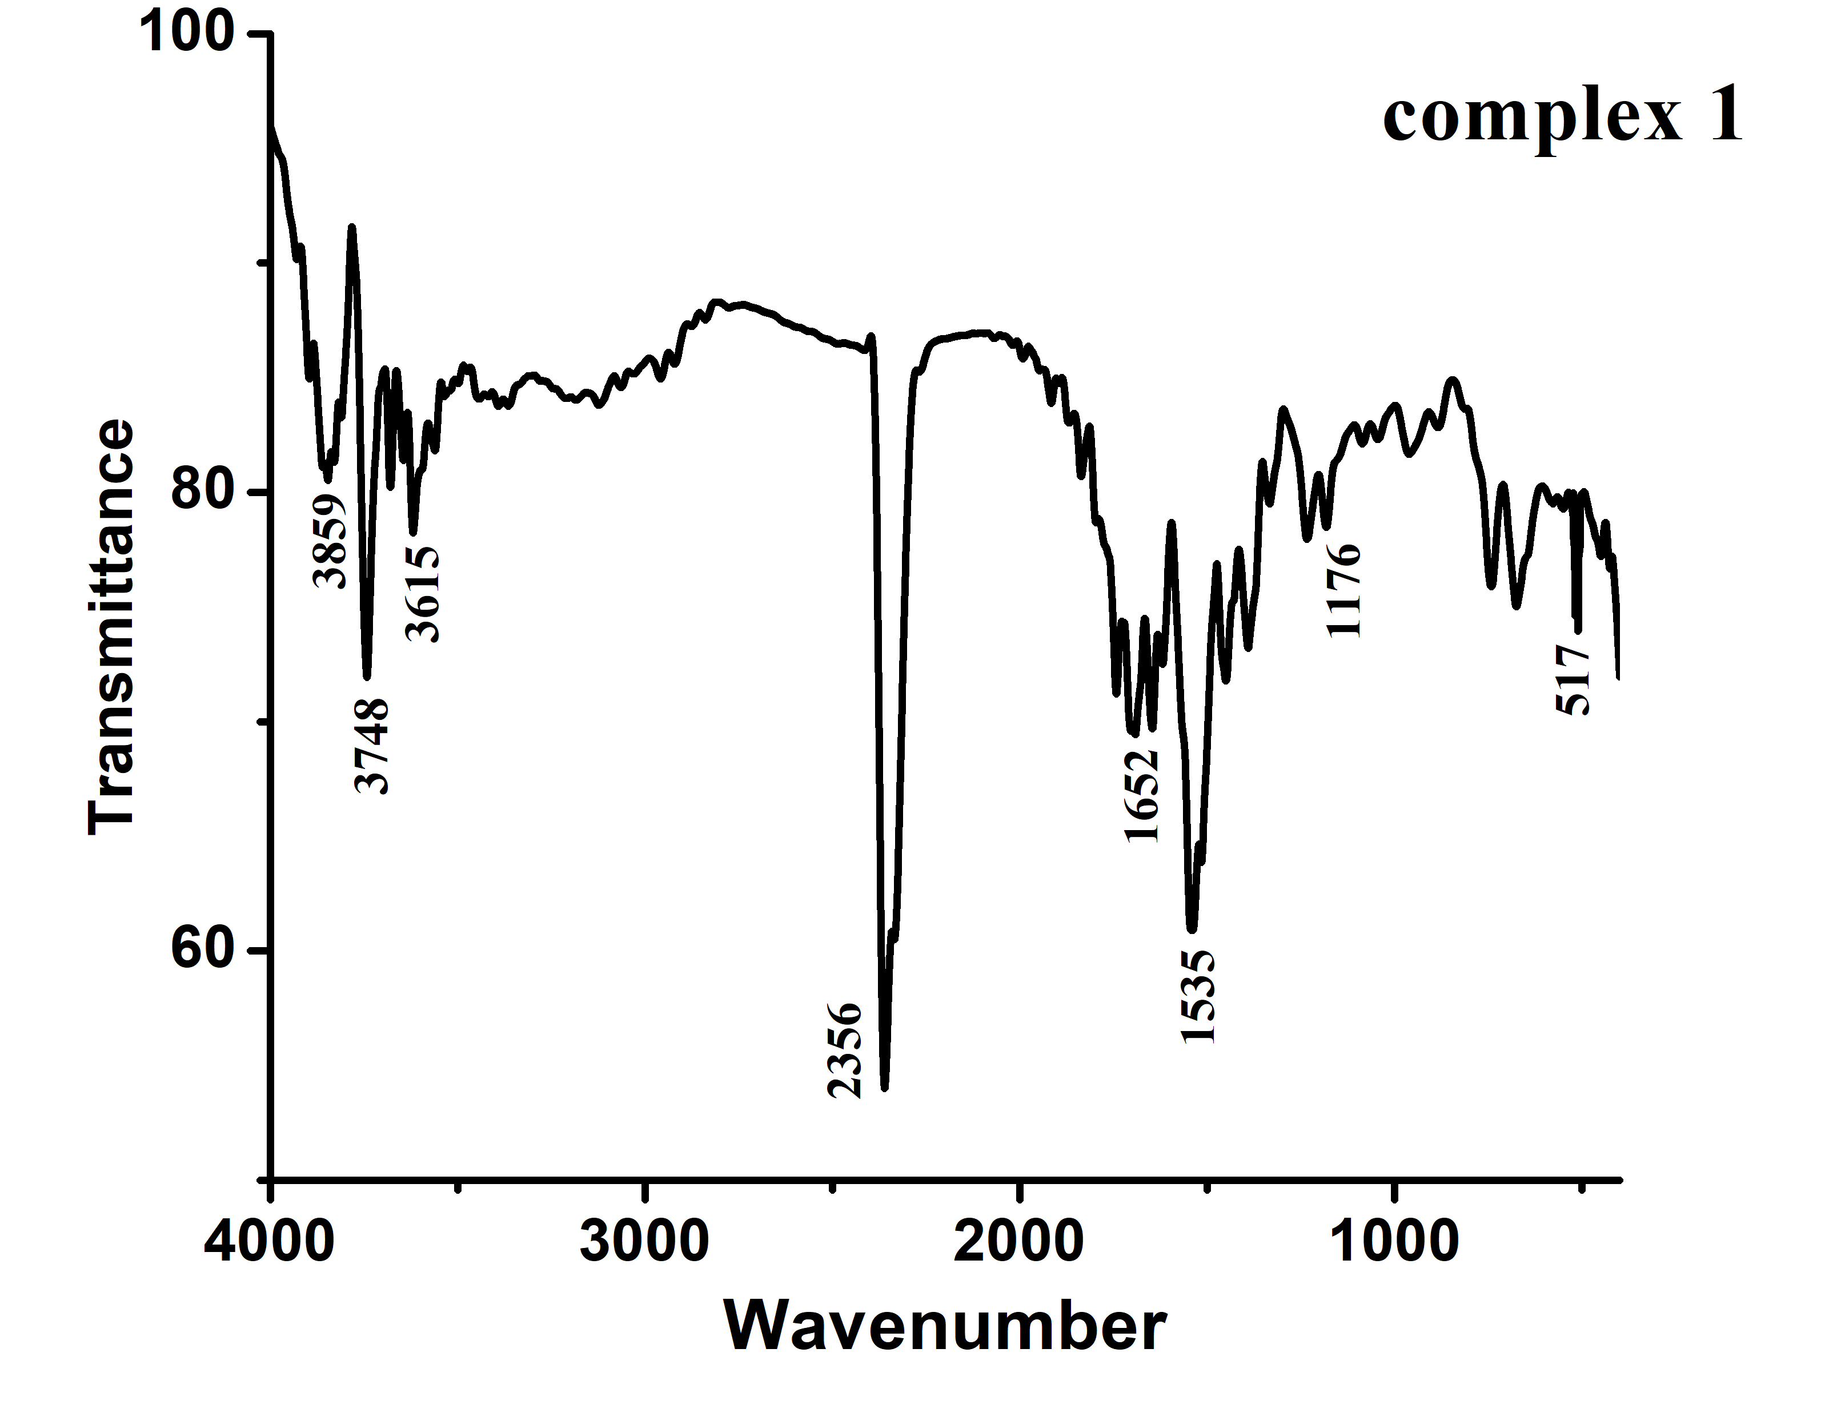
Fig. S3 IR spectrum of complex 1

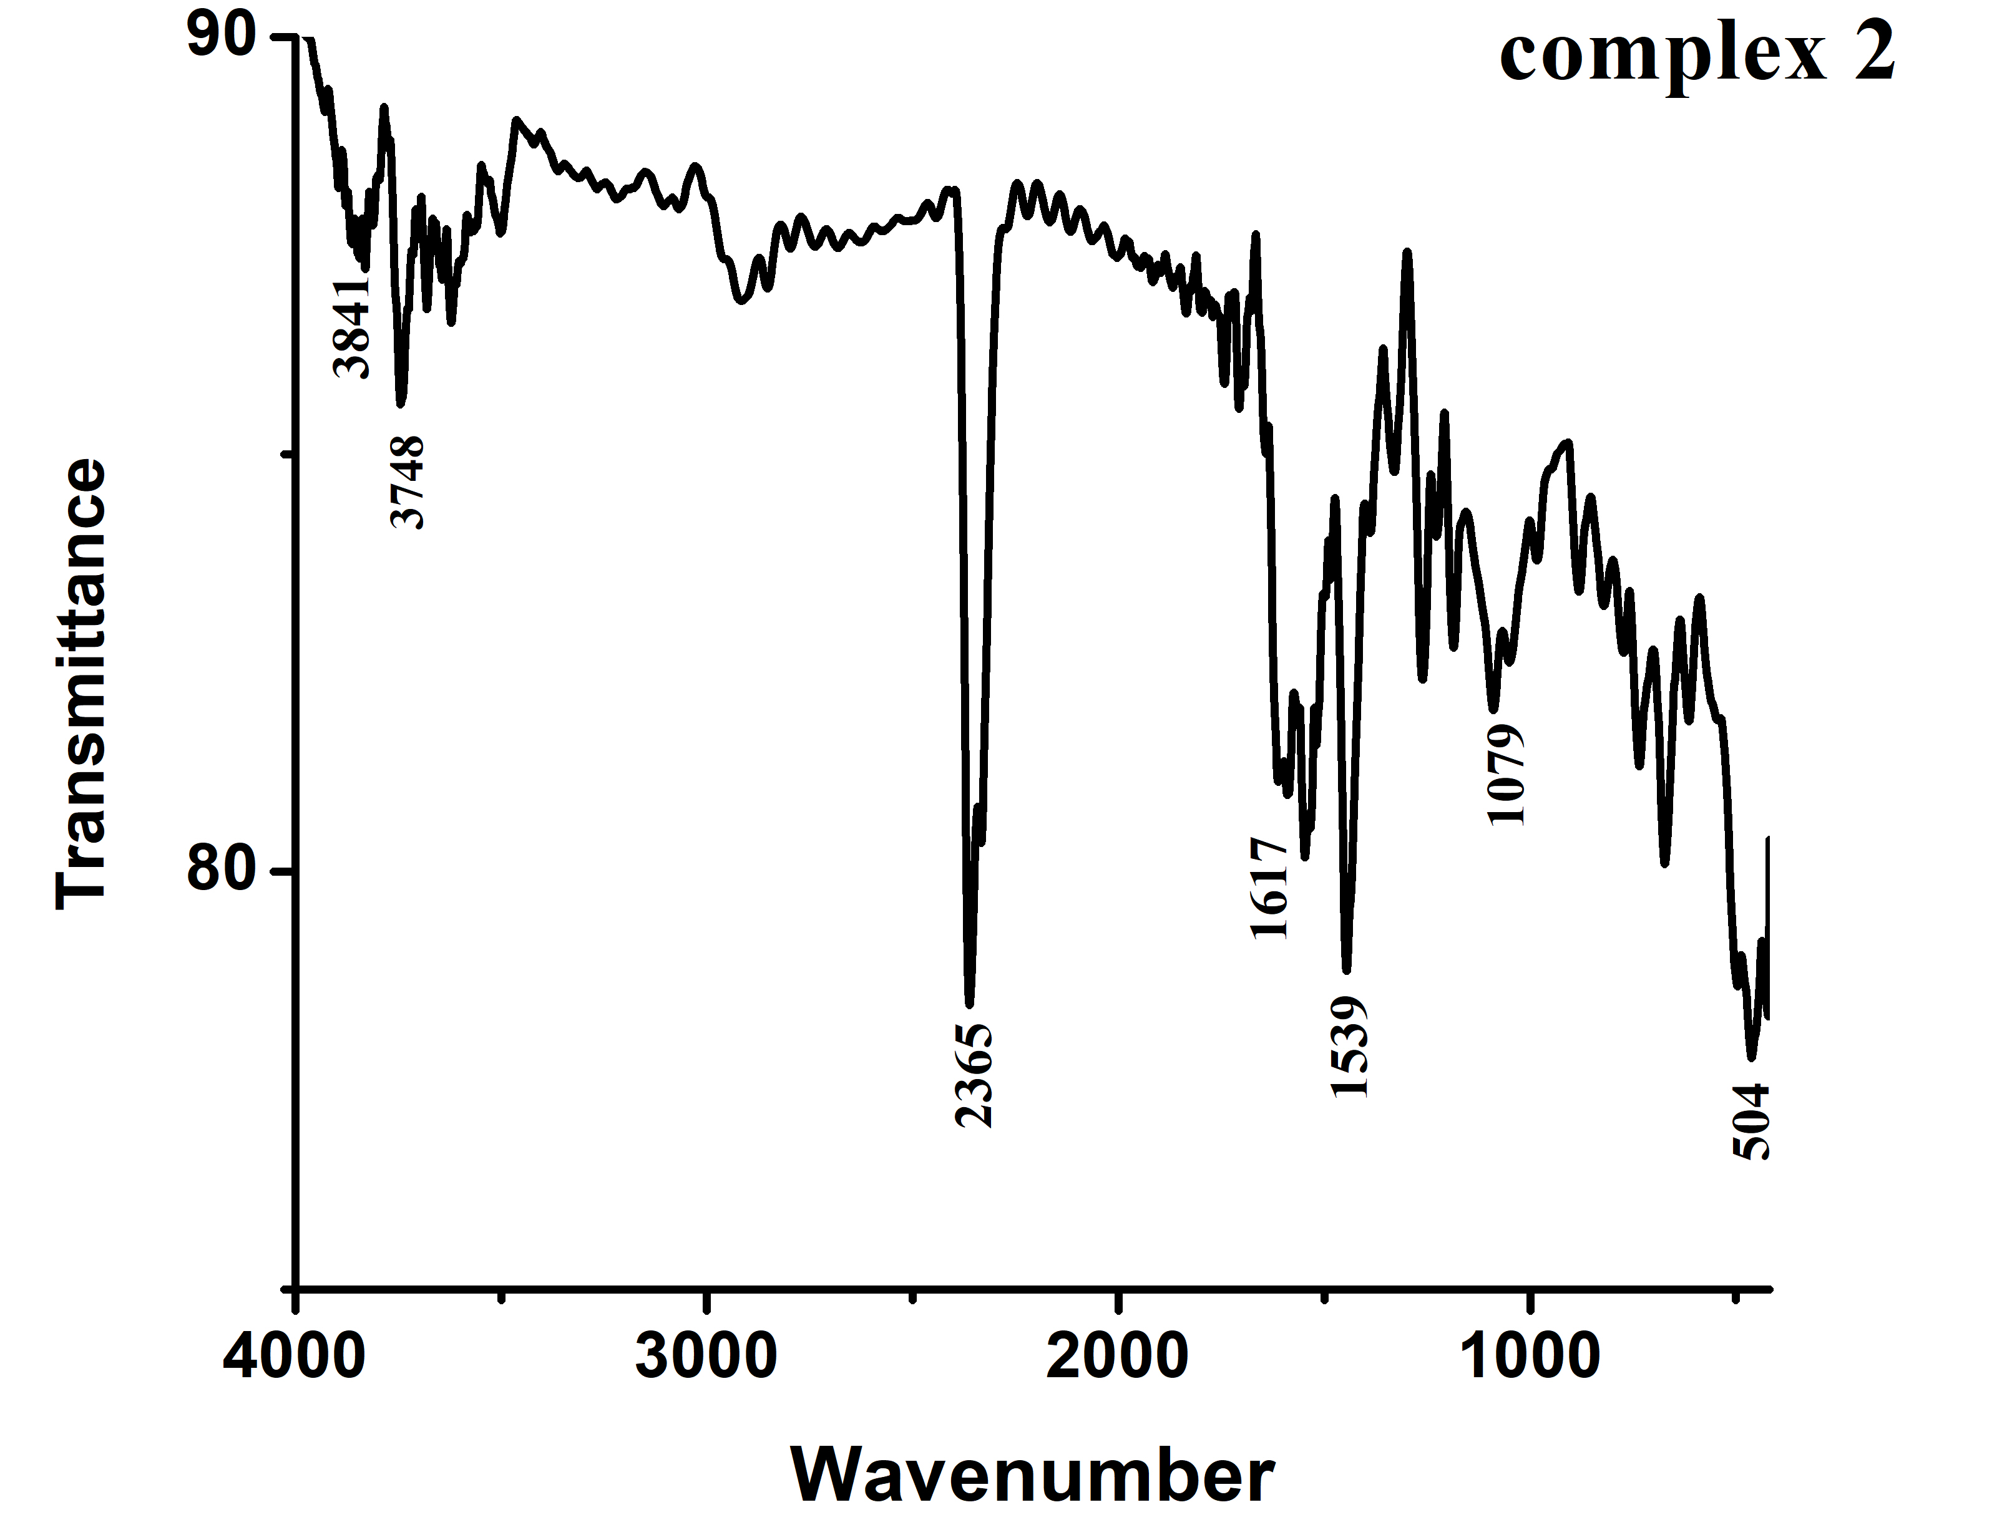
Fig. S4 IR spectrum of complex 2

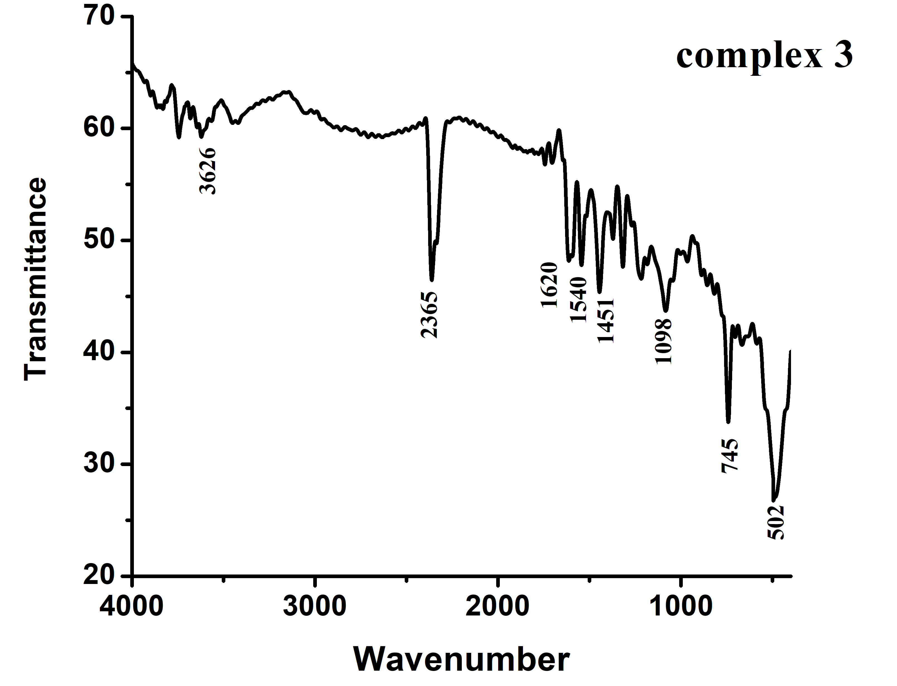
Fig. S5 IR spectrum of complex 3

