Supplementary data

Comparative untargeted metabolomics analysis of serum metabolic alterations in patients infected with hepatitis B virus genotypes B and C

Min Deng a,b,1, Mingkai Tong a,1, Fanchun Fu b*, Dahai Wei b,c*

a*Jiaxing University Master Degree Cultivation Base, Zhejiang Chinese Medical University, Hangzhou 310053, PR China*

b*Department of Infectious Diseases, Affiliated Hospital of Jiaxing University, Jiaxing 314001, PR China*

c*Institute of Hepatology, Affiliated Hospital of Jiaxing University, Jiaxing 314001, PR China*

*Corresponding Authors at D. Wei. Institute of Hepatology, Affiliated Hospital of Jiaxing University, Jiaxing 314001, PR China; and F. Fu. Department of Infectious Diseases, Affiliated Hospital of Jiaxing University, Jiaxing 314001, PR China

E-mail addresses: weidahai3166@hotmail.com (D. Wei), x0451140125@126.com (F. Fu).

1Contributed equally as the first author.

Running title: The metabolome differences between HBV genotypes B and C

**Supplementary Figures:**

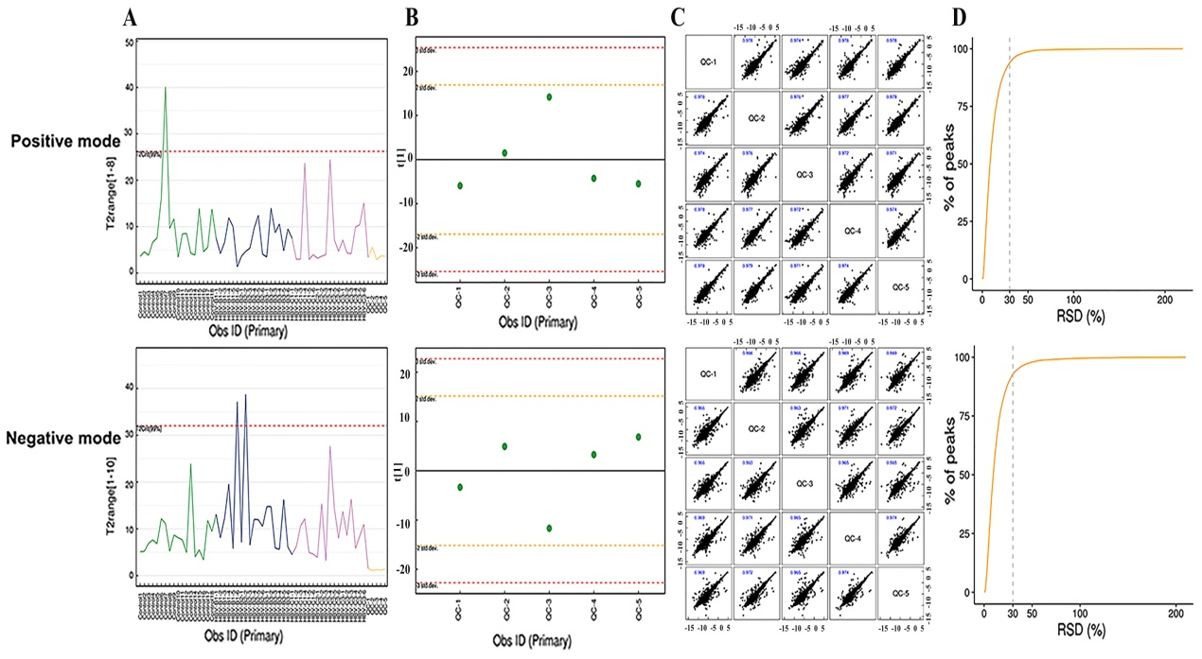

Supplementary Fig. 1 The qualities of the metabolome dataset. (A) Hotelling T2 value range plot. (B) Multivariate control chart of quality control samples. (C) [Correlation analysis](javascript:;) of quality control samples. (D) Relative standard deviation of quality control samples.

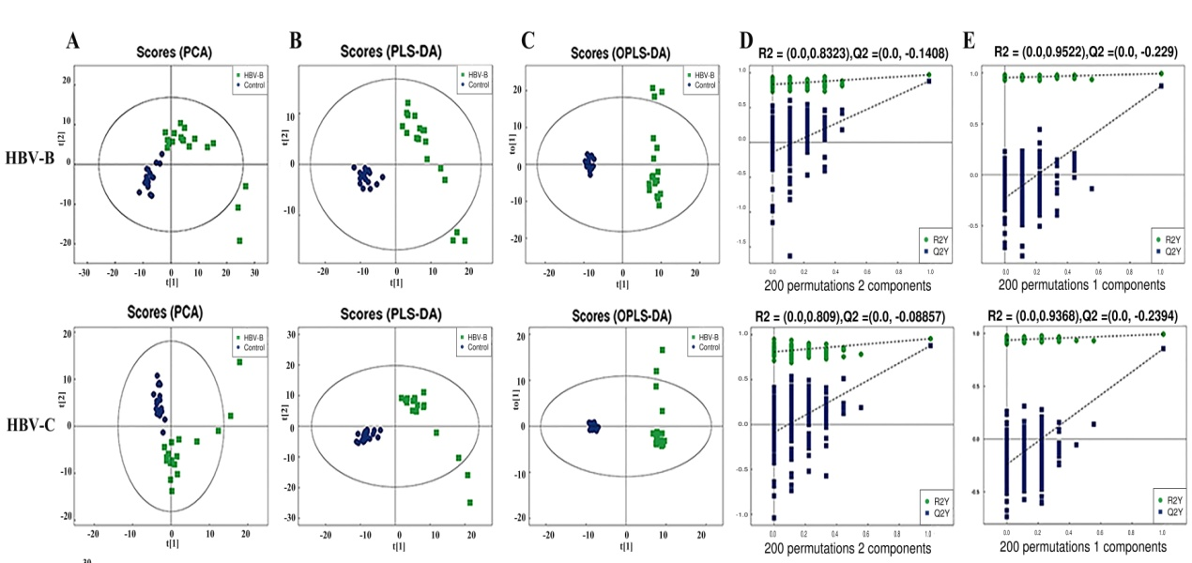

Supplementary Fig. 2 Multivariate statistical analyses of the serum samples of patients infected with HBV genotypes B and C in the NEG mode. (A) PCA, (B) PLS-DA, and (C) OPLS-DA scores of the overall sample. (D) PLS-DA and (E) OPLS-DA were performed for the permutation test (200 times).

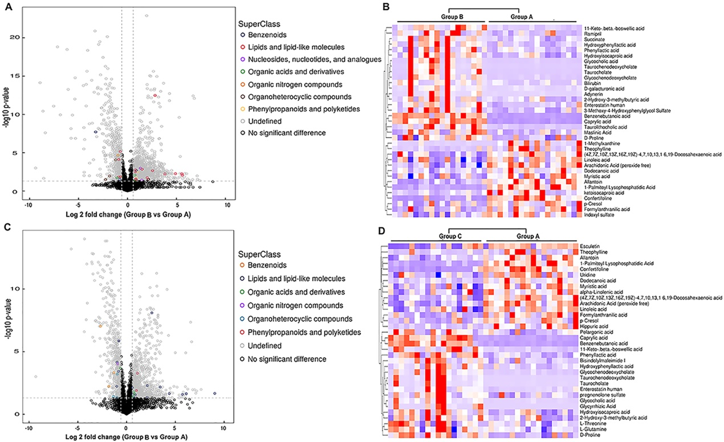

Supplementary Fig. 3 Bioinformatics analysis of the differentially expressed metabolites in the NEG mode. (A) Volcano plot representing the differences in protein abundance in the serum samples of healthy controls and patients infected with HBV genotype B (groups B vs. A). (B) Hierarchical clustering of the28 metabolites dysregulated between the serum samples of healthy controls and patients infected with HBVgenotype B (groups B vs. A). (C) Volcano plot representing the differences in protein abundance betweenthe serum samples of healthy controls and patients infected with HBV genotype C (groups C vs. A). (D) Hierarchical clustering of the 23 metabolites dysregulated betweenthe serum samples of healthy controls and patients infected with HBV genotype C (groups C vs. A).

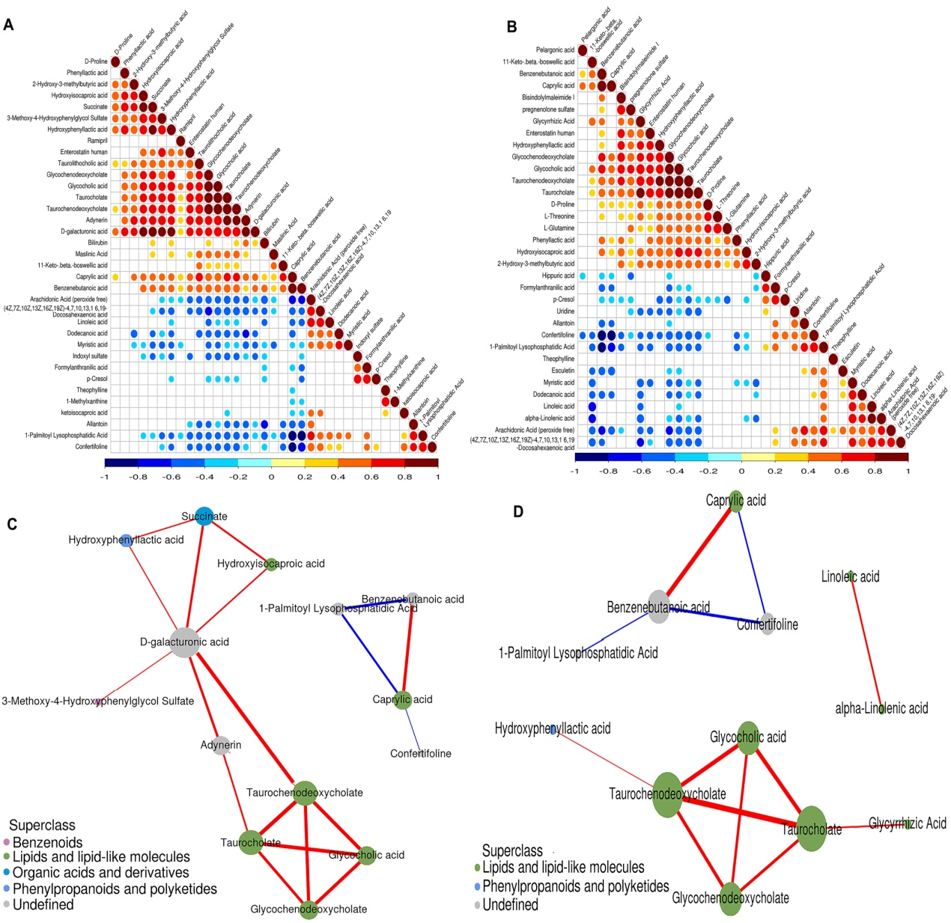

Supplementary Fig. 4 Correlation analysis of the differentially expressed metabolites in the NEG mode. (A) Heatmap of the results of correlation analysis of the 28 metabolites dysregulated between the serum samples of healthy controls and patients infected with HBV genotype B. (B) Heatmap depicting the results of correlation analysis of the 23 metabolites dysregulated between the serum samples of healthy controls and patients infected with HBV genotype C. (C) Predicted network of the metabolites that were differentially expressed between the serum samples of healthy controls and patients infected with HBV genotype B. (D) Predicted network of the metabolites that were differentially expressed between the serum samples of healthy controls and patients infected with HBV genotype C.

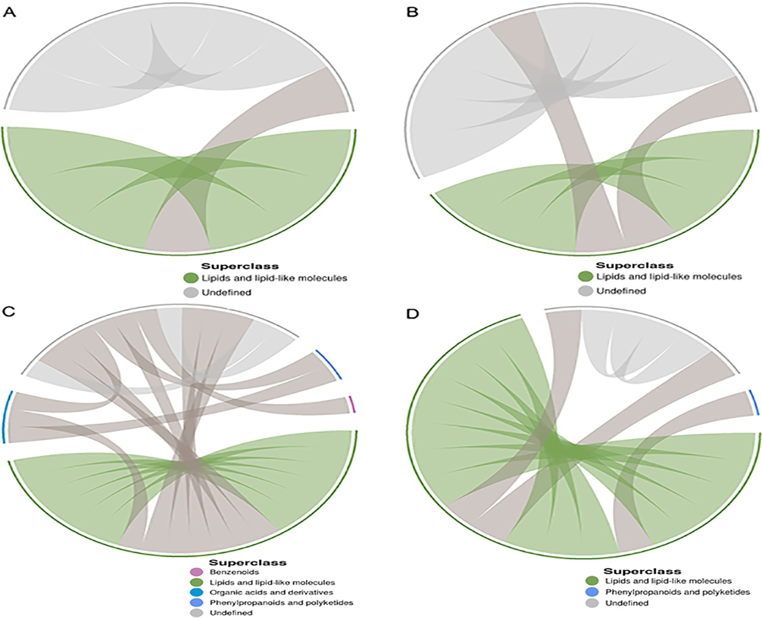

Supplementary Fig. 5 Chord diagram of the dysregulated metabolites. (A) Chord diagram of the dysregulated metabolites from groups of healthy control individuals and HBV-B in POS mode. (B) Chord diagram of the dysregulated metabolites from groups of healthy control individuals and HBV-C in POSe mode. (C) Chord diagram of the dysregulated metabolites from groups of healthy control individuals and HBV-B in NEG mode. (D) Chord diagram of the dysregulated metabolites from groups of healthy control individuals and HBV-C in NEG mode.

**Supplementary Tables:**

|  |  |  |  |  |  |  |  |
| --- | --- | --- | --- | --- | --- | --- | --- |
| Supplementary Table 1 Differential metabolites between the serum samples of the healthy controls and those of HBV genotype B infected patients in POS mode. | | | | | | | |
| **Metabolite ID** | **Adducted form** | **Metabolite name** | **VIP** | ***P*-value** | **m/z** | **rt (s)** | **Fold change** |
| M352T364 | (M+H)+ | Phe-Trp | 1.21 | 0.0000 | 352.17 | 364.19 | 0.35 |
| M104T525 | M+ | Choline | 1.33 | 0.0000 | 104.11 | 525.02 | 0.62 |
| M274T708 | (M+H)+ | Val-Arg | 1.30 | 0.0000 | 274.19 | 707.67 | 4.45 |
| M258T771 | M+ | Glycerophosphocholine | 2.75 | 0.0000 | 258.11 | 770.96 | 0.57 |
| M160T763_2 | (M+CH3COO+2H)+ | Cyclohexylamine | 1.70 | 0.0009 | 160.13 | 762.58 | 0.64 |
| M416T405 | (M+H-H2O)+ | Glycolithocholic acid | 1.53 | 0.0014 | 416.32 | 405.19 | 4.04 |
| M568T393 | (M-H+2Na)+ | 1-Stearoyl-2-hydroxy-sn-glycero-3-phosphocholine | 2.12 | 0.0015 | 568.34 | 392.70 | 0.66 |
| M450T438 | (M+H)+ | Glycochenodeoxycholate | 5.09 | 0.0030 | 450.32 | 437.84 | 9.47 |
| M466T520 | (M+H)+ | Glycocholic acid | 2.90 | 0.0035 | 466.32 | 520.44 | 28.37 |
| M795T300 | (M+CH3CN+Na)+ | Sphingomyelin (d18:1/18:0) | 3.60 | 0.0036 | 794.60 | 300.39 | 1.45 |
| M314T275 | (M+NH4)+ | Phe-Met | 1.10 | 0.0037 | 314.16 | 275.49 | 0.58 |
| M313T193 | (M+H)+ | Phe-Phe | 3.08 | 0.0062 | 313.15 | 193.46 | 0.38 |
| M298T139 | (M+H)+ | S-Methyl-5'-thioadenosine | 1.34 | 0.0069 | 298.10 | 139.27 | 2.92 |
| M544T395 | (M+Na)+ | 1-Oleoyl-sn-glycero-3-phosphocholine | 4.16 | 0.0081 | 544.34 | 394.80 | 0.70 |
| M823T777 | (M+H)+ | Glycyrrhizic Acid | 1.25 | 0.0083 | 823.41 | 777.17 | 209.07 |
| M550T376 | M+ | 1-O-(cis-9-Octadecenyl)-2-O-acetyl-sn-glycero-3-phosphocholine | 1.84 | 0.0098 | 550.39 | 376.31 | 0.67 |
| M517T283 | (M+NH4)+ | Taurodeoxycholic acid | 1.32 | 0.0098 | 517.33 | 282.71 | 16.37 |
| M243T67 | (M+H-2H2O)+ | all cis-(6,9,12)-Linolenic acid | 1.51 | 0.0099 | 243.21 | 67.11 | 1.78 |
| M182T597_2 | (M+H)+ | L-Tyrosine | 1.50 | 0.0111 | 182.08 | 597.12 | 1.45 |
| M116T621 | (M+H)+ | D-Proline | 1.50 | 0.0175 | 116.07 | 620.58 | 1.10 |
| M149T440 | (M+H-H2O)+ | 1,2-Benzenedicarboxylic acid | 1.25 | 0.0229 | 149.02 | 440.38 | 0.60 |
| M471T136 | (M+H)+ | Enoxolone | 1.04 | 0.0243 | 471.35 | 136.28 | 8.41 |
| M585T106 | (M+H)+ | Bilirubin | 2.41 | 0.0309 | 585.27 | 106.12 | 2.51 |
| M498T416 | (M+H-H2O)+ | Taurocholate | 1.26 | 0.0324 | 498.29 | 415.84 | 3.82 |
| M500T341 | (M+H)+ | Taurochenodeoxycholate | 1.31 | 0.0342 | 500.30 | 340.60 | 4.03 |
| M546T396 | (M+Na)+ | 1-Stearoyl-sn-glycerol 3-phosphocholine | 1.89 | 0.0394 | 546.35 | 396.01 | 0.80 |
| M132T690_2 | (M+H)+ | Creatine | 1.17 | 0.0487 | 132.08 | 690.43 | 0.86 |
| M338T55_2 | (M+H)+ | Erucamide | 3.44 | 0.0495 | 338.34 | 54.54 | 1.41 |

|  |  |  |  |  |  |  |  |  |  |  |  |  |  |
| --- | --- | --- | --- | --- | --- | --- | --- | --- | --- | --- | --- | --- | --- |
| Supplementary Table 2 Differential metabolites between the serum samples of the healthy controls and those of HBV genotype C infected patients in POS mode | | | | | | | | | | | | | |
| **Metabolite ID** | **Adducted form** | **Metabolite name** | | | | **VIP** | ***P*-value** | | **m/z** | **rt (s)** | | **Fold change** | |
| M352T364 | (M+H)+ | Phe-Trp | | | | 1.17 | 0.0000 | | 352.17 | 364.188 | | 0.34 | |
| M258T771 | M+ | Glycerophosphocholine | | | | 3.04 | 0.0000 | | 258.11 | 770.96 | | 0.48 | |
| M274T708 | (M+H)+ | Val-Arg | | | | 1.66 | 0.0000 | | 274.19 | 707.67 | | 5.92 | |
| M568T393 | (M-H+2Na)+ | 1-Stearoyl-2-hydroxy-sn-glycero-3-phosphocholine | | | | 2.36 | 0.0000 | | 568.34 | 392.70 | | 0.54 | |
| M468T382 | (M+H)+ | 1-Myristoyl-sn-glycero-3-phosphocholine | | | | 1.10 | 0.0000 | | 468.31 | 382.13 | | 0.56 | |
| M544T395 | (M+Na)+ | 1-Oleoyl-sn-glycero-3-phosphocholine | | | | 4.61 | 0.0001 | | 544.34 | 394.80 | | 0.57 | |
| M338T55_2 | (M+H)+ | Erucamide | | | | 6.51 | 0.0002 | | 338.34 | 54.54 | | 1.76 | |
| M243T67 | (M+H-2H2O)+ | all cis-(6,9,12)-Linolenic acid | | | | 2.24 | 0.0002 | | 243.21 | 67.11 | | 2.21 | |
| M550T376 | M+ | 1-O-(cis-9-Octadecenyl)-2-O-acetyl-sn-glycero-3-phosphocholine | | | | 2.26 | 0.0003 | | 550.39 | 376.31 | | 0.54 | |
| M450T438 | (M+H)+ | Glycochenodeoxycholate | | | | 5.67 | 0.0017 | | 450.32 | 437.84 | | 9.29 | |
| M471T136 | (M+H)+ | Enoxolone | | | | 1.01 | 0.0030 | | 471.35 | 136.28 | | 8.23 | |
| M165T597 | (M+H)+ | trans-2-Hydroxycinnamic acid | | | | 1.16 | 0.0047 | | 165.05 | 597.03 | | 1.50 | |
| M182T597_2 | (M+H)+ | L-Tyrosine | | | | 1.95 | 0.0048 | | 182.08 | 597.12 | | 1.55 | |
| M546T396 | (M+Na)+ | 1-Stearoyl-sn-glycerol 3-phosphocholine | | | | 2.11 | 0.0050 | | 546.35 | 396.01 | | 0.71 | |
| M416T405 | (M+H-H2O)+ | Glycolithocholic acid | | | | 1.50 | 0.0052 | | 416.32 | 405.19 | | 3.67 | |
| M116T621 | (M+H)+ | D-Proline | | | | 1.97 | 0.0053 | | 116.07 | 620.58 | | 1.13 | |
| M147T742_2 | (M+H)+ | L-Glutamine | | | | 2.22 | 0.0119 | | 147.08 | 741.65 | | 1.15 | |
| M149T440 | (M+H-H2O)+ | 1,2-Benzenedicarboxylic acid | | | | 1.07 | 0.0170 | | 149.02 | 440.38 | | 0.58 | |
| M517T283 | (M+NH4)+ | Taurodeoxycholic acid | | | | 1.51 | 0.0212 | | 517.33 | 282.71 | | 15.27 | |
| M823T777 | (M+H)+ | Glycyrrhizic Acid | | | | 1.91 | 0.0228 | | 823.41 | 777.17 | | 412.40 | |
| M391T50 | (M+H)+ | Dioctyl phthalate | | | | 1.37 | 0.0376 | | 391.28 | 50.20 | | 1.44 | |
| M146T748_2 | M+ | (3-Carboxypropyl) trimethylammonium cation | | | | 1.51 | 0.0418 | | 146.12 | 747.95 | | 1.15 | |
| M466T520 | (M+H)+ | Glycocholic acid | | | | 2.57 | 0.0495 | | 466.32 | 520.44 | | 17.60 | |
| Supplementary Table 3Differential metabolites between the serum samples of the healthy controls and those of HBV genotype B infected patients in NEG mode. | | | | | | | | | | | | | | |
| **Metabolite ID** | **Adducted form** | | **Metabolite name** | **VIP** | ***P*-value** | | | **m/z** | | | **rt (s)** | | **Fold change** | |
| M143T78_2 | (M-H)- | | Caprylic acid | 13.12 | 0.0000 | | | 143.11 | | | 78.44 | | 7.06 | |
| M163T147 | (M-H)- | | Benzenebutanoic acid | 2.46 | 0.0000 | | | 163.08 | | | 147.50 | | 10.07 | |
| M409T450 | (M-H)- | | 1-Palmitoyl Lysophosphatidic Acid | 1.23 | 0.0000 | | | 409.23 | | | 449.67 | | 0.17 | |
| M233T140 | (M-H)- | | Confertifoline | 1.23 | 0.0000 | | | 233.15 | | | 140.27 | | 0.48 | |
| M303T69 | (M-H)- | | Arachidonic Acid (peroxide free) | 12.40 | 0.0000 | | | 303.23 | | | 69.24 | | 0.60 | |
| M157T326 | (M-H)- | | Allantoin | 1.65 | 0.0001 | | | 157.04 | | | 326.48 | | 0.43 | |
| M263T62 | (M-H)- | | 3-Methoxy-4-Hydroxyphenylglycol Sulfate | 2.26 | 0.0022 | | | 263.02 | | | 62.11 | | 1.88 | |
| M482T74 | (M-H)- | | Taurolithocholic acid | 1.84 | 0.0022 | | | 482.29 | | | 74.23 | | 5.89 | |
| M131T210_2 | (M-H)- | | Hydroxyisocaproic acid | 3.22 | 0.0031 | | | 131.07 | | | 209.84 | | 1.74 | |
| M181T360 | (M-H)- | | Hydroxyphenyllactic acid | 1.31 | 0.0034 | | | 181.05 | | | 359.86 | | 2.10 | |
| M117T734 | (M-H)- | | Succinate | 1.32 | 0.0037 | | | 117.02 | | | 733.67 | | 1.49 | |
| M464T460_2 | (M-H)- | | Glycocholic acid | 7.29 | 0.0055 | | | 464.30 | | | 459.76 | | 29.86 | |
| M514T361 | (M-H)- | | Taurocholate | 6.67 | 0.0057 | | | 514.28 | | | 360.63 | | 47.00 | |
| M448T375 | (M-H)- | | Glycochenodeoxycholate | 11.73 | 0.0059 | | | 448.31 | | | 375.16 | | 14.15 | |
| M469T78 | (M-H)- | | 11-Keto-.beta.-boswellic acid | 1.72 | 0.0070 | | | 469.33 | | | 77.92 | | 3.78 | |
| M495T48 | (M-H)- | | Enterostatin human | 1.60 | 0.0075 | | | 495.28 | | | 48.15 | | 1.95 | |
| M498T178_3 | (M-H)- | | Taurochenodeoxycholate | 21.59 | 0.0086 | | | 498.29 | | | 177.51 | | 48.60 | |
| M471T177 | (M-H)- | | Maslinic Acid | 1.71 | 0.0091 | | | 471.35 | | | 176.88 | | 1.94 | |
| M179T107 | (M-H)- | | Theophylline | 1.15 | 0.0112 | | | 179.06 | | | 106.70 | | 0.28 | |
| M212T42_1 | (M-H)- | | Indoxyl sulfate | 8.86 | 0.0131 | | | 212.00 | | | 41.99 | | 0.64 | |
| M327T69_3 | (M-H)- | | (4Z,7Z,10Z,13Z,16Z,19Z)-4,7,10,13,1 6,19-Docosahexaenoic acid | 8.38 | 0.0134 | | | 327.23 | | | 69.26 | | 0.62 | |
| M199T77_2 | (M-H)- | | Dodecanoic acid | 3.36 | 0.0145 | | | 199.17 | | | 76.65 | | 0.54 | |
| M165T176 | (M-H)- | | Phenyllactic acid | 2.35 | 0.0169 | | | 165.06 | | | 175.69 | | 1.85 | |
| M129T178 | (M-H)- | | ketoisocaproic acid | 2.01 | 0.0187 | | | 129.06 | | | 178.25 | | 0.48 | |
| M279T72_4 | (M-H)- | | Linoleic acid | 12.89 | 0.0217 | | | 279.23 | | | 72.46 | | 0.75 | |
| M117T289 | (M-H)- | | 2-Hydroxy-3-methylbutyric acid | 2.03 | 0.0270 | | | 117.06 | | | 289.01 | | 1.80 | |
| M227T75 | (M-H)- | | Myristic acid | 2.95 | 0.0275 | | | 227.20 | | | 75.47 | | 0.80 | |
| M515T123 | (M-H)- | | Adynerin | 1.39 | 0.0280 | | | 515.30 | | | 122.95 | | 11.68 | |
| M114T567_2 | (M-H)- | | D-Proline | 1.69 | 0.0292 | | | 114.06 | | | 566.87 | | 1.22 | |
| M164T109 | (M-H)- | | Formylanthranilic acid | 1.71 | 0.0304 | | | 164.04 | | | 108.50 | | 0.58 | |
| M583T74 | (M-H)- | | Bilirubin | 3.14 | 0.0309 | | | 583.25 | | | 74.22 | | 4.34 | |
| M165T200 | (M-H)- | | 1-Methylxanthine | 1.64 | 0.0316 | | | 165.04 | | | 200.46 | | 0.21 | |
| M415T61 | (M-H)- | | Ramipril | 2.09 | 0.0334 | | | 415.22 | | | 61.03 | | 1.85 | |
| M107T38 | (M-H)- | | p-Cresol | 1.33 | 0.0404 | | | 107.05 | | | 37.59 | | 0.52 | |
| M193T726 | (M-H)- | | D-galacturonic acid | 2.27 | 0.0424 | | | 193.04 | | | 726.35 | | 4.63 | |

|  |  |  |  |  |  |  |  |
| --- | --- | --- | --- | --- | --- | --- | --- |
| Supplementary Table 4 Differential metabolites between the serum samples of the healthy controls and those of HBV genotype C infected patients in NEG mode. | | | | | | | |
| **Metabolite ID** | **Adducted form** | **Metabolite name** | **VIP** | ***P*-value** | **m/z** | **rt (s)** | **Fold change** |
| M163T147 | (M-H)- | Benzenebutanoic acid | 2.31 | 0.0000 | 163.08 | 147.50 | 9.25 |
| M143T78_2 | (M-H)- | Caprylic acid | 11.36 | 0.0000 | 143.11 | 78.44 | 6.03 |
| M233T140 | (M-H)- | Confertifoline | 1.31 | 0.0000 | 233.15 | 140.27 | 0.43 |
| M409T450 | (M-H)- | 1-Palmitoyl Lysophosphatidic Acid | 1.26 | 0.0000 | 409.23 | 449.67 | 0.15 |
| M303T69 | (M-H)- | Arachidonic Acid (peroxide free) | 13.28 | 0.0000 | 303.23 | 69.24 | 0.58 |
| M327T69_3 | (M-H)- | (4Z,7Z,10Z,13Z,16Z,19Z)-4,7,10,13,1 6,19-Docosahexaenoic acid | 10.21 | 0.0001 | 327.23 | 69.26 | 0.51 |
| M164T109 | (M-H)- | Formylanthranilic acid | 2.25 | 0.0005 | 164.04 | 108.50 | 0.40 |
| M165T176 | (M-H)- | Phenyllactic acid | 2.78 | 0.0005 | 165.06 | 175.69 | 2.16 |
| M157T326 | (M-H)- | Allantoin | 1.50 | 0.0006 | 157.04 | 326.48 | 0.51 |
| M469T78 | (M-H)- | 11-Keto-.beta.-boswellic acid | 1.86 | 0.0032 | 469.33 | 77.92 | 4.06 |
| M227T75 | (M-H)- | Myristic acid | 3.56 | 0.0039 | 227.20 | 75.47 | 0.72 |
| M177T260 | (M-H)- | Esculetin | 2.37 | 0.0056 | 177.02 | 259.81 | 0.54 |
| M114T567_2 | (M-H)- | D-Proline | 1.83 | 0.0057 | 114.06 | 566.87 | 1.30 |
| M243T288_2 | (M-H)- | Uridine | 2.18 | 0.0059 | 243.06 | 288.40 | 0.81 |
| M178T357 | (M-H)- | Hippuric acid | 2.08 | 0.0059 | 178.05 | 356.79 | 0.28 |
| M199T77_2 | (M-H)- | Dodecanoic acid | 3.75 | 0.0059 | 199.17 | 76.65 | 0.50 |
| M448T375 | (M-H)- | Glycochenodeoxycholate | 9.93 | 0.0068 | 448.31 | 375.16 | 10.89 |
| M131T210_2 | (M-H)- | Hydroxyisocaproic acid | 2.23 | 0.0076 | 131.07 | 209.84 | 1.52 |
| M181T360 | (M-H)- | Hydroxyphenyllactic acid | 1.22 | 0.0126 | 181.05 | 359.86 | 2.01 |
| M279T72_4 | (M-H)- | Linoleic acid | 13.57 | 0.0132 | 279.23 | 72.46 | 0.71 |
| M411T49 | (M-H)- | Bisindolylmaleimide I | 2.17 | 0.0157 | 411.18 | 48.77 | 1.62 |
| M107T38 | (M-H)- | p-Cresol | 1.40 | 0.0201 | 107.05 | 37.59 | 0.48 |
| M821T716 | (M-H)- | Glycyrrhizic Acid | 3.98 | 0.0219 | 821.40 | 715.89 | 528.09 |
| M118T644 | (M-H)- | L-Threonine | 1.03 | 0.0222 | 118.05 | 643.79 | 1.26 |
| M464T460_2 | (M-H)- | Glycocholic acid | 5.05 | 0.0226 | 464.30 | 459.76 | 20.87 |
| M277T74 | (M-H)- | alpha-Linolenic acid | 5.00 | 0.0230 | 277.22 | 73.58 | 0.68 |
| M498T178_3 | (M-H)- | Taurochenodeoxycholate | 24.82 | 0.0230 | 498.29 | 177.51 | 69.39 |
| M495T48 | (M-H)- | Enterostatin human | 2.58 | 0.0230 | 495.28 | 48.15 | 2.95 |
| M117T289 | (M-H)- | 2-Hydroxy-3-methylbutyric acid | 1.14 | 0.0252 | 117.06 | 289.01 | 1.55 |
| M145T682_3 | (M-H)- | L-Glutamine | 2.21 | 0.0261 | 145.06 | 682.10 | 1.15 |
| M514T361 | (M-H)- | Taurocholate | 6.47 | 0.0263 | 514.28 | 360.63 | 52.82 |
| M179T107 | (M-H)- | Theophylline | 1.02 | 0.0376 | 179.06 | 106.70 | 0.39 |
| M395T41 | (M-H)- | pregnenolone sulfate | 3.61 | 0.0433 | 395.19 | 41.16 | 1.64 |
| M157T103 | (M-H)- | Pelargonic acid | 1.11 | 0.0459 | 157.12 | 103.13 | 1.27 |

|  |  |  |  |  |
| --- | --- | --- | --- | --- |
| Supplementary Table 5 List of the metabolites of targeted metabolomics for bile acid. | | | | |
|
| **Metabolite name** | **Types** | **Fold change HBV-B/Healthy controls** | **Fold change HBV-C/Healthy controls** | **Fold change HBV-C/HBV-B** |
| Taurolithocholic acid (TLCA) | Secondary/Conjugated | 3.37 | 5.23 | 1.55 |
| Lithocholic acid (LCA) | Secondary/Free | 2.70 | 1.92 | 0.71 |
| Glycocholic acid (GCA) | Primary/Conjugated | 1.79 | 1.67 | 0.93 |
| Taurocholic acid (TCA) | Primary/Conjugated | 3.46 | 4.72 | 1.36 |
| Apocholic acid (ApoCA) |  | 0.28 | 0.34 | 1.20 |
| Glycodeoxycholic acid (GDCA) | Secondary/Conjugated | 1.78 | 2.02 | 1.13 |
| Taurochenodeoxycholic acid (TCDCA) | Primary/Conjugated | 3.14 | 3.93 | 1.25 |
| Glycolithocholic acid (GLCA) | Secondary/Conjugated | 4.37 | 3.56 | 0.81 |
| γ-muricholic acid (r-MCA) | Primary/Free | 1.83 | 2.07 | 1.13 |
| 12-ketolithocholic acid (12-KLCA) |  | 0.64 | 0.47 | 0.74 |
| Taurodeoxycholic acid (TDCA) | Secondary/Conjugated | 3.45 | 2.94 | 0.85 |
| Deoxycholic acid (DCA) | Secondary/Free | 0.69 | 0.59 | 0.85 |
| Isolithocholic acid (IsoLCA) | Secondary/Free | 2.76 | 2.10 | 0.76 |
| Glycochenodeoxycholic acid (GCDCA) | Primary/Conjugated | 1.41 | 0.98 | 0.70 |
| Tauroursodeoxycholic acid (TUDCA) | Secondary/Conjugated | 5.17 | 6.41 | 1.24 |
| 3-dehydrocholic acid (3-DHCA) | Free | 1.08 | 1.10 | 1.02 |
| Tauro muricholic acid (TMCA) |  | 3.45 | 4.56 | 1.32 |
| Glycoursodeoxycholic acid (GUDCA) | Secondary/Conjugated | 1.72 | 3.47 | 2.01 |
| Hyodeoxycholic acid (HDCA) | Secondary/Free | 0.88 | 0.64 | 0.72 |
| Ursodeoxycholic acid (UDCA) | Secondary/Conjugated | 1.30 | 1.88 | 1.44 |
| α-Muricholic acid (a-MCA) | Primary/Free | 1.03 | 1.26 | 1.22 |
| Cholic acid (CA) | Primary/Free | 0.87 | 1.12 | 1.29 |
| Chenodeoxycholic acid (CDCA) | Primary/Free | 0.81 | 1.06 | 1.31 |
| Tetrahydrocannabinolic Acid （THCA） |  | 3.80 | 4.40 | 1.16 |