Table S1. LC/MS analysis parameters of analytes.
Analytes | DP | EP | CE | CXP
Deethylated phenacetin | 65 | 6 | 20 | 15
4-Hydroxylated bupropion | 60 | 10 | 20 | 16
6-Hydroxylated paclitaxel | 140 | 10 | 30 | 13
4-Hydroxylated diclofenac | 80 | 10 | 30 | 13
4'-hydroxylated S-mephenytoin | 60 | 10 | 25 | 15
Demethylated dextromethorphan | 60 | 9 | 35 | 15
Defluorinated gefitinib | 90 | 10 | 15 | 12
1’-Hydroxylated midazolam | 80 | 9 | 25 | 15
4-Hydroxylated atorvastatin | 90 | 10 | 35 | 12
S-oxidated quetiapine | 80 | 9 | 51 | 15

Table S2. The experimental and predicted pIC₅₀ values for all the compounds in CoMFA model.
No. | Data set | IC₅₀ (µM) | COMFA | Experimental pIC₅₀ | Predicted pIC₅₀
1 | Training | 7.02 | 208 | 5.15 | 4.76
2 | Training | 1.94 | 206 | 5.71 | 5.91
3 | Training | 2.47 | 222 | 5.61 | 5.64
4 | Test | 3.41 | 208 | 5.47 | 5.93
5 | Training | 4.47 | 230 | 5.35 | 5.34
6 | Test | 4.56 | 214 | 5.34 | 5.18
7 | Training | 18.49 | 226 | 4.73 | 5.10
8 | Training | 5.35 | 246 | 5.27 | 5.52
9 | Training | 1.42 | 246 | 5.85 | 5.89
10 | Training | 1.91 | 234 | 5.72 | 5.81
11 | Training | 1.27 | 220 | 5.90 | 6.21
12 | Training | 111.6 | 200 | 3.95 | 3.98
13 | Training | 30.39 | 196 | 4.52 | 4.60
14 | Training | 44.7 | 208 | 4.35 | 4.20
15 | Test | 219.8 | 236 | 3.66 | 3.33
16 | Training | 127.3 | 218 | 3.90 | 3.93
17 | Training | 231 | 220 | 3.64 | 3.33
18 | Training | 70874 | 224 | 1.15 | 1.24
19 | Training | 383.1 | 224 | 3.42 | 3.55
20 | Training | 798.5 | 232 | 3.10 | 3.24
21 | Training | 246.7 | 232 | 3.61 | 3.75
22 | Training | 10.93 | 222 | 4.96 | 4.81
23 | Training | 207.9 | 222 | 3.68 | 3.99
24 | Test | 4.61 | 214 | 5.34 | 4.46
25 | Training | 3.72 | 212 | 5.43 | 5.42
26 | Training | 2.66 | 210 | 5.58 | 5.31
27 | Training | 139.2 | 220 | 3.86 | 4.23
28 | Training | 10.77 | 244 | 4.97 | 4.71
29 | Training | 12.25 | 238 | 4.91 | 4.87
30 | Test | 5.35 | 228 | 5.27 | 4.78
31 | Training | 3.35 | 218 | 5.47 | 5.59
32 | Training | 1.8 | 222 | 5.74 | 5.75
33 | Training | 4.94 | 218 | 5.31 | 5.34
34 | Training | 3.22 | 214 | 5.49 | 5.65
35 | Training | 27.41 | 328 | 4.56 | 4.40
36 | Training | 9.87 | 320 | 5.01 | 4.59
37 | Test | 9.12 | 258 | 5.04 | 4.52
38 | Training | 53.66 | 276 | 4.27 | 4.29
39 | Training | 49.18 | 290 | 4.31 | 3.94
40 | Training | 26.68 | 274 | 4.57 | 4.25
41 | Training | 5.14 | 272 | 5.29 | 5.50
42 | Training | 52.25 | 220 | 4.28 | 4.38
43 | Training | 4.93 | 234 | 5.31 | 5.21
44 | Test | 0.65 | 244 | 6.19 | 5.49
45 | Training | 107 | 226 | 3.97 | 4.45
46 | Training | 45.08 | 236 | 4.35 | 4.62
47 | Training | 0.42 | 240 | 6.38 | 6.04

Table S3. PLS result of 3D-QSAR based on CoMFA
Parameters of COMFA model
ONC | 4
q² | 0.522
SEE | 0.266
r² | 0.936
F_{test} | 132.444
Fraction of steric field | 0.342
Fraction of electrostatic field | 0.658

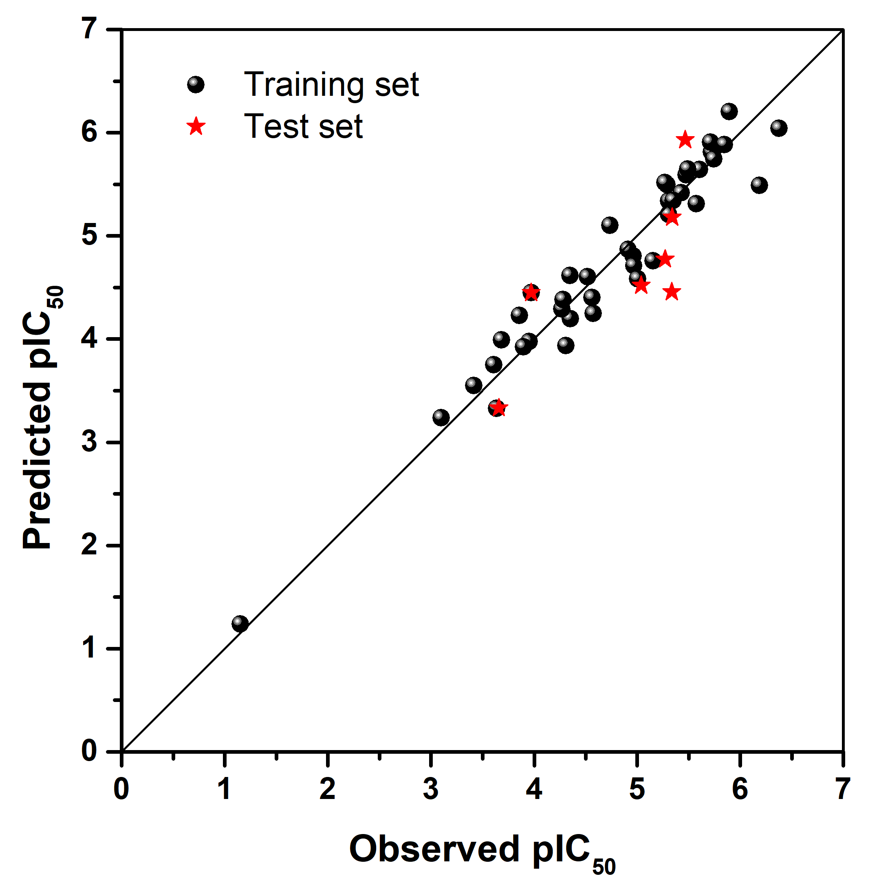
Figure. S1 Scatter plot of experimental and predicted pIC₅₀ of CoMFA model.

