Supplementary file

(Supporting information)

Table S1. Specification of hot corrosion salt

|  |  |  |  |
| --- | --- | --- | --- |
| Mixed content | Melting point | Density (g/cm3) | Type of salt |
| 45 wt.% | 888 | 2.70 | Na2SO4 |
| 55 wt.% | 690 | 3.36 | V2O5 |

Table S2: Crystallite size of ScCeYSZ powders at different calcination temperatures

|  |  |  |  |
| --- | --- | --- | --- |
| Crystallite size at 1600 °C | Crystallite size at 1000 °C | Crystallite size at 800 °C | Composition |
| 29 nm | 19nm | 16 nm | (ScCeYSZ)3 |

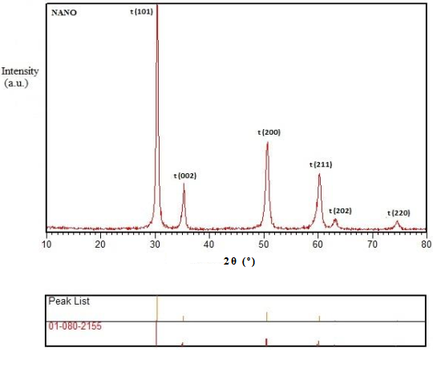

Fig. S1: XRD analysis of the commercial 8YSZ nanogranule sample.

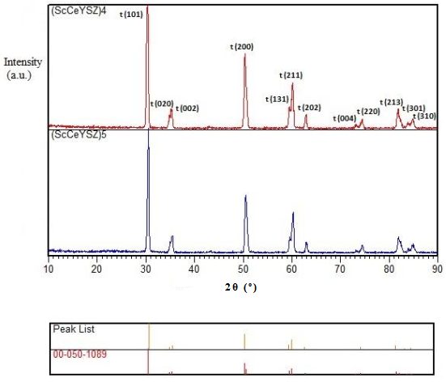

Fig. S2: XRD pattern of (ScCeYSZ)4 and (ScCeYSZ)5 samples at an annealing temperature of 1600 ˚C/2h.

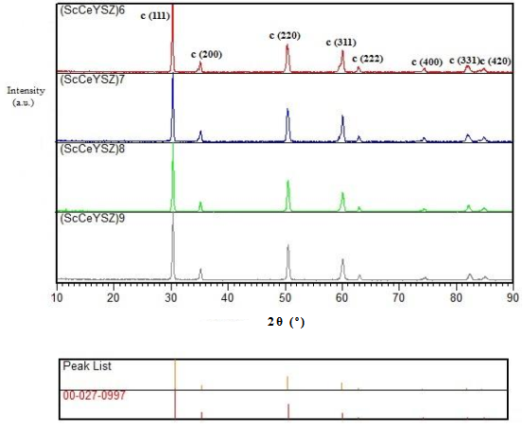

Fig. S3: XRD pattern of (ScCeYSZ)6-9 samples at an annealing temperature of 1600 ˚C/2h.

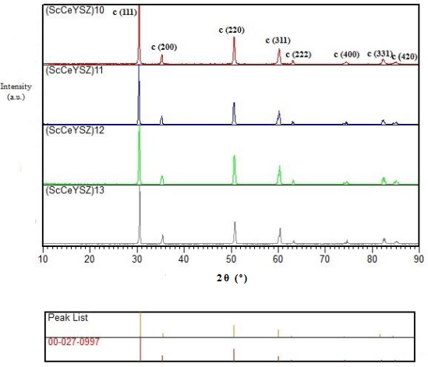

Fig. S4: XRD pattern of (ScCeYSZ)10-13 samples at an annealing temperature of 1600 ˚C/2h.

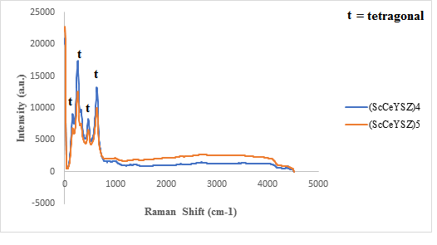

Fig. S5: Raman Spectra of the (ScCeYSZ)4 and (ScCeYSZ)5 powders at an annealing temperature of 1600 ˚C/2h.

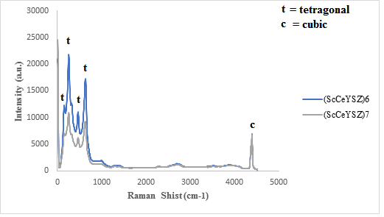

Fig. S6: Raman Spectra of the (ScCeYSZ)6 and (ScCeYSZ)7 powders at an annealing temperature of 1600 ˚C/2h.

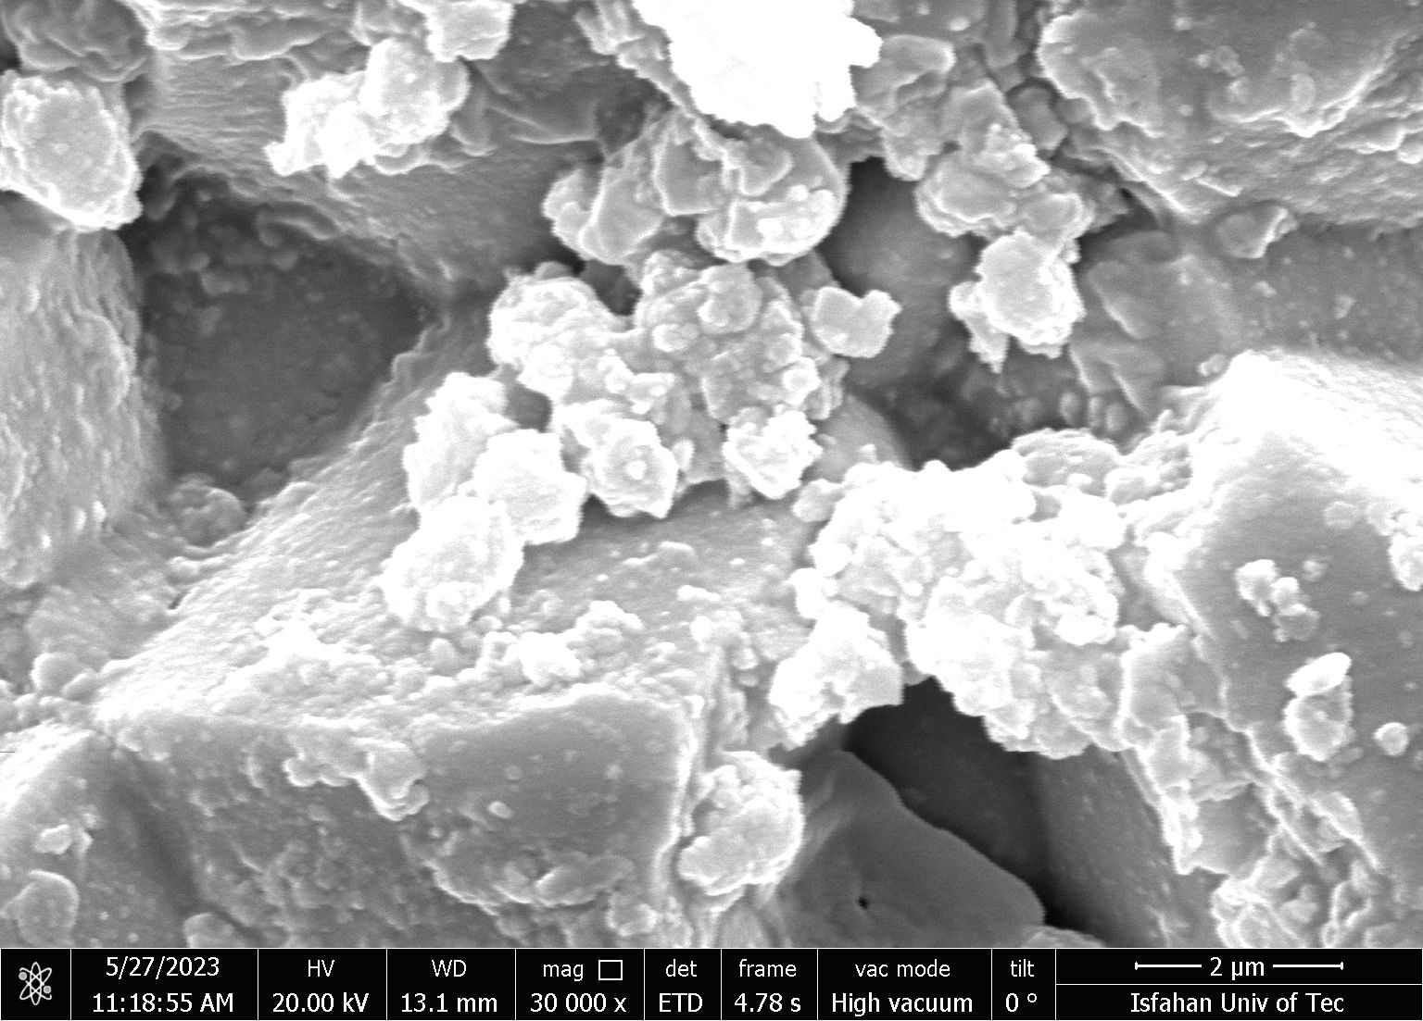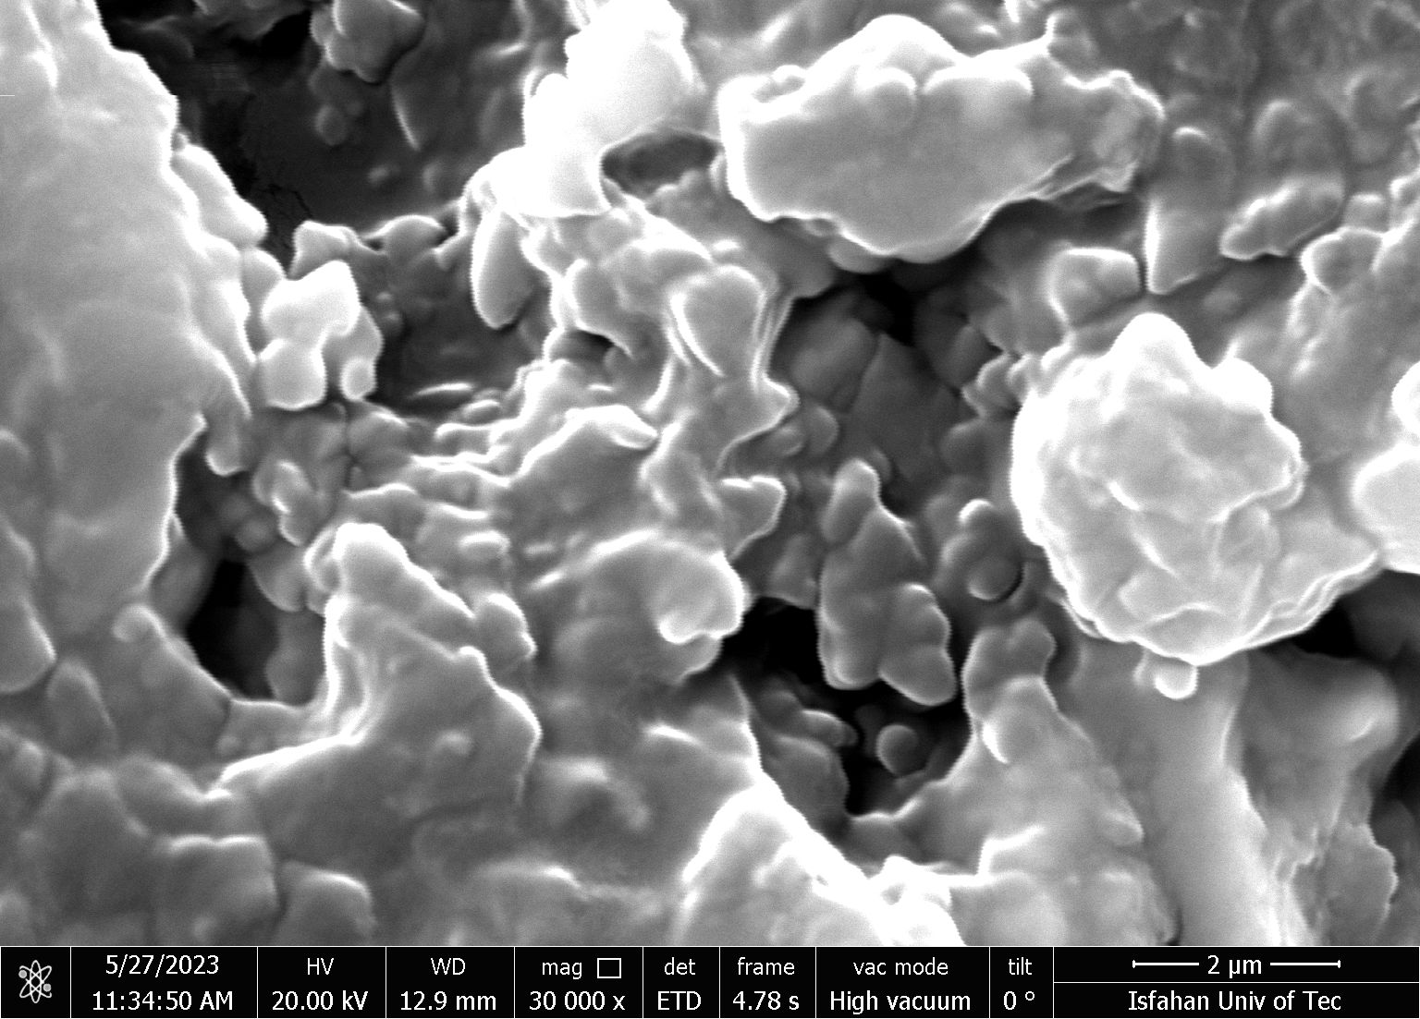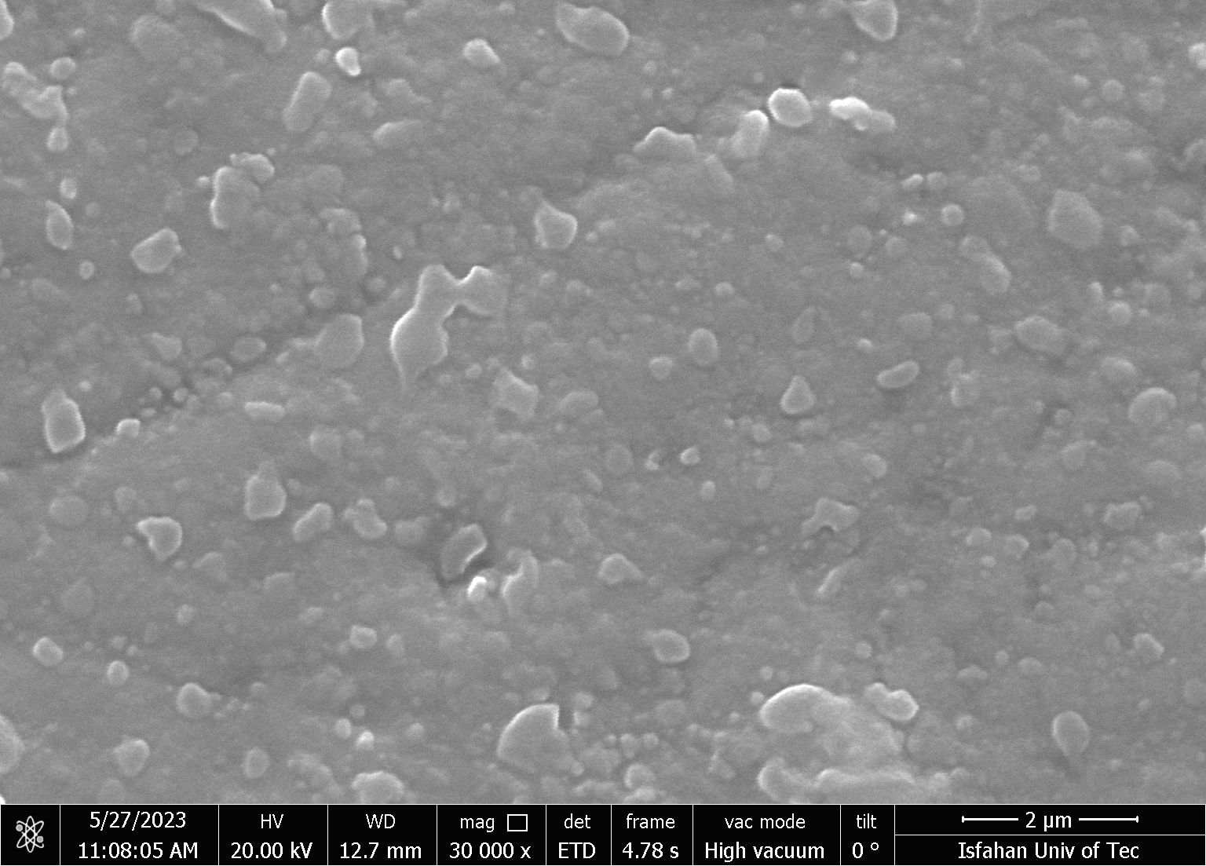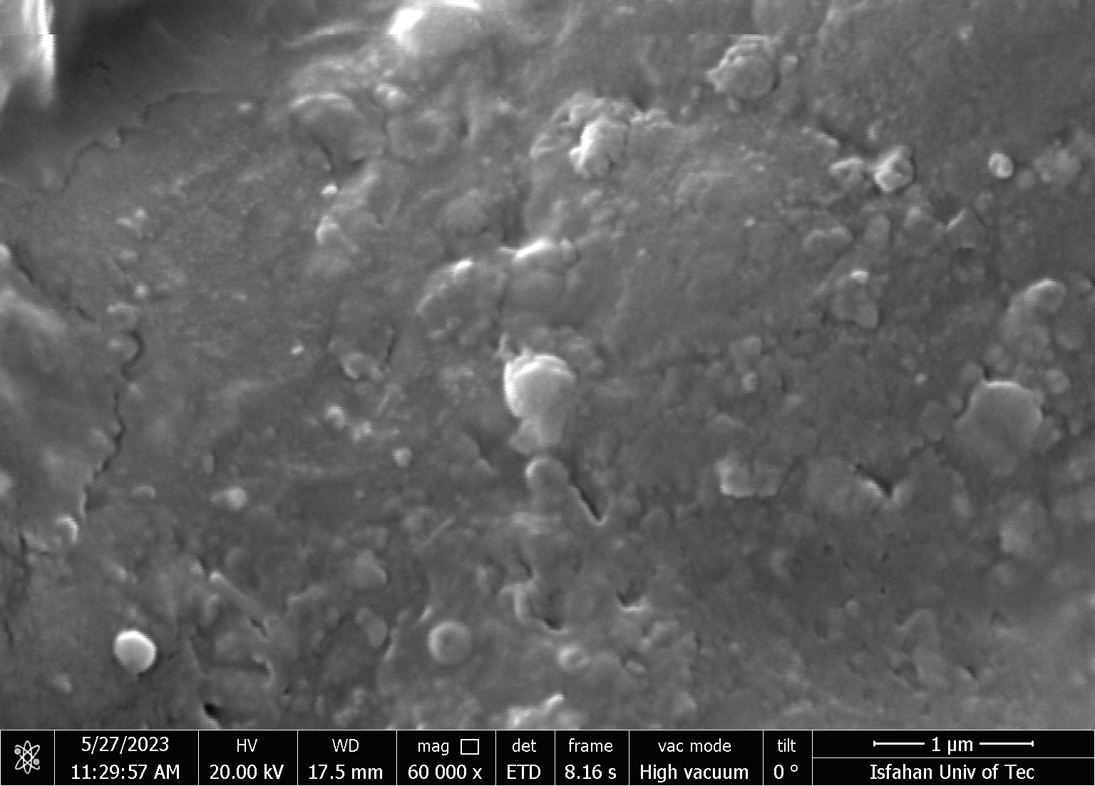

**NanoYSZ**

**(ScCeYZ)3**

**(ScCeYZ)2**

**(ScCeYZ)1**

Fig. S7: Fractured cross-section FESEM images of sintered (ScCeYSZ)1-3 and NanoYSZ sample.