Investigation of silver nanoparticle synthesis with various nonthermal plasma reactor configurations
Md. Mokter Hossain ª, Ndeddy Aka Robinson junior ^{b}, Sarah Wu ^{a*}
ª Department of Chemical and Biological Engineering, University of Idaho, 875 Perimeter Drive MS 0904, Moscow, ID, 83844, United States

* Corresponding author: Dr. Sarah Wu
Department of Chemical and Biological Engineering
University of Idaho
875 Perimeter Drive MS 0904
Moscow, ID 83844-0904
Email: xwu@uidahi.edu
Tel.: +1 208-885-1532; Fax: +1 208-885-7908

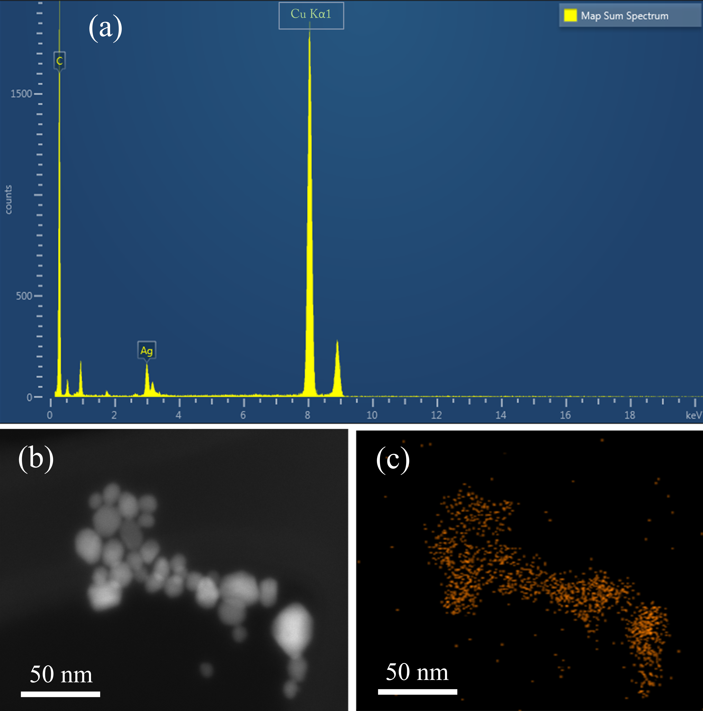
Figure S1. (a) EDS spectrum, (b) dark-field TEM image of silver nanoparticles, and (c) with the corresponding EDS maps for silver.

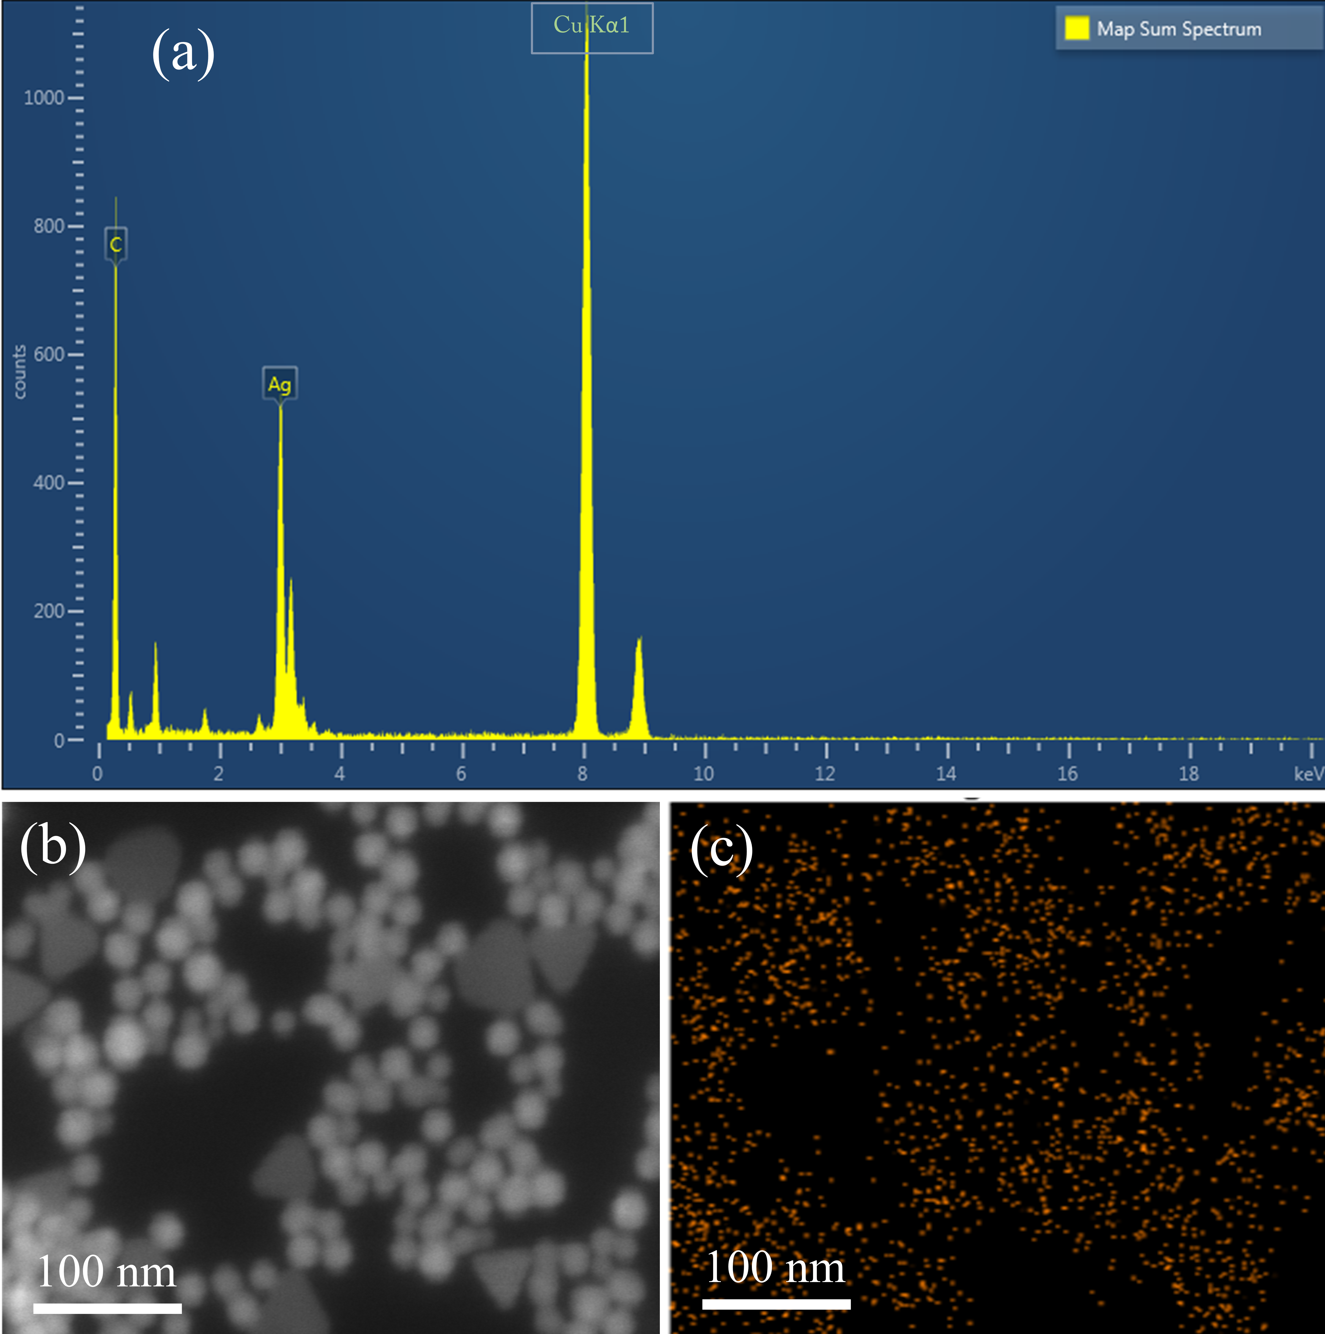
Figure S2. (a) EDS spectrum, (b) dark-field TEM image of silver nanoparticles, and (c) with the corresponding EDS maps for silver.

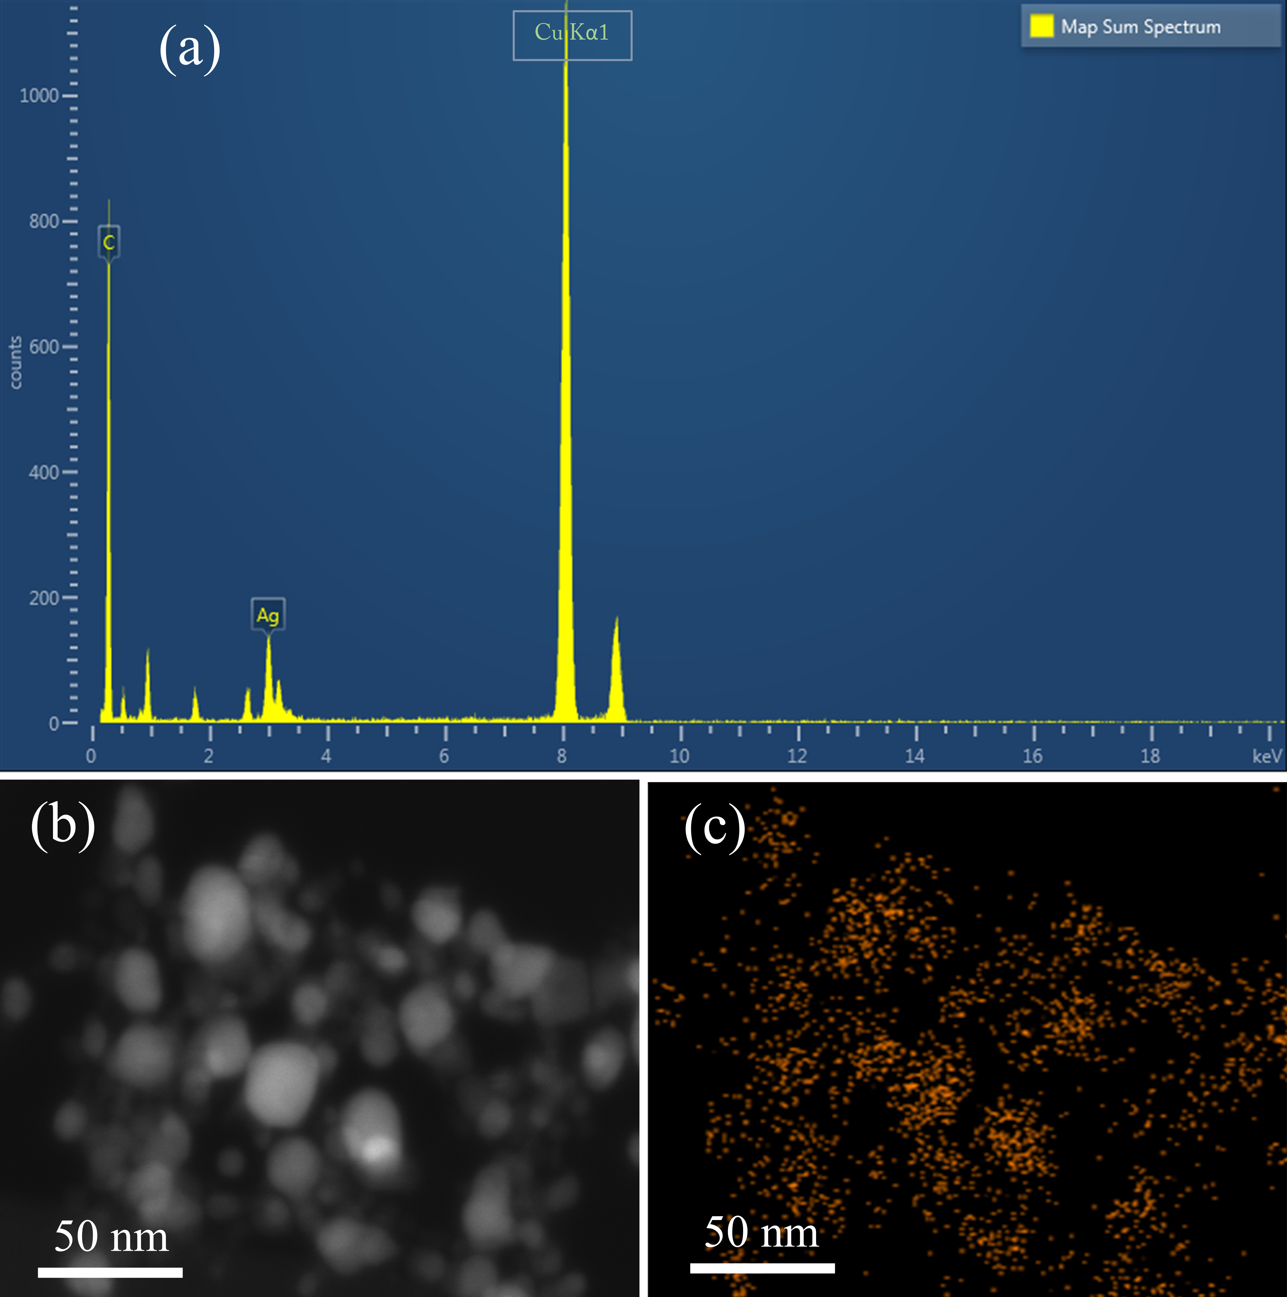
Figure S3. (a) EDS spectrum, (b) dark-field TEM image of silver nanoparticles, and (c) with the corresponding EDS maps for silver.

