**Supporting Information file for:**

**Microwave –assisted pyrolysis aspen wood for production of valuable products under different temperatures**

Ying Zhang a, Song Cheng b, c*, Bing Wang d, Changliang Shib, c*, Yanhe Nie b, c

a. School of Emergency Management, Henan Polytechnic University, Jiaozuo 454003, China;

b. College of Chemistry and Chemical Engineering, Henan Polytechnic University, Jiaozuo 454003, China；

c. Collaborative Innovation Center of Coal Work Safety and Clean High Efficiency Utilization, Jiaozuo, 454003, China

d. Jiangxi Hanyaofu Lithium Technology Co., Ltd, Yichun, 336023, China)

* Corresponding authors email: chengsong@hpu.edu.cn

**Ag+ adsorption experiment**

50 mL Ag+ solution is mixed with 0.05 g biochar. The mixture solution is put in the thermostatic oscillator with the temperature of 25℃. The stirring speed is 300r/min. The residue Ag+ in the solution is analyzed by the atomic absorption spectrum until adsorption equilibrium. The adsorption amount (*qe*) is calculated as follows:

${ q}_{e}=\frac{\left(C_{o}-C_{e}\right)M}{V}$ (1)

The qe is the adsorption amount. Co and Ce are the initial and equilibrium concentration, respectively. M is weight of biochar (g), and V is volume of solution (L).

**Catalytic** **degradation experiment**

The rhodamine B with NaBH4 solution is adopted as a main model reaction to investigate the catalytic activities of Ag@biochar. In a typical reaction procedure, Ag@biochar is placed into a conical flask containing 50 mL rhodamine B solution (20-40 mg/L). Then, 0.05 mmol NaBH4 is added into the solution with stirring at room temperature. Aqueous samples are collected at different time intervals and the residual concentrations of rhodamine B are measured using UV-vis spectroscopy. The amount of rhodamine B adsorbed over time, qt (mg/g), is calculated by the following equation:

 (2)

Where Ct (mg/L) is the liquid-phase concentration of rhodamine B solution at time t (min). *qt* is adsorption amount at t time. Co and Ce are initial and equilibrium concentration, respectively. M is weight of Ag@biochar (g), and V is volume of solution (L). The degradation removal of the rhodamine B is named as η.

$η=\frac{\left(C_{o}-C_{t}\right)}{C_{o}} 100\%$ (3)

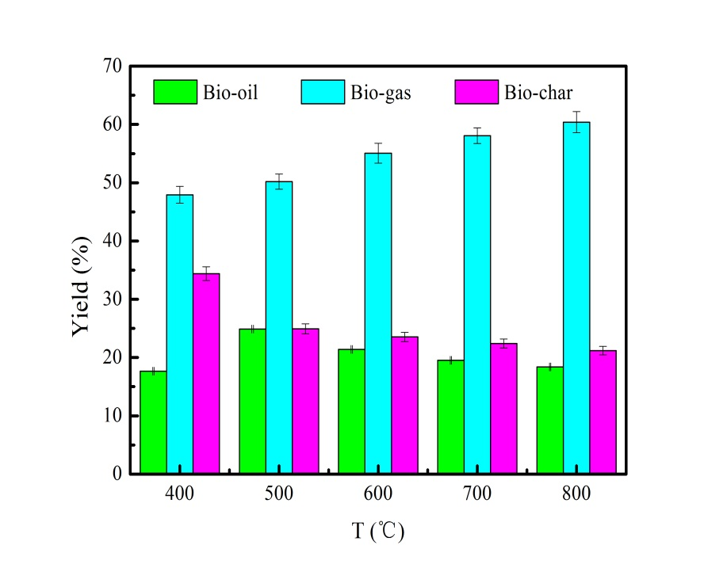

**Fig.S2** Yield of pyrolysis product at different pyrolysis temperatures.

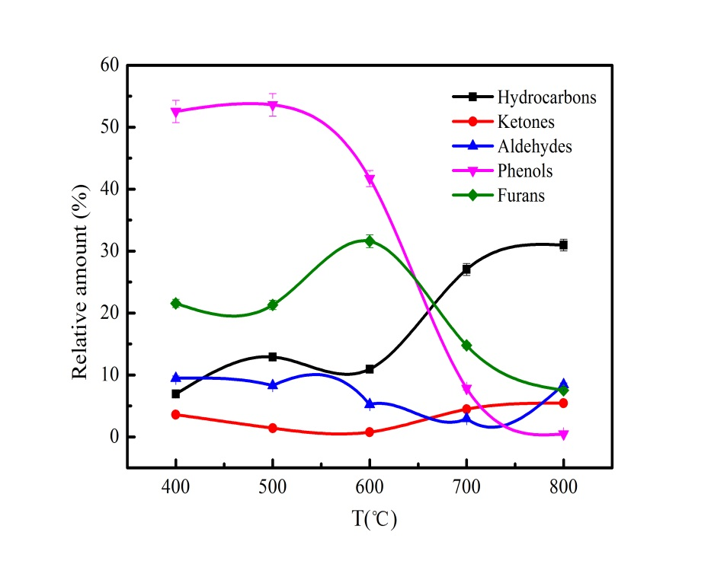

**Fig.S3** The main component of bio-oil at different pyrolysis temperatures.

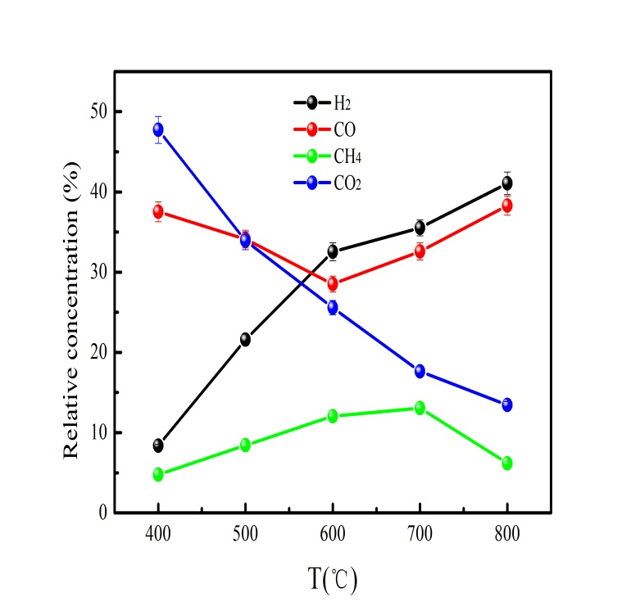 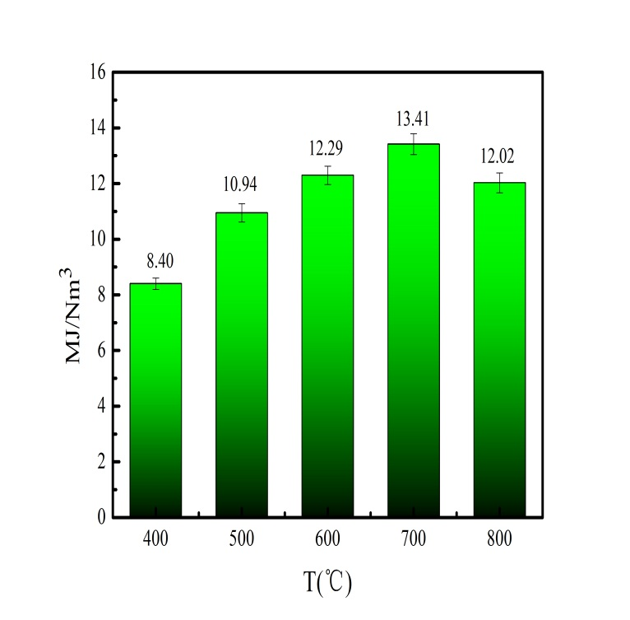

**Fig.S4** The component (a) and heating value (b) of bio-gas at different pyrolysis temperatures.

E:\D盘重要资料\大论文数据-2018\SEM\chengsong\1-1 (9).tiff E:\D盘重要资料\大论文数据-2018\SEM\chengsong\1-1 (8).tiff E:\D盘重要资料\大论文数据-2018\SEM\chengsong\2-1 (7).tiff

c

b

a

e

E:\D盘重要资料\大论文数据-2018\SEM\chengsong\2-1 (7).tiffE:\D盘重要资料\大论文数据-2018\SEM\chengsong\2-1 (9).tiff

d

**Fig.S5** SEM of biochar produced at 400-800℃(a:poplar sawdust-400℃, b:poplar sawdust-500℃, c:poplar sawdust-600℃, d:poplar sawdust-700℃ and e:poplar sawdust-800℃).

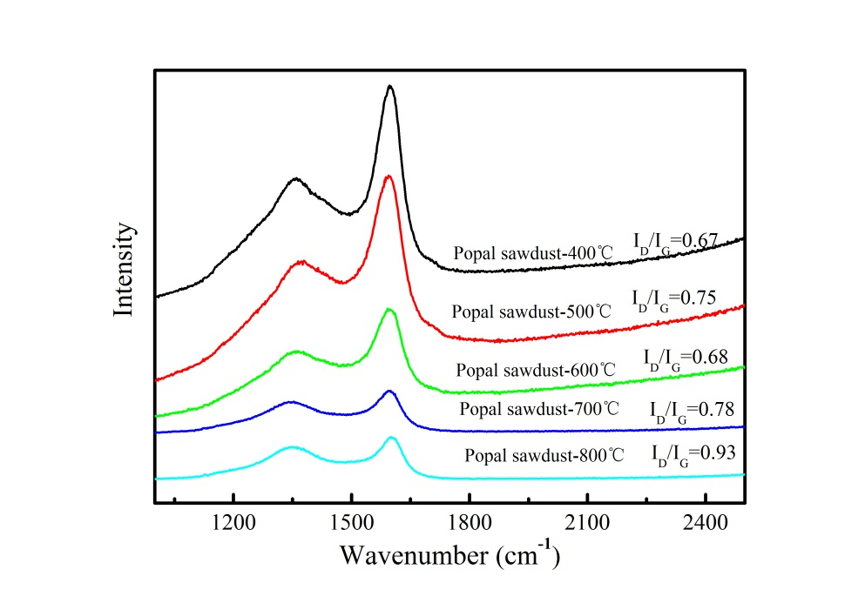

**Fig.S6** Raman analysis of biochar produced at different pyrolysis temperatures.

**Table S1** The application of the biochar in wastewater treatment and energy storage

|  |  |  |  |
| --- | --- | --- | --- |
| Biochar | Application | Performance | Reference |
| Corn straw-biochar | Cr(VI) removal | 116.28mg/g | [1] |
| Pinewood-biochar | Pb(II) removal | 91.98 mg/g | [2] |
| Cornstalk-biochar | Cd(II) removal | 36.4 mg/g | [3] |
| Coconut shell-biohcar | Methylene blue removal | 916.26 mg/g | [4] |
| Durian rind-biochar | Congo red removal | 87.32 mg/g | [5] |
| Switchgrass-biochar | Orange G removal | 38.2 mg/g | [6] |
| Chestnut shells | Microbial fuel cell | 850 mW/m3 | [7] |
| Bamboo charcoal | Microbial fuel cell | 1652 mW/m3 | [8] |
| Barbed chestnut shell | Microbial fuel cell | 759 mW/m3 | [9] |
| Crayfish shell | Lithium-ion-batteries | 100 mAh g-1 | [10] |
| Banana peel waste | Lithium-ion-batteries | 225 mAh g-1 | [11] |
| Wheat stalk | Lithium-ion-batteries | 215 mAh g-1 | [12] |
| Hazelnut shells | Lithium-ion-batteries | 307 mAh g-1 | [13] |
| Tea leaves waste | Supercapacitor | 167 F/g | [14] |
| Corncob cellulose | Supercapacitor | 208 F/g | [15] |
| Rice brain | Supercapacitor | 265 F/g | [16] |
| Moringa oleifera stem | Supercapacitor | 283 F/g | [17] |

**Reference**

[1] Zhao N, Zhao C, Lv Y, et al. Adsorption and coadsorption mechanisms of Cr(VI) and organic contaminants on H3PO4 treated biochar[J]. Chemosphere, 2017,186: 422-429.

[2] Wang X, Xu Y, Rao H, et al. Novel porous molybdenum tungsten phosphide hybrid nanosheets on carbon cloth for efficient hydrogen evolution[J]. Energy & Environmental Science, 2016,9(4): 1468-1475.

[3] Youssef A M, El-Nabarawy T, Samra S E. Sorption properties of chemically-activated carbons[J]. Colloids and Surfaces A: Physicochemical and Engineering Aspects, 2004,235(1-3): 153-163.

[4] Cazetta A L, Vargas A M M, Nogami E M, et al. NaOH-activated carbon of high surface area produced from coconut shell: Kinetics and equilibrium studies from the methylene blue adsorption[J]. Chemical Engineering Journal, 2011,174(1): 117-125.

[5] Khan I A, Badshah A, Khan I, et al. Soft-template carbonization approach of MOF-5 to mesoporous carbon nanospheres as excellent electrode materials for supercapacitor[J]. Microporous and Mesoporous Materials, 2017,253: 169-176.

[6] Park J, Wang J J, Meng Y, et al. Adsorption/desorption behavior of cationic and anionic dyes by biochars prepared at normal and high pyrolysis temperatures[J]. Colloids and Surfaces A: Physicochemical and Engineering Aspects, 2019,572: 274-282.

[7] Cheng Y, Mallavarapu M, Naidu R, et al. In situ fabrication of green reduced graphene-based biocompatible anode for efficient energy recycle[J]. Chemosphere, 2018,193: 618-624.

[8] Zhang J, Li J, Ye D, et al. Tubular bamboo charcoal for anode in microbial fuel cells[J]. Journal of Power Sources, 2014,272: 277-282.

[9] Chen S, Tang J, Jing X, et al. A hierarchically structured urchin-like anode derived from chestnut shells for microbial energy harvesting[J]. Electrochimica Acta, 2016,212: 883-889.

[10] Wang L, Zheng Y, Wang X, et al. Nitrogen-Doped Porous Carbon/Co3 O4 Nanocomposites as Anode Materials for Lithium-Ion Batteries[J]. ACS Applied Materials & Interfaces, 2014,6(10): 7117-7125.

[11] Serna-Jiménez J A, Luna-Lama F, Caballero Á, et al. Valorisation of banana peel waste as a precursor material for different renewable energy systems[J]. Biomass and Bioenergy, 2021,155: 106279.

[12] Zhou X, Chen F, Bai T, et al. Interconnected highly graphitic carbon nanosheets derived from wheat stalk as high performance anode materials for lithium ion batteries[J]. Green Chemistry, 2016,18: 2078-2088.

[13] Unur E, Brutti S, Panero S, et al. Nanoporous carbons from hydrothermally treated biomass as anode materials for lithium ion batteries[J]. Microporous and Mesoporous Materials, 2013,174: 25-33.

[14] Song X, Ma X, Li Y, et al. Tea waste derived microporous active carbon with enhanced double-layer supercapacitor behaviors[J]. Applied Surface Science, 2019,487: 189-197.

[15] Ai J, Yang S, Sun Y, et al. Corncob cellulose-derived hierarchical porous carbon for high performance supercapacitors[J]. Journal of Power Sources, 2021,484: 229221.

[16] Hou J, Cao C, Ma X, et al. From Rice Bran to High Energy Density Supercapacitors: A New Route to Control Porous Structure of 3D Carbon[J]. Scientific Reports, 2014,4(1).

[17] Cai Y, Luo Y, Dong H, et al. Hierarchically porous carbon nanosheets derived from Moringa oleifera stems as electrode material for high-performance electric double-layer capacitors[J]. Journal of Power Sources, 2017,353: 260-269.