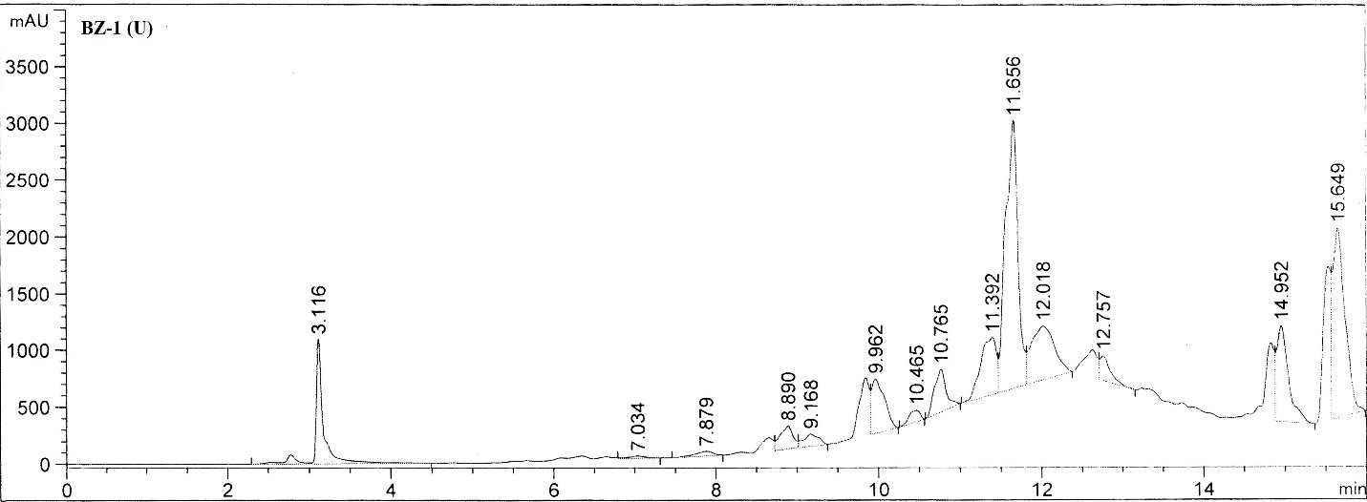

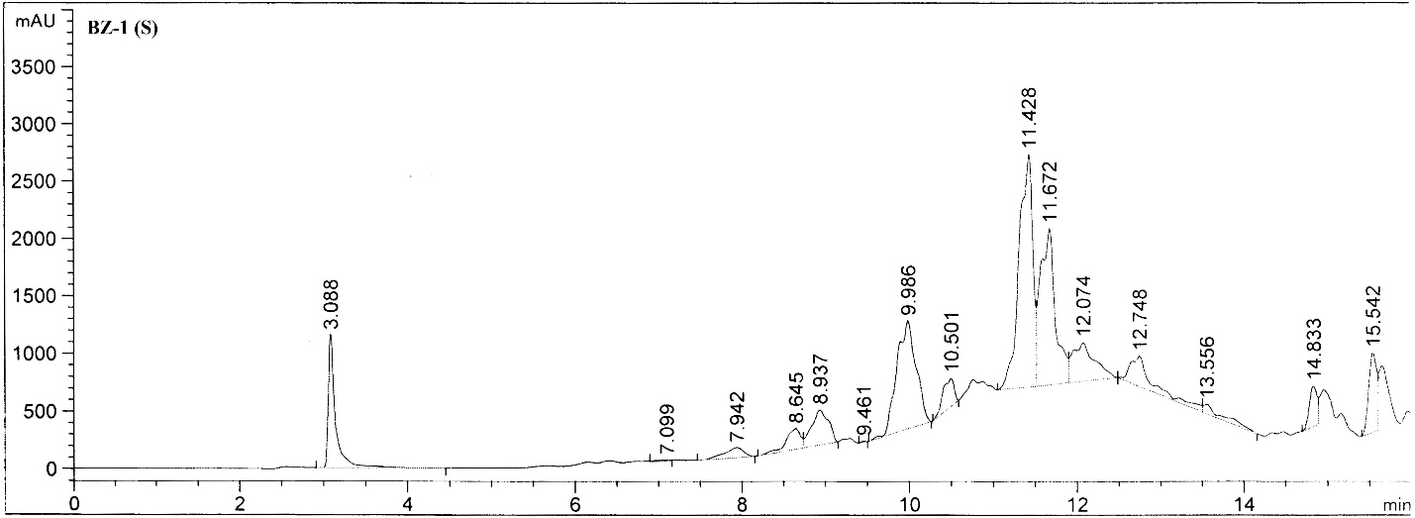

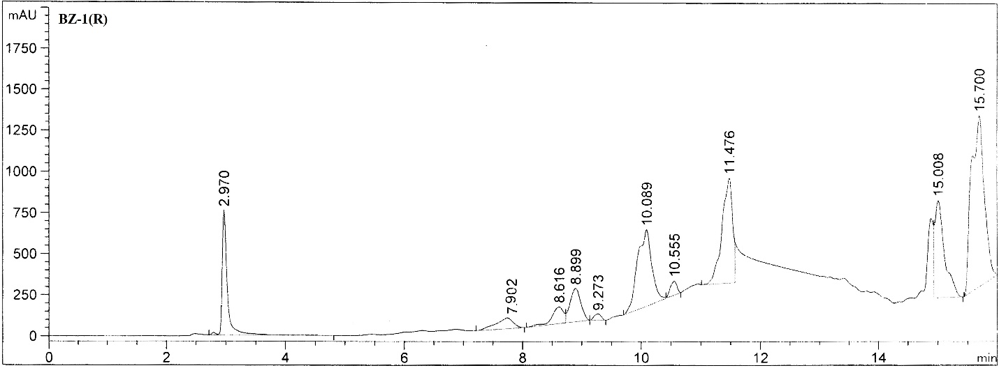

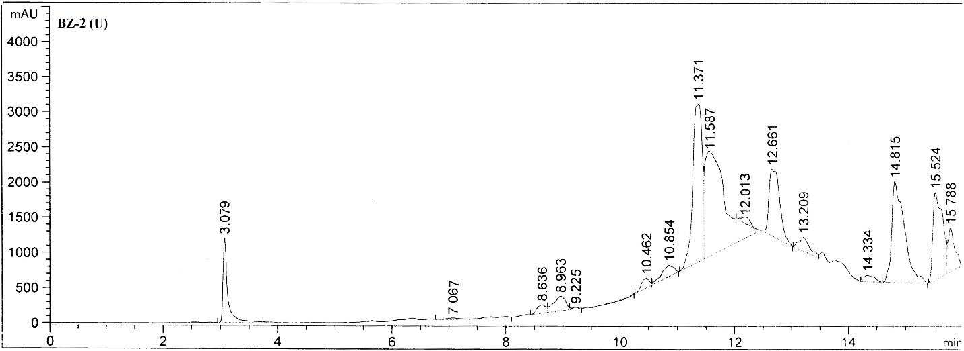

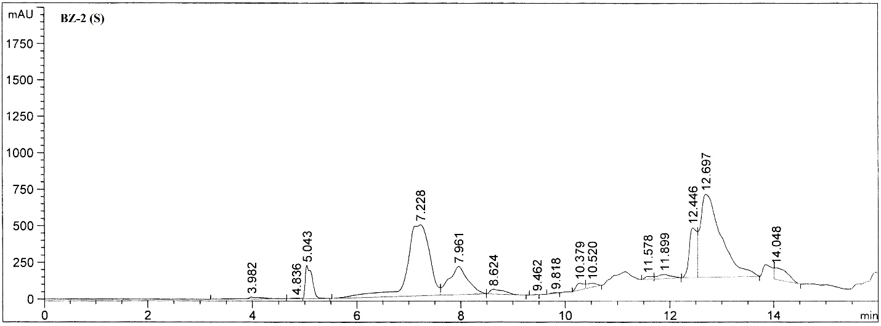

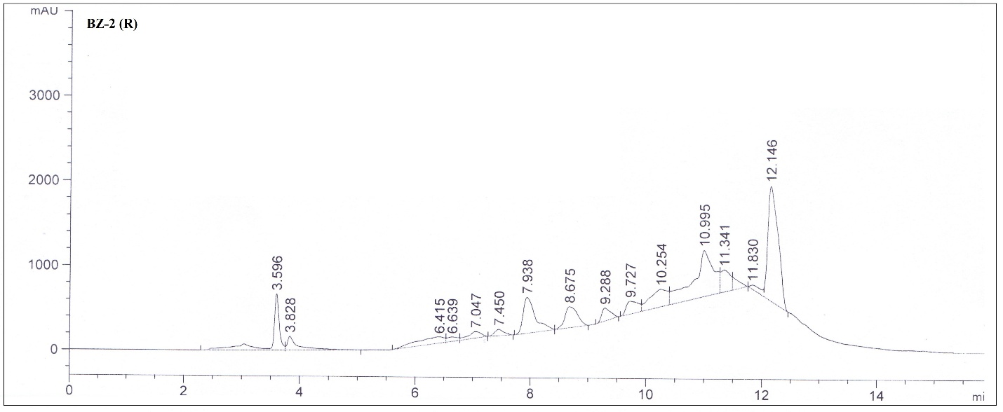

**Figure S1.** HPLC Chromatogram of phenolic bioactives from BZ1 and BZ2 at unripen, semi-ripen and fully-ripen stages

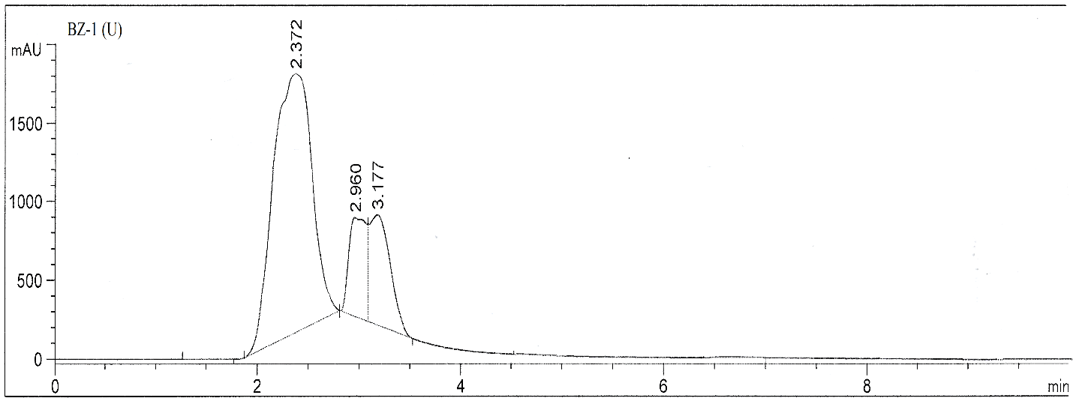

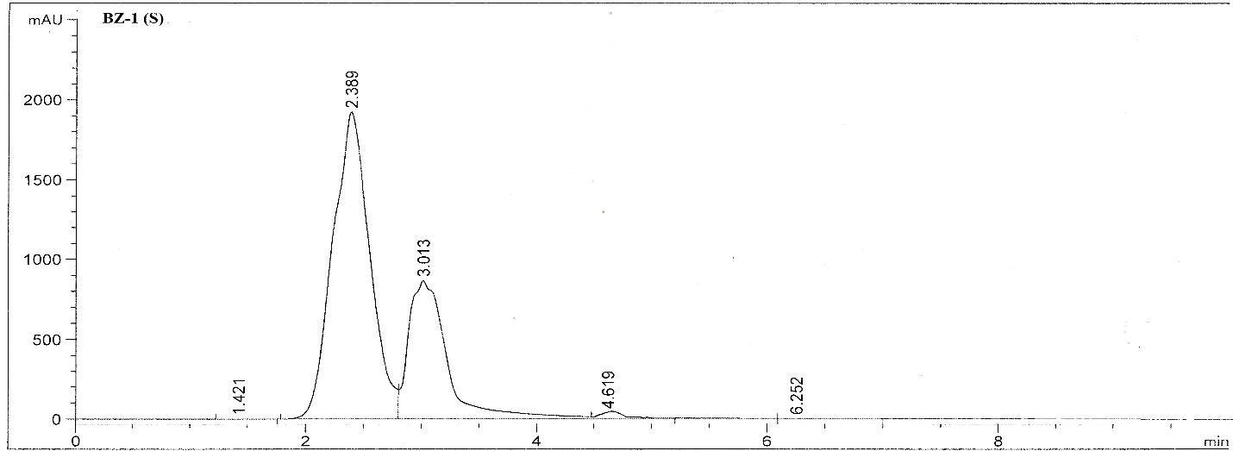

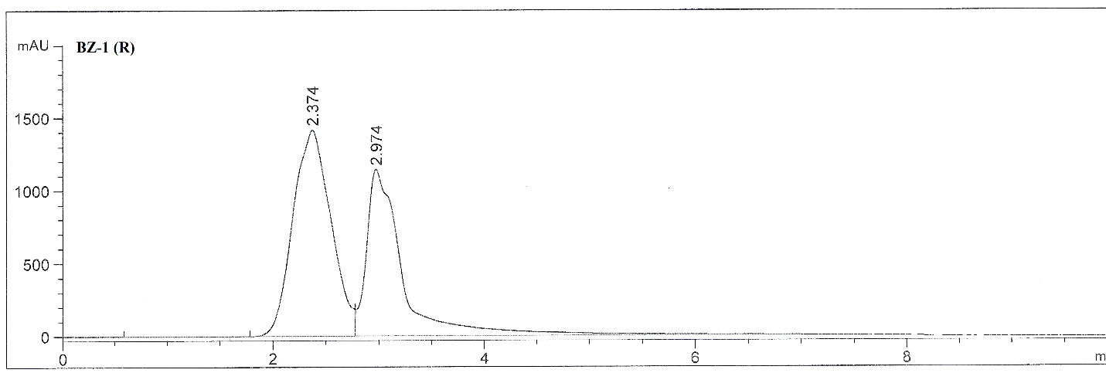

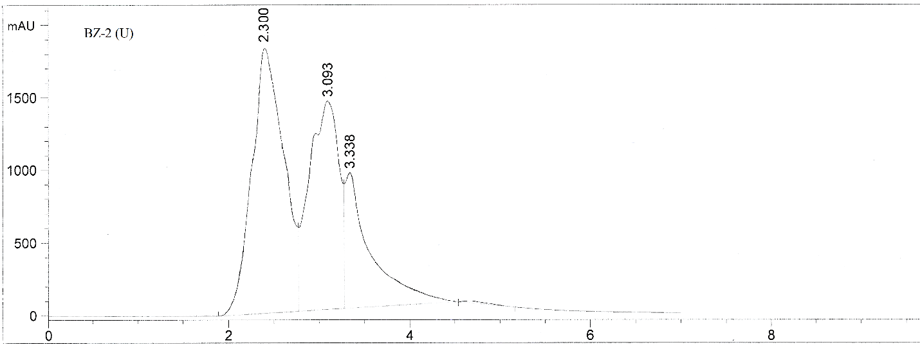

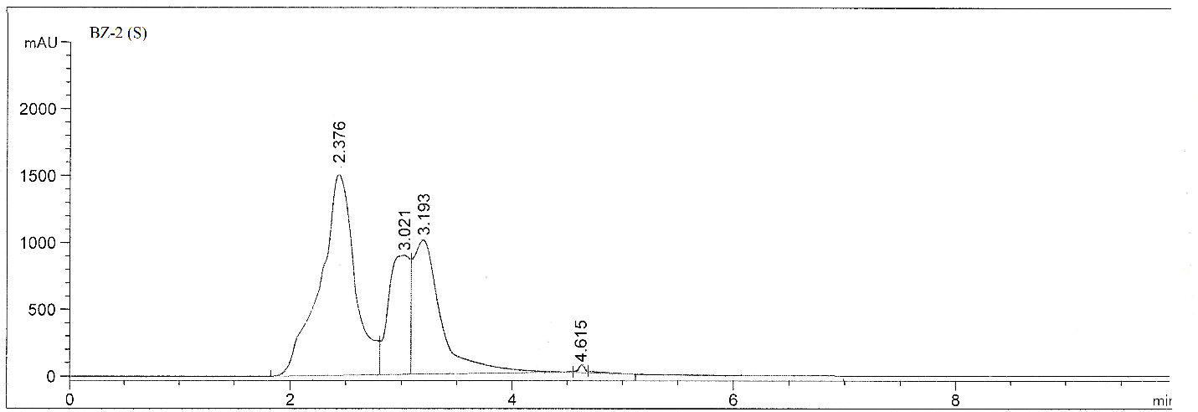

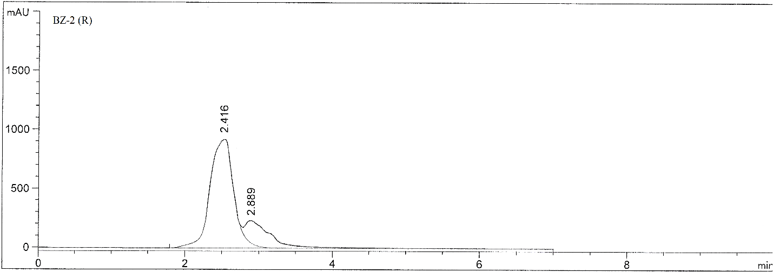

**Figure S2.** HPLC Chromatogram of flavonoids from BZ1 and BZ2 at unripen, semi-ripen and fully-ripen stages

**Table S1.** Inhibition zones of OFEs (2.5 mg/mL) from selected cultivars at different maturity stages against different bacterial strains

|  |  |  |  |  |  |  |
| --- | --- | --- | --- | --- | --- | --- |
| **Cultivars** | **Stages** | **Inhibition zones** (mm) | | | | |
| *K. oxytoca* | *S. typhi* | *E. coli* | *S. aureus* | *B. subtilis* |
| BZ1 | U | 6.0± 0.4 | 3.1± 0.2 | 2.0± 0.2 | 15.3± 0.1 | 14.2± 0.4 |
| S | 4.1± 0.1 | ------------ | 2.4± 0.1 | 15.6± 0.2 | 13.5± 1.0 |
| F | 3.5± 0.0 | 2.0± 0.1 | 2.05± 0.1 | 14.6± 0.5 | 12.6± 0.6 |
| BZ2 | U | 2.3± 0.2 | ------------ | ----------- | 16.7± 0.3 | 11.1± 1.3 |
| S | 4.0± 0.1 | ------------ | 3.6± 0.2 | 18.3± 1.0 | 9.2± 0.7 |
| F | 5.2± 0.3 | 2.5± 0.1 | 3.9± 0.5 | 15.9± 0.7 | 8.3± 1.2 |
| **Cefixime** |  | 19.7± 2.3 | 7.2 ± 3.2 | 27.1± 1.5 | 24.3± 2.1 | 18.1 ± 1.1 |