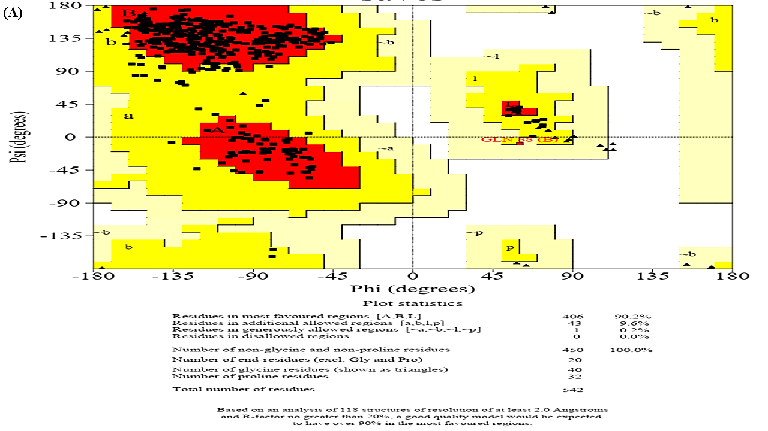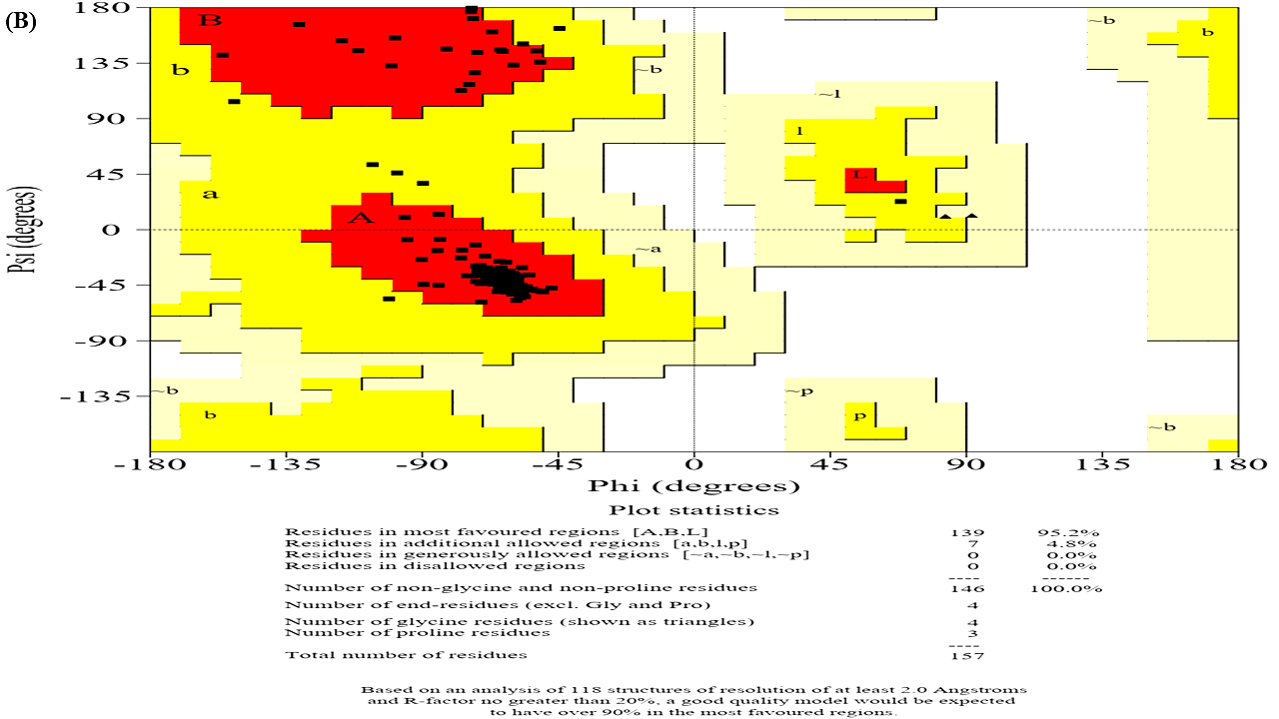

**Supplementary Fig. 1** Ramachandran plot **(A)** TNF-a **(B)** IL-6.

**F:\papers 2023\muneeb sir papers\rheumatoid paper\eeeeeeion1\Slide26.TIF**

**F:\papers 2023\muneeb sir papers\rheumatoid paper\eeeeeeion1\Slide27.TIF**

**F:\papers 2023\muneeb sir papers\rheumatoid paper\eeeeeeion1\Slide28.TIF**

**Supplementary Fig. 2** b2b results of TNF-α (A) Prediction via multiple tools (B) PSP analysis.

**F:\papers 2023\muneeb sir papers\rheumatoid paper\eeeeeeion1\Slide23.TIF**

**F:\papers 2023\muneeb sir papers\rheumatoid paper\eeeeeeion1\Slide24.TIF**

**F:\papers 2023\muneeb sir papers\rheumatoid paper\eeeeeeion1\Slide25.TIF**

**Supplementary Fig. 3.** b2b results of IL-6 protein (A) Prediction via multiple tools (B) PSP analysis.