New thieno[2,3-b]pyridine-based compounds: Synthesis, molecular modelling, antibacterial and antifungal activities

Noof A. Alenazi¹, Haifa Alharbi², Ahmad Fawzi Qarah³, Amerah Alsoliemy⁴, Matokah M. Abualnaja⁴, Alaa Karkashan⁵, Basma Abbas⁵, Nashwa M. El-Metwaly^{4,6*}

¹Department of Chemistry, College of Science and Humanities in Al-Kharj, Prince Sattam bin Abdulaziz University, Al-Kharj 11942, Saudi Arabia
²Department of Chemistry, College of Science, Northern Border University, Saudi Arabia
³Department of Chemistry, College of Science, Taibah University, Madinah, P. O. Box 344, Saudi Arabia
⁴Department of Chemistry, Faculty of Applied Sciences, Umm Al-Qura University, Makkah, Saudi Arabia
⁵Department of biology, College of Sciences, University of Jeddah, Jeddah 21959, Saudi Arabia
⁶Department of Chemistry, Faculty of Science, Mansoura University, El-Gomhoria Street 35516, Egypt

Table S1. The DFT dihedral angle data of the investigated compounds.
 | 4 |  | 5 |  | 6
Dihedral | (°) | Dihedral | (°) | Dihedral | (°)
N(16)-C(17)-N(18)-H(33) | 172.3 | C(19)-C(20)-S(21)-C(17) | 0.0 | C(25)-C(26)-C(27)-C(22) | 0.0
N(16)-C(17)-N(18)-H(34) | -16.0 | N(18)-C(19)-C(20)-S(21) | 0.0 | C(24)-C(25)-C(26)-C(27) | 0.0
S(19)-C(17)-N(18)-H(33) | -4.0 | C(22)-C(19)-C(20)-S(21) | -180.0 | C(23)-C(24)-C(25)-C(26) | 0.0
S(19)-C(17)-N(18)-H(34) | 167.7 | C(17)-N(18)-C(19)-C(20) | 0.0 | C(22)-C(23)-C(24)-C(25) | 0.0
N(14)-N(16)-C(17)-N(18) | -178.0 | C(17)-N(18)-C(19)-C(22) | -180.0 | C(19)-C(22)-C(27)-C(26) | 179.9
N(14)-N(16)-C(17)-S(19) | -1.9 | N(16)-C(17)-S(21)-C(20) | -180.0 | C(23)-C(22)-C(27)-C(26) | -0.1
H(32)-N(16)-C(17)-N(18) | -24.3 | N(18)-C(17)-S(21)-C(20) | 0.0 | C(19)-C(22)-C(23)-C(24) | -179.9
H(32)-N(16)-C(17)-S(19) | 151.8 | N(16)-C(17)-N(18)-C(19) | 180.0 | C(27)-C(22)-C(23)-C(24) | 0.1
C(13)-N(14)-N(16)-C(17) | -54.8 | S(21)-C(17)-N(18)-C(19) | 0.0 | C(19)-C(20)-S(21)-C(17) | 0.0
C(13)-N(14)-N(16)-H(32) | 150.3 | N(14)-N(16)-C(17)-N(18) | 179.2 | N(18)-C(19)-C(22)-C(23) | -0.7
C(8)-C(13)-N(14)-N(16) | 177.8 | N(14)-N(16)-C(17)-S(21) | -0.8 | N(18)-C(19)-C(22)-C(27) | 179.2
C(15)-C(13)-N(14)-N(16) | -8.4 | H(35)-N(16)-C(17)-N(18) | 0.5 | C(20)-C(19)-C(22)-C(23) | 179.2
C(5)-C(9)-N(12)-H(27) | -0.3 | H(35)-N(16)-C(17)-S(21) | -179.5 | C(20)-C(19)-C(22)-C(27) | -0.8
C(5)-C(9)-N(12)-H(28) | -170.0 | C(13)-N(14)-N(16)-C(17) | 177.9 | N(18)-C(19)-C(20)-S(21) | 0.0
C(8)-C(9)-N(12)-H(27) | 177.8 | C(13)-N(14)-N(16)-H(35) | -3.5 | C(22)-C(19)-C(20)-S(21) | -179.9
C(8)-C(9)-N(12)-H(28) | 8.1 | C(8)-C(13)-N(14)-N(16) | -177.5 | C(17)-N(18)-C(19)-C(20) | 0.0
S(7)-C(8)-C(13)-N(14) | 6.7 | C(15)-C(13)-N(14)-N(16) | -2.5 | C(17)-N(18)-C(19)-C(22) | 180.0
S(7)-C(8)-C(13)-C(15) | -167.3 | C(5)-C(9)-N(12)-H(30) | 5.8 | N(16)-C(17)-S(21)-C(20) | -179.9
C(9)-C(8)-C(13)-N(14) | -172.6 | C(5)-C(9)-N(12)-H(31) | -158.1 | N(18)-C(17)-S(21)-C(20) | 0.0
C(9)-C(8)-C(13)-C(15) | 13.4 | C(8)-C(9)-N(12)-H(30) | -176.8 | N(16)-C(17)-N(18)-C(19) | 179.9
S(7)-C(8)-C(9)-C(5) | 3.4 | C(8)-C(9)-N(12)-H(31) | 19.3 | S(21)-C(17)-N(18)-C(19) | 0.0
S(7)-C(8)-C(9)-N(12) | -174.9 | S(7)-C(8)-C(13)-N(14) | 14.6 | N(14)-N(16)-C(17)-N(18) | 179.1
C(13)-C(8)-C(9)-C(5) | -177.3 | S(7)-C(8)-C(13)-C(15) | -160.4 | N(14)-N(16)-C(17)-S(21) | -1.0
C(13)-C(8)-C(9)-N(12) | 4.5 | C(9)-C(8)-C(13)-N(14) | -165.7 | H(40)-N(16)-C(17)-N(18) | 0.5
C(4)-S(7)-C(8)-C(9) | -2.8 | C(9)-C(8)-C(13)-C(15) | 19.3 | H(40)-N(16)-C(17)-S(21) | -179.5
C(4)-S(7)-C(8)-C(13) | 177.8 | S(7)-C(8)-C(9)-C(5) | 4.1 | C(13)-N(14)-N(16)-C(17) | 177.9
C(4)-C(5)-C(9)-C(8) | -2.2 | S(7)-C(8)-C(9)-N(12) | -173.6 | C(13)-N(14)-N(16)-H(40) | -3.7
C(4)-C(5)-C(9)-N(12) | 176.1 | C(13)-C(8)-C(9)-C(5) | -175.6 | C(8)-C(13)-N(14)-N(16) | -177.6
C(6)-C(5)-C(9)-C(8) | 178.0 | C(13)-C(8)-C(9)-N(12) | 6.8 | C(15)-C(13)-N(14)-N(16) | -2.5
C(6)-C(5)-C(9)-N(12) | -3.7 | C(4)-S(7)-C(8)-C(9) | -3.3 | C(5)-C(9)-N(12)-H(35) | 5.7
C(4)-C(5)-C(6)-C(1) | -0.2 | C(4)-S(7)-C(8)-C(13) | 176.4 | C(5)-C(9)-N(12)-H(36) | -158.7
C(4)-C(5)-C(6)-C(11) | 179.4 | C(4)-C(5)-C(9)-C(8) | -2.8 | C(8)-C(9)-N(12)-H(35) | -176.9
C(9)-C(5)-C(6)-C(1) | 179.6 | C(4)-C(5)-C(9)-N(12) | 174.9 | C(8)-C(9)-N(12)-H(36) | 18.8
C(9)-C(5)-C(6)-C(11) | -0.8 | C(6)-C(5)-C(9)-C(8) | 178.1 | S(7)-C(8)-C(13)-N(14) | 14.4
N(3)-C(4)-S(7)-C(8) | -178.8 | C(6)-C(5)-C(9)-N(12) | -4.2 | S(7)-C(8)-C(13)-C(15) | -160.7
C(5)-C(4)-S(7)-C(8) | 1.5 | C(4)-C(5)-C(6)-C(1) | 0.2 | C(9)-C(8)-C(13)-N(14) | -165.9
N(3)-C(4)-C(5)-C(6) | 0.2 | C(4)-C(5)-C(6)-C(11) | 179.8 | C(9)-C(8)-C(13)-C(15) | 19.0
N(3)-C(4)-C(5)-C(9) | -179.6 | C(9)-C(5)-C(6)-C(1) | 179.3 | S(7)-C(8)-C(9)-C(5) | 4.1
S(7)-C(4)-C(5)-C(6) | 179.9 | C(9)-C(5)-C(6)-C(11) | -1.1 | S(7)-C(8)-C(9)-N(12) | -173.6
S(7)-C(4)-C(5)-C(9) | 0.0 | N(3)-C(4)-S(7)-C(8) | -179.0 | C(13)-C(8)-C(9)-C(5) | -175.7
C(2)-N(3)-C(4)-C(5) | 0.0 | C(5)-C(4)-S(7)-C(8) | 1.7 | C(13)-C(8)-C(9)-N(12) | 6.7
C(2)-N(3)-C(4)-S(7) | -179.6 | N(3)-C(4)-C(5)-C(6) | 0.1 | C(4)-S(7)-C(8)-C(9) | -3.3
C(1)-C(2)-N(3)-C(4) | -0.2 | N(3)-C(4)-C(5)-C(9) | -179.1 | C(4)-S(7)-C(8)-C(13) | 176.5
C(10)-C(2)-N(3)-C(4) | 179.8 | S(7)-C(4)-C(5)-C(6) | 179.5 | C(4)-C(5)-C(9)-C(8) | -2.7
C(2)-C(1)-C(6)-C(5) | 0.0 | S(7)-C(4)-C(5)-C(9) | 0.2 | C(4)-C(5)-C(9)-N(12) | 175.0
C(2)-C(1)-C(6)-C(11) | -179.6 | C(2)-N(3)-C(4)-C(5) | -0.3 | C(6)-C(5)-C(9)-C(8) | 178.2
C(6)-C(1)-C(2)-N(3) | 0.2 | C(2)-N(3)-C(4)-S(7) | -179.6 | C(6)-C(5)-C(9)-N(12) | -4.1
C(6)-C(1)-C(2)-C(10) | -179.8 | C(1)-C(2)-N(3)-C(4) | 0.2 | C(4)-C(5)-C(6)-C(1) | 0.2
 |  | C(10)-C(2)-N(3)-C(4) | -179.7 | C(4)-C(5)-C(6)-C(11) | 179.9
 |  | C(2)-C(1)-C(6)-C(5) | -0.3 | C(9)-C(5)-C(6)-C(1) | 179.3
 |  | C(2)-C(1)-C(6)-C(11) | -180.0 | C(9)-C(5)-C(6)-C(11) | -1.1
 |  | C(6)-C(1)-C(2)-N(3) | 0.1 | N(3)-C(4)-S(7)-C(8) | -179.0
 |  | C(6)-C(1)-C(2)-C(10) | 180.0 | C(5)-C(4)-S(7)-C(8) | 1.7
 |  |  |  | N(3)-C(4)-C(5)-C(6) | 0.1
 |  |  |  | N(3)-C(4)-C(5)-C(9) | -179.1
 |  |  |  | S(7)-C(4)-C(5)-C(6) | 179.4
 |  |  |  | S(7)-C(4)-C(5)-C(9) | 0.2
 |  |  |  | C(2)-N(3)-C(4)-C(5) | -0.3
 |  |  |  | C(2)-N(3)-C(4)-S(7) | -179.6
 |  |  |  | C(1)-C(2)-N(3)-C(4) | 0.2
 |  |  |  | C(10)-C(2)-N(3)-C(4) | -179.7
 |  |  |  | C(2)-C(1)-C(6)-C(5) | -0.3
 |  |  |  | C(2)-C(1)-C(6)-C(11) | -180.0
 |  |  |  | C(6)-C(1)-C(2)-N(3) | 0.1
 |  |  |  | C(6)-C(1)-C(2)-C(10) | 180.0
 | 7 |  | 8 |  | 9
Dihedral | (°) | Dihedral | (°) | Dihedral | (°)
C(19)-C(20)-S(21)-C(17) | 0.1 | C(27)-C(28)-C(29)-C(24) | 0.1 | C(27)-C(28)-C(29)-C(24) | 0.0
N(18)-C(19)-C(20)-S(21) | -0.1 | C(26)-C(27)-C(28)-C(29) | -0.3 | C(26)-C(27)-O(30)-C(31) | 179.8
O(22)-C(19)-C(20)-S(21) | 179.9 | C(30)-C(27)-C(28)-C(29) | 179.2 | C(28)-C(27)-O(30)-C(31) | -0.2
C(17)-N(18)-C(19)-C(20) | 0.1 | C(25)-C(26)-C(27)-C(28) | 0.3 | C(26)-C(27)-C(28)-C(29) | 0.0
C(17)-N(18)-C(19)-O(22) | -179.9 | C(25)-C(26)-C(27)-C(30) | -179.2 | O(30)-C(27)-C(28)-C(29) | 180.0
N(16)-C(17)-S(21)-C(20) | 180.0 | C(24)-C(25)-C(26)-C(27) | -0.1 | C(25)-C(26)-C(27)-C(28) | 0.1
N(18)-C(17)-S(21)-C(20) | -0.1 | C(23)-C(24)-C(29)-C(28) | -179.9 | C(25)-C(26)-C(27)-O(30) | -179.9
N(16)-C(17)-N(18)-C(19) | 180.0 | C(25)-C(24)-C(29)-C(28) | 0.1 | C(24)-C(25)-C(26)-C(27) | 0.0
S(21)-C(17)-N(18)-C(19) | 0.0 | C(23)-C(24)-C(25)-C(26) | 179.9 | C(23)-C(24)-C(29)-C(28) | -179.8
N(14)-N(16)-C(17)-N(18) | -179.3 | C(29)-C(24)-C(25)-C(26) | -0.1 | C(25)-C(24)-C(29)-C(28) | 0.1
N(14)-N(16)-C(17)-S(21) | 0.6 | C(20)-C(23)-C(24)-C(25) | -179.5 | C(23)-C(24)-C(25)-C(26) | 179.8
H(35)-N(16)-C(17)-N(18) | -0.8 | C(20)-C(23)-C(24)-C(29) | 0.5 | C(29)-C(24)-C(25)-C(26) | 0.0
H(35)-N(16)-C(17)-S(21) | 179.1 | C(19)-C(20)-C(23)-C(24) | 179.9 | C(20)-C(23)-C(24)-C(25) | -179.9
C(13)-N(14)-N(16)-C(17) | -177.3 | S(21)-C(20)-C(23)-C(24) | 0.0 | C(20)-C(23)-C(24)-C(29) | -0.1
C(13)-N(14)-N(16)-H(35) | 4.4 | C(19)-C(20)-S(21)-C(17) | -0.1 | C(19)-C(20)-C(23)-C(24) | 179.7
C(8)-C(13)-N(14)-N(16) | 178.5 | C(23)-C(20)-S(21)-C(17) | 179.9 | S(21)-C(20)-C(23)-C(24) | -0.2
C(15)-C(13)-N(14)-N(16) | 2.5 | N(18)-C(19)-C(20)-S(21) | 0.1 | C(19)-C(20)-S(21)-C(17) | -0.2
C(5)-C(9)-N(12)-H(30) | -4.8 | N(18)-C(19)-C(20)-C(23) | -179.9 | C(23)-C(20)-S(21)-C(17) | 179.7
C(5)-C(9)-N(12)-H(31) | 162.9 | O(22)-C(19)-C(20)-S(21) | -179.9 | N(18)-C(19)-C(20)-S(21) | 0.2
C(8)-C(9)-N(12)-H(30) | 177.6 | O(22)-C(19)-C(20)-C(23) | 0.1 | N(18)-C(19)-C(20)-C(23) | -179.7
C(8)-C(9)-N(12)-H(31) | -14.7 | C(17)-N(18)-C(19)-C(20) | 0.0 | O(22)-C(19)-C(20)-S(21) | -179.8
S(7)-C(8)-C(13)-N(14) | -12.0 | C(17)-N(18)-C(19)-O(22) | 179.9 | O(22)-C(19)-C(20)-C(23) | 0.3
S(7)-C(8)-C(13)-C(15) | 164.0 | N(16)-C(17)-S(21)-C(20) | -180.0 | C(17)-N(18)-C(19)-C(20) | -0.1
C(9)-C(8)-C(13)-N(14) | 168.2 | N(18)-C(17)-S(21)-C(20) | 0.0 | C(17)-N(18)-C(19)-O(22) | 179.9
C(9)-C(8)-C(13)-C(15) | -15.8 | N(16)-C(17)-N(18)-C(19) | -180.0 | N(16)-C(17)-S(21)-C(20) | -179.7
S(7)-C(8)-C(9)-C(5) | -3.8 | S(21)-C(17)-N(18)-C(19) | 0.0 | N(18)-C(17)-S(21)-C(20) | 0.1
S(7)-C(8)-C(9)-N(12) | 174.1 | N(14)-N(16)-C(17)-N(18) | 179.1 | N(16)-C(17)-N(18)-C(19) | 179.9
C(13)-C(8)-C(9)-C(5) | 176.0 | N(14)-N(16)-C(17)-S(21) | -0.9 | S(21)-C(17)-N(18)-C(19) | 0.0
C(13)-C(8)-C(9)-N(12) | -6.2 | H(43)-N(16)-C(17)-N(18) | 0.7 | N(14)-N(16)-C(17)-N(18) | 178.9
C(4)-S(7)-C(8)-C(9) | 3.1 | H(43)-N(16)-C(17)-S(21) | -179.3 | N(14)-N(16)-C(17)-S(21) | -1.2
C(4)-S(7)-C(8)-C(13) | -176.7 | C(13)-N(14)-N(16)-C(17) | 177.3 | H(44)-N(16)-C(17)-N(18) | 0.6
C(4)-C(5)-C(9)-C(8) | 2.5 | C(13)-N(14)-N(16)-H(43) | -4.4 | H(44)-N(16)-C(17)-S(21) | -179.6
C(4)-C(5)-C(9)-N(12) | -175.4 | C(8)-C(13)-N(14)-N(16) | -178.7 | C(13)-N(14)-N(16)-C(17) | 176.4
C(6)-C(5)-C(9)-C(8) | -178.3 | C(15)-C(13)-N(14)-N(16) | -2.8 | C(13)-N(14)-N(16)-H(44) | -5.3
C(6)-C(5)-C(9)-N(12) | 3.8 | C(5)-C(9)-N(12)-H(38) | 4.8 | C(8)-C(13)-N(14)-N(16) | -179.0
C(4)-C(5)-C(6)-C(1) | -0.2 | C(5)-C(9)-N(12)-H(39) | -162.5 | C(15)-C(13)-N(14)-N(16) | -2.9
C(4)-C(5)-C(6)-C(11) | -179.9 | C(8)-C(9)-N(12)-H(38) | -177.7 | C(5)-C(9)-N(12)-H(39) | 4.3
C(9)-C(5)-C(6)-C(1) | -179.4 | C(8)-C(9)-N(12)-H(39) | 15.0 | C(5)-C(9)-N(12)-H(40) | -163.8
C(9)-C(5)-C(6)-C(11) | 0.9 | S(7)-C(8)-C(13)-N(14) | 12.0 | C(8)-C(9)-N(12)-H(39) | -178.1
N(3)-C(4)-S(7)-C(8) | 178.8 | S(7)-C(8)-C(13)-C(15) | -164.0 | C(8)-C(9)-N(12)-H(40) | 13.9
C(5)-C(4)-S(7)-C(8) | -1.7 | C(9)-C(8)-C(13)-N(14) | -168.0 | S(7)-C(8)-C(13)-N(14) | 11.0
N(3)-C(4)-C(5)-C(6) | 0.1 | C(9)-C(8)-C(13)-C(15) | 16.0 | S(7)-C(8)-C(13)-C(15) | -165.2
N(3)-C(4)-C(5)-C(9) | 179.4 | S(7)-C(8)-C(9)-C(5) | 3.9 | C(9)-C(8)-C(13)-N(14) | -169.0
S(7)-C(4)-C(5)-C(6) | -179.4 | S(7)-C(8)-C(9)-N(12) | -173.7 | C(9)-C(8)-C(13)-C(15) | 14.8
S(7)-C(4)-C(5)-C(9) | -0.1 | C(13)-C(8)-C(9)-C(5) | -176.0 | S(7)-C(8)-C(9)-C(5) | 3.7
C(2)-N(3)-C(4)-C(5) | 0.2 | C(13)-C(8)-C(9)-N(12) | 6.3 | S(7)-C(8)-C(9)-N(12) | -174.1
C(2)-N(3)-C(4)-S(7) | 179.6 | C(4)-S(7)-C(8)-C(9) | -3.2 | C(13)-C(8)-C(9)-C(5) | -176.3
C(1)-C(2)-N(3)-C(4) | -0.2 | C(4)-S(7)-C(8)-C(13) | 176.8 | C(13)-C(8)-C(9)-N(12) | 5.9
C(10)-C(2)-N(3)-C(4) | 179.7 | C(4)-C(5)-C(9)-C(8) | -2.7 | C(4)-S(7)-C(8)-C(9) | -3.0
C(2)-C(1)-C(6)-C(5) | 0.2 | C(4)-C(5)-C(9)-N(12) | 175.1 | C(4)-S(7)-C(8)-C(13) | 177.0
C(2)-C(1)-C(6)-C(11) | 179.9 | C(6)-C(5)-C(9)-C(8) | 178.1 | C(4)-C(5)-C(9)-C(8) | -2.6
C(6)-C(1)-C(2)-N(3) | 0.0 | C(6)-C(5)-C(9)-N(12) | -4.1 | C(4)-C(5)-C(9)-N(12) | 175.3
C(6)-C(1)-C(2)-C(10) | -179.9 | C(4)-C(5)-C(6)-C(1) | 0.2 | C(6)-C(5)-C(9)-C(8) | 178.0
 |  | C(4)-C(5)-C(6)-C(11) | 179.9 | C(6)-C(5)-C(9)-N(12) | -4.1
 |  | C(9)-C(5)-C(6)-C(1) | 179.4 | C(4)-C(5)-C(6)-C(1) | 0.1
 |  | C(9)-C(5)-C(6)-C(11) | -0.9 | C(4)-C(5)-C(6)-C(11) | 179.7
 |  | N(3)-C(4)-S(7)-C(8) | -178.8 | C(9)-C(5)-C(6)-C(1) | 179.5
 |  | C(5)-C(4)-S(7)-C(8) | 1.6 | C(9)-C(5)-C(6)-C(11) | -0.9
 |  | N(3)-C(4)-C(5)-C(6) | 0.0 | N(3)-C(4)-S(7)-C(8) | -178.9
 |  | N(3)-C(4)-C(5)-C(9) | -179.3 | C(5)-C(4)-S(7)-C(8) | 1.5
 |  | S(7)-C(4)-C(5)-C(6) | 179.6 | N(3)-C(4)-C(5)-C(6) | 0.1
 |  | S(7)-C(4)-C(5)-C(9) | 0.2 | N(3)-C(4)-C(5)-C(9) | -179.4
 |  | C(2)-N(3)-C(4)-C(5) | -0.2 | S(7)-C(4)-C(5)-C(6) | 179.7
 |  | C(2)-N(3)-C(4)-S(7) | -179.7 | S(7)-C(4)-C(5)-C(9) | 0.2
 |  | C(1)-C(2)-N(3)-C(4) | 0.2 | C(2)-N(3)-C(4)-C(5) | -0.2
 |  | C(10)-C(2)-N(3)-C(4) | -179.7 | C(2)-N(3)-C(4)-S(7) | -179.8
 |  | C(2)-C(1)-C(6)-C(5) | -0.2 | C(1)-C(2)-N(3)-C(4) | 0.1
 |  | C(2)-C(1)-C(6)-C(11) | -179.9 | C(10)-C(2)-N(3)-C(4) | -179.7
 |  | C(6)-C(1)-C(2)-N(3) | 0.1 | C(2)-C(1)-C(6)-C(5) | -0.2
 |  | C(6)-C(1)-C(2)-C(10) | 179.9 | C(2)-C(1)-C(6)-C(11) | -179.8
 |  |  |  | C(6)-C(1)-C(2)-N(3) | 0.1
 |  |  |  | C(6)-C(1)-C(2)-C(10) | 179.9
 | 10
Dihedral | (°)
C(27)-C(28)-C(29)-C(24) | 0.0
C(26)-C(27)-C(28)-C(29) | 0.0
Cl(30)-C(27)-C(28)-C(29) | 180.0
C(25)-C(26)-C(27)-C(28) | 0.0
C(25)-C(26)-C(27)-Cl(30) | -180.0
C(24)-C(25)-C(26)-C(27) | 0.0
C(23)-C(24)-C(29)-C(28) | -179.9
C(25)-C(24)-C(29)-C(28) | 0.0
C(23)-C(24)-C(25)-C(26) | 179.9
C(29)-C(24)-C(25)-C(26) | 0.0
C(20)-C(23)-C(24)-C(25) | -179.7
C(20)-C(23)-C(24)-C(29) | 0.2
C(19)-C(20)-C(23)-C(24) | 179.9
S(21)-C(20)-C(23)-C(24) | -0.1
C(19)-C(20)-S(21)-C(17) | -0.2
C(23)-C(20)-S(21)-C(17) | 179.7
N(18)-C(19)-C(20)-S(21) | 0.2
N(18)-C(19)-C(20)-C(23) | -179.7
O(22)-C(19)-C(20)-S(21) | -179.8
O(22)-C(19)-C(20)-C(23) | 0.3
C(17)-N(18)-C(19)-C(20) | -0.1
C(17)-N(18)-C(19)-O(22) | 179.9
N(16)-C(17)-S(21)-C(20) | -179.8
N(18)-C(17)-S(21)-C(20) | 0.2
N(16)-C(17)-N(18)-C(19) | 179.9
S(21)-C(17)-N(18)-C(19) | 0.0
N(14)-N(16)-C(17)-N(18) | 179.0
N(14)-N(16)-C(17)-S(21) | -1.1
H(43)-N(16)-C(17)-N(18) | 0.6
H(43)-N(16)-C(17)-S(21) | -179.5
C(13)-N(14)-N(16)-C(17) | 176.4
C(13)-N(14)-N(16)-H(43) | -5.3
C(8)-C(13)-N(14)-N(16) | -179.0
C(15)-C(13)-N(14)-N(16) | -2.8
C(5)-C(9)-N(12)-H(38) | 4.2
C(5)-C(9)-N(12)-H(39) | -164.2
C(8)-C(9)-N(12)-H(38) | -178.2
C(8)-C(9)-N(12)-H(39) | 13.5
S(7)-C(8)-C(13)-N(14) | 10.7
S(7)-C(8)-C(13)-C(15) | -165.5
C(9)-C(8)-C(13)-N(14) | -169.4
C(9)-C(8)-C(13)-C(15) | 14.4
S(7)-C(8)-C(9)-C(5) | 3.8
S(7)-C(8)-C(9)-N(12) | -174.1
C(13)-C(8)-C(9)-C(5) | -176.1
C(13)-C(8)-C(9)-N(12) | 6.0
C(4)-S(7)-C(8)-C(9) | -3.0
C(4)-S(7)-C(8)-C(13) | 176.9
C(4)-C(5)-C(9)-C(8) | -2.6
C(4)-C(5)-C(9)-N(12) | 175.4
C(6)-C(5)-C(9)-C(8) | 178.0
C(6)-C(5)-C(9)-N(12) | -4.1
C(4)-C(5)-C(6)-C(1) | 0.1
C(4)-C(5)-C(6)-C(11) | 179.7
C(9)-C(5)-C(6)-C(1) | 179.5
C(9)-C(5)-C(6)-C(11) | -0.9
N(3)-C(4)-S(7)-C(8) | -178.8
C(5)-C(4)-S(7)-C(8) | 1.5
N(3)-C(4)-C(5)-C(6) | 0.1
N(3)-C(4)-C(5)-C(9) | -179.4
S(7)-C(4)-C(5)-C(6) | 179.7
S(7)-C(4)-C(5)-C(9) | 0.2
C(2)-N(3)-C(4)-C(5) | -0.2
C(2)-N(3)-C(4)-S(7) | -179.8
C(1)-C(2)-N(3)-C(4) | 0.1
C(10)-C(2)-N(3)-C(4) | -179.7
C(2)-C(1)-C(6)-C(5) | -0.2
C(2)-C(1)-C(6)-C(11) | -179.8
C(6)-C(1)-C(2)-N(3) | 0.1
C(6)-C(1)-C(2)-C(10) | 179.9

Table S2. The DFT bond length data of the investigated compounds.
 | 4 |  |  | 5 |  |  | 6
Bond | Å | Std. | Bond | Å | Std. | Bond | Å | Std.
N(18)-H(34) | 1.02 | 1.01 | C(20)-S(21) | 1.80 | 1.66 | C(26)-C(27) | 1.40 | 1.42
N(18)-H(33) | 1.02 | 1.01 | C(19)-C(22) | 1.49 | 1.50 | C(25)-C(26) | 1.41 | 1.42
C(17)-S(19) | 1.72 | 1.58 | C(19)-C(20) | 1.38 | 1.42 | C(24)-C(25) | 1.40 | 1.42
C(17)-N(18) | 1.37 | 1.37 | N(18)-C(19) | 1.39 | 1.36 | C(23)-C(24) | 1.40 | 1.42
N(16)-H(32) | 1.03 | 1.01 | C(17)-S(21) | 1.82 | 1.66 | C(22)-C(27) | 1.41 | 1.42
N(16)-C(17) | 1.38 | 1.37 | C(17)-N(18) | 1.31 | 1.36 | C(22)-C(23) | 1.41 | 1.42
N(14)-N(16) | 1.38 | 1.43 | N(16)-H(35) | 1.03 | 1.05 | C(20)-S(21) | 1.80 | 1.66
C(13)-C(15) | 1.49 | 1.50 | N(16)-C(17) | 1.37 | 1.46 | C(19)-C(22) | 1.46 | 1.50
C(13)-N(14) | 1.33 | 1.26 | N(14)-N(16) | 1.36 | 1.43 | C(19)-C(20) | 1.38 | 1.42
N(12)-H(28) | 1.02 | 1.05 | C(13)-C(15) | 1.50 | 1.50 | N(18)-C(19) | 1.39 | 1.36
N(12)-H(27) | 1.02 | 1.05 | C(13)-N(14) | 1.32 | 1.26 | C(17)-S(21) | 1.82 | 1.66
C(9)-N(12) | 1.38 | 1.46 | N(12)-H(31) | 1.02 | 1.05 | C(17)-N(18) | 1.31 | 1.36
C(8)-C(13) | 1.43 | 1.50 | N(12)-H(30) | 1.02 | 1.05 | N(16)-H(40) | 1.03 | 1.05
C(8)-C(9) | 1.40 | 1.42 | C(9)-N(12) | 1.39 | 1.46 | N(16)-C(17) | 1.37 | 1.46
S(7)-C(8) | 1.82 | 1.66 | C(8)-C(13) | 1.44 | 1.50 | N(14)-N(16) | 1.36 | 1.43
C(6)-C(11) | 1.50 | 1.50 | C(8)-C(9) | 1.40 | 1.42 | C(13)-C(15) | 1.50 | 1.50
C(5)-C(9) | 1.45 | 1.42 | S(7)-C(8) | 1.82 | 1.66 | C(13)-N(14) | 1.32 | 1.26
C(5)-C(6) | 1.42 | 1.42 | C(6)-C(11) | 1.50 | 1.50 | N(12)-H(36) | 1.02 | 1.05
C(4)-S(7) | 1.80 | 1.66 | C(5)-C(9) | 1.45 | 1.42 | N(12)-H(35) | 1.02 | 1.05
C(4)-C(5) | 1.43 | 1.42 | C(5)-C(6) | 1.42 | 1.42 | C(9)-N(12) | 1.38 | 1.46
N(3)-C(4) | 1.33 | 1.36 | C(4)-S(7) | 1.80 | 1.66 | C(8)-C(13) | 1.44 | 1.50
C(2)-C(10) | 1.49 | 1.50 | C(4)-C(5) | 1.43 | 1.42 | C(8)-C(9) | 1.40 | 1.42
C(2)-N(3) | 1.35 | 1.36 | N(3)-C(4) | 1.33 | 1.36 | S(7)-C(8) | 1.82 | 1.66
C(1)-C(6) | 1.40 | 1.42 | C(2)-C(10) | 1.49 | 1.50 | C(6)-C(11) | 1.50 | 1.50
C(1)-C(2) | 1.41 | 1.42 | C(2)-N(3) | 1.35 | 1.36 | C(5)-C(9) | 1.45 | 1.42
RSMD | 6.02E-02 |  | C(1)-C(6) | 1.40 | 1.42 | C(5)-C(6) | 1.42 | 1.42
 |  |  | C(1)-C(2) | 1.41 | 1.42 | C(4)-S(7) | 1.80 | 1.66
 |  |  | RSMD | 6.93E-02 |  | C(4)-C(5) | 1.43 | 1.42
 |  |  |  |  |  | N(3)-C(4) | 1.33 | 1.36
 |  |  |  |  |  | C(2)-C(10) | 1.49 | 1.50
 |  |  |  |  |  | C(2)-N(3) | 1.35 | 1.36
 |  |  |  |  |  | C(1)-C(6) | 1.40 | 1.42
 |  |  |  |  |  | C(1)-C(2) | 1.41 | 1.42
 |  |  |  |  |  | RSMD | 6.34E-02
 | 7 |  |  | 8 |  |  | 9
Bond | Å | Std. | Bond | Å | Std. | Bond | Å | Std.
C(20)-S(21) | 1.88 | 1.86 | C(28)-C(29) | 1.39 | 1.42 | O(30)-C(31) | 1.44 | 1.40
C(19)-O(22) | 1.24 | 1.21 | C(27)-C(30) | 1.50 | 1.50 | C(28)-C(29) | 1.40 | 1.42
C(19)-C(20) | 1.54 | 1.51 | C(27)-C(28) | 1.41 | 1.42 | C(27)-O(30) | 1.37 | 1.36
N(18)-C(19) | 1.39 | 1.43 | C(26)-C(27) | 1.41 | 1.42 | C(27)-C(28) | 1.41 | 1.42
C(17)-S(21) | 1.83 | 1.86 | C(25)-C(26) | 1.40 | 1.42 | C(26)-C(27) | 1.41 | 1.42
C(17)-N(18) | 1.31 | 1.26 | C(24)-C(29) | 1.42 | 1.42 | C(25)-C(26) | 1.39 | 1.42
N(16)-H(35) | 1.03 | 1.05 | C(24)-C(25) | 1.42 | 1.42 | C(24)-C(29) | 1.41 | 1.42
N(16)-C(17) | 1.35 | 1.46 | C(23)-C(24) | 1.44 | 1.50 | C(24)-C(25) | 1.42 | 1.42
N(14)-N(16) | 1.36 | 1.43 | C(20)-C(23) | 1.36 | 1.34 | C(23)-C(24) | 1.44 | 1.50
C(13)-C(15) | 1.50 | 1.50 | C(20)-S(21) | 1.82 | 1.86 | C(20)-C(23) | 1.36 | 1.34
C(13)-N(14) | 1.32 | 1.26 | C(19)-O(22) | 1.25 | 1.21 | C(20)-S(21) | 1.82 | 1.86
N(12)-H(31) | 1.02 | 1.05 | C(19)-C(20) | 1.50 | 1.52 | C(19)-O(22) | 1.25 | 1.21
N(12)-H(30) | 1.02 | 1.05 | N(18)-C(19) | 1.40 | 1.43 | C(19)-C(20) | 1.50 | 1.52
C(9)-N(12) | 1.38 | 1.46 | C(17)-S(21) | 1.84 | 1.86 | N(18)-C(19) | 1.41 | 1.43
C(8)-C(13) | 1.43 | 1.50 | C(17)-N(18) | 1.31 | 1.26 | C(17)-S(21) | 1.84 | 1.86
C(8)-C(9) | 1.40 | 1.42 | N(16)-H(43) | 1.03 | 1.05 | C(17)-N(18) | 1.31 | 1.26
S(7)-C(8) | 1.82 | 1.66 | N(16)-C(17) | 1.36 | 1.46 | N(16)-H(44) | 1.03 | 1.05
C(6)-C(11) | 1.50 | 1.50 | N(14)-N(16) | 1.36 | 1.43 | N(16)-C(17) | 1.36 | 1.46
C(5)-C(9) | 1.45 | 1.42 | C(13)-C(15) | 1.50 | 1.50 | N(14)-N(16) | 1.36 | 1.43
C(5)-C(6) | 1.42 | 1.42 | C(13)-N(14) | 1.32 | 1.26 | C(13)-C(15) | 1.50 | 1.50
C(4)-S(7) | 1.80 | 1.66 | N(12)-H(39) | 1.02 | 1.05 | C(13)-N(14) | 1.32 | 1.26
C(4)-C(5) | 1.42 | 1.42 | N(12)-H(38) | 1.02 | 1.05 | N(12)-H(40) | 1.02 | 1.05
N(3)-C(4) | 1.34 | 1.36 | C(9)-N(12) | 1.38 | 1.46 | N(12)-H(39) | 1.02 | 1.05
C(2)-C(10) | 1.49 | 1.50 | C(8)-C(13) | 1.43 | 1.50 | C(9)-N(12) | 1.38 | 1.46
C(2)-N(3) | 1.35 | 1.36 | C(8)-C(9) | 1.40 | 1.42 | C(8)-C(13) | 1.43 | 1.50
C(1)-C(6) | 1.40 | 1.42 | S(7)-C(8) | 1.82 | 1.66 | C(8)-C(9) | 1.40 | 1.42
C(1)-C(2) | 1.42 | 1.42 | C(6)-C(11) | 1.50 | 1.50 | S(7)-C(8) | 1.82 | 1.66
RSMD | 5.73E-02 |  | C(5)-C(9) | 1.45 | 1.42 | C(6)-C(11) | 1.50 | 1.50
 |  |  | C(5)-C(6) | 1.42 | 1.42 | C(5)-C(9) | 1.45 | 1.42
 |  |  | C(4)-S(7) | 1.80 | 1.66 | C(5)-C(6) | 1.42 | 1.42
 |  |  | C(4)-C(5) | 1.43 | 1.42 | C(4)-S(7) | 1.80 | 1.66
 |  |  | N(3)-C(4) | 1.33 | 1.36 | C(4)-C(5) | 1.42 | 1.42
 |  |  | C(2)-C(10) | 1.49 | 1.50 | N(3)-C(4) | 1.34 | 1.36
 |  |  | C(2)-N(3) | 1.35 | 1.36 | C(2)-C(10) | 1.49 | 1.50
 |  |  | C(1)-C(6) | 1.40 | 1.42 | C(2)-N(3) | 1.35 | 1.36
 |  |  | C(1)-C(2) | 1.41 | 1.42 | C(1)-C(6) | 1.40 | 1.42
 |  |  | RSMD | 5.09E-02 |  | C(1)-C(2) | 1.41 | 1.42
 |  |  |  |  |  | RSMD | 5.07E-02
 | 10
Bond | Å | Std.
C(28)-C(29) | 1.40 | 1.42
C(27)-Cl(30) | 1.80 | 1.72
C(27)-C(28) | 1.40 | 1.42
C(26)-C(27) | 1.40 | 1.42
C(25)-C(26) | 1.40 | 1.42
C(24)-C(29) | 1.42 | 1.42
C(24)-C(25) | 1.42 | 1.42
C(23)-C(24) | 1.45 | 1.50
C(20)-C(23) | 1.36 | 1.34
C(20)-S(21) | 1.82 | 1.86
C(19)-O(22) | 1.25 | 1.21
C(19)-C(20) | 1.51 | 1.52
N(18)-C(19) | 1.40 | 1.43
C(17)-S(21) | 1.84 | 1.86
C(17)-N(18) | 1.31 | 1.26
N(16)-H(43) | 1.03 | 1.05
N(16)-C(17) | 1.35 | 1.46
N(14)-N(16) | 1.36 | 1.43
C(13)-C(15) | 1.50 | 1.50
C(13)-N(14) | 1.32 | 1.26
N(12)-H(39) | 1.02 | 1.05
N(12)-H(38) | 1.02 | 1.05
C(9)-N(12) | 1.38 | 1.46
C(8)-C(13) | 1.43 | 1.50
C(8)-C(9) | 1.40 | 1.42
S(7)-C(8) | 1.82 | 1.66
C(6)-C(11) | 1.50 | 1.50
C(5)-C(9) | 1.45 | 1.42
C(5)-C(6) | 1.42 | 1.42
C(4)-S(7) | 1.80 | 1.66
C(4)-C(5) | 1.42 | 1.42
N(3)-C(4) | 1.34 | 1.36
C(2)-C(10) | 1.49 | 1.50
C(2)-N(3) | 1.35 | 1.36
C(1)-C(6) | 1.40 | 1.42
C(1)-C(2) | 1.41 | 1.42
RSMD | 5.27E-02

Table S3. The DFT bond angle data of the investigated compounds.
 | 4 |  |  | 5 |  |  | 6
Angle | (°) | Std. | Angle | (°) | Std. | Angle | (°) | Std.
H(34)-N(18)-H(33) | 119.7 | 118.8 | C(20)-S(21)-C(17) | 85.8 | 98.5 | C(26)-C(27)-C(22) | 120.7 | 120.0
H(34)-N(18)-C(17) | 122.9 | 118.8 | S(21)-C(20)-C(19) | 111.8 | 115.0 | C(27)-C(26)-C(25) | 120.2 | 120.0
H(33)-N(18)-C(17) | 116.9 | 118.8 | C(22)-C(19)-C(20) | 126.0 | 121.4 | C(26)-C(25)-C(24) | 119.6 | 120.0
S(19)-C(17)-N(18) | 121.1 | 124.3 | C(22)-C(19)-N(18) | 119.1 | 115.1 | C(25)-C(24)-C(23) | 120.2 | 120.0
S(19)-C(17)-N(16) | 125.9 | 124.3 | C(20)-C(19)-N(18) | 114.9 | 120.0 | C(24)-C(23)-C(22) | 120.7 | 120.0
N(18)-C(17)-N(16) | 112.8 | 120.0 | C(19)-N(18)-C(17) | 111.9 | 115.0 | C(27)-C(22)-C(23) | 118.7 | 120.0
H(32)-N(16)-C(17) | 116.3 | 117.4 | S(21)-C(17)-N(18) | 115.7 | 126.0 | C(27)-C(22)-C(19) | 122.3 | 120.0
H(32)-N(16)-N(14) | 110.8 | 107.0 | S(21)-C(17)-N(16) | 120.4 | 120.0 | C(23)-C(22)-C(19) | 118.9 | 120.0
C(17)-N(16)-N(14) | 128.3 | 120.0 | N(18)-C(17)-N(16) | 124.0 | 126.0 | C(20)-S(21)-C(17) | 85.9 | 98.5
N(16)-N(14)-C(13) | 119.5 | 120.0 | H(35)-N(16)-C(17) | 116.7 | 118.0 | S(21)-C(20)-C(19) | 111.9 | 113.0
C(15)-C(13)-N(14) | 124.8 | 115.1 | H(35)-N(16)-N(14) | 124.0 | 113.0 | C(22)-C(19)-C(20) | 126.2 | 120.0
C(15)-C(13)-C(8) | 120.8 | 121.4 | C(17)-N(16)-N(14) | 119.3 | 124.0 | C(22)-C(19)-N(18) | 119.2 | 120.0
N(14)-C(13)-C(8) | 114.1 | 120.0 | N(16)-N(14)-C(13) | 119.2 | 115.0 | C(20)-C(19)-N(18) | 114.6 | 120.0
H(28)-N(12)-H(27) | 118.9 | 118.8 | C(15)-C(13)-N(14) | 122.1 | 115.1 | C(19)-N(18)-C(17) | 112.0 | 115.0
H(28)-N(12)-C(9) | 120.3 | 120.0 | C(15)-C(13)-C(8) | 121.8 | 121.4 | S(21)-C(17)-N(18) | 115.6 | 126.0
H(27)-N(12)-C(9) | 120.0 | 120.0 | N(14)-C(13)-C(8) | 115.9 | 120.0 | S(21)-C(17)-N(16) | 119.9 | 120.0
N(12)-C(9)-C(8) | 125.0 | 120.0 | H(31)-N(12)-H(30) | 118.2 | 118.8 | N(18)-C(17)-N(16) | 124.5 | 126.0
N(12)-C(9)-C(5) | 122.4 | 120.0 | H(31)-N(12)-C(9) | 120.3 | 120.0 | H(40)-N(16)-C(17) | 117.0 | 118.0
C(8)-C(9)-C(5) | 112.6 | 120.0 | H(30)-N(12)-C(9) | 119.6 | 120.0 | H(40)-N(16)-N(14) | 124.0 | 113.0
C(13)-C(8)-C(9) | 129.5 | 120.0 | N(12)-C(9)-C(8) | 124.5 | 120.0 | C(17)-N(16)-N(14) | 118.9 | 124.0
C(13)-C(8)-S(7) | 117.3 | 119.0 | N(12)-C(9)-C(5) | 122.6 | 120.0 | N(16)-N(14)-C(13) | 119.3 | 115.0
C(9)-C(8)-S(7) | 113.2 | 119.0 | C(8)-C(9)-C(5) | 112.9 | 120.0 | C(15)-C(13)-N(14) | 122.2 | 115.1
C(8)-S(7)-C(4) | 88.8 | 98.5 | C(13)-C(8)-C(9) | 129.6 | 120.0 | C(15)-C(13)-C(8) | 121.8 | 121.4
C(11)-C(6)-C(5) | 123.4 | 121.4 | C(13)-C(8)-S(7) | 117.5 | 119.0 | N(14)-C(13)-C(8) | 115.9 | 120.0
C(11)-C(6)-C(1) | 119.4 | 121.4 | C(9)-C(8)-S(7) | 113.0 | 119.0 | H(36)-N(12)-H(35) | 118.2 | 118.8
C(5)-C(6)-C(1) | 117.2 | 120.0 | C(8)-S(7)-C(4) | 89.0 | 98.5 | H(36)-N(12)-C(9) | 120.4 | 120.0
C(9)-C(5)-C(6) | 130.7 | 120.0 | C(11)-C(6)-C(5) | 123.3 | 121.4 | H(35)-N(12)-C(9) | 119.6 | 120.0
C(9)-C(5)-C(4) | 112.5 | 120.0 | C(11)-C(6)-C(1) | 119.5 | 121.4 | N(12)-C(9)-C(8) | 124.6 | 120.0
C(6)-C(5)-C(4) | 116.8 | 120.0 | C(5)-C(6)-C(1) | 117.3 | 120.0 | N(12)-C(9)-C(5) | 122.5 | 120.0
S(7)-C(4)-C(5) | 112.7 | 119.0 | C(9)-C(5)-C(6) | 130.8 | 120.0 | C(8)-C(9)-C(5) | 112.8 | 120.0
S(7)-C(4)-N(3) | 121.7 | 126.0 | C(9)-C(5)-C(4) | 112.6 | 120.0 | C(13)-C(8)-C(9) | 129.6 | 120.0
C(5)-C(4)-N(3) | 125.6 | 120.0 | C(6)-C(5)-C(4) | 116.6 | 120.0 | C(13)-C(8)-S(7) | 117.4 | 119.0
C(4)-N(3)-C(2) | 117.7 | 115.0 | S(7)-C(4)-C(5) | 112.4 | 119.0 | C(9)-C(8)-S(7) | 113.0 | 119.0
C(10)-C(2)-N(3) | 116.8 | 115.1 | S(7)-C(4)-N(3) | 121.8 | 126.0 | C(8)-S(7)-C(4) | 89.0 | 98.5
C(10)-C(2)-C(1) | 122.1 | 121.4 | C(5)-C(4)-N(3) | 125.8 | 120.0 | C(11)-C(6)-C(5) | 123.3 | 121.4
N(3)-C(2)-C(1) | 121.1 | 120.0 | C(4)-N(3)-C(2) | 117.7 | 115.0 | C(11)-C(6)-C(1) | 119.5 | 121.4
C(6)-C(1)-C(2) | 121.7 | 120.0 | C(10)-C(2)-N(3) | 116.9 | 115.1 | C(5)-C(6)-C(1) | 117.3 | 120.0
RSMD | 4.94E+00 | max | C(10)-C(2)-C(1) | 122.2 | 121.4 | C(9)-C(5)-C(6) | 130.8 | 120.0
 |  | min | N(3)-C(2)-C(1) | 121.0 | 120.0 | C(9)-C(5)-C(4) | 112.6 | 120.0
 |  |  | C(6)-C(1)-C(2) | 121.7 | 120.0 | C(6)-C(5)-C(4) | 116.6 | 120.0
 |  |  | RSMD | 5.46E+00 | max | S(7)-C(4)-C(5) | 112.4 | 119.0
 |  |  |  |  | min | S(7)-C(4)-N(3) | 121.8 | 126.0
 |  |  |  |  |  | C(5)-C(4)-N(3) | 125.8 | 120.0
 |  |  |  |  |  | C(4)-N(3)-C(2) | 117.7 | 115.0
 |  |  |  |  |  | C(10)-C(2)-N(3) | 116.9 | 115.1
 |  |  |  |  |  | C(10)-C(2)-C(1) | 122.2 | 121.4
 |  |  |  |  |  | N(3)-C(2)-C(1) | 121.0 | 120.0
 |  |  |  |  |  | C(6)-C(1)-C(2) | 121.7 | 120.0
 |  |  |  |  |  | RSMD | 5.00E+00
 | 7 |  |  | 8 |  |  | 9
Angle | (°) | Std. | Angle | (°) | Std. | Angle | (°) | Std.
C(20)-S(21)-C(17) | 85.8 | 98.5 | C(28)-C(29)-C(24) | 120.8 | 120.0 | C(31)-O(30)-C(27) | 117.5 | 110.8
S(21)-C(20)-C(19) | 108.4 | 111.0 | C(29)-C(28)-C(27) | 121.4 | 120.0 | C(28)-C(29)-C(24) | 121.4 | 120.0
O(22)-C(19)-C(20) | 121.1 | 122.5 | C(30)-C(27)-C(28) | 120.7 | 121.4 | C(29)-C(28)-C(27) | 119.8 | 120.0
O(22)-C(19)-N(18) | 125.8 | 124.3 | C(30)-C(27)-C(26) | 121.3 | 121.4 | O(30)-C(27)-C(28) | 123.9 | 124.3
C(20)-C(19)-N(18) | 113.2 | 116.5 | C(28)-C(27)-C(26) | 117.9 | 120.0 | O(30)-C(27)-C(26) | 116.2 | 124.3
C(19)-N(18)-C(17) | 113.0 | 115.0 | C(27)-C(26)-C(25) | 121.0 | 120.0 | C(28)-C(27)-C(26) | 119.9 | 120.0
S(21)-C(17)-N(18) | 119.6 | 126.0 | C(26)-C(25)-C(24) | 121.3 | 120.0 | C(27)-C(26)-C(25) | 119.8 | 120.0
S(21)-C(17)-N(16) | 118.2 | 120.0 | C(29)-C(24)-C(25) | 117.6 | 120.0 | C(26)-C(25)-C(24) | 121.5 | 120.0
N(18)-C(17)-N(16) | 122.2 | 126.0 | C(29)-C(24)-C(23) | 124.6 | 120.0 | C(29)-C(24)-C(25) | 117.6 | 120.0
H(35)-N(16)-C(17) | 116.7 | 118.0 | C(25)-C(24)-C(23) | 117.7 | 120.0 | C(29)-C(24)-C(23) | 124.5 | 120.0
H(35)-N(16)-N(14) | 124.1 | 113.0 | C(24)-C(23)-C(20) | 131.0 | 120.0 | C(25)-C(24)-C(23) | 117.9 | 120.0
C(17)-N(16)-N(14) | 119.2 | 124.0 | C(20)-S(21)-C(17) | 85.2 | 98.5 | C(24)-C(23)-C(20) | 131.0 | 120.0
N(16)-N(14)-C(13) | 119.2 | 115.0 | C(23)-C(20)-S(21) | 129.0 | 119.0 | C(20)-S(21)-C(17) | 85.3 | 98.5
C(15)-C(13)-N(14) | 123.0 | 115.1 | C(23)-C(20)-C(19) | 119.8 | 117.6 | C(23)-C(20)-S(21) | 128.7 | 119.0
C(15)-C(13)-C(8) | 121.5 | 121.4 | S(21)-C(20)-C(19) | 111.2 | 113.0 | C(23)-C(20)-C(19) | 120.0 | 117.6
N(14)-C(13)-C(8) | 115.5 | 120.0 | O(22)-C(19)-C(20) | 123.0 | 123.0 | S(21)-C(20)-C(19) | 111.2 | 113.0
H(31)-N(12)-H(30) | 118.3 | 118.8 | O(22)-C(19)-N(18) | 124.8 | 124.3 | O(22)-C(19)-C(20) | 123.1 | 123.0
H(31)-N(12)-C(9) | 120.9 | 120.0 | C(20)-C(19)-N(18) | 112.1 | 122.0 | O(22)-C(19)-N(18) | 124.7 | 124.3
H(30)-N(12)-C(9) | 119.7 | 120.0 | C(19)-N(18)-C(17) | 112.6 | 115.0 | C(20)-C(19)-N(18) | 112.1 | 122.0
N(12)-C(9)-C(8) | 125.0 | 120.0 | S(21)-C(17)-N(18) | 118.8 | 126.0 | C(19)-N(18)-C(17) | 112.6 | 115.0
N(12)-C(9)-C(5) | 122.3 | 120.0 | S(21)-C(17)-N(16) | 117.9 | 117.0 | S(21)-C(17)-N(18) | 118.8 | 126.0
C(8)-C(9)-C(5) | 112.7 | 120.0 | N(18)-C(17)-N(16) | 123.3 | 126.0 | S(21)-C(17)-N(16) | 117.8 | 117.0
C(13)-C(8)-C(9) | 129.7 | 120.0 | H(43)-N(16)-C(17) | 116.5 | 118.0 | N(18)-C(17)-N(16) | 123.5 | 126.0
C(13)-C(8)-S(7) | 117.2 | 119.0 | H(43)-N(16)-N(14) | 124.0 | 113.0 | H(44)-N(16)-C(17) | 116.6 | 118.0
C(9)-C(8)-S(7) | 113.1 | 119.0 | C(17)-N(16)-N(14) | 119.4 | 124.0 | H(44)-N(16)-N(14) | 124.2 | 113.0
C(8)-S(7)-C(4) | 88.9 | 98.5 | N(16)-N(14)-C(13) | 119.2 | 115.0 | C(17)-N(16)-N(14) | 119.2 | 124.0
C(11)-C(6)-C(5) | 123.3 | 121.4 | C(15)-C(13)-N(14) | 122.8 | 115.1 | N(16)-N(14)-C(13) | 119.6 | 115.0
C(11)-C(6)-C(1) | 119.6 | 121.4 | C(15)-C(13)-C(8) | 121.6 | 121.4 | C(15)-C(13)-N(14) | 123.0 | 115.1
C(5)-C(6)-C(1) | 117.1 | 120.0 | N(14)-C(13)-C(8) | 115.5 | 120.0 | C(15)-C(13)-C(8) | 121.5 | 121.4
C(9)-C(5)-C(6) | 130.8 | 120.0 | H(39)-N(12)-H(38) | 118.3 | 118.8 | N(14)-C(13)-C(8) | 115.4 | 120.0
C(9)-C(5)-C(4) | 112.5 | 120.0 | H(39)-N(12)-C(9) | 120.8 | 120.0 | H(40)-N(12)-H(39) | 118.3 | 118.8
C(6)-C(5)-C(4) | 116.7 | 120.0 | H(38)-N(12)-C(9) | 119.7 | 120.0 | H(40)-N(12)-C(9) | 120.9 | 120.0
S(7)-C(4)-C(5) | 112.7 | 119.0 | N(12)-C(9)-C(8) | 125.0 | 120.0 | H(39)-N(12)-C(9) | 119.7 | 120.0
S(7)-C(4)-N(3) | 121.6 | 126.0 | N(12)-C(9)-C(5) | 122.3 | 120.0 | N(12)-C(9)-C(8) | 125.0 | 120.0
C(5)-C(4)-N(3) | 125.7 | 120.0 | C(8)-C(9)-C(5) | 112.7 | 120.0 | N(12)-C(9)-C(5) | 122.2 | 120.0
C(4)-N(3)-C(2) | 117.6 | 115.0 | C(13)-C(8)-C(9) | 129.7 | 120.0 | C(8)-C(9)-C(5) | 112.7 | 120.0
C(10)-C(2)-N(3) | 117.7 | 115.1 | C(13)-C(8)-S(7) | 117.3 | 119.0 | C(13)-C(8)-C(9) | 129.9 | 120.0
C(10)-C(2)-C(1) | 121.3 | 121.4 | C(9)-C(8)-S(7) | 113.1 | 119.0 | C(13)-C(8)-S(7) | 117.1 | 119.0
N(3)-C(2)-C(1) | 121.0 | 120.0 | C(8)-S(7)-C(4) | 88.9 | 98.5 | C(9)-C(8)-S(7) | 113.0 | 119.0
C(6)-C(1)-C(2) | 121.8 | 120.0 | C(11)-C(6)-C(5) | 123.4 | 121.4 | C(8)-S(7)-C(4) | 88.9 | 98.5
RSMD | 5.27E+00 |  | C(11)-C(6)-C(1) | 119.4 | 121.4 | C(11)-C(6)-C(5) | 123.3 | 121.4
 |  |  | C(5)-C(6)-C(1) | 117.2 | 120.0 | C(11)-C(6)-C(1) | 119.6 | 121.4
 |  |  | C(9)-C(5)-C(6) | 130.8 | 120.0 | C(5)-C(6)-C(1) | 117.2 | 120.0
 |  |  | C(9)-C(5)-C(4) | 112.6 | 120.0 | C(9)-C(5)-C(6) | 130.8 | 120.0
 |  |  | C(6)-C(5)-C(4) | 116.7 | 120.0 | C(9)-C(5)-C(4) | 112.6 | 120.0
 |  |  | S(7)-C(4)-C(5) | 112.6 | 119.0 | C(6)-C(5)-C(4) | 116.7 | 120.0
 |  |  | S(7)-C(4)-N(3) | 121.7 | 126.0 | S(7)-C(4)-C(5) | 112.7 | 119.0
 |  |  | C(5)-C(4)-N(3) | 125.7 | 120.0 | S(7)-C(4)-N(3) | 121.5 | 126.0
 |  |  | C(4)-N(3)-C(2) | 117.7 | 115.0 | C(5)-C(4)-N(3) | 125.8 | 120.0
 |  |  | C(10)-C(2)-N(3) | 116.8 | 115.1 | C(4)-N(3)-C(2) | 117.6 | 115.0
 |  |  | C(10)-C(2)-C(1) | 122.2 | 121.4 | C(10)-C(2)-N(3) | 117.7 | 115.1
 |  |  | N(3)-C(2)-C(1) | 121.0 | 120.0 | C(10)-C(2)-C(1) | 121.3 | 121.4
 |  |  | C(6)-C(1)-C(2) | 121.7 | 120.0 | N(3)-C(2)-C(1) | 121.0 | 120.0
 |  |  | RSMD | 5.25E+00 |  | C(6)-C(1)-C(2) | 121.8 | 120.0
 |  |  |  |  |  | RSMD | 5.42E+00
 | 7
Angle | (°) | Std.
C(28)-C(29)-C(24) | 120.9 | 120.0
C(29)-C(28)-C(27) | 119.5 | 120.0
Cl(30)-C(27)-C(28) | 119.4 | 118.8
Cl(30)-C(27)-C(26) | 119.5 | 118.8
C(28)-C(27)-C(26) | 121.1 | 120.0
C(27)-C(26)-C(25) | 119.0 | 120.0
C(26)-C(25)-C(24) | 121.4 | 120.0
C(29)-C(24)-C(25) | 118.1 | 120.0
C(29)-C(24)-C(23) | 124.3 | 120.0
C(25)-C(24)-C(23) | 117.7 | 120.0
C(24)-C(23)-C(20) | 130.8 | 120.0
C(20)-S(21)-C(17) | 85.3 | 98.5
C(23)-C(20)-S(21) | 129.1 | 119.0
C(23)-C(20)-C(19) | 119.6 | 117.6
S(21)-C(20)-C(19) | 111.2 | 113.0
O(22)-C(19)-C(20) | 122.8 | 123.0
O(22)-C(19)-N(18) | 125.0 | 124.3
C(20)-C(19)-N(18) | 112.1 | 122.0
C(19)-N(18)-C(17) | 112.6 | 115.0
S(21)-C(17)-N(18) | 118.8 | 126.0
S(21)-C(17)-N(16) | 117.6 | 117.0
N(18)-C(17)-N(16) | 123.7 | 126.0
H(43)-N(16)-C(17) | 116.7 | 118.0
H(43)-N(16)-N(14) | 124.2 | 113.0
C(17)-N(16)-N(14) | 119.2 | 124.0
N(16)-N(14)-C(13) | 119.5 | 115.0
C(15)-C(13)-N(14) | 123.0 | 115.1
C(15)-C(13)-C(8) | 121.5 | 121.4
N(14)-C(13)-C(8) | 115.3 | 120.0
H(39)-N(12)-H(38) | 118.3 | 118.8
H(39)-N(12)-C(9) | 121.0 | 120.0
H(38)-N(12)-C(9) | 119.7 | 120.0
N(12)-C(9)-C(8) | 125.1 | 120.0
N(12)-C(9)-C(5) | 122.2 | 120.0
C(8)-C(9)-C(5) | 112.7 | 120.0
C(13)-C(8)-C(9) | 129.9 | 120.0
C(13)-C(8)-S(7) | 117.1 | 119.0
C(9)-C(8)-S(7) | 113.0 | 119.0
C(8)-S(7)-C(4) | 88.9 | 98.5
C(11)-C(6)-C(5) | 123.3 | 121.4
C(11)-C(6)-C(1) | 119.6 | 121.4
C(5)-C(6)-C(1) | 117.1 | 120.0
C(9)-C(5)-C(6) | 130.8 | 120.0
C(9)-C(5)-C(4) | 112.6 | 120.0
C(6)-C(5)-C(4) | 116.7 | 120.0
S(7)-C(4)-C(5) | 112.7 | 119.0
S(7)-C(4)-N(3) | 121.5 | 126.0
C(5)-C(4)-N(3) | 125.8 | 120.0
C(4)-N(3)-C(2) | 117.6 | 115.0
C(10)-C(2)-N(3) | 117.7 | 115.1
C(10)-C(2)-C(1) | 121.3 | 121.4
N(3)-C(2)-C(1) | 121.0 | 120.0
C(6)-C(1)-C(2) | 121.8 | 120.0
RSMD | 5.28E+00

Antibacterial activity
Minimum inhibitory concentration testing
Minimum inhibitory concentration (MIC) values of the synthesized derivatives were specified using agar dilution bacterial cultures were grown in nutrient broth medium at 30°C. After 16 h of growth, each microorganism, at a concentration of 10⁸cells/mL, was inoculated on the surface of Mueller–Hinton agar plates using sterile cotton swab. Subsequently, uniform size filter paper disks (6 mm in diameter) were impregnated by equal volume (10 μL) from the specific concentration of dissolved compounds and carefully placed on surface of each inoculated plate. The plates were incubated in the upright position at 36°C for 24 h. After incubation, the diameters of the growth inhibition zones formed around the disc were measured with transparent ruler in millimetre, averaged and the mean values were recorded

Molecular docking

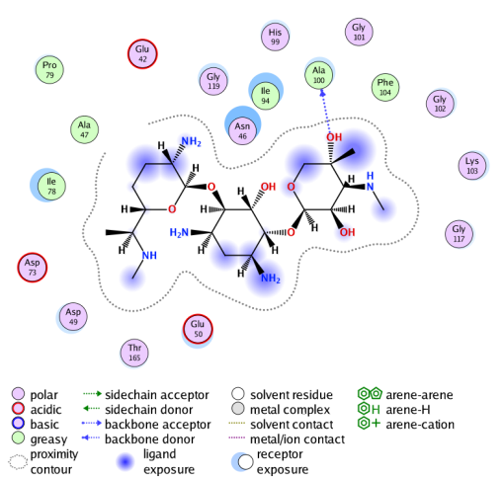 | 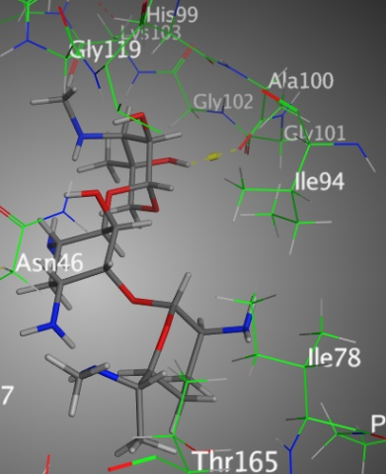 | 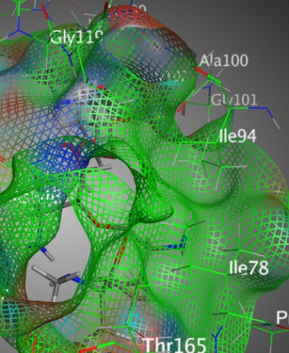
2D | 3D | Surface Map
Figure S1: Binding interactions between Gentamicin and 1AJ6 amino-acids

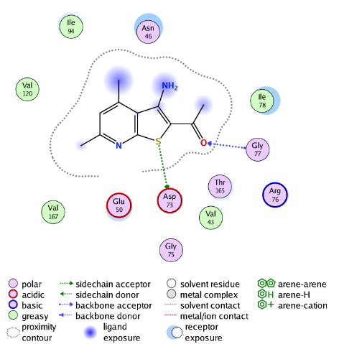 | 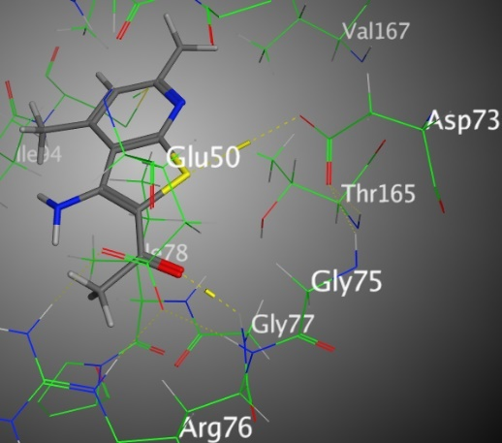 | 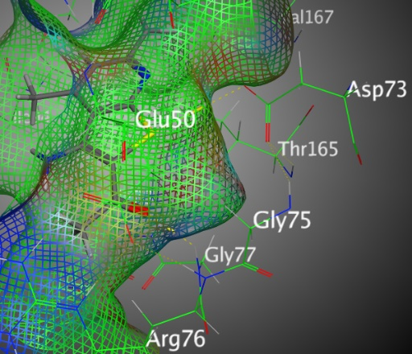
2D | 3D | Surface Map
Figure S2: Binding interactions between derivative 3 and 1AJ6 amino-acids

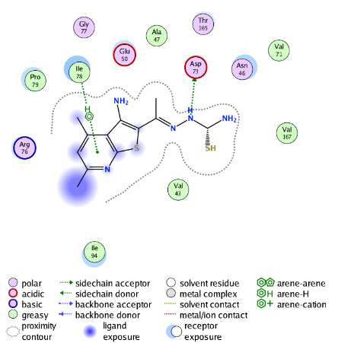 | 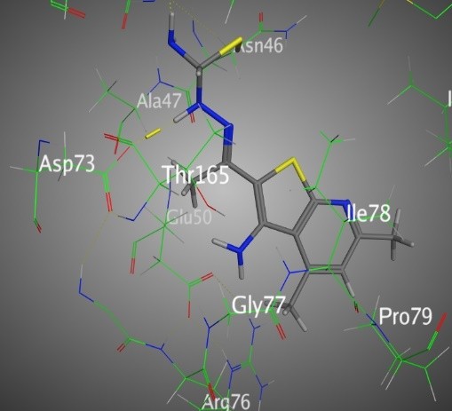 | 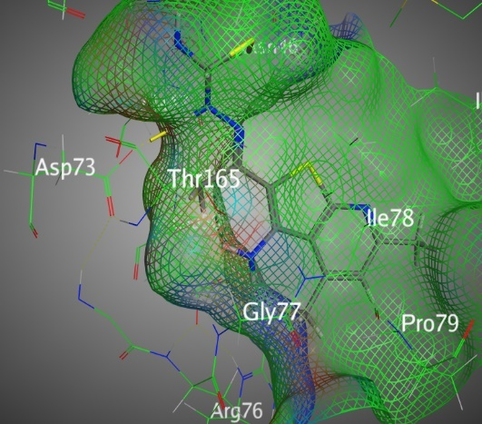
2D | 3D | Surface Map
Figure S3: Binding interactions between derivative 4 and 1AJ6 amino-acids

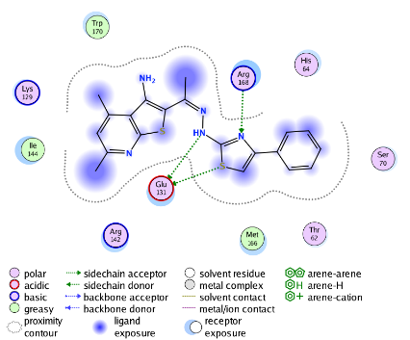 | 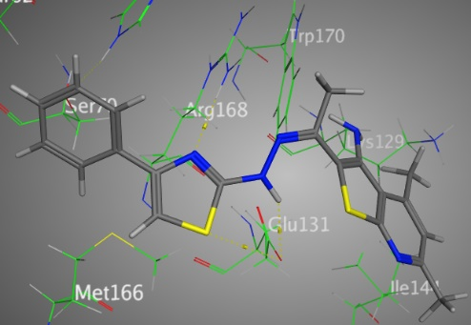 | 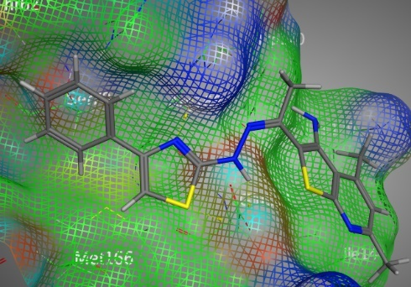
2D | 3D | Surface Map
Figure S4: Binding interactions between derivative 6 and 1AJ6 amino-acids

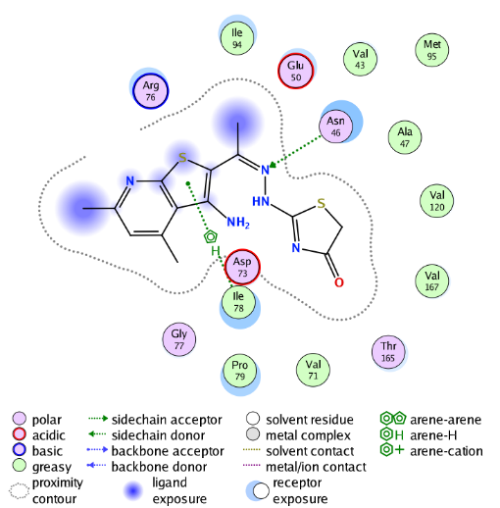 | 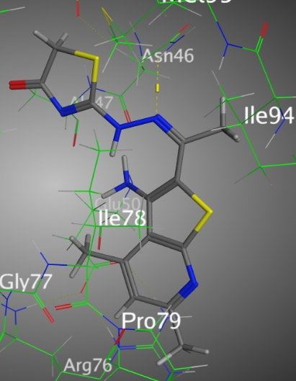 | 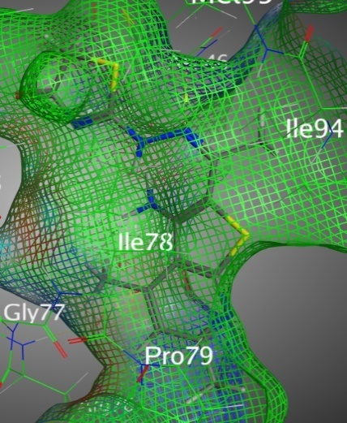
2D | 3D | Surface Map
Figure S5: Binding interactions between derivative 7 and 1AJ6 amino-acids

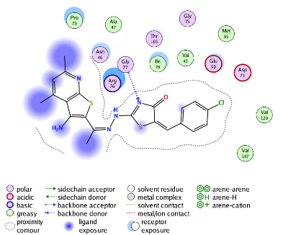 | 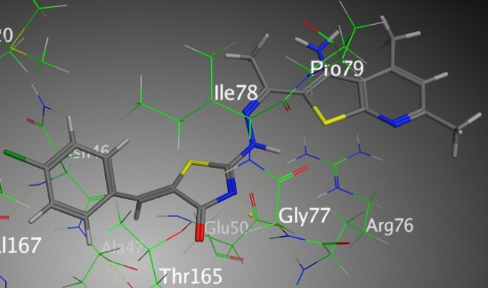 | 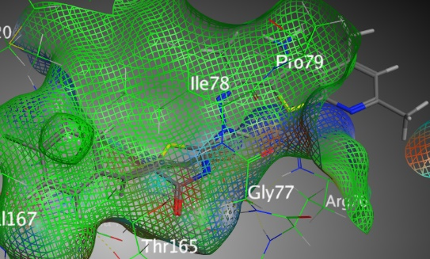
2D | 3D | Surface Map
Figure S6: Binding interactions between derivative 10 and 1AJ6 amino-acids

