**Supporting information**

**High Performance Biobased Poly(ethylene 2,5-furandicarboxylate) Nanocomposites for Food and Cosmetics Packaging Materials: PMDA Chain Extended and TiO2 NPs Functionalized**

Yuxuan Lia,b, Yuhao Zhaoa,b, Yuze Daia, Ying Zhang b,[1]*, Min Jiang a,[2]*, Guangyuan Zhoua,[3]*

a Division of Energy Materials (DNL 22), Dalian Institute of Chemical Physics, Chinese Academy of Sciences, Dalian, 116023, China.

b Laboratory of Industrial Ecology and Environmental Engineering (MOE), School of Environmental Science and Technology, Dalian University of Technology, Dalian, 116024, China.

**1. Materials and methods**

**1.1. Synthesis of PEF and the extended PEF**

PEF and the extended PEF was synthesized by in situ polycondensation (Fig 1). The PMDA (0-7‰ mol/mol of DMFD, denoted as PEF, PEF0.5, PEF1, PEF3, PEF5, PEF7, respectively), DMFD, EG (DMFD: EG = 1:1.6, mol/mol), TBT (2‰ mol/mol of DMFD) were added to 50 mL three-necked flask at 170 oC-210 °C for 6h under N2 atmosphere in the first stage. In the second stage, the temperature was raised to specified polycondensation temperature (230 °C or 240°C) and lasted specified time (4h/5h/6h/8h) with high vacuum (Achilias et al., 2017). The concentration of PMDA, polycondensation time and temperature were adjusted successively to select the synthesis condition with the best ηsp/C but no gel content (high gel content will affect the processing properties of polyester). Firstly, the screening process of the amount of PMDA was expressed as follows: the concentration of PMDA was 0.5-7‰, and the polycondensation condition was 230 ℃×4h, but the PEF7 was excludeddue to its high gel content. Then, PEF5 was prepared at 240 °C or 250 °C for 4h, and gel content was higher than 40% in both entries. Finally, PEF5 was prepared under the polycondensation condition of 230 °C for 5h or 6h or 8h, until the gel appeared at 6h. In conclusion, PEF5 (polycondensation conditions was 230 °C for 5h) was synthesized as the substrate material for subsequent nanocomposites.

**1.2. Preparation of films**

The PEF5 and PEF/TiO2 nanocomposites were pulverized intermittently by a grinder rather than by a continuous rotation to prevent mechanical impact on the polyester chain connection. The powder was then kept at 80 °C in a vacuum oven for 24 h to remove any moisture. Weight the powder of a certain quality in the mold, firstly, 5 N pressure was used for a few seconds at room temperature to remove the air between the powder, then they were placed in a plate vulcanizing machine already heated to 190 °C, 3 kPa for a few seconds to get the film.

**2. Results and Discussion**

**2.1 Analysis of chain extension structure**

Cole-Cole diagram is used to characterize the elastic behavior of polymers, which is related to the molecular weight distribution and branching structure, while is independent of molecular weight (Dolatshah et al., 2020). Fig. S2 shows the Cole-Cole diagram of samples with different contents of PMDA [PEF0.5-PEF7, 230 °C×4h] and PEF5 [230 °C×5h], and compares them with pure PEF. At a constant loss modulus, the storage modulus of the extended chain PEF gradually increased with the increasing of PMDA content, which showed the improvement of the melt elasticity and molecular weight distribution. In addition, the Cole-Cole diagram could distinguish the linear chain from the branched chain. For PEF, it showed an incomplete semicircle, which was due to the low viscosity of pure PEF; while all the extended chain PEF curves deviated from the semicircle, and the tail was upturned, reflecting the existence of the branched structure.

**2.2 Characterizations of TiO2 NPs**

The FTIR of 30nm, 60nm, 100nm TiO2 NPs has been added to Fig.S3. In the FTIR spectrum of TiO2 the band centred around 3300 cm-1 and 1646 cm-1 in Fig. S3 are due to the stretching and bending vibrations of hydroxyl groups. The peak centred around 450-800 cm-1 is due to the stretching vibration of Ti–O bond (RSC Adv.,2017, 7, 46155–46163). The relative density of anatase TiO2 is 3.8-3.9 g/cm3 and the dielectric constant of anatase TiO2 is only 48. The Mohs hardness of anatase TiO2 is 5.5-6.

Fig. S5 displayed the N2 adsorption-desorption curves of 30, 60, 100nm TiO2 NPs. The curves displayed the typical IV pattern, and there was a H3 hysteresis loop in the high-pressure region of isothermal adsorption (P/P0=0.8-1.0), which was the characteristic curve of mesopores present in the sample(Zhang et al., 2022b, Bi et al., 2023). The pore size distribution of the sample was analyzed using the Barrett Joyner Halenda (BJH) method applied to isotherm adsorption branching, shown in Fig. S6. The pore diameter of TiO2 NPs at 30nm, 60nm, and 100nm were 23.74 nm, 7.79 nm, and 17.24 nm, respectively. Although 30nm TiO2 NPs were likely to form narrow pores due to particle accumulation. The values of BET specific surface area (SBET) of TiO2 NPs at 30nm, 60nm, and 100nm were 56.84, 80.49, 69.06 m2 g-1, respectively.

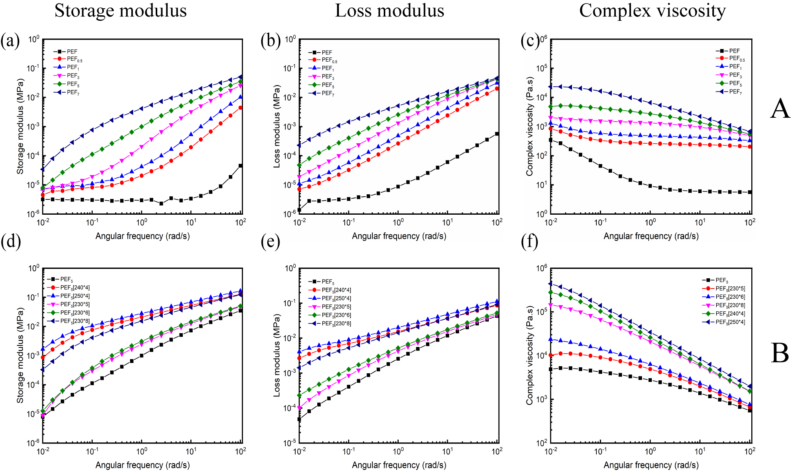

**Fig. S1**. Rheological characterization of extended PEF.

Group A represents the storage modulus(G'), loss modulus(G") and complex viscosity (η*) of chain-extended PEF with PMDA concentration of 0-7‰.

Group B represents the storage modulus(G'), loss modulus(G") and complex viscosity (η*) of polyester with PMDA addition of 5‰, polycondensation at 230 °C or 240 °C for 4h, and polycondensation at 230 °C for 5h, 6h and 8h.



**Fig. S2** Cole-Cole plots of PEF and extended PEF.

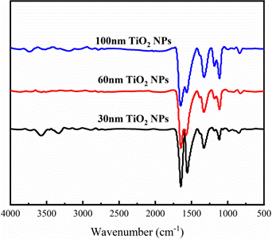

**Fig. S3.** FT-IR spectra of 30nm, 60nm, 100nm TiO2 NPs.

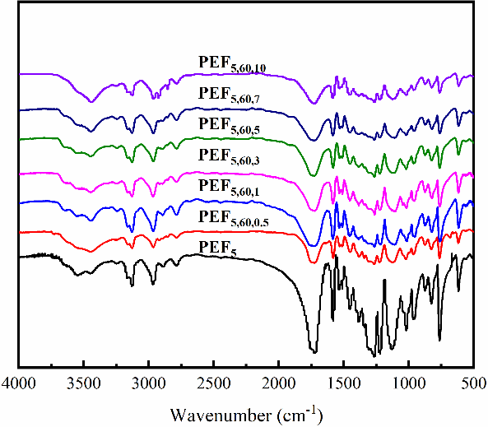

**Fig. S4.** FT-IR spectra of PEF5 and PEF/TiO2 nanocomposites.



**Fig. S5.** N2 adsorption-desorption curves of a) 30nm, b) 60nm and c) 100 nm TiO2 NPs



**Fig. S6.** Pore size distribution a) 30nm, b) 60nm and c) 100 nm TiO2 NPs calculated by BJH method



**Fig. S7.** Heat flow of PEF5 and PEF/TiO2 nanocomposites with different concentrations of 60 nm TiO2 vs time.



**Fig. S8.** Isothermal crystallization heat flow vs time of PEF5 and PEF/TiO2 nanocomposites.

**References**

Achilias, D. S., A. Chondroyiannis, M. Nerantzaki, K.-V. Adam, Z. Terzopoulou, G. Z. Papageorgiou & D. N. Bikiaris, 2017. Solid State Polymerization of Poly(Ethylene Furanoate) and Its Nanocomposites with SiO2 and TiO2. Macromolecular Materials and Engineering. 302. <https://doi.org/10.1002/mame.201700012>.

Dolatshah, S., S. Ahmadi, A. Ershad‐Langroudi & H. Jashni, 2020. Rheological/thermal properties of poly(ethylene terephthalate) modified by chain extenders of pyromellitic dianhydride and pentaerythritol. Journal of Applied Polymer Science. 138. <https://doi.org/10.1002/app.49917>.

Lian, Z., Y. Zhang & Y. Zhao, 2016. Nano-TiO2 particles and high hydrostatic pressure treatment for improving functionality of polyvinyl alcohol and chitosan composite films and nano-TiO2 migration from film matrix in food simulants. Innovative Food Science & Emerging Technologies. 33, 145-153. <https://doi.org/10.1016/j.ifset.2015.10.008>.

Qu, X., G. Zhou, R. Wang, H. Zhang, Z. Wang, M. Jiang & J. Tang, 2021. Insights into high molecular weight poly(ethylene 2,5-furandicarboxylate) with satisfactory appearance: Roles of in-situ catalysis of metal zinc. Journal of Industrial and Engineering Chemistry. 99, 422-430. <https://doi.org/10.1016/j.jiec.2021.04.052>.

Zhou, G., L. Li, M. Jiang, G. Wang, R. Wang, G. Wu & G. Zhou, 2021. Renewable Poly(butene 2, 5-furan dicarboxylate) Nanocomposites Constructed by TiO2 Nanocubes: Synthesis, Crystallization, and Properties. Polymer Degradation and Stability. 189. <https://doi.org/10.1016/j.polymdegradstab.2021.109591>

1.
2. * Corresponding author:
3. E-mail address: yzhang@dlut.edu.cn (Ying Zhang)

   E-mail address: jiangmin@dicp.ac.cn (Min Jiang)

   E-mail address: gyzhou@dicp.ac.cn (Guangyuan Zhou)