**Modified physical properties of Ni doped ZnO NPs as potential photocatalyst and antibacterial agents**

Yasir Zaman a, Muhammad Zahid Ishaque a, Khadija Waris a, Muhammad Shahzad a,Abu Bakar Siddique b*, Muhammad Imran Arshad c, Hira Zaman d, Hayssam M. Ali e, Fariha Kanwal f, Muhammad Aslam g, Muhammad Mustaqeem b

a Department of Physics, University of Sargodha, Sargodha, 40100, Pakistan

b Institute of Chemistry, University of Sargodha, Sargodha, 40100, Pakistan

c Department of Physics, Government College University Faisalabad, Faisalabad-38000, Pakistan

d Institute of Chemical Sciences, University of Peshawar, Khyber Pakhtunkhwa, 25120, Pakistan

e Department of Botany and Microbiology, College of Science, King Saud University, Riyadh– 11451, Saudi Arabia.

f School of Biomedical Engineering, Shanghai JiaoTong University, Shanghai 200030, China

g Institute of Physics and Technology, Ural Federal University, Mira Str.19, 620002 Yekaterinburg, Russia.

*Corresponding Author: Abu Bakar Siddique- Institute of Chemistry, University of Sargodha, Sargodha, 40100, Pakistan; <https://orcid.org/0000-0003-2834-5708> ; [abubakar.siddique@uos.edu.pk](mailto:abubakar.siddique@uos.edu.pk), [abubakar054@gmail.com](mailto:abubakar054@gmail.com)

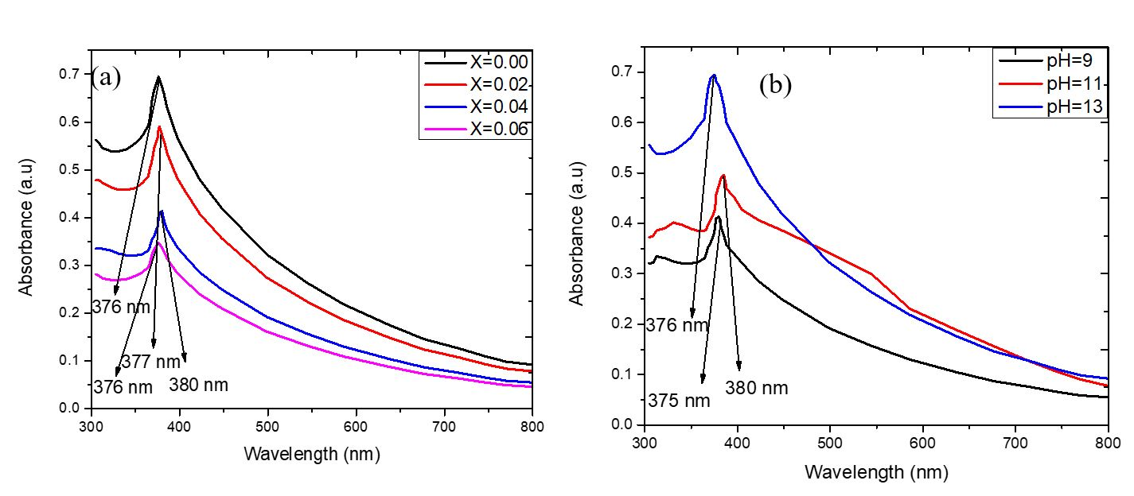

**Fig. S1** UV-Visible spectra of Zn1-xNixO NPs at varying **(a)** concentration **(b)** pH