Revealing the effect of humic substance compounds on the aged characteristics and release compounds profiles from photodegradation of polyethylene microplastics

Minghong Xie1, Deqing Ren1, Atif Muhmood2, Pengjiao Tian1, Yingjie Su3, Xiqing Wang1\*

*1College of Food Science Technology and Chemical Engineering, Hubei University of Arts and Science, Xiangyang, Hubei, 441053, China*

*2 Department of Agroecology, Aarhus University, Dennark*

*3 Jilin Agricultural University, Changchun, Jilin Province, China*

\* Correspondence

E-mail: [xiqingwang91@163.com](mailto:xiqingwang91@163.com)

Including 5 pages, 4 figure.

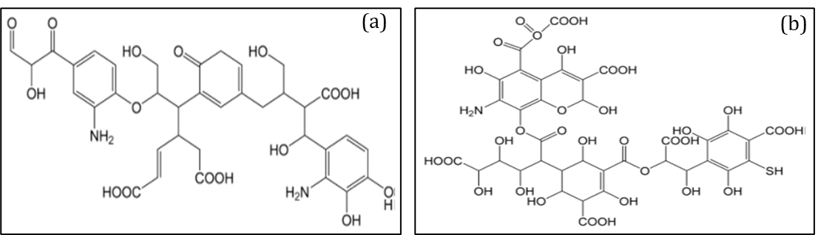

Fig. S1 The structural model of HA (a) and FA unit (b), respectively.

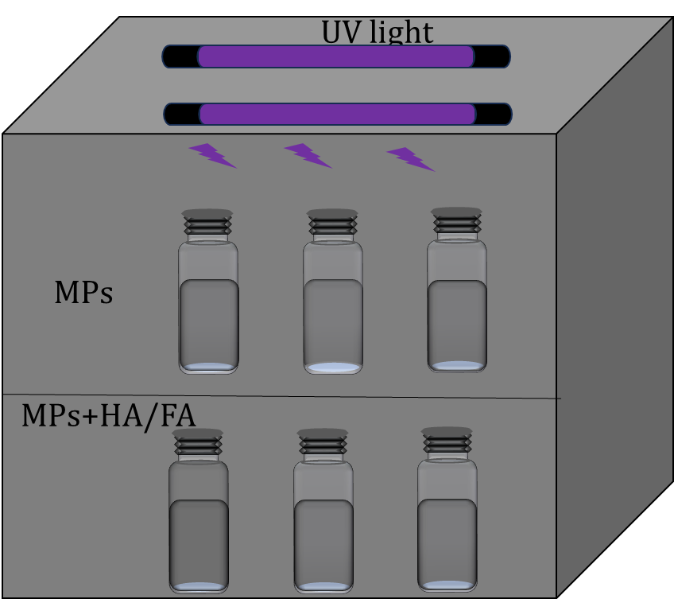

Fig. S2 Schematic drawing of the chamber for UV-weathering experiments

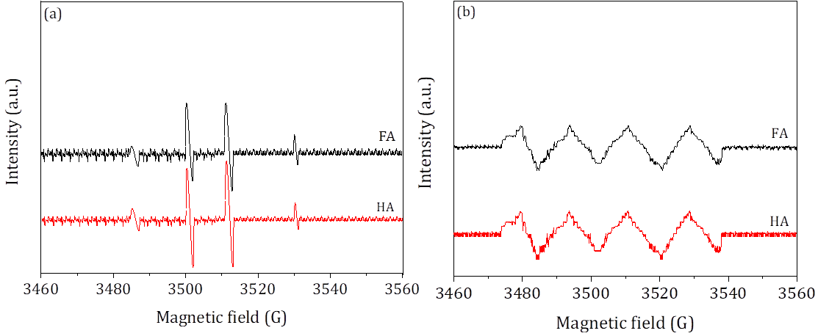

Fig. S3 EPR spectra of ▪OH (a) and O2▪- (b) generation in the photodegradation of the PE-MPs in the presence of HA and FA.

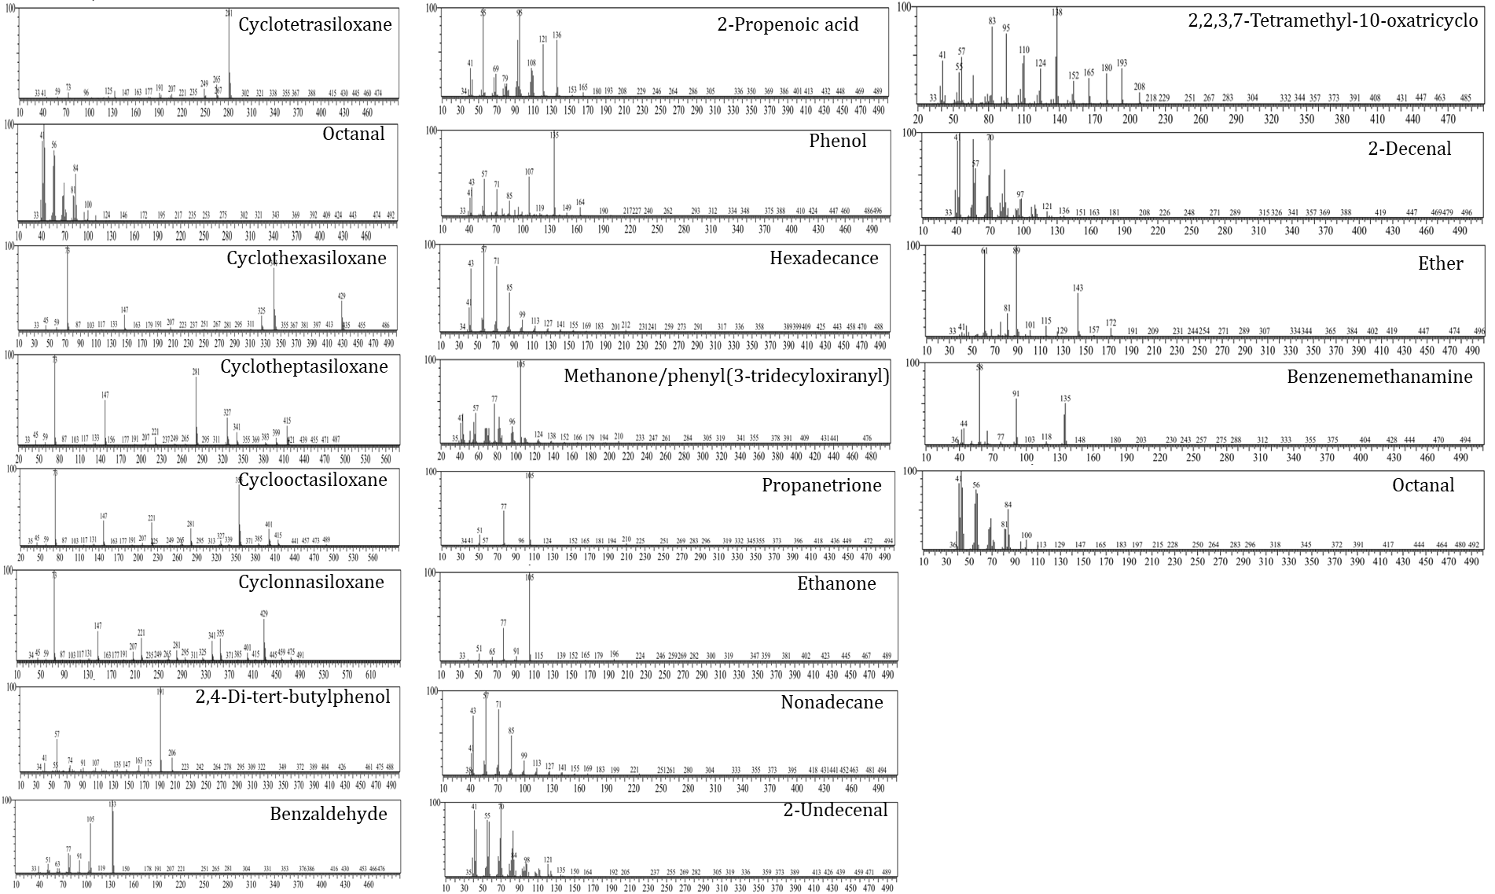

Fig. S4 The chromatograms for identification of main photodegradation products of PE-MPs.