**Supporting Information**

**Unraveling the Molecular Structure, Spectroscopic Properties, and Antioxidant Activities of new 2,4-Dinitrophenylhydrazone Derivatives through a Comprehensive Investigation**

Muhammad Riazb,1, Faheem. Janc,g,1, Azim. Khana,d,*, A. Ullahd, Hameed. Haqe, Abdullah F. AlAsmarif, Metab Alharbif, Fawaz Alasmarif, MominKhanb*

*aKey Laboratory of Green Fabrication and Surface Technology of Advanced Metal Materials, Ministry of Education , School of Material Science and Engineering, Anhui University of Technology, Maanshan 243000, P.R. China*

*bDepartment of Chemistry, Abdul Wali Khan University, Mardan, KPK, Pakistan.*

*cShenyang national laboratory for Materials Science, Institute of Metal Research Chineses Academy of Sciences, Shenyang 110016, Liaoning, People’s Republic of China*

*dlaboratory for Corrosion and Protection, Institute of Metal Research, Chinese Academy of Sciences, Shenyang, 62 Wencui Road,110016, China*

*eGdansk University of Technology, Faculty of Chemistry, Department of Process Engineering and Chemical Technology, 80 – 233 Gdansk, G. Narutowicza St. 11/12, Poland*

*fDepartment of Pharmacology and Toxicology, College of Pharmacy, King Saud University, Riyadh 11451, Saudi Arabia.*

*gSchool of Materials Science and Engineering, University of Science and Technology of China, Shenyang 110016, Liaoning, People’s Republic of China*

**13C-NMR**

Table S 1. Calculated 13C-NMR at at B3LYP/6-311+G(2d,p).

|  |  |  |  |  |  |
| --- | --- | --- | --- | --- | --- |
| Atom No | 2,3-diEt-DNPH | 3NO2-DNPH | 4NO2-DNPH | 2NO2-DNPH | Experimental |
| C-1 | 108.5 | 108.5 | 108.5 | 108.5 | --- |
| C-2 | 139 | 139 | 139 | 139 | 143b |
| C-3 | 129.5 | 129.5 | 129.5 | 129.5 | 129.1b |
| C-4 | 104 | 104 | 104 | 104 | 105.1a |
| C-5 | 115 | 115 | 115 | 115 | 113.3b |
| C-6 | 146 | 146 | 146 | 146 | 143b |
| C-15 | 129.6 | 129.6 | 129.5 | 129.5 | 130b |
| C-16 | 113 | 113 | 113 | 113 | 113b |
| C-17 | 108 | 108 | 108 | 108 |
| C-18 | 128 | 128 | 128 | 128 | 129.9b |
| C-19 | 129.6 | 129.6 | 129.6 | 129.6 |
| C-21 | 125.5 | 126 | 126.2 | 126 |
| C-23 | 119 | 118 | 118 | 118 | --- |
| C-34 | 123 | 125.6 | 126.4 | 125 | 130b |
| C-36 | 114 | 121 | 126.6 | 116 | --- |
| C-37 | 102.4 | 104 | 109 | 112 | --- |
| C-38 | 158.02 | 122.6 | 115 | 135 | --- |
| C-39 | 108 | 137 | 108 | 120 | --- |
| C-41 | 99.4 | 108 | 136 | 114 | --- |
| C-47 | 58 | --- | --- | --- | --- |
| C-52 | 4.13 | --- | --- | --- | --- |
| C-54 | 53.6 | --- | --- | --- | --- |
| C-57 | 3.63 | --- | --- | --- | --- |
| **RMSD** | **2.57** | | | | |

aRef (Karrouchi et al., 2020)

bRef (Yakalı et al., 2017)

Vibranationa analysis

Table S2. Calculated frequencies (unscaled and scaled) for synthesized derivatives at B3LYP/6-311++G(d,p).

|  |  |  |  |  |
| --- | --- | --- | --- | --- |
| Unscaled | Scaled | Experimental | Ref | Assignment |
| 3653 | 3500 | 3500 | (“A Guide to the Complete Interpretation of Infrared Spectra of Organic Structures (Roeges, Noel P. G.),” 1995) | ν N-H(13) |
| 3329 | 3190 | 3130 | (Coates, 2000) | ν C-Haromatic |
| 3325 | 3186 | ν C-H (68) |
| 3324 | 3184 | ν C-H (25,22) |
| 3288 | 3150 | 3000-2900 | (Parsaee et al., 2016) | δ C-H (CH2) |
| 3287 | 3149 | 3210.9 | (Akram et al., 2019) | ν C-H (33) |
| 3286 | 3148 | ν C-H (32) |
| 1678 | 1607 | 1628.54 | (Parsaee et al., 2016) | ν C=C (1-6, 3-4) |
| 1673 | 1602 | ν C=C (37-39, 38-41) |
| 1620 | 1552 | 1622.54 | ν C=C (16-18, 19-23) |
| 1602 | 1535 | 1520.99 | ν C=C (36-38, 39-42) |
| 1583 | 1517 | 1592 | (Akram et al., 2019) | ν C-N (3-12) |
| 1577 | 1511 | 1580.02 | (Parsaee et al., 2016) | ν C=N (14-15) |
| 1557 | 1492 | 1564.68 | ν C=N (14-15, 28-34) |
| 1561 | 1538 | 1543 | (Akram et al., 2019) | δ NO2 (29), s C-N-H (3-12-13) |
| 1515 | 1451 |
| 1476 | 1414 | 1475 | (Karrouchi et al., 2020) | s C-H3 |
| 1469 | 1407 | 1468 | s C-H3 |
| 1451 | 1390 | 1444 | s C-H3 |
| 1458 | 1397 | 1492-1417 | (Akram et al., 2019) | r C-Haromatic |
| 1456 | 1395 | r C-Haromatic |
| 1428 | 1368 | r C-Haromatic |
| 1379 | 1321 | 1359 | (Karrouchi et al., 2020) | δ N-H |
| 1370 | 1312 | 1373 | δ C=C (16-17, 21-23) |
| 1338 | 1282 | 1359 | r CH3 |
| 1334 | 1277 | r CH3 |
| 1318 | 1263 | 1320 | (Coates, 2000) | δ C-NO2 (6-29) |
| 1300 | 1245 | 1318 | (Akram et al., 2019) | r C-H (20, 24, 32, 33) |
| 1295 | 1241 | r C-H (20, 24, 44, 55) |
| 1212 | 1161 | 1203-1131 | s C-Haromatic (7,8,13) |
| 1187 | 1137 | s C-Haromatic (40, 43, 44) |
| 1148 | 1100 | s C-Haromatic (40,43) |
| 1017 | 974 | 1033.7 | ν N-N (12-14) |
| 991 | 950 | 1002 | ν N-N (27-28) |
| 942 | 902 | 974.9 | τ C-Haromatic (4,5,6) |
| 904 | 866 | --- |  | ν NO2 |
| 873 | 836 | --- |  | s NO2 |
| 704 | 675 | --- |  | γ NO2 |

ν Symmetric stretching, δ asymmetric starching, γ out of plane bending, τ twisting, s scissoring, r rocking

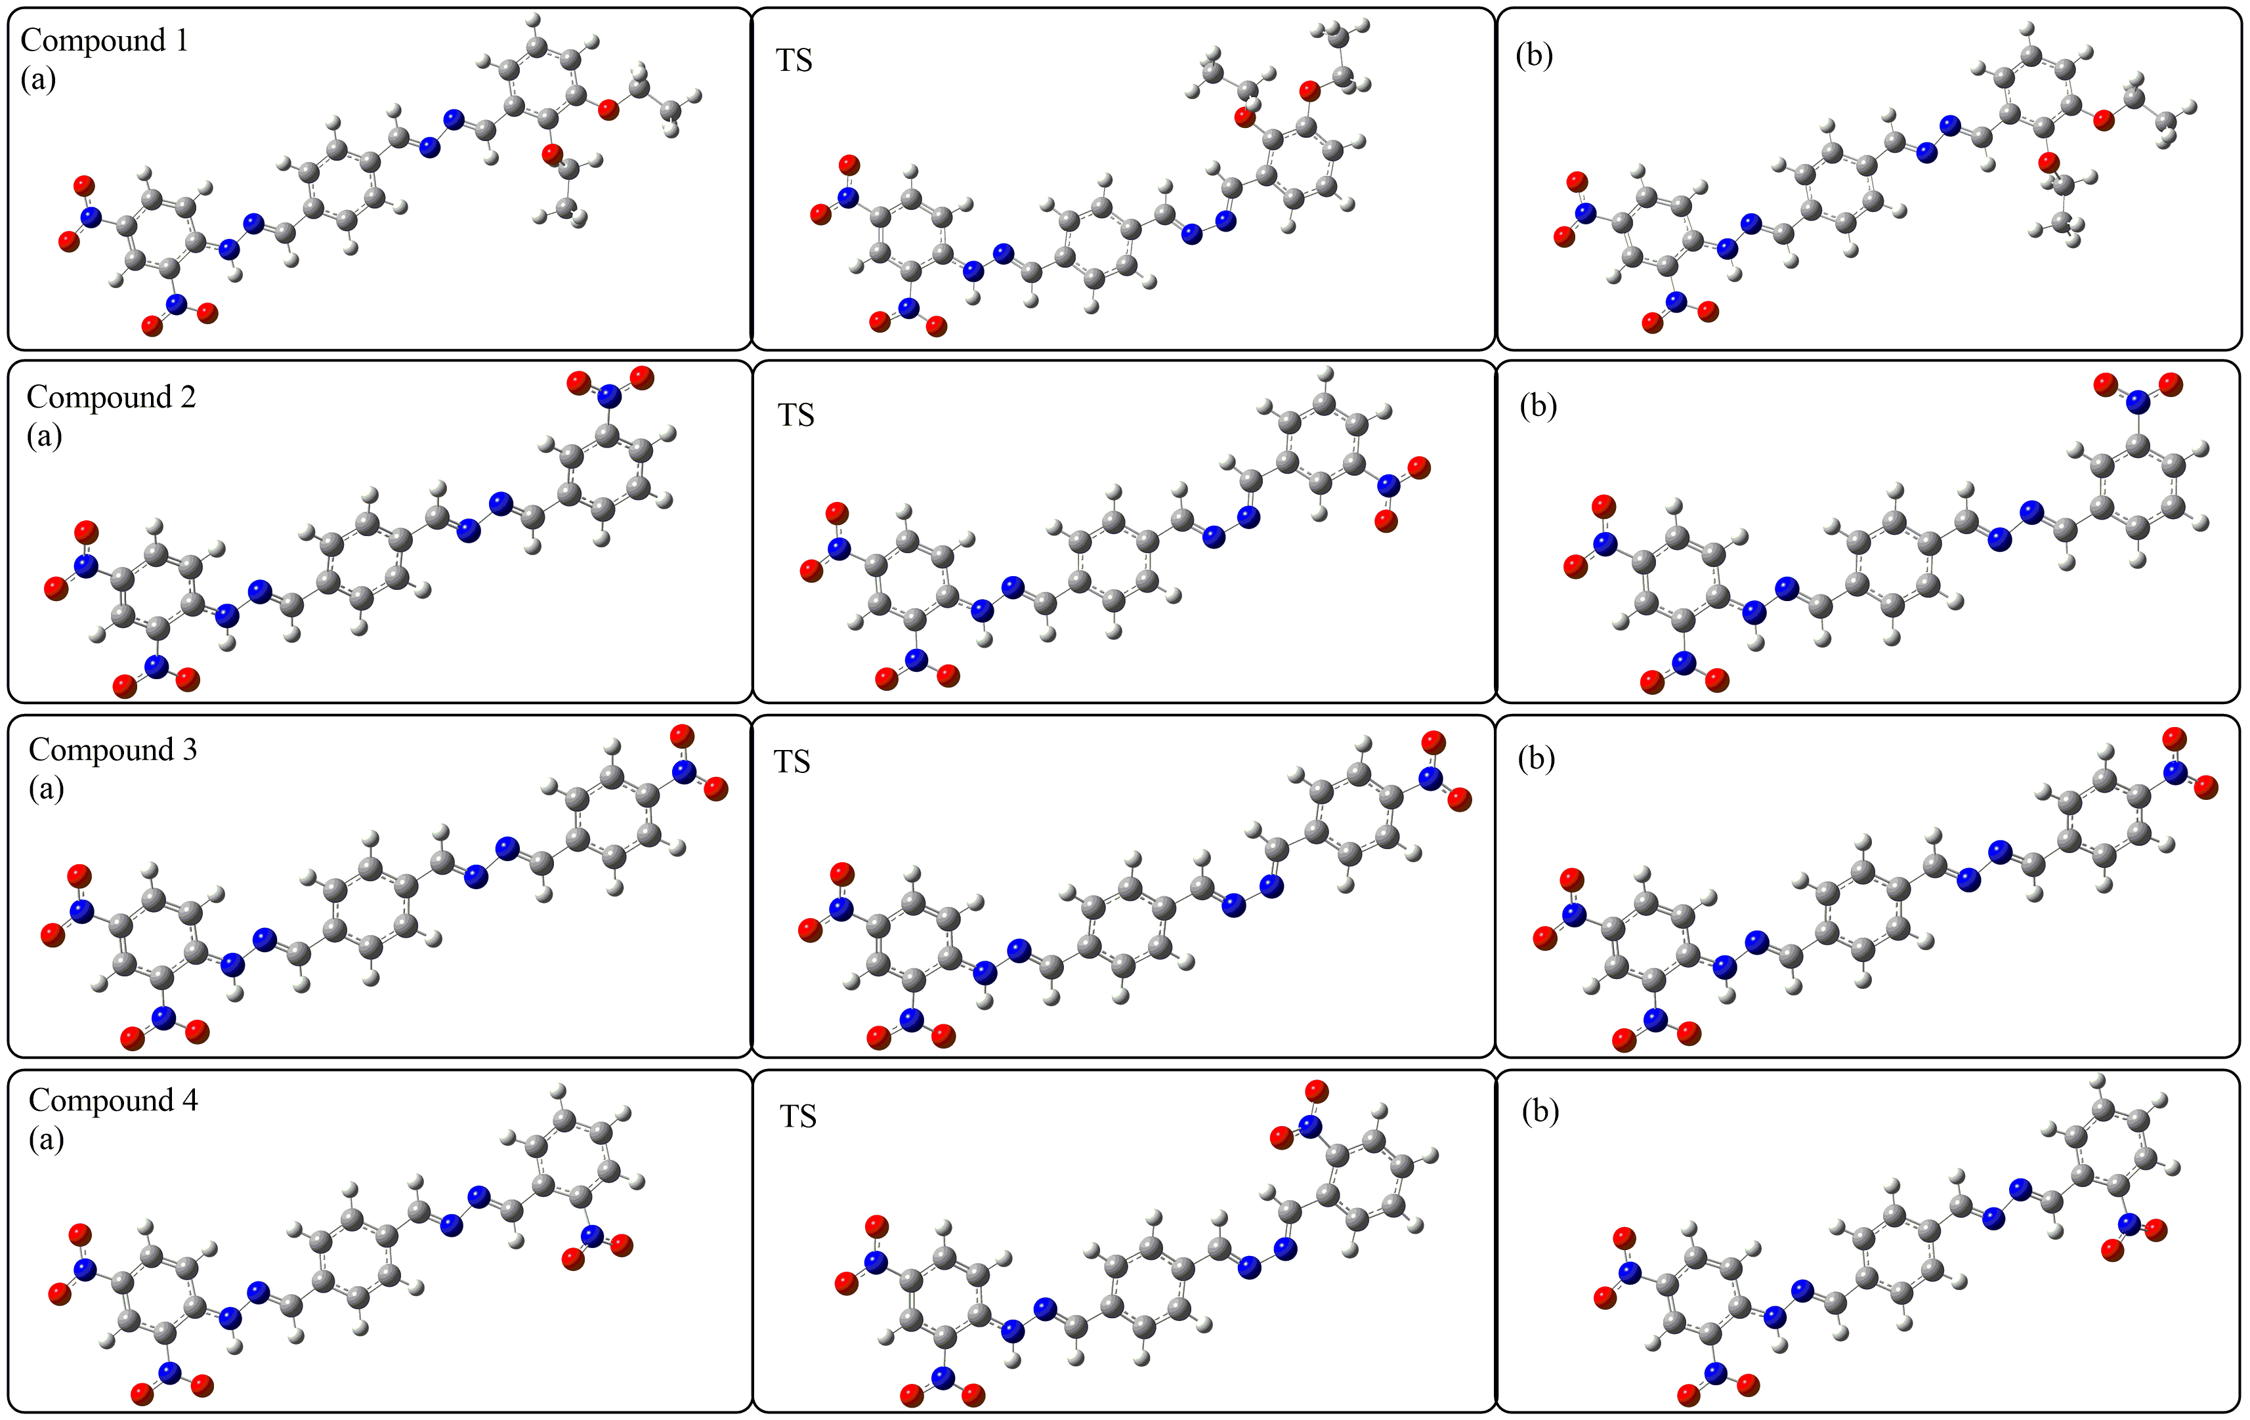

Figure S1. Potential energy surface path around the dihedral angle D(C26-N27-N28-C34), (a), and (b) show the stable conformers. The transition structure between two stable conformers is shown in the middle of the figure as TS.

C:\Users\fahim jan\Desktop\Schiff-base\H-bonding-1.tif

Figure S2. Possible hydrogen bonding between nitro and N-H group, calculated with D3 method at B3LYP/6-311++G(d,p).

C:\Users\fahim jan\Desktop\IR-calc\Figure S 5.tif

Figure S3. Plots of frontier molecular orbitals at B3LYP/6-31G of synthesized derivatives respectively, simulated in the gaseous and aqueous phase using isovalue of 0.02, as labeled by black and blue colors.

G:\New-submission\12-07-2021\Review-aug-2021\Fig-6 6311g++dp.tif

Figure S4. Plots of frontier molecular orbitals for all derivatives calculated at B3LYP/6-311++G(d,p). The orbitals surfaces were calculated using an isovalue of 0.02.

**C:\Users\Azim khan\Desktop\Riaz\fig3.tif**

Figure S5. Plots of molecular electrostatic potential of synthesized derivatives.

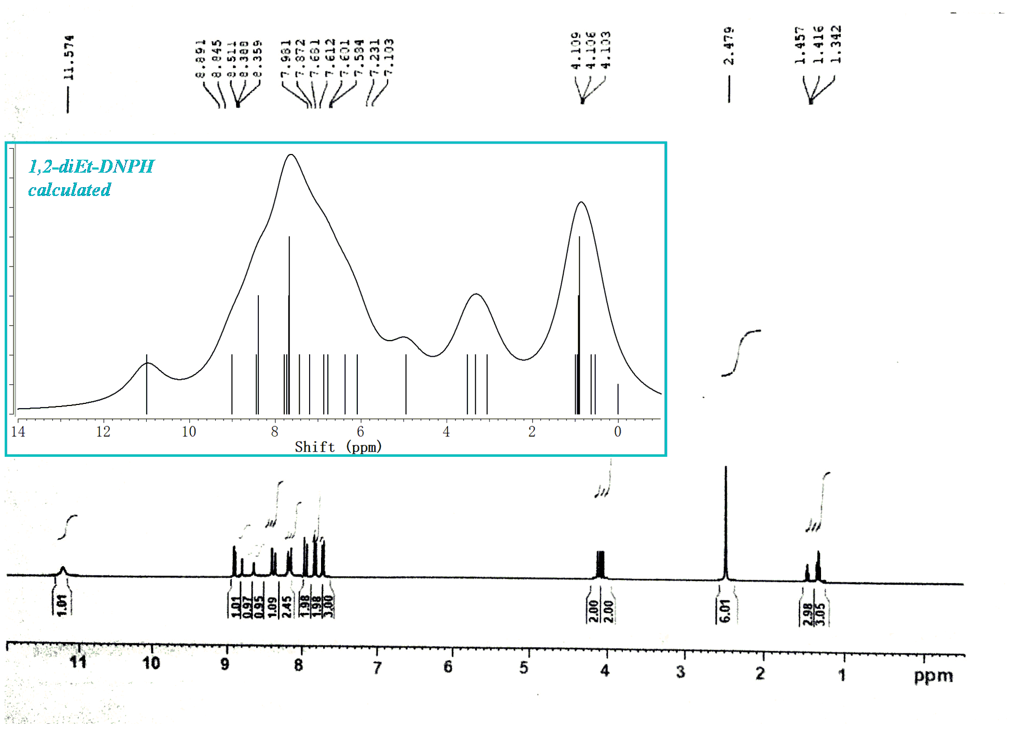Figure S6. Calculated and experimental 1H-NMR spectra of 2,3-diEt-DNPH

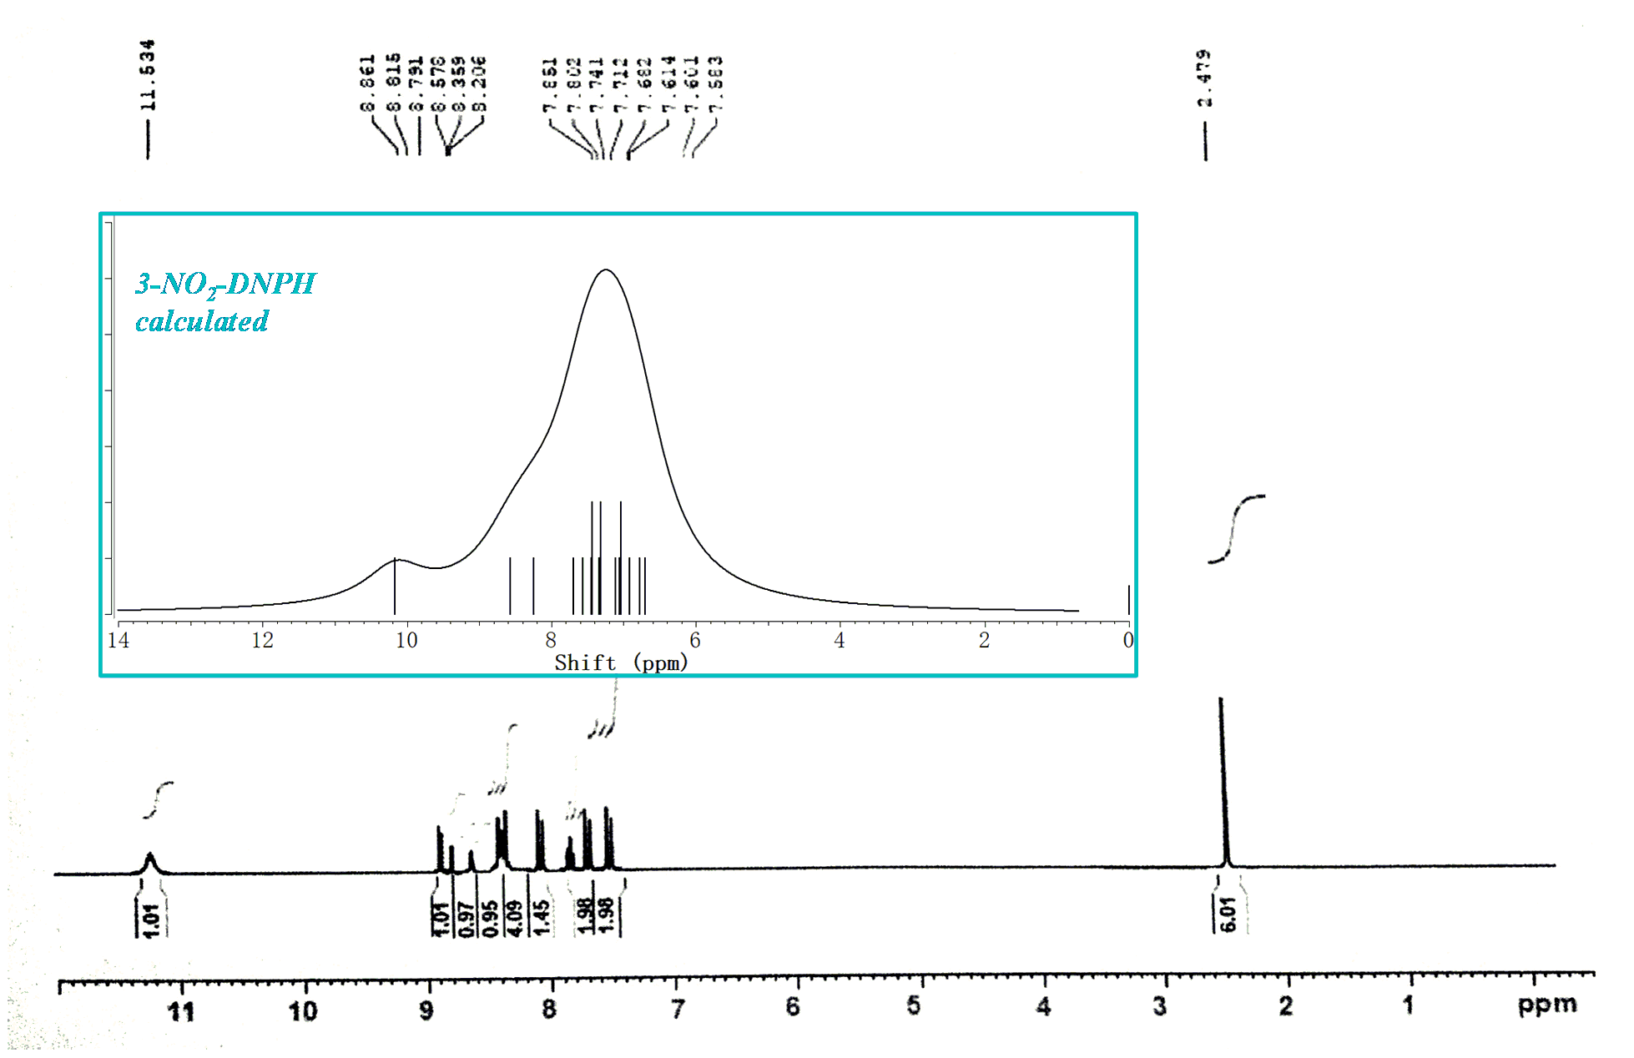

Figure S7. Calculated and experimental 1H-NMR spectra of 3-NO2-DNPH.

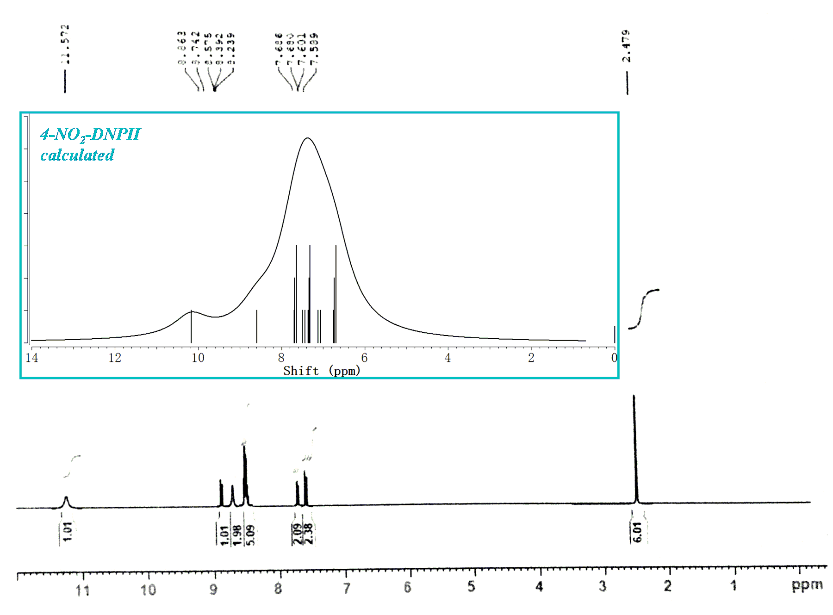

Figure S8. Calculated and experimental 1H-NMR spectra of 4-NO2-DNPH.

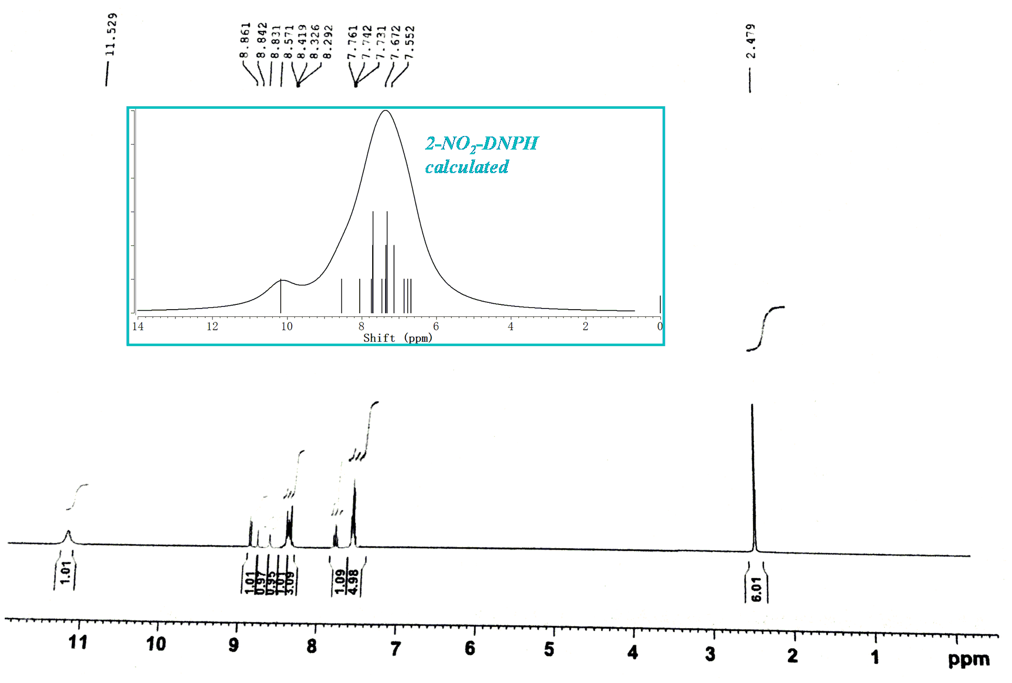

Figure S9. Calculated and experimental 1H-NMR spectra of 2-NO2-DNPH.

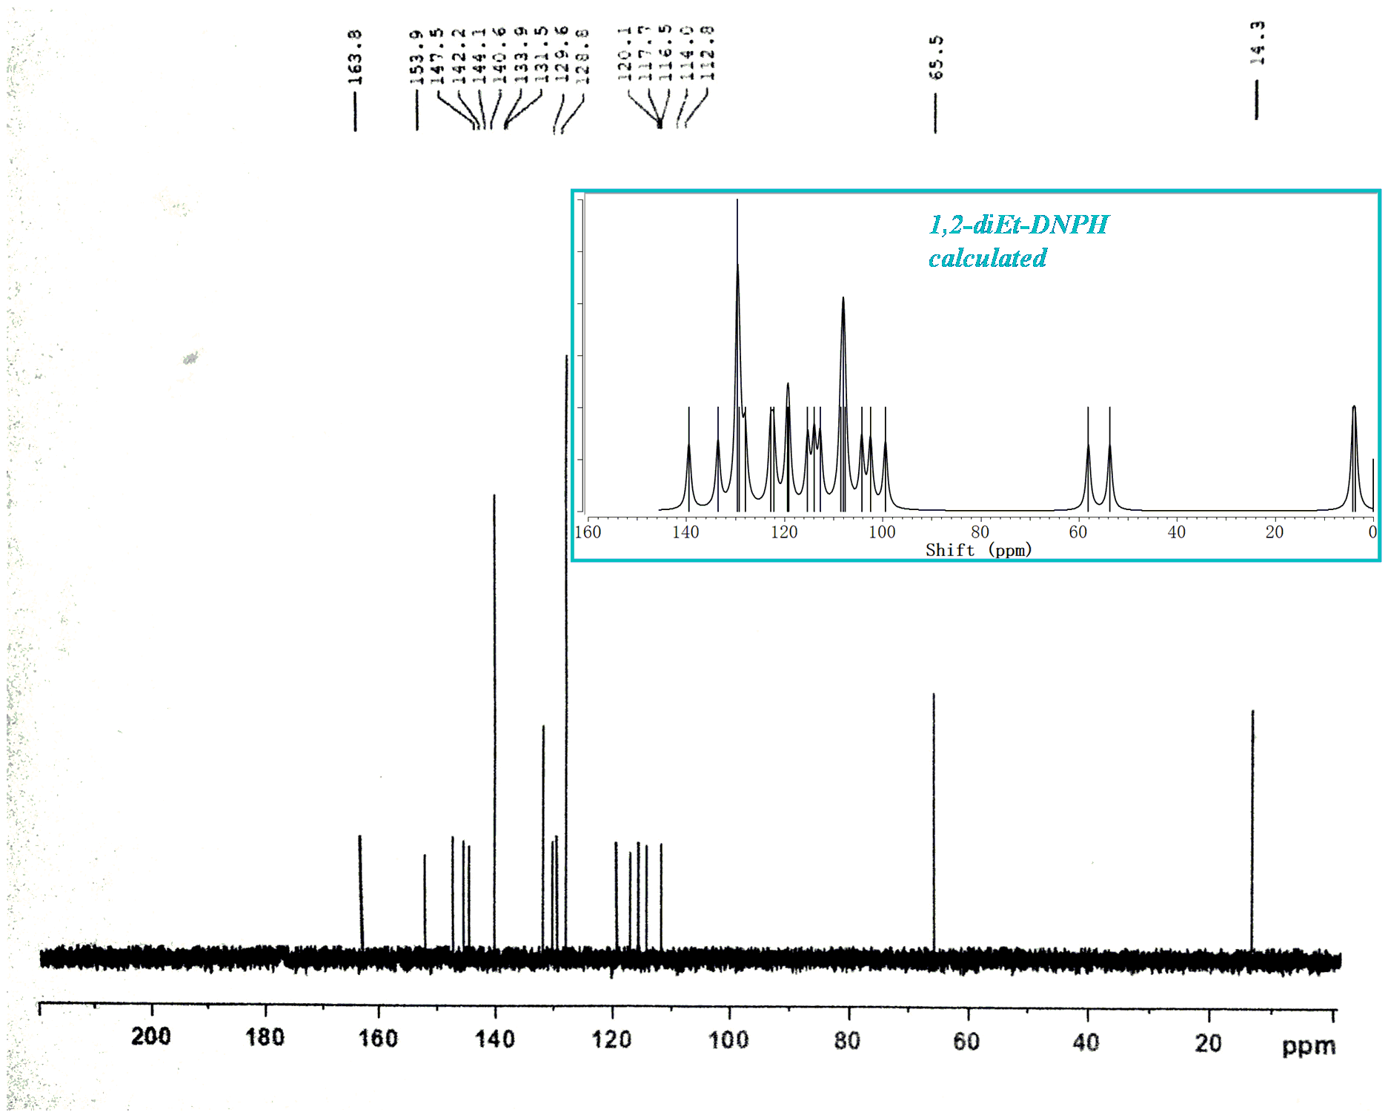

Figure S10. Calculated and experimental 13C-NMR spectra of 2,3-diEt-DNPH.

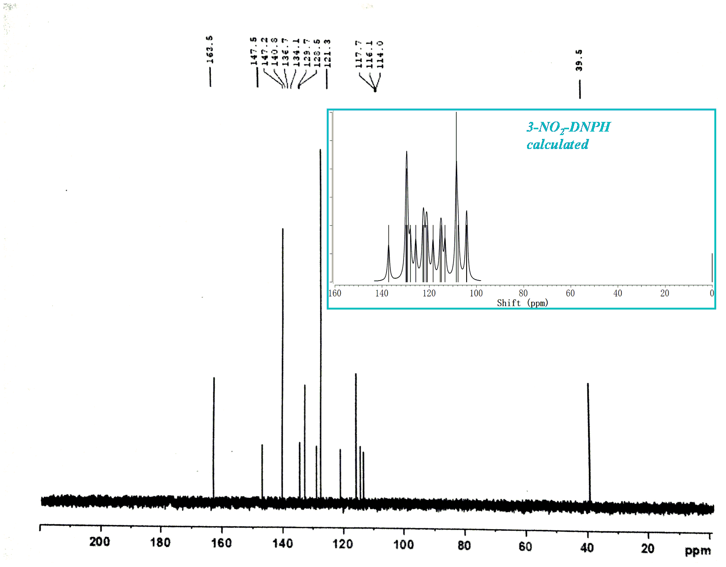

Figure S11. Calculated and experimental 13C-NMR spectra of 3-NO2-DNPH.

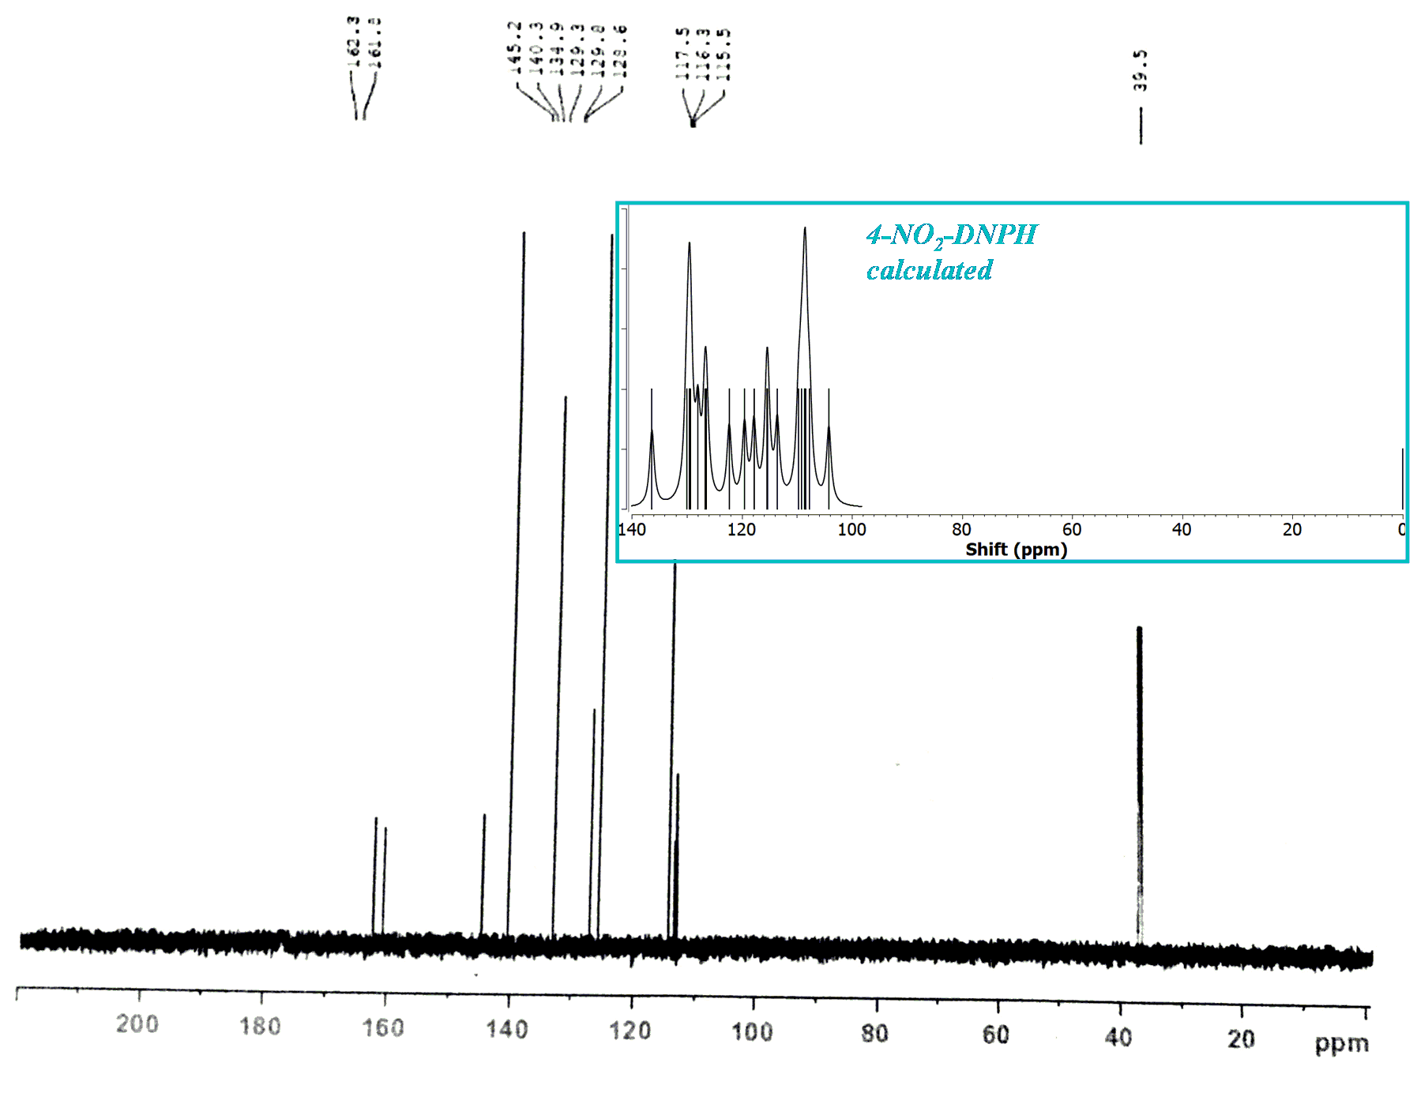

Figure S12. Calculated and experimental 13C-NMR spectra of 4-NO2-DNPH.

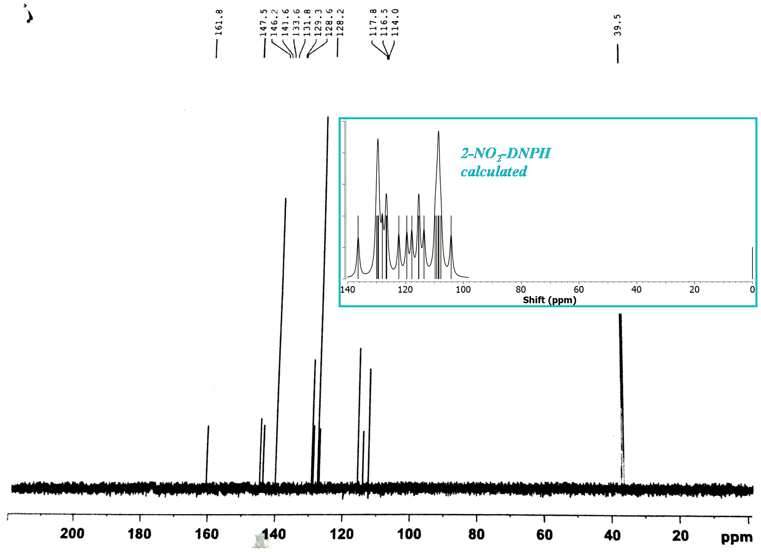

Figure S13. Calculated and experimental 13C-NMR spectra of 2-NO2-DNPH

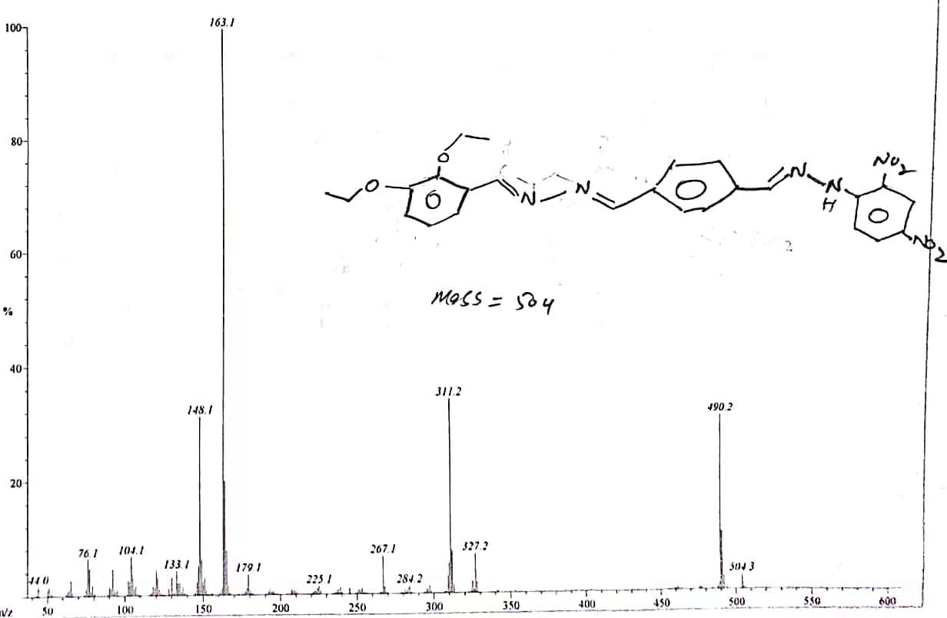

Figure S14. EI-MS spectrum of 2,3-diEt-DNPH.

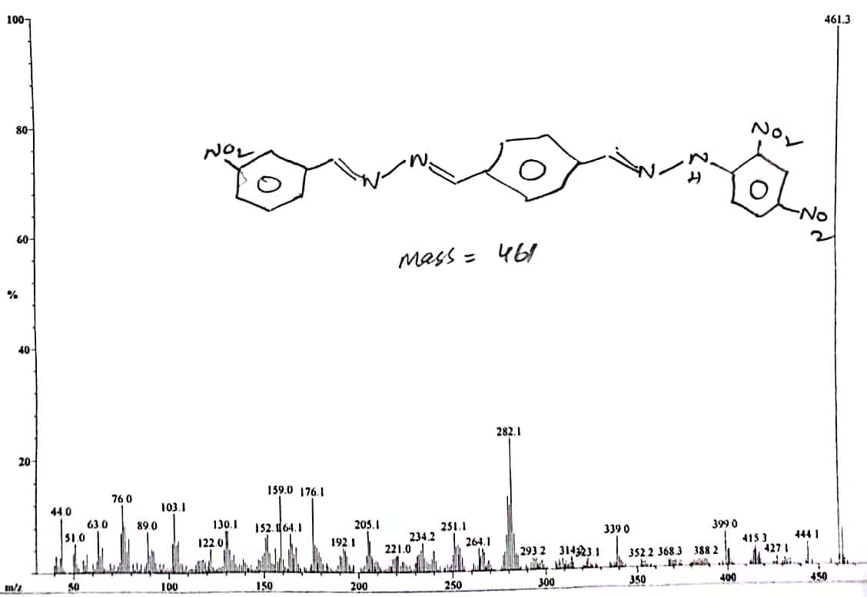

Figure S15. EI-MS spectrum of of 3-NO2-DNPH.

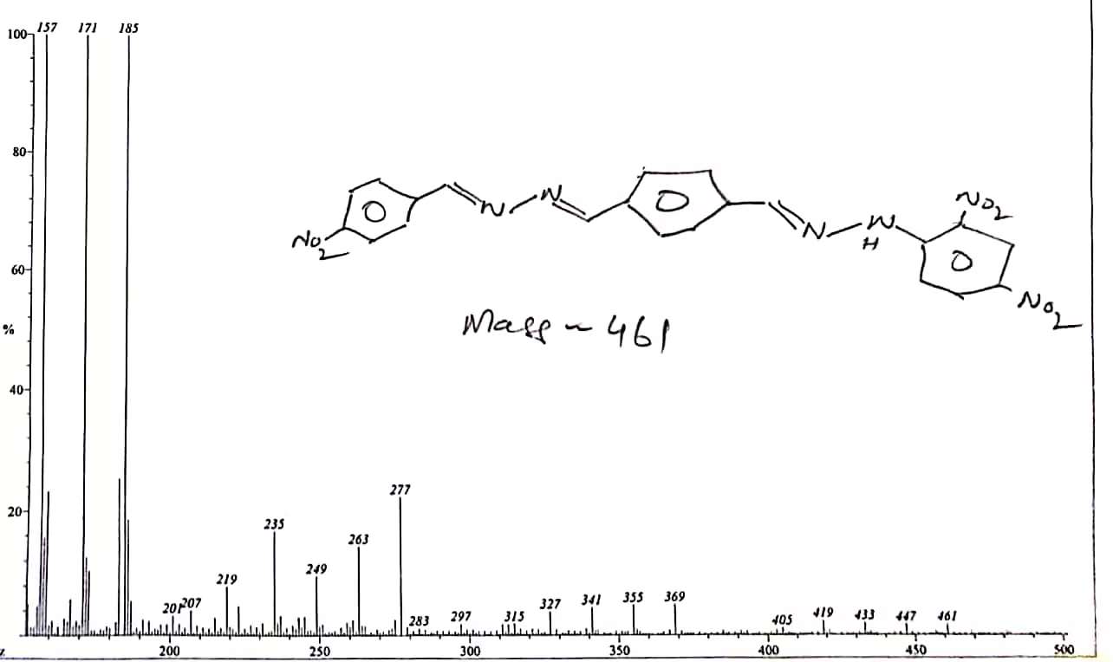

Figure S16. EI-MS spectrum of of 4-NO2-DNPH.

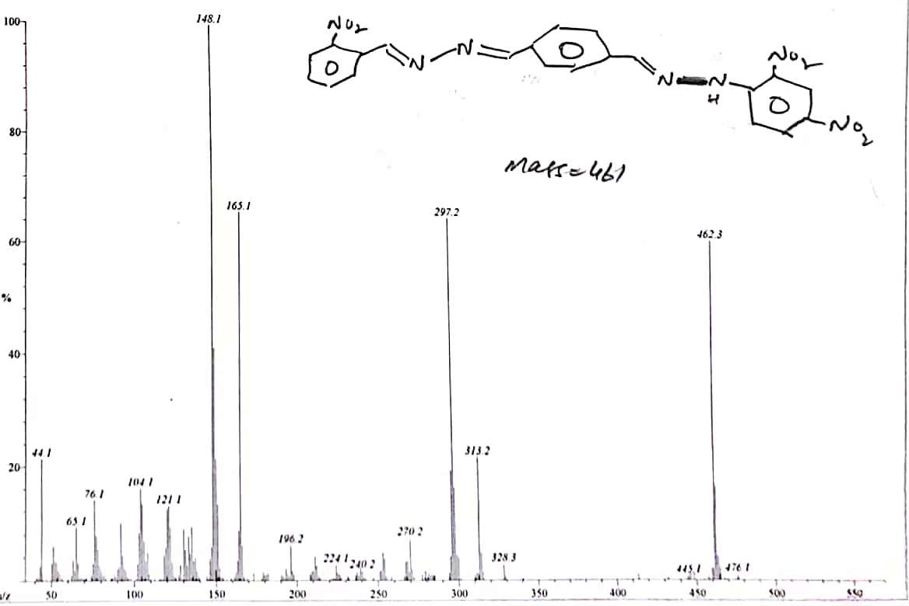

Figure S17. EI-MS spectrum of of 2-NO2-DNPH.

G:\New-submission\pic\Fig 6.tif

Figure S18. Calculated FT-IR spectra for synthesized derivatives at B3LYP/6-311++G(d,p).

G:\New-submission\pic\uv.tif

Figure S19. Simulated UV-Vis spectra at B3LYP/6-311++G(d,p). (a), (b) represents the 2,3-diEt-DNPH and 3NO2-DNPH, while (c) and (d) represent 4NO2-DNPH and 2NO2-DNPH, respectively.

**References**

A Guide to the Complete Interpretation of Infrared Spectra of Organic Structures (Roeges, Noel P. G.), 1995. . J. Chem. Educ. https://doi.org/10.1021/ed072pa93.4

Akram, T., Abbasi, M.A., Mahmood, A., Barboza de Lima, E., Perveen, F., Ashraf, M., Ahmad, I., Goumri-Said, S., 2019. Synthesis, molecular structure, spectroscopic properties and biological evaluation of 4-substituted-N-(1H-tetrazol-5-yl)benzenesulfonamides: Combined experimental, DFT and docking study. J. Mol. Struct. https://doi.org/10.1016/j.molstruc.2019.05.065

Coates, J., 2000. Interpretation of Infrared Spectra, A Practical Approach.

Karrouchi, K., Brandán, S.A., Sert, Y., El-marzouqi, H., Radi, S., Ferbinteanu, M., Faouzi, M.E.A., Garcia, Y., Ansar, M., 2020. Synthesis, X-ray structure, vibrational spectroscopy, DFT, biological evaluation and molecular docking studies of (E)-N’-(4-(dimethylamino)benzylidene)-5-methyl-1H-pyrazole-3-carbohydrazide. J. Mol. Struct. https://doi.org/10.1016/j.molstruc.2020.128541

Parsaee, Z., Mohammadi, K., Ghahramaninezhad, M., Hosseinzadeh, B., 2016. A novel nano-sized binuclear nickel(ii) Schiff base complex as a precursor for NiO nanoparticles: synthesis, characterization, DFT study and antibacterial activity. New J. Chem. https://doi.org/10.1039/c6nj02642g

Yakalı, G., Çakıcı, A., Eke, C., Cin, G.T., Aygün, M., 2017. Synthesis, spectroscopic and X-ray structural characterization, quantum chemical studies and investigation of gama-irradiated effects of the novel hydrazone compound: [(E)-3-(2-nitrophenyl)-(E)-1-(2-phenylhydrazono)]-1-phenylallylidene. J. Mol. Struct. https://doi.org/10.1016/j.molstruc.2016.12.092