**Chemical deposition from a liquid crystal template: a highly active mesoporous nickel phosphate electrocatalyst for electro-oxidation of urea in alkaline solution**

**Weaam Al-Sulmi,1 Mohamed A. Ghanem,1,* Saba A. Aladeemy,1,2 Abdullah M. Al-Mayouf,1 Nouf H. Alotaibi1**

*1 Chemistry Department, College of Science, King Saud University, Riyadh-11451, Saudi Arabia*

*2 Chemistry Department, College of Science and Humanities, Prince Satam Ben Abdul-Aziz University, Al-Kharj, Saudi Arabia*

**\*** Correspondence: [mghanem@ksu.edu.sa](mailto:mghanem@ksu.edu.sa); https://orcid.org/0000-0003-2866-9016

**Supporting Materials:**

**1. Experimental procedure of catalyst preparation**

*1. Prepared the mesoporous catalyst to the electrochemical characterization*

The mesoporous NiPO catalyst ink was prepared by mixing of 10 mg of the grounded catalyst with 20 mg of carbon black (Vulcan XC-72R), 10 μl of Nafion (5.0 wt. %), 0.5 ml of isopropanol, and 0.5 ml of deionized water then dispersing by using ultrasonication (Masonic ultrasonic, Switzerland) for 1.0 h .After that, the drop-casting of pre-defined amount of mesoporous catalyst on carbon paper substrate (HCP030, China) at geometric area 1.0 x 1.0 cm2.

**Prepared the mesoporous catalyst to the Physiochemical characterization :**

For the physiochemical characterization methods such as SEM (Scanning Electron Microscopy), XRD (X-Ray Diffraction), and BET (Brunauer-Emmett-Teller analysis), the original powder of the mesoporous catalyst was used. Before the XRD measurements, the mesoporous nickel phosphate nanoparticles were finely ground using porcelain mortar and Pestle, then loaded as a thin layer onto the XRD aluminum holder. Before the BET measurement, the catalyst (0.210 g) was outgassed at 350 K for 2.0 h to remove the adsorbed moisture. The surface functionality of the *meso*-NiPO powder was identified using a Bruker (TENSOR 27) Fourier-transform infrared spectrometer (FTIR). The sample for FTIR analysis was prepared by uniformly mixing about 10 mg of the grounded catalyst with 1.0 g of KBr, and then the mixture was pressed into a pellet that was placed in the sample holder. For the SEM (scanning electron microscope) and TEM (Transmission Electron Microscope)samples preparation, a small quantity of the *meso*-NiPO powder (approximately 1.0 mg) was dispersed in isopropanol and subjected to ultrasonication for 15 minutes to achieve proper dispersion. Then a drop of the catalyst’s suspension was casted onto the sample holder for the SEM or copper grid for TEM characterisation and left to dry at room temperature.

For after-use characterization using SEM-EDX (Scanning Electron Microscopy-Energy Dispersive X-ray Spectroscopy). The ink used was identical to the electrochemical characterization ink without the addition of carbon black (Vulcan XC-72R) to avoid the overlap with catalyst particles. The catalyst ink was loaded onto carbon paper electrode and exposed to the urea electrolysis process in solution of 0.33 M urea and 2.0 M KOH at applied potential 0.6 V vs. Ag/AgCl for 3.0 hours. Then, the carbon paper electrode with the catalyst was removed from the electrochemical cell and rinsed with deionised water, dried with hot air and keep for SEM-EDX analysis.

**2. Effect of urea concentration on the activity and stability of the meso-NiPO electrode**





Fig. S1 (a) presents the CVs of the meso-NiPO electrode in 2.0 M KOH containing different concentrations of urea at 50 mV/s, (b) relationship of the oxidation current density at 0.6 V vs. Ag/AgCl and the urea concentration in 2.0 M KOH solution, and (c) the multi-cycle responses (100 cycles) of the meso-NiPO electrode in 0.33M urea solution in 2.0 M KOH at 50 mV/s.

**3. Comparison of the X-ray diffraction of *meso*-NiPO and *bare*-NiPO catalysts**



Figure S2 comparitive XRD patterns of the meso-NiPO with bare-NiPO catalyst.

**4. Comparing the cyclic voltammetry of the *meso*-NiPO catalyst loaded onto carbon paper and nickel foam substrate towards urea electrooxidation**



Figure S3 comparison between the cyclic voltammetry of the 200 µg/cm2 at 50 mV/s of *meso*-NiPO loaded on carbon paper and nickel foam substrate in 0.33 M urea solution and 2.0 M KOH.

**5. Hydrogen volumetric determination**

The volume of hydrogen gas generated at the cathode was collected and measured using home-made two-electrode H-shape electrolyzer as showing in Figure S4. The volumetric determination of hydrogen was performed using a home-made glass electrolyzer assembled with the anode as working electrode (2.0 x 3.0 cm2) carbon paper loaded with mesoporous NiPO catalyst (0.50 mg/cm2) and the cathode made of nickel foam (2.0 x 3.0 cm2). The urea electrolysis was performed at constant potential by applying various bias potential 1.6, 1.8 and 2.0 V using power supply at room temperature (25 °C). The formula for calculating Faradaic Efficiency, was EF = nmF. In this equation, n represents the number of transferred electrons (n = 2 for H2), m represents the number of hydrogen moles, F is the Faradaic constant ( 96,485 C/mol) and Q represents the total passed charge. The overall passed charge Q was obtained from the measured current density (Q = I* t) passed across the anode and the cathode while measuring the evolved hydrogen during the urea electrolysis using the H-shape electrolyzer as shown in Figure S4 below.

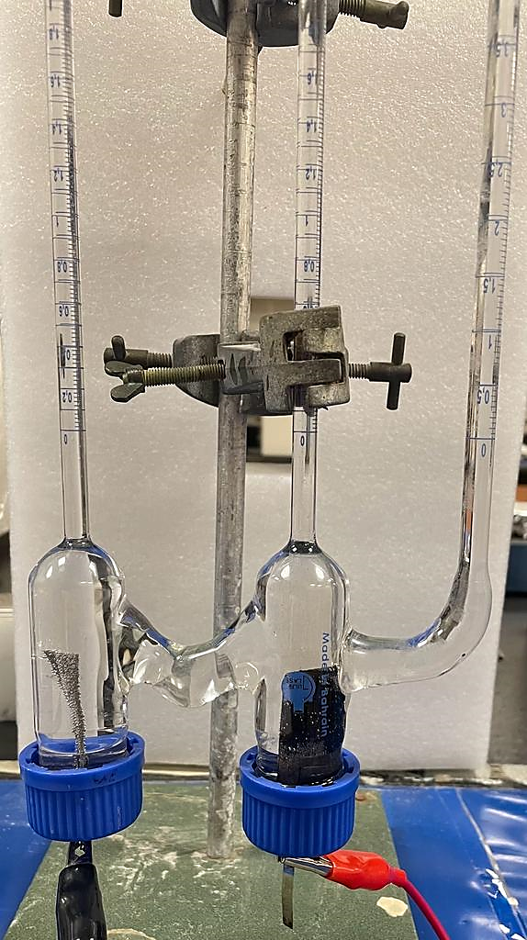

The evolved hydrogen measured by burette

Nickel Foam cathode

Carbon paper working electrode with catalyst

Figure S4 A symmetric home-made glass electrolyzer used for the volumetric determination of hydrogen gas produced at the cathode during urea electrolysis at the *meso*-NiPO or *bare*-NiPO anode in alkaline urea solution.