Photovoltaic Response Promoted Via Intramolecular Charge Transfer in Pyrazoline-based Small Molecular Acceptors: Efficient Organic Solar Cells
Muhammad Khalid,*^{a,b} Ayesha Mustafa,^{a,b} Sarfraz Ahmed,^{c} Muhammad Adnan Asghar,^{d} Tansir Ahamad,^{e} Ataualpa A. C. Braga,^{f} Suvash Chandra Ojha,*^{g}
ªInstitute of Chemistry, Khwaja Fareed University of Engineering & Information Technology, Rahim Yar Khan, 64200, Pakistan
^{b}Centre for Theoretical and Computational Research, Khwaja Fareed University of Engineering & Information Technology, Rahim Yar Khan, 64200, Pakistan
^{c}Wellman Center for Photomedicine, Harvard Medical School, Massachusetts General Hospital, Boston, MA 02114, United States
^{d}Department of Chemistry, Division of Science and Technology, University of Education Lahore, Pakistan
^{e}Department of Chemistry, College of Science, King Saud University, Saudi Arabia, tahamed@ksu.edu.sa
^{f}Departamento de Qu´ımica Fundamental, Instituto de Qu´ımica, Universidade de Sao˜ Paulo, Av. Prof. Lineu Prestes, 748, Sao Paulo, 05508-000, Brazil
^{g}Departamento de Qu´ımica Fundamental, Instituto de Qu´ımica, Universidade de Sao˜ Paulo, Av. Prof. Lineu Prestes, 748, Sao Paulo, 05508-000, Brazil
^{g}Department of Infectious Diseases, The Affiliated Hospital of Southwest Medical University, Luzhou 646000, China
*Corresponding author's E-mail addresses:
Dr.Muhammad Khalid (khalid@iq.usp.br)
Dr.Suvash Chandra Ojha (suvash_ojha@swmu.edu.cn)
Table S1: Cartesian coordinates of THP1.
Atom | X-axis | Y-axis | Z-axis
C | -0.71004 | -1.17245 | 0.206562
C | 0.668195 | -1.23115 | 0.240424
C | 1.375258 | -0.04825 | 0.031981
C | 0.71004 | 1.172458 | -0.20662
C | -0.6682 | 1.231156 | -0.24048
C | -1.37526 | 0.048257 | -0.03204
H | 1.189336 | -2.16933 | 0.42307
H | -1.18934 | 2.169333 | -0.42313
C | -5.19466 | -0.82821 | 0.07366
C | -4.37473 | -1.91238 | 0.285168
C | -3.01112 | -1.57482 | 0.239131
C | -2.78888 | -0.24493 | -0.00278
S | -4.25594 | 0.633995 | -0.19413
H | -4.75967 | -2.90547 | 0.495657
C | 2.788884 | 0.244931 | 0.002737
C | 3.011114 | 1.574825 | -0.23919
C | 4.37473 | 1.912382 | -0.28521
C | 5.19466 | 0.82821 | -0.07371
S | 4.255938 | -0.63398 | 0.194152
H | 4.759674 | 2.905472 | -0.49571
C | -1.70352 | -2.30825 | 0.400496
C | 1.703516 | 2.308253 | -0.40055
C | 6.648161 | 0.785473 | -0.03538
C | 7.361619 | -0.39255 | -0.29692
C | 7.388217 | 1.93143 | 0.268071
C | 8.737313 | -0.43339 | -0.25177
H | 6.821497 | -1.29835 | -0.55824
C | 8.769541 | 1.910532 | 0.305387
H | 6.869685 | 2.85558 | 0.504762
C | 9.459184 | 0.723672 | 0.051567
H | 9.272805 | -1.35222 | -0.45719
H | 9.307252 | 2.820494 | 0.550375
C | 12.81388 | -0.17249 | 0.013258
C | -1.57813 | -2.92159 | 1.794137
H | -1.69741 | -2.15743 | 2.568835
H | -2.34612 | -3.68918 | 1.946488
H | -0.59787 | -3.39415 | 1.92439
C | 1.532919 | 3.379641 | 0.675177
H | 2.301408 | 4.154645 | 0.570471
H | 0.552467 | 3.862159 | 0.591237
H | 1.617563 | 2.943681 | 1.675765
C | 1.578132 | 2.921598 | -1.7942
H | 1.697407 | 2.157431 | -2.56889
H | 0.597878 | 3.394159 | -1.92445
H | 2.34613 | 3.689177 | -1.94655
C | -1.53292 | -3.37964 | -0.67523
H | -0.55247 | -3.86216 | -0.59129
H | -2.30141 | -4.15464 | -0.57053
H | -1.61756 | -2.94368 | -1.67582
C | -6.64816 | -0.78547 | 0.035324
C | -7.36162 | 0.392538 | 0.296951
C | -7.38822 | -1.93141 | -0.26817
C | -8.73731 | 0.433379 | 0.251821
H | -6.82149 | 1.29832 | 0.558334
C | -8.76954 | -1.91051 | -0.30548
H | -6.86969 | -2.85555 | -0.5049
C | -9.45918 | -0.72367 | -0.05158
H | -9.2728 | 1.352189 | 0.457319
H | -9.30725 | -2.82046 | -0.5505
N | -10.8509 | -0.70021 | -0.10881
C | -11.7009 | -1.86753 | -0.39272
C | -13.1076 | -1.26846 | -0.34853
H | -11.4413 | -2.28861 | -1.36989
C | -12.8139 | 0.172483 | -0.01321
H | -13.7472 | -1.73934 | 0.403153
C | 11.70094 | 1.867541 | 0.392699
H | 11.44128 | 2.288712 | 1.369817
H | 11.53516 | 2.640028 | -0.36661
C | 13.10759 | 1.268441 | 0.348639
H | 13.63198 | 1.360372 | 1.304284
H | 13.7473 | 1.739326 | -0.40298
N | 10.85086 | 0.700204 | 0.108838
N | 11.53498 | -0.4089 | -0.09999
N | -11.535 | 0.408894 | 0.100019
H | -13.6321 | -1.36041 | -1.30413
H | -11.5351 | -2.64008 | 0.366512
C | 13.70866 | -1.25201 | -0.17962
H | 13.23244 | -2.20243 | -0.40702
C | -13.7087 | 1.252005 | 0.17966
H | -13.2324 | 2.202436 | 0.40702
C | -15.0709 | 1.235174 | 0.11415
C | 15.07086 | -1.23519 | -0.11408
C | -15.8255 | 0.062088 | -0.16958
N | -16.4308 | -0.89454 | -0.399
C | 15.80406 | -2.43474 | -0.33911
N | 16.38861 | -3.41333 | -0.523
C | 15.82551 | -0.06211 | 0.16969
N | 16.43081 | 0.894497 | 0.399147
C | -15.8041 | 2.434729 | 0.339158
N | -16.3886 | 3.413318 | 0.523037
Table S2: Cartesian coordinates of THP2.
Atom | X-axis | Y-axis | Z-axis
C | -0.57369 | 1.230405 | -0.86216
C | 0.803231 | 1.142493 | -0.84327
C | 1.374848 | -0.12785 | -0.892
C | 0.576749 | -1.28882 | -0.96116
C | -0.80023 | -1.20075 | -0.98176
C | -1.37198 | 0.069467 | -0.92966
H | 1.425743 | 2.033794 | -0.7881
H | -1.42293 | -2.09218 | -1.03233
C | -5.07121 | 1.369005 | -0.8595
C | -4.13328 | 2.37386 | -0.82054
C | -2.81614 | 1.8844 | -0.85563
C | -2.74511 | 0.517799 | -0.92114
S | -4.30579 | -0.21045 | -0.95212
H | -4.40507 | 3.421456 | -0.73283
C | 2.747532 | -0.57674 | -0.87827
C | 2.819119 | -1.94356 | -0.93708
C | 4.135364 | -2.43541 | -0.90584
C | 5.072641 | -1.43205 | -0.82425
S | 4.306671 | 0.150042 | -0.79684
H | 4.404133 | -3.48735 | -0.90703
C | -1.43366 | 2.483875 | -0.80823
C | 1.436987 | -2.54284 | -0.99852
C | 6.521212 | -1.55447 | -0.76857
C | 7.328342 | -0.57014 | -0.18188
C | 7.161084 | -2.67989 | -1.29435
C | 8.698316 | -0.69734 | -0.11817
H | 6.864854 | 0.310803 | 0.254204
C | 8.533461 | -2.82891 | -1.2284
H | 6.571935 | -3.44791 | -1.78619
C | 9.319928 | -1.8358 | -0.6397
H | 9.307842 | 0.069859 | 0.343324
H | 8.990005 | -3.71746 | -1.65155
C | 12.7265 | -1.41335 | -0.12137
C | -1.17624 | 3.386358 | -2.01395
H | -1.3319 | 2.840965 | -2.9503
H | -1.85466 | 4.247742 | -2.00055
H | -0.14808 | 3.765901 | -2.00346
C | 1.226155 | -3.31811 | -2.29819
H | 1.904037 | -4.17861 | -2.34655
H | 0.198362 | -3.69285 | -2.36434
H | 1.416911 | -2.68065 | -3.16736
C | 1.165201 | -3.43799 | 0.209456
H | 1.308884 | -2.8867 | 1.144245
H | 0.13759 | -3.81854 | 0.188477
H | 1.844082 | -4.2991 | 0.210312
C | -1.20779 | 3.251327 | 0.493538
H | -0.17953 | 3.626329 | 0.549893
H | -1.88529 | 4.111189 | 0.555581
H | -1.38806 | 2.6085 | 1.360971
C | -6.52062 | 1.49224 | -0.83208
C | -7.34337 | 0.479811 | -0.32023
C | -7.14387 | 2.650212 | -1.30385
C | -8.71339 | 0.613844 | -0.27067
H | -6.89238 | -0.42821 | 0.070966
C | -8.51639 | 2.804946 | -1.25263
H | -6.53986 | 3.440762 | -1.73913
C | -9.31849 | 1.786793 | -0.73166
H | -9.33525 | -0.17408 | 0.136188
H | -8.9603 | 3.719314 | -1.63185
N | -10.6982 | 1.944486 | -0.67715
C | -11.4275 | 3.142139 | -1.11541
C | -12.8804 | 2.772114 | -0.81242
H | -11.0804 | 4.017162 | -0.5533
C | -12.7262 | 1.40581 | -0.19146
H | -13.5025 | 2.737336 | -1.71151
C | 11.44769 | -3.14042 | -1.09039
H | 11.26013 | -3.26283 | -2.16333
H | 11.11791 | -4.05353 | -0.58213
C | 12.89573 | -2.76406 | -0.77222
H | 13.52291 | -2.70625 | -1.66645
H | 13.38051 | -3.47854 | -0.10105
N | 10.70045 | -1.98332 | -0.5794
N | 11.47818 | -1.04753 | -0.04957
N | -11.4852 | 1.011596 | -0.15533
H | -13.3639 | 3.476835 | -0.13015
H | -11.2417 | 3.326965 | -2.17915
C | 13.71057 | -0.52589 | 0.390424
C | 15.0614 | -0.68317 | 0.432768
H | 13.28527 | 0.385929 | 0.801067
C | -13.7176 | 0.537406 | 0.33897
C | -15.0642 | 0.720544 | 0.402051
H | -13.3064 | -0.39011 | 0.728925
C | -15.9851 | -0.25431 | 1.005219
C | -17.3575 | -0.1889 | 0.734029
C | -15.5232 | -1.26015 | 1.865047
C | -18.2372 | -1.10355 | 1.280552
H | -17.7386 | 0.589344 | 0.079942
C | -16.3921 | -2.17959 | 2.414395
H | -14.4733 | -1.31419 | 2.131363
C | -17.7417 | -2.09184 | 2.112488
H | -19.2998 | -1.06579 | 1.073394
H | -16.0484 | -2.95805 | 3.084568
C | 15.98006 | 0.33 | 0.973199
C | 15.56365 | 1.647772 | 1.208362
C | 17.30914 | -0.00677 | 1.260096
C | 16.43011 | 2.58626 | 1.728071
H | 14.55323 | 1.956422 | 0.963521
C | 18.18656 | 0.926102 | 1.778438
H | 17.65833 | -1.01823 | 1.076571
C | 17.73466 | 2.213097 | 2.010451
H | 16.11918 | 3.60782 | 1.910221
H | 19.21469 | 0.673909 | 2.007973
N | 18.66363 | 3.213581 | 2.561938
O | 19.80117 | 2.856892 | 2.784753
O | 18.2301 | 4.329422 | 2.758968
N | -18.6726 | -3.0679 | 2.703489
O | -19.8473 | -2.96129 | 2.421674
O | -18.2034 | -3.91573 | 3.433497
C | -15.6577 | 1.890369 | -0.15729
N | -16.1661 | 2.825182 | -0.60831
C | 15.65673 | -1.8895 | -0.04057
N | 16.16429 | -2.85937 | -0.41131
Table S3: Cartesian coordinates of THP3.
Atom | X-axis | Y-axis | Z-axis
C | -0.56487 | -1.06985 | -0.47758
C | 0.810042 | -0.97401 | -0.54695
C | 1.395593 | 0.244897 | -0.21102
C | 0.612959 | 1.34963 | 0.183672
C | -0.76253 | 1.253515 | 0.253463
C | -1.34865 | 0.033205 | -0.07888
H | 1.42105 | -1.82176 | -0.85228
H | -1.37315 | 2.100947 | 0.560487
C | -5.0515 | -1.26451 | -0.17131
C | -4.12413 | -2.21052 | -0.53868
C | -2.8069 | -1.72178 | -0.49654
C | -2.72324 | -0.41224 | -0.1047
S | -4.27399 | 0.258635 | 0.236998
H | -4.40619 | -3.21108 | -0.85244
C | 2.771343 | 0.681817 | -0.16967
C | 2.860399 | 1.990506 | 0.223179
C | 4.183265 | 2.463466 | 0.294025
C | 5.106388 | 1.503616 | -0.04755
S | 4.319328 | -0.00934 | -0.47472
H | 4.471531 | 3.459863 | 0.615656
C | -1.4362 | -2.2774 | -0.78606
C | 1.488385 | 2.554763 | 0.494725
C | 6.556205 | 1.620987 | -0.09827
C | 7.399347 | 0.522758 | 0.116708
C | 7.160763 | 2.852724 | -0.35791
C | 8.77112 | 0.640659 | 0.076118
H | 6.964305 | -0.44718 | 0.342518
C | 8.535891 | 2.991894 | -0.39257
H | 6.537342 | 3.71845 | -0.56149
C | 9.361047 | 1.883901 | -0.17759
H | 9.410101 | -0.21658 | 0.249292
H | 8.964571 | 3.965901 | -0.60433
C | 12.78462 | 1.351565 | -0.13011
C | -1.10728 | -3.45092 | 0.135049
H | -1.19794 | -3.15927 | 1.186293
H | -1.79255 | -4.28673 | -0.05029
H | -0.08497 | -3.80711 | -0.03672
C | 1.346178 | 2.981383 | 1.955118
H | 2.03677 | 3.801888 | 2.18362
H | 0.327432 | 3.328463 | 2.16267
H | 1.569474 | 2.147353 | 2.62805
C | 1.173746 | 3.723894 | -0.43705
H | 1.275302 | 3.425638 | -1.48544
H | 0.150444 | 4.083657 | -0.27894
H | 1.859402 | 4.558795 | -0.249
C | -1.30651 | -2.69415 | -2.25062
H | -0.28796 | -3.03431 | -2.47024
H | -1.99509 | -3.51679 | -2.4775
H | -1.54081 | -1.85701 | -2.91591
C | -6.49528 | -1.41784 | -0.07141
C | -7.37967 | -0.34323 | -0.23278
C | -7.05145 | -2.67302 | 0.18601
C | -8.74542 | -0.50643 | -0.14488
H | -6.98411 | 0.644766 | -0.45332
C | -8.4183 | -2.8573 | 0.266739
H | -6.39457 | -3.52206 | 0.350486
C | -9.28602 | -1.77288 | 0.104021
H | -9.41673 | 0.333375 | -0.27671
H | -8.80785 | -3.84841 | 0.474022
N | -10.6547 | -1.96082 | 0.192602
C | -11.3096 | -3.24894 | 0.439245
C | -12.7904 | -2.87078 | 0.432623
H | -11.0452 | -3.965 | -0.34764
C | -12.729 | -1.38268 | 0.199424
H | -13.292 | -3.10552 | 1.377734
C | 11.45929 | 3.273256 | -0.45775
H | 11.19365 | 4.014233 | 0.305326
H | 11.18685 | 3.6861 | -1.43663
C | 12.92185 | 2.830959 | -0.38255
H | 13.47078 | 3.321481 | 0.428977
H | 13.47243 | 3.02889 | -1.30863
N | 10.73863 | 2.019128 | -0.21837
N | 11.55183 | 0.966967 | -0.04758
N | -11.5188 | -0.94166 | 0.074118
H | -13.3513 | -3.3739 | -0.36284
H | -10.9768 | -3.66486 | 1.398035
C | 13.85188 | 0.414685 | 0.016224
C | 15.15785 | 0.731005 | -0.05875
H | 13.529 | -0.60832 | 0.197348
H | 15.43046 | 1.770178 | -0.24522
C | -13.8505 | -0.50228 | 0.118784
C | -15.1284 | -0.90798 | 0.237656
H | -13.6007 | 0.543332 | -0.04912
H | -15.3195 | -1.96942 | 0.39786
C | -16.3142 | -0.07456 | 0.173343
C | -17.5723 | -0.68367 | 0.280357
C | -16.2648 | 1.319009 | 0.012305
C | -18.7372 | 0.055016 | 0.228045
H | -17.6267 | -1.76146 | 0.40604
C | -17.4198 | 2.069019 | -0.04035
H | -15.306 | 1.820973 | -0.0692
C | -18.6461 | 1.427379 | 0.067427
H | -19.7137 | -0.40677 | 0.309794
H | -17.3981 | 3.145449 | -0.16137
C | 16.27266 | -0.18775 | 0.083149
C | 16.10275 | -1.55776 | 0.337069
C | 17.57991 | 0.3041 | -0.03684
C | 17.18739 | -2.39827 | 0.462802
H | 15.10506 | -1.97204 | 0.438336
C | 18.67598 | -0.52668 | 0.086562
H | 17.72848 | 1.362632 | -0.23187
C | 18.4654 | -1.87246 | 0.335412
H | 17.06812 | -3.45712 | 0.658121
H | 19.69019 | -0.15717 | -0.00519
N | 19.62592 | -2.76536 | 0.467926
O | 20.72849 | -2.27161 | 0.34922
O | 19.40864 | -3.93918 | 0.68752
N | -19.8781 | 2.227447 | 0.011978
O | -20.9353 | 1.636973 | 0.095686
O | -19.7596 | 3.428865 | -0.11429
Table S4: Cartesian coordinates of THP4.
Atom | X-axis | Y-axis | Z-axis
C | -0.61654 | 1.282009 | -0.70989
C | 0.76263 | 1.242464 | -0.74335
C | 1.379722 | -0.00751 | -0.7243
C | 0.621364 | -1.19576 | -0.67455
C | -0.75778 | -1.15625 | -0.64149
C | -1.37477 | 0.093754 | -0.65878
H | 1.352828 | 2.156474 | -0.78135
H | -1.34791 | -2.07018 | -0.6007
C | -5.11579 | 1.274369 | -0.56749
C | -4.21186 | 2.308221 | -0.62877
C | -2.87958 | 1.860074 | -0.66634
C | -2.76209 | 0.49587 | -0.63206
S | -4.29838 | -0.28231 | -0.5657
H | -4.51579 | 3.35049 | -0.61291
C | 2.767286 | -0.40964 | -0.74206
C | 2.884395 | -1.77395 | -0.70876
C | 4.217464 | -2.22121 | -0.69862
C | 5.122184 | -1.18673 | -0.72542
S | 4.304745 | 0.368901 | -0.77562
H | 4.52345 | -3.26113 | -0.63592
C | -1.5188 | 2.506447 | -0.71807
C | 1.523522 | -2.42012 | -0.65896
C | 6.57566 | -1.26342 | -0.72032
C | 7.373714 | -0.24692 | -0.17906
C | 7.229471 | -2.38042 | -1.24537
C | 8.747981 | -0.33874 | -0.15058
H | 6.899238 | 0.630062 | 0.253668
C | 8.606699 | -2.494 | -1.21657
H | 6.644627 | -3.1716 | -1.70539
C | 9.386659 | -1.47327 | -0.66408
H | 9.351077 | 0.450721 | 0.280935
H | 9.073004 | -3.37811 | -1.6387
C | 12.77515 | -1.02023 | -0.10211
C | -1.33972 | 3.317549 | -2.00058
H | -1.51049 | 2.692861 | -2.88312
H | -2.04888 | 4.153542 | -2.0283
H | -0.32639 | 3.730918 | -2.06151
C | 1.2821 | -3.30369 | -1.88186
H | 1.99067 | -4.14055 | -1.89647
H | 0.267905 | -3.71921 | -1.86798
H | 1.407015 | -2.73184 | -2.80696
C | 1.340808 | -3.22481 | 0.627128
H | 1.509068 | -2.59564 | 1.506928
H | 0.327276 | -3.6378 | 0.687064
H | 2.049747 | -4.06069 | 0.661688
C | -1.2739 | 3.383891 | 0.508581
H | -0.2597 | 3.799358 | 0.493728
H | -1.98221 | 4.220788 | 0.530023
H | -1.39619 | 2.807348 | 1.43108
C | -6.56882 | 1.349517 | -0.52623
C | -7.35091 | 0.355153 | 0.07596
C | -7.23882 | 2.438304 | -1.08898
C | -8.72542 | 0.437897 | 0.120124
H | -6.86363 | -0.4984 | 0.540158
C | -8.61618 | 2.54311 | -1.04511
H | -6.66743 | 3.211468 | -1.59417
C | -9.38048 | 1.540802 | -0.43965
H | -9.31618 | -0.33686 | 0.593413
H | -9.09563 | 3.404038 | -1.49923
N | -10.76 | 1.644714 | -0.40111
C | -11.5381 | 2.74527 | -0.97692
C | -12.9757 | 2.332895 | -0.65866
H | -11.2516 | 3.696502 | -0.5131
C | -12.7713 | 1.014642 | 0.043517
H | -13.5914 | 2.215401 | -1.55696
C | 11.52261 | -2.76242 | -1.07757
H | 11.35432 | -2.94037 | -2.14589
H | 11.19262 | -3.65543 | -0.53189
C | 12.96383 | -2.36609 | -0.75413
H | 13.59165 | -2.28488 | -1.64857
H | 13.4558 | -3.07436 | -0.07905
N | 10.76566 | -1.58978 | -0.63048
N | 11.53745 | -0.64632 | -0.06721
N | -11.5241 | 0.691449 | 0.155676
H | -13.4879 | 3.051429 | -0.00925
H | -11.3432 | 2.824323 | -2.05349
C | 13.80783 | -0.19248 | 0.435851
C | 15.11275 | -0.51981 | 0.445961
H | 13.45848 | 0.748089 | 0.856588
C | -13.8005 | 0.166079 | 0.555397
C | -15.116 | 0.428662 | 0.453224
H | -13.4408 | -0.73943 | 1.039582
C | -16.203 | -0.39895 | 0.944699
C | -17.5226 | -0.03539 | 0.646728
C | -15.9965 | -1.5565 | 1.70946
C | -18.5931 | -0.79223 | 1.078109
H | -17.7012 | 0.86057 | 0.058301
C | -17.0582 | -2.31786 | 2.14619
H | -14.9878 | -1.86054 | 1.970206
C | -18.3693 | -1.9442 | 1.833061
H | -19.61 | -0.50105 | 0.836718
H | -16.8881 | -3.21082 | 2.738723
C | 16.1977 | 0.278749 | 0.98788
C | 16.00342 | 1.549286 | 1.549171
C | 17.50127 | -0.23262 | 0.958122
C | 17.06009 | 2.270514 | 2.059651
H | 15.00755 | 1.979322 | 1.584342
C | 18.567 | 0.481831 | 1.467073
H | 17.6713 | -1.21519 | 0.526095
C | 18.35506 | 1.74313 | 2.024896
H | 16.89831 | 3.252762 | 2.491662
H | 19.57136 | 0.072158 | 1.43869
C | -19.4676 | -2.73191 | 2.285597
N | -20.357 | -3.36977 | 2.652563
C | 19.44905 | 2.488513 | 2.553285
N | 20.33551 | 3.091717 | 2.981176
H | -15.424 | 1.341771 | -0.0571
H | 15.41085 | -1.47713 | 0.017263
Table S5: Cartesian coordinates of THP5.
Atom | X-axis | Y-axis | Z-axis
C | -0.6316 | 1.241936 | -0.46695
C | 0.748379 | 1.221262 | -0.47592
C | 1.381907 | -0.02032 | -0.50097
C | 0.638534 | -1.21901 | -0.51613
C | -0.74143 | -1.19832 | -0.50774
C | -1.37494 | 0.043263 | -0.48327
H | 1.326752 | 2.143551 | -0.46287
H | -1.31983 | -2.12062 | -0.5187
C | -5.13256 | 1.172593 | -0.42712
C | -4.24115 | 2.21902 | -0.42189
C | -2.90255 | 1.789224 | -0.44788
C | -2.76785 | 0.426393 | -0.46992
S | -4.29506 | -0.37262 | -0.47287
H | -4.55924 | 3.255754 | -0.36752
C | 2.774794 | -0.4035 | -0.51578
C | 2.909403 | -1.76629 | -0.53994
C | 4.247962 | -2.19672 | -0.53725
C | 5.139788 | -1.15078 | -0.51363
S | 4.302158 | 0.395156 | -0.50374
H | 4.565454 | -3.23485 | -0.51815
C | -1.54992 | 2.454072 | -0.43779
C | 1.556808 | -2.43126 | -0.54024
C | 6.594193 | -1.20744 | -0.51062
C | 7.379606 | -0.19286 | 0.05277
C | 7.262389 | -2.2994 | -1.06913
C | 8.755457 | -0.26104 | 0.067997
H | 6.894451 | 0.664996 | 0.511211
C | 8.641334 | -2.39 | -1.05361
H | 6.688071 | -3.08732 | -1.54751
C | 9.408408 | -1.37016 | -0.48198
H | 9.348899 | 0.528599 | 0.512677
H | 9.119433 | -3.25385 | -1.50358
C | 12.80178 | -0.83069 | -0.03155
C | -1.35377 | 3.330715 | -1.67374
H | -1.49494 | 2.749164 | -2.59041
H | -2.07514 | 4.156692 | -1.67609
H | -0.3459 | 3.761266 | -1.69049
C | 1.346928 | -3.26018 | -1.80655
H | 2.066651 | -4.08656 | -1.8481
H | 0.338071 | -3.68809 | -1.82913
H | 1.479639 | -2.64402 | -2.70157
C | 1.365149 | -3.29725 | 0.704026
H | 1.509937 | -2.70773 | 1.614962
H | 0.357096 | -3.72703 | 0.728053
H | 2.086193 | -4.12344 | 0.711478
C | -1.34452 | 3.272066 | 0.836462
H | -0.33539 | 3.698885 | 0.866356
H | -2.06382 | 4.098511 | 0.882921
H | -1.48104 | 2.648239 | 1.725516
C | -6.58702 | 1.228479 | -0.41876
C | -7.37078 | 0.200874 | 0.122889
C | -7.25652 | 2.331692 | -0.95294
C | -8.74688 | 0.265706 | 0.137404
H | -6.88408 | -0.66531 | 0.563677
C | -8.63569 | 2.418657 | -0.93815
H | -6.68283 | 3.131153 | -1.41261
C | -9.40141 | 1.383953 | -0.3919
H | -9.33937 | -0.53422 | 0.564683
H | -9.11503 | 3.291401 | -1.36913
N | -10.7826 | 1.473206 | -0.37989
C | -11.5573 | 2.597855 | -0.91135
C | -12.9962 | 2.168667 | -0.62525
H | -11.2758 | 3.527526 | -0.40281
C | -12.7966 | 0.813461 | 0.006254
H | -13.6054 | 2.102007 | -1.53304
C | 11.56245 | -2.59203 | -0.99225
H | 11.37965 | -2.7052 | -2.06807
H | 11.26088 | -3.5244 | -0.50057
C | 12.99989 | -2.18209 | -0.67147
H | 13.63028 | -2.11397 | -1.56447
H | 13.49183 | -2.87756 | 0.017972
N | 10.78909 | -1.4655 | -0.46295
N | 11.5559 | -0.49512 | 0.057138
N | -11.5491 | 0.489745 | 0.1155
H | -13.5118 | 2.851428 | 0.059452
H | -11.3538 | 2.725866 | -1.98181
C | 13.83184 | 0.033849 | 0.455871
C | 15.13841 | -0.29199 | 0.421452
H | 13.47786 | 0.974665 | 0.86641
C | -13.8272 | -0.06764 | 0.461812
C | -15.137 | 0.23564 | 0.371373
H | -13.4709 | -1.00112 | 0.886017
C | -16.306 | -0.52703 | 0.774716
C | -17.5569 | 0.073297 | 0.571103
C | -16.3118 | -1.81734 | 1.351671
C | -18.7422 | -0.54877 | 0.910991
H | -17.5821 | 1.065514 | 0.128692
C | -17.5138 | -2.44178 | 1.693271
C | -18.7271 | -1.81681 | 1.477681
H | -19.6856 | -0.04205 | 0.73329
H | -17.4736 | -3.43338 | 2.132903
C | 16.2907 | 0.456952 | 0.894435
C | 16.30404 | 1.819224 | 1.268045
C | 17.50845 | -0.23148 | 0.984241
C | 17.47892 | 2.422679 | 1.723264
C | 18.66702 | 0.370226 | 1.435758
H | 17.52713 | -1.27829 | 0.693514
C | 18.65733 | 1.707177 | 1.812883
H | 17.44729 | 3.471682 | 1.999827
H | 19.585 | -0.2061 | 1.493327
C | 15.15416 | 2.65839 | 1.183746
N | 14.25319 | 3.378808 | 1.130979
C | -15.1212 | -2.55645 | 1.614322
N | -14.1864 | -3.19407 | 1.844679
H | -15.3937 | 1.200913 | -0.06696
H | -19.6521 | -2.31414 | 1.748422
H | 15.40023 | -1.26998 | 0.015463
H | 19.56175 | 2.189184 | 2.16773
Table S6: Cartesian coordinates of THP6.
Atom | X-axis | Y-axis | Z-axis
C | -0.60504 | -1.21841 | 0.663568
C | 0.773732 | -1.16484 | 0.64784
C | 1.37693 | 0.091501 | 0.678114
C | 0.606734 | 1.272296 | 0.724332
C | -0.77215 | 1.218661 | 0.740557
C | -1.37551 | -0.0377 | 0.709013
H | 1.373774 | -2.07236 | 0.610927
H | -1.37225 | 2.126248 | 0.774756
C | -5.10445 | -1.25397 | 0.674106
C | -4.18928 | -2.27975 | 0.648474
C | -2.86159 | -1.81949 | 0.668871
C | -2.75897 | -0.45379 | 0.708782
S | -4.30349 | 0.309463 | 0.734227
H | -4.48357 | -3.32269 | 0.581352
C | 2.760236 | 0.50716 | 0.669535
C | 2.863866 | 1.872715 | 0.710683
C | 4.191664 | 2.333005 | 0.691009
C | 5.105703 | 1.307205 | 0.635792
S | 4.303345 | -0.25677 | 0.617501
H | 4.485167 | 3.378281 | 0.683054
C | -1.494 | -2.45195 | 0.631899
C | 1.496355 | 2.505757 | 0.748204
C | 6.557674 | 1.396858 | 0.606837
C | 7.354229 | 0.401107 | 0.025493
C | 7.211301 | 2.501715 | 1.158363
C | 8.727926 | 0.498581 | -0.00953
H | 6.879783 | -0.46414 | -0.42985
C | 8.587539 | 2.620597 | 1.122178
H | 6.628788 | 3.276435 | 1.647619
C | 9.363974 | 1.617141 | 0.537522
H | 9.329908 | -0.27659 | -0.46774
H | 9.05475 | 3.493412 | 1.565805
C | 12.77091 | 1.1354 | 0.077186
C | -1.25827 | -3.33829 | 1.854005
H | -1.40006 | -2.77208 | 2.780127
H | -1.95795 | -4.18261 | 1.856451
H | -0.23986 | -3.74337 | 1.850465
C | 1.292785 | 3.309934 | 2.031392
H | 1.991938 | 4.153742 | 2.070997
H | 0.274401 | 3.711995 | 2.080775
H | 1.459097 | 2.684134 | 2.913963
C | 1.258081 | 3.385074 | -0.47853
H | 1.39745 | 2.813341 | -1.40159
H | 0.239788 | 3.790448 | -0.47471
H | 1.957899 | 4.229206 | -0.48817
C | -1.28726 | -3.24861 | -0.65553
H | -0.26857 | -3.64992 | -0.7048
H | -1.98588 | -4.09246 | -0.70217
H | -1.45182 | -2.61765 | -1.53473
C | -6.5564 | -1.34744 | 0.66193
C | -7.36478 | -0.32791 | 0.141454
C | -7.19736 | -2.48397 | 1.161358
C | -8.73793 | -0.43519 | 0.110047
H | -6.90027 | 0.564003 | -0.27059
C | -8.5729 | -2.61216 | 1.128385
H | -6.60473 | -3.27843 | 1.604876
C | -9.36108 | -1.58747 | 0.598734
H | -9.34941 | 0.357644 | -0.30314
H | -9.02981 | -3.51055 | 1.529495
N | -10.7435 | -1.72023 | 0.563074
C | -11.488 | -2.89756 | 1.028753
C | -12.9371 | -2.51019 | 0.730473
H | -11.1592 | -3.78881 | 0.481586
C | -12.7689 | -1.14704 | 0.106228
H | -13.5564 | -2.46879 | 1.630954
C | 11.50652 | 2.87199 | 1.047856
H | 11.30784 | 2.977015 | 2.120842
H | 11.19828 | 3.800225 | 0.553791
C | 12.95201 | 2.478383 | 0.740743
H | 13.57059 | 2.406797 | 1.63978
H | 13.45153 | 3.19084 | 0.078104
N | 10.74758 | 1.737246 | 0.50581
N | 11.51871 | 0.791926 | -0.02019
N | -11.5225 | -0.77474 | 0.04877
H | -13.4304 | -3.20908 | 0.048879
H | -11.2976 | -3.06518 | 2.094802
C | 13.75152 | 0.239186 | -0.42841
C | 15.10406 | 0.379743 | -0.44828
H | 13.32181 | -0.66272 | -0.85636
C | -13.7564 | -0.26384 | -0.40885
C | -15.106 | -0.42655 | -0.44673
H | -13.3389 | 0.657081 | -0.8079
C | -16.0245 | 0.561381 | -1.03366
C | -17.3896 | 0.525893 | -0.72737
C | -15.569 | 1.552648 | -1.91177
C | -18.2637 | 1.45506 | -1.25591
H | -17.7691 | -0.24088 | -0.05874
C | -16.4356 | 2.484586 | -2.44208
H | -14.5255 | 1.585016 | -2.20652
C | -17.7933 | 2.446869 | -2.11606
H | -19.3186 | 1.420131 | -1.00518
H | -16.0725 | 3.24509 | -3.12539
C | 16.01905 | -0.63878 | -0.98659
C | 15.59964 | -1.95496 | -1.21832
C | 17.34826 | -0.30957 | -1.27653
C | 16.46285 | -2.89562 | -1.73833
H | 14.58871 | -2.25974 | -0.96938
C | 18.21908 | -1.24698 | -1.79574
H | 17.70258 | 0.700647 | -1.09498
C | 17.7832 | -2.54966 | -2.03576
H | 16.12676 | -3.91293 | -1.90941
H | 19.24523 | -0.97628 | -2.02076
C | -15.7084 | -1.58585 | 0.125138
N | -16.2261 | -2.51043 | 0.58659
C | 15.70937 | 1.572878 | 0.045717
N | 16.22774 | 2.530872 | 0.432201
C | -18.6899 | 3.408811 | -2.66729
N | -19.4131 | 4.18935 | -3.11415
C | 18.67659 | -3.52334 | -2.57108
N | 19.39714 | -4.3133 | -3.00556
Table S7: Cartesian coordinates of THP7.
Atom | X-axis | Y-axis | Z-axis
C | -0.62629 | 1.185135 | -0.43247
C | 0.753204 | 1.159306 | -0.41425
C | 1.382836 | -0.07844 | -0.53245
C | 0.637801 | -1.26887 | -0.66542
C | -0.74195 | -1.24277 | -0.68521
C | -1.37188 | -0.00481 | -0.56805
H | 1.333399 | 2.074451 | -0.30928
H | -1.32225 | -2.15812 | -0.78781
C | -5.12548 | 1.13115 | -0.48948
C | -4.2321 | 2.169905 | -0.37517
C | -2.89484 | 1.738872 | -0.4116
C | -2.76376 | 0.382068 | -0.55004
S | -4.29169 | -0.40776 | -0.65216
H | -4.54973 | 3.198708 | -0.23502
C | 2.774499 | -0.46392 | -0.54992
C | 2.907809 | -1.82061 | -0.68611
C | 4.245628 | -2.25149 | -0.69604
C | 5.137422 | -1.21197 | -0.5702
S | 4.2998 | 0.328766 | -0.44492
H | 4.560797 | -3.28853 | -0.75984
C | -1.5412 | 2.394269 | -0.31331
C | 1.554166 | -2.47825 | -0.77561
C | 6.591132 | -1.26912 | -0.54496
C | 7.365109 | -0.27243 | 0.064782
C | 7.270365 | -2.34006 | -1.13139
C | 8.740735 | -0.33702 | 0.095618
H | 6.871813 | 0.568619 | 0.544645
C | 8.649033 | -2.42705 | -1.09889
H | 6.706966 | -3.11341 | -1.64457
C | 9.401819 | -1.42429 | -0.48352
H | 9.325163 | 0.44029 | 0.5727
H | 9.137179 | -3.27353 | -1.57008
C | 12.79476 | -0.89227 | 0.013448
C | -1.3163 | 3.380368 | -1.45815
H | -1.43693 | 2.886705 | -2.42779
H | -2.03684 | 4.204858 | -1.39942
H | -0.3083 | 3.808316 | -1.41228
C | 1.371294 | -3.1864 | -2.11723
H | 2.086541 | -4.01159 | -2.21653
H | 0.360723 | -3.60197 | -2.20302
H | 1.52958 | -2.49169 | -2.94828
C | 1.332005 | -3.45297 | 0.379545
H | 1.454056 | -2.94954 | 1.343933
H | 0.324055 | -3.88168 | 0.339583
H | 2.052892 | -4.27764 | 0.328356
C | -1.35983 | 3.08862 | 1.035801
H | -0.34892 | 3.502149 | 1.127231
H | -2.07436 | 3.913411 | 1.142753
H | -1.52019 | 2.385621 | 1.859418
C | -6.57908 | 1.196999 | -0.50145
C | -7.37913 | 0.133399 | -0.06299
C | -7.22941 | 2.350902 | -0.94527
C | -8.75465 | 0.214373 | -0.05763
H | -6.90706 | -0.7725 | 0.30767
C | -8.60744 | 2.452401 | -0.93816
H | -6.64121 | 3.181153 | -1.32478
C | -9.3875 | 1.383027 | -0.49187
H | -9.36115 | -0.61063 | 0.295991
H | -9.07192 | 3.365171 | -1.29544
N | -10.7727 | 1.490905 | -0.48178
C | -11.5244 | 2.687792 | -0.88096
C | -12.972 | 2.267507 | -0.62513
H | -11.2107 | 3.546314 | -0.27602
C | -12.7973 | 0.859972 | -0.11077
H | -13.5866 | 2.298422 | -1.52886
C | 11.57048 | -2.6232 | -1.01569
H | 11.38635 | -2.69967 | -2.09371
H | 11.27048 | -3.56989 | -0.55252
C | 13.0054 | -2.21697 | -0.67813
H | 13.63537 | -2.11152 | -1.56624
H | 13.50573 | -2.93938 | -0.0272
N | 10.78763 | -1.51614 | -0.45088
N | 11.53712 | -0.57043 | 0.103024
N | -11.5477 | 0.499464 | -0.05785
H | -13.472 | 2.90429 | 0.110735
H | -11.3243 | 2.923132 | -1.93259
C | 13.75757 | 0.009304 | 0.545837
C | 15.10589 | -0.14701 | 0.620812
H | 13.32006 | 0.922456 | 0.940951
C | -13.783 | -0.07125 | 0.319329
C | -15.1346 | 0.077822 | 0.321922
H | -13.3623 | -1.00679 | 0.677984
C | -16.0744 | -0.95374 | 0.798359
C | -17.3092 | -1.09791 | 0.160667
C | -15.801 | -1.80683 | 1.885901
C | -18.2187 | -2.06393 | 0.551225
H | -17.5518 | -0.43754 | -0.66647
C | -16.7235 | -2.7831 | 2.271439
C | -17.9265 | -2.91803 | 1.605985
H | -19.1642 | -2.15106 | 0.025635
H | -16.4817 | -3.4199 | 3.116134
C | 16.01067 | 0.865957 | 1.195136
C | 15.82202 | 2.250676 | 1.018828
C | 17.11536 | 0.453181 | 1.943132
C | 16.69239 | 3.166079 | 1.61616
C | 17.97479 | 1.365698 | 2.52811
H | 17.2914 | -0.61075 | 2.072247
C | 17.76174 | 2.729126 | 2.373923
H | 16.52083 | 4.225834 | 1.457754
H | 18.81749 | 1.008717 | 3.1113
C | -15.7404 | 1.25057 | -0.21721
N | -16.2635 | 2.181223 | -0.66093
C | 15.72899 | -1.36048 | 0.207897
N | 16.26262 | -2.33805 | -0.10252
C | -14.6201 | -1.68611 | 2.679303
N | -13.6846 | -1.61932 | 3.352486
C | 14.78979 | 2.781522 | 0.187189
N | 13.97581 | 3.252723 | -0.48224
H | -18.6375 | -3.67603 | 1.916004
H | 18.43352 | 3.447531 | 2.830895
Table S8: Cartesian coordinates of THP8.
Atom | X-axis | Y-axis | Z-axis
C | 0.582678 | -1.18976 | 0.550776
C | -0.7912 | -1.08067 | 0.626508
C | -1.36947 | 0.134358 | 0.264029
C | -0.57951 | 1.221405 | -0.16474
C | 0.79444 | 1.111922 | -0.24159
C | 1.372779 | -0.10381 | 0.11903
H | -1.40678 | -1.91514 | 0.958215
H | 1.409899 | 1.946353 | -0.57363
C | 5.068282 | -1.41937 | 0.238966
C | 4.136519 | -2.35096 | 0.631223
C | 2.821267 | -1.85671 | 0.576975
C | 2.744127 | -0.55776 | 0.150798
S | 4.297778 | 0.095907 | -0.21007
H | 4.414198 | -3.34389 | 0.971999
C | -2.74142 | 0.585399 | 0.226526
C | -2.81953 | 1.885485 | -0.19583
C | -4.1366 | 2.374984 | -0.25959
C | -5.06764 | 1.436949 | 0.118057
S | -4.29542 | -0.07668 | 0.568929
H | -4.4161 | 3.367485 | -0.60033
C | 1.447608 | -2.39483 | 0.886733
C | -1.44524 | 2.426847 | -0.49839
C | -6.51397 | 1.583531 | 0.194316
C | -7.38688 | 0.50621 | -0.00596
C | -7.08369 | 2.829243 | 0.465492
C | -8.75498 | 0.657651 | 0.058001
H | -6.9787 | -0.47372 | -0.23919
C | -8.45375 | 3.001873 | 0.524536
H | -6.43504 | 3.678912 | 0.657967
C | -9.3105 | 1.914875 | 0.322801
H | -9.41759 | -0.18346 | -0.10525
H | -8.85518 | 3.985708 | 0.743836
C | -12.7498 | 1.500764 | 0.256855
C | 1.105939 | -3.59004 | -0.00092
H | 1.193606 | -3.32726 | -1.06001
H | 1.786203 | -4.42551 | 0.203572
H | 0.081853 | -3.93376 | 0.185257
C | -1.31598 | 2.810475 | -1.97204
H | -2.00111 | 3.631138 | -2.21608
H | -0.29622 | 3.140863 | -2.20093
H | -1.5555 | 1.959764 | -2.61799
C | -1.10744 | 3.618312 | 0.395839
H | -1.19838 | 3.350633 | 1.45343
H | -0.08294 | 3.963482 | 0.21465
H | -1.78768 | 4.454175 | 0.192891
C | 1.322171 | -2.77142 | 2.362581
H | 0.302652 | -3.09951 | 2.595817
H | 2.007103 | -3.59168 | 2.608527
H | 1.564457 | -1.91793 | 3.003818
C | 6.511825 | -1.57827 | 0.142277
C | 7.397317 | -0.50131 | 0.28021
C | 7.067071 | -2.83865 | -0.08946
C | 8.762623 | -0.66662 | 0.192432
H | 7.002723 | 0.491174 | 0.481653
C | 8.433849 | -3.02521 | -0.17005
H | 6.409146 | -3.69063 | -0.23415
C | 9.303158 | -1.93791 | -0.03296
H | 9.434401 | 0.175505 | 0.305379
H | 8.822634 | -4.02062 | -0.35755
N | 10.6703 | -2.1263 | -0.12151
C | 11.3265 | -3.4133 | -0.36467
C | 12.80629 | -3.03098 | -0.37179
H | 11.07046 | -4.12683 | 0.427177
C | 12.74197 | -1.53751 | -0.17576
H | 13.30675 | -3.28946 | -1.31113
C | -11.3565 | 3.365766 | 0.627468
H | -11.0902 | 4.082616 | -0.15982
H | -11.0461 | 3.792039 | 1.588273
C | -12.8321 | 2.968066 | 0.593935
H | -13.403 | 3.52282 | -0.15804
H | -13.3339 | 3.121118 | 1.556219
N | -10.681 | 2.086971 | 0.39427
N | -11.5337 | 1.072505 | 0.16518
N | 11.53378 | -1.09826 | -0.04139
H | 13.37077 | -3.5103 | 0.435965
H | 10.9888 | -3.83579 | -1.31944
C | -13.8604 | 0.622277 | 0.056922
C | -15.1465 | 1.004324 | 0.142893
H | -13.5898 | -0.4045 | -0.18049
H | -15.3614 | 2.045403 | 0.386377
C | 13.8642 | -0.65205 | -0.13358
C | 15.13979 | -1.05629 | -0.26421
H | 13.61404 | 0.396695 | 0.013096
H | 15.33166 | -2.12085 | -0.40335
C | 16.32727 | -0.21827 | -0.24083
C | 17.58245 | -0.82061 | -0.36315
C | 16.27818 | 1.177146 | -0.10419
C | 18.74657 | -0.0716 | -0.35088
H | 17.64072 | -1.9006 | -0.4694
C | 17.43401 | 1.927245 | -0.09157
H | 15.31972 | 1.678052 | -0.00968
C | 18.67497 | 1.305288 | -0.21495
H | 19.71231 | -0.55517 | -0.4478
H | 17.38272 | 3.007203 | 0.012765
C | -16.3176 | 0.167762 | -0.06291
C | -16.2404 | -1.19096 | -0.38945
C | -17.5896 | 0.740975 | 0.062276
C | -17.3836 | -1.94198 | -0.58755
H | -15.2714 | -1.6688 | -0.49418
C | -18.7345 | -0.00495 | -0.13369
H | -17.6697 | 1.794491 | 0.316899
C | -18.6346 | -1.35203 | -0.46129
H | -17.3081 | -2.99287 | -0.84414
H | -19.7134 | 0.454902 | -0.03434
C | 19.90264 | 2.155717 | -0.20377
C | -19.8931 | -2.12945 | -0.67081
F | -19.6602 | -3.40182 | -0.99732
F | -20.6553 | -2.13341 | 0.430181
F | -20.6403 | -1.59768 | -1.64667
F | 19.89467 | 3.039902 | -1.20956
F | 19.89467 | 3.039902 | -1.20956
F | 21.0224 | 1.438704 | -0.31453
F | 19.99518 | 2.868311 | 0.926124
Table S9: The IUPAC names and abbreviations of parent and investigated compounds (THP1-THP8).
Compounds | IUPAC name
PZ-dIDTC6  (Parent compound) | 2-ethylhexyl 4-(7-(((Z)-1-(dicyanomethylene)-3-oxo-1,3-dihydro-2H-inden-2-ylidene)methyl)-4,4,9,9-tetramethyl-4,9-dihydro-s-indaceno[1,2-b:5,6-b']dithiophen-2-yl)-6-(((Z)-1-(dicyanomethylene)-5,6-difluoro-3-oxo-1,3-dihydro-2H-inden-2-ylidene)methyl)-3-fluorothieno[3,4-b]thiophene-2-carboxylate
THP1 | 3,3'-((((4,4,9,9-tetramethyl-4,9-dihydro-s-indaceno[1,2-b:5,6-b']dithiophene-2,7-diyl)bis(4,1-phenylene))bis(4,5-dihydro-1H-pyrazole-1,3-diyl))bis(methaneylylidene))di(pentanedinitrile)
THP2 | (2Z,2'Z)-3,3'-(((4,4,9,9-tetramethyl-4,9-dihydro-s-indaceno[1,2-b:5,6-b']dithiophene-2,7-diyl)bis(4,1-phenylene))bis(4,5-dihydro-1H-pyrazole-1,3-diyl))bis(2-(4-nitrophenyl)acrylonitrile)
THP3 | 1,1'-((4,4,9,9-tetramethyl-4,9-dihydro-s-indaceno[1,2-b:5,6-b']dithiophene-2,7-diyl)bis(4,1-phenylene))bis(3-((E)-4-nitrostyryl)-4,5-dihydro-1H-pyrazole)
THP4 | 4,4'-((1E,1'E)-(((4,4,9,9-tetramethyl-4,9-dihydro-s-indaceno[1,2-b:5,6-b']dithiophene-2,7-diyl)bis(4,1-phenylene))bis(4,5-dihydro-1H-pyrazole-1,3-diyl))bis(ethene-2,1-diyl))dibenzonitrile
THP5 | 2,2'-((1E,1'E)-(((4,4,9,9-tetramethyl-4,9-dihydro-s-indaceno[1,2-b:5,6-b']dithiophene-2,7-diyl)bis(4,1-phenylene))bis(4,5-dihydro-1H-pyrazole-1,3-diyl))bis(ethene-2,1-diyl))dibenzonitrile
THP6 | 4,4'-((1Z,1'Z)-(((4,4,9,9-tetramethyl-4,9-dihydro-s-indaceno[1,2-b:5,6-b']dithiophene-2,7-diyl)bis(4,1-phenylene))bis(4,5-dihydro-1H-pyrazole-1,3-diyl))bis(1-cyanoethene-2,1-diyl))dibenzonitrile
THP7 | 2,2'-((1Z,1'Z)-(((4,4,9,9-tetramethyl-4,9-dihydro-s-indaceno[1,2-b:5,6-b']dithiophene-2,7-diyl)bis(4,1-phenylene))bis(4,5-dihydro-1H-pyrazole-1,3-diyl))bis(1-cyanoethene-2,1-diyl))dibenzonitrile
THP8 | (E)-1,1'-((4,4,9,9-tetramethyl-4,9-dihydro-s-indaceno[1,2-b:5,6-b']dithiophene-2,7-diyl)bis(4,1-phenylene))bis(3-((E)-4-(trifluoromethyl)styryl)-4,5-dihydro-1H-pyrazole)
Table S10: Calculated energies (E) and energy gap (∆E) for THP1-THP8.
Compounds | E_{HOMO-1} | E_{LUMO+1} | $∆$E (eV) | E_{HOMO-2} | E_{LUMO+2} | $∆$E (eV)
THP1 | -6.160 | -2.973 | 3.187 | -6.643 | -1.923 | 4.720
THP2 | -5.935 | -2.991 | 2.944 | -6.379 | -2.089 | 4.290
THP3 | -5.615 | -2.675 | 2.940 | -6.079 | -1.714 | 4.365
THP4 | -5.563 | -2.337 | 3.226 | -6.025 | -1.560 | 4.465
THP5 | -5.398 | -2.154 | 3.244 | -5.871 | -1.424 | 4.447
THP6 | -5.889 | -2.812 | 3.077 | -6.326 | -1.798 | 4.528
THP7 | -5.724 | -2.536 | 3.188 | -6.182 | -1.645 | 4.537
THP8 | -5.475 | -2.086 | 3.389 | -5.940 | -1.454 | 4.486
E= energy, ∆E(eV)= E_{LUMO}-E_{HOMO}; HOMO= highest occupied molecular orbital; LUMO= lowest unoccupied molecular orbital, MO, molecular orbital, Units in eV.
Table S11: Percentages of acceptor and π-spacer for HOMOs and LUMOs of THP1- THP8.
Compounds | LUMO |  | HOMO
 | Acceptor | π-spacer | Acceptor | π-spacer
THP1 | 52.2 | 47.8 | 4.5 | 95.5
THP2 | 70.4 | 29.6 | 5.5 | 94.5
THP3 | 81.7 | 18.3 | 5.0 | 95.0
THP4 | 68.2 | 31.8 | 5.1 | 94.9
THP5 | 69.2 | 30.7 | 5.0 | 95.0
THP6 | 62.4 | 37.6 | 5.6 | 94.4
THP7 | 60.2 | 39.8 | 5.1 | 94.9
THP8 | 61.2 | 38.8 | 5.0 | 95.0
Table S12: Computed data of absorption spectra of designed compounds (THP1-THP8) in gas phase.
Compounds | DFT  λ (nm) | E(eV) | f_{os} | MO contributions
THP1 | 584.555 | 2.121 | 1.934 | H→L (95%), H-1→L+1 (3%)
THP2 | 617.482 | 2.008 | 1.948 | H→L (93%), H-1→L+1 (4%)
THP3 | 589.166 | 2.104 | 1.807 | H→L (89%), H-1→L+1 (4%), H→L+1 (3%), H→L+2 (3%)
THP4 | 539.202 | 2.299 | 2.610 | H→L (87%), H-1→L+1 (7%), H→L+2 (5%)
THP5 | 537.123 | 2.308 | 2.434 | H→L (82%), H-1→L+1 (7%), H→L+1 (4%), H→L+2 (5%)
THP6 | 588.021 | 2.109 | 2.287 | H→L (92%), H-1→L+1 (5%), H→L+2 (3%)
THP7 | 567.096 | 2.186 | 2.287 | H→L (89%), H-1→L+1 (5%), H→L+1 (2%), H→L+2 (3%)
THP8 | 512.861 | 2.417 | 2.951 | H→L (83%), H-1→L+1 (8%), H→L+2 (7%)
Table S13: Computed data of absorption spectra of THP1 in gaseous phase.
No. | DFT  λ (nm) | E(eV) | f_{os} | MO contributions
1 | 584.555 | 2.121 | 1.9347 | H→L (95%) H-1→L+1 (3%)
2 | 549.697 | 2.256 | 0.000 | H→L+1 (99%),
3 | 439.957 | 2.818 | 1.562 | H-1→L+1 (65%), H→L+2 (25%), H-2→L (4%), H→L (5%)
4 | 438.122 | 2.830 | 0.000 | H-1→L (97%), H-2→L+1 (2%)
5 | 404.318 | 3.067 | 0.303 | H-1→L+1 (32%), H→L+2 (60%), H-2→L (5%)
6 | 369.716 | 3.354 | 0.274 | H-2→L (88%), H→L+2 (9%)
MO=molecular orbital, f= oscillator strength, H=HOMO, L=LUMO
Table S14: Computed data of absorption spectra of THP2 in gaseous phase.
No. | DFT  λ (nm) | E(eV) | f_{os} | MO contributions
1 | 617.482 | 2.008 | 1.948 | H→L (93%), H-1→L+1 (4%)
2 | 586.519 | 2.114 | 0.026 | H→L+1 (98%),
3 | 476.111 | 2.604 | 1.537 | H-1→L+1 (70%), H-2→L (5%), H-1→L (4%), H→L (6%), H→L+2 (8%), H→L+4 (6%)
4 | 474.635 | 2.612 | 0.082 | H-1→L (89%), H-2→L+1 (4%), H-1→L+1 (4%)
5 | 429.382 | 2.888 | 0.626 | H-1→L+1 (20%), H→L+2 (57%), H→L+4 (14%), H-2→L (4%)
6 | 404.873 | 3.062 | 0.013 | H→L+3 (84%), H-2→L (4%), H-2→L+1 (4%), H-1→L+2 (2%)
MO=molecular orbital, f= oscillator strength, H=HOMO, L=LUMO
Table S15: Computed data of absorption spectra of THP3 in gaseous phase.
No. | DFT λ (nm) | E(eV) | f_{os} | MO contributions
1 | 589.166 | 2.104 | 1.807 | H→L (89%), H-1→L+1 (4%), H→L+1 (3%), H→L+2 (3%)
2 | 567.771 | 2.184 | 0.004 | H→L+1 (94%), H→L (3%)
3 | 473.312 | 2.620 | 1.581 | H-1→L+1 (64%), H→L+2 (13%), H-2→L (4%), H-1→L (8%), H→L (7%)
4 | 470.403 | 2.636 | 0.014 | H-1→L (84%), H-2→L+1 (4%), H-1→L+1 (9%), H→L+1 (2%)
5 | 430.620 | 2.879 | 0.867 | H-1→L+1 (21%), H→L+2 (68%), H-2→L (2%), H→L+4 (4%)
6 | 397.283 | 3.121 | 0.040 | H-2→L (36%), H-2→L+1 (52%), H-1→L (4%)
MO=molecular orbital, f= oscillator strength, H=HOMO, L=LUMO
Table S16: Computed data of absorption spectra of THP4 in gaseous phase.
No. | DFT λ (nm) | E(eV) | f_{os} | MO contributions
1 | 539.202 | 2.299 | 2.610 | H→L (87%), H-1→L+1 (7%), H→L+2 (5%)
2 | 509.050 | 2.436 | 0.031 | H→L+1 (96%), H-1→L (4%)
3 | 435.690 | 2.846 | 1.491 | H-1→L+1 (45%), H→L (13%), H→L+2 (33%), H-2→L (5%)
4 | 433.314 | 2.861 | 0.061 | H-1→L (88%), H-2→L+1 (5%), H→L+1 (4%)
5 | 408.905 | 3.032 | 0.193 | H-1→L+1 (44%), H→L+2 (54%),
6 | 369.034 | 3.360 | 0.333 | H-2→L (91%), H-1→L+1 (2%), H→L+2 (3%)
MO=molecular orbital, f= oscillator strength, H=HOMO, L=LUMO
Table S17: Computed data of absorption spectra of THP5 in gaseous phase.
No. | DFT λ (nm) | E(eV) | f_{os} | MO contributions
1 | 537.123 | 2.308 | 2.434 | H→L (82%), H-1→L+1 (7%), H→L+1 (4%), H→L+2 (5%)
2 | 507.300 | 2.444 | 0.028 | H→L+1 (89%), H-1→L (4%), H→L (5%)
3 | 435.338 | 2.848 | 0.981 | H-1→L (39%), H-1→L+1 (17%), H→L (11%), H→L+2 (25%), H-2→L (4%)
4 | 432.755 | 2.865 | 0.380 | H-1→L (46%), H-1→L+1 (28%), H→L+2 (11%), H-2→L+1 (5%), H→L+1 (6%)
5 | 412.154 | 3.008 | 0.227 | H-1→L+1 (42%), H→L+2 (52%), H-1→L (2%)
6 | 369.727 | 3.353 | 0.145 | H-2→L (82%), H-1→L+1 (3%), H→L+4 (6%)
MO=molecular orbital, f= oscillator strength, H=HOMO, L=LUMO
Table S18: Computed data of absorption spectra of THP6 in gaseous phase.
No. | DFT λ (nm) | E(eV) | f_{os} | MO contributions
1 | 588.021 | 2.109 | 2.287 | H→L (92%), H-1→L+1 (5%), H→L+2 (3%)
2 | 553.946 | 2.238 | 0.022 | H→L+1 (98%),
3 | 456.294 | 2.717 | 0.643 | H-1→L (61%), H-1→L+1 (22%), H-2→L (2%), H-2→L+1 (2%), H→L (3%), H→L+2 (6%)
4 | 455.740 | 2.721 | 0.967 | H-1→L (31%), H-1→L+1 (47%), H→L+2 (10%), H-2→L (3%), H-2→L+1 (2%), H→L (4%)
5 | 412.497 | 3.006 | 0.492 | H-1→L+1 (24%), H→L+2 (64%), H-2→L (8%)
6 | 386.521 | 3.208 | 0.187 | H-2→L (62%), H-2→L+1 (23%), H→L+2 (9%)
MO=molecular orbital, f= oscillator strength, H=HOMO, L=LUMO
Table S19: Computed data of absorption spectra of THP7 in gaseous phase.
No. | DFT λ (nm) | E(eV) | f_{os} | MO contributions
1 | 567.096 | 2.186 | 2.287 | H→L (89%), H-1→L+1 (5%), H→L+1 (2%), H→L+2 (3%)
2 | 532.647 | 2.328 | 0.018 | H→L+1 (95%), H-1→L (2%), H→L (2%)
3 | 444.197 | 2.791 | 0.511 | H-1→L (70%), H-1→L+1 (11%), H-2→L (3%), H-2→L+1 (3%), H→L (4%), H→L+2 (6%)
4 | 441.492 | 2.808 | 0.899 | H-1→L (20%), H-1→L+1 (51%), H→L+2 (14%), H-2→L (3%), H-2→L+1 (3%), H→L (5%)
5 | 409.216 | 3.030 | 0.343 | H-1→L+1 (29%), H→L+2 (64%), H→L+4 (2%)
6 | 377.793 | 3.282 | 0.170 | H-2→L (82%), H-3→L+1 (2%), H-1→L+1 (2%), H→L+2 (6%), H→L+4 (3%)
MO=molecular orbital, f= oscillator strength, H=HOMO, L=LUMO
Table S20: Computed data of absorption spectra of THP8 in gaseous phase.
No. | DFT  λ (nm) | E(eV) | f_{os} | MO contributions
1 | 512.861 | 2.417 | 2.951 | H→L (83%) H-1→L+1 (8%), H→L+2 (7%)
2 | 478.556 | 2.591 | 0.001 | H→L+1 (94%), H-1→L (5%)
3 | 417.779 | 2.968 | 1.091 | H-1→L+1 (21%), H→L (15%), H→L+2 (54%), H-2→L (3%), H-1→L (3%)
4 | 414.649 | 2.990 | 0.026 | H-1→L (84%), H-2→L+1 (5%), H→L+1 (5%)
5 | 397.054 | 3.123 | 0.187 | H-1→L+1 (66%), H→L+2 (32%),
6 | 355.225 | 3.490 | 0.320 | H-2→L (91%), H-1→L+1 (3%)
MO=molecular orbital, f= oscillator strength, H=HOMO, L=LUMO

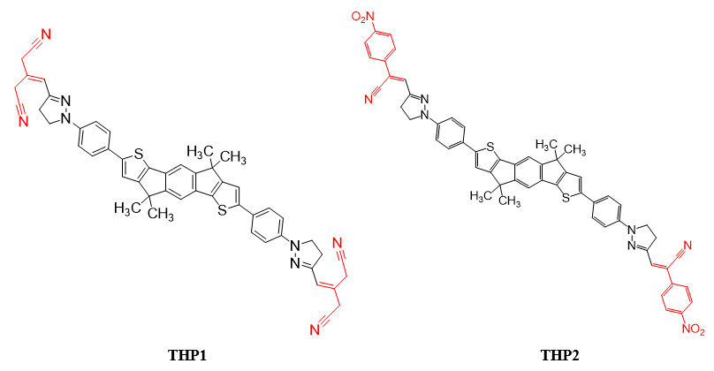
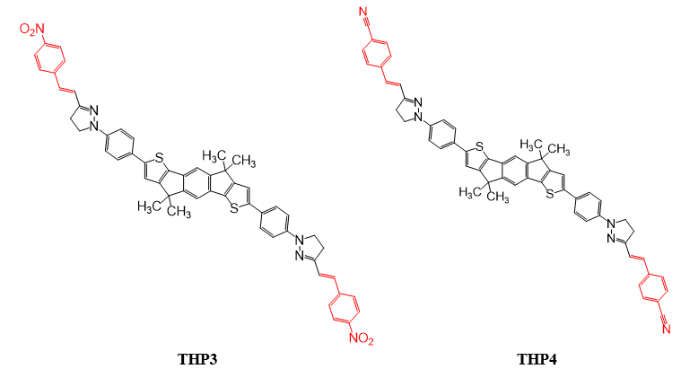
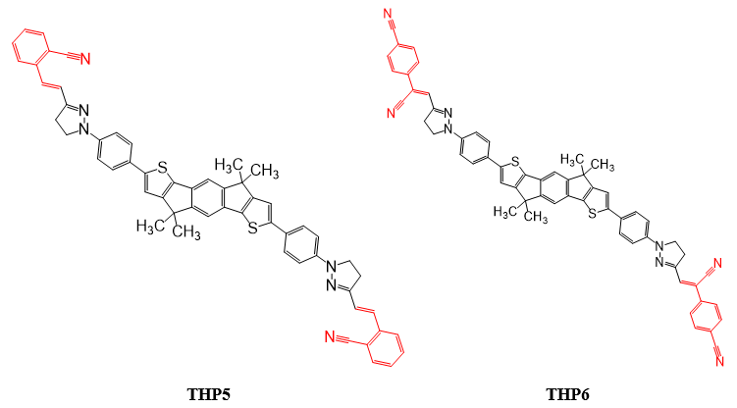
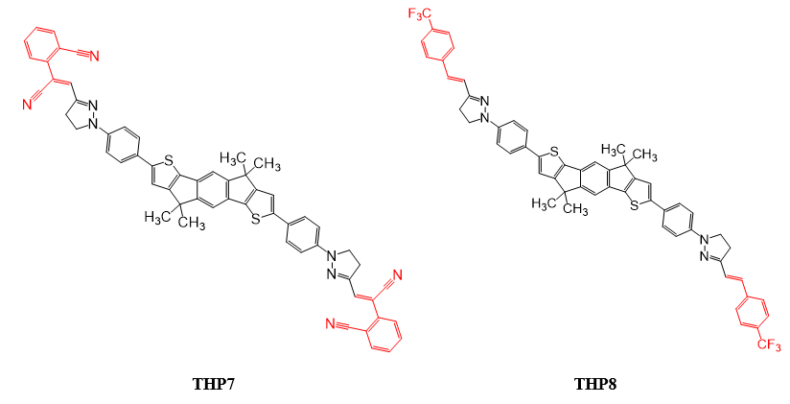
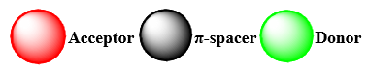
Figure S1: The chemical structures of investigated compounds (THP1-THP8).
3-ethylidenepentanedinitrile | 2-(4-nitrophenyl)acrylonitrile | 1-nitro-4-vinylbenzene
4-vinylbenzonitrile | 2-vinylbenzonitrile | 4-(1-cyanovinyl)benzonitrile
2-(1-cyanovinyl)benzonitrile | 1-(trifluoromethyl)-4-vinylbenzene
Figure S2: The structures of various acceptors with IUPAC names used in the designed molecules.
Compounds…. | HOMO-1 | LUMO+1
THP1 | 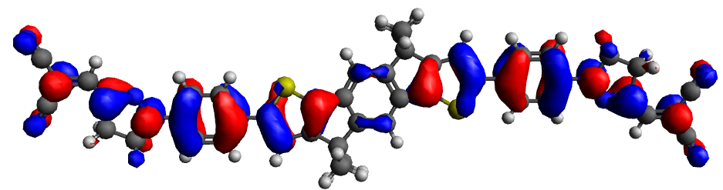 | 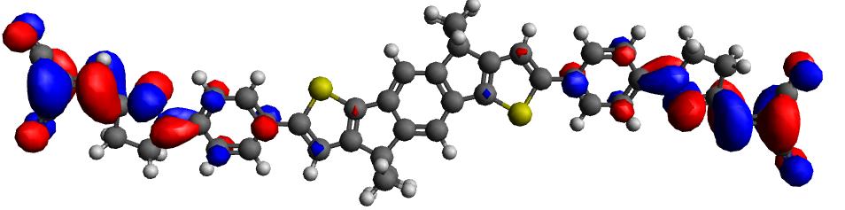
THP2 | 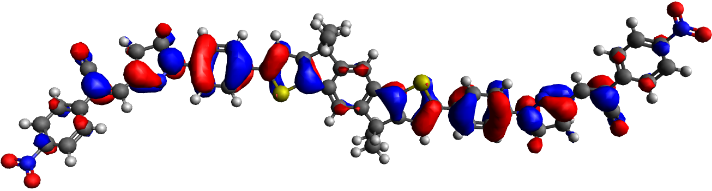 | 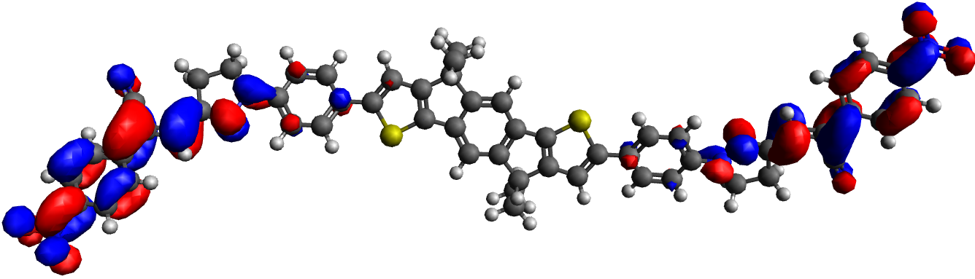
THP3 | 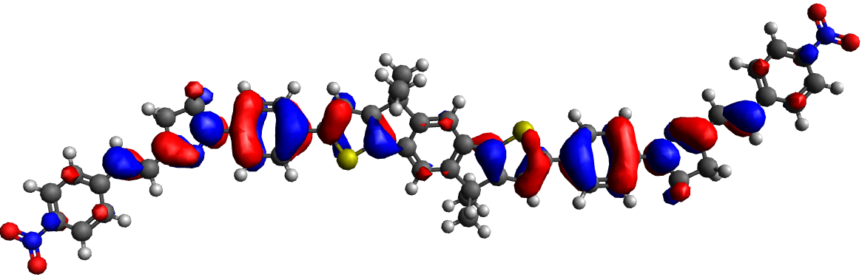 | 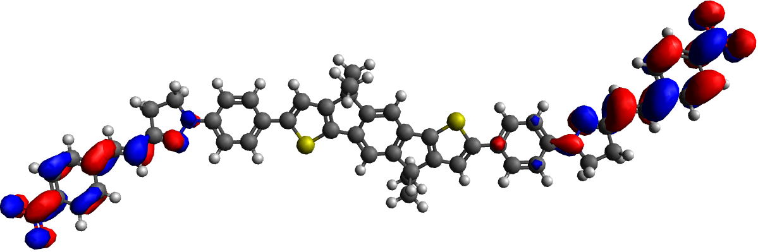
THP4 | 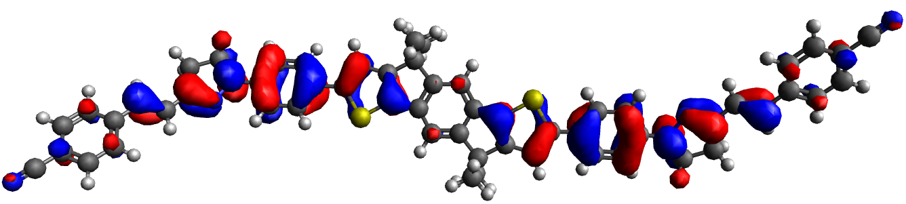 | 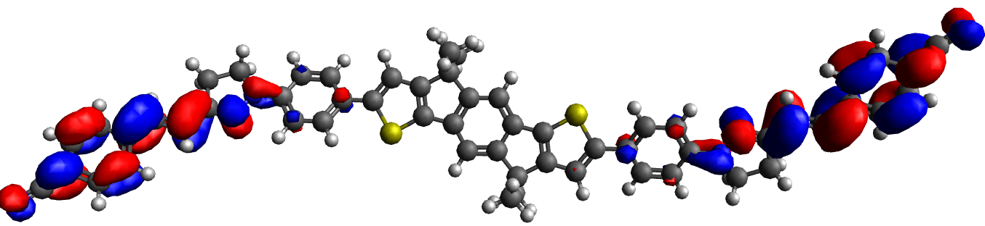
THP5 | 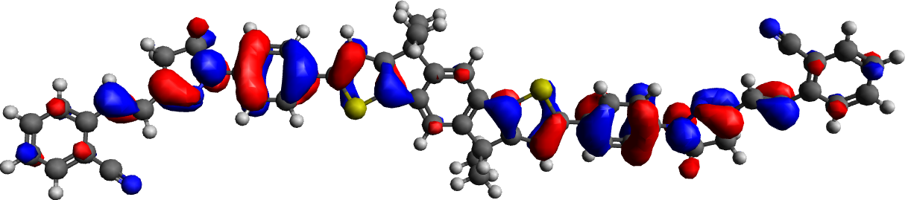 | 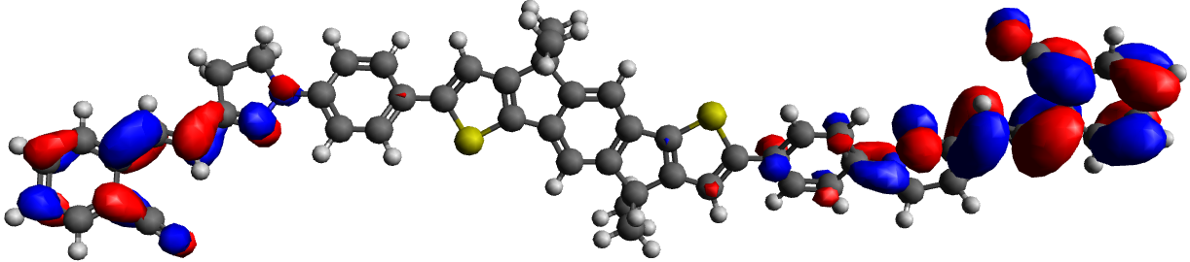
THP6 | 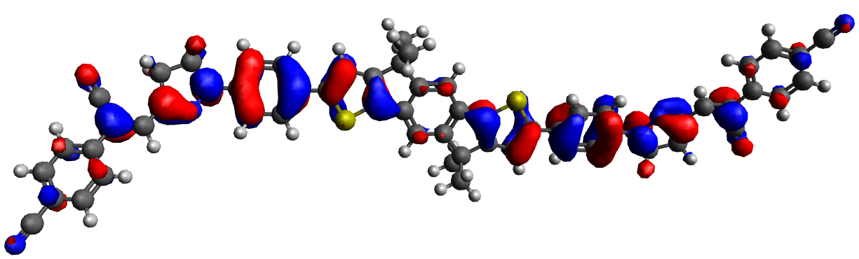 | 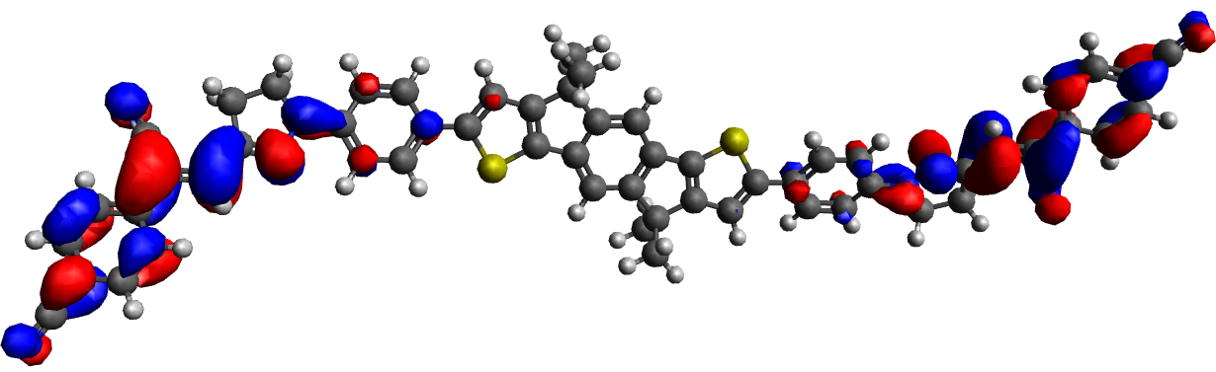
THP7 | 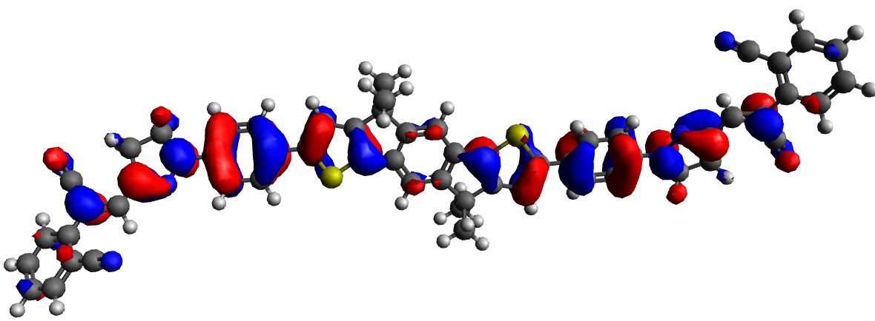 | 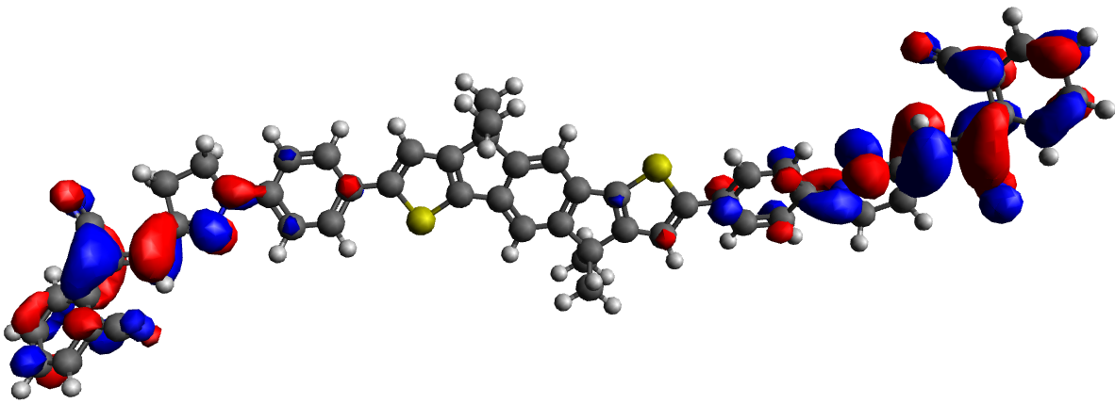
THP8 | 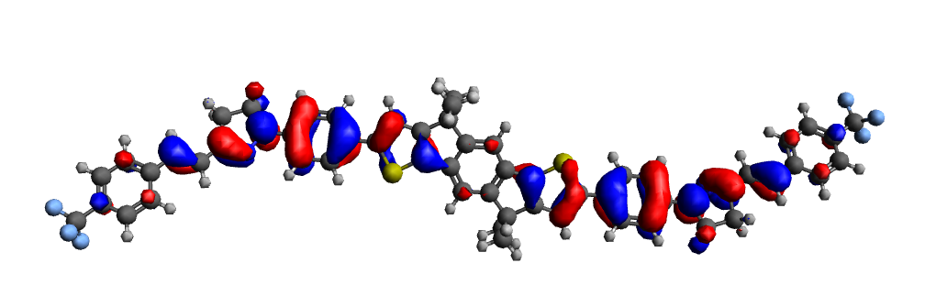 | 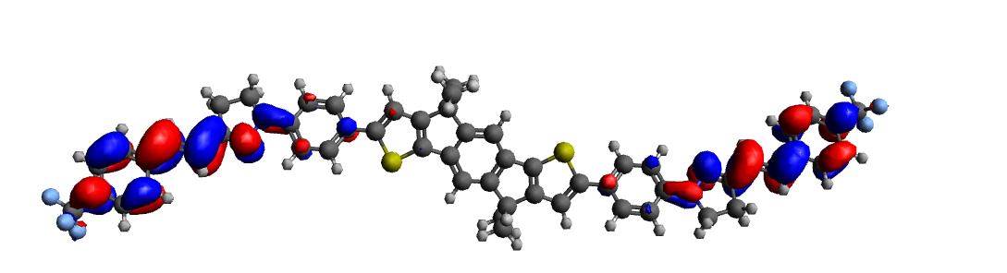
 | HOMO-2 | LUMO+2
THP1 | 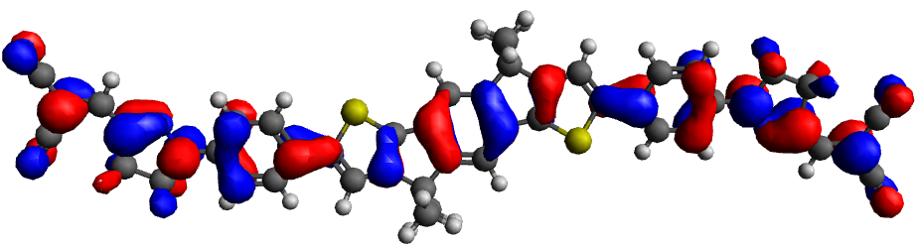 | 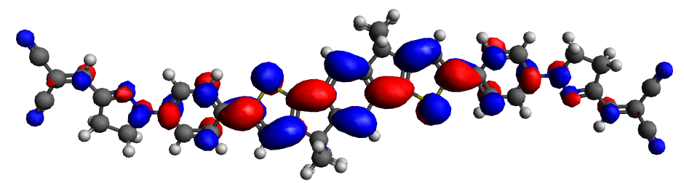
THP2 | 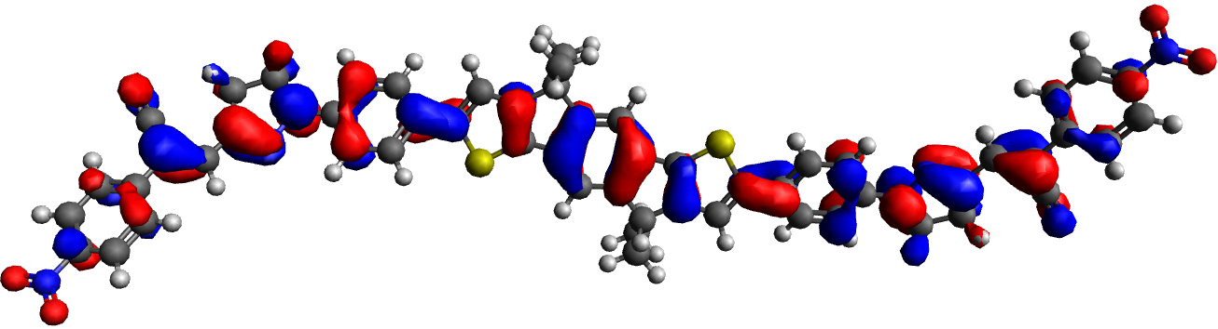 | 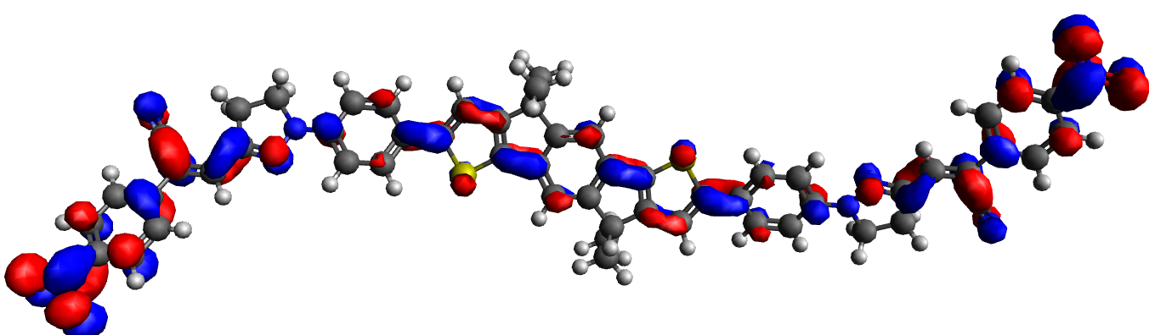
THP3 | 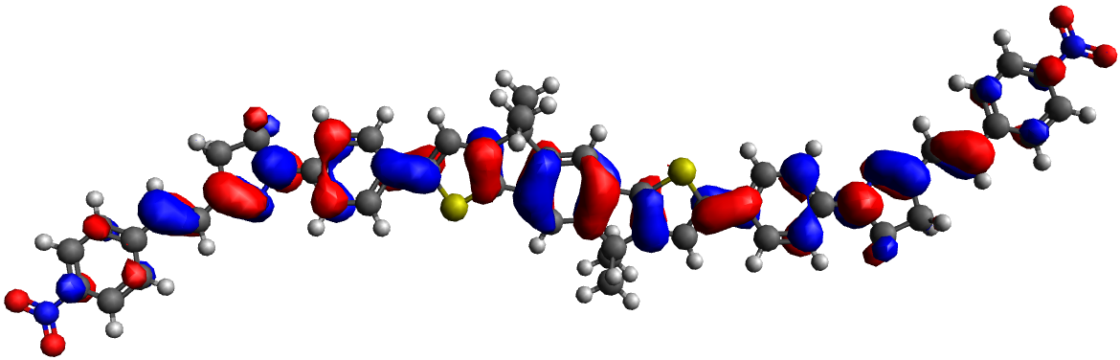 | 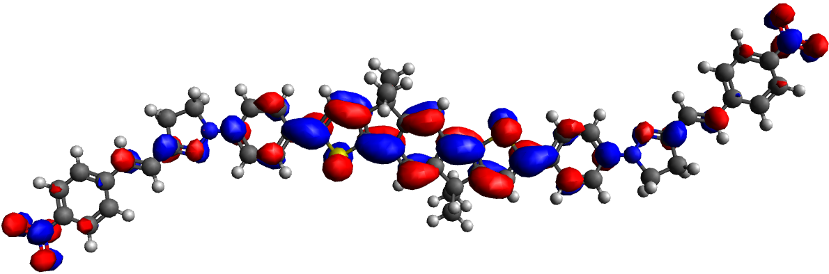
THP4 | 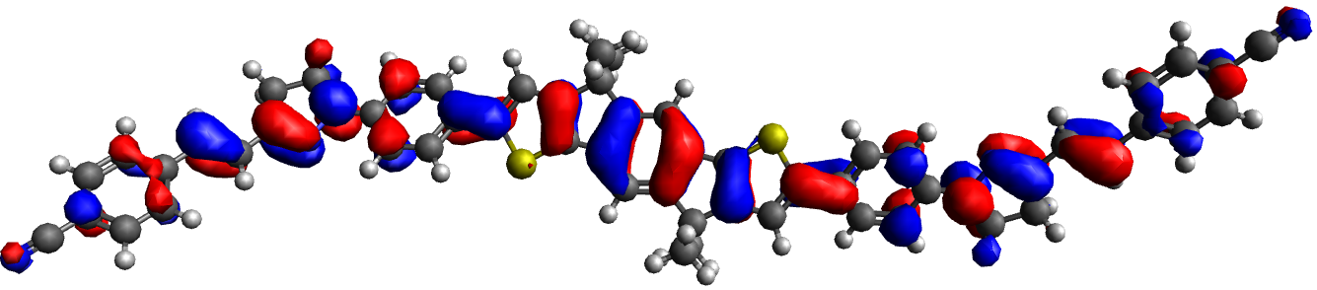 | 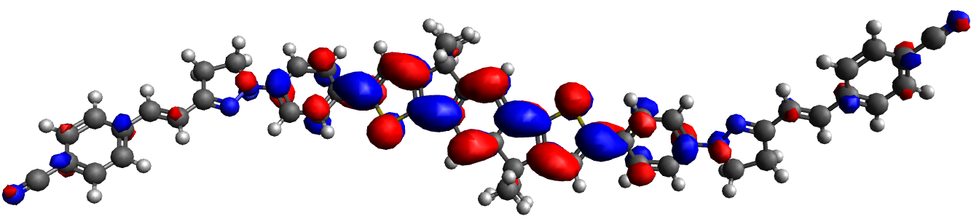
THP5 | 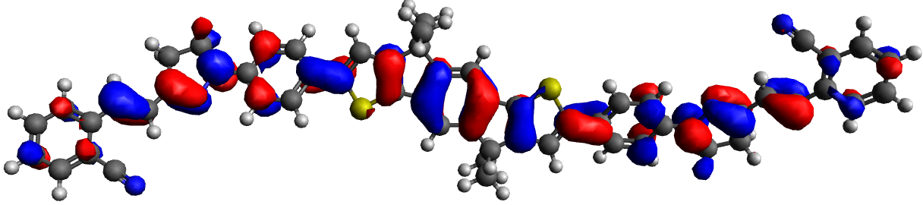 | 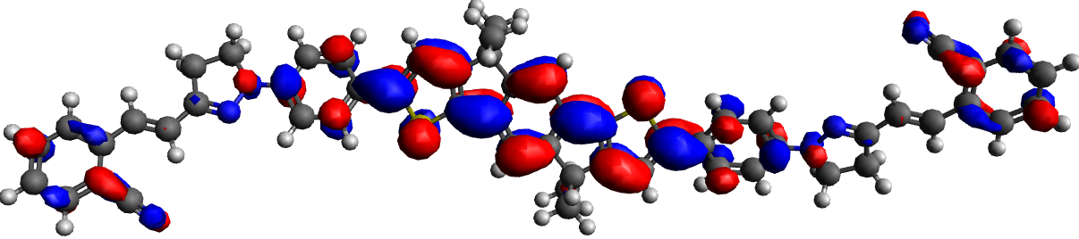
THP6 | 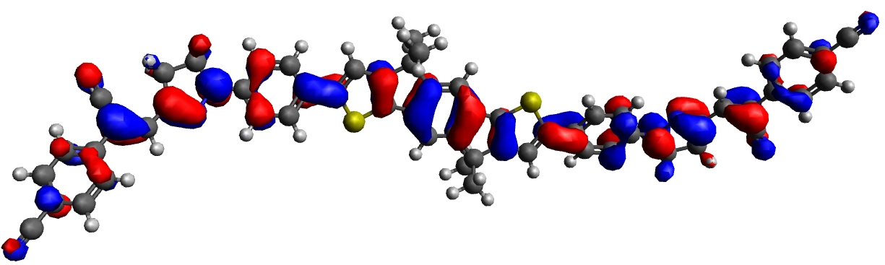 | 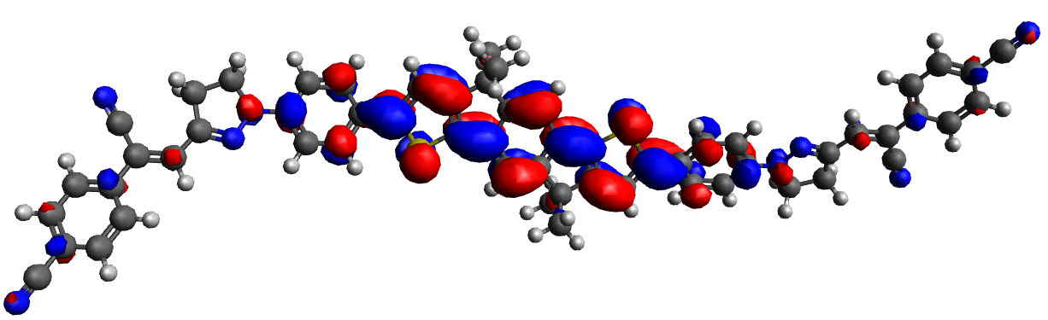
THP7 | 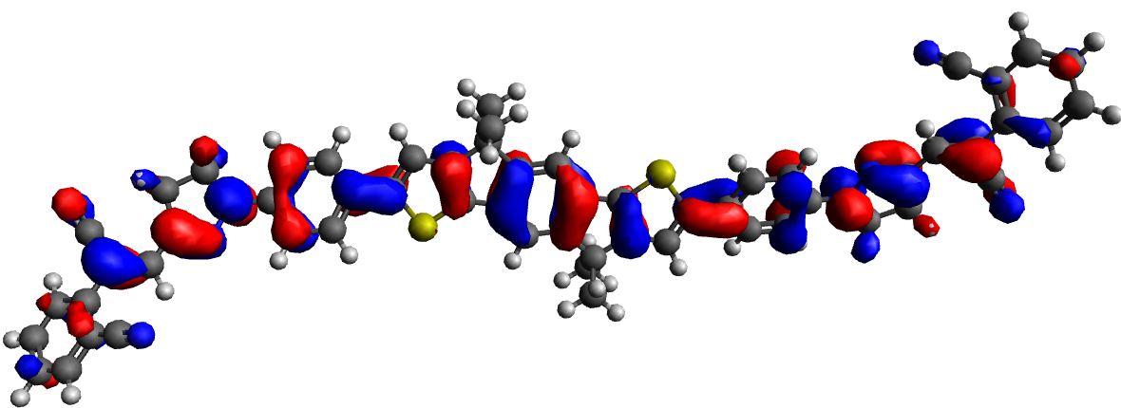 | 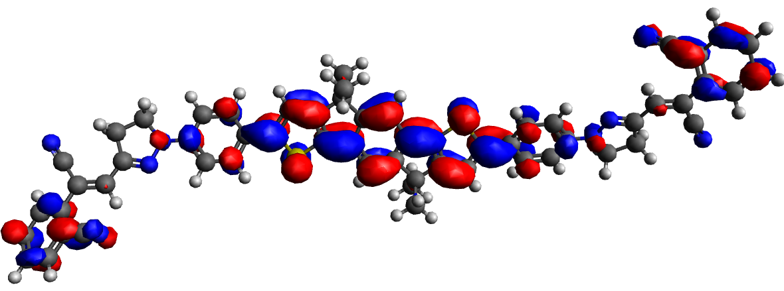
THP8 | 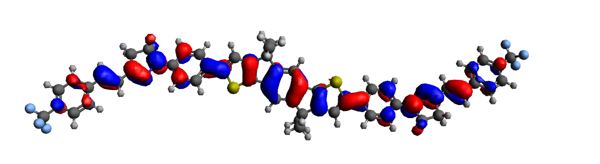 | 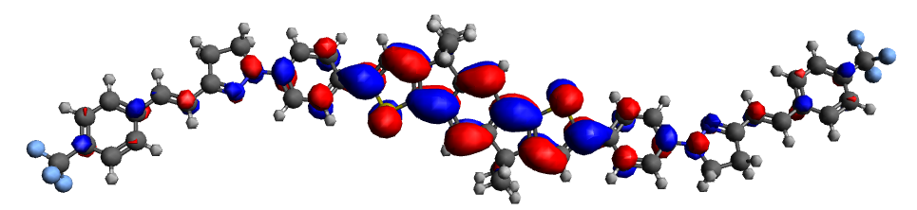
Figure S3: Frontier Molecular Orbitals (FMOs) of the studied compounds (THP1-THP8).

