Supporting Information

Synthesis and biological evaluation of chromone-thiazolidine-2,4-dione derivatives as potential α-glucosidase inhibitors

Yingying Zheng ª, Mengyu Li ª, Simin Wu ª, Lu Li ª, Zhuang Xiong ª, Xuetao Xu ^{a,} *, Kun Zhang ^{a,} *, Yi Wen ^{b,} *

Synthesis and characterization data of derivatives e1~ e28………………..……...…..2-9
¹H NMR and ¹³C NMR of compouds………………………………………..........…..10-37

Synthesis of derivatives e1~e28
The chromone derivatives bearing TZD moiety (e1~e28) were synthesized according to the synthetic route shown in Schemes 1. TZD (a) reacted with ethyl bromoacetate to yield ethyl 2-(2,4-dioxothiazolidin-3-yl) acetate b, which underwent Knoevenagel condensation reaction with chromene-3-carbaldehyde to produce intermediate c. Intermediate c underwent hydrolysis reaction to obtain corresponding intermediate d, followed by the condensation reaction with substituted amines to get the target chromone-thiazolidinedione derivatives (e1~e28). The structures of the compounds had been characterized and confirmed by ¹H-NMR, ¹³C-NMR and HRMS.
(e1, C₂₁H₁₄N₂O₅S). White sold; Yield 65%; m.p. 284.4 – 289.5 °C; ¹H NMR (500 MHz, DMSO) δ 10.39 (s, 1H), 8.98 (s, 1H), 8.15 (dd, J = 8.0, 1.6 Hz, 1H), 7.93 – 7.86 (m, 1H), 7.76 (t, J = 4.3 Hz, 2H), 7.57 (dd, J = 17.3, 8.0 Hz, 3H), 7.32 (t, J = 7.7 Hz, 2H), 7.08 (t, J = 7.4 Hz, 1H), 4.49 (s, 2H); ¹³C NMR (126 MHz, DMSO) δ 174.96, 168.64, 165.78, 163.90, 162.25, 155.41, 138.46, 135.21, 128.91, 126.71, 126.55, 125.60, 123.69, 123.06, 122.61, 119.13, 118.68, 117.80, 43.87. HRMS (ESI) [M+H]⁺ calcd. for C₂₁H₁₄N₂O₅S: 425.0517; found: 425.0516.
(e2, C₂₁H₁₃FN₂O₅S). White sold; Yield 54%; m.p. 296.2 – 302.5 °C; ¹H NMR (500 MHz, DMSO) δ 10.27 (s, 1H), 8.97 (s, 1H), 8.18 – 8.12 (m, 1H), 7.89 (t, J = 8.2 Hz, 2H), 7.75 (t, J = 4.1 Hz, 2H), 7.58 (t, J = 7.5 Hz, 1H), 7.33 – 7.25 (m, 1H), 7.17 (dt, J = 6.4, 3.1 Hz, 2H), 4.57 (s, 2H); ¹³C NMR (126 MHz, DMSO) δ 175.42, 169.08, 166.21, 164.98, 162.73, 155.86, 154.80, 152.86, 135.67, 127.18, 127.00, 126.10, 126.05, 124.98, 124.96, 124.19, 123.50, 123.04, 119.14, 118.24, 116.16, 116.00, 44.16. HRMS (ESI) [M+H]⁺ calcd. for C₂₁H₁₃FN₂O₅S: 447.0424; found: 447.0421.
(e3, C₂₁H₁₃FN₂O₅S). White sold; Yield 67%; m.p. 274.5 – 279.2 °C; ¹H NMR (500 MHz, DMSO) δ 10.63 (s, 1H), 8.97 (s, 1H), 8.15 (dd, J = 7.9, 1.7 Hz, 1H), 7.93 – 7.86 (m, 1H), 7.78 – 7.72 (m, 2H), 7.58 (t, J = 7.6 Hz, 1H), 7.53 (dt, J = 11.6, 2.3 Hz, 1H), 7.37 (q, J = 8.1 Hz, 1H), 7.28 (dd, J = 8.2, 1.9 Hz, 1H), 6.92 (td, J = 8.5, 2.6 Hz, 1H), 4.50 (s, 2H); ¹³C NMR (126 MHz, DMSO) δ 174.98, 168.65, 165.76, 164.39, 163.12, 162.32, 161.20, 155.42, 140.17, 140.08, 135.23, 130.68, 130.60, 126.83, 126.56, 125.61, 123.06, 122.54, 118.69, 117.78, 114.94, 114.92, 110.32, 110.15, 106.11, 105.90, 43.90. HRMS (ESI) [M+H]⁺ calcd. for C₂₁H₁₃FN₂O₅S: 447.0422; found: 447.0421.
(e4, C₂₁H₁₃FN₂O₅S). White sold; Yield 67%; m.p. 288.3 – 293.5 °C; ¹H NMR (500 MHz, DMSO) δ 10.44 (s, 1H), 8.96 (s, 1H), 8.17 – 8.12 (m, 1H), 7.92 – 7.85 (m, 1H), 7.75 (d, J = 7.2 Hz, 2H), 7.61 – 7.54 (m, 3H), 7.17 (t, J = 8.6 Hz, 2H), 4.48 (s, 2H); ¹³C NMR (126 MHz, DMSO) δ 174.94, 168.62, 165.75, 163.87, 162.23, 159.14, 157.23, 155.40, 135.20, 134.85, 134.83, 126.71, 126.53, 125.58, 123.04, 122.58, 120.98, 120.92, 118.66, 117.78, 115.58, 115.41, 43.79. HRMS (ESI) [M+H]⁺ calcd. for C₂₁H₁₃FN₂O₅S: 447.0422; found: 447.0421.
(e5, C₂₁H₁₃ClN₂O₅S). White sold; Yield 67%; m.p. 297.3 – 302.5 °C; ¹H NMR (500 MHz, DMSO) δ 10.07 (s, 1H), 8.98 (s, 1H), 8.15 (s, 1H), 7.96 – 7.47 (m, 6H), 7.40 – 7.16 (m, 2H), 4.58 (s, 2H). ¹³C NMR (126 MHz, DMSO) δ 174.96, 168.59, 165.73, 164.61, 162.23, 155.41, 135.21, 134.25, 129.64, 127.57, 126.69, 126.54, 126.37, 126.01, 125.59, 123.05, 122.62, 118.68, 117.80, 43.65. HRMS (ESI) [M+H]⁺ calcd. for C₂₁H₁₃ClN₂O₅S: 463.0128; found: 463.0126.
(e6, C₂₁H₁₃ClN₂O₅S). White sold; Yield 70%; m.p. 288.9 – 290.1 °C; ¹H NMR (500 MHz, DMSO) δ 10.60 (s, 1H), 8.98 (s, 1H), 8.15 (d, J = 7.9 Hz, 1H), 7.89 (t, J = 7.9 Hz, 1H), 7.75 (d, J = 6.8 Hz, 3H), 7.57 (s, 1H), 7.48 – 7.31 (m, 2H), 7.14 (d, J = 7.9 Hz, 1H), 4.50 (s, 2H); ¹³C NMR (126 MHz, DMSO) δ 174.97, 168.65, 165.75, 164.42, 162.33, 155.41, 139.84, 135.22, 133.20, 130.67, 126.83, 126.55, 125.60, 123.46, 123.05, 122.52, 118.68, 117.77, 117.57, 43.91. HRMS (ESI) [M+H]⁺ calcd. for C₂₁H₁₃ClN₂O₅S: 463.0126; found: 463.0126.
(e7, C₂₁H₁₃ClN₂O₅S). White sold; Yield 67%; m.p. 289.3- 291.3°C; ¹H NMR (500 MHz, DMSO) δ 10.54 (s, 1H), 8.98 (s, 1H), 8.15 (dd, J = 8.0, 1.6 Hz, 1H), 7.93 – 7.87 (m, 1H), 7.76 (t, J = 4.3 Hz, 2H), 7.63 – 7.55 (m, 3H), 7.39 (d, J = 8.5 Hz, 2H), 4.49 (s, 2H); ¹³C NMR (126 MHz, DMSO) δ 174.97, 168.65, 165.77, 164.15, 162.30, 155.41, 137.40, 135.22, 128.85, 127.27, 126.79, 126.56, 125.60, 123.06, 122.56, 120.73, 118.69, 117.78, 43.88. HRMS (ESI) [M+H]⁺ calcd. for C₂₁H₁₃ClN₂O₅S: 463.0126; found: 463.0126.
(e8, C₂₁H₁₃BrN₂O₅S). White sold; Yield 69%; m.p. 310.5 - 315 °C;¹H NMR (500 MHz, DMSO) δ 10.01 (s, 1H), 8.97 (s, 1H), 8.15 (d, J = 8.0 Hz, 1H), 7.89 (t, J = 7.9 Hz, 1H), 7.75 (d, J = 7.1 Hz, 2H), 7.68 (d, J = 8.0 Hz, 1H), 7.58 (dd, J = 8.2, 5.1 Hz, 2H), 7.38 (t, J = 7.8 Hz, 1H), 7.16 (t, J = 7.8 Hz, 1H), 4.55 (s, 2H). ¹³C NMR (126 MHz, DMSO) δ 175.42, 169.03, 166.17, 162.68, 155.87, 136.02, 135.67, 133.29, 131.46, 130.56, 129.43, 128.59, 127.50, 127.12, 127.00, 126.05, 123.51, 123.09, 119.14, 118.25, 44.07. HRMS (ESI) [M+H]⁺ calcd. for C₂₁H₁₃BrN₂O₅S: 506.9623; found: 506.9621.
(e9, C₂₁H₁₃BrN₂O₅S). White sold; Yield 73%; m.p. 304.5 - 310.5 °C; ¹H NMR (500 MHz, DMSO) δ 10.58 (s, 1H), 8.97 (s, 1H), 8.18 - 8.12 (m, 1H), 7.89 (dt, J = 8.6, 4.5 Hz, 2H), 7.75 (d, J = 7.3 Hz, 2H), 7.58 (t, J = 7.5 Hz, 1H), 7.49 - 7.44 (m, 1H), 7.33 - 7.25 (m, 2H), 4.50 (s, 2H); ¹³C NMR (126 MHz, DMSO) δ 174.97, 168.64, 165.75, 164.40, 162.32, 155.41, 139.97, 135.21, 130.96, 126.82, 126.55, 126.36, 125.60, 123.05, 122.52, 121.66, 121.53, 118.68, 117.95, 117.77, 43.90. HRMS (ESI) [M+H]⁺ calcd. for C₂₁H₁₃BrN₂O₅S: 506.9624; found: 506.9621.
(e10, C₂₁H₁₃BrN₂O₅S). Yellow sold; Yield 71%; m.p. 293.3 - 300.5 °C; ¹H NMR (500 MHz, DMSO) δ 10.54 (s, 1H), 8.97 (s, 1H), 8.15 (d, J = 7.9 Hz, 1H), 7.89 (t, J = 7.9 Hz, 1H), 7.75 (t, J = 4.3 Hz, 2H), 7.58 (t, J = 7.6 Hz, 1H), 7.56 - 7.48 (m, 4H), 4.49 (s, 2H); ¹³C NMR (126 MHz, DMSO) δ 174.96, 168.64, 165.76, 164.16, 162.30, 155.41, 137.81, 135.22, 131.75, 126.79, 126.55, 125.59, 123.05, 122.55, 121.10, 118.68, 117.77, 115.32, 43.90. HRMS (ESI) [M+H]⁺ calcd. for C₂₁H₁₃BrN₂O₅S: 506.9623; found: 506.9621.
(e11, C₂₁H₁₃N₃O₇S). White sold; Yield 67%; m.p. 295.4 - 298.8 °C; ¹H NMR (500 MHz, DMSO) δ 10.72 (s, 1H), 8.98 (s, 1H), 8.15 (d, J = 8.0 Hz, 1H), 8.02 - 7.85 (m, 2H), 7.82 - 7.53 (m, 5H), 7.42 (t, J = 8.1 Hz, 1H), 4.53 (s, 2H). ¹³C NMR (126 MHz, DMSO) δ 174.96, 168.50, 165.61, 164.68, 162.31, 155.41, 142.54, 135.22, 134.11, 130.28, 126.83, 126.55, 125.88, 125.59, 125.55, 125.06, 123.04, 122.52, 118.68, 117.76, 43.66. HRMS (ESI) [M+H]⁺ calcd. for C₂₁H₁₃N₃O₇S: 474.0368; found: 474.0366.
(e12, C₂₁H₁₃N₃O₇S). White sold; Yield 77%; m.p. 287.8 - 295.5 °C;¹H NMR (500 MHz, DMSO) δ 11.04 (s, 1H), 8.98 (s, 1H), 8.24 (d, J = 9.3 Hz, 2H), 8.15 (dd, J = 8.0, 1.6 Hz, 1H), 7.90 (t, J = 7.8 Hz, 1H), 7.81 (d, J = 8.8 Hz, 2H), 7.77 - 7.74 (m, 2H), 7.58 (t, J = 7.6 Hz, 1H), 4.57 (s, 2H); ¹³C NMR (126 MHz, DMSO) δ 174.99, 168.64, 165.73, 165.10, 162.41, 155.42, 144.50, 142.58, 135.24, 126.97, 126.57, 125.60, 125.15, 123.05, 122.46, 119.01, 118.69, 117.76, 44.07. HRMS (ESI) [M+H]⁺ calcd. for C₂₁H₁₃N₃O₇S: 474.0368; found: 474.0366.
(e13, C₂₁H₁₃N₃O₇S). Yellow sold; Yield 61%; m.p. 280.5 - 285.3 °C; ¹H NMR (500 MHz, DMSO) δ 11.04 (s, 1H), 8.98 (s, 1H), 8.24 (d, J = 9.1 Hz, 2H), 8.15 (dd, J = 7.9, 1.6 Hz, 1H), 7.90 (td, J = 7.7, 1.7 Hz, 1H), 7.81 (d, J = 8.8 Hz, 2H), 7.78 – 7.73 (m, 2H), 7.58 (q, J = 7.4 Hz, 1H), 4.57 (s, 2H); ¹³C NMR (126 MHz, DMSO) δ 175.43, 169.09, 166.18, 165.55, 162.85, 155.86, 144.94, 143.02, 135.69, 127.42, 127.02, 126.05, 125.60, 123.50, 122.91, 119.46, 119.14, 118.20, 44.52. HRMS (ESI) [M+H]⁺ calcd. for C₂₁H₁₃N₃O₇S: 452.0547; found: 452.0547.
(e14, C₂₂H₁₆N₂O₅S). White sold; Yield 63%; m.p. 307.7 - 310.8 °C; ¹H NMR (500 MHz, DMSO) δ 9.76 (s, 1H), 8.98 (s, 1H), 8.15 (s, 1H), 8.01 - 7.51 (m, 4H), 7.43 – 6.99 (m, 4H), 4.52 (s, 2H), 2.22 (s, 3H). ¹³C NMR (126 MHz, DMSO) δ 174.95, 168.62, 165.79, 164.14, 162.15, 155.41, 135.61, 135.20, 131.87, 130.42, 126.53, 126.06, 125.59, 124.89, 123.05, 122.73, 118.67, 117.82, 43.65, 17.80. HRMS (ESI) [M+H]⁺ calcd. for C₂₂H₁₆N₂O₅S: 443.0675; found: 443.0672.
(e15, C₂₂H₁₆N₂O₅S). White sold; Yield 65%; m.p. 277.8 - 282.5 °C; ¹H NMR (500 MHz, DMSO) δ 10.31 (s, 1H), 8.97 (s, 1H), 8.15 (d, J = 7.9 Hz, 1H), 7.89 (t, J = 8.0 Hz, 1H), 7.75 (t, J = 4.2 Hz, 2H), 7.58 (t, J = 7.5 Hz, 1H), 7.41 (s, 1H), 7.33 (d, J = 8.1 Hz, 1H), 7.20 (t, J = 7.8 Hz, 1H), 6.89 (d, J = 7.5 Hz, 1H), 4.47 (s, 2H), 2.27 (s, 3H); ¹³C NMR (126 MHz, DMSO) δ 175.41, 169.10, 166.23, 164.27, 162.68, 155.86, 138.83, 138.57, 135.66, 129.18, 127.12, 126.99, 126.05, 124.83, 123.50, 123.07, 120.15, 119.13, 118.24, 116.78, 44.33, 21.63. HRMS (ESI) [M+H]⁺ calcd. for C₂₂H₁₆N₂O₅S: 443.0674; found: 443.0672.
(e16, C₂₂H₁₆N₂O₅S). White sold; Yield 54%; m.p. 306.9 - 311.3 °C; ¹H NMR (500 MHz, DMSO) δ 10.29 (s, 1H), 8.97 (s, 1H), 8.15 (dd, J = 8.1, 1.7 Hz, 1H), 7.89 (ddd, J = 8.6, 7.2, 1.7 Hz, 1H), 7.75 (t, J = 4.2 Hz, 2H), 7.58 (t, J = 7.5 Hz, 1H), 7.44 (d, J = 8.4 Hz, 2H), 7.12 (d, J = 8.1 Hz, 2H), 4.47 (s, 2H), 2.25 (s, 3H); ¹³C NMR (126 MHz, DMSO) δ 174.96, 168.64, 165.78, 163.63, 162.22, 155.41, 135.96, 135.21, 132.63, 129.27, 126.66, 126.54, 125.60, 123.05, 122.64, 119.15, 118.68, 117.80, 43.83, 20.46. HRMS (ESI) [M+H]⁺ calcd. for C₂₂H₁₆N₂O₅S: 443.0674; found: 443.0672.
(e17, C₂₂H₁₆N₂O₆S). White sold; Yield 57%; m.p. 274.3 - 275.2 °C; ¹H NMR (500 MHz, DMSO) δ 9.74 (s, 1H), 8.97 (s, 1H), 8.15 (d, J = 7.9 Hz, 1H), 7.96 - 7.84 (m, 2H), 7.75 (d, J = 6.2 Hz, 2H), 7.58 (t, J = 7.6 Hz, 1H), 7.08 (d, J = 9.0 Hz, 2H), 6.90 (t, J = 7.5 Hz, 1H), 4.58 (s, 2H), 3.87 (s, 3H); ¹³C NMR (126 MHz, DMSO) δ 175.40, 169.09, 166.24, 164.56, 162.65, 155.85, 149.90, 135.65, 127.13, 127.08, 126.98, 126.04, 125.19, 123.50, 123.06, 122.11, 120.75, 119.12, 118.25, 111.73, 56.17, 44.33. HRMS (ESI) [M+H]⁺ calcd. for C₂₂H₁₆N₂O₆S: 459.0621; found: 459.0621.
(e18, C₂₂H₁₆N₂O₆S). White sold; Yield 66%; m.p. 266.9 - 281.4 °C; ¹H NMR (500 MHz, DMSO) δ 10.39 (s, 1H), 8.97 (s, 1H), 8.20 – 8.10 (m, 1H), 7.93 - 7.84 (m, 1H), 7.75 (t, J = 4.3 Hz, 2H), 7.58 (t, J = 7.5 Hz, 1H), 7.30 - 7.18 (m, 2H), 7.07 (d, J = 8.5 Hz, 1H), 6.66 (dd, J = 8.3, 2.5 Hz, 1H), 4.48 (s, 2H), 3.72 (s, 3H); ¹³C NMR (126 MHz, DMSO) δ 174.96, 168.65, 165.77, 163.96, 162.26, 159.58, 155.41, 139.64, 135.21, 129.73, 126.74, 126.54, 125.60, 123.05, 122.58, 118.68, 117.79, 111.33, 109.25, 104.78, 54.99, 43.89. HRMS (ESI) [M+H]⁺ calcd. for C₂₂H₁₆N₂O₆S: 459.0621; found: 459.0621.
(e19, C₂₂H₁₆N₂O₆S). White sold; Yield 63%; m.p. 288.5 - 295.7 °C; 1H NMR (500 MHz, DMSO) δ 10.24 (s, 1H), 8.97 (s, 1H), 8.15 (dd, J = 8.0, 1.7 Hz, 1H), 7.89 (ddd, J = 8.6, 7.2, 1.7 Hz, 1H), 7.75 (t, J = 4.3 Hz, 2H), 7.58 (t, J = 7.6 Hz, 1H), 7.50 - 7.43 (m, 2H), 6.93 - 6.86 (m, 2H), 4.45 (s, 2H), 3.72 (s, 3H); ¹³C NMR (126 MHz, DMSO) δ 175.40, 169.10, 166.24, 163.82, 162.66, 155.90, 155.86, 135.65, 132.04, 127.08, 126.99, 126.05, 123.50, 123.09, 121.13, 119.13, 118.25, 114.44, 55.62, 44.21. HRMS (ESI) [M+H]⁺ calcd. for C₂₂H₁₆N₂O₆S: 459.0621; found: 459.0621.
(e20, C₂₂H₁₃N₃O₅S). Yellow sold; Yield 54%; m.p. 291.4 - 295.7 °C; ¹H NMR (500 MHz, DMSO) δ 10.68 (s, 1H), 8.99 (s, 1H), 8.16 (d, J = 8.0 Hz, 1H), 7.93 - 7.83 (m, 2H), 7.78 - 7.69 (m, 3H), 7.65 (d, J = 8.2 Hz, 1H), 7.59 (t, J = 7.6 Hz, 1H), 7.39 (t, J = 7.6 Hz, 1H), 4.57 (s, 2H); ¹³C NMR (126 MHz, DMSO) δ 174.97, 168.56, 165.68, 164.90, 162.30, 155.40, 139.38, 135.21, 134.00, 133.50, 126.78, 126.54, 126.07, 125.59, 125.22, 123.05, 122.57, 118.68, 117.77, 116.60, 106.70, 43.62. HRMS (ESI) [M+H]⁺ calcd. for C₂₂H₁₃N₃O₅S: 454.0468; found: 454.0468.
(e21, C₂₂H₁₃N₃O₅S). White sold; Yield 67%; m.p. 287.1 - 294.2 °C; ¹H NMR (500 MHz, DMSO) δ 10.77 (s, 1H), 8.97 (s, 1H), 8.15 (d, J = 8.0 Hz, 1H), 8.03 (s, 1H), 7.89 (s, 1H), 7.77 (d, J = 14.3 Hz, 3H), 7.56 (s, 3H), 4.52 (s, 2H); ¹³C NMR (126 MHz, DMSO) δ 175.41, 169.09, 166.19, 165.18, 162.80, 155.85, 139.63, 135.66, 130.92, 127.79, 127.33, 126.99, 126.04, 124.21, 123.49, 122.93, 122.30, 119.12, 119.03, 118.20, 112.19, 44.35. HRMS (ESI) [M+H]⁺ calcd. for C₂₂H₁₃N₃O₅S: 454.0468; found: 454.0468.
(e22, C₂₂H₁₃N₃O₅S). White sold; Yield 59%; m.p. 302.2 - 305.7 °C; ¹H NMR (500 MHz, DMSO) δ 10.85 (s, 1H), 8.97 (s, 1H), 8.14 (d, J = 7.9 Hz, 1H), 7.89 (t, J = 8.0 Hz, 1H), 7.84 - 7.66 (m, 6H), 7.58 (t, J = 7.7 Hz, 1H), 4.54 (s, 2H); ¹³C NMR (126 MHz, DMSO) δ 174.98, 168.64, 165.73, 164.91, 162.38, 155.41, 142.58, 135.23, 133.49, 126.94, 126.56, 125.60, 123.05, 122.47, 119.26, 118.96, 118.69, 117.76, 105.53, 44.02. HRMS (ESI) [M+H]⁺ calcd. for C₂₂H₁₃N₃O₅S: 470.0212; found: 470.0207.
(e23, C₂₂H₁₃F₃N₂O₅S). Yellow sold; Yield 67%; m.p. 309.4 - 312.5 °C; ¹H NMR (500 MHz, DMSO) δ 10.11 (s, 1H), 8.98 (s, 1H), 8.16 (s, 1H), 7.90 (s, 1H), 7.76 (s, 3H), 7.64 - 7.37 (m, 3H), 4.51 (s, 2H). ¹³C NMR (126 MHz, DMSO) δ 167.49, 162.22, 159.76, 156.88, 141.41, 140.89, 135.66, 134.56, 134.25, 133.55, 131.77, 131.04, 130.07, 128.86, 127.30, 126.56, 125.61, 124.75, 119.12, 116.89, 49.49. HRMS (ESI) [M+H]⁺ calcd. for C₂₂H₁₃F₃N₂O₅S: 497.0389; found: 497.0389.
(e24, C₂₂H₁₃F₃N₂O₅S). Yellow sold; Yield 52 %; m.p. 297.4 - 302.5 °C; ¹H NMR (500 MHz, DMSO) δ 9.92 (s, 1H), 8.14 (s, 1H), 7.31 (d, J = 7.9 Hz, 1H), 7.21 (s, 1H), 7.05 (t, J = 7.9 Hz, 1H), 6.93 - 6.87 (m, 3H), 6.74 (t, J = 7.7 Hz, 2H), 6.60 (d, J = 7.7 Hz, 1H), 3.68 (s, 2H); ¹³C NMR (126 MHz, DMSO) δ 175.42, 169.11, 166.21, 165.13, 162.79, 155.86, 139.61, 135.67, 130.70, 130.15, 129.90, 127.31, 127.00, 126.05, 125.57, 123.50, 123.40, 123.21, 122.96, 120.56, 119.13, 118.22, 115.68, 44.36. HRMS (ESI) [M+H]⁺ calcd. for C₂₂H₁₃F₃N₂O₅S: 497.0389; found: 497.0389.
(e25, C₂₂H₁₃F₃N₂O₅S). Yellow sold; Yield 68%; m.p. 297.0 - 302.6 °C; ¹H NMR (500 MHz, DMSO) δ 10.78 (s, 1H), 8.98 (s, 1H), 8.15 (d, J = 7.9 Hz, 1H), 7.89 (t, J = 7.9 Hz, 1H), 7.77 (d, J = 8.3 Hz, 4H), 7.70 (d, J = 8.5 Hz, 2H), 7.58 (t, J = 7.6 Hz, 1H), 4.54 (s, 2H); ¹³C NMR (126 MHz, DMSO) δ 175.43, 169.10, 166.21, 165.15, 162.81, 155.86, 142.42, 135.68, 127.33, 127.01, 126.74, 126.71, 126.05, 123.51, 122.96, 119.58, 119.14, 118.22, 44.42. HRMS (ESI) [M+H]⁺ calcd. for C₂₂H₁₃F₃N₂O₅S: 497.0391; found: 497.0389.
(e26, C₂₁H₁₂F₂N₂O₅S). White sold; Yield 57%; m.p. 284.5 - 290.5 °C; ¹H NMR (500 MHz, DMSO) δ 10.65 (s, 1H), 8.97 (s, 1H), 8.14 (d, J = 7.9 Hz, 1H), 7.92 - 7.85 (m, 1H), 7.78 - 7.68 (m, 3H), 7.58 (t, J = 7.5 Hz, 1H), 7.41 (q, J = 9.6 Hz, 1H), 7.30 – 7.24 (m, 1H), 4.49 (s, 2H); ¹³C NMR (126 MHz, DMSO) δ 174.97, 168.64, 165.74, 164.33, 162.33, 155.41, 135.47, 135.41, 135.22, 126.85, 126.56, 125.60, 123.05, 122.51, 118.68, 117.77, 117.63, 115.55, 108.35, 108.17, 43.83. HRMS (ESI) [M+H]⁺ calcd. for C₂₁H₁₃F₂N₂O₅S: 465.0327; found: 465.0327.
(e27, C₂₁H₁₂Cl₂N₂OS). White sold; Yield 62%; m.p. 293.6 - 295.4 °C; ¹H NMR (500 MHz, DMSO) δ 10.71 (s, 1H), 8.98 (s, 1H), 8.15 (d, J = 7.9 Hz, 1H), 7.95 - 7.83 (m, 2H), 7.75 (t, J = 4.2 Hz, 2H), 7.59 (dd, J = 8.4, 3.4 Hz, 2H), 7.46 (dd, J = 8.8, 2.5 Hz, 1H), 4.50 (s, 2H); 13C NMR (126 MHz, DMSO) δ 174.98, 168.64, 165.74, 164.60, 162.37, 155.41, 138.47, 135.23, 131.15, 130.91, 126.89, 126.56, 125.60, 125.22, 123.05, 122.49, 120.43, 119.26, 118.69, 117.76, 43.92. HRMS (ESI) [M+H]⁺ calcd. for C₂₁H₁₃Cl₂N₂O₅S: 496.9739; found: 496.9736.
(e28, C₂₁H₁₂Br₂N₂OS). White sold; Yield 70%; m.p. 297.4 - 299.5 °C; ¹H NMR (500 MHz, DMSO) δ 10.68 (s, 1H), 8.98 (s, 1H), 8.22 - 8.01 (m, 2H), 7.89 (t, J = 7.9 Hz, 1H), 7.83 - 7.65 (m, 3H), 7.58 (t, J = 7.7 Hz, 1H), 7.42 (d, J = 8.8 Hz, 1H), 4.50 (s, 2H). ¹³C NMR (126 MHz, DMSO) δ 174.97, 168.64, 165.74, 164.58, 162.36, 155.41, 138.94, 135.22, 133.96, 126.88, 126.56, 125.60, 123.87, 123.55, 123.05, 122.49, 119.92, 118.68, 117.76, 117.40, 43.93. HRMS (ESI) [M+H]⁺ calcd. for C₂₁H₁₃Br₂N₂O₅S: 600.8467; found: 600.8465.
¹H NMR and ¹³C NMR of compouds
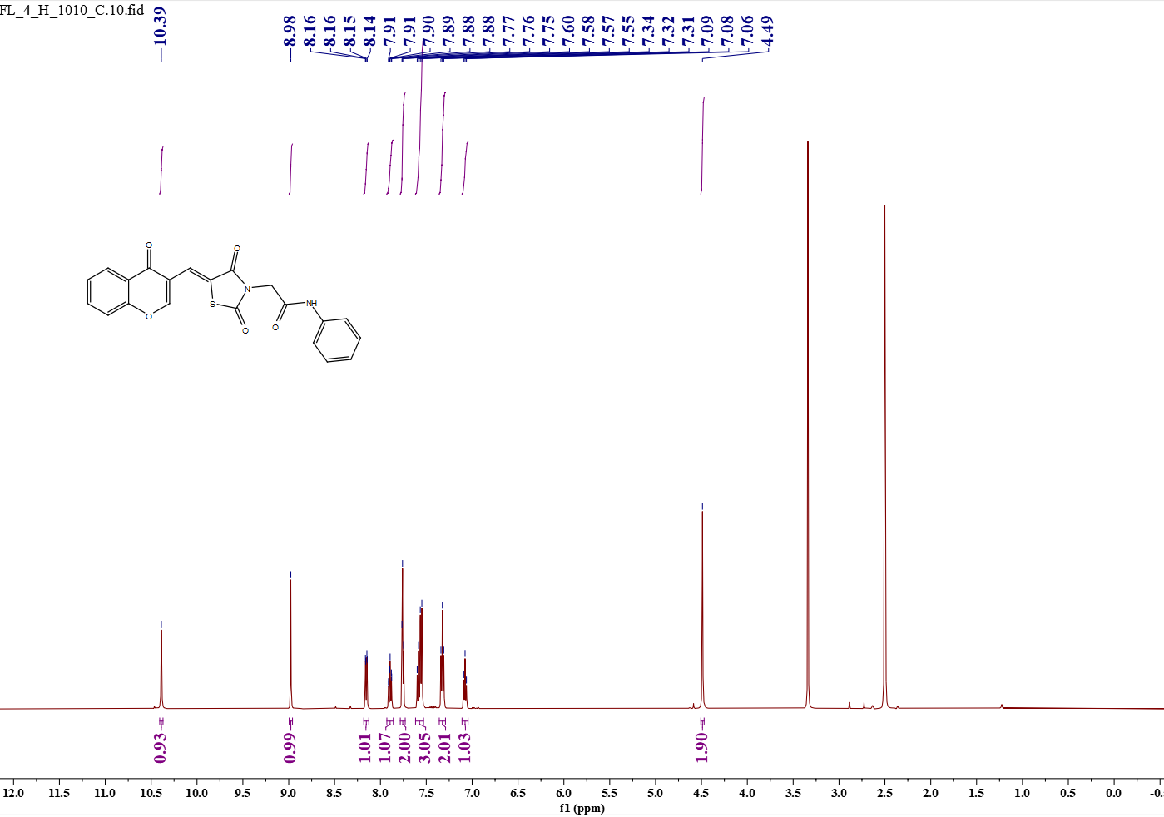
Fig.1 e1 (¹H NMR)
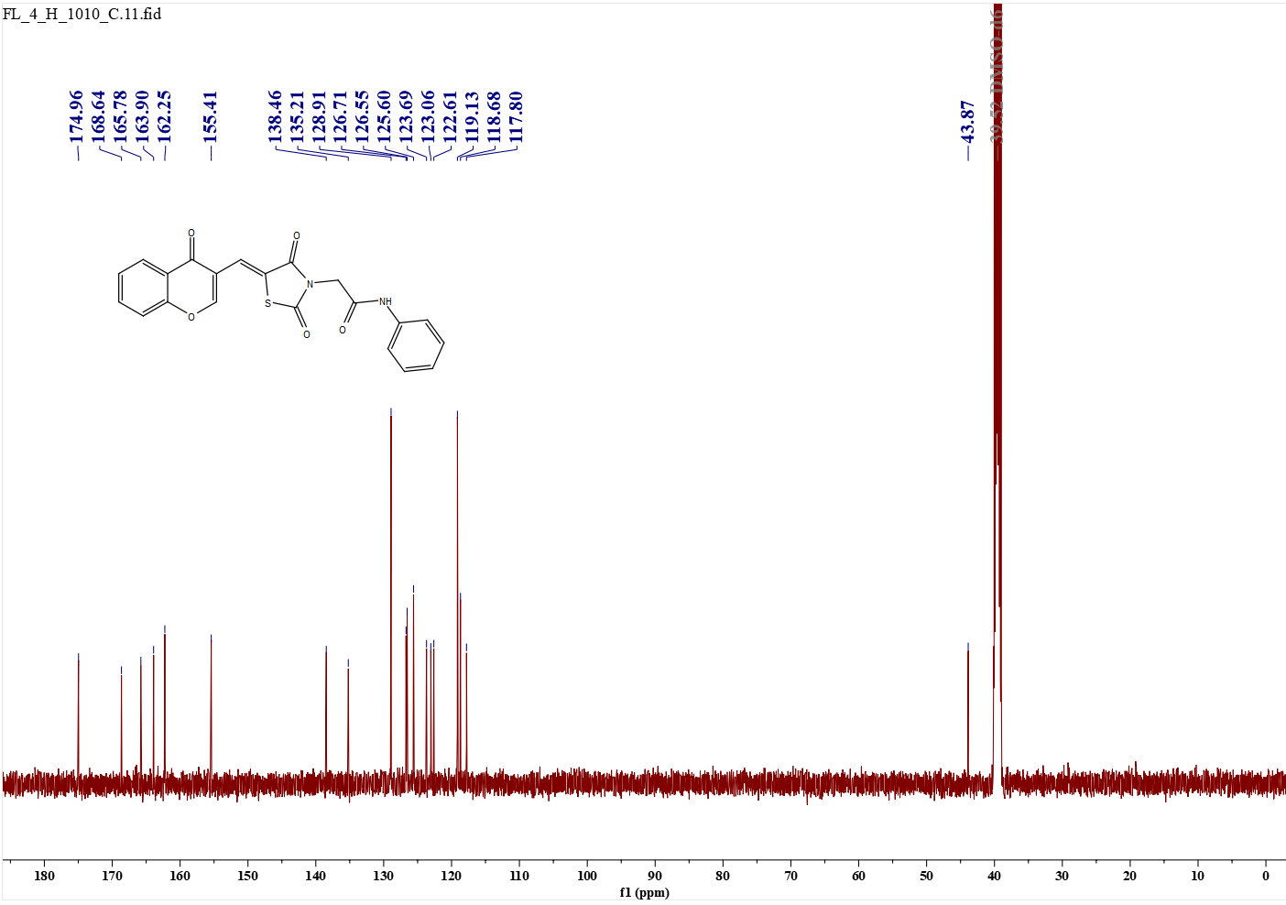
Fig.2 e2 (¹³C NMR)
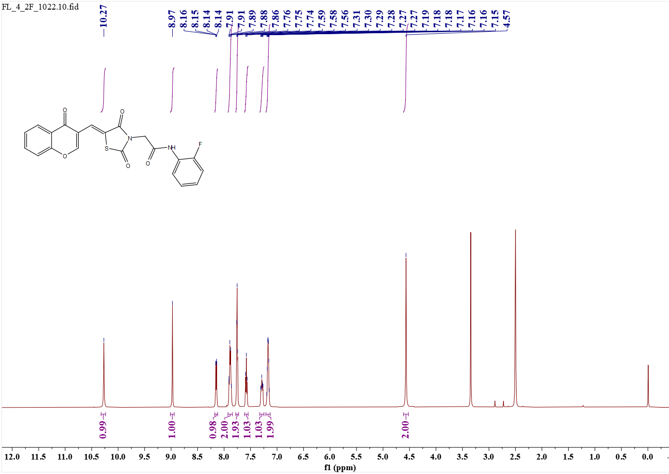 Fig.3 e2 (¹H NMR)
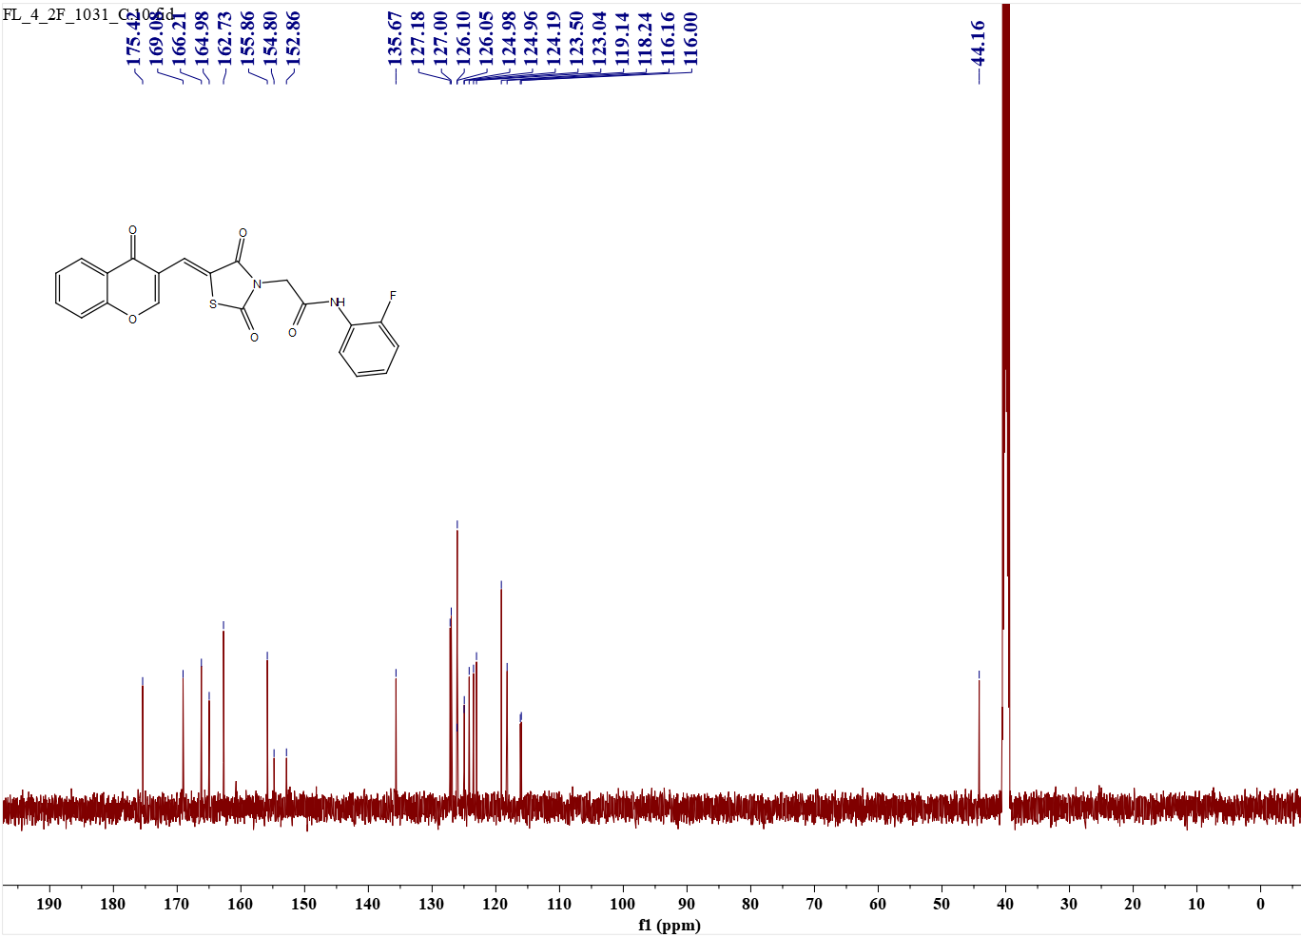 Fig.4 e2(¹³C NMR)
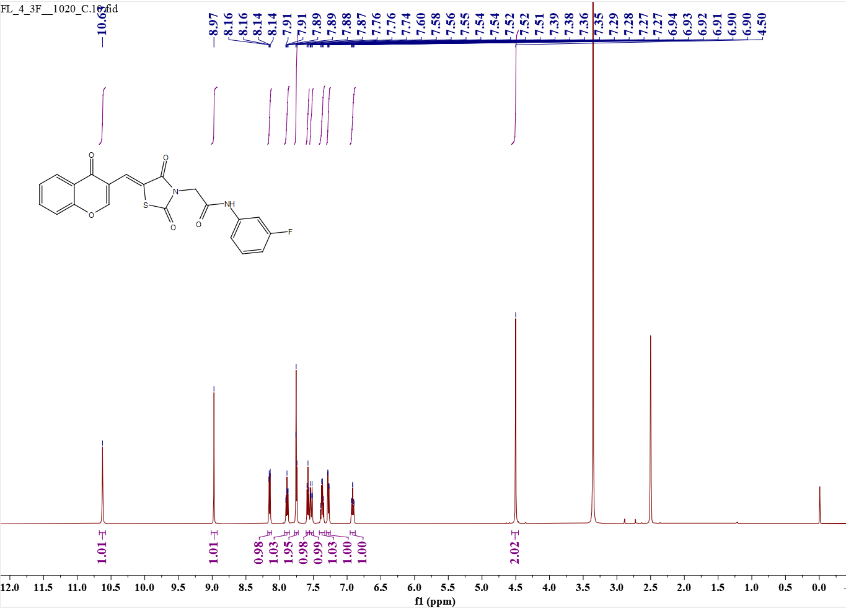 Fig.5 e3 (¹H NMR)
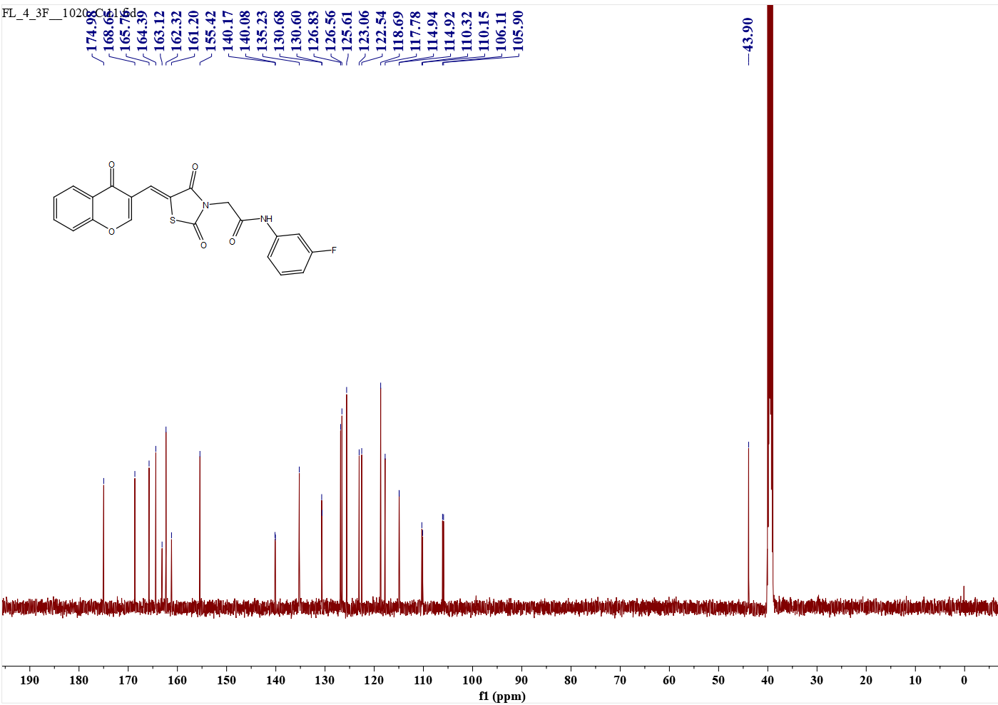 Fig.6 e3 (¹³C NMR)
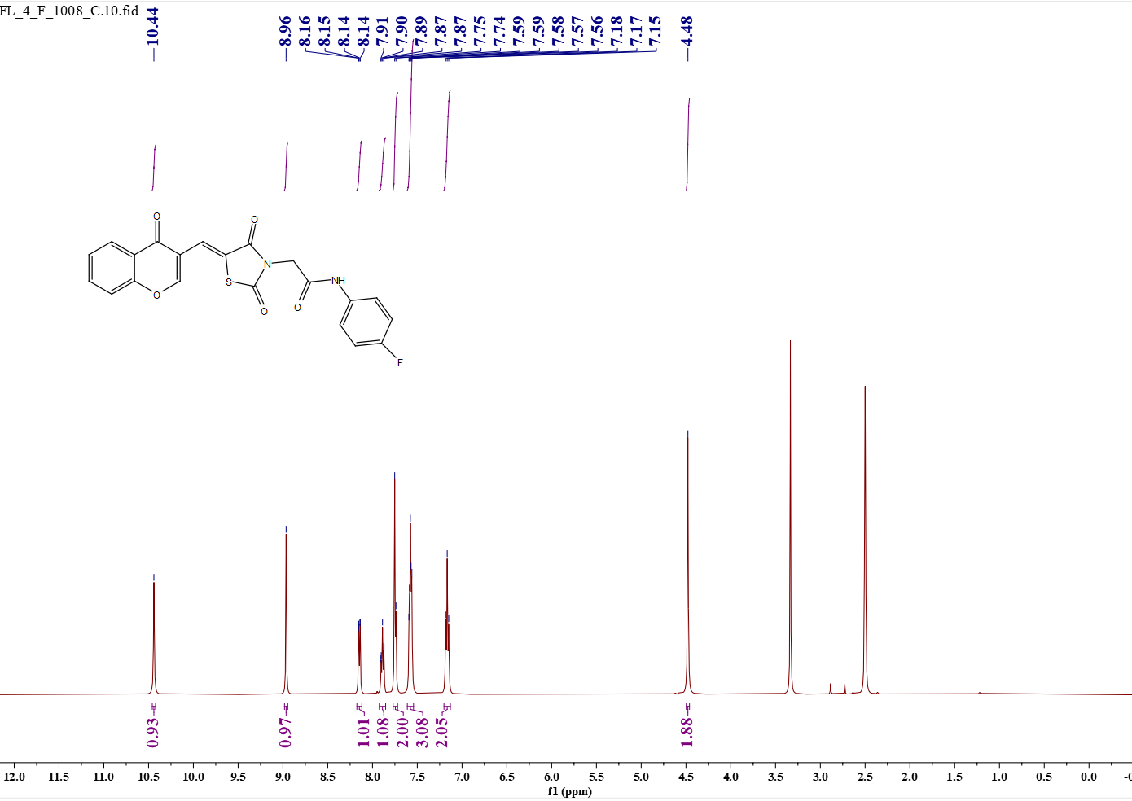
Fig.7 e4 (¹H NMR)
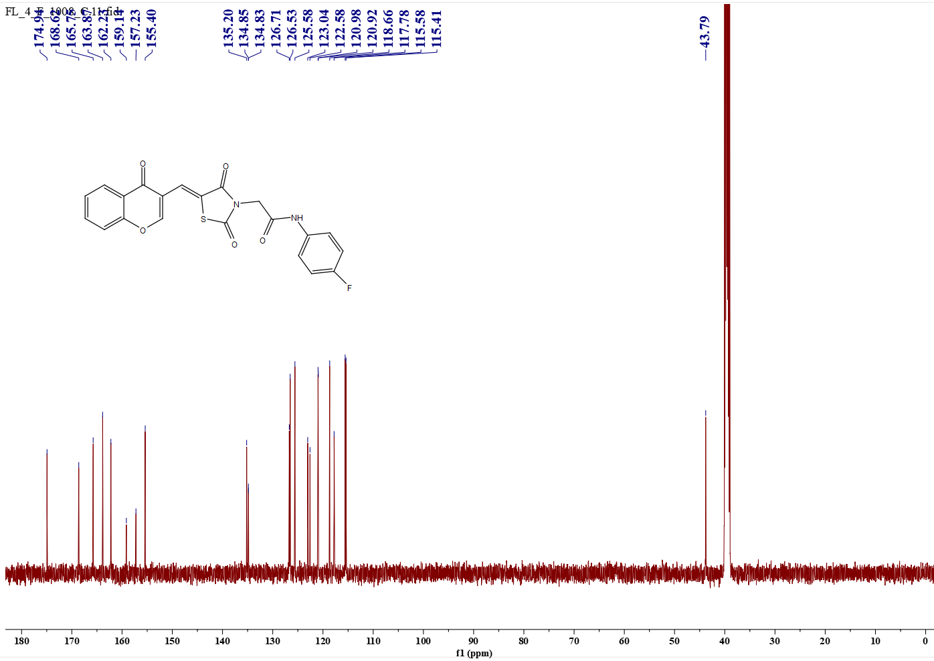 Fig.8 e4 (¹³C NMR)

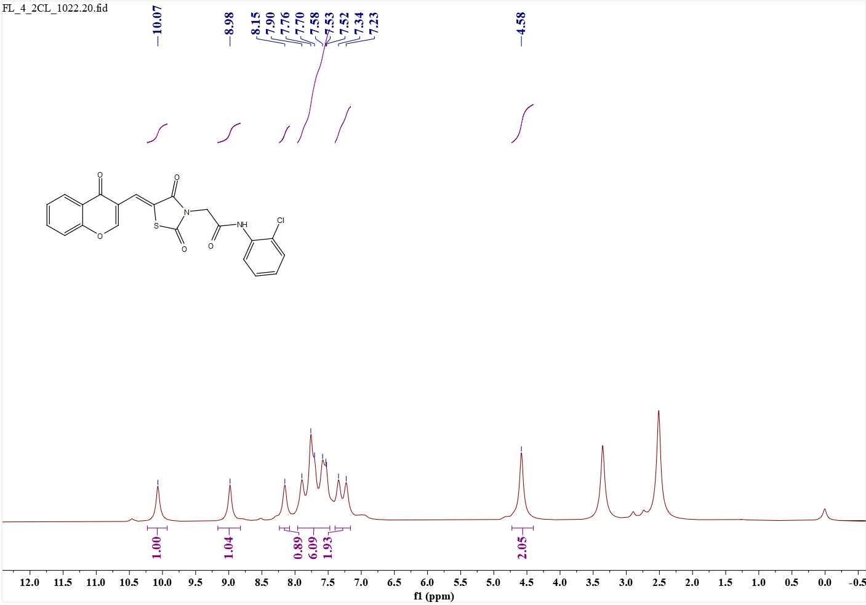 Fig.9 e5 (¹H NMR)
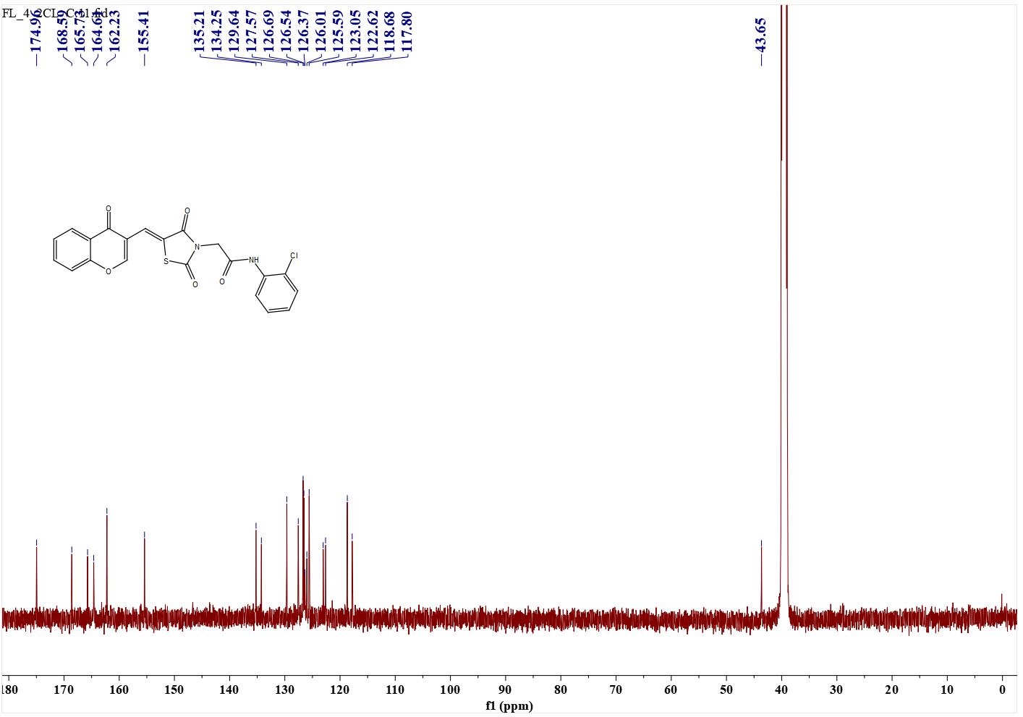
Fig.10 e5 (¹³C NMR)
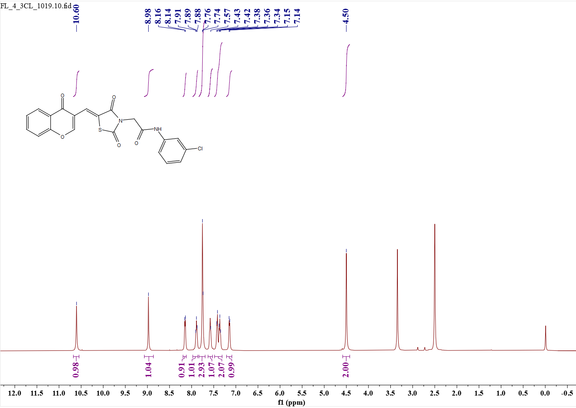 Fig.11 e6 (¹H NMR)
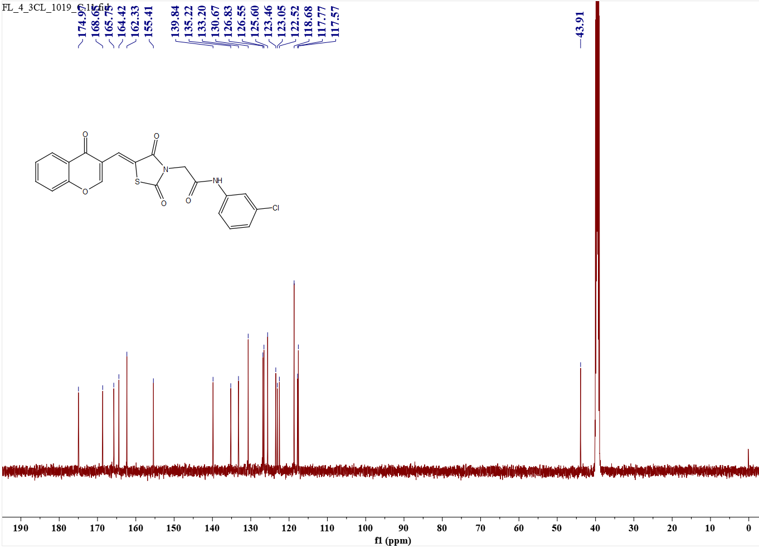 Fig.12 e6 (¹³C NMR)
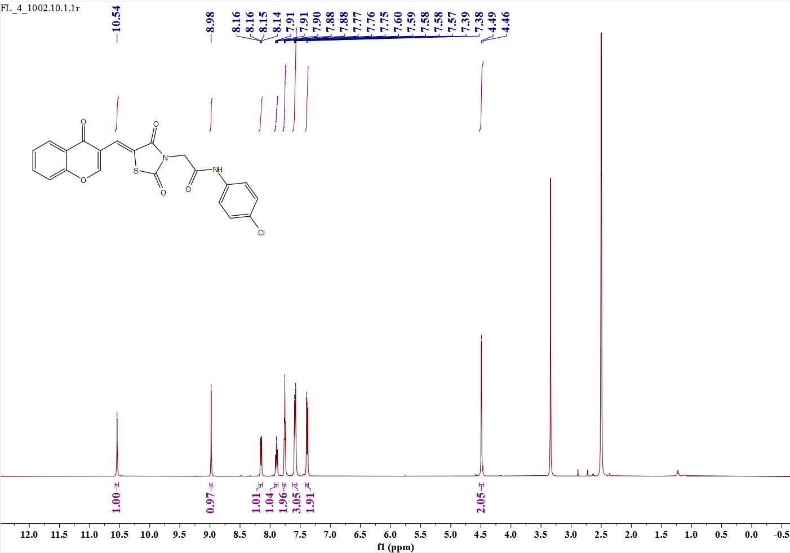 Fig.13 e7 (¹H NMR)
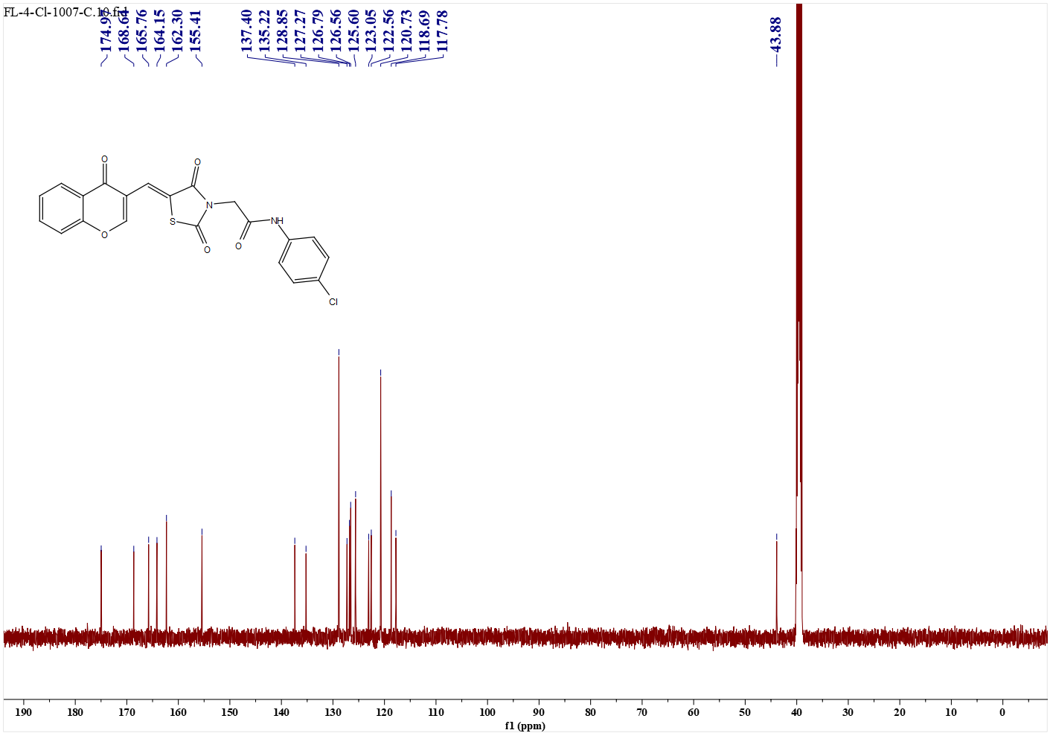 Fig.14 e7 (¹³C NMR)
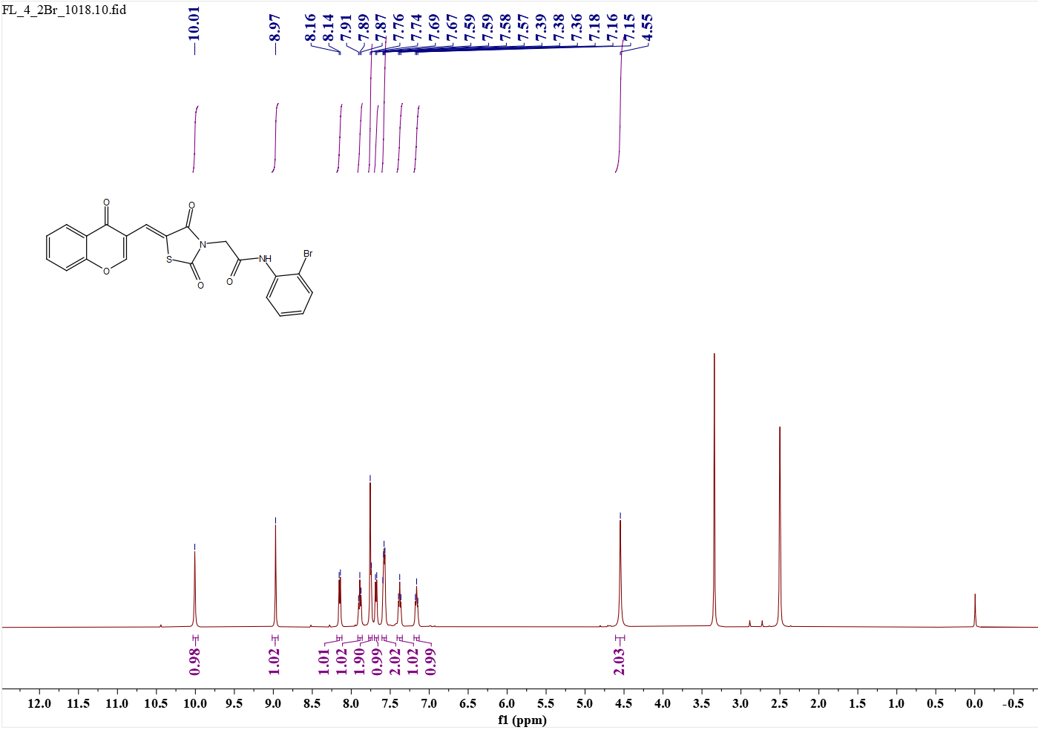 Fig.15 e8 (¹H NMR)
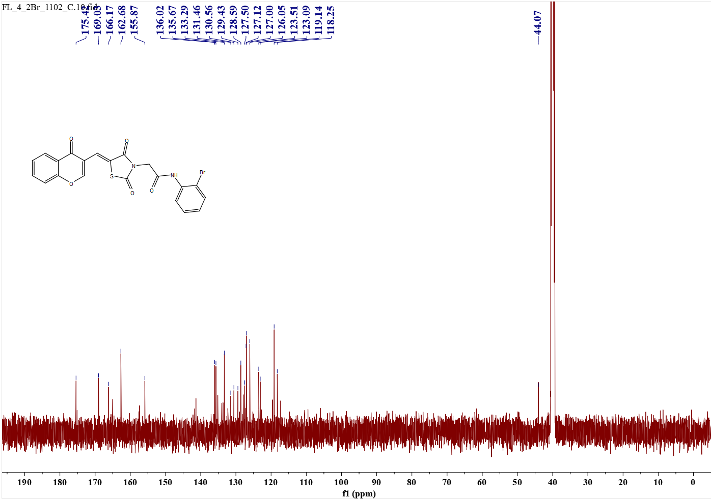 Fig.16 e8 (¹³C NMR)
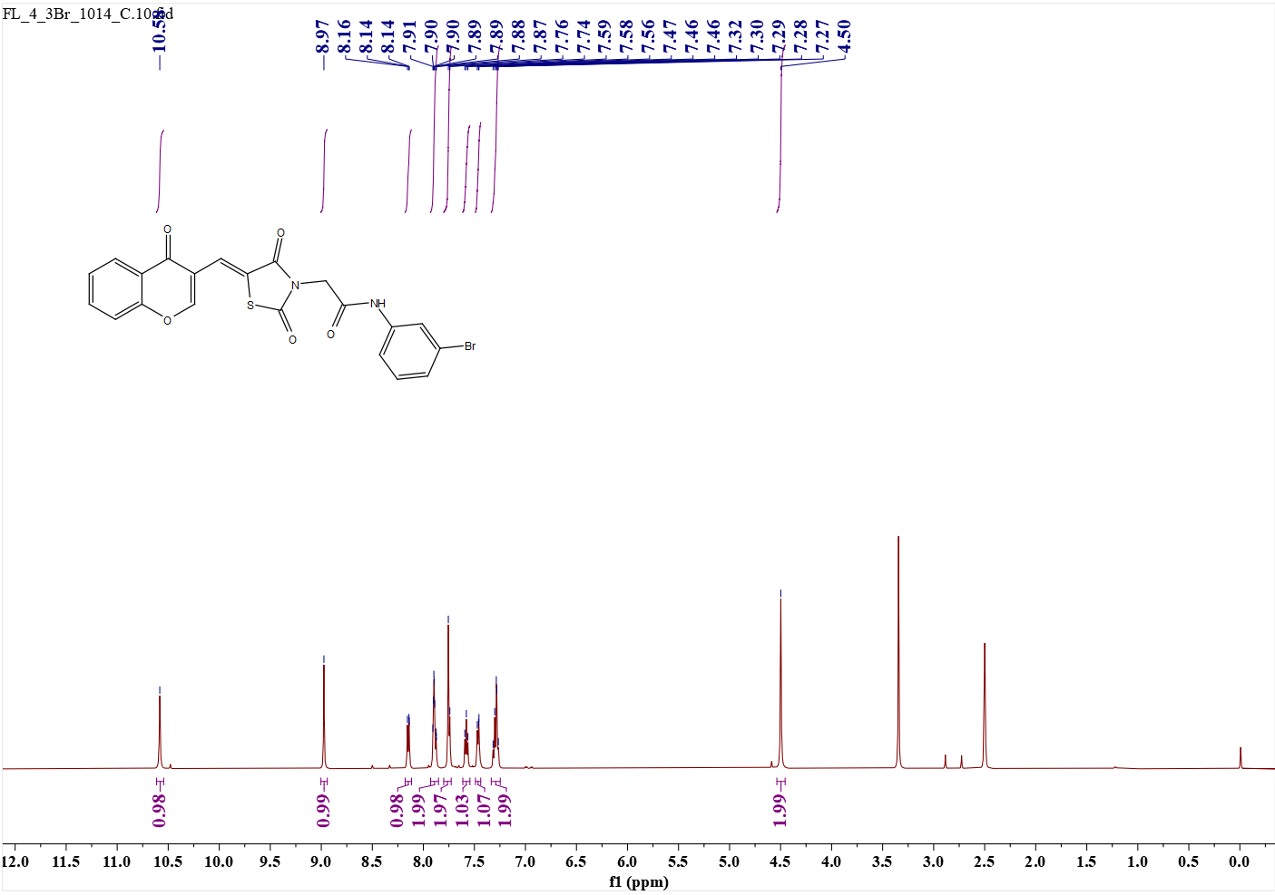 Fig.17 e9 (¹H NMR)
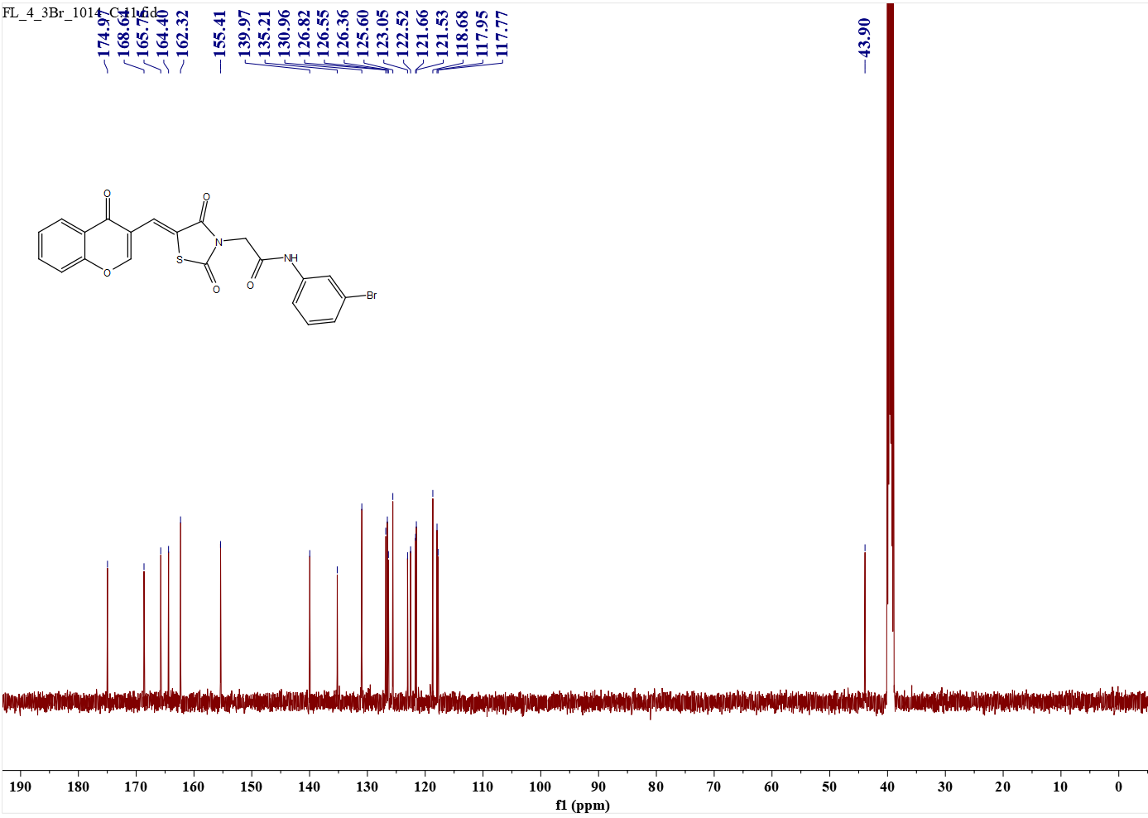 Fig.18 e9 (¹³C NMR)
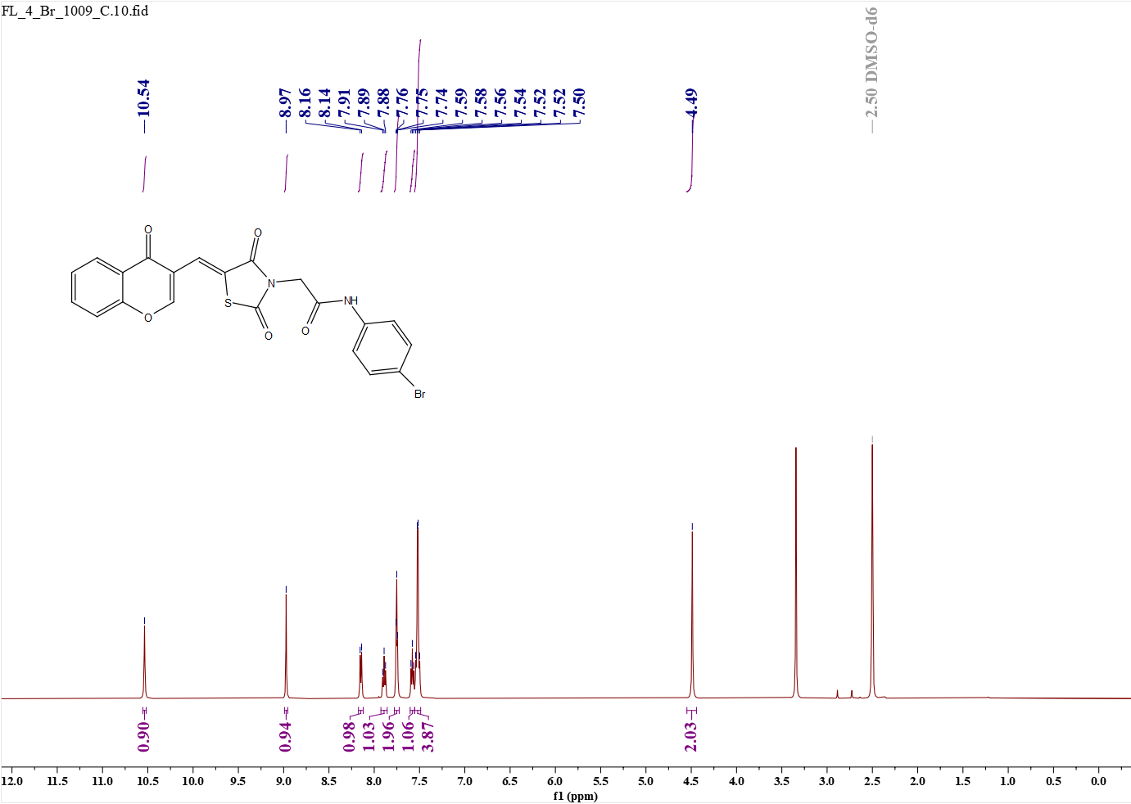 Fig.19 e10 (¹H NMR)
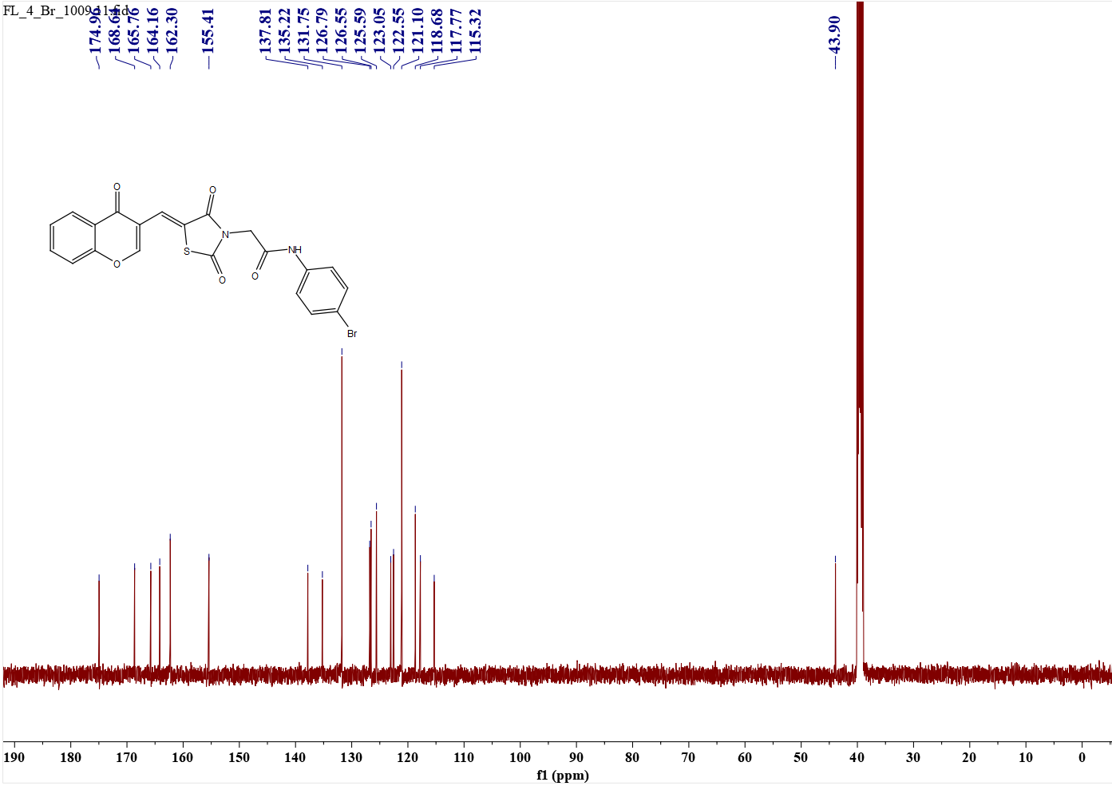 Fig.20 e10 (¹³C NMR)
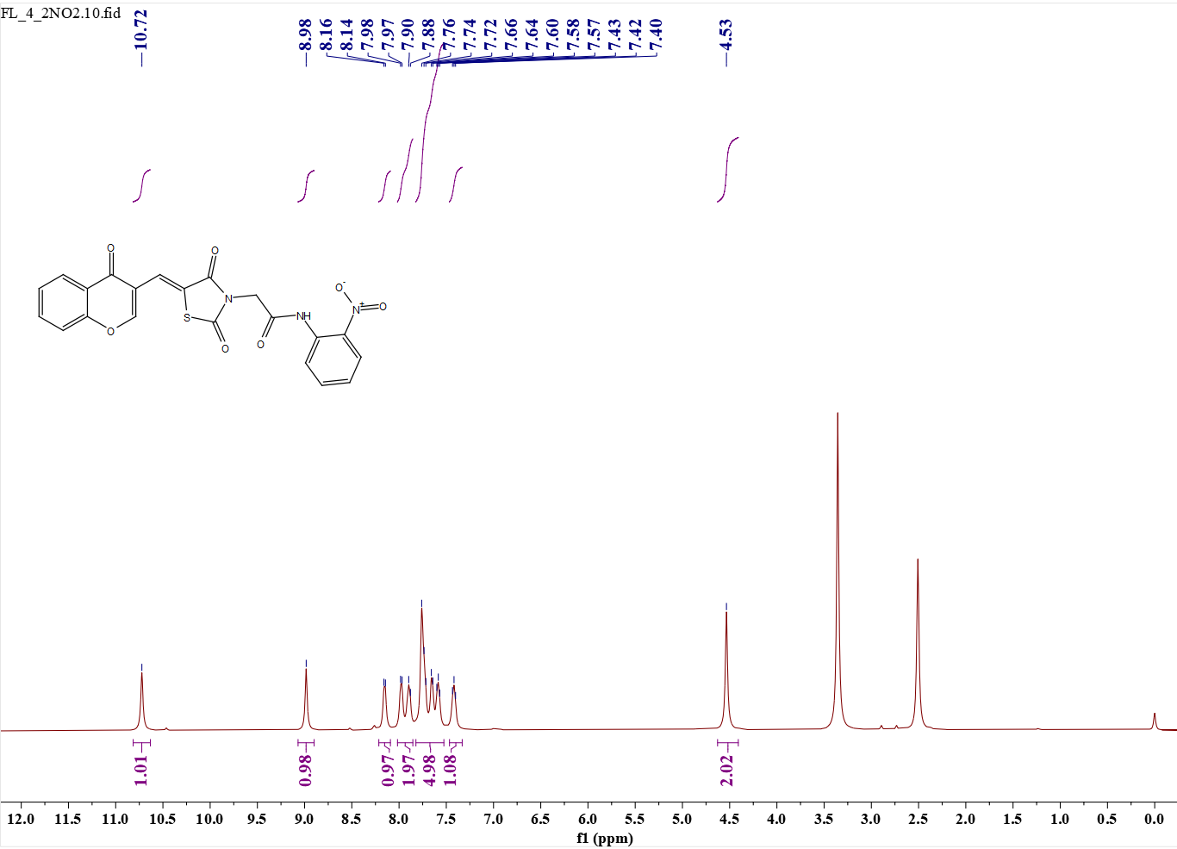 Fig.21 e11 (¹H NMR)
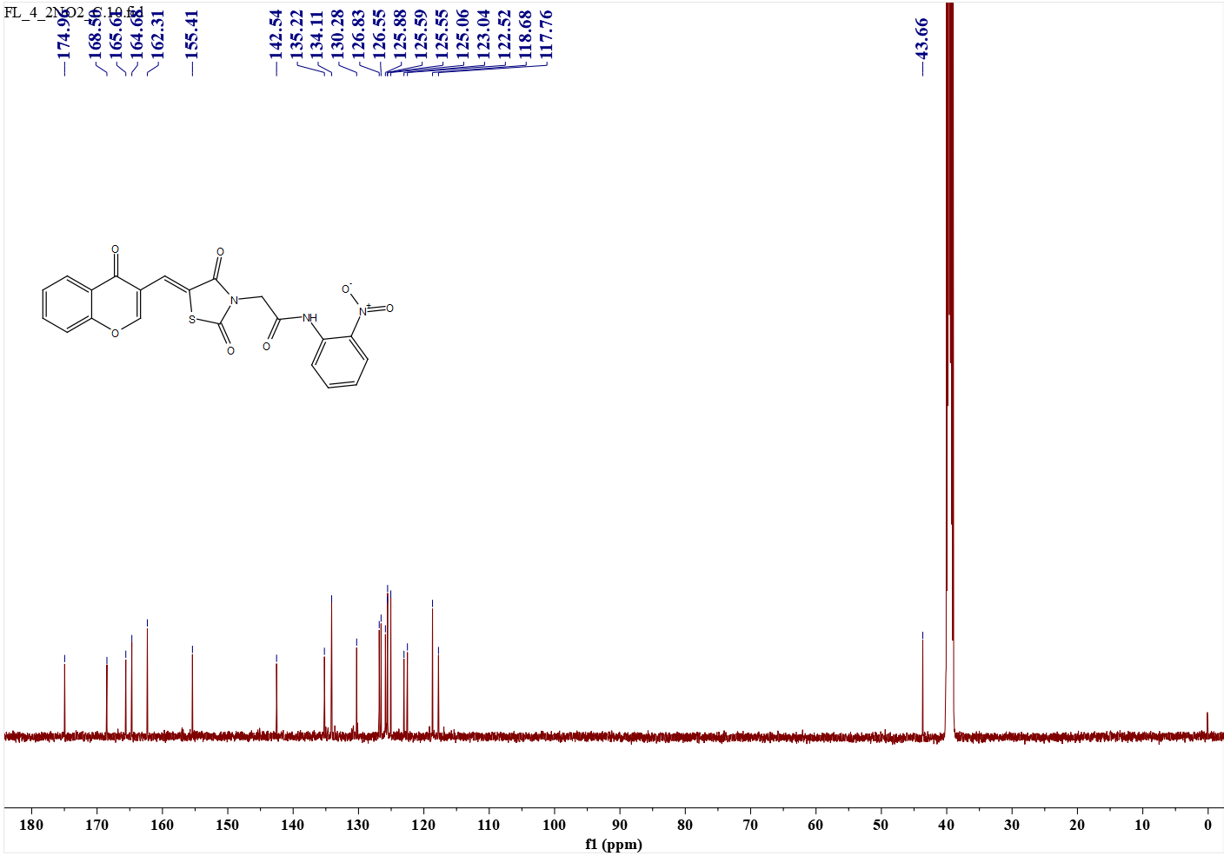 Fig.22 e11(¹³C NMR)
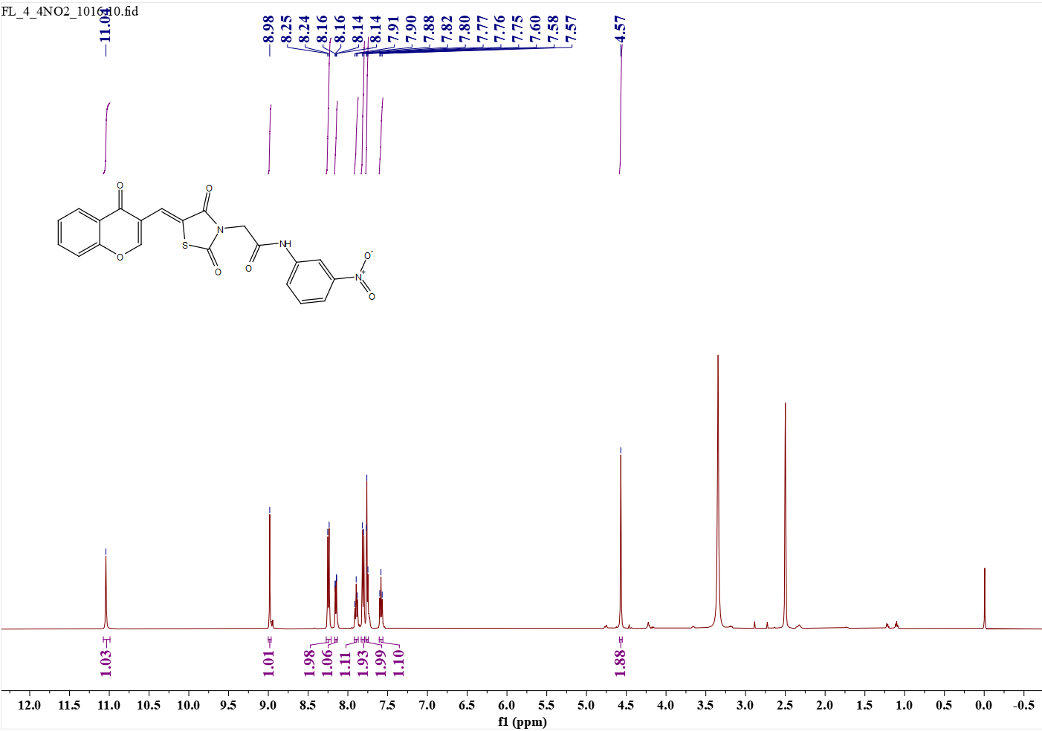 Fig.23 e12 (¹H NMR)
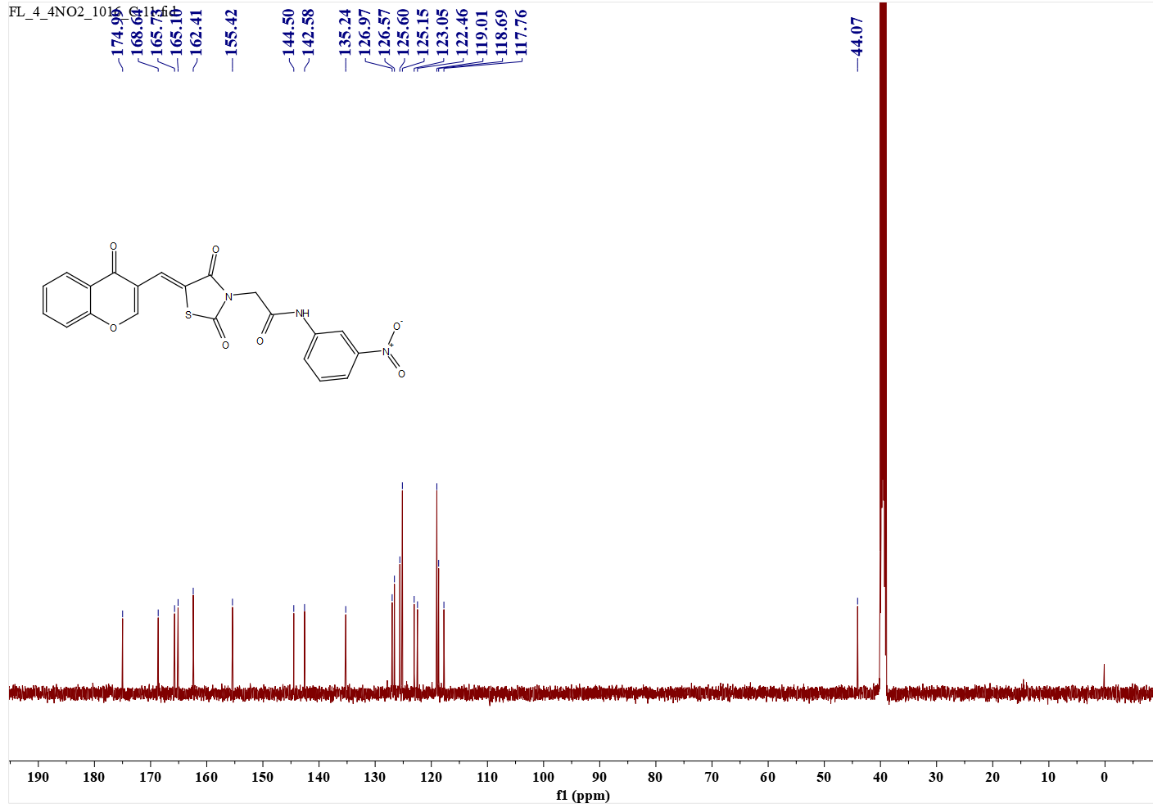 Fig.24 e12 (¹³C NMR)
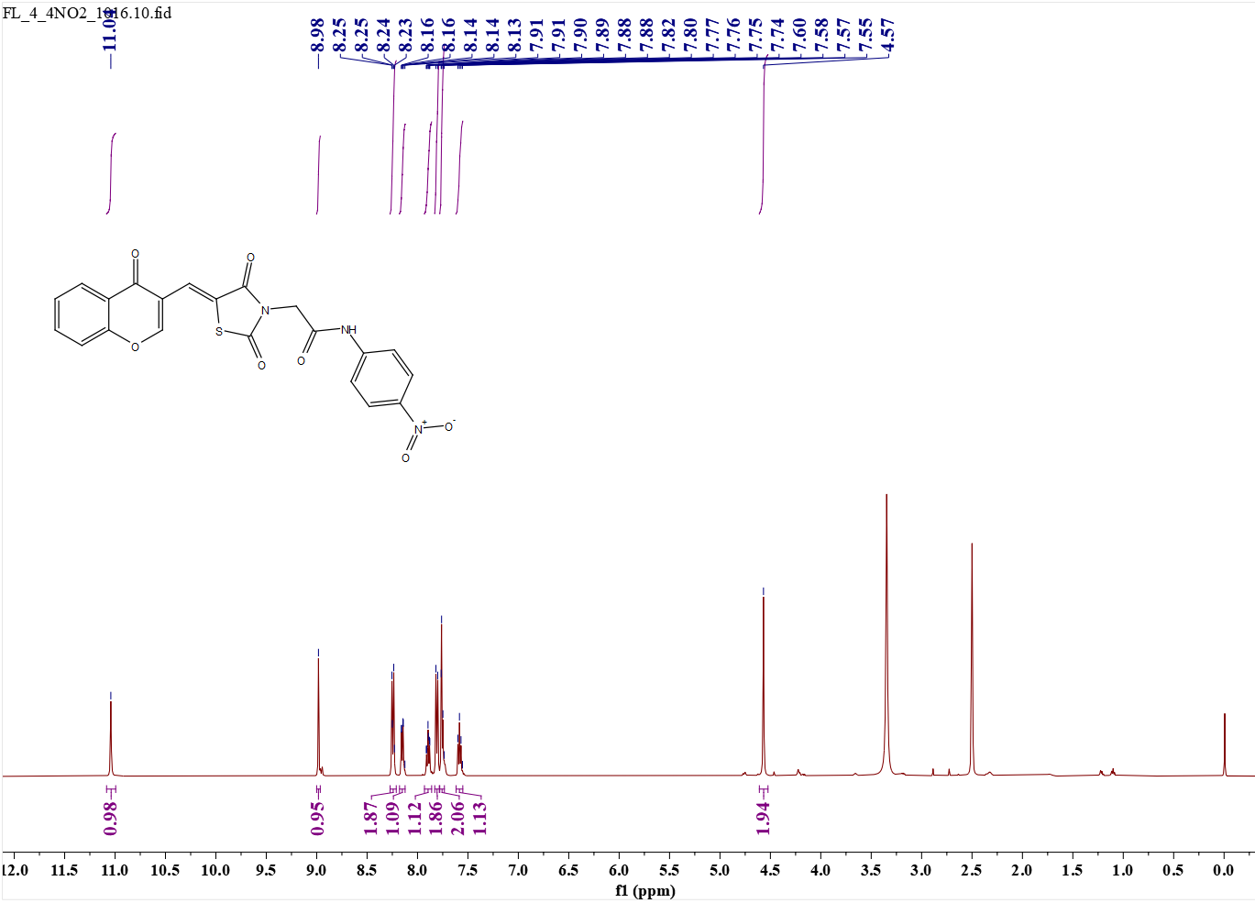 Fig.25 e13 (¹H NMR)
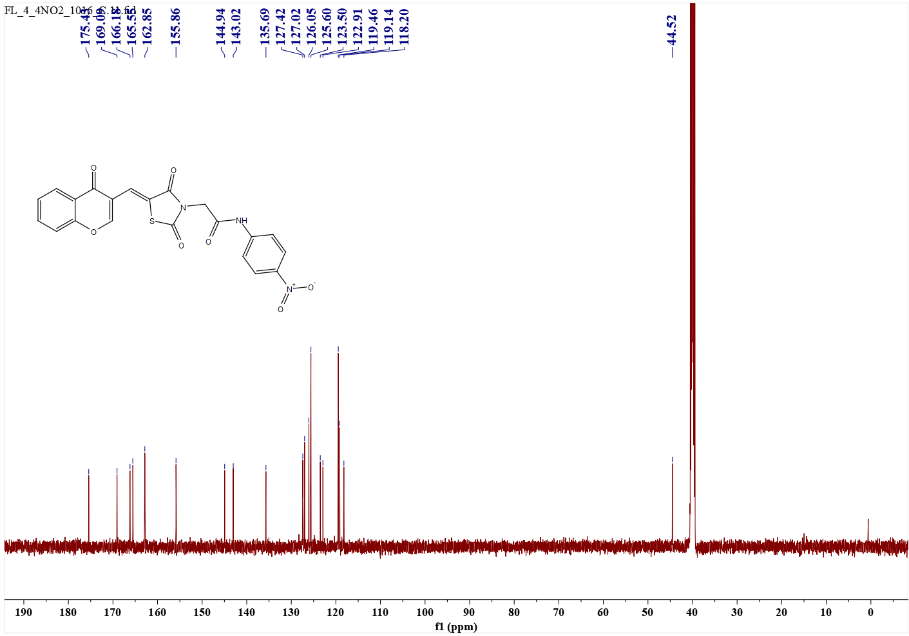 Fig.26 e13 (¹³C NMR)
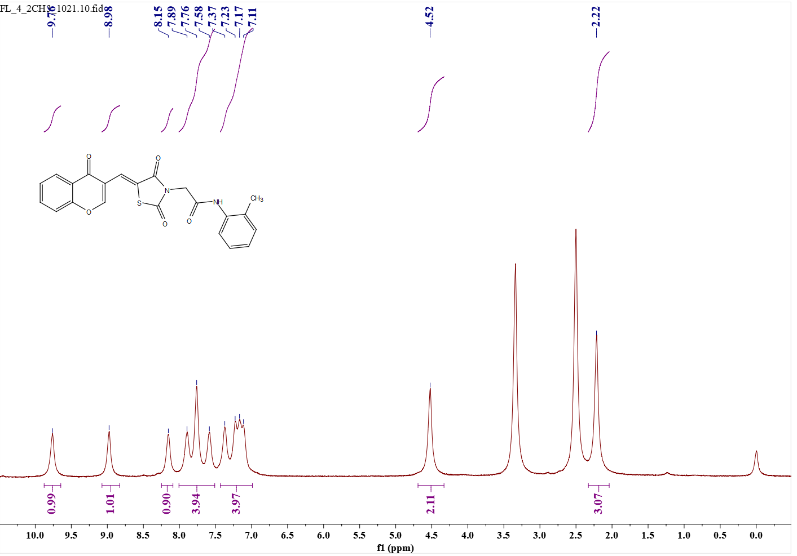 Fig.27 e14 (¹H NMR)
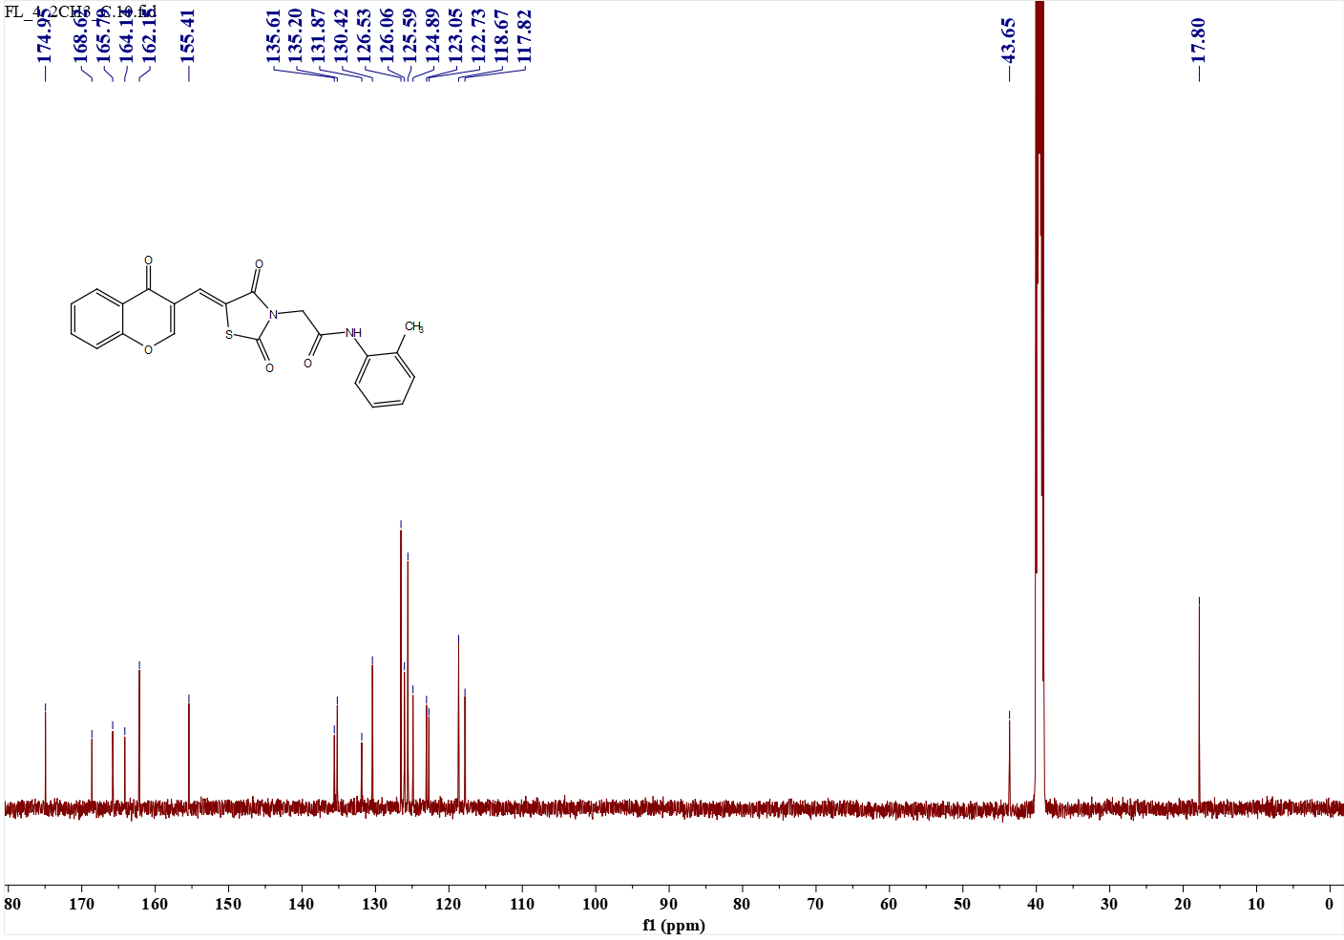 Fig.28 e14 (¹³C NMR)
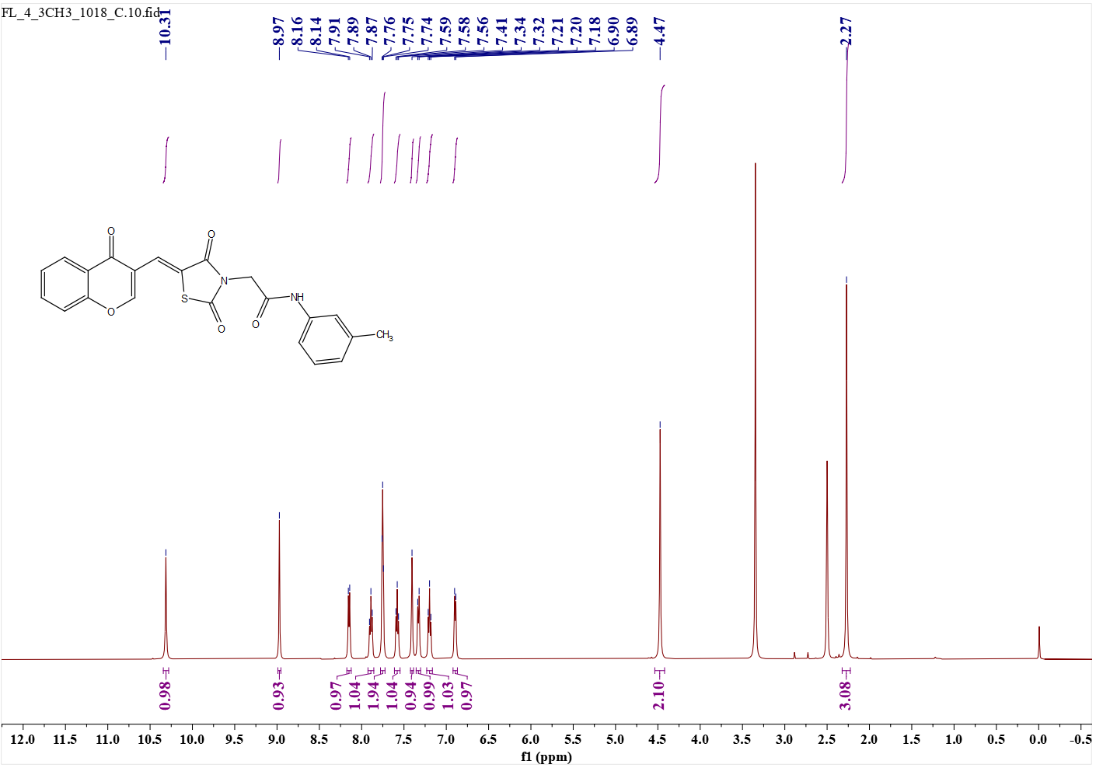 Fig.29 e15 (¹H NMR)
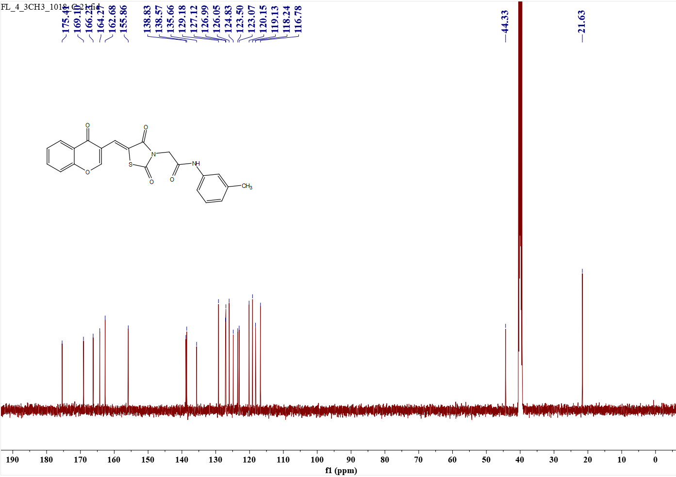 Fig.30 e15(¹³C NMR)
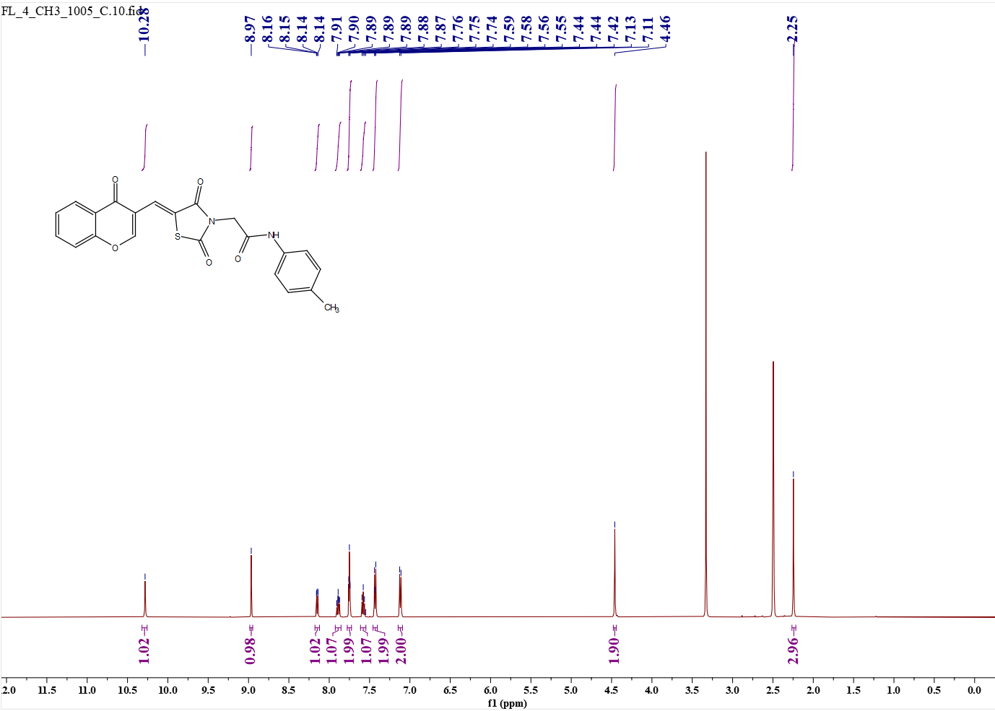 Fig.31 e16 (¹H NMR)
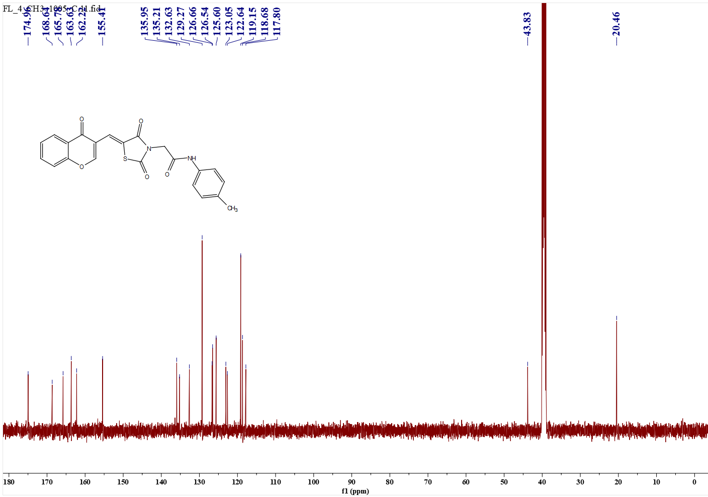 Fig.32 e16 (¹³C NMR)
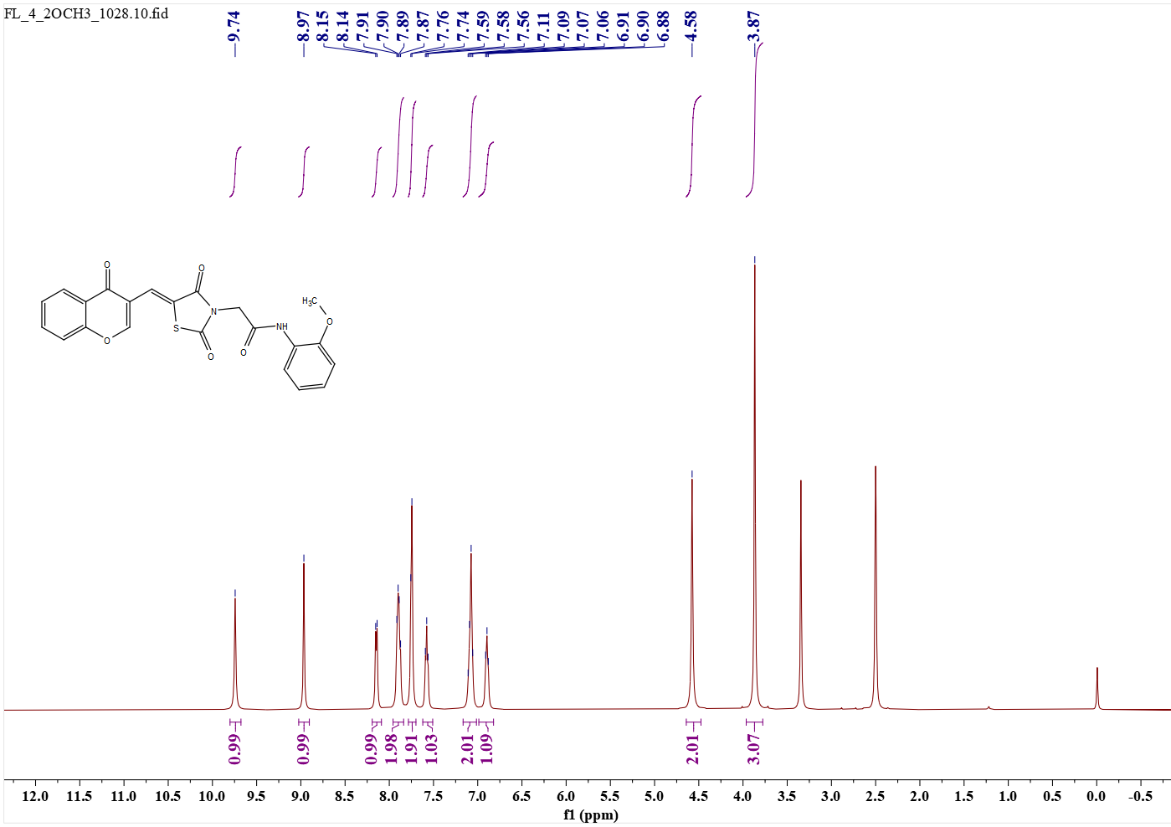 Fig.33 e17 (¹H NMR)
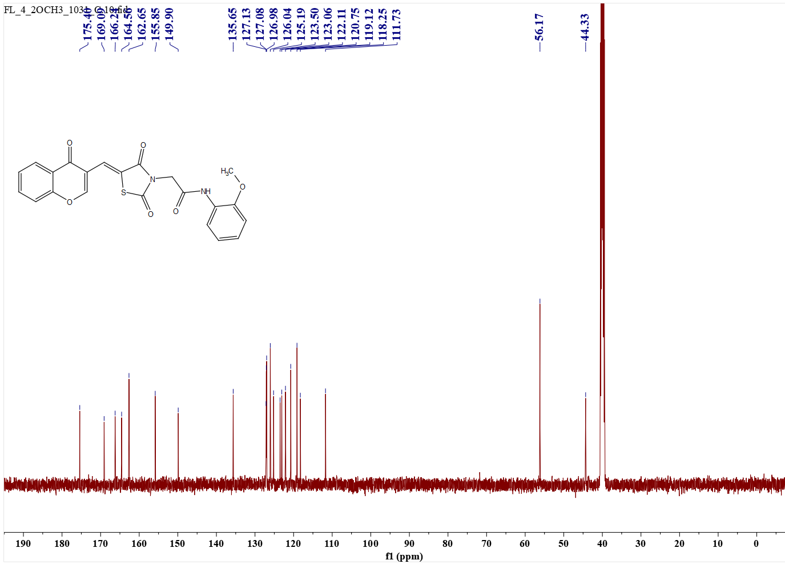 Fig.34 e17 (¹³C NMR)
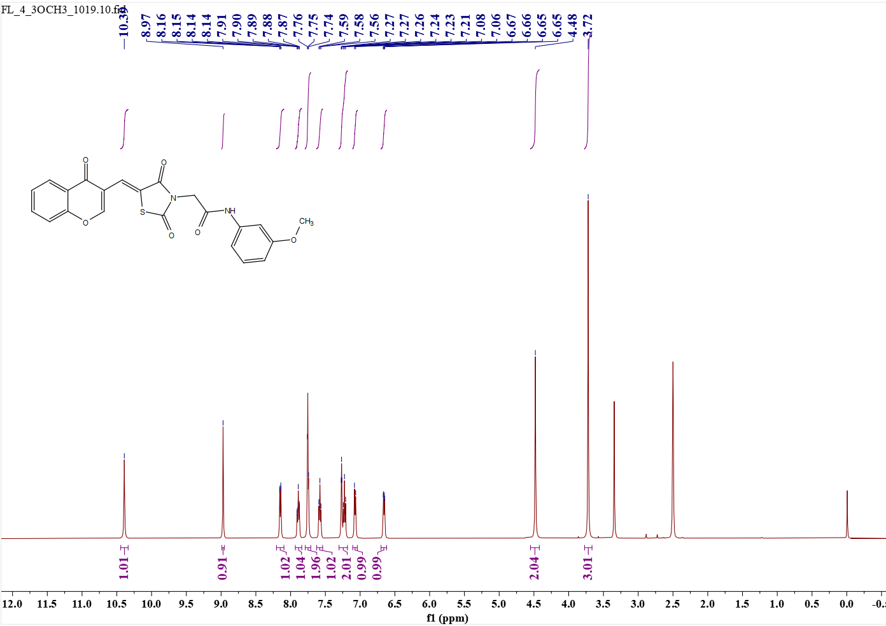 Fig.35 e18 (¹H NMR)
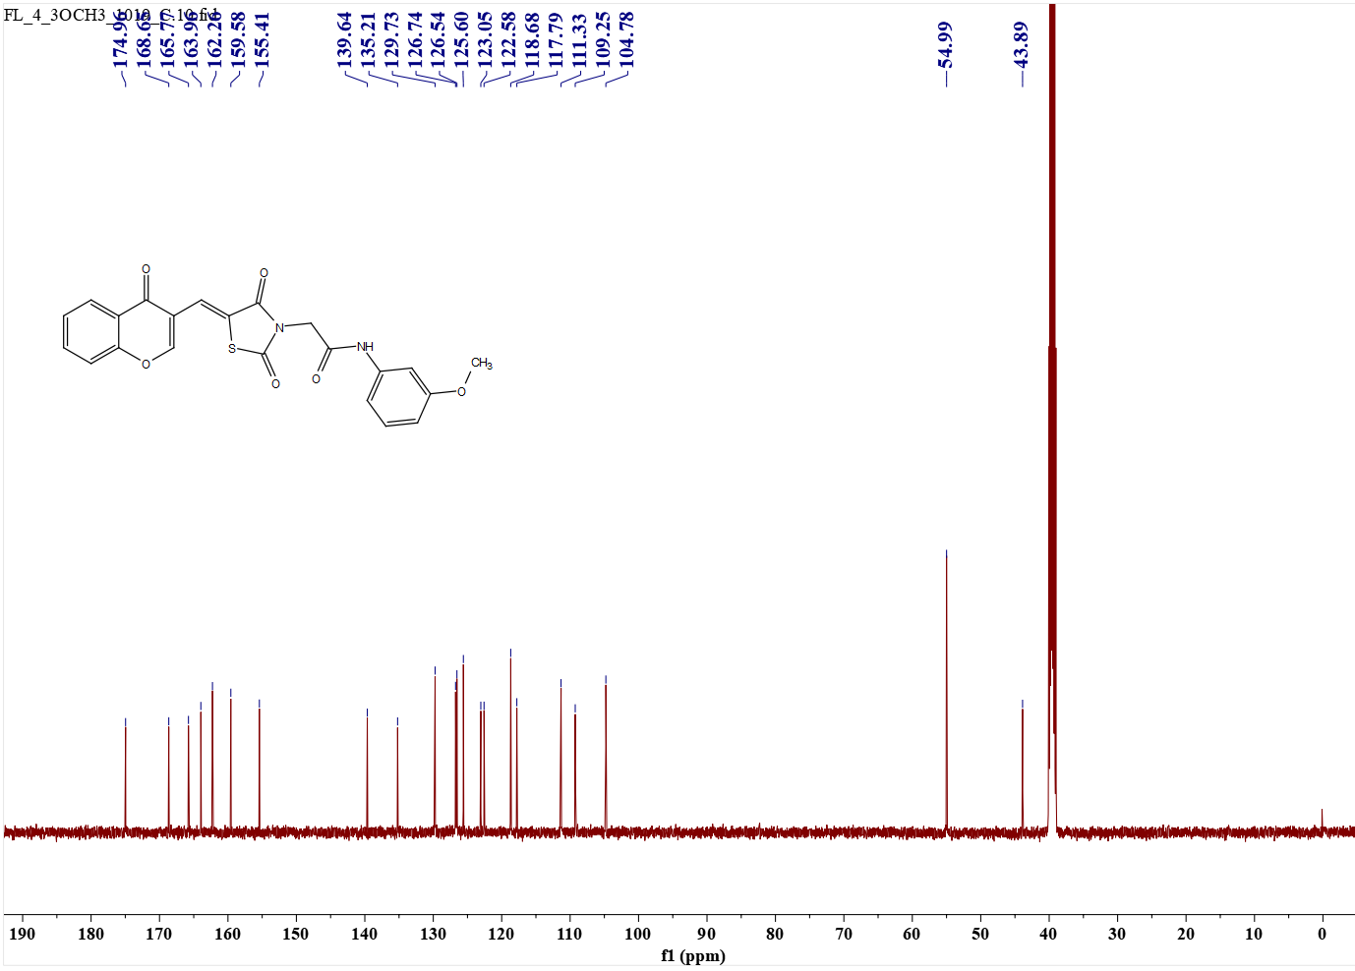 Fig.36 e18 (¹³C NMR)
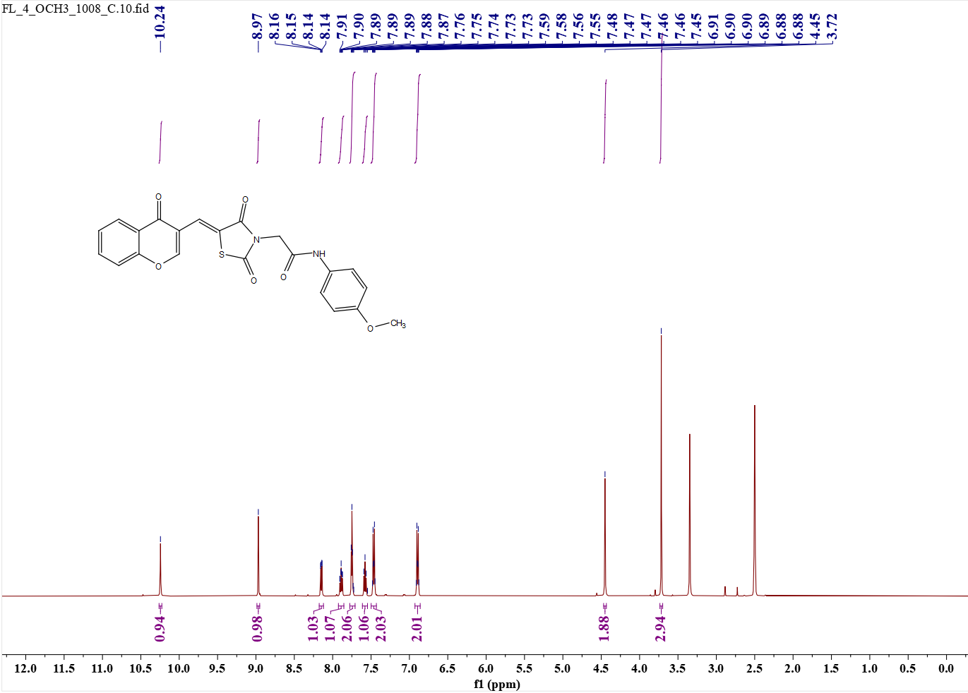 Fig.37 e19 (¹H NMR)
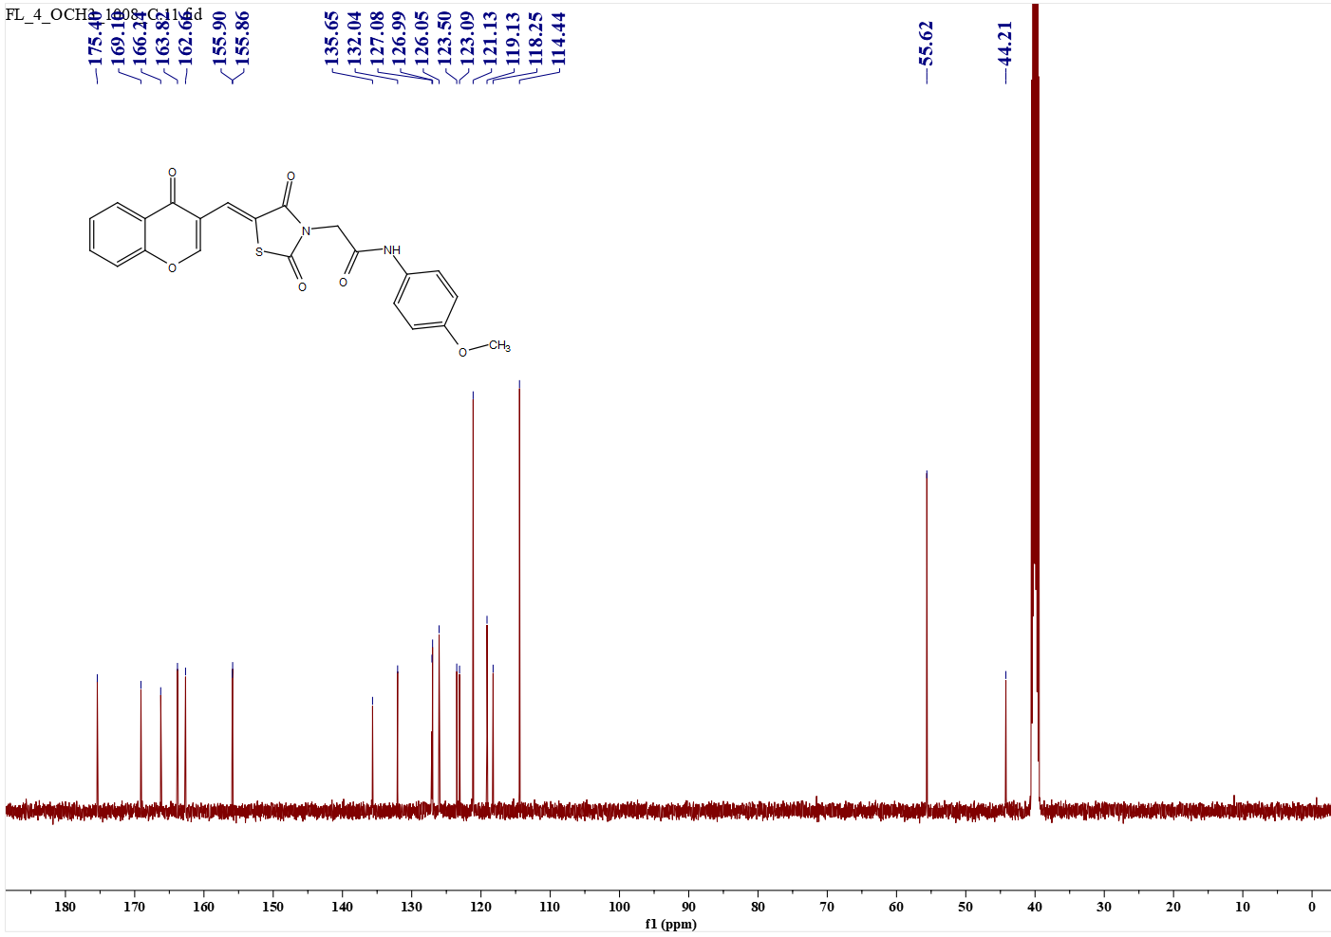 Fig.38 e19 (¹³C NMR)
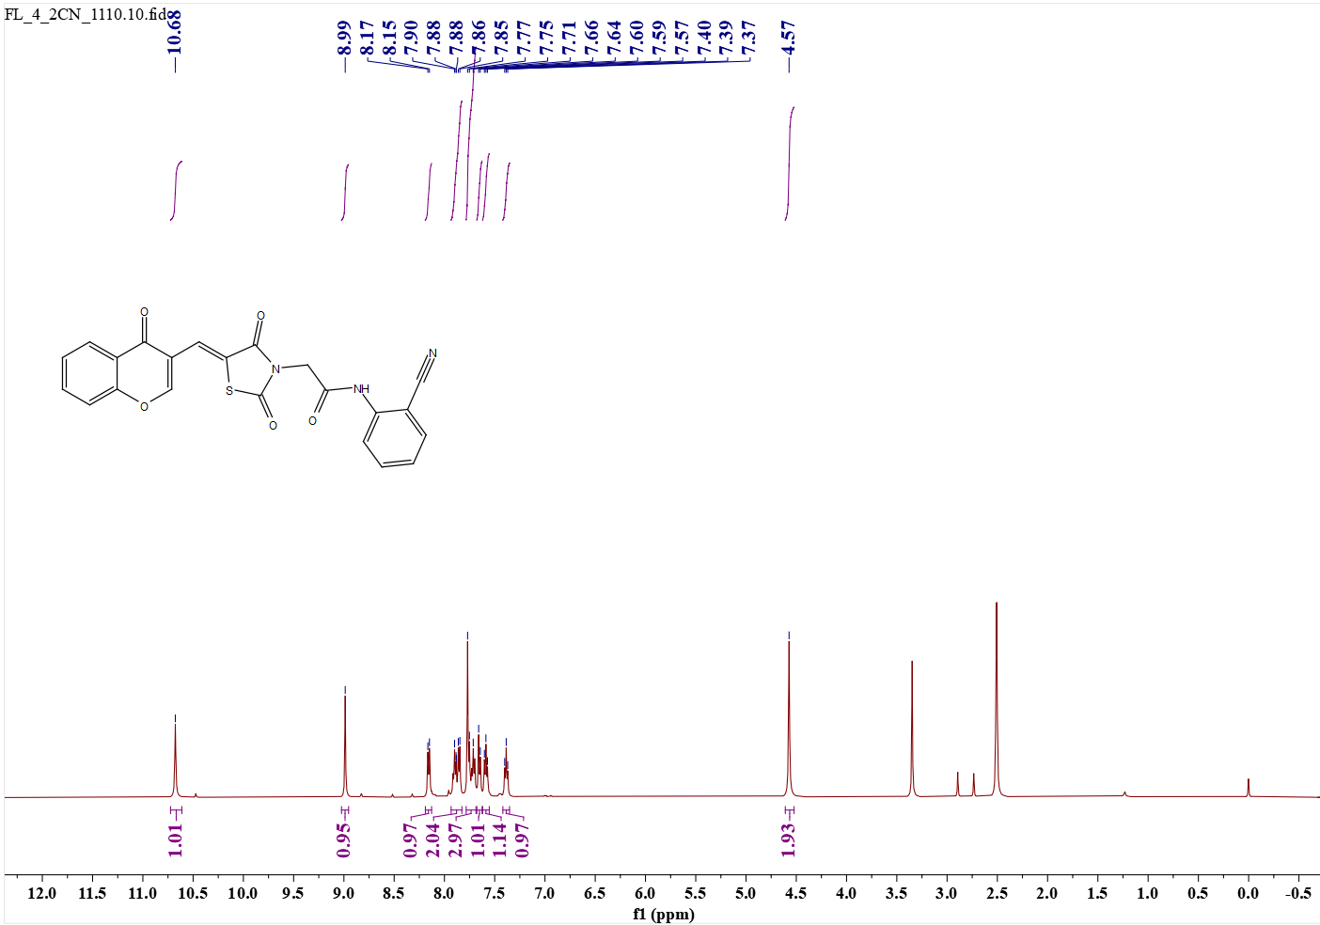 Fig.39 20 (¹H NMR) 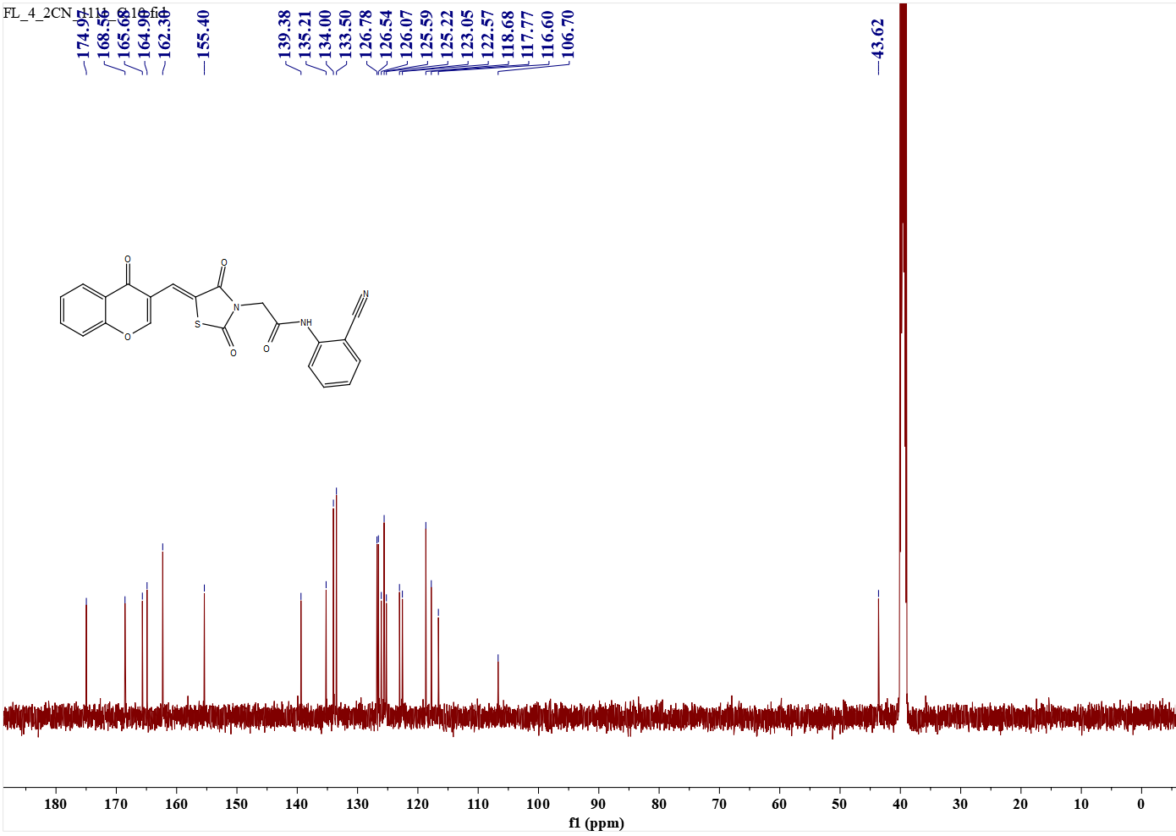 Fig.40 20(¹³C NMR)
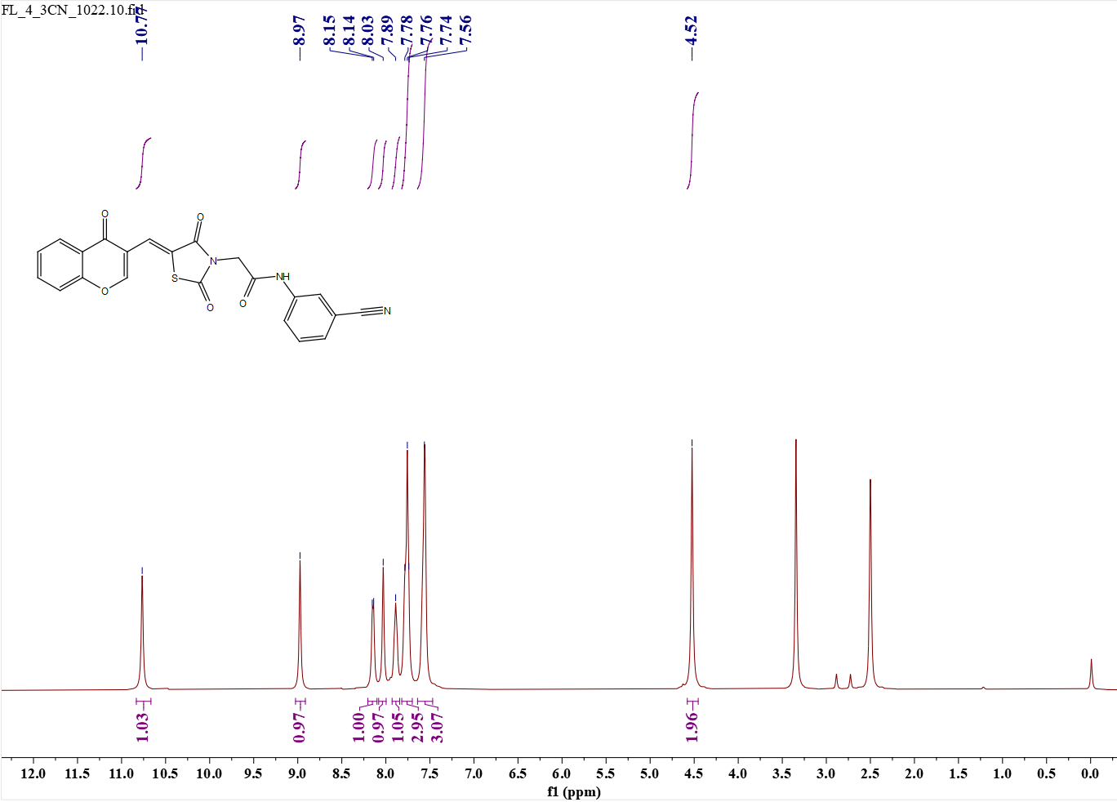 Fig.41 e21 (¹H NMR)
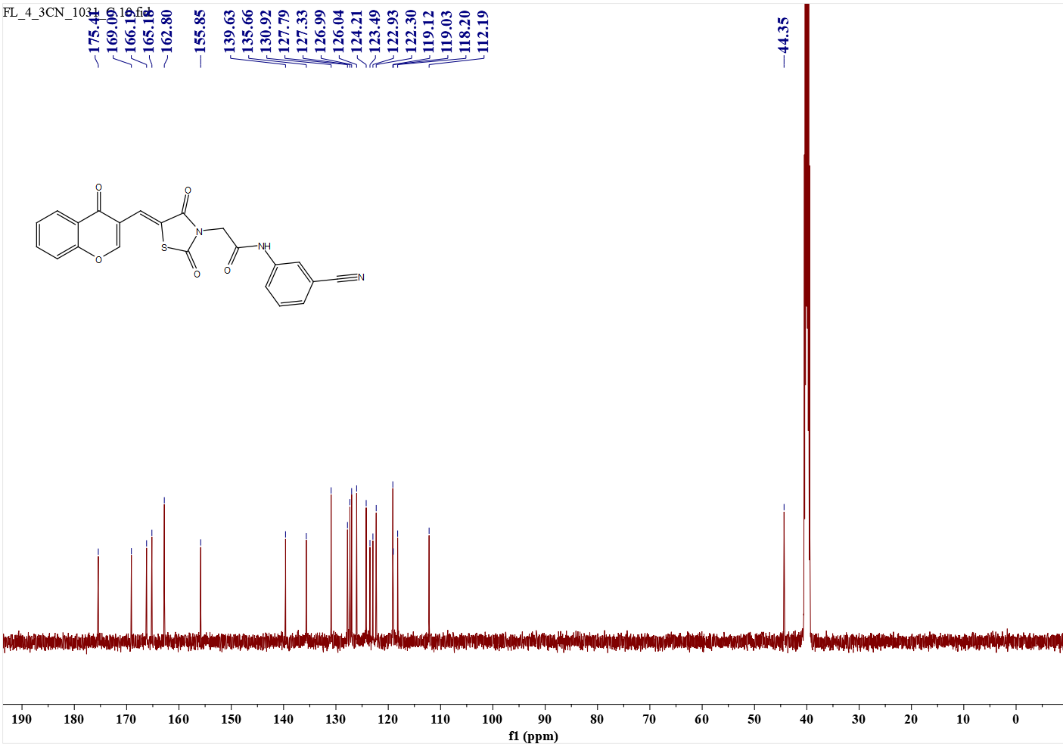 Fig.42 e21(¹³C NMR)
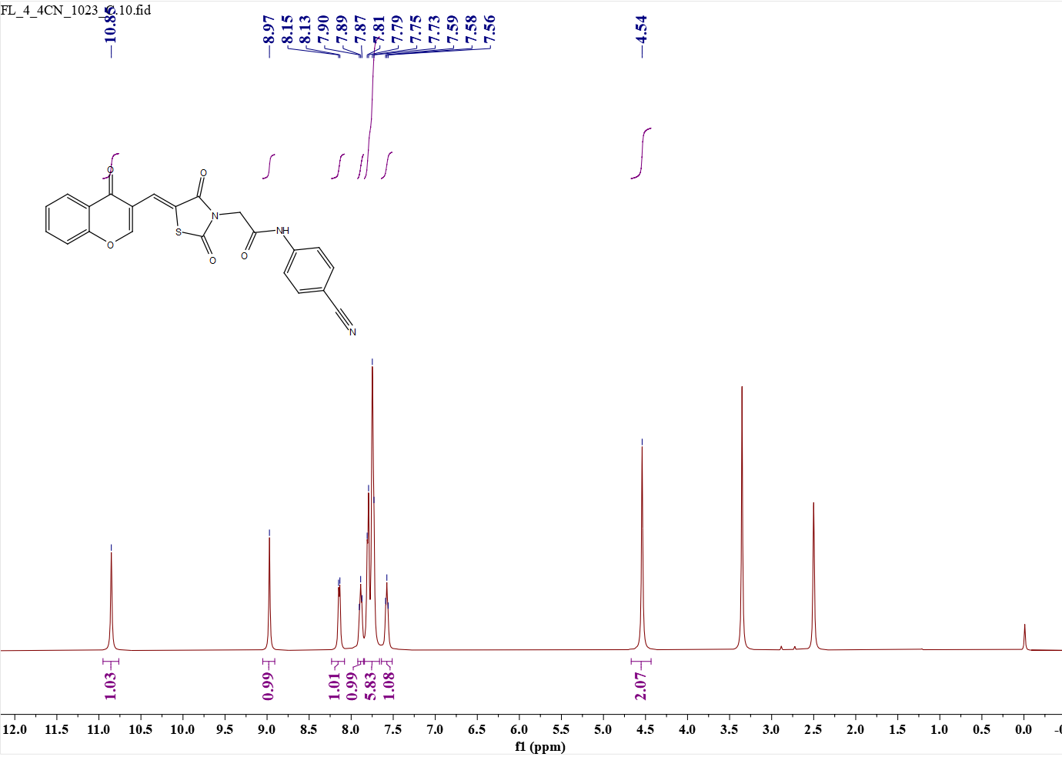 Fig.43 e22 (¹H NMR)
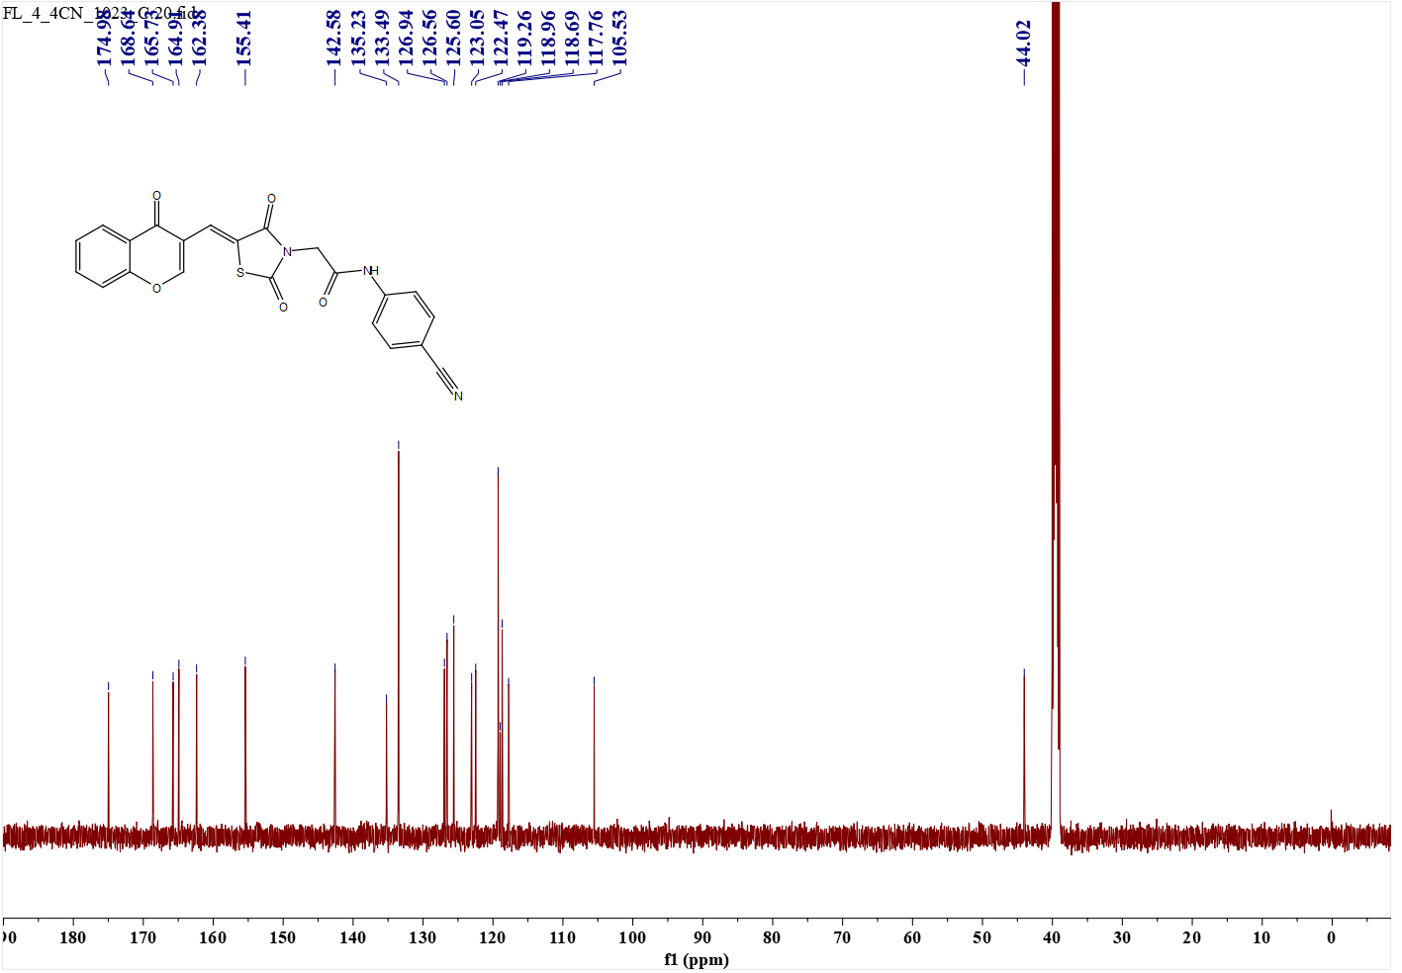 Fig.44 e22 (¹³C NMR)
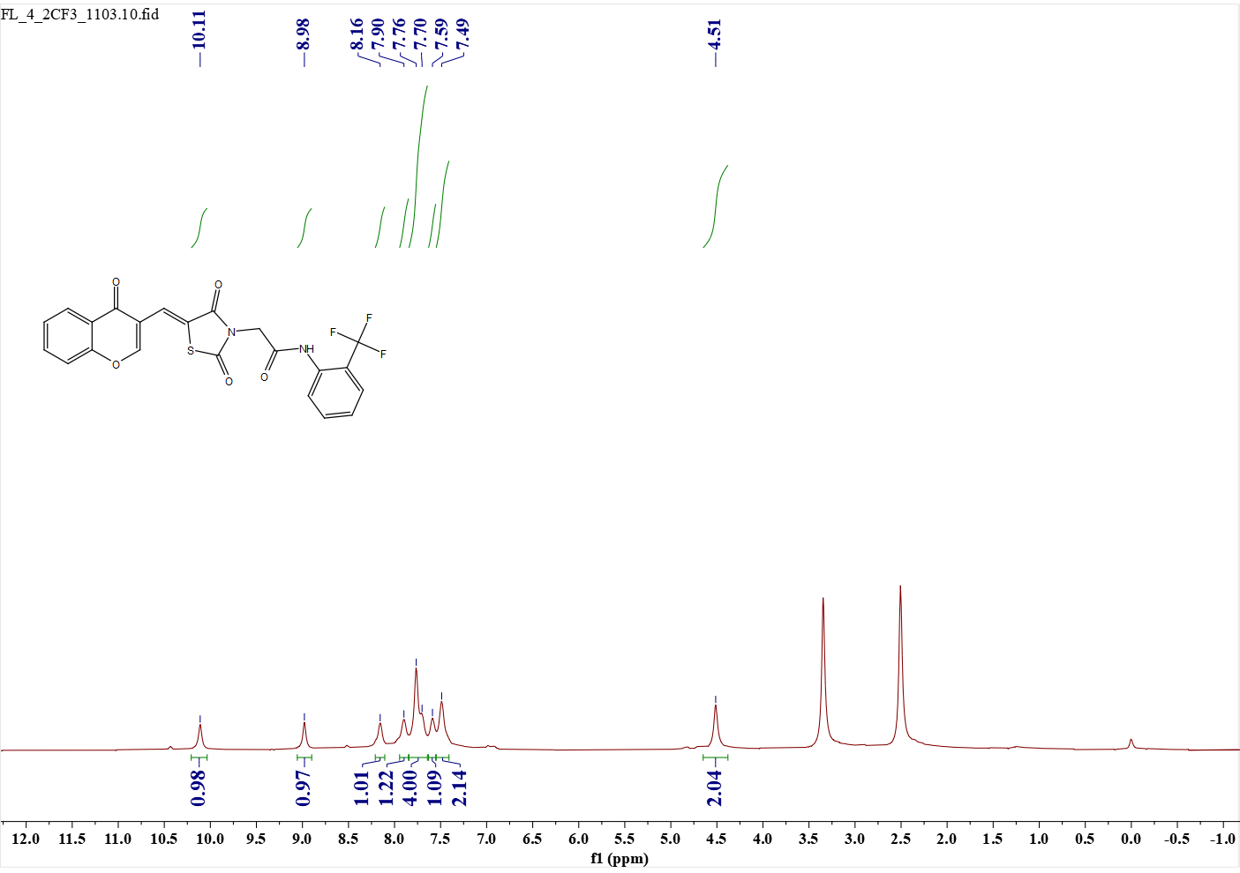 Fig.45 e23 (¹H NMR)
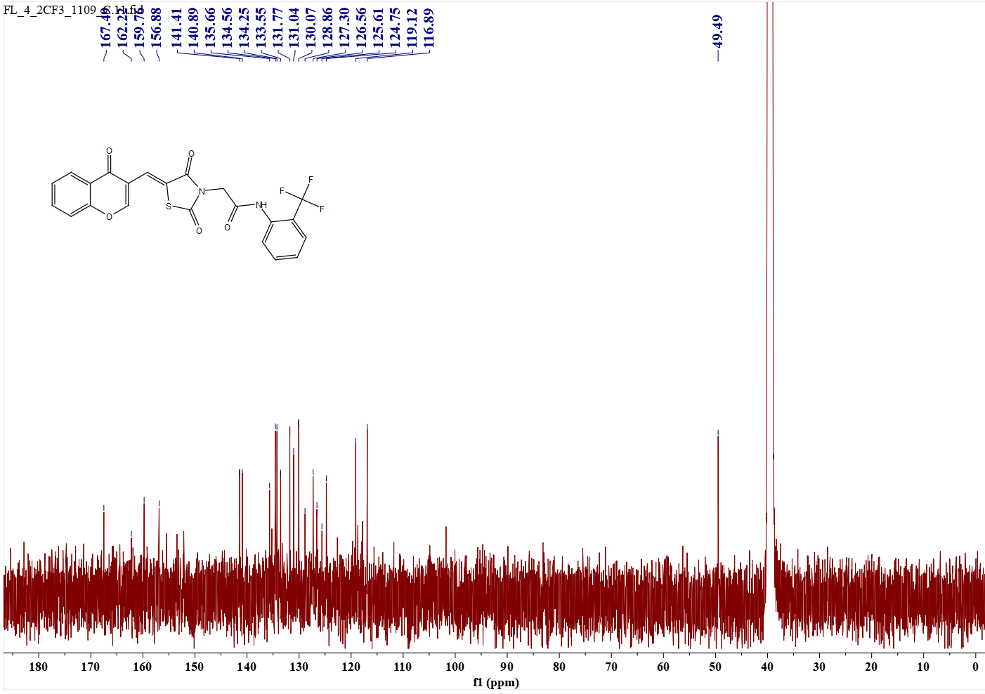 Fig.46 e23(¹³C NMR)
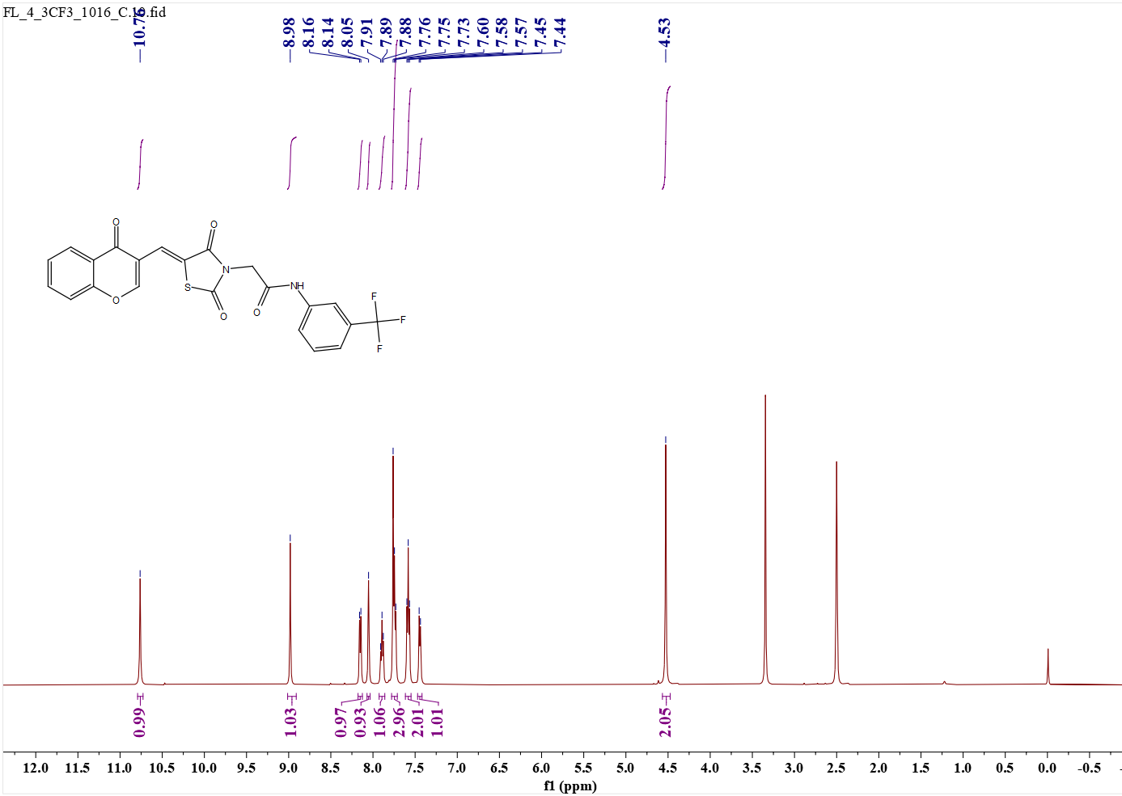 Fig.47 e24 (¹H NMR)
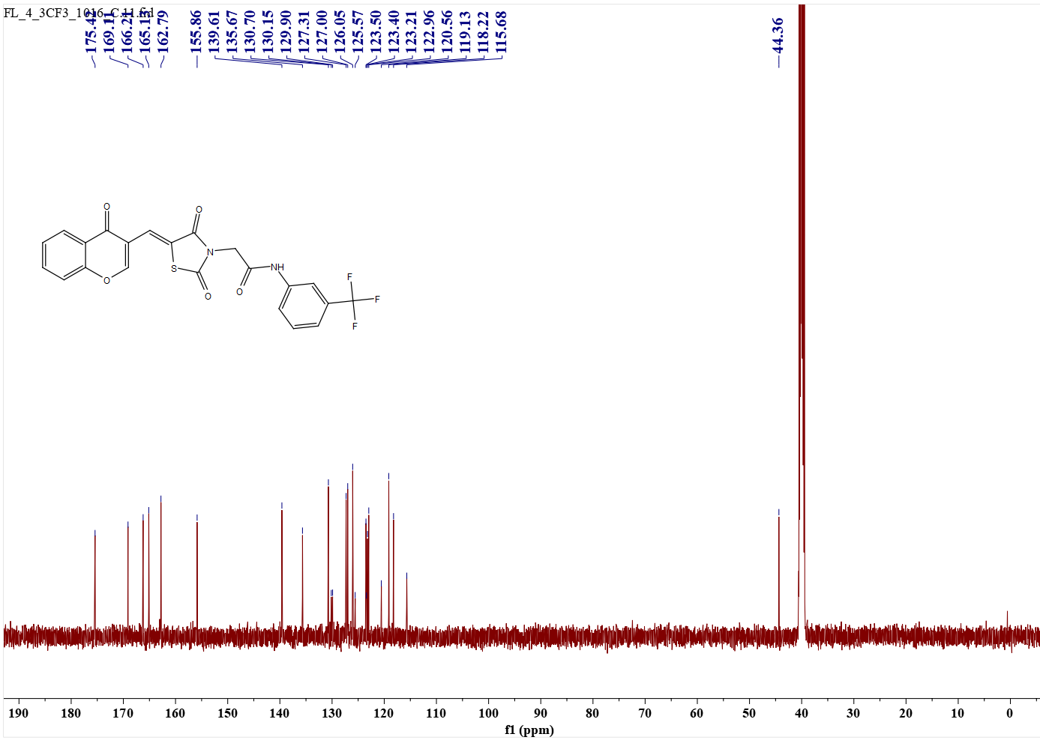 Fig.48 e24 (¹³C NMR)
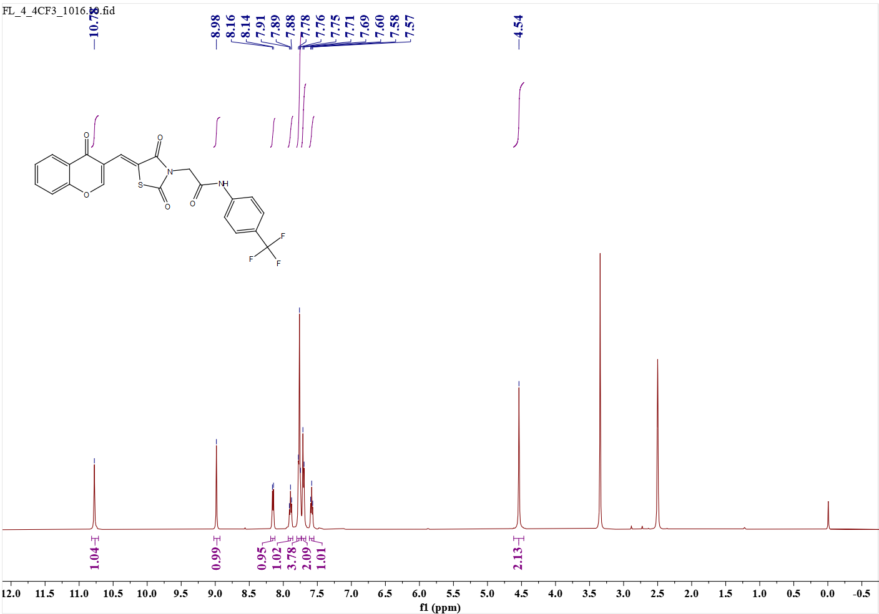 Fig.49 e25 (¹H NMR)
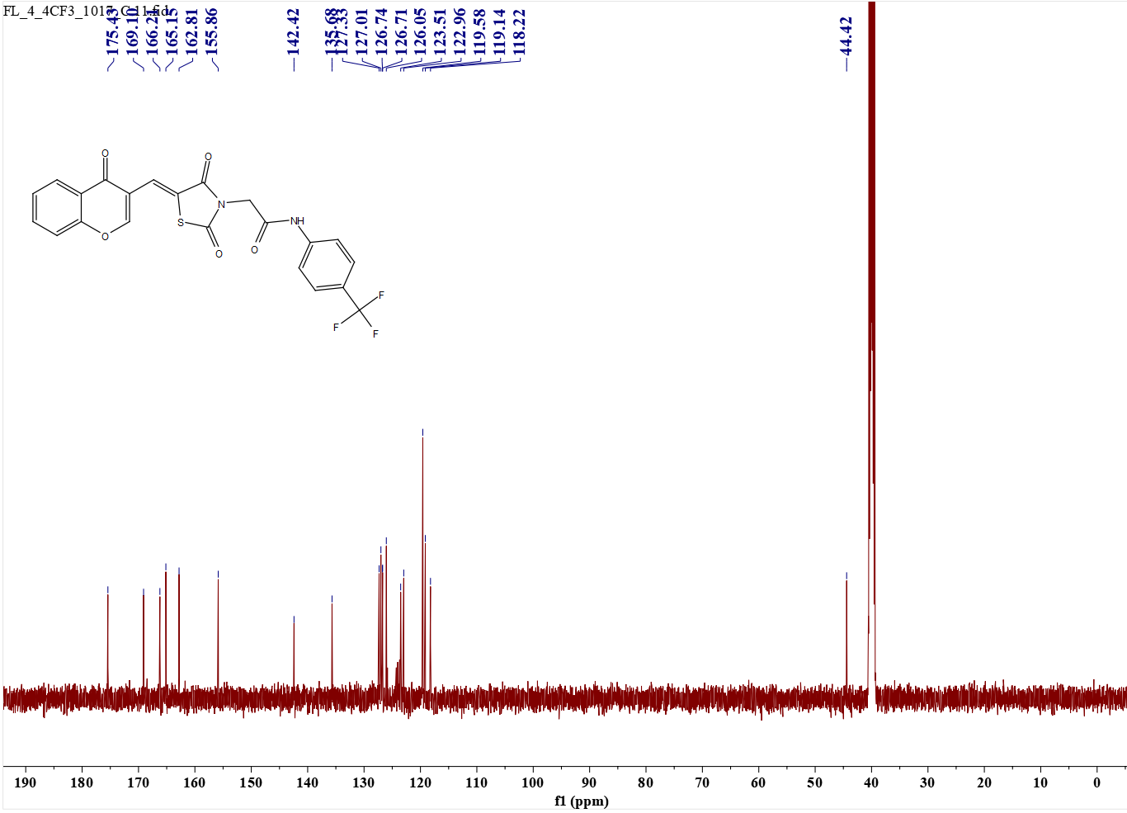 Fig.50 e25 (¹³C NMR)
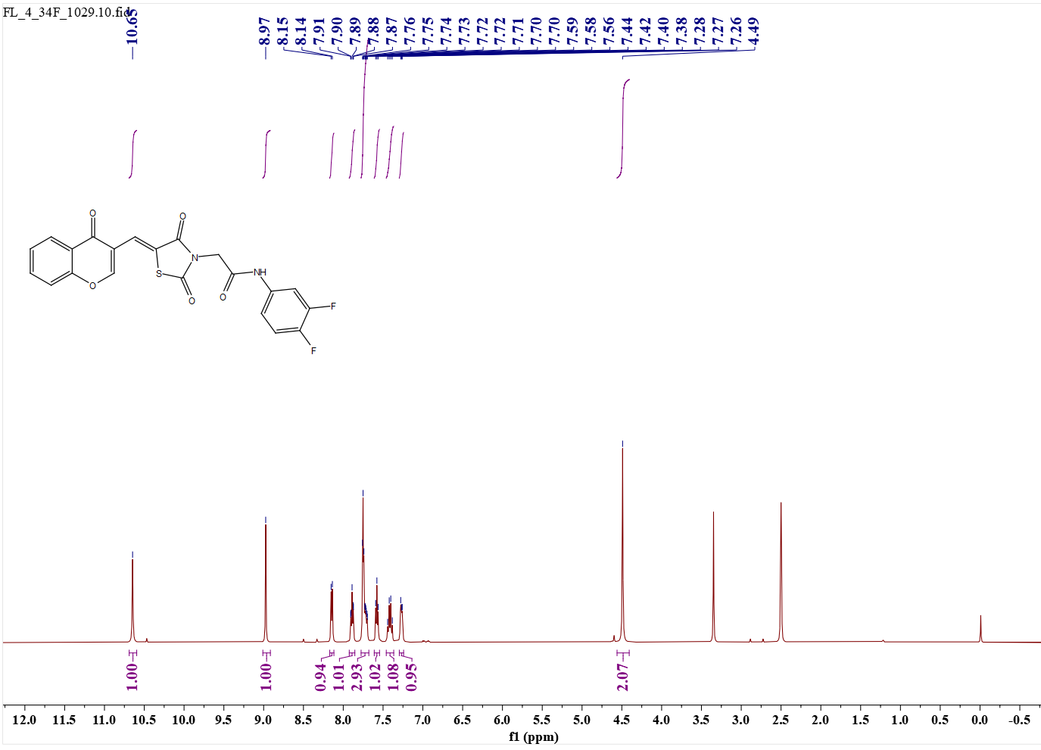 Fig.51 e26 (¹H NMR)
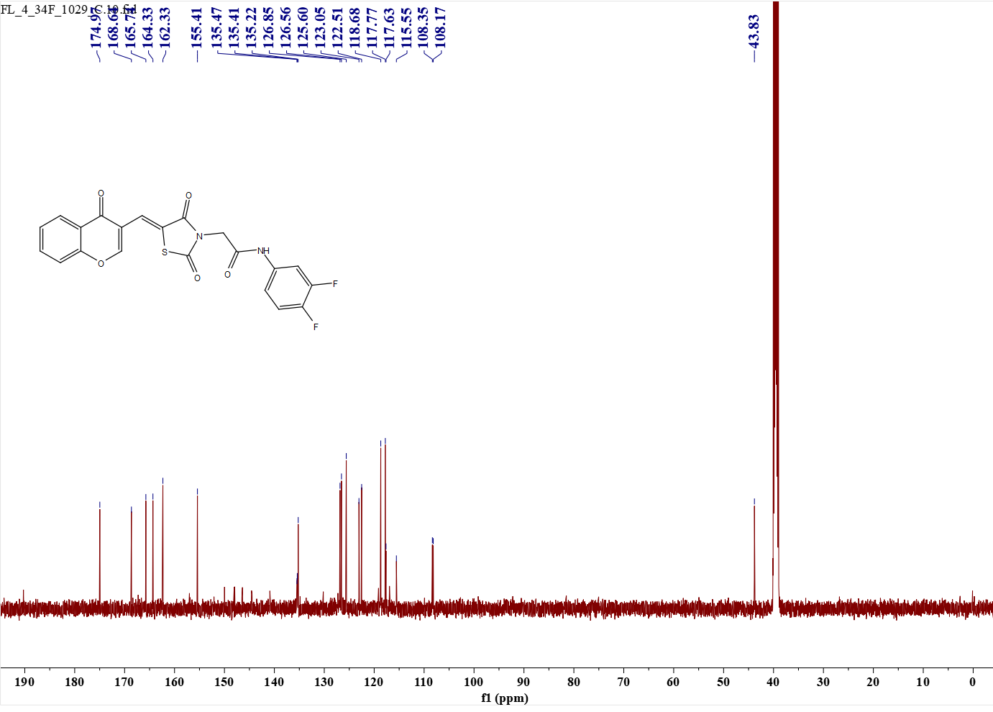 Fig.52 e26(¹³C NMR)
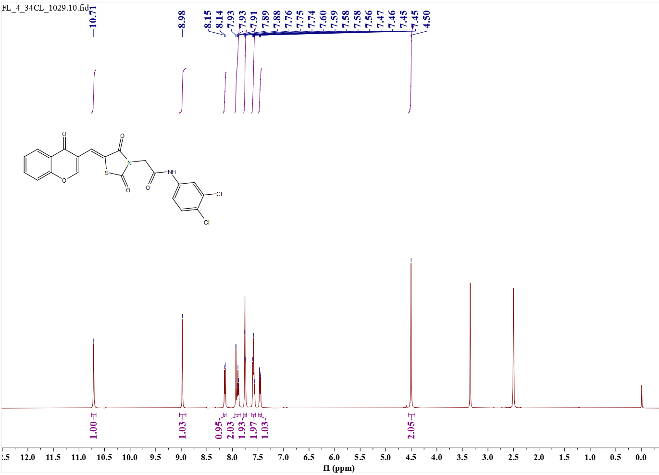 Fig.53 e27 (¹H NMR)
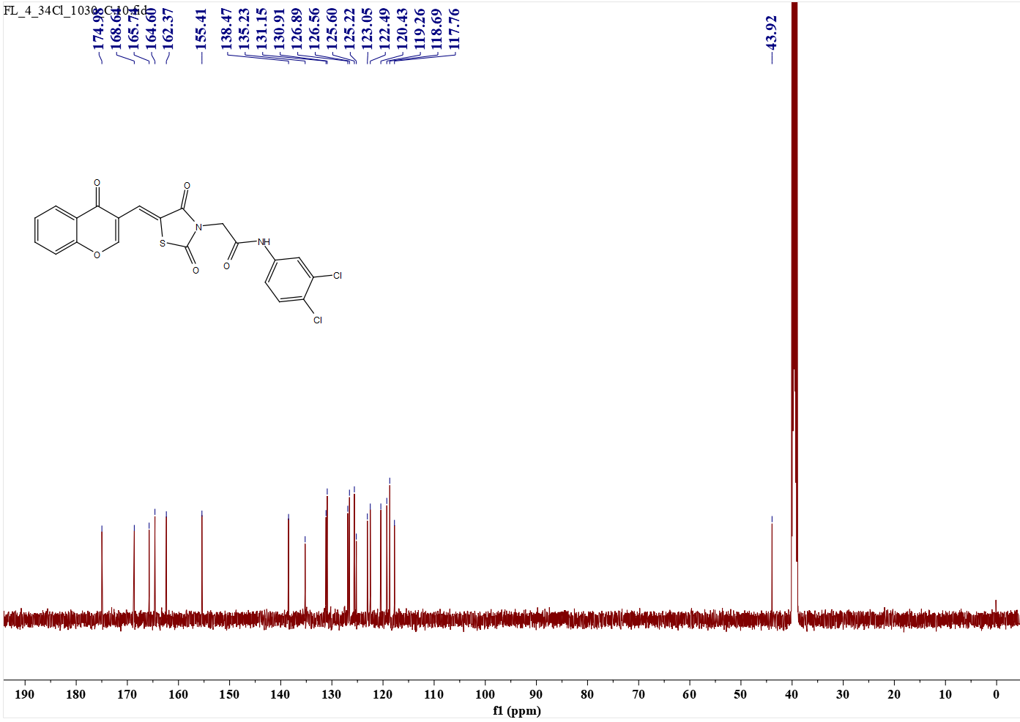 Fig.54 e27 (¹³C NMR)
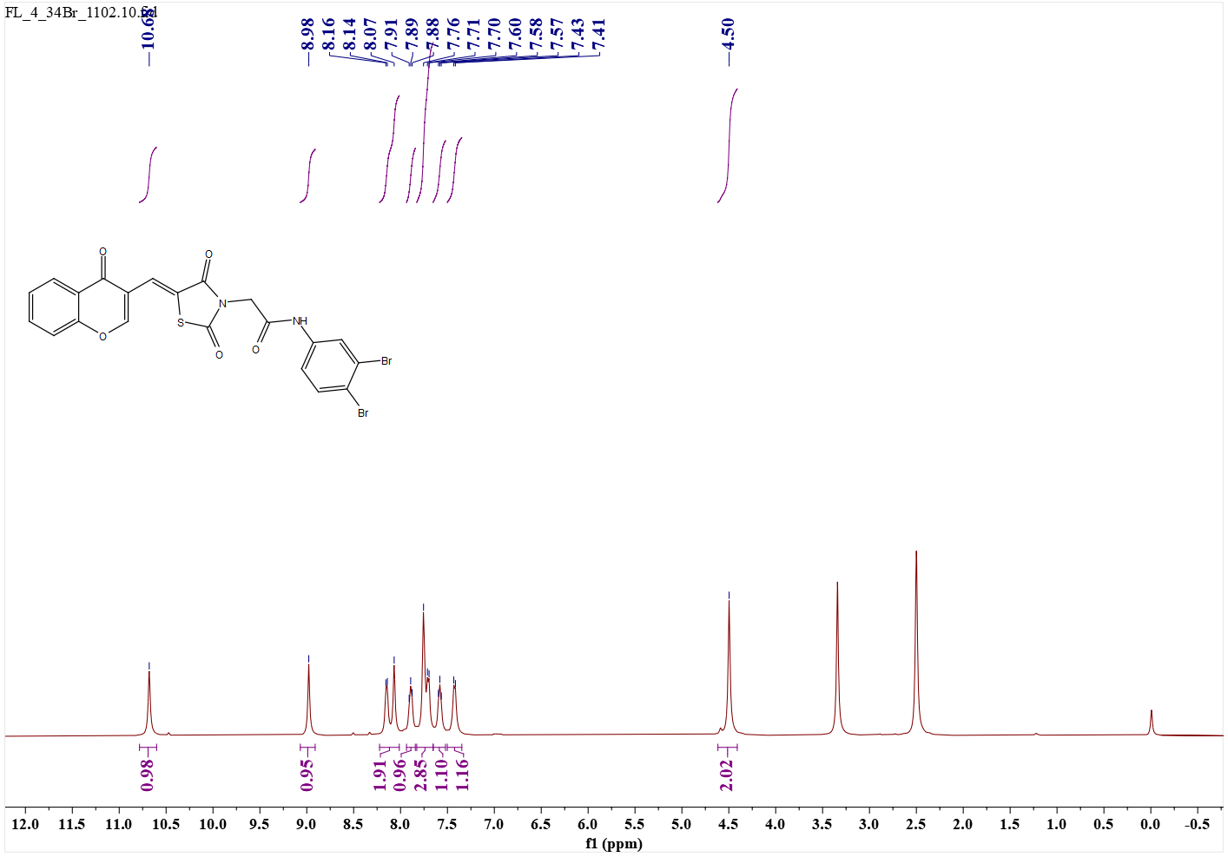 Fig.55 28 (¹H NMR)
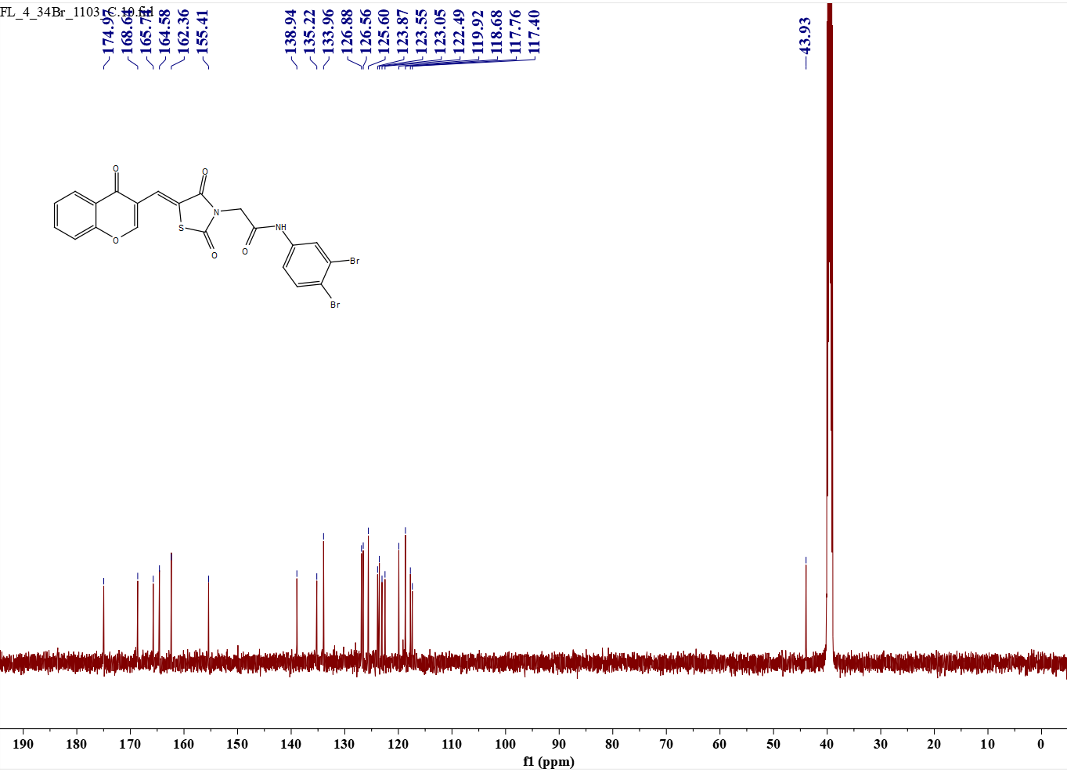 Fig.56 e28 (¹³C NMR)

