**Synthesis, crystal structure investigation, hirshfeld and DFT studies of newly synthesized dihydroisoquinoline derivatives**

Youness El Bakri a,*, Shaaban K. Mohamed b, Atazaz Ahsin c, Subramani Karthikeyan d, Suzan Abuelhassan e, Abdu E. Abdel-Rahman e, Islam S. Marae e, Etify A. Bakhite e, Joel T. Mague f and Rashad Al-Salahi g

*a Department of Theoretical and Applied Chemistry, South Ural State University, Lenin prospect 76, Chelyabinsk, 454080, Russian Federation.*

*b Chemistry and Environmental Division, Manchester Metropolitan University, Manchester, M1 5GD, England.*

*c Beijing National Laboratory for Molecular Sciences, Institute of Chemistry, Chinese Academy of Sciences, Beijing 100190, China, School of chemical sciences, University of Chinese Academy of Sciences, Beijing 100049, China.*

*d Centre for Healthcare Advancement, Innovation and Research, Vellore Institute of Technology University, Chennai Campus, Chennai 600127, India.*

*e Department of Chemistry, Faculty of science, Assiut University, Assiut 71516, Egypt.*

*f Department of Chemistry, Tulane University, New Orleans, LA 70118, USA.*

*g Department of Pharmaceutical Chemistry, College of Pharmacy, King Saud University, Riyadh 11451, Saudi Arabia.*

Corresponding author: [yns.elbakri@gmail.com](mailto:yns.elbakri@gmail.com); shaabankamel@yahoo.com

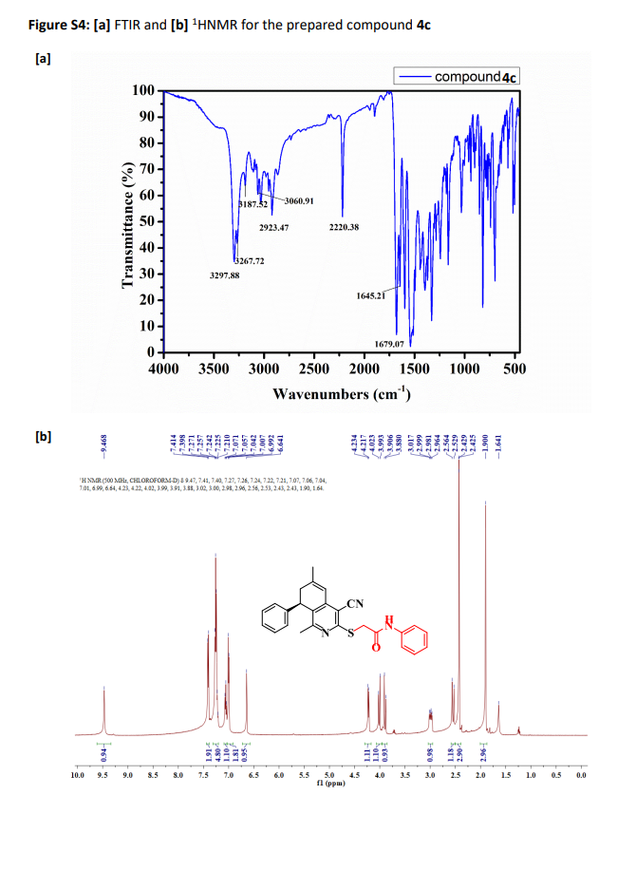

**Compound III**

**Figure S1: [a]** FT-IR and **[b]** 1H NMR for the prepared compound **III**

**[a]**



**[b]**





**Figure S2: [a]** FT-IR and **[b]** 1H NMR for the prepared compound **IV**

**Table S1.** Bond lengths (Å) for compound **III**

|  |  |  |  |
| --- | --- | --- | --- |
| **Atoms** | **Distance** | **Atoms** | **Distance** |
| S1-C1 | 1.7606(12) | S1-C19 | 1.7862(14) |
| O1-C20 | 1.2070(17) | N1-C1 | 1.3263(15) |
| N1-C9 | 1.3522(15) | N2-C10 | 1.1441(18) |
| C1-C2 | 1.4054(16) | C2-C3 | 1.4077(15) |
| C2-C10 | 1.4299(17) | C3-C8 | 1.4002(15) |
| C3-C4 | 1.4600(16) | C4-C5 | 1.3458(17) |
| C4-H4 | 0.950000 | C5-C11 | 1.4985(17) |
| C5-C6 | 1.4991(17) | C6-C7 | 1.5421(17) |
| C6-H6A | 0.990000 | C6-H6B | 0.990000 |
| C7-C8 | 1.5178(15) | C7-C12 | 1.5239(17) |
| C7-H7 | 1.000000 | C8-C9 | 1.3980(16) |
| C9-C18 | 1.5024(16) | C11-H11A | 0.980000 |
| C11-H11B | 0.980000 | C11-H11C | 0.980000 |
| C12-C13 | 1.3924(18) | C12-C17 | 1.3937(17) |
| C13-C14 | 1.393(2) | C13-H13 | 0.950000 |
| C14-C15 | 1.386(2) | C14-H14 | 0.950000 |
| C15-C16 | 1.380(3) | C15-H15 | 0.950000 |
| C16-C17 | 1.396(2) | C16-H16 | 0.950000 |
| C17-H17 | 0.950000 | C18-H18A | 0.980000 |
| C18-H18B | 0.980000 | C18-H18C | 0.980000 |
| C19-C20 | 1.5155(19) | C19-H19A | 0.990000 |
| C19-H19B | 0.990000 | C20-C21 | 1.504(2) |
| C21-H21A | 0.980000 | C21-H21B | 0.980000 |
| C21-H21C | 0.980000 |  |  |

**Table S2.** Bond angles (°) for compound **III**

|  |  |  |  |
| --- | --- | --- | --- |
| **Atoms** | **Angles** | **Atoms** | **Angles** |
| C1-S1-C19 | 99.19(6) | C1-N1-C9 | 118.38(10) |
| N1-C1-C2 | 122.83(10) | N1-C1-S1 | 118.50(9) |
| C2-C1-S1 | 118.65(9) | C1-C2-C3 | 119.26(10) |
| C1-C2-C10 | 118.60(11) | C3-C2-C10 | 122.14(11) |
| C8-C3-C2 | 117.44(10) | C8-C3-C4 | 121.16(10) |
| C2-C3-C4 | 121.39(10) | C5-C4-C3 | 121.08(11) |
| C5-C4-H4 | 119.500000 | C3-C4-H4 | 119.500000 |
| C4-C5-C11 | 122.68(12) | C4-C5-C6 | 120.26(11) |
| C11-C5-C6 | 116.96(11) | C5-C6-C7 | 114.88(10) |
| C5-C6-H6A | 108.500000 | C7-C6-H6A | 108.500000 |
| C5-C6-H6B | 108.500000 | C7-C6-H6B | 108.500000 |
| H6A-C6-H6B | 107.500000 | C8-C7-C12 | 111.01(9) |
| C8-C7-C6 | 111.87(9) | C12-C7-C6 | 111.14(10) |
| C8-C7-H7 | 107.500000 | C12-C7-H7 | 107.500000 |
| C6-C7-H7 | 107.500000 | C9-C8-C3 | 119.20(10) |
| C9-C8-C7 | 121.26(10) | C3-C8-C7 | 119.45(10) |
| N1-C9-C8 | 122.81(10) | N1-C9-C18 | 114.87(10) |
| C8-C9-C18 | 122.32(11) | N2-C10-C2 | 176.37(16) |
| C5-C11-H11A | 109.500000 | C5-C11-H11B | 109.500000 |
| H11A-C11-H11B | 109.500000 | C5-C11-H11C | 109.500000 |
| H11A-C11-H11C | 109.500000 | H11B-C11-H11C | 109.500000 |
| C13-C12-C17 | 118.90(12) | C13-C12-C7 | 121.88(11) |
| C17-C12-C7 | 119.20(12) | C12-C13-C14 | 120.52(13) |
| C12-C13-H13 | 119.700000 | C14-C13-H13 | 119.700000 |
| C15-C14-C13 | 120.17(15) | C15-C14-H14 | 119.900000 |
| C13-C14-H14 | 119.900000 | C16-C15-C14 | 119.77(14) |
| C16-C15-H15 | 120.100000 | C14-C15-H15 | 120.100000 |
| C15-C16-C17 | 120.35(14) | C15-C16-H16 | 119.800000 |
| C17-C16-H16 | 119.800000 | C12-C17-C16 | 120.29(14) |
| C12-C17-H17 | 119.900000 | C16-C17-H17 | 119.900000 |
| C9-C18-H18A | 109.500000 | C9-C18-H18B | 109.500000 |
| H18A-C18-H18B | 109.500000 | C9-C18-H18C | 109.500000 |
| H18A-C18-H18C | 109.500000 | H18B-C18-H18C | 109.500000 |
| C20-C19-S1 | 114.97(10) | C20-C19-H19A | 108.500000 |
| S1-C19-H19A | 108.500000 | C20-C19-H19B | 108.500000 |
| S1-C19-H19B | 108.500000 | H19A-C19-H19B | 107.500000 |
| O1-C20-C21 | 122.03(13) | O1-C20-C19 | 123.38(13) |
| C21-C20-C19 | 114.53(13) | C20-C21-H21A | 109.500000 |
| C20-C21-H21B | 109.500000 | H21A-C21-H21B | 109.500000 |
| C20-C21-H21C | 109.500000 | H21A-C21-H21C | 109.500000 |
| H21B-C21-H21C | 109.500000 |  |  |

**Table S3.** Bond lengths (Å) for compound **IV**

|  |  |  |  |
| --- | --- | --- | --- |
| **Atoms** | **Distance** | **Atoms** | **Distance** |
| S1-C1 | 1.7680(8) | S1-C19 | 1.8166(10) |
| O1-C20 | 1.2245(11) | N1-C1 | 1.3330(10) |
| N1-C9 | 1.3519(10) | N2-C10 | 1.1486(13) |
| N3-C20 | 1.3531(12) | N3-C21 | 1.4085(11) |
| N3-H3 | 0.902(9) | C1-C2 | 1.4036(11) |
| C2-C3 | 1.4064(12) | C2-C10 | 1.4354(12) |
| C3-C8 | 1.4008(12) | C3-C4 | 1.4597(12) |
| C4-C5 | 1.3429(15) | C4-H4 | 0.95 |
| C5-C6 | 1.4923(18) | C5-C11 | 1.5005(15) |
| C6-C7 | 1.5414(14) | C6-H6A | 0.99 |
| C6-H6B | 0.99 | C7-C8 | 1.5127(11) |
| C7-C12 | 1.5285(12) | C7-H7 | 1.0 |
| C8-C9 | 1.3991(12) | C9-C18 | 1.4994(12) |
| C11-H11A | 0.98 | C11-H11B | 0.98 |
| C11-H11C | 0.98 | C12-C17 | 1.3918(12) |
| C12-C13 | 1.3958(12) | C13-C14 | 1.3887(14) |
| C13-H13 | 0.95 | C14-C15 | 1.3857(16) |
| C14-H14 | 0.95 | C15-C16 | 1.3845(14) |
| C15-H15 | 0.95 | C16-C17 | 1.3940(13) |
| C16-H16 | 0.95 | C17-H17 | 0.95 |
| C18-H18A | 0.98 | C18-H18B | 0.98 |
| C18-H18C | 0.98 | C19-C20 | 1.5229(13) |
| C19-H19A | 0.99 | C19-H19B | 0.99 |
| C21-C22 | 1.3916(13) | C21-C26 | 1.3953(12) |
| C22-C23 | 1.3877(14) | C22-H22 | 0.95 |
| C23-C24 | 1.3897(16) | C23-H23 | 0.95 |
| C24-C25 | 1.3777(17) | C24-H24 | 0.95 |
| C25-C26 | 1.3921(15) | C25-H25 | 0.95 |
| C26-H26 | 0.95 |  |  |

**Table S4.** Bond angles (°) for compound **IV**

|  |  |  |  |
| --- | --- | --- | --- |
| **Atoms** | **Angles** | **Atoms** | **Angles** |
| C1-S1-C19 | 102.02(4) | C1-N1-C9 | 118.88(7) |
| C20-N3-C21 | 128.57(8) | C20-N3-H3 | 115.6(9) |
| C21-N3-H3 | 115.9(9) | N1-C1-C2 | 122.19(7) |
| N1-C1-S1 | 119.49(6) | C2-C1-S1 | 118.32(6) |
| C1-C2-C3 | 119.46(7) | C1-C2-C10 | 120.09(8) |
| C3-C2-C10 | 120.44(8) | C8-C3-C2 | 117.79(7) |
| C8-C3-C4 | 120.66(8) | C2-C3-C4 | 121.53(8) |
| C5-C4-C3 | 120.76(10) | C5-C4-H4 | 119.6 |
| C3-C4-H4 | 119.6 | C4-C5-C6 | 120.04(9) |
| C4-C5-C11 | 122.46(12) | C6-C5-C11 | 117.36(10) |
| C5-C6-C7 | 114.57(8) | C5-C6-H6A | 108.6 |
| C7-C6-H6A | 108.6 | C5-C6-H6B | 108.6 |
| C7-C6-H6B | 108.6 | H6A-C6-H6B | 107.6 |
| C8-C7-C12 | 112.78(7) | C8-C7-C6 | 110.74(8) |
| C12-C7-C6 | 111.63(7) | C8-C7-H7 | 107.1 |
| C12-C7-H7 | 107.1 | C6-C7-H7 | 107.1 |
| C9-C8-C3 | 118.96(7) | C9-C8-C7 | 121.30(8) |
| C3-C8-C7 | 119.66(8) | N1-C9-C8 | 122.64(8) |
| N1-C9-C18 | 116.16(7) | C8-C9-C18 | 121.20(7) |
| N2-C10-C2 | 178.11(10) | C5-C11-H11A | 109.5 |
| C5-C11-H11B | 109.5 | H11A-C11-H11B | 109.5 |
| C5-C11-H11C | 109.5 | H11A-C11-H11C | 109.5 |
| H11B-C11-H11C | 109.5 | C17-C12-C13 | 118.13(8) |
| C17-C12-C7 | 123.49(7) | C13-C12-C7 | 118.38(8) |
| C14-C13-C12 | 120.94(9) | C14-C13-H13 | 119.5 |
| C12-C13-H13 | 119.5 | C15-C14-C13 | 120.41(9) |
| C15-C14-H14 | 119.8 | C13-C14-H14 | 119.8 |
| C16-C15-C14 | 119.27(9) | C16-C15-H15 | 120.4 |
| C14-C15-H15 | 120.4 | C15-C16-C17 | 120.35(9) |
| C15-C16-H16 | 119.8 | C17-C16-H16 | 119.8 |
| C12-C17-C16 | 120.87(8) | C12-C17-H17 | 119.6 |
| C16-C17-H17 | 119.6 | C9-C18-H18A | 109.5 |
| C9-C18-H18B | 109.5 | H18A-C18-H18B | 109.5 |
| C9-C18-H18C | 109.5 | H18A-C18-H18C | 109.5 |
| H18B-C18-H18C | 109.5 | C20-C19-S1 | 114.43(6) |
| C20-C19-H19A | 108.7 | S1-C19-H19A | 108.7 |
| C20-C19-H19B | 108.7 | S1-C19-H19B | 108.7 |
| H19A-C19-H19B | 107.6 | O1-C20-N3 | 125.19(9) |
| O1-C20-C19 | 120.88(9) | N3-C20-C19 | 113.91(8) |
| C22-C21-C26 | 119.20(9) | C22-C21-N3 | 117.14(8) |
| C26-C21-N3 | 123.66(8) | C23-C22-C21 | 120.46(9) |
| C23-C22-H22 | 119.8 | C21-C22-H22 | 119.8 |
| C22-C23-C24 | 120.50(10) | C22-C23-H23 | 119.7 |
| C24-C23-H23 | 119.7 | C25-C24-C23 | 118.87(10) |
| C25-C24-H24 | 120.6 | C23-C24-H24 | 120.6 |
| C24-C25-C26 | 121.48(10) | C24-C25-H25 | 119.3 |
| C26-C25-H25 | 119.3 | C25-C26-C21 | 119.49(10) |
| C25-C26-H26 | 120.3 | C21-C26-H26 | 120.3 |

**Table S5.** Metabolism and excretion by the CYP450 isoenzymes inhibition and toxicity end points of the compounds **III** and **IV**

|  |  |  |  |  |  |  |  |  |  |  |
| --- | --- | --- | --- | --- | --- | --- | --- | --- | --- | --- |
| Metabolism and Excretion Toxicity endpoints | | | | | | | | | | |
| CY450 Inhibitors | | | | | | | | | | |
|  | 1A2 | 2C19 | 2C9 | 2D6 | 3A4 | Hepato | Carcino | Immuno | Mutagen | Cyto |
| **III** | No | Yes | Yes | No | Yes | 0.57 | -0.66 | -0.99 | -0.55 | -0.65 |
| **IV** | No | Yes | Yes | No | Yes | 0.51 | -0.54 | -0.99 | -0.60 | -0.72 |

(*Note: CYP450 (inhibition of the Cytochrome P450 isoenzymes), LD50 (Letal dosage is 600 mg/kg),- (Inactive toxic class (probability score)), and + (Active toxic class (probability score)).*