Design, synthesis, and biological evaluation of benzenesulfonyl chloride-substituted evodiamine derivatives as potential PGAM1 inhibitors

Binbin Wei, Jingjing Ma, Hui Guo*, Yingying Zhang, Weitong Zhang, Wenzhuo Chen, Dongyan Guo, Yuwei Wang*, Yuping Tang*
College of Pharmacy, Shaanxi Key Lab Basic & New Herbal Medicament Res, Shaanxi University of Chinese Medicine, Xixian New Area, Shaanxi Province, 712046, PR China

*Correspondence:
Hui Guo
guohui@sntcm.edu.cn

Yuwei Wang
wangyw09@gmail.com;

Yuping Tang
yupingtang@sntcm.edu.cn

- General Information
3-NH-EVO comes from our own lab, others were purchased commercially. Solvent was dried using 4 Å molecular sieve. ¹H and ¹³C NMR raw data were collected by a Bruker AVANCE400 and AVANCE500 spectrometer and spectrums were exported through MestReNova software. Deuterated solvent included DMSO-d₆, CDCl₃ and D₂O, teramethylsilane was used as the internal standard. The chemical shifts (δ) are reported in parts per million (ppm) and the coupling constant (J) unit is Hz. ESI mass spectra were performed on an Agilent 7250&JEOL-JMS-T100LP AccuTOF. spectrometer. TLC analysis was carried out on silica gel plates GF254 (Qingdao Haiyang Chemical, China). Silica gel column chromatography was performed with Silica gel 60 G (Qingdao Haiyang Chemical, China). Commercial solvents were used without any pretreatment.

- ¹H NMR ,¹³C NMR spectrums and mass spectrometric data
¹H NMR,¹³C NMR spectrums data for compound 9
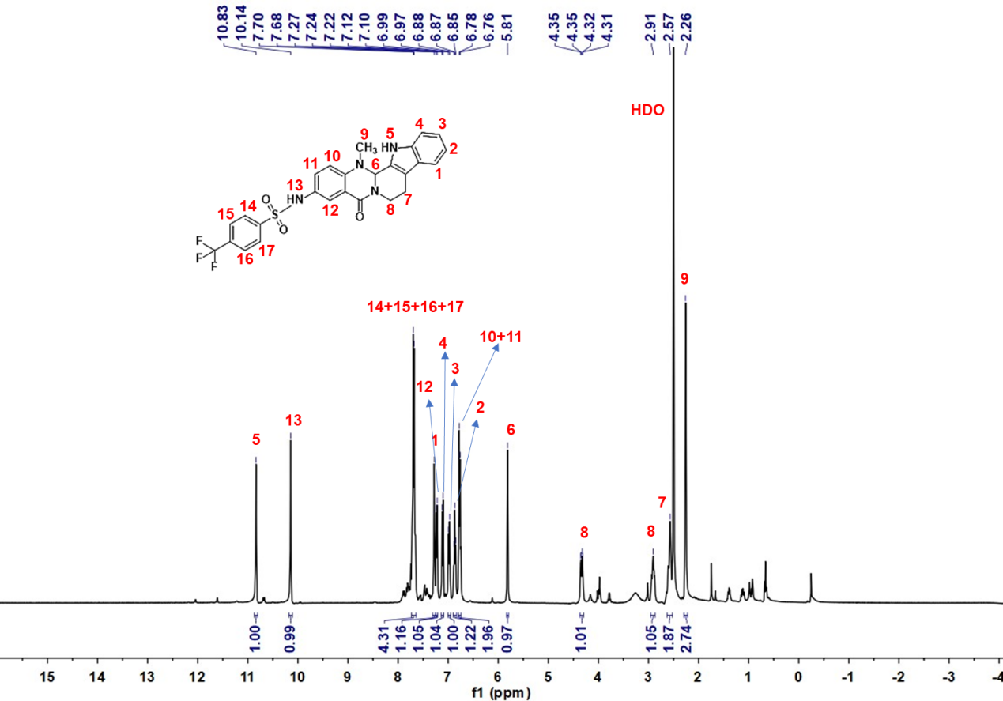
Deuterated solvent: DMSO-d₆, NMR frequency: 400.15 MHz, temperature: 25℃.

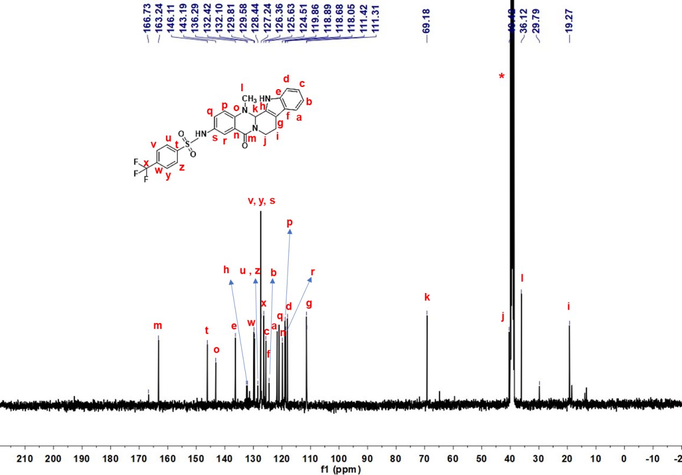
Deuterated solvent: DMSO-d₆, NMR frequency: 100.63 MHz, temperature: 25℃.

¹H NMR,¹³C NMR spectrums data for compound 10
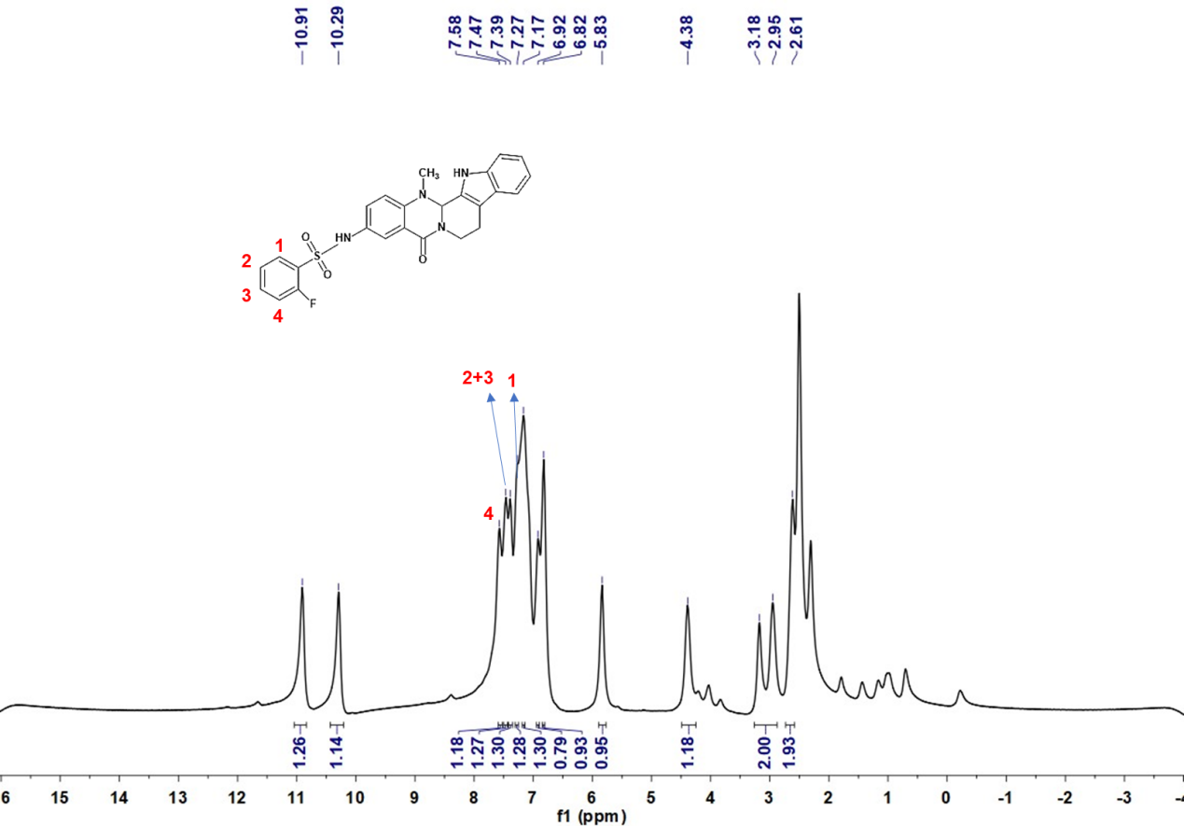
Deuterated solvent: DMSO-d₆, NMR frequency: 400.15 MHz, temperature: 25℃.

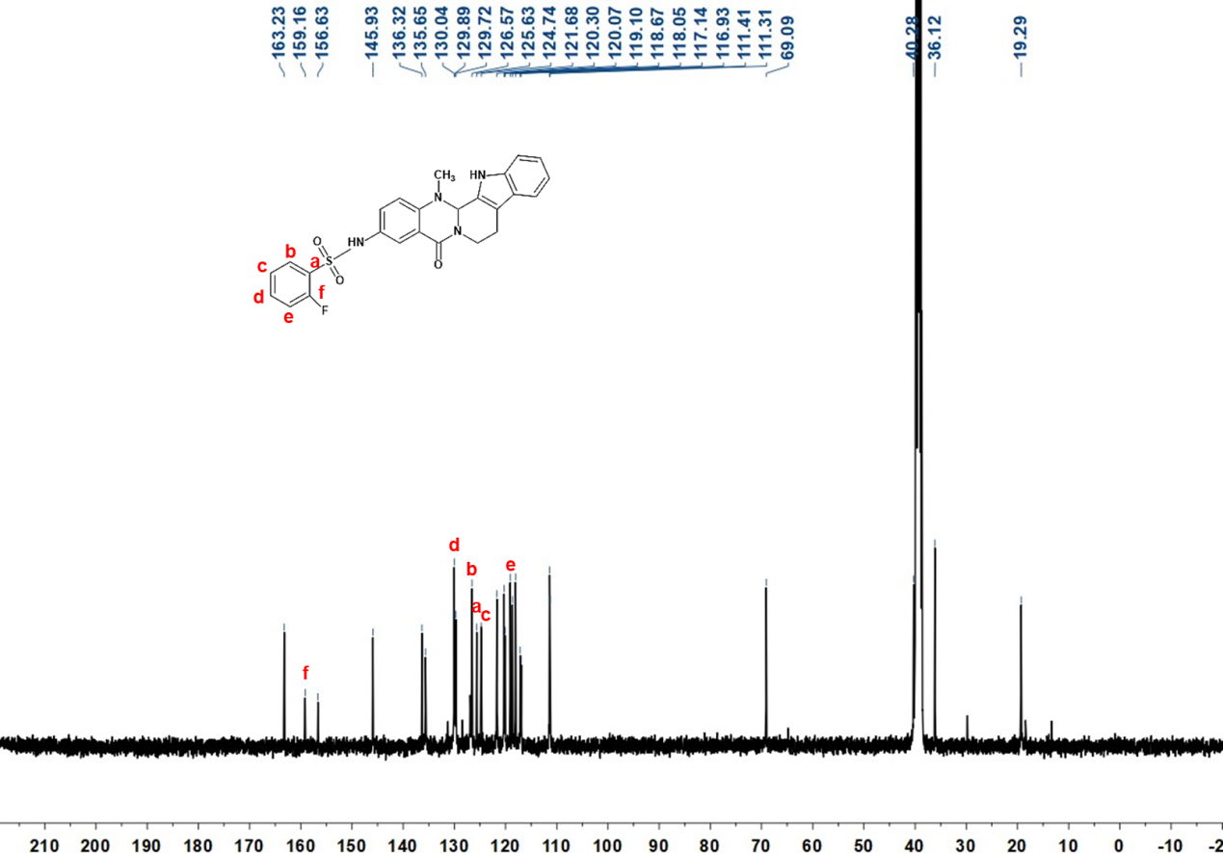
Deuterated solvent: DMSO-d₆, NMR frequency: 100.63 MHz, temperature: 25℃.

¹H NMR,¹³C NMR spectrums data for compound 11
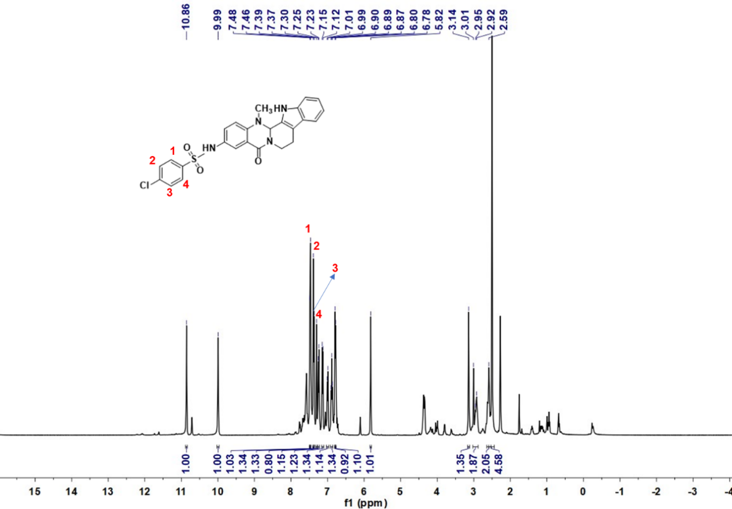
Deuterated solvent: DMSO-d₆, NMR frequency: 400.15 MHz, temperature: 25℃.

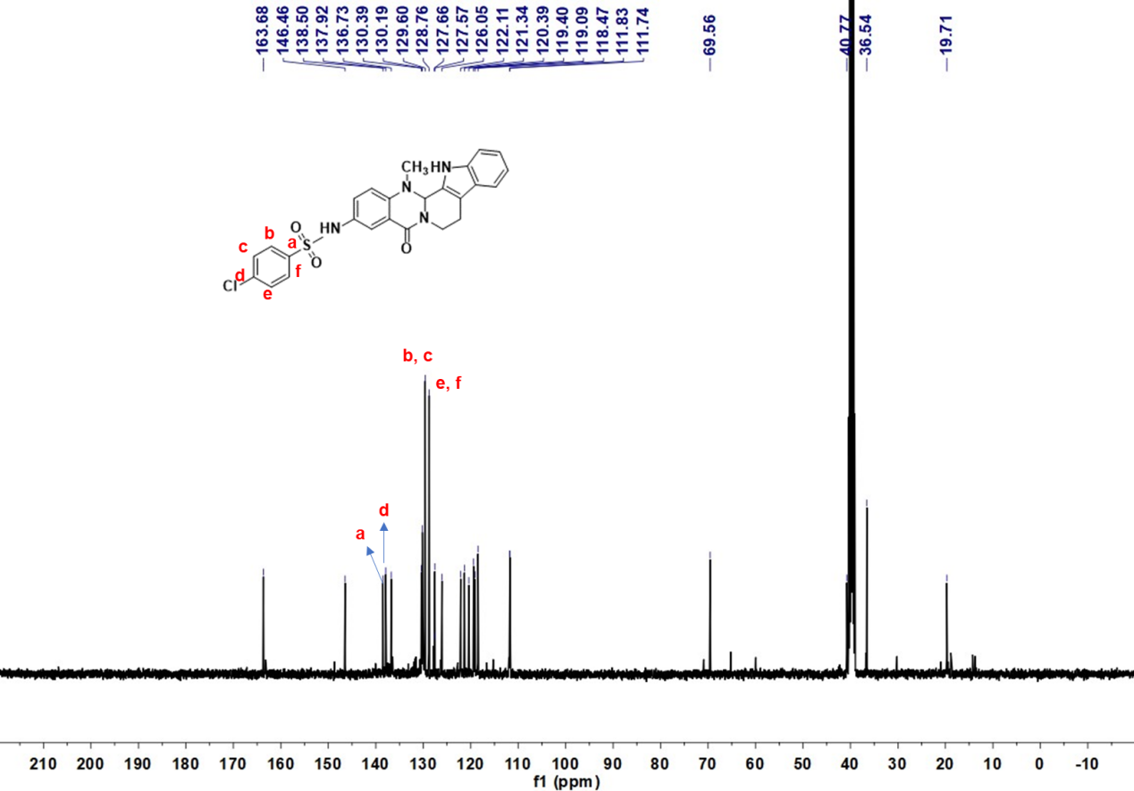
Deuterated solvent: DMSO-d₆, NMR frequency: 100.63 MHz, temperature: 25℃.

¹H NMR,¹³C NMR spectrums data for compound 12
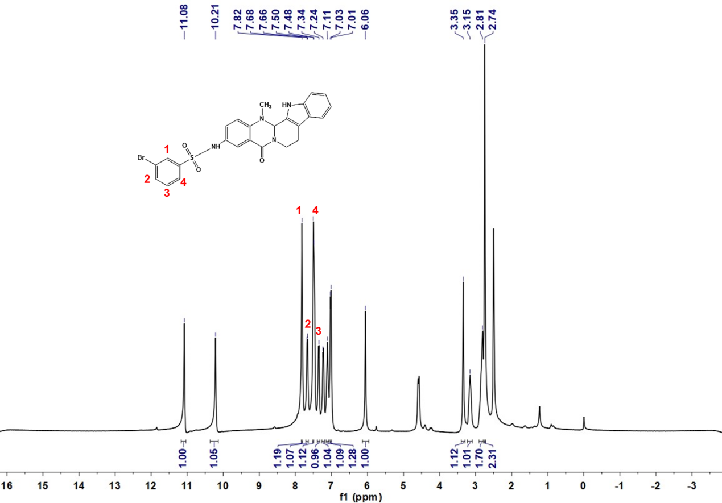
Deuterated solvent: DMSO-d₆, NMR frequency: 400.15 MHz, temperature: 25℃.

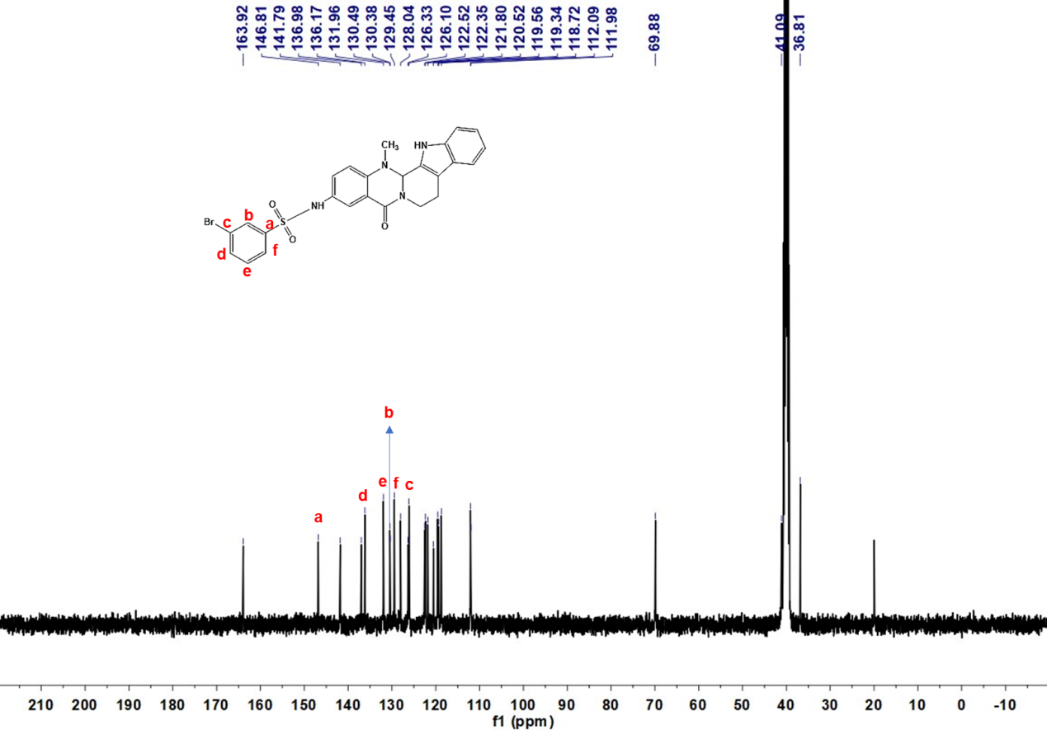
Deuterated solvent: DMSO-d₆, NMR frequency: 100.63 MHz, temperature: 25℃.

¹H NMR,¹³C NMR spectrums data for compound 13
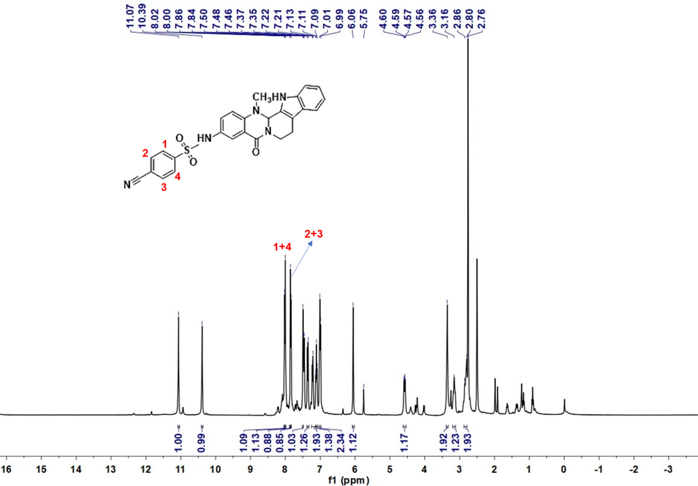
Deuterated solvent: DMSO-d₆, NMR frequency: 400.15 MHz, temperature: 25℃.

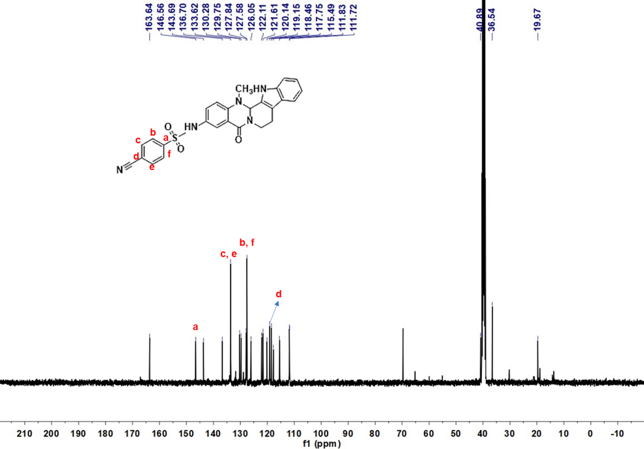
Deuterated solvent: DMSO-d₆, NMR frequency: 100.63 MHz, temperature: 25℃.

¹H NMR,¹³C NMR spectrums data for compound 14
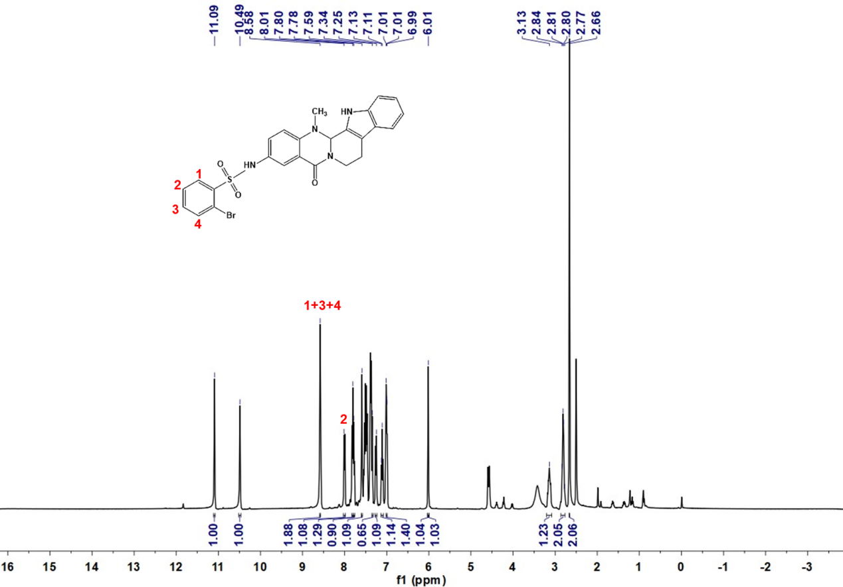
Deuterated solvent: DMSO-d₆, NMR frequency: 400.15 MHz, temperature: 25℃.

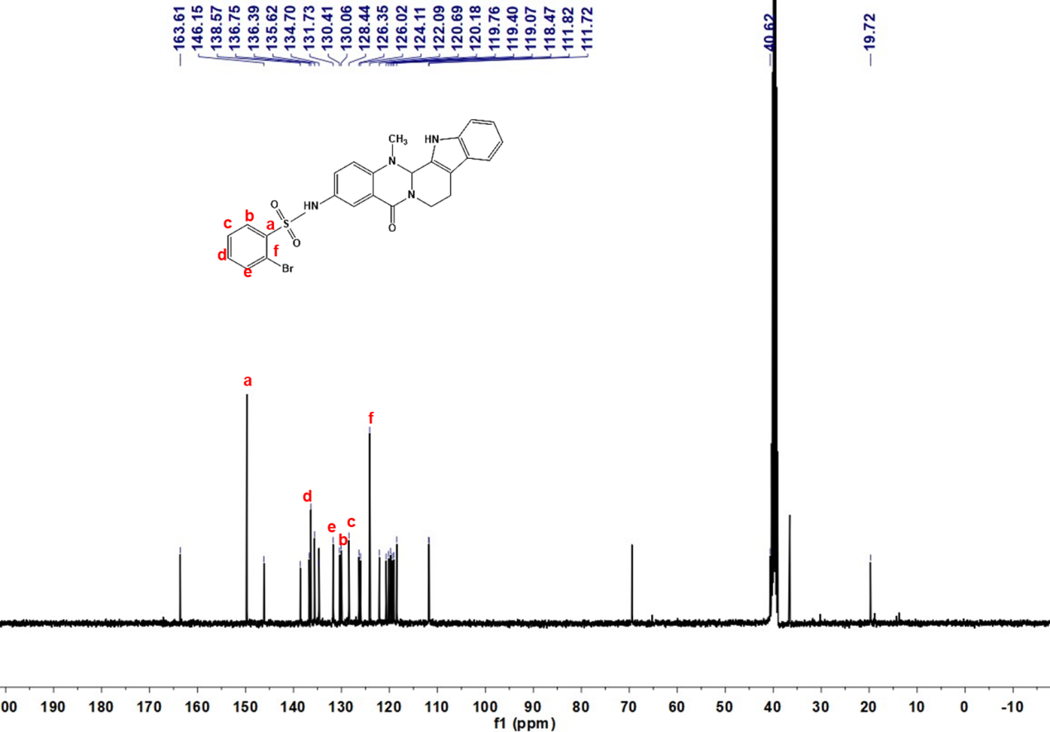
Deuterated solvent: DMSO-d₆, NMR frequency: 100.63 MHz, temperature: 25℃.

¹H NMR,¹³C NMR spectrums data for compound 15
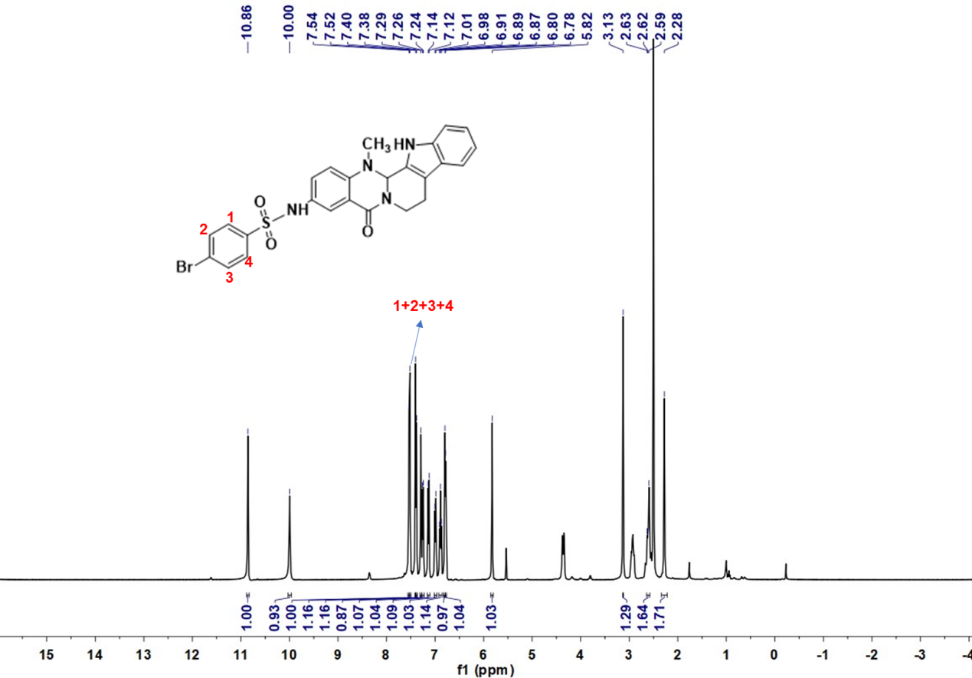
Deuterated solvent: DMSO-d₆, NMR frequency: 400.15 MHz, temperature: 25℃.

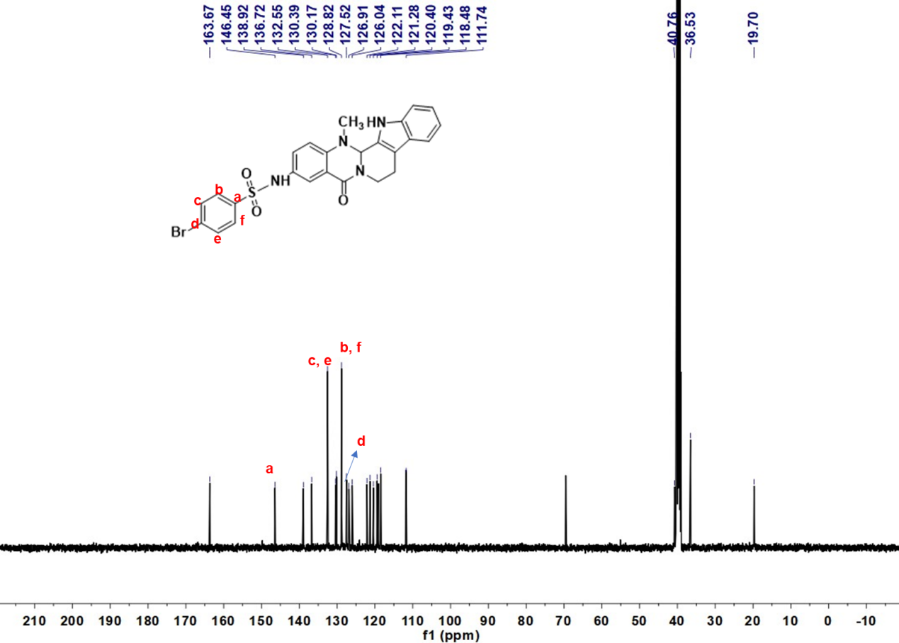
Deuterated solvent: DMSO-d₆, NMR frequency: 100.63 MHz, temperature: 25℃.

¹H NMR,¹³C NMR spectrums data for compound 16
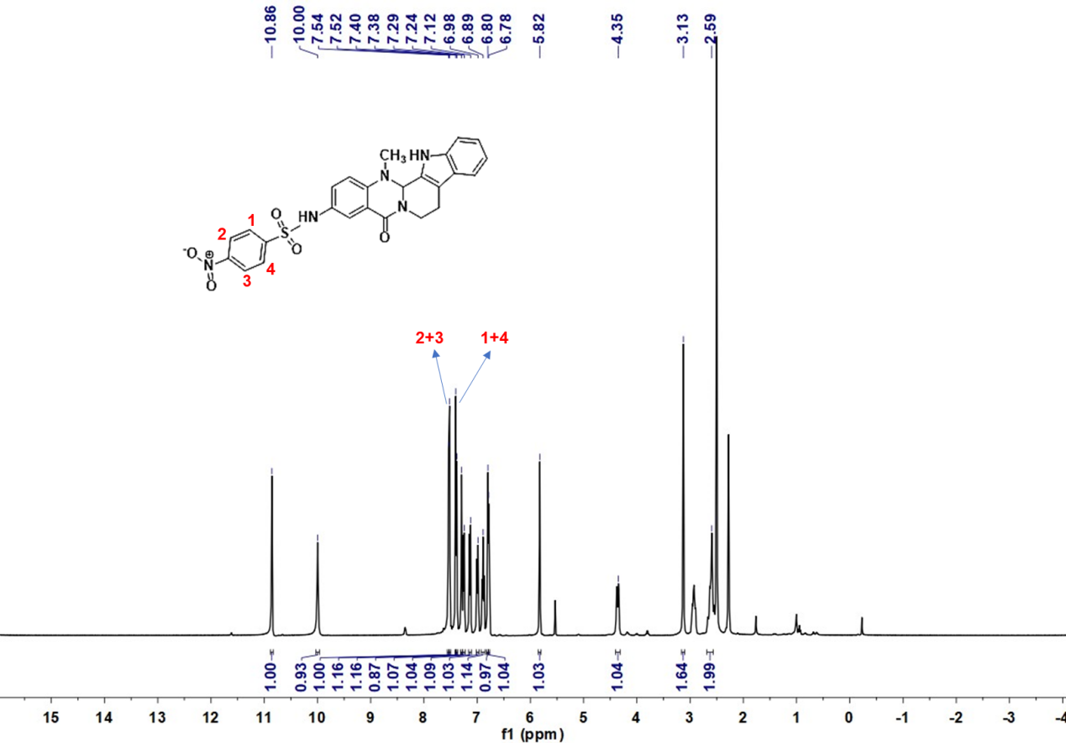
Deuterated solvent: DMSO-d₆, NMR frequency: 400.15 MHz, temperature: 25℃.

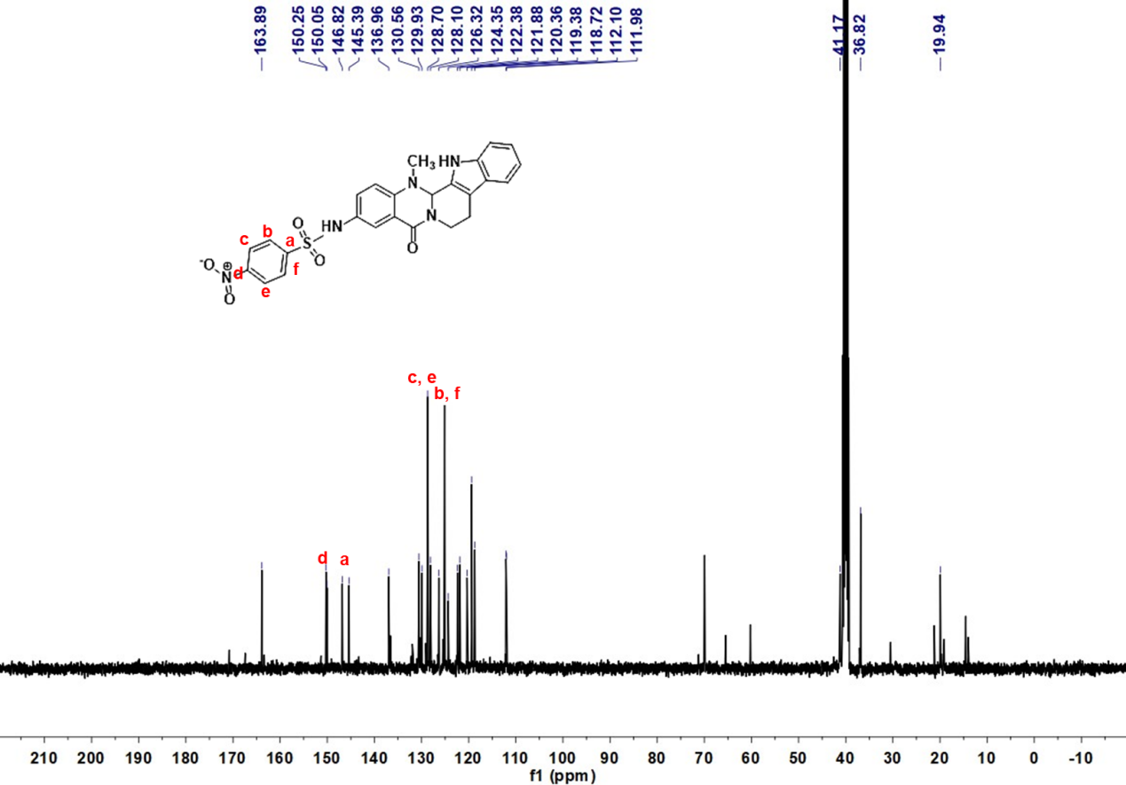
Deuterated solvent: DMSO-d₆, NMR frequency: 100.63 MHz, temperature: 25℃.

¹H NMR,¹³C NMR spectrums data for compound 17
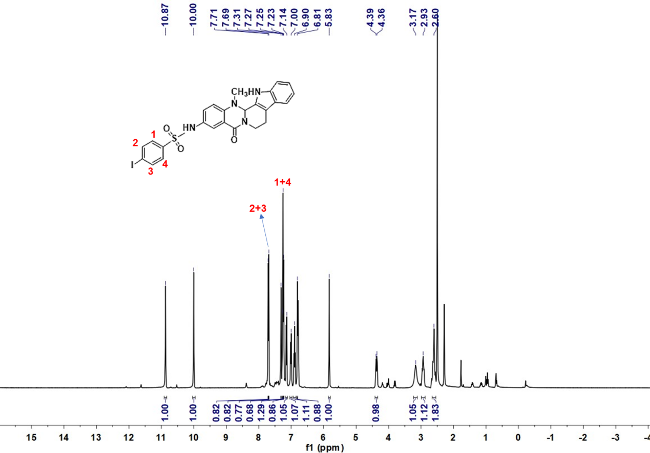
Deuterated solvent: DMSO-d₆, NMR frequency: 400.15 MHz, temperature: 25℃.

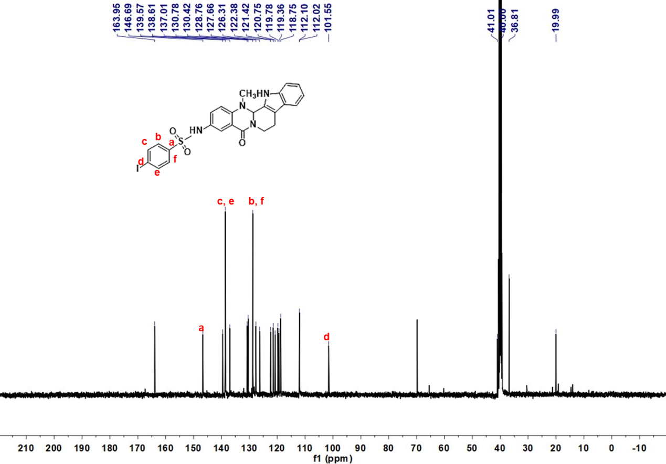
Deuterated solvent: DMSO-d₆, NMR frequency: 100.63 MHz, temperature: 25℃.

¹H NMR,¹³C NMR spectrums data for compound 18
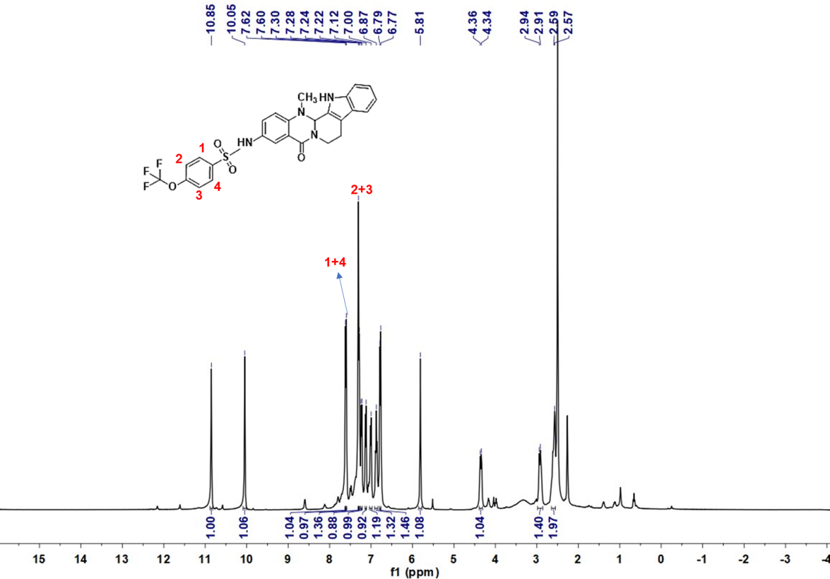
Deuterated solvent: DMSO-d₆, NMR frequency: 400.15 MHz, temperature: 25℃.

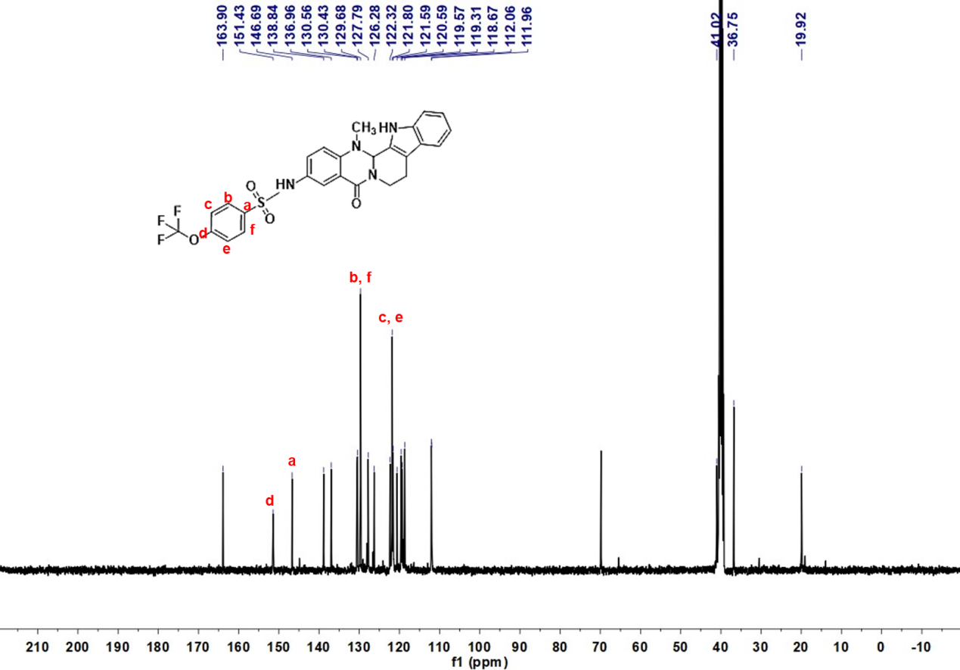
Deuterated solvent: DMSO-d₆, NMR frequency: 100.63 MHz, temperature: 25℃.
¹H NMR,¹³C NMR spectrums data for compound 19
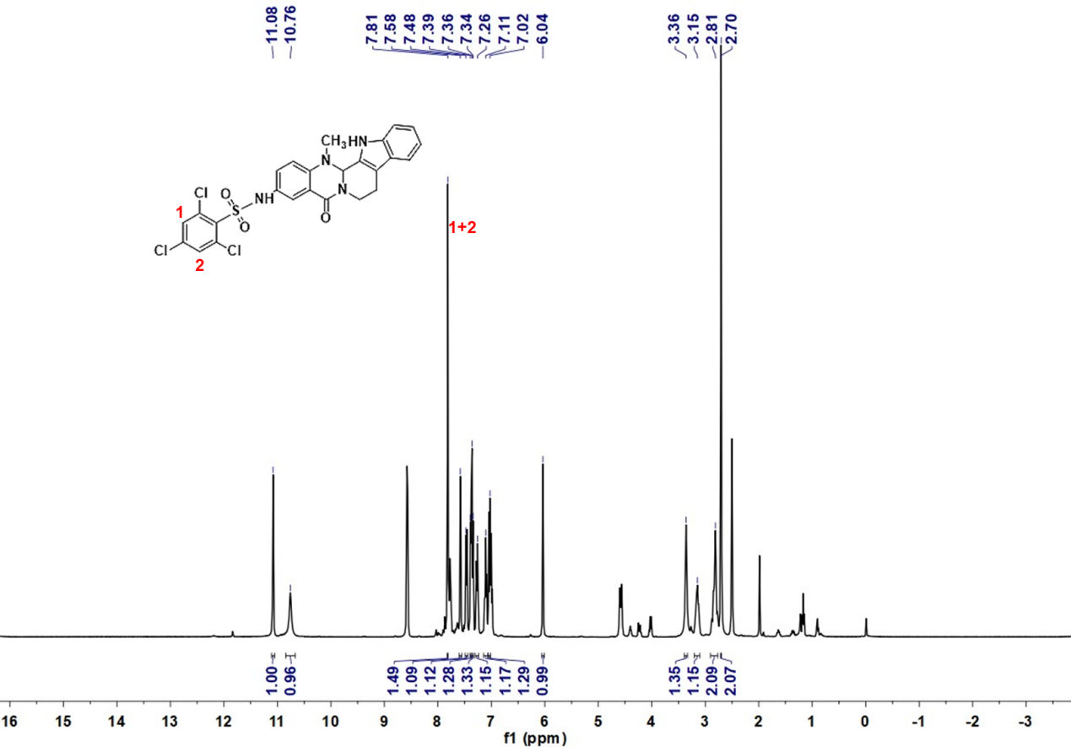
Deuterated solvent: DMSO-d₆, NMR frequency: 400.15 MHz, temperature: 25℃.

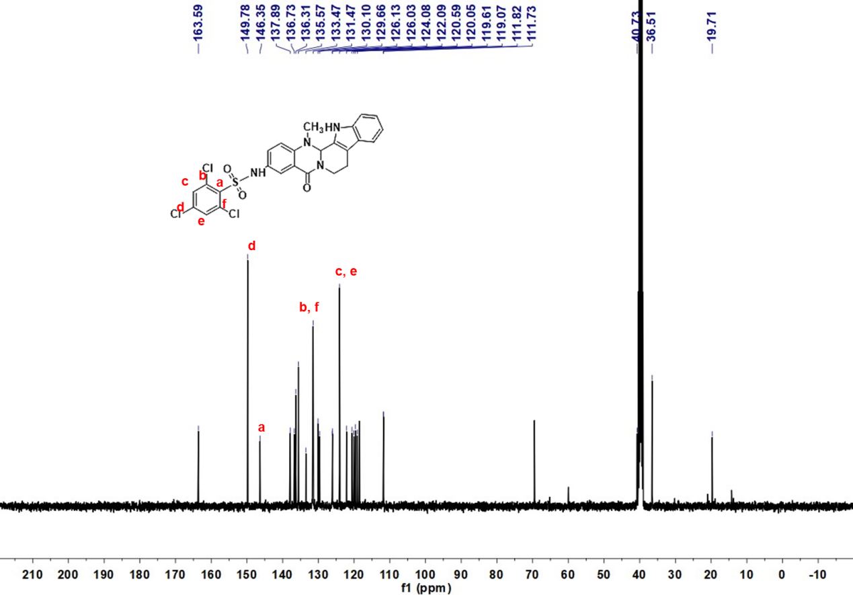
Deuterated solvent: DMSO-d₆, NMR frequency: 100.63 MHz, temperature: 25℃.

¹H NMR,¹³C NMR spectrums data for compound 20
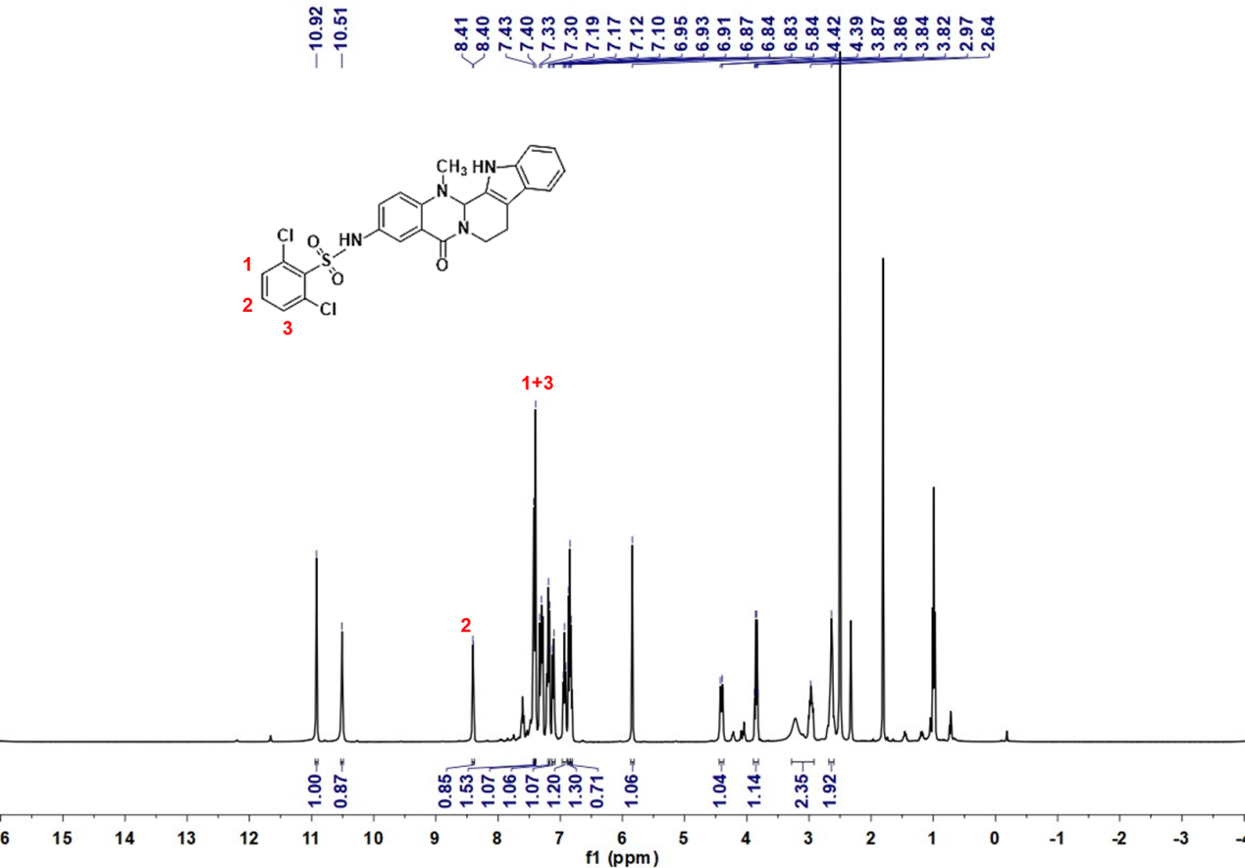
Deuterated solvent: DMSO-d₆, NMR frequency: 400.15 MHz, temperature: 25℃.

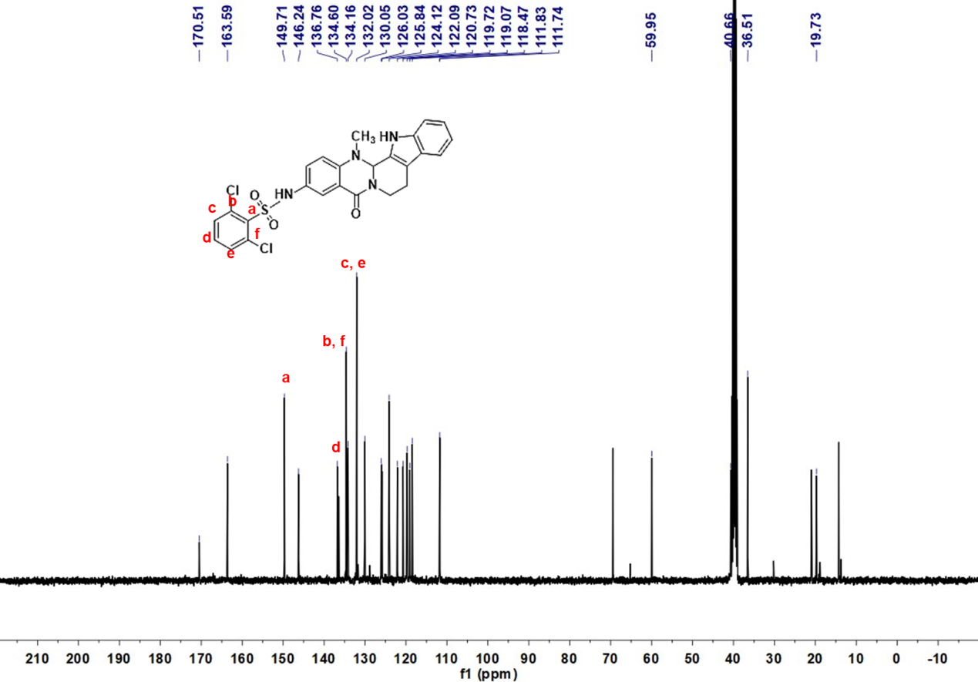
Deuterated solvent: DMSO-d₆, NMR frequency: 100.63 MHz, temperature: 25℃.

¹H NMR,¹³C NMR spectrums data for compound 21
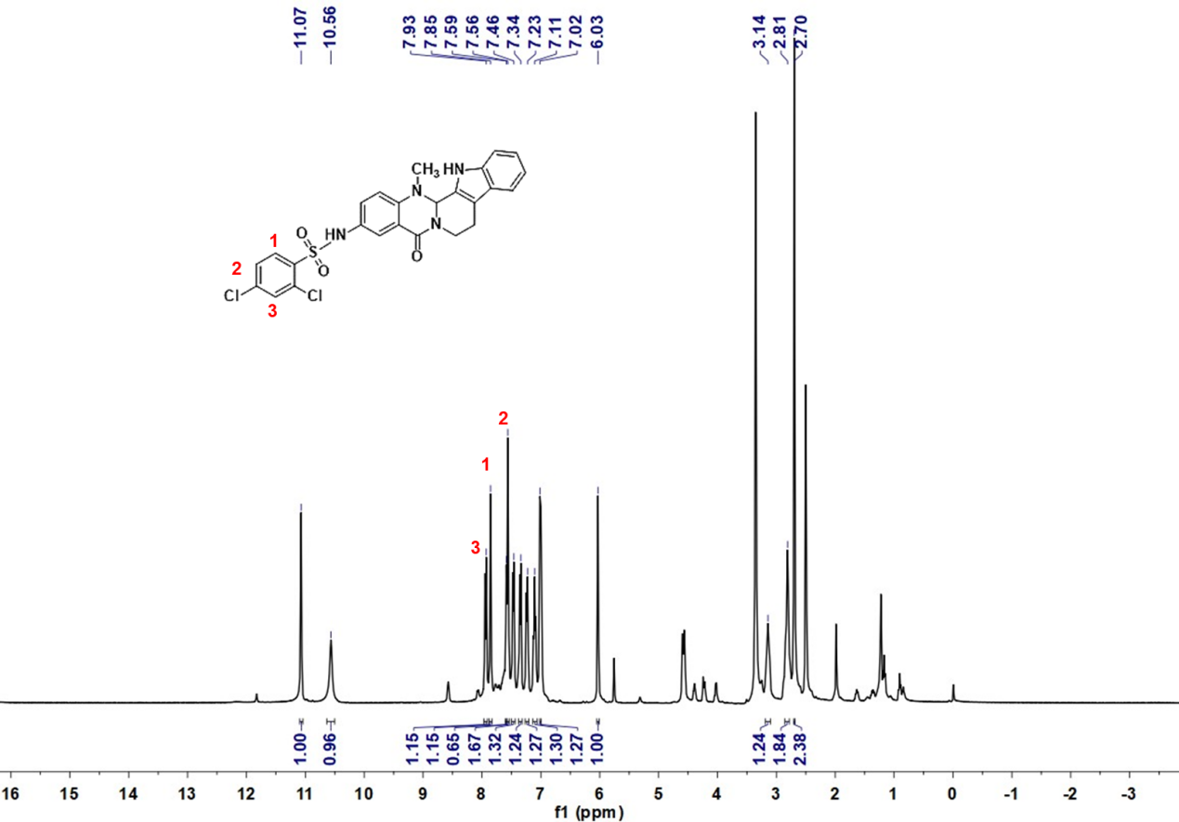
Deuterated solvent: DMSO-d₆, NMR frequency: 400.15 MHz, temperature: 25℃.

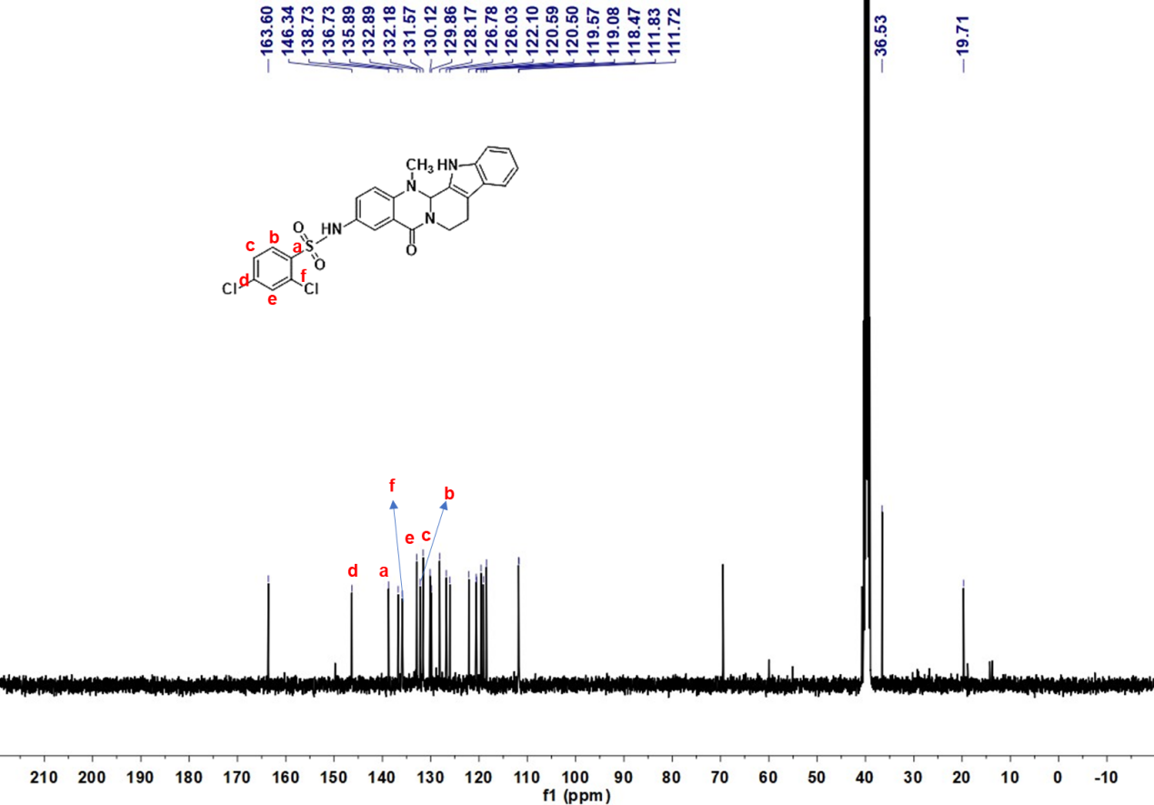
Deuterated solvent: DMSO-d₆, NMR frequency: 100.63 MHz, temperature: 25℃.

¹H NMR,¹³C NMR spectrums data for compound 22
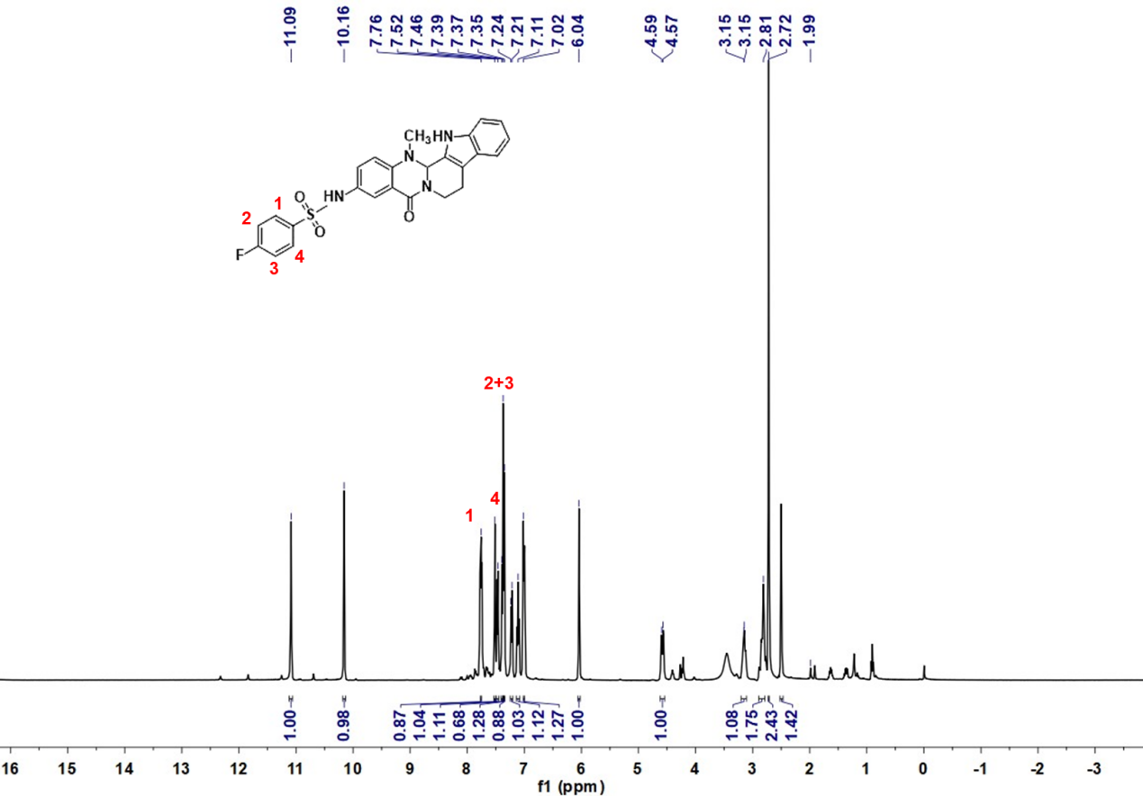
Deuterated solvent: DMSO-d₆, NMR frequency: 400.15 MHz, temperature: 25℃.

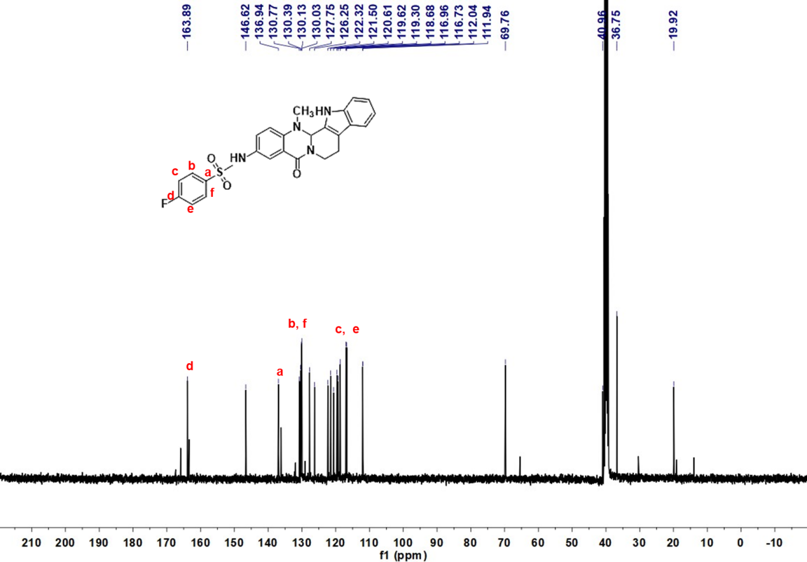 Deuterated solvent: DMSO-d₆, NMR frequency: 100.63 MHz, temperature: 25℃.

¹H NMR,¹³C NMR spectrums data for compound 23
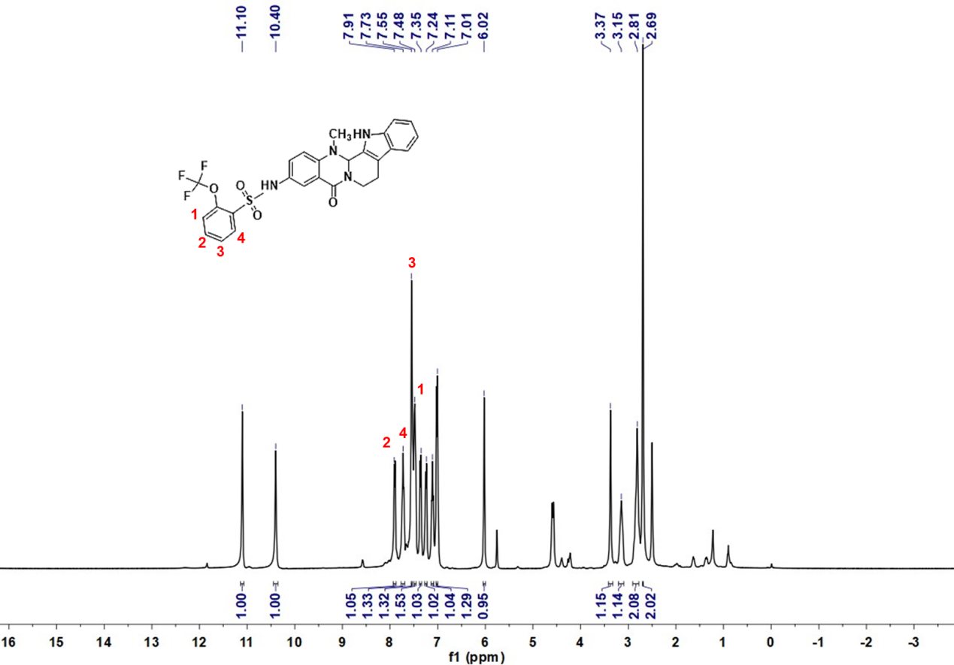
Deuterated solvent: DMSO-d₆, NMR frequency: 400.15 MHz, temperature: 25℃.

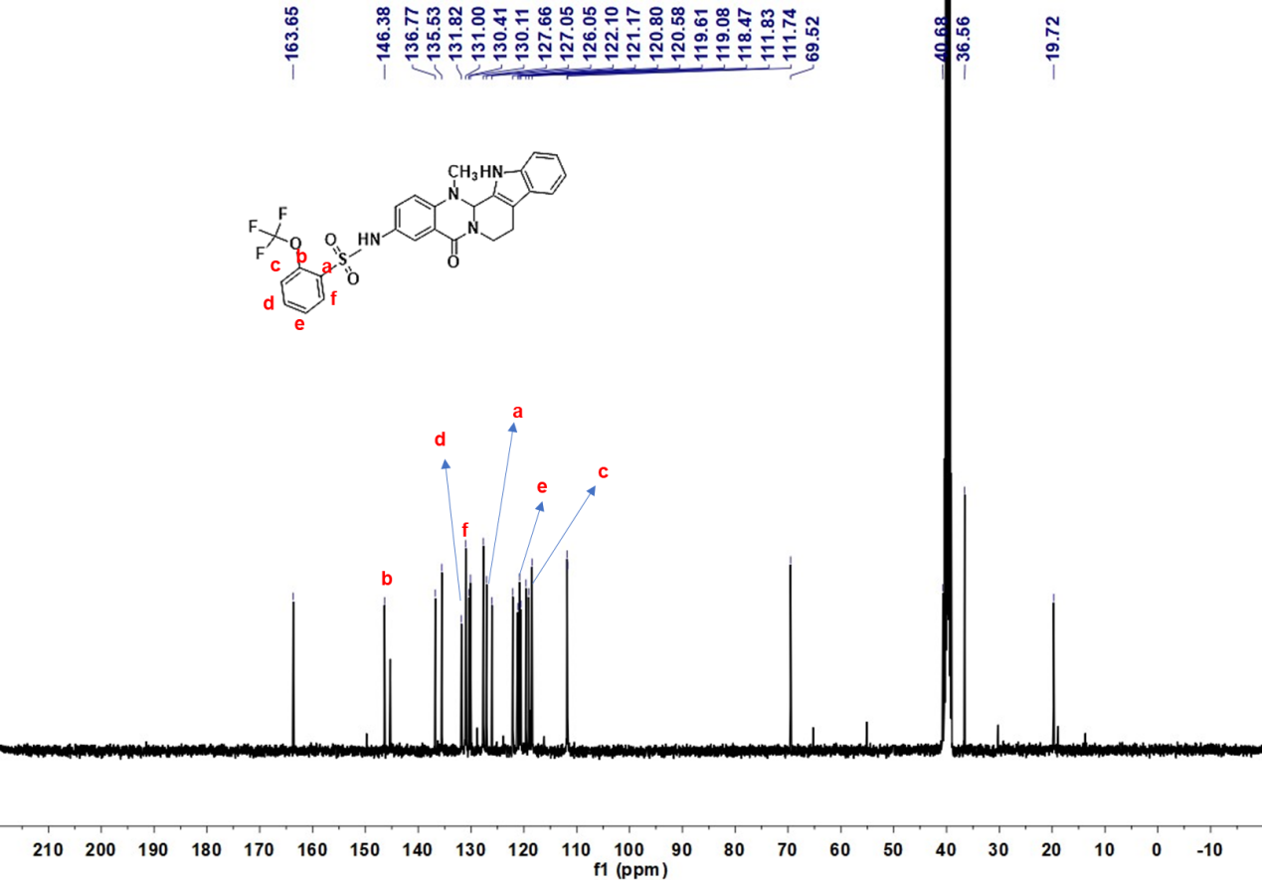
Deuterated solvent: DMSO-d₆, NMR frequency: 100.63 MHz, temperature: 25℃.

¹H NMR,¹³C NMR spectrums data for compound 24
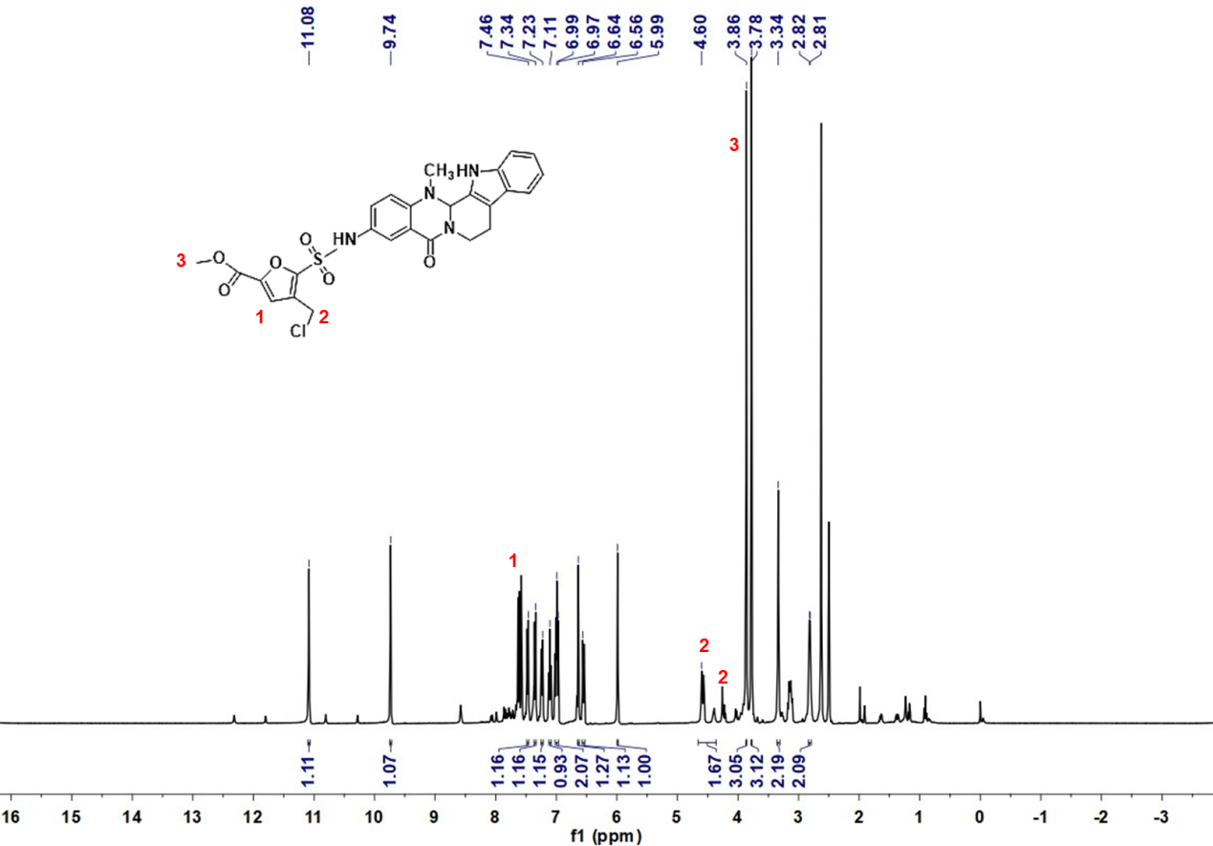
Deuterated solvent: DMSO-d₆, NMR frequency: 400.15 MHz, temperature: 25℃.

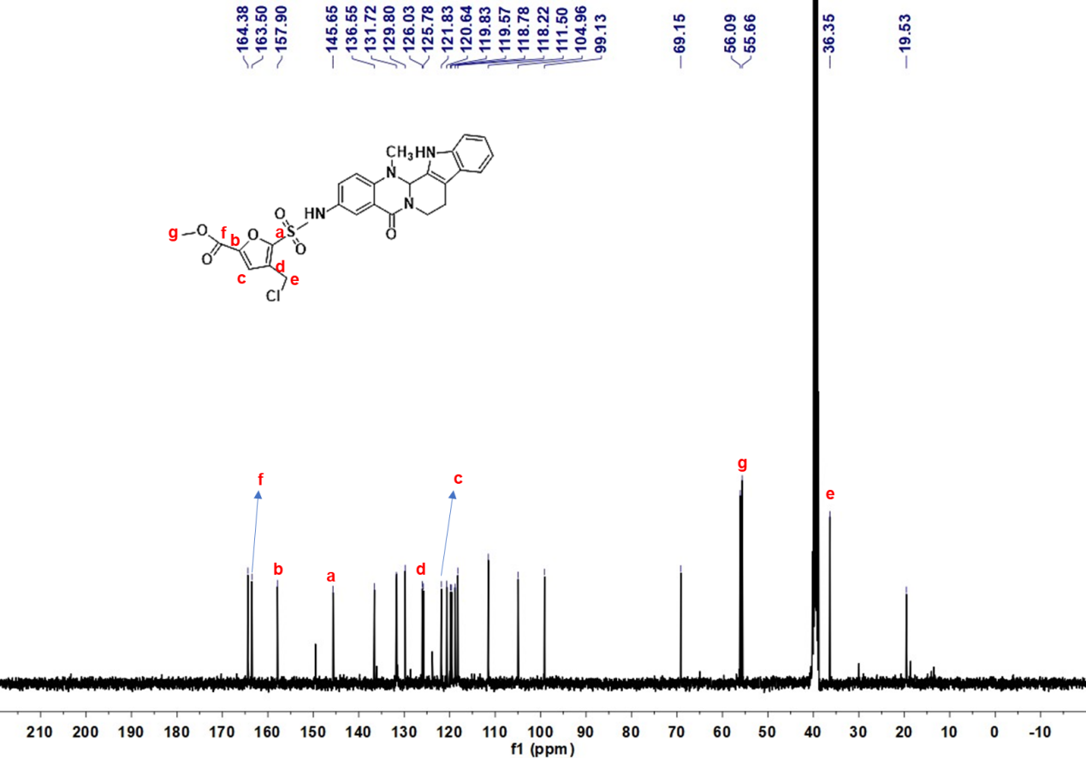 Deuterated solvent: DMSO-d₆, NMR frequency: 100.63 MHz, temperature: 25℃.

¹H NMR,¹³C NMR spectrums data for compound 25
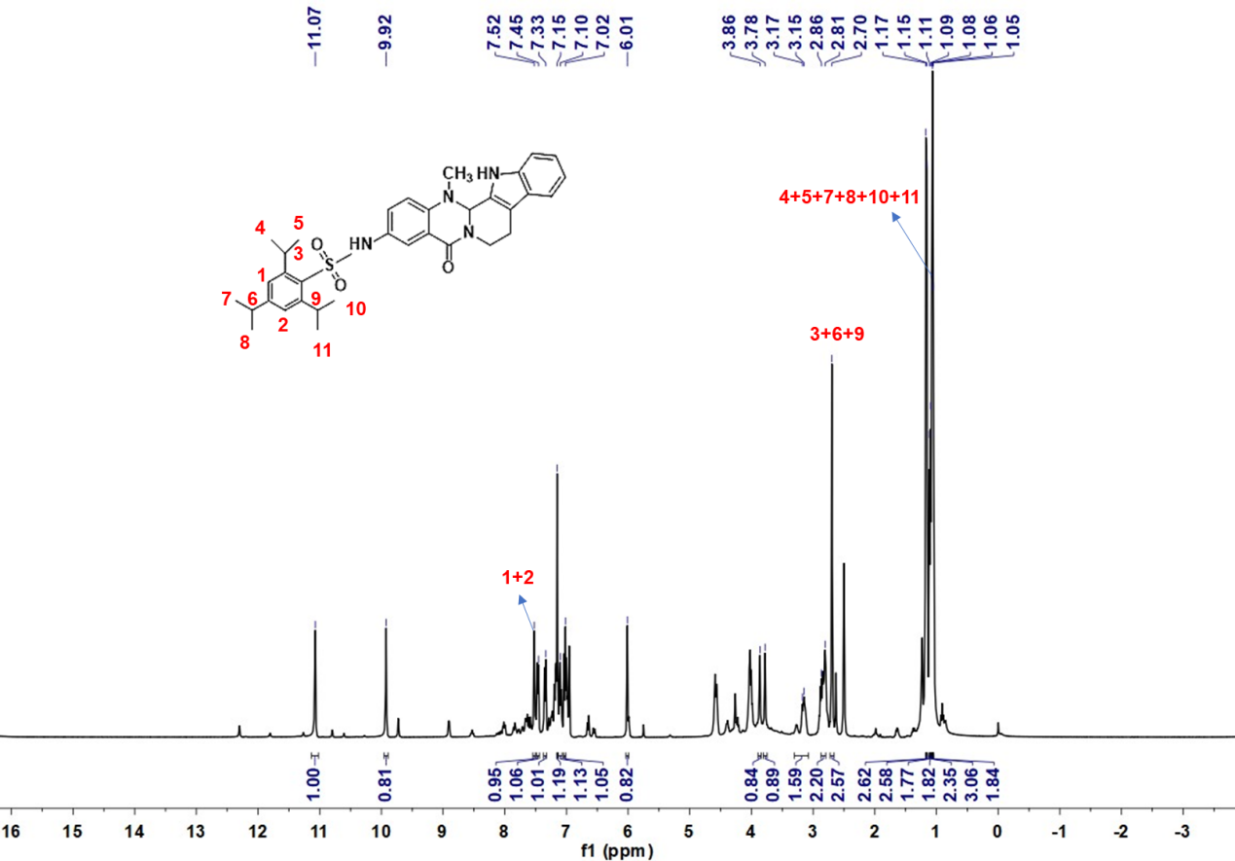
Deuterated solvent: DMSO-d₆, NMR frequency: 400.15 MHz, temperature: 25℃.

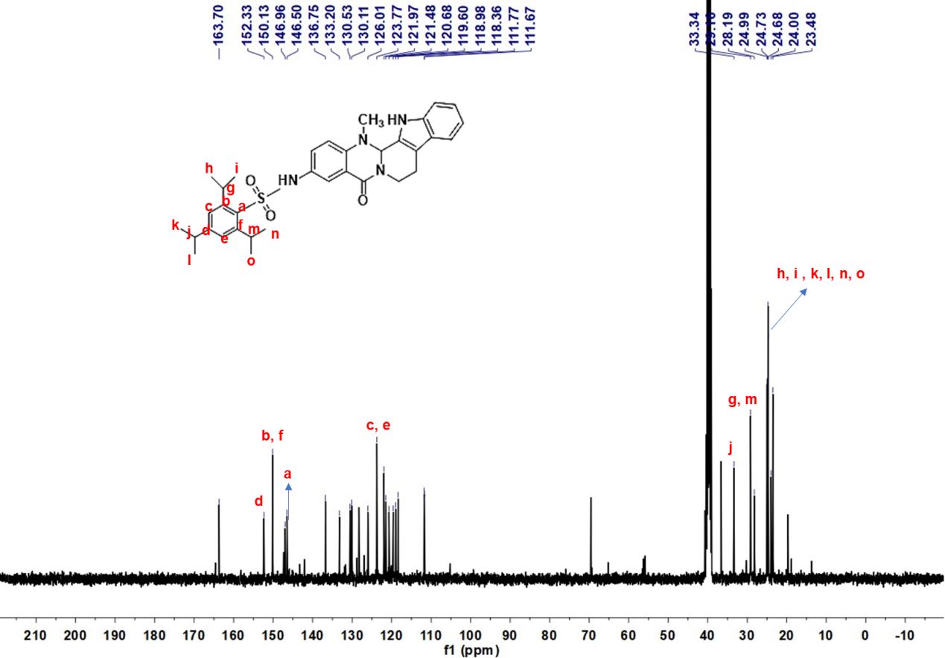 Deuterated solvent: DMSO-d₆, NMR frequency: 100.63 MHz, temperature: 25℃.

¹H NMR,¹³C NMR spectrums data for compound 26
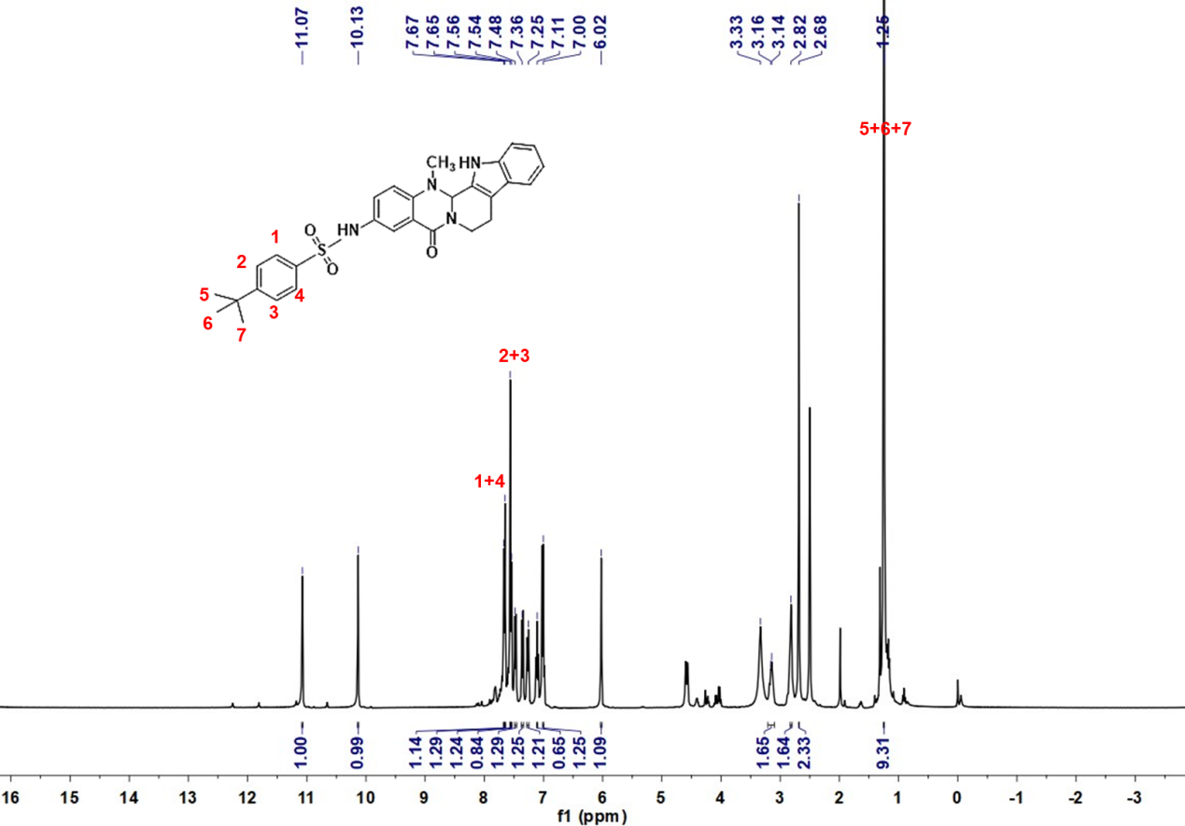
Deuterated solvent: DMSO-d₆, NMR frequency: 400.15 MHz, temperature: 25℃.

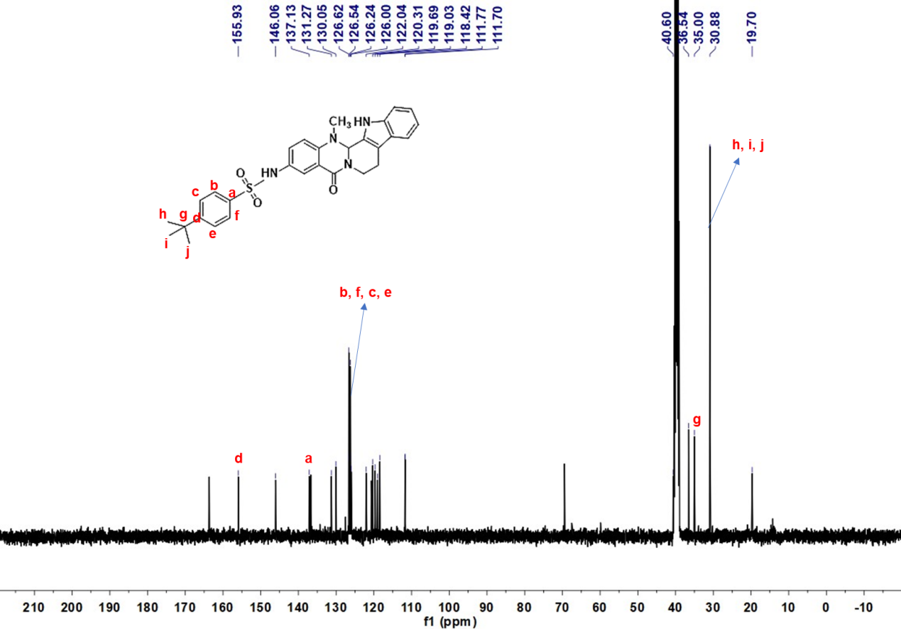
Deuterated solvent: DMSO-d₆, NMR frequency: 100.63 MHz, temperature: 25℃.

¹H NMR,¹³C NMR spectrums data for compound 27
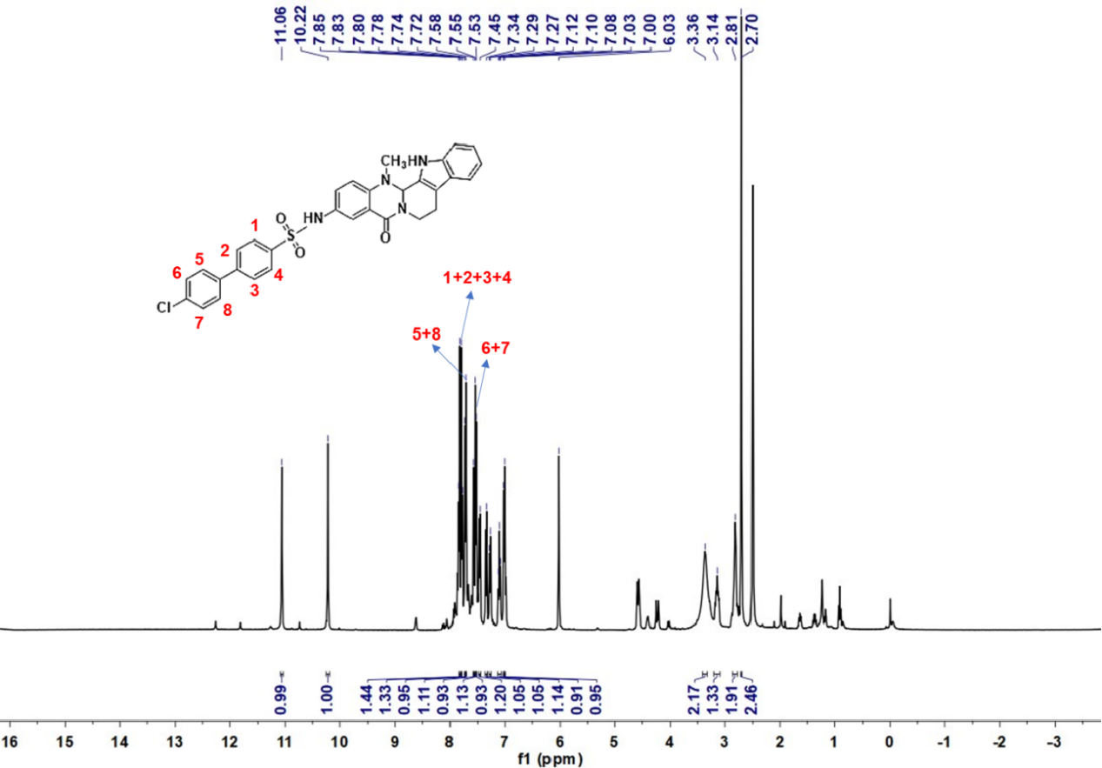
Deuterated solvent: DMSO-d₆, NMR frequency: 400.15 MHz, temperature: 25℃.

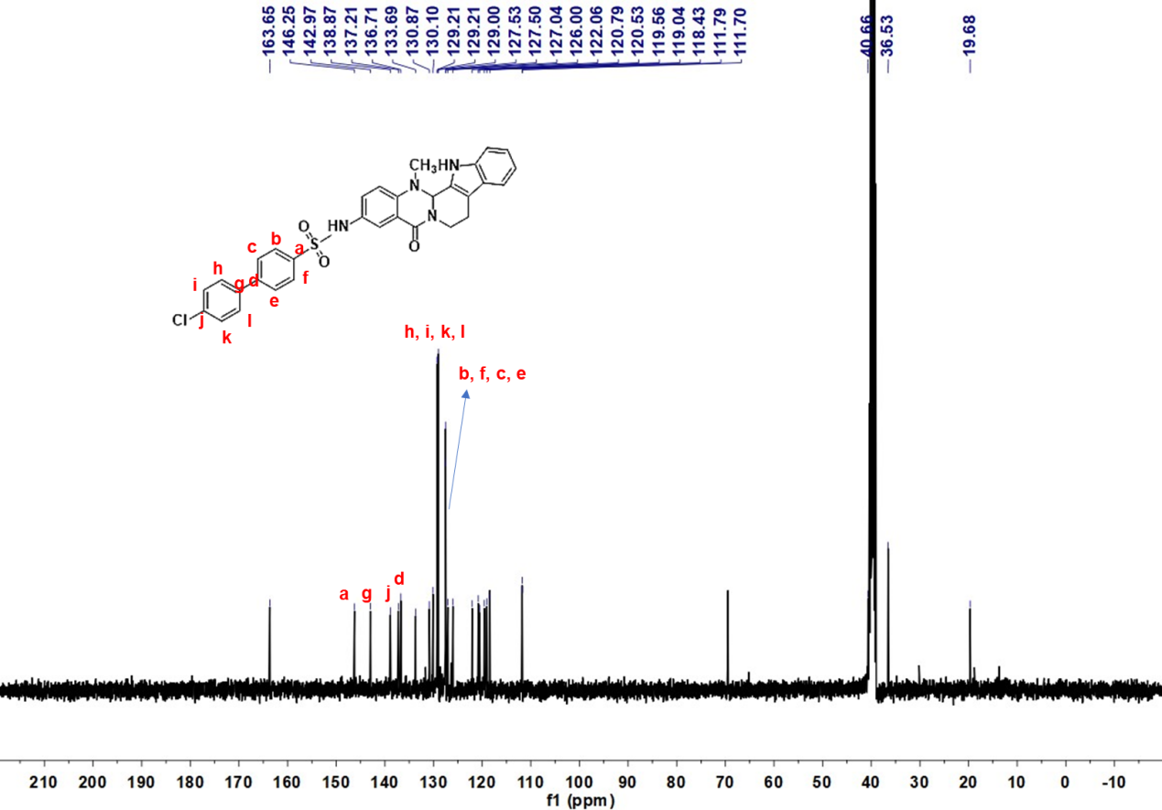 Deuterated solvent: DMSO-d₆, NMR frequency: 100.63 MHz, temperature: 25℃.

¹H NMR,¹³C NMR spectrums data for compound 28
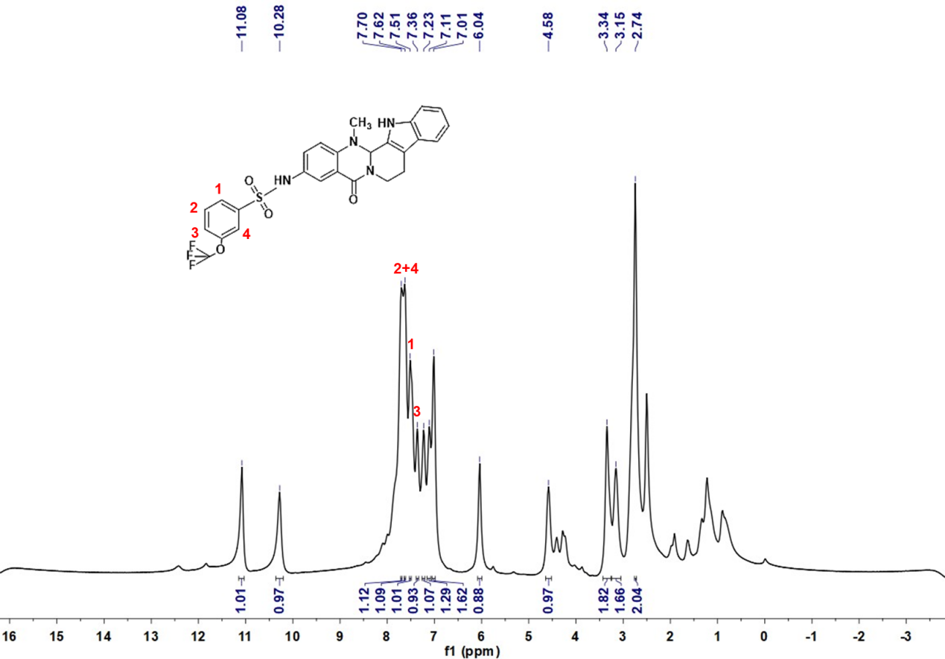
Deuterated solvent: DMSO-d₆, NMR frequency: 400.15 MHz, temperature: 25℃.

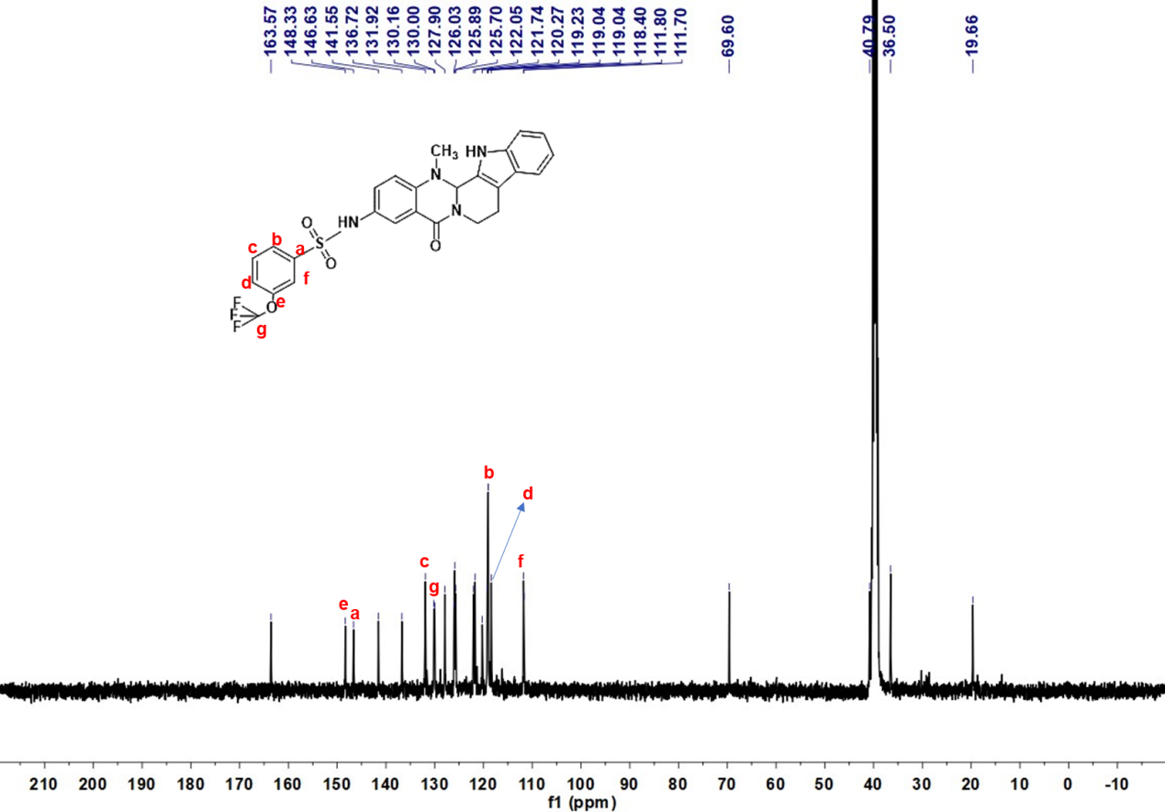 Deuterated solvent: DMSO-d₆, NMR frequency: 100.63 MHz, temperature: 25℃.

¹H NMR,¹³C NMR spectrums data for compound 29
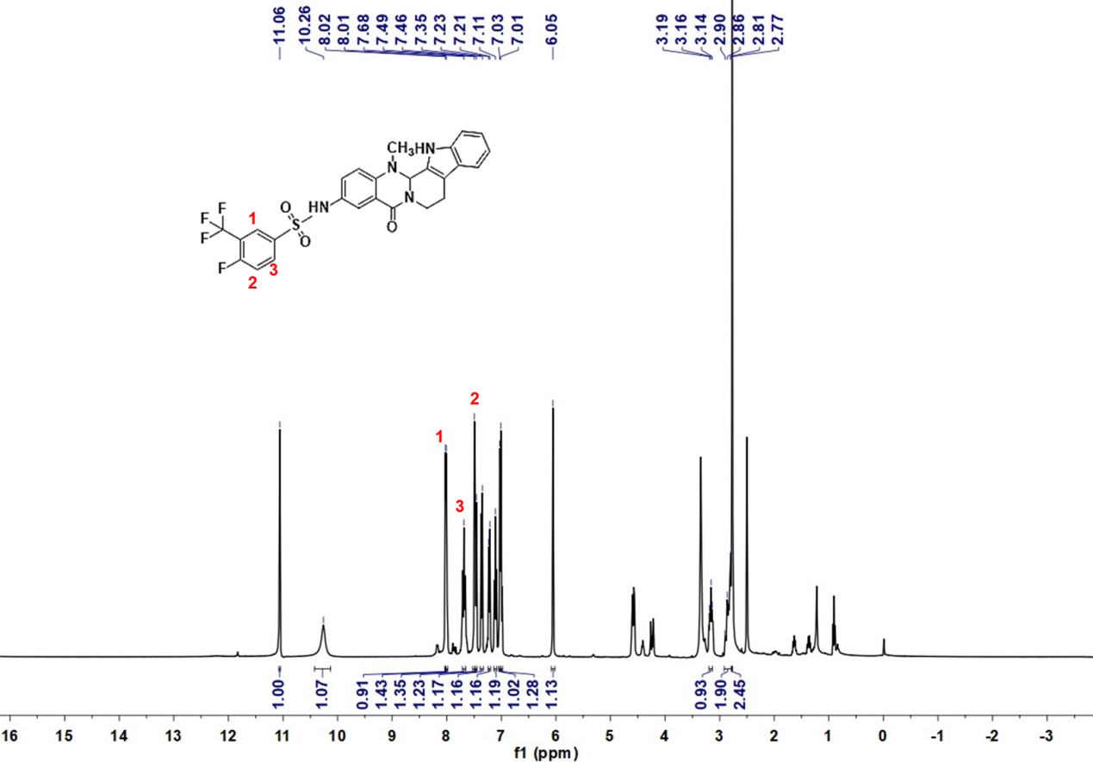
Deuterated solvent: DMSO-d₆, NMR frequency: 400.15 MHz, temperature: 25℃.

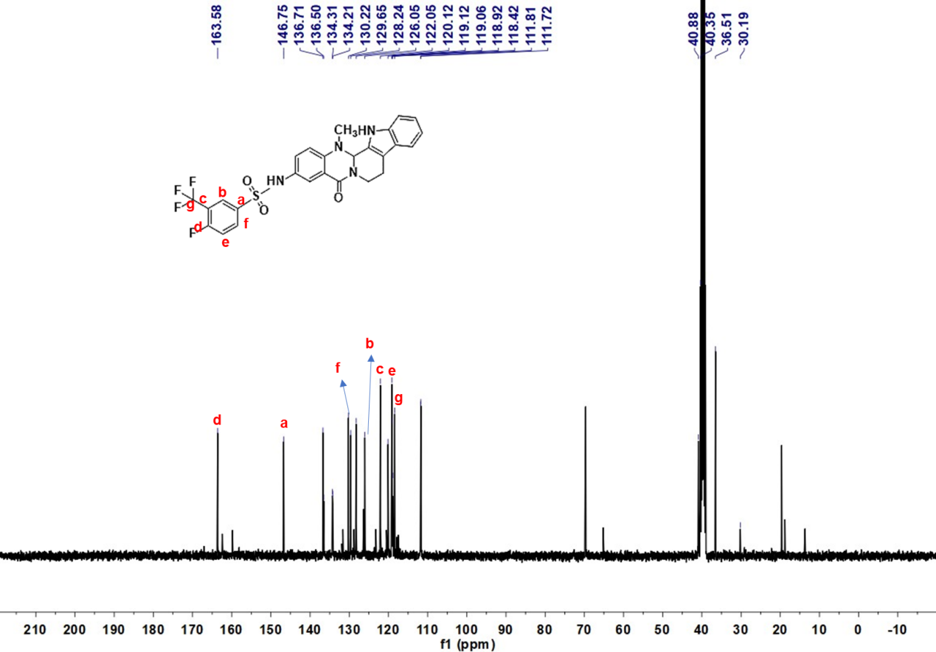
Deuterated solvent: DMSO-d₆, NMR frequency: 100.63 MHz, temperature: 25℃.

¹H NMR,¹³C NMR spectrums data for compound 30
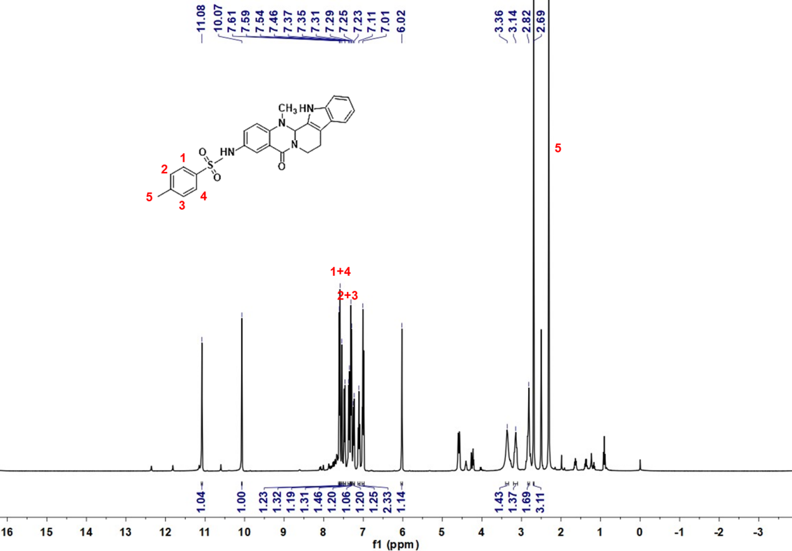
Deuterated solvent: DMSO-d₆, NMR frequency: 400.15 MHz, temperature: 25℃.

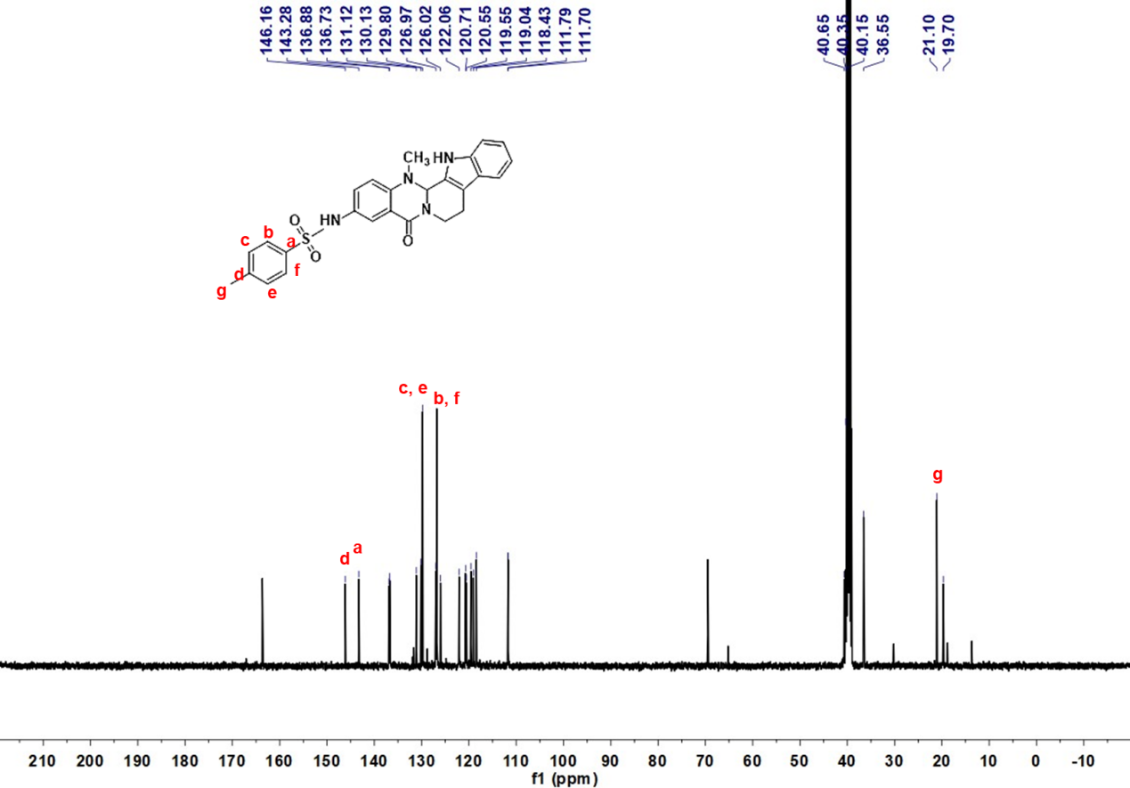 Deuterated solvent: DMSO-d₆, NMR frequency: 100.63 MHz, temperature: 25℃.

¹H NMR,¹³C NMR spectrums data for compound 31
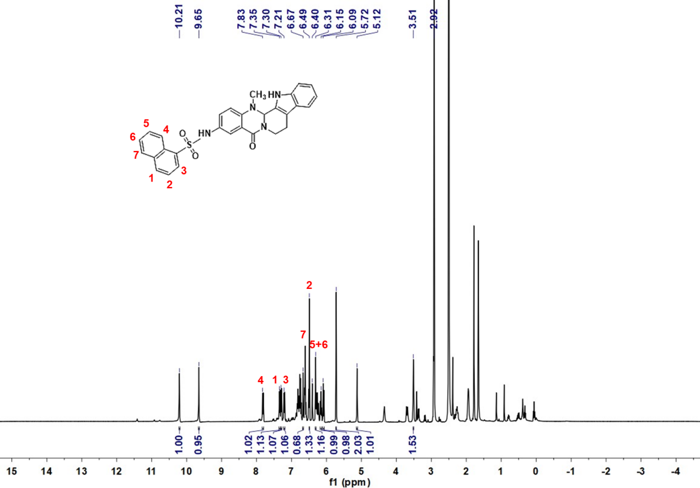
Deuterated solvent: DMSO-d₆, NMR frequency: 400.15 MHz, temperature: 25℃.

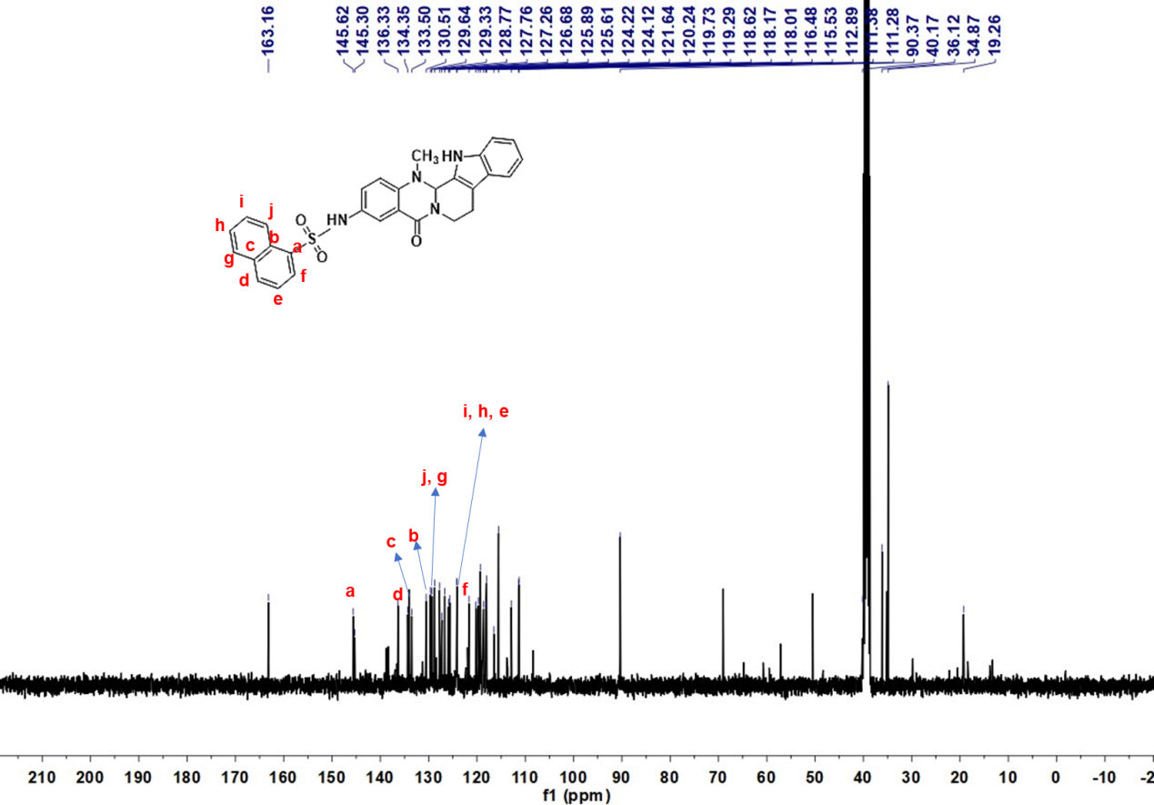 Deuterated solvent: DMSO-d₆, NMR frequency: 100.63 MHz, temperature: 25℃.

¹H NMR,¹³C NMR spectrums data for compound 32
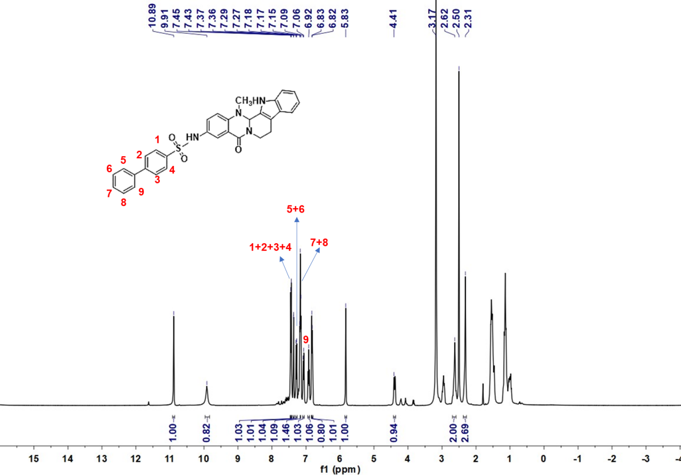
Deuterated solvent: DMSO-d₆, NMR frequency: 400.15 MHz, temperature: 25℃.

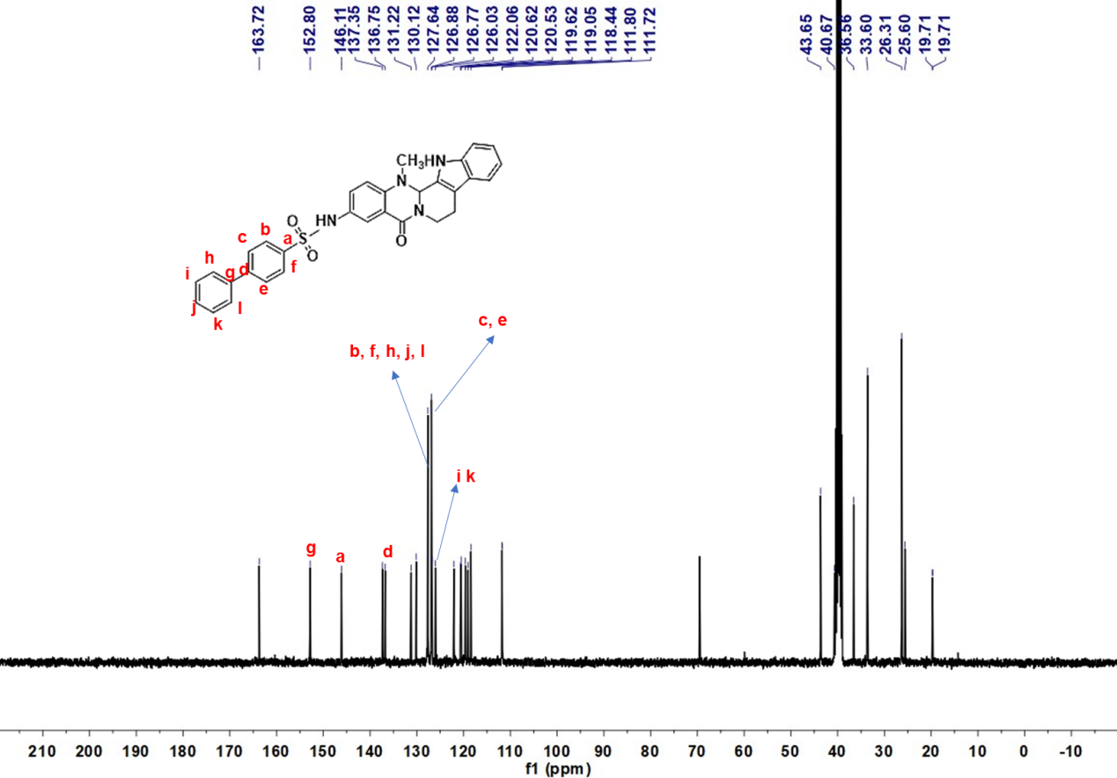 Deuterated solvent: DMSO-d₆, NMR frequency: 100.63 MHz, temperature: 25℃.

¹H NMR,¹³C NMR spectrums data for compound 33
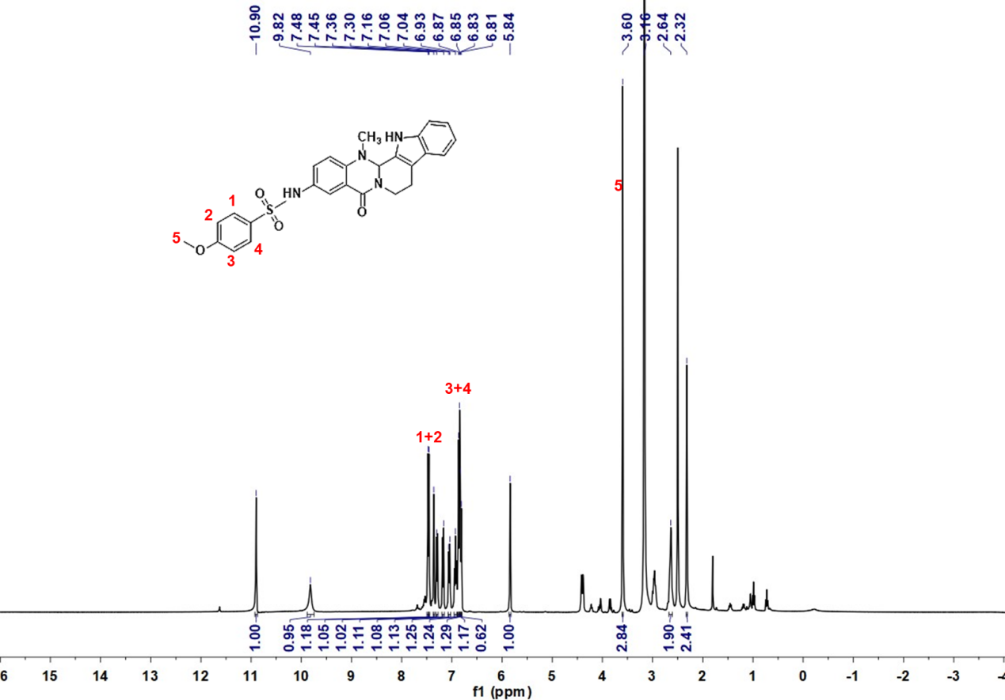
Deuterated solvent: DMSO-d₆, NMR frequency: 400.15 MHz, temperature: 25℃.

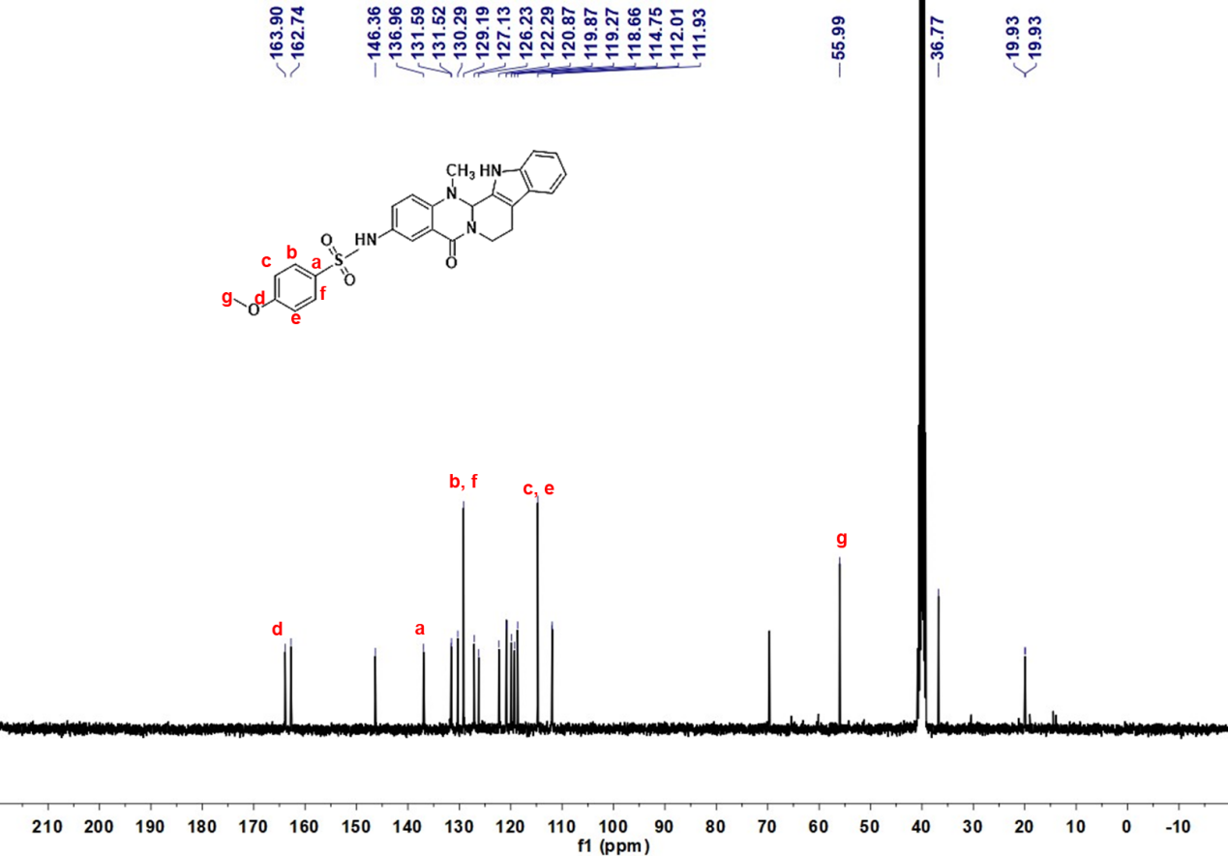 Deuterated solvent: DMSO-d₆, NMR frequency: 100.63 MHz, temperature: 25℃.

¹H NMR,¹³C NMR spectrums data for compound 34
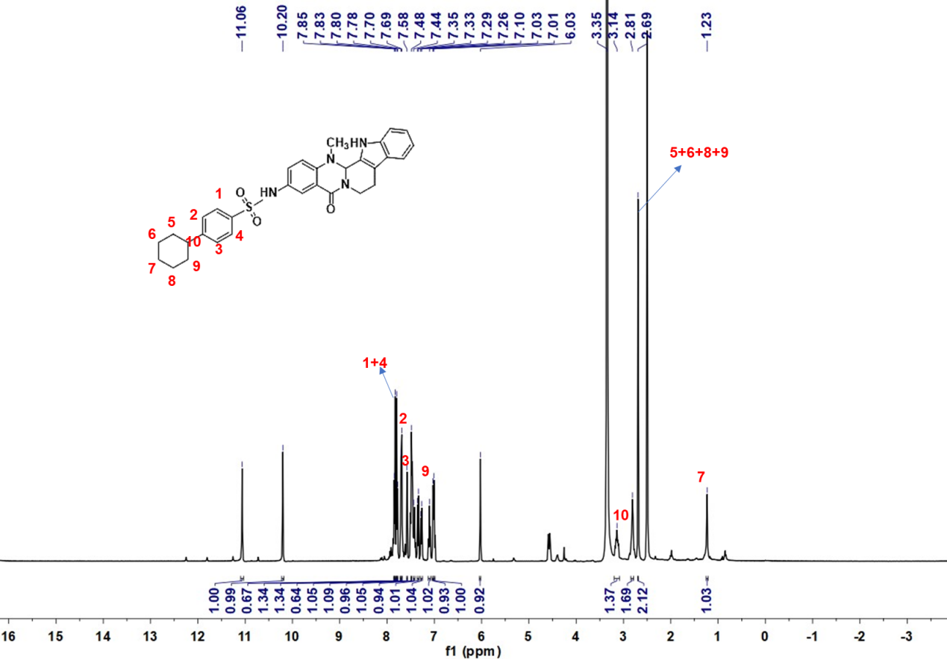
Deuterated solvent: DMSO-d₆, NMR frequency: 400.15 MHz, temperature: 25℃.

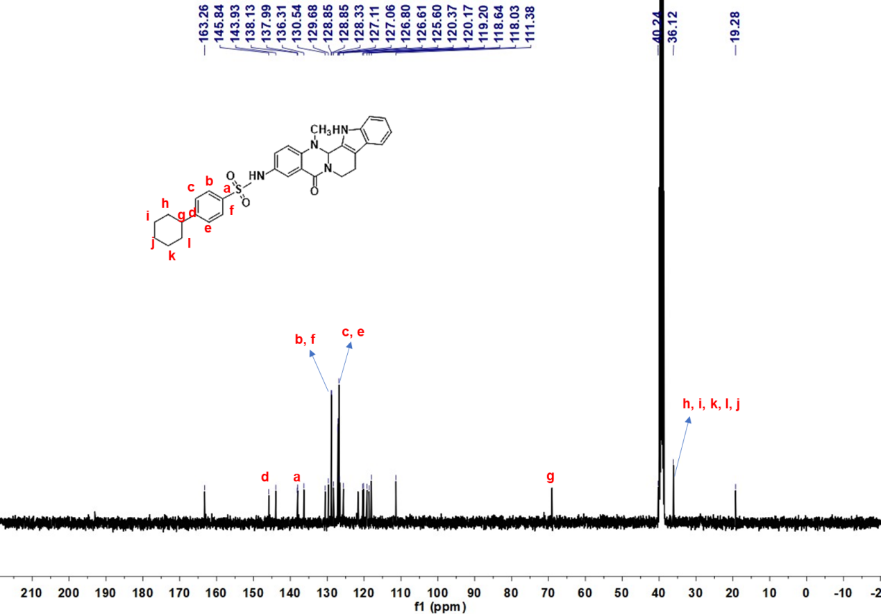 Deuterated solvent: DMSO-d₆, NMR frequency: 100.63 MHz, temperature: 25℃.

¹H NMR,¹³C NMR spectrums data for compound 35
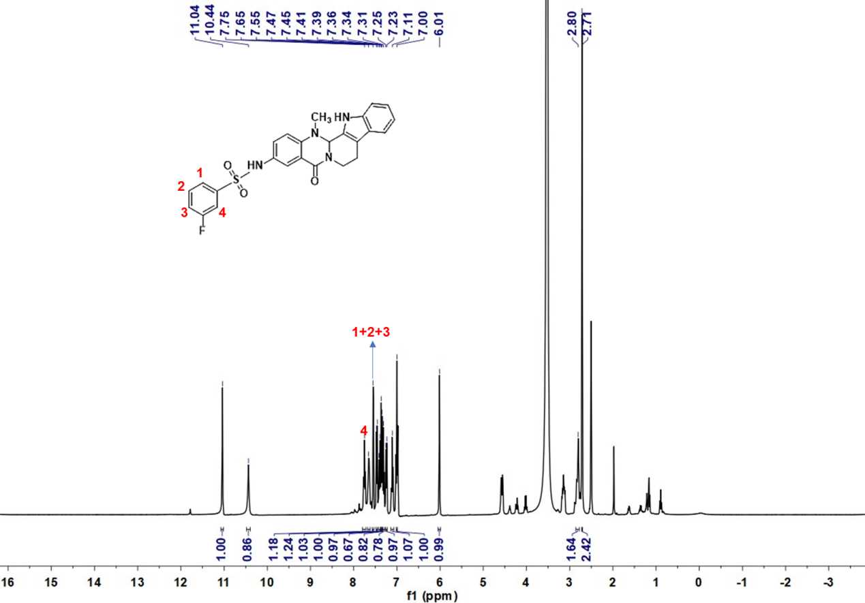
Deuterated solvent: DMSO-d₆, NMR frequency: 400.15 MHz, temperature: 25℃.

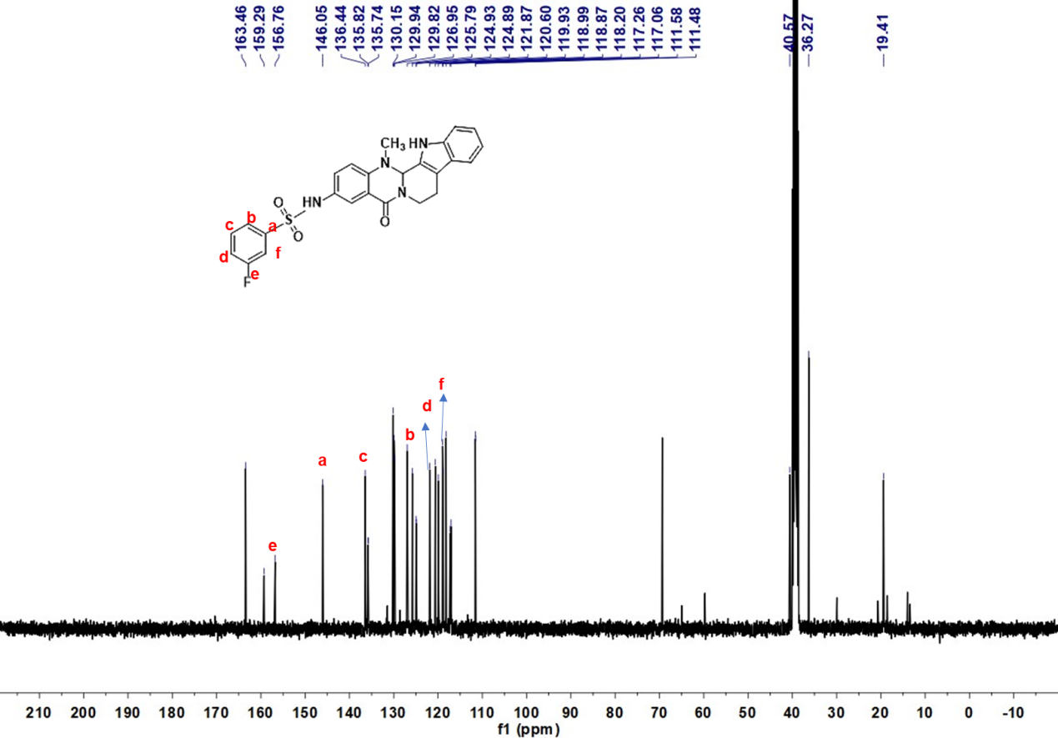 Deuterated solvent: DMSO-d₆, NMR frequency: 100.63 MHz, temperature: 25℃.

¹H NMR,¹³C NMR spectrums data for compound 36
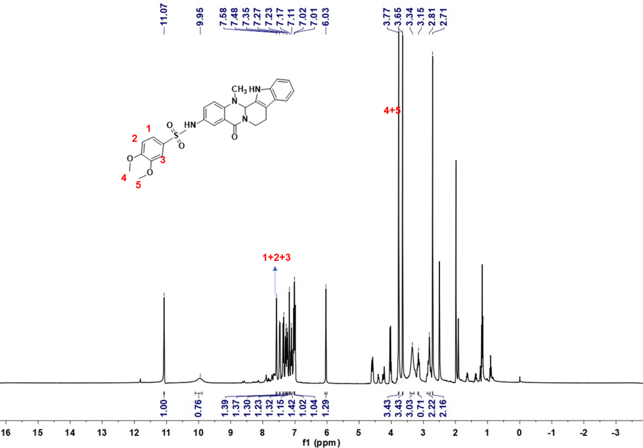
Deuterated solvent: DMSO-d₆, NMR frequency: 400.15 MHz, temperature: 25℃.

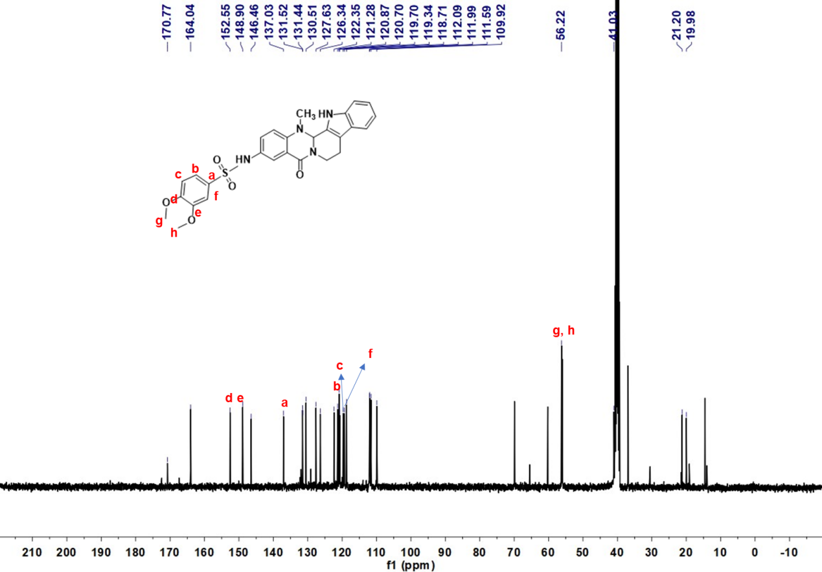 Deuterated solvent: DMSO-d₆, NMR frequency: 100.63 MHz, temperature: 25℃.

¹H NMR,¹³C NMR spectrums data for compound 37
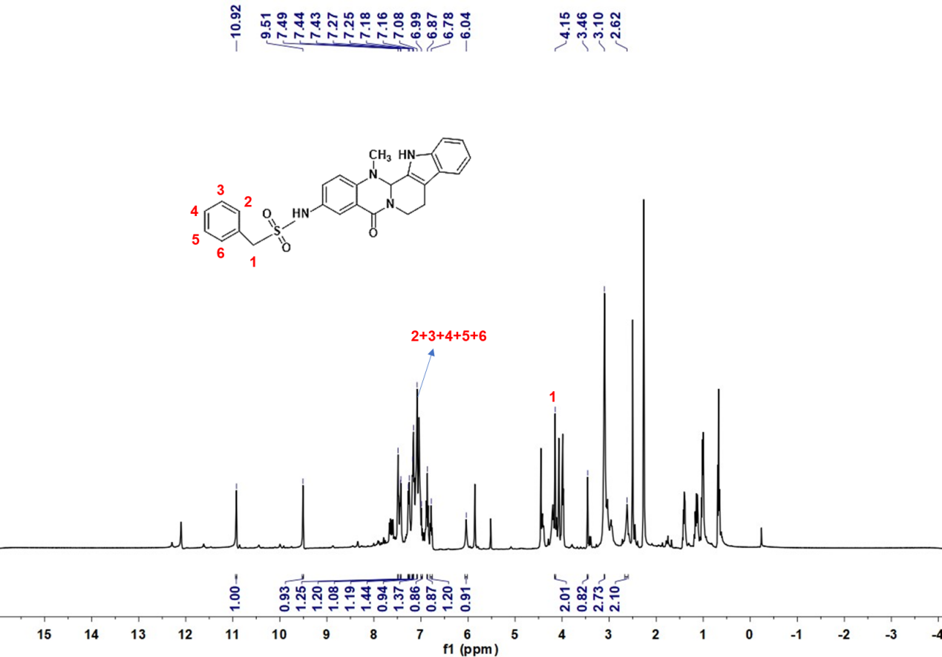
Deuterated solvent: DMSO-d₆, NMR frequency: 400.15 MHz, temperature: 25℃.

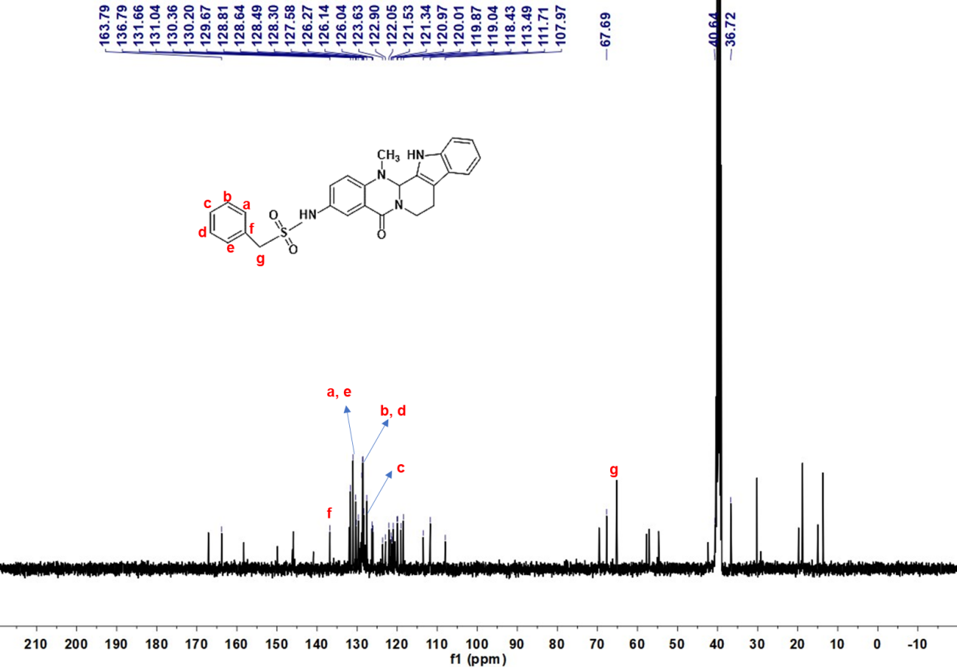
Deuterated solvent: DMSO-d₆, NMR frequency: 100.63 MHz, temperature: 25℃.

¹H NMR,¹³C NMR spectrums data for compound 38
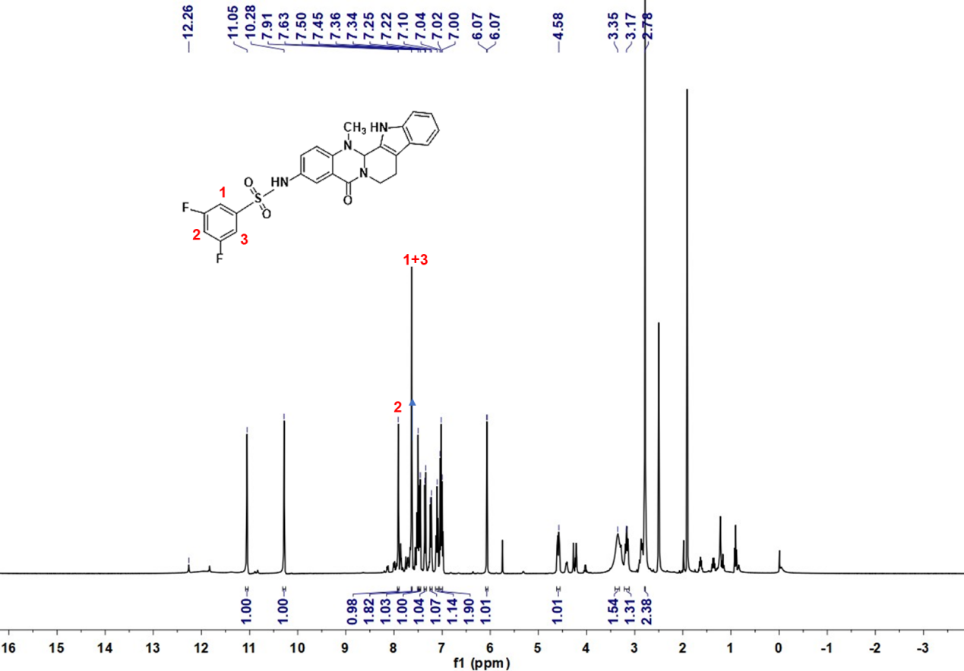
Deuterated solvent: DMSO-d₆, NMR frequency: 400.15 MHz, temperature: 25℃.

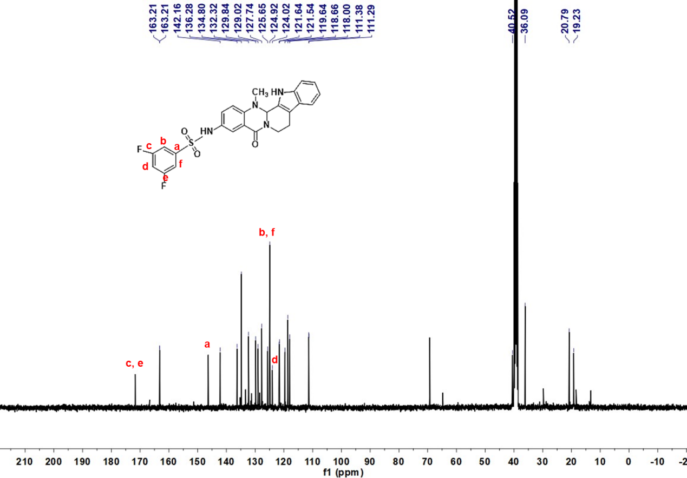 Deuterated solvent: DMSO-d₆, NMR frequency: 100.63 MHz, temperature: 25℃.

Mass spectrometric data for compound 9
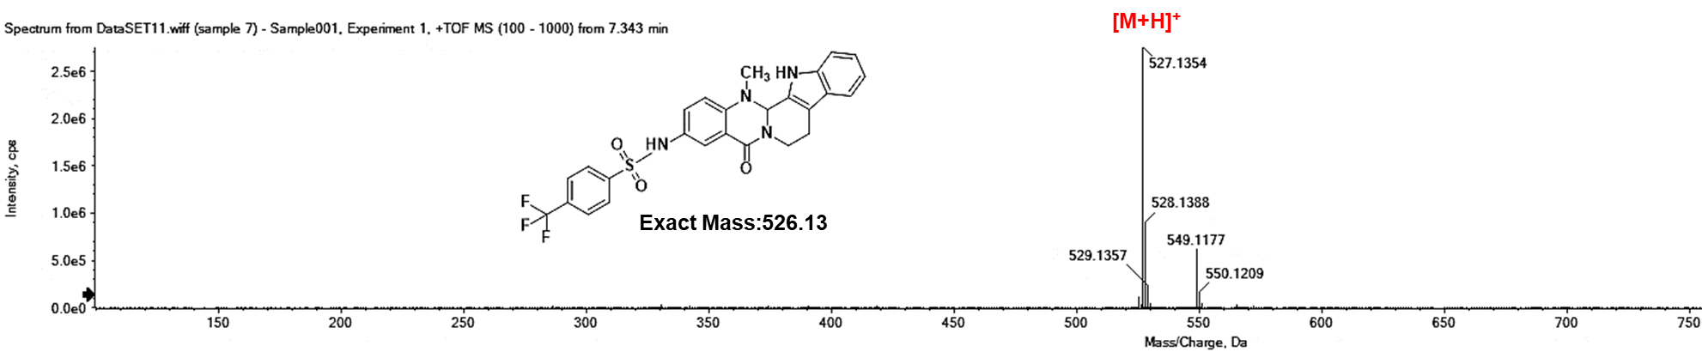

Mass spectrometric data for compound 10
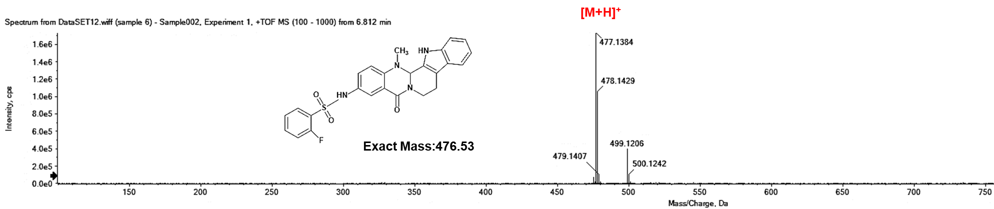

Mass spectrometric data for compound 11
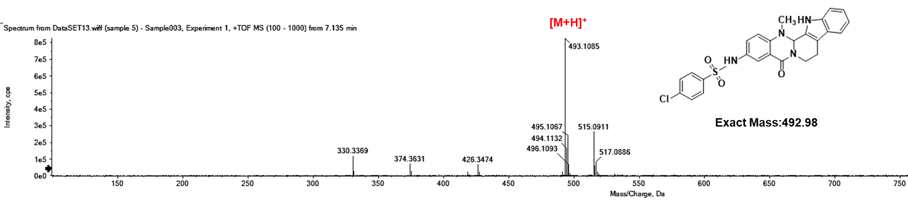

Mass spectrometric data for compound 12
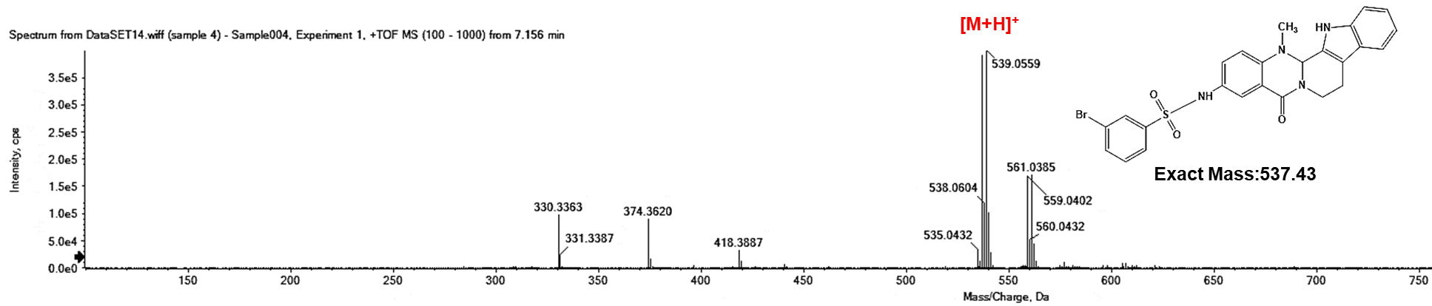

Mass spectrometric data for compound 13
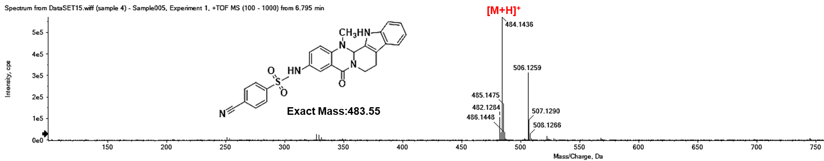

Mass spectrometric data for compound 14
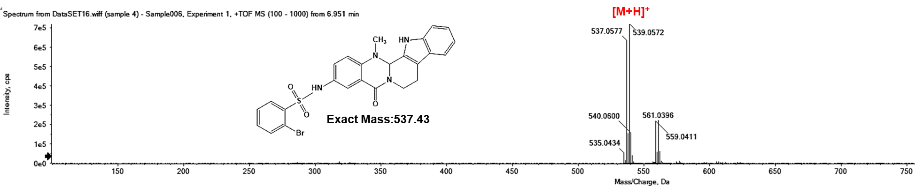

Mass spectrometric data for compound 15
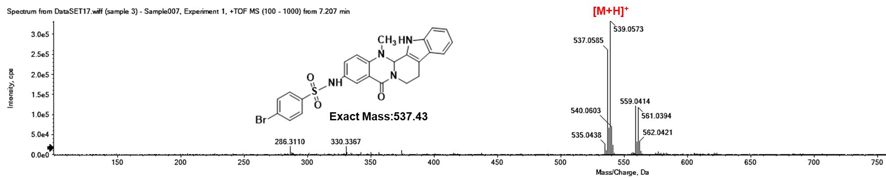

Mass spectrometric data for compound 16
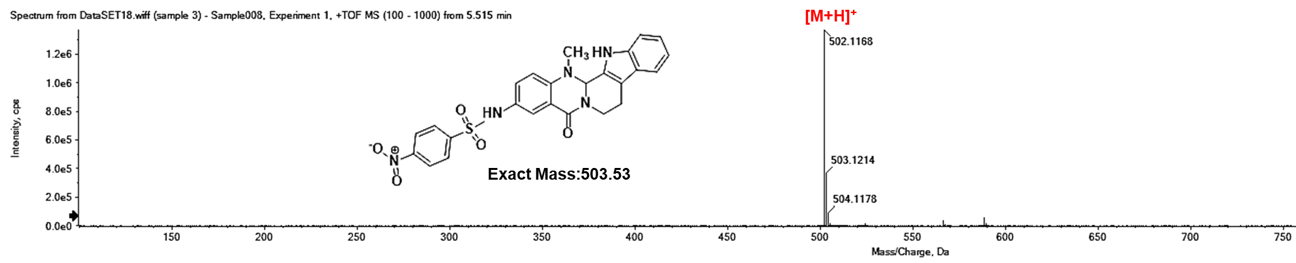

Mass spectrometric data for compound 17
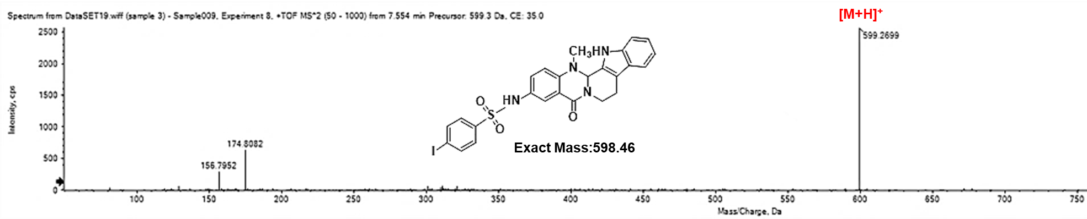

Mass spectrometric data for compound 18
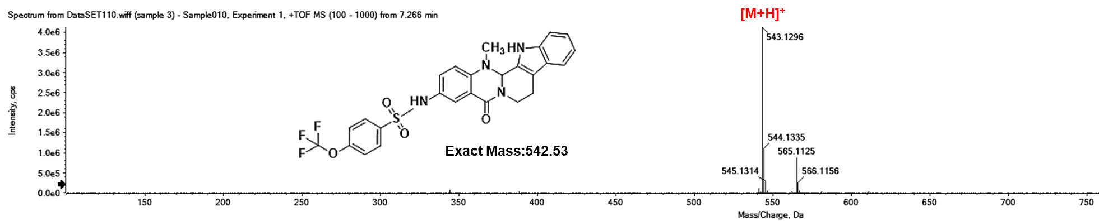

Mass spectrometric data for compound 19
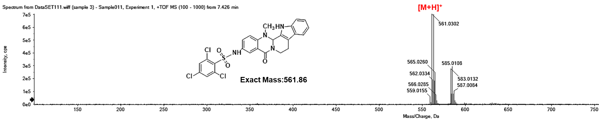

Mass spectrometric data for compound 20
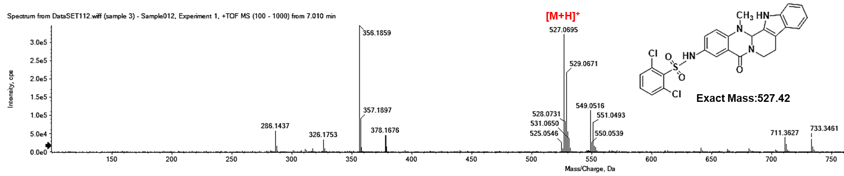

Mass spectrometric data for compound 21
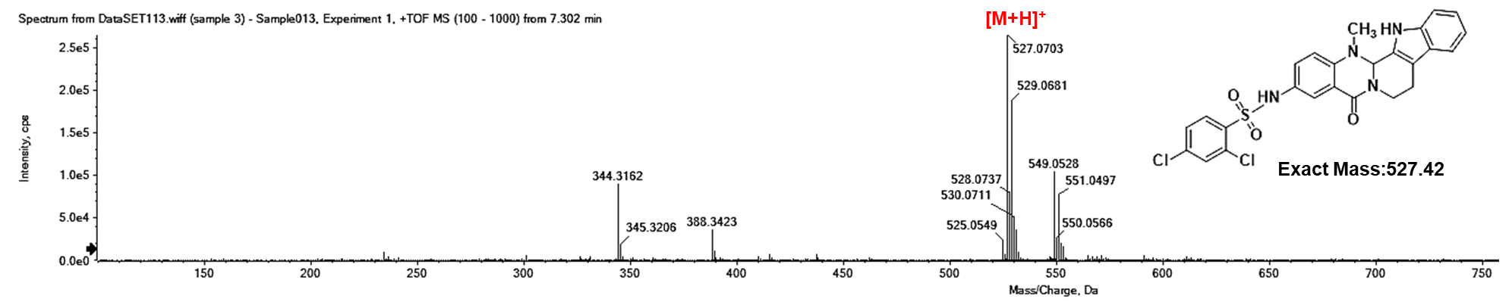

Mass spectrometric data for compound 22
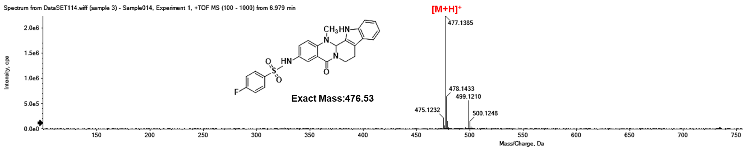

Mass spectrometric data for compound 23
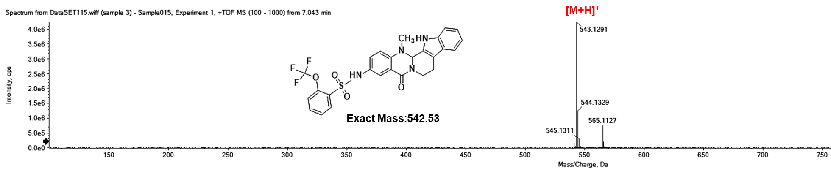

Mass spectrometric data for compound 24
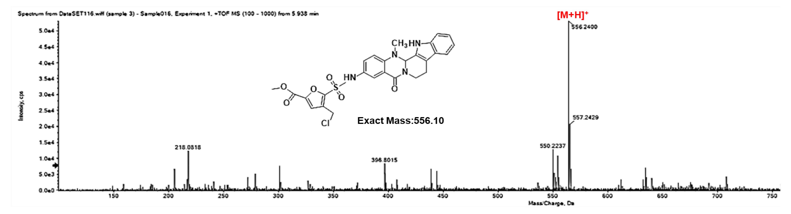

Mass spectrometric data for compound 25
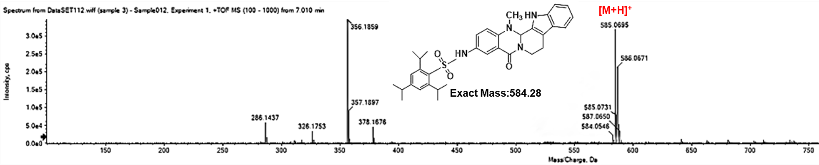

Mass spectrometric data for compound 26
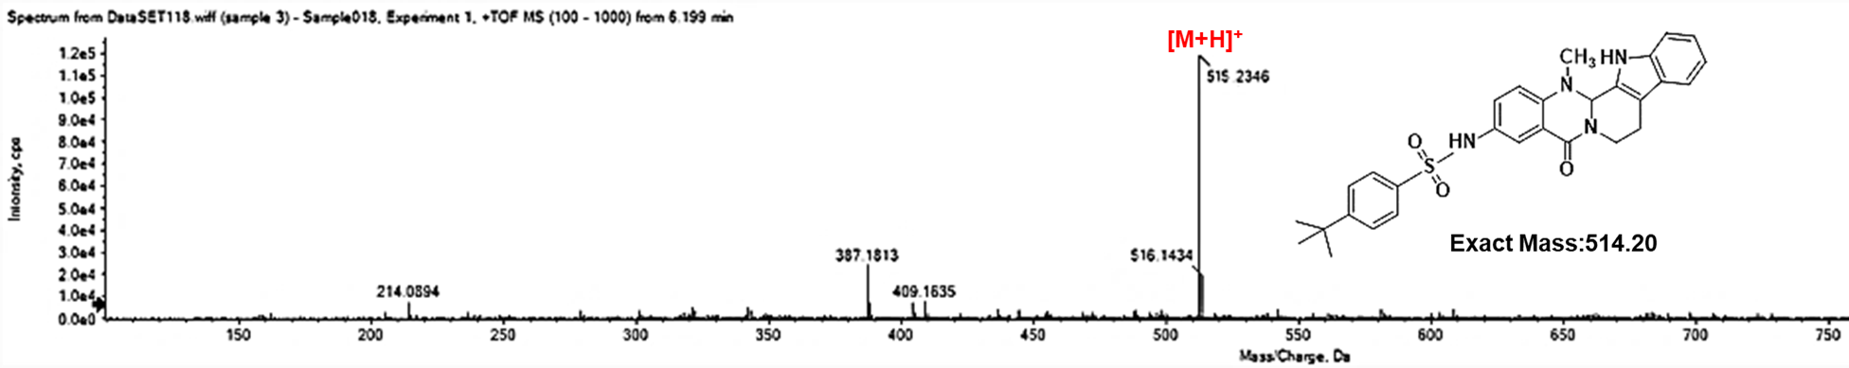

Mass spectrometric data for compound 27
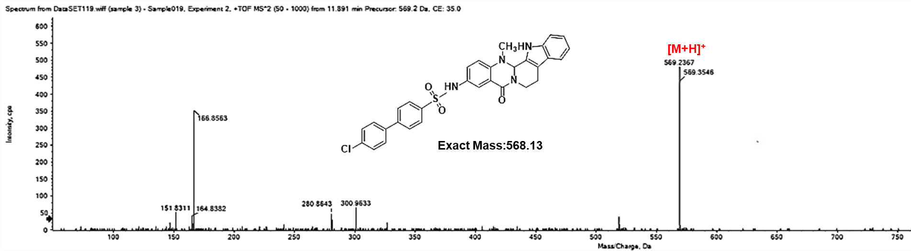

Mass spectrometric data for compound 28
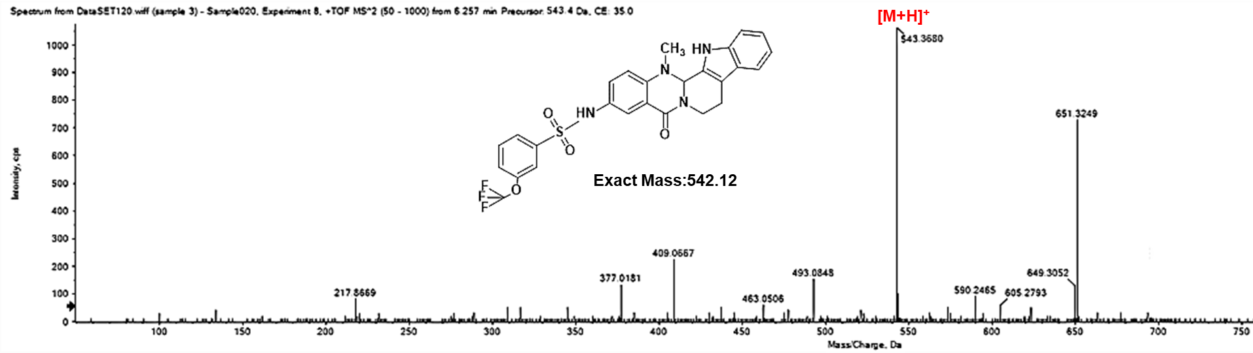
Mass spectrometric data for compound 29
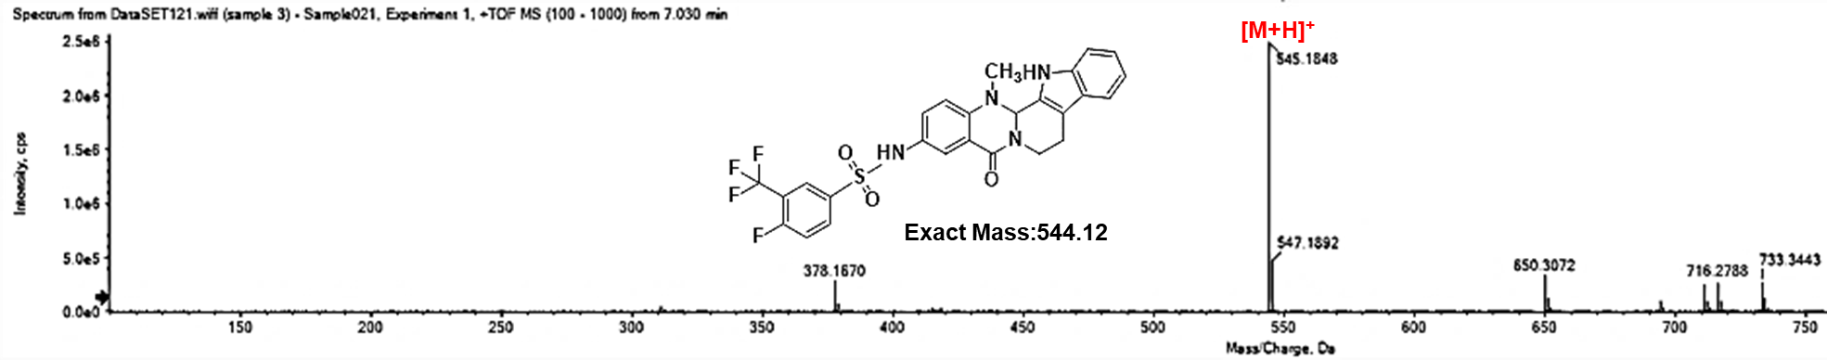

Mass spectrometric data for compound 30
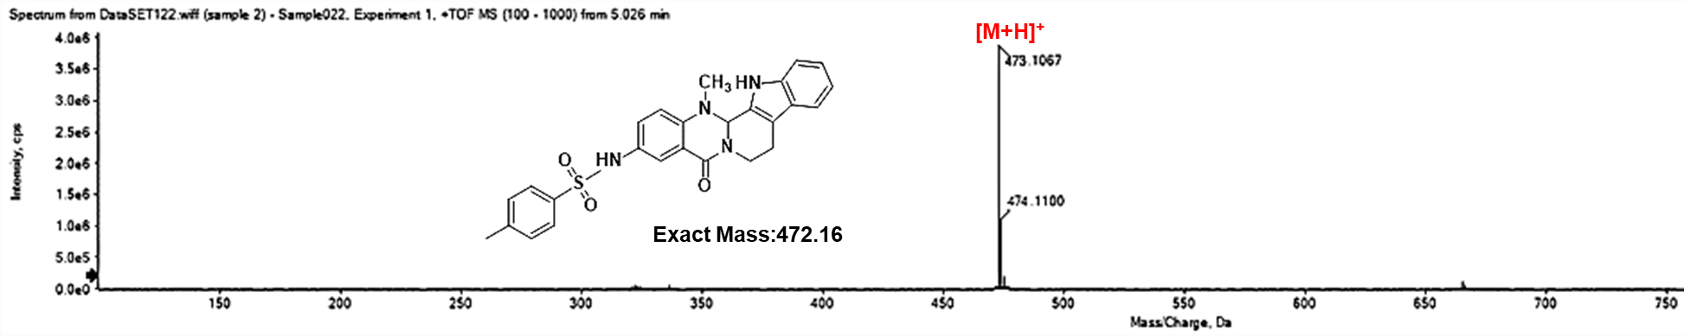

Mass spectrometric data for compound 31
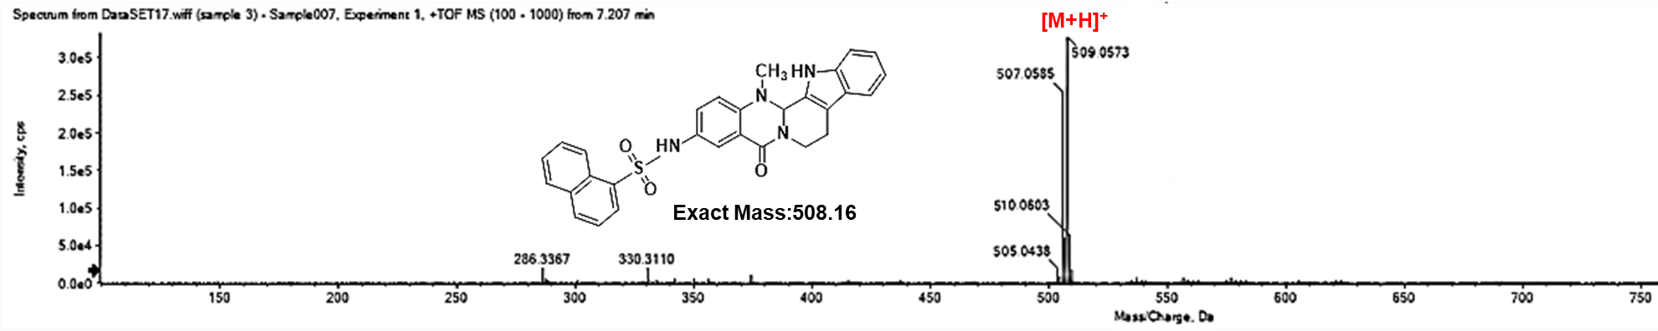

Mass spectrometric data for compound 32
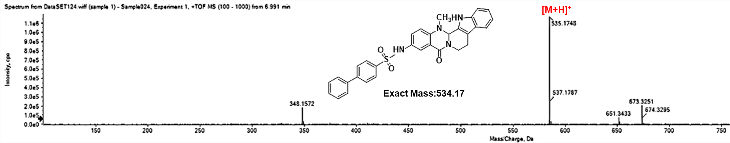

Mass spectrometric data for compound 33
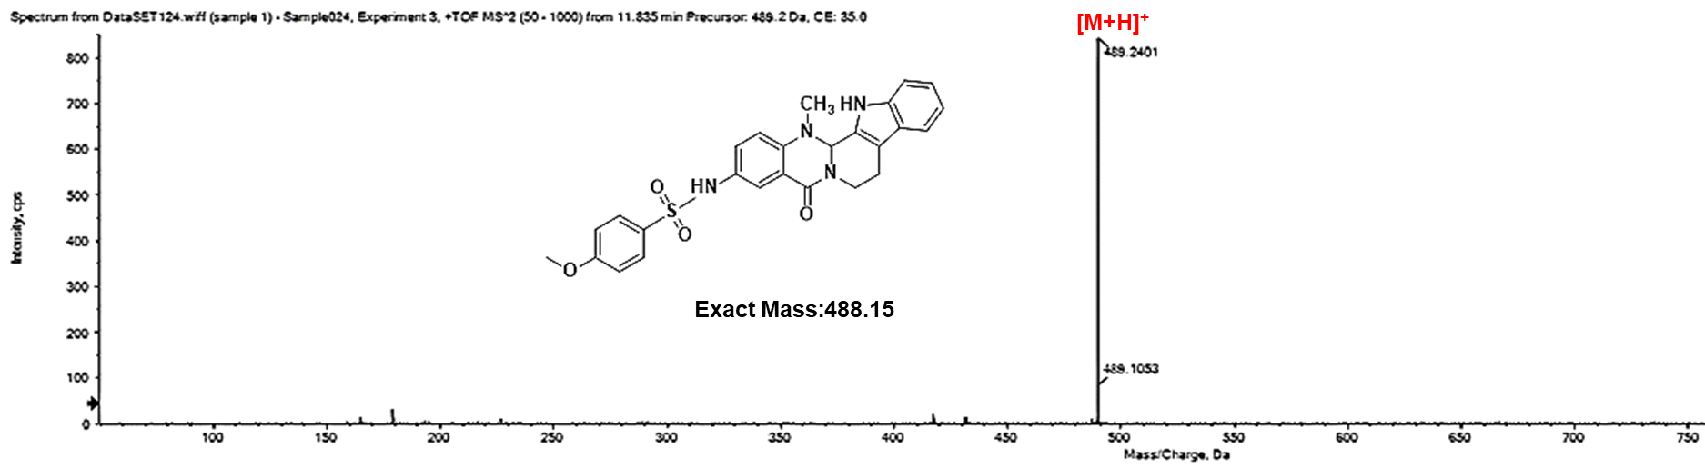

Mass spectrometric data for compound 34
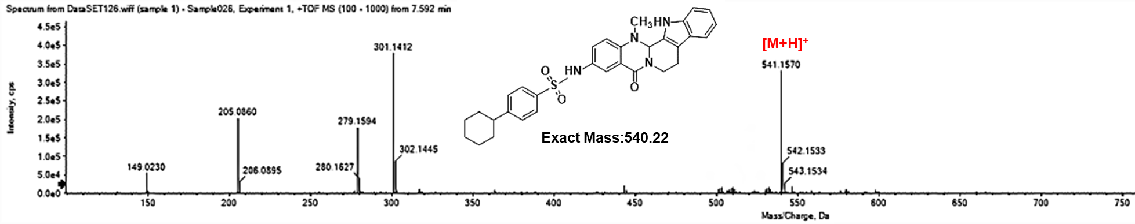

Mass spectrometric data for compound 35
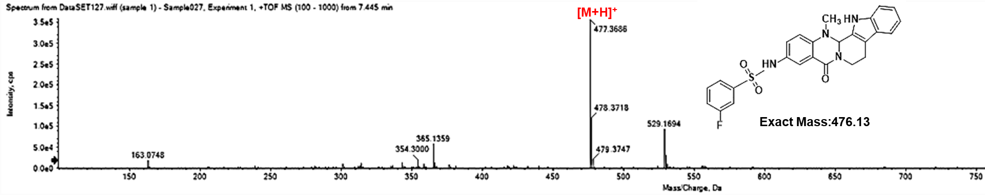

Mass spectrometric data for compound 36
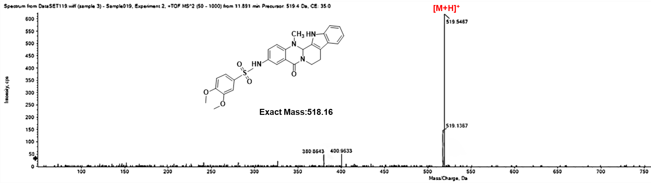

Mass spectrometric data for compound 37
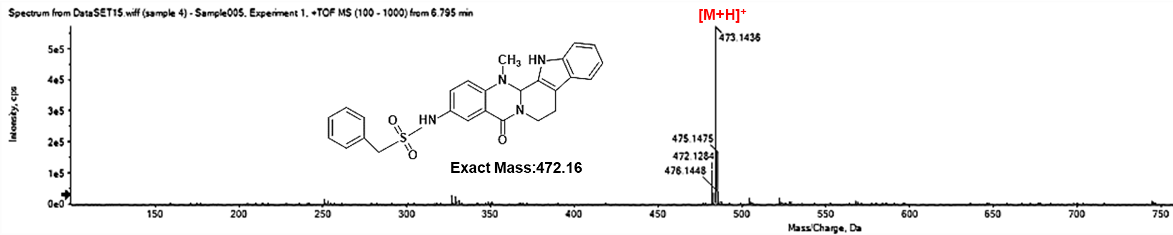

Mass spectrometric data for compound 38
