**Cell Lysis, labeling efficacy and biodistribution of intravenously administered Technetium-99m labeled Multifunctional Zirconia Nanoparticles in animal model**

Ifra SanaUllah1), Saira Riaz1), Irfan Ullah Khan2), Daoud Ali3),S Shamaila4), M Akram Raza1), Amna Sajjad5), Anjum N Sabri6), Shahzad Naseem1)

1) Centre of Excellence in Solid State Physics, University of the Punjab, QAC, Lahore-54590, Pakistan

2) Department of Cyclotron and Allied Radiopharmaceutics, INMOL Cancer Hospital, Lahore-54600, Pakistan

3) Department of Zoology, College of Science, King Saud university, Riyadh-11451, Saudia Arabia

4) Waterloo institute for nanotechnology, university of waterloo, Ontario, Canada.

5) Department of Zoology, Government College University, Faisalabad, Pakistan

6) Department of Microbiology and Molecular Genetics, University of the Punjab, QAC, Lahore-54590, Pakistan

Raman spectroscopy was employed to gain a thorough understanding of the creation of distinct phases. Figure S1 revealed peaks consistent with the tetragonal phase of zirconia. Raman bands of 322 cm-1 and 148 cm-1 for Eg and B1g vibrations agreed with the literature. [1-2].

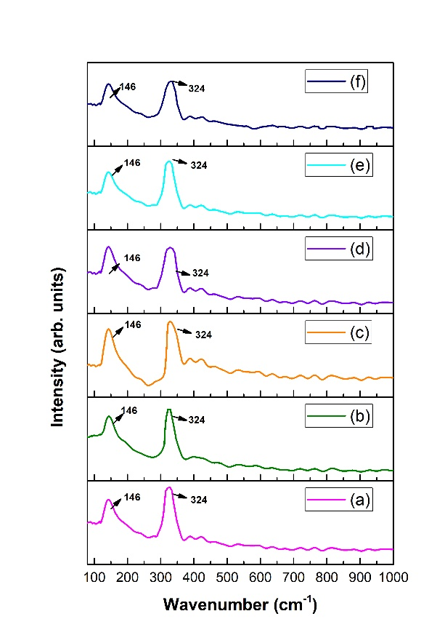

Figure S1. Raman spectra of as synthesized IOZH nanoparticles at iron oxide content of (a) 5wt. % (b) 6wt. % (c) 7wt. % (d) 8wt. % (e) 9wt. % (f) 10wt. %.

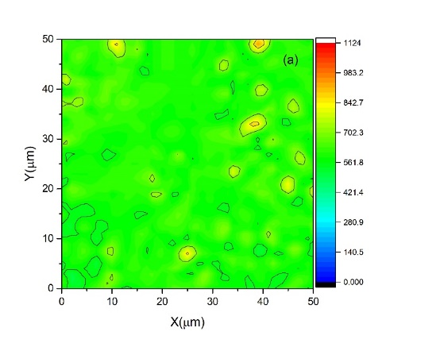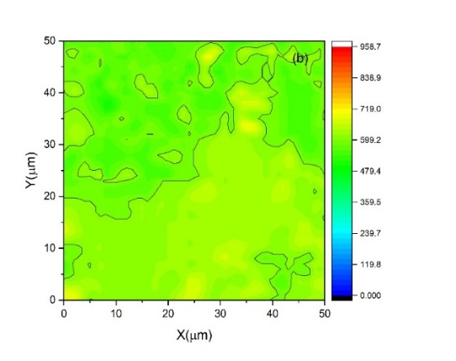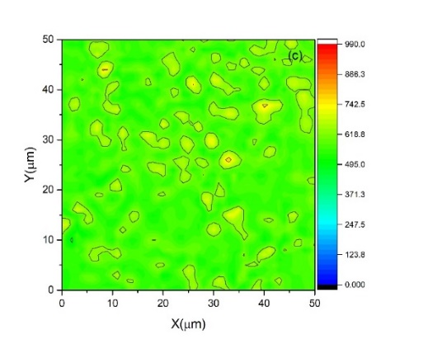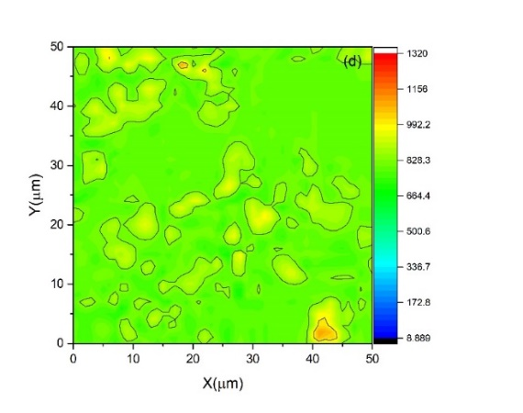

Figure S2: Hardness mapping of samples with iron oxide concentration of (a-d) 1-4 wt%

Real and imaginary impedance values help in obtaining Cole-Cole plots. These plots are used in polycrystalline samples to assess the effect of grains as well as grain boundaries. The Cole-Cole arrangement is made up of three semicircles. High frequency semicircles represent grains, medium frequency semicircles represent grain boundaries, and low frequency semicircles represent the interface between grain boundary/grain and electrode [3]. Eqs. 1 and 2 were used to compute real and imaginary impedance [4].

(1)

(2)

C:\Users\DELL\Desktop\effic.tifC:\Users\DELL\Desktop\effic.tif

C:\Users\DELL\Desktop\effic.tif

Figure S3. (i) Real, (ii) imaginary impedance and (c) Cole-Cole plots of as synthesized nanoparticles using various concentration of iron oxide (a-j) 1-10wt%

**References**

[1] Marsh, B. D. (1998). On the interpretation of crystal size distributions in magmatic systems. Journal of Petrology, 39(4), 553-599.

[2] Sajjadi, S. (2007). Nanoparticle formation by monomer-starved semibatch emulsion polymerization. Langmuir, 23(3), 1018-1024.

[3] Jha, A. K. (2013). Electrical characterization of zirconium substituted barium titanate using complex impedance spectroscopy. Bulletin of Materials Science, 36(1), 135-141.

[4] Macdonald, J. R., & Barsoukov, E. (2005). Impedance spectroscopy: theory, experiment, and applications. History, 1(8), 1-583.