**Supporting Information for**

**Enhanced adsorption performance of tetracycline in aqueous solutions Using Mg-Al-LDH/AC nanocomposite**

**Mahsa khorshidia, Saeid Asadpour*a,b, Narges Sarmast*a, Zahra Aramesh-Boroujenic and Negar Sadegha**

*aDepartment of Chemistry, Faculty of Sciences, Shahrekord University, Shahrekord 115, Iran*

*bNanotechnology Research Institute, Shahrekord University, 8818634141, Shahrekord, Iran*

*cDepartment of Chemistry, University of Isfahan, Isfahan, Iran*

*Corresponding Author Tel.: +989173422008, fax: +983832324419,

E-mail address: [s.asadpour@gmail.com](mailto:s.asadpour@gmail.com) , [s.asadpour@sku.ac.ir](mailto:s.asadpour@sku.ac.ir) , n.sarmast2010@gmail.com

Calibration curve for Tetracycline Determination

Calibration graph was constructed by preparing aqueous solutions of TC at different concentrations (3, 8, 10, 20, 30, 40, and 50 mg/L). The resulting calibration curve is presented in Figure 1S.

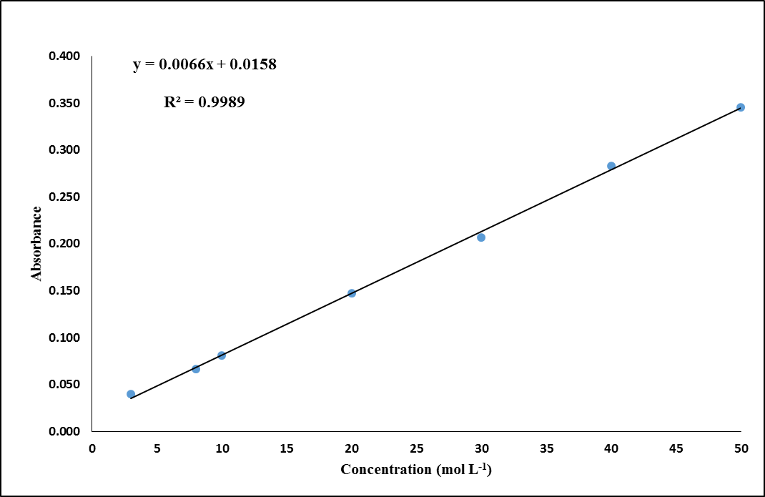

Fig. 1S. The calibration curve for Tetracycline Determination.

***3.11. Analytical figures of merit***

Above 90 % removal efficiency was achieved for TC when the procedure was performed under the optimal experimental conditions. The calibration graph was linear between 3 and 50 mg L-1 with a correlation coefficient of 0.9989. The regression equation was A = 0.0066C + 0.0158, where A is absorbance and C is TC concentration in mg L-1. The relative standard deviation (RSD, %), based on six replicate analysis of 30 mg L-1 of TC was 1.68 % and the limit of detection (LOD) which is defined as three times of standard deviation of blank (n = 8) was 1.03 mg L-1. The sensitivity of proposed method for removal efficiency of TC based on 0.0044/m (where m is the slope of calibration curve) was 0.667 mg L-1.