**Supporting Information**

**Facile Fabrication of Hollow Molecularly Imprinted Polymer Microspheres via Pickering Emulsion Polymerization Stabilized with TiO2 Nanoparticles**

Zehu Wang,*abc Zongqi Li,abc Ruiye Yan,*d Guangshuo Wang,abc Yanming Wang,abc Xiaoliang Zhang,abc Zhixiao Zhang abc

*aCollege of Materials Science and Engineering,* *Hebei University of*

*Engineering, Handan 056038, PR China*

*bTechnology Innovation Center of Modified Plastics of Hebei Province,*

*Handan 056038, PR China*

*cKey Laboratory of New Inorganic Nonmetallic Composite Materials of Handan, Handan 056038, PR China*

*dAcademic Affairs Office,* *Hebei University of Engineering, Handan 056038, PR China*

* Corresponding authors:

E-mail: [wangzehu12@126.com](mailto:wangzehu12@126.com)

E-mail: [253041131@qq.com](mailto:253041131@qq.com)

Tel/Fax: +86-0310-3967973

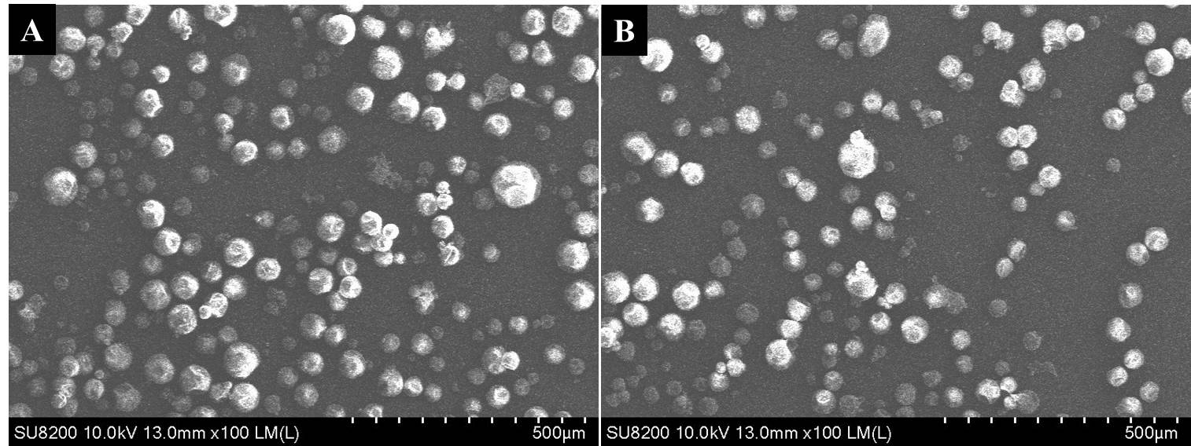

Fig. S1 FESEM images of H-MIPs (A) and H-NIPs (B) microspheres