**Supplementary**

**On the optimal Cs/Co ratio responsible for the N2O decomposition activity of the foam supported cobalt oxide catalysts.**

**Anna Klegova1, Kateřina Pacultová*,1, Tomáš Kiška1, 2, Joanna Gryboś3**,**Zbigniew Sojka3, Lucie Obalová1**

*1) Institute of Environmental Technology, CEET, VSB-Technical University of Ostrava, 17. listopadu 15/2172, Ostrava, 708 00, Czech Republic*

*2)* [*Faculty of Materials Science and Technology*](https://innet.vsb.cz/en/contacts/phonebook)*, VSB-Technical University of Ostrava, 17.  listopadu 15/2172, Ostrava, 708 00, Czech Republic*

*3) 3Faculty of Chemistry, Jagiellonian University, Gronostajowa 2, 30-387 Kraków, Poland*

|  |  |
| --- | --- |
| **\***corresponding author: email: katerina.pacultova@vsb.cz, tel: | +420 597 327 327 |

S1: Content of used impregnation solutions for the preparation of foam catalysts.

|  |  |
| --- | --- |
| **Sample** | **Composition of impregnation solution** |
| *L (c.i.)* | 42.667g Co(NO3)2∙6H2O + H2O up to 75 ml |
| *L (Ace)* | 42.667g Co(NO3)2∙6H2O + 8.804g Acetic acid + H2O up to 75 ml |
| *L (Cit)* | 42.667g Co(NO3)2∙6H2O + 28.166g Citric acid + H2O up to 75 ml |
| *L (Glr)* | 42.667g Co(NO3)2∙6H2O + 13.501g Glycerol + H2O up to 75 ml |
| *L (Gly)* | 42.667g Co(NO3)2∙6H2O + 11.005g Glycin + H2O up to 75 ml |
| *L (Ure)* | 42.667g Co(NO3)2∙6H2O + 8.805g Urea + H2O up to 75 ml |
| *H (c.i.)* | 50.4 g Co(NO3)2∙6H2O + 25 ml H2O |
| *H (Glr-1)* | 50.4 g Co(NO3)2∙6H2O + 12.5 ml H2O + 12.5 ml (~15.74 g) Glycerol |
| *H (Glr-2)* | 50.4 g Co(NO3)2∙6H2O + 25 ml (~31.49 g) Glycerol |
| *C.i.(Cs1)* | 67.2 g Co(NO3)2∙6H2O + 0.300 g CsNO3 + 38 ml H2O |
| *C.i.(Cs2)* | 67.2 g Co(NO3)2∙6H2O + 0.600 g CsNO3 + 38 ml H2O |
| *C.i.(Cs3)* | 67.2 g Co(NO3)2∙6H2O + 0.900 g CsNO3 + 38 ml H2O |
| *C.i.(Cs4)* | 67.2 g Co(NO3)2∙6H2O + 1.200 g CsNO3 + 38 ml H2O |
| *C.i.(Cs5)* | 67.2 g Co(NO3)2∙6H2O + 1.500 g CsNO3 + 38 ml H2O |
| *C.i.(Cs6)* | 67.2 g Co(NO3)2∙6H2O + 1.800 g CsNO3 + 38 ml H2O |
| *Glr (Cs1)* | 50.4 g Co(NO3)2∙6H2O + 12.5 ml H2O + 12.5 ml (~15.74 g) Glycerol + 0.225 g CsNO3 |
| *Glr (Cs2)* | 50.4 g Co(NO3)2∙6H2O + 12.5 ml H2O + 12.5 ml (~15.74 g) Glycerol + 0.450 g CsNO3 |
| *Glr (Cs3)* | 50.4 g Co(NO3)2∙6H2O + 12.5 ml H2O + 12.5 ml (~15.74 g) Glycerol + 0.675 g CsNO3 |
| *Glr (Cs4)* | 50.4 g Co(NO3)2∙6H2O + 12.5 ml H2O + 12.5 ml (~15.74 g) Glycerol + 0.900 g CsNO3 |
| *Glr (Cs5)* | 50.4 g Co(NO3)2∙6H2O + 12.5 ml H2O + 12.5 ml (~15.74 g) Glycerol + 1.125 g CsNO3 |
| *Glr (Cs6)* | 50.4 g Co(NO3)2∙6H2O + 12.5 ml H2O + 12.5 ml (~15.74 g) Glycerol + 1.350 g CsNO3 |

S2: Ascription of the XRD diffraction lines to individual phases.

|  |  |
| --- | --- |
| **Sample** | **Determined phases/2-Theta (°)** |
| *L (c.i.)* | **Corundum Al2O3 (PDF ICDD 01-075-1862)**/ 29.7, 40.9, 48.7, 50.7, 54.1, 61.7, 57.9, 72.5, 77.4, 79.2, 81.1, 84.0;  **Mullite Al4.54Si1.46O9.73****(PDF ICDD 01-079-1456)** /19.0, 26.9, 27.3, 30.1, 30.5, 36.0, 38.7, 40.9, 42.9, 44.1, 45.9, 47.7, 49.8, 55.5, 56.6, 59.7, 62.8, 63.7, 67.8, 69.0, 71.8, 75.5, 76.6, 77.6, 79.0, 84.0, 85.0;  **Spinel Co3O4****(PDF ICDD 00-042-1467)** / 22.0, 36.4, 42.9, 45.0, 52.4, 58.1, 65.6, 70.1, 77.4, 83.2, 88.9; |
| *L (Ace)* |
| *L (Cit)* |
| *L (Glr)* |
| *L (Gly)* |
| *L (Ure)* |
| *H (c.i.)* |
| *H (Glr-1)* |
| *H (Glr-2)* |
| *Co3O4* | **Spinel Co3O4****(PDF ICDD 00-042-1467)** / 22.0, 36.4, 42.9, 45.0, 52.4, 58.1, 65.6, 70.1, 77.4, 83.2, 88.9; |
| *Foam* | **Corundum Al2O3 (PDF ICDD 01-075-1862)**/ 29.7, 40.9, 48.7, 50.7, 54.1, 61.7, 57.9, 72.5, 77.4, 79.2, 81.1, 84.0;  **Mullite Al4.54Si1.46O9.73****(PDF ICDD 01-079-1456)** /19.0, 26.9, 27.3, 30.1, 30.5, 36.0, 38.7, 40.9, 42.9, 44.1, 45.9, 47.7, 49.8, 55.5, 56.6, 59.7, 62.8, 63.7, 67.8, 69.0, 71.8, 75.5, 76.6, 77.6, 79.0, 84.0, 85.0; |

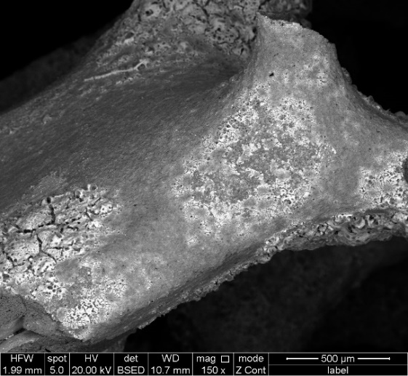

S3: SEM micrographs of the L(grl) catalyst.

S4: HAADF and EDX chemical maps (Kα - lines) showing local distribution of the elements for: a1-a6) L(c.i.), b1 – b6) L (Ace), c1 – c6) L (Glr) samples. *Color coding*: Co (blue), O (red), Al (pink), Mg (green), Si (yellow).

|  |  |
| --- | --- |
|  |  |

S5: TPR-H2 profiles of the the catalysts prepared by a) conventional and c) glycerol assisted impregnation differing in cesium loading.

S6: HAADF and EDX chemical maps (Kα - lines) showing local distribution of the elements for: a1-a7) C.i. (Cs0), b1 – b7) C.i. (Cs1), c1 – c7) C.i. (Cs4), d1 – d7) C.i. (Cs6) samples. *Color coding*: Cs (orange), Co (blue), O (red), Mg (green), Al (yellow), Si (peach orange).

S7: HAADF and EDX chemical maps (Kα - lines) showing local distribution of the elements for: a1-a7) Glr (Cs0), b1 – b7) Glr (Cs1), c1 – c7) Glr (Cs3), d1 – d7) Glr (Cs6) samples. *Color coding*: Cs (orange), Co (blue), O (red), Mg (green), Al (yellow), Si (peach orange).

S8: Dependence of Co/Cs molar ratio determined from AAS results on the cesium amount (wt. % of active phase).

|  |  |
| --- | --- |
|  |  |

S9: Dependence of Co/Cs molar ratio obtained by TEM on the places covered by spinel on the nominal amount of cesium. Left) Supported catalyst prepared by conventional impregnation. Right) Supported catalyst prepared by glycerol assisted impregnation.

|  |  |
| --- | --- |
|  |  |

S10: Dependence of cesium amount (wt. % of active phase from AAS) on the nominal amount of cesium. Left) Supported catalyst prepared by conventional impregnation. Right) Supported catalyst prepared by glycerol assisted impregnation.