**Supplement information**

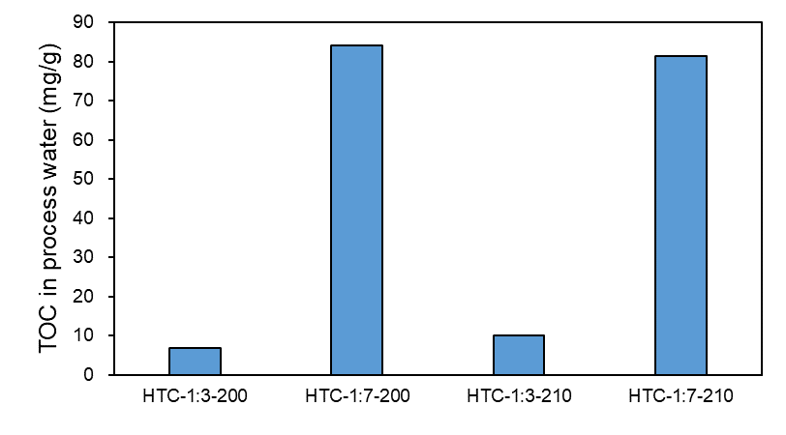

Supplement Figure 1. TOC concentration in process water

Supplement Figure 2. Effect of maxing ratio of sludge and spent coffee grounds on (a) hydrochar yield (b) fixed carbon (c) carbon retention

Supplement Figure 3. Effect of maxing ratio of sludge and bagasse on (a) hydrochar yield (b) fixed carbon (c) carbon retention

Supplement Figure 4. Inorganic composition of the raw sewage sludge feedstock determined by XRF

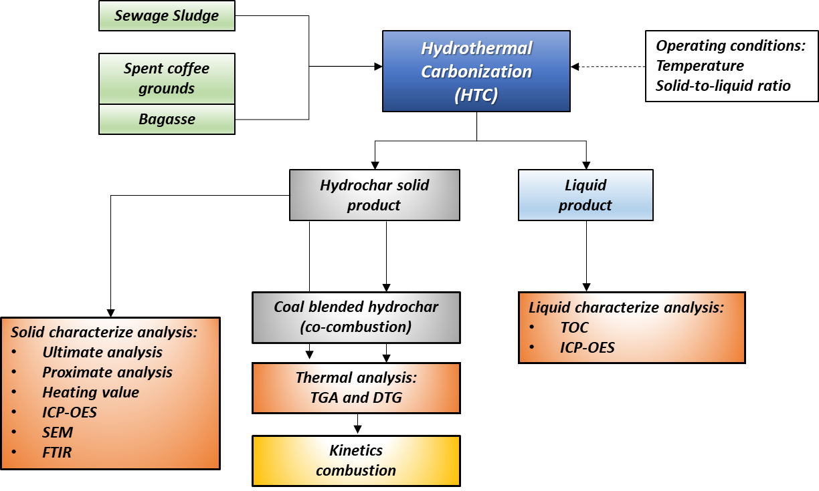

Supplement Figure 5. Research diagram

Supplement Table 1. Metal EPA industrial wastewater standard of EPA compared with process water from HTC

|  |  |  |  |  |
| --- | --- | --- | --- | --- |
| Metal (mg/L) | EPA | HTC-S | HTC-50%SB | HTC-50%SC |
| Mercury (Hg) | 0.2 | 0.285 | 0.071 | 0.300 |
| Lead (Pb) | 5 | 0.044 | 0.084 | 0.060 |
| Cadmium (Cd) | 1 | 0.108 | 0.015 | 0.010 |
| Arsenic (As) | 5 | 0.067 | 0.044 | 0.029 |