***Arabian Journal of Chemistry***

**Supplementary Information**

Phytochemical from Zingiberaceae as a sustainable optical probe for heavy metal determination

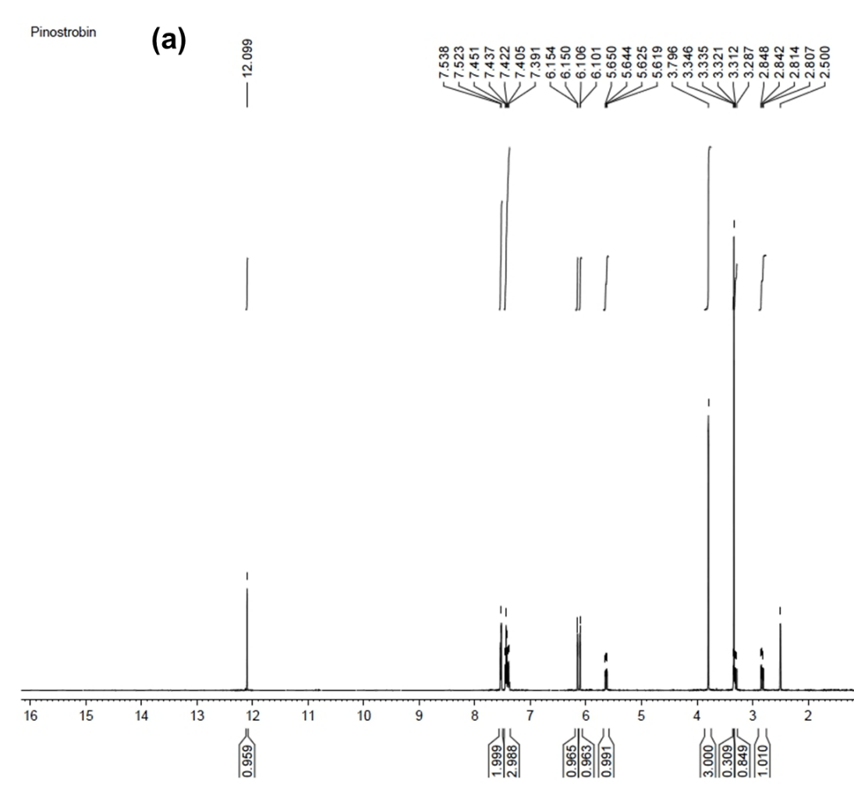

**Fig S1(a)** 1H-NMR spectrum of pinostrobin.

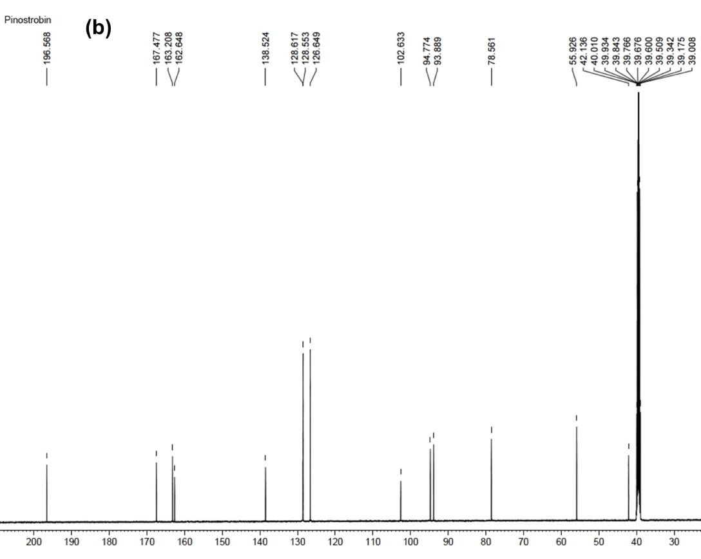

**Fig. S1(b)** 13C-NMR spectrum of pinostrobin.

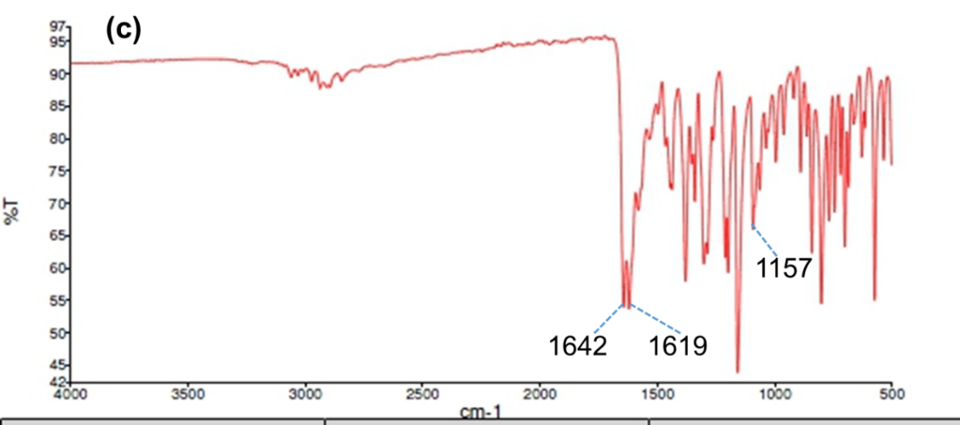

**Fig. S1(c)** FTIR spectrum of pinostrobin.

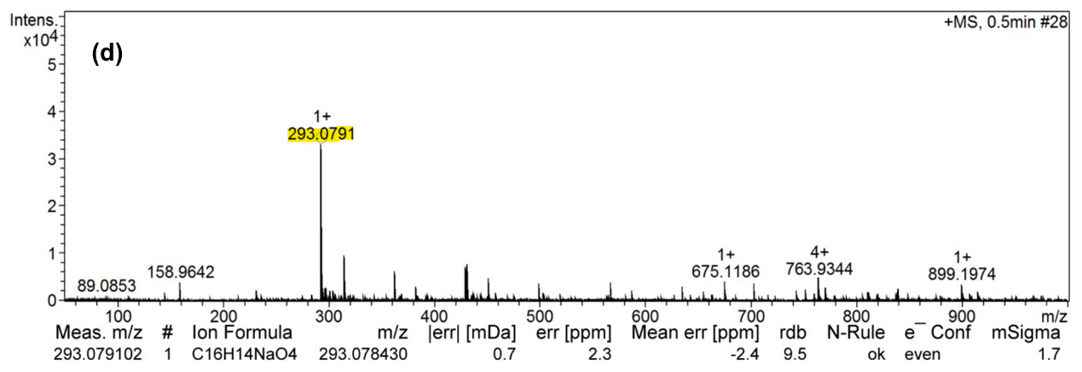

**Fig. S1(d)** Mass spectrum of sodiated pinostrobin [M+Na]+ with m/z of 293.0791.

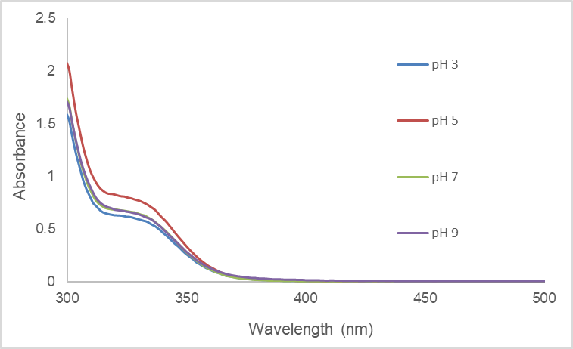

**Fig. S2** Absorption spectra of free pinostrobin in solution pH 3 to 9.

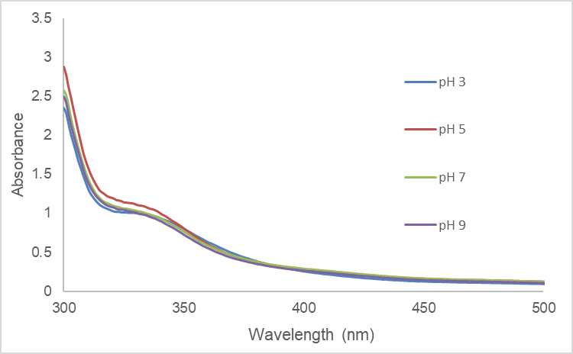

**Fig. S3** Absorption spectra of Fe3+ᅳ(PS)n complex in solution pH 3 to 9.

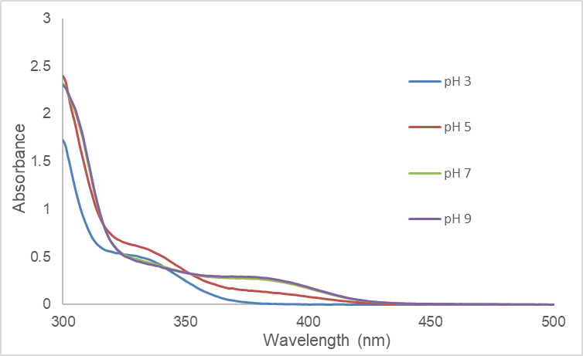

**Fig. S4** Absorption spectra of Cu2+ᅳ(PS)n complex in solution pH 3 to 9.

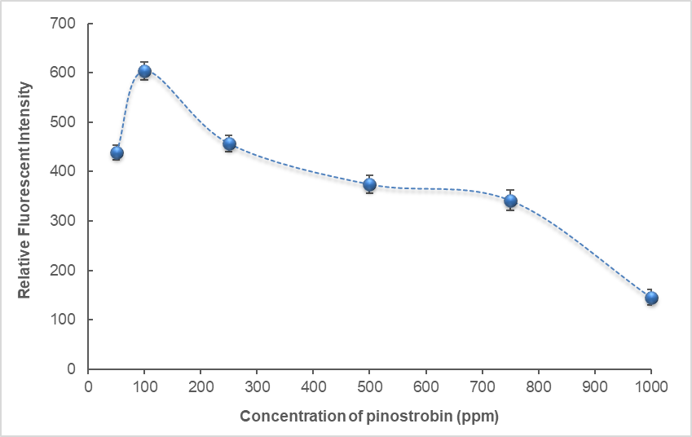

**Fig. S5** Relative fluorescent intensities of different concentrations of PS in the presence of 100 ppm Al3+ ions.

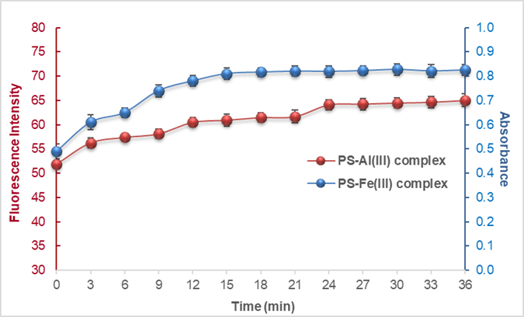

**Fig. S6** Fluorescence intensity of Al3+ complex and absorbance of Fe3+ complex after mixing 100 ppm of PS and 100 ppm of metal ions at different reaction times.

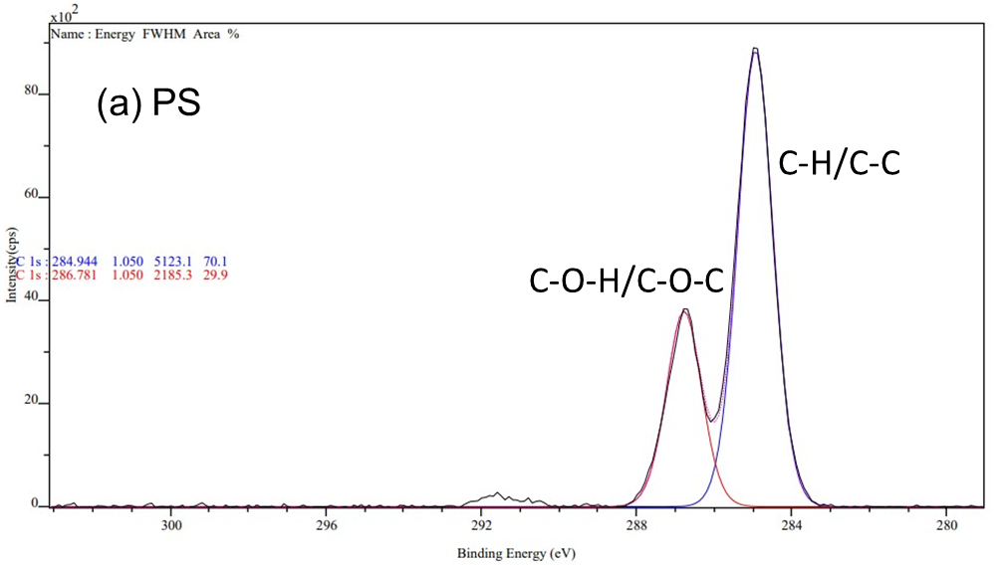

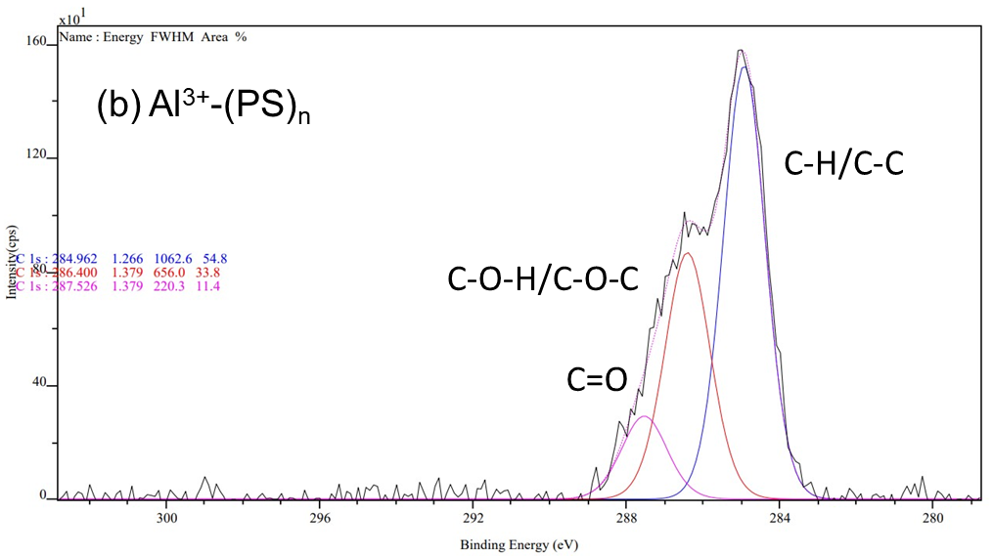

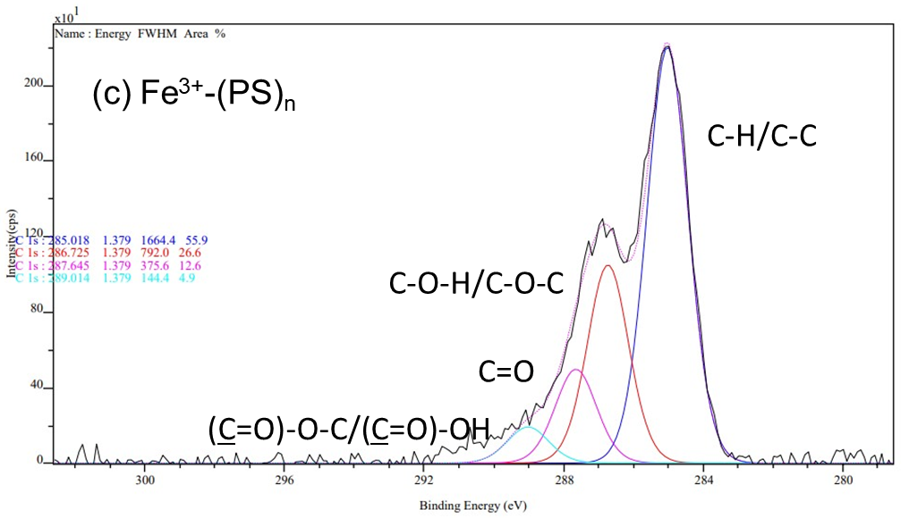

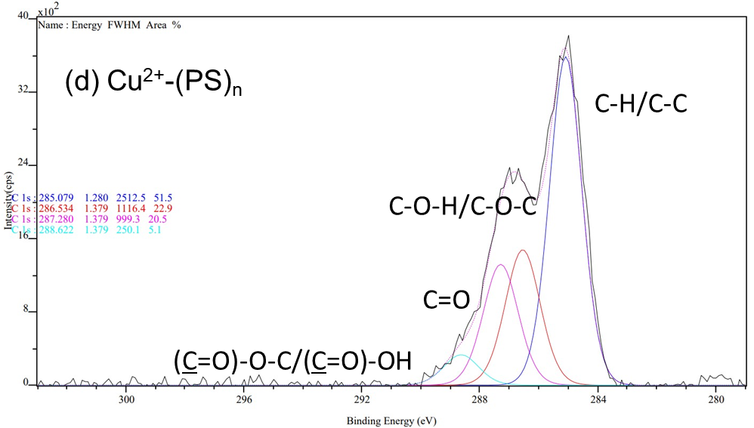

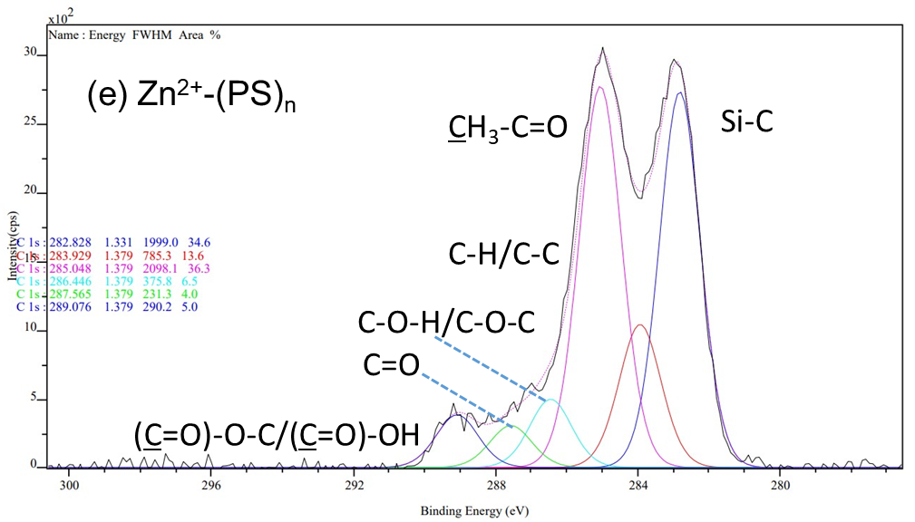

**Fig. S7(a-e)** Deconvoluted peaks of C 1s of PS (a), and PS complexes with metal ions (b-e).

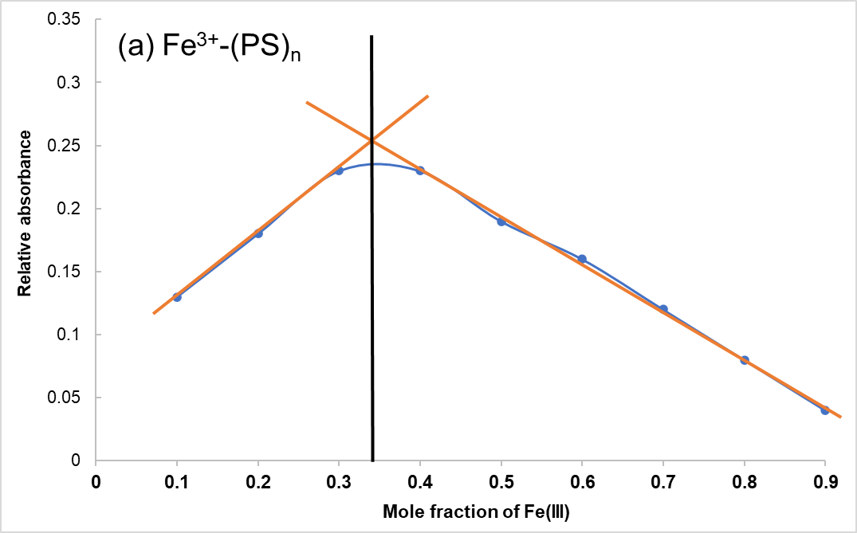

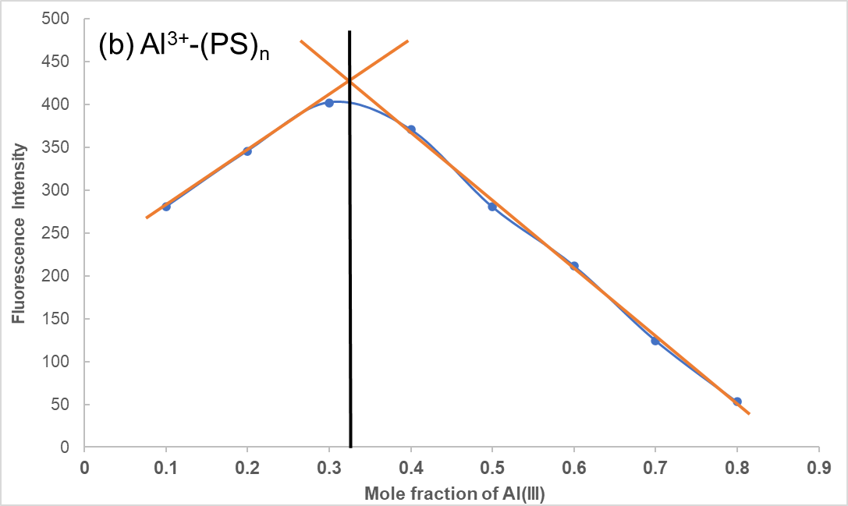

**Fig. S8** Job’s plots analyses by measurement of (a) the absorbance of mixtures with different mole ratios of PS and Fe3+, and (b) the fluorescence intensity of mixtures with different mole ratios of PS and Al3+.

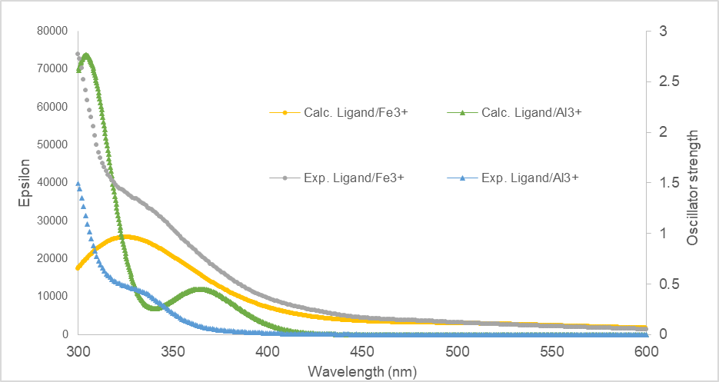

**Fig. S9** The calculated (Calc.) and the experimental (Exp.) absorption spectra of the pinostrobin to each metal complex were obtained at the TD-B3LYP/LANL2DZ/6-311++G(d,p) level in CPCM water model.

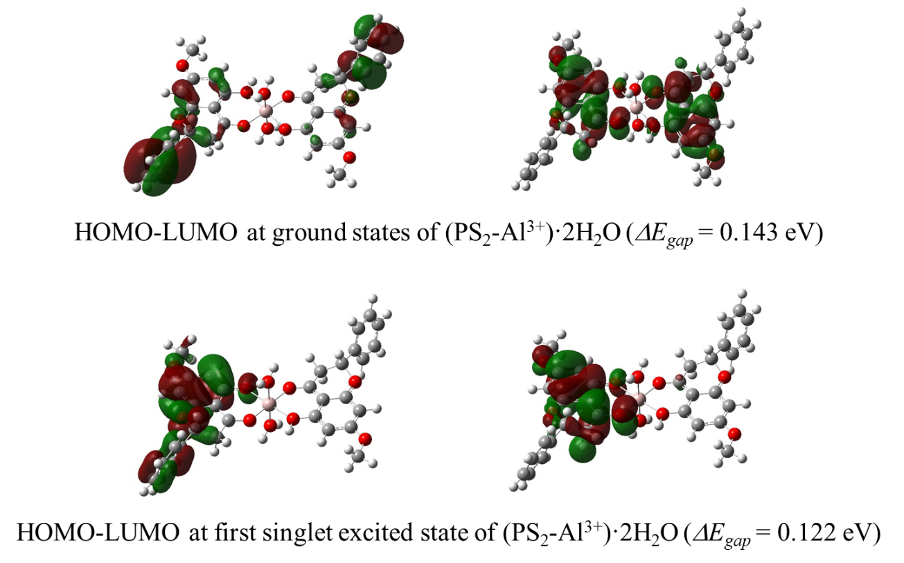

**Fig. S10** The HOMO and LUMO orbitals at ground state and the first excited state, and the energy gaps (*ΔEgap*) of Al3+ complex calculated at the TD-B3LYP/LANL2DZ/6-311++G(d,p) method in CPCM water model.