Bioactive Molecular Family Construction: Design, Optimization and Antifungal Mechanism Study of Novel 2-Phenylglycine Derivatives
Cailong Zhao ª, Hong Zhang ª, Xiaocui Chen ª, Dandan Song ª, Kuai Chen ª, Zhibing Wu ^{a,}*
ª National Key Laboratory of Green Pesticide, Key Laboratory of Green Pesticide and Agricultural Bioengineering, Ministry of Education, Center for R&D of Fine Chemicals of Guizhou University, Guiyang, 550025, China.
* Corresponding author.
Cailong Zhao and Hong Zhang should be considered joint first author.
E-mail address: zbwu@gzu.edu.cn (Z.B. Wu).

Contents
1. The spectral data for the intermediates and target compounds 2
2. The copies of the intermediates and target compounds 26
3. In vitro antifungal activity evaluation 111
4. In vivo antifungal activity evaluation 114

1. The spectral data for the intermediates and target compounds
Data for A: A light yellow solid, yield 75%, m.p. 278–279 ºC. ¹H NMR (400 MHz, CDCl₃) δ: 7.37–7.27 (m, 5H, benzene H), 4.59 (s, 1H, NH₂CH), 3.67 (s, 3H, OCH₃), 1.99 (s, 2H, NH₂); ¹³C NMR (101 MHz, CDCl₃) δ: 174.49, 140.25, 128.83, 128.07, 126.83, 58.74, 52.44.
Data for B: A white solid, yield 94%, m.p. 72–74 ºC. ¹H NMR (400 MHz, CDCl₃) δ: 7.36–7.29 (m, 5H, benzene H), 5.55 (d, J = 4.0 Hz, 1H, CONH), 5.32 (d, J = 8.0 Hz, 1H, NHCH), 3.71 (s, 3H, OCH₃), 1.43 (s, 9H, C(CH₃)₃); ¹³C NMR (101 MHz, CDCl₃) δ: 171.69, 154.84, 136.88, 128.92, 128.46, 127.15, 80.19, 57.60, 52.71, 28.31.
Data for C: A white solid, yield 85%, m.p. 115–117 ºC. ¹H NMR (400 MHz, CDCl₃) δ: 8.22 (s, 1H, CONHNH₂), 7.37–7.28 (m, 5H, benzene H), 6.03 (d, J = 8.0 Hz, 1H, CONH), 5.29 (d, J = 8.0 Hz, 1H, NHCH), 3.86 (s, 2H, CONHNH₂), 1.41 (s, 9H, C(CH₃)₃); ¹³C NMR (101 MHz, CDCl₃) δ: 171.28, 155.38, 137.73, 128.96, 128.40, 127.01, 80.42, 56.94, 28.35.
Data for D: A white solid, yield 66%, m.p. 195–197 ºC. ¹H NMR (400 MHz, DMSO-d₆) δ: 14.52 (s, 1H, SH), 8.27 (d, J = 8.0 Hz, 1H, CONH), 7.45–7.35 (m, 5H, benzene H), 5.95 (d, J = 8.0 Hz, 1H, NHCH), 1.40 (s, 9H, C(CH₃)₃); ¹³C NMR (101 MHz, DMSO-d₆) δ: 178.43, 163.58, 155.33, 136.56, 129.02, 128.87, 128.19, 79.60, 50.99, 28.56.
Data for E₁: A light yellow solid, yield 86%, m.p. 52–54 °C. ¹H NMR (400 MHz, DMSO-d₆) δ: 7.50–7.41 (m, 4H, benzene H), 7.38–7.25 (m, 5H, benzene H), 5.31 (s, 1H, NH₂CH), 4.48 (s, 2H, SCH₂), 2.65 (s, 2H, NH₂); ¹³C NMR (101 MHz, DMSO-d₆) δ: 170.64, 163.25, 148.15 (q, J = 2.5 Hz), 140.89, 136.81, 131.38, 128.92, 128.19, 127.36, 121.45, 119.22, 52.09, 35.23; ¹⁹F NMR (376 MHz, DMSO-d₆) δ: -56.83.
Data for F₃: A light yellow solid, yield 83%, m.p. 91–93 ºC. ¹H NMR (400 MHz, CDCl₃) δ: 8.09–8.05 (m, 1H, benzene H), 7.83 (q, J = 10.0, 1H, NHCH), 7.51–7.45 (m, 3H, benzene H), 7.41–7.32 (m, 3H, benzene H), 7.27–7.23 (m, 1H, benzene H), 7.17–7.12 (m, 1H, benzene H), 5.78 (q, q, J = 4.0, 1H, NHCH), 3.77 (s, 3H, OCH₃); ¹³C NMR (101 MHz, CDCl₃) δ: 171.20, 162.55 (d, J = 3.0 Hz), 159.68, 136.38, 133.82 (d, J = 9.1 Hz), 132.14 (d, J = 2.0 Hz), 129.08, 128.67, 127.35, 124.86 (d, J = 3.0 Hz), 120.34 (d, J = 11.1 Hz), 116.26 (d, J = 25.3 Hz), 57.14, 52.98; ¹⁹F NMR (376 MHz, CDCl₃) δ: -112.77.
Data for G₃: A white solid, yield 88%, m.p. 122–123 ºC. ¹H NMR (400 MHz, DMSO-d₆) δ: 9.66 (s, 1H, CONHNH₂), 8.80 (q, J = 6.0, 1H, NHCH), 7.69–7.65 (m, 1H, benzene H), 7.58–7.49 (m, 3H, benzene H), 7.37–7.26 (m, 5H, benzene H), 5.63 (d, J = 8.0 Hz, 1H, NHCH), 4.37 (s, 2H, CONHNH₂); ¹³C NMR (101 MHz, DMSO-d₆) δ: 169.29, 163.26 (d, J = 1.0 Hz), 161.25, 158.78, 139.11, 133.47 (d, J = 8.1 Hz), 131.00 (d, J = 2.0 Hz), 128.82, 128.11, 127.44, 125.03 (d, J = 3.0 Hz), 123.27 (d, J = 3.0 Hz).116.72 (d, J = 22.2 Hz), 55.79; ¹⁹F NMR (376 MHz, DMSO-d₆) δ: -113.70, -113.71, -113.73, -113.75, -113.76, -113.78.
Data for H₁₁: A white solid, yield 84%, m.p. 151–153 ºC. ¹H NMR (400 MHz, CDCl₃) δ: 8.29 (s, 1H, CONH), 7.69–7.60 (m, 4H, benzene H), 4.04 (d, J = 4.0 Hz, 2H, COCH₂); ¹³C NMR (101 MHz, CDCl₃) δ: 163.72, 139.96, 127.06 (d, J = 32.3 Hz), 126.44 (q, J = 5.6 Hz), 122.59, 119.66, 29.31. ¹⁹F NMR (376 MHz, CDCl₃) δ: -62.24.
Data for І₁: A white solid, yield 81%, m.p. 98–99 °C. ¹H NMR (400 MHz, CDCl₃) δ: 8.53 (d, J = 4.0 Hz, 1H, pyridine H), 7.63–7.59 (m, 1H, pyridine H), 7.41 (d, J = 8.0 Hz, 1H, pyridine H), 7.35–7.31 (m, 5H, benzene H), 7.19–7.16 (m, 1H, pyridine H), 6.07 (d, J = 8.0 Hz, 1H, NHCH), 5.67 (d, J = 4.0 Hz, 1H, NHCH), 4.54 (s, 2H, SCH₂), 1.42 (s, 9H, C(CH₃)₃); ¹³C NMR (101 MHz, CDCl₃) δ: 166.81, 164.92, 155.29, 154.61, 149.72, 136.87, 136.59, 129.14, 128.85, 127.09, 123.44, 122.77, 80.75, 51.45, 38.35, 28.27; HRMS (ESI): m/z calcd for C₂₂H₂₃O₃N₄S [M+H]⁺ 399.14854, found 399.14706.
Data for І₂: A brown solid, yield 82%, m.p. 99–101. ¹H NMR (400 MHz, CDCl₃) δ: 8.40 (d, J = 4.0 Hz, 1H, pyridine H), 7.72–7.70 (m, 1H, pyridine H), 7.36–7.29 (m, 5H, benzene H), 7.24 (d, J = 8.0 Hz, 1H, pyridine H), 6.05 (d, J = 8.0 Hz, 1H, NHCH), 5.64 (d, J = 4.0 Hz, 1H, NHCH), 4.35 (s, 2H, SCH₂), 1.42 (s, 9H, C(CH₃)₃); ¹³C NMR (101 MHz, CDCl₃) δ: 167.21, 163.80, 151.10, 150.02, 139.48, 136.32, 130.87, 129.22, 128.99, 127.10, 124.28, 80.86, 51.51, 32.87, 29.70, 28.26; HRMS (ESI): m/z calcd for C₂₀H₂₂O₃N₄ClS [M+H]⁺ 433.10957, found 433.10852.
Data for І₃: A light yellow solid, yield 75%, m.p. 93–95 °C. ¹H NMR (500 MHz, CDCl₃) δ: 7.47 (s, 1H, thiazole H), 7.40–7.32 (m, 5H, benzene H), 6.08 (d, J = 10.0 Hz, 1H, NHCH), 5.65 (d, J = 5.0 Hz, 1H, NHCH), 4.57–4.50 (m, 2H, SCH₂), 1.43 (s, 9H, C(CH₃)₃); ¹³C NMR (126 MHz, CDCl₃) δ: 167.41, 163.64, 152.47, 141.16, 136.27, 135.41, 129.25, 129.03, 127.12, 80.88, 51.54, 29.70, 28.51, 28.26; HRMS (ESI): m/z calcd for C₁₈H₂₀O₃N₄S₂ [M+H]⁺ 439.06599, found 439.06439.
Data for І₄: A yellow solid, yield 69%, m.p. 108–109 °C. ¹H NMR (400 MHz, CDCl₃) δ: 11.00 (s, 1H, benzimidazole H), 7.69 (s, 1H, benzene H), 7.39–7.32 (m, 6H, benzene H), 7.25–7.21 (m, 2H, benzene H), 6.12 (d, J = 4.0 Hz, 1H, NHCH), 5.70 (s, 1H, NHCH), 4.62 (s, 2H, SCH₂), 1.44 (s, 9H, C(CH₃)₃); ¹³C NMR (101 MHz, CDCl₃) δ: 167.64, 166.38, 154.67, 149.47, 135.90, 129.31, 129.14, 127.13, 123.53, 119.52, 111.34, 81.08, 51.57, 29.73, 28.28; HRMS (ESI): m/z calcd for C₂₂H₂₄O₃N₅S [M+H]⁺ 438.15944, found 438.15826.
Data for І₅: A light yellow solid, yield 82%, m.p. 122–125 °C. ¹H NMR (400 MHz, CDCl₃) δ: 12.67 (s, 1H, aromaticnucleus H), 7.70 (d, J = 8.0 Hz, 1H, aromaticnucleus H), 7.53 (t, J = 8.0 Hz, 1H, aromaticnucleus H), 7.46 (d, J = 8.0 Hz, 1H, aromaticnucleus H), 7.36–7.22 (m, 5H, aromaticnucleus H), 7.25–7.22 (m, 1H, aromaticnucleus H), 6.85 (s, 1H, aromaticnucleus H), 6.10 (d, J = 8.0 Hz, 1H, NHCH), 5.87 (d, J = 8.0 Hz, 1H, NHCH), 4.66 (s, 2H, SCH₂), 1.41 (s, 9H, C(CH₃)₃); ¹³C NMR (101 MHz, CDCl₃) δ: 167.37, 163.97, 163.71, 154.71, 145.30, 138.80, 136.32, 131.18, 129.23, 128.96, 127.16, 123.80, 123.01, 122.11, 118.28, 117.12, 80.79, 51.56, 33.13, 28.28; HRMS (ESI): m/z calcd for C₂₄H₂₅O₄N₄S [M+H]⁺ 465.15910, found 465.15784.
Data for І₆: A white solid, yield 79%, m.p. 115–117 °C. ¹H NMR (500 MHz, CDCl₃) δ: 7.36–7.29 (m, 6H, aromaticnucleus H), 6.76 (t, J = 7.5 Hz, 2H, aromaticnucleus H), 6.27 (s, 1H, aromaticnucleus H), 6.08 (d, J = 5.0 Hz, 1H, NHCH), 5.84 (d, J = 10.0 Hz, 1H, NHCH), 4.40 (s, 2H, SCH₂), 1.40 (s, 9H, C(CH₃)₃); ¹³C NMR (126 MHz, CDCl₃) δ: 167.58, 163.90, 161.65, 155.46, 154.90, 149.49, 135.83, 129.31, 129.14, 127.15, 125.22, 114.07, 111.75, 110.28, 103.76, 81.18, 51.62, 32.32, 29.72, 28.27; HRMS (ESI): m/z calcd for C₂₄H₂₄O₆N₃S [M+H]⁺ 482.13803, found 482.13715.
Data for І₇: A yellow solid, yield 76%, m.p. 101–103 °C. ¹H NMR (500 MHz, DMSO-d₆) δ: 8.86 (d, J = 10.0 Hz, 1H, NHCH), 7.87 (d, J = 5.0 Hz, 1H, thiophene H), 7.53–7.50 (m, 2H, benzene H), 7.37 (d, J = 10.0 Hz, 1H, thiophene H), 7.30–7.27 (m, 7H, benzene H), 6.01 (d, J = 10.0 Hz, 1H, NHCH), 4.47 (s, 2H, SCH₂), 3.78 (s, 3H, CH₃); ¹³C NMR (126 MHz, DMSO-d₆) δ: 166.06, 163.90, 159.95, 147.77, 143.45, 136.34, 135.29, 131.89, 131.68, 131.10, 130.41, 128.56 (d, J = 6.3 Hz), 127.52, 121.12, 119.08, 53.07 (d, J = 18.9 Hz), 34.70, 26.99 (d, J = 27.7 Hz); ¹⁹F NMR (471 MHz, DMSO-d₆) δ: -56.71; HRMS (ESI): m/z calcd for C₂₃H₁₈O₆N₃F₃S₃ [M+H]⁺ 586.03826, found 586.03748.
Data for І₈: A yellow solid, yield 63%, m.p. 96–97 °C. ¹H NMR (500 MHz, DMSO-d₆) δ: 7.95–7.93 (m, 2H, benzene H), 7.84–7.82 (m, 2H, benzene H), 7.50–7.48 (m, 2H, benzene H), 7.30–7.27 (m, 7H, benzene H), 5.99 (s, 1H, NHCH), 4.43 (s, 2H, SCH₂); ¹³C NMR (126 MHz, DMSO-d₆) δ: 165.78, 163.95, 147.79, 144.56, 136.14, 135.13, 133.15, 131.03, 128.70, 128.66, 127.51, 127.31, 121.13, 117.75, 114.96, 52.78, 34.76, 27.10, 26.92; ¹⁹F NMR (471 MHz, DMSO-d₆) δ: -56.71; HRMS (ESI): m/z calcd for C₂₄H₁₇O₄N₄F₃S₂ [M+H]⁺ 547.07161, found 547.07098.
Data for І₉: A light yellow solid, yield 78%, m.p. 122–124 °C. ¹H NMR (500 MHz, DMSO-d₆) δ: 9.37 (d, J = 10.0 Hz, 1H, NHCH), 7.69–7.66 (m, 2H, benzene H), 7.61–7.59 (m, 2H, benzene H), 7.51–7.48 (m, 2H, benzene H), 7.31–7.27 (m, 7H, benzene H), 5.93 (d, J = 10.0 Hz, 1H, NHCH), 4.43 (s, 2H, SCH₂); ¹³C NMR (126 MHz, DMSO-d₆) δ: 165.72, 163.89, 147.74, 139.61, 136.10, 135.27, 132.03, 131.01, 128.66, 128.55, 128.47, 127.41, 126.58, 121.11, 119.02, 52.65, 34.73; ¹⁹F NMR (471 MHz, DMSO-d₆) δ: -56.71; HRMS (ESI): m/z calcd for C₂₃H₁₇O₄N₃BrF₃S₂ [M+H]⁺ 599.98687, found 599.98608.
Data for І₁₀: A brown liquid, yield 70%. ¹H NMR (400 MHz, DMSO-d₆) δ: 9.43 (d, J = 8.0 Hz, 1H, NHCH), 7.81–7.77 (m, 2H, benzene H), 7.48 (d, J = 12.0 Hz, 2H, benzene H), 7.41 (d, J = 8.0 Hz, 2H, benzene H), 7.30–7.26 (m, 7H, benzene H), 5.96 (d, J = 8.0 Hz, 1H, NHCH), 4.43 (s, 2H, SCH₂); ¹³C NMR (101 MHz, DMSO-d₆) δ: 165.82, 163.93, 150.86 (d, J = 2.0 Hz), 147.78 (d, J = 1.0 Hz), 139.41, 136.20, 135.20, 131.00, 130.49 (d, J = 11.1 Hz), 129.12, 128.60, 128.52, 127.47, 121.15 (d, J = 15.2 Hz), 118.70 (d, J = 23.2 Hz), 52.79, 34.69, 26.98 (d, J = 14.1 Hz); ¹⁹F NMR (376 MHz, DMSO-d₆) δ: -56.83, -56.90; HRMS (ESI): m/z calcd for C₂₄H₁₇O₅N₃F₆S₂ [M+H]⁺ 606.05866, found 606.05798.
Data for І₁₁: A white solid, yield 62%, m.p. 134–136 °C. ¹H NMR (500 MHz, DMSO-d₆) δ: 9.17 (d, J = 10.0 Hz, 1H, NHCH), 7.58–7.56 (m, 2H, benzene H), 7.51–7.48 (m, 2H, benzene H), 7.33–7.30 (m, 5H, benzene H), 7.28 (d, J = 10.0 Hz, 2H, benzene H), 7.24 (d, J = 10.0 Hz, 2H, benzene H), 5.87 (d, J = 10.0 Hz, 1H, NHCH), 4.41 (s, 2H, SCH₂), 2.29 (s, 3H, CH₃); ¹³C NMR (126 MHz, DMSO-d₆) δ: 165.87, 163.80, 147.75, 142.95, 137.49, 136.27, 135.55, 131.00, 129.39, 128.66, 128.51, 127.35, 126.47, 121.11, 119.05, 52.65, 34.67, 20.98; ¹⁹F NMR (471 MHz, DMSO-d₆) δ: -56.74; HRMS (ESI): m/z calcd for C₂₄H₂₀O₄N₃F₃S₂ [M+H]⁺ 536.09201, found 536.09119.
Data for І₁₂: A yellow solid, yield 69%, m.p. 116–118 °C. ¹H NMR (400 MHz, CDCl₃) δ: 7.62 (d, J = 8.0 Hz, 2H, benzene H), 7.34–7.27 (m, 4H, benzene H), 7.25–7.13 (m, 7H, benzene H), 6.10 (d, J = 4.0 Hz, 1H, NHCH), 5.80 (d, J = 8.0 Hz, 1H, NHCH), 4.32 (s, 2H, SCH₂), 2.34 (s, 3H, CH₃); ¹³C NMR (101 MHz, CDCl₃) δ: 165.47, 164.52, 149.32 (q, J = 5.1 Hz), 143.88, 137.65, 136.29, 134.76, 130.22, 129.60, 129.10, 127.47, 127.11 (q, J = 4.0 Hz), 121.56, 120.56, 119.07, 53.53, 35.92, 21.49; ¹⁹F NMR (376 MHz, CDCl₃) δ: -57.74; HRMS (ESI): m/z calcd for C₂₄H₂₀O₄N₃F₃S₂ [M+H]⁺ 536.09201, found 536.09070.
Data for І₁₃: A light yellow solid, yield 68%, m.p. 88–89 °C. ¹H NMR (400 MHz, DMSO-d₆) δ: 9.38 (d, J = 8.0 Hz, 1H, NHCH), 7.69–7.66 (m, 2H, benzene H), 7.62–7.59 (m, 2H, benzene H), 7.48–7.43 (m, 2H, benzene H), 7.36–7.29 (m, 7H, benzene H), 7.27–7.23 (m, 1H, benzene H), 5.94 (d, J = 8.0 Hz, 1H, NHCH), 4.47 (s, 2H, SCH₂); ¹³C NMR (101 MHz, DMSO-d₆) δ: 166.35, 163.93, 140.08, 135.71, 133.95, 133.76, 132.48, 131.90, 130.50, 130.10, 129.11, 129.01, 128.92, 127.91, 127.86, 127.02, 53.11, 34.59; HRMS (ESI): m/z calcd for C₂₂H₁₇O₃N₃BrClS₂ [M+H]⁺ 549.96560, found 549.96490.
Data for І₁₄: A yellow liquid, yield 66%. ¹H NMR (400 MHz, DMSO-d₆) δ: 8.84 (d, J = 8.0 Hz, 1H, NHCH), 7.90 (d, J = 4.0 Hz, 1H, thiophene H), 7.39 (d, J = 4.0 Hz, 1H, thiophene H), 7.34–7.29 (m, 5H, benzene H), 6.02 (d, J = 8.0 Hz, 1H, NHCH), 3.82 (s, 3H, SCH₃), 2.65 (s, 3H, CH₃); ¹³C NMR (101 MHz, DMSO-d₆) δ: 166.15, 165.80, 160.41, 143.86, 135.80, 132.31, 132.09, 130.79, 128.96, 127.90, 53.57, 53.37, 23.10, 14.72; HRMS (ESI): m/z calcd for C₁₆H₁₅O₅N₃S₃ [M+H]⁺ 426.02466, found 426.02393.
Data for І₁₅: A brown solid, yield 82%, m.p. 106–107 °C. ¹H NMR (500 MHz, DMSO-d₆) δ: 9.67 (d, J = 5.0 Hz, 1H, NHCH), 7.64–7.60 (m, 1H, benzene H), 7.58–7.54 (m, 1H, benzene H), 7.52–7.50 (m, 3H, benzene H), 7.44–7.41 (m, 2H, benzene H), 7.40–7.37 (m, 1H, benzene H), 7.33–7.25 (m, 5H, benzene H), 6.58 (d, J = 5.0 Hz, 1H, NHCH), 4.50 (s, 2H, SCH₂); ¹³C NMR (126 MHz, DMSO-d₆) δ: 167.25, 164.24 (d, J = 8.8 Hz), 160.71, 158.72, 148.21, 136.84 (d, J = 10.1 Hz), 133.41 (d, J = 8.8 Hz) 131.50, 130.62 (d, J = 2.5 Hz), 129.21, 128.97, 128.23, 125.02 (d, J = 3.8 Hz), 123.93 (d, J = 13.9 Hz), 121.53, 119.53, 116.79, (d, J = 21.4 Hz), 49.87, 35.29, 27.77 (d, J = 30.2 Hz); ¹⁹F NMR (471 MHz, DMSO-d₆) δ: -56.71; HRMS (ESI): m/z calcd for C₂₄H₁₇O₃N₃F₄S [M+H]⁺ 504.09995, found 504.09836.
Data for І₁₆: A light yellow solid, yield 81%, m.p. 129–131 °C. ¹H NMR (400 MHz, CDCl₃) δ: 7.75 (d, J = 8.0 Hz, 2H, benzene H), 7.49 (s, 1H, NHCH), 7.39–7.37 (m, 9H, benzene H), 7.12 (d, J = 8.0 Hz, 2H, benzene H), 6.55 (d, J = 8.0Hz, 1H, NHCH), 4.42–4.33 (m, 2H, SCH₂); ¹³C NMR (101 MHz, CDCl₃) δ: 166.59, 165.68, 164.82, 148.92 (d, J = 2.0 Hz), 138.45, 135.99, 134.17, 131.49, 130.59, 129.22 (d, J = 14.1 Hz), 128.85 (d, J = 11.1 Hz), 127.44, 121.67, 121.18, 119.11, 50.57, 35.85, 29.71; ¹⁹F NMR (376 MHz, CDCl₃) δ: -57.81; HRMS (ESI): m/z calcd for C₂₄H₁₇O₃N₃F₃ClS [M+H]⁺ 520.07040, found 520.06909.
Data for І₁₇: A brown solid, yield 75%, m.p. 67–68 °C. ¹H NMR (500 MHz, CDCl₃) δ: 7.61–7.60 (m, 1H, thiophene H), 7.49–7.48 (m, 1H, thiophene H), 7.45 (d, J = 5.0 Hz, 1H, NHCH), 7.39–7.33 (m, 7H, benzene H), 7.11 (d, J = 10.0 Hz, 2H, benzene H), 7.04–7.02 (m, 1H, thiophene H), 6.56 (d, J = 10.0 Hz, 1H, NHCH), 4.40–4.33 (m, 2H, SCH₂). ¹³C NMR (126 MHz, CDCl₃) δ: 166.56, 164.70, 161.17, 148.86, 137.50, 135.97, 134.21, 131.08, 130.58, 129.20, 129.06, 127.77, 127.45, 121.38, 121.15, 119.34, 50.31, 35.79; ¹⁹F NMR (471 MHz, CDCl₃) δ: -57.69; HRMS (ESI): m/z calcd for C₂₂H₁₆O₂N₃F₃S₃ [M+H]⁺ 508.04295, found 508.04260.
Data for І₁₈: A yellow solid, yield 78%, m.p. 111–113 °C. ¹H NMR (500 MHz, CDCl₃) δ: 8.74 (d, J = 2.5 Hz, 1H, thiazole H), 8.38 (d, J = 10.0 Hz, 1H, NHCH), 8.19 (d, J = 5.0 Hz, 1H, thiazole H), 7.42–7.39 (m, 3H, benzene H), 7.38–7.33 (m, 4H, benzene H), 7.11 (d, J = 10.0 Hz, 2H, benzene H), 6.58 (d, J = 10.0 Hz, 1H, NHCH), 4.42–4.35 (m, 2H, SCH₂); ¹³C NMR (126 MHz, CDCl₃) δ: 166.31, 164.52, 160.08, 153.05, 149.85, 148.81, 135.87, 134.33, 130.58, 129.14 (d, J = 23.9 Hz), 127.33, 124.36, 121.11, 119.31, 49.81, 35.77, 27.72; ¹⁹F NMR (471 MHz, CDCl₃) δ: -57.68; HRMS (ESI): m/z calcd for C₂₁H₁₅O₂N₄F₃S₃ [M+H]⁺ 509.03820, found 509.03687.
Data for Ⅱ₁: (Z/E) A light yellow solid, yield 86%, m.p. 189–191 °C. ¹H NMR (500 MHz, DMSO-d₆) δ: 12.08 (s, 1H, CONH), 11.73 (s, 1H, CONH), 8.91 (d, J = 10.0 Hz, 1H, NHCH), 8.76 (d, J = 5.0 Hz, 1H, NHCH), 8.35 (q, J = 2.5 Hz, 1H, aromaticnucleus H), 8.32 (q, J = 2.5 Hz, 1H, aromaticnucleus H), 8.27 (s, 1H, NHNCH), 7.95 (s, 1H, NHNCH), 7.86 (d, J = 10.0 Hz, 2H, aromaticnucleus H), 7.81 (d, J = 5.0 Hz, 2H, aromaticnucleus H), 7.75 (d, J = 10.0 Hz, 4H, aromaticnucleus H), 7.58–7.49 (m, 8H, aromaticnucleus H), 7.38–7.29 (m, 5H, aromaticnucleus H), 7.26–7.23 (m, 1H, aromaticnucleus H), 6.50 (d, J = 5.0 Hz, 1H, NHCH), 5.71 (d, J = 10.0 Hz, 1H, NHCH); ¹³C NMR (126 MHz, DMSO-d₆) δ: 172.17, 167.41, 162.59, 162.33, 146.25, 142.36, 138.59, 138.49, 137.71, 137.64, 137.45, 137.27, 130.32, 130.16, 130.08, 129.91, 129.02, 128.99, 128.95, 128.55, 128.46, 128.36, 128.22, 127.90, 127.02, 127.00, 126.29, 126.26, 126.22, 126.19, 125.69, 123.53, 56.73, 54.62; ¹⁹F NMR (471 MHz, DMSO-d₆) δ: -61.08, -61.09; HRMS (ESI): m/z calcd for C₂₁H₁₆O₂N₃F₃S [M+H]⁺ 432.09881, found 432.09741.
Data for Ⅱ₂: (Z/E) A light yellow solid, yield 81%, m.p. 200–201 °C. ¹H NMR (500 MHz, DMSO-d₆) δ: 12.01 (s, 1H, CONH), 11.66 (s, 1H, CONH), 8.92 (d, J = 10.0 Hz, 1H, NHCH), 8.77 (d, J = 5.0 Hz, 1H, NHCH), 8.39 (q, J = 1.3 Hz, 1H, aromaticnucleus H), 8.35 (q, J = 1.0 Hz, 1H, aromaticnucleus H), 8.26 (s, 1H, NHNCH), 7.94 (s, 1H, NHNCH), 7.83–7.75 (m, 4H, aromaticnucleus H), 7.61–7.52 (m, 8H, aromaticnucleus H), 7.44–7.32 (m, 9H, aromaticnucleus H), 7.30–7.27 (m, 1H, aromaticnucleus H), 6.52 (d, J = 10.0 Hz, 1H, NHCH), 5.73 (d, J = 10.0 Hz, 1H, NHCH); ¹³C NMR (126 MHz, DMSO-d₆) δ: 172.02, 167.22, 162.56, 162.29, 149.79, 149.61, 146.41, 142.45, 137.84, 137.74, 137.47, 137.28, 133.88, 133.84, 130.30, 130.05, 129.52, 129.18, 129.01, 128.98, 128.91, 128.52, 128.41, 128.32, 127.92, 127.88, 127.03, 127.00, 56.66, 54.52; ¹⁹F NMR (471 MHz, DMSO-d₆) δ: -56.60, -56.61; HRMS (ESI): m/z calcd for C₂₁H₁₆O₃N₃F₃S [M+H]⁺ 448.09372, found 448.09250.
Data for Ⅱ₃: (Z/E) A light yellow solid, yield 88%, m.p. 174–175 °C. ¹H NMR (400 MHz, DMSO-d₆) δ: 12.06 (s, 1H, CONH), 11.75 (s, 1H, CONH), 9.05 (q, J = 6.0 Hz, 1H, NHCH), 8.90 (q, J = 6.0 Hz, 1H, NHCH), 8.26 (s, 1H, NHNCH), 7.97 (s, 1H, NHNCH), 7.83 (d, J = 8.0 Hz, 4H, benzene H), 7.69–7.64 (m, 2H, benzene H), 7.58–7.50 (m, 6H, benzene H), 7.49–7.38 (m, 6H, benzene H), 7.36–7.26 (m, 8H, benzene H), 6.51 (d, J = 8.0 Hz, 1H, NHCH), 5.75 (d, J = 4.0 Hz, 1H, NHCH); ¹³C NMR (101 MHz, DMSO-d₆) δ: 171.50, 169.31, 166.79, 163.95, 163.48, 161.23, 161.18, 158.76, 158.71, 149.80, 149.79, 149.63, 149.62, 146.69, 142.89, 137.88, 137.84, 133.73, 133.68, 133.35, 133.32, 133.27, 133.23, 132.14, 130.97, 130.94, 130.91, 130.88, 129.51, 129.24, 129.04, 128.98, 128.81, 128.51, 128.33, 127.94, 127.44, 124.95, 124.92, 124.87, 123.62, 123.48, 123.35, 121.90, 121.74, 121.14, 119.21, 119.19, 116.70, 116.68, 116.47, 116.46, 56.63, 54.59; HRMS (ESI): m/z calcd for C₂₃H₁₇O₃N₃F₄ [M+H]⁺ 460.12788, found 460.12643.
Data for Ⅱ₄: (Z/E) A brown solid, yield 73%, m.p. 197–199 °C. ¹H NMR (500 MHz, DMSO-d₆) δ: 12.00 (s, 1H, CONH), 11.68 (s, 1H, CONH), 9.22 (d, J = 5.0 Hz, 1H, NHCH), 9.07 (d, J = 10.0 Hz, 1H, NHCH), 8.25 (s, 1H, NHNCH), 7.98–7.95 (m, 5H, benzene H), 7.83–7.76 (m, 4H, benzene H), 7.57–7.52 (m, 8H, benzene H), 7.49–7.32 (m, 9H, benzene H), 7.30–7.27 (m, 1H, benzene H), 6.53 (d, J = 5.0 Hz, 1H, NHCH), 5.74 (d, J = 10.0 Hz, 1H, NHCH); ¹³C NMR (126 MHz, DMSO-d₆) δ: 171.88, 167.13, 166.12, 165.78, 149.80, 149.61, 146.40, 142.47, 137.64, 137.53, 136.85, 136.75, 133.88, 133.83, 133.08, 132.94, 132.22, 130.37, 130.27, 129.52, 129.19, 129.01, 128.96, 128.76, 128.57, 128.51, 128.37, 121.93, 121.80, 121.55, 121.24, 119.51, 57.12, 55.04; ¹⁹F NMR (471 MHz, DMSO-d₆) δ: -56.62, -56.64; HRMS (ESI): m/z calcd for C₂₃H₁₇ClO₂N₃F₃ [M+H]⁺ 460.10342, found 460.10382.
Data for Ⅱ₅: (Z/E) A white solid, yield 83%, m.p. 204–206 °C. ¹H NMR (400 MHz, DMSO-d₆) δ: 11.78 (s, 1H, CONH), 11.49 (s, 1H, CONH), 8.20 (s, 1H, NHNCH), 7.91 (s, 1H, NHNCH), 7.69–7.65 (m, 4H, benzene H), 7.62 (d, J = 8.0 Hz, 1H, NHCH), 7.50–7.45 (m, 7H, benzene H), 7.43–7.41 (m, 3H, benzene H), 7.38–7.26 (m, 6H, benzene H), 7.24 (d, J = 8.0 Hz, 1H, NHCH), 6.10 (d, J = 8.0 Hz, 1H, NHCH), 5.25 (d, J = 8.0 Hz, 1H, NHCH), 1.39 (d, J = 4.0 Hz, 18H, O(CH₃)₃); ¹³C NMR (101 MHz, DMSO-d₆) δ: 172.21, 167.35, 155.63, 155.50, 147.85, 143.96, 138.25, 138.18, 134.49, 134.46, 130.61, 130.38, 129.37, 129.26, 128.87, 128.80, 128.46, 128.32, 128.09, 127.96, 127.56, 127.27, 78.93, 78.75, 57.57, 55.16, 28.65; HRMS (ESI): m/z calcd for C₂₀H₂₃O₃N₃ [M+H]⁺ 354.18122, found 354.18027.
Data for Ⅱ₆: (Z/E) A white solid, yield 77%, m.p. 207–209 °C. ¹H NMR (400 MHz, DMSO-d₆) δ: 11.78 (s, 1H, CONH), 11.48 (s, 1H, CONH), 8.19 (s, 1H, NHNCH), 7.89 (s, 1H, NHNCH), 7.75–7.70 (m, 4H, benzene H), 7.61 (d, J = 8.0 Hz, 1H, NHCH), 7.48–7.44 (m, 5H, benzene H), 7.34 (d, J = 8.0 Hz, 1H, NHCH), 7.33–7.29 (m, 5H, benzene H), 7.28–7.22 (m, 4H, benzene H), 6.08 (d, J = 8.0 Hz, 1H, NHCH), 5.24 (d, J = 8.0 Hz, 1H, NHCH), 1.39 (d, J = 4.0 Hz, 18H, O(CH₃)₃); ¹³C NMR (101 MHz, DMSO-d₆) δ: 172.21, 167.36, 164.82, 164.66, 162.36, 162.20, 155.63, 155.50, 146.73, 142.82, 138.22, 138.16, 131.10, 129.80, 129.71, 129.48, 129.40, 128.86, 128.80, 128.47, 128.32, 128.09, 127.95, 116.53, 116.44, 116.31, 116.22, 78.93, 78.75, 57.56, 55.16, 28.65; ¹⁹F NMR (376 MHz, DMSO-d₆) δ: -110.46, -110.73; HRMS (ESI): m/z calcd for C₂₀H₂₂O₃N₃F [M+H]⁺ 372.17180, found 372.17065.
Data for Ⅱ₇: (Z/E) A white solid, yield 86%, m.p. 216–218 °C. ¹H NMR (400 MHz, DMSO-d₆) δ: 11.98 (s, 1H, CONH), 11.67 (s, 1H, CONH), 8.28 (s, 1H, NHNCH), 7.97 (s, 1H, NHNCH), 7.90–7.87 (m, 4H, benzene H), 7.81–7.78 (m, 4H, benzene H), 7.66 (d, J = 8.0 Hz, 1H, NHCH), 7.51–7.46 (m, 5H, benzene H), 7.37 (d, J = 8.0 Hz, 1H, NHCH), 7.34–7.23 (m, 5H, benzene H), 6.10 (d, J = 8.0 Hz, 1H, NHCH), 5.27 (d, J = 8.0 Hz, 1H, NHCH), 1.39 (d, J = 4.0 Hz, 18H, O(CH₃)₃); ¹³C NMR (101 MHz, DMSO-d₆) δ: 172.50, 167.70, 155.67, 155.53, 146.14, 142.30, 138.50, 138.41, 138.00, 137.93, 130.32, 130.12, 130.01, 129.81, 128.89, 128.84, 128.53, 128.39, 128.15, 128.04, 127.87, 126.24, 126.21, 126.14, 126.11, 125.91, 123.20, 78.95, 78.78, 57.65, 55.30, 28.64; ¹⁹F NMR (376 MHz, DMSO-d₆) δ: -61.18, -61.20; HRMS (ESI): m/z calcd for C₂₁H₂₂O₃N₃F₃ [M+H]⁺ 422.16860, found 422.16748.
Data for Ⅱ₈: (Z/E) A white solid, yield 82%, m.p. 187–189 °C. ¹H NMR (500 MHz, DMSO-d₆) δ: 11.86 (s, 1H, CONH), 11.56 (s, 1H, CONH), 8.22 (s, 1H, NHNCH), 7.92 (s, 1H, NHNCH), 7.81–7.78 (m, 4H, benzene H), 7.62 (d, J = 5.0 Hz, 1H, NHCH), 7.48–7.41 (m, 9H, benzene H), 7.36 (d, J = 5.0 Hz, 1H, NHCH), 7.34–7.23 (m, 5H, benzene H), 6.08 (d, J = 10.0 Hz, 1H, NHCH), 5.25 (d, J = 10.0 Hz, 1H, NHCH), 1.38 (d, J = 10.0 Hz, 18H, O(CH₃)₃); ¹³C NMR (126 MHz, DMSO-d₆) δ: 172.40, 167.57, 155.70, 155.57, 149.79, 149.60, 146.37, 142.46, 138.17, 138.12, 133.86, 133.82, 129.50, 129.20, 128.93, 128.88, 128.55, 128.41, 128.18, 128.04, 121.93, 121.78, 121.56, 119.52, 79.01, 78.82, 57.66, 55.27, 28.69; ¹⁹F NMR (376 MHz, DMSO-d₆) δ: -56.64, -50.65; HRMS (ESI): m/z calcd for C₂₁H₂₂O₄N₃F₃ [M+H]⁺ 438.16352, found 438.16238.
Data for Ⅲ₁: A yellow solid, yield 76%, m.p. 90–92 °C. ¹H NMR (400 MHz, CDCl₃) δ: 9.22 (s, 1H, CONH), 7.51 (d, J = 8.0 Hz, 2H, benzene H), 7.37–7.27 (m, 7H, benzene H), 7.10 (t, J = 8.0 Hz, 1H, benzene H), 6.10 (d, J = 8.0 Hz, 1H, NHCH), 5.67 (d, J = 8.0 Hz, 1H, NHCH), 3.97 (s, 2H, SCH₂), 1.44 (s, 9H, C(CH₃)₃); ¹³C NMR (101 MHz, CDCl₃) δ: 167.55, 165.85, 165.25, 154.64, 137.60, 135.93, 129.32, 129.14, 129.02, 127.14, 124.71, 119.98, 81.03, 51.57, 36.43, 28.28; HRMS (ESI): m/z calcd for C₂₂H₂₄O₄N₄S [M+H]⁺ 441.15910, found 441.15854.
Data for Ⅲ₂: A yellow solid, yield 68%, m.p. 125–127 °C. ¹H NMR (500 MHz, DMSO-d₆) δ: 10.79 (s, 1H, CONH), 8.30 (d, J = 10.0 Hz, 1H, NHCH), 7.51 (s, 1H, benzene H), 7.47 (s, 1H, benzene H), 7.40–7.34 (m, 6H, benzene H), 7.08 (s, 1H, benzene H), 6.08 (d, J = 5.0 Hz, 1H, NHCH), 4.24 (s, 2H, SCH₂), 1.39 (s, 9H, C(CH₃)₃); ¹³C NMR (101 MHz, DMSO-d₆) δ: 167.52, 164.21, 137.26, 136.72, 129.05, 128.74, 127.99, 125.49, 121.64, 109.60, 79.51, 50.99, 36.60, 28.57, 21.23, 14.55; HRMS (ESI): m/z calcd for C₂₀H₂₂O₄N₄S₂ [M+H]⁺ 447.11552, found 447.11511.
Data for Ⅲ₃: A white solid, yield 77%, m.p. 157–159 °C. ¹H NMR (400 MHz, DMSO-d₆) δ: 10.57 (s, 1H, CONH), 8.30 (d, J = 8.0 Hz, 1H, NHCH), 7.93–7.90 (m, 2H, thiophene H), 7.41–7.38 (m, 2H, benzene H), 7.36–7.31 (m, 3H, benzene H), 6.08 (d, J = 8.0 Hz, 1H, NHCH), 4.35 (s, 2H, SCH₂), 3.81 (s, 3H, CH₃), 1.38 (s, 9H, C(CH₃)₃); ¹³C NMR (101 MHz, DMSO-d₆) δ: 167.29, 164.55, 163.32, 163.23, 154.89, 142.89, 136.75, 133.26, 128.55, 128.28, 127.53, 122.10, 111.17, 79.04, 52.21, 50.53, 36.11, 28.10; HRMS (ESI): m/z calcd for C₂₂H₂₄O₆N₄S₂ [M+H]⁺ 505.12100, found 505.12051.
Data for Ⅲ₄: A white solid, yield 71%, m.p. 167–169 °C. ¹H NMR (400 MHz, DMSO-d₆) δ: 10.46 (s, 1H, CONH), 8.31 (d, J = 12.0 Hz, 1H, NHCH), 7.60–7.55 (m, 2H, benzene H), 7.42–7.40 (m, 2H, benzene H), 7.38–7.32 (m, 3H, benzene H), 7.19–7.13 (m, 2H, benzene H), 6.08 (d, J = 8.0 Hz, 1H, NHCH), 4.27 (s, 2H, SCH₂), 1.39 (s, 9H, C(CH₃)₃); ¹³C NMR (101 MHz, DMSO-d₆) δ: 167.09, 164.58, 163.82, 159.79, 157.00, 154.91, 136.82, 135.09 (d, J = 3.0 Hz), 128.48 (d, J = 101.3 Hz), 127.59, 120.94 (d, J = 8.1 Hz), 115.47 (d, J = 22.2 Hz), 79.05, 50.53, 36.65, 28.11; ¹⁹F NMR (376 MHz, DMSO-d₆) δ: -118.81; HRMS (ESI): m/z calcd for C₂₂H₂₃O₄N₄FS [M+H]⁺ 459.14968, found 459.14923.
Data for Ⅲ₅: A light yellow solid, yield 81%, m.p. 112–114 °C. ¹H NMR (400 MHz, DMSO-d₆) δ: 10.53 (s, 1H, CONH), 8.29 (d, J = 8.0 Hz, 1H, NHCH), 7.60–7.57 (m, 2H, benzene H), 7.42–7.38 (m, 3H, benzene H), 7.37–7.32 (m, 4H, benzene H), 6.07 (d, J = 8.0 Hz, 1H, NHCH), 4.28 (s, 2H, SCH₂), 1.39 (s, 9H, C(CH₃)₃); ¹³C NMR (101 MHz, DMSO-d₆) δ: 167.54, 165.28, 164.19, 155.35, 138.05, 137.25, 129.24, 129.05, 128.74, 128.00, 127.69, 121.16, 79.50, 50.97, 37.16, 28.56; HRMS (ESI): m/z calcd for C₂₂H₂₃O₄N₄ClS [M+H]⁺ 475.12013, found 475.11960.
Data for Ⅲ₆: A white solid, yield 73%, m.p. 157–159 °C. ¹H NMR (400 MHz, CDCl₃) δ: 9.35 (s, 1H, CONH), 7.43–7.39 (m, 4H, benzene H), 7.38–7.32 (m, 5H, benzene H), 6.09 (d, J = 8.0 Hz, 1H, NHCH), 5.60 (d, J = 8.0 Hz, 1H, NHCH), 3.95 (s, 2H, SCH₂), 1.44 (s, 9H, C(CH₃)₃); ¹³C NMR (101 MHz, CDCl₃) δ: 167.65, 165.92, 165.29, 154.60, 136.70, 135.76, 131.93, 129.34, 129.20, 127.12, 121.44, 117.25, 81.09, 51.60, 36.33, 28.26; HRMS (ESI): m/z calcd for C₂₂H₂₃O₄N₄BrS [M+H]⁺ 519.06962, found 519.06934.
Data for Ⅲ₇: A yellow solid, yield 69%, m.p. 186–188 °C. ¹H NMR (400 MHz, DMSO-d₆) δ: 11.00 (s, 1H, CONH), 8.29 (d, J = 8.0 Hz, 1H, NHCH), 8.26–8.22 (m, 2H, benzene H), 7.83–7.79 (m, 2H, benzene H), 7.42–7.32 (m, 5H, benzene H), 6.08 (d, J = 8.0 Hz, 1H, NHCH), 4.35 (s, 2H, SCH₂), 1.39 (s, 9H, C(CH₃)₃); ¹³C NMR (101 MHz, DMSO-d₆) δ: 167.18, 165.79, 163.66, 154.92, 144.74, 142.53, 136.80, 128.61, 128.32), 127.57, 125.13, 118.96, 79.08, 50.55, 36.83, 28.13; HRMS (ESI): m/z calcd for C₂₂H₂₃O₆N₄S [M+H]⁺ 486.14418, found 486.14365.
Data for Ⅲ₈: A yellow solid, yield 66%, m.p. 121–123 °C. ¹H NMR (500 MHz, DMSO-d₆) δ: 10.29 (s, 1H, CONH), 8.75 (d, J = 2.5 Hz, 1H, NHCH), 8.31 (d, J = 10.0 Hz, 1H, benzene H), 8.02–8.00 (m, 1H, benzene H), 7.79 (d, J = 5.0 Hz, 1H, benzene H), 7.42 (d, J = 10.0 Hz, 2H, benzene H), 7.36–7.30 (m, 3H, benzene H), 6.10 (d, J = 10 Hz, 1H, NHCH), 4.43 (s, 2H, SCH₂), 1.39 (s, 9H, C(CH₃)₃). ¹³C NMR (101 MHz, DMSO-d₆) δ: 167.25, 166.32, 163.67, 154.96, 146.32, 136.84, 135.59, 131.69, 130.85, 128.61, 128.31, 127.59, 120.48, 118.79, 79.10, 50.63, 36.37, 28.14; HRMS (ESI): m/z calcd for C₂₂H₂₂O₆N₅ClS [M+H]⁺ 520.10521, found 520.10498.
Data for Ⅲ₉: A white solid, yield 75%, m.p. 144–146 °C. ¹H NMR (400 MHz, DMSO-d₆) δ: 10.03 (s, 1H, CONH), 8.30 (d, J = 8.0 Hz, 1H, NHCH), 7.74 (d, J = 8 Hz, 1H, benzene H), 7.68 (t, J = 8 Hz, 1H, benzene H), 7.49–7.41 (m, 4H, benzene H), 7.40–7.34 (m, 3H, benzene H), 6.09 (d, J = 8.0 Hz, 1H, NHCH), 4.30 (s, 2H, SCH₂), 1.39 (s, 9H, C(CH₃)₃); ¹³C NMR (101 MHz, DMSO-d₆) δ: 167.13, 166.05, 163.64, 154.93, 136.85, 134.81, 134.79, 133.15, 129.79, 128.63, 128.32, 127.57, 127.07, 126.38 (q, J = 5.1 Hz), 124.83, 122.11, 79.06, 50.57, 35.91, 28.13; ¹⁹F NMR (376 MHz, DMSO-d₆) δ: -59.35; HRMS (ESI): m/z calcd for C₂₃H₂₃O₄N₄F₃S [M+H]⁺ 509.14649, found 509.14587.
Data for Ⅲ₁₀: A light yellow solid, yield 78%, m.p. 101–103 °C. ¹H NMR (400 MHz, CDCl₃) δ: 9.52 (s, 1H, CONH), 7.86 (s, 1H, benzene H), 7.65 (d, J = 8.0 Hz, 1H, benzene H), 7.39–7.32 (m, 7H, benzene H), 6.09 (d, J = 8.0 Hz, 1H, NHCH), 5.67 (s, 1H, NHCH), 4.00 (s, 2H, SCH₂), 1.43 (s, 9H, C(CH₃)₃); ¹³C NMR (101 MHz, CDCl₃) δ: 167.67, 165.78, 165.54, 154.66, 138.20, 135.78, 131.33 (q, J = 49.0 Hz), 129.31 (t, J = 15.6 Hz), 127.11, 125.14, 122.96, 122.44, 121.14 (q, J = 5.6 Hz), 116.64 (q, J = 6.1 Hz), 81.09, 51.63, 36.42, 29.70, 28.22; ¹⁹F NMR (376 MHz, CDCl₃) δ: -62.69; HRMS (ESI): m/z calcd for C₂₃H₂₄O₄N₄F₃S [M+H]⁺ 509.14649, found 509.14609.
Data for Ⅲ₁₁: A white solid, yield 67%, m.p. 187–189 °C. ¹H NMR (400 MHz, CDCl₃) δ: 9.57 (s, 1H, CONH), 7.63 (d, J = 8.0 Hz, benzene H), 7.52 (d, J = 8.0 Hz, benzene H), 7.38–7.32 (m, 5H, benzene H), 6.09 (d, J = 4.0 Hz, 1H, NHCH), 5.60 (d, J = 4.0 Hz, 1H, NHCH), 3.98 (s, 2H, SCH₂), 1.43 (s, 9H, C(CH₃)₃); ¹³C NMR (101 MHz, CDCl₃) δ: 167.76, 165.91, 165.59, 154.62, 140.73, 135.77, 129.36 (d, J = 13.1 Hz), 129.23, 127.12, 126.22 (q, J = 5.1 Hz) , 122.68, 119.55, 81.14, 51.64, 36.40, 29.72, 28.25; ¹⁹F NMR (376 MHz, CDCl₃) δ: -62.17; HRMS (ESI): m/z calcd for C₂₃H₂₃O₄N₄F₃S [M+H]⁺ 509.14649, found 509.14612.
Data for Ⅲ₁₂: A yellow solid, yield 75%, m.p. 125–127 °C. ¹H NMR (400 MHz, CDCl₃) δ: 9.08 (s, 1H, CONH), 8.27 (d, J = 8.0 Hz, benzene H), 7.36–7.31 (m, 5H, benzene H), 7.05 (t, J = 8.0 Hz, 1H, benzene H), 6.93 (t, J = 6.0 Hz, 1H, benzene H), 6.84 (d, J = 8.0 Hz, 1H, benzene H), 6.11 (d, J = 4.0 Hz, 1H, NHCH), 5.59 (d, J = 4.0 Hz, 1H, NHCH), 4.04 (d, J = 4.0 Hz, 2H, SCH₂), 3.82 (s, 3H, OCH₃), 1.43 (s, 9H, C(CH₃)₃). ¹³C NMR (101 MHz, CDCl₃) δ: 167.34, 164.95, 164.81, 154.56, 148.40, 136.28, 129.24, 129.01, 127.30, 127.04, 124.39, 120.93, 120.10, 110.13, 80.91, 55.77, 51.47, 36.49, 28.27; HRMS (ESI): m/z calcd for C₂₃H₂₆O₅N₄S [M+H]⁺ 471.16967, found 471.16934.
Data for Ⅲ₁₃: A white solid, yield 64%, m.p. 155–157 °C. ¹H NMR (400 MHz, CDCl₃) δ: 9.64 (s, 1H, CONH), 7.96 (s, 1H, benzene H), 7.70–7.68 (m, 1H, benzene H), 7.37–7.33 (m, 7H, benzene H), 6.09 (d, J = 8.0 Hz, 1H, NHCH), 5.66 (d, J = 8.0 Hz, 1H, NHCH), 4.00 (s, 2H, SCH₂), 1.43 (s, 9H, C(CH₃)₃); ¹³C NMR (101 MHz, CDCl₃) δ: 167.74, 165.87, 165.62, 154.63, 138.53, 135.64, 129.83, 129.35, 129.23, 127.95, 127.13, 123.94, 122.93, 118.47, 112.88, 81.10, 51.63, 36.37, 28.24; HRMS (ESI): m/z calcd for C₂₃H₂₃O₄N₅S [M+H]⁺ 466.15435, found 466.15375.
Data for Ⅲ₁₄: A yellow solid, yield 73%, m.p. 119–121 °C. ¹H NMR (500 MHz, DMSO-d₆) δ: 10.46 (s, 1H, CONH), 7.58 (s, 2H, benzene H), 7.43 (d, J = 5.0 Hz, 2H, benzene H), 7.33–7.29 (m, 3H, benzene H), 7.16 (t, J = 7.5 Hz, 2H, benzene H), 5.35 (s, 1H, NH₂CH), 4.25 (s, 2H, SCH₂); ¹³C NMR (101 MHz, DMSO-d₆) δ: 169.62, 164.70, 163.30, 157.04, 139.96, 135.11 (d, J = 2.0 Hz), 128.56, 127.94, 127.04, 121.04 (d, J = 8.1 Hz), 115.61 (d, J = 22.2 Hz), 51.52, 36.60; ¹⁹F NMR (376 MHz, DMSO-d₆) δ: -118.79; HRMS (ESI): m/z calcd for C₁₇H₁₅FN₄O₂S [M+H]⁺ 359.09725, found 359.09622.
Data for Ⅲ₁₅: A white solid, yield 82%, m.p. 156–158 °C. ¹H NMR (500 MHz, DMSO-d₆) δ: 10.53 (s, 1H, CONH), 7.56–7.53 (m, 2H, benzene H), 7.52–7.48 (m, 2H, benzene H), 7.43–7.40 (m, 2H, benzene H), 7.34–7.31 (m, 2H, benzene H), 7.29–7.26 (m, 1H, benzene H), 5.29 (s, 1H, NH₂CH), 4.26 (s, 2H, SCH₂), 2.65 (s, 2H, NH₂CH); ¹³C NMR (101 MHz, DMSO-d₆) δ: 169.97, 164.95, 163.11, 140.41, 138.05, 131.72, 128.49, 127.77, 126.94, 121.09, 115.29, 51.62, 36.67; HRMS (ESI): m/z calcd for C₁₇H₁₅BrN₄O₂S [M+H]⁺ 419.01719, found 419.01611.
Data for Ⅲ₁₆: A brown liquid, yield 63%. ¹H NMR (400 MHz, DMSO-d₆) δ: 10.58 (s, 1H, CONH), 7.93–7.90 (m, 2H, benzene H), 7.41–7.38 (m, 2H, benzene H), 7.33–7.30 (m, 1H, benzene H), 7.29–7.24 (m, 2H, thiophene H), 5.29 (s, 1H, NH₂CH), 4.34 (s, 2H, SCH₂), 3.08 (s, 3H, OCH₃); ¹³C NMR (101 MHz, DMSO-d₆) δ: 170.65, 165.09, 163.67, 163.14, 143.33, 140.84, 133.75, 128.87, 128.18, 127.57 (d, J = 8.1 Hz), 127.34, 122.56, 111.62, 52.67(d, J = 61.6 Hz), 36.50; HRMS (ESI): m/z calcd for C₁₇H₁₆N₄O₄S₂ [M+H]⁺ 405.06857, found 405.06747.
Data for Ⅲ₁₇: A yellow solid, yield 68%, m.p. 88–89 °C. ¹H NMR (500 MHz, DMSO-d₆) δ: 10.79 (s, 1H, CONH), 8.05 (s, 1H, benzene H), 7.77 (s, 1H, benzene H), 7.54 (s, 2H, benzene H), 7.43 (s, 2H, benzene H), 7.32–7.27 (m, 3H, benzene H), 5.34 (s, 1H, NH₂CH), 4.29 (s, 2H, SCH₂); ¹³C NMR (101 MHz, CDCl₃) δ: 170.21, 165.91 (d, J = 15.2 Hz), 138.67 (d, J = 11.1 Hz), 129.86, 129.19, 129.07, 128.87, 127.99, 127.47, 126.82, 123.92, 122.92, 118.45, 113.02, 52.70, 36.19; HRMS (ESI): m/z calcd for C₁₈H₁₅N₅O₂S [M+H]⁺ 366.10192, found 366.10098.

2. The copies of the intermediates and target compounds
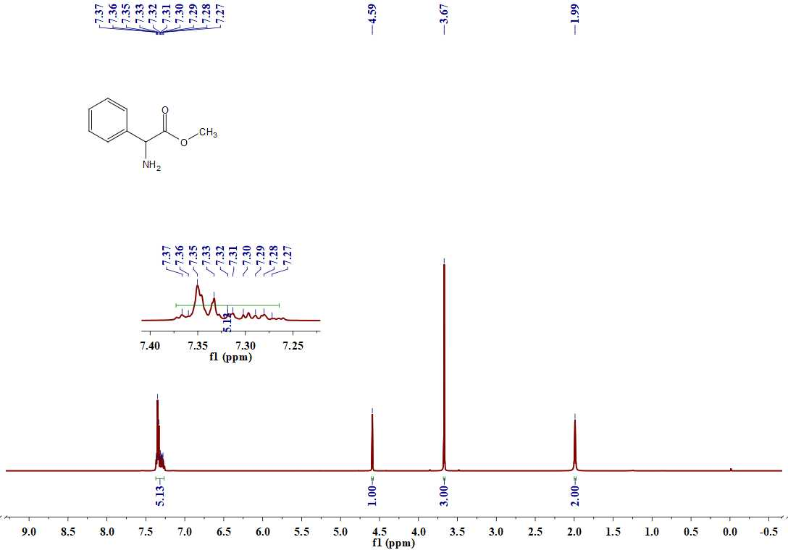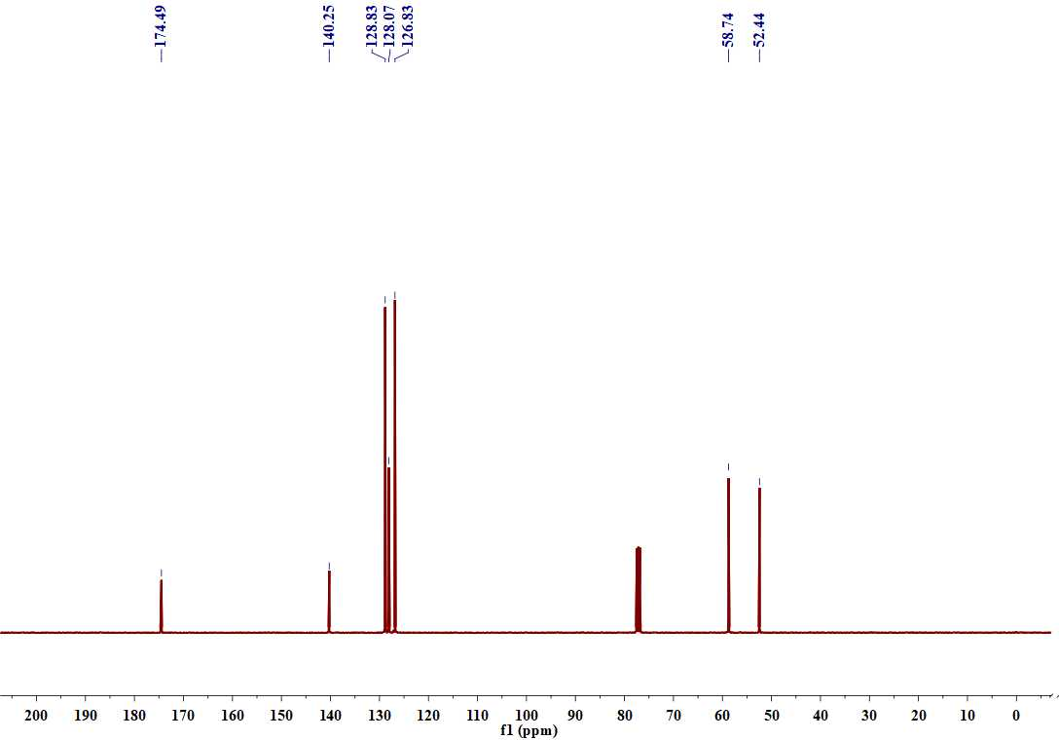
Figure S1. ¹H NMR and ¹³C NMR for A
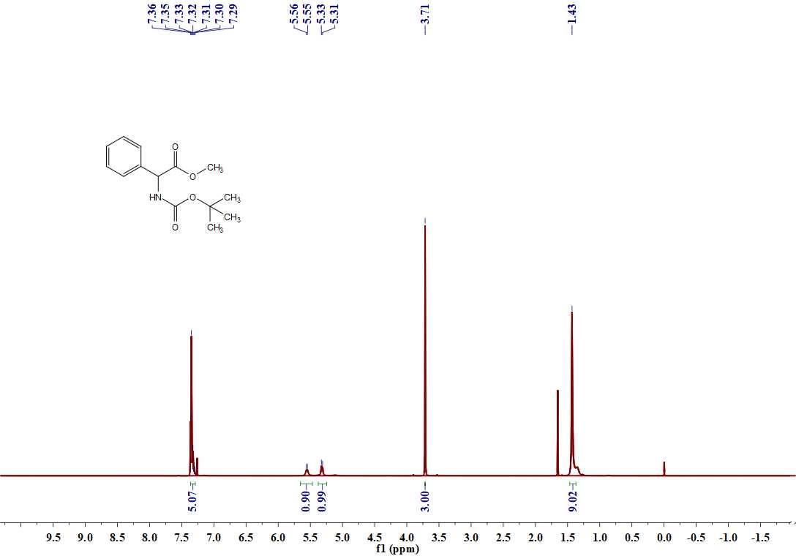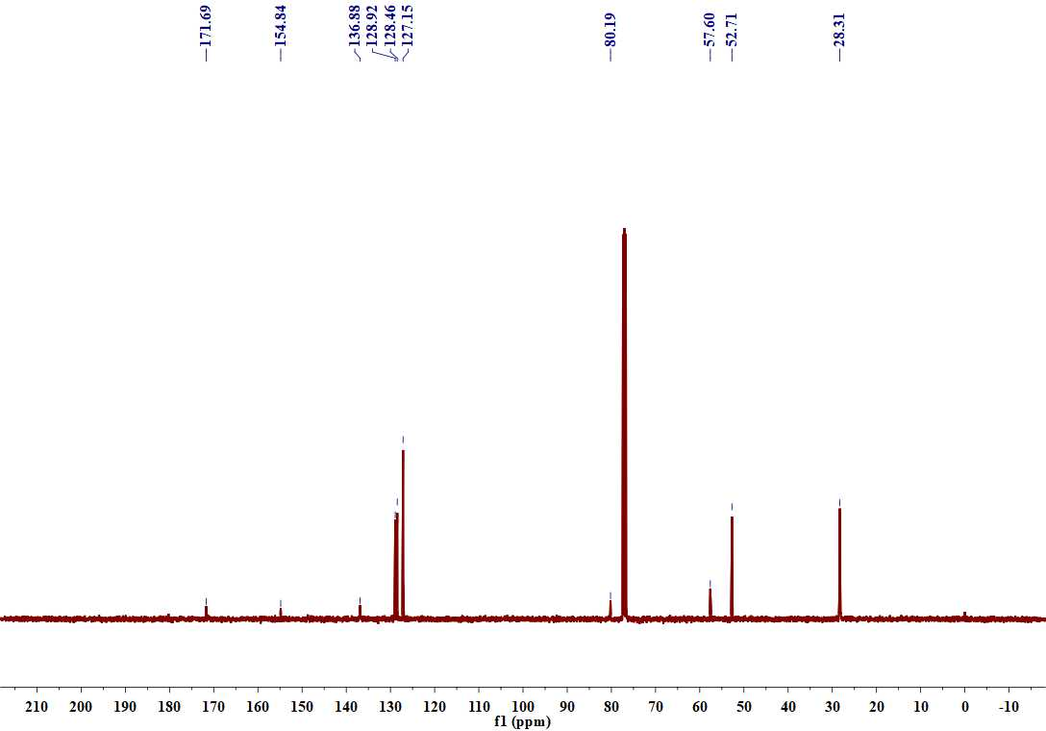
Figure S2. ¹H NMR and ¹³C NMR for B
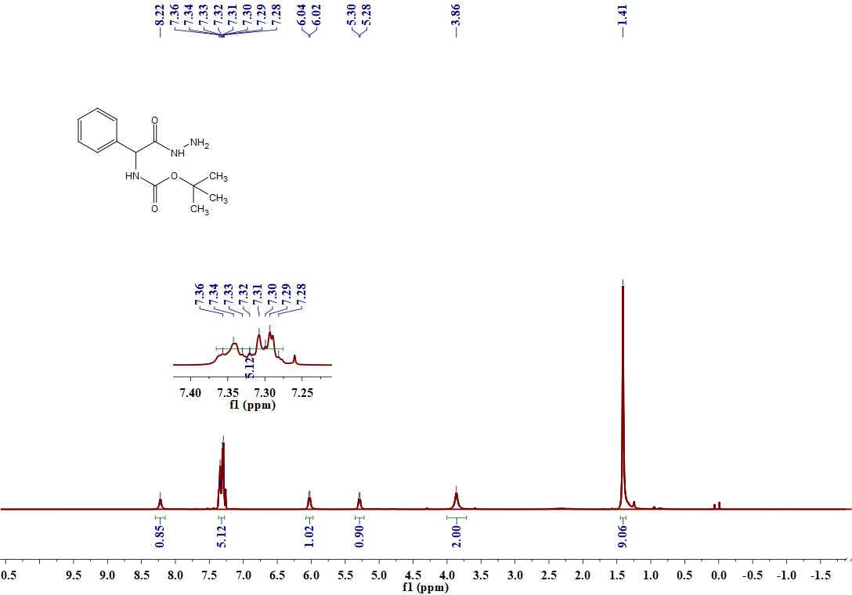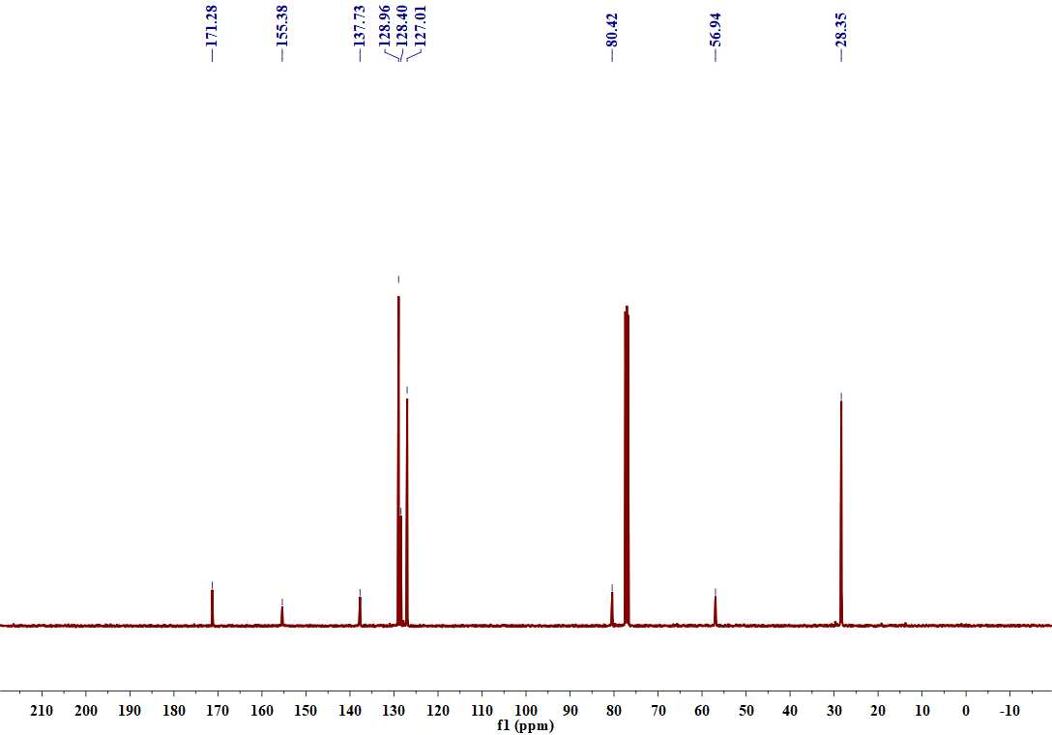
Figure S3. ¹H NMR and ¹³C NMR for C
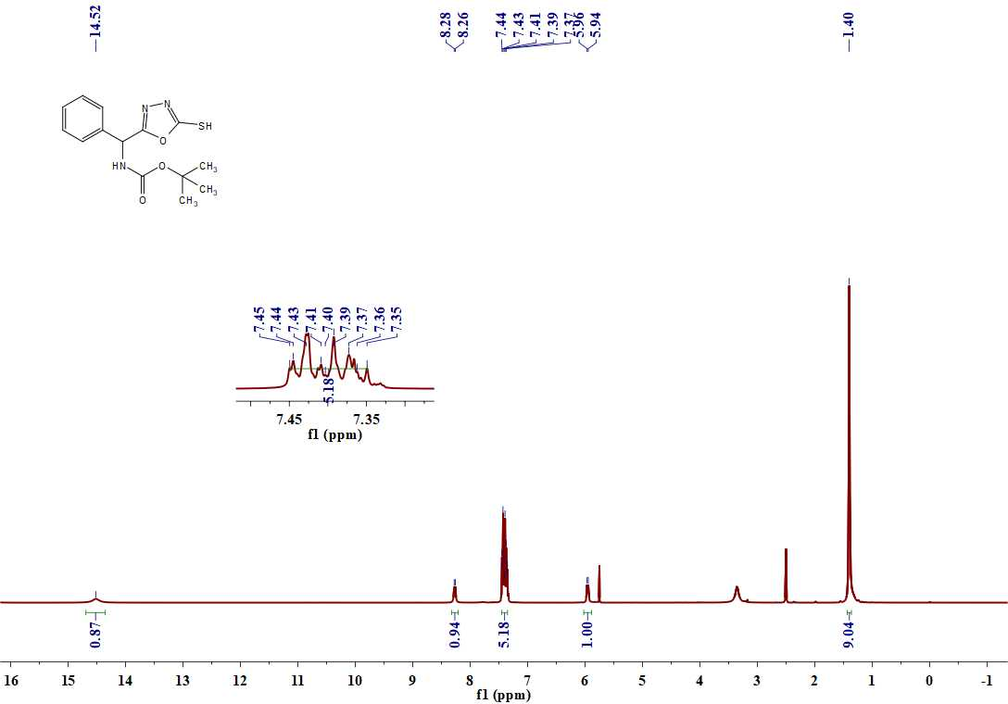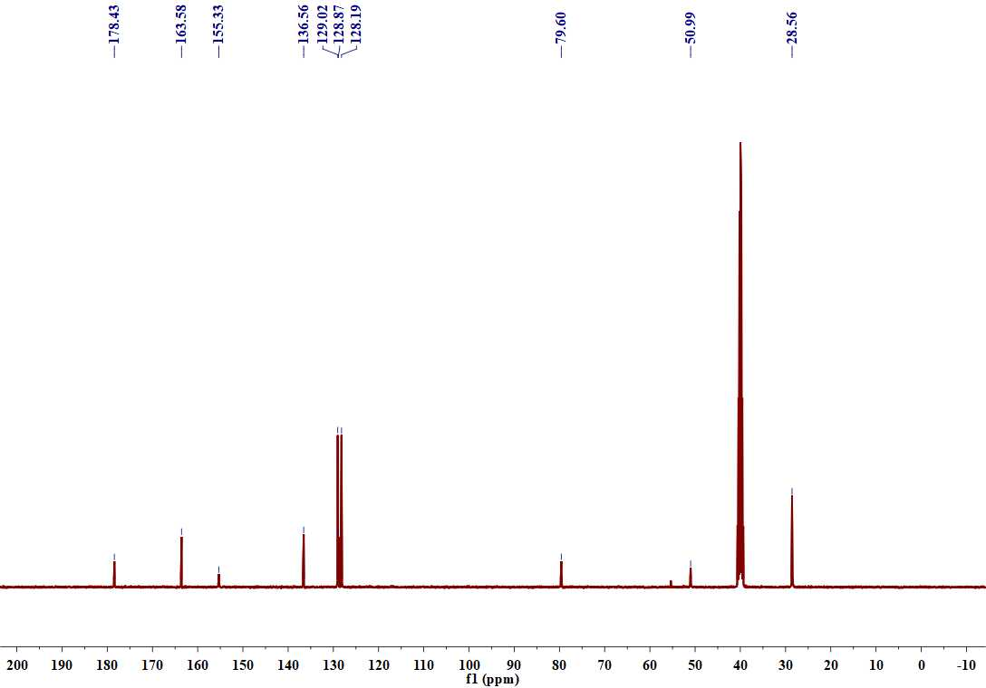
Figure S4. ¹H NMR and ¹³C NMR for D
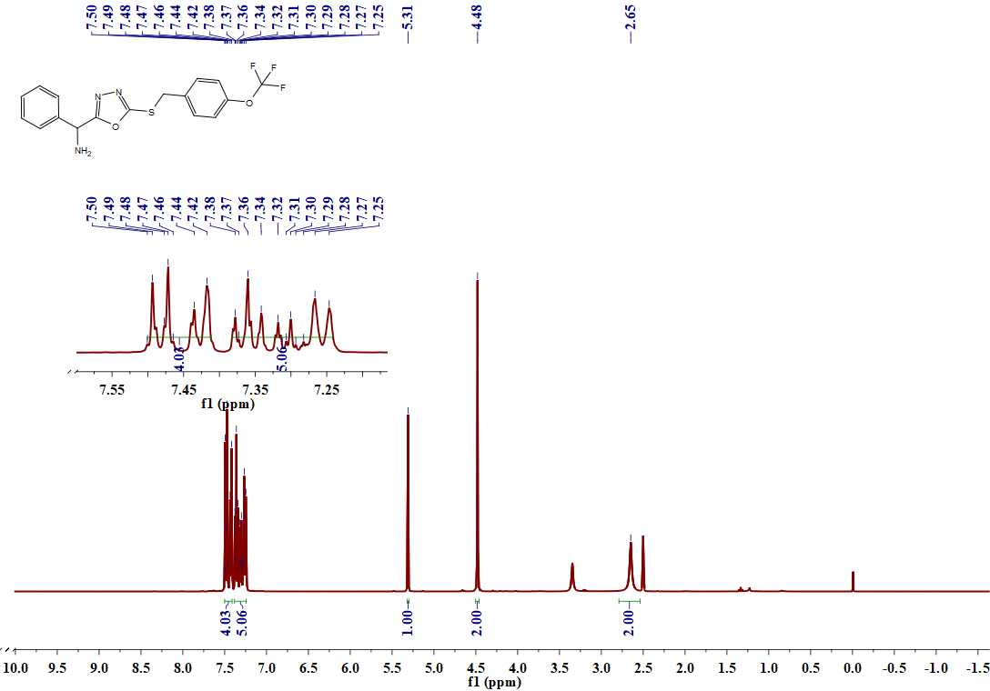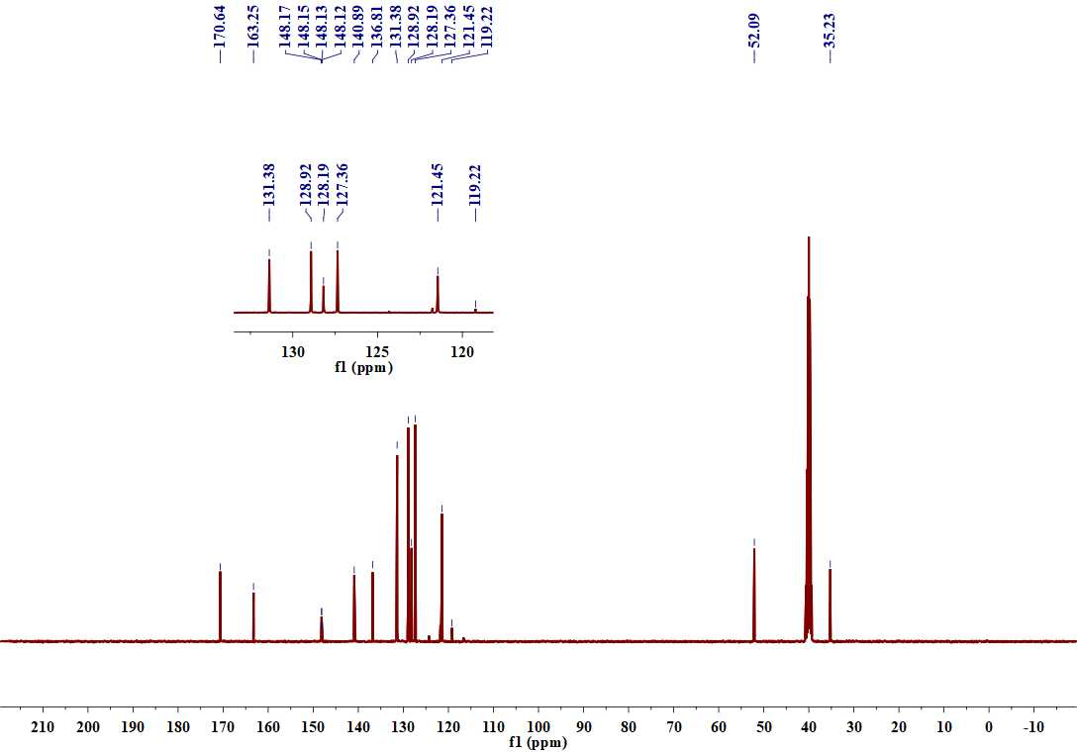
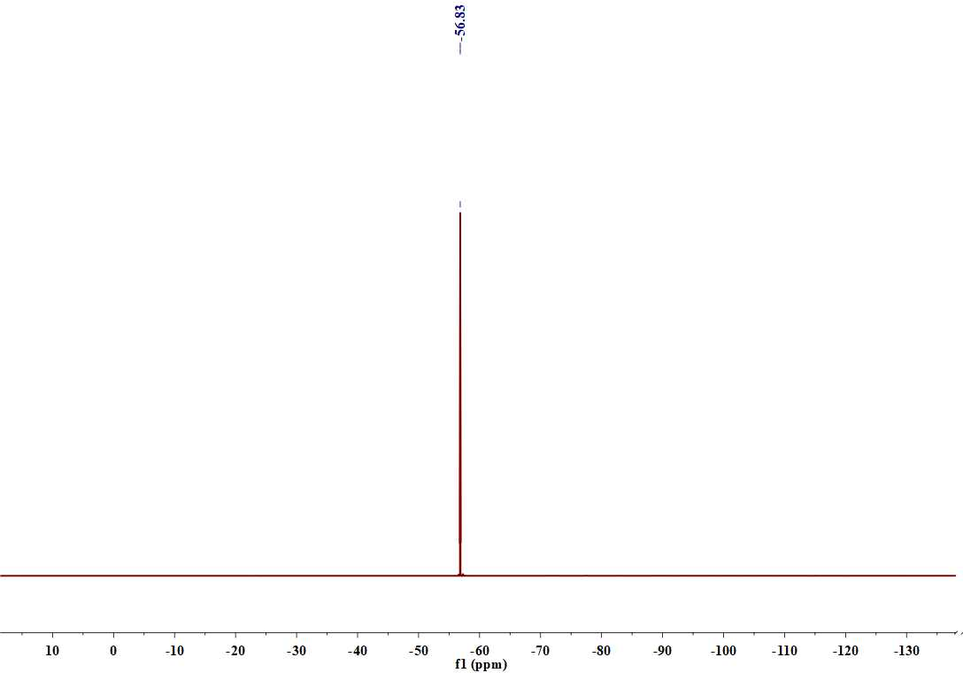
Figure S5. ¹H NMR, ¹³C NMR and ¹⁹F NMR for E₁
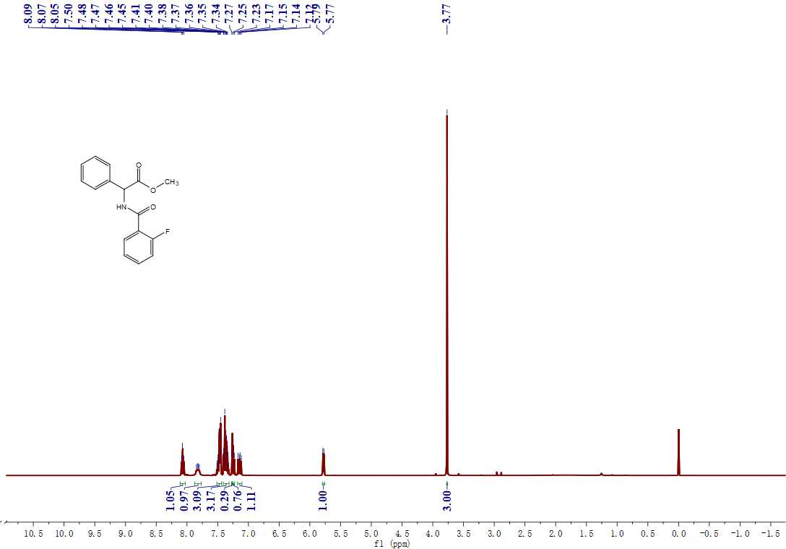
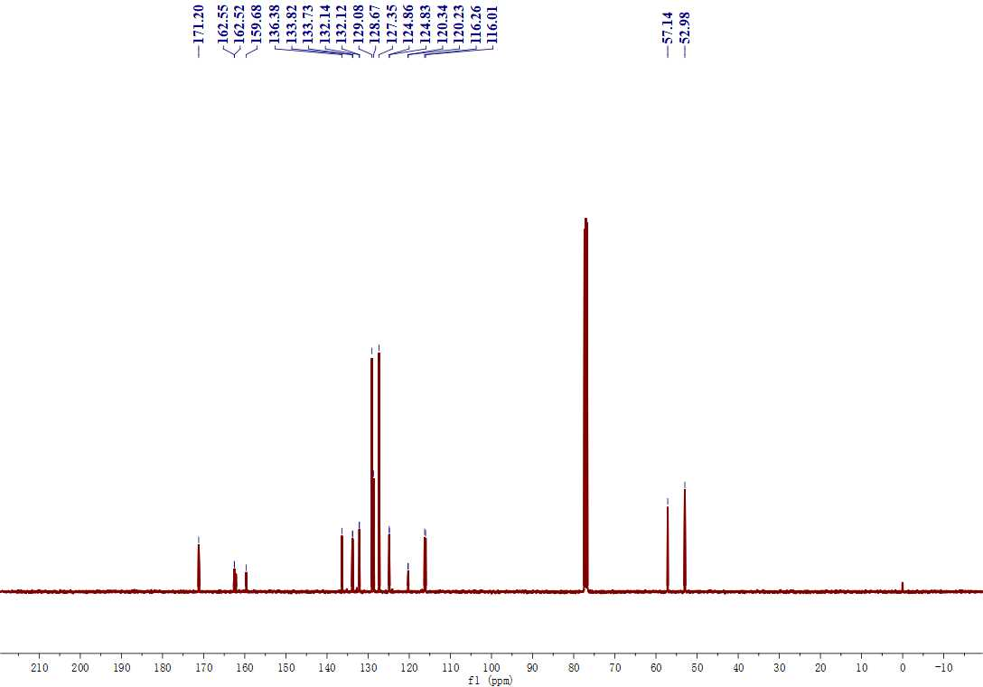
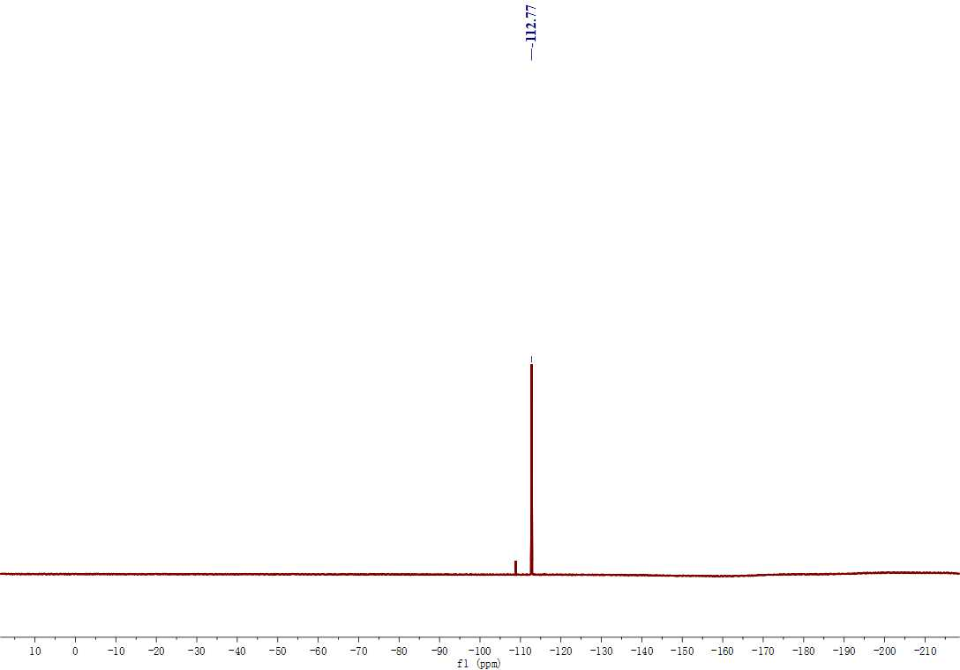
Figure S6. ¹H NMR, ¹³C NMR and ¹⁹F NMR for F₃

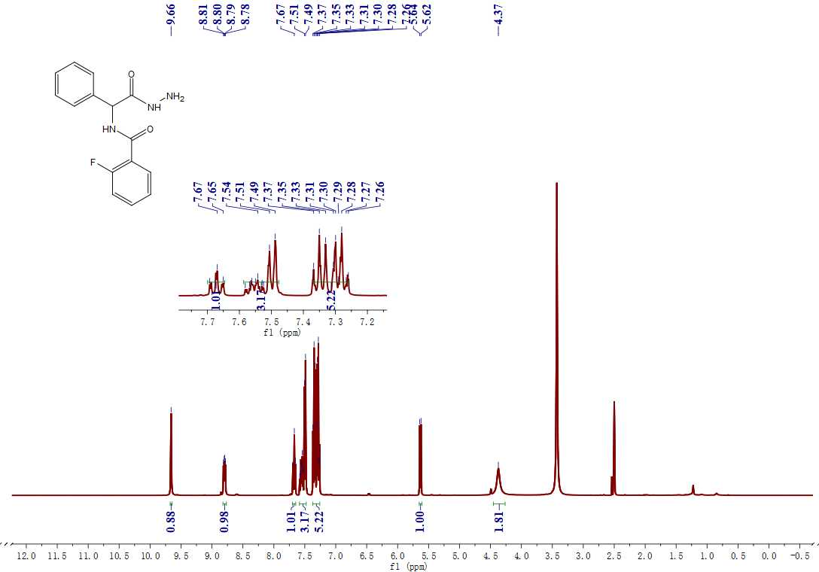
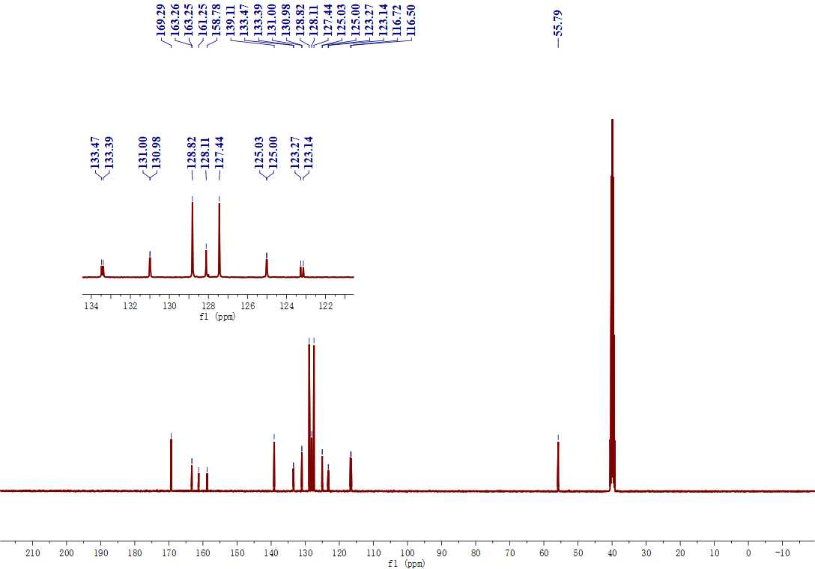
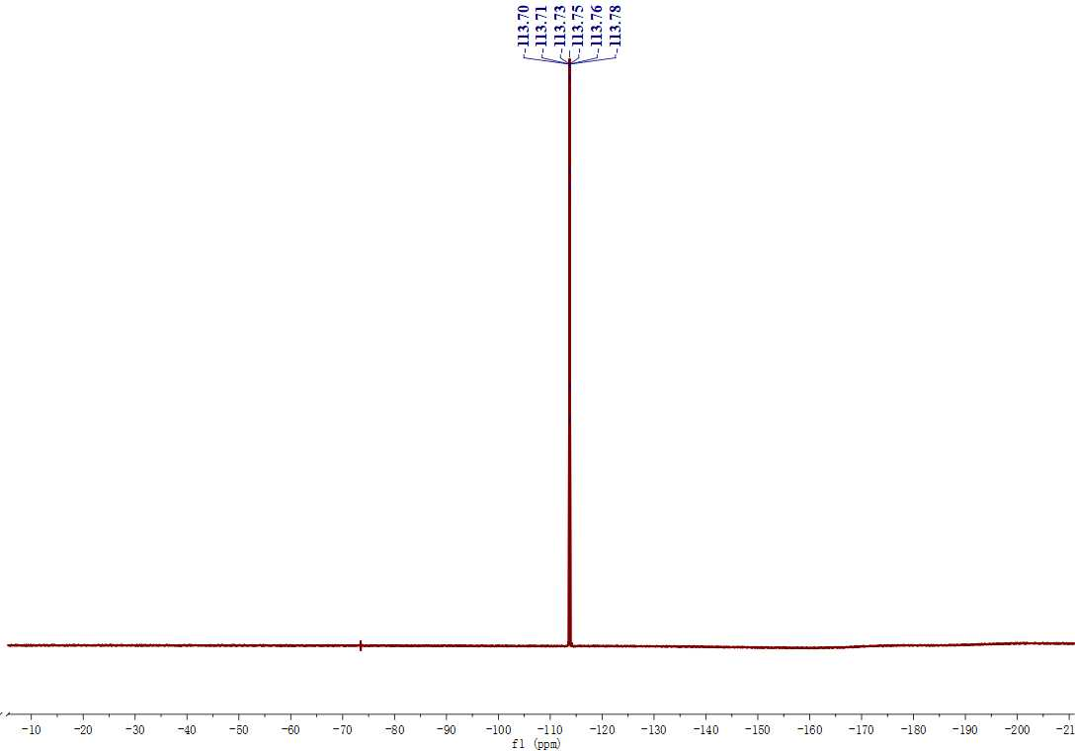
Figure S7. ¹H NMR, ¹³C NMR and ¹⁹F NMR for G₃

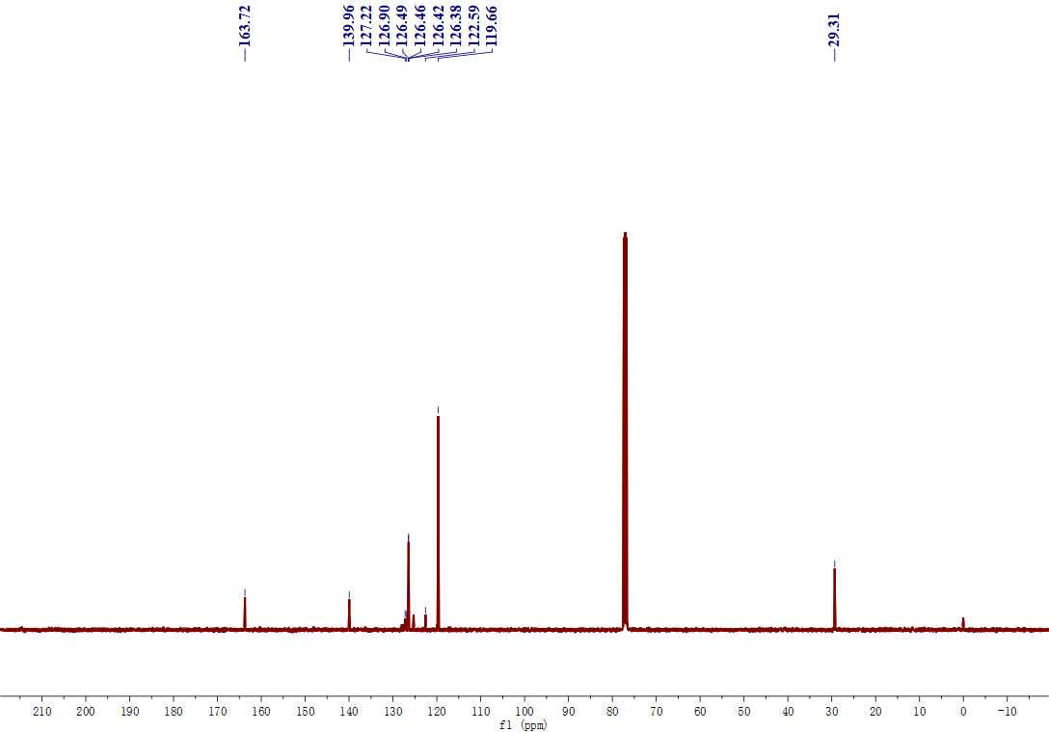Figure S8. ¹H NMR, ¹³C NMR and ¹⁹F NMR for H₁₁

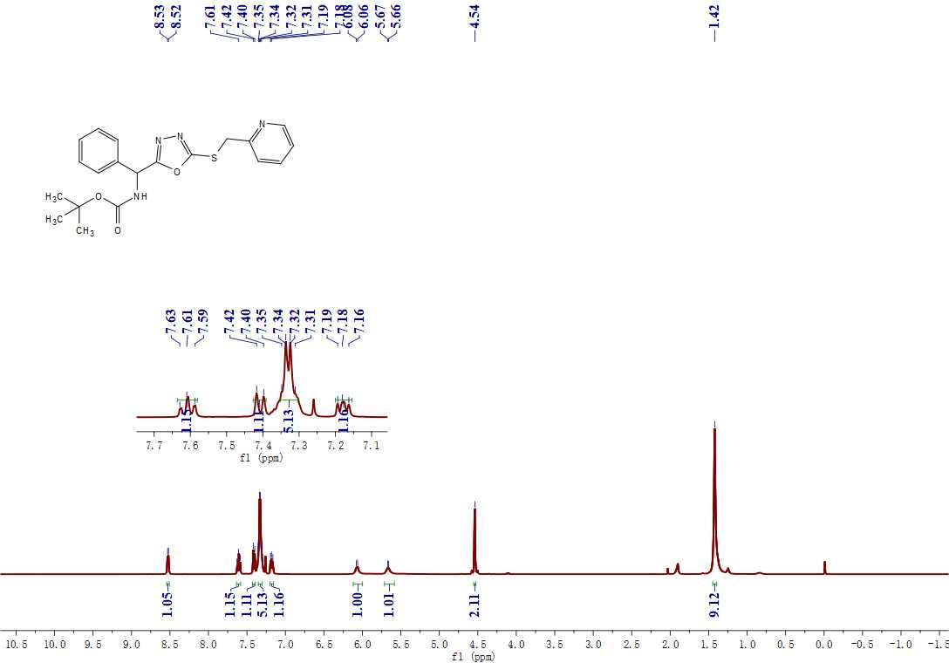
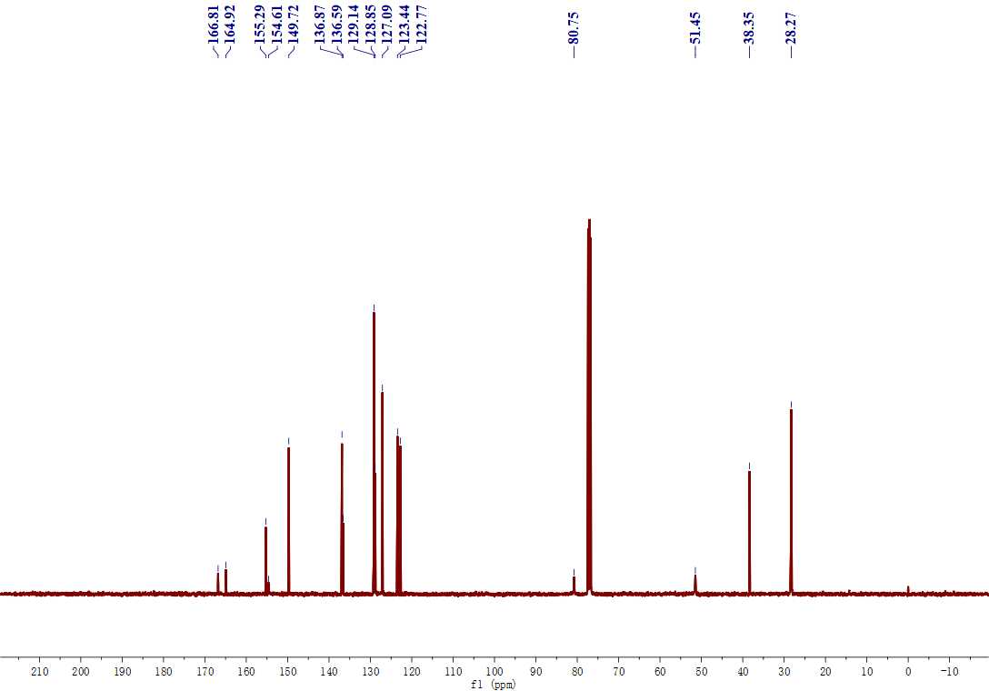
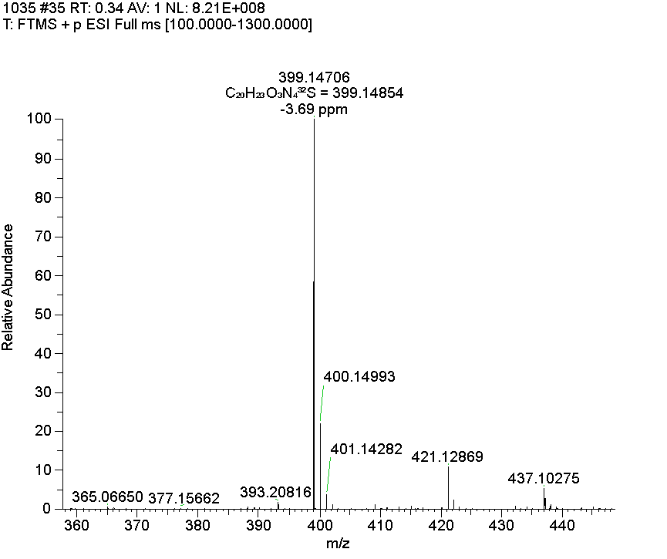
Figure S9. ¹H NMR, ¹³C NMR and HRMS for І₁
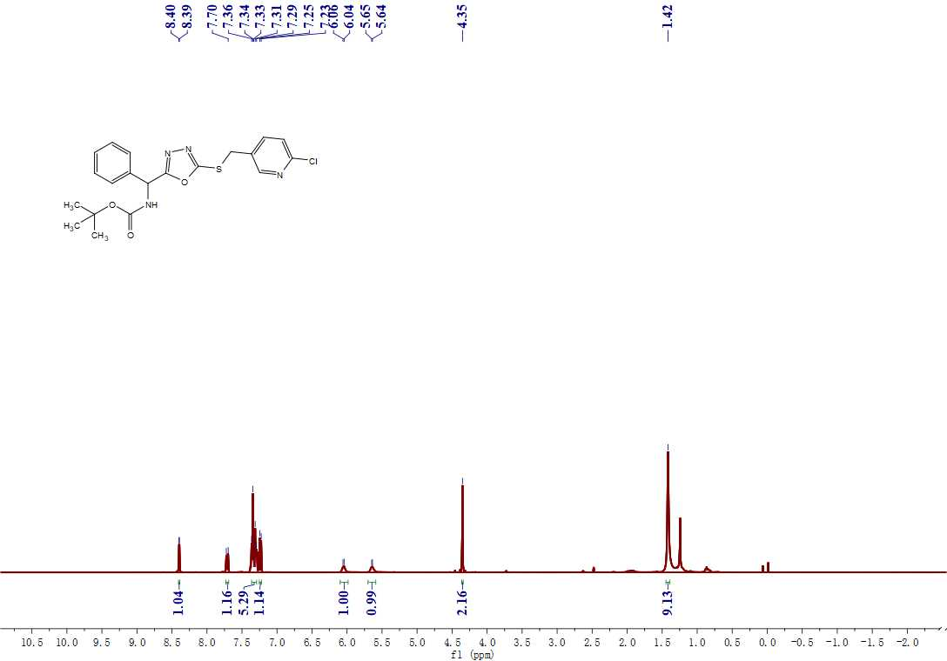
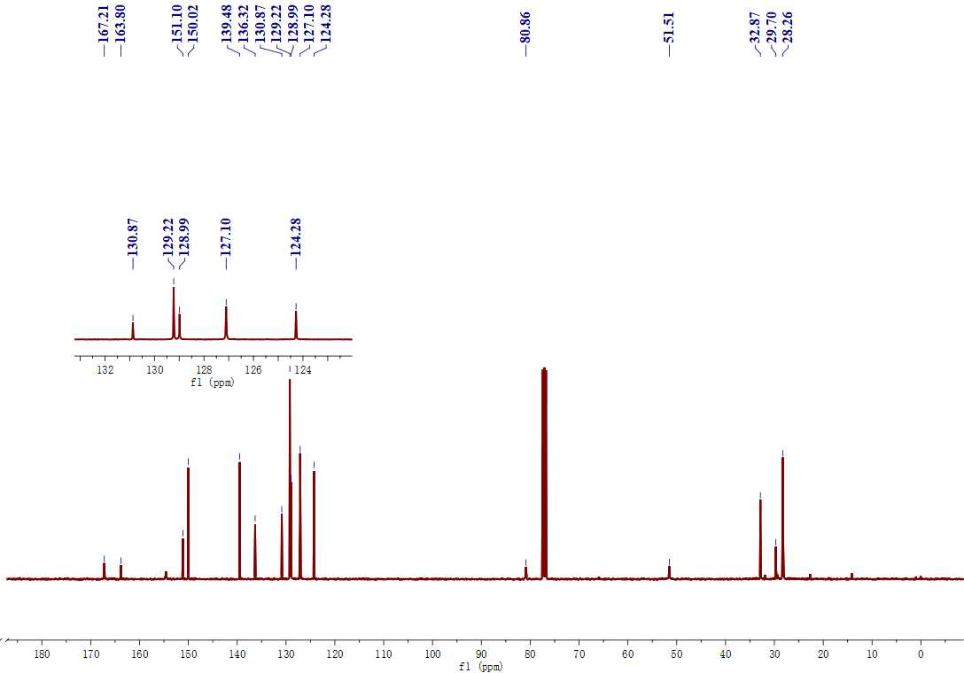
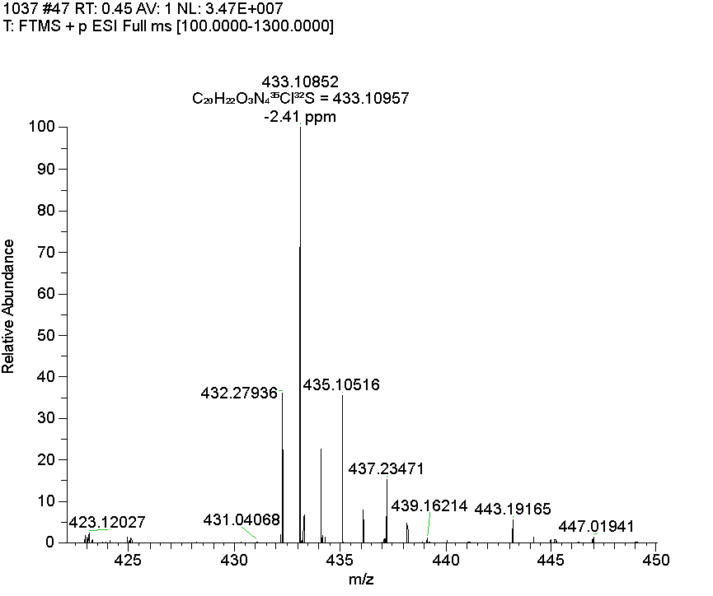
Figure S10. ¹H NMR, ¹³C NMR and HRMS for І₂

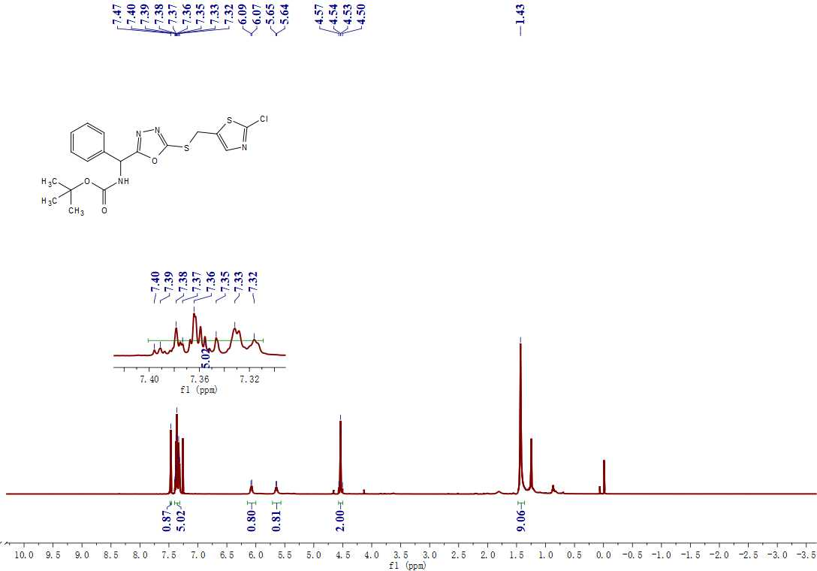
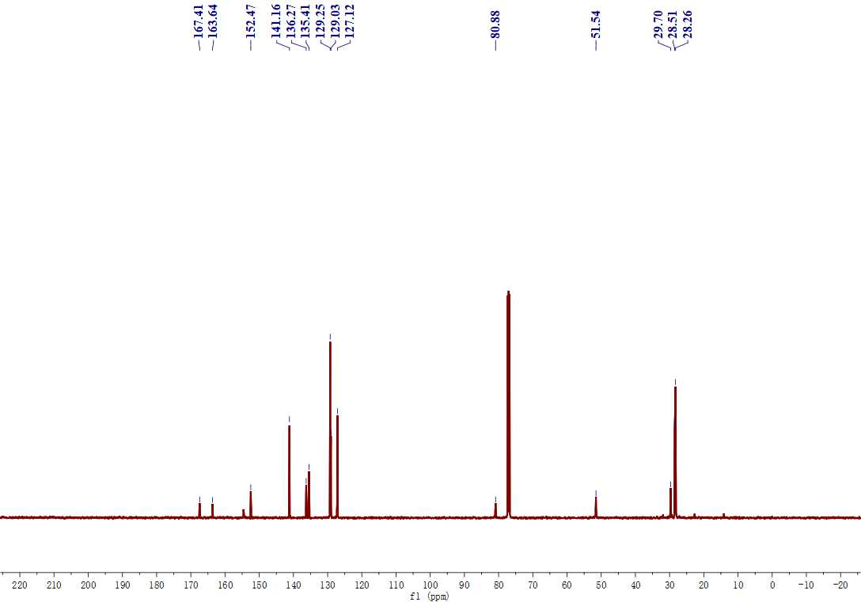
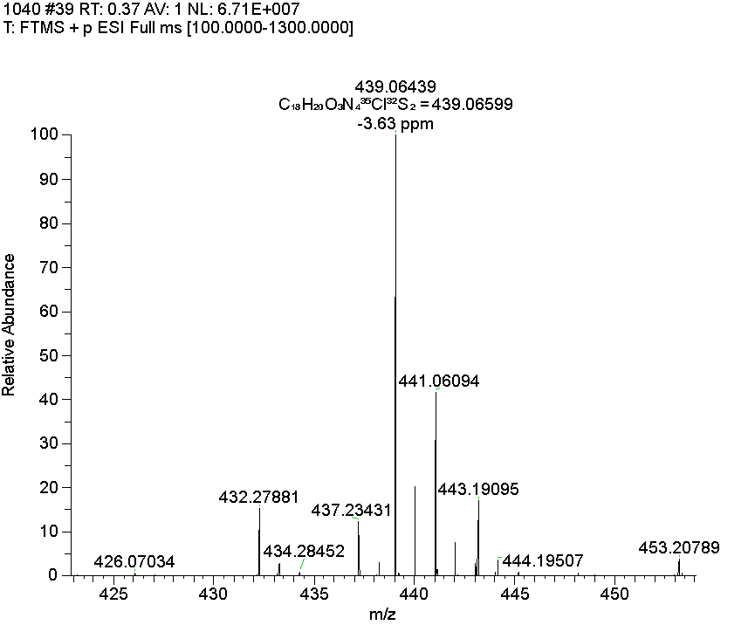
Figure S11. ¹H NMR, ¹³C NMR and HRMS for І₃
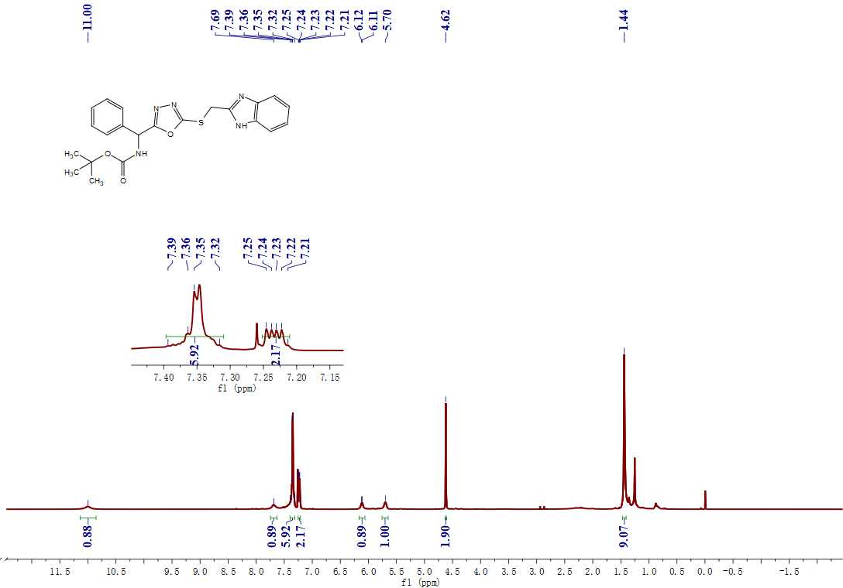
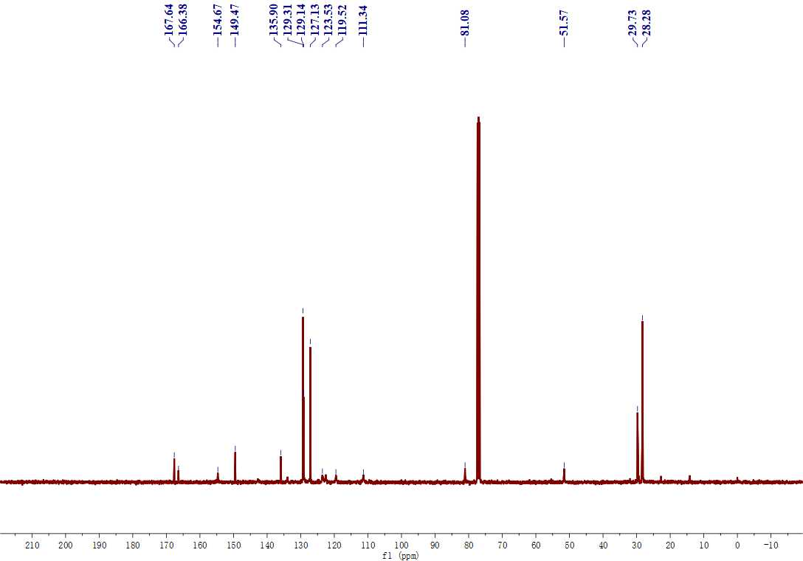
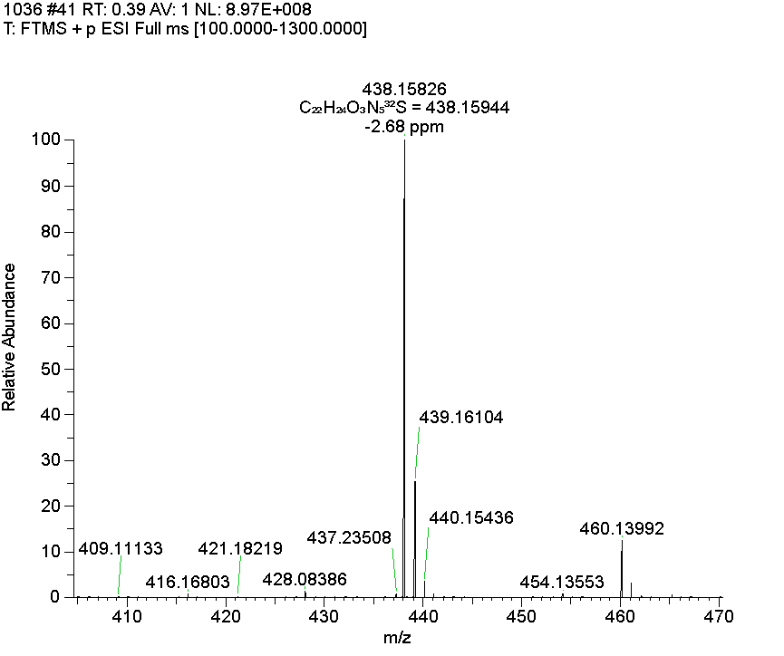
Figure S12. ¹H NMR, ¹³C NMR and HRMS for І₄
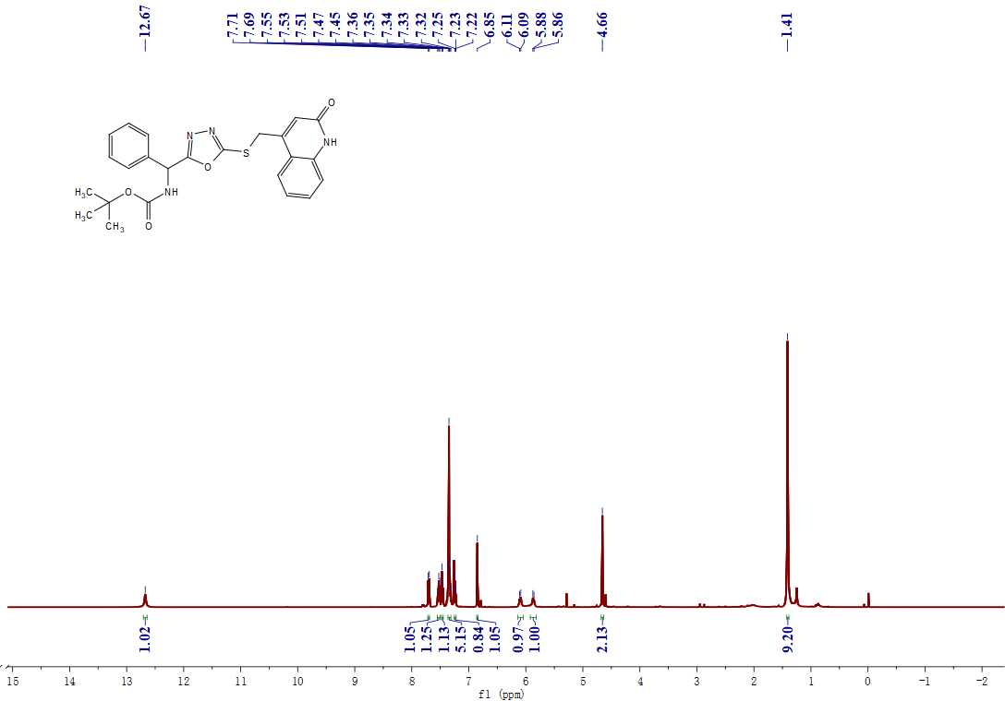
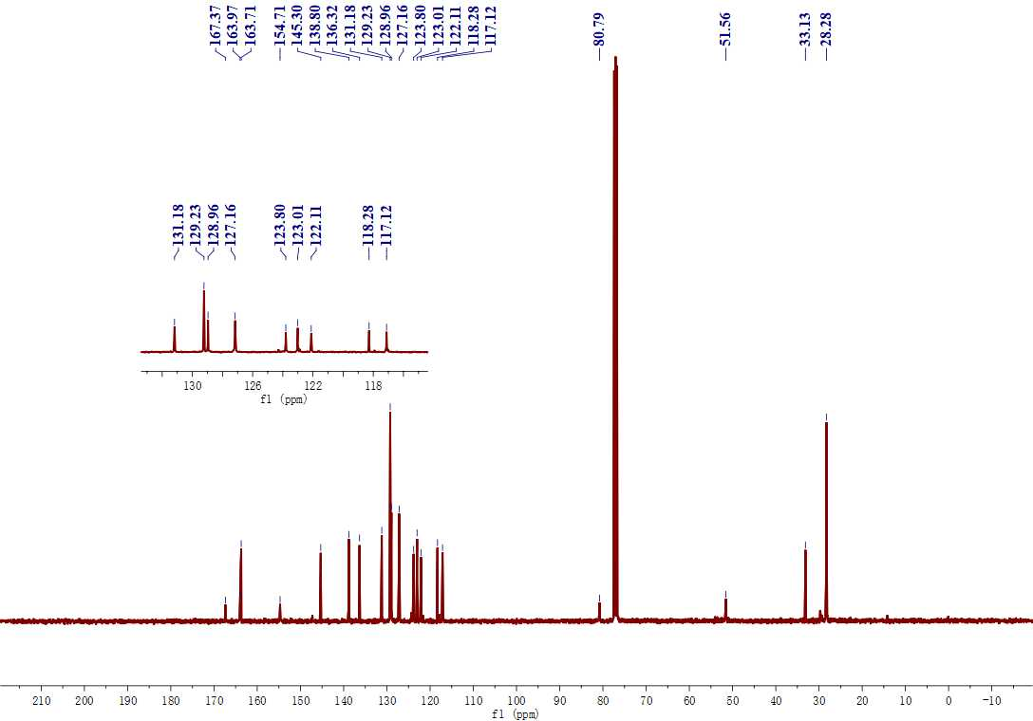
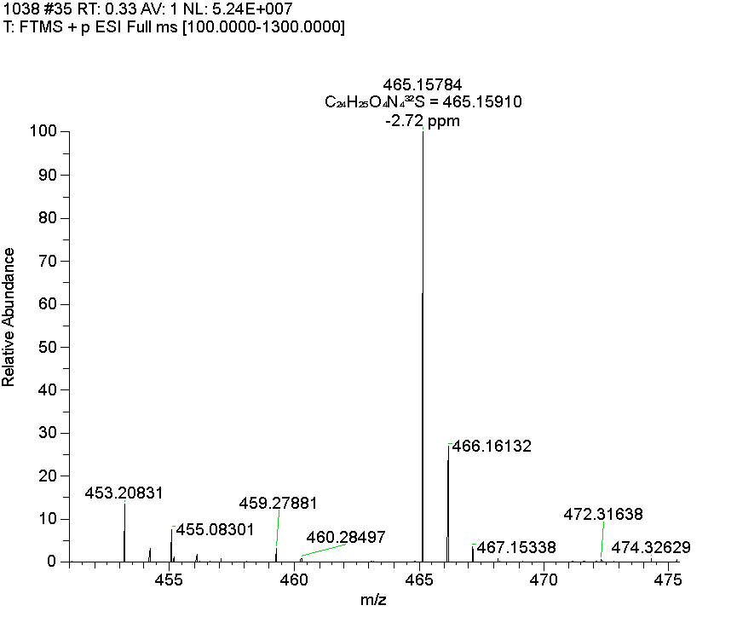
Figure S13. ¹H NMR, ¹³C NMR and HRMS for І₅
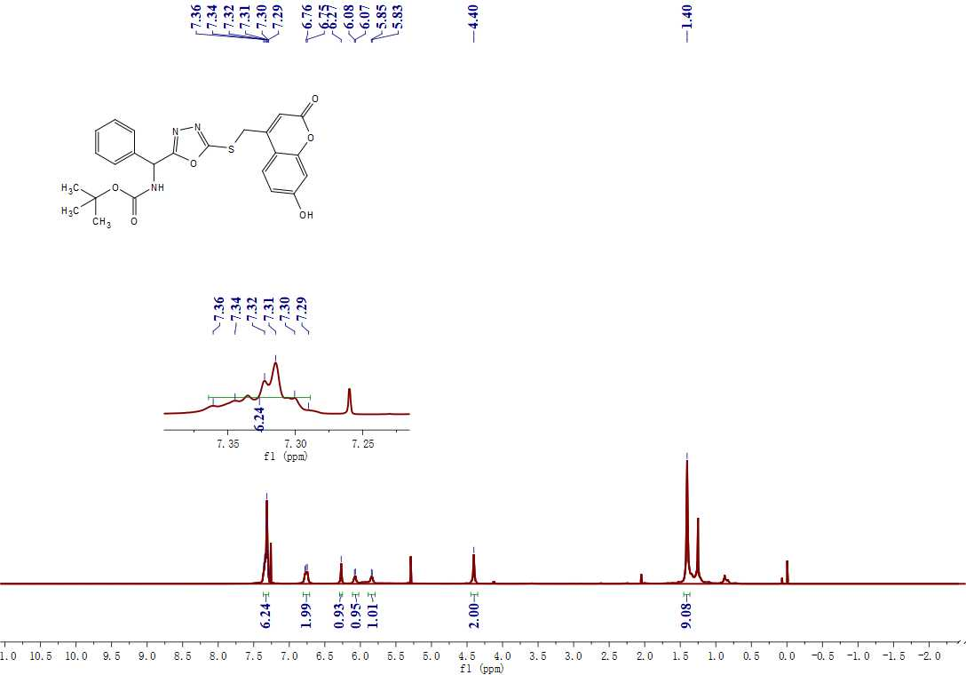
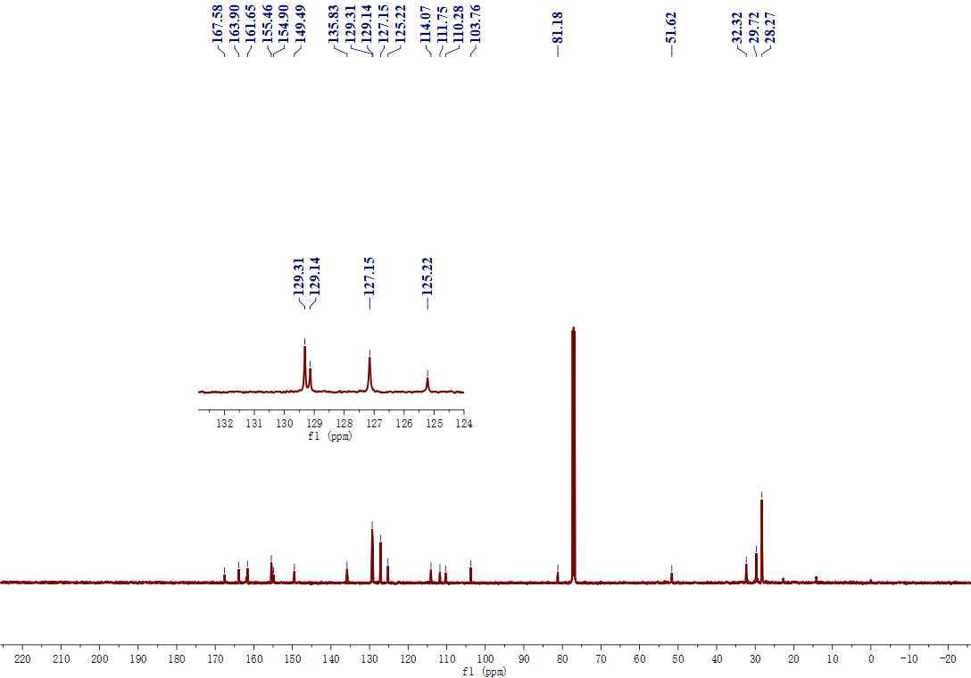
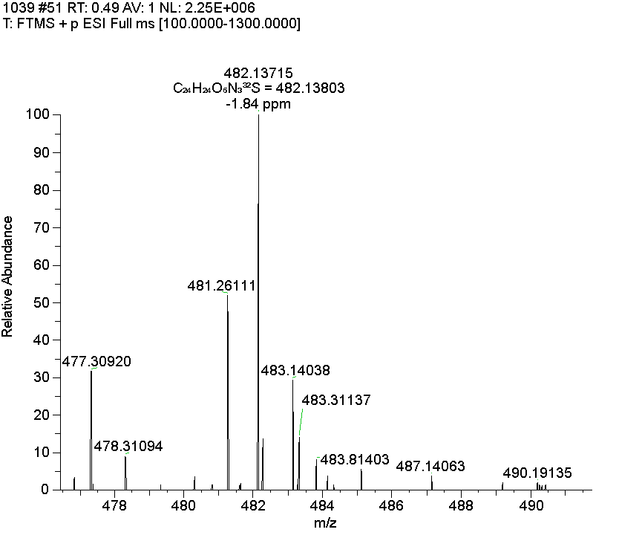
Figure S14. ¹H NMR, ¹³C NMR and HRMS for І₆
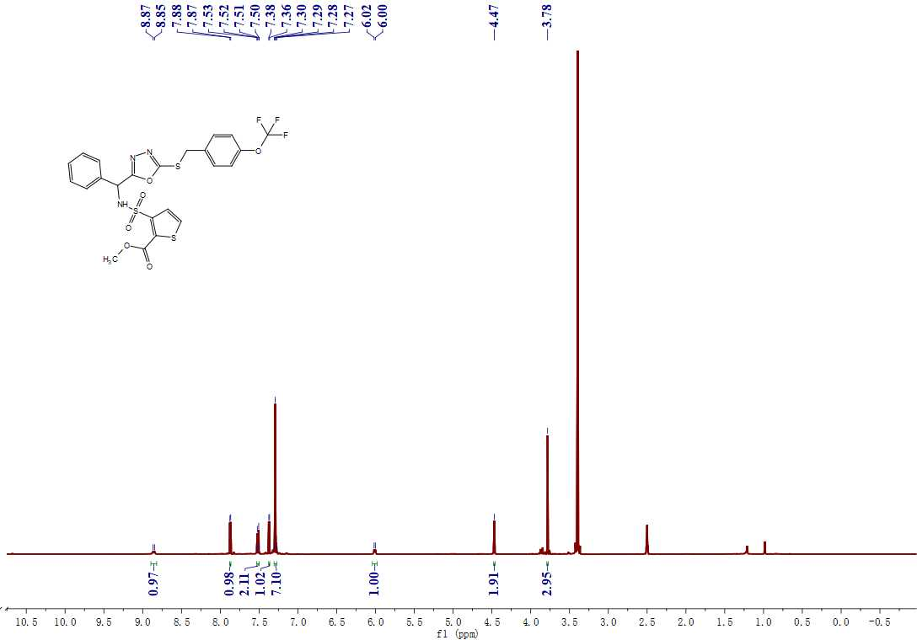
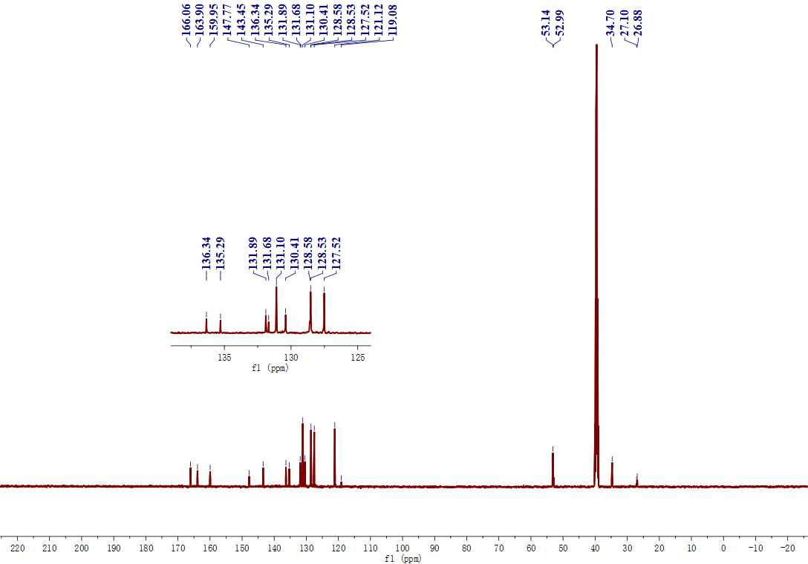
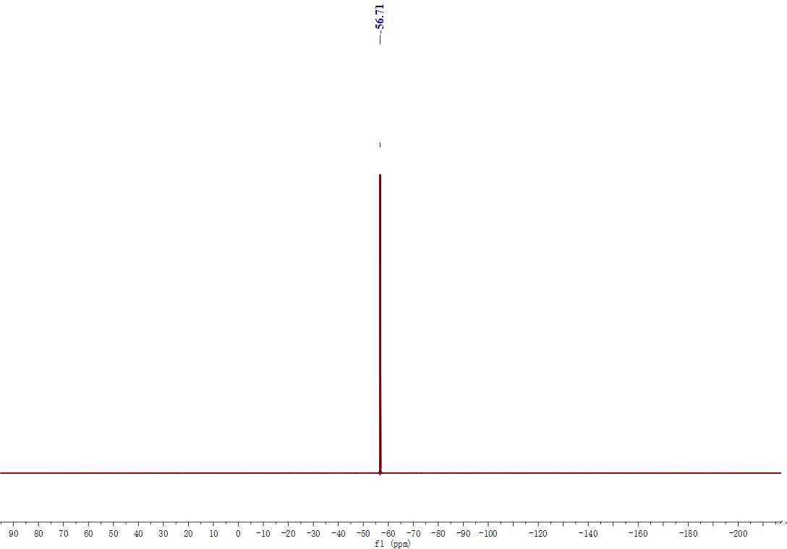
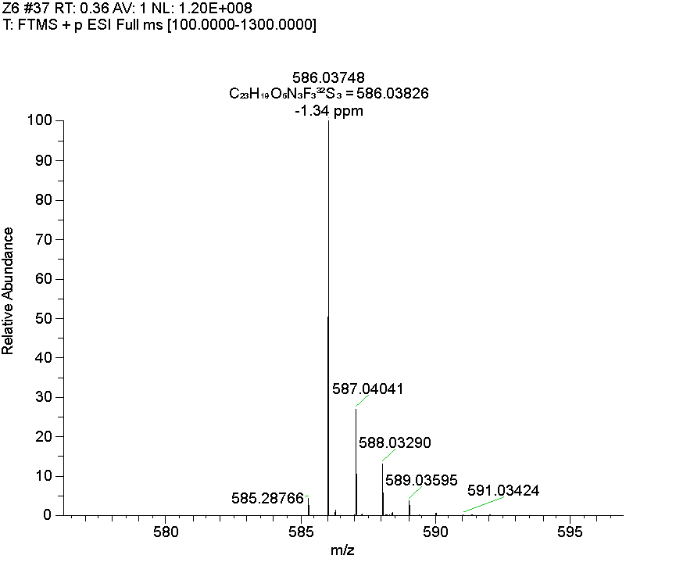
Figure S15. ¹H NMR, ¹³C NMR, ¹⁹F NMR and HRMS for І₇
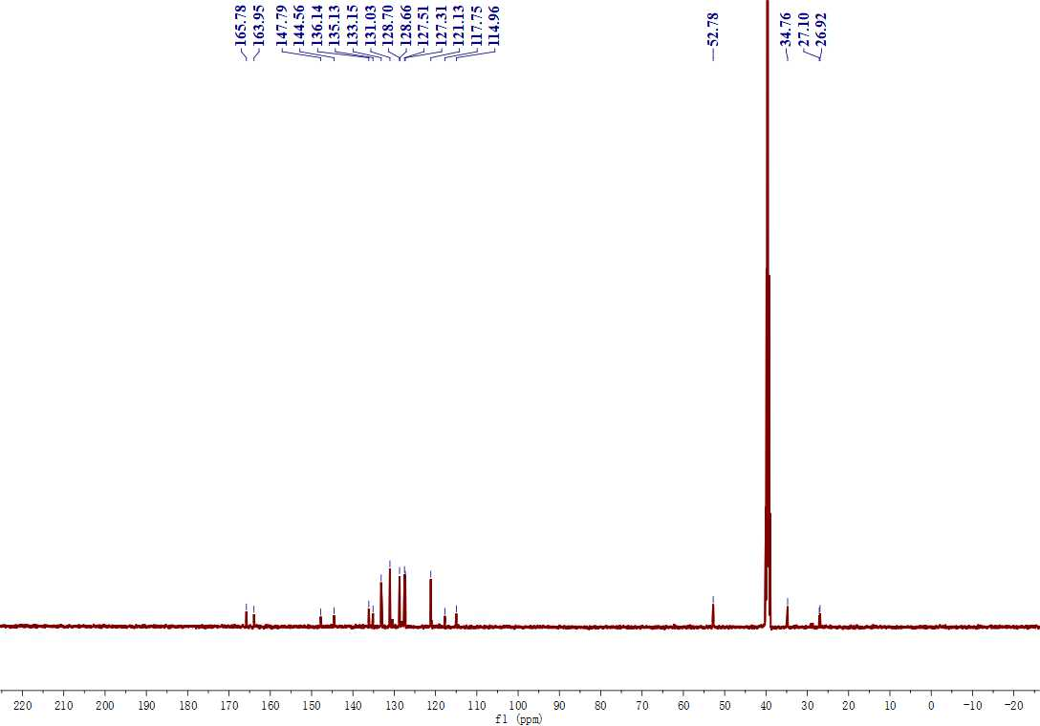
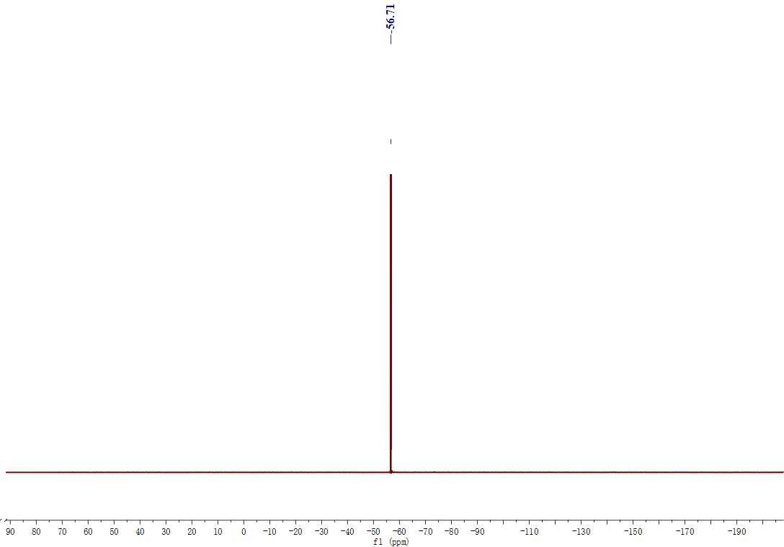
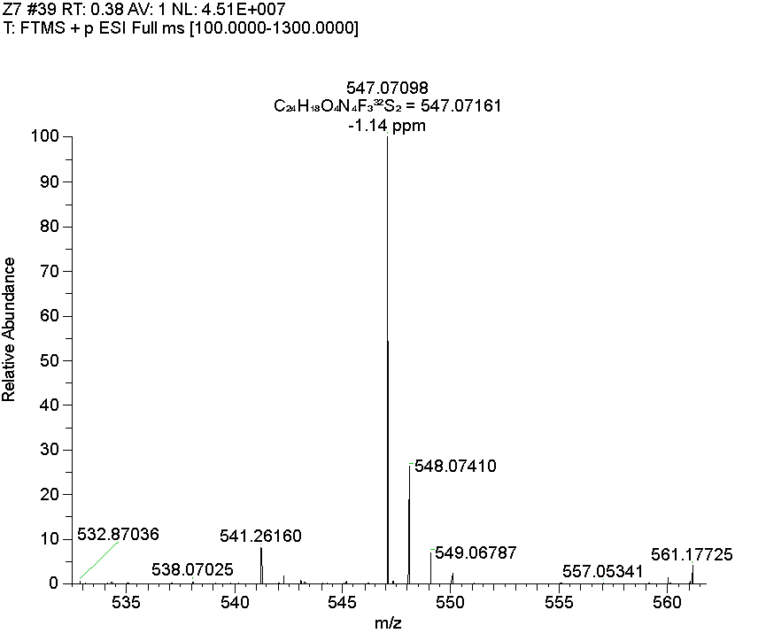
Figure S16. ¹H NMR, ¹³C NMR, ¹⁹F NMR and HRMS for І₈
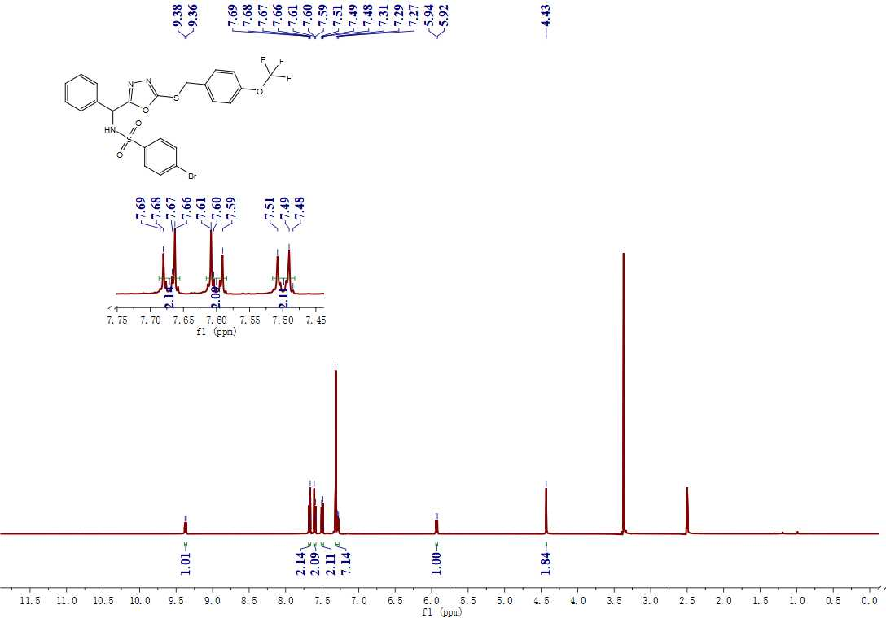
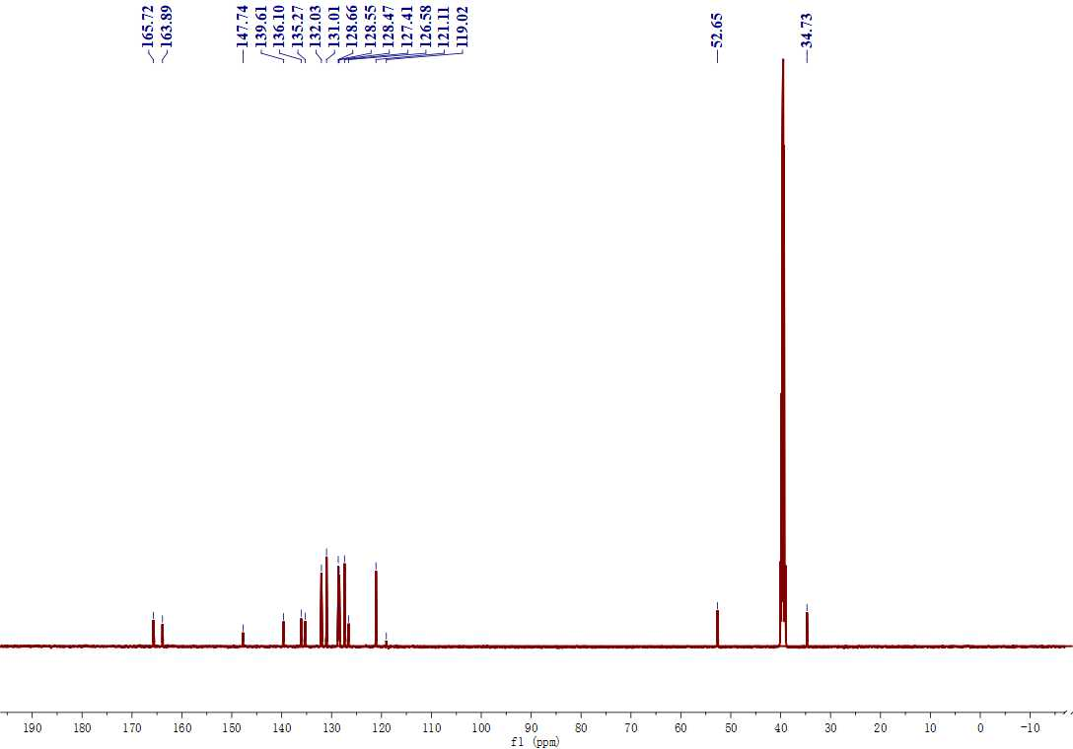
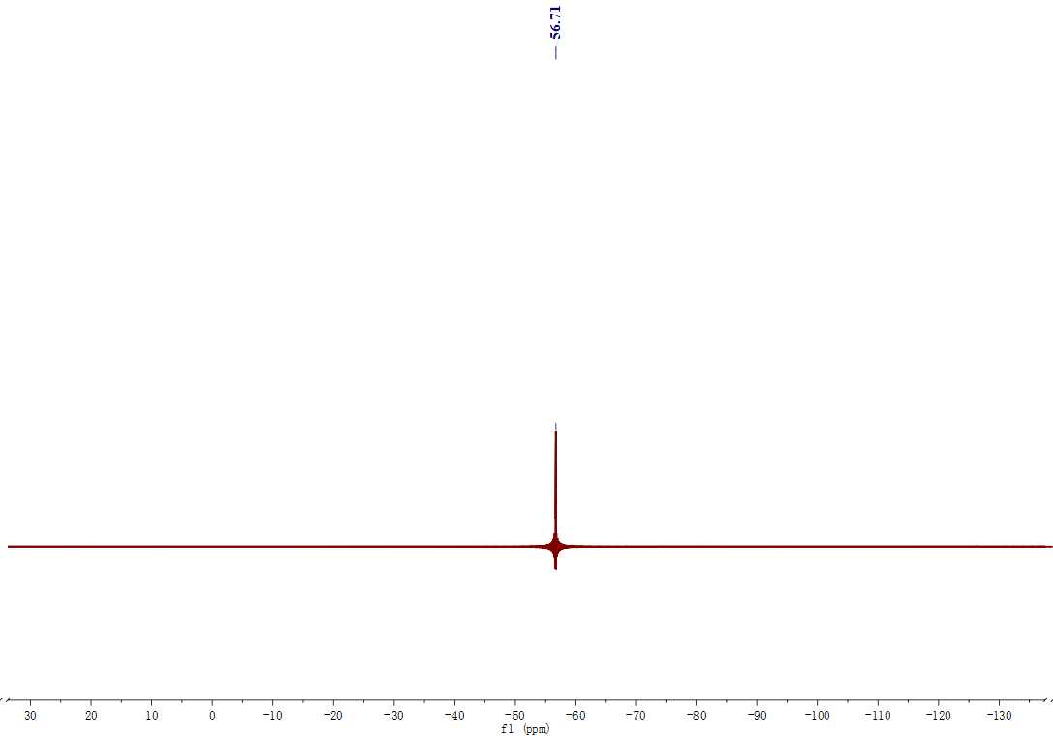
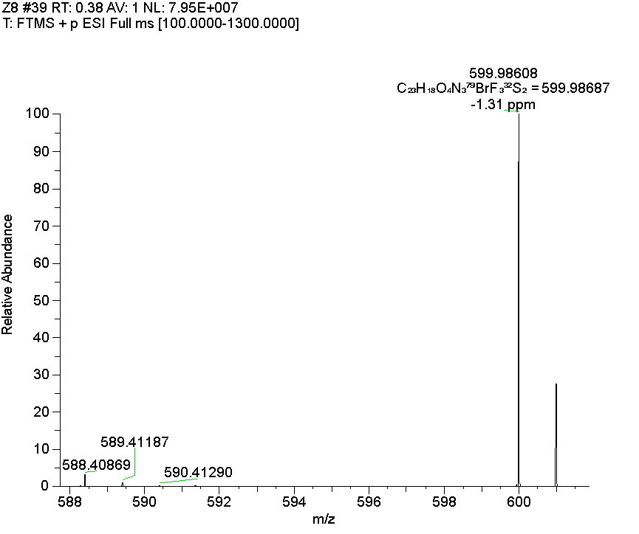
Figure S17. ¹H NMR, ¹³C NMR, ¹⁹F NMR and HRMS for І₉
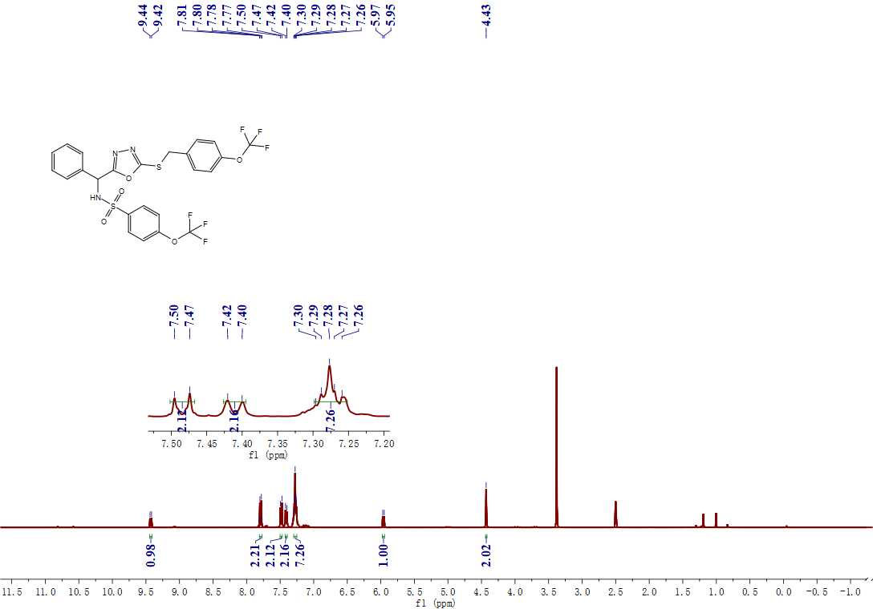
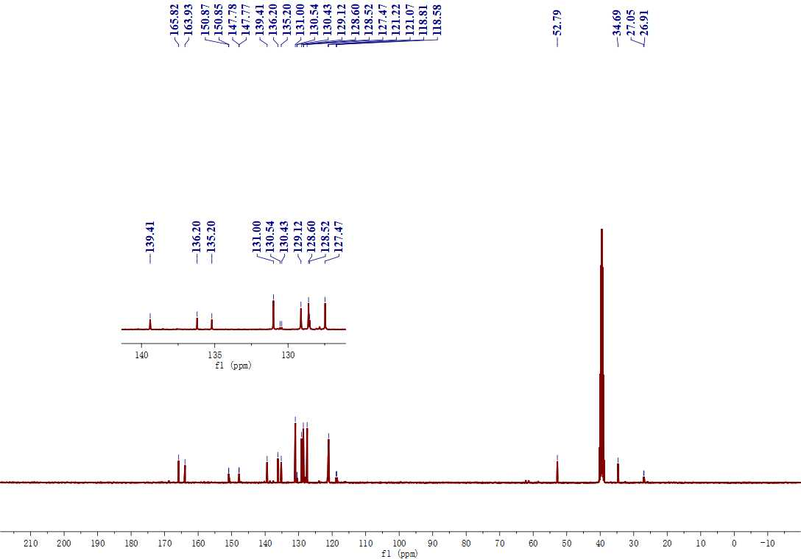
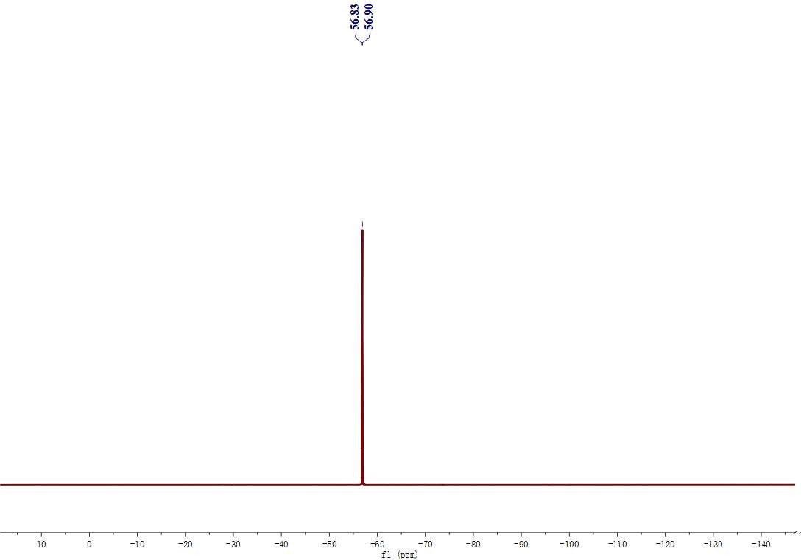
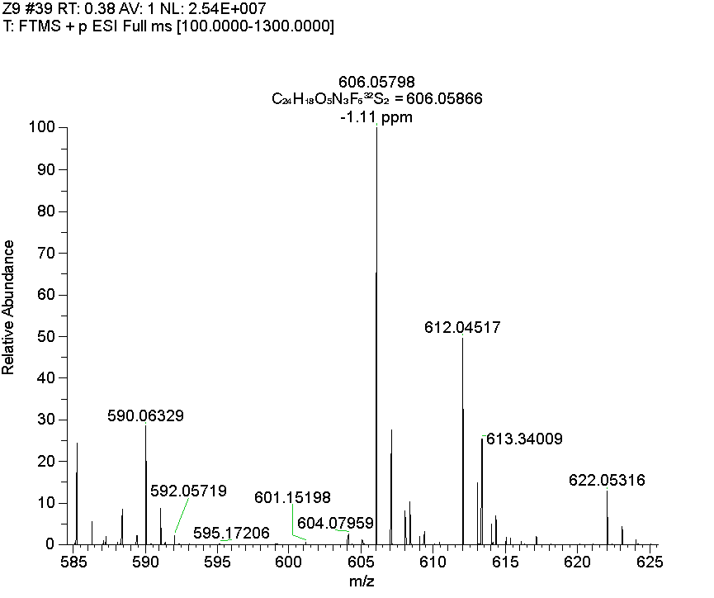
Figure S18. ¹H NMR, ¹³C NMR, ¹⁹F NMR and HRMS for І₁₀
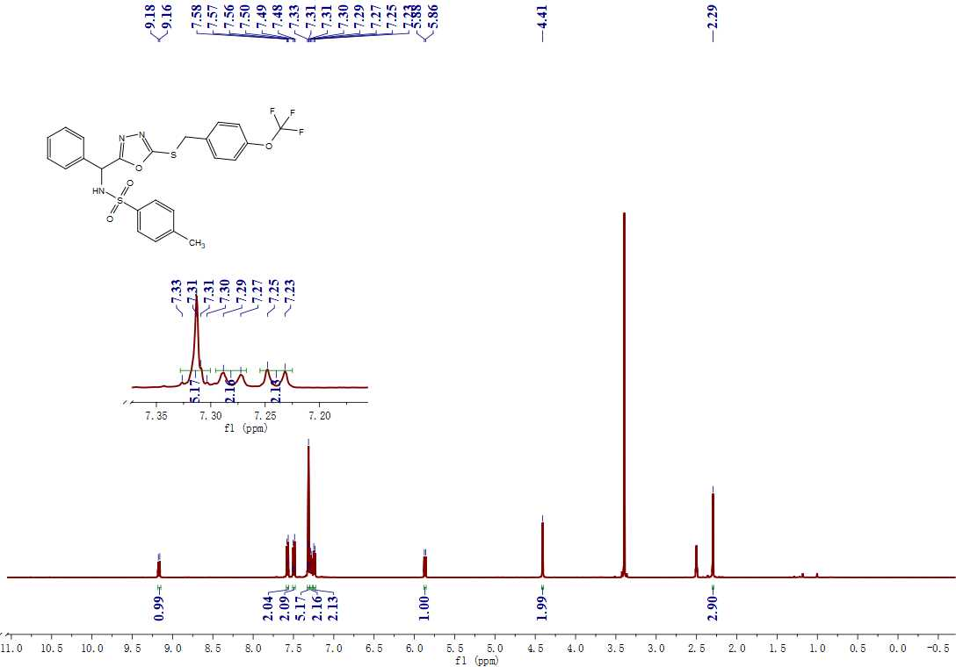
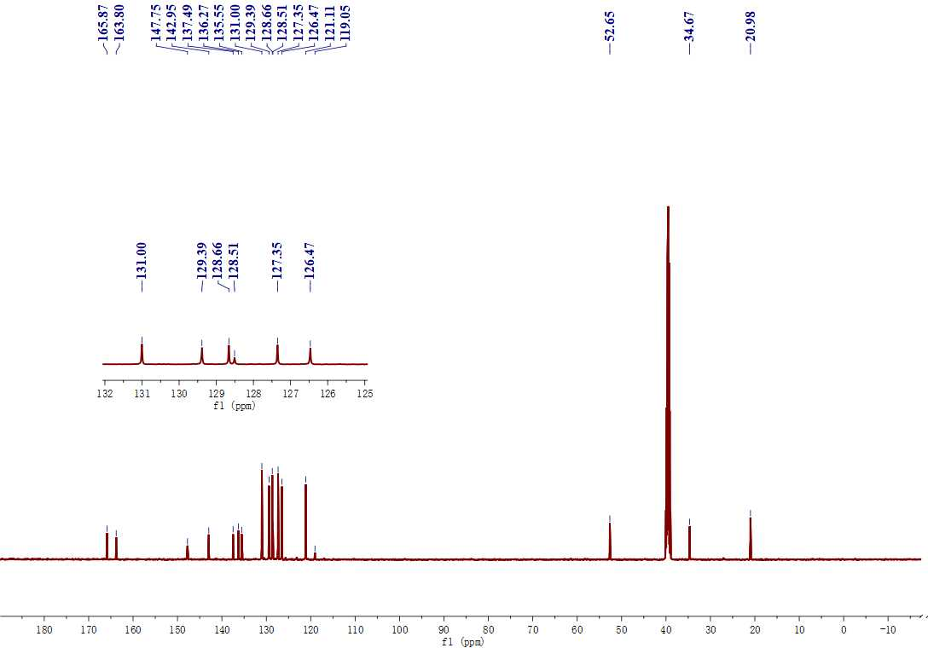
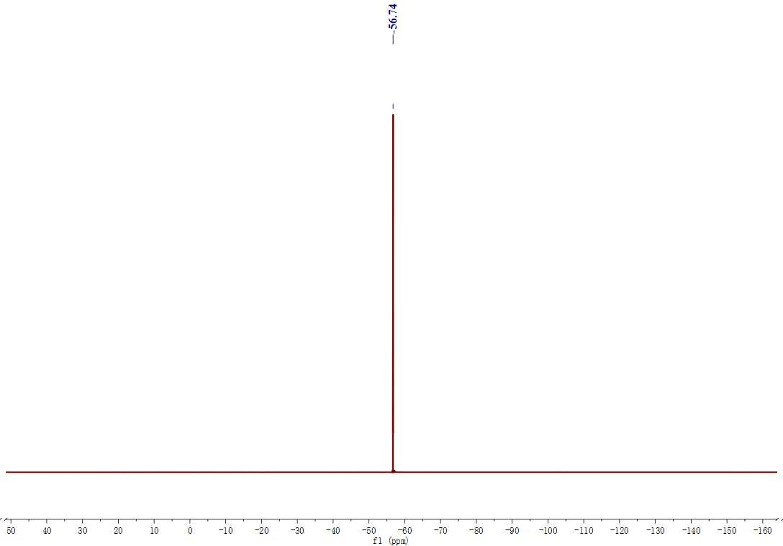
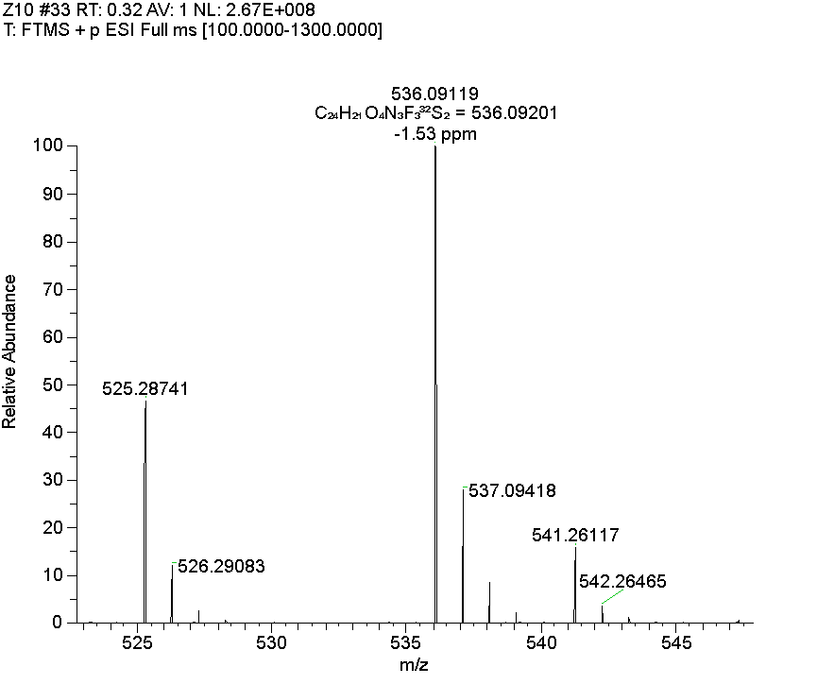
Figure S19. ¹H NMR, ¹³C NMR, ¹⁹F NMR and HRMS for І₁₁
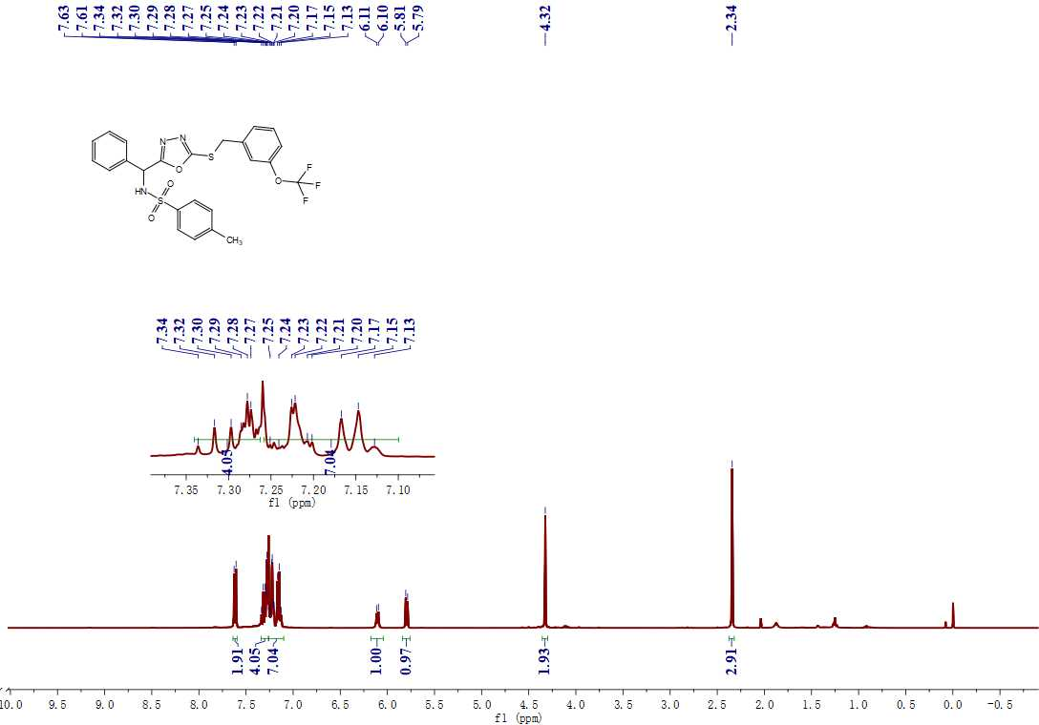
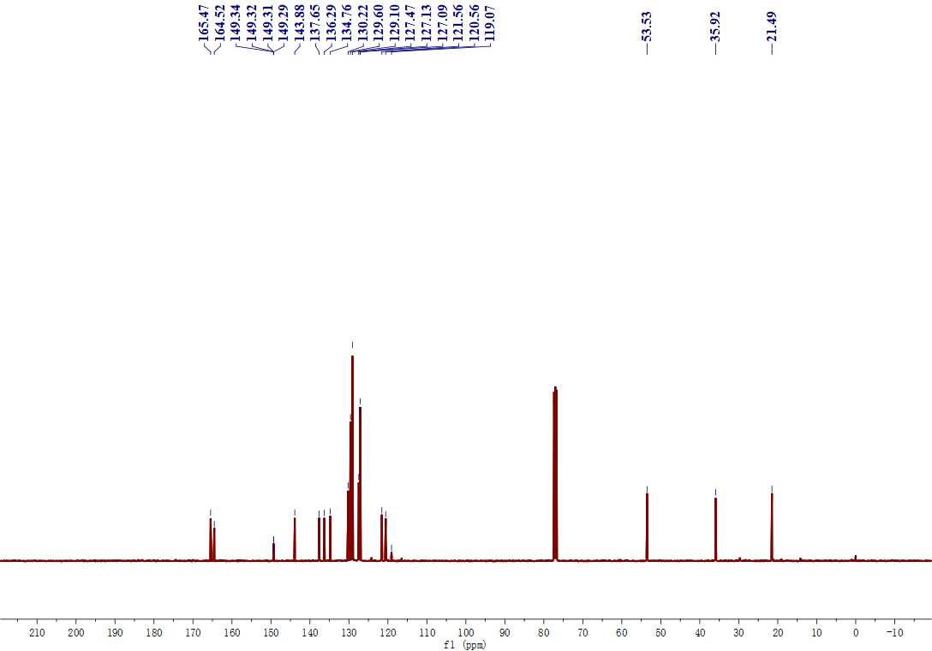
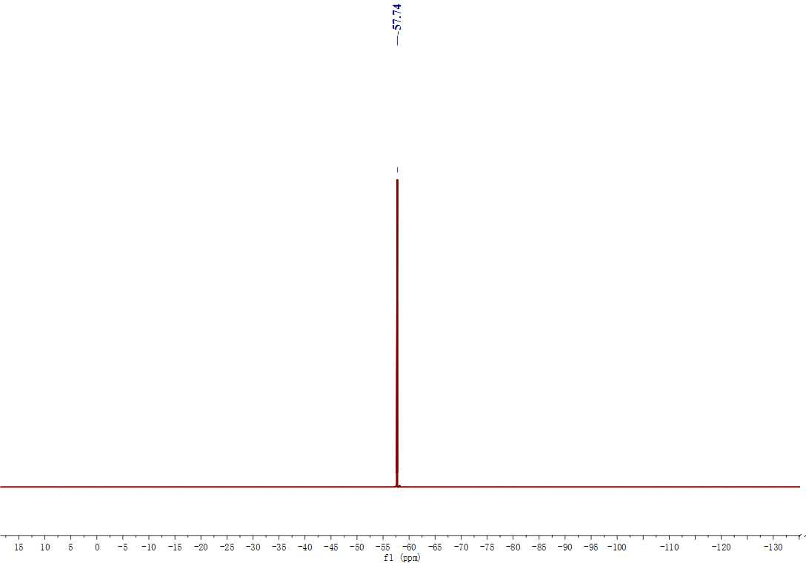
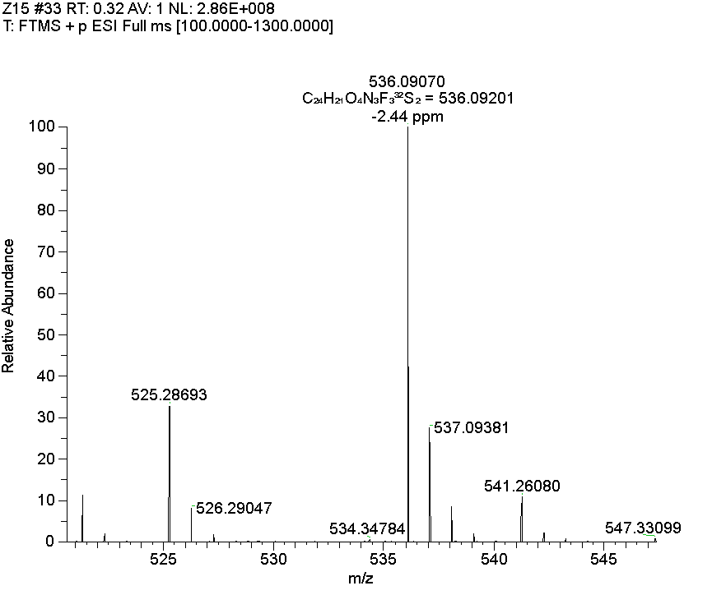
Figure S20. ¹H NMR, ¹³C NMR, ¹⁹F NMR and HRMS for І₁₂
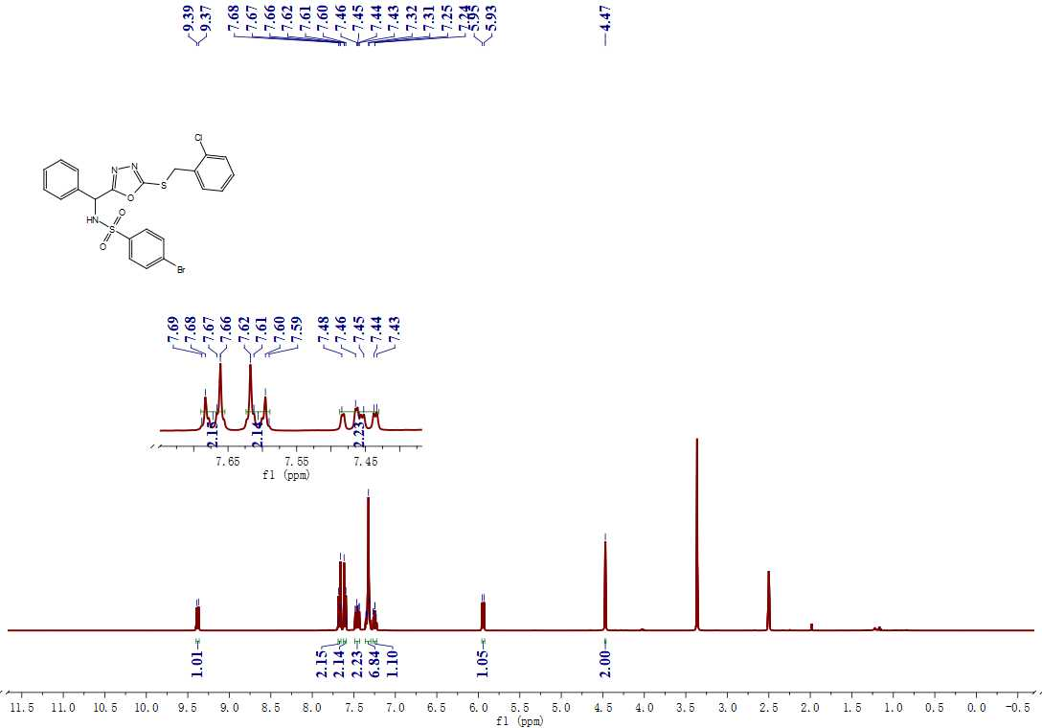
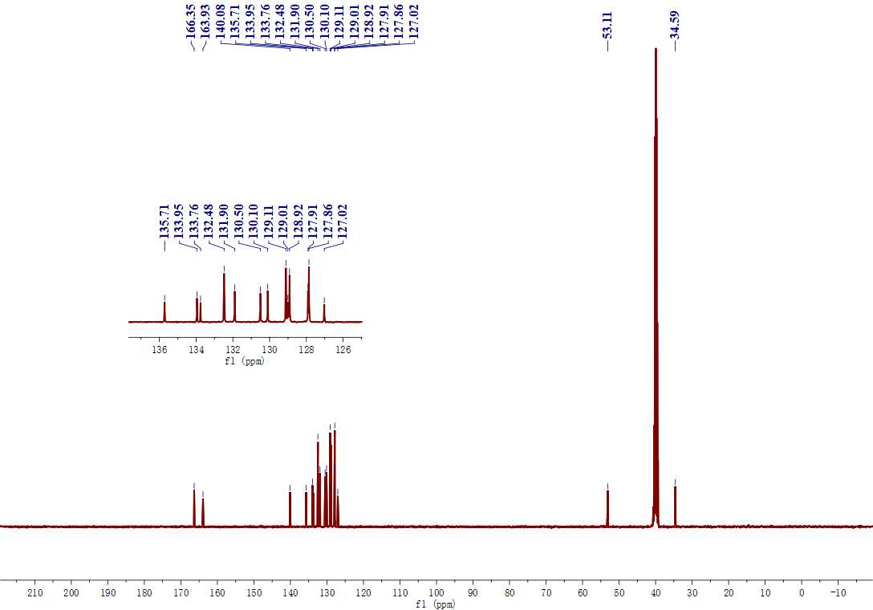
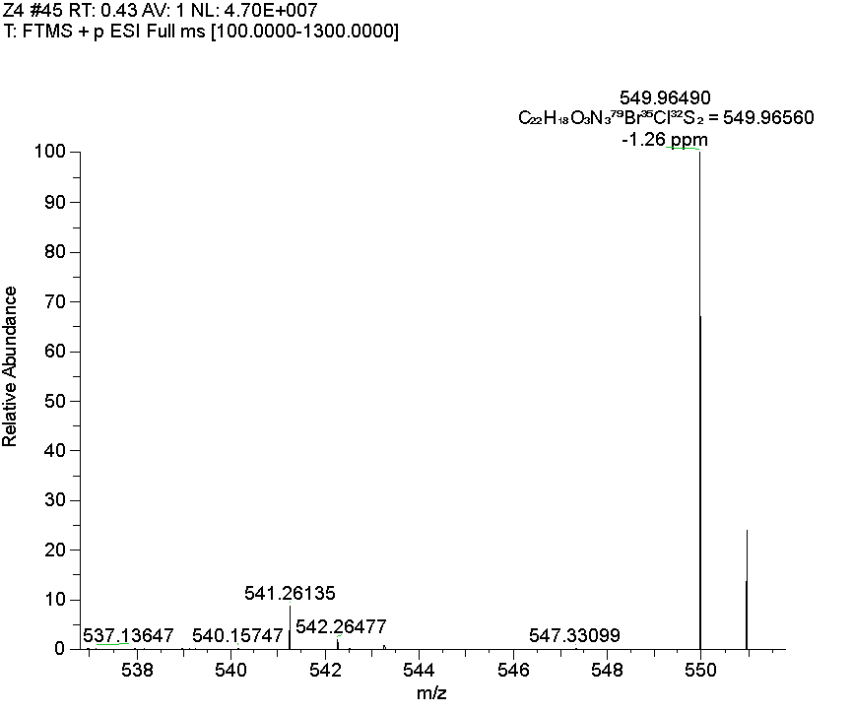
Figure S21. ¹H NMR, ¹³C NMR and HRMS for І₁₃
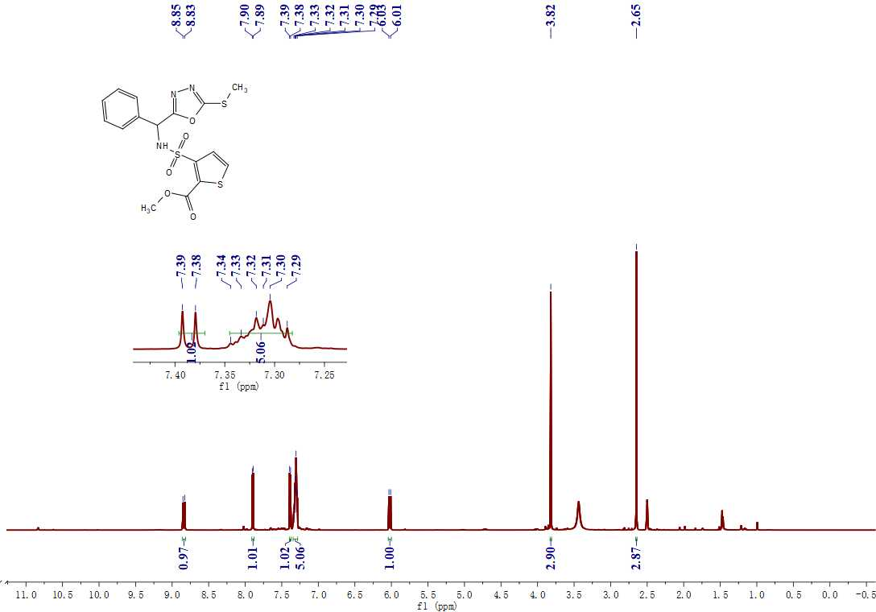
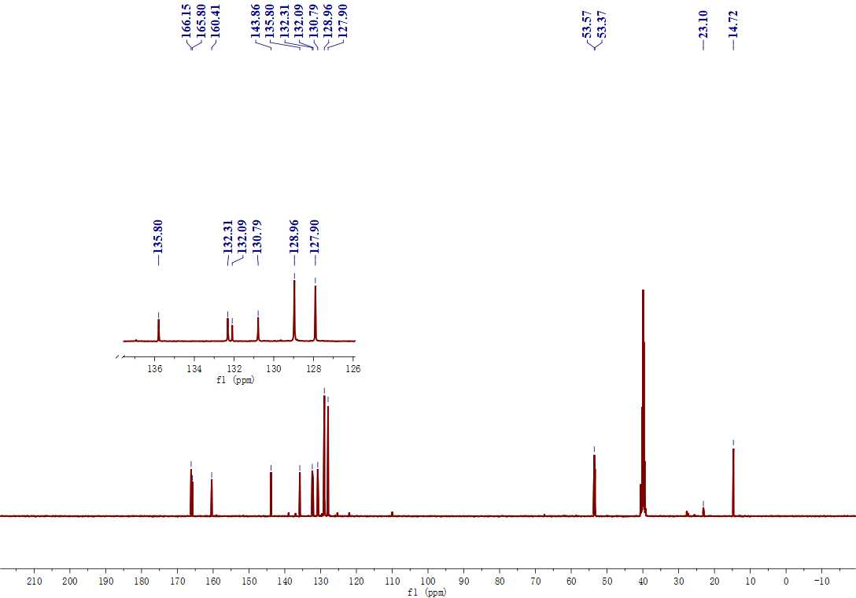
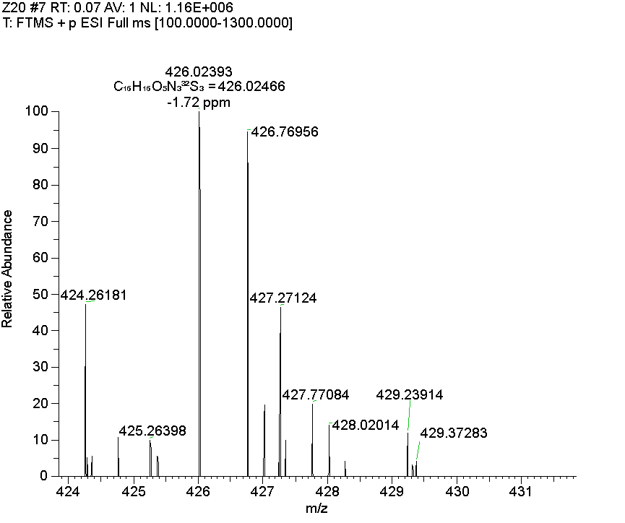
Figure S22. ¹H NMR, ¹³C NMR and HRMS for І₁₄
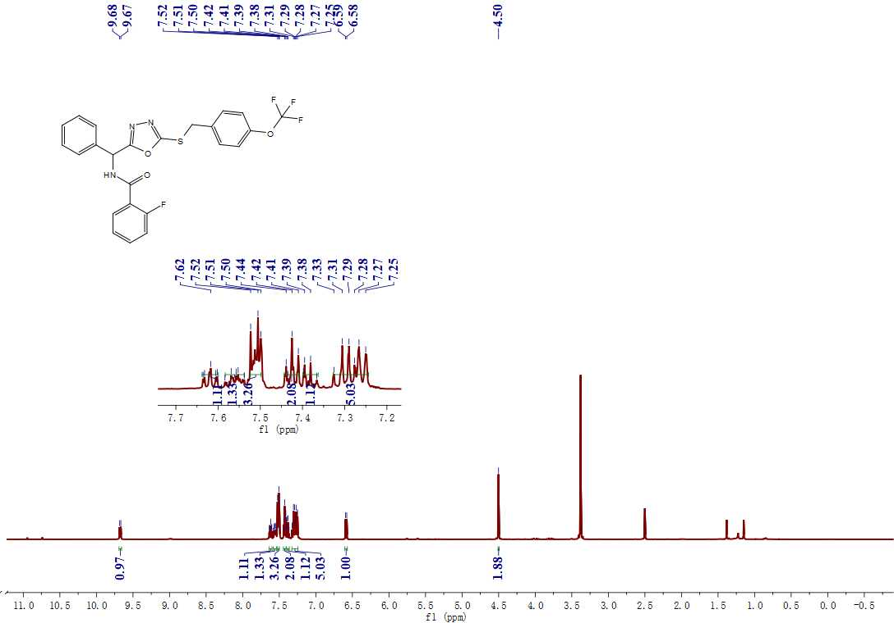
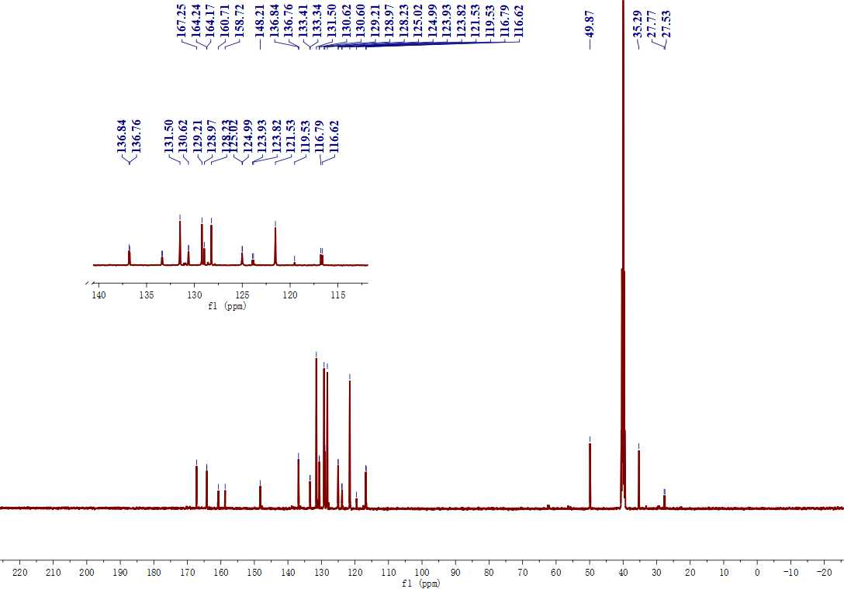
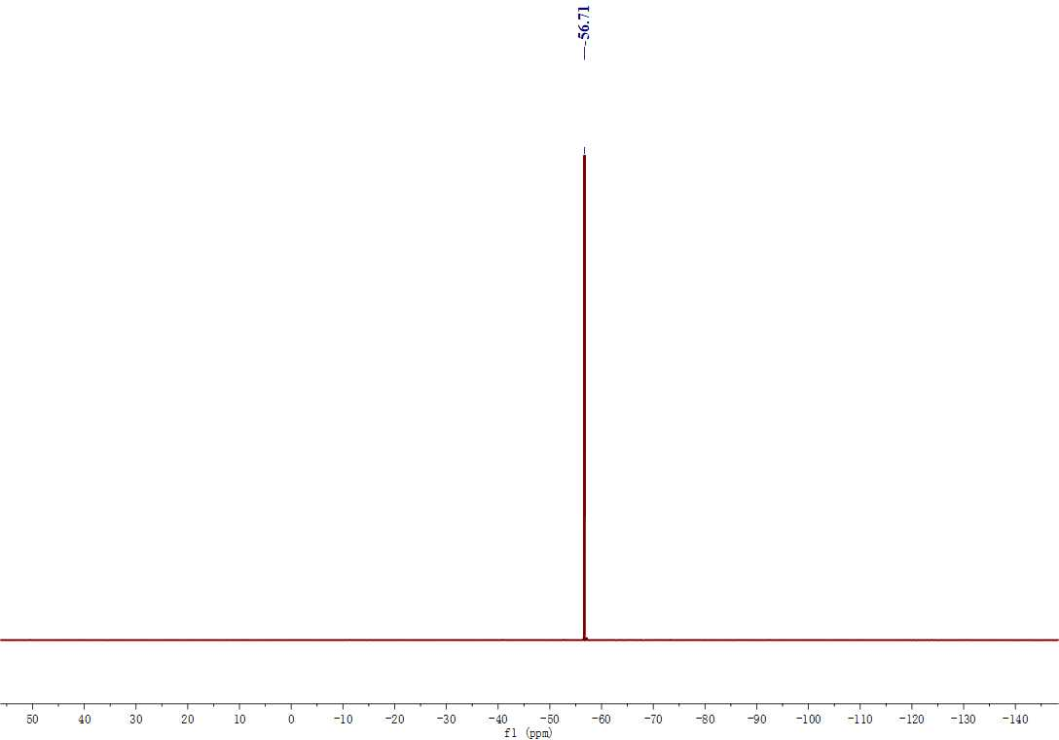
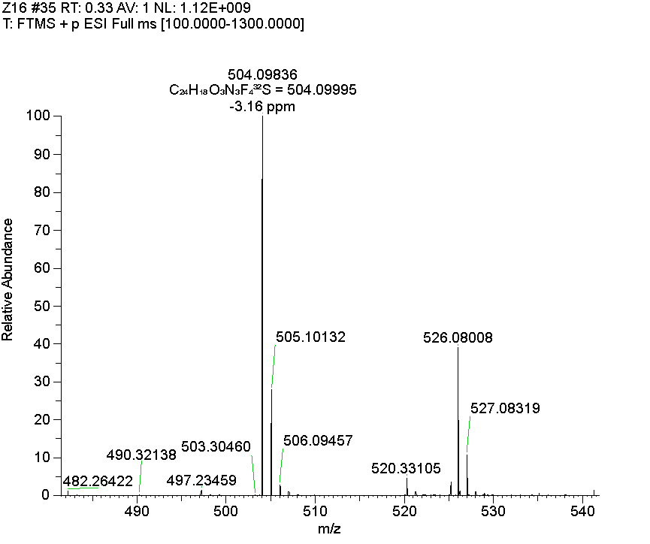
Figure S23. ¹H NMR, ¹³C NMR, ¹⁹F NMR and HRMS for І₁₅
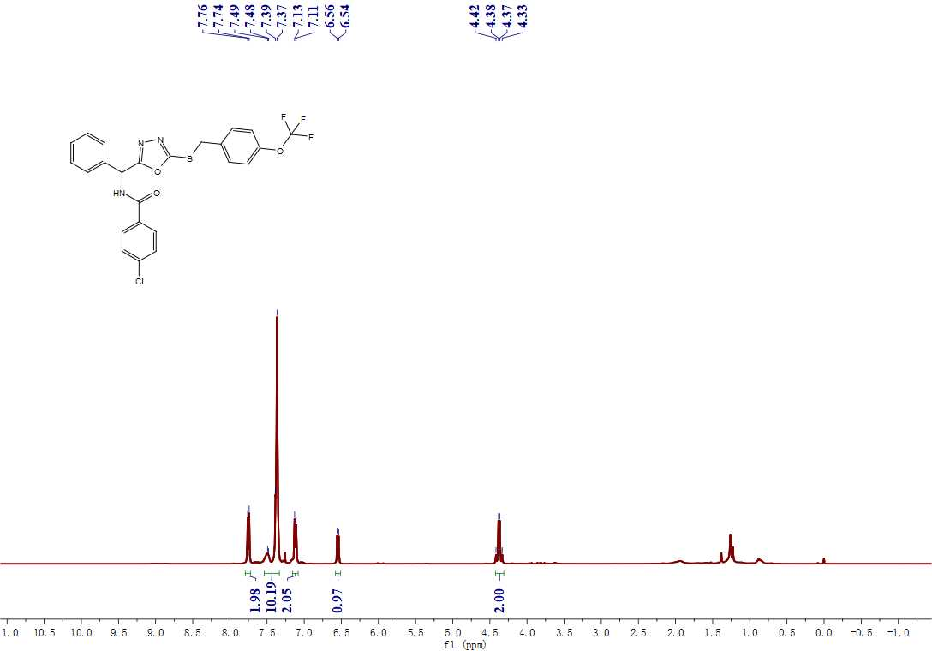
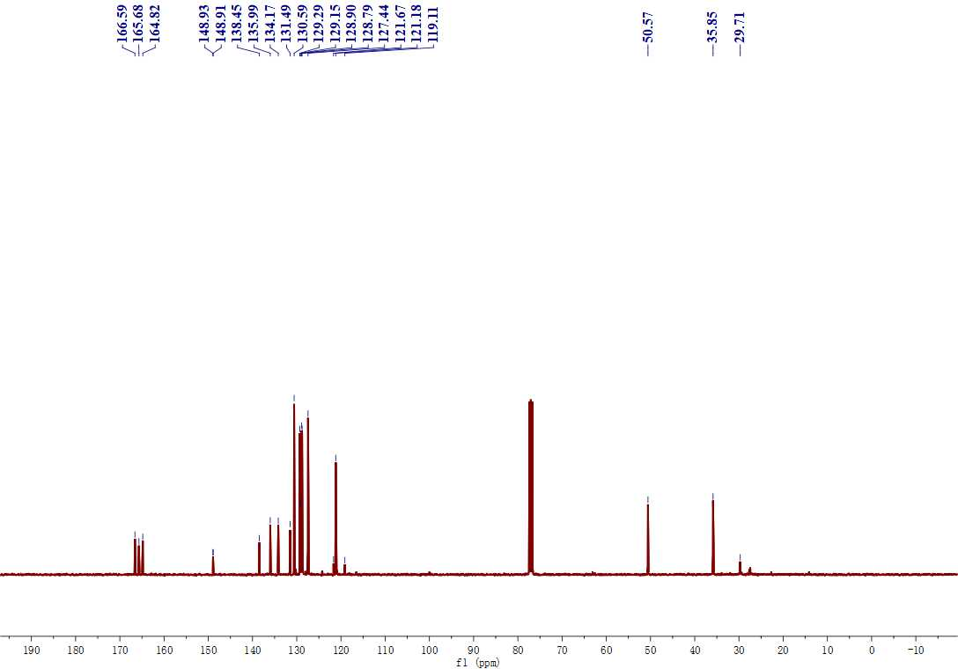
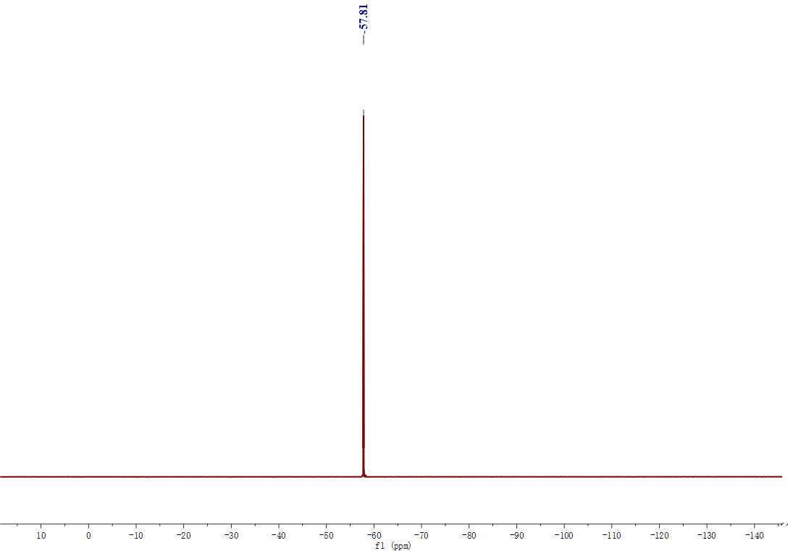
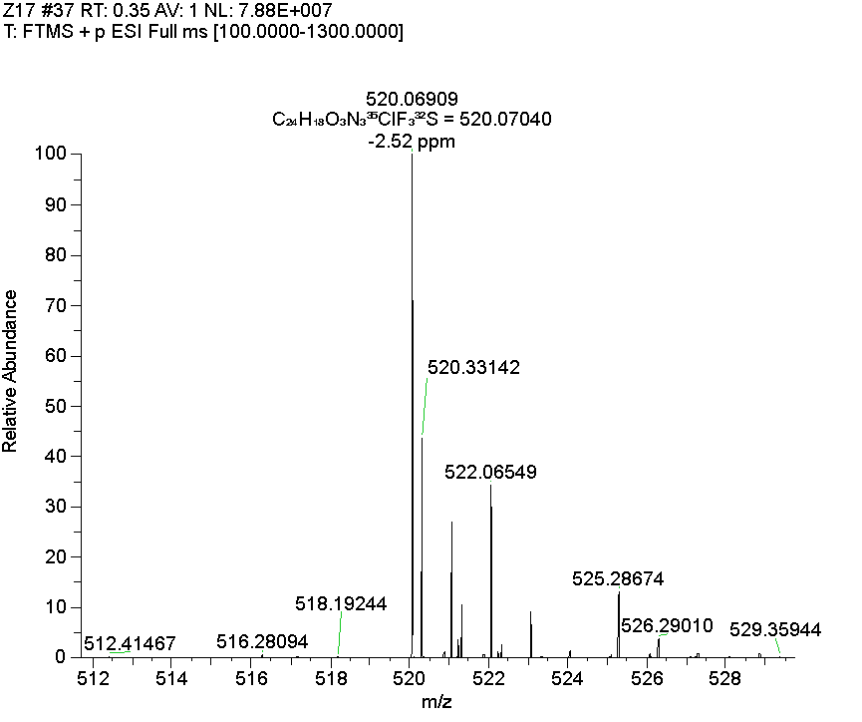
Figure S24. ¹H NMR, ¹³C NMR, ¹⁹F NMR and HRMS for І₁₆
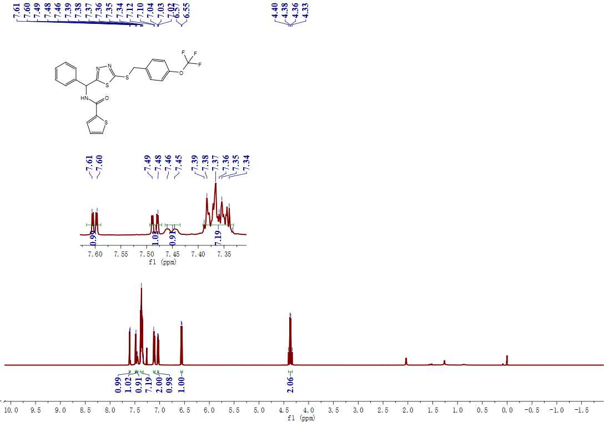
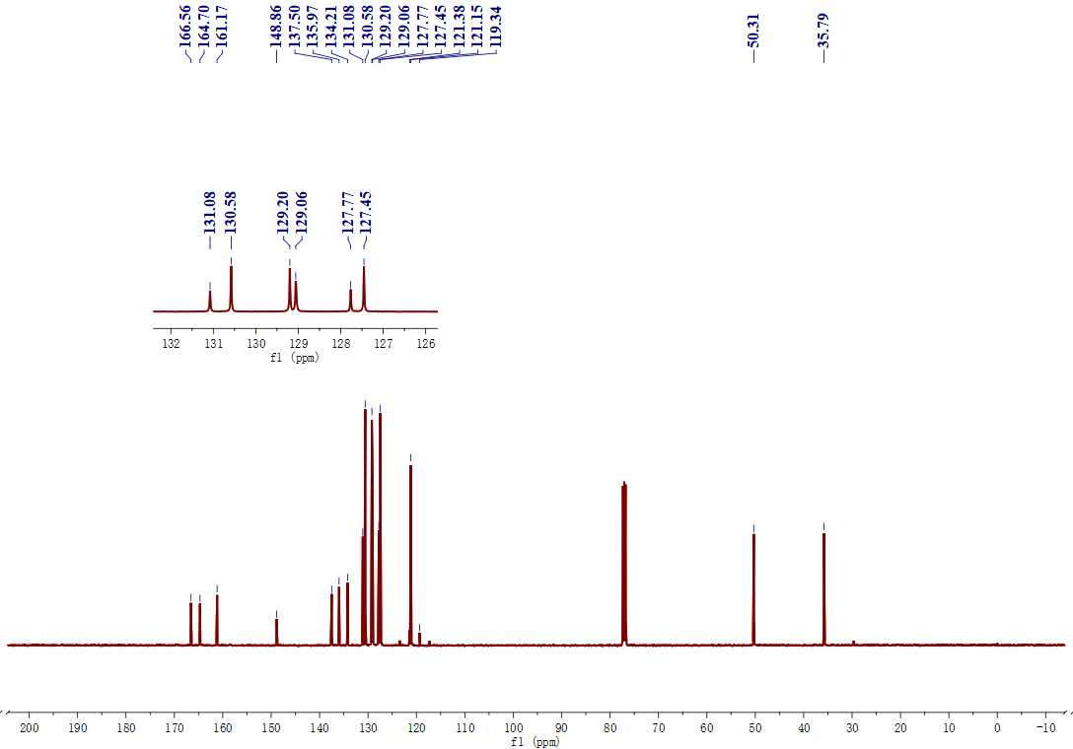
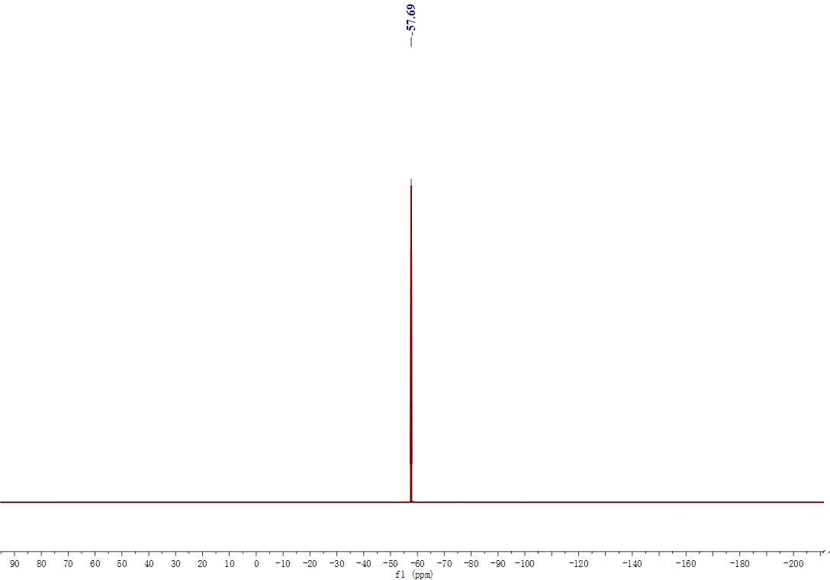
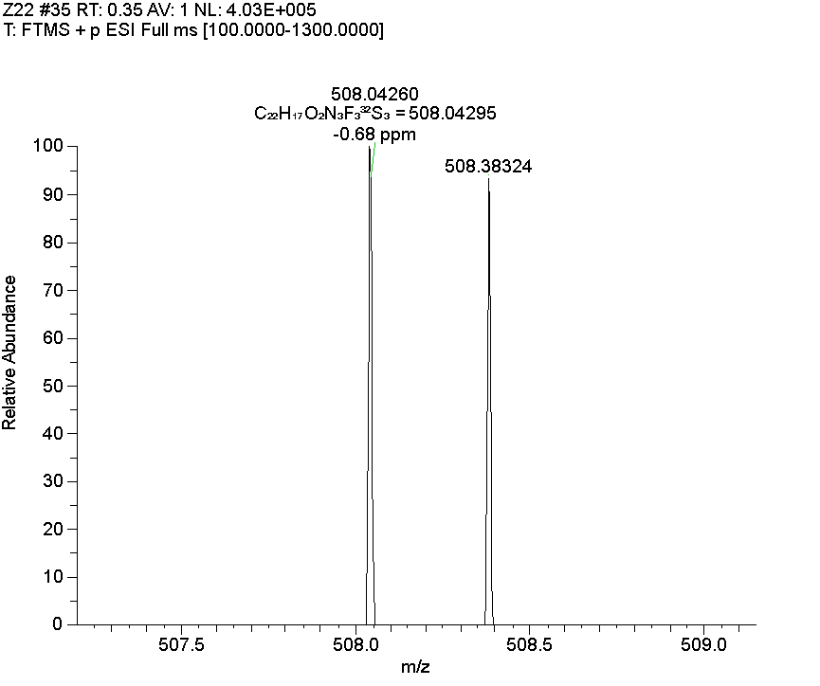
Figure S25. ¹H NMR, ¹³C NMR, ¹⁹F NMR and HRMS for І₁₇
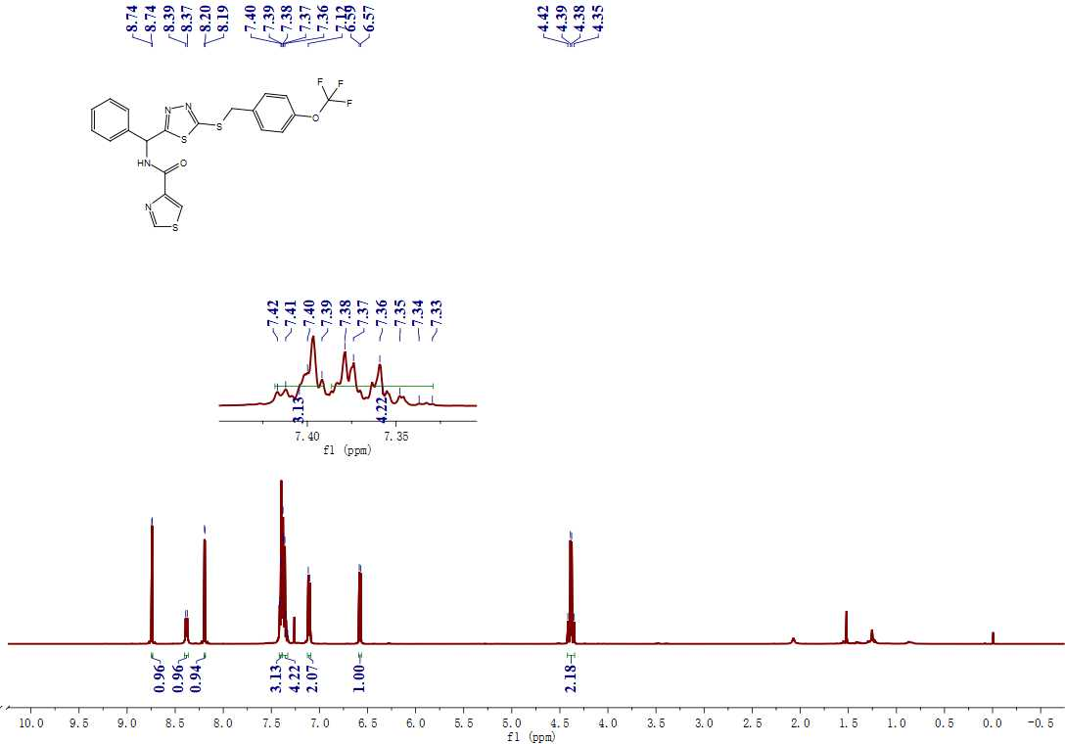
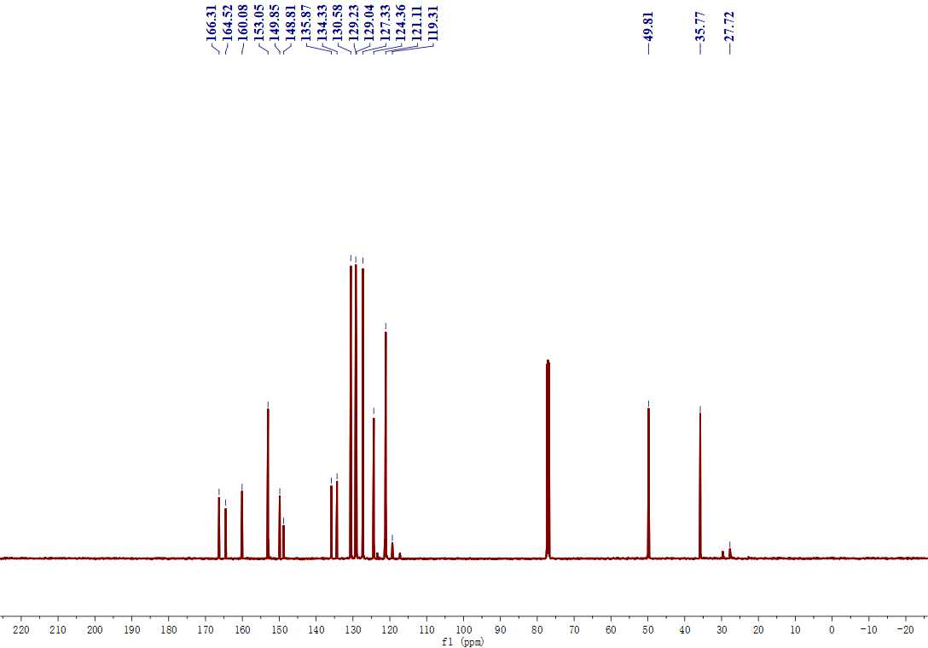
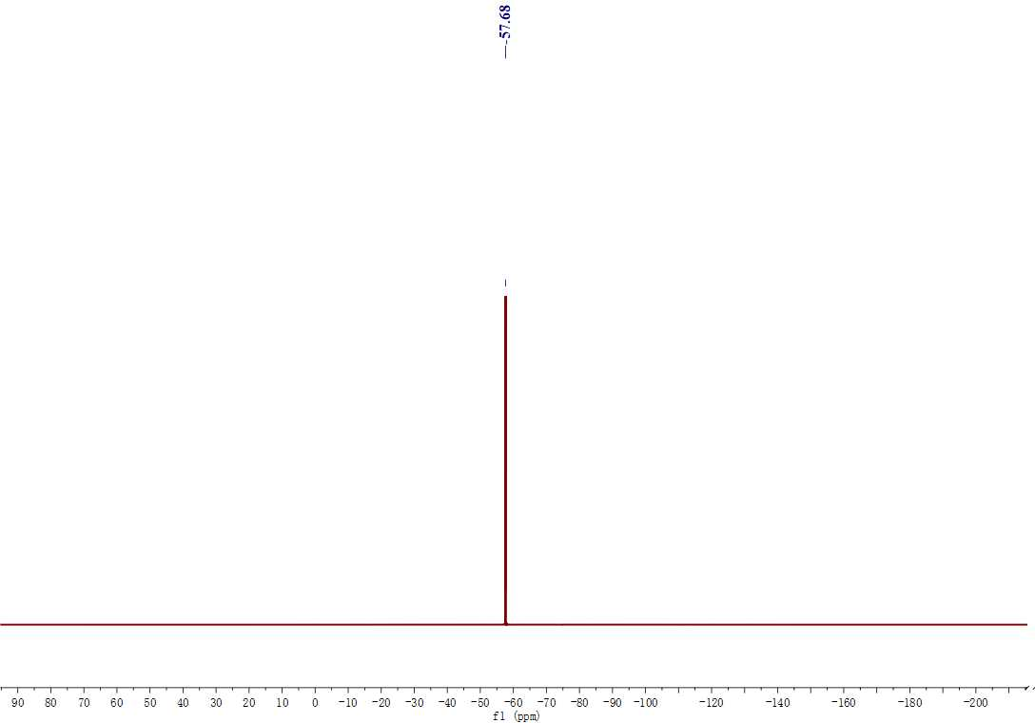
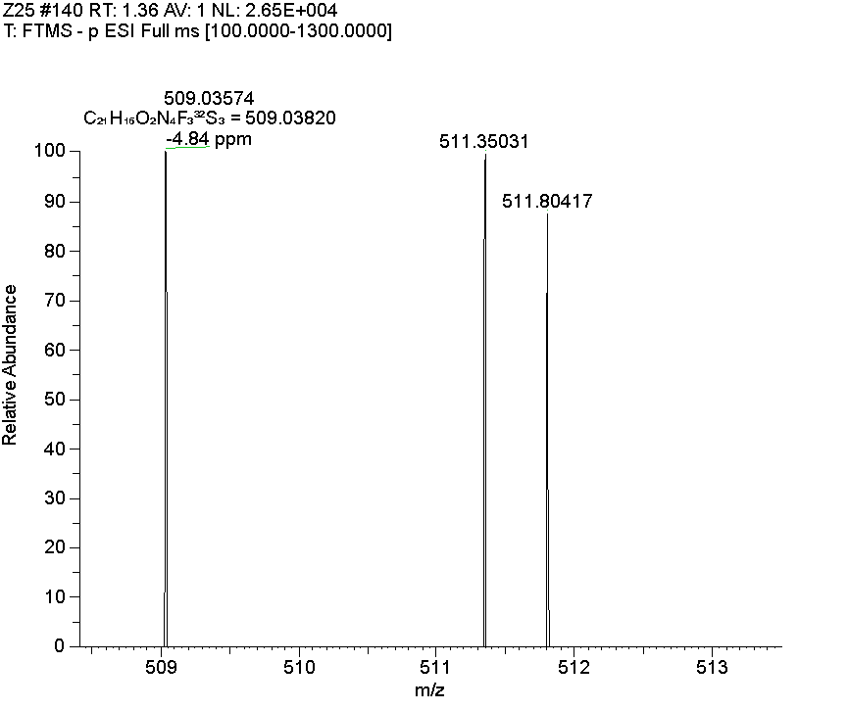
Figure S26. ¹H NMR, ¹³C NMR, ¹⁹F NMR and HRMS for І₁₈
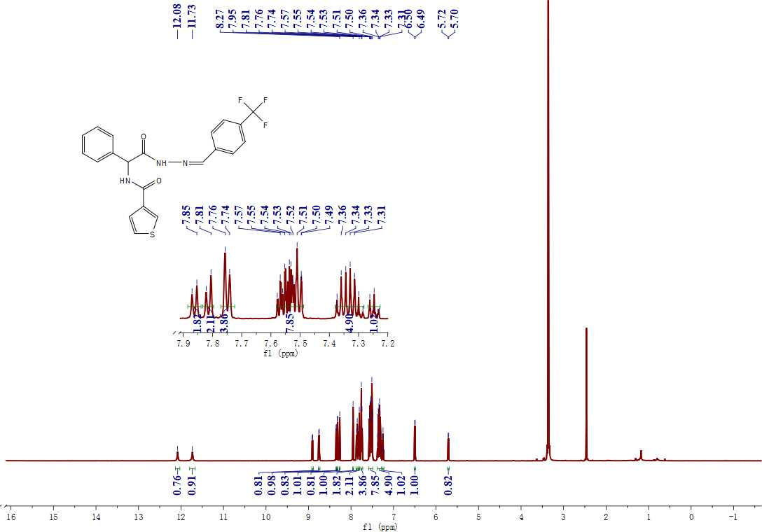
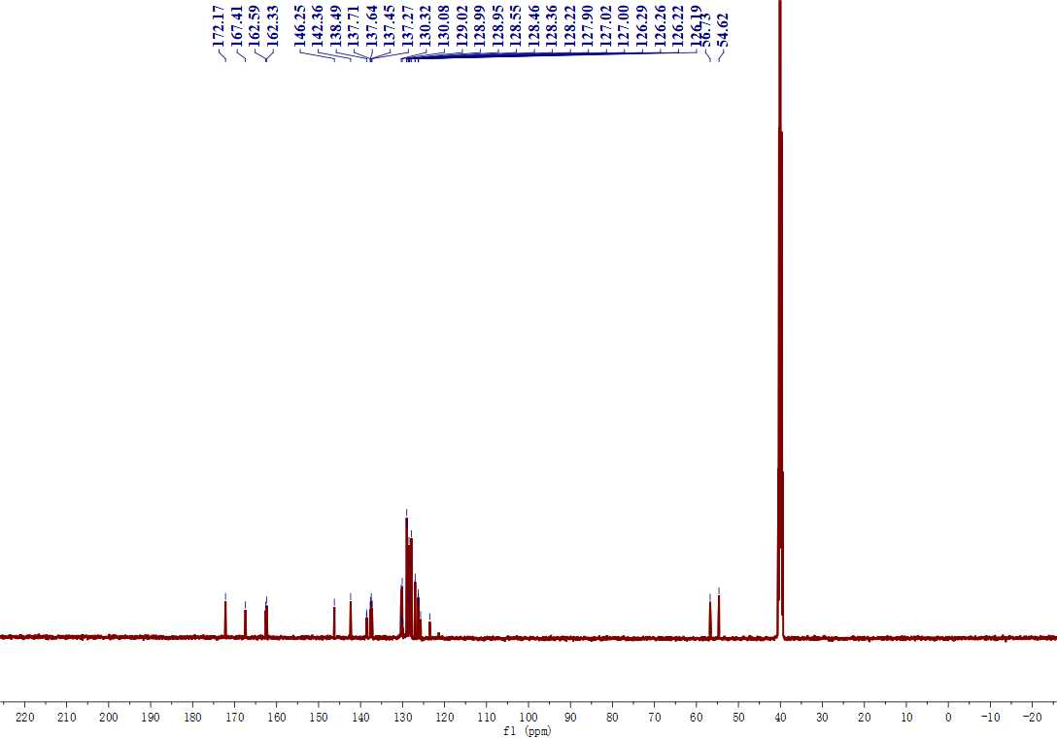
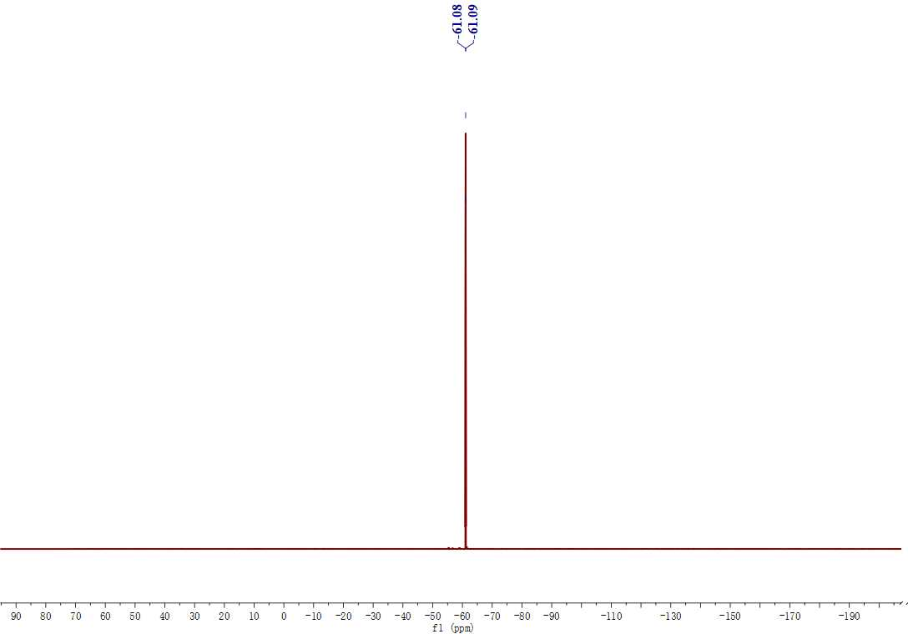
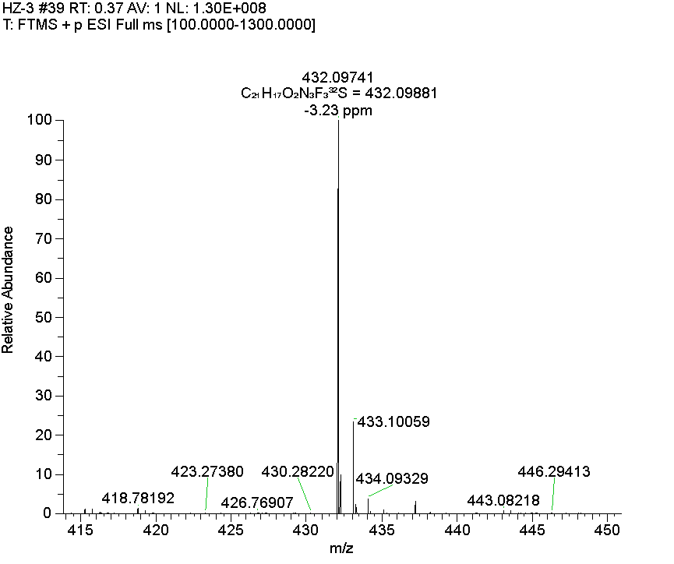
Figure S27. ¹H NMR, ¹³C NMR ¹⁹F NMR and HRMS for Ⅱ₁
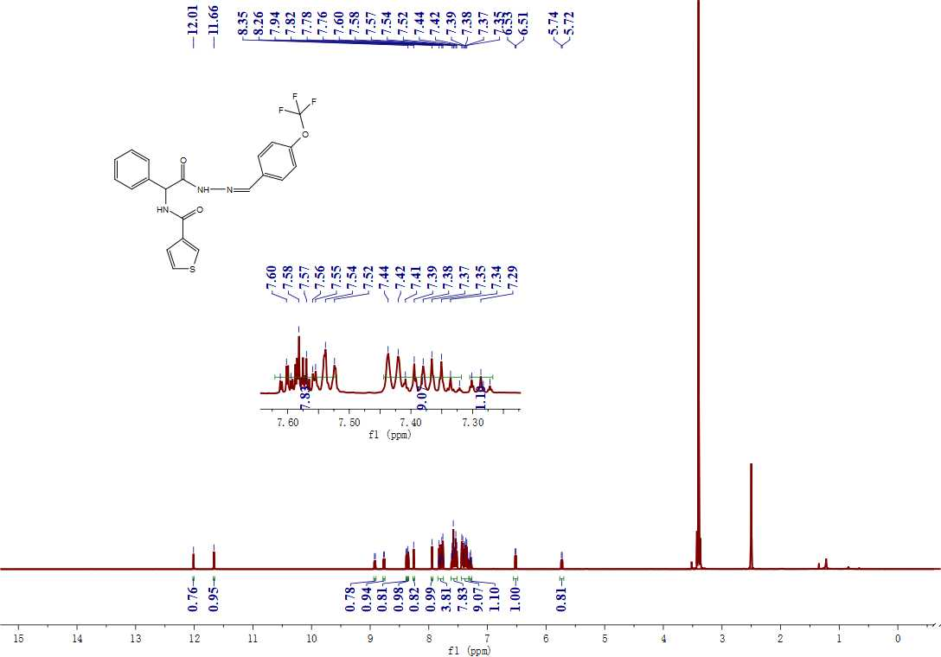

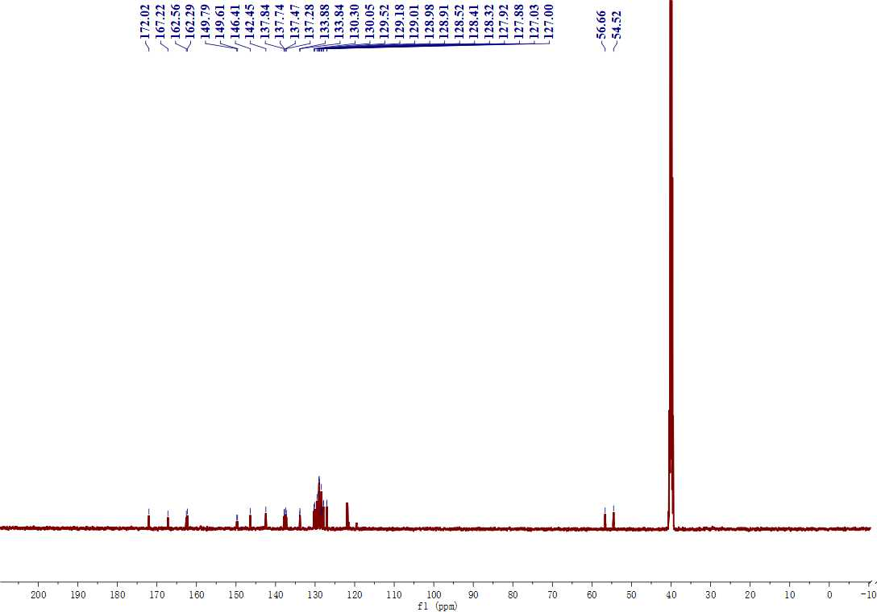
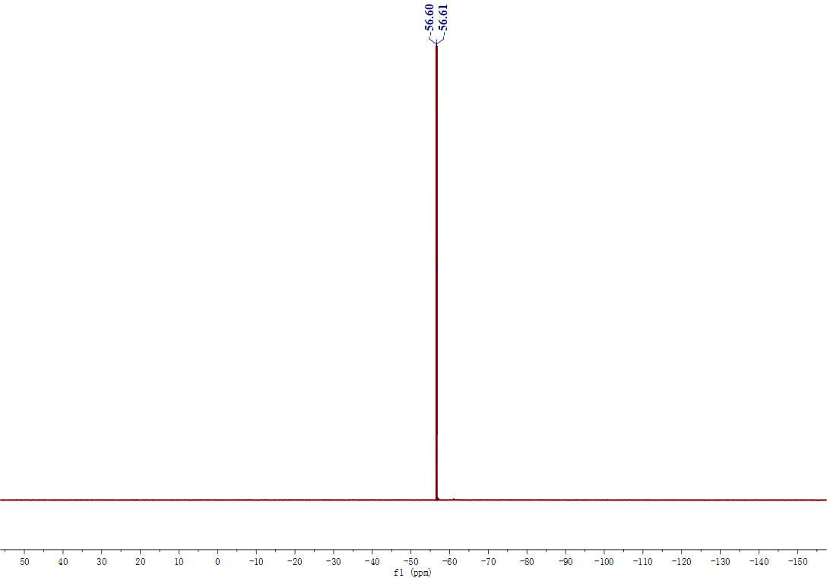
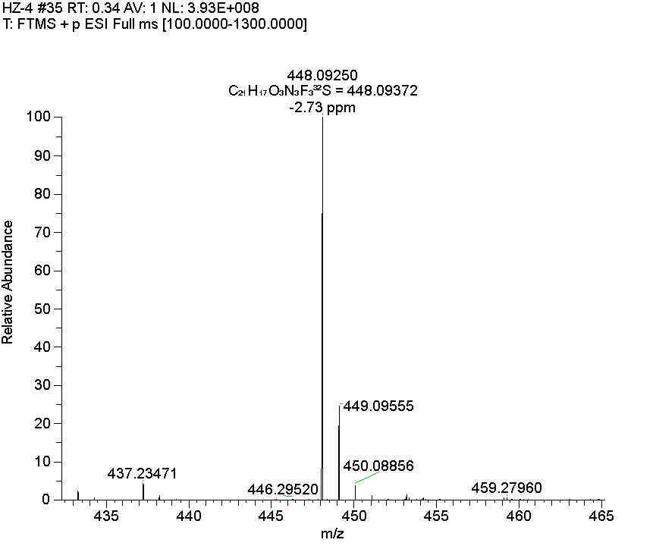
Figure S28. ¹H NMR, ¹³C NMR ¹⁹F NMR and HRMS for Ⅱ₂
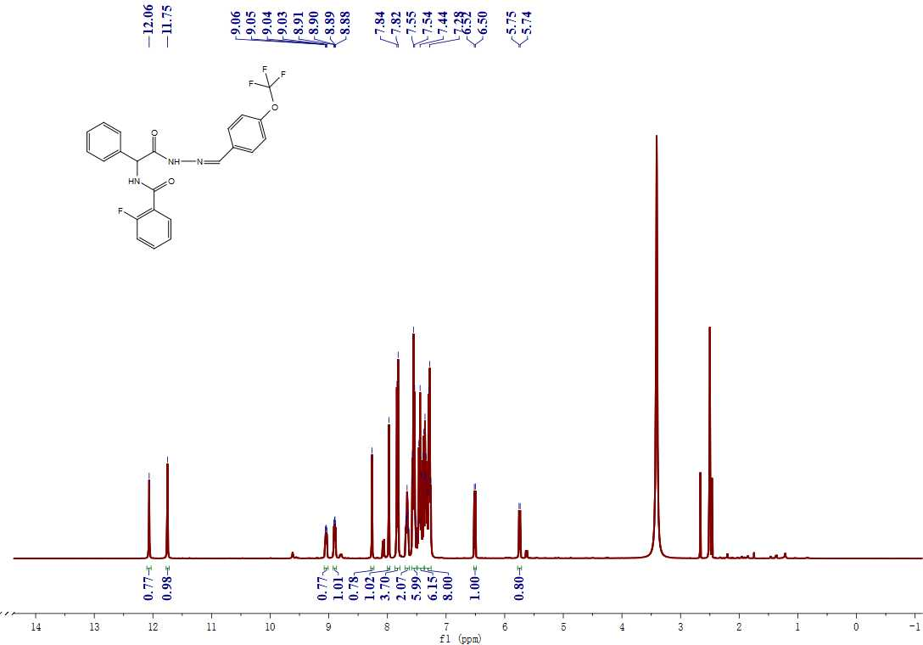
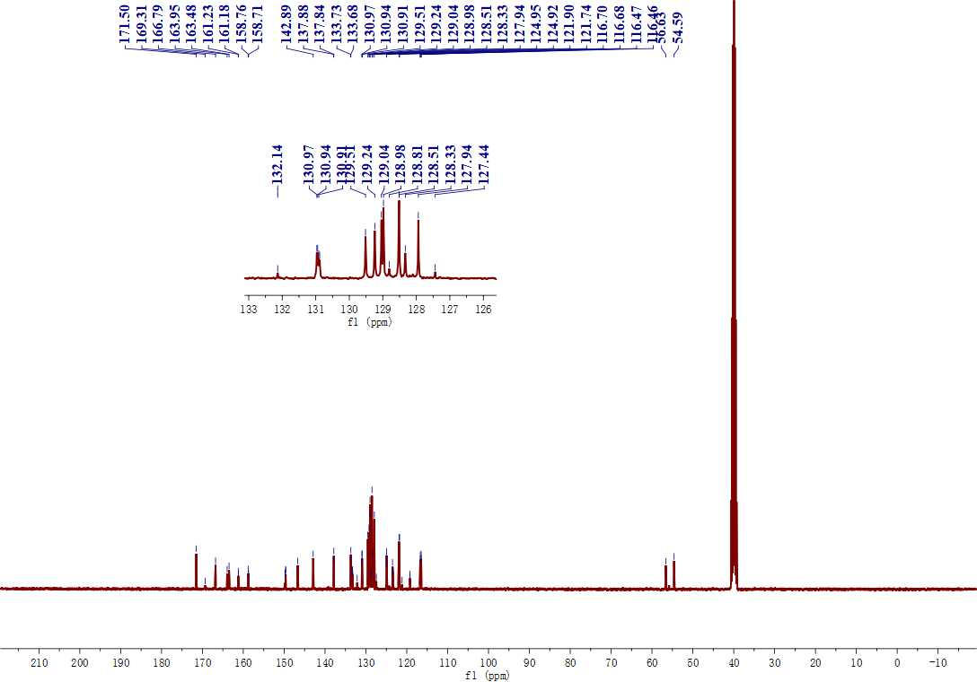
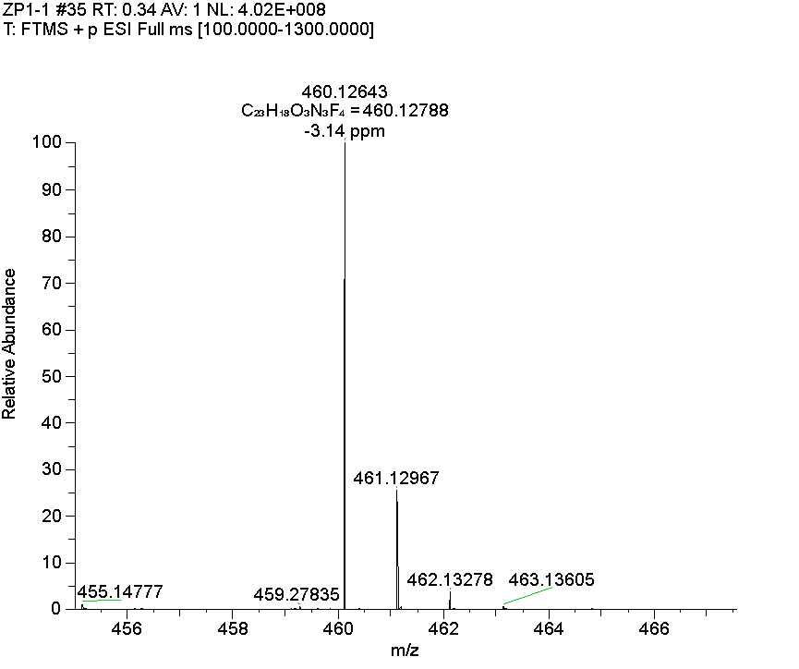
Figure S29. ¹H NMR, ¹³C NMR ¹⁹F NMR and HRMS for Ⅱ₃
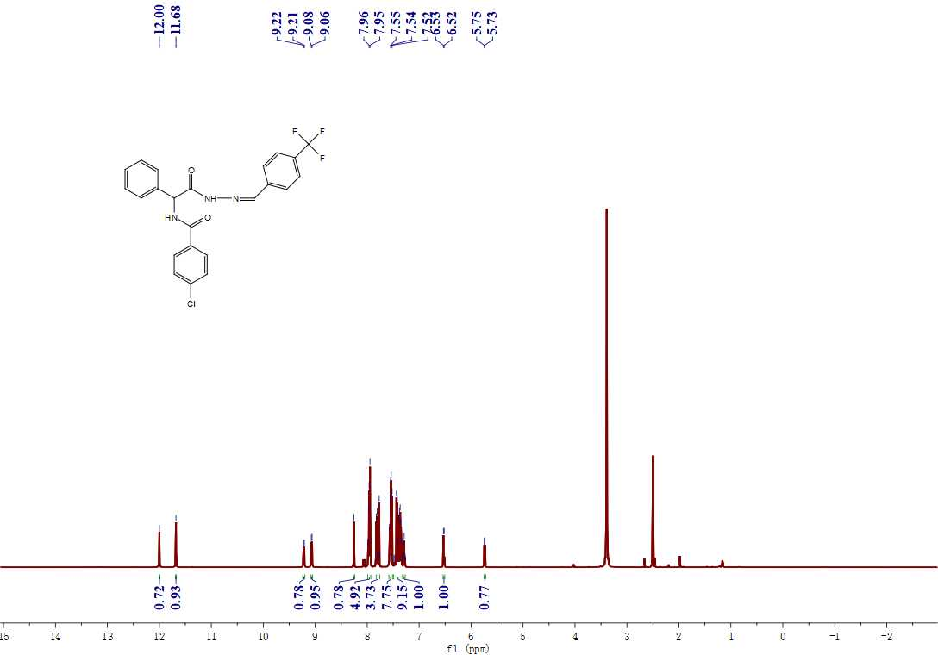
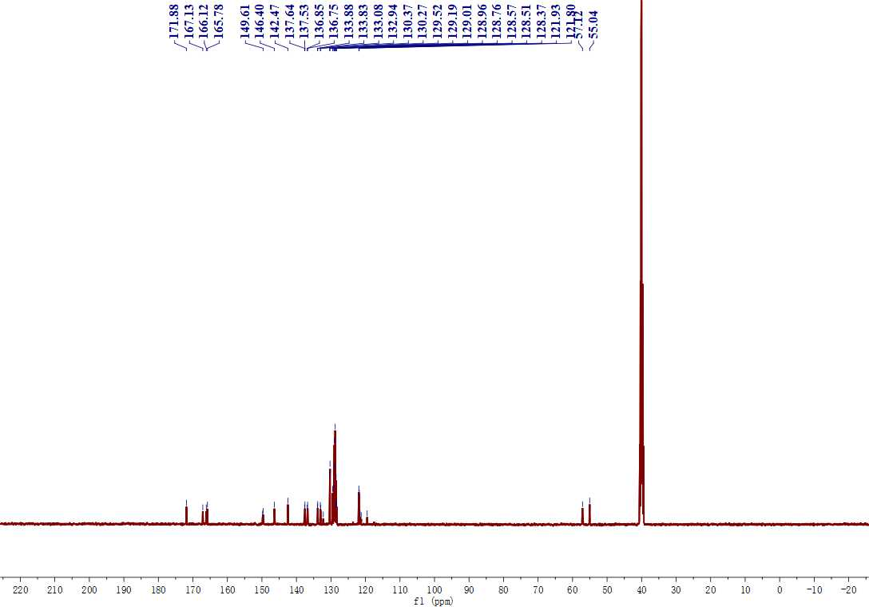
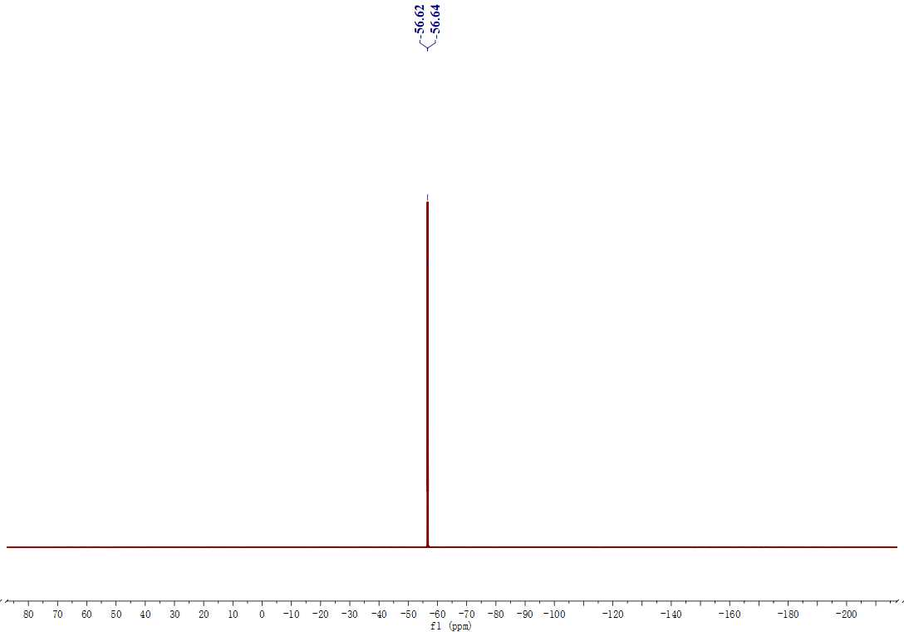
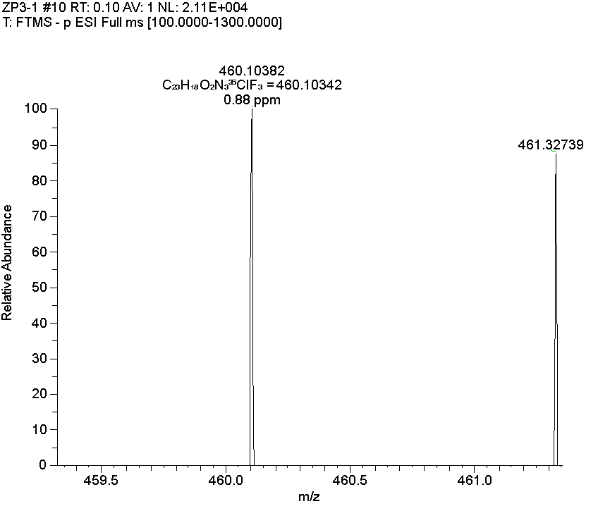
Figure S30. ¹H NMR, ¹³C NMR ¹⁹F NMR and HRMS for Ⅱ₄
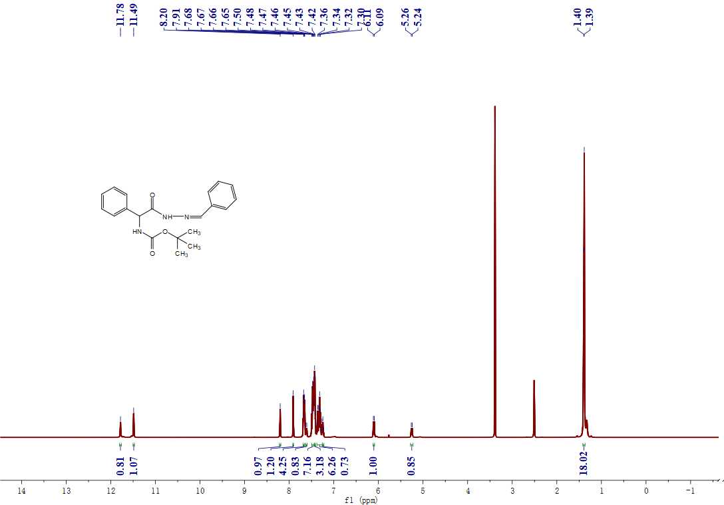
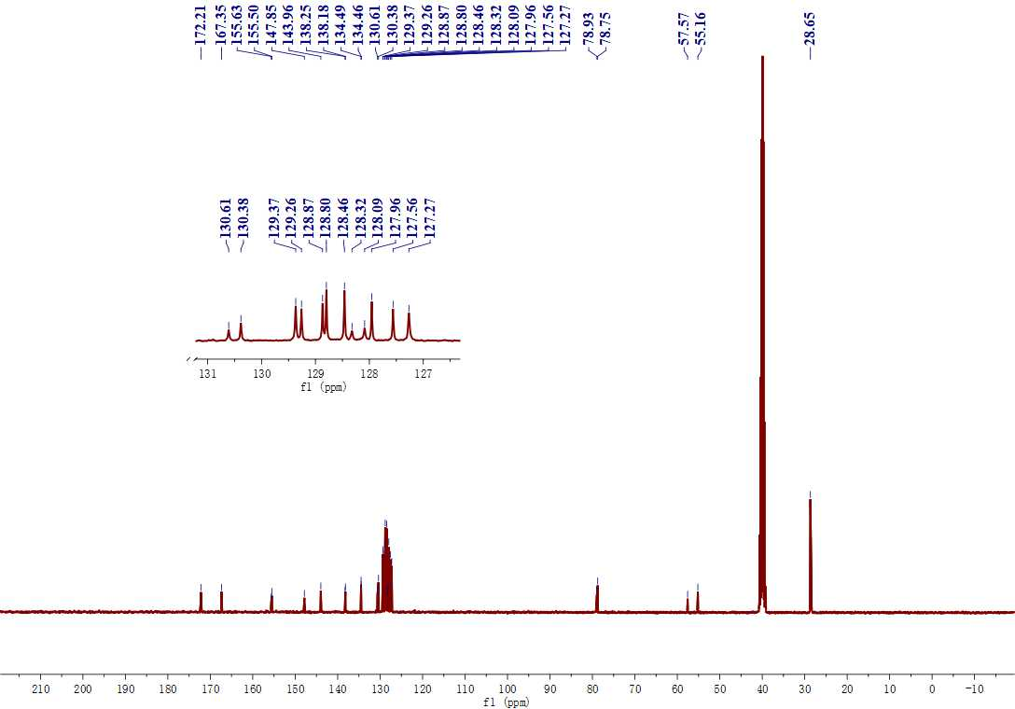
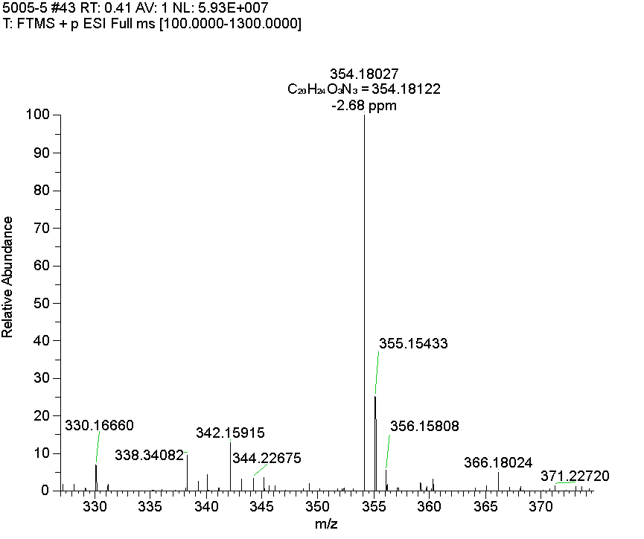
Figure S31. ¹H NMR, ¹³C NMR ¹⁹F NMR and HRMS for Ⅱ₅
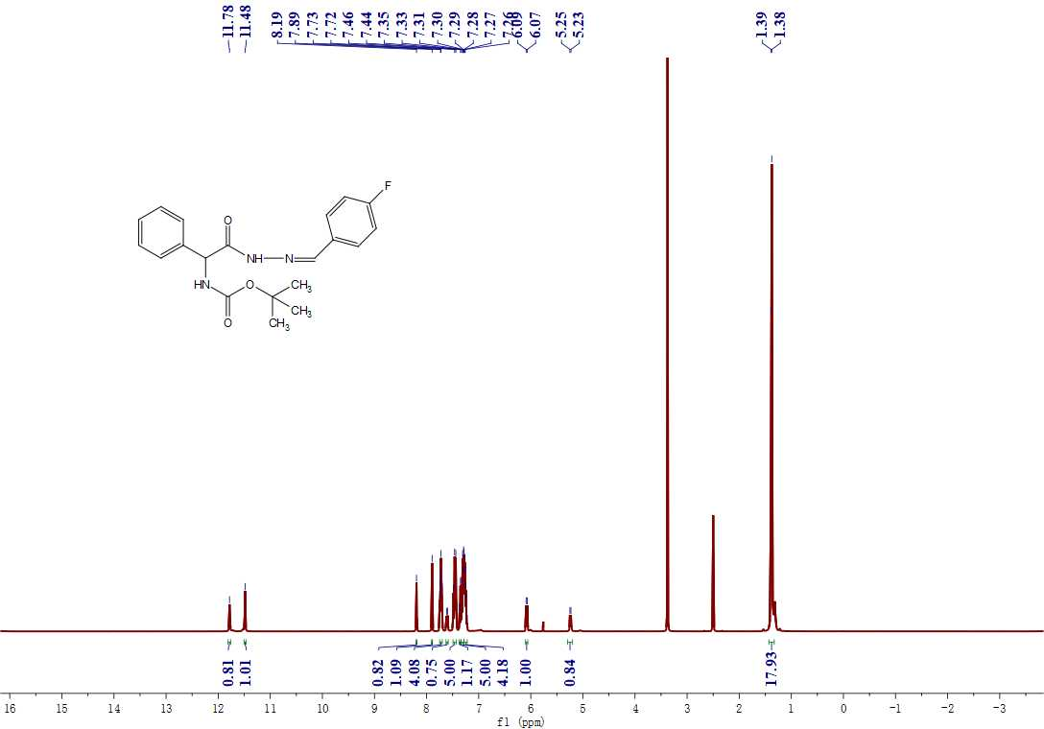
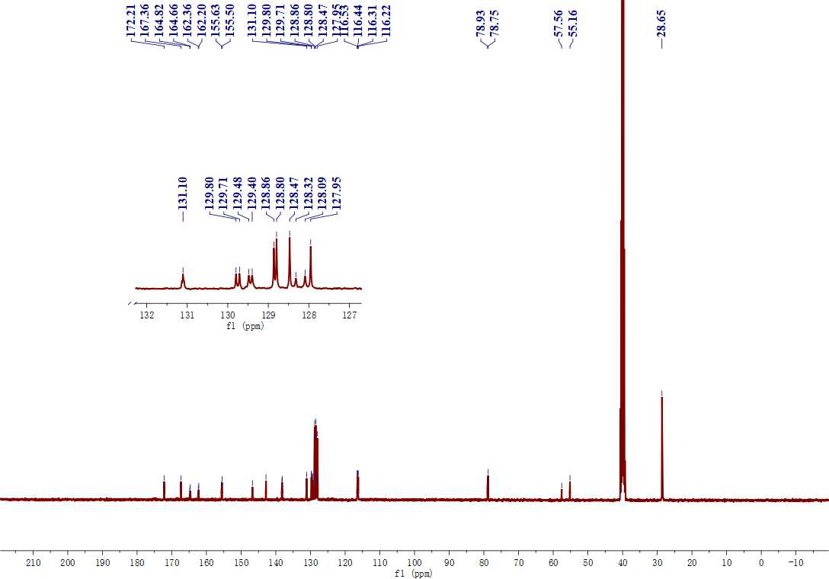
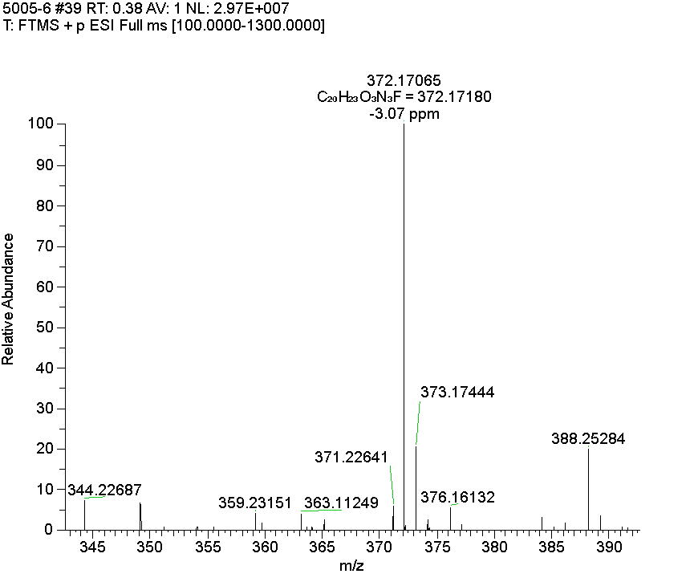
Figure S32. ¹H NMR, ¹³C NMR ¹⁹F NMR and HRMS for Ⅱ₆
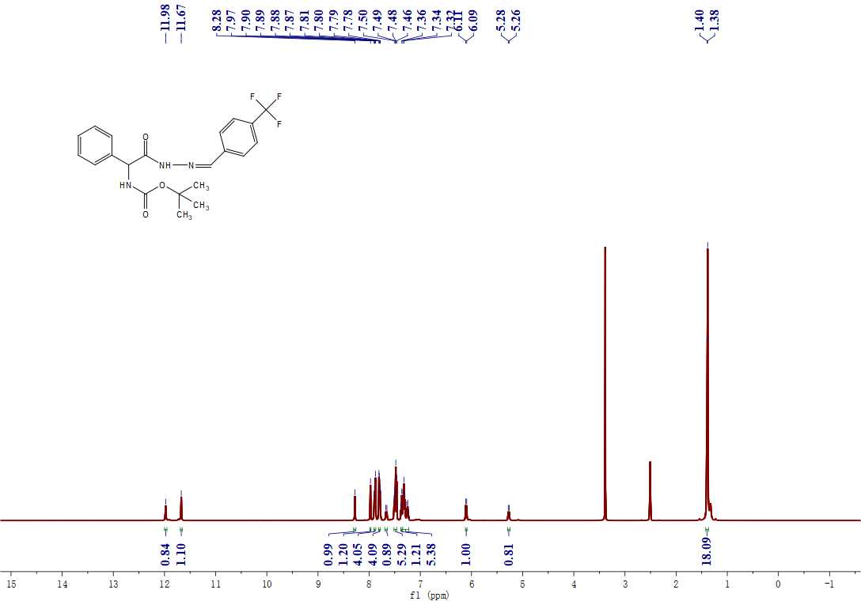
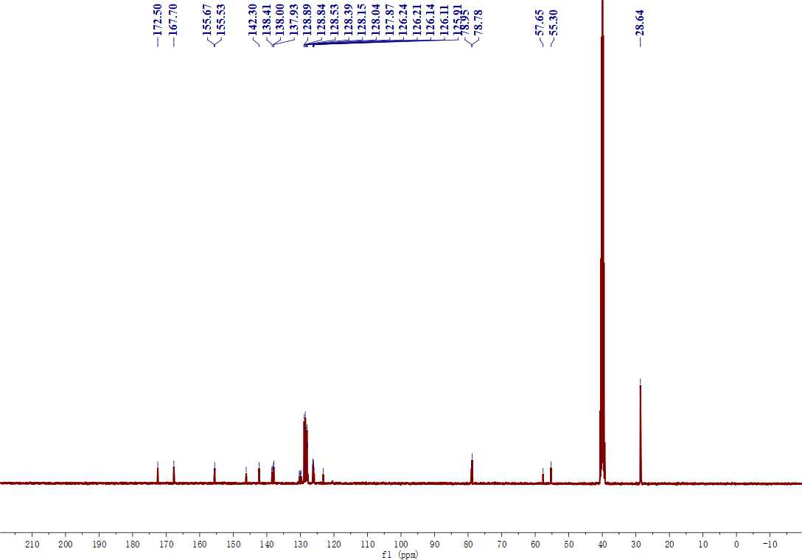
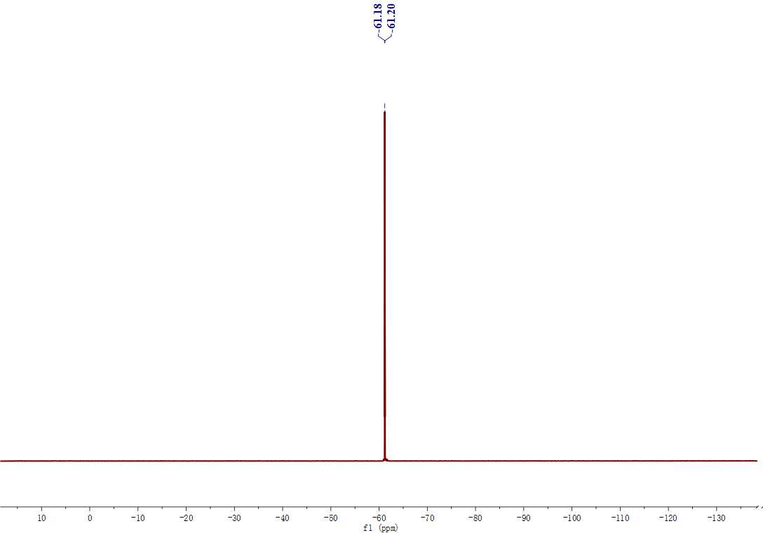
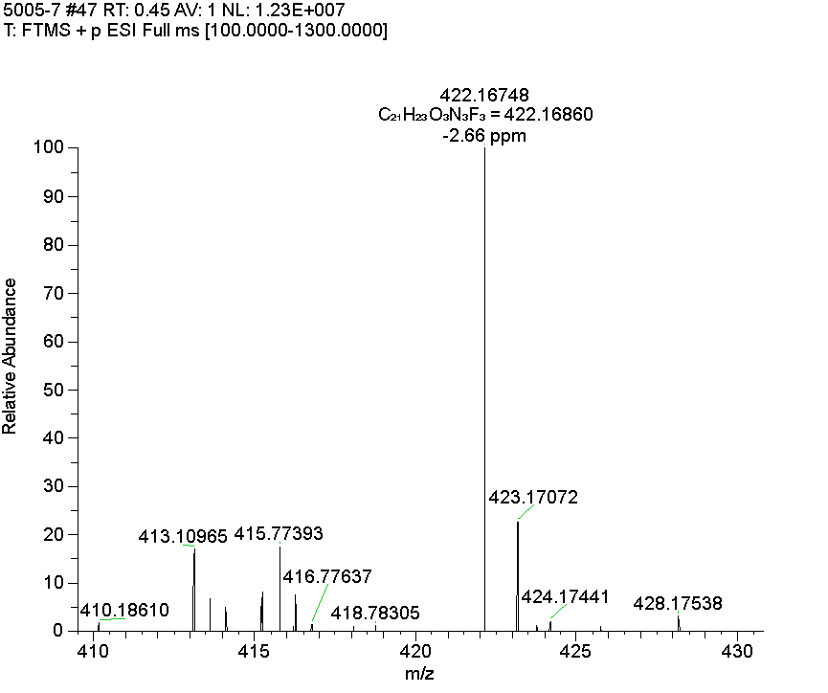
Figure S33. ¹H NMR, ¹³C NMR ¹⁹F NMR and HRMS for Ⅱ₇
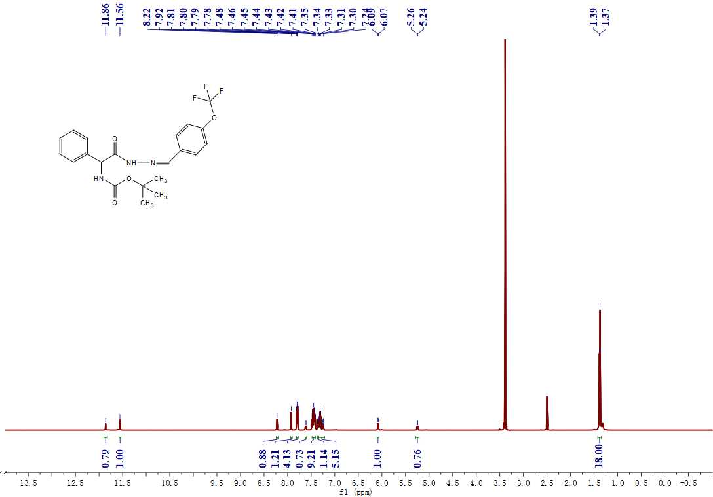
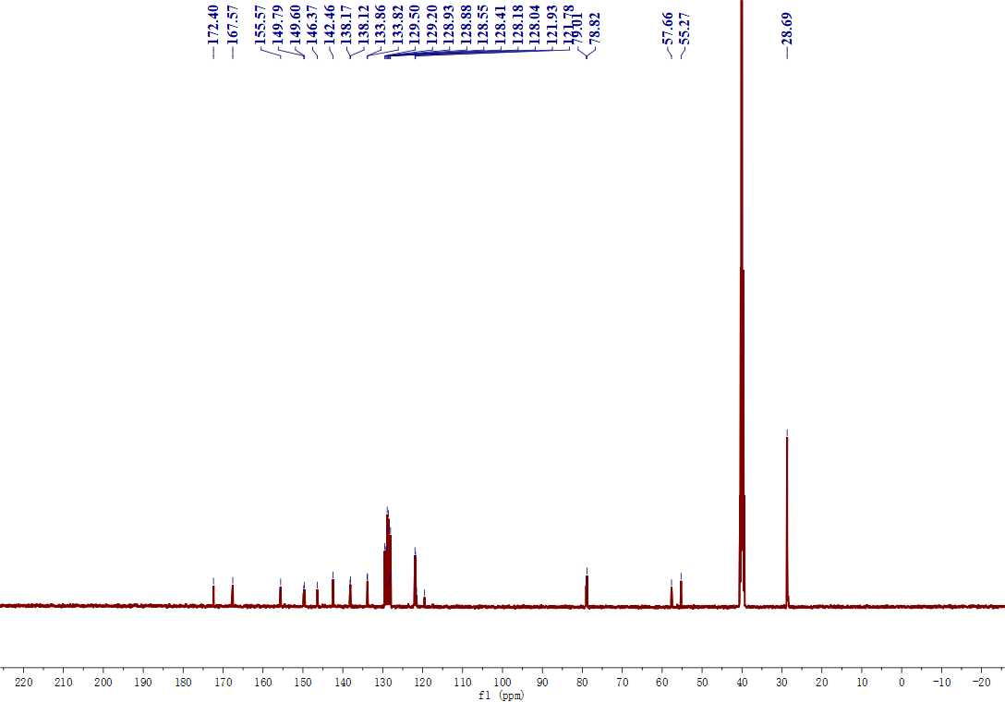
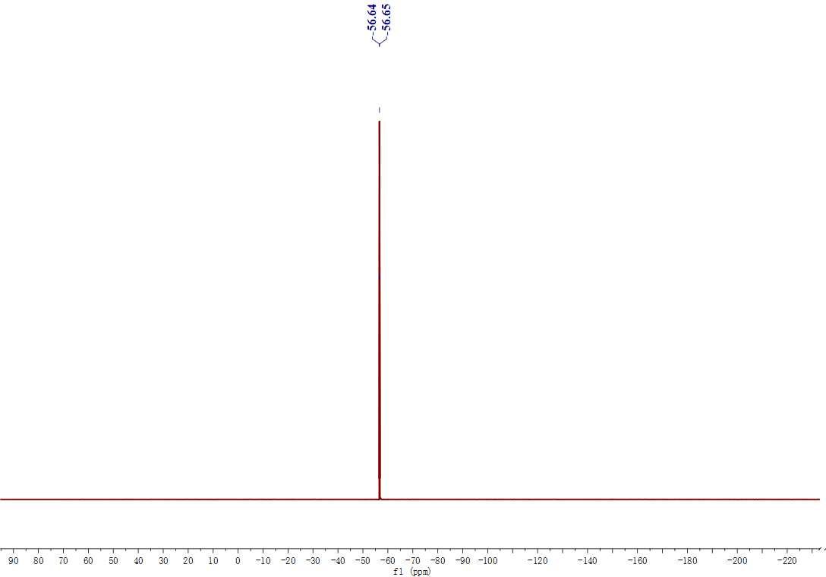
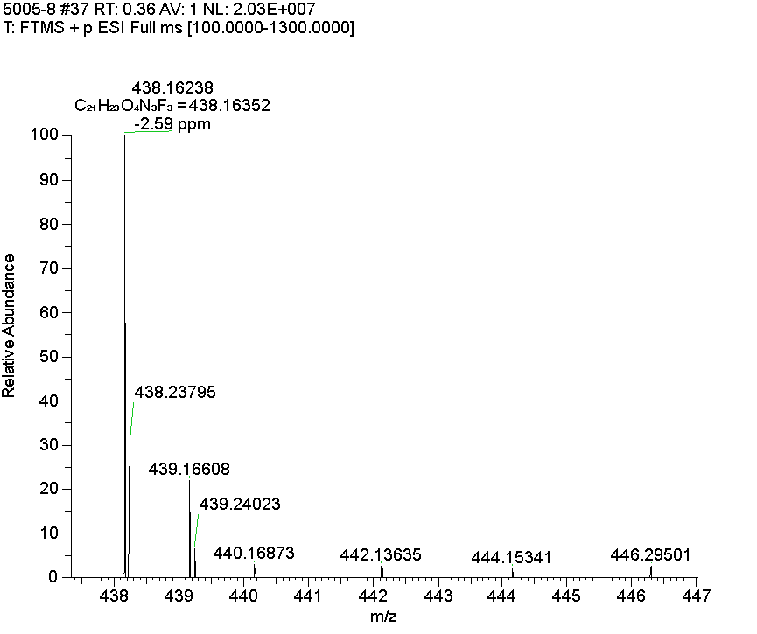
Figure S34. ¹H NMR, ¹³C NMR ¹⁹F NMR and HRMS for Ⅱ₈
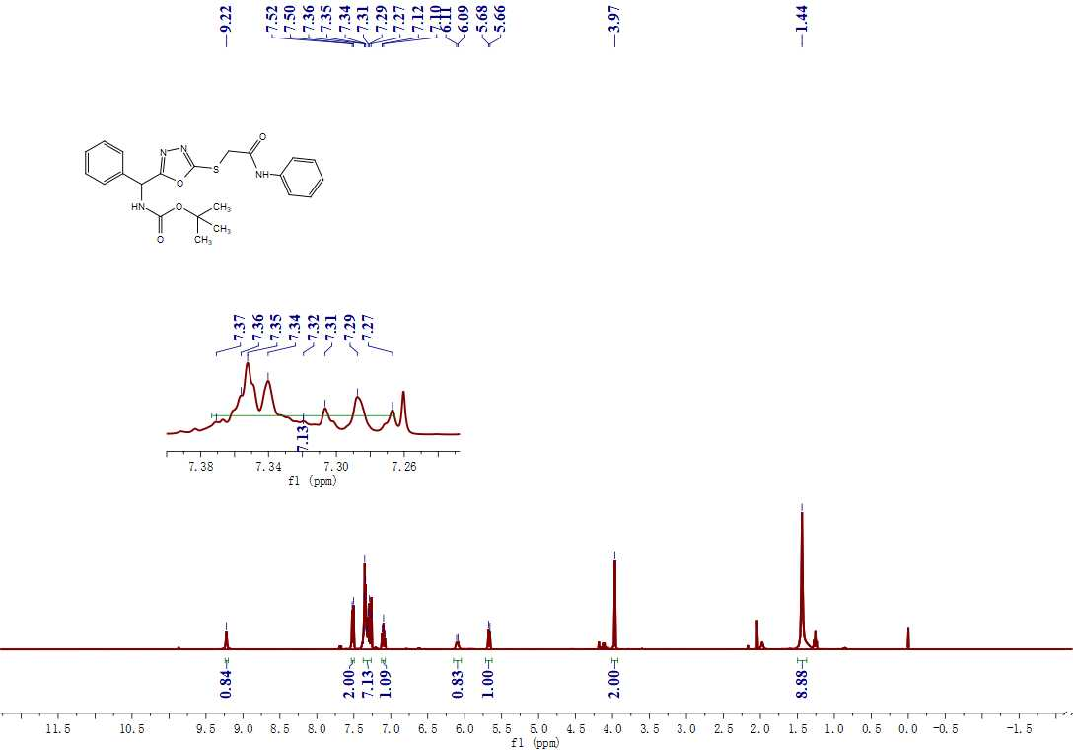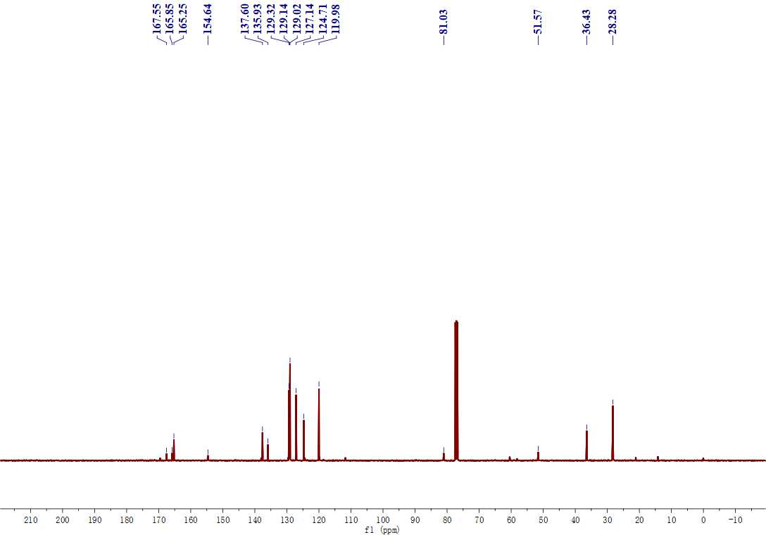
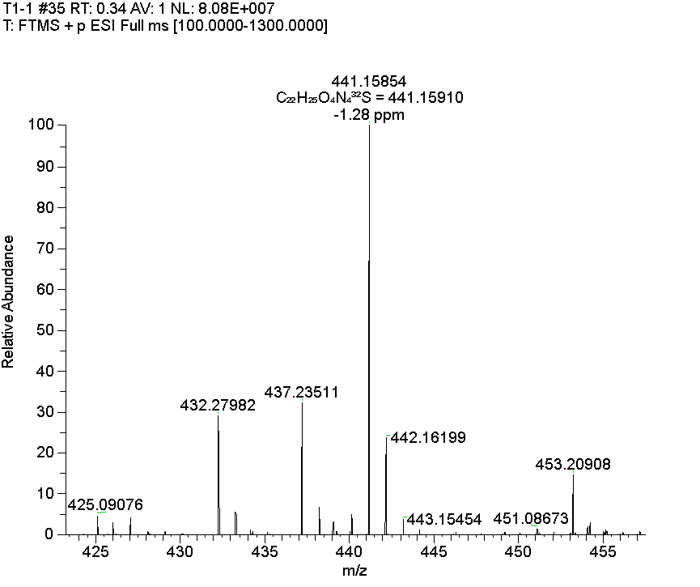
Figure S35. ¹H NMR, ¹³C NMR and HRMS for Ⅲ₁
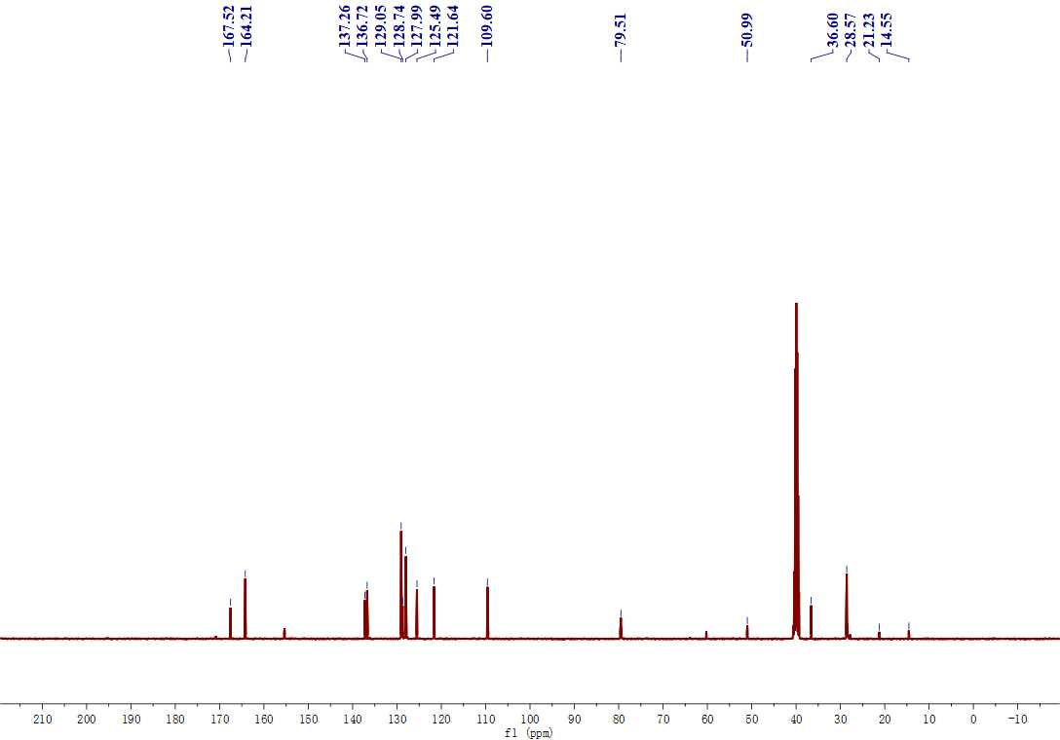
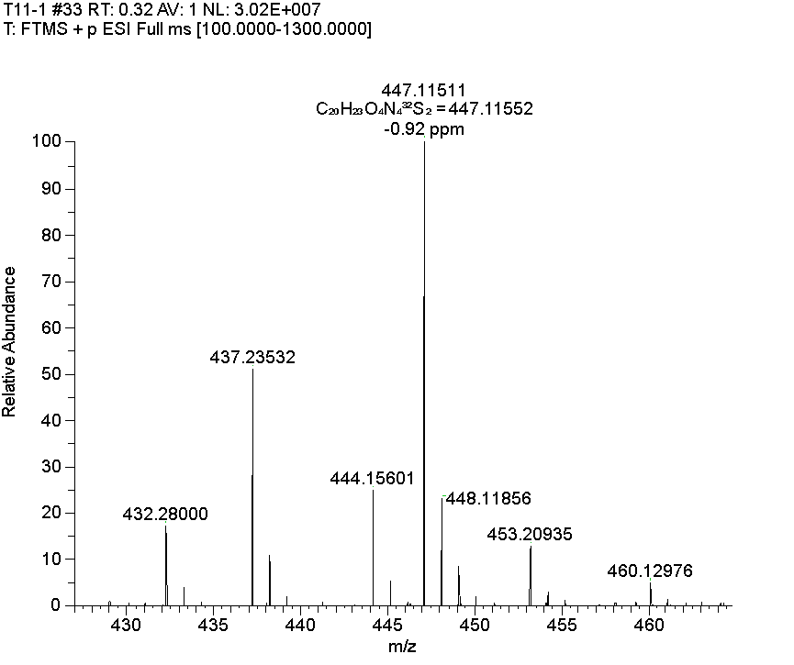
Figure S36. ¹H NMR, ¹³C NMR and HRMS for Ⅲ₂
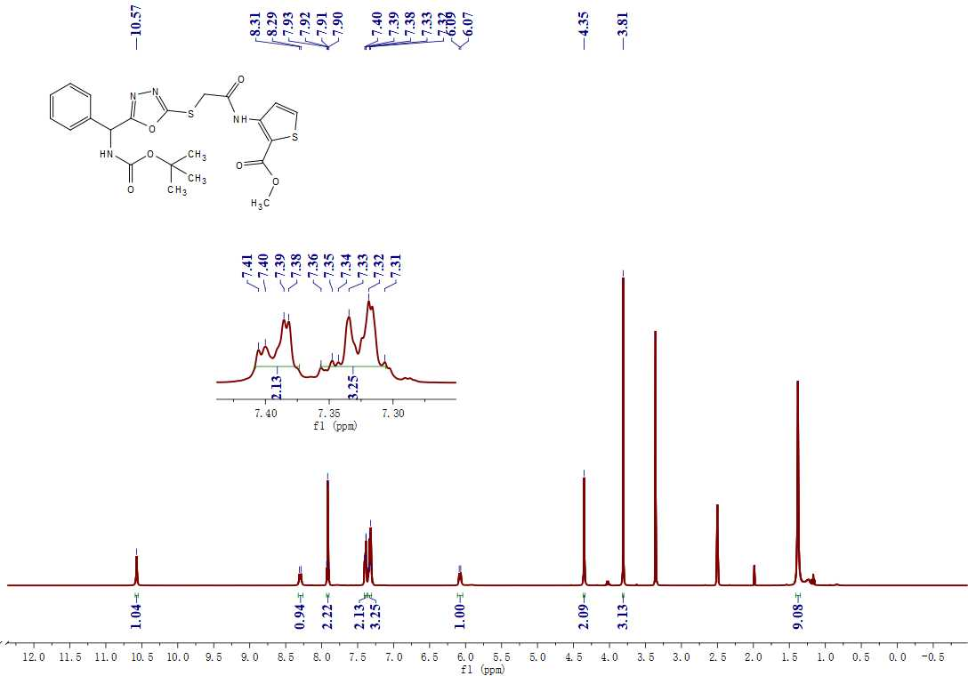
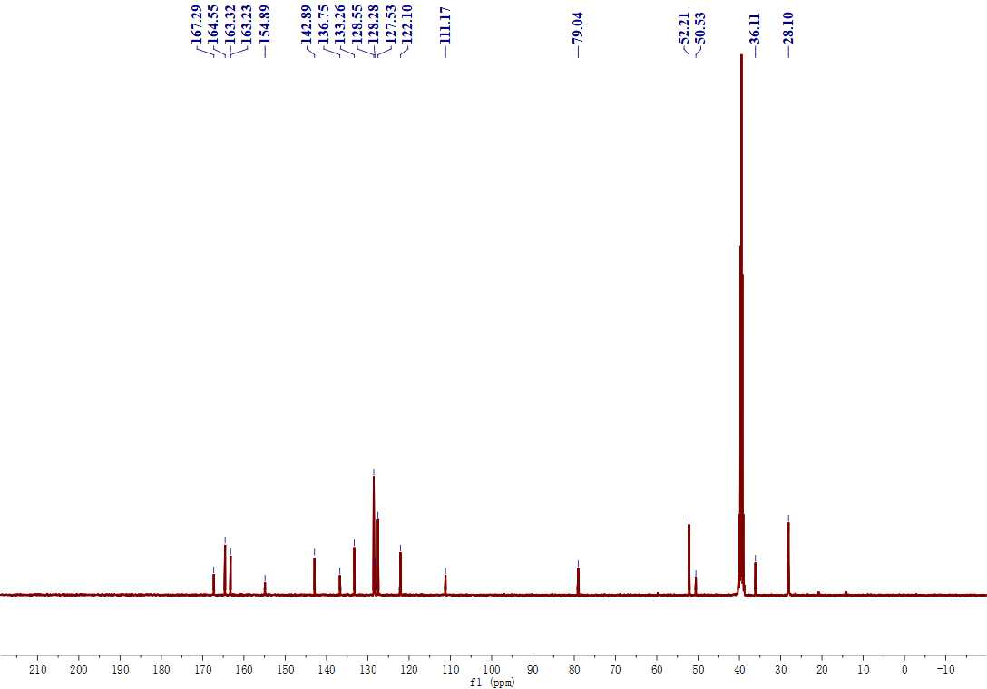
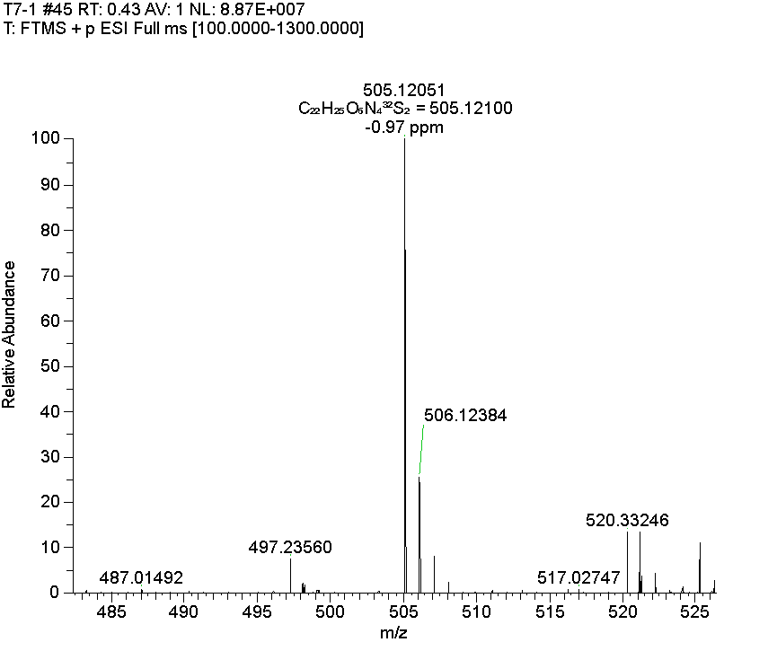
Figure S37. ¹H NMR, ¹³C NMR and HRMS for Ⅲ₃
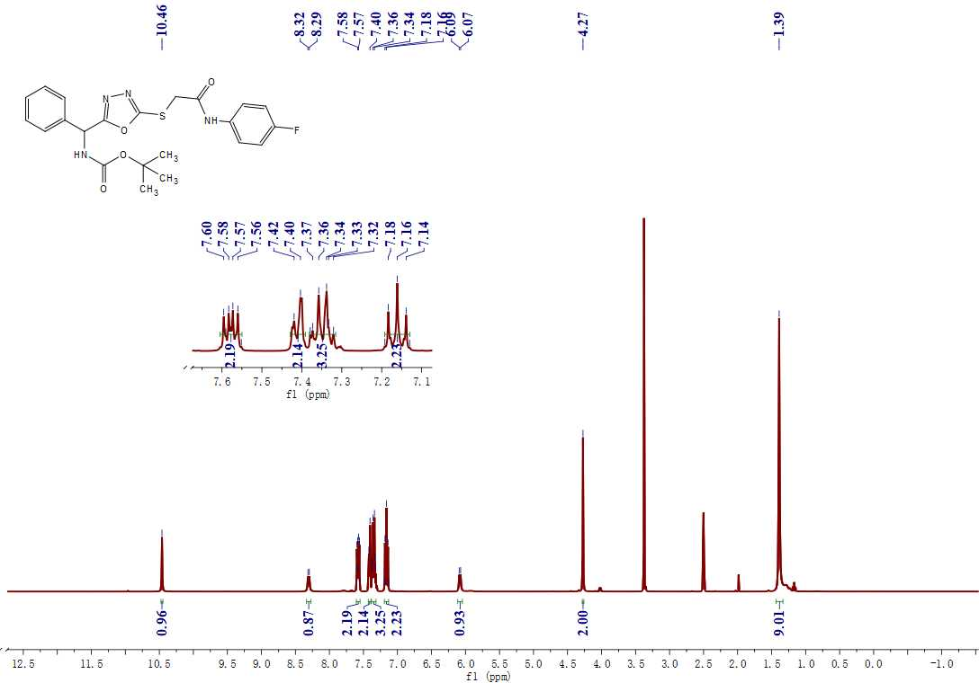
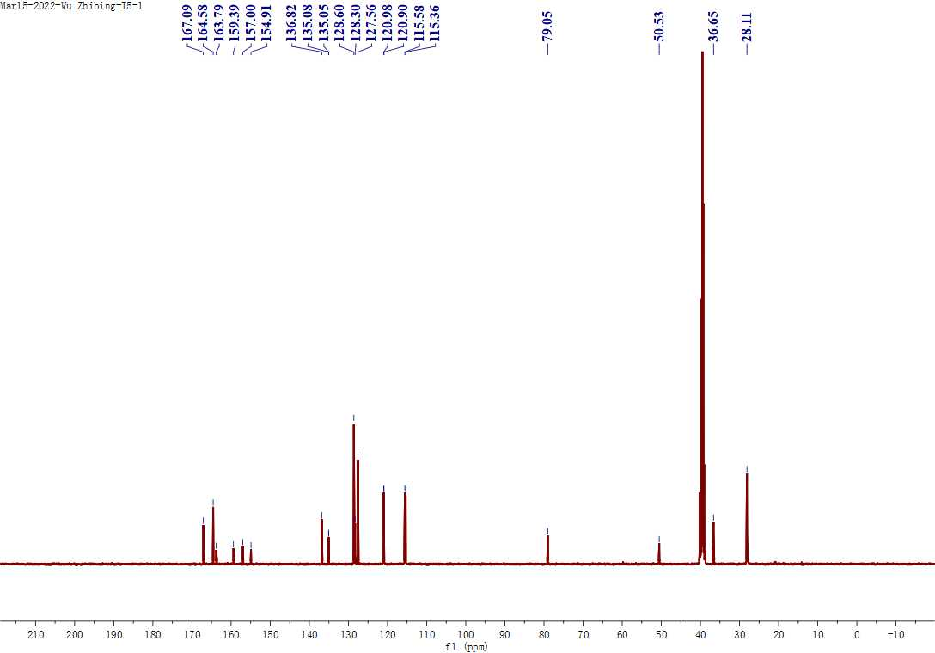
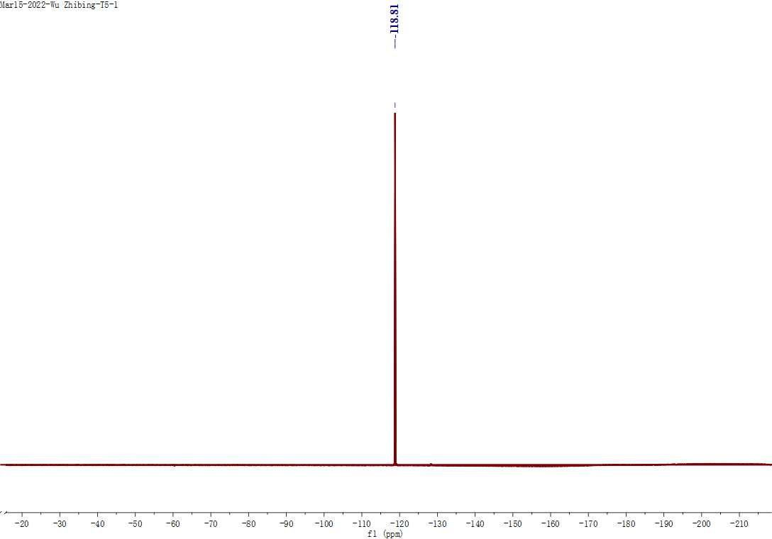
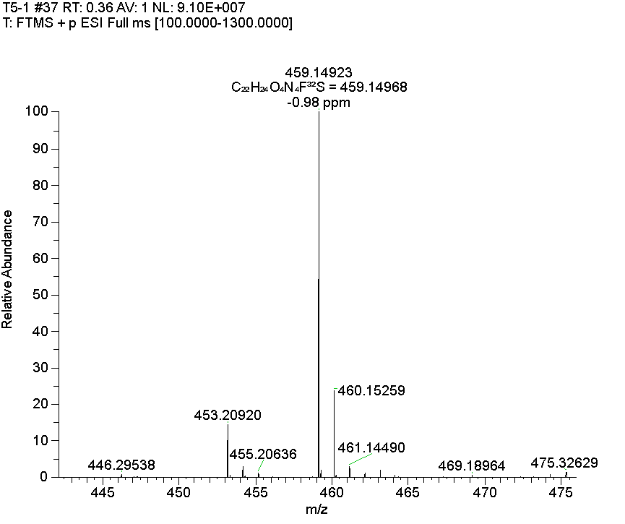
Figure S38. ¹H NMR, ¹³C NMR, ¹⁹F NMR and HRMS for Ⅲ₄
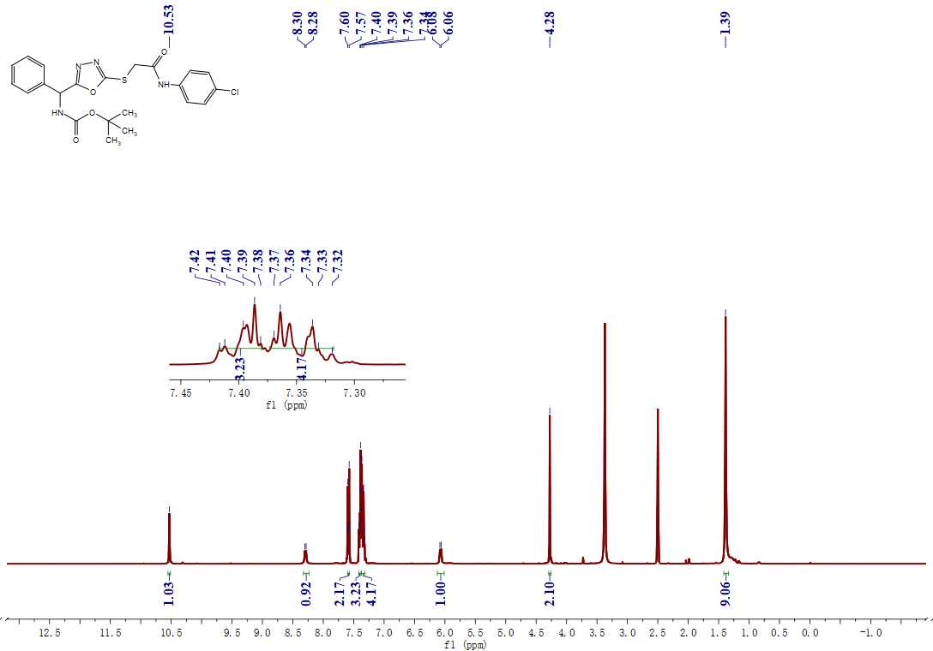
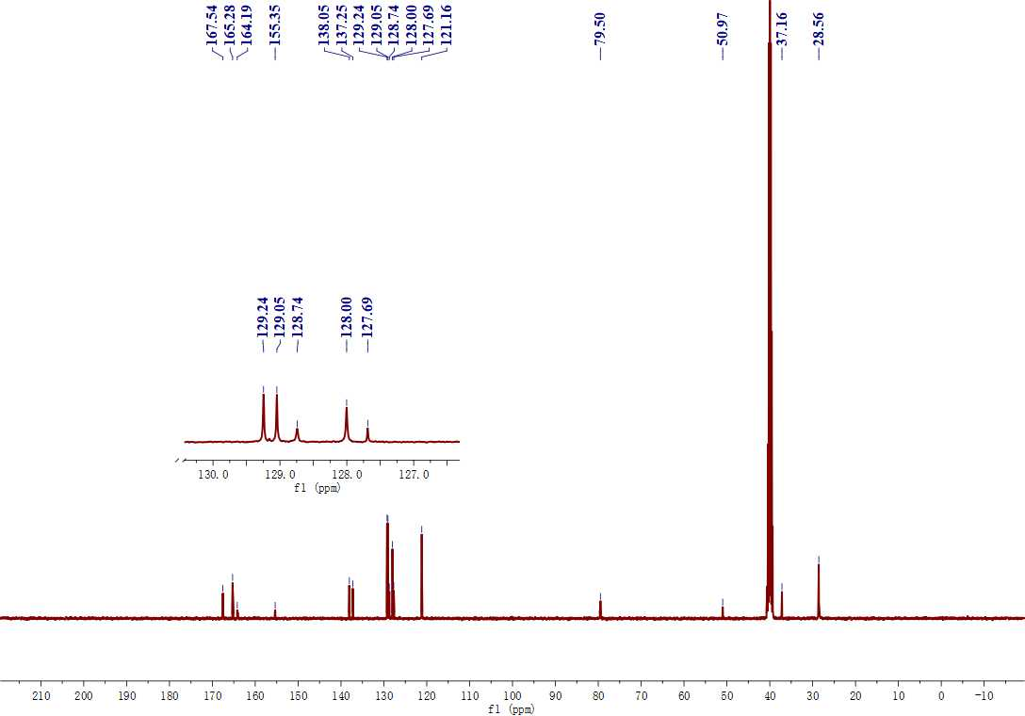
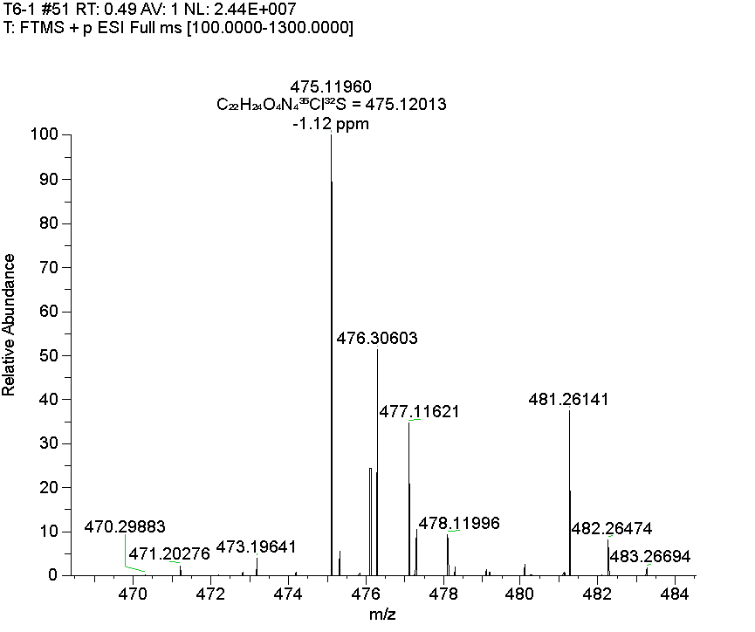
Figure S39. ¹H NMR, ¹³C NMR and HRMS for Ⅲ₅
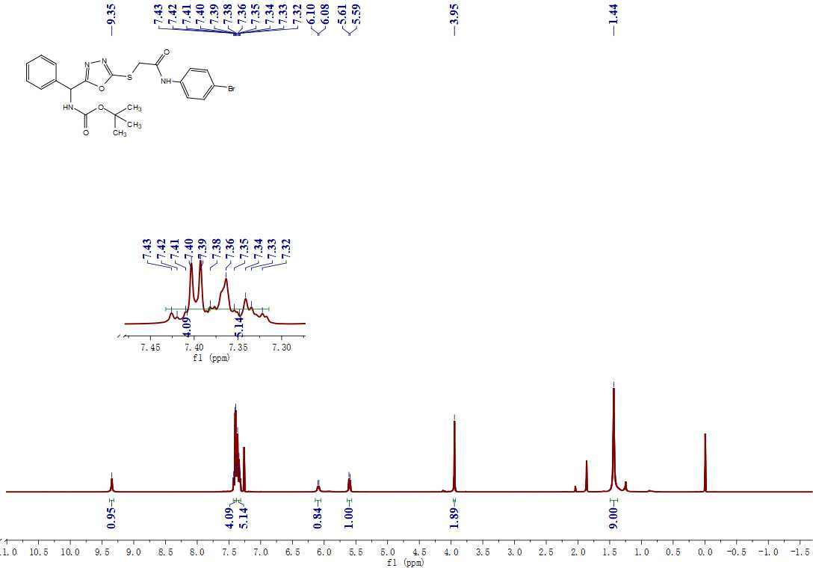
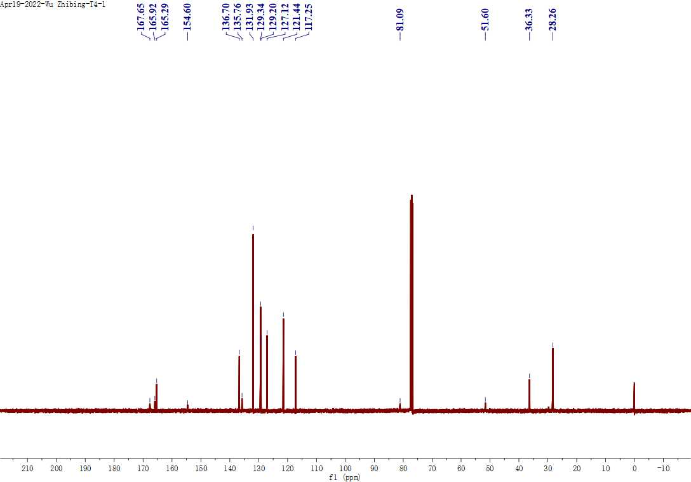
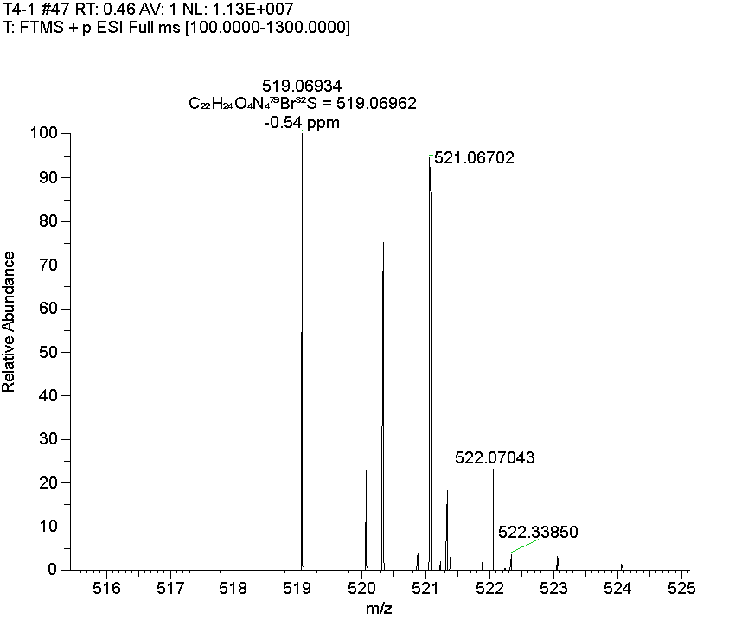
Figure S40. ¹H NMR, ¹³C NMR and HRMS for Ⅲ₆
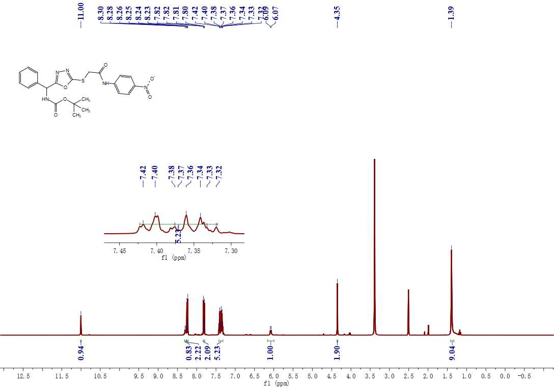
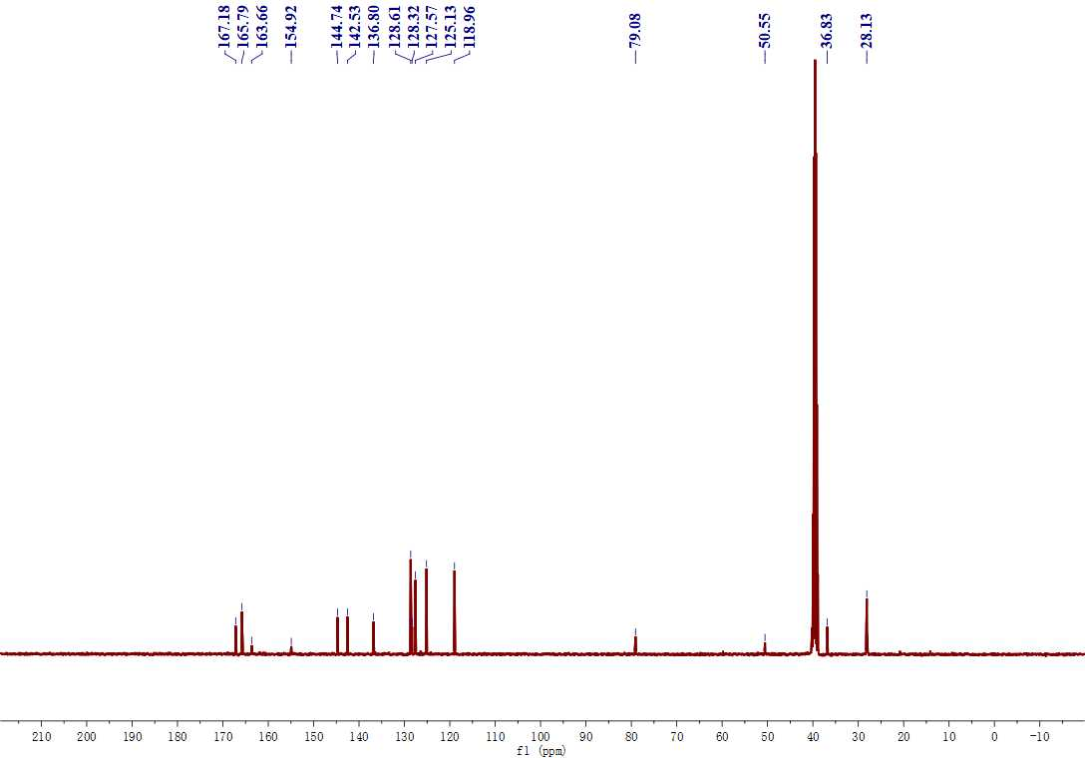
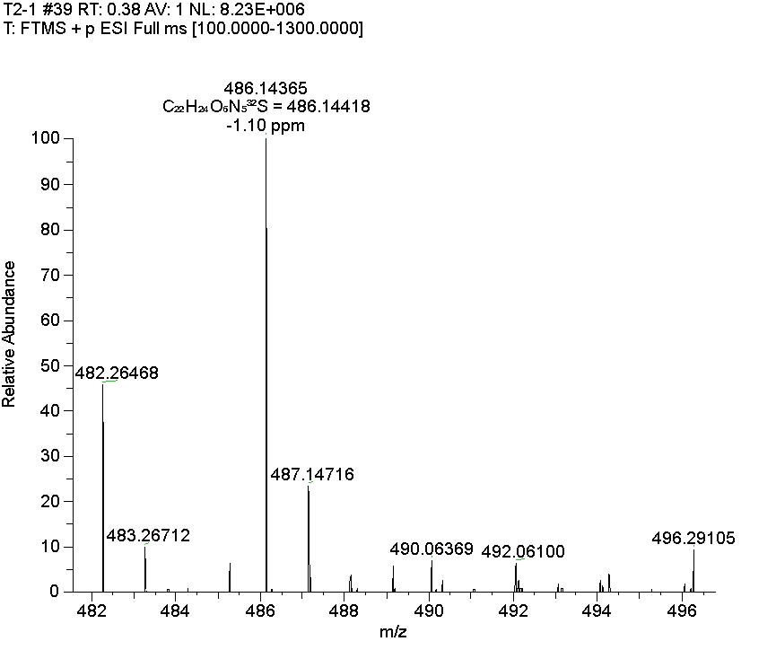
Figure S41. ¹H NMR, ¹³C NMR and HRMS for Ⅲ₇
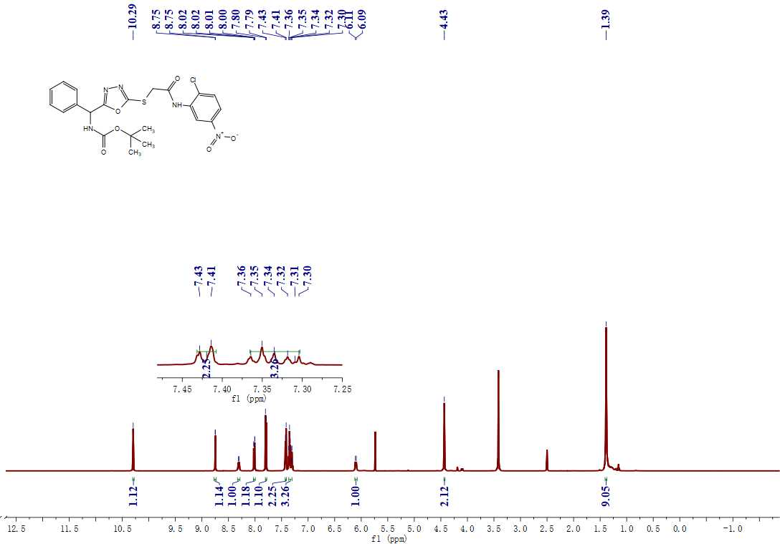
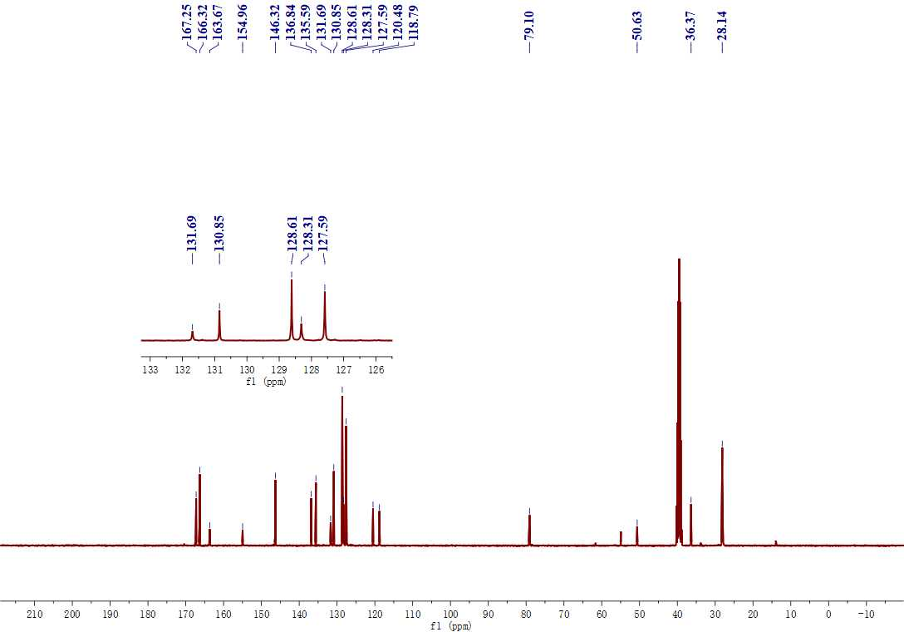
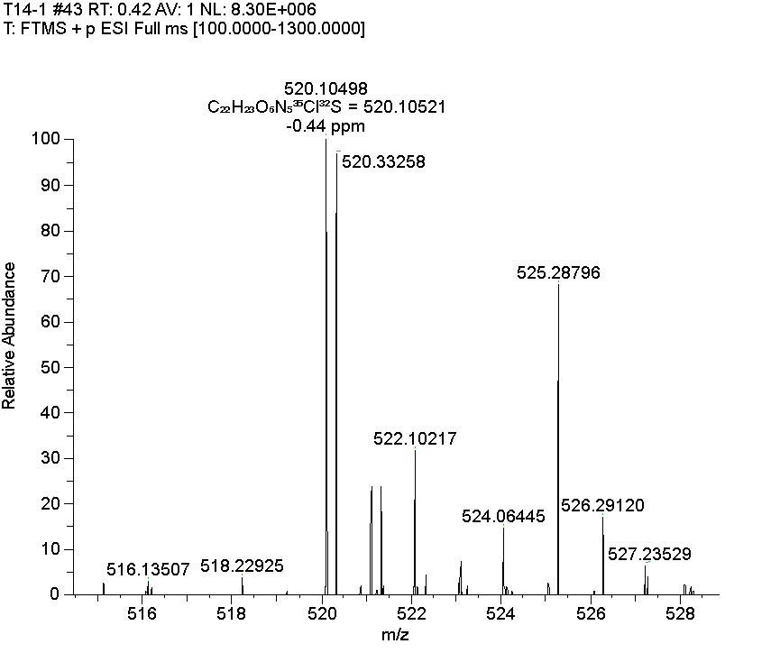Figure S42. ¹H NMR, ¹³C NMR and HRMS for Ⅲ₈
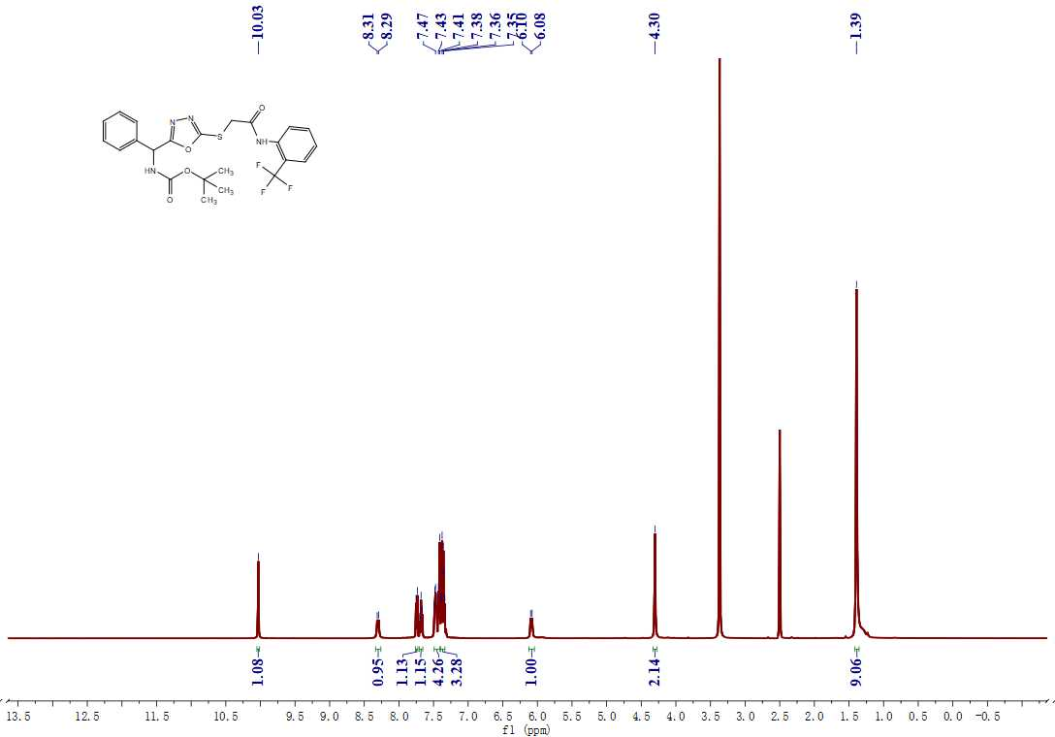
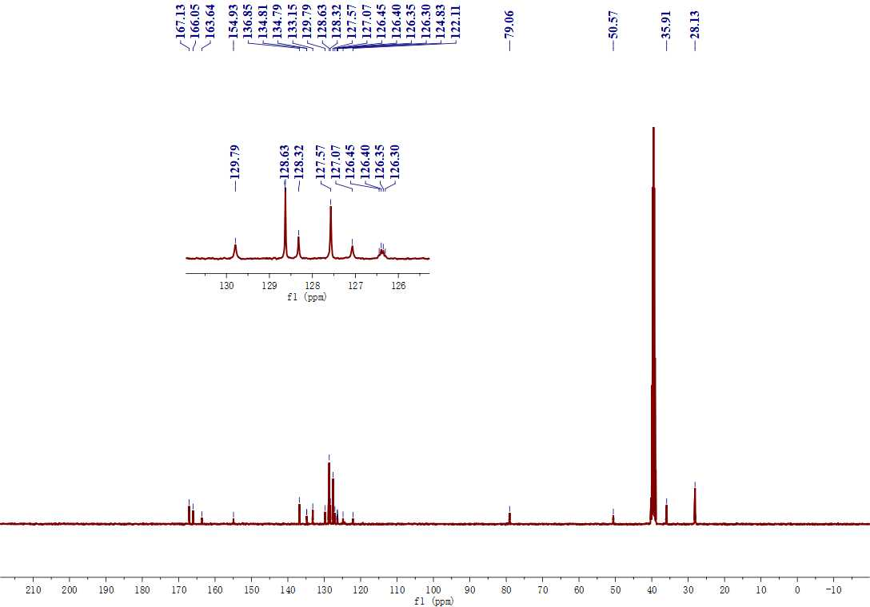
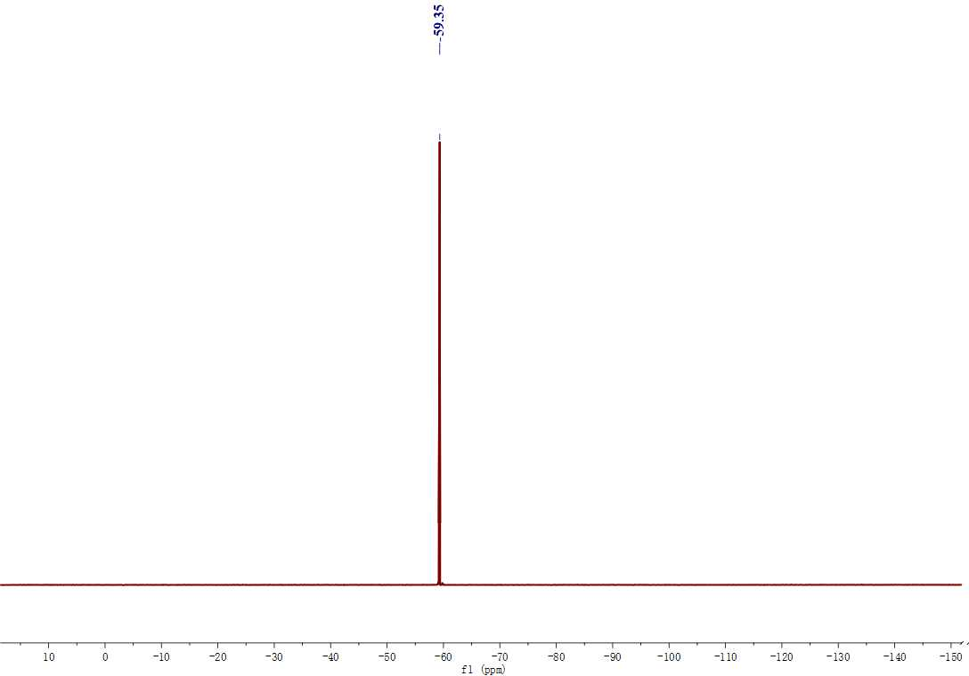
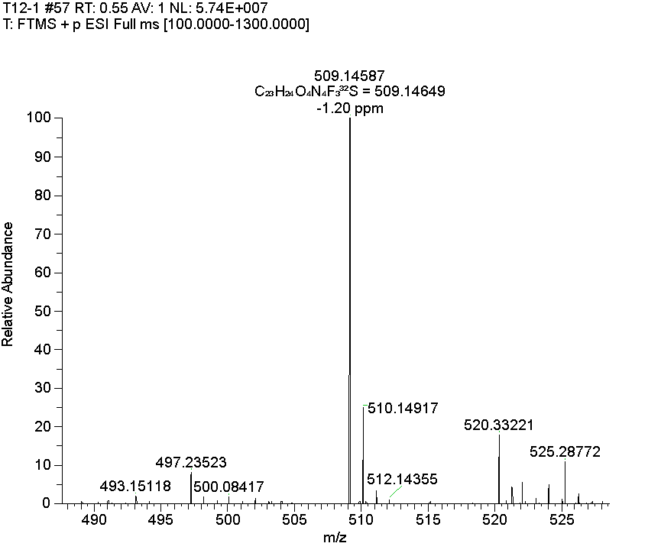
Figure S43. ¹H NMR, ¹³C NMR, ¹⁹F NMR and HRMS for Ⅲ₉
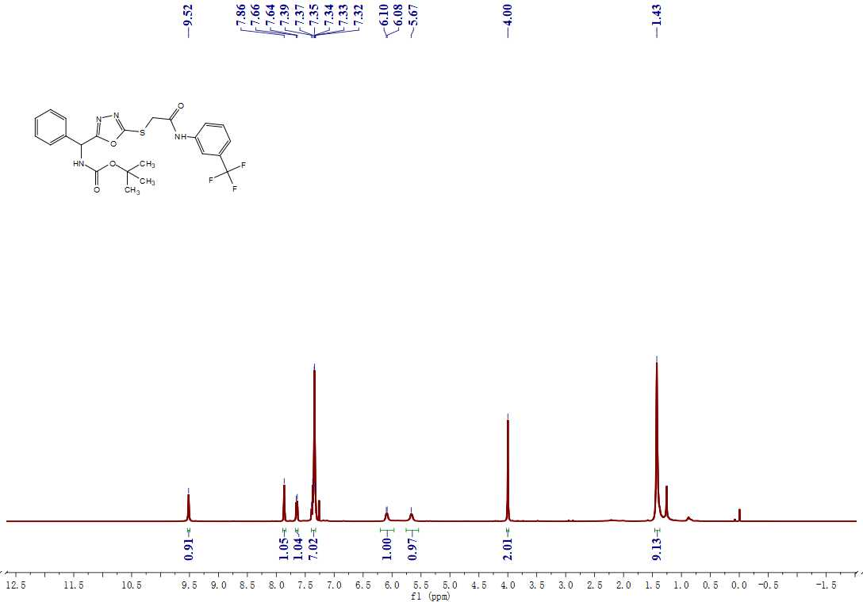

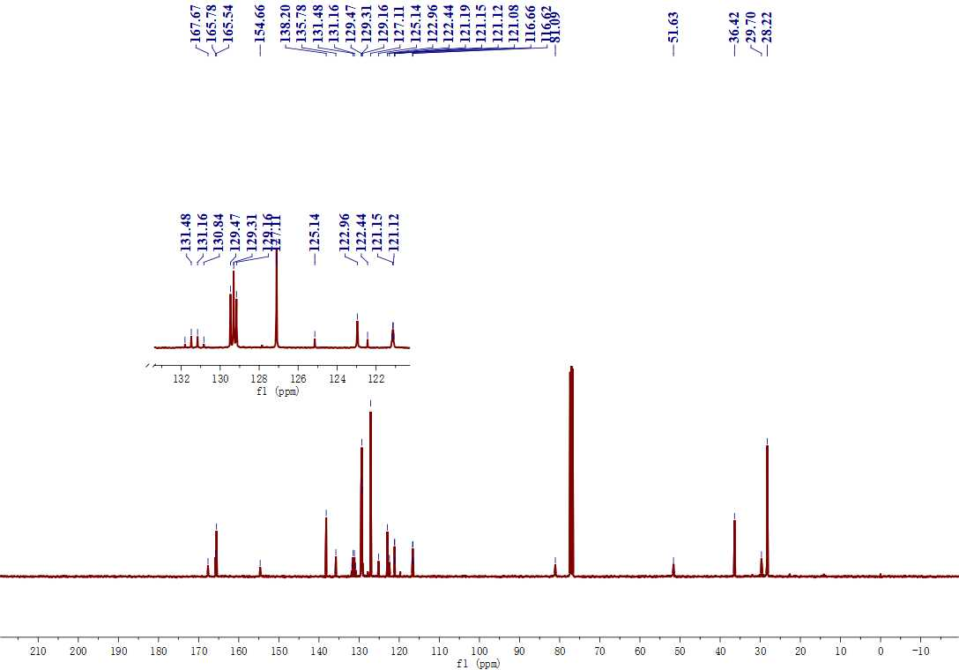
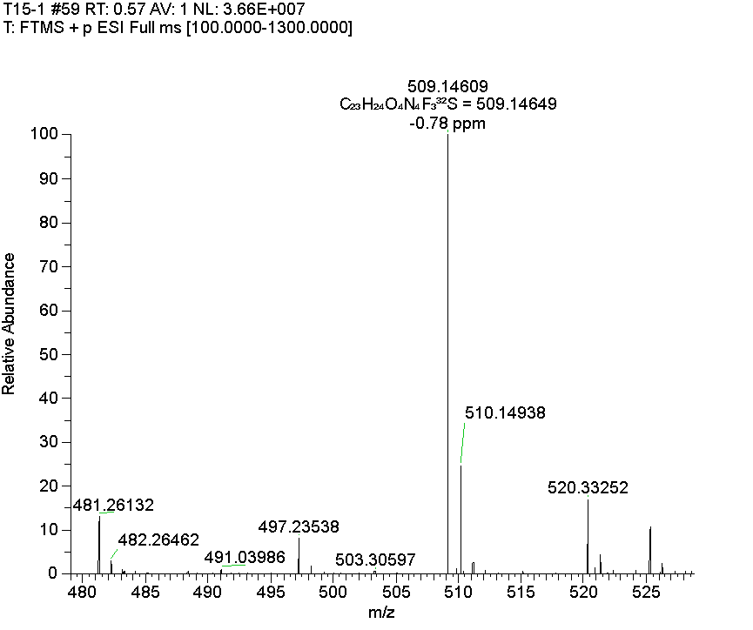
Figure S44. ¹H NMR, ¹³C NMR, ¹⁹F NMR and HRMS for Ⅲ₁₀
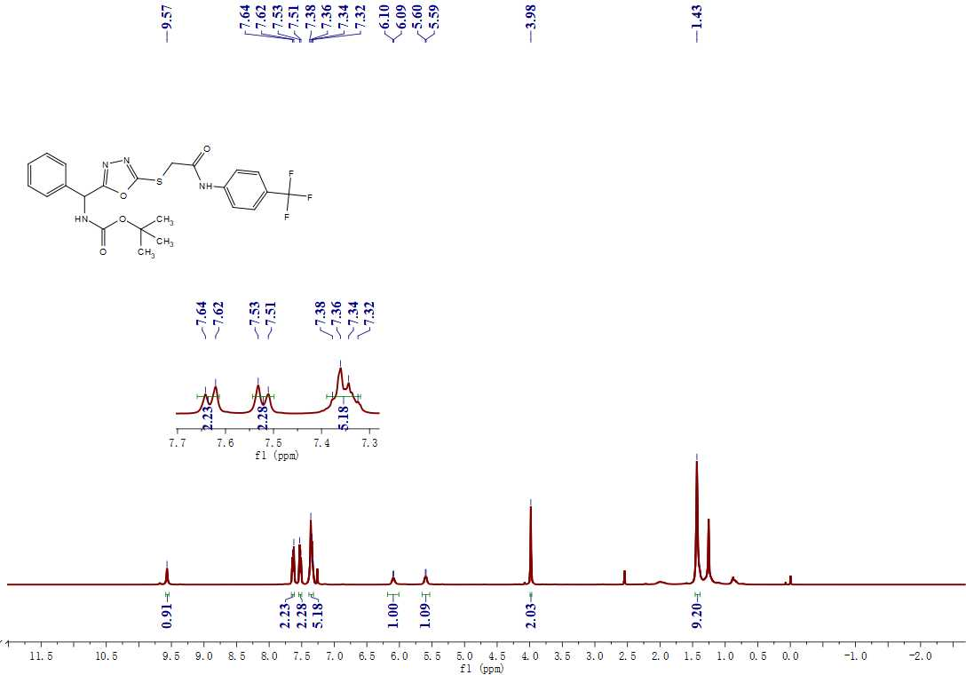
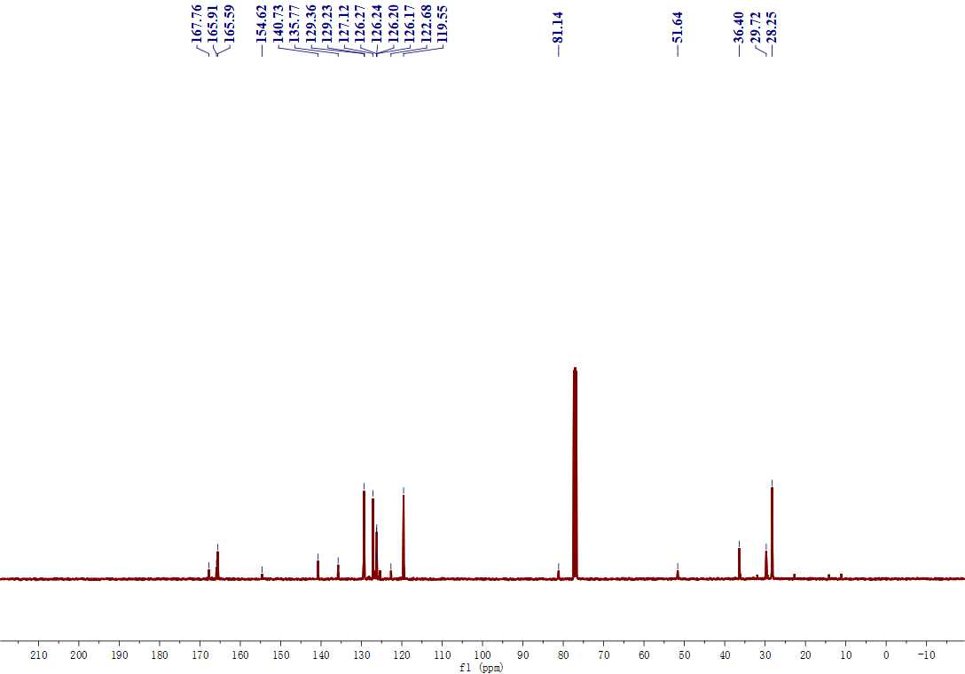
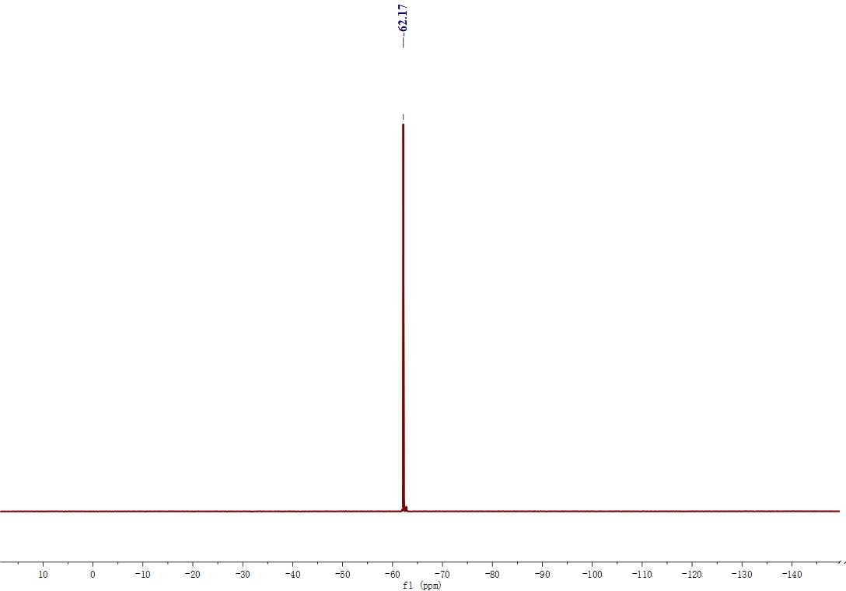
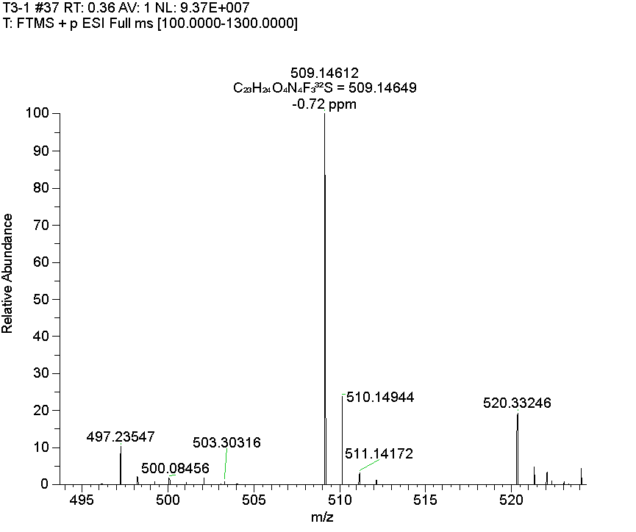
Figure S45. ¹H NMR, ¹³C NMR, ¹⁹F NMR and HRMS for Ⅲ₁₁
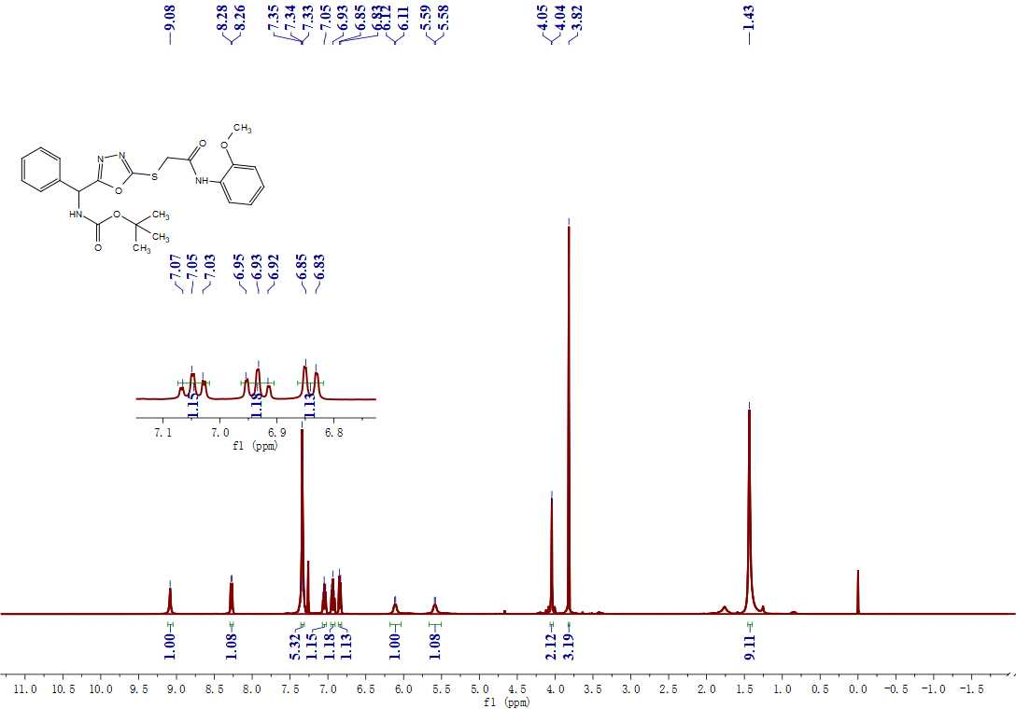
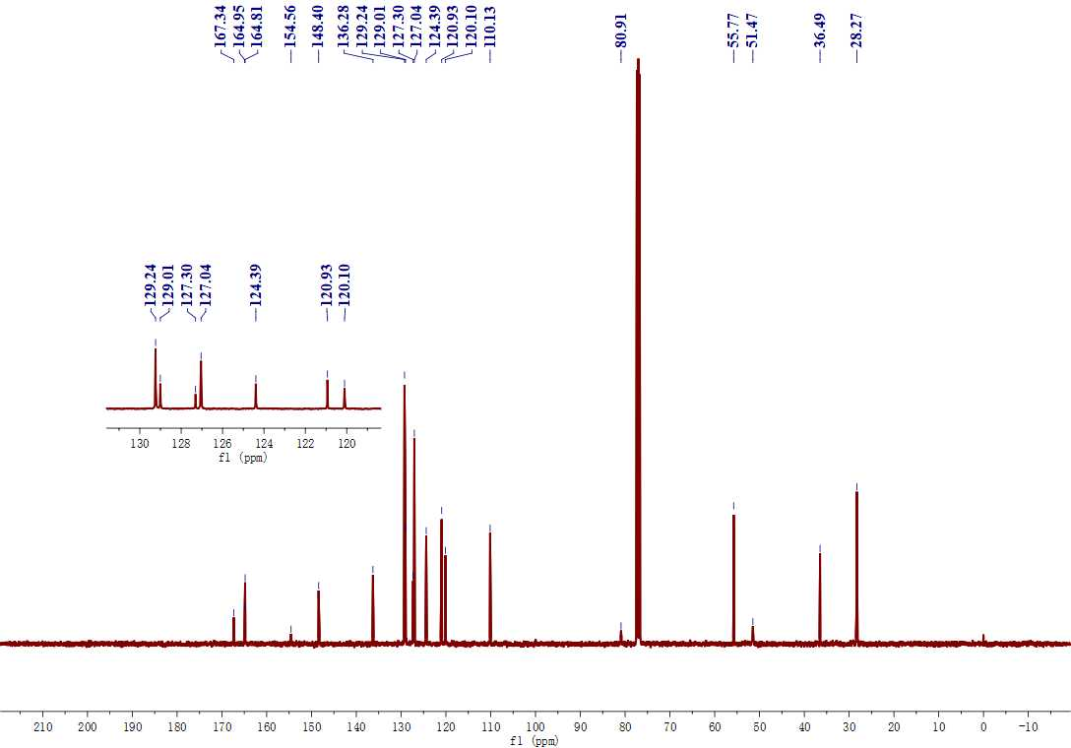
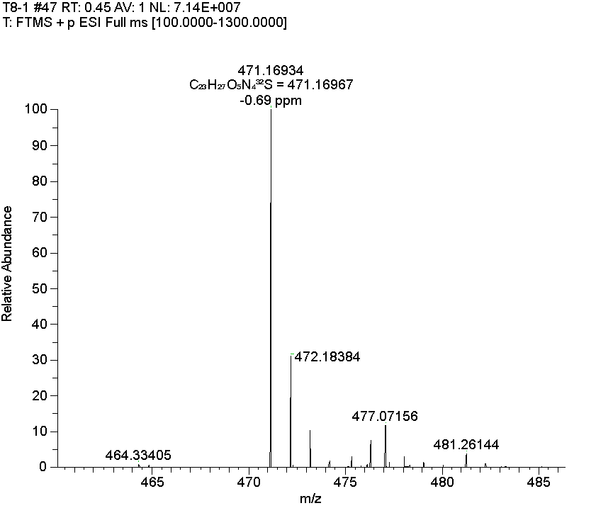
Figure S46. ¹H NMR, ¹³C NMR and HRMS for Ⅲ₁₂
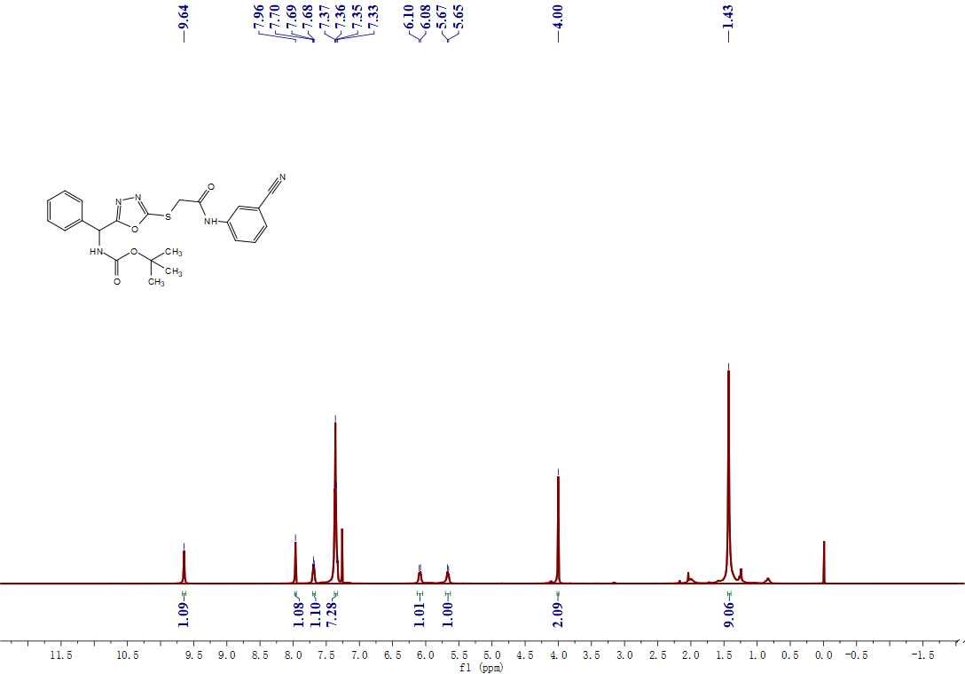
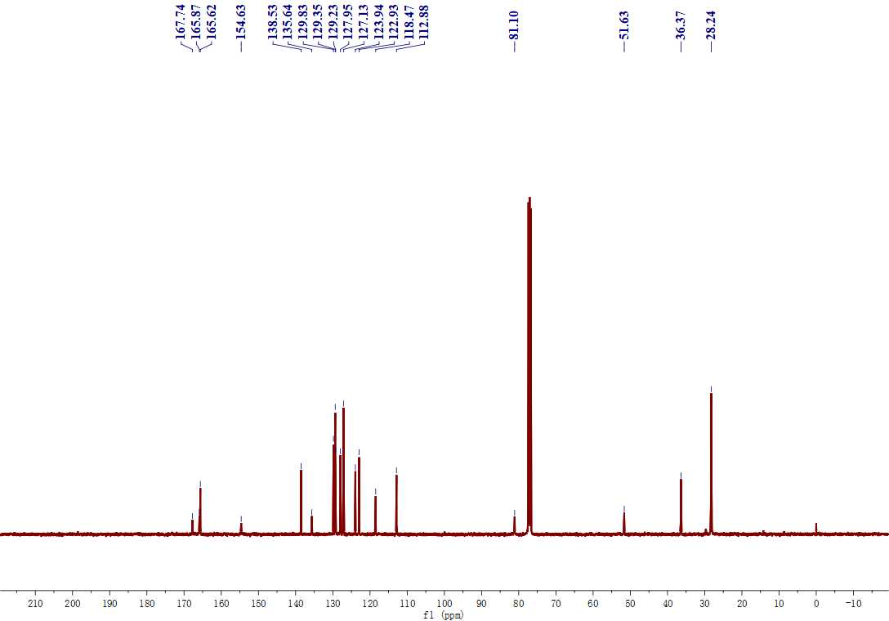
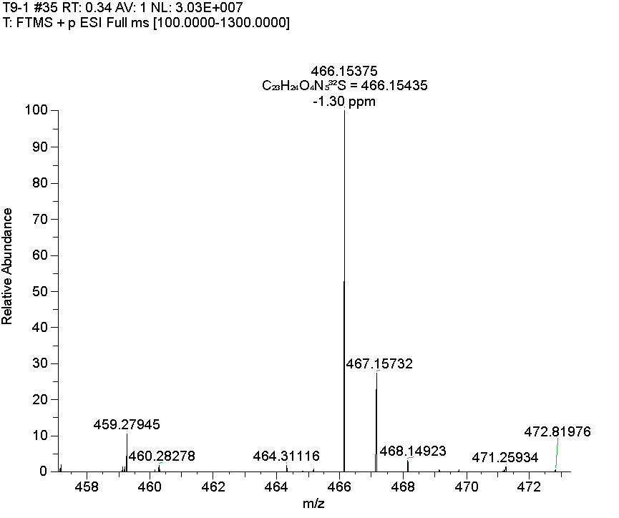
Figure S47. ¹H NMR, ¹³C NMR and HRMS for Ⅲ₁₃
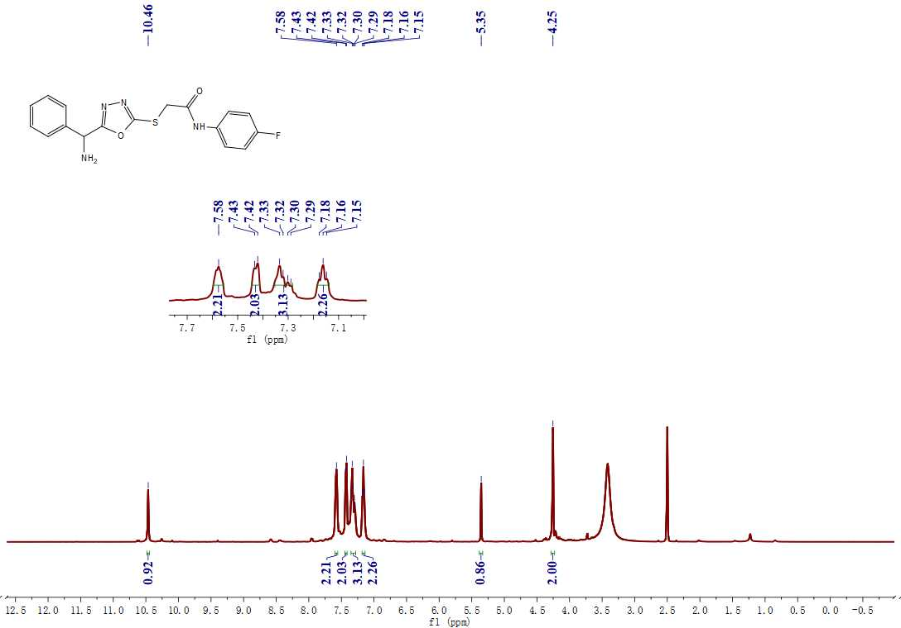
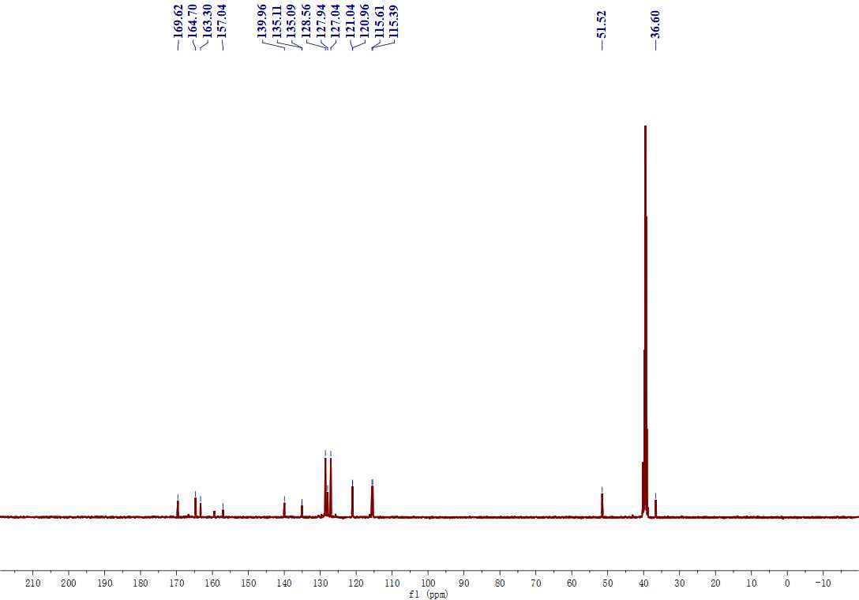
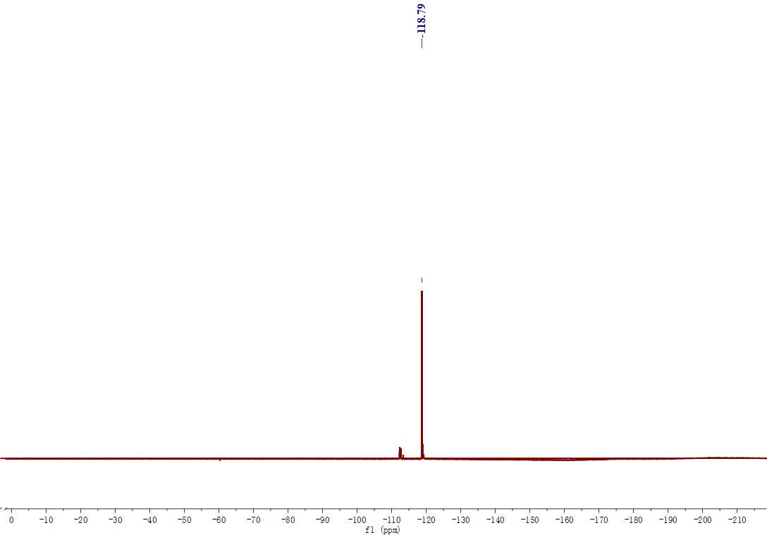
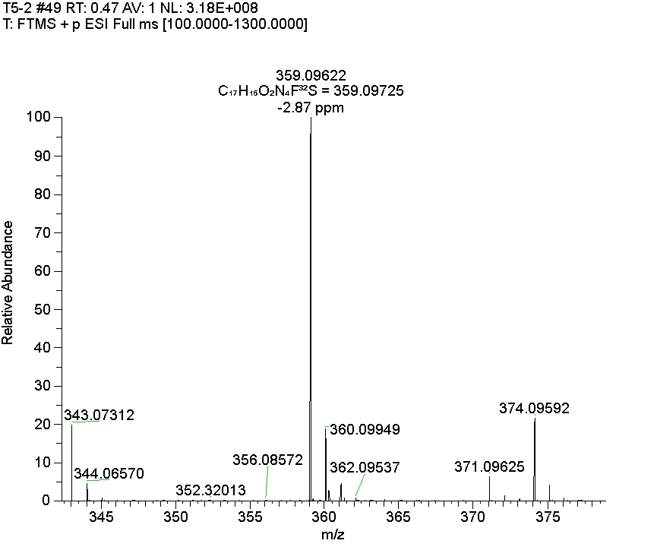
Figure S48. ¹H NMR, ¹³C NMR ¹⁹F NMR and HRMS for Ⅲ₁₄
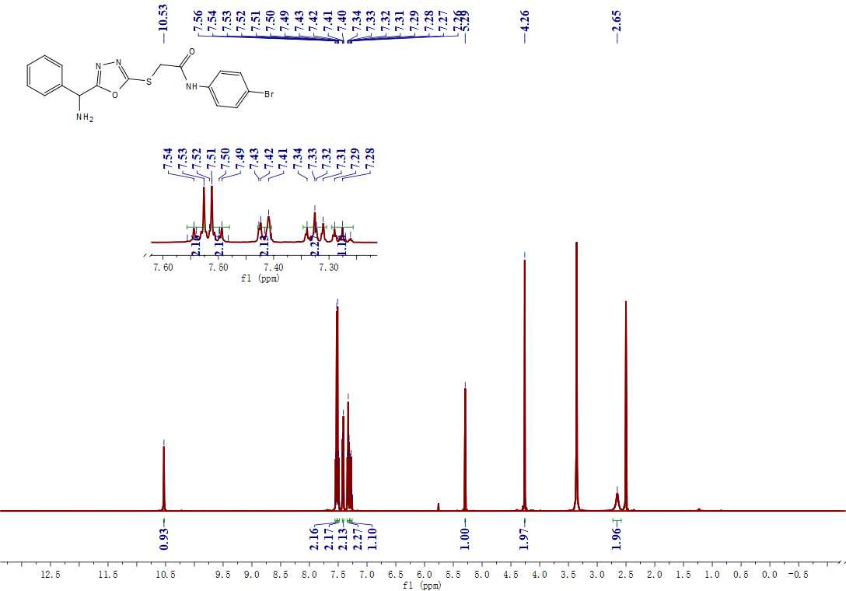
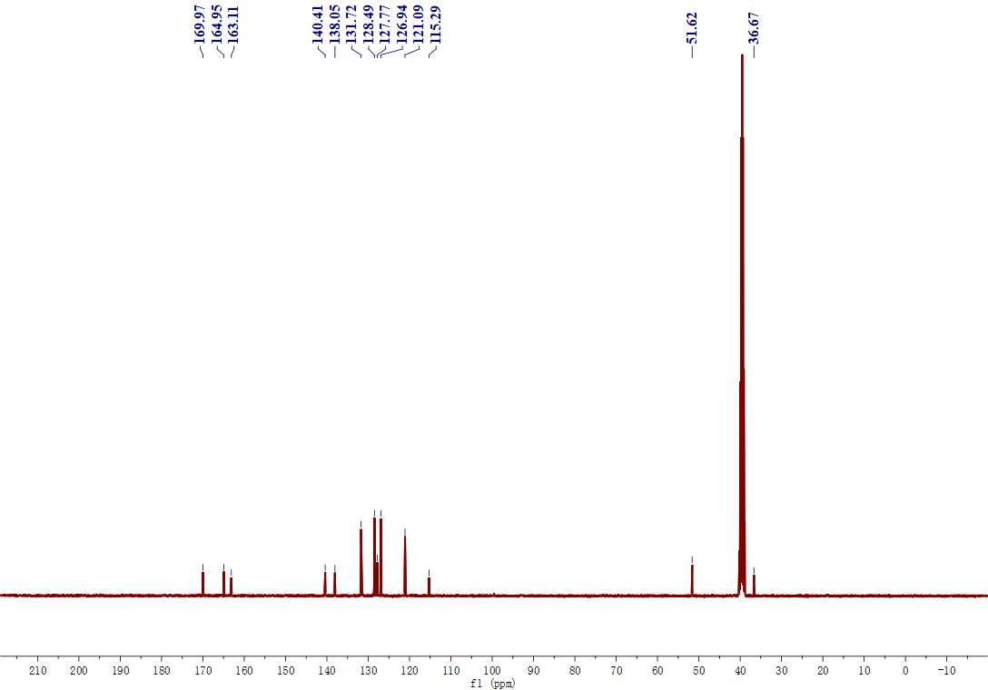
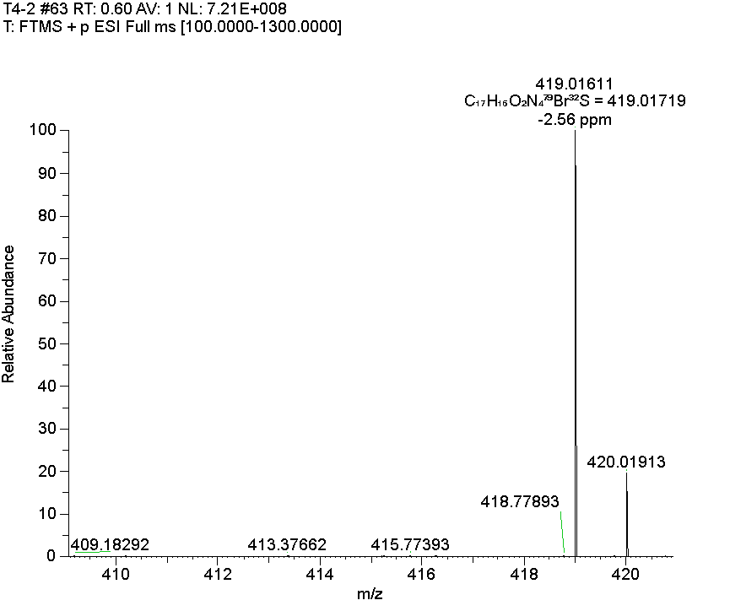
Figure S49. ¹H NMR, ¹³C NMR and HRMS for Ⅲ₁₅
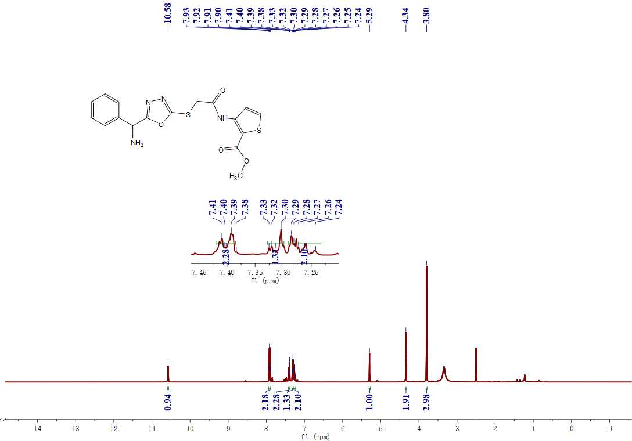
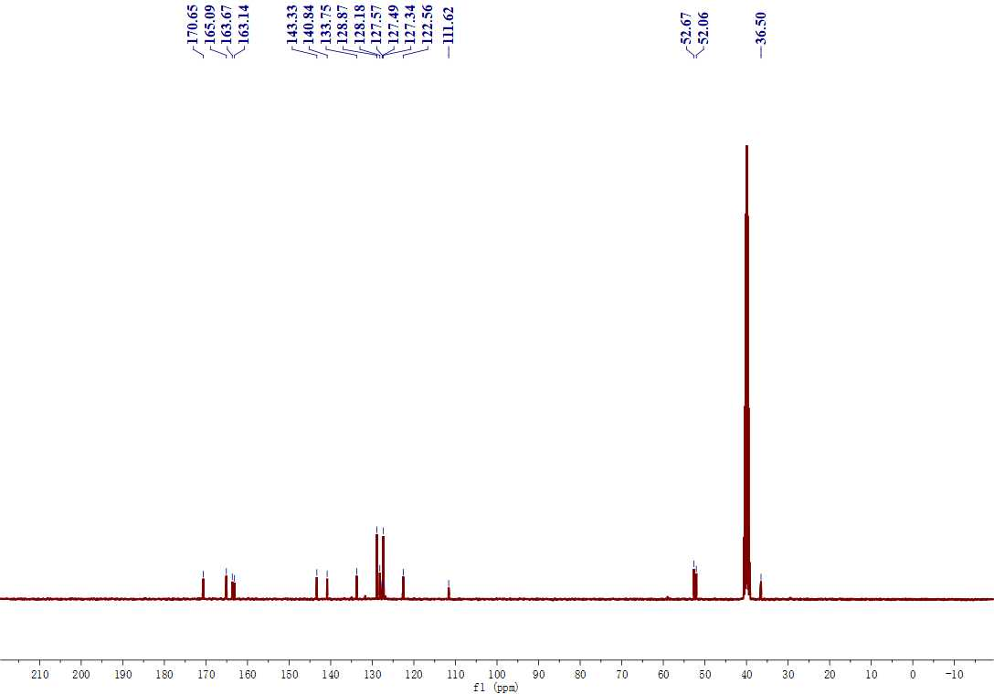
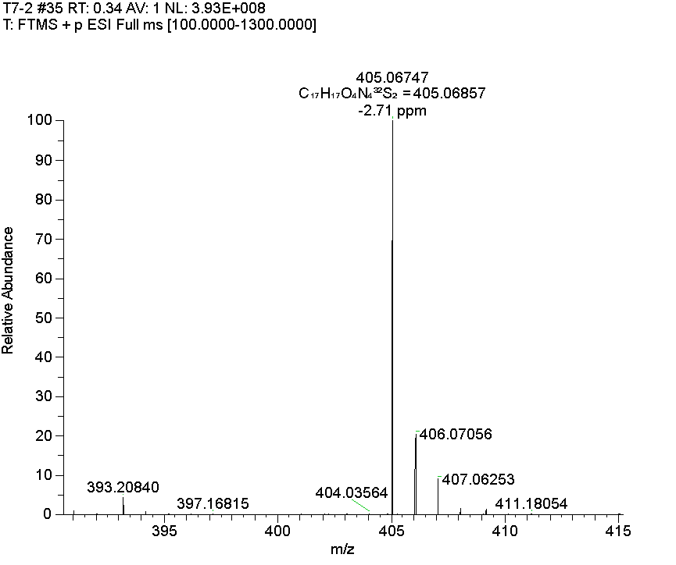
Figure S50. ¹H NMR, ¹³C NMR and HRMS for Ⅲ₁₆
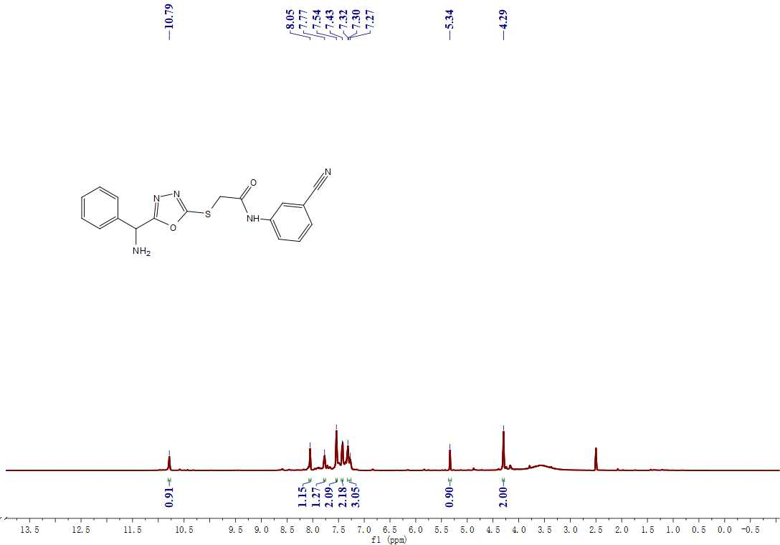
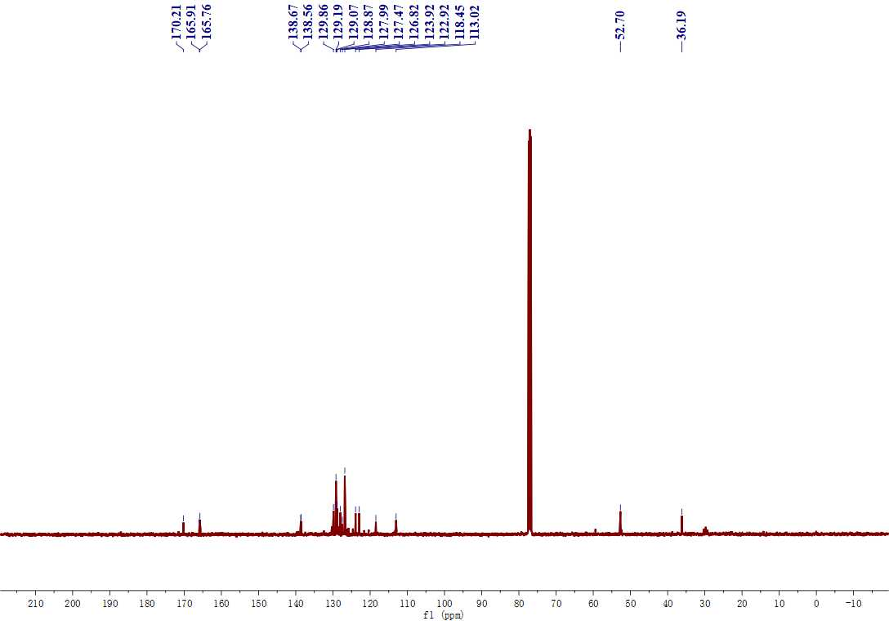
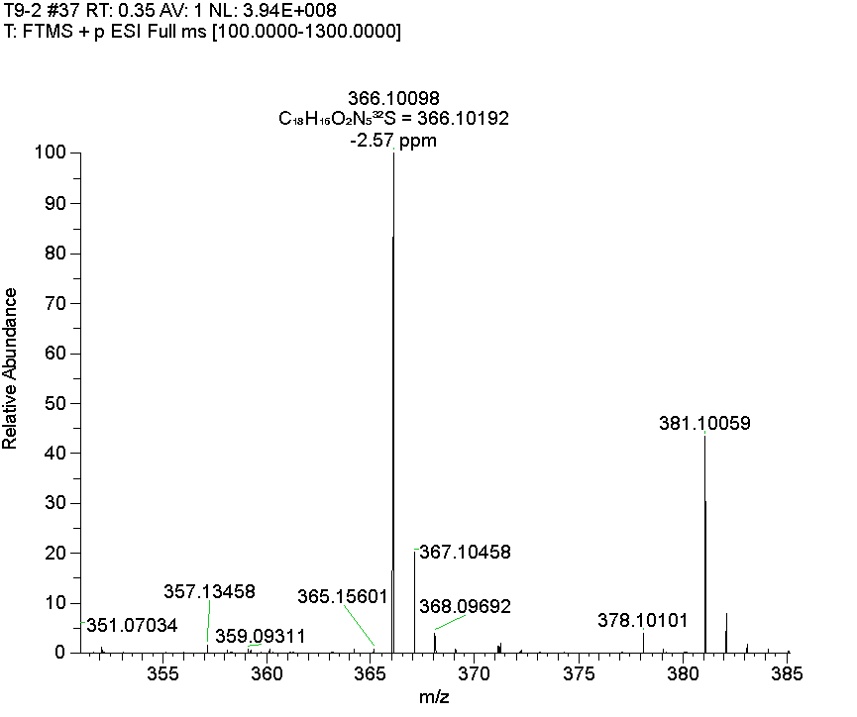
Figure S51. ¹H NMR, ¹³C NMR and HRMS for Ⅲ₁₇

3. In vitro antifungal activity evaluation
According to the mycelial growth inhibition method, all target compounds were preliminary evaluated for in vitro antifungal activity against eight plant pathogenic fungi at the concentration of 50 μg/mL (F. prolifeatum, G. zeae, T. cucumeris, A. solani, N. oryzae, S. sclerotiorum, F. oxysporum, C. camelliae). The sterile distilled water with DMSO (1%) was used as a blank control, and commercial fungicide boscalid was used as a positive control. When the mycelia of the blank control group grew to 6 cm, the diameter of the mycelia of the treatment group was recorded, and each treatment group consists of three replicates. Preliminary screening results are as follows:
Table S1. Inhibitory effect of D and І₁–I₁₈ against eight phytopathogenic fungi at 50 μg/mL.ª
No. | Inhibition ± SD (%)
 | F.P. | G.Z. | T.C. | A.S. | N.O. | S.S. | F.O. | C.C.
D | 0 | 11.8 ± 2.4 | 12.8 ± 3.8 | 16.8 ± 2.1 | 40.0 ± 1.9 | 0 | 35.5 ± 2.0 | 0
І₁ | 27.5 ± 1.8 | 34.1 ± 1.2 | 34.4 ± 1.2 | 47.7 ± 3.2 | 58.4 ± 4.0 | 28.8 ± 1.5 | 24.6 ± 1.2 | 33.7 ± 1.7
І₂ | 0 | 33.5 ± 2.8 | 40.4 ± 3.2 | 42.1 ± 2.1 | 57.8 ± 2.9 | 30.4 ± 2.0 | 25.3 ± 2 | 15.7 ± 5.1
І₃ | 22.1 ± 2.6 | 18.4± 2.9 | 39.4 ± 2.1 | 50.5 ± 2.1 | 67.9 ± 1.1 | 47.4 ± 1.1 | 18.4 ± 1.2 | 0
І₄ | 35.6 ± 2.9 | 31.9 ± 2.5 | 44.3 ± 3.3 | 56.8 ± 2.1 | 67.0 ± 2.0 | 0 | 40.3 ± 3.1 | 0
І₅ | 25.3 ± 2.9 | 48.9 ± 2.3 | 34.8 ± 2.2 | 52.6 ± 2.1 | 55.2 ± 1.9 | 0 | 17.1 ± 2.0 | 23.6 ± 2.7
І₆ | 36.7 ± 1.9 | 39.4 ± 2.6 | 44.7 ± 3.8 | 46.3 ± 5.6 | 55.9 ± 2.9 | 61.4 ± 1.9 | 34.1 ± 3.1 | 19.3 ± 3.4
І₇ | 19.0 ± 1.2 | 29.4 ± 0.9 | 16.0 ± 2.1 | 0 | 41.9 ± 1.2 | 75.9 ± 0.9 | 35.2 ± 1.2 | 45.7±0.5
І₈ | 0 | 22.6 ± 1.2 | 37.6 ± 1.6 | 12.3 ± 3.4 | 47.8 ± 0.6 | 31.0 ± 4.1 | 0 | 36.8 ± 0.6
І₉ | 44.3 ± 1.7 | 0 | 18.1 ± 2.1 | 13.0 ± 2.2 | 47.4 ± 1.0 | 0 | 22.6 ± 1.4 | 29.4 ± 1.0
І₁₀ | 0 | 0 | 9.2 ± 1.6 | 18.9 ± 2.1 | 44.0 ± 1.6 | 79.3 ± 2.5 | 17.3 ± 2.8 | 0
І₁₁ | 10.0 ± 1.0 | 0 | 0 | 17.5 ± 2.4 | 37.1 ± 3.6 | 0 | 9.4 ± 4.6 | 0
І₁₂ | 27.4± 1.7 | 21.4 ± 0.9 | 43.5 ± 2.1 | 55.4 ± 1.5 | 32.7 ± 2.6 | 0 | 0 | 11.6 ± 2.9
І₁₃ | 0 | 15.0 ± 1.2 | 37.2 ± 2.1 | 17.9 ± 2.8 | 43.3 ± 2.1 | 77.1 ± 2.9 | 36.7 ± 2.1 | 0
І₁₄ | 0 | 27.6 ± 0.9 | 58.5 ± 2.1 | 43.9 ± 1.6 | 41.9 ± 1.2 | 0 | 36.1 ± 1.2 | 38.4±1.3
І₁₅ | 0 | 0 | 29.4 ± 1.1 | 0 | 48.3±1.9 | 38.4 ± 2.7 | 15.4 ± 1.8 | 0
І₁₆ | 0 | 23.4 ± 1.6 | 10.6 ± 3.8 | 8.4 ± 2.1 | 40.2 ± 1.0 | 22.5 ± 2.0 | 11.9 ± 1.6 | 33.6 ± 3.1
І₁₇ | 36.2 ± 2.9 | 33.1 ± 1.8 | 44.0 ± 1.6 | 37.9 ± 2.1 | 37.5 ± 1.1 | 0 | 22.6 ± 1.7 | 0
І₁₈ | 26.3 ± 3.6 | 58.6 ± 3.9 | 40.1 ± 3.3 | 51.2 ± 3.2 | 55.9 ± 1.4 | 5.9 ± 1.0 | 25.9 ± 2.4 | 0
BA | 0 | 11.4±1.3 | 94.3 ± 1.6 | 19.6 ± 3.2 | 76.3 ± 1.4 | 79.4 ± 2.0 | 12.3 ± 1.2 | 43.2 ± 2.3
ª Values are means ± SD of three replicates. F.P.: F. prolifeatum, G.Z.: G. zeae, T.C.: T. cucumeris, A.S.: A. solani, N.O.: N. oryzae, S.S.: S. sclerotiorum, F.O.: F. oxysporum, C.C.: C. camelliae, BA: boscalid.
Table S2. Inhibitory effect of compounds Ⅱ₁–Ⅱ₈ against eight phytopathogenic fungi at 50 μg/mL. ª
No | Inhibition ± SD (%)
 | F.P. | G.Z. | T.C. | A.S. | N.O. | S.S. | F.O. | C.C.
Ⅱ₁ | 0 | 33.5 ± 2.7 | 49.3 ± 4.3 | 49.8 ± 3.2 | 55.1 ± 1.3 | 0 | 37.4 ± 3.1 | 25.3 ± 1.8
Ⅱ₂ | 0 | 11.1 ± 2.7 | 52.1 ± 2.4 | 22.5 ± 4.3 | 37.4 ± 2.5 | 33.7 ± 5.8 | 0 | 0
Ⅱ₃ | 13.1 ± 1.2 | 0 | 0 | 26.7 ± 1.0 | 19.0 ± 2.5 | 42.1 ± 1.4 | 0 | 0
Ⅱ₄ | 20.6 ± 2.1 | 0 | 15.4 ± 2.4 | 22.4 ± 3.0 | 13.6 ± 2.5 | 44.6 ± 1.5 | 0 | 19.6 ± 3.2
Ⅱ₅ | 18.6 ± 2.1 | 0 | 18.9 ± 2.1 | 18.5 ± 3.0 | 0 | 0 | 17.7 ± 1.2 | 16.8 ± 2.1
Ⅱ₆ | 11.7 ± 2.4 | 0 | 0 | 0 | 0 | 0 | 35.3 ± 2.1 | 14.0 ± 0.6
Ⅱ₇ | 23.4 ± 1.2 | 0 | 0 | 21.8 ± 2 | 15.7 ± 3.4 | 24.1 ± 2.3 | 13.4 ± 3.2 | 22.1 ± 1.1
Ⅱ₈ | 0 | 0 | 0 | 22.1 ± 2.1 | 11.4 ± 3.3 | 13.2 ± 3.4 | 0 | 11.9 ± 3.2
BA | 0 | 11.4±1.3 | 94.3 ± 1.6 | 19.6 ± 3.2 | 76.3 ± 1.4 | 79.4 ± 2.0 | 12.3 ± 1.2 | 43.2 ± 2.3
ª Values are means ± SD of three replicates. F.P.: F. prolifeatum, G.Z.: G. zeae, T.C.: T. cucumeris, A.S.: A. solani, N.O.: N. oryzae, S.S.: S. sclerotiorum, F.O.: F. oxysporum, C.C.: C. camelliae, BA: boscalid.
Table S3. Inhibitory effect of compounds Ⅲ₁–Ⅲ₁₇ against eight phytopathogenic fungi at 50 μg/mL. ª
No. | Inhibition ± SD (%)
 | F.P. | G.Z. | T.C. | A.S. | N.O. | S.S. | F.O. | C.C.
Ⅲ₁ | 20.5 ± 1.0 | 22.4 ± 0.9 | 41.5 ± 2.1 | 41.4 ± 3.2 | 53.3 ± 1.6 | 17.3 ± 3.0 | 18.4 ± 1.9 | 33.4 ± 1.8
Ⅲ₂ | 27.5 ± 1.1 | 19.3 ± 1.0 | 44.0 ± 1.6 | 54.7 ± 2.1 | 60.1 ± 1.0 | 0 | 27.5 ± 1.1 | 0
Ⅲ₃ | 0 | 0 | 0 | 14.7 ± 2.1 | 44.0 ± 3.1 | 25.8 ± 3.0 | 0 | 24.5 ± 2.0
Ⅲ₄ | 17.2 ± 1.0 | 20.6 ± 2.0 | 39.4 ± 2.1 | 32.6 ± 1.8 | 63.2 ± 4.3 | 11.4 ± 4.1 | 29.7 ±1.9 | 28.3 ± 1.9
Ⅲ₅ | 0 | 14.6 ± 1.7 | 52.5 ± 2.7 | 64.6 ± 1.2 | 41.5 ± 1.1 | 70.2 ± 2.4 | 0 | 18.4 ± 1.5
Ⅲ₆ | 10.0 ± 1.0 | 32.1 ± 1.5 | 52.8 ± 3.3 | 42.8 ± 1.2 | 52.6 ± 1.0 | 44.1 ± 2.0 | 14.5 ± 1.1 | 0
Ⅲ₇ | 21.0 ± 1.1 | 34.2 ± 1.0 | 0 | 63.9 ± 1.2 | 71.8 ± 1.2 | 41.5 ± 1.1 | 23.0 ± 1.1 | 0
Ⅲ₈ | 18.9 ± 1.3 | 0 | 0 | 40.0 ± 2.1 | 45.2 ± 2.0 | 13.4 ± 1.1 | 0 | 31.9±1.7
Ⅲ₉ | 0 | 0 | 41.5 ± 2.1 | 17.5 ± 1.2 | 63.1 ± 2.0 | 18.6 ± 3.9 | 21.0±1.1 | 0
Ⅲ₁₀ | 0 | 0 | 0 | 57.2 ± 1.6 | 53.3 ± 1.9 | 0 | 17.1 ± 2.0 | 0
Ⅲ₁₁ | 16.6 ± 1.0 | 19.3 ± 1.8 | 0 | 40.7 ± 3.2 | 81.9 ± 1.0 | 13.4 ± 4.1 | 12.3 ± 3.1 | 25.4 ± 0.9
Ⅲ₁₂ | 10.5 ± 2.0 | 31.3 ± 0.5 | 51.4 ± 4.4 | 54.0 ± 3.2 | 46.5 ± 1.2 | 27.1 ± 1.1 | 12.5 ± 2.0 | 0
Ⅲ₁₃ | 10.5 ± 1.0 | 19.1 ± 0.8 | 28.7 ± 2.1 | 41.4 ± 3.2 | 50.9 ± 1.2 | 25.2 ± 3.0 | 41.3 ± 1.9 | 0
Ⅲ₁₄ | 0 | 0 | 21.3 ± 1.1 | 12.6 ± 2.1 | 21.9 ± 1.2 | 56.5 ± 3.0 | 15.7±1.1 | 0
Ⅲ₁₅ | 0 | 12.9 ± 1.7 | 28.7 ± 2.1 | 15.1 ± 1.6 | 43.9 ± 1.4 | 82.1 ± 1.9 | 0 | 30.0±1.7
Ⅲ₁₆ | 0 | 0 | 51.2 ± 2.7 | 22.1 ± 1.6 | 53.9 ± 2.7 | 57.9 ± 3.8 | 0 | 0
Ⅲ₁₇ | 0 | 16.5 ± 1.7 | 44.3 ± 1.2 | 0 | 39.4 ± 2.6 | 43.7 ± 2.4 | 0 | 0
BA | 0 | 11.4±1.3 | 94.3 ± 1.6 | 19.6 ± 3.2 | 76.3 ± 1.4 | 79.4 ± 2.0 | 12.3 ± 1.2 | 43.2 ± 2.3
ª Values are means ± SD of three replicates. F.P.: F. prolifeatum, G.Z.: G. zeae, T.C.: T. cucumeris, A.S.: A. solani, N.O.: N. oryzae, S.S.: S. sclerotiorum, F.O.: F. oxysporum, C.C.: C. camelliae, BA: boscalid.

4. In vivo antifungal activity evaluation
Table S4. Protective activity of compound Ⅲ₁₁ and boscalid on rice plants. ª
Compound | Treatment (μg/mL) | Control efficacy (%)
Control | – | –
Ⅲ₁₁ | 50.0 | 44.3 ± 14.4
Ⅲ₁₁ | 100.0 | 65.8 ± 9.5
BA | 50.0 | 71.0 ± 8.0
BA | 100.0 | 76.3 ± 8.8
ª Values are means ± SD of ten replicates, BA: boscalid.

