Efficient and sustainable bleaching of cotton/spandex integrating UVA radiation and peroxide activator: A study focus on the degradation mechanism of natural pigments in fibres
Qing Li^{a,b,1}, Run Lu^{a,1}, Huiyu Jiang^{a,*}, Yuyang Zhou^{b,*}
ª Hubei Key Laboratory of Biomass Fibers and Eco-Dyeing & Finishing, School of Textile Science and Engineering, Wuhan Textile University, Wuhan, China
^{b} Jiangsu Engineering Research Center of Textile Dyeing and Printing for Energy Conservation, Discharge Reduction and Cleaner Production, National Engineering Laboratory for Modern Silk, China National Textile and Apparel Council Key Laboratory of Natural Dyes, College of Textile and Clothing Engineering, Soochow University, Suzhou, China

Corresponding author:
huiyujiang@wtu.edu.cn (H. Jiang)
yuyangzhou@suda.edu.cn; zhouyuyang_suda@hotmail.com (Y. Zhou)
¹Q. Li and R. Lu contributed equally to this work (co-first author).

Eight figures and Three tables in Twelve pages
Contents of Supporting Information Pages
Figure S1 S3, S4
Figure S2, S3 S5
Figure S4, S5 S6
Figure S6 S7
Figure S7 S8
Figure S8 S9, S10
Table S1, S2 S11
Table S3 S12

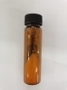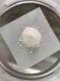
(a)
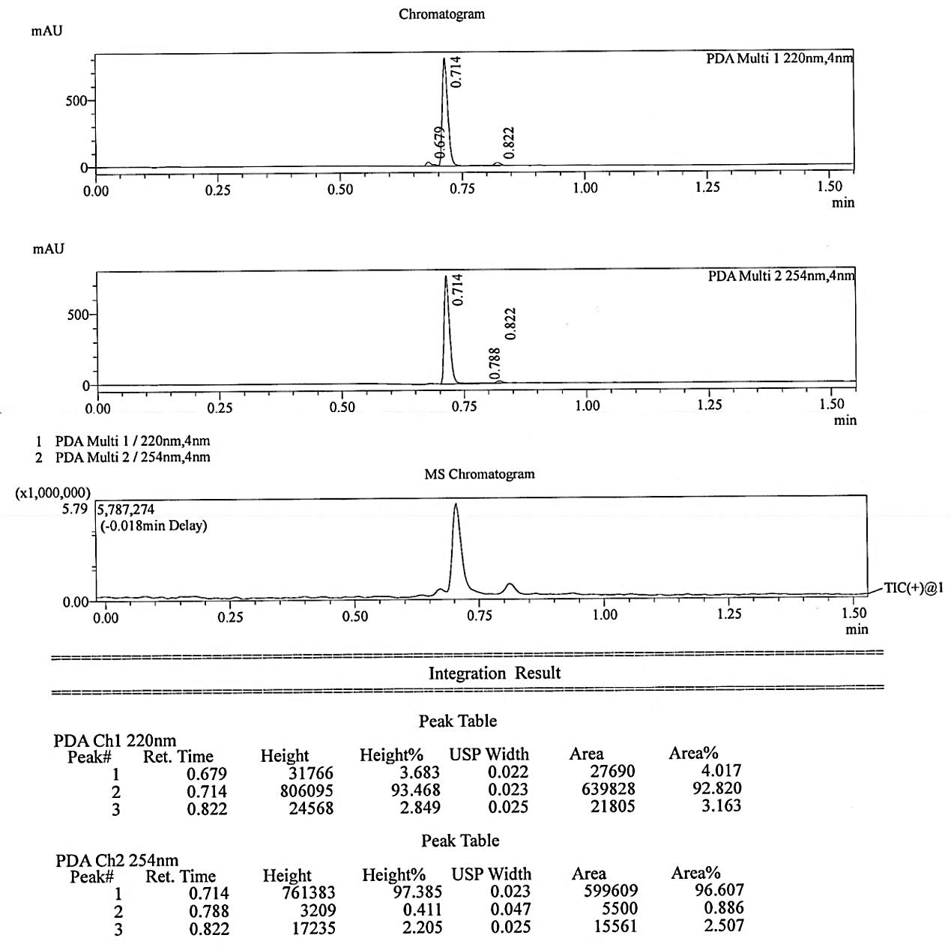
(b)
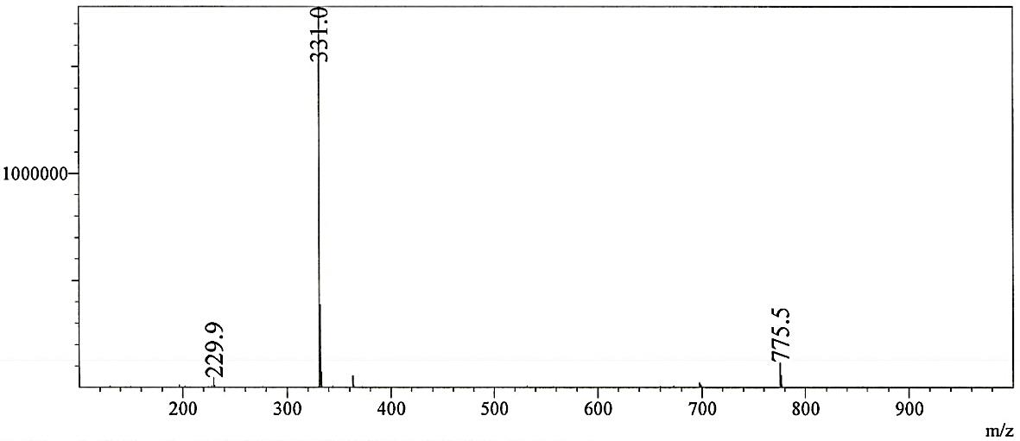
MS at 0.714min

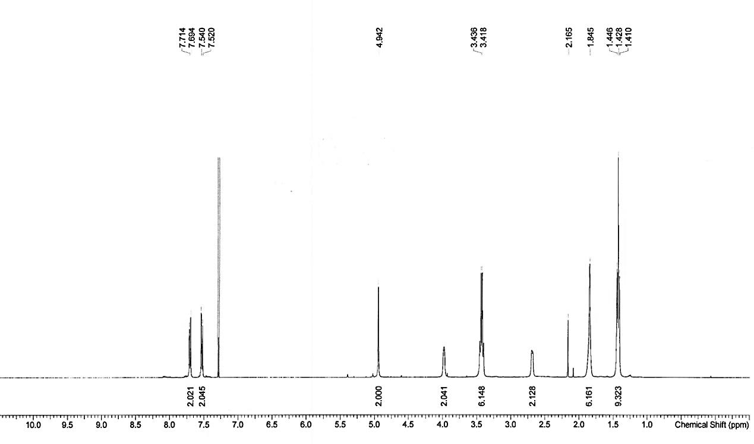
(c)
Figure S1 (a) Synthesis routine, (b) LC-MC and (c) ¹H-NMR spectrum of TBCC.
N-[4-(Triethylammoniomethyl)-benzoyl]-caprolactam-chloride (TBCC) used in this study was prepared according to a reported synthesis method shown in Figure S1a. The appearance of TBCC is a slightly yellowish powder. Liquid chromatography-mass spectrometry (LC-MS, Shimadzu, Japan) was performed using positive ion mode (Figure S1). The liquid chromatogram of TBCC exhibits a sharp peak appearing at the retention time of 0.714min.The peak area ratio at 220nm and 254nm are 92.820% and 96.607%, respectively, indicating that the purity of prepared TBCC exceeds 90%. Figure S1b shows the molecular ion peak at m/z 331 (M) which is consistent with the molecular weight of TBCC. The hydrogen atoms in TBCC and their corresponding chemical shifts are clearly shown by nuclear magnetic resonance hydrogen spectroscopy(¹H-NMR, 400 MHz, CDCl₃, Bruker-400, USA) : 7.70 (d, J=8.0 Hz, 2H), 7.53 (d, J=8.0 Hz, 2H), 4.94 (s, 2H), 3.98 (s, 2H), 3.42 (q, J=7.2 Hz, 6H), 2.65 (d, J= 6.7 Hz, 2H), 1.85 (s, 6H), 1.43 (m, 9H) (Figure S1c). In general, highly purified TBCC as the activator of H₂O₂ was synthesized successfully.
Figure S2 Structures of direct dyes.

Figure S3 Scheme for lamp-box.
Figure S4 Bleaching routines of TBCC/H₂O₂ system
Figure S5 (a) ATR-FTIR curves and (b) XRD patterns of untreated, UVA-assisted NaOH/H₂O₂ bleached and UVA-assisted TBCC/H₂O₂ bleached C/S fabrics.
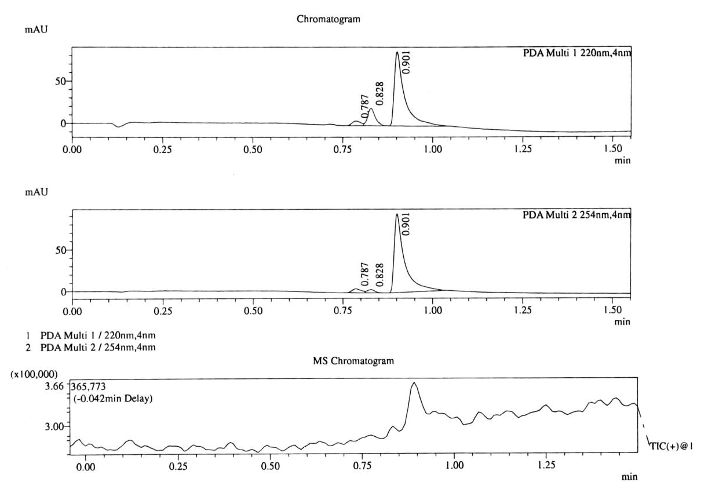
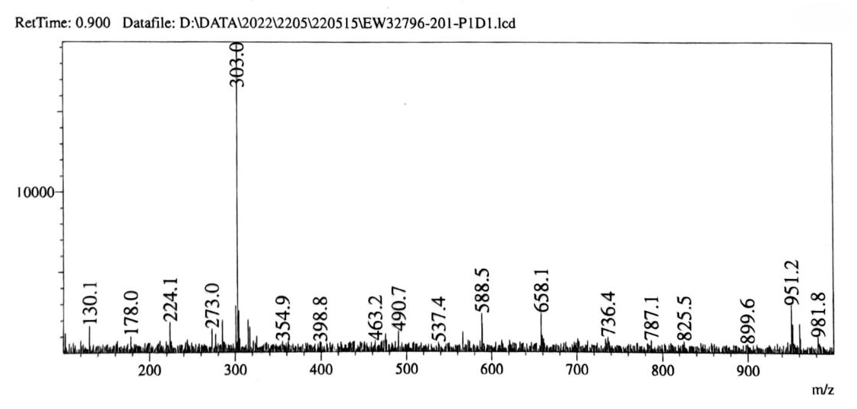
Figure S6 LC-MS spectrum of original morin (Positive ion mode).

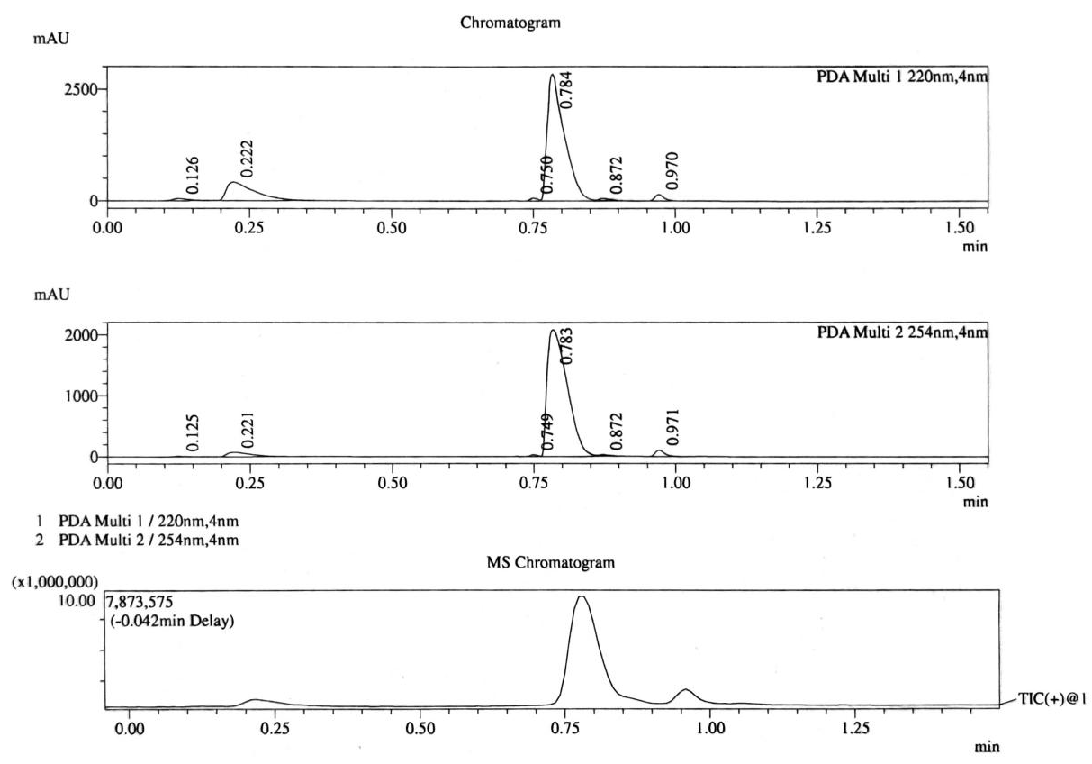
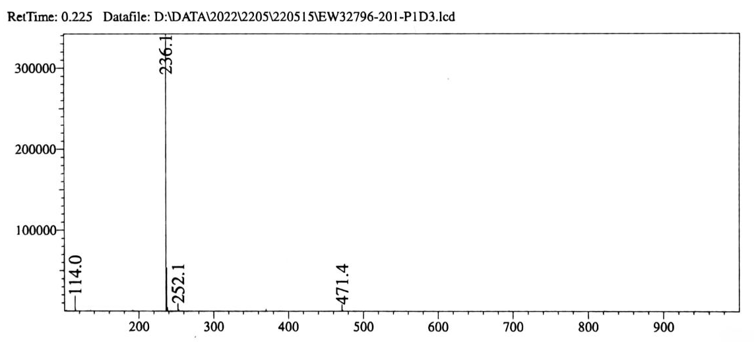
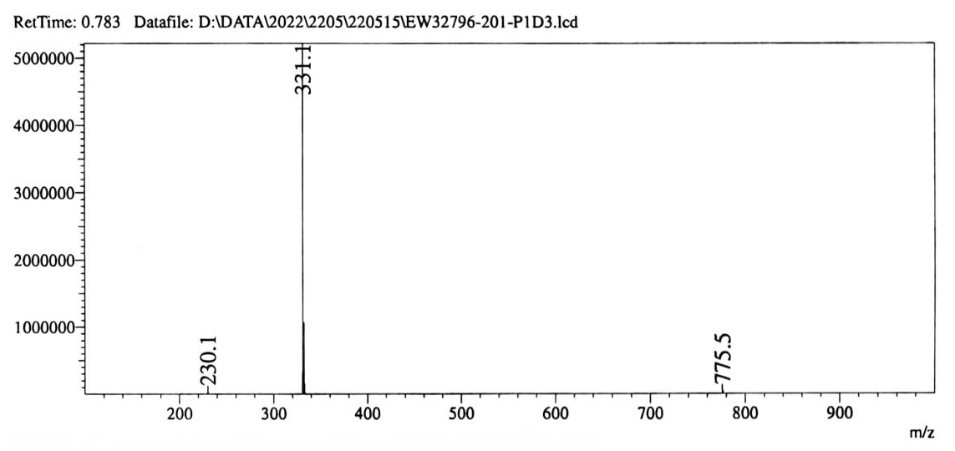
Figure S7 LC-MS spectra (positive ion mode) of morin after degradation in UVA-assisted TBCC/ H₂O₂ bleaching system.

Figure S8 Energy consumption distribution of St-Bl and Conv-Bl processes.

Assumption and calculation of energy/water consumption: UV-Bl, St-Bl, Conv-Bl and CP-Bl represent UV-radiating bleaching, steaming bleaching, conventional waterbath bleaching and cold pad-batch bleaching processes, respectively. The estimation was carried out based on the treatment of 29 kg C/S fabric (100 m × 1 m). Energy consumption is the sum (Q) for heating fabric (Q1) and bath solution (Q2), evaperation of the water on fabric (Q3) and the energy loss by the outer wall of equipment (Q4). Caculation processes are as follows:
UV-Bl: Q is merely generated from the electricity consumption by UVA lamps.
St-Bl: Q ₌ Q₁ + Q₂ + Q₃ + Q₄ = C₁M₁(T₂-T₁) + C₂M₂(T₂-T₁) + (M₃/M)H + αSΔTD
Conv-Bl: Q ₌ Q₁ + Q₂ + Q₄ = C₁M₁(T₂-T₁) + C₂M₂(T₂-T₁) + αSΔTD
CP-Bl: Q is almost zero due to the ambient temperature processing.
where, C₁ and C₂ are the specific heat capacity of cotton (1.296 kJ/(kg·ºC)) and water (4.186 kJ/(kg·ºC)); T₁ and T₂ are the environment and steaming/bath temperature; M₁ and M₂ are the weights of fabric and water within fabric (uptake ratio: 100%) or the weights of fabric and bath (bath ratio of 1:20); M₃ is the weight of evaporated water from fabric during steaming (evaporation ratio: 50%); M is molecular weight of water; H (40.668kJ/mol) is molar enthalpy of water evaporation; α (0.02 kW·m⁻²·K⁻¹) is the heat transfer coefficient of air convection; S is the outerwall area of steaming setup (6 faces of reservoir: 7.5 m in length, 1.5 m in width, 2.5 m in height) or the total outer surface area (6 faces of 1.5 m length cubic sealed reservoir) of equipment; ΔT is the temperature difference between environment and outerwall of steaming setup/reservoir; D is the bleaching duration. As the cotton content in fabric (97%) is much higher than Spandex (3%), only the specific heat capacity of cotton is involved.
Water consumption is the sum (W) of those used for bleaching (W₁) and rinsing (W₂) of fabric. In terms of W₁, the dip-pad bleahing bath used in UV-Bl, St-Bl and CP-Bl was prepared based on the bath ratio of 1:10. The immering bleahing bath used in Conv-Bl was prepared based on the bath ratio of 1:20. In terms of W₂, two immersing washings (liqure ratio = 1:20) and one overflow washing (overflow velocity = 20L/min) for 10min are applied to the fabric bleached by alikaline bleaching. For neutral bleaching, one immersing washing and one overflow washing for 5min were used.

Table S1 Conventional waterbath bleaching process.
Recipe | Penetr.  (g/L) | 30%H₂O₂  (g/L) | TBCC  (g/L) | NaHCO₃  (g/L) | NaOH  (g/L) | pH | Temp.  ºC
Conv-Bl-1 | 1 | 4 | 12.6 | 3 | 0 | 6.85 | 50
Conv-Bl-2 | 1 | 6 | 0 | 0 | 1 | 11.5 | 95
Note: Penetr. is short from Penetrating agent. Conventional water-bath process is only used for the estimation of energy/water consumption in 3.4. Sustainability evaluation.

Table S2 Impact of bleaching compositions and conditions on WI and capillary effect of C/S fabric.
No. | 30%H₂O₂  (g/L) | TBCC  (g/L) | NaHCO₃  (g/L) | EDTA-2Na  (g/L) | Penetr. (g/L) | UVA  (90 W) | WI | CE  (cm/30min)
1 | 0 | 0 | 0 | 0 | 3 |  | 54.7 | 9.1±0.2
2 | 0 | 0 | 6.8 | 0 | 3 |  | 57.4 | 9.2±0.4
3 | 7.4 | 0 | 6.8 | 2 | 3 |  | 64.6 | 9.7±0.1
4 | 7.4 | 20 | 6.8 | 2 | 3 |  | 78.0 | 9.6±0.4
5 | 0 | 0 | 0 | 0 | 3 | × | 54.1 | 7.5±0.9
6 | 0 | 0 | 6.8 | 0 | 3 | × | 53.9 | 6.7±0.4
7 | 7.4 | 0 | 6.8 | 2 | 3 | × | 55.2 | 8.6±0.1
8 | 7.4 | 20 | 6.8 | 2 | 3 | × | 71.6 | 8.1±0.3
Note: Penetr. is short from Penetrating agent; CE stands for capillary effect. The temperature was controlled at 30 ºC. The WI and CE of original C/S fabrics are 51.8 and 0.
Table S3 Colour features of untreated and bleached C/S fabric using formulation A-5 and B-5.
Sample information | L* | a* | b* | C | h
Untreated | 85.38±0.35 | 2.13±0.13 | 10.18±0.33 | 10.40±0.32 | 78.16±0.8
Formulation A-5 | 92.27±0.19 | 0.12±0.12 | 5.31±0.13 | 5.31±0.12 | 88.74±0.47
Formulation B-5 | 92.64±0.13 | -0.13±0.03 | 4.48±0.09 | 4.48±0.09 | 91.7±0.36

Ref:
Cui, S., Zhang, Y., Gao, J. et al., 2016. Synthesis of peroxide activator for low-temperature bleaching of cotton fabric. Journal of Textile Research. 37, 88-92.
Li, Q., Zhao, X. Quan, H. et al., 2022. Establishing an energy-saving scouring/bleaching one-step process for cotton/spandex fabric using UVA-assisted irradiation. RSC advances. 12, 9404-9415. https://doi.org/10.1039/d2ra00659f

