**Supplementary Material**

**Facile synthesis of palladium nanoparticles/polypyrrole-carbon black/Bi2O3 ternary nanocomposite for efficient photocatalytic degradation of colorless and colored pollutants under visible light**

M. Faisala,b, Jahir Ahmeda,b, Jari S. Algethamia,b, Mabkhoot Alsaiaria,c,

Farid A. Harraza,c,*

a Promising Centre for Sensors and Electronic Devices (PCSED), Advanced Materials and Nano-Research Centre, Najran University, Najran 11001, Saudi Arabia

b Department of Chemistry, Faculty of Science and Arts, Najran University, Najran 11001, Saudi Arabia

c Department of Chemistry, Faculty of Science and Arts at Sharurah, Najran University, Sharurah 68342, Saudi Arabia

**Corresponding author:**

* E. mail: faharraz@nu.edu.sa (F. A. Harraz)

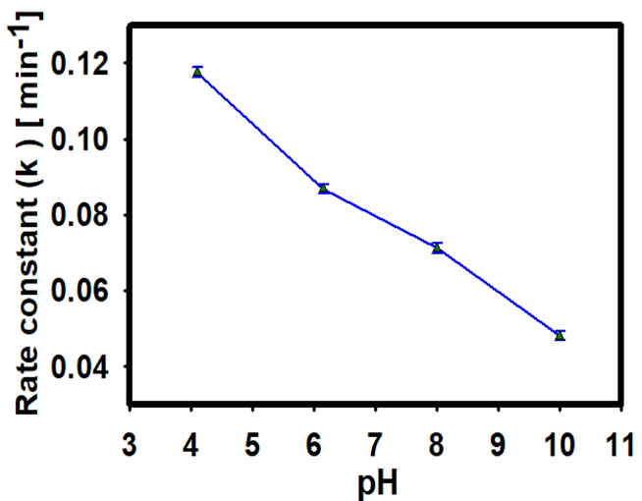

**Fig. S1.** Comparison of rate constant (*k*) for the decomposition of imidacloprid at different pH (4.1, 6.15, 8, 10).

**Fig. S2.** Absorbance *versus* wavelength plot as a function of irradiation time for the removal of imidacloprid using Pd@PPC/Bi2O3 photocatalyst.

C:\Users\mdfai\Desktop\Arabian JC(Revsion)\Pd@PPyC-Bi2O3\DEGRADATION\MB Deg.tif

**Fig. S3.** Absorbance *vs.* wavelength as a function of illumination time for the photocatalytic degradation of MB (0.02mM solution) with Pd@PPC/Bi2O3 nanocomposite photocatalyst.

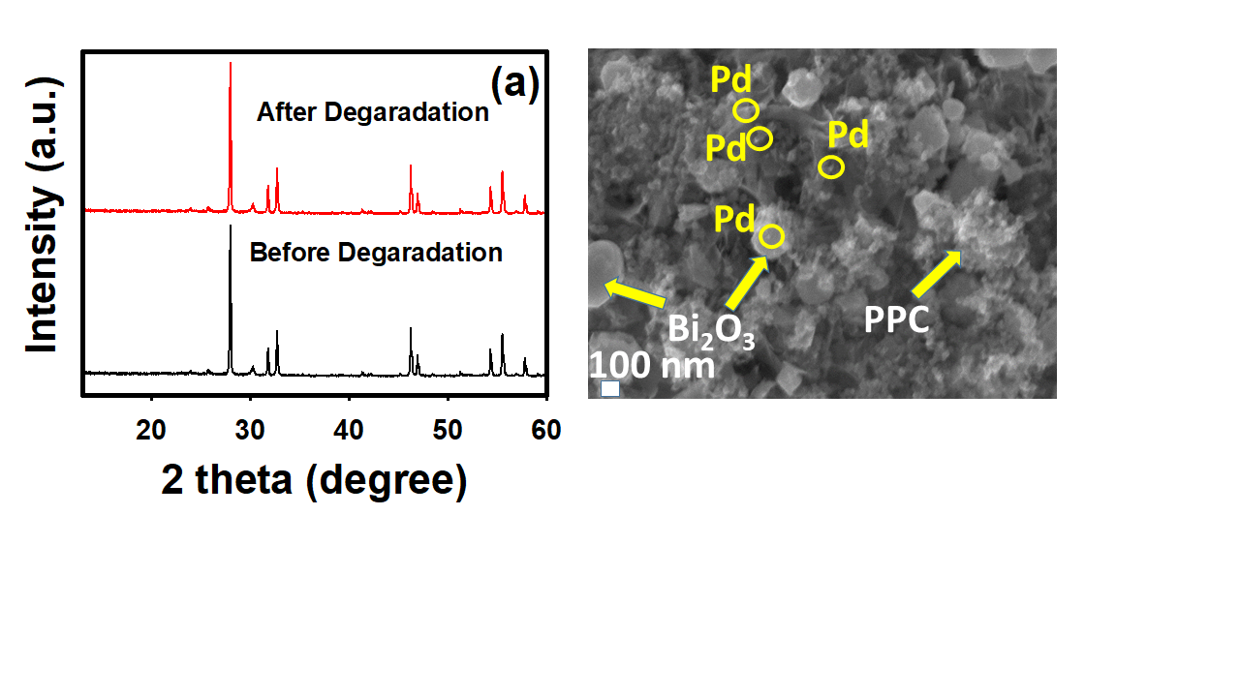

**(b)**

**Fig. S4** (a)XRD patterns and (b) FESEM image of the Pd@PPC/Bi2O3 photocatalyst after the cyclic photodegradation tests.

Spectra of the 250 W visible light lamp used for photocatalytic experiments.

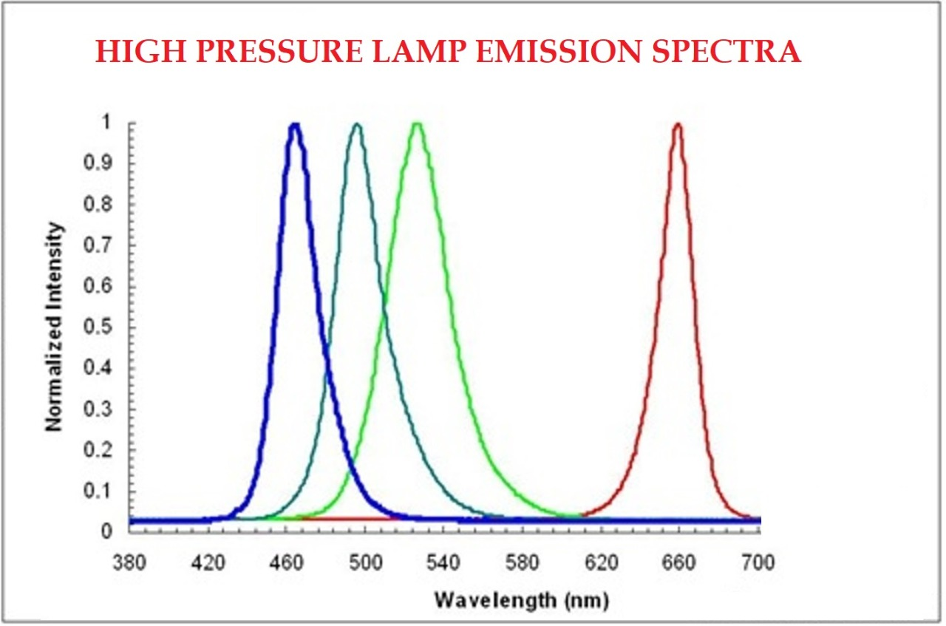

LED used in photo-electrochemical tests

