**Appendix A. Supporting Information**

**Surface modification of pyrophyllite for optimizing properties of castor oil-based polyurethane composite and its application in controlled-release fertilizer**

Shiping Wanga, Xiang Lia, Kun Rena, Rui Huanga, Ganchang Leia, Lijuan Shenb,

Yingying Zhana, *, Lilong Jianga,*

*a National Engineering Research Center of Chemical Fertilizer Catalyst, Fuzhou University, Fuzhou 350002, China*

*b College of Environmental Science and Engineering, Fujian Normal University,*

*Fuzhou 350007, China*

**E-mail addresses**: jll@fzu.edu.cn (L. Jiang), zhanyingying@fzu.edu.cn (Y. Zhan)

1. **Tables**

**Table S 1.** The preparation conditions for the xMPY and their composite with PU (xMPY/PU).

|  |  |  |  |  |  |
| --- | --- | --- | --- | --- | --- |
|  | **Preparation of xMPY** | | **Preparation of xMPY/PU** | | |
| **Sample Name** | **PY**  **addition** | **NDZ-201**  **emulsion solution** | **PY or MPY**  **addition** | **CO**  **addition** | **TDI**  **addition** |
| **PY/PU** | 10 g | 0 g | 0.24 g | 3.87 g | 1 g |
| **0.2MPY/PU** | 10 g | 0.04 g | 0.24 g | 3.87 g | 1 g |
| **0.3MPY/PU** | 10 g | 0.06 g | 0.24 g | 3.87 g | 1 g |
| **0.4MPY/PU(-5)** | 10 g | 0.08 g | 0.24 g | 3.87 g | 1 g |
| **0.5MPY/PU** | 10 g | 0.10 g | 0.24 g | 3.87 g | 1 g |
| **0.4MPY/PU-3** | 10 g | 0.08 g | 0.15 g | 3.87 g | 1 g |
| **0.4MPY/PU-7** | 10 g | 0.08 g | 0.34 g | 3.87 g | 1 g |
| **0.4MPY/PU-9** | 10 g | 0.08 g | 0.44 g | 3.87 g | 1 g |
| **0.4MPY/PU-11** | 10 g | 0.08 g | 0.54 g | 3.87 g | 1 g |

**Note:** The NDZ-201 emulsion solution was prepared from the mixture of isopropanol and NDZ-201 with a mass ratio of 1:1.

**Table S2.** The surface concentrations of Al, Si and O in the PY and different modified MPY measured by XPS.

|  |  |  |  |  |
| --- | --- | --- | --- | --- |
| **Sample Name** | **Al (at%)** | **Si (at%)** | **O (at%)** | **O/Al** |
| **PY** | 12.31 | 23.46 | 64.23 | 5.22 |
| **0.2MPY** | 12.14 | 23.86 | 64.00 | 5.27 |
| **0.3MPY** | 11.85 | 23.62 | 64.53 | 5.46 |
| **0.4MPY** | 11.67 | 24.08 | 64.24 | 5.50 |
| **0.5MPY** | 12.05 | 24.40 | 63.55 | 5.27 |

**Table S3.** Retention of tensile strength and elongation at break of PU, PY/PU and 0.4MPY/PU.

|  |  |  |
| --- | --- | --- |
| **Sample Name** | **Retention of tensile strength (%)** | **Retention of elongation at break (%)** |
| **PU** | 88.4 | 80.0 |
| **PY/PU** | 85.4 | 73.8 |
| **0.4MPY/PU** | 94.0 | 91.6 |

**Table S4.** Thenitrogen cumulative release for PCU, PY/PCU, and the xMPY/PCU at different release time.

|  |  |  |  |  |  |  |
| --- | --- | --- | --- | --- | --- | --- |
| **Sample Name** | **Release at**  **3.5d (%)** | **Release at**  **7d (%)** | **Release at**  **14d (%)** | **Release at 21d (%)** | **Release at 28d (%)** | **Release at 35d (%)** |
| **PCU** | 1.5 | 13.2 | 64.0 | 77.9 | 80.4 | 82.22 |
| **PY/PCU** | 8.3 | 40.9 | 66.1 | 79.7 | 86.6 | - |
| **0.2MPY/PCU** | 6.5 | 26.1 | 65.6 | 76.2 | 79.7 | - |
| **0.3MPY/PCU** | 3.6 | 18.5 | 52.4 | 74.9 | 78.8 | - |
| **0.4MPY/PCU** | 1.7 | 10.4 | 43.2 | 66.2 | 76.1 | 80.5 |
| **0.5MPY/PCU** | 2.2 | 16.2 | 47.9 | 68.3 | 77.6 | 81.4 |

**Table S5.** Thenitrogen cumulative releases for 0.4MPY/PCU-y with various filling amounts of MPY.

|  |  |  |  |  |  |
| --- | --- | --- | --- | --- | --- |
| **Sample Name** | **Release at**  **14 d (%)** | **Release at**  **21d (%)** | **Release at**  **28 d (%)** | **Release at**  **40 d (%)** | **Release at**  **56 d (%)** |
| **0.4MPY/PCU-3** | 47.4 | 73.2 | 79.2 | 81.5 | 84.8 |
| **0.4MPY/PCU-5** | 43.2 | 66.2 | 76.1 | 80.9 | 83.7 |
| **0.4MPY/PCU-7** | 33.1 | 62.0 | 73.9 | 78.9 | 84.5 |
| **0.4MPY/PCU-9** | 53.9 | 74.8 | 80.6 | 83.0 | 87.2 |
| **0.4MPY/PCU-11** | 65.9 | 77.6 | 80.3 | 83.6 | 86.7 |

**Table S6.** The release durations of the reported polymer coatings based on natural biomass.

|  |  |  |  |
| --- | --- | --- | --- |
| **Biomass-Based**  **PU Coatings** | **Coating Rate** | **Release Duration**  **(75%)** | **References** |
| DPCU | 8.5% inner and 8.7% outer coating | 42 d | *J. Agri. Food Chem.* **2013**, 61, 8166-8174. |
| Soybean-based PU | 2.5%  4.5% | 8 d  23 d | *J. Appl. Polym. Sci.* **2016,** *133*, 43790. |
| castor oil-based PU | 2.5%  4% | 13 d  32 d | *J. Appl. Polym. Sci.* **2016,** *133*, 43790. |
| Soybean oil, oleic acid-based PU | 3% | 28 d | *J. Agri. Food Chem.* **2018,***66*, 11265-11272. |
| Castor-oil based PU | 4%  6%  8% | 14 d  33 d  47 d | *J. Clean. Prod.* **2020,** 249, 119329. |
| Castor-oil based PU/ Nano fumed silica | 2%  3% | 105 d  137 d | *J. Clean. Prod.* **2020,** 249, 119329. |
| Castor oil-base PU/Soy-protein microcapsules | 3% | 45 d | *Mater. Today Chem.* **2021**, 20, 100413 |
| Castor-oil based PU/Halloysite | 3% | 30-38 d | *Prog. Org. Coat.* **2022**, 165, 106756 |
| Wheat straw-derived PU | 3% | 32 d | *Chem. Eng. J.* **2022**, 435, 134985 |

1. **Figures**



**Figure S1.** The chemical structure of the NDZ-201 coupling agent.

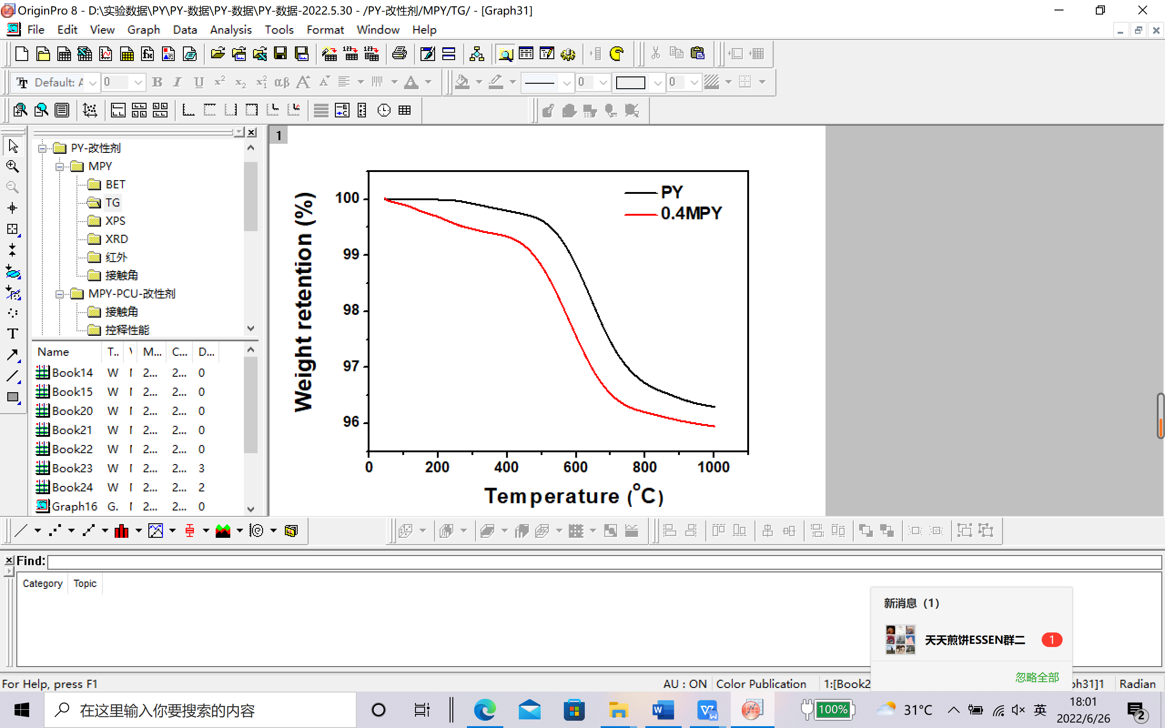

**Figure S2.** TG curves of PY and 0.4MPY with a NDZ-201 addition amount of 0.4 wt%.

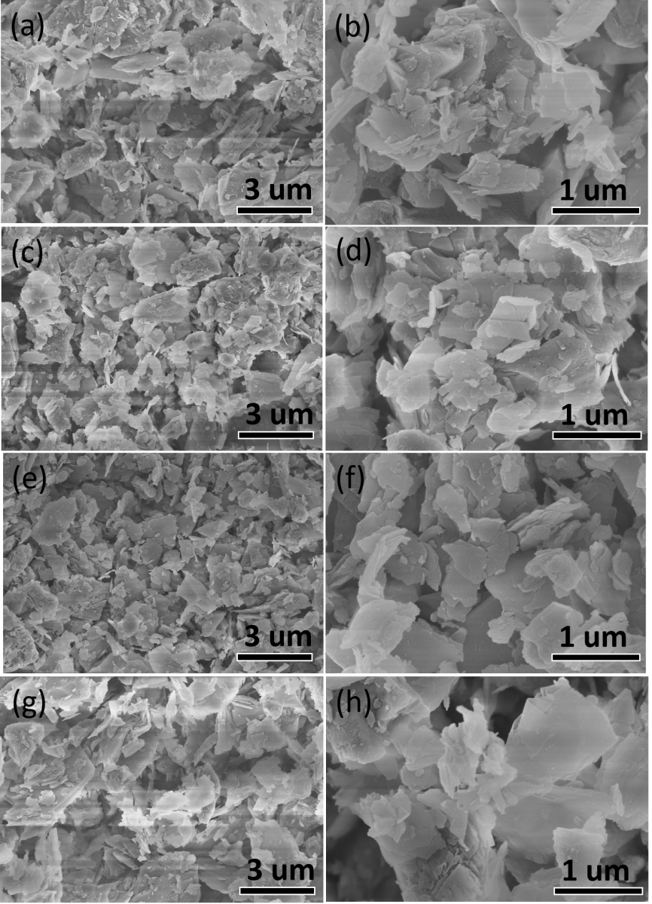

**Figure S3.** (a) and (b) SEM images the ball-milled PY (0.2MPY) with the NDZ-201 addition amount of 0.2 wt%, (c) and (d) the ball-milled PY (0.3MPY) with the NDZ-201 addition amount of 0.3 wt%, (e) and (f) the ball-milled PY (0.4MPY) with the NDZ-201 addition amount of 0.4 wt%, and the ball-milled PY (0.5MPY) with the NDZ-201 addition amount of 0.5wt% (g, h).

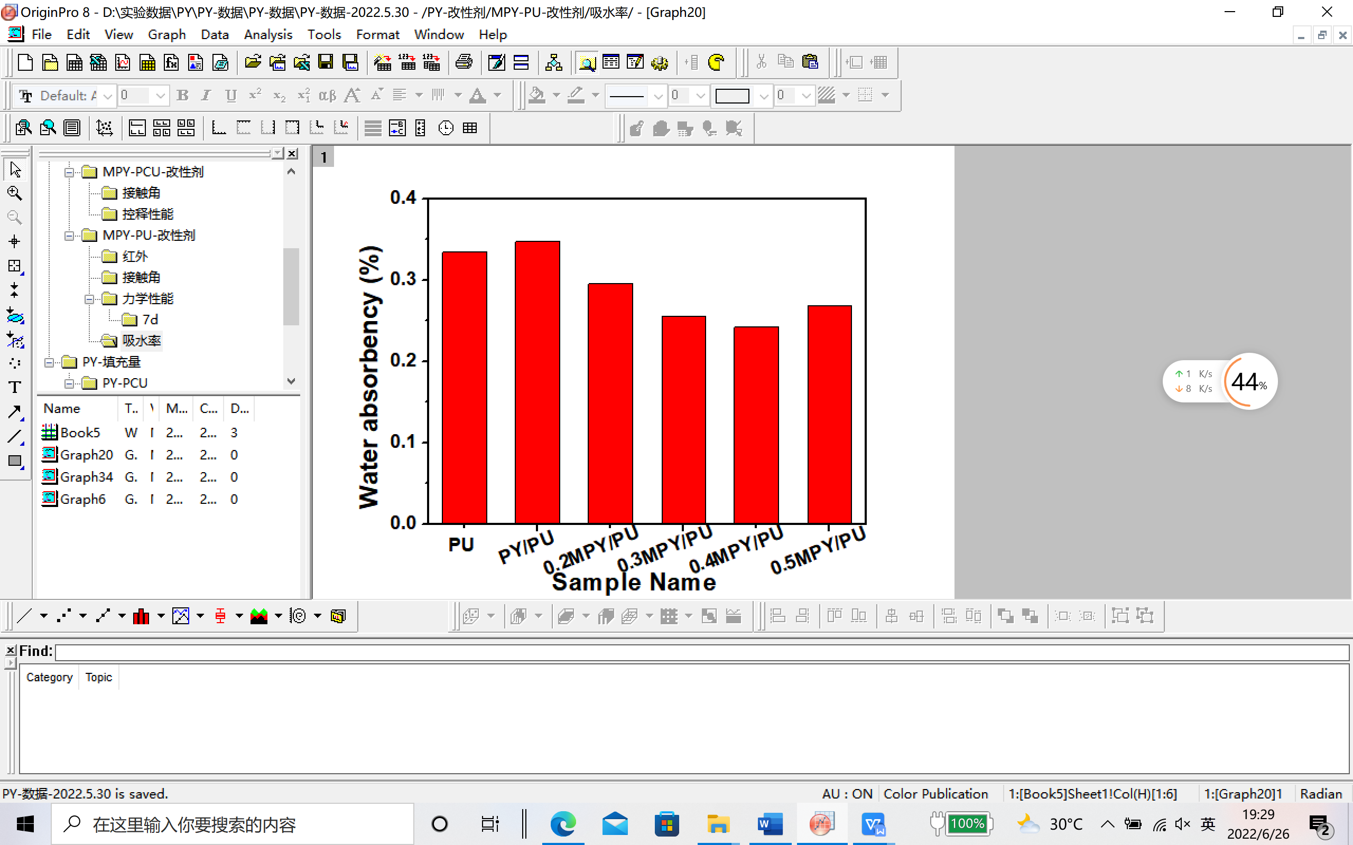

**Figure S4.** The water absorbency of the PU, PY/PU, and xMPY/PU, corresponding to the XMP modified by various addition amount of NDZ-201.

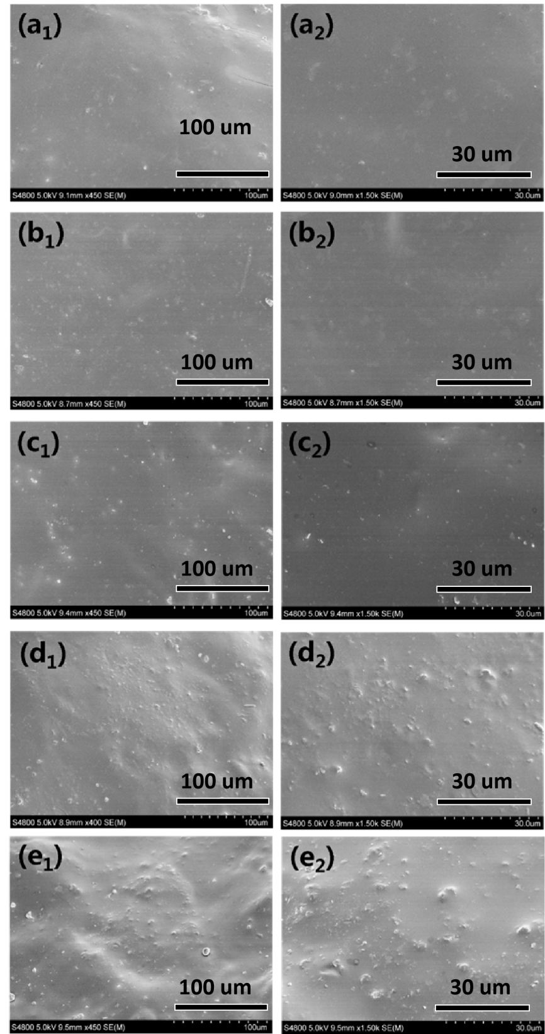

**Figure S5.** SEM images of 0.4MPY/PU-3 (a1, a2), 0.4MPY/PU-5 (b1, b2), 0.4MPY/PU-7 (c1, c2), 0.4MPY/PU-9 (d1, d2), and 0.4MPY/PU-11 (e1, e2), which were corresponded to the MPY/PU composites with various filling amount of MPY.

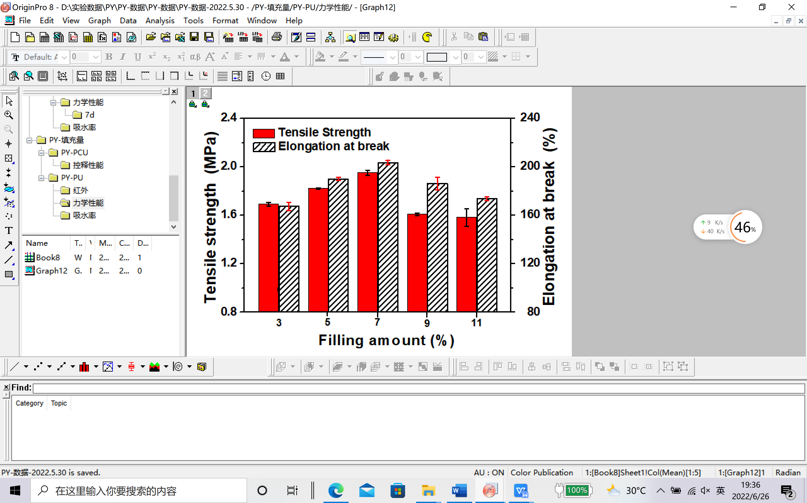

**Figure S6.** Mechanical properties of 0.4MPY/PU-y samples corresponded to the MPY/PU composites with different filling amounts of MPY.

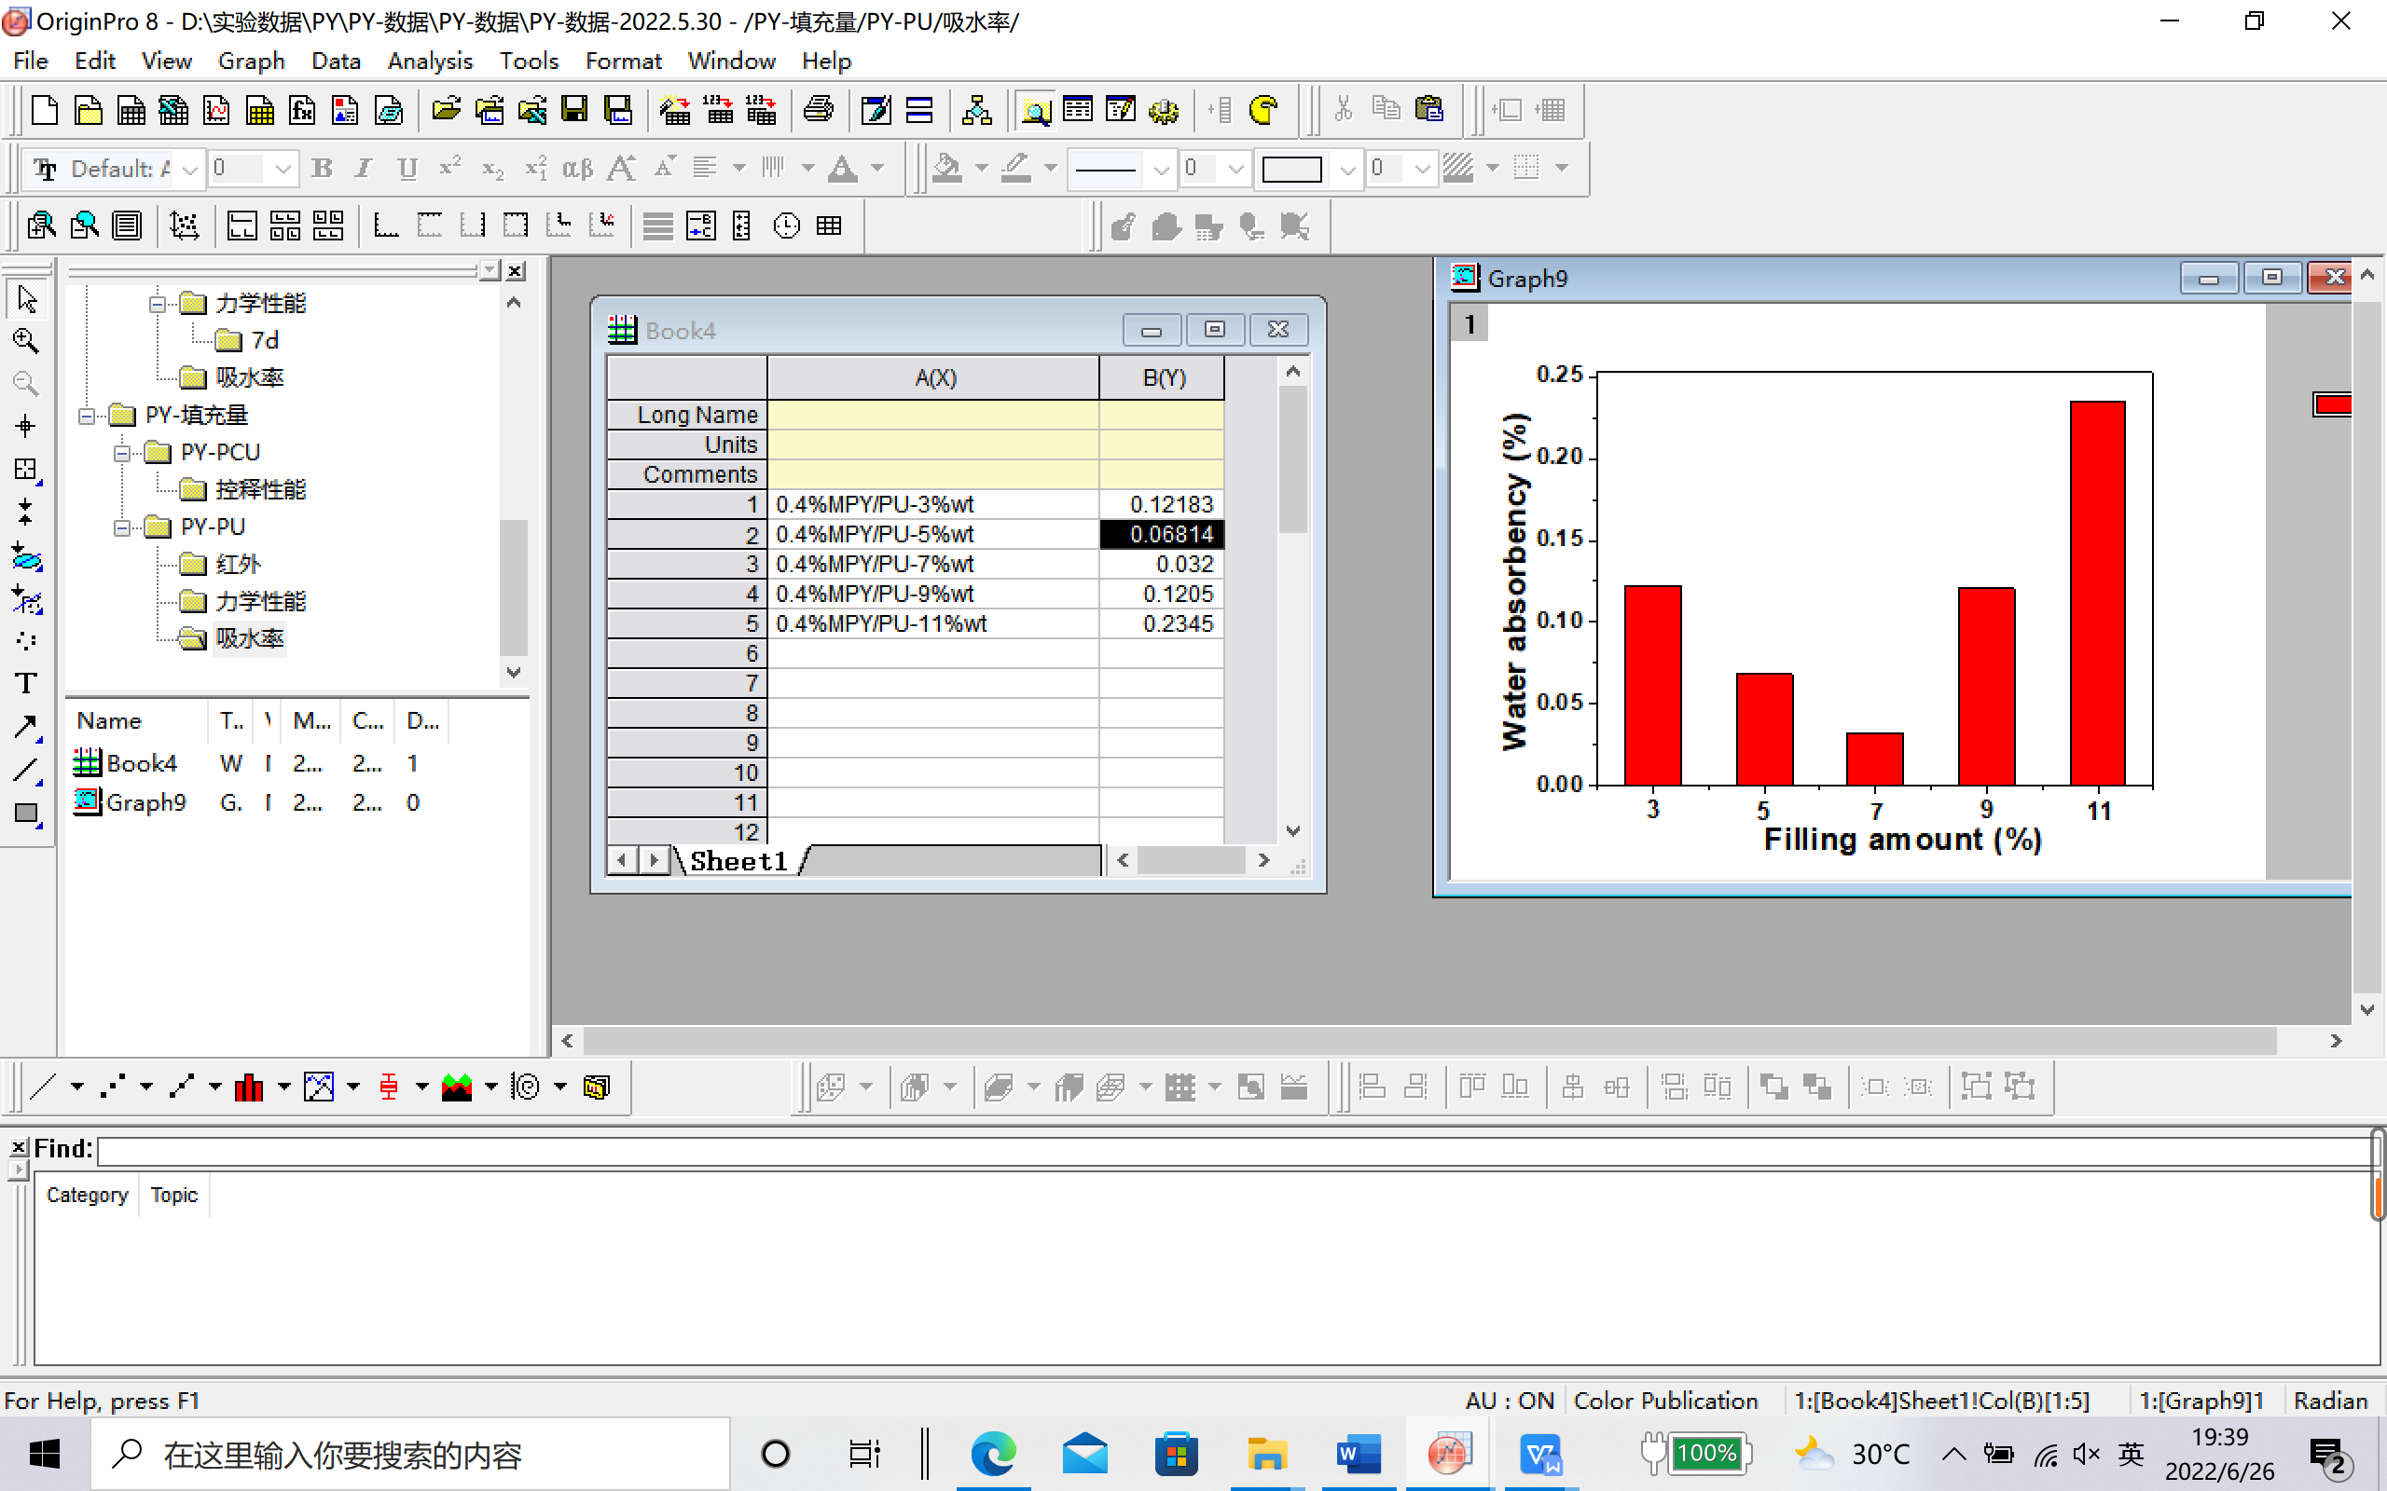

**Figure S7.** Water absorbency of 0.4MPY/PU-y samples corresponded to the MPY/PU composites with different filling amounts of MPY.