**Introduction of CdO Nanoparticles into Graphene and Graphene Oxide Nanosheets for increasing Adsorption Capacity of Cr from Wastewater Collected from Petroleum Refinery**

Aysha Bukhari1, Irfan Ijaz1, Dr. Hina Zain2, Dr Uqba Mehmood2, Dr. Muhammad Mudassir Iqbal2, Ezaz Gilani1, Ammara Nazir1

1

School of Chemistry, Faculty of Basic Sciences and Mathematics, Minhaj University Lahore, Lahore 54700, Pakistan

2

Department of Biological Sciences, Superior University Lahore, Lahore 54700, Pakistan

3

**Corresponding author:** iffichemixt266@gmail.com

|  |  |  |  |
| --- | --- | --- | --- |
| **Retention time (min)** | **Name of phytochemicals** | **Molecular formula** | **Peak area** |
| 10.70 | Benzeneacetaldehyde | C8H8O | 1.74% |
| 13.67 | Benzene 1-ethyl-2,4 diethyl | C10H14 | 1.30% |
| 16.00 | 1-Piperazinecarboxaldehyde | C5H10N2O | 2.60% |
| 20.75 | Benzene, 2methoxy1,3,4 trimethyl | C10H14O | 5.9% |
| 22.95 | Pyrroliodine5,1, 2[3hydroxypropyl] | C7H13NO2 | 1.10% |
| 28.80 | 3Methyl-4phynl-1H-pyrolle | C11H11N | 1.12% |
| 31.69 | Hexadecamethylcyclooctasiloxane | C16H48O8Si8 | 3.01% |
| 35.91 | Cyclononasiloxane | H18O9Si9 | 2.80% |
| 37.29 | nHexadecanoic acid | C16H32O2 | 11.03% |
| 38.31 | Phytol | C20H40O | 8.90 |
| 39.35 | Amonafide | C16H17N3O2 | 1.57% |

**Table.S1: Bioactive compound present in aqueous extract of *A. indica* analyzed in GC-MS chromatogram**

**Figure 12: Langmuir adsorption isotherm non-linear (a) and linear (b)**

**Isotherm Models**

**Adsorbents Langmuir Freundlich Temkin Dubinin–**

**Radushkevih**

**Linear**

**G**

qm (mg/g) = 80 R2 = 0.9883 B = 14.2 qm = 57.03

KL (Lmg-1) = 0.014 KF = 7.9 A (Lg-1) = 12.9 EDR = 0.131

RL = 0.0094 n = 2.9 ± 0.1 b (jmol-1) = 183.7

R2 = 0.8714 R2 = 0.9901 R2 = 0.9884

X2**=** 6.682.31 8.609.99RMSE**=**19.35 5.54 33.50 18.31

**Non-linear**

qm (mg/g) = 27 R2 = 0.9625 B = 2.7 qm = 13.41

KL (Lmg-1) = 0.09 KF =593 A (Lg-1) = 10.9 EDR = 0.09

RL = 0.0023 n = 0.6 b (jmol-1) = 23.1

R2 = 0.8714 R2 = 0.9501 R2 = 0.9327

X2**=** 5.092.01 8.097.14RMSE**=**15.30 4.47 27.10 17.40

GO

**Linear**

qm (mg/g) = 65.71 R2 = 0.9820 B = 23.9 qm = 63.02

KL (Lmg-1) = 0.02 KF = 18.33 A (Lg-1) = 2.133 EDR = 0.119

RL = 0.18 n = 2.5 b (Jmol-1) = 0.1736 R2 = 0.9727

R2 = 0.8938 R2 = 0.9291

X2**=** 4.21.78 7.326.00RMSE**=**15.30 3.20 18.08 15.33

**Non-linear**

qm (mg/g) = 10 R2 = 0.7920 B = 16.1 qm = 33.02

KL (Lmg-1) = 0.07 KF =621 A (Lg-1) = 0.149 EDR = 0.007

RL = 0.07 n = 2.3 b (Jmol-1) = 0.1129

R2 = 0.8938 R2 = 0.9291 R2 = 0.9727

X2**=** 11.966.08 9.435.57RMSE**=**19.59 5.11 23.91 15.09

**CdO NPs**

**Linear**

qm (mg/g) = 400 R2 = 0.9929 B = 60.0 qm = 357.8

KL (Lmg-1) = 0.46 KF = 110 A (Lg-1) = 1.66 EDR = 0.102

RL = 0.29 n = 4.5 b (Jmol-1) = 0.043

R2 = 0.9304 R2 = 0.9034 R2 = 0.9237

X2**=** 3.021.31 5.664.74RMSE**=**7.59 2.07 10.32 13.12

**Non-linear**

qm (mg/g) = 119 R2 = 0.9145 B = 33.0 qm = 89.4

KL (Lmg-1) = 0.46 KF = 736 A (Lg-1) = 1.23 EDR = 0.935

RL = 0.17 n = 3.1 b (Jmol-1) = 0.011

R2 = 0.8521 R2 = 0.8361 R2 = 0.8938

X2= 9.93 3.44 8.436.81RMSE=8.73 4.29 19.03 17.54

**G-CdO**

**Linear**

qm (mg/g) = 430 R2 = 0.9969 B = 51.07 qm = 389.0

KL (Lmg-1) = 0.89 KF = 149 A (Lg-1) = 11.0 EDR =0.333

RL = 0.0179 n = 6 b (Jmol-1) = 0.50 R2 = 0.8726

R2 = 0.9543 R2 = 0.9638

X2= 3.02 1.31 5.664.74RMSE=3.59 1.78 7.63 11.04

**Non-linear**

qm (mg/g) = 90 R2 = 0.9133 B = 33.25 qm = 160.4

KL (Lmg-1) = 0.47 KF = 785 A (Lg-1) = 9.03 EDR =0.151

RL = 0.0096 n = 3.9 b (Jmol-1) = 0.19

R2 = 0.7697 R2 = 0.9541 R2 = 0.7538

X2= 7.22 1.99 4.035.99RMSE=9.73 4.29 11.79 14.00

**CdO-GO**

**Linear**

qm (mg/g) = 699.46 R2 = 0.9993 B = 64.1 qm = 0.349

KL (Lmg-1) = 0.8 KF = 11.61 A (Lg-1) = 13.45 EDR = 0.472

RL = 0.0134 n = 13.0 b (Jmol-1) =0.57

R2 = 0.9834 R2 = 0.9791 R2 = 0.9120

X2= 3.02 0.07 1.043.69RMSE=1.01 0.96 5.09 7.33

**Non-linear**

qm (mg/g) = 452.22 R2 = 0.9876 B = 43.1 qm = 0.147

KL (Lmg-1) = 0.6 KF = 912 A (Lg-1) = 5.68 EDR = 0.164

RL = 0.0068 n = 9.0 b (Jmol-1) =0.13

R2 = 0.9501 R2 = 0.9330 R2 = 0.8937

X2= 6.68 1.35 2.876.38RMSE=8.77 3.11 9.98 10.01

**Table.S2: Linear and nonlinear isotherm parameters for sorption of Cr (VI) onto prepared G nanosheets, GO nanosheets, CdO NPs, G-CdO, and CdO-GO nanocomposites.**

**Kinetic Models**

**Constants G GO** G-CdO **CdO-GO**

**Nanosheets Nanosheets nanocomposite nanocomposite**

**Pseudo-first-order**

**Linear**

**qe (cal)** 24.72 35.10 44.53 119.86 51.27

**K1** 3.76 8.50 4.90 12.89 54.2

**R2** 0.9834 0.9587 0.9323 0.9767 0.7231

**Δqe** 2.11 4.69 7.42 4.76 8.77

**χ2** 11.12 64.69318.62132.22 1270.16

**RMSE** 3.53 3.09 5.81 6.93 9.32

**Non-linear**

**qe (cal)** 16.32 19.9 29.4 33.2 56.31

**K1** 3.42 5.53 6.19 4.31 9.36

**R2** 0.7631 0.8914 0.8949 0.9237 0.6912

**Δqe** 1.90 2.12 4.01 3.35 5.61

**χ2** 2.24 9.42 19.94 33.02 64.51

**RMSE** 6.31 4.32 1.97 12.93 8.34

**Pseudo-second-order**

**Linear**

**qe cal** 48.17 86.12 168.39 249.00 311.40

**K2** 3.23 7.33 3.61 2.33 3.83

**H** 6.43 45.01 103.11 142.00 379.99

**R2** 0.9993 0.9990 0.9994 0.9995 0.9995

**Δqe (%)** 11.30 1.90 0.40 0.95 3.19×10-3

**χ2** 0.2731 0.0736 0.0517 0.1631 0.0075

**RMSE** 0.90 0.83 0.57 0.49 0.21

**Non-linear**

**qe cal** 32.72 39.92 84.38 73.09 114.6

**K2×** 1.90 2.07 3.01 0.99 3.22

**H** 0.77 6.21 19.00 33.06 160.01

**R2** 0.8932 0.9821 0.9903 0.9923 0.9986

**Δqe (%)** 4.53 0.63 0.21 0.66 1.95

**χ2** 0.0978 0.7987 0.9693 0.7243 0.8703

**RMSE** 1.96 2.32 2.91 7.36 9.08

**Intra-particle-diffusion**

**Linear**

**C1** 0.13 0.37 0.99 1.21 2.14

**Ki1** 3.99 11.09 13.00 25.32 18.67

**(R21)** 0.9745 0.9538 0.8513 0.9437 0.7429

**C2**× 0.76 0.17 1.23 2.39 2.53

**Ki2** 1.33 3.62 4.02 1.49 5.91

**(R22)**0.6034 0.8269 0.9832 0.6395 0.9367

**χ2** 5.36 4.98 4.22 3.47 2.01

**RMSE** 9.20 8.03 7.86 7.02 6.03

**Non-linear**

**C1** 0.91 0.10 0.13 1.71 1.92

**Ki1** 1.32 3.63 10.72 14.11 16.11

**(R21)** 0.8708 0.8915 0.7622 0.9167 0.7356

**C2** 0.55 0.08 0.89 1.63 1.80

**Ki2** 0.36 1.73 3.05 2.21 4.98

**(R22)**0.7627 0.7996 0.9338 0.683 0.157

**χ2** 9.06 9.68 5.74 5.02 2.98

**RMSE** 12.7 11.0 9.1 8.06 3.29

**Fractional power**

**Linear**

**V** 0.2203 0.1702 0.1028 0.1432 0.0805

**KFP** 17.98 47.91 111.54 146.01 230.89

**KV** 3.75 8.00 12.01 20.98 17.56

**R2** 0.9445 0.9589 0.9156 0.9323 0.8734

**Δqe** 33.67 34.00 35.16 35.19 35.22

**χ2** 1062.00 3612.98 13,115.62 23,156.90 39,316.22

**RMSE** 19.1 17.05 18.58 13.89 6.95

**Non-linear**

**V** 0.1424 0.1469 0.1932 0.1396 0.0639

**KFP** 9.36 23.89 57.32 97.59 167.21

**KV** .0.76 3.03 9.06 16.79 16.98

**R2** 0.8862 0.9053 0.9099 0.9378 0.890

**Δqe** 30.56 32.89 33.90 35.01 36.34

**χ2** 112.00 2586.98 12,235.00 19,356.21 21,215.0

**RMSE** 15.31 13.19 13.06 9.05 1.59

**Bangham**

**Linear**

**α** 0.38 0.27 0.18 0.23 0.14

**Kj (g)** 34.99 58.01 79.71 63.92 89.12

**R2** 0.9167 0.9613 0.9146 0.9319 0.9206

**χ2** 47.06 85.85 98.41 109.63 99.38

**RMSE** 28.62 33.60 15.05 23.39 10.02

**Non-linear**

**α** 0.33 0.17 0.21 0.08 0.11

**Kj (g)** 19.03 31.01 45.71 32.92 48.39

**R2** 0.8563 0.8774 0.9096 0.9240 0.9135

**χ2** 33.68 35.98 110.65 134.24 123.09

**RMSE** 19.55 25.39 11.26 7.29 3.08

**Avarami**

**Linear**

**nAV** 0.4232 0.4467 0.3872 0.443 0.2634

**KAV** 0.1303 0.4349 0.9673 0.5519 3.3071

**R2 (%)** 0.8100 0.9601 0.9189 0.8390 0.9345

**Δqe (%)** 33.90 34.00 35.02 35.13 35.28

**χ2** 2154.09 4731.02 21,878.43 36,890.09 68,412.00

**RMSE** 49.36 96.25 164.34 190.62 210.00

**Non-Linear**

**nAV** 0.1316 0.1980 0.2976 0.3167 0.2578

**KAV** 0.0251 0.1493 0.3298 0.3278 2.1356

**R2 (%)** 0.7341 0.9543 0.9038 0.7939 0.9284

**Δqe (%)** 20.11 29.91 31.67 32.08 34.28

**χ2** 1539.28 2569.96 17,685.07 28,691.38 49, 32.54

**RMSE** 62.89 93.25 128.99 169.05 188.35

**Elovich**

**Linear**

**αEl** 54.12 843.08 35,034.16 7167.13` 5790.54×103

**βEl** 0.1380 0.0861 0.07247 0.0486 0.0645

**R2 (%)** 0.9012 0.9725 0.9212 0.9323 0.9134

**Δqe (%)** 6.95 6.77 0.77 6.29 4.00

**χ2** 0.070 0.12 2.15 **×** 10-5 0.25 0.06

**RMSE** 8.89 9.98 6.29 5.50 2.89

**Non-linear**

**αEl** 36.49 654.97 11,869.05 5698.13` 6357.68

**βEl** 0.0968 0.07583 0.06785 0.0358 0.0598

**R2 (%)** 0.8568 0.9735 0.9038 0.9369 0.9269

**Δqe (%)** 3.09 6.38 0.68 5.68 3.99

**χ2** 0.020 0.36 1.65 0.98 0.02

**RMSE** 11.55 15.26 5.94 2.68 1.06

**Units: qe cal= mg g-1, K1= min-1, K2 =gm g-1m-1, h=mg-1gmin-1, C1 and C2 = mg g-1,Ki1 and Ki2 (mg g-1 min-1/2), V= min-1, KFP= mg g-1, KV = (mg/g/min), Kj = g, KAV = min-1, αEl = mg g-1 min, βEl= mg g-1.**

**Table.S3: List of linear and nonlinear parameters of various kinetic models for the sorption of Cr (VI) onto prepared G nanosheets, GO nanosheets, CdO NPs, G-CdO, and CdO-GO nanocomposites.**

**Adsorbents Temp (K) ΔGo (kJ/mol) ΔSo (J/mol k) ΔHo (kJ/mol)**

**G nanosheets**

290 4.32 -42.35 -150.23

294 5.01

298 5.55

302 6.71

**GO nanosheets**

290 -1.21 40.01 141.72

294 -1.79

298 -2.20

302 -2.47

**CdO Nps**

290 -1.27 43.9 133.08

294 -1.99

298 -2.03

302 2.69

**G-CdO nanocomposites**

290 -1.24 36.29 122.5

294 -2.37

298 -2.56

302 -3.19

**CdO-GO nanocomposites**

290 -1.33 35.63 120.42

294 -2.78

298 -3.35

302 -3.90

**Table.S4: Thermodynamic parameters for sorption of Cr (VI) onto prepared G nanosheets, GO nanosheets, CdO NPs, G-CdO, and CdO-GO nanocomposites.**

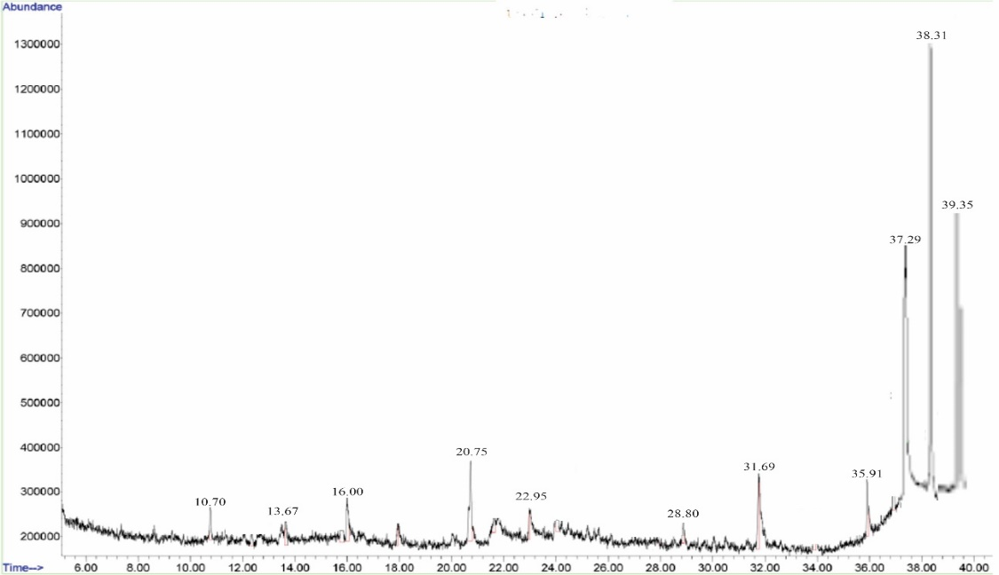

**Figure.S1: GC-MS chromatogram aqueous extract of *A. indica***

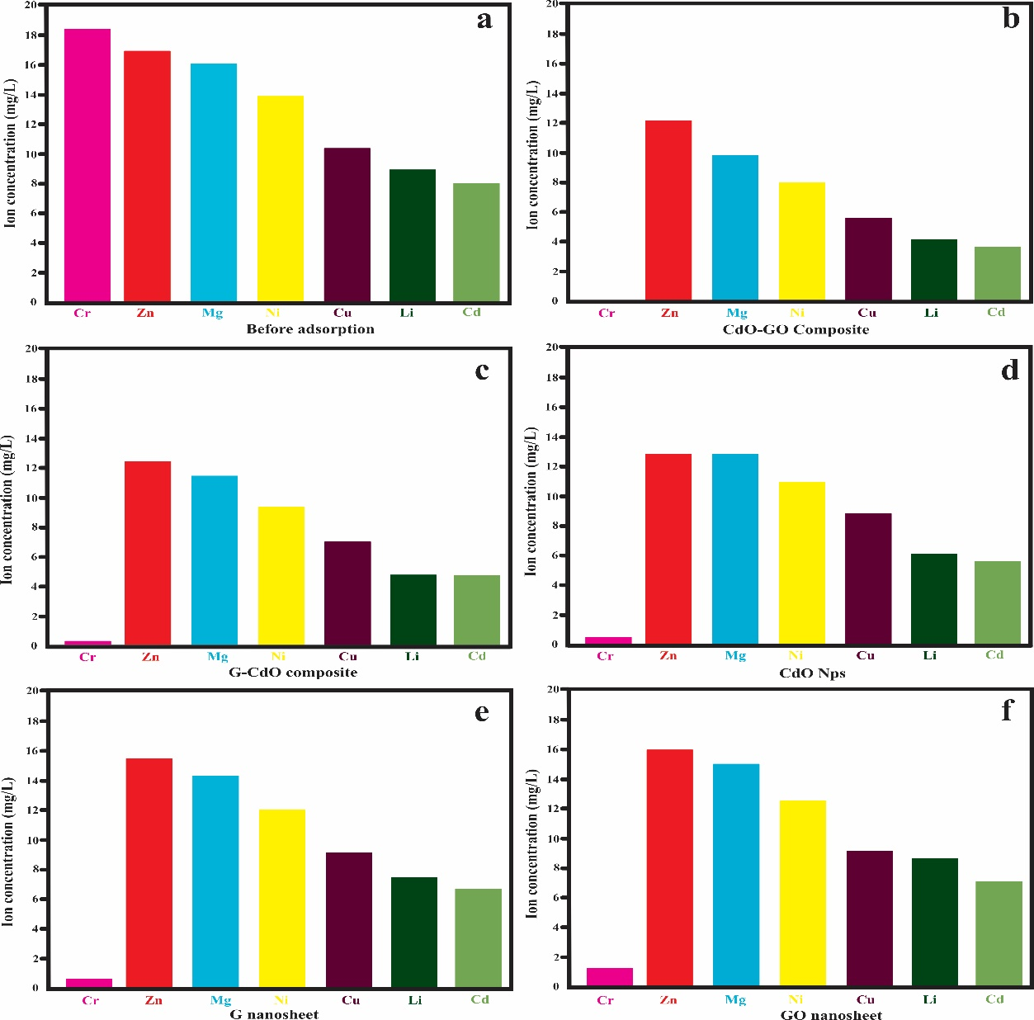

**Figure.S2: Selectivity of Cr (VI) before sorption on CdO-GO composite (a), G-CdO composite (b), CdO NPs (c), G nanosheet, and GO nanosheet**