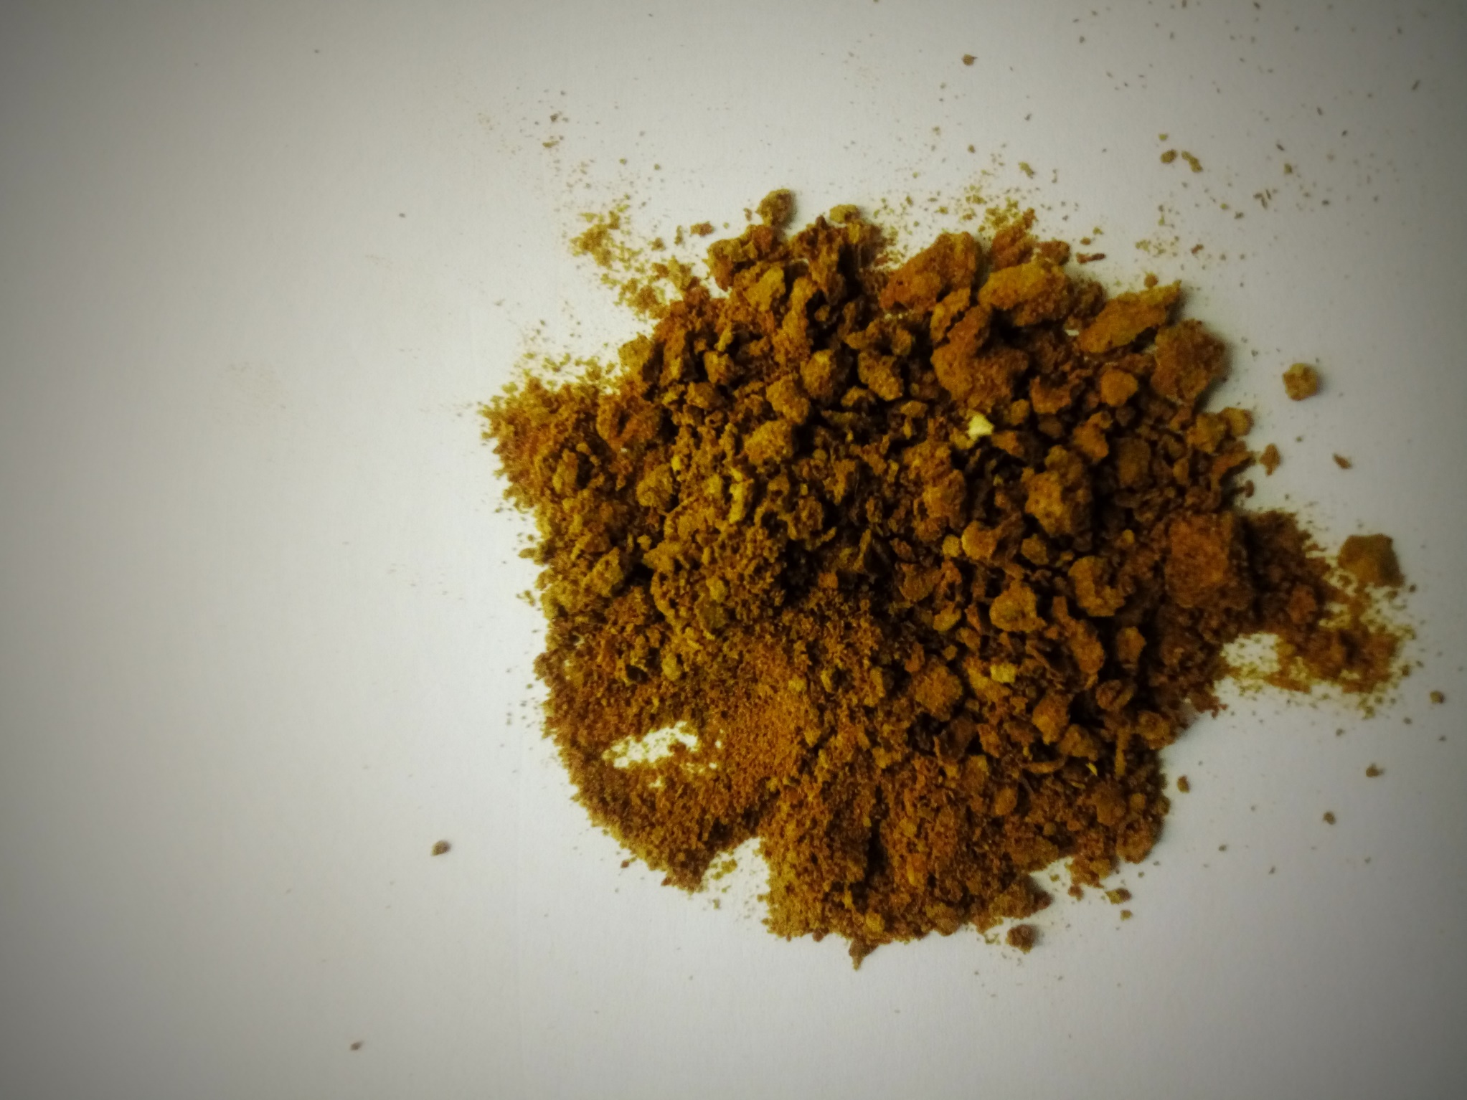
Fig. S1: 70% ethanolic crude extract of Myrtus communis ‘Variegatha’.

