Supplementary file

Phytochemical, Antimicrobial, Antidiabetic, Thrombolytic, Anticancer Activities, and *In silico* Studies of *Ficus palmata* Forssk.

Jawaher Al-Qahtani a*†, Aliza Abbasi b, Hanan Y. Aati a, Areej Al-Taweel a, Sultan Aati c, Kashif-ur-Rehman Khan b*†, Atheer N. Yanbawi a, Mohsin Abbas Khan b, Bilal Ahmad Ghalloo b, Mariyam Anwar b

Department of Pharmacognosy, College of Pharmacy, King Saud University, Riyadh 11495, Saudi Arabia.

b Department of Pharmaceutical Chemistry, Faculty of Pharmacy, The Islamia University of Bahawalpur, Bahawalpur 63100, Pakistan.

c UWA, University of Western Australia, 17Monash Avenue, Nedland WA 6009, Australia.

**\*** Correspondence: jalqahtani@ksu.edu.sa (J.A.-Q.); kashifur.rahman@iub.edu.pk (K.-u.-R.K.)

† Both corresponding authors have equal contribution

**Figure S1.** Zone of inhibition (*F. palmata* extract and standard) against seven bacterial strains

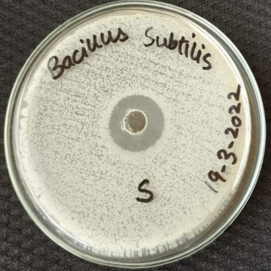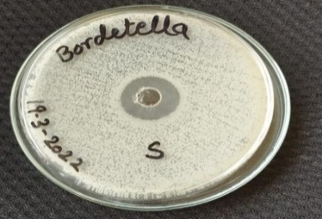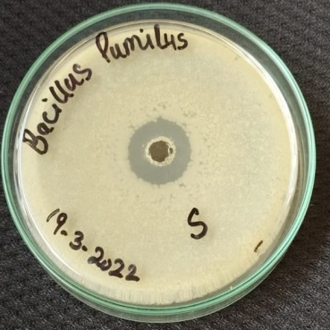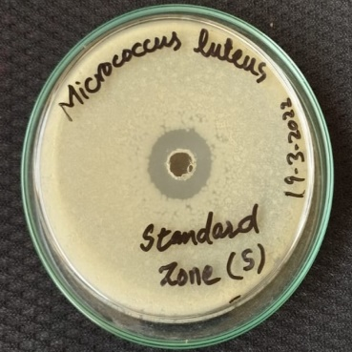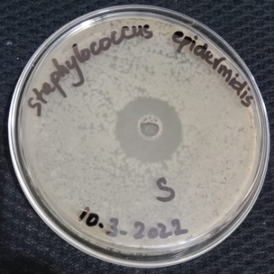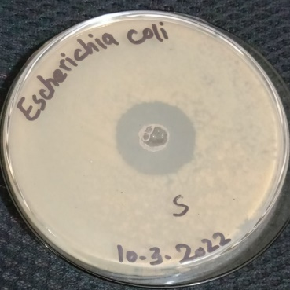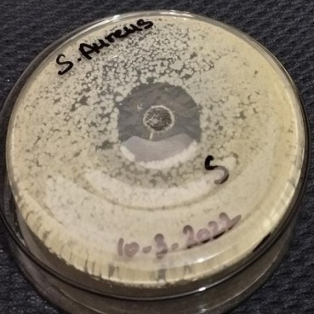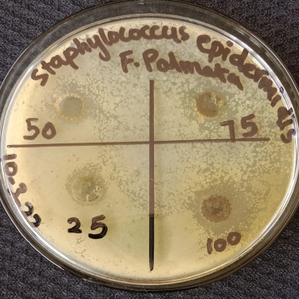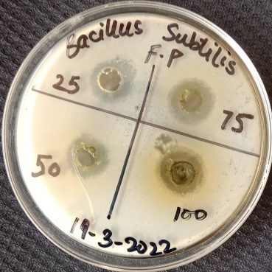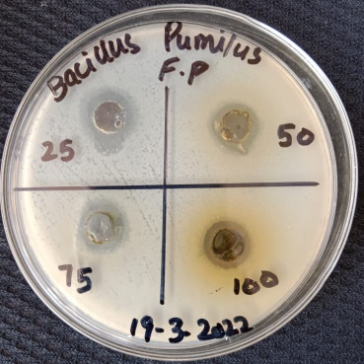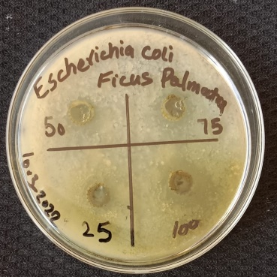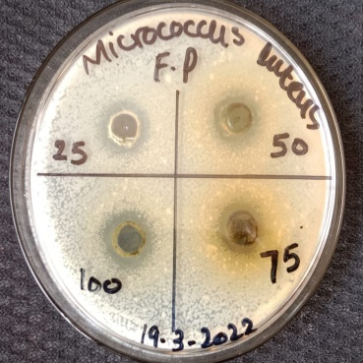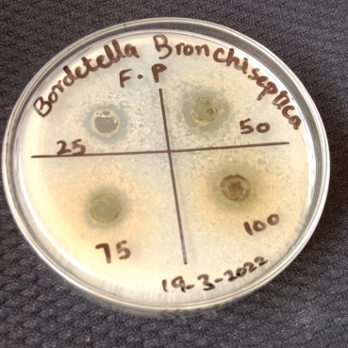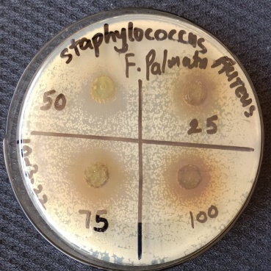

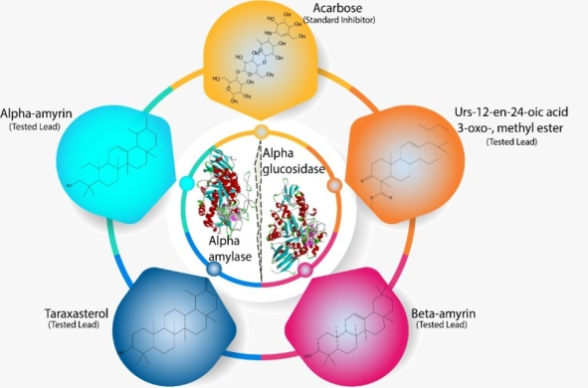

**Figure S2.** Graphical representation of best three docked compounds and acarbose against enzymes α-glucosidase and α-amylase.

C:\Users\Dr. Bilal\Downloads\3D 1 Amylase..tif

C:\Users\Dr. Bilal\Downloads\3D 2 Amylase.tif

**Figure S3 .** 3D interaction between amylase and “A” Acarbose, “B” Brucine, “C” α-Amyrin, “D” β-Amyrin, “E” Lupeol, “F” Stigmasterol, “G” 22,23-dihydro-Stigmasterol, “H” Taxasterol, and “I” Urs-12-en-24-oic acid, 3-oxo-,

C:\Users\Dr. Bilal\Downloads\Revision of F. palmata\Glucosidase 1.tif

C:\Users\Dr. Bilal\Downloads\Revision of F. palmata\Glucosidase 2.tif

**Figure S4.** 3D interaction between amylase and “A” Acarbose, “B” Brucine, “C” α-Amyrin, “D” β-Amyrin, “E” Lupeol, “F” Stigmasterol, “G” 22,23-dihydro-Stigmasterol, “H” Taxasterol, and “I” Urs-12-en-24-oic acid, 3-oxo-,

C:\Users\Dr. Bilal\Downloads\Picture1.tif

C:\Users\Dr. Bilal\Downloads\Picture2.tif

C:\Users\Dr. Bilal\Downloads\Picture3.tif

**Figure S5.** 3D interaction between α-amylase and “A” Benzoic acid, “B” Ferulic acid, “C” Coumarin, “D” Quercetin, “E” Rutin, “F” Kaempherol

C:\Users\Dr. Bilal\Downloads\Picture1.tif

C:\Users\Dr. Bilal\Downloads\Picture2.tif

C:\Users\Dr. Bilal\Downloads\Picture3.tif

**Figure S6.** 3D interaction between α-glucosidase and “A” Benzoic acid, “B” Ferulic acid, “C” Coumarin, “D” Quercetin, “E” Rutin, “F” Kaempherol

**Table S1.** Binding affinity of HPLC quantified compounds with α-amylase and α-glucosidase

|  |  |  |
| --- | --- | --- |
| **Compound Name** | **Binding affinity with α-amylase (Kcal/mol)** | **Binding affinity α-glucosidase (Kcal/mol)** |
| Benzoic acid | -5.2 | -5.8 |
| Ferulic acid | -6.6 | -6.4 |
| Coumarin | -6.2 | -6.0 |
| Quercetin | -8.8 | -7.6 |
| Rutin | -9.0 | -8.9 |
| Kaempherol | -8.4 | -7.9 |

**Table S2.** ADME Study of best docked compounds.

|  |  |  |  |  |  |  |  |  |  |  |
| --- | --- | --- | --- | --- | --- | --- | --- | --- | --- | --- |
| **Sr. no.** | **Best docked compounds** | **Gastrointe-stinal absorption** | **Blood brain barrier permeant** | **Pgp**  **inhibitor** | **CYP1A2**  **Inhibit-or** | **CYP2C19**  **Inhibitor** | **CYP2C9**  **Inhibitor** | **CYP2D6**  **Inhibitor** | **CYP3A4 inhibitor** | **Log Kp**  **(cm/s)** |
| 1. 1. | urs-12-en-24-oic acid, 3-oxo-, methyl ester | Low | No | No | No | No | No | No | No | -3.31 |
| 1. 2. | β-amyrin | Low | No | No | No | No | No | No | No | -2.41 |
| 1. 3. | acetic acid, 4,4,6a,6b,8a,11,11,14b-octamethyl-13-oxodocosahydropicen-3-yl ester | Low | No | No | No | No | No | No | No | -2.85 |
| 1. 5. | α-amyrin | Low | No | No | No | No | No | No | No | -2.51 |
| 1. 7. | taraxasterol | Low | No | No | No | No | No | No | No | -2.42 |
| 1. 9. | stigmasterol | Low | No | No | No | No | Yes | No | No | -2.74 |
| 1. 10. | lupeol | Low | No | No | No | No | No | No | No | -1.90 |
| 1. 12. | brucine | High | Yes | No | No | No | No | Yes | No | -8.01 |
| 1. 13. | stigmasterol, 22,23-dihydro- | Low | No | No | No | No | No | No | No | -2.20 |

Table S3. Lipinski rule of five and solubility of best docked compounds.

|  |  |  |  |  |  |  |  |  |  |  |
| --- | --- | --- | --- | --- | --- | --- | --- | --- | --- | --- |
| **Sr no.** | **Best docked compounds** | **Lipinski's rule** | | | | | | **Solubility** | | |
| **HBD** | **HBA** | **MWT** | **Lipophilicity** | **M.R** | **LR** | **ESOL Class** | **Ali Class** | **Silicos-IT class** |
| 1. 1 | urs-12-en-24-oic acid, 3-oxo-, methyl ester | 0 | 3 | 468.71 | 4.63 | 140.27 | 1 | Poorly soluble | Poorly soluble | Poorly soluble |
| 1. 2 | β-amyrin | 1 | 1 | 426.72 | 4.74 | 134.88 | 1 | Poorly soluble | Poorly soluble | Poorly soluble |
| 1. 3 | acetic acid, 4,4,6a,6b,8a,11,11,14b-octamethyl-13-oxodocosahydropicen-3-yl ester | 0 | 3 | 484.75 | 4.81 | 145.08 | 1 | Poorly soluble | Poorly soluble | Poorly soluble |
| 1. 4 | α-amyrin | 1 | 1 | 426.72 | 4.77 | 135.14 | 1 | Poorly soluble | Poorly soluble | Poorly soluble |
| 1. 5 | taraxasterol | 1 | 1 | 426.72 | 4.8 | 135.14 | 1 | Poorly soluble | Poorly soluble | Poorly soluble |
| 1. 6 | stigmasterol | 1 | 1 | 412.69 | 5.01 | 132.75 | 1 | Poorly soluble | Poorly soluble | Moderately soluble |
| 1. 7 | lupeol | 1 | 1 | 426.72 | 4.68 | 135.14 | 1 | Poorly soluble | Insoluble | Poorly soluble |
|  | brucine | 0 | 5 | 394.46 | 3 | 114.04 | 0 | Soluble | Very soluble | Soluble |
|  | stigmasterol, 22,23-dihydro- | 1 | 1 | 414.71 | 4.79 | 133.23 | 1 | Poorly soluble | Poorly soluble | Poorly soluble |

HBD: Hydrogen bond doners; HBA: Hydrogen bond acceptors; MWT: Molecular weight; M.R: Molar refractivity; LR: Lipinski rule; RB: Rotable bond.

**Table S4.** Toxicity of best docked compounds.

|  |  |  |  |  |  |  |  |  |
| --- | --- | --- | --- | --- | --- | --- | --- | --- |
| **Sr no.** | **Best docked compounds** | **Predicted LD50**  **mg/kg** | **Predicted toxicity class** | **Hepatotoxicity** | **Carcinogenicity** | **Immunotoxicity** | **Mutagenicity** | **Cytotoxicity** |
|  | urs-12-en-24-oic acid, 3-oxo-, methyl ester | 5000 | 5 | Inactive | Active | Active | Inactive | Inactive |
|  | β-amyrin | 70000 | 6 | Inactive | Inactive | Active | Inactive | Inactive |
|  | stigmasterol, 22,23-dihydro- | 890 | 4 | Inactive | Inactive | Active | Inactive | Inactive |
|  | α-amyrin | 7000 | 6 | Inactive | Inactive | Active | Inactive | Inactive |
|  | taraxasterol | 5000 | 5 | Inactive | Inactive | active | Inactive | Inactive |
|  | stigmasterol | 890 | 4 | Inactive | Inactive | Active | Inactive | Inactive |
|  | lupeol | 2000 | 4 | Inactive | Inactive | Active | Inactive | Inactive |
|  | brucine | 150 | 3 | Inactive | Active | Inactive | Inactive | Inactive |
|  | acetic acid, 4,4,6a,6b,8a,11,11,14b-octamethyl-13-oxodocosahydropicen-3-yl ester | 5000 | 5 | Inactive | Inactive | Active | Inactive | Inactive |

Class i: LD50 ≤ 5, class ii: 5 < LD50 ≤ 50, class iii: 50 < LD50 ≤ 300, class iv: 300 < LD50≤ 2000, class v: 2000 < LD50 ≤ 5000, and class vi: LD50 > 5000.