**Supplementary data**

***In Vivo* Monitoring an Important Plant Immune Signaling Molecule Salicylic Acid by Rhodamine-Engineered Probes and Their Density Functional Theory (DFT) Calculations**

Zi-Mian Fang, Li-Long Zhang, Jin-Jing Wang, Fang-Ze Li, Tian Wang, Hu Li,* Yan Mao, Pei-Yi Wang*

State Key Laboratory Breeding Base of Green Pesticide and Agricultural Bioengineering, Key Laboratory of Green Pesticide and Agricultural Bioengineering, Ministry of Education, Center for R&D of Fine Chemicals of Guizhou University, Guiyang, 550025, China.

* Corresponding author

E-mail: pywang888@126.com (P.-Y. Wang), hli13@gzu.edu.cn (H. Li).

**Contents**

1. Synthetic procedures for the intermediate 2

2. Determination of the fluorescence quantum yield 2

3. Calculation of the detection limit 2

4. The 1H NMR, 13C NMR and HMRS spectra of probes **F1-F4** 3

5. UV-Vis spectra of probes **F1-F4** in the presence of SA and its analogs 10

6. Job’s plot and Benesi-Hildebrand plot of probe **F1** with SA 10

7. DLS data and SEM images 11

8. Electrochemical data of probes **F1-F4** 11

9. HRMS spectrum for the new product after the probe **F1** was treated with SA 12

10. Chemical shift of probe **F1** and SA after the formation of the complex probe **F1**-SA with different molar ratios 12

11. Phytotoxicity assay for probe **F1** 13

12. Comparing the property for detecting SA in this work with other works 14

References 15

# 

# 1. Synthetic procedures for the intermediate



**Synthesis of intermediate 4,5-dimethoxy-2-nitrobenzyl hydrazinecarboxylate**.[1] 4,5-Dimethoxy-2-nitrobenzyl alcohol (0.13 g, 0.59 mmol) and 0.5 mL TEA were dissolved in 5 mL anhydrous tetrahydrofuran at 0℃ for 5 min, then triphosgene (0.18 g, 0.59 mmol) was added and stirred overnight at room temperature. And then the solution was concentrated by evaporation under reduced pressure. The obtained oil was dissolved in 10 mL anhydrous methanol, then hydrazine hydrate (98%, 0.12 mL, 3.80 mmol) was added into the above solution, and the mixture was refluxed for 5 h. The solvent was then removed under vacuum to give a yellow-green solid, 71 mg, yield 44.7%. 1H NMR (400 MHz, CDCl3) δ 7.71 (s, 1H, benzene-H), 6.98 (s, 1H, benzene-H), 6.17 (s, 1H, CO-NH), 5.55 (s, 2H, O-CH2), 3.96 (d, *J* = 9.8 Hz, 6H, O-CH3), 3.79 (s, 2H, CO-NHNH2). 13C NMR (101 MHz, CDCl3) δ 154.0, 148.8, 110.8, 108.7, 64.7, 56.9, 56.9.

# 2. Determination of the fluorescence quantum yield

The fluorescence quantum yield of probe **F1** (10 *µ*M) reacting with SA (50 *μ*M) was determined by quantum yield calculator integrating sphere in CH3CN-H2O (V/V, 7/3). According to the emission trace integral of probe **F1** reacting with SA and the emission trace integral of blank solvent, the Ф**F1**+SA was calculated as 0.195, while probe **F1** itself provided Φ**F1** as 0.000 at the same conditions.

# 3. Calculation of the detection limit

The detection limit of **F1** for SA was calculated by the signal-to-noise ratio (S/N).[2] The fluorescence intensity of **F1** without target analytes was measured 20 times at designated wavelengths. On the basis of these data, the average fluorescence intensity (averageblank) along with the associated standard deviation (SDblank) was determined, and the SDblank was considered as the noise (N) of our detection system. Subsequently, the fluorescence intensity of F**1** by adding the corresponding analytes with a relatively low concentration was measured for five times, and the average value (averagesample) was recorded. Finally, S/N was calculated as follows:

$$S/{N= {\left(\left|{average}_{sample}\right.-\left.{average}_{blank}\right|\right)}/{{SD}_{blank}}}$$

If the S/N value fell within the range of 3 to 5, suggesting that the corresponding concentration was determined as the detection limit.

# 4. The 1H NMR, 13C NMR and HMRS spectra of probes F1-F4

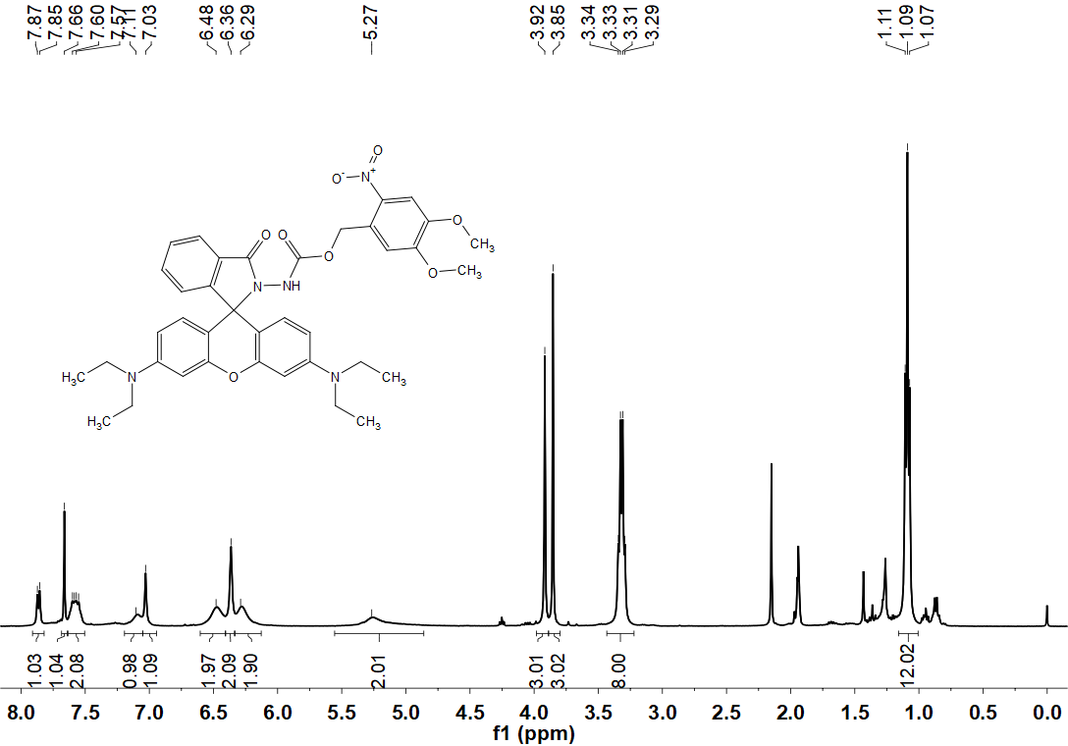

**Figure S1.** 1H NMR spectrum of probe **F1** in CD3CN (400 MHz).

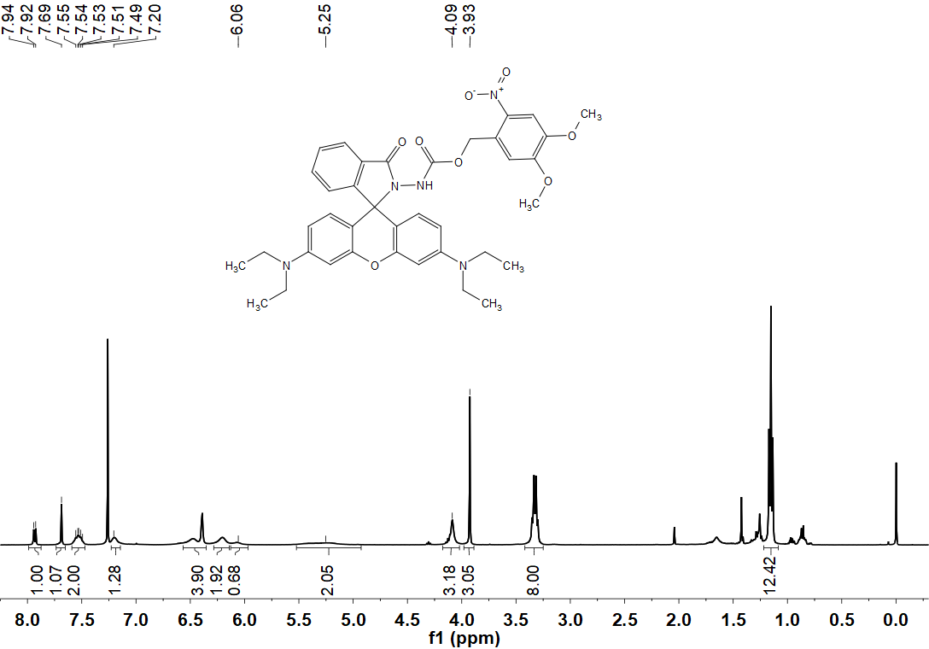

**Figure S2.** 1H NMR spectrum of probe **F1** in CDCl3 (400 MHz).

**Figure S3.** 13C NMR spectrum of probe **F1** in CD3CN (101 MHz).

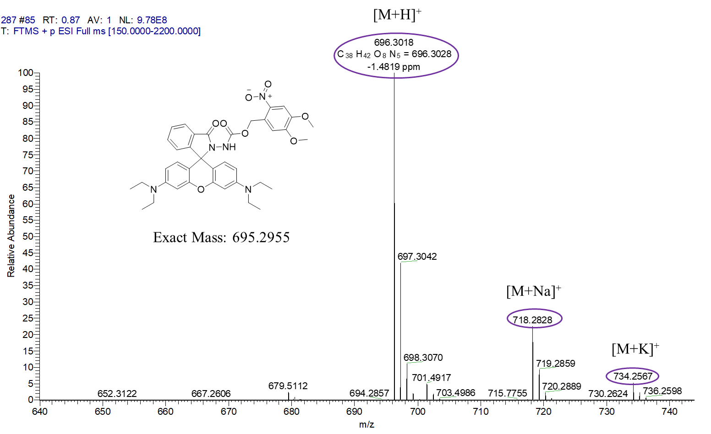

**Figure S4.** HRMS spectrum of probe **F1**.

**Figure S5.** 1H NMR spectrum of probe **F2** in CDCl3 (400 MHz).

**Figure S6.** 13C NMR spectrum of probe **F2** in CDCl3 (101 MHz).

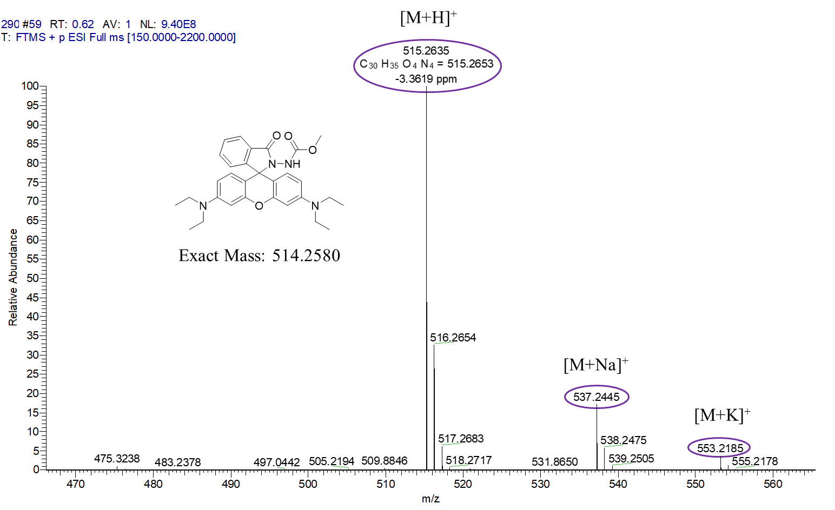

**Figure S7.** HRMS spectrum of probe **F2**.

**Figure S8.** 1H NMR spectrum of probe **F3** in CDCl3 (400 MHz).

**Figure S9.** 13C NMR spectrum of probe **F3** in DMSO (101 MHz).

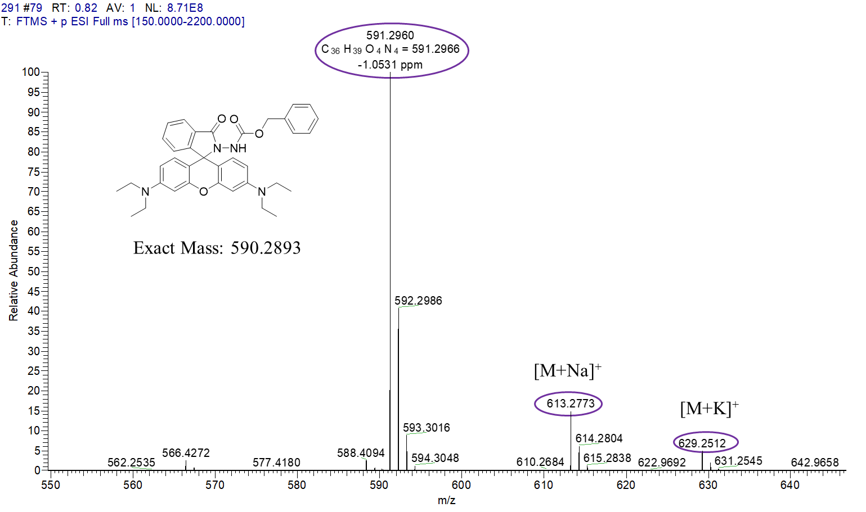

**Figure S10.** HRMS spectrum of probe **F3**.

**Figure S11.** 1H NMR spectrum of probe **F4** in CDCl3 (400 MHz).

图示

**Figure S12.** 13C NMR spectrum of probe **F4** in CDCl3 (101 MHz).

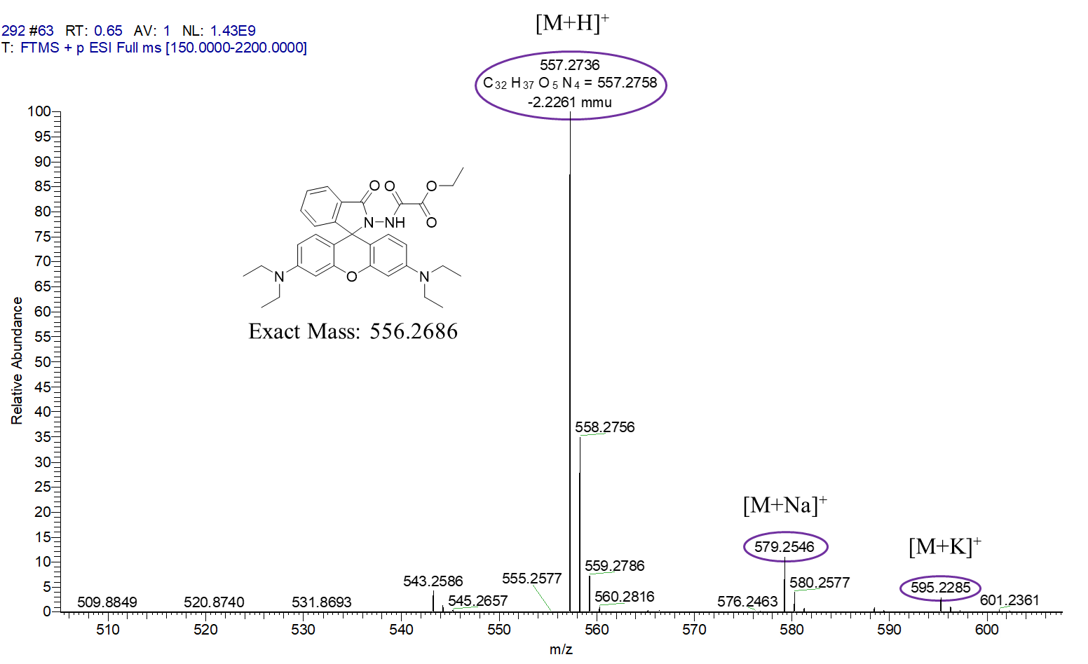

**Figure S13.** HRMS spectrum of probe **F4**.

# 5. UV-Vis spectra of probes F1-F4 in the presence of SA and its analogs

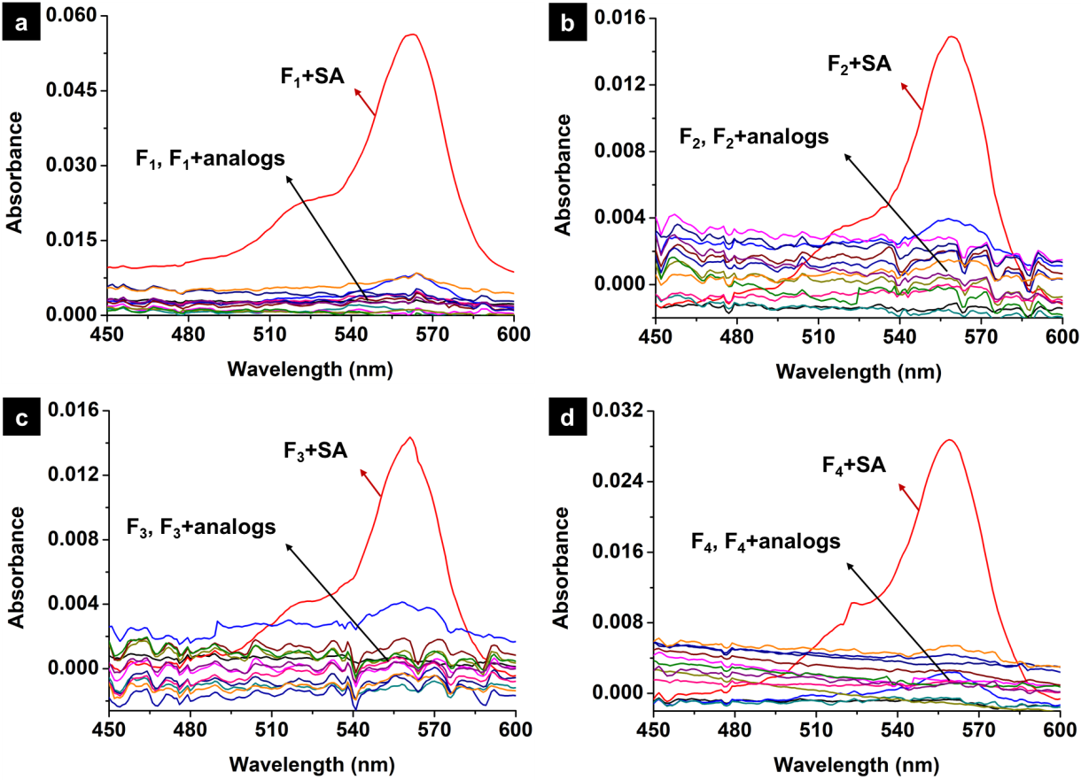

**Figure S14.** UV absorption spectra of probes **F1** (a), **F2** (b), **F3** (c) and **F4** (d) (20 *µ*M) upon the addition of SA and its analogs (200 *µ*M) in the mixed solution (MeCN:H2O = 7:3 , v/v).

# 6. Job’s plot and Benesi-Hildebrand plot of probe F1 with SA

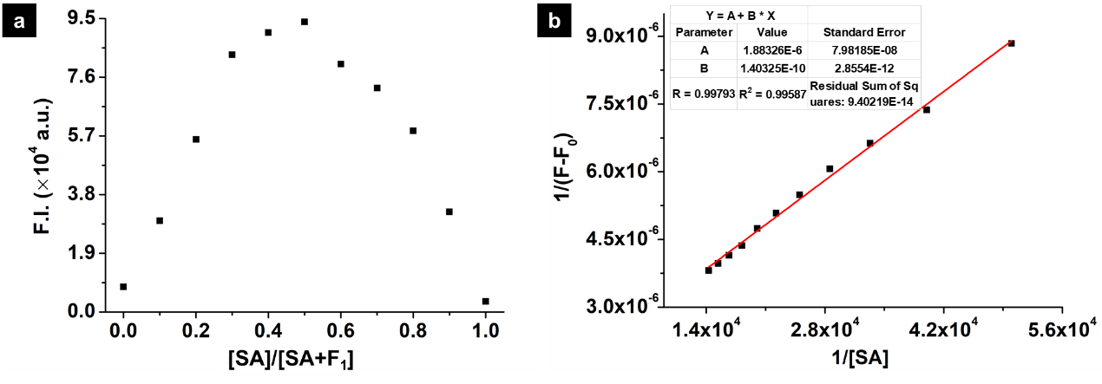

**Figure S15.** The Job’s plot (a) and Benesi-Hildebrand plot (b) of probe **F1** with SA. Binding constant (Ka = 1.34 × 104 *μ*M-1) was determined by fluorescence method (λex = 564 nm, slits: 2 nm/2 nm).

# 7. DLS data and SEM images

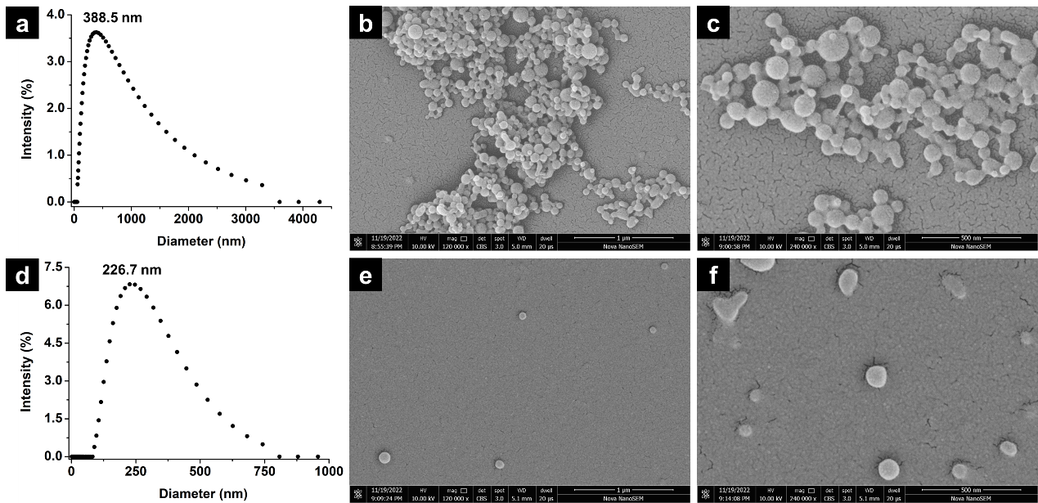

**Figure S16.** Intensity-based DLS data of probe **F1** (30 *µ*M) (a) and probe **F1** (30 *µ*M) upon addition of SA (150 *µ*M) (d) in same solution (MeCN:H2O =1:9 , v/v) at 25 °C; SEM images of probe **F1** (30 *µ*M) (b, c) and probe **F1** (30 *µ*M) upon the addition of SA (150 µM) (e, f).

# 8. Electrochemical data of probes F1-F4

**Table S1.** DFT-based descriptors of probes **F1**-**F4** after absorption of SA (mode I and mode II)

|  |  |  |  |  |  |  |  |
| --- | --- | --- | --- | --- | --- | --- | --- |
| Probes | Binding energy (kcal/mol) | | | *E*LUMO  (kj/mol) | *E*HUMO  (kj/mol) | *ΔE* L−H (kj/mol) | |
| SA mode I | SA mode II | |
| **F1** | -9.65 | | -12.41 | -116.96 | -615.86 | | 498.89 |
| **F2** | -11.02 | | -11.01 | -31.20 | -622.51 | | 591.31 |
| **F3** | -7.76 | | -11.89 | -29.86 | -631.60 | | 601.74 |
| **F4** | -17.49 | | -8.37 | -58.24 | -625.31 | | 567.07 |

# 9. HRMS spectrum for the new product after the probe F1 was treated with SA

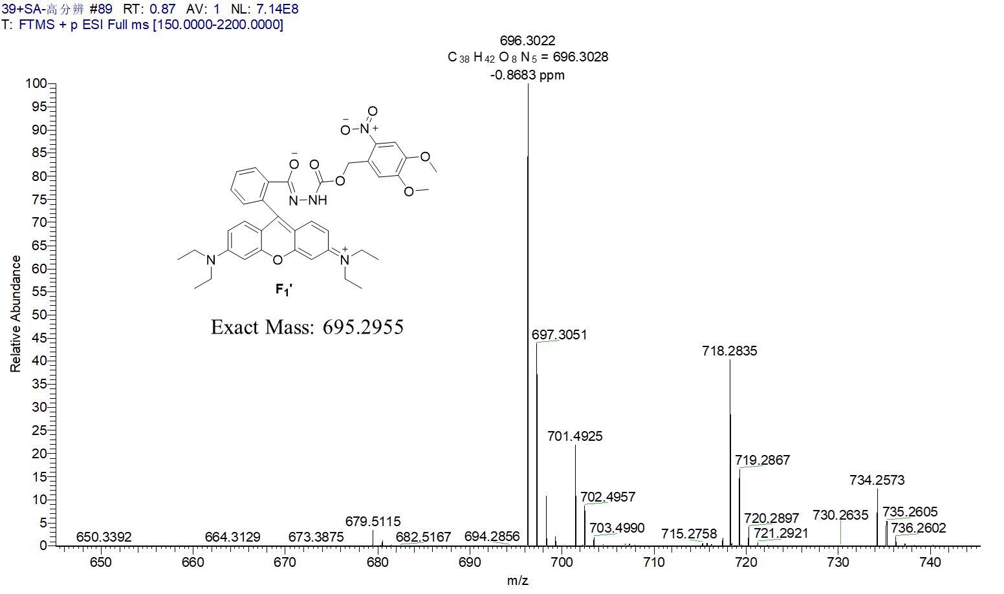

**Figure S17.** HRMS spectrum of the new product after the probe **F1** was treated with SA

# 10. Chemical shift of probe F1 and SA after the formation of the complex probe F1-SA with different molar ratios

**Table S2.** Chemical shift of SA after the formation of the complex probe **F1**-SA with different molar ratios.

|  |  |  |  |  |
| --- | --- | --- | --- | --- |
| Chemical shift (ppm) | proton | | | |
| a | b | c | d |
| SA | 7.94 | 7.53 | 7.02 | 6.95 |
| **F1** : SA =1 : 1 | 7.88 | 7.48 | 6.96 | 6.89 |
| **F1** : SA =1 : 2 | 7.90 | 7.49 | 6.98 | 6.90 |
| **F1** : SA =1 : 3 | 7.90 | 7.50 | 6.99 | 6.91 |
| Shift(**F1** : SA =1 : 1) | -0.06 | -0.05 | -0.06 | -0.06 |
| Shift(**F1** : SA =1 : 2) | -0.04 | -0.04 | -0.04 | -0.05 |
| Shift(**F1** : SA =1 : 3) | -0.04 | -0.03 | -0.03 | -0.04 |

**Table S3.** Chemical shift of probe **F1** after formation of the complex probe **F1**-SA with different molar ratios.

|  |  |  |  |  |  |  |  |  |
| --- | --- | --- | --- | --- | --- | --- | --- | --- |
| Chemical shift (ppm) | proton | | | | | | | |
| 1 | 2 | 3、4 | 5、6 | 7、8 | 9、10 | 11、12 | 13 |
| **F1** | 7.93 | 7.69 | 7.53 | 7.20 | 6.48 | 6.40 | 6.20 | 6.06 |
| **F1** : SA =1 : 1 | 7.96 | 7.68 | 7.54 | 7.21 | 6.49 | 6.40 | 6.22 | 6.72 |
| **F1** : SA =1 : 2 | 7.97 | 7.68 | 7.55 | 7.22 | 6.50 | 6.42 | 6.23 | 7.22 |
| **F1** : SA =1 : 3 | 7.98 | 7.68 | 7.56 | 7.22 | 6.50 | 6.43 | 6.24 | 7.22 |
| Shift(**F1** : SA =1 : 1) | 0.03 | -0.01 | 0.01 | 0.01 | 0.01 | 0 | 0.02 | 0.66 |
| Shift(**F1** : SA =1 : 2) | 0.04 | -0.01 | 0.02 | 0.02 | 0.02 | 0.02 | 0.03 | 1.16 |
| Shift(**F1** : SA =1 : 3) | 0.05 | -0.01 | 0.03 | 0.02 | 0.02 | 0.03 | 0.04 | 1.16 |

# 11. Phytotoxicity assay for probe F1

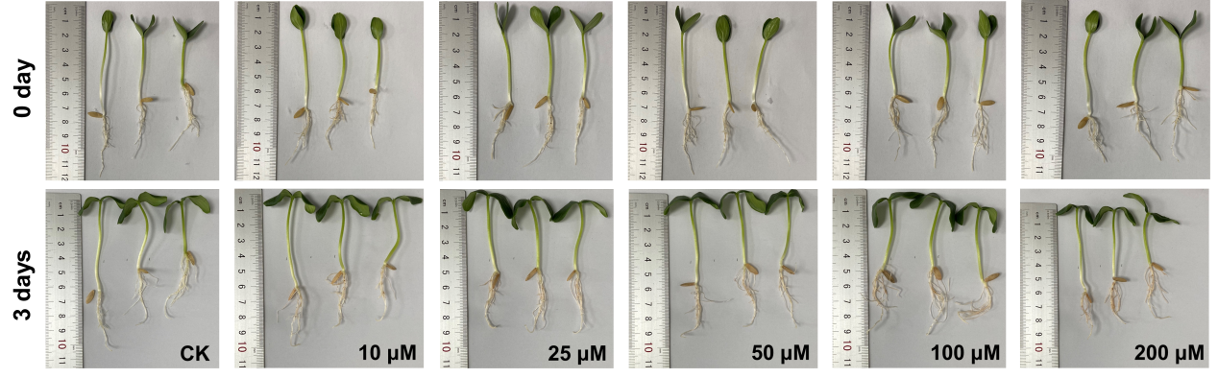

**Figure S18.** Cultivating 5-day-old cucumber seedlings in distilled water (CK) and different concentrations (10-200 µM) of **F1** aqueous solutions (1% MeCN, v/v) for three days at 25 °C.

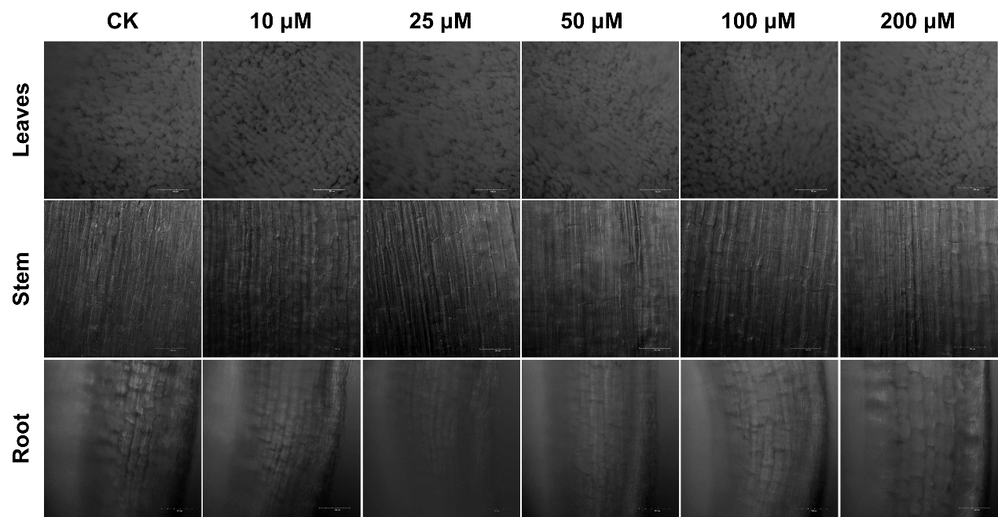

**Figure S19.** Laser scanning two-photon fluorescence microscopy images of cucumber seedling leaves, stems, and roots (bright-field): After cultivating cucumber seedlings in distilled water (CK) and various concentrations of **F1** aqueous solutions (1% MeCN, v/v) for three days at 25 °C.

**Table S4.** The weight and lengths of stems and roots of cucumber seedlings after cultivating them in distilled water (CK) and various concentrations of **F1** solutions for 3 days at 25 °C.

|  |  |  |  |  |  |  |  |  |  |
| --- | --- | --- | --- | --- | --- | --- | --- | --- | --- |
| 0 days | | | | | 3 days later | | | | |
|  |  | Seedling 1 | Seedling 2 | Seedling 3 |  |  | Seedling 1 | Seedling 2 | Seedling 3 |
| CK | Stem (cm) | 5.6 | 4.3 | 2.9 | CK | Stem (cm) | 6.1 | 4.5 | 3.4 |
| Root (cm) | 4.4 | 4.5 | 5.5 | Root (cm) | 4.6 | 4.9 | 5.7 |
| Weight (g) | 0.244 | 0.252 | 0.377 | Weight (g) | 0.311 | 0.332 | 0.428 |
| 10 µM | Stem (cm) | 5.4 | 4.0 | 3.5 | 10 µM | Stem (cm) | 5.9 | 4.6 | 4.0 |
| Root (cm) | 4.4 | 3.9 | 4.2 | Root (cm) | 4.5 | 4.7 | 5.0 |
| Weight (g) | 0.293 | 0.271 | 0.251 | Weight (g) | 0.373 | 0.389 | 0.353 |
| 25 µM | Stem (cm) | 4.7 | 4.1 | 4.1 | 25 µM | Stem (cm) | 5.1 | 4.5 | 4.5 |
| Root (cm) | 3.9 | 5.4 | 4.6 | Root (cm) | 4.3 | 5.9 | 5.0 |
| Weight (g) | 0.311 | 0.313 | 0.252 | Weight (g) | 0.412 | 0.439 | 0.364 |
| 50 µM | Stem (cm) | 5.2 | 4.2 | 4.4 | 50 µM | Stem (cm) | 5.6 | 4.6 | 4.6 |
| Root (cm) | 4.8 | 4.6 | 5.0 | Root (cm) | 4.9 | 5.3 | 5.5 |
| Weight (g) | 0.291 | 0.318 | 0.265 | Weight (g) | 0.386 | 0.386 | 0.339 |
| 100 µM | Stem (cm) | 4.2 | 3.9 | 4.4 | 100 µM | Stem (cm) | 4.6 | 4.2 | 4.7 |
| Root (cm) | 4.8 | 5.2 | 4.9 | Root (cm) | 4.9 | 5.7 | 5.3 |
| Weight (g) | 0.316 | 0.325 | 0.306 | Weight (g) | 0.432 | 0.445 | 0.433 |

# 12. Comparing the property for detecting SA in this work with other works

**Table S5.** Comparison of the property for detecting SA in this work with other works.

|  |  |  |  |  |  |
| --- | --- | --- | --- | --- | --- |
| Structure | LOD | Selectivity | Application | Detection medium | References |
| MPA-CdTe QDs | 150 ng·mL-1 | No data | In vitro | Water,  pH = 5.5 | 3 |
|  | No data | Poor | In vitro | EtOH | 4 |
|  | No data | Poor | In vitro | EtOH | 5 |
|  | No data | Poor | In vitro | EtOH | 6 |
|  | No data | Poor | In vitro | EtOH | 7 |
|  | No data | Poor | In vitro | PBS/EtOH (5/95, v/v, pH = 7.4) | 8 |
|  | 2 nM | High | In vitro and cells | CH3CN/H2O (1/1, v/v) | 9 |
|  | 1 nM | High | In vitro and cells | CH3OH/H2O (9/1, v/v) | 10 |
|  | 3 μM | High | In vitro and cells | DMF/H2O (7/3, v/v) and DMF/MES (7/3, v/v, 20 mM, pH=7.2) | 11 |
|  | 1 μM | High | In Vivo | CH3CN/H2O (7/3, v/v) | This work |

# References

[1] Veetil, A. T.; Chakraborty, K.; Xiao, K.; Minter, M. R.; Sisodia, S. S.; Krishnan, Y. Cell-targetable DNA nanocapsules for spatiotemporal release of caged bioactive small molecules. *Nat. Nanotechnol.* **2017**, *12*, 1183-1189.

[2] Yang, L. L.; Zou, S. Y.; Fu, Y. H.; Li, W.; Wen, X. P.; Wang, P. Y.; Wang, Z. C.; Ouyang, G. P.; Li, Z.; Yang, S. Highly Selective and Sensitive Detection of Biogenic Defense Phytohormone Salicylic Acid in Living Cells and Plants Using a Novel and Viable Rhodamine-Functionalized Fluorescent Probe. *J. Agric. Food Chem.* **2020**, *68*, 4285-4291.

[3] Bunkoed, O.; Kanatharana, P. Mercaptopropionic acid-capped CdTe quantum dots as fluorescence probe for the determination of salicylic acid in pharmaceutical products. *Luminescence* **2015**, *30*, 1083-1089.

[4] Ahmad, M. W.; Kim, B. Y.; Kim, H. S. Selective fluorescence sensing of salicylic acid using a simple pyrene appended imidazole receptor. *New J. Chem.* **2014**, *38*, 1711-1716.

[5] Kumar, A.; Ghosh, M. K.; Choi, C. H.; Kim, H. S. Selective fluorescence sensing of salicylic acids using a simple pyrenesulfonamide receptor. *RSC Adv.* **2015**, *5*, 23613-23621.

[6] Pandith, A.; Hazra, G.; Kim, H. S. A new fluorogenic sensing platform for salicylic acid derivatives based on π-π and NH-π interactions between electron-deficient and electron-rich aromatics. *Spectrochimic. Acta A* **2017**, *178*, 151-159.

[7] Kumar, A.; Lee, J. Y.; Kim, H. S. Selective fluorescence sensing of 3,5-dinitrosalicylic acid based on pyrenesulfonamide-functionalized inorganic/organic hybrid nanoparticles. *J. Ind. Eng. Chem*. **2016**, *44*, 82-89.

[8] Kumar, A.; Pandith, A.; Kim, H. S. Pyrenebutylamidopropylimidazole as a multi-analyte sensor for 3,5-dinitrosalicylic acid and Hg2+ ions. *J. Lumines*. **2016**, *172*, 309-316.

[9] Wang, P. Y.; Luo, X.; Yang, L. L.; Zhao, Y. C.; Dong, R.; Li, Z.; Yang, S. A rhodamine-based highly specific fluorescent probe for the *in situ* and *in vivo* imaging of the biological signalling molecule salicylic acid. *Chem. Commun*. **2019**, *55*, 7691-7694.

[10] Yang, L.L., Zou, S.Y., Fu, Y.H., Li, W., Wen, X.P., Wang, P.Y., Wang, Z.C., Ouyang, G.P., Li, Z., Yang, S. Highly Selective and Sensitive Detection of Biogenic Defense Phytohormone Salicylic Acid in Living Cells and Plants Using a Novel and Viable Rhodamine-Functionalized Fluorescent Probe. *J. Agric. Food Chem.*, **2020**, *68*, 4285-4291.

[11] Chen, C., Yang, L.L., Tang, A.L., Wang, P.Y., Dong, R., Wu, Z.B., Li, Z., Yang, S. Curcumin−Cu(II) Ensemble-Based Fluorescence “Turn-On” Mode Sensing the Plant Defensive Hormone Salicylic Acid In Situ and In Vivo. *J. Agric. Food Chem.*, **2020**, *68*, 4844-4850.