Supporting Information
Novel 1,3,4-Oxadiazole Thioether and Sulfone Derivatives Bearing a Flexible N-Heterocyclic Moiety: Synthesis, Characterization, and Anti-microorganism Activity

Fang Wang, Bin-Xin Yang, Tai-Hong Zhang, Qing-Qing Tao, Xiang Zhou*, Pei-Yi Wang, Song Yang*

State Key Laboratory Breeding Base of Green Pesticide and Agricultural Bioengineering, Key Laboratory of Green Pesticide and Agricultural Bioengineering, Ministry of Education, Center for R and D of Fine Chemicals of Guizhou University, Guiyang, 550025, China.
E-mail: jhzx.msm@gmail.com (YS); zhoux1534@163.com (ZX)

Contents
1. 1,3,4,-oxadizoles and their activities in various fields 2
2. Homologous modeling 5
3. The binding efficacy 5
4. Characterization data of title molecules 6
5. ¹H NMR, ¹³C NMR , ¹⁹F NMR and HRMS spectra of target compounds 4~10, 12~20 and 23~34 15
6. Phytotoxicity of compound 33 at 200 mg L⁻¹ toward rice plants after seven days under greenhouse conditions 61
7.References 61

1. 1,3,4,-oxadizoles and their activities in various fields
Table S1. 1,3,4,-oxadizoles and their activities in various fields
Ser.  No | Inhibitory activity | Structures | Mechanisms | Ref.
1 | Anti-Xoo activity,  EC₅₀=0.1 mg L⁻¹ |  | Damage the cell membrane | [1]
2 | Anti-Xoo activity,  EC₅₀=0.79 mg L⁻¹ |  | Inhibiting the formation of extracellular polysaccharides | [2]
3 | Antifungal activity  EC₅₀=0.65 mg L⁻¹ |  | Targeting SDH enzyme | [3]
4 | Antiviral  Against TMV  protection activity  EC₅₀=137.7 mg L⁻¹ |  | Inducing the plant’s  defense responses | [4]
5 | Antiviral activity toward TMV,  protective activity  EC₅₀=189.9 mg L⁻¹ |  | Targeting TMV-CP | [5]
6 | Antiviral activity toward TMV,  protective activity:  69.2% at 500 mg L⁻¹ |  |  | [6]
7 | Insecticidal activity  against E. lanigerum  LC₅₀=27.6 mg L⁻¹ |  | Destroying the mitochondria and nuclear membranes in insect midgut cells | [7]
8 | Insecticidal activity  against Tylenchulus semipenetrans  LC₅₀=8.5 mg L⁻¹ |  |  | [8]
9 | Insecticidal activity  against  Tylenchulus semipenetrans  LC₅₀=11.7 mg L⁻¹ |  |  | [9]
References
[1] Wang, M.W., Zhu, H.H., Wang, P.Y., Zeng, D., Wu, Y.Y., Liu, L.W., Wu, Z.B., Li, Z., Yang, S., 2019. Synthesis of thiazolium-labeled 1,3,4-oxadiazole thioethers as
prospective antimicrobials: in vitro and in vivo bioactivity and mechanism of action. J. Agr. Food Chem. 67 (46), 12696−12708. https://doi.org/10.1021/acs.jafc.9b03952
[2] Xiang, J., Liu, D.Y., Chen, J.X., Hu, D.Y., Song, B.A., 2020. Design and synthesis of novel 1,3,4-oxadiazole sulfone compounds containing 3,4-dichloroisothiazolylamide moiety and evaluation of rice bacterial activity. Pestic. Biochem. Phys. 170, 104695. https://doi.org/10.1016/j.pestbp.2020.104695
[3] Wu, Y.Y., Shao, W.B., Zhu, J.J., Long, Z.Q., Liu, L.W., Wang, P.Y., Li, Z., Yang, S., 2019. Novel 1,3,4-oxadiazole-2-carbohydrazides as prospective agricultural antifungal agents potentially targeting succinate dehydrogenase. J. Agr. Food Chem. 67 (50), 13892−13903. https://doi.org/10.1021/acs.jafc.9b05942
[4] Ji, J., Shao, W.B., Chu, P.L., Xiang, H.M., Qi, P.Y., Zhou, X., Wang, P.Y., Yang, S., 2022. 1,3,4-oxadiazole derivatives as plant activators for controlling plant viral diseases: preparation and assessment of the effect of auxiliaries. J. Agr. Food Chem. 70 (26), 7929−7940. https://doi.org/10.1021/acs.jafc.2c01988
[5] Peng, F., Liu, T.T., Wang, Q.F., Liu, F., Cao, X., Yang, J.S., Liu, L.W., Xie, C.W., Xue, W., 2021. Antibacterial and antiviral activities of 1,3,4-oxadiazole thioether
4H-chromen-4-one derivatives. J. Agr. Food Chem. 69 (37), 11085−11094. https://doi.org/10.1021/acs.jafc.1c03755
[6] Gan, X.H., Hu, D.Y., Li, P., Wu, J., Chen, X.W., Xue, W., Song, B.A., 2016. Design, synthesis, antiviral activity and three-dimensional quantitative structure–activity relationship study of novel 1,4-pentadien-3-one derivatives containing the 1,3,4-oxadiazole moiety. Pest Manag. Sci. 72 (3), 534−543. https://doi.org/ 10.1002/ps.4018
[7] Ma, S.C., Jiang, W.Q., Li, Q., Li, T., Wu, W.J., Bai, H.Y., Shi, B.J., 2021. Design, synthesis, and study of the insecticidal activity of novel steroidal 1,3,4-oxadiazoles. J. Agr. Food Chem. 69 (39), 11572−11581. https://doi.org/10.1021/acs.jafc.1c00088
[8] Chen, J.X., Chen, Y.Z., Gan, X.H., Song, B.J., Hu, D.Y., Song, B.A., 2018. Synthesis, nematicidal evaluation, and 3D-QSAR analysis of novel 1,3,4-oxadiazole−cinnamic acid hybrids. J. Agr. Food Chem. 66 (37), 9616−9623.
https://doi.org/10.1021/acs.jafc.8b03020
[9] Chen, J.X., Gan, X.H., Yi, C.F., Wang, S.B., Yang, Y.Y., He, F.C., Hu, D.Y., Song, B.A., 2018. Synthesis, nematicidal activity, and 3D-QSAR of novel 1,3,4-oxadiazole/ thiadiazole thioether derivatives. Chin. J. Chem. 36 (10), 939−944. https://doi.org/10.1002/cjoc.201800282

2. Homologous modeling
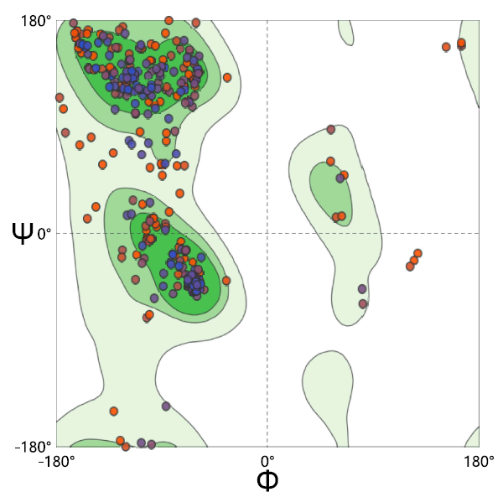

Residues in most favored regions [A,B,L] | 82.8%
Residues in additional allowed regions [a,b,l,p] | 14.6%
Residues in generously allowed regions [~a,~b,~l,~p] | 1.3%
Residues in disallowed regious | 1.4%
Number of non-glycine and non-proline residues | 100.0%

3. The binding efficacy
Total Score | Crash | Polar | D_SCORE | PMF_SCORE | G_SORE | CHEMSCORE | CSCORE | GLOBA
5.24 | -0.49 | 1.17 | -36.982 | -0.260 | -134.458 | -8.673 | 1 | 1

4. Characterization data of title molecules
2-(4-methylpiperazin-1-yl)-5-(methylthio)-1,3,4-oxadiazole (4)
A yellow oil, yield 33.90%; ¹H NMR (400 MHz, CDCl₃) δ 3.52-3.46 (m, 4H, oxadiazole-N-(CH₂)₂), 2.61 (s, 3H, S-CH₃), 2.50-2.46 (m, 4H, CH₃-N-(CH₂)₂), 2.31 (s, 3H, N-CH₃); ¹³C NMR (101 MHz, CDCl₃) δ 165.3, 157.5, 53.9, 47.7, 46.1, 15.0; HRMS (ESI) [M+H]⁺ calcd for C₈H₁₅ON₄S: 215.0961, found: 215.0955.
2-((4-methylbenzyl)thio)-5-(4-methylpiperazin-1-yl)-1,3,4-oxadiazole (5)
A white solid, yield 29.31%; ¹H NMR (400 MHz, CDCl₃) δ 7.26 (d, J = 8.0 Hz, 2H, Ph-3,5-H), 7.12 (d, J = 7.9 Hz, 2H, Ph-2,6-H), 4.28 (s, 2H, S-CH₂), 3.52-3.43 (m, 4H, N-(CH₂)₂), 2.55-2.42 (m, 4H, CH₃-N-(CH₂)₂), 2.33 (d, J = 1.2 Hz, 6H, CH_{3,} Ph-CH₃); ¹³C NMR (101 MHz, CDCl₃) δ 165.3, 156.1, 137.8, 133.0, 129.5, 129.1, 53.9, 46.3, 46.0, 37.4, 21.3; HRMS (ESI) [M+H]⁺ calcd for C₁₅H₂₁ON₄S: 305.1431, found: 305.1420.
2-((2-methoxybenzyl)thio)-5-(4-methylpiperazin-1-yl)-1,3,4-oxadiazole (6)
A yellow oil, yield 31.62%; ¹H NMR (400 MHz, CDCl₃) δ 7.29 (d, J = 7.5 Hz, 1H, Ph-6-H), 7.24 (t, J = 7.8 Hz, 1H, Ph-5-H), 6.85 (t, J = 8.0 Hz, 2H, Ph-3,4-H), 4.29 (s, 2H, S-CH₂), 3.82 (s, 3H, O-CH₃), 3.49-3.42 (m, 4H, N-(CH₂)₂), 2.50-2.40 (m, 4H, CH₃-N-(CH₂)₂), 2.30 (s, 3H, N-CH₃); ¹³C NMR (101 MHz, CDCl₃) δ 165.1, 157.3, 156.6, 130.6, 129.4, 124.6, 120.4, 110.5, 55.4, 53.8, 46.2, 45.9, 32.5; HRMS (ESI) [M+H]⁺ calcd for C₁₅H₂₁O₂N₄S: 321.1380, found: 321.1373.
2-((3-chlorobenzyl)thio)-5-(4-methylpiperazin-1-yl)-1,3,4-oxadiazole (7)
A yellow oil, yield 37.52%; ¹H NMR (400 MHz, CDCl₃) δ 7.39 (s, 1H, Ph-2-H), 7.29 (dd, J = 6.3, 3.7 Hz, 3H, Ph-4,5,6-H), 4.29 (s, 2H, S-CH₂), 3.50-3.41 (m, 4H, N-(CH₂)₂), 2.55-2.47 (m, 4H, CH₃-N-(CH₂)₂), 2.33 (s, 3H, CH₃); ¹³C NMR (101 MHz, MeOD) δ 166.5, 157.2, 140.6, 135.3, 131.3, 130.1, 128.9, 128.5, 54.6, 46.6, 46.2, 37.6; HRMS (ESI) [M+H]⁺ calcd for C₁₄H₁₈ON₄ClS: 325.0884, found: 325.0873.
2-((2,4-difluorobenzyl)thio)-5-(4-methylpiperazin-1-yl)-1,3,4-oxadiazole (8)
A yellow oil, yield 26.05%. ¹H NMR (400 MHz, CDCl₃) δ 7.46-7.38 (m, 1H, Ph-6-H), 6.80 (m, 2H, Ph-3,5-H), 4.27 (s, 2H, S-CH₂), 3.53-3.43 (m, 4H, N-(CH₂)₂), 2.53-2.45 (m, 4H, CH₃-N-(CH₂)₂), 2.32 (s, 3H, CH₃);¹³C NMR (101 MHz, CDCl₃) δ 165.3, 160.9 (d, J = 262.8 Hz), 162.7 (d, J = 261.8 Hz), 155.4, 132.1 (d, J = 14.7 Hz), 119.7 (d, J = 18.5 Hz), 111.4 (d, J = 25.0 Hz), 104.0 (d, J = 50.7 Hz), 53.8, 46.2, 45.9, 30.0; ¹⁹F NMR (376 MHz, CDCl₃) δ -109.6 (dt, J = 16.2, 8.2 Hz), -112.6 (dd, J = 17.4, 8.7 Hz); HRMS (ESI) [M+H]⁺ calcd for C₁₄H₁₇ON₄F₂S: 327.1086, found: 327.1081.
2-((2-chloro-4-fluorobenzyl)thio)-5-(4-methylpiperazin-1-yl)-1,3,4-oxadiazole (9)
A white solid, yield 50.01%, m. p. 80.3-81.6 ℃. ¹H NMR (400 MHz, CDCl₃) δ 7.48 (dd, J = 8.6, 6.0 Hz, 1H, Ph-H), 7.12 (dd, J = 8.4, 2.6 Hz, 1H, Ph-H ), 6.91 (td, J = 8.3, 2.6 Hz, 1H, Ph-H), 4.36 (s, 2H, S-CH₂ ), 3.50-3.44 (m, 4H, N-(CH₂)₂), 2.48-2.44 (m, 4H, CH₃-N-(CH₂)₂), 2.31 (s, 3H, -CH₃); ¹³C NMR (101 MHz, CH₃OH) δ 165.9, 162.8 (d, J = 249.5 Hz), 156.2, 135.3 (d, J = 10.8 Hz), 133.0 (d, J = 9.0 Hz), 131.3 (d, J = 3.7 Hz), 117.3 (d, J = 25.2Hz), 114.7 (d, J = 21.5 Hz), 53.9, 45.8, 45.4, 34.8; HRMS (ESI) [M+H]⁺ calcd for C₁₄H₁₇ON₄ClFS: 343.0790, found: 343.0786.
2-(((6-chloropyridin-2-yl)methyl)thio)-5-(4-methylpiperazin-1-yl)-1,3,4-oxa Diazole (10)
A yellow solid, yield 40.90%; m. p. 79.2-81.6 ℃. ¹H NMR (400 MHz, CDCl₃) δ 8.39 (d, J = 2.4 Hz, 1H, Ph-4-H), 7.76 (dd, J = 8.2, 2.5 Hz, 1H, Ph-3-H), 7.29 (d, J = 8.2 Hz, 1H, Ph-5-H), 4.27 (s, 2H, S-CH₂), 3.51-3.47 (m, 4H, N-(CH₂)₂), 2.51-2.47 (m, 4H, CH₃-N-(CH₂)₂), 2.34 (s, 3H, -CH₃); ¹³C NMR (101 MHz, CDCl₃) δ 165.4, 154.8, 151.0, 150.0, 139.6, 131.6, 124.3, 53.8, 46.2, 46.0, 33.5; HRMS (ESI) [M+H]⁺ calcd for C₁₃H₁₇ON₅ClS: 326.0837, found: 326.0833.
2-((isopropylthio)methyl)-5-(1-(prop-2-yn-1-yl)piperidin-4-yl)-1,3,4-oxadiazole (12)
A yellow oily, yield 78.82%; ¹H NMR (400 MHz, CDCl₃) δ 3.83 (s, 2H, S-CH₂), 3.32 (d, J = 2.4 Hz, 2H, CHCCH₂), 2.94-2.85 (m, 4H, piperidine-2,6-H), 2.36 (td, J = 11.5, 2.3 Hz, 2H, piperidine-4-H, S-CH), 2.24 (t, J = 2.4 Hz, 1H, CCH), 2.12-1.90 (m, 4H, piperidine-3,5-H), 1.25 (d, J = 6.7 Hz, 6H, S-CH(CH₃)₂); ¹³C NMR (101 MHz, CDCl₃) δ 169.5, 164.6, 78.7, 73.4, 51.5, 47.2, 35.5, 33.0, 29.2, 24.1, 23.0; HRMS (ESI) [M+H]⁺ calcd for C₁₄H₂₂ON₃S: 280.1478, found: 280.1475.
2-(1-benzylpiperidin-4-yl)-5-((isopropylthio)methyl)-1,3,4-oxadiazole (13)
A brown solid, yield 89.71%; m. p. 45.1-46.3 ℃.¹H NMR (400 MHz, CDCl₃) δ 7.34-7.23 (m, 5H, Ph-H), 3.84 (s, 2H, S-CH₂), 3.53 (s, 2H, Ph-CH₂), 3.00-2.88 (m, 4H, piperidine-2,6-H), 2.17-1.92 (m, 6H, piperidine-3,4,5-H, S-CH), 1.27 (d, J = 6.7 Hz, 6H, S-CH(CH₃)₂); ¹³C NMR (101 MHz, CDCl₃) δ 169.9, 164.5, 138.3, 129.2, 128.4, 127.2, 63.3, 52.8, 35.6, 33.5, 29.4, 24.1, 23.0; HRMS (ESI) [M+H]⁺ calcd for C₁₄H₁₇ON₄F₂S: 332.1791, found: 332.1788.
2-((isopropylthio)methyl)-5-(1-(4-methylbenzyl)piperidin-4-yl)-1,3,4-oxadiazole (14)
A brown oil, yield 71.62%; ¹H NMR (400 MHz, CDCl₃) δ 7.20 (d, J = 7.9 Hz, 2H, Ph-3,5-H), 7.13 (d, J = 7.8 Hz, 2H, Ph-2,6-H), 3.84 (s, 2H, S-CH₂), 3.49 (s, 2H, Ph-CH₂), 3.01-2.85 (m, 4H, piperidine-2,6-H), 2.34 (s, 3H, Ph-CH₃), 2.12-1.88 (m, 6H, piperidine-3,4,5-H, S-CH), 1.27 (d, J = 6.7 Hz, 6H, S-CH(CH₃)₂); ¹³C NMR (101 MHz, CDCl₃) δ 169.9, 164.5, 136.8, 135.1, 129.2, 129.1, 63.0, 52.7, 35.6, 33.6, 29.4, 24.1, 23.0, 21.2; HRMS (ESI) [M+H]⁺ calcd for C₁₉H₂₈ON₃S: 346.1948, found: 346.1945.
2-((isopropylthio)methyl)-5-(1-(2-methylbenzyl)piperidin-4-yl)-1,3,4-oxadiazole (15)
A yellow oil, yield 77.74%; ¹H NMR (400 MHz, CDCl₃) δ 7.27-7.13 (m, 4H,Ph-H), 3.85 (s, 2H, S-CH₂), 3.47 (s, 2H, Ph-CH₂), 2.96-2.89 (m, 4H, piperidine-2,6-H), 2.36 (s, 3H), 2.18-1.88 (m, 6H, piperidine-3,4,5-H, S-CH), 1.28 (d, J = 6.7 Hz, 6H, S-CH(CH₃)₂); ¹³C NMR (101 MHz, CDCl₃) δ 170.0, 164.5, 137.7, 136.6, 130.4, 129.8, 127.2, 125.6, 61.2, 52.9, 35.6, 33.7, 29.6, 24.1, 23.0, 19.4; HRMS (ESI) [M+H]⁺ calcd for C₁₉H₂₈ON₃S: 346.1948, found: 346.1943.
2-chlorophenyl)(4-(5-((isopropylthio)methyl)-1,3,4-oxadiazol-2-yl)piperidin-1-yl)methanone (16)
A yellow oil, yield 88.51%; ¹H NMR (400 MHz, CDCl₃) δ 7.33 (dd, J = 9.0,2.0 Hz, 1H, Ph-H), 7.30-7.25 (m, 2H, Ph-H), 7.19 (dd, J = 17.3, 10.7 Hz, 1H,Ph-H), 3.79 (s, 2H, S-CH₂), 2.84 (dd, J = 13.4, 6.7 Hz, 1H, piperidine-H), 2.74 (s, 6H, piperidine-H), 2.04 (dd, J = 13.4, 3.4 Hz, 1H, S-CH), 1.89 (dt, J = 4.4, 2.2 Hz, 2H, piperidine-H), 1.08 (d, J = 6.7 Hz, 6H, S-CH(CH₃)₂); ¹³C NMR (101 MHz, CDCl₃) δ 210.7, 173.87, 171.1, 141.8, 135.4, 135.0, 134.7, 133.2, 132.7, 50.9, 45.3, 40.3, 38.1, 28.5, 27.5; HRMS (ESI) [M+H]⁺ calcd for C₁₈H₂₃O₂N₃ClS: 380.1194, found: 380.1198.
2-(1-(2,4-difluorobenzyl)piperidin-4-yl)-5-((isopropylthio)methyl)-1,3,4-oxadi
azole (17)
A brown oil, yield 47.94%; ¹H NMR (400 MHz, CDCl₃) δ 7.35 (dd, J = 15.1, 8.3 Hz, 1H, Ph-6-H), 6.82 (dt, J =18.9, 8.8 Hz, 2H, Ph-3,5-H), 3.83 (s, 2H, S-CH₂), 3.55 (s, 2H, Ph-CH₂), 3.00-2.84 (m, 4H, piperidine-2,6-H), 2.18-1.84 (m, 6H, piperidine-3,4,5-H, S-CH), 1.26 (d, J = 6.7 Hz, 6H, S-CH(CH₃)₂); ¹³C NMR (101 MHz, CDCl₃) δ 169.8, 164.6, 162.2 (dd, J = 247.8, 12.0 Hz), 161.4 (dd, J = 248.7, 11.9 Hz), 132.3 (dd, J = 9.5, 6.2 Hz), 120.7 (d, J = 18.7 Hz), 111.2 (dd, J = 20.9, 3.7 Hz), 103.8, 103.6, 103.3, 55.0, 52.5, 35.6, 33.4, 29.3, 24.1, 23.0; HRMS (ESI) [M+H]⁺ calcd for C₁₈H₂₄ON₃F₂S: 368.1603, found: 368.1598.
(4-(5-((isopropylthio)methyl)-1,3,4-oxadiazol-2-yl)piperidin-1-yl)(phenyl)meth Anone (18)
A yellow oil, yield 90.07%; ¹H NMR (400 MHz, CDCl₃) δ 7.31 (s, 5H, Ph-H), 3.83 (s, 2H, S-CH₂ ), 2.88 (dt, J = 13.4, 6.7 Hz, 1H, piperidine-H), 2.77 (s, 6H, piperidine-H), 1.93-1.91 (m, 1H, S-CH), 1.67 (q, J = 14.6 Hz, 2H, piperidine-H), 1.11 (d, J = 6.7 Hz, 6H, S-CH(CH₃)₂); ¹³C NMR (101 MHz, CDCl₃) δ 210.6, 174.7, 174.0, 169.9, 141.9, 134.5, 133.5, 132.1, 40.3, 38.2, 28.5, 27.5; HRMS (ESI) [M+H]⁺ calcd for C₁₈H₂₄O₂N₃S: 346.1584, found: 346.1588.
2-((isopropylthio)methyl)-5-(1-tosylpiperidin-4-yl)-1,3,4-oxadiazole (19)
A white solid, yield 84.21%, m. p. 78.9-79.3 ℃; ¹H NMR (400 MHz, CDCl₃) δ 7.65 (d, J = 8.1 Hz, 2H, Ph-2,6-H), 7.33 (d, J = 8.1 Hz, 2H, Ph-3,5-H), 3.82 (s, 2H, S-CH₂), 2.92 (dt, J = 21.0, 8.6 Hz, 2H, piperidine-2,6-H), 2.58 (t, J = 12.6 Hz, 2H, piperidine-2,6-H), 2.44 (s, 3H, Ph-CH₃), 2.22-1.53 (m, 6H, piperidine-3,4,5-H, S-CH), 1.26 (d, J = 6.7 Hz, 6H, S-CH(CH₃)₂); ¹³C NMR (101 MHz, CDCl₃) δ 168.5, 164.9, 143.9, 133.2, 129.9, 127.8, 45.3, 35.7, 32.5, 28.5, 24.1, 23.0, 21.7; HRMS (ESI) [M+H]⁺ calcd for C₁₈H₂₆O₃N₃S₂: 396.1410, found: 396.1406.
2-(1-((2-chlorophenyl)sulfonyl)piperidin-4-yl)-5-((isopropylthio)methyl)-1,3,4-oxadiazole (20)
A yellow oil, yield 86.21%. ¹H NMR (400 MHz, CDCl₃) δ 8.06 (d, J = 8.0 Hz, 1H, Ph-6-H), 7.57-7.36 (m, 3H, Ph-3,4,5-H), 3.84 (s, 2H, S-CH₂), 3.07-2.93 (m, 4H, piperidine-2,6-H), 2.22-1.62 (m, 6H, piperidine-3,4,5-H, S-CH), 1.26 (d, J = 6.7 Hz, 6H, S-CH(CH₃)₂); ¹³C NMR (101 MHz, CDCl₃) δ 168.5, 164.9, 136.5 133.9, 132.4, 132.4, 132.2, 127.1, 44.8, 35.6, 32.8, 28.9, 24.0, 23.0; HRMS (ESI) [M+H]⁺ calcd for C₁₇H₂₃O₃N₃ClS₂: 416.0864, found: 416.0857.
5-(tetrahydro-2H-pyran-4-yl)-1,3,4-oxadiazole-2-thiol (23)
A white solid, yield 46.89%; m. p. 196.1-197.8 ℃. ¹H NMR (400 MHz, CDCl₃) δ 10.74 (s, 1H, -SH), 4.04 (dt, J =11.8, 3.6 Hz, 2H, Pyran-H), 3.53 (td, J = 11.7, 2.6 Hz, 2H, Pyran-H), 3.00 (tt, J = 10.9, 4.2 Hz, 1H, Pyran-H), 1.99 (dd, J =13.3, 2.8 Hz, 2H, Pyran-H), 1.95-1.85 (m, 2H, Pyran-H); ¹³C NMR (101 MHz, CDCl₃) δ 178.6, 166.0, 66.6, 32.6, 28.7; HRMS (ESI) [M+H]⁺ calcd for C₇H₁₀N₂O₂S: 187.0535, found: 187.0528.
2-(methylthio)-5-(tetrahydro-2H-pyran-4-yl)-1,3,4-oxadiazole (24)
A white oil, yield 70.30%. ¹H NMR (400 MHz, CDCl₃) δ 4.03 (dt, J = 11.7, 3.6 Hz, 2H, Pyran-H), 3.58-3.50 (m, 2H, Pyran-H), 3.19-3.10 (m, 1H, Pyran-H), 2.72 (s, 3H, -CH₃), 2.03-1.98 (m, 2H, Pyran-H), 1.98-1.88 (m, 2H, Pyran-H); ¹³C NMR (101 MHz, CDCl₃) δ 169.5, 165.0, 66.8, 32.4, 29.5, 14.5; HRMS (ESI) [M+H]⁺ calcd for C₈H₁₂N₂O₂S: 201.0692, found: 201.0693.
2-(ethylthio)-5-(tetrahydro-2H-pyran-4-yl)-1,3,4-oxadiazole (25)
A white oil, yield 51.16%. ¹H NMR (400 MHz, CDCl₃) δ 4.03 (dt, J = 11.7, 3.6 Hz, 2H, Pyran-H), 3.53 (ddd, J = 17.2, 9.6, 4.3 Hz, 2H, Pyran-H), 3.25 (q, J = 7.4 Hz, 2H, -CH₂), 3.14 (tt, J = 9.8, 4.7 Hz, 1H, Pyran-H), 2.04-1.98 (m, 2H, Pyran-H), 1.98-1.89 (m, 2H, Pyran-H), 1.48 (t, J = 7.4 Hz, 3H, -CH₃). ¹³C NMR (101 MHz, CDCl₃) δ 169.4, 164.3, 66.8, 32.5, 29.5, 26.9, 14.7; HRMS (ESI) [M+H]⁺ calcd for C₉H₁₄N₂O₂S: 215.0848, found: 215.0848.
2-(propylthio)-5-(tetrahydro-2H-pyran-4-yl)-1,3,4-oxadiazole (26)
A white oil, yield 76.29%. ¹H NMR (400 MHz, CDCl₃) δ 4.03 (dt, J = 11.7, 3.6 Hz, 2H, Pyran-H), 3.57-3.50 (m, 2H, Pyran-H), 3.25-3.18 (m, 2H, -CH₂), 3.18-3.10 (m, 1H, Pyran-H), 2.03-1.98 (m, 2H, Pyran-H), 1.98-1.88 (m, 2H, Pyran-H), 1.87-1.79 (m, 2H, -CH₂), 1.06 (t, J = 7.4 Hz, 3H, -CH₃); ¹³C NMR (101 MHz, CDCl₃) δ 169.3, 164.5, 66.8, 34.3, 32.5, 29.5, 22.6, 13.1; HRMS (ESI) [M+H]⁺ calcd for C₁₀H₁₇N₂O₂S: 229.1005, found: 229.1005.
2-(prop-2-yn-1-ylthio)-5-(tetrahydro-2H-pyran-4-yl)-1,3,4-oxadiazole (27)
A white solid, yield 49.37%; m. p. 58.0-59.3 ℃. ¹H NMR (400 MHz, CDCl₃)δ 4.03 (dt, J = 11.7, 3.6 Hz, 2H, Pyran-H), 3.99 (d, J = 2.6 Hz, 2H, -CH₂), 3.58-3.50 (m, 2H, Pyran-H), 3.21-3.12 (m, 1H, Pyran-H), 2.32 (t, J = 2.6 Hz, 1H, -CH), 2.05-1.99 (m, 2H, Pyran-H), 1.98-1.89 (m, 2H, Pyran-H); ¹³C NMR(101 MHz, CDCl₃) δ 170.0, 162.6, 72.9, 66.8, 32.5, 29.4, 20.9; HRMS (ESI) [M+H]⁺ calcd for C₁₀H₁₂N₂O₂S: 225.0619, found: 225.0619.
2-((4-methylbenzyl)thio)-5-(tetrahydro-2H-pyran-4-yl)-1,3,4-oxadiazole (28)
A white oil, yield 59.86%. ¹H NMR (400 MHz, CDCl₃) δ 7.36 (d, J = 7.5 Hz, 1H, Ph-H), 7.26-7.10 (m, 3H, Ph-H), 4.48 (s, 2H, -CH₂), 4.02 (dt, J = 11.7,3.6 Hz, 2H, Pyran-H), 3.56-3.48 (m, 2H, Pyran-H), 3.17-3.07 (m, 1H, Pyran-H), 2.42 (s, 3H, -CH₃), 2.01-1.96 (m, 2H, Pyran-H), 1.96-1.86 (m, 2H, Pyran-H); ¹³C NMR (101 MHz, CDCl₃) δ 169.5, 163.9, 137.0, 133.0, 130.7, 130.2, 128.5, 126.3, 66.8, 35.0, 32.5, 29.5, 19.2; HRMS (ESI) [M+H]⁺ calcd for C₁₅H₁₈N₂O₂S: 313.09812, found: 313.09819.
2-(tetrahydro-2H-pyran-4-yl)-5-((2-(trifluoromethyl)benzyl)thio)-1,3,4-oxadiazole (29)
A white solid, yield 61.79%; m. p. 64.3-65.4 ℃. ¹H NMR (400 MHz, CDCl₃ δ 7.77 (d, J = 7.7 Hz, 1H, Ph-H), 7.68 (d, J = 7.8 Hz, 1H, Ph-H), 7.52 (t, J= 7.5 Hz, 1H, Ph-H), 7.42 (t, J = 7.7 Hz, 1H, Ph-H), 4.65 (s, 2H, -CH₂), 4.03 (dt, J = 11.7, 3.6 Hz, 2H, Pyran-H), 3.57-3.49 (m, 2H, Pyran-H), 3.13 (tt, J= 9.3, 4.6 Hz, 1H, Pyran-H), 1.99 (dd, J = 10.4, 3.6 Hz, 2H, Pyran-H), 1.97-1.87 (m, 2H, Pyran-H); ¹³C NMR (101 MHz, CDCl₃) δ 169.9, 163.9, 134.5 (d, J = 1.0 Hz), 132.3 (d, J = 0.8 Hz), 132.1, 128.8, 128.5, 128.3, 126.4 (d, J = 5.7 Hz), 66.8, 33.1, 32.6, 29.5; HRMS (ESI) [M+H]⁺ calcd for C₁₅H₁₅F₃N₂O₂S: 367.0698, found: 367.0695.
2-((2-fluorobenzyl)thio)-5-(tetrahydro-2H-pyran-4-yl)-1,3,4-oxadiazole (30)
A white solid, yield 73.16%; m. p. 54.0-55.4 ℃. ¹H NMR (400 MHz, CDCl₃)δ 7.50 (td, J = 7.6, 1.6 Hz, 1H, Ph-H), 7.30 (ddd, J = 7.9, 4.7, 1.9 Hz, 1H, Ph-H), 7.10 (t, J = 5.2 Hz, 1H, Ph-H), 7.06 (t, J = 7.1 Hz, 1H, Ph-H), 4.47 (s, 2H, -CH₂), 4.02 (dt, J = 11.7, 3.6 Hz, 2H, Pyran-H), 3.56-3.49 (m, 2H, Pyran-H), 3.17-3.08 (m, 1H, Pyran-H), 1.98 (dd, J = 8.8, 5.3 Hz, 2H, Pyran-H), 1.96-1.86 (m, 2H, Pyran-H); ¹³C NMR (101 MHz, CDCl₃) δ 169.8, 163.7, 162.2, 161.0, 159.7, 131.4 (d, J = 3.4 Hz), 130.0 (d, J = 8.3 Hz), 124.3 (d, J = 3.7 Hz), 123.2 (d, J = 14.5 Hz), 115.6 (d, J = 21.1 Hz), 66.8, 32.5, 30.0 (d, J = 3.4 Hz), 29.5; HRMS (ESI) [M+H]⁺ calcd for C₁₄H₁₅FN₂O₂S: 317.0730, found: 317.0729.
2-(benzylthio)-5-(tetrahydro-2H-pyran-4-yl)-1,3,4-oxadiazole (31)
A white oil, yield 65.19%. ¹H NMR (400 MHz, CDCl₃) δ 7.42 (dd, J = 7.9, 1.4 Hz, 2H, Ph-H), 7.36-7.31 (m, 2H, Ph-H), 7.31-7.26 (m, 1H, Ph-H), 4.45 (s2H, -CH₂), 4.02 (dt, J = 11.7, 3.6 Hz, 2H, Pyran-H), 3.56-3.48 (m, 2H, Pyran-H), 3.17-3.07 (m, 1H, Pyran-H), 2.00-1.95 (m, 2H, Pyran-H), 1.95-1.85 (m, 2H, Pyran-H); ¹³C NMR (101 MHz, CDCl₃) δ 169.6, 163.9, 135.6, 129.1, 128.8,128.1, 66.8, 36.8, 32.5, 29.5; HRMS (ESI) [M+H]⁺ calcd for C₁₄H₁₆N₂O₂S: 299.0824, found: 299.0822.
2-(methylsulfonyl)-5-(tetrahydro-2H-pyran-4-yl)-1,3,4-oxadiazole (32)
A yellow solid, yield 43.47%; m. p. 139.4-141.2 ℃. ¹H NMR (400 MHz, DMSO-d₆) δ 3.93-3.87 (m, 2H, Pyran-H), 3.64 (s, 3H, -CH₃), 3.50 (dd, J = 11.4, 2.2 Hz, 2H, Pyran-H), 2.35 (s, 1H, Pyran-H), 1.99 (d, J = 12.9 Hz, 2H, Pyran-H), 1.84-1.77 (m, 2H, Pyran-H); ¹³C NMR (101 MHz, DMSO-d₆) δ 171.3, 162.7, 66.2, 43.2, 32.1, 29.5; HRMS (ESI) [M+H]⁺ calcd for C₈H₁₂N₂O₄S: 255.0409, found: 255.0408.
2-(ethylsulfonyl)-5-(tetrahydro-2H-pyran-4-yl)-1,3,4-oxadiazole (33)
A yellow solid, yield 49.39%; m. p. 124.1-125.2 ℃. ¹H NMR (400 MHz, DMSO-d₆) δ 3.93-3.87 (m, 2H, Pyran-H), 3.73 (q, J = 7.3 Hz, 2H, -CH₂), 3.51-3.45 (m, 2H, Pyran-H), 3.44-3.41 (m, 1H, Pyran-H), 2.00 (dd, J = 13.0, 2.2 Hz,2H, Pyran-H), 1.80 (ddd, J = 13.5, 8.9, 4.2 Hz, 2H, Pyran-H), 1.30 (t, J = 7.3 Hz, 3H, -CH₃); ¹³C NMR (101 MHz, DMSO-d₆) δ 171.6, 161.6, 66.2, 49.8 32.1, 29.4, 7.0; HRMS (ESI) [M+H]⁺ calcd for C₉H₁₄N₂O₄S: 269.05664, found:269.05662.
2-(propylsulfonyl)-5-(tetrahydro-2H-pyran-4-yl)-1,3,4-oxadiazole (34)
A yellow solid, yield 40.29%; m. p. 121.6-123.1 ℃. ¹H NMR (400 MHz, DMSO-d₆) δ 3.90 (dd, J = 8.3, 3.2 Hz, 2H, Pyran-H), 3.73-3.68 (m, 2H, -CH₂), 3.51-3.45 (m, 2H, Pyran-H), 3.39 (dd, J = 7.1, 3.4 Hz, 1H, Pyran-H), 2.03-1.82(m, 2H, Pyran-H), 1.88-1.77 (m, 2H, Pyran-H), 1.77-1.58 (m, 2H, -CH₃), 0.99 (t, J = 7.4 Hz, 3H, -CH₃); ¹³C NMR (101 MHz, DMSO-d₆) δ 171.6, 161.6, 66.2, 49.8, 45.6, 32.1, 29.4, 7.0; HRMS (ESI) [M+H]⁺ calcd for C₁₀H₁₆N₂O₄S:283.0722, found: 283.0722

5. ¹H NMR, ¹³C NMR , ¹⁹F NMR and HRMS spectra of target compounds 4~10, 12~20 and 23~34
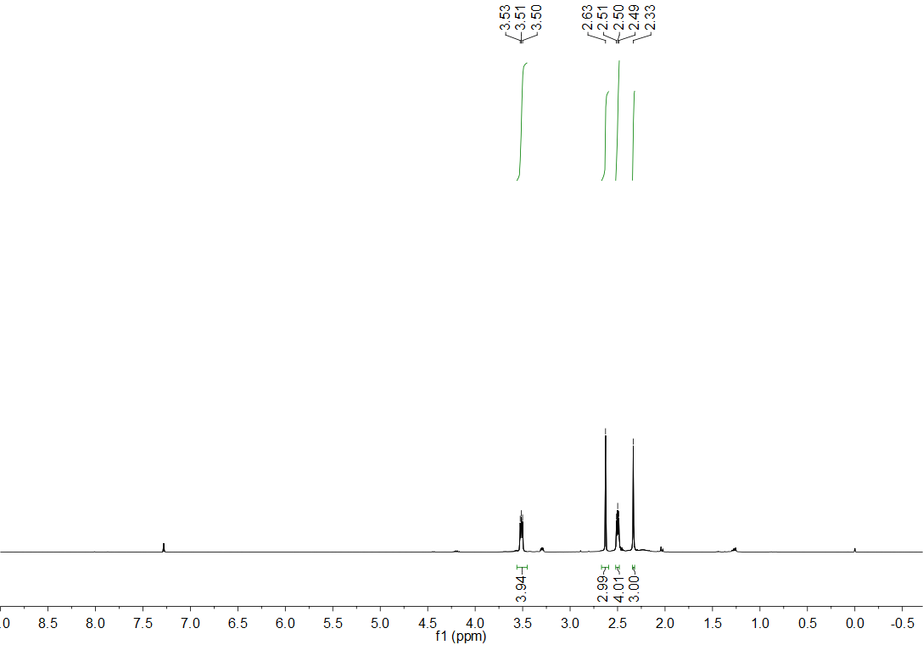
Figure S1. ¹H NMR spectrum (CDCl₃, 400 MHz) of compound 4.
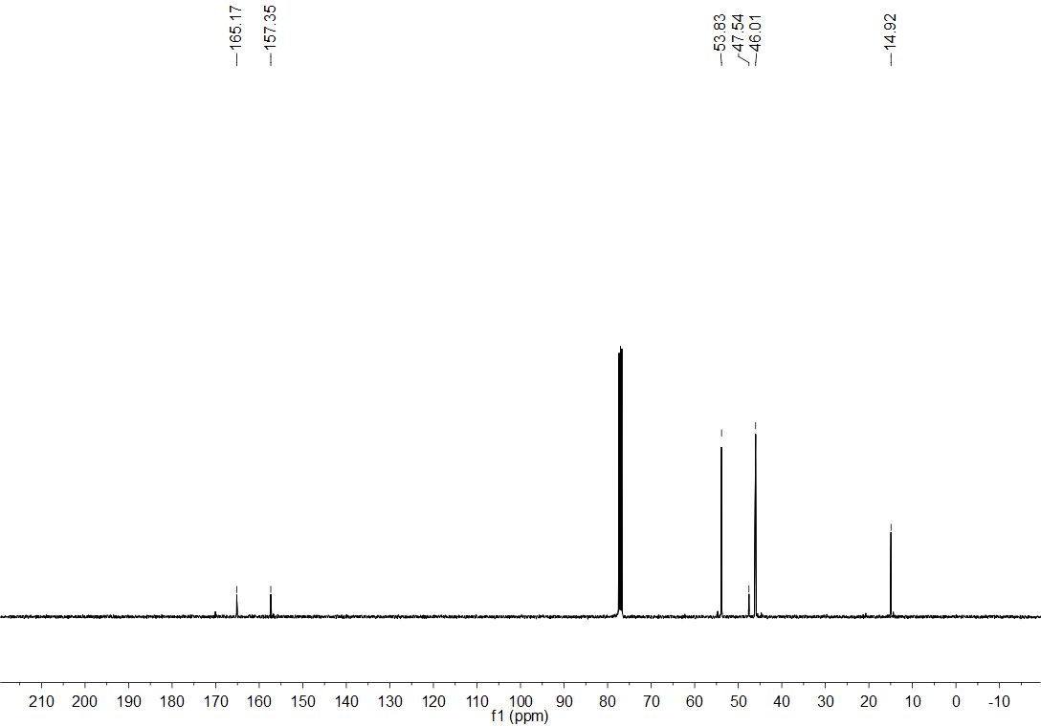
Figure S2. ¹³C NMR spectrum (CDCl₃, 101 MHz) of compound 4.

Figure S3. HRMS spectrum of compound 4.

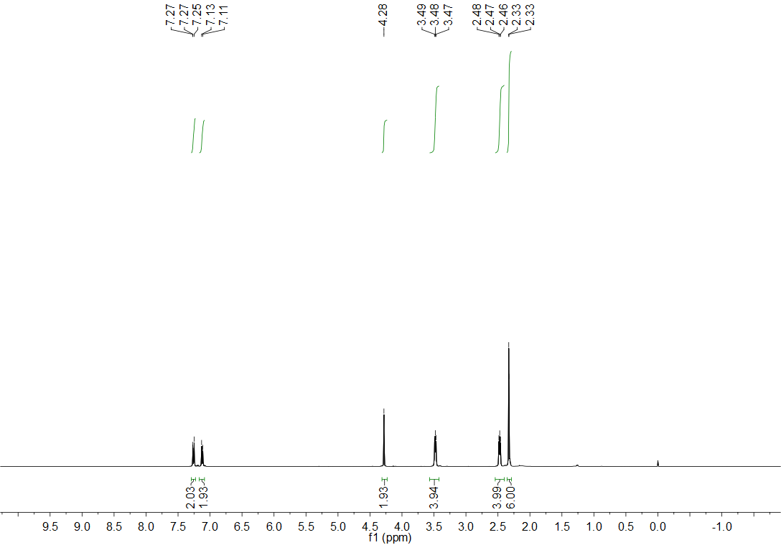
Figure S4. ¹H NMR spectrum (CDCl₃, 400 MHz) of compound 5.

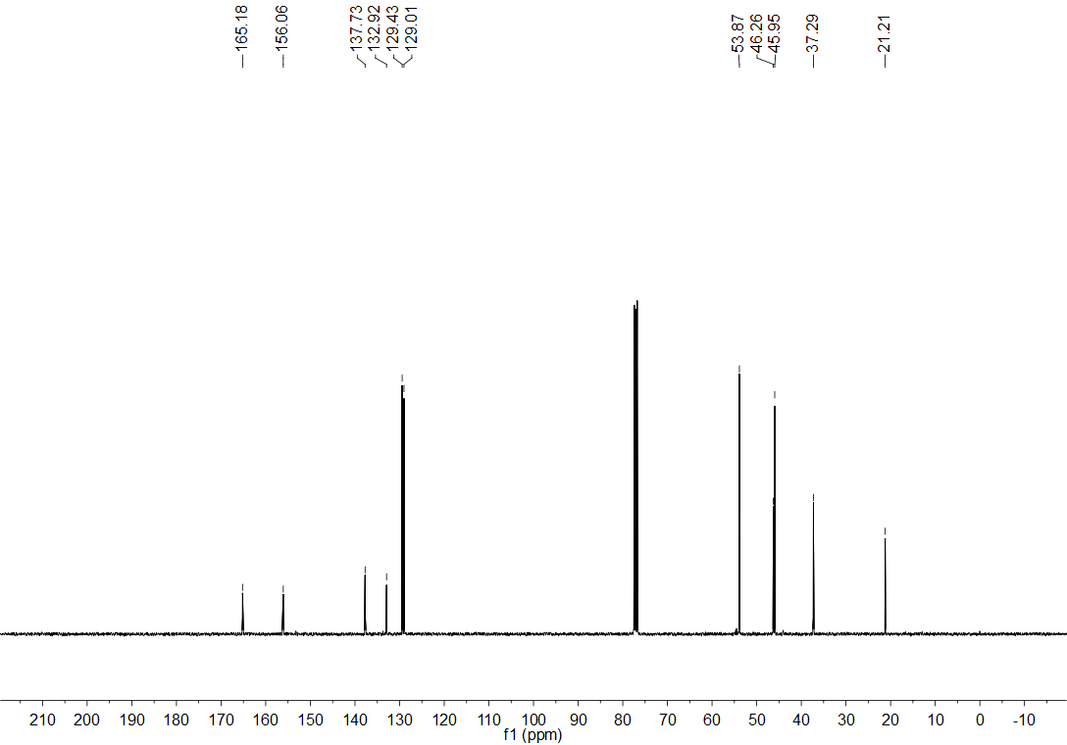
Figure S5. ¹³C NMR spectrum (CDCl₃, 101 MHz) of compound 5.
Figure S6. HRMS spectrum of compound 5.

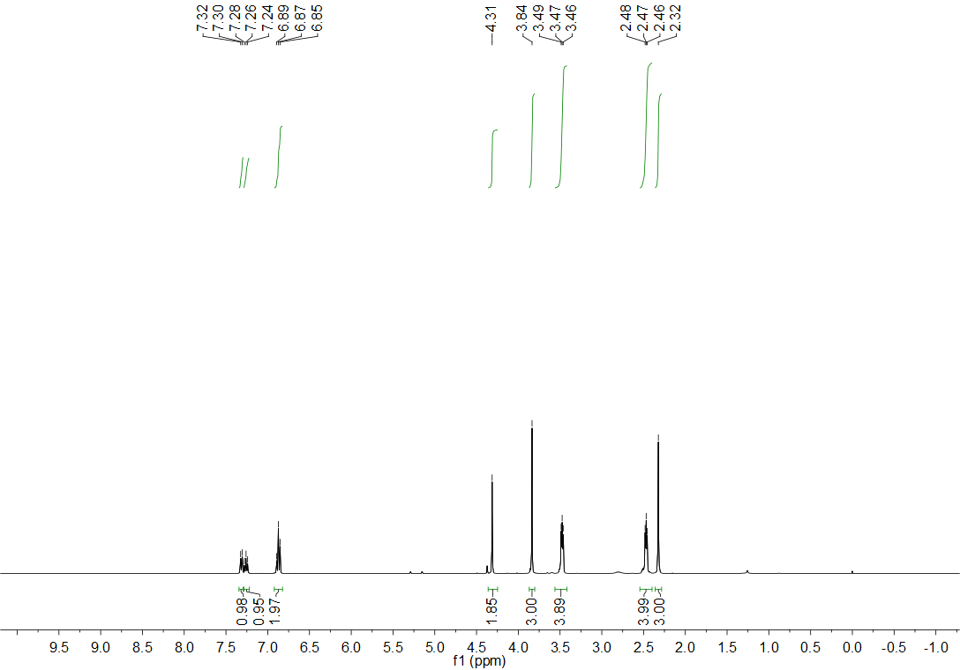
Figure S7. ¹H NMR spectrum (CDCl₃, 400 MHz) of compound 6.

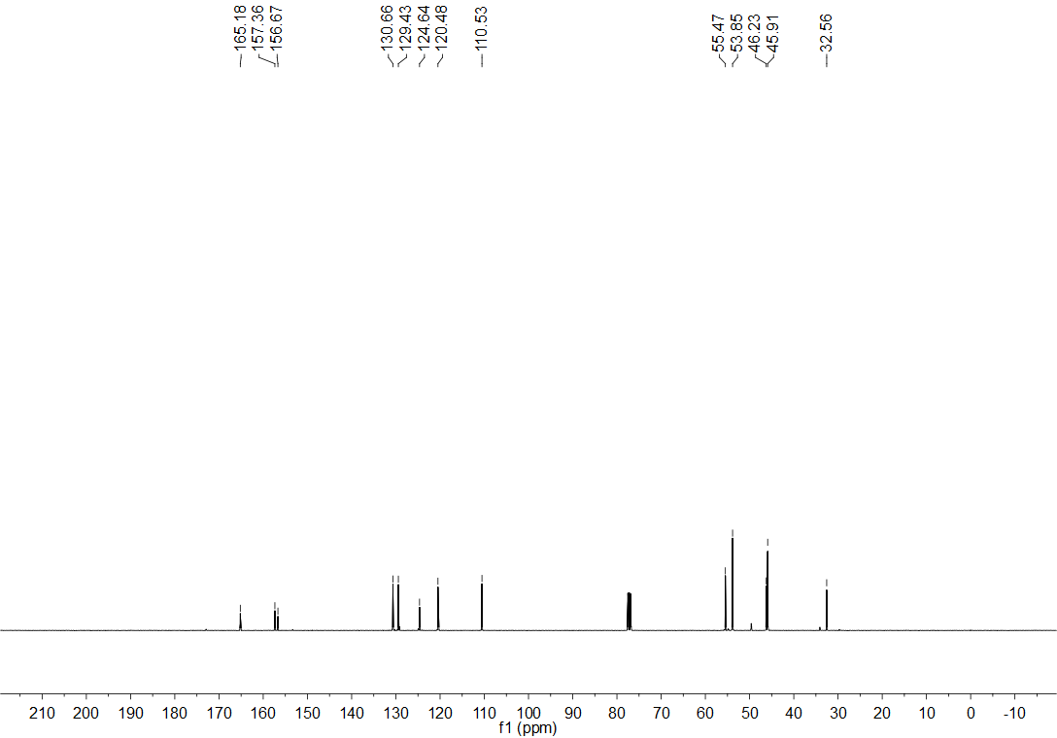
Figure S8. ¹³C NMR Spectrum (CDCl₃, 101 MHz) of compound 6.

Figure S9. HRMS spectrum of compound 6.
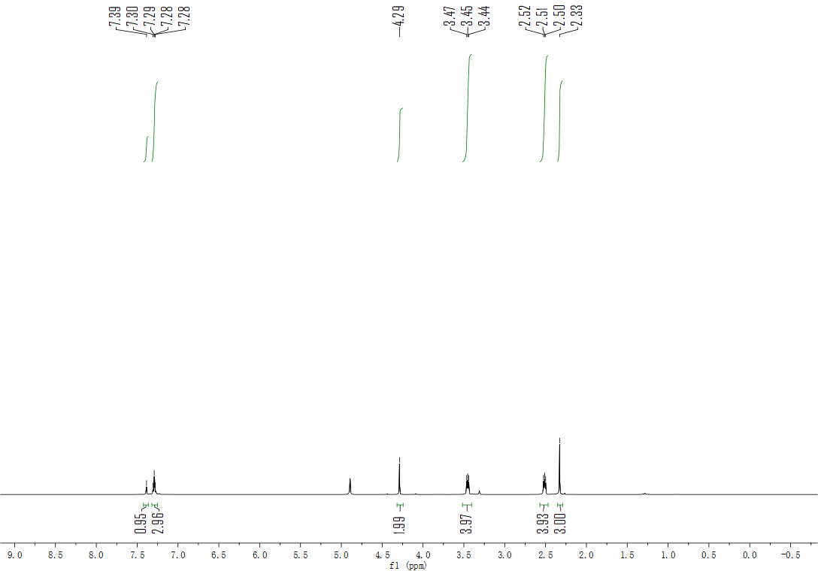
Figure S10. ¹H NMR spectrum (CDCl₃, 400 MHz) of compound 7.
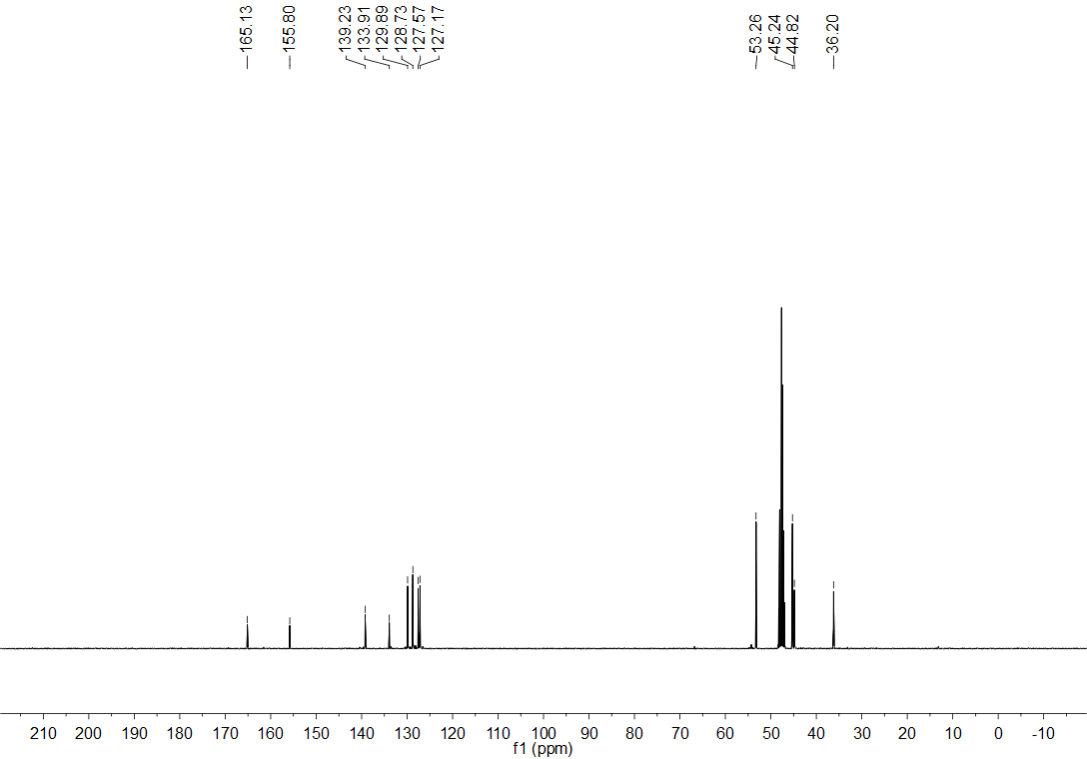
Figure S11. ¹³C NMR spectrum (CDCl₃, 101 MHz) of compound 7.

Figure S12. HRMS spectrum of compound 7.

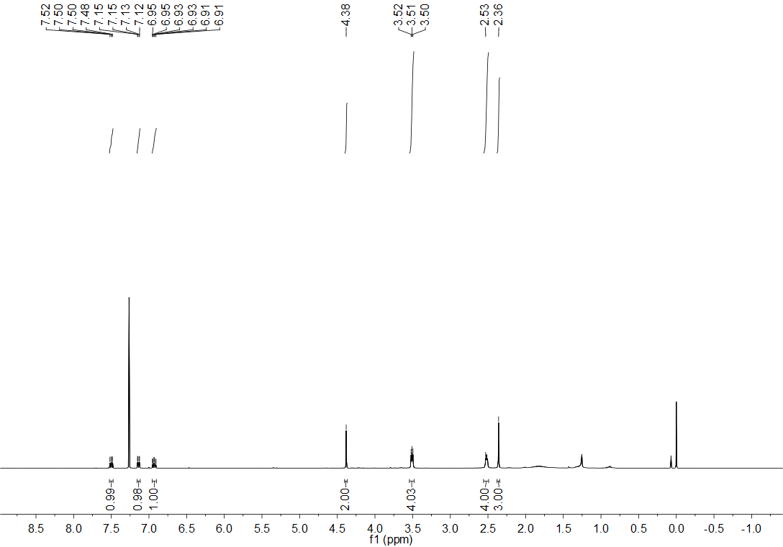
Figure S13. ¹H NMR spectrum (CDCl₃, 400 MHz) of compound 8.

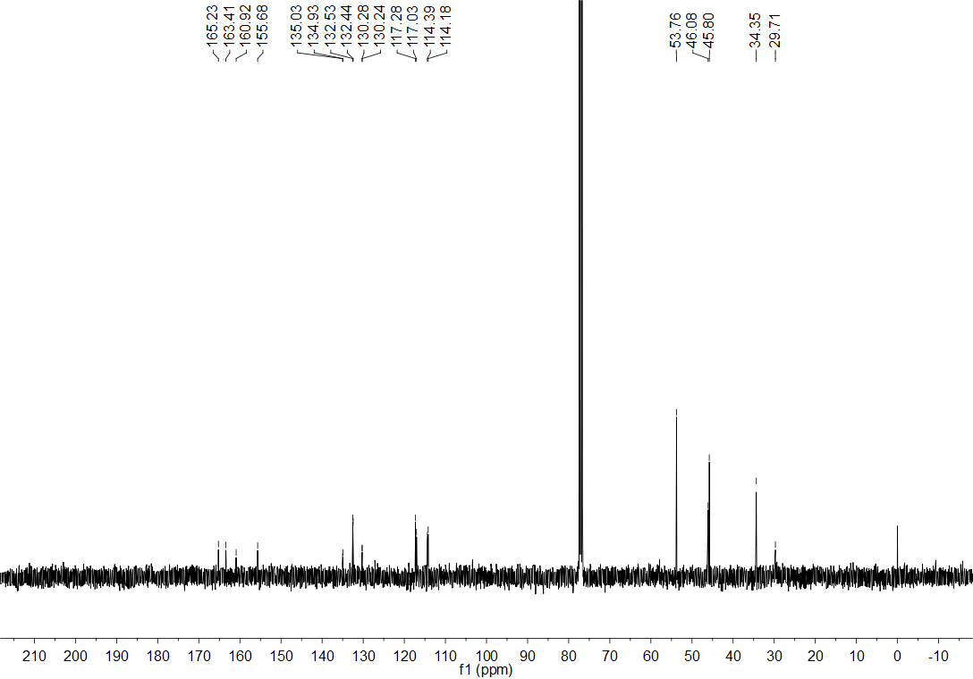
Figure S14. ¹³C NMR spectrum (CDCl₃, 101 MHz) of compound 8.

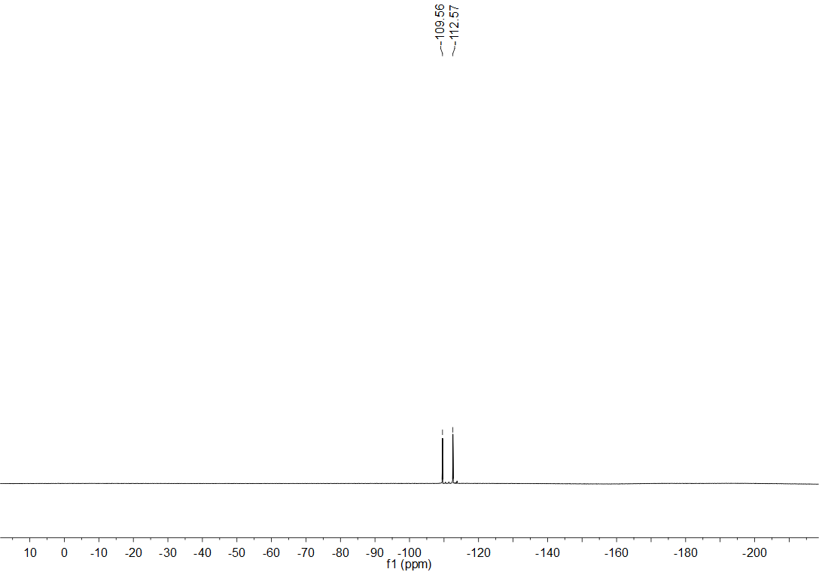
Figure S15. ¹⁹F NMR spectrum (CDCl₃, 376 MHz) of compound 8.

Figure S16. HRMS spectrum of compound 8.

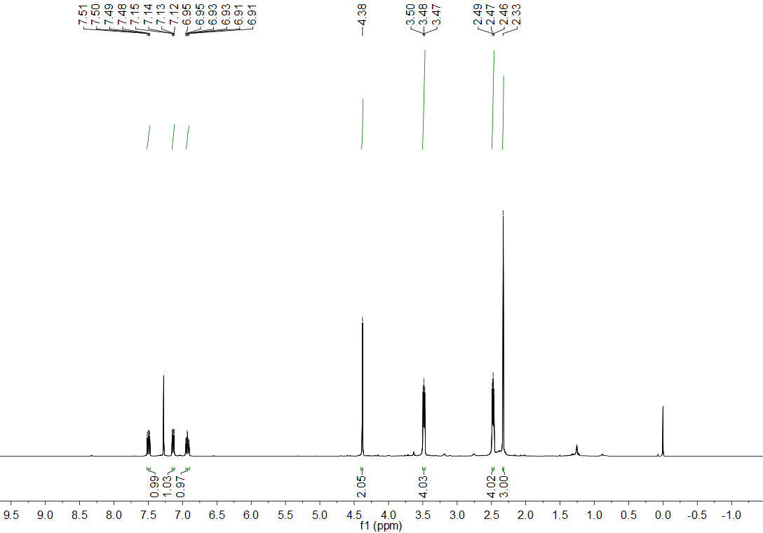
Figure S17. ¹H NMR spectrum (CDCl₃, 400 MHz) of compound 9.

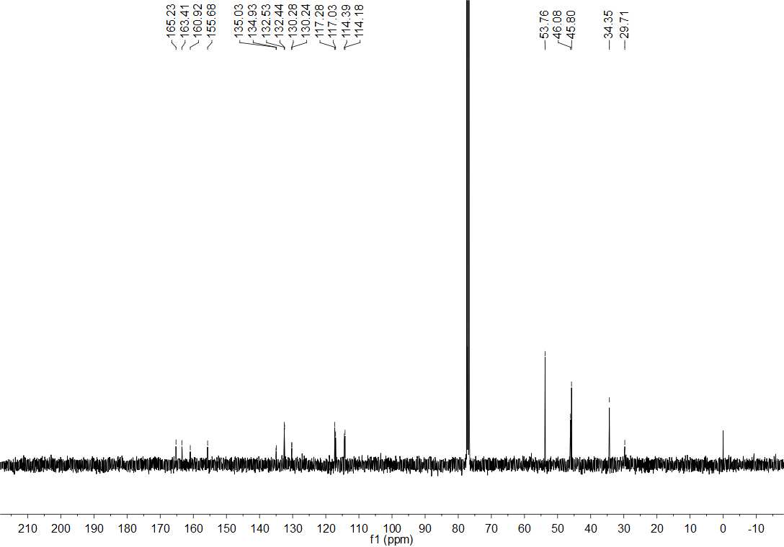
Figure S18. ¹³C NMR spectrum (CDCl₃, 101 MHz) of compound 9.

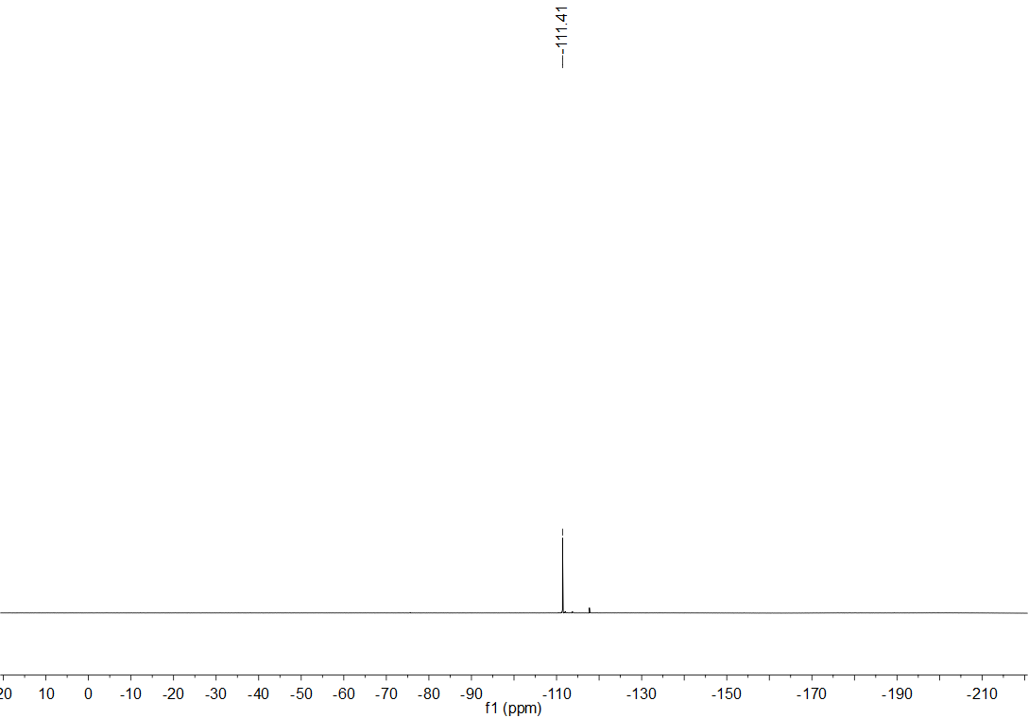
Figure S19. ¹⁹F NMR spectrum (CDCl₃, 376 MHz) of compound 9.
Figure S20. HRMS spectrum of compound 9.

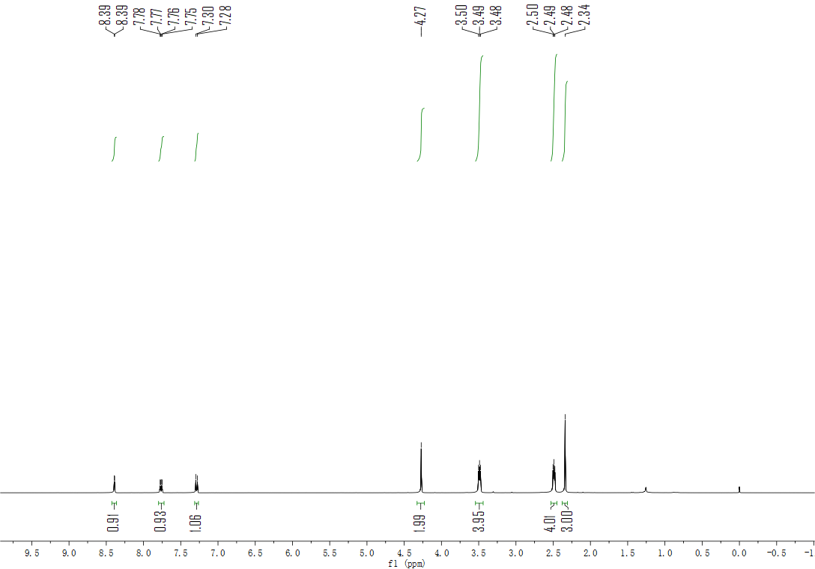
Figure S21. ¹H NMR spectrum (CDCl₃, 400 MHz) of compound 10.

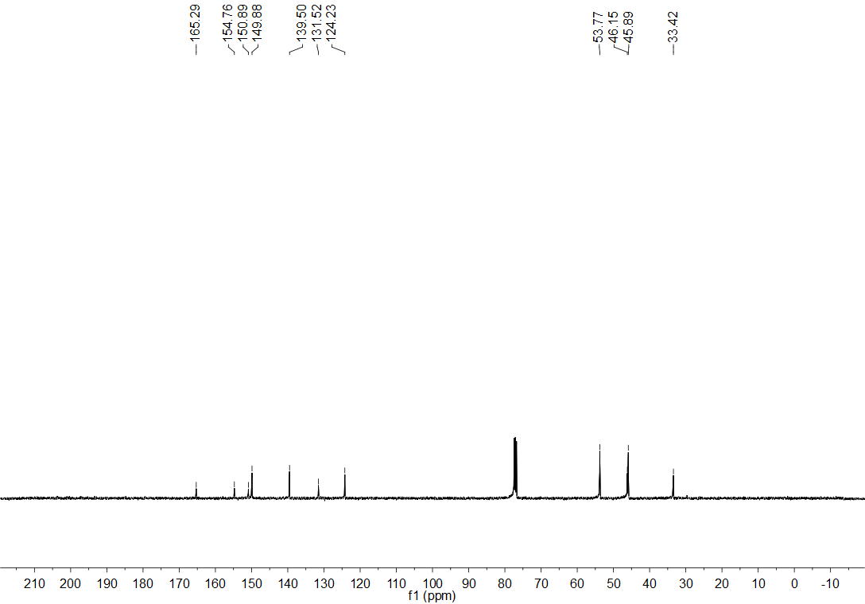
Figure S22. ¹³C NMR spectrum (CDCl₃, 101 MHz) of compound 10.

Figure S23. HRMS spectrum of compound 10.

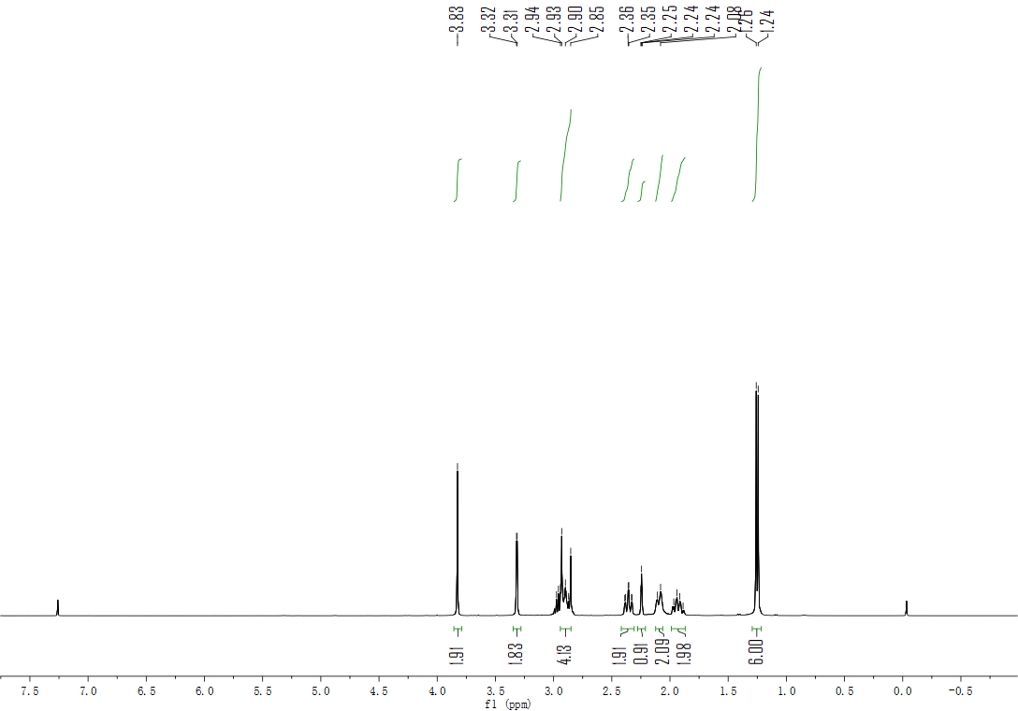
Figure S24. ¹H NMR spectrum (CDCl₃, 400 MHz) of compound 12.

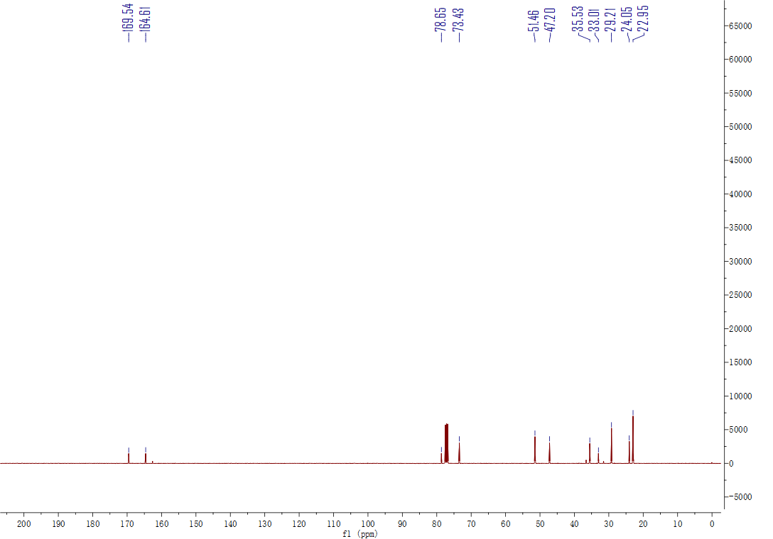
Figure S25. ¹³C NMR spectrum (CDCl₃, 101 MHz) of compound 12.
Figure S26. HRMS spectrum of compound 12.

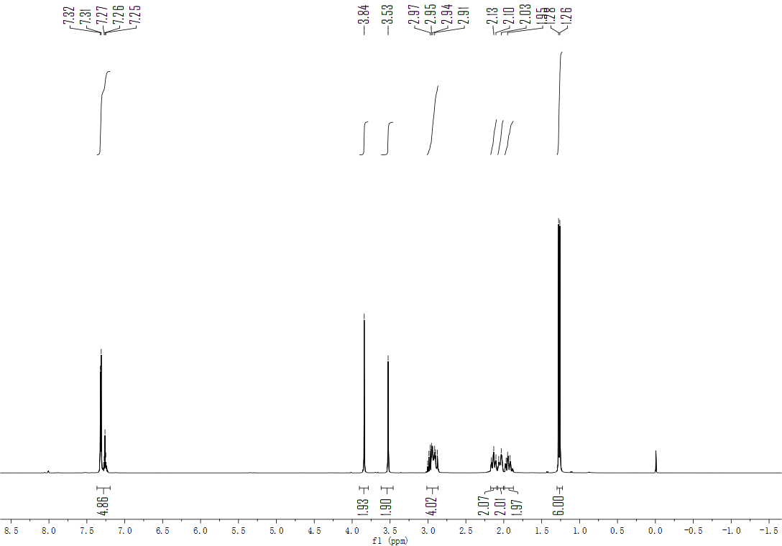
Figure S27. ¹H NMR spectrum (CDCl₃, 400 MHz) of compound 13.
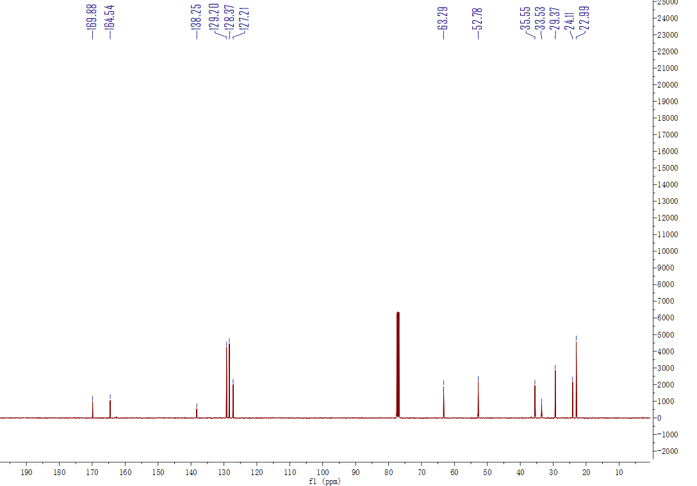
Figure S28. ¹³C NMR spectrum (CDCl₃, 101 MHz) of compound 13.

Figure S29. HRMS spectrum of compound 13.

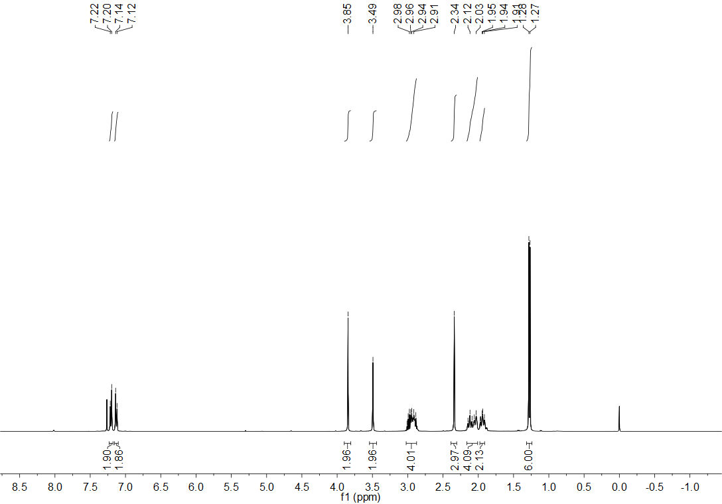
Figure S30. ¹H NMR spectrum (CDCl₃, 400 MHz) of compound 14.

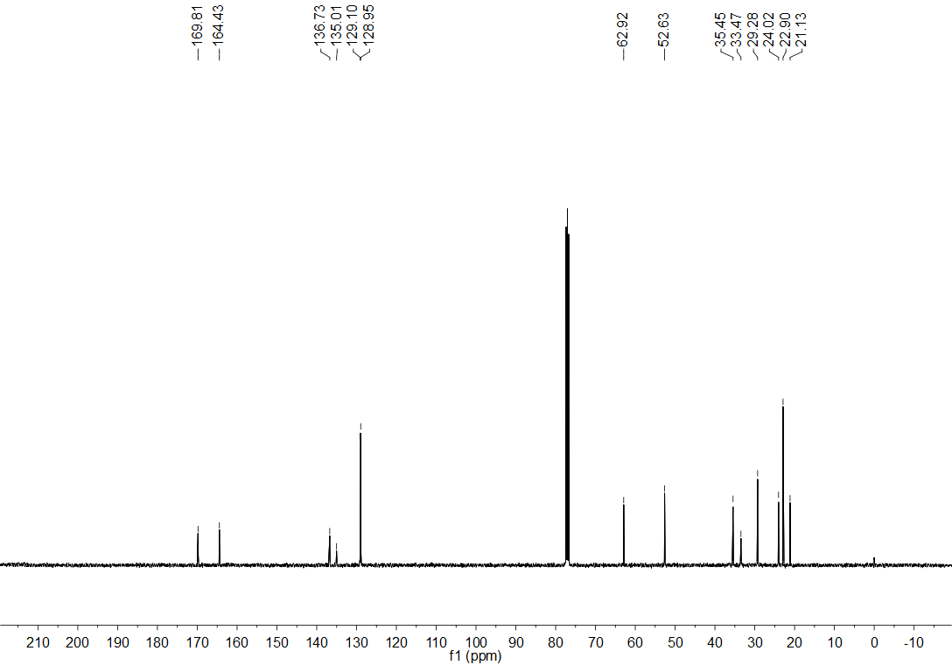
Figure S31. ¹³C NMR spectrum (CDCl₃, 101 MHz) of compound 14.

Figure S32. HRMS spectrum of compound 14.

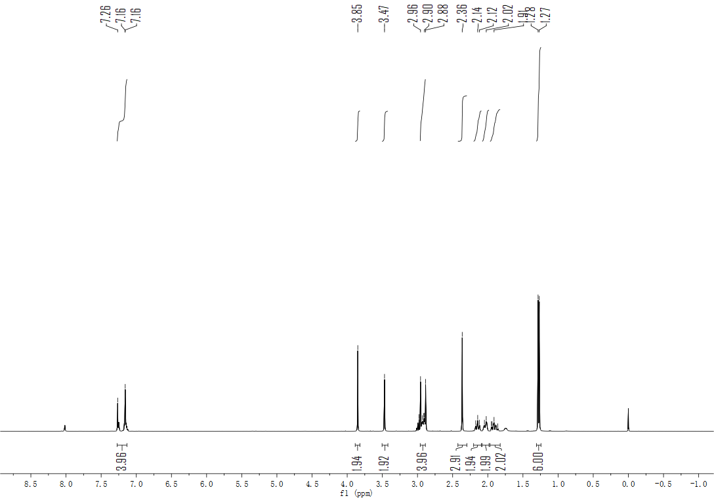
Figure S33. ¹H NMR spectrum (CDCl₃, 400 MHz) of compound 15.

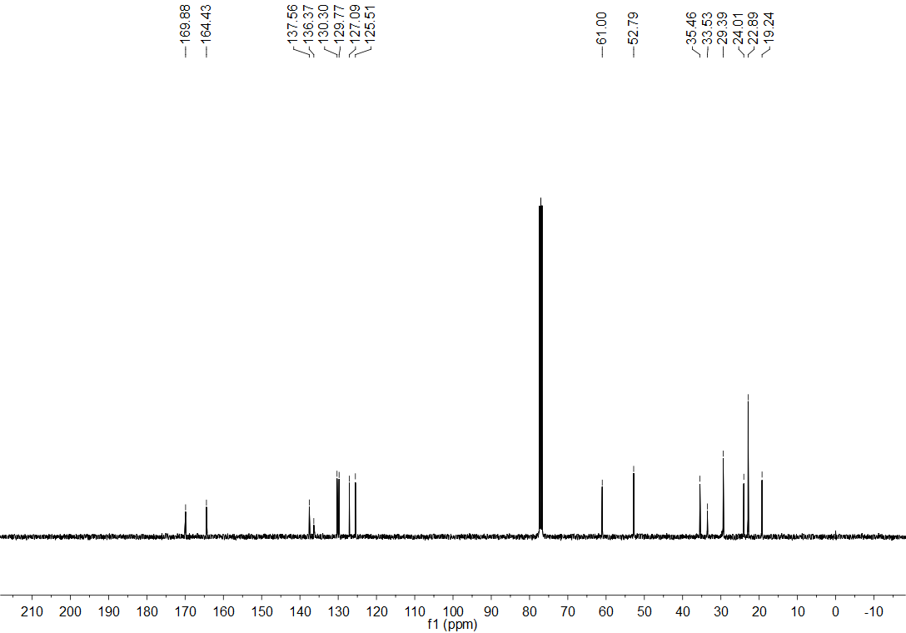

Figure S34. ¹³C NMR spectrum (CDCl₃, 101 MHz) of compound 15.

Figure S35. HRMS spectrum of compound 15.

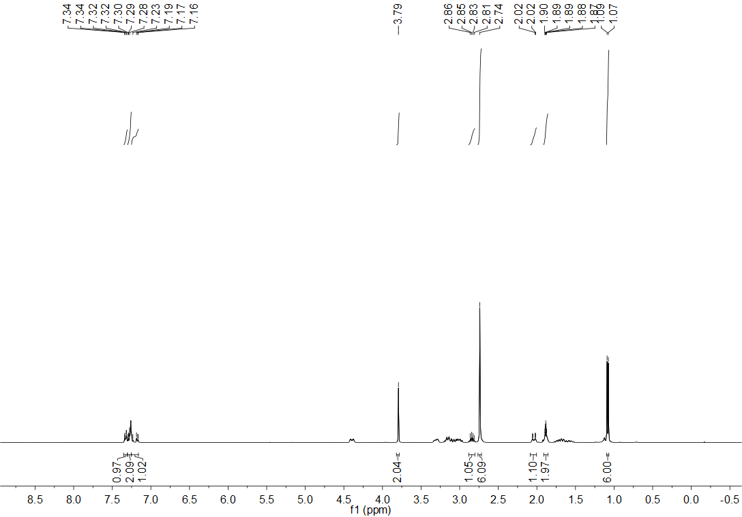
Figure S36. ¹H NMR spectrum (CDCl₃, 400 MHz) of compound 16.

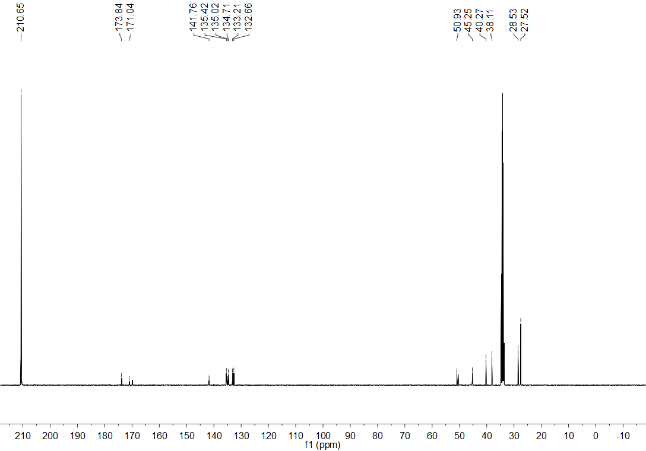
Figure S37. ¹³C NMR spectrum (CDCl₃, 101 MHz) of compound 16.

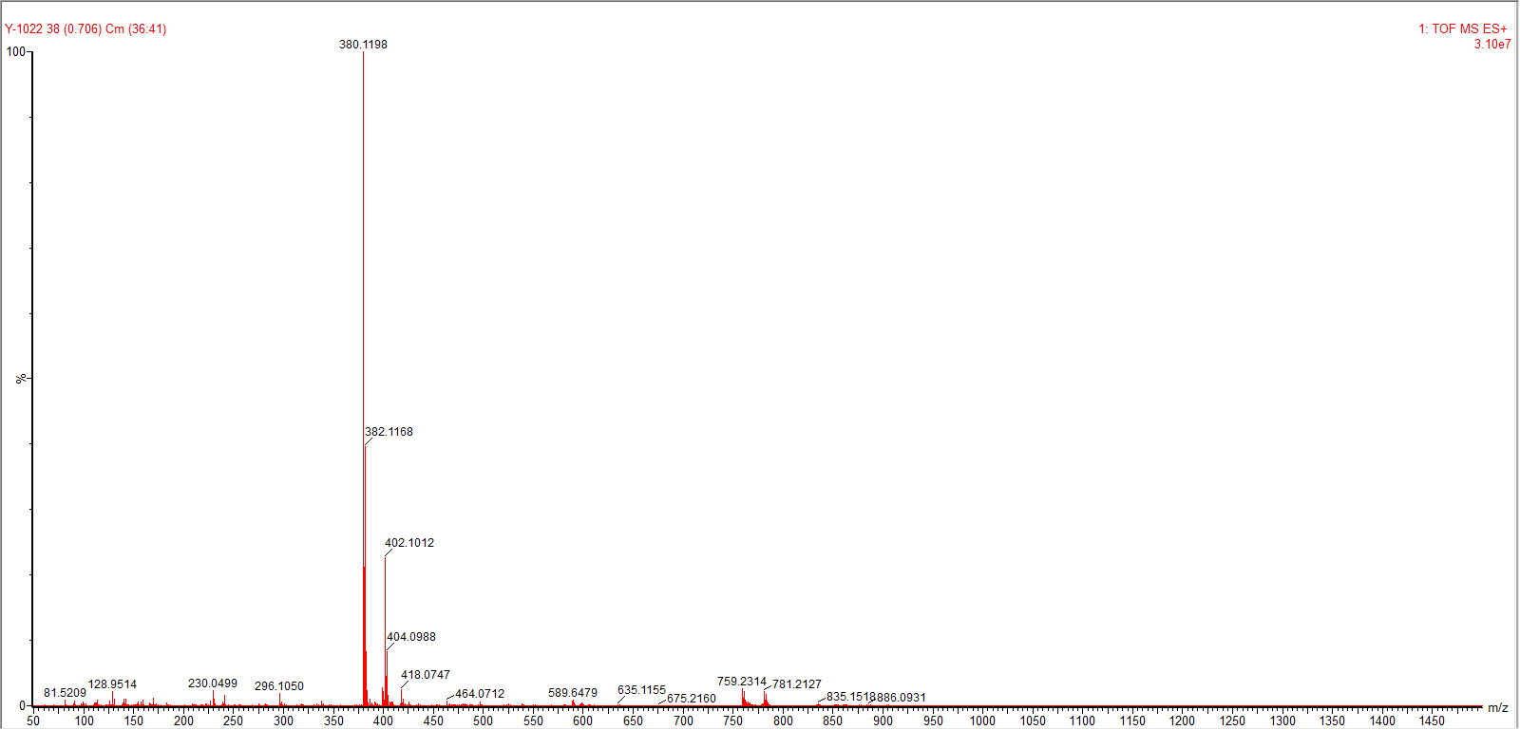
Figure S38. HRMS spectrum of compound 16.

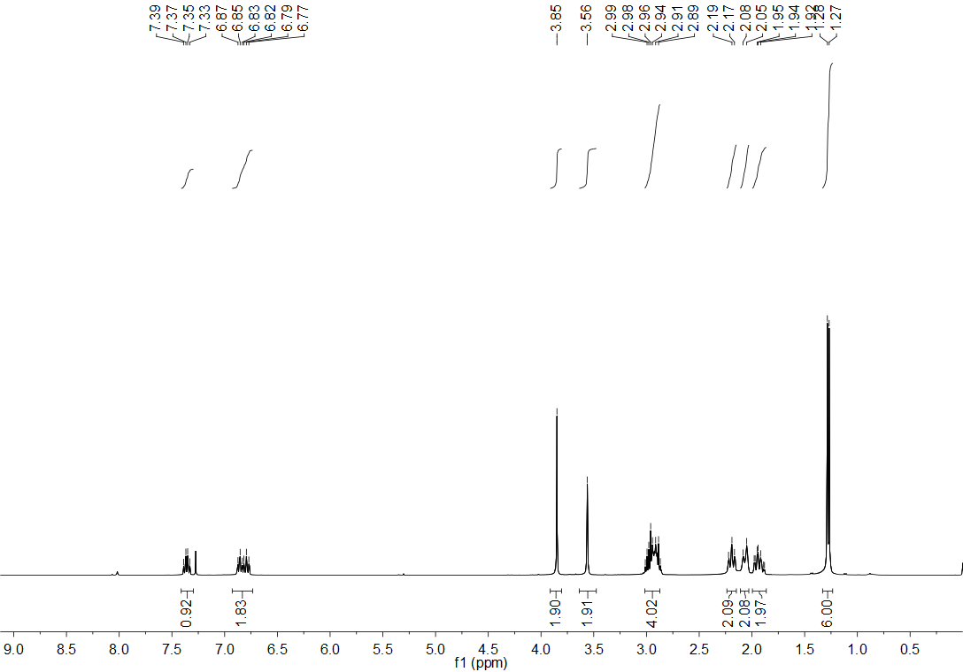
Figure S44. ¹H NMR spectrum (CDCl₃, 400 MHz) of compound 17.

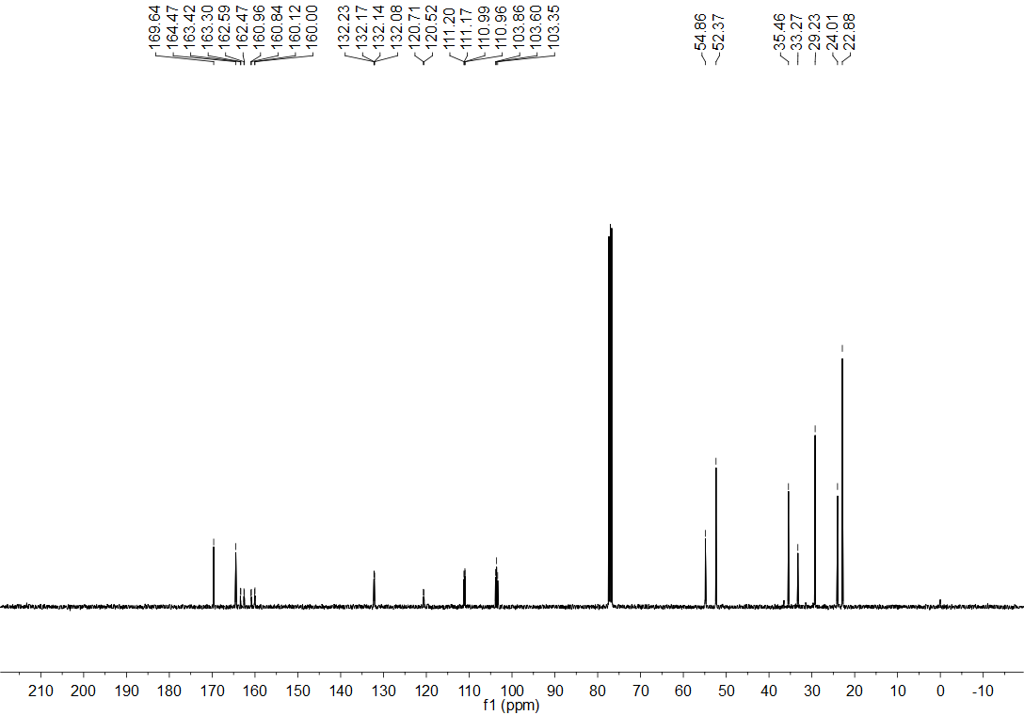
Figure S45. ¹³C NMR spectrum (CDCl₃, 101 MHz) of compound 17.

Figure S46. HRMS spectrum of compound 17.

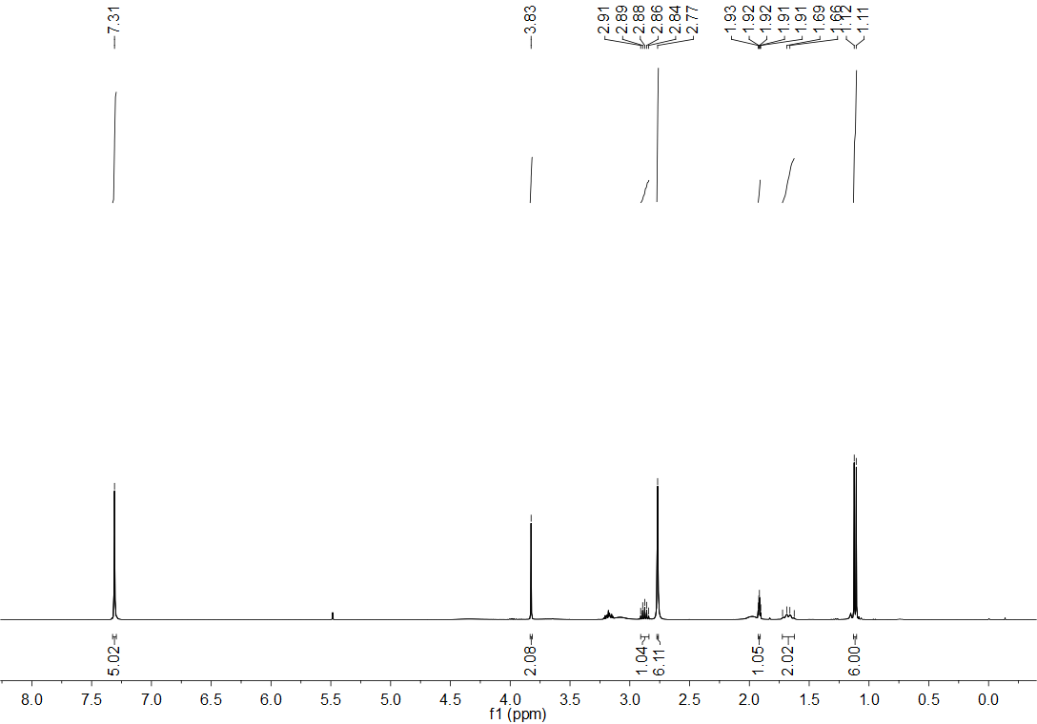
Figure S47. ¹H NMR spectrum (CDCl₃, 400 MHz) of compound 18.

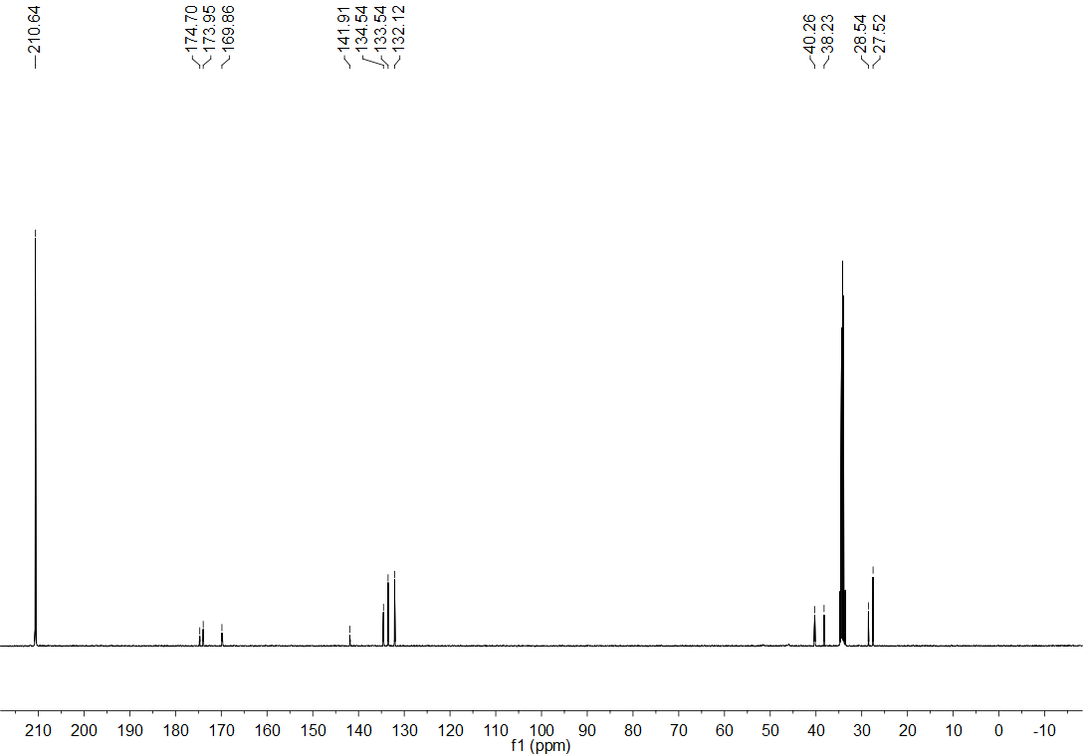
Figure S48. ¹³C NMR spectrum (CDCl₃, 101 MHz) of compound 18.

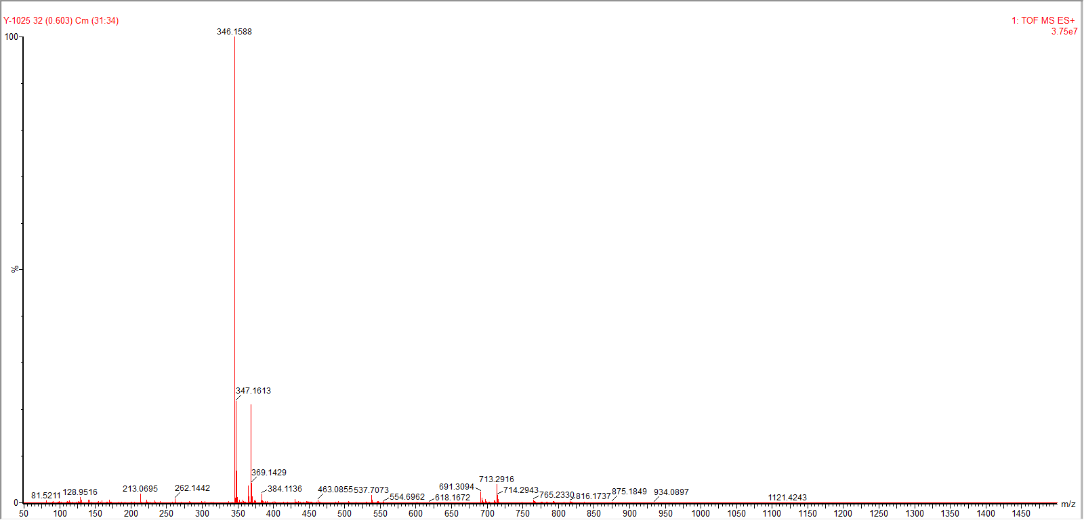
Figure S49. HRMS spectrum of compound 18.

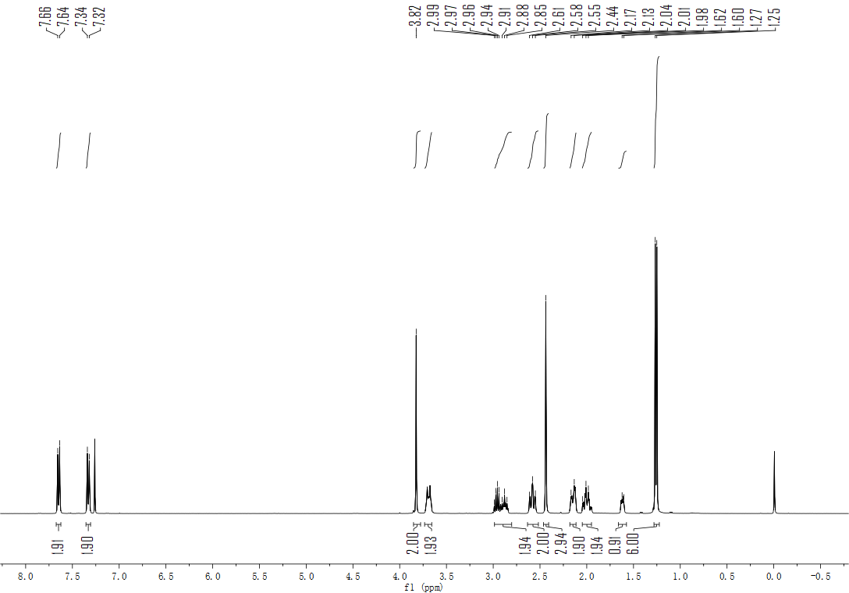
Figure S50. ¹H NMR spectrum (CDCl₃, 400 MHz) of compound 19.

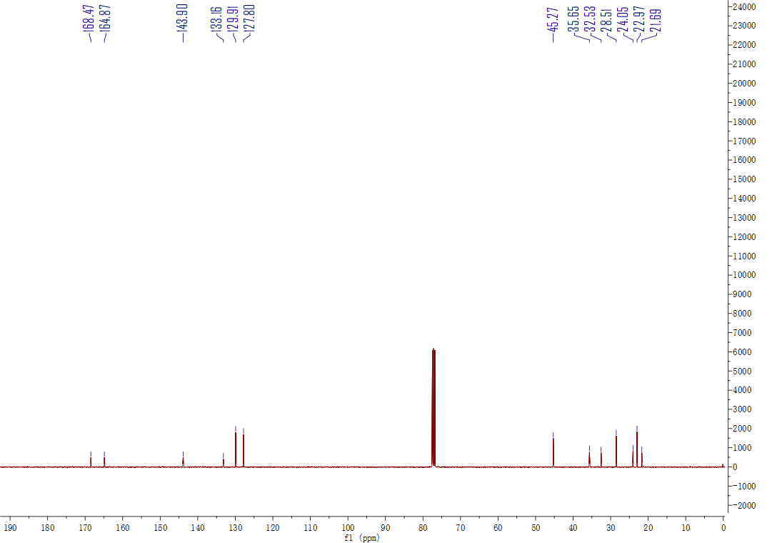
Figure S51. ¹³C NMR spectrum (CDCl₃, 101 MHz) of 19.

Figure S52. HRMS spectrum of compound 19.

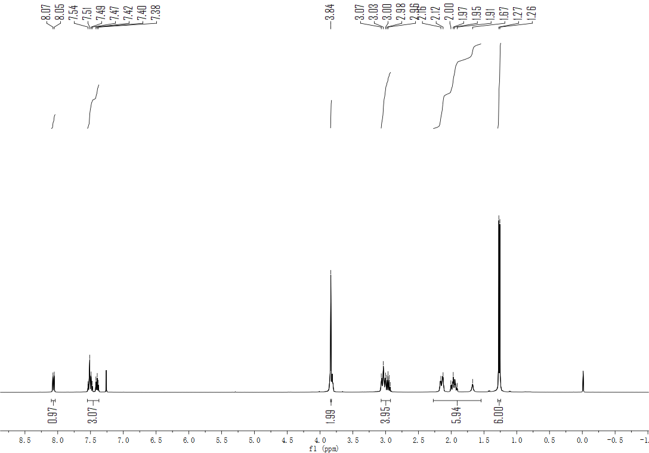
Figure S53. ¹H NMR spectrum (CDCl₃, 400 MHz) of compound 20.

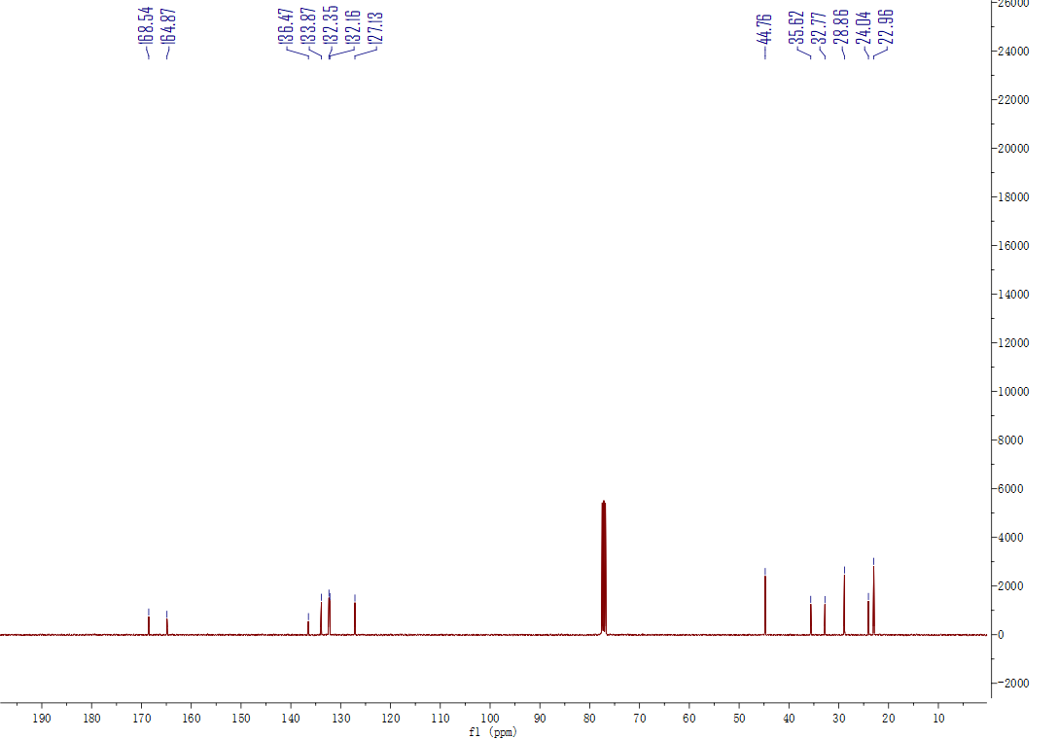
Figure S54. ¹³C NMR spectrum (CDCl₃, 101 MHz) of compound 20.

Figure S55. HRMS spectrum of compound 20.

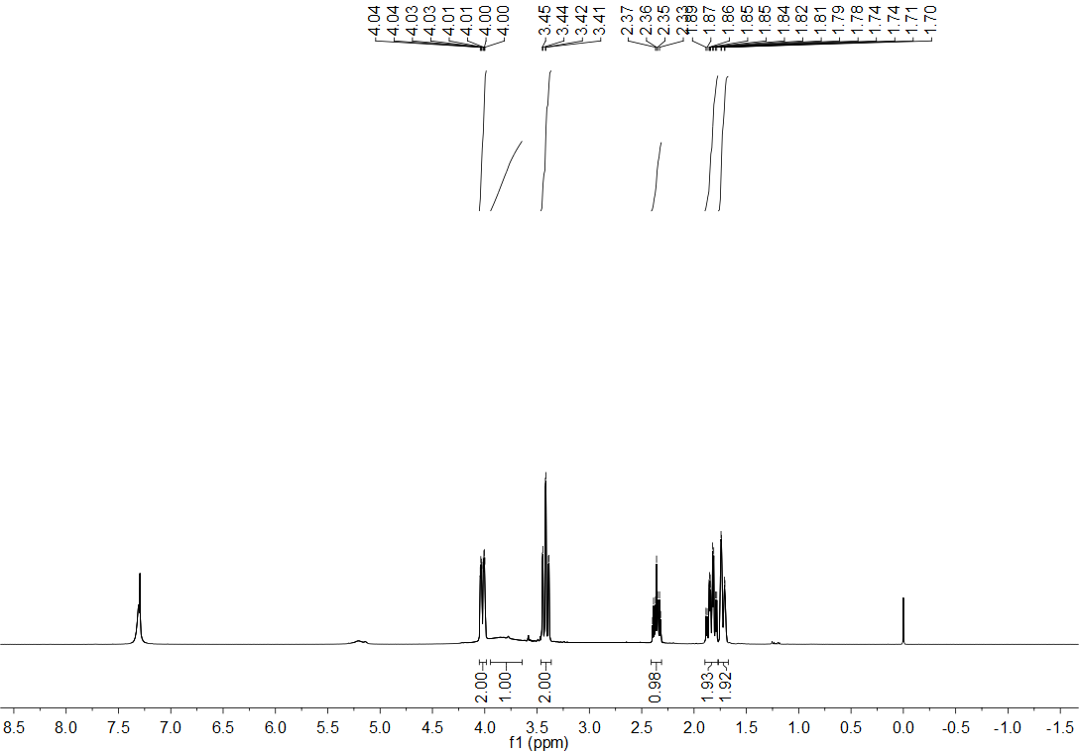
Figure S56. ¹H NMR spectrum (CDCl₃, 400 MHz) of compound 22.
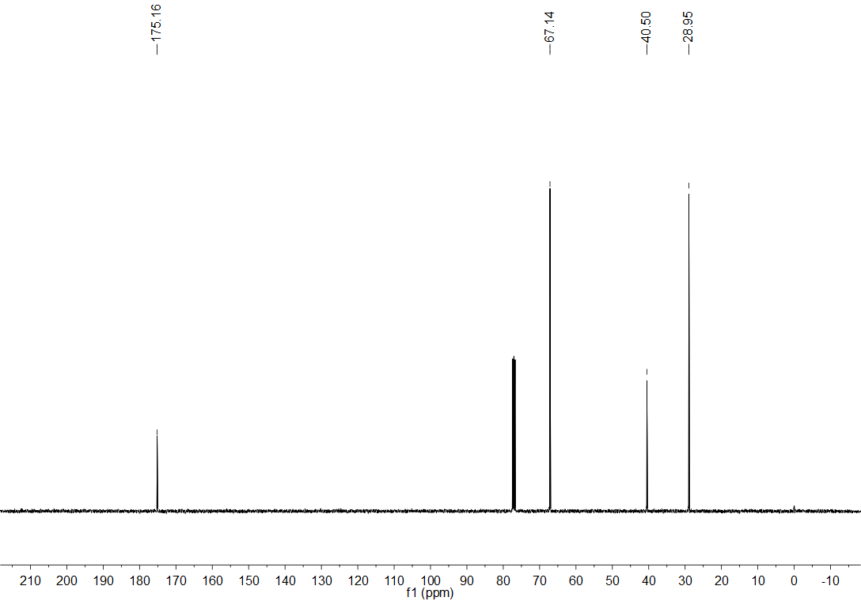
Figure S57. ¹³C NMR spectrum (CDCl₃, 101 MHz) of compound 22.
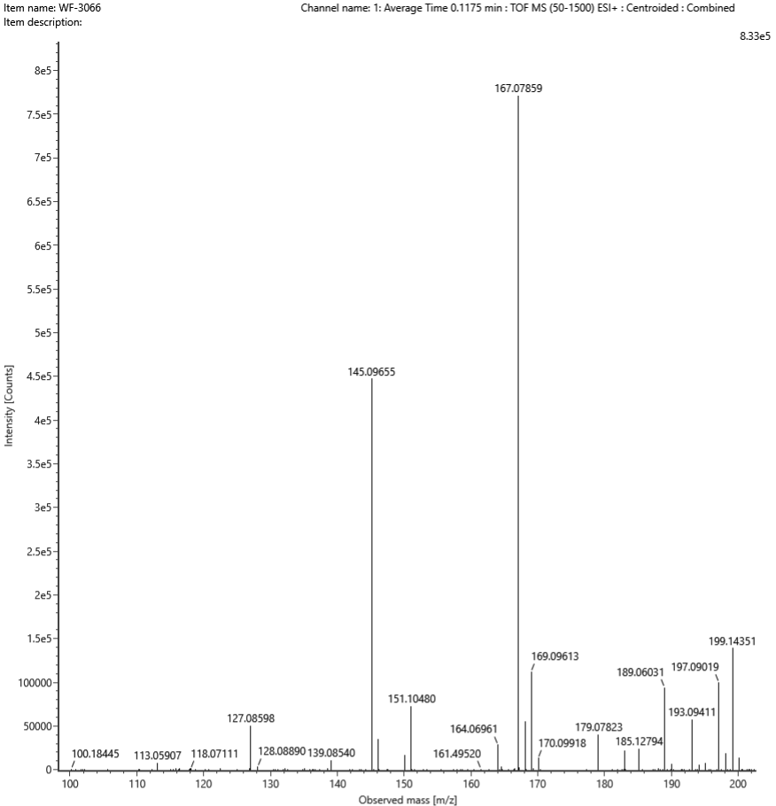
Figure S58. HRMS spectrum of compound 22.
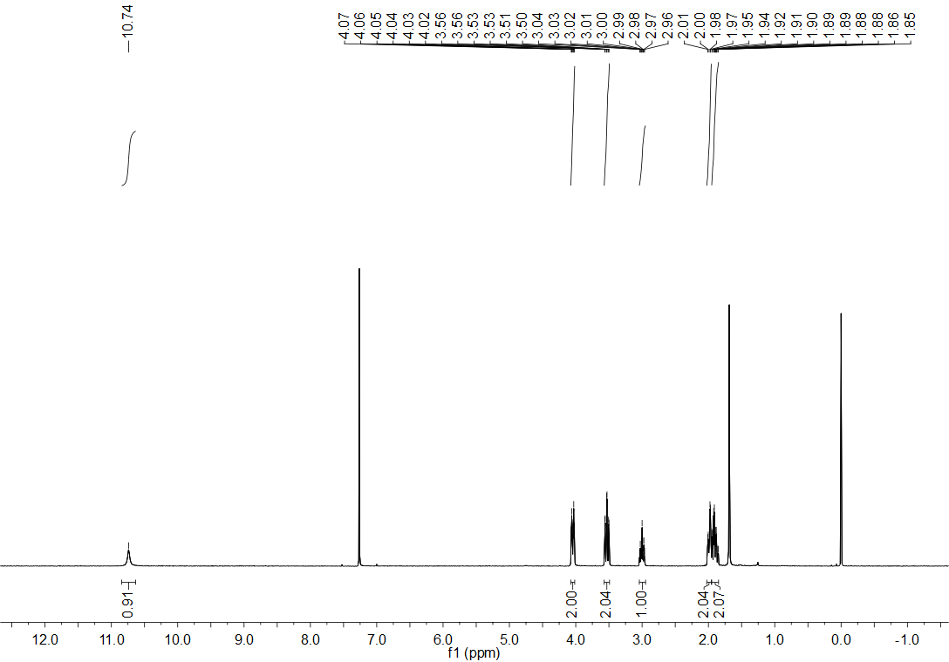
Figure S59. ¹H NMR spectrum (CDCl₃, 400 MHz) of compound 23.

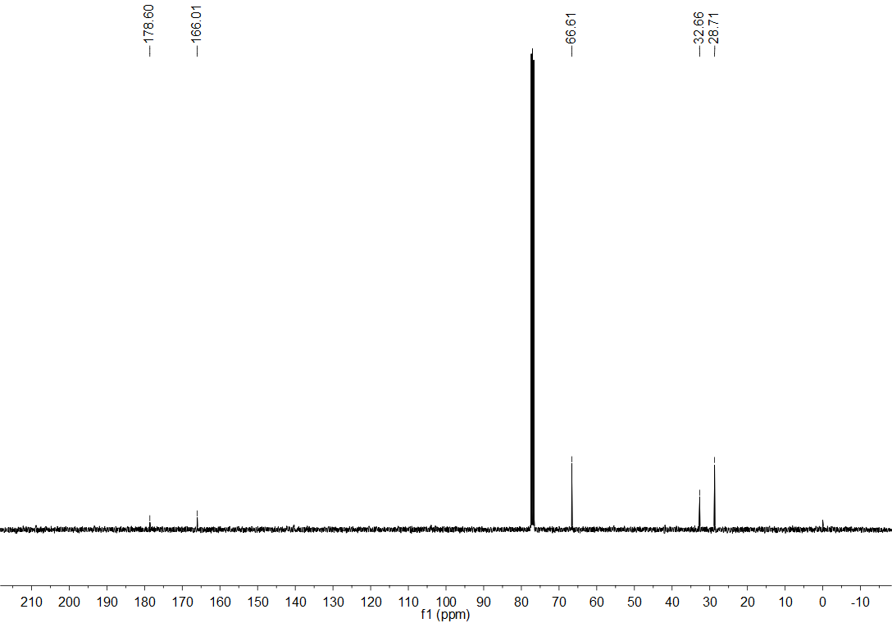
Figure S60. ¹³C NMR spectrum (CDCl₃, 101 MHz) of compound 23.
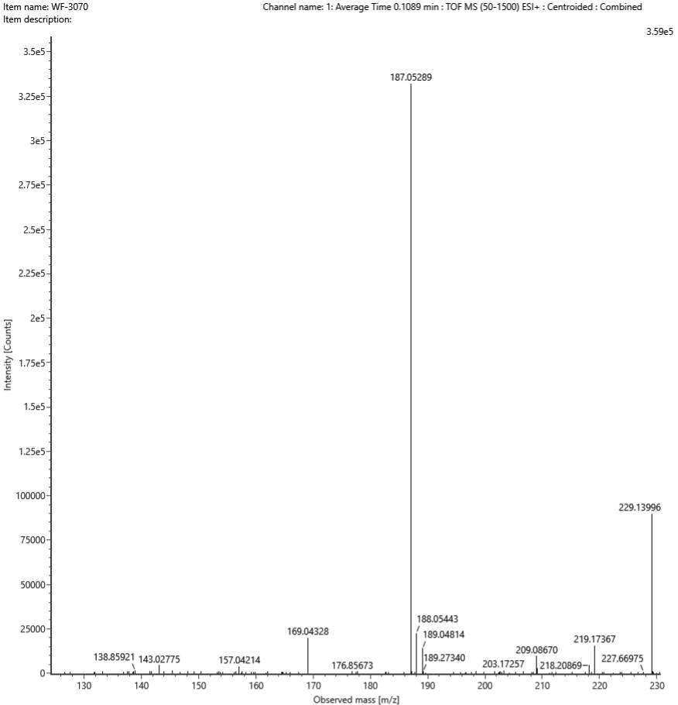
Figure S61. HRMS spectrum of compound 23.
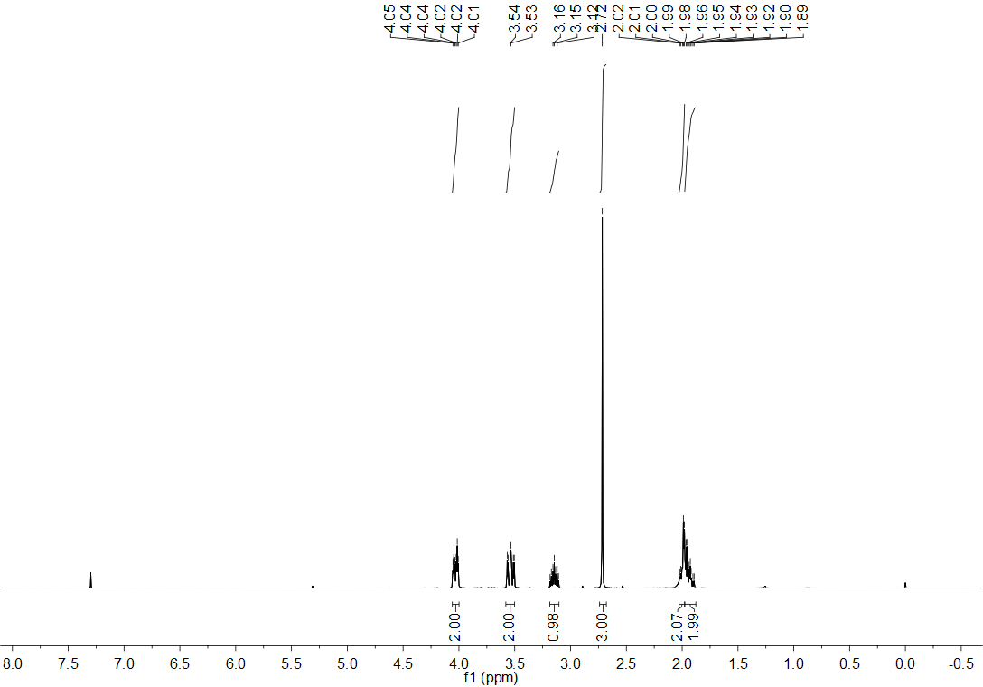
Figure S62. ¹H NMR spectrum (CDCl₃, 400 MHz) of compound 24.
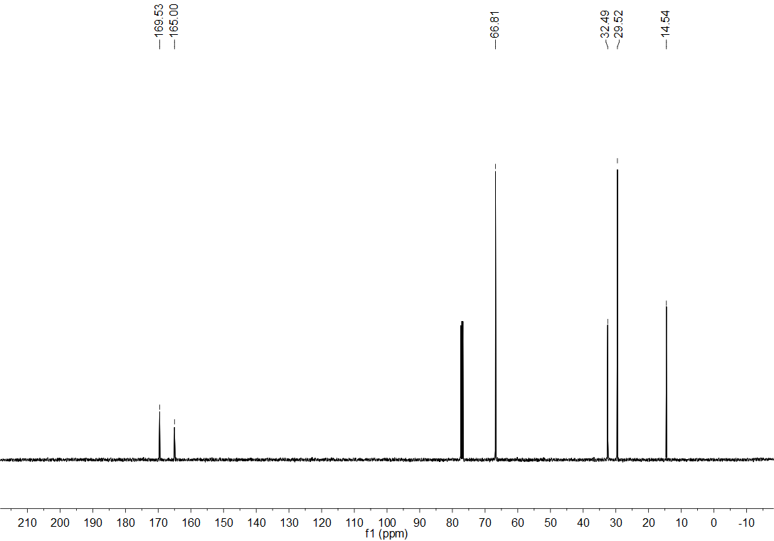
Figure S63. ¹³C NMR spectrum (CDCl₃, 101 MHz) of compound 24.
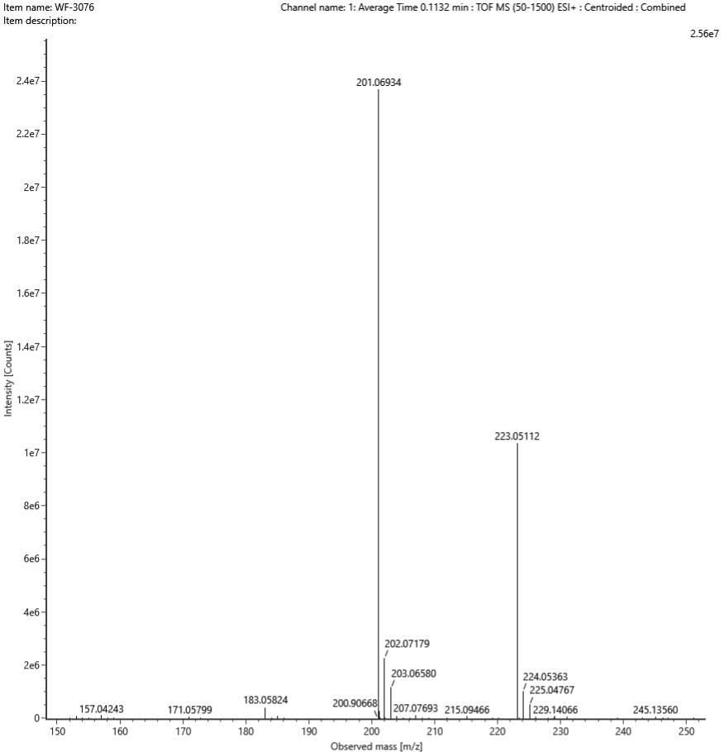
Figure S64. HRMS spectrum of compound 24.
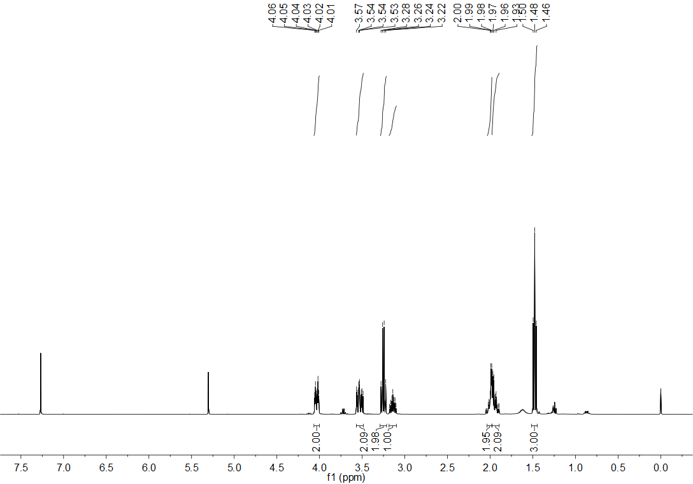
Figure S65. ¹H NMR spectrum (CDCl₃, 400 MHz) of compound 25.
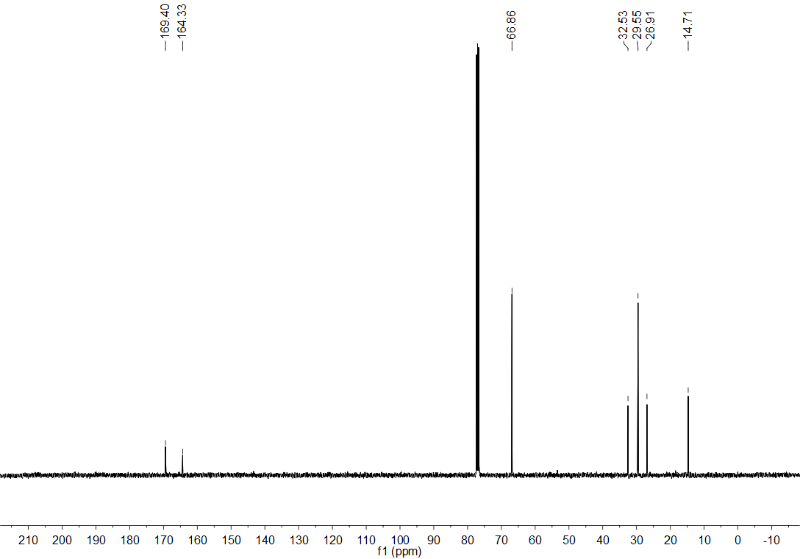
Figure S66. ¹³C NMR spectrum (CDCl₃, 101 MHz) of compound 25.
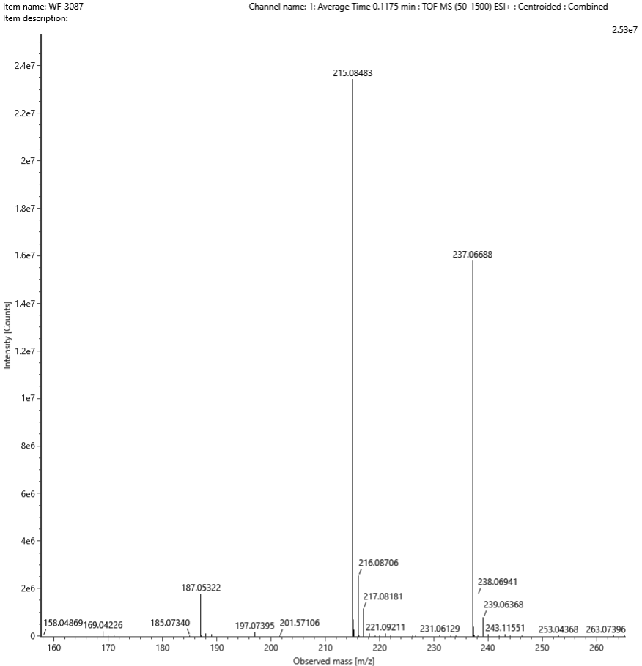
Figure S67. HRMS spectrum of compound 25.

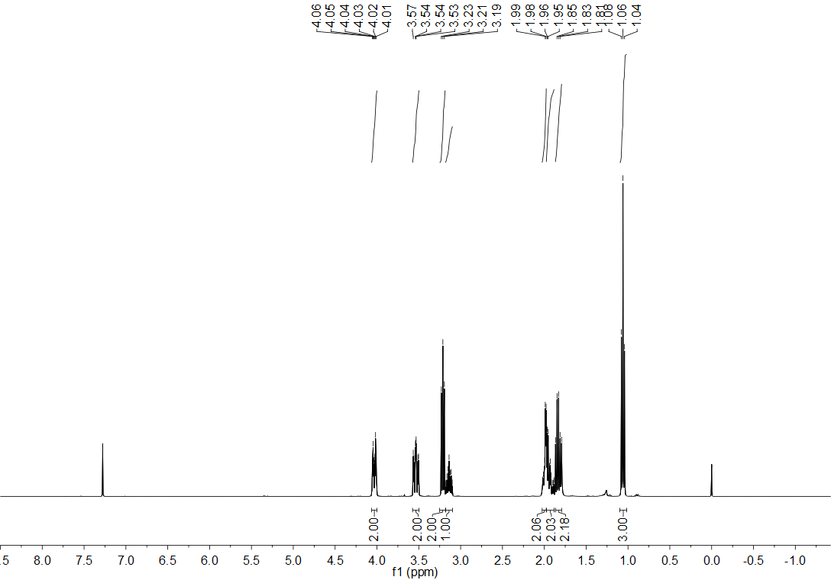
Figure S68. ¹H NMR spectrum (CDCl₃, 400 MHz) of compound 26.
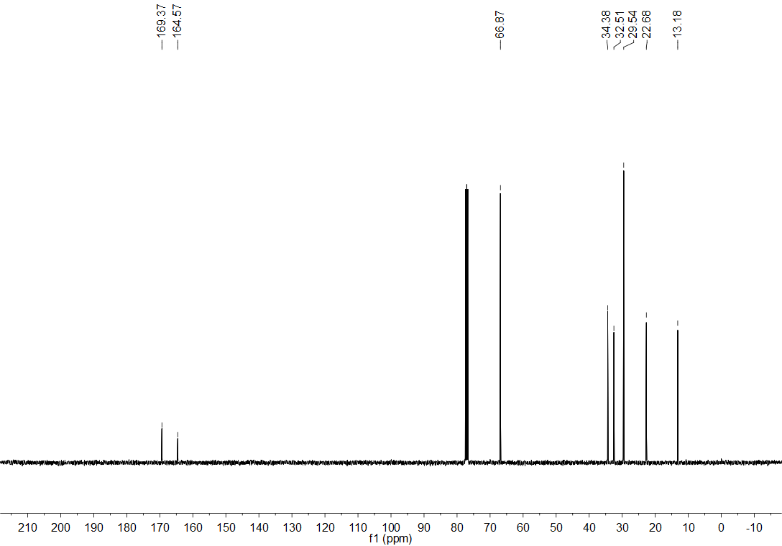
Figure S69. ¹³C NMR spectrum (CDCl₃, 101 MHz) of compound 26.
Figure S70. HRMS spectrum of compound 26.
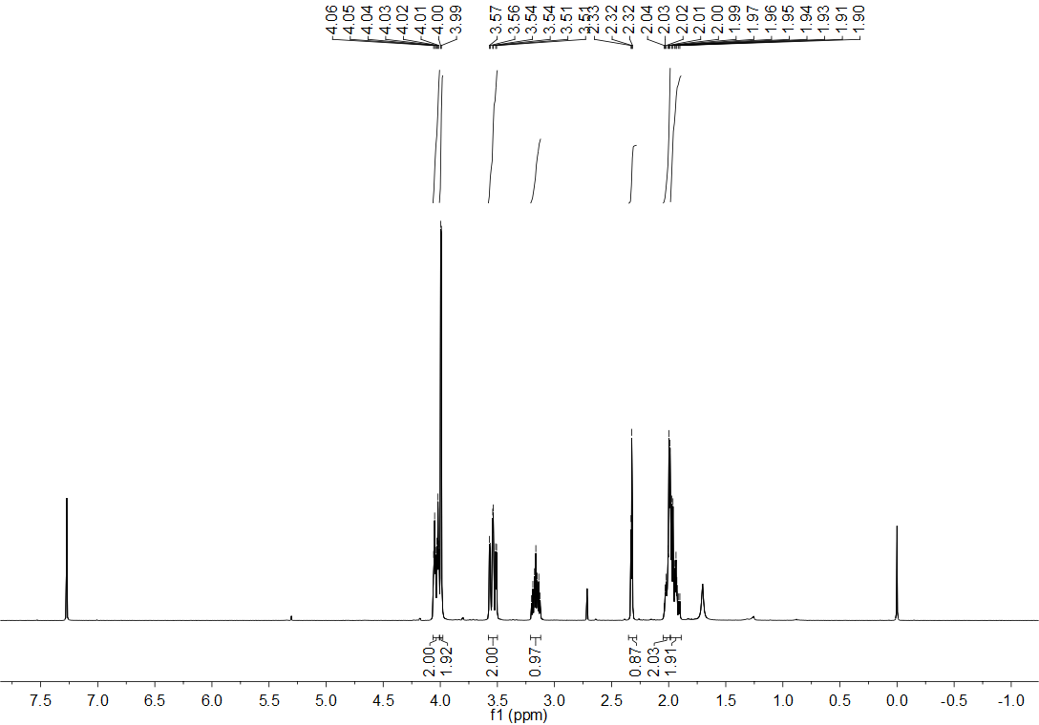
Figure S68. ¹H NMR spectrum (CDCl₃, 400 MHz) of compound 27.
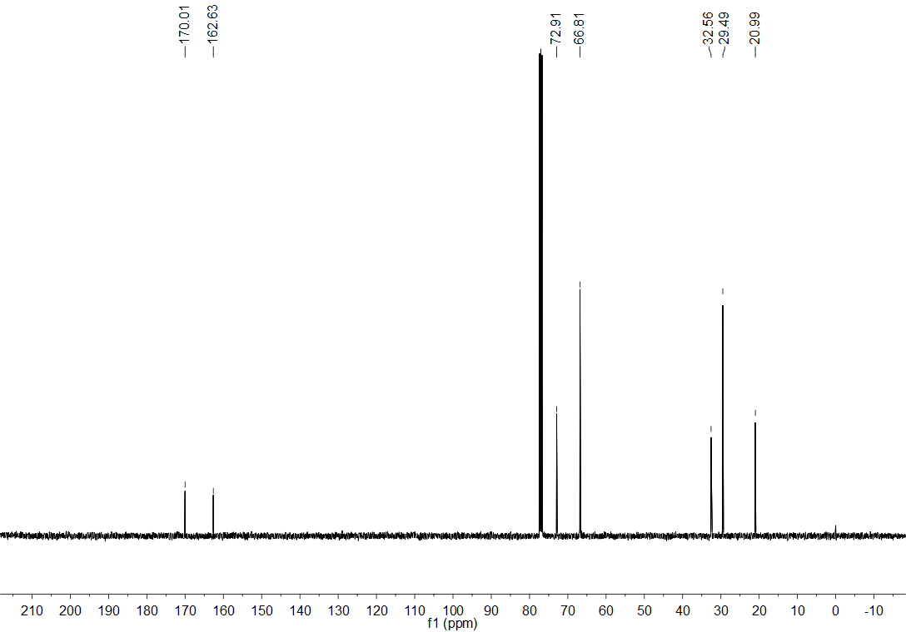
Figure S69. ¹³C NMR spectrum (CDCl₃, 101 MHz) of compound 27.
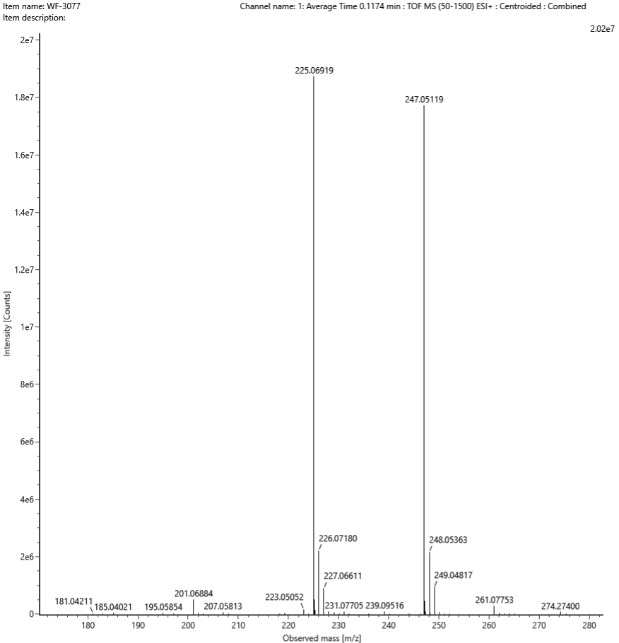
Figure S70. HRMS spectrum of compound 27.
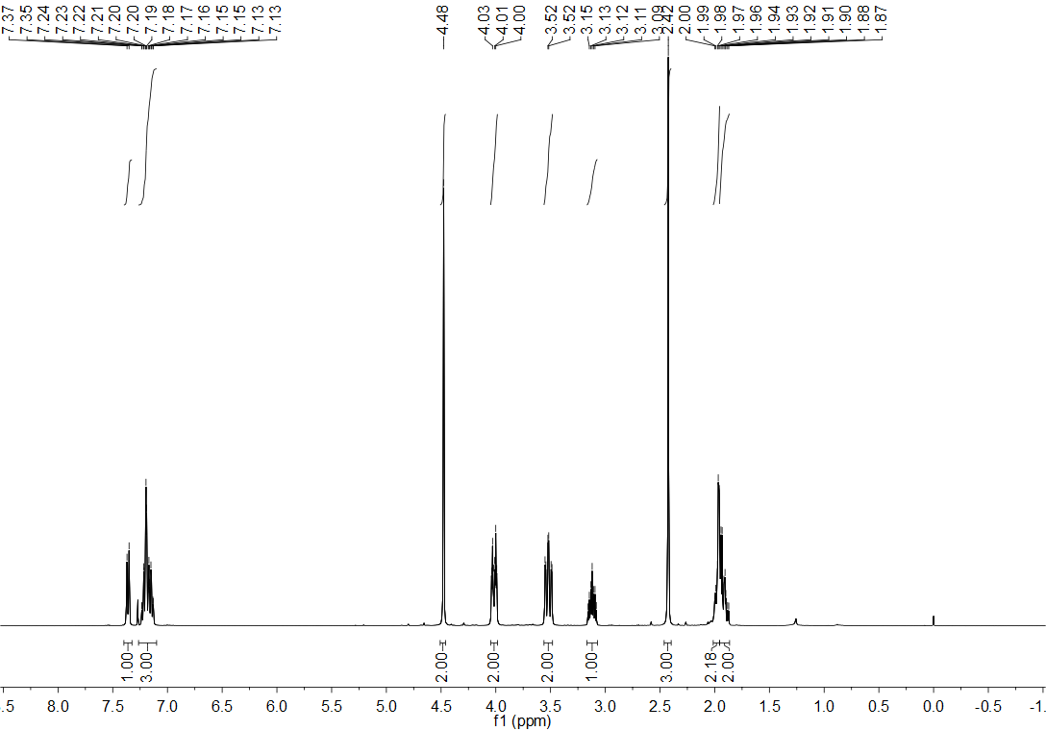
Figure S71. ¹H NMR spectrum (CDCl₃, 400 MHz) of compound 28.
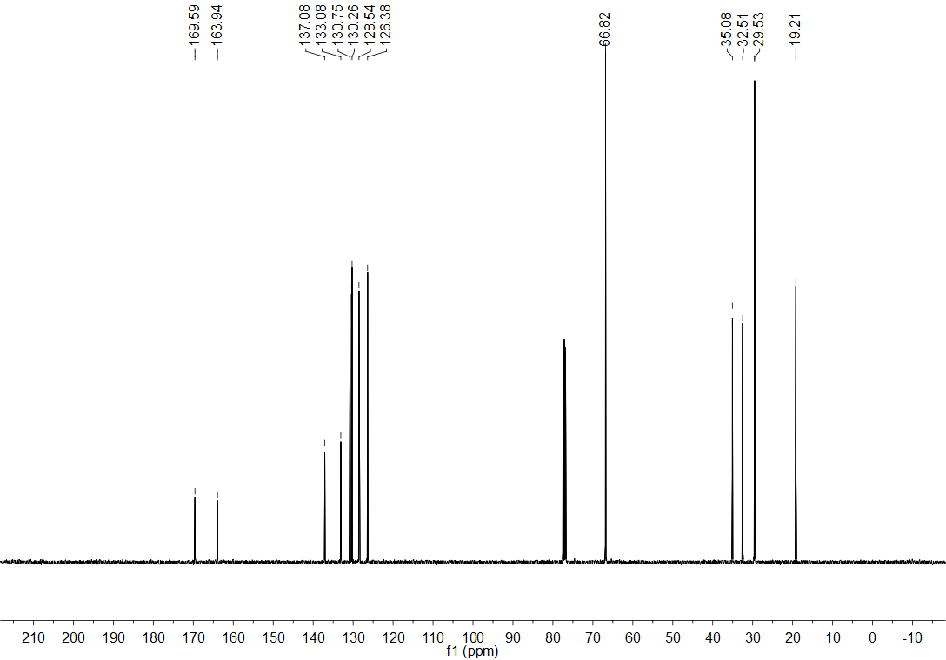
Figure S72. ¹³C NMR spectrum (CDCl₃, 101 MHz) of compound 28.
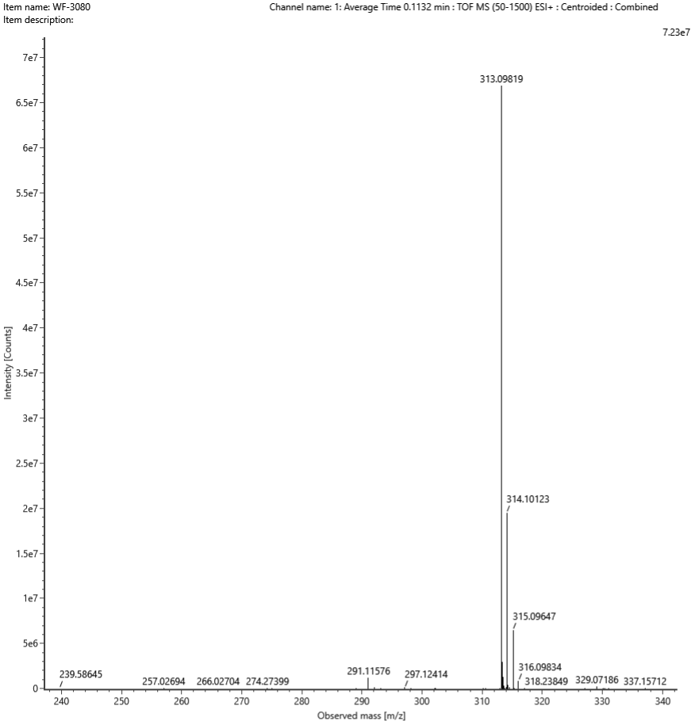
Figure S73. HRMS spectrum of compound 28.
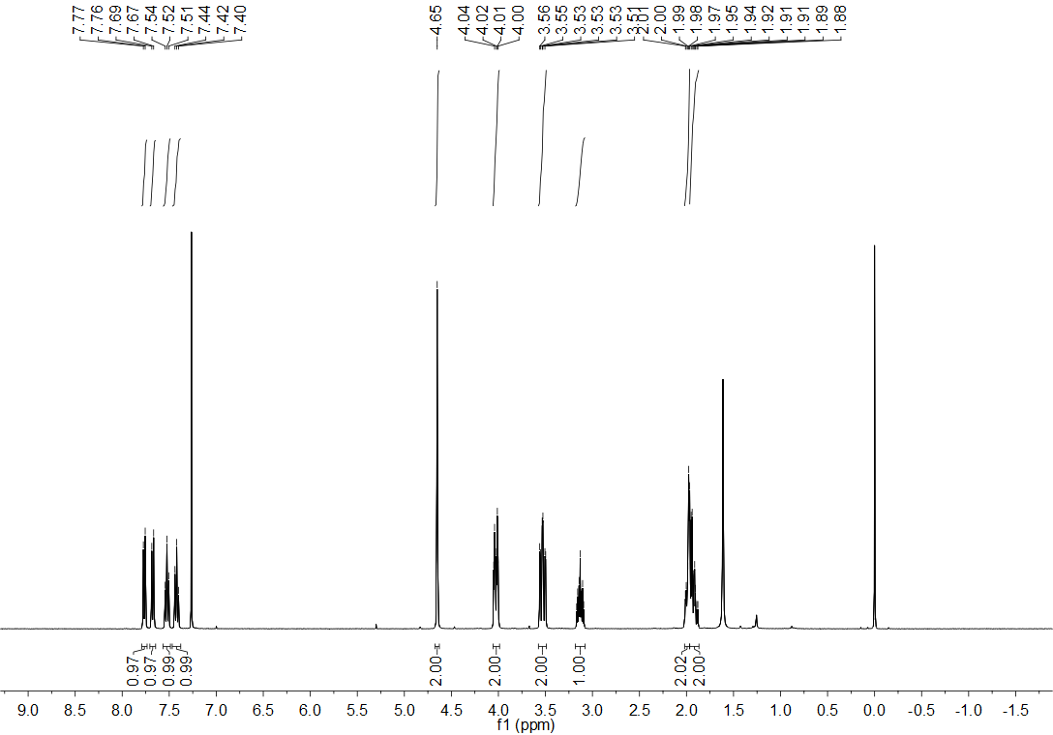
Figure S74. ¹H NMR spectrum (CDCl₃, 400 MHz) of compound 29.
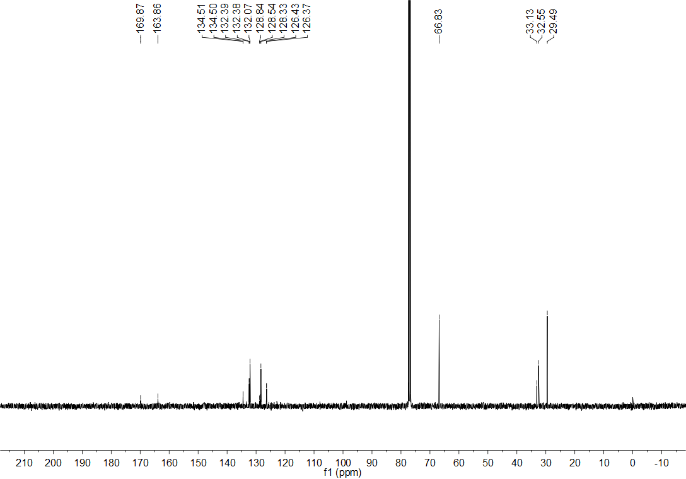
Figure S75. ¹³C NMR spectrum (CDCl₃, 101 MHz) of compound 29.
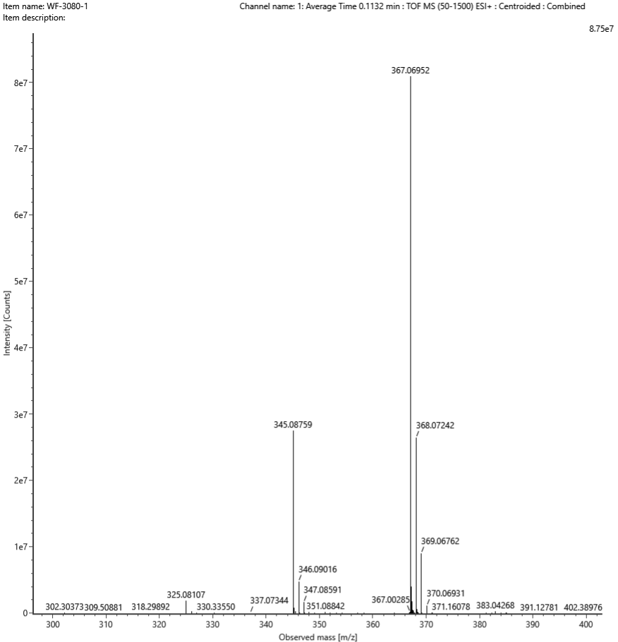
Figure S76. HRMS spectrum of compound 29.
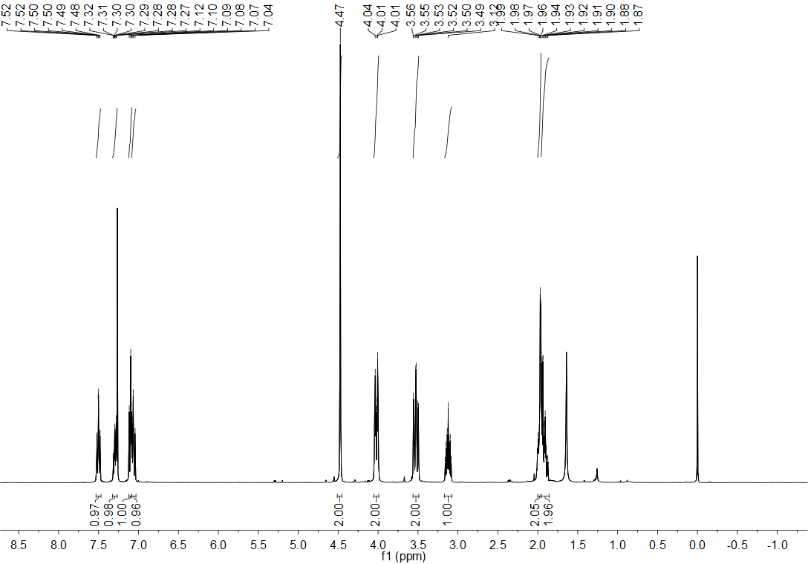
Figure S77. ¹H NMR spectrum (CDCl₃, 400 MHz) of compound 30.
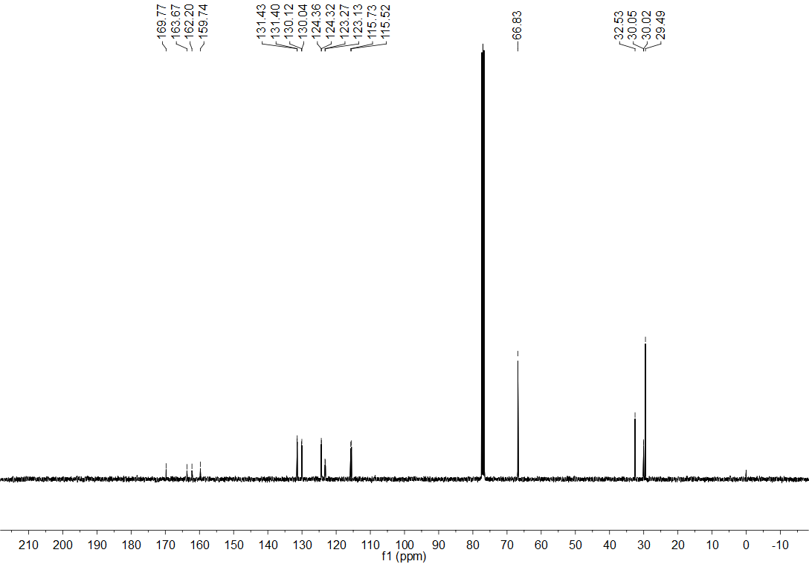
Figure S78. ¹³C NMR spectrum (CDCl₃, 101 MHz) of compound 30.
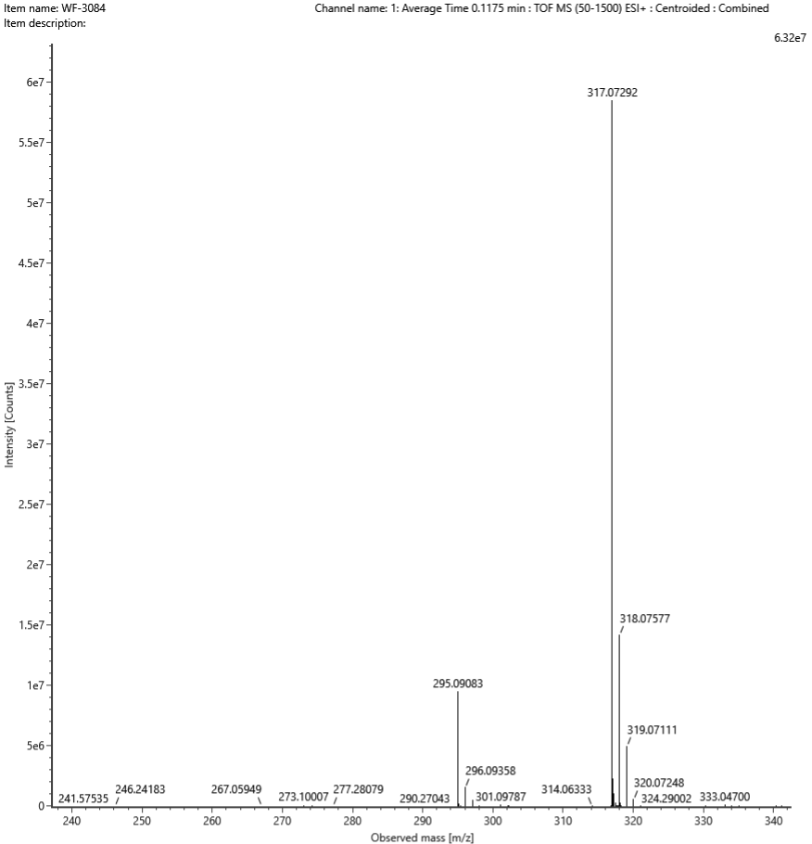
Figure S79. HRMS spectrum of compound 30.
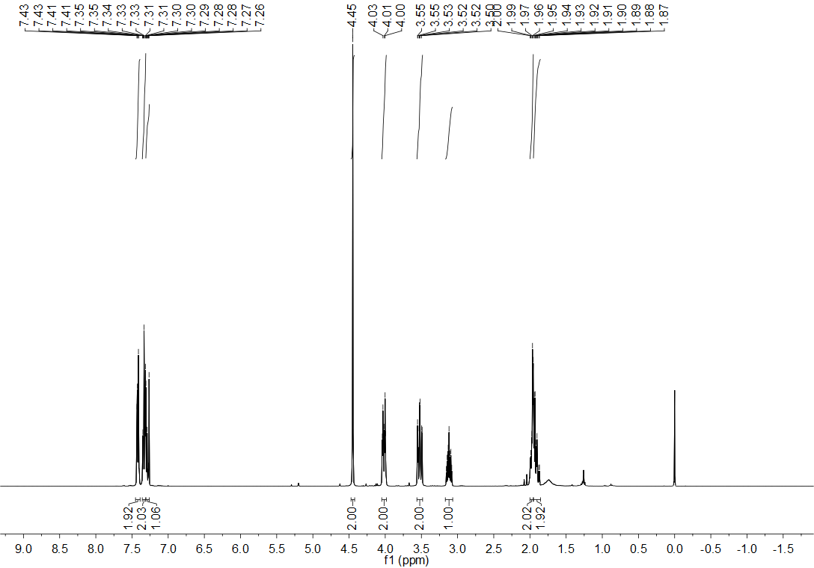
Figure S80. ¹H NMR spectrum (CDCl₃, 400 MHz) of compound 31.
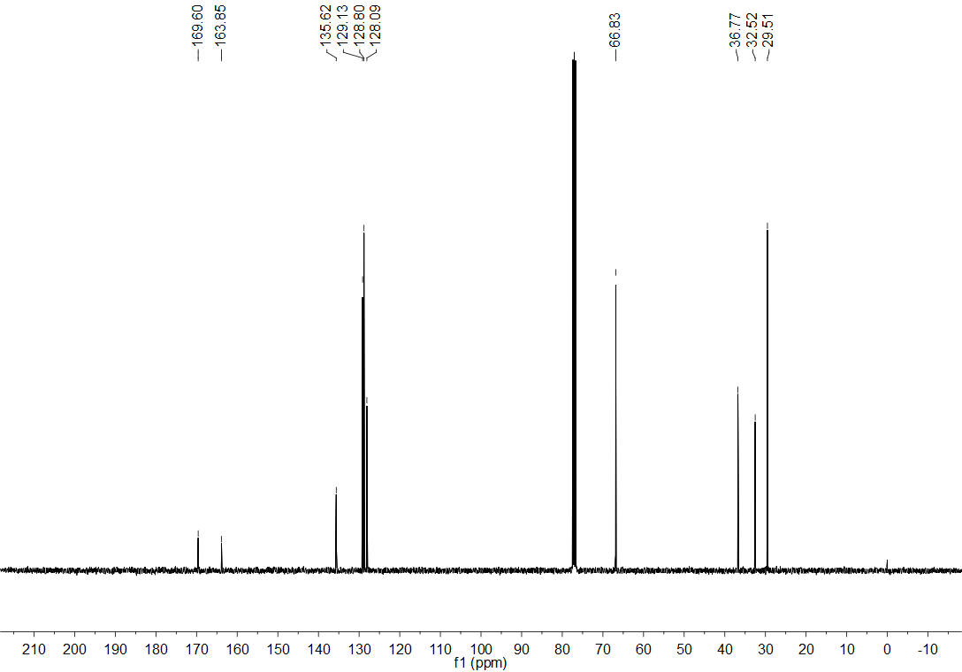
Figure S81. ¹³C NMR spectrum (CDCl₃, 101 MHz) of compound 31.
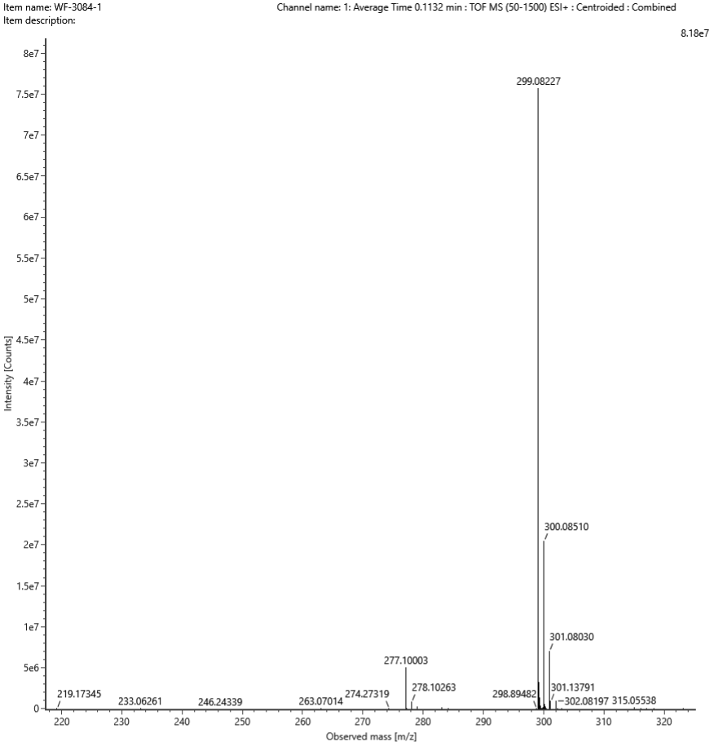
Figure S82. HRMS spectrum of compound 31.
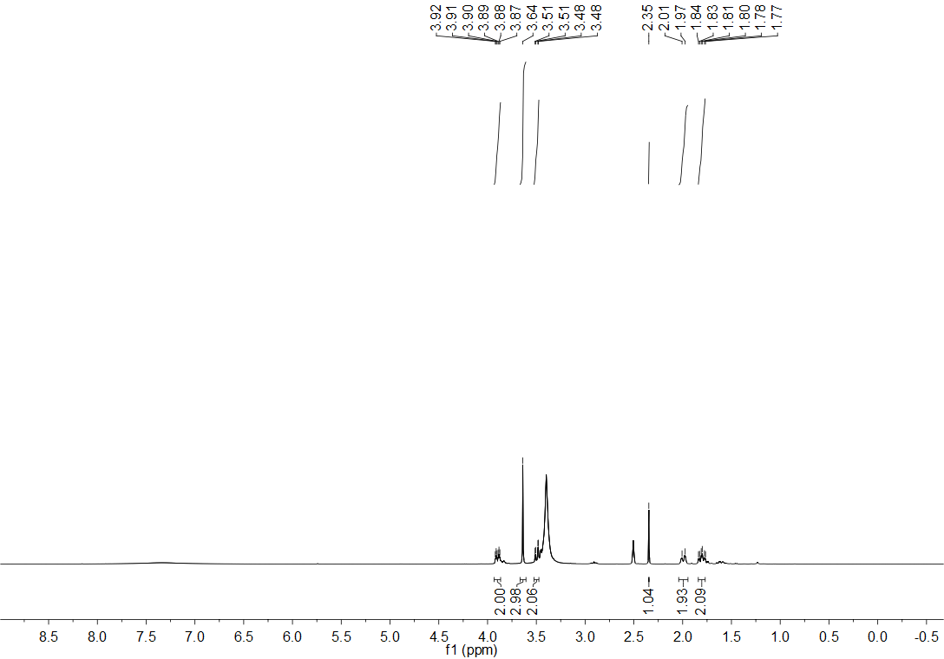
Figure S83. ¹H NMR spectrum (CDCl₃, 400 MHz) of compound 32.
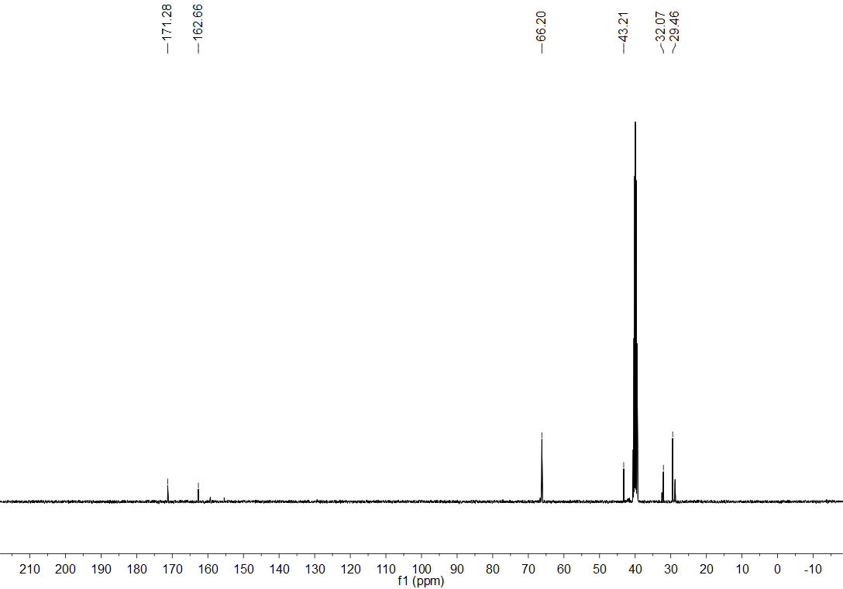
Figure S84. ¹³C NMR spectrum (CDCl₃, 101 MHz) of compound 32.
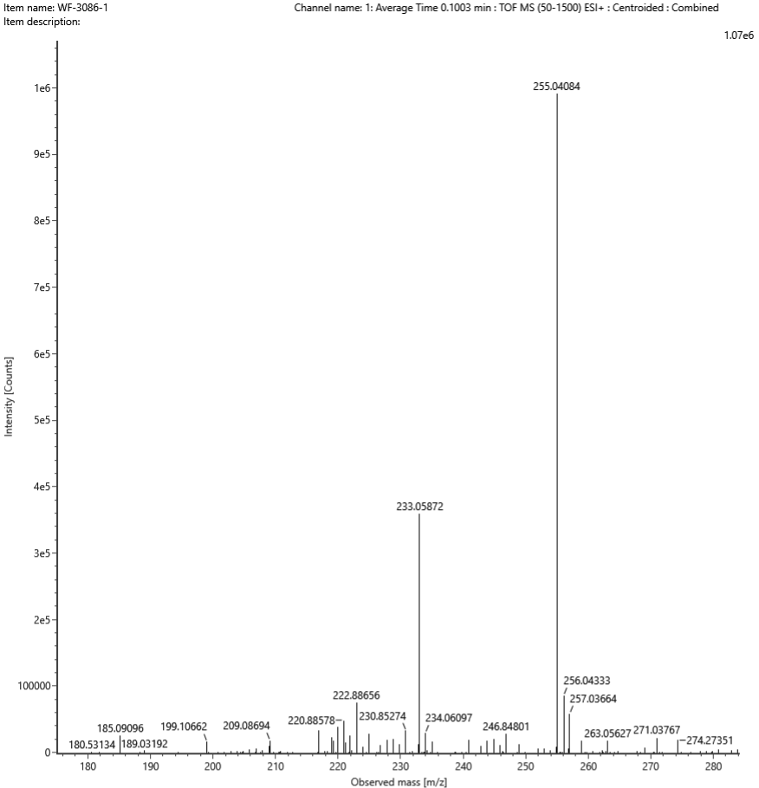
Figure S85. HRMS spectrum of compound 32.
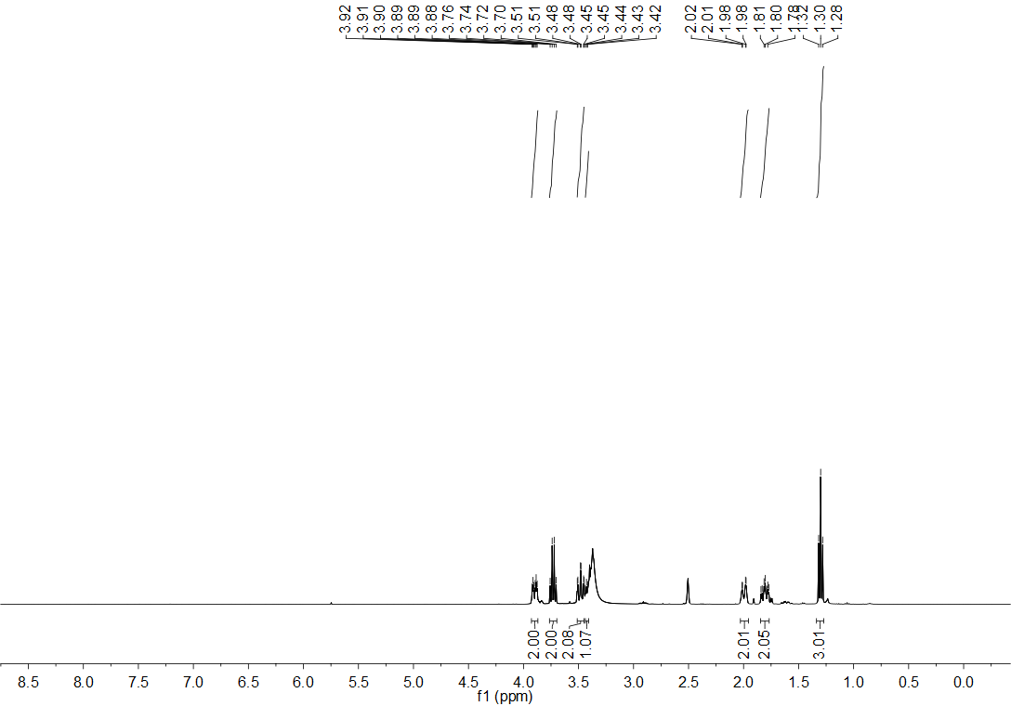
Figure S86. ¹H NMR spectrum (CDCl₃, 400 MHz) of compound 33.
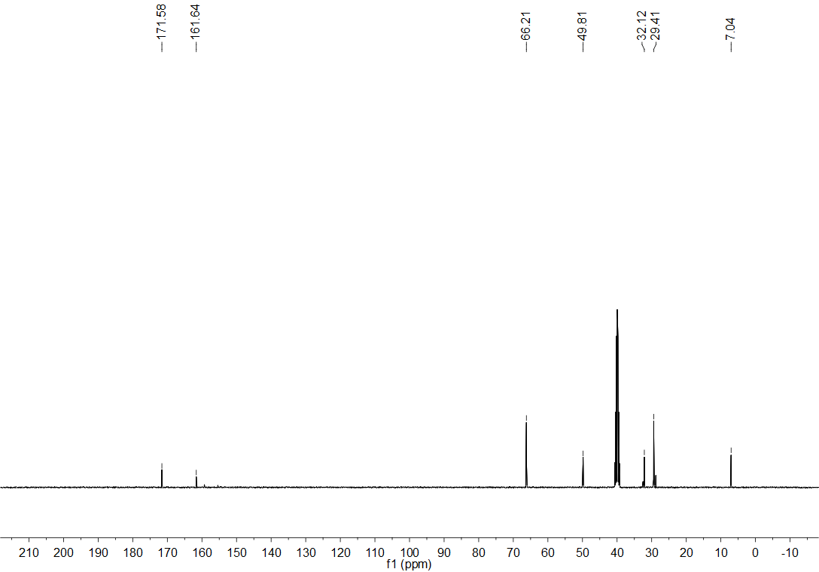
Figure S87. ¹³C NMR spectrum (CDCl₃, 101 MHz) of compound 33.
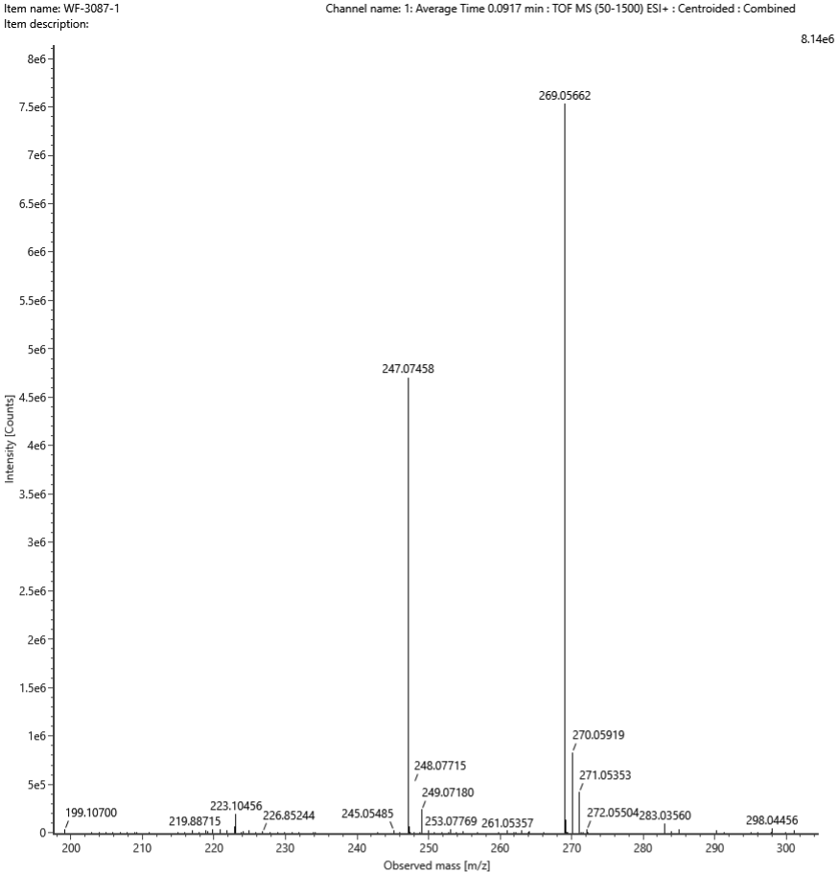
Figure S88. HRMS spectrum of compound 33.
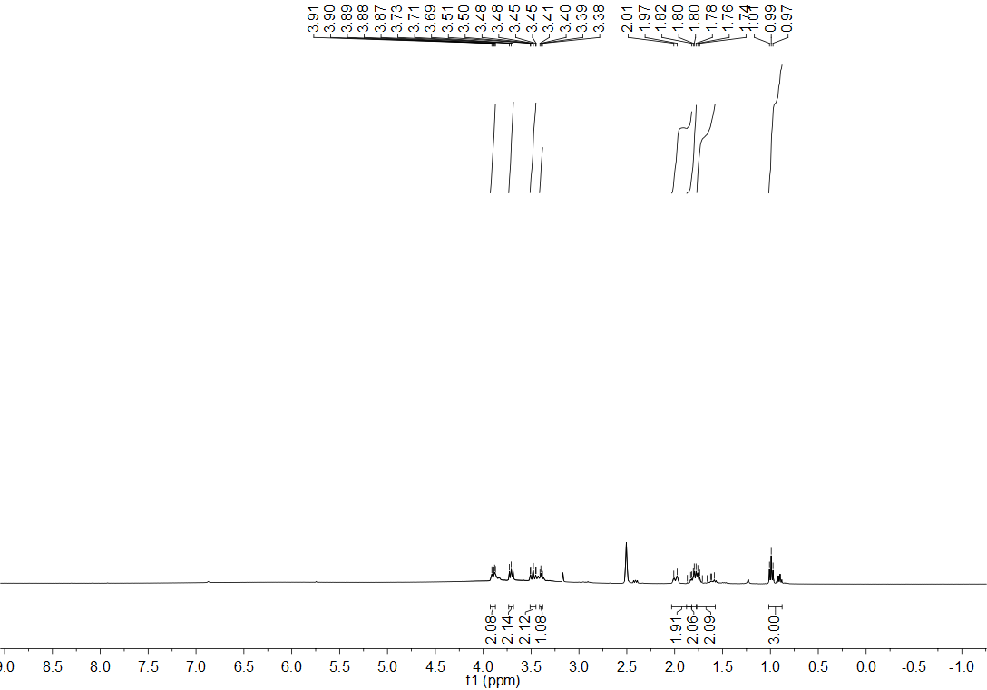
Figure S89. ¹H NMR spectrum (CDCl₃, 400 MHz) of compound 34.
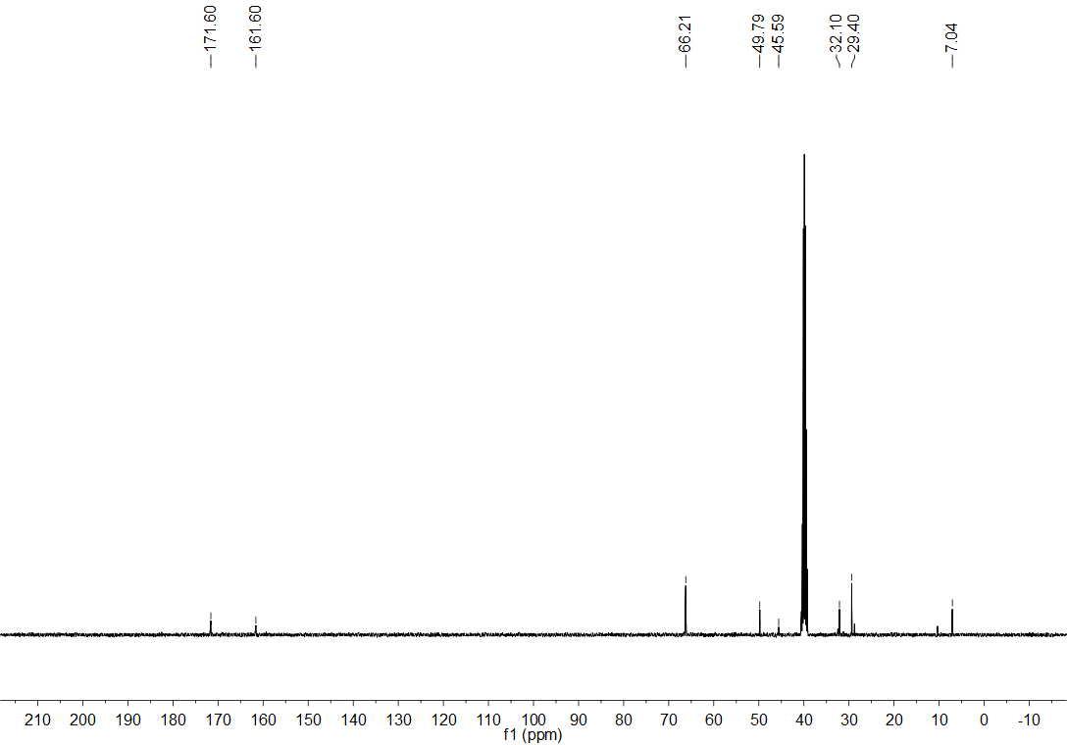
Figure S90. ¹³C NMR spectrum (CDCl₃, 101 MHz) of compound 34.
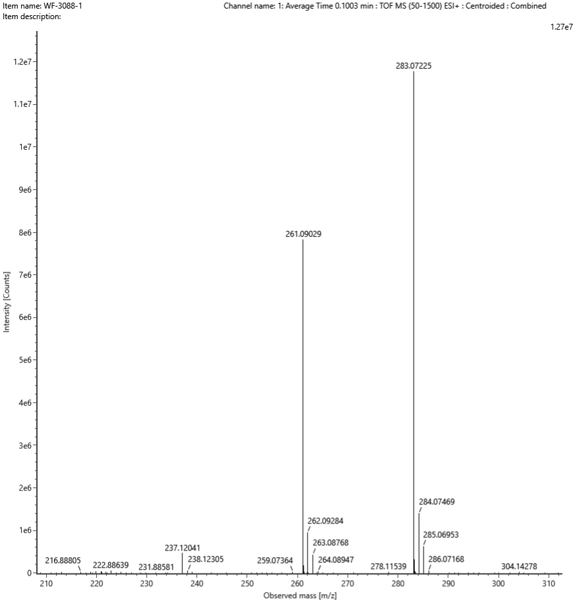
Figure S91. HRMS spectrum of compound 34.

6. Phytotoxicity of compound 33 at 200 mg L⁻¹ toward rice plants after seven days under greenhouse conditions
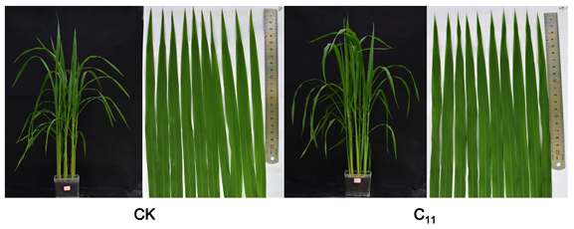
Figure S92. The phytotoxicity of compound 33 at 200 mg L⁻¹ toward rice plants.

7.References
Chen, J.X., Yi, C.F., Wang, S.W., Wu, S.K., Li, S.Y., Hu, D.Y., Song, B.A., 2019. Novel amide derivatives containing 1,3,4-thiadiazole moiety: Design, synthesis, nematocidal and antibacterial activities. Bioorg. Med. Chem. Lett. 29 (10), 1203−1210.
Li, P., Hu, D.Y., Xie, D.D., Chen, J.X., Jin, L.H., Song, B.A., 2018. Design, synthesis, and evaluation of new sulfone derivatives containing a 1,3,4-oxadiazole moiety as active antibacterial agents. J. Agri. Food Chem. 66 (12), 3093−3100.

