Supplementary Information
Paper test strip for silver ions detection in drinking water samples based on combined fluorometric and colorimetric methods
Xiaoyu Fanª, Jiapei Lv^{b}, Rui Liª, Yafei Chenª, Shuai Zhangª, Tao Liuª, Shuxing Zhou^{c}*, Xiaodong Shao^{d}, Shuhao Wangª, Guangzhi Hu^{e}* and Qiaoli Yueª*
ªSchool of Chemistry and Chemical Engineering, Shandong Provincial Key Laboratory of Chemical Energy Storage and Novel Cell Technology, Liaocheng University, Liaocheng 252059, China.
^{b}State Key Laboratory of Environmental Criteria and Risk Assessment, Chinese Research Academy of Environmental Sciences, Beijing 100012, China.
^{c}Hubei Key Laboratory of Low Dimensional Optoelectronic Materials and Devices, Hubei University of Arts and Science, Xiangyang 441053, P. R. China.
^{d} State Key Laboratory for Performance and Structure Safety of Petroleum Tubular Goods and Equipment Materials, Tubular Goods Research Institute, Xi'an 710077, China.
^{e} Department of Physics, Umeå University, S-901 87 Umeå, Sweden.

*The corresponding author E-mails: sxzhou@hbuas.edu.cn (S. Zhou), guangzhi.hu@umu.se (G. Hu), and yueqiaoli@lcu.edu.cn (Q. Yue)
Figures and Tables Captions
Fig. S1 Viscosity curve of BPQDs solution (inset: photos of dried BPQDs under natural and ultraviolet light).
Fig. S2 The excitation and emission spectra of BPQDs in different solvents (a), the corresponding maximum emission intensity of BPQDs (λ_{ex} = 365 nm) (b), and the maximum intensity of BPQDs in different mixing solvents with the volume ratio of DMF and others at 1:1 (λ_{ex} = 365 nm) (c) (DMSO: dimethyl sulfoxide).
Fig. S3 Effect of solution pH (a) and response time (b) for colorimetric detection of Ag⁺.
Fig. S4 Fluorescence (a) and absorption (b) spectra of Ag⁺, DMF, DMF + Ag⁺, BPQDs (DMF), and BPQDs (DMF) + Ag⁺ (condition: 25.48 µg/mL Ag⁺, 0.34 mg/mL BPQDs, pH 9, time 6 min).
Fig. S5 Fluorescence (a) and absorption spectra (b) of BPQDs with different water content in DMF solution, and corresponding test for paper test strip (c).
Fig. S6 Fluorescence intensity (a) and absorbance (b) of BPQDs with and without Ag⁺ in the presence of various metal ions (condition: 0.34 mg/mL BPQDs, pH 9, time 6 min, 150 μM Ag⁺, and 150 μM other metal ions).
Fig. S7 Absorbance change of BPQDs + Ag⁺ over time under different storage temperatures of BPQDs (0.34 mg/mL BPQDs, pH 9, time 6 min) (a), the relationship between the fluorescence intensity change and the illumination time for QS, CDs, Au-NCs, and BPQDs after the illumination of a 300 W Xe lamp (b), the photographs of QS, CDs, Au-NCs and BPQDs under UV lamp after a certain period of Xe lamp irradiation (c-g).
Fig. S8 Photographs of BPQDs@filter paper samples with Ag⁺ (a) and Chun Yue ⋅ fruit water spiked with different concentrations of Ag⁺ (b).
Fig. S9 Stern–Volmer curves of BPQDs + Ag⁺ obtained at different temperatures (0.34 mg/mL BPQDs, pH 9, time 6 min) (a) and fluorescence decay of BPQDs + Ag⁺ and BPQDs (b).
Table S1 Results of Ag⁺ detection using various fluorescence and colorimetric methods.
Table S2 Results of Ag⁺ detection in Chun Yue · fruit water and Changbai Snow · mineral water.
Table S3 t_{α, f} values (bilateral).
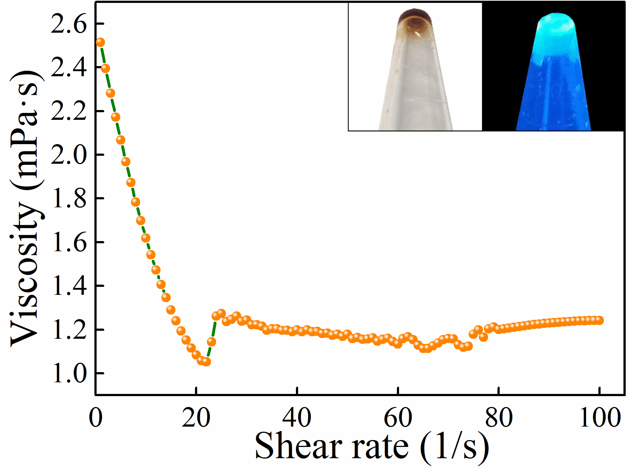
Fig. S1 Viscosity curve of BPQDs solution (inset: photos of dried BPQDs under natural and ultraviolet light)
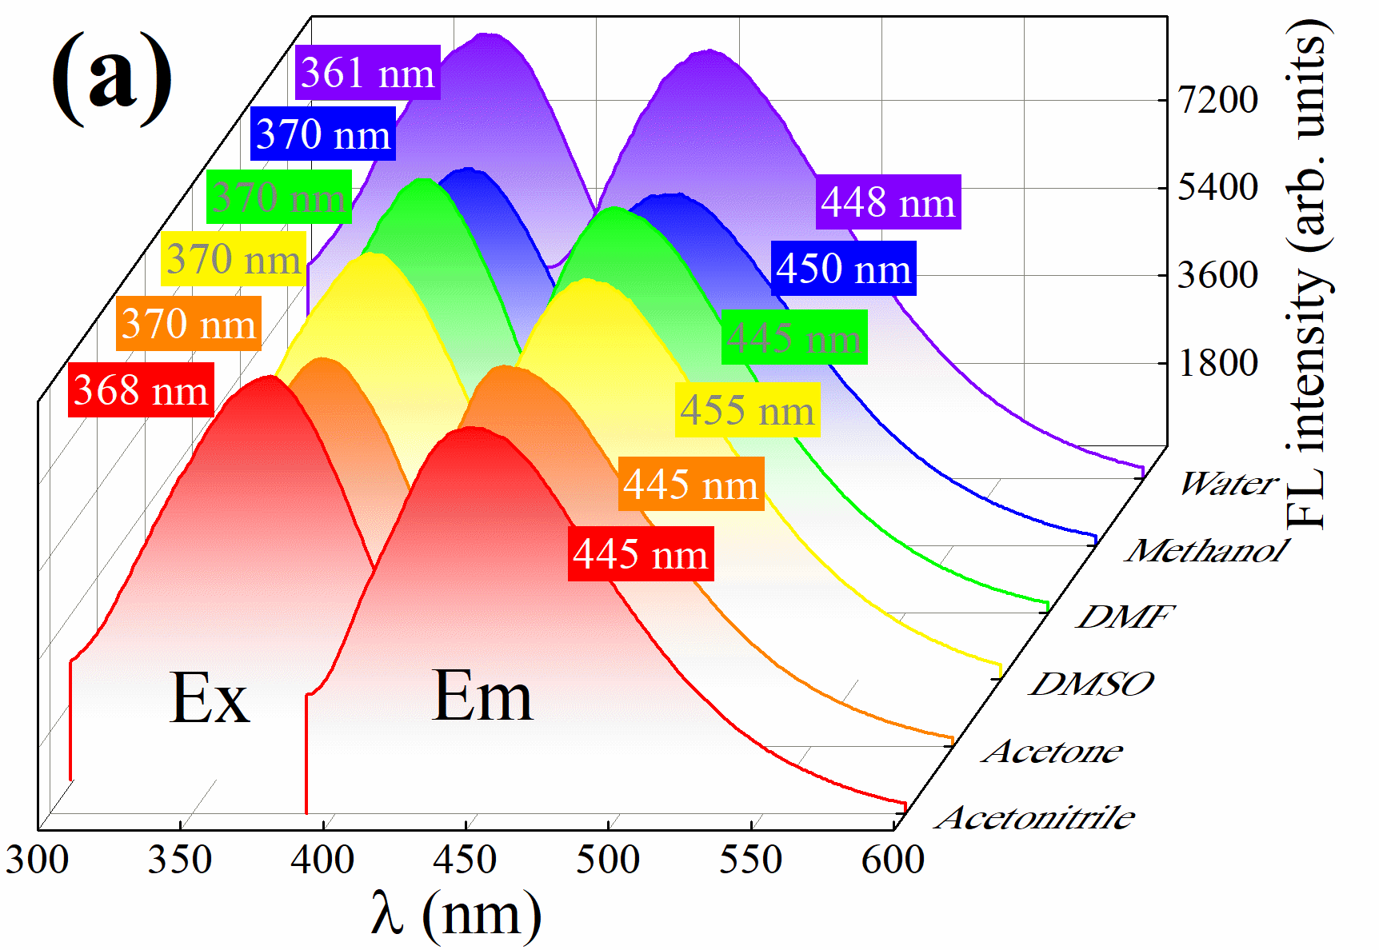
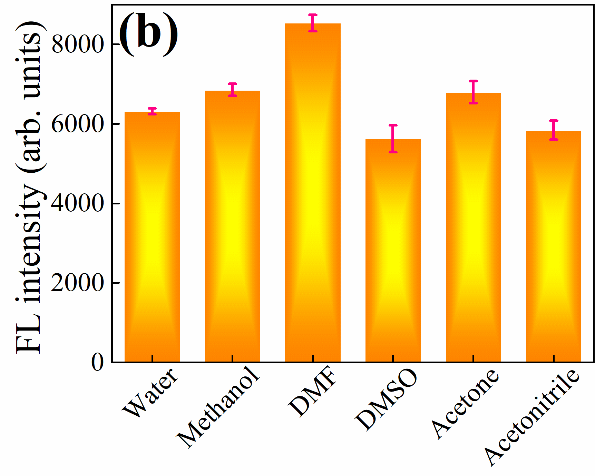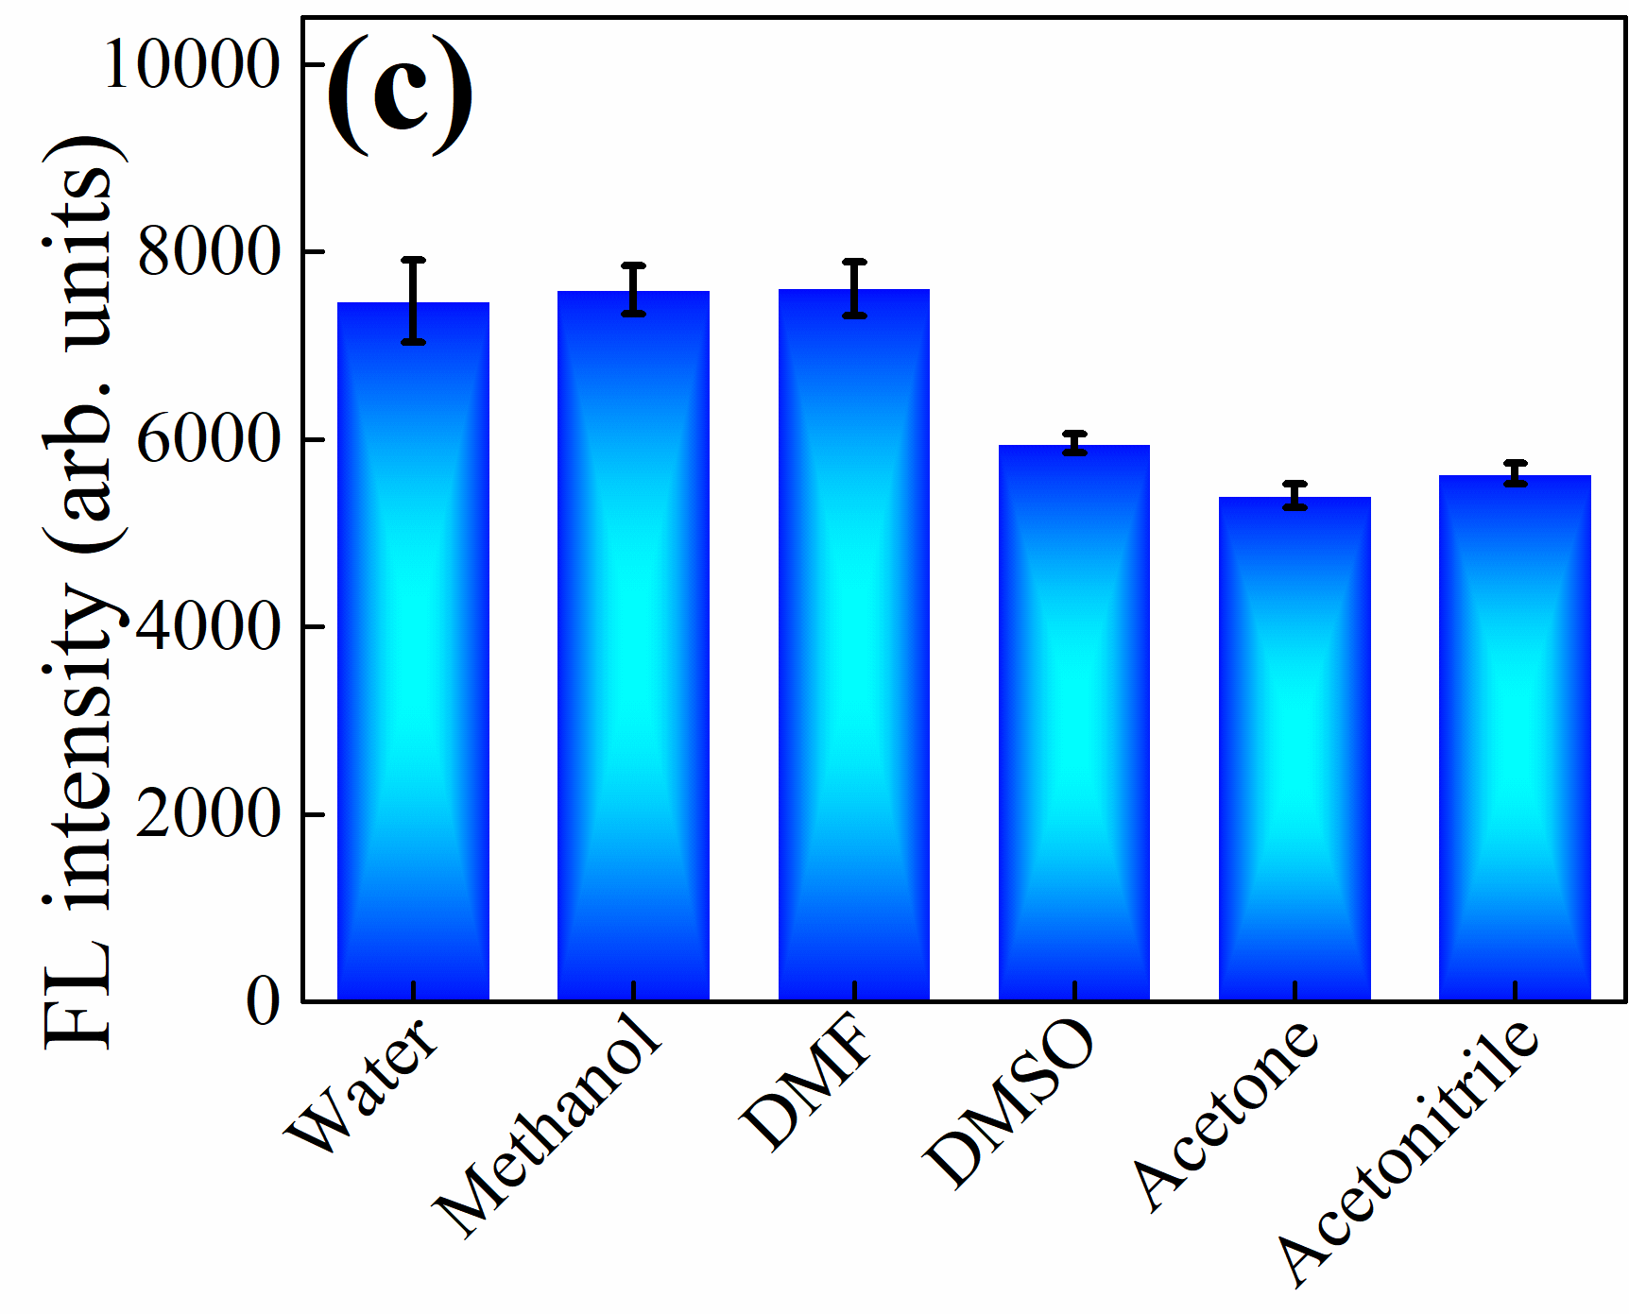Fig. S2 The excitation and emission spectra of BPQDs in different solvents (a), the corresponding maximum emission intensity of BPQDs (λ_{ex} = 365 nm) (b), and the maximum intensity of BPQDs in different mixing solvents with the volume ratio of DMF and others at 1:1 (λ_{ex} = 365 nm) (c) (DMSO: dimethyl sulfoxide)
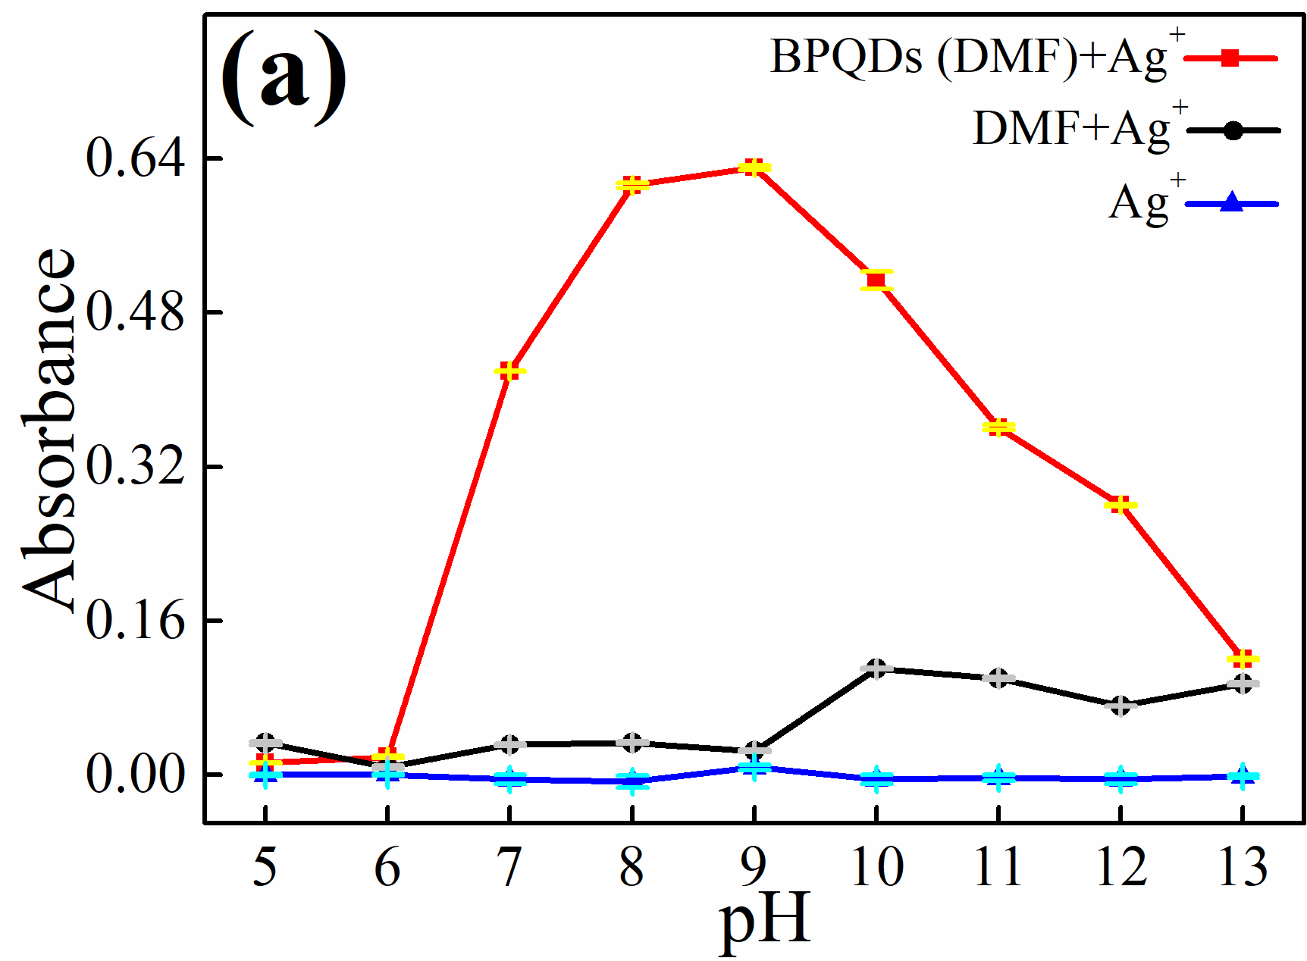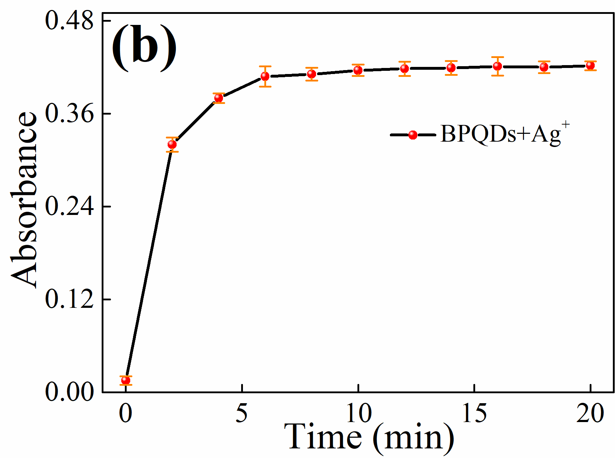Fig. S3 Effect of solution pH (a) and response time (b) for colorimetric detection of Ag⁺
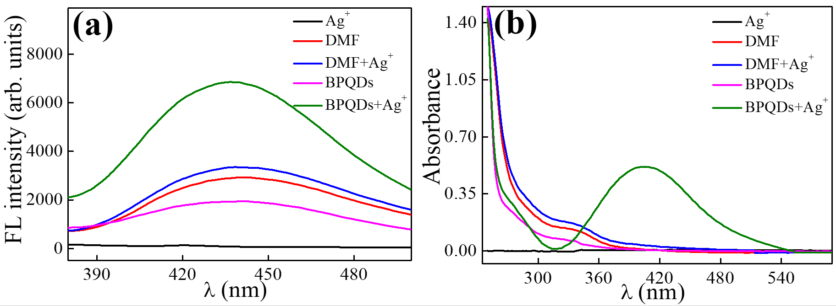
Fig. S4 Fluorescence (a) and absorption (b) spectra of Ag⁺, DMF, DMF + Ag⁺, BPQDs (DMF), and BPQDs (DMF) + Ag⁺ (condition: 25.48 µg/mL Ag⁺, 0.34 mg/mL BPQDs, pH 9, time 6 min)
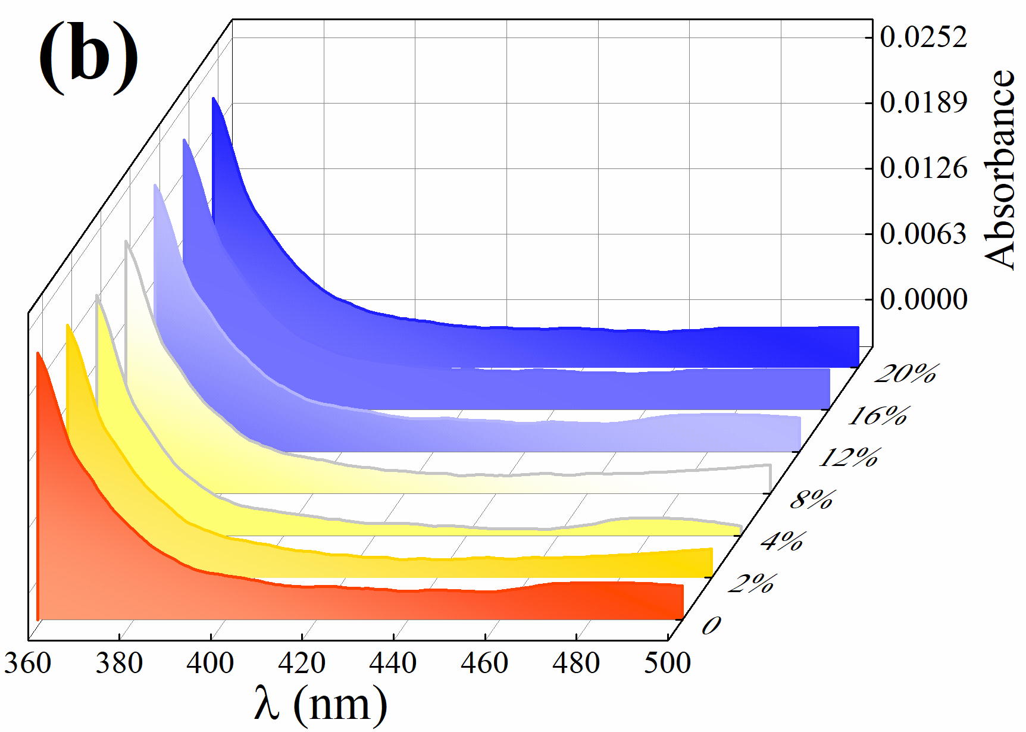
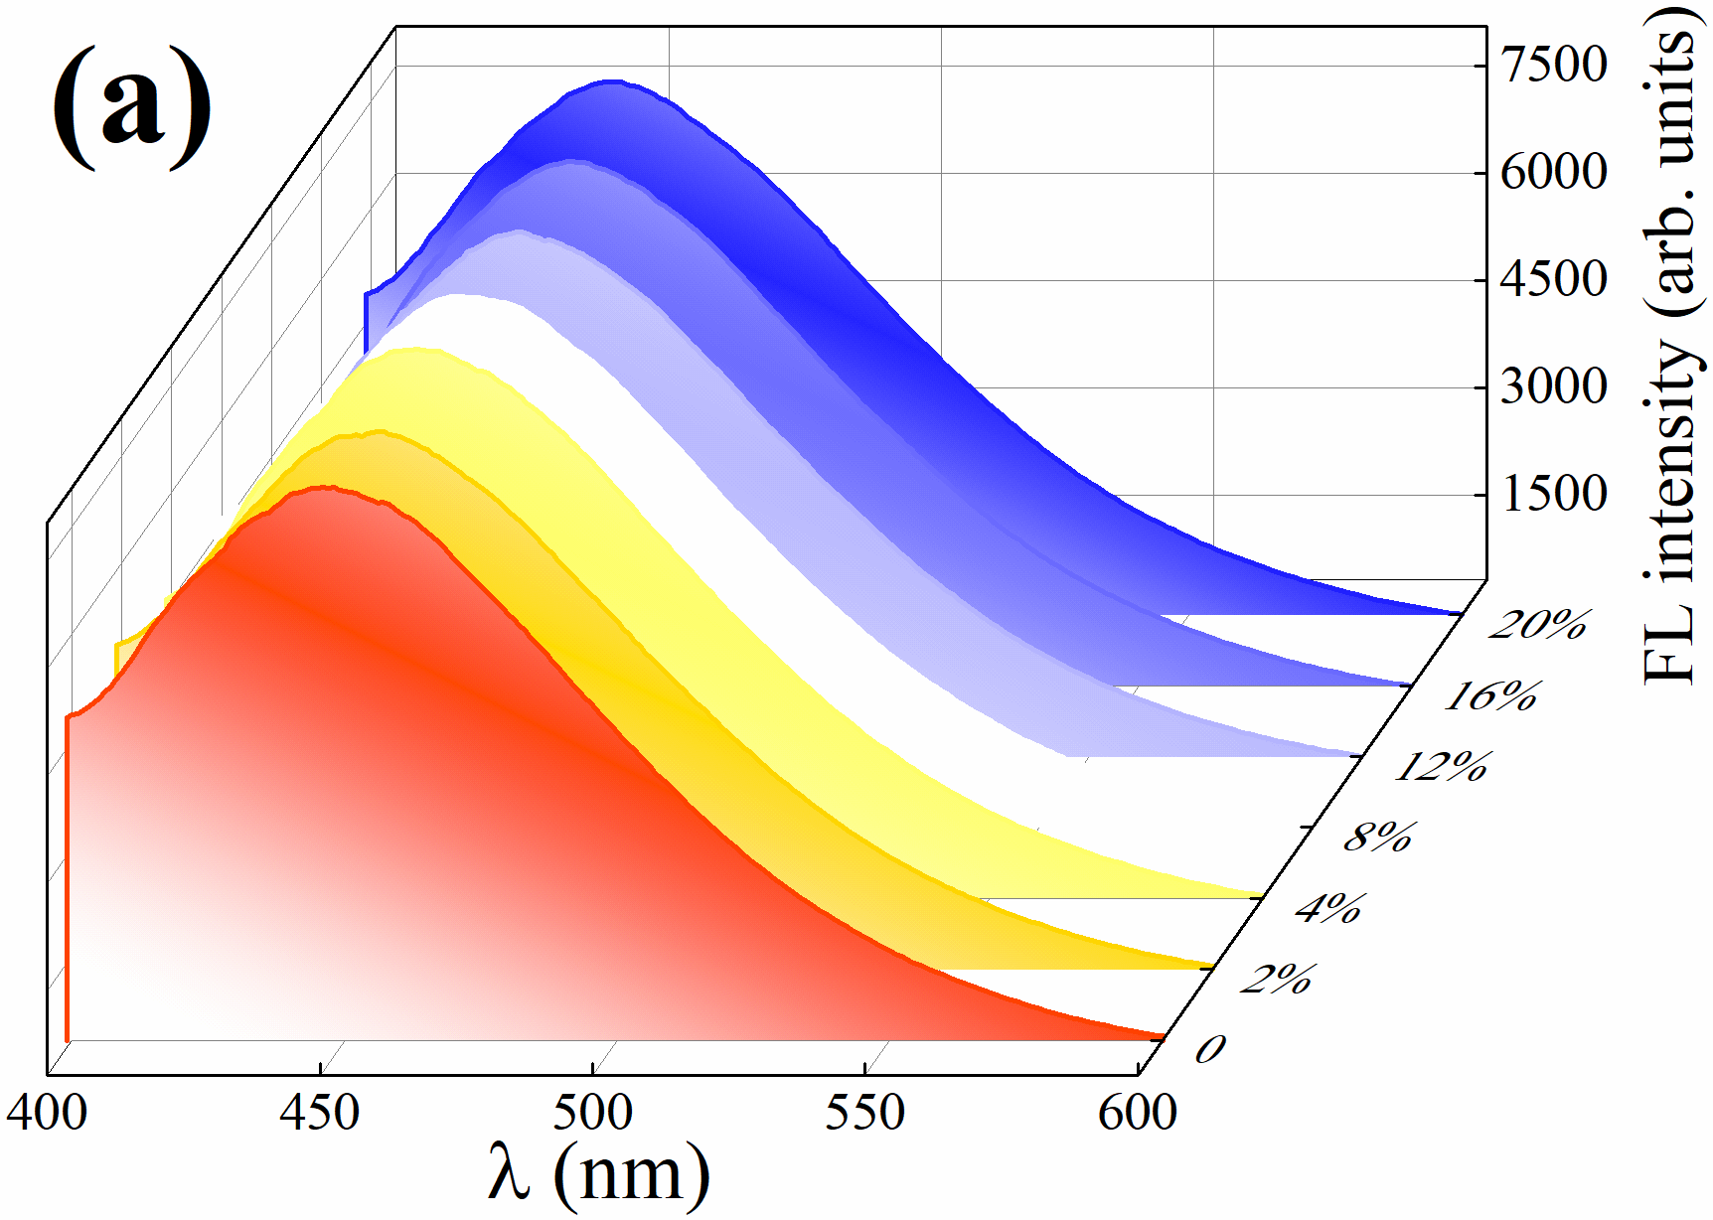
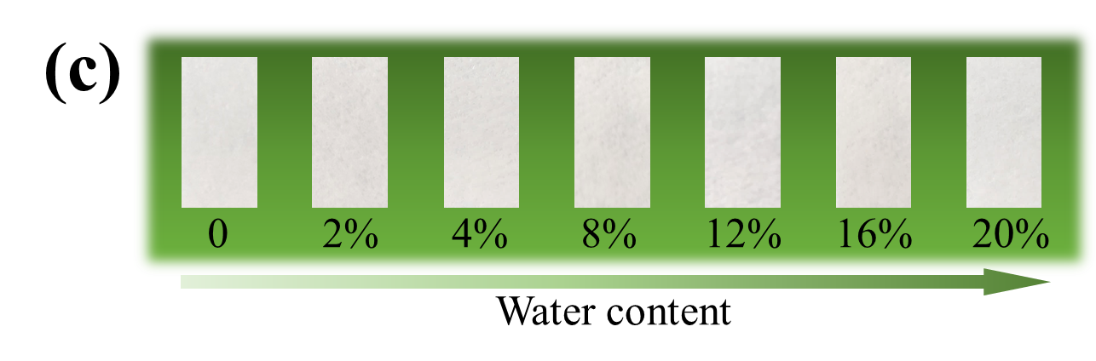
Fig. S5 Fluorescence (a) and absorption spectra (b) of BPQDs with different water content in DMF solution, and corresponding test for paper test strip (c)
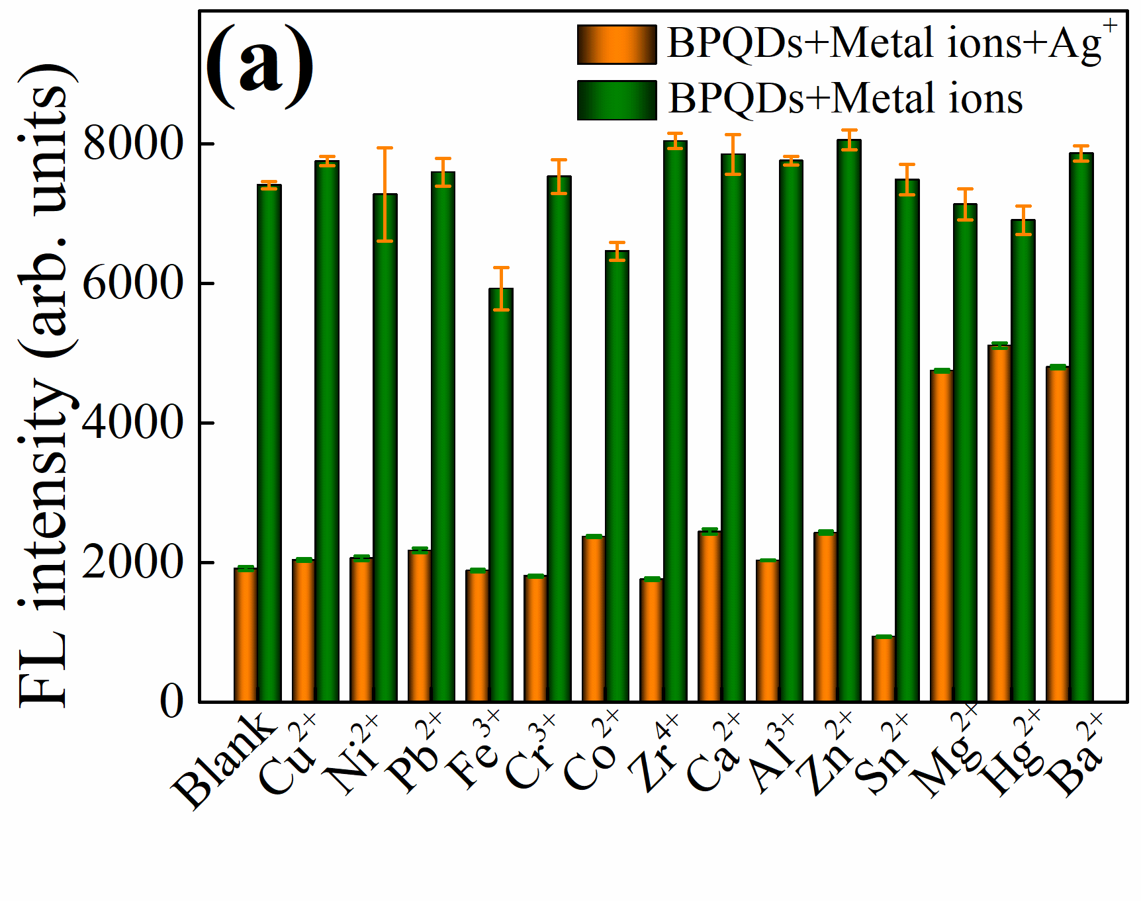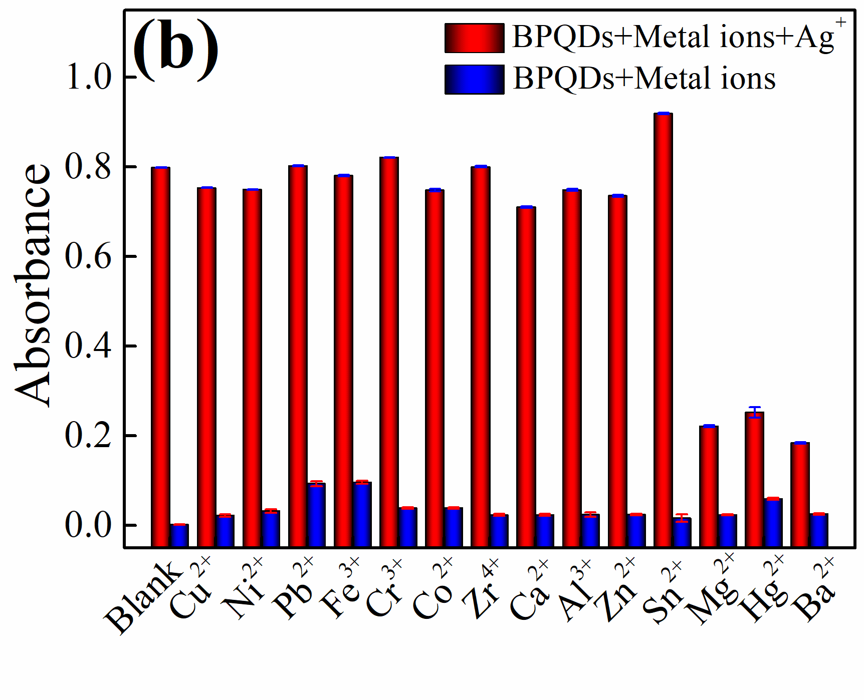Fig. S6 Fluorescence intensity (a) and absorbance (b) of BPQDs with and without Ag⁺ in the presence of various metal ions (condition: 0.34 mg/mL BPQDs, pH 9, time 6 min, 150 μM Ag⁺, and 150 μM other metal ions)
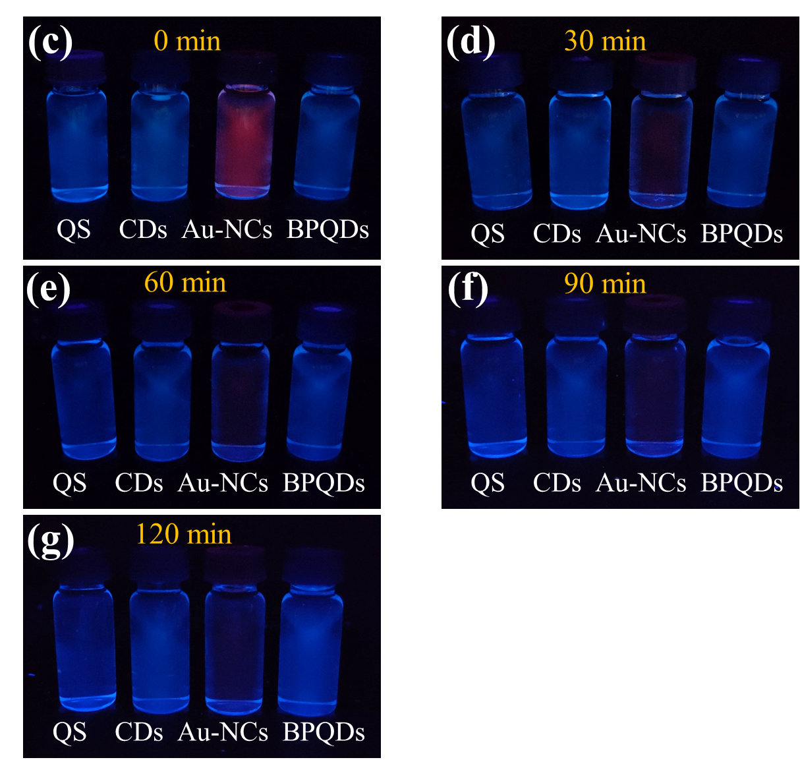
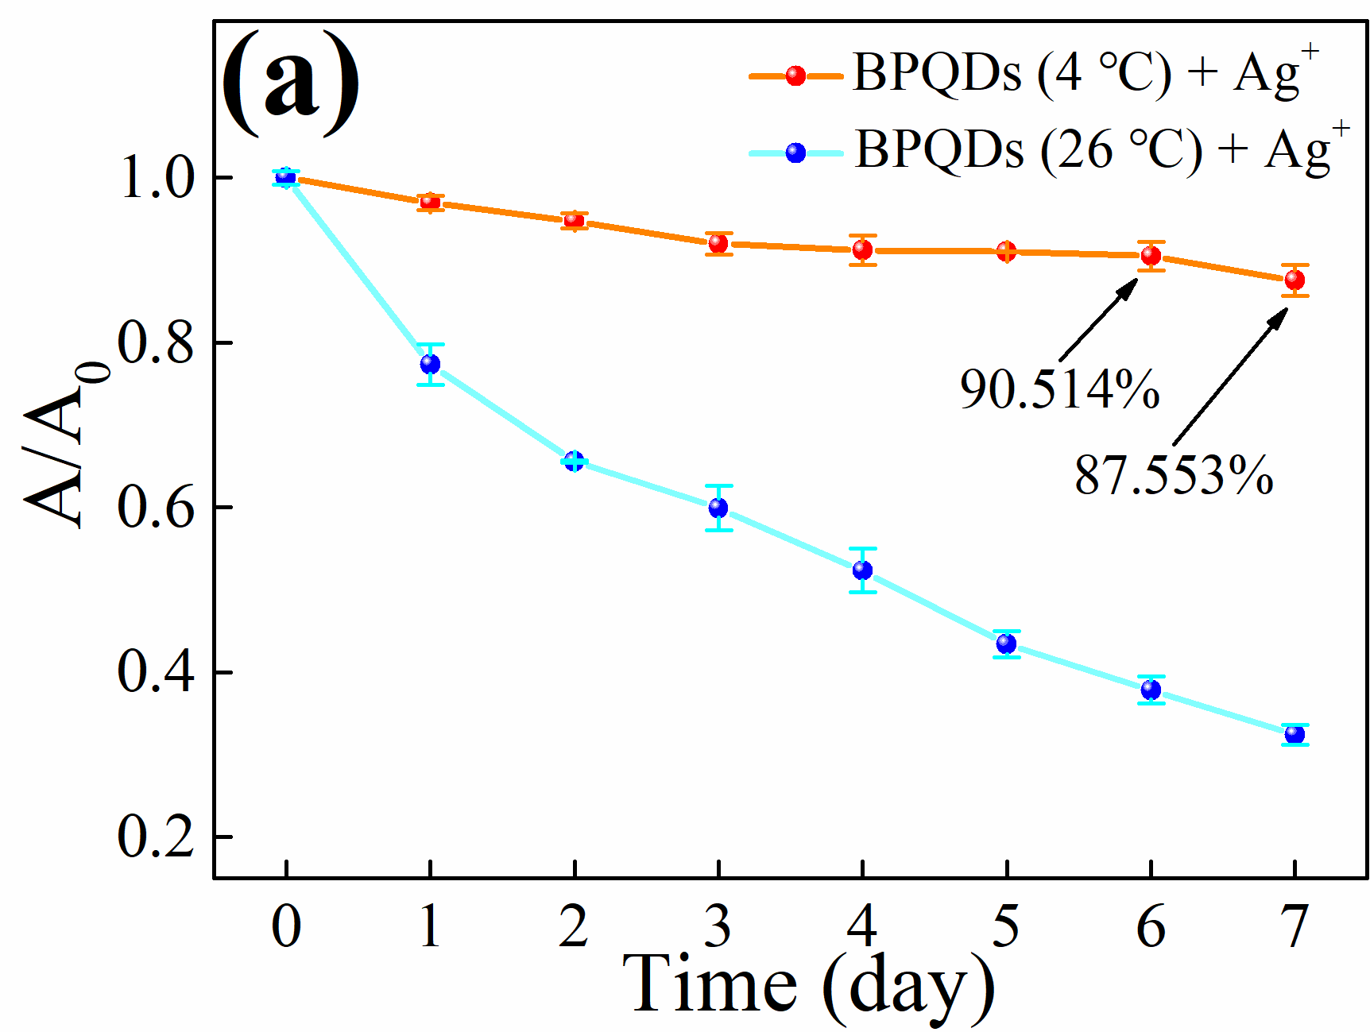
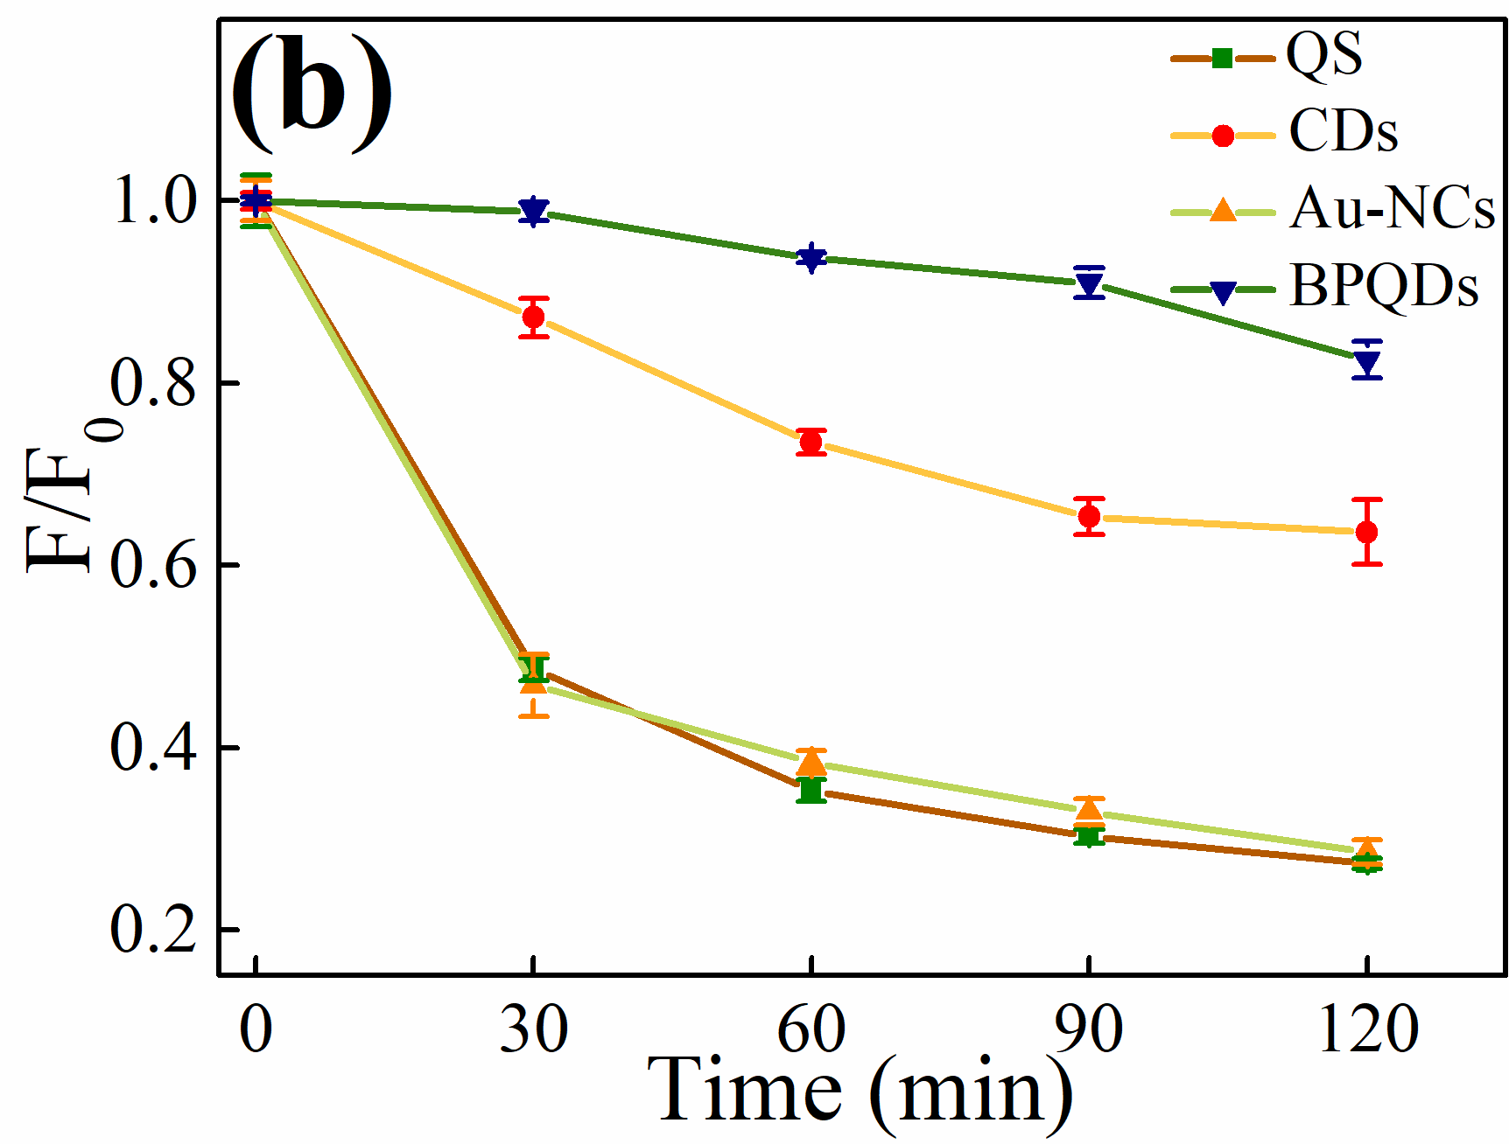
Fig. S7 Absorbance change of BPQDs + Ag⁺ over time under different storage temperatures of BPQDs (0.34 mg/mL BPQDs, pH 9, time 6 min) (a), the relationship between the fluorescence intensity change and the illumination time for QS, CDs, Au-NCs, and BPQDs after the illumination of a 300 W Xe lamp (b), the photographs of QS, CDs, Au-NCs and BPQDs under UV lamp after a certain period of Xe lamp irradiation (c-g)
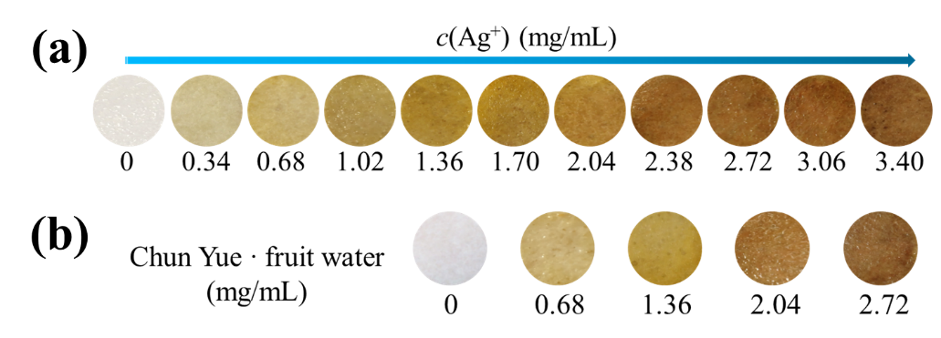
Fig. S8 Photographs of BPQDs@filter paper samples with Ag⁺ (a) and Chun Yue ⋅ fruit water spiked with different concentrations of Ag⁺ (b)
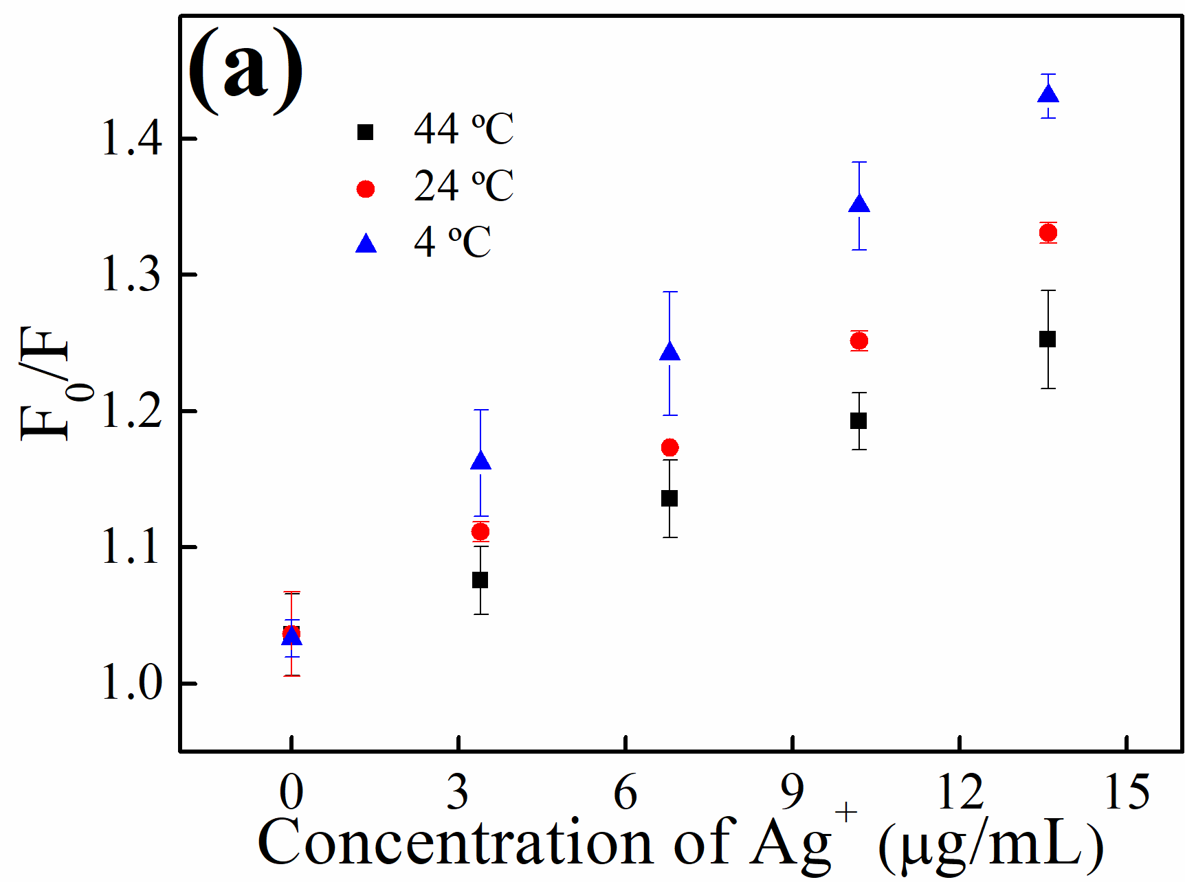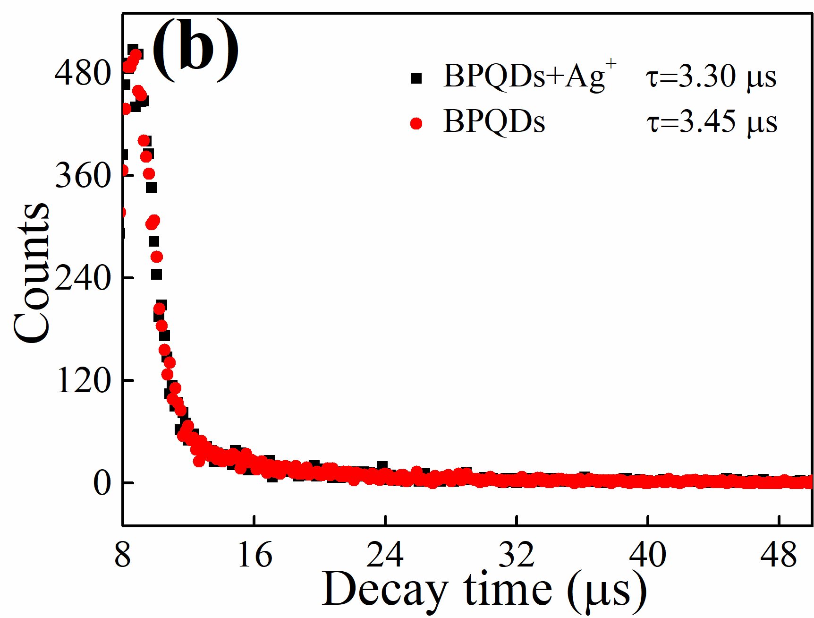Fig. S9 Stern–Volmer curves of BPQDs + Ag⁺ obtained at different temperatures (0.34 mg/mL BPQDs, pH 9, time 6 min) (a) and fluorescence decay of BPQDs + Ag⁺ and BPQDs (b)

Table S1 Results of Ag⁺ detection using various fluorescence and colorimetric methods
Material | Analytical range | LOD | Method | Sample | Portable | Ref.
N-CDs | 0−140 μM | 0.12 μM | Fluorometry | Intracellular imaging | No | ( Jiao et al., 2019)
Lcys-Cd ZnTe QDs | 0.5−4.0 μM | 0.17 μM | Fluorometry | Tap water and lake water | No | (Cui et al., 2021)
Rh6G | 0–15 μM | 0.38 μM | Fluorometry | Lake water and river water | No | (Han et al., 2021)
CQDs | 0.2–50 μM | 0.075 μM | Fluorometry | Tap water and river water | No | (Li et al., 2019)
N-CDs | 0–70 μM | 0.091 μM | Fluorometry | Intracellular imaging | No | (Chen et al., 2021)
CDs | 5–100 μM | 1.4 μM | Fluorometry | Water samples and a human serum sample | No | (Ma et al., 2019)
CDs | 50–500 μM | 29.18 μM | Fluorometry | Drinking  water and lake  water | Yes | ( Silva Júnior et al., 2021)
C_{SM}-dots | 5–290 μM | 0.5 μM | Fluorometry | Tap water intracellular imaging | No | (Zhou et al., 2021)
CL | 2–20 μM | 8.8 μM | Fluorometry | - | No | (Jiang et al., 2022)
BPQDs | 3.40–21.23 μg/mL | 1.56 μg/mL | Fluorometry | Chun Yue · fruit water and Changbai Snow · mineral water | Yes | This work
BPQDs | 3.40–25.48 μg/mL | 0.19 μg/mL | Colorimetry | Chun Yue · fruit water and Changbai Snow · mineral water | Yes | This work
Note: nitrogen-doped carbon dots (N-CDs), L-cysteine-protected CdZnTe quantum dots (Lcys-CdZnTe QDs), rhodamine 6G (Rh6G), carbon quantum dots (CQDs), nitrogen-doped carbon dots (N-CDs), carbon dots (CDs), lignin-derived structural memory carbon nanodots (C_{SM}-dots), A new near-infrared probe based on a coumarinyl ligand (CL).

Table S2 Results of Ag⁺ detection in Chun Yue · fruit water and Changbai Snow · mineral water
Sample | Spiked (μg/mL) | Found (μg/mL ) | AAS method (μg/mL ) | Recovery (%) | RSD (%) | t-test
Chun Yue · fruit water | 3.40 | 3.35 ± 0.08 | 3.40 ± 0.01 | 98.53 | 2.39 | 0.368
Chun Yue · fruit water | 6.79 | 6.89 ± 0.08 | 6.94 ± 0.01 | 101.47 | 1.16 | 0.343
Chun Yue · fruit water | 10.19 | 10.34 ± 0.09 | 10.41 ± 0.01 | 101.47 | 0.87 | 0.252
Changbai Snow · mineral water | 3.40 | 3.31 ± 0.08 | 3.43 ± 0.01 | 97.35 | 2.42 | 0.061
Changbai Snow · mineral water | 6.79 | 6.87 ± 0.07 | 6.96 ± 0.01 | 101.18 | 1.02 | 0.092
Changbai Snow · mineral water | 10.19 | 10.28± 0.08 | 10.37 ± 0.09 | 100.88 | 0.78 | 0.265

Table S3 t_{α, f} values (bilateral)
f=n-1 | Confidence, Significance level
f=n-1 | P=0.90  α=0.10 | P=0.95  α=0.05 | P=0.99  α=0.01
1 | 6.31 | 12.71 | 63.66
2 | 2.92 | 4.30 | 9.92
3 | 2.35 | 3.18 | 5.84
4 | 2.13 | 2.78 | 4.60
5 | 2.02 | 2.57 | 4.03
6 | 1.94 | 2.45 | 3.71
7 | 1.90 | 2.36 | 3.50
8 | 1.86 | 2.31 | 3.36
9 | 1.83 | 2.26 | 3.25
10 | 1.81 | 2.23 | 3.17
20 | 1.72 | 2.09 | 2.84
∞ | 1.64 | 1.96 | 2.58
Note: f, n, P and α are respectively degrees of freedom, detection times, confidence and significance levels.

References
Jiao, Y., Gao, Y., Meng, Y., et al., 2019. One-step synthesis of label-free ratiometric fluorescence carbon dots for the detection of silver ions and glutathione and cellular imaging applications. ACS Appl. Mater. Inter. 11(18). 16822–16829. doi:10.1021/acsami.9b01319.
Cui, H., Wang, C., Jia, S., et al., 2021. Controlling the ligands of CdZnTe quantum dots to design a super simple ratiometric fluorescence nanosensor for silver ion detection. Analyst. 146. 5747–5755. doi:10.1039/d1an01200b.
Han, Q., Liu, X., Wang, X., et al., 2021. Photoactivated fluorescence-based analysis for the facilitative and selective detection of silver(I) in aqueous solutions. Dyes. Pigments. 184. 108793. doi:10.1016/j.dyepig.2020.108793.
Li, C., Zhang, X., Zhang, W., et al., 2019. Carbon quantum dots derived from pure solvent tetrahydrofuran as a fluorescent probe to detect pH and silver ion. J. Photoch. Photobio. A., 382, 111981. doi:10.1016/j.jphotochem.2019.111981.
Chen, X., Bai, J., Yuan, G., et al., 2021. One-pot preparation of nitrogen-doped carbon dots for sensitive and selective detection of Ag⁺ and glutathione. Microchem. J. 165, 106156. doi:10.1016/j.microc.2021.106156.
Ma, Y., Lv, W., Chen, Y., et al., 2019. Facile preparation of orange-emissive carbon dots for the highly selective detection of silver ions. New J. Chem. 43, 5070–5076. doi:10.1039/c8nj06109b.
Silva Júnior, A.H., Macuvele, D.L.P., Riella, H.G., et al., 2021. Polymeric Blends of carboxymethyl cellulose and sodium alginate containing functionalized carbon dots result in stable and efficient fluorescent films for silver and iron (III) sensing. J. Environ. Chem. Eng. 9(4). 105728. doi:10.1016/j.jece.2021.105728.
Zhou, X., Cao, Y., Zhou, X., et al., 2021. Nanosensors based on structural memory carbon nanodots for Ag⁺ fluorescence determination. Nanomaterials-Basel. 11(10), 2687. doi:10.3390/nano11102687.
Jiang, L., Zheng, T., Xu, Z., et al., 2022. New NIR spectroscopic probe with a large stokes shift for Hg²⁺ and Ag⁺ detection and living cells imaging. Spectrochim. Acta A. 271, 120916. doi:10.1016/j.saa.2022.120916.

