**Selective recovery of lanthanum from magnesium-containing solution via phosphoric acid modified** **kaolin prepared by a simple mechanochemical process**

Kaibo Hu a, b, ChuanQi Zhang b, Tianci Chen b, Ke Li a, b, Yucheng Liu b, Shuai Wei a, b, Xuewei Li b*

a School of Resource and Environment, Nanchang University, Nanchang 330031, China

b Ganjiang Innovation Academy, Chinese Academy of Sciences, Ganzhou 341000, China

c School of Public Health and Management, Nanchang Medical College, Nanchang 330052, Jiangxi, China

*Corresponding author

E-mail: [xwli@gia.cas.cn](mailto:xwli@gia.cas.cn)



**Fig. S1** Crystalline phase of raw kaolin.

Table S1 Main components of raw kaolin

|  |  |  |  |
| --- | --- | --- | --- |
| Component | Kaolinite | Quartz | Other minerals (Fe, Ti and so on) |
| Content (%) | 90 | 8 | 2 |

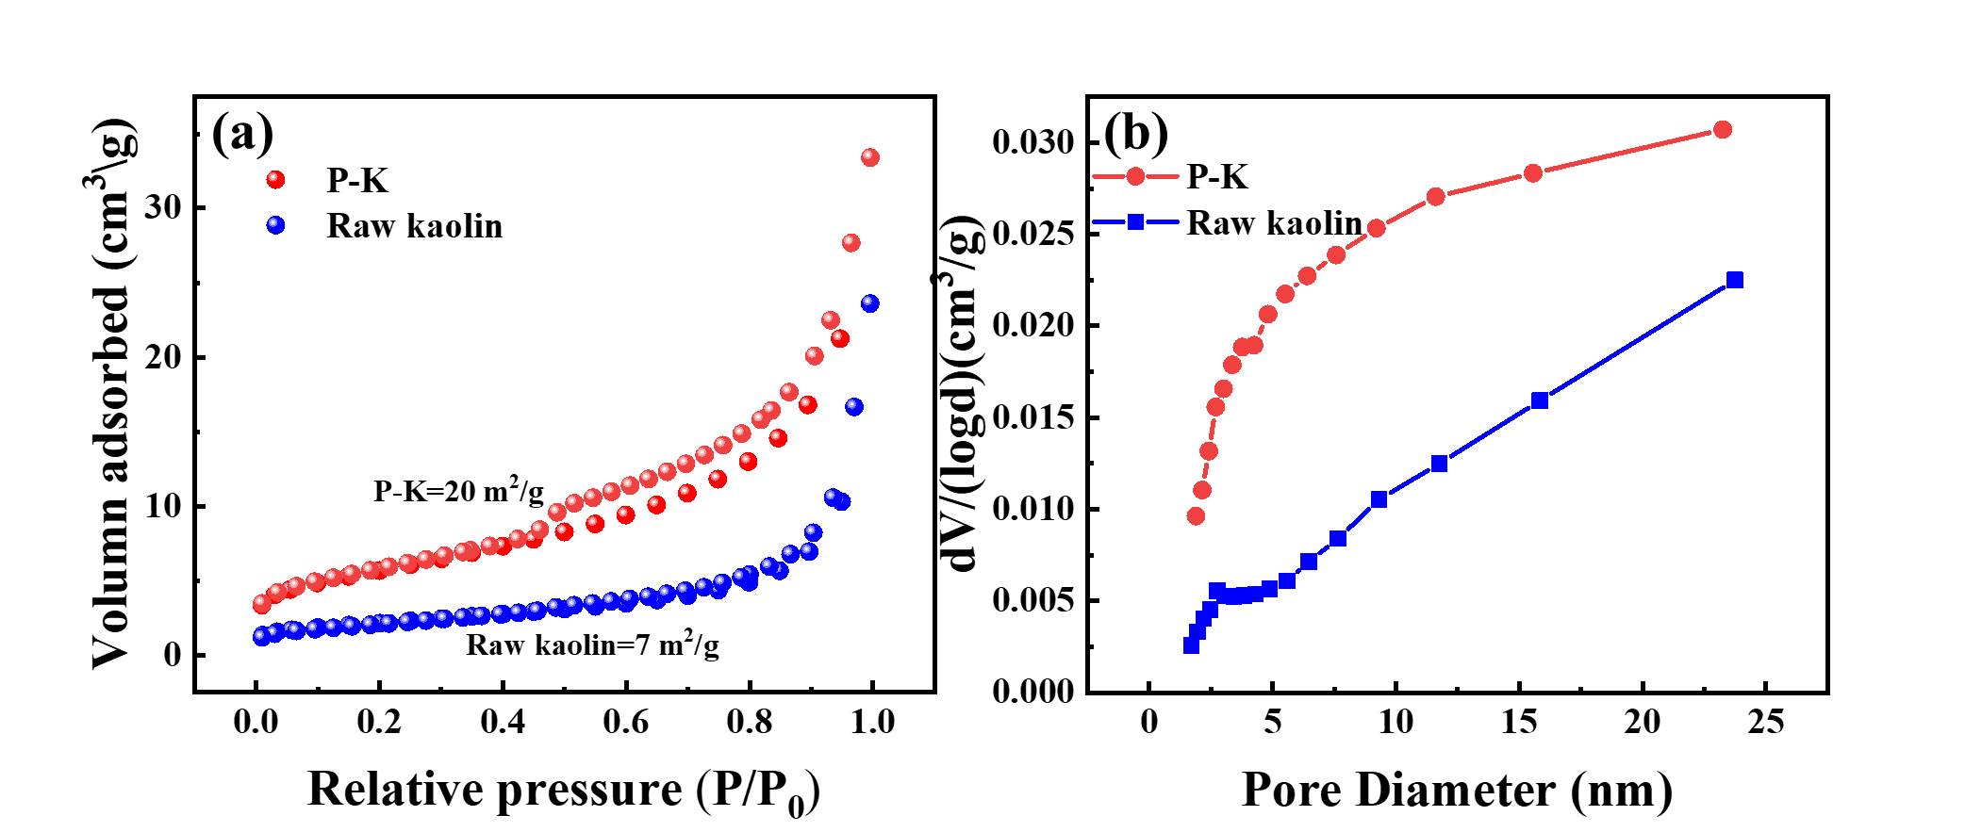

**Fig. S2** The N2 adsorption-desorption isotherms and pore size distribution curves for raw kaolin and P-K.



**Fig. S3** The relationship between the zeta potential of P-K and pH.