Supporting Information for:

**New benzimidazole derivatives: Design, synthesis, docking, and biological evaluation**

**Rami J. Obaida\***

aDepartment of Chemistry, Faculty of Applied Sciences, Umm Al-Qura University, 21955 Makkah Saudi Arabia

**\*Correspondence should be addressed to**: Rami J. Obaid; **Email:** [rjobaid@uqu.edu.sa](mailto:rjobaid@uqu.edu.sa)

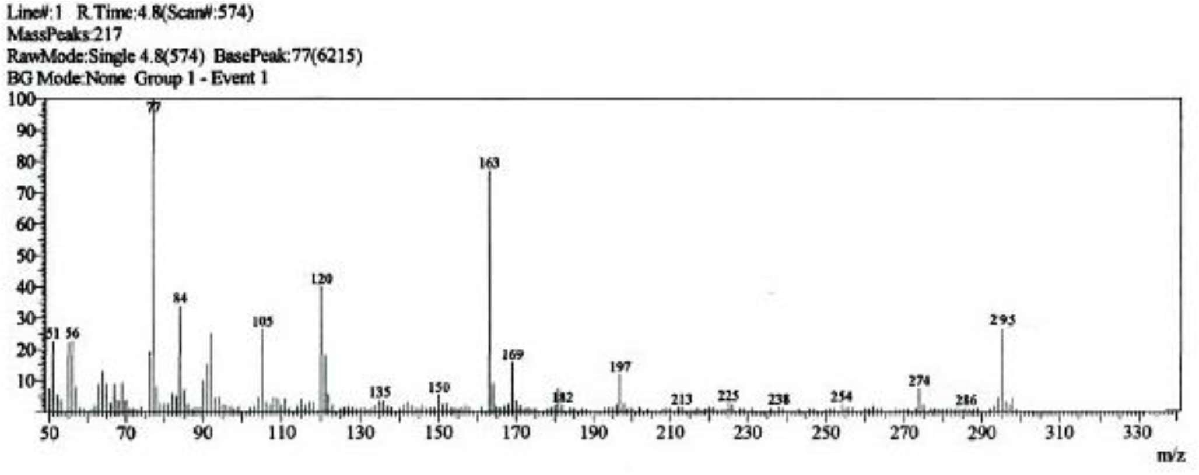

**Figure 1:** Mass spectrum of compound **3.**

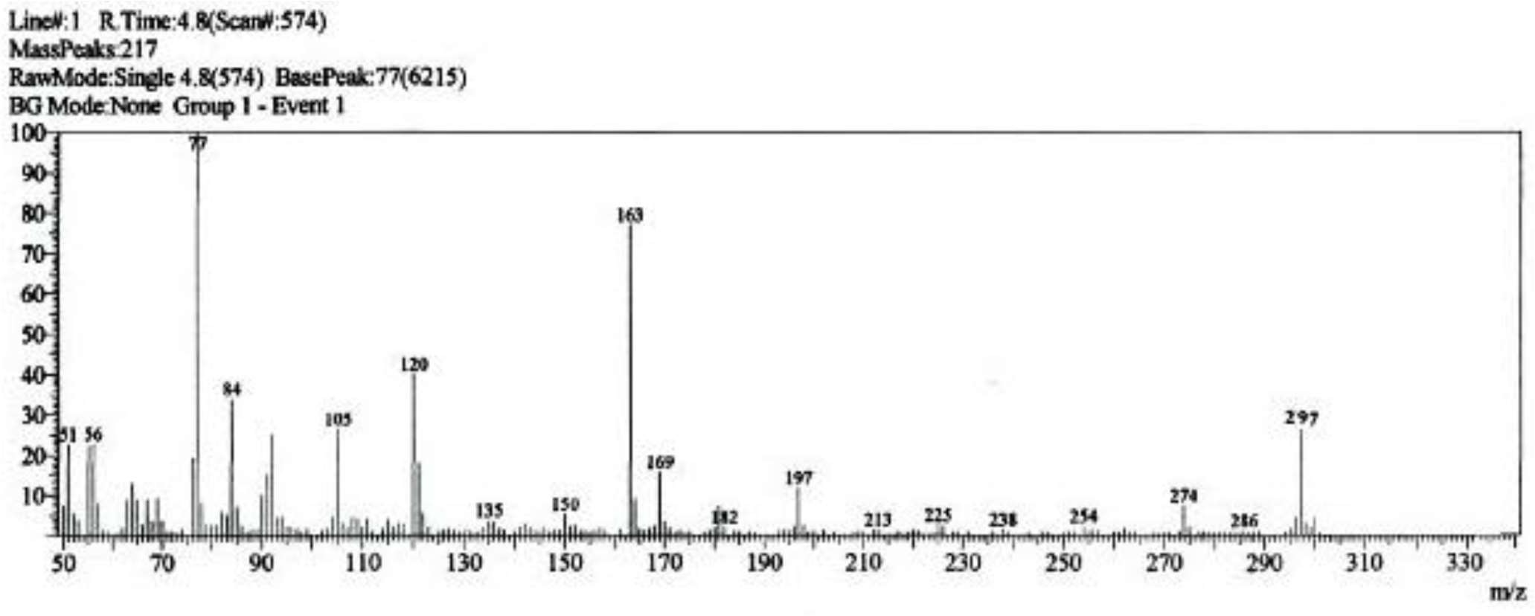

**Figure 2:** Mass spectrum of compound **4**.

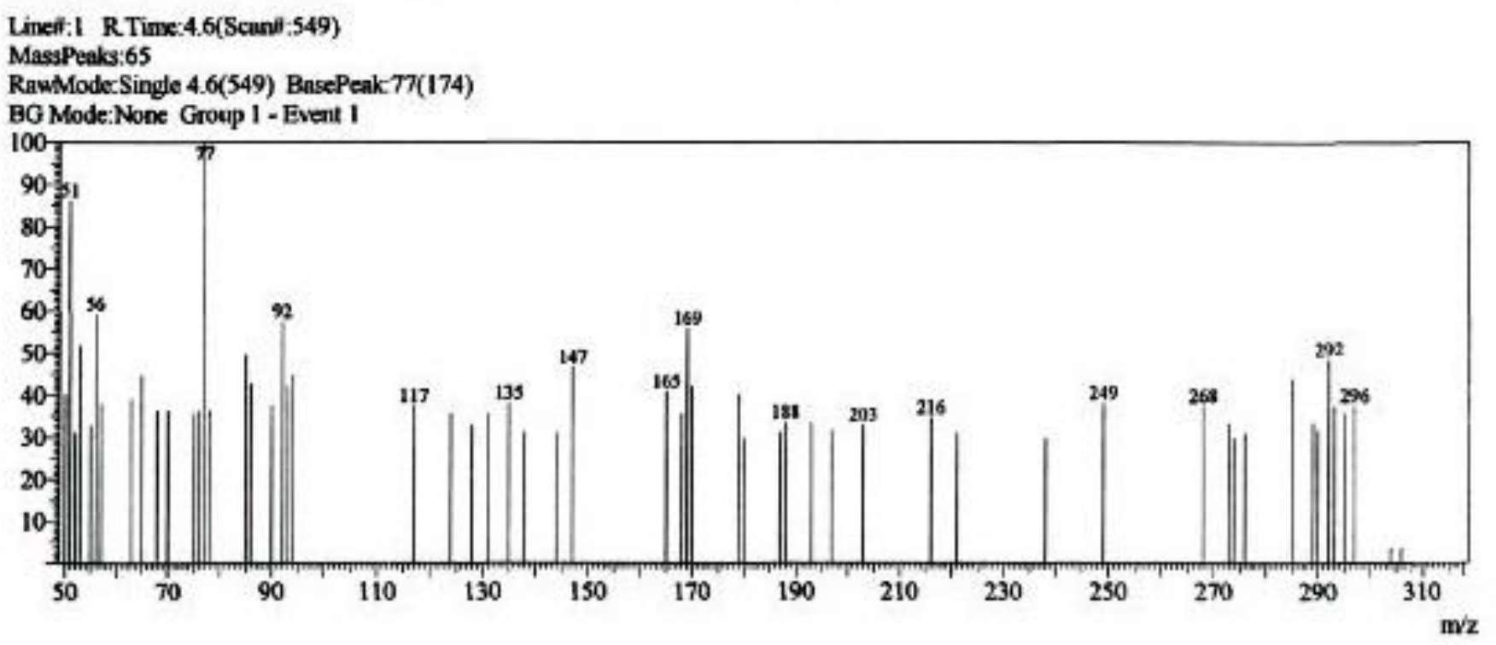

**Figure 3:** Mass spectrum of compound **5.**

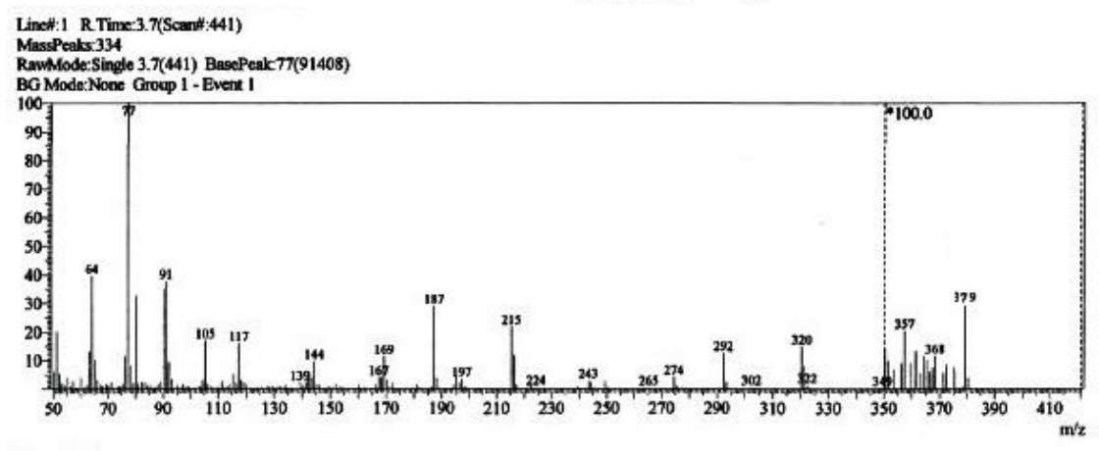

**Figure 4:** Mass spectrum of compound **6**.

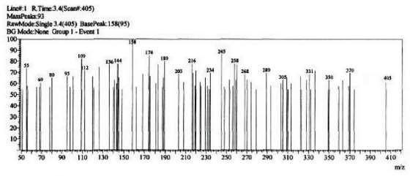

**Figure 5:** Mass spectrum of compound **7**.

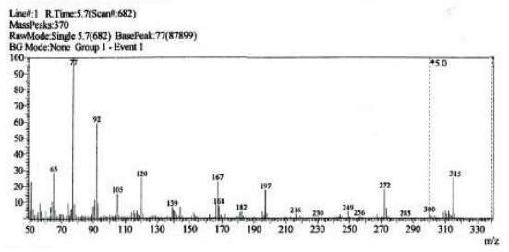

**Figure 6:** Mass spectrum of compound **8**.

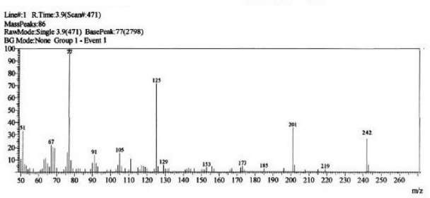

**Figure 7:** Mass spectrum of compound **9**.

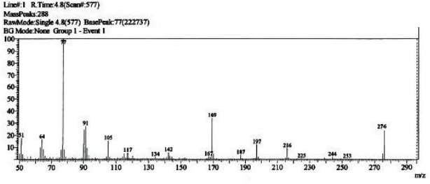

**Figure 8:** Mass spectrum of compound **11**.

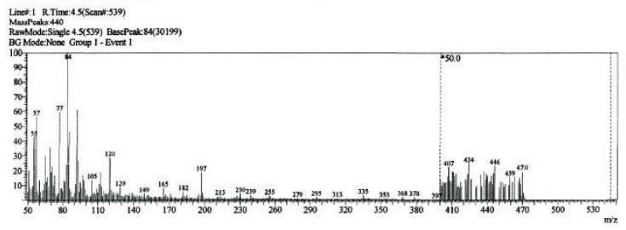

**Figure 9:** Mass spectrum of compound **14**.

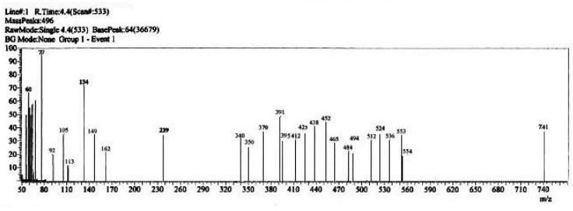

**Figure 10:** Mass spectrum of compound **15**.

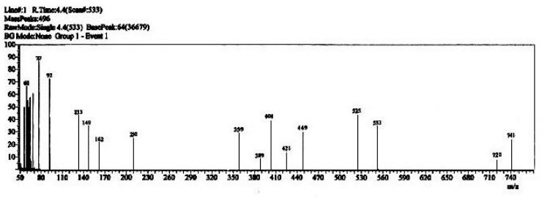

**Figure 11:** Mass spectrum of compound **16**.

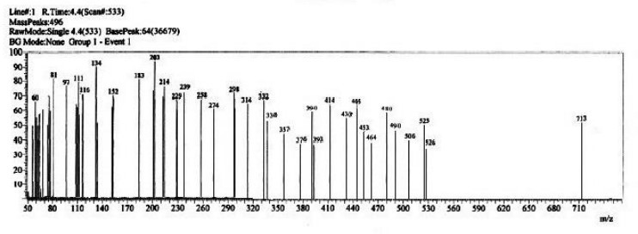

**Figure 12:** Mass spectrum of compound **17**.

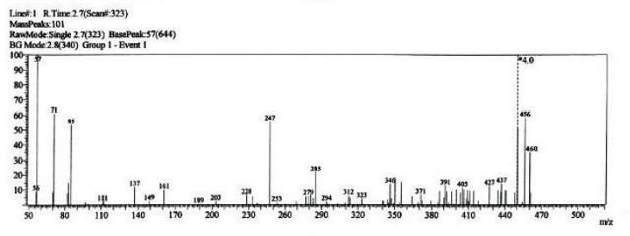

**Figure 13:** Mass spectrum of compound **18**.

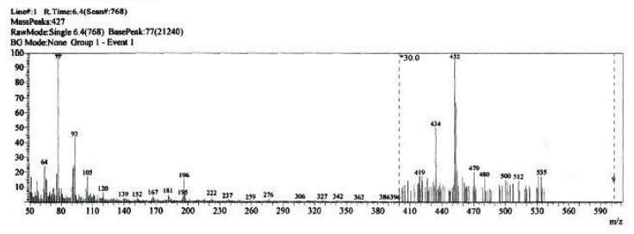

**Figure 14:** Mass spectrum of compound **19**.

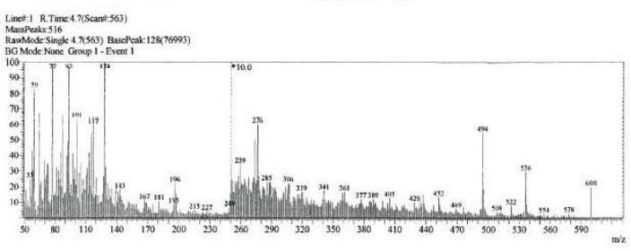

**Figure 15:** Mass spectrum of compound **20**.

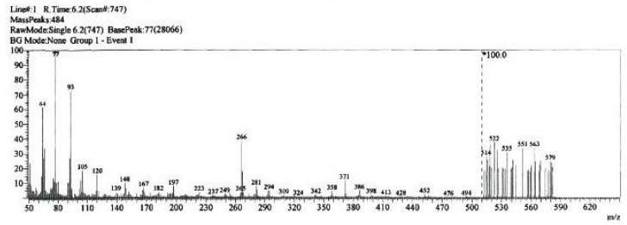

**Figure 16:** Mass spectrum of compound **22**.

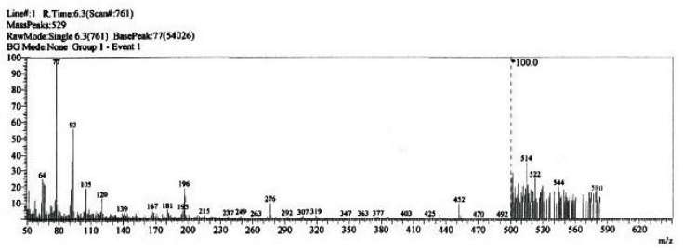

**Figure 17:** Mass spectrum of compound **23**.

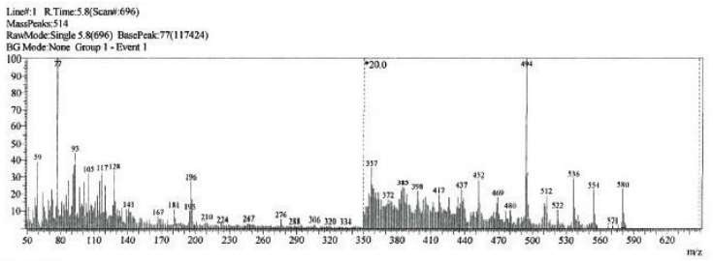

**Figure 18:** Mass spectrum of compound **24**.

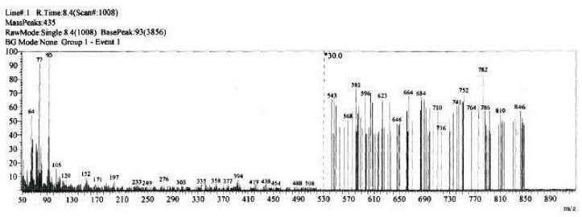

**Figure 19:** Mass spectrum of compound **25**.

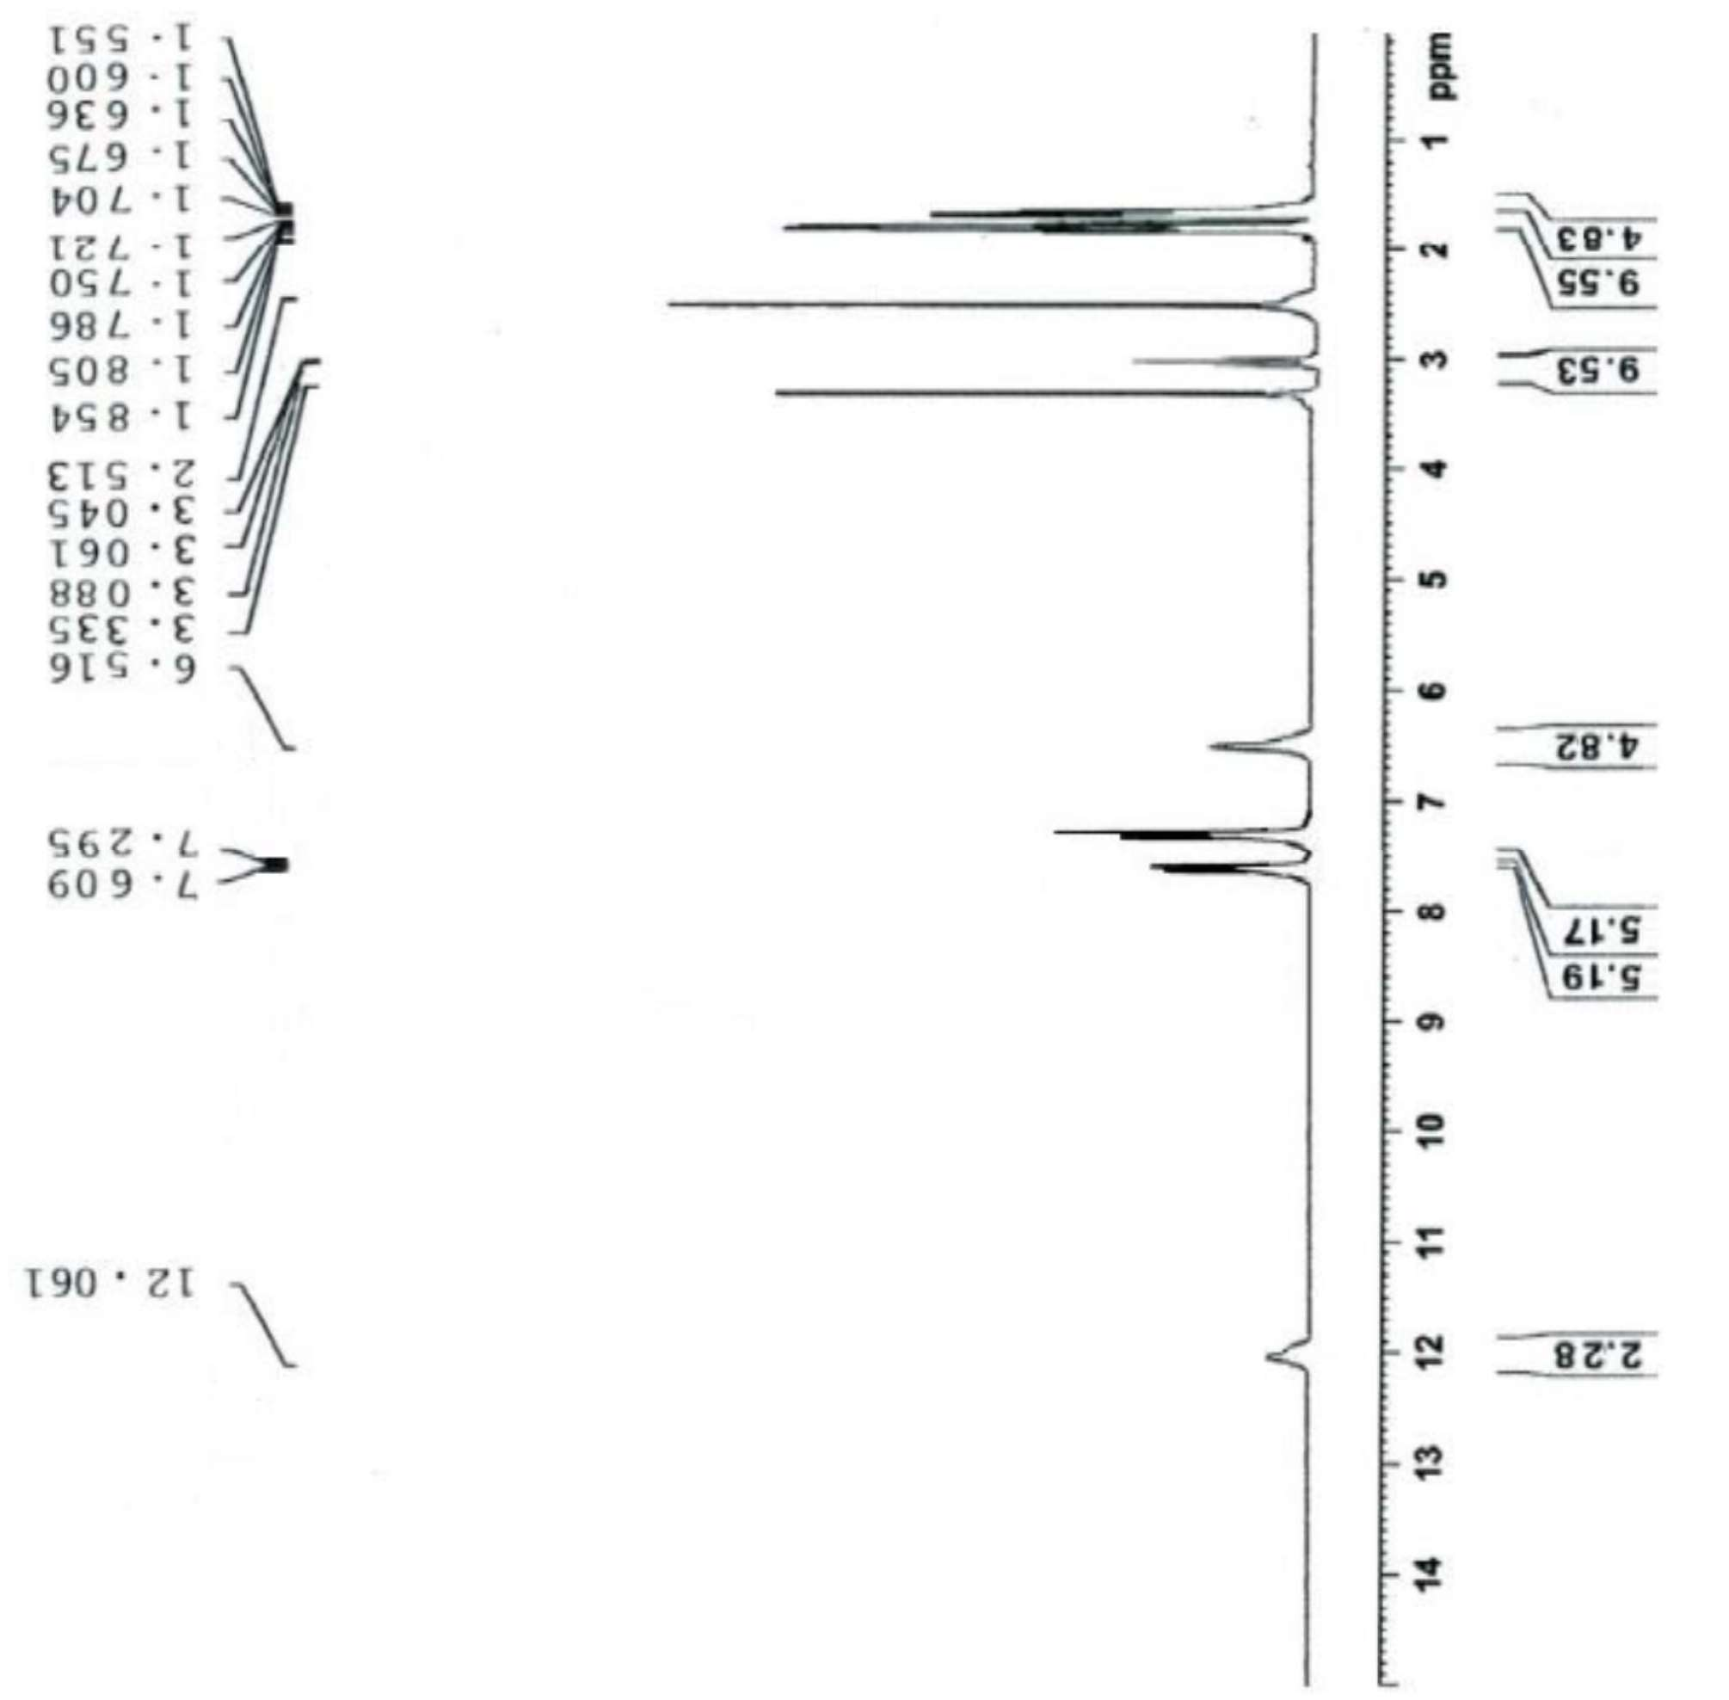

**Figure 20:** 1H NMR of compound **3.**

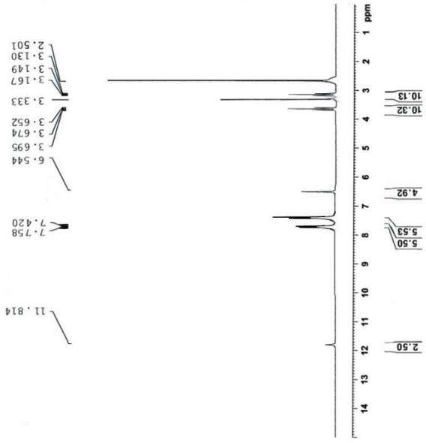

**Figure 21:** 1H NMR of compound **4**.

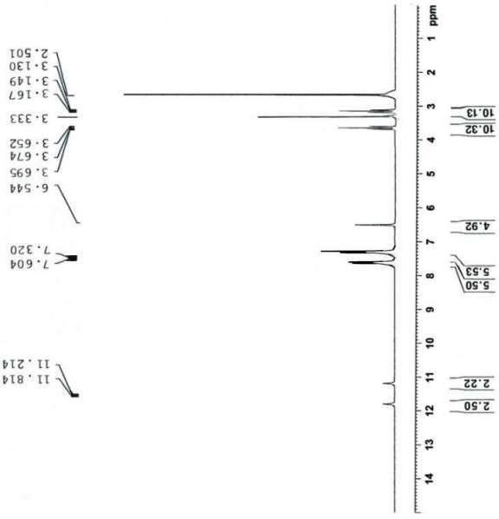

**Figure 22:** 1H NMR of compound **5**.

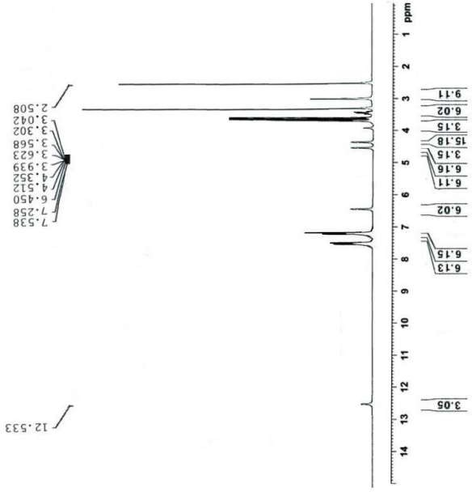

**Figure 23:** 1H NMR of compound **7**.

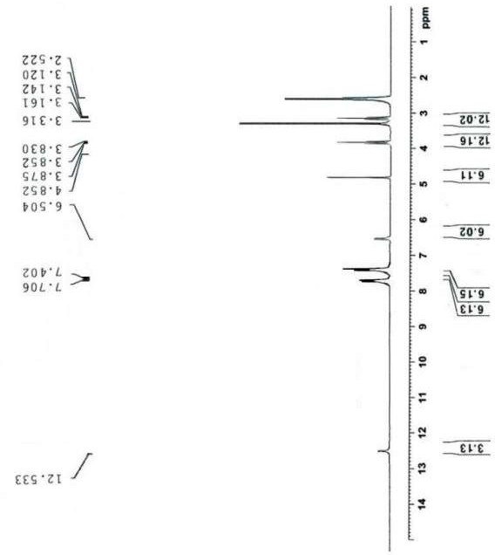

**Figure 24:** 1H NMR of compound **8**.

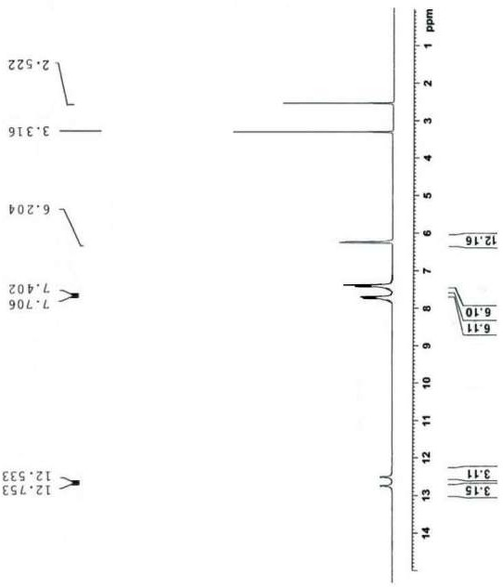

**Figure 25:** 1H NMR of compound **9**.

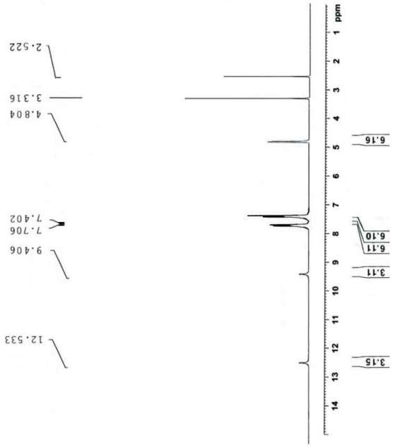

**Figure 26:** 1H NMR of compound **11**.

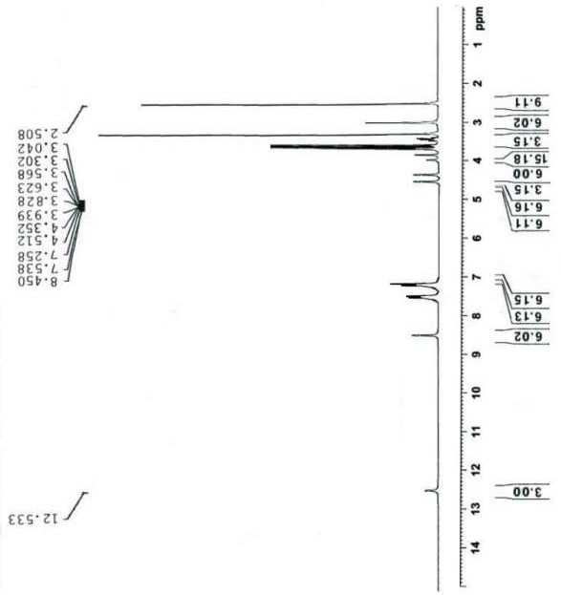

**Figure 27:** 1H NMR of compound **14**.

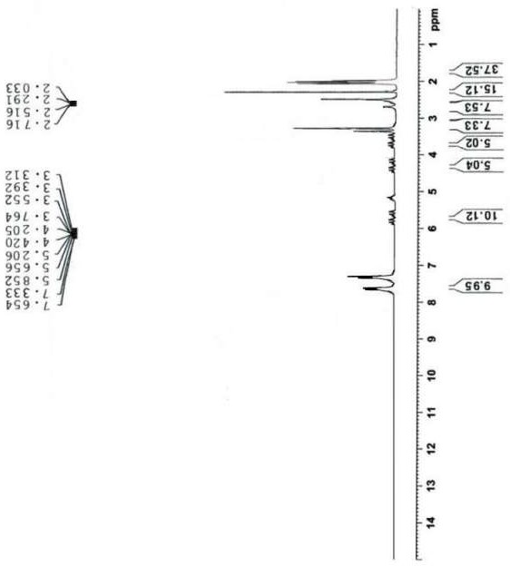

**Figure 28:** 1H NMR of compound **15**.

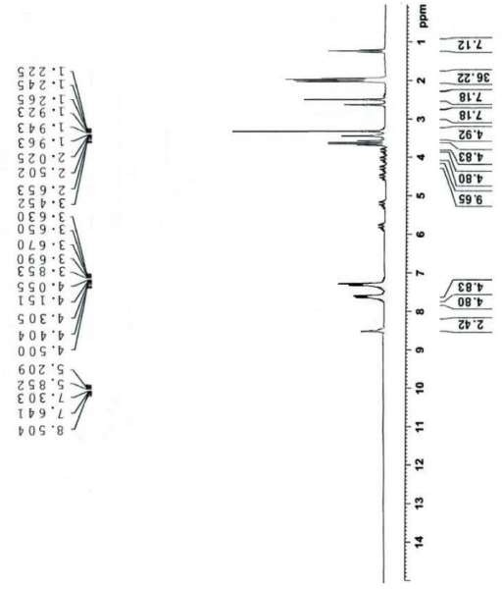

**Figure 29:** 1H NMR of compound **17**.

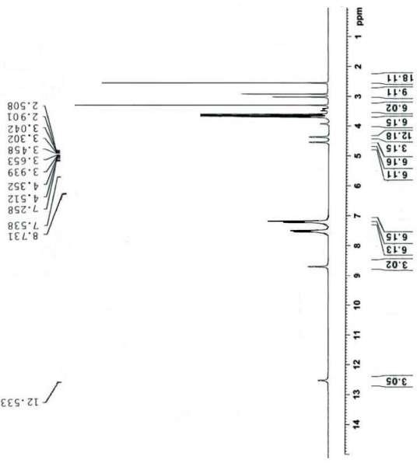

**Figure 30:** 1H NMR of compound **18**.

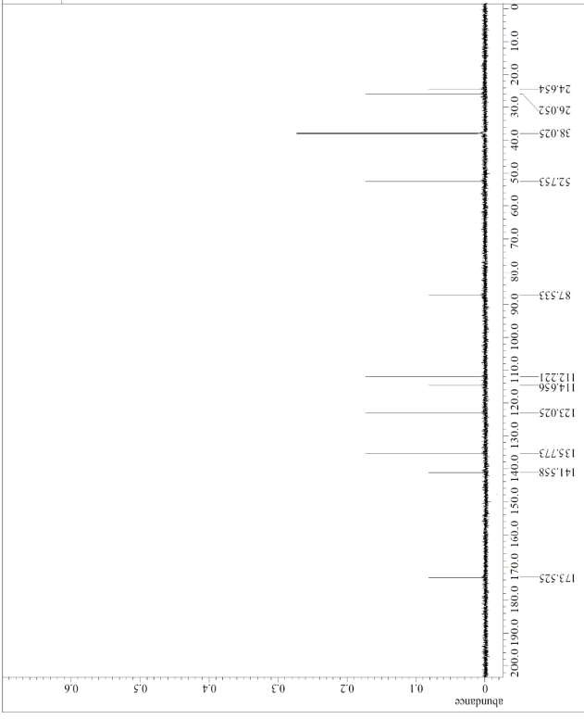

**Figure 31:** 13C NMR of compound **3**.

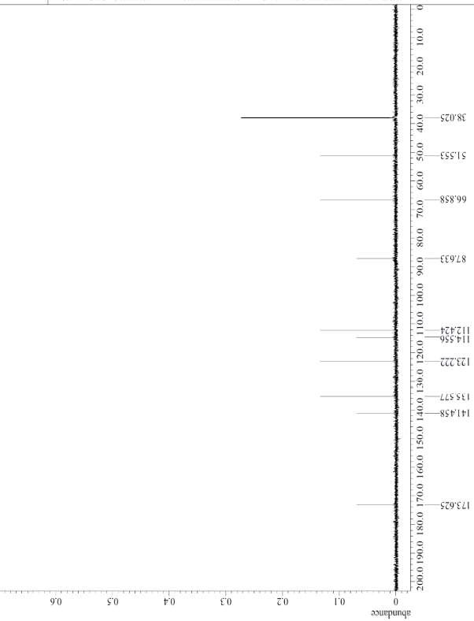

**Figure 32:** 13C NMR of compound **4**.

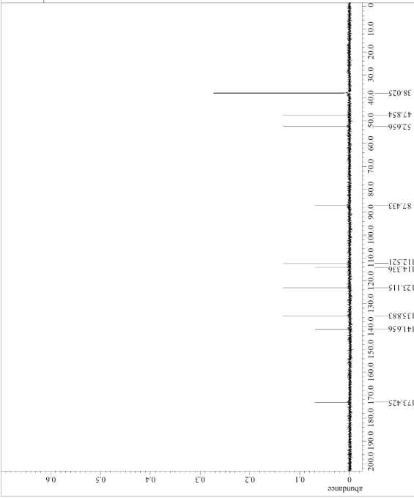

**Figure 33:** 13C NMR of compound **5**.

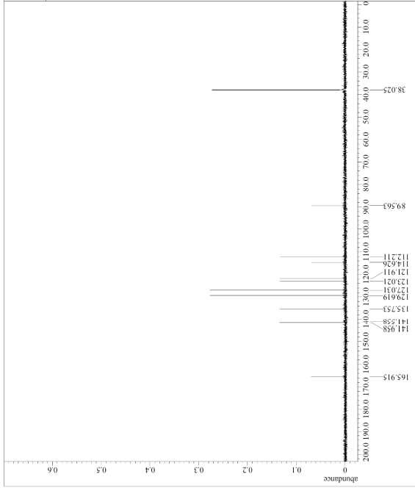

**Figure 34:** 13C NMR of compound **6**.

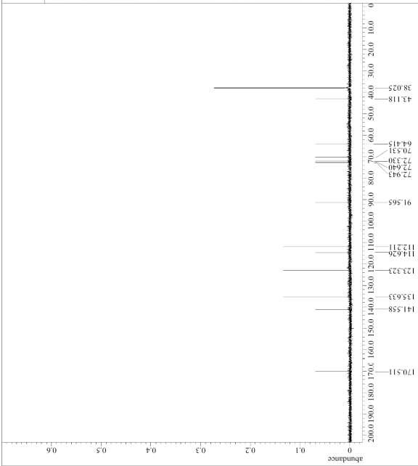

**Figure 35:** 13C NMR of compound **7**.

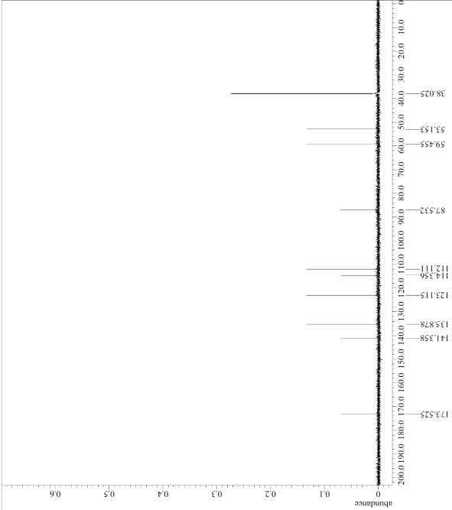

**Figure 36:** 13C NMR of compound **8**.

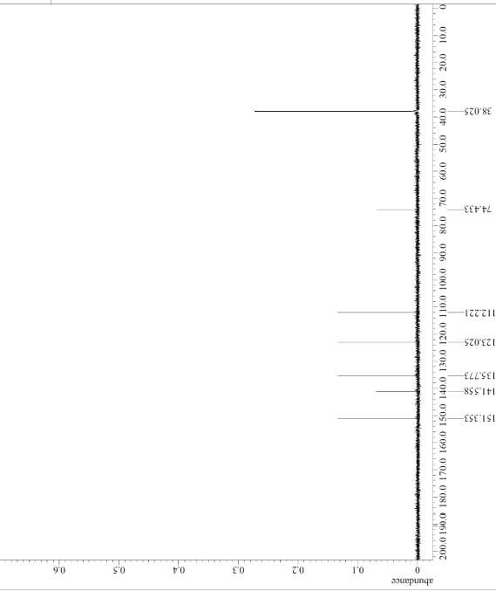

**Figure 37:** 13C NMR of compound **9**.

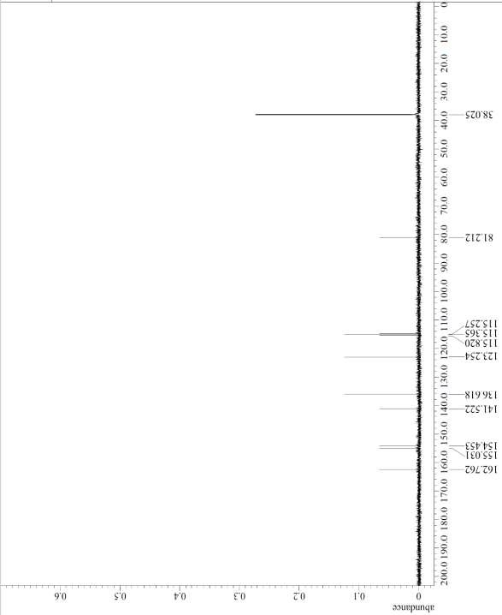

**Figure 38:** 13C NMR of compound **11**.

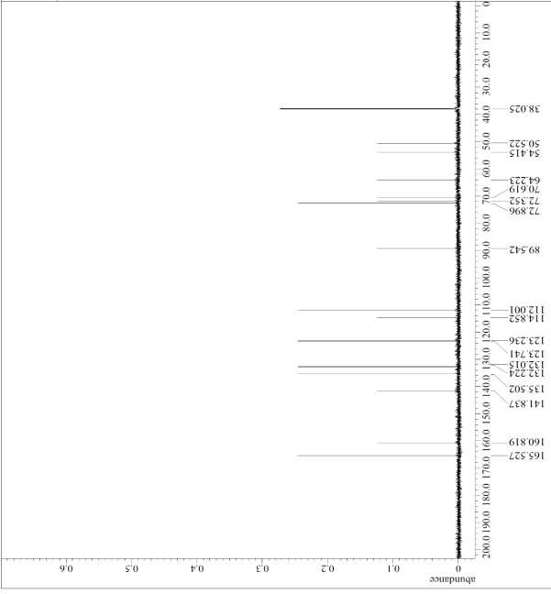

**Figure 39:** 13C NMR of compound **19**.

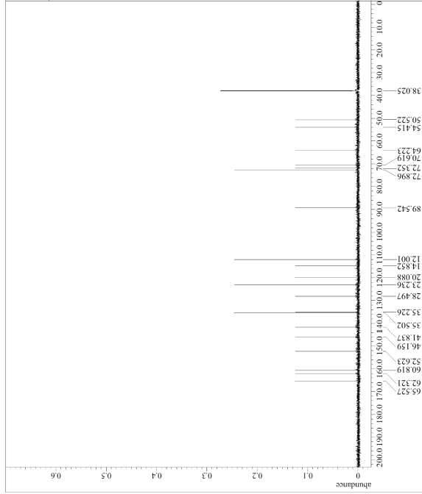

**Figure 40:** 13C NMR of compound **20**.

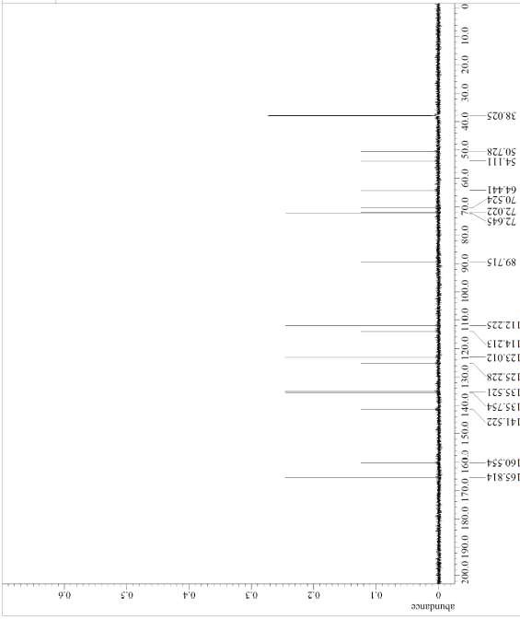

**Figure 41:** 13C NMR of compound **21**.

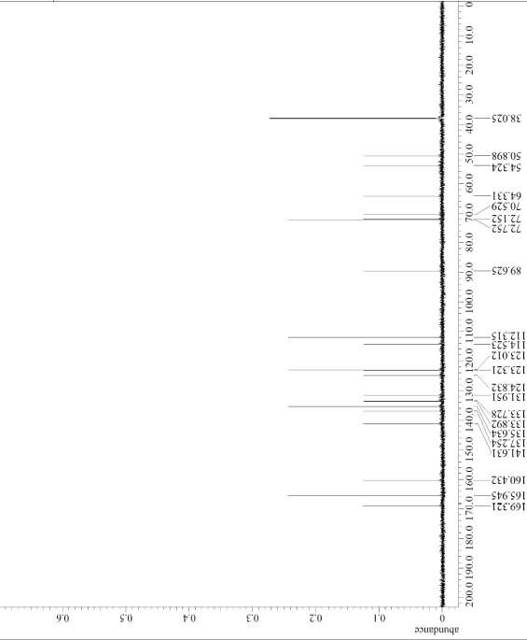

**Figure 42:** 13C NMR of compound **22**.

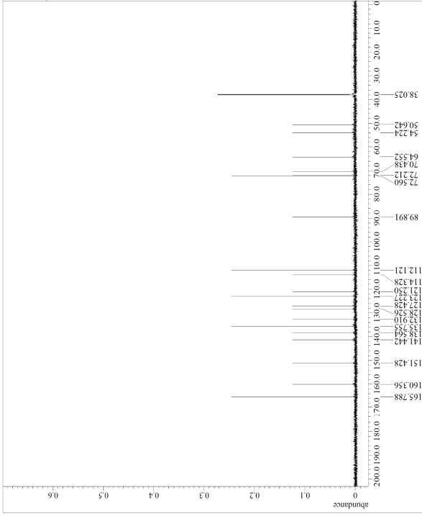

**Figure 43:** 13C NMR of compound **23**.

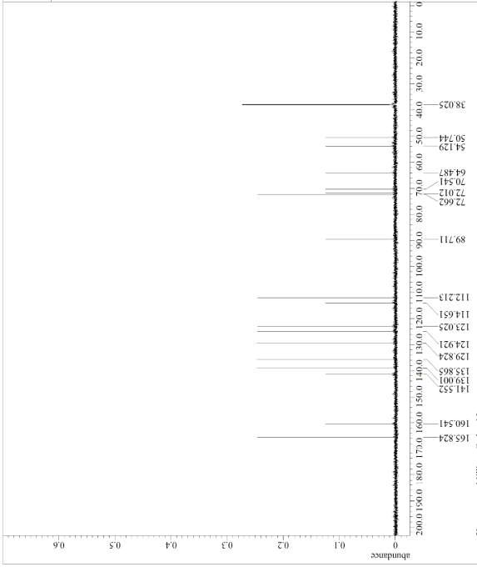

**Figure 44:** 13C NMR of compound **25**.

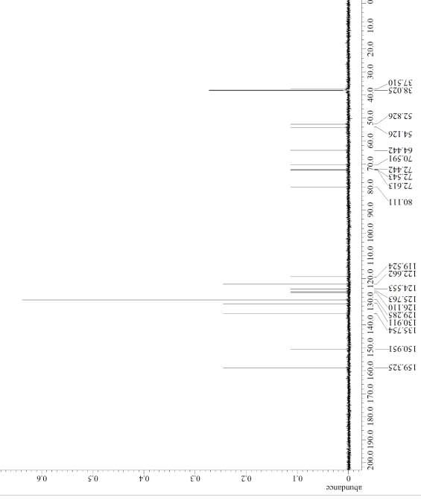

**Figure 45:** 13C NMR of compound **26**.

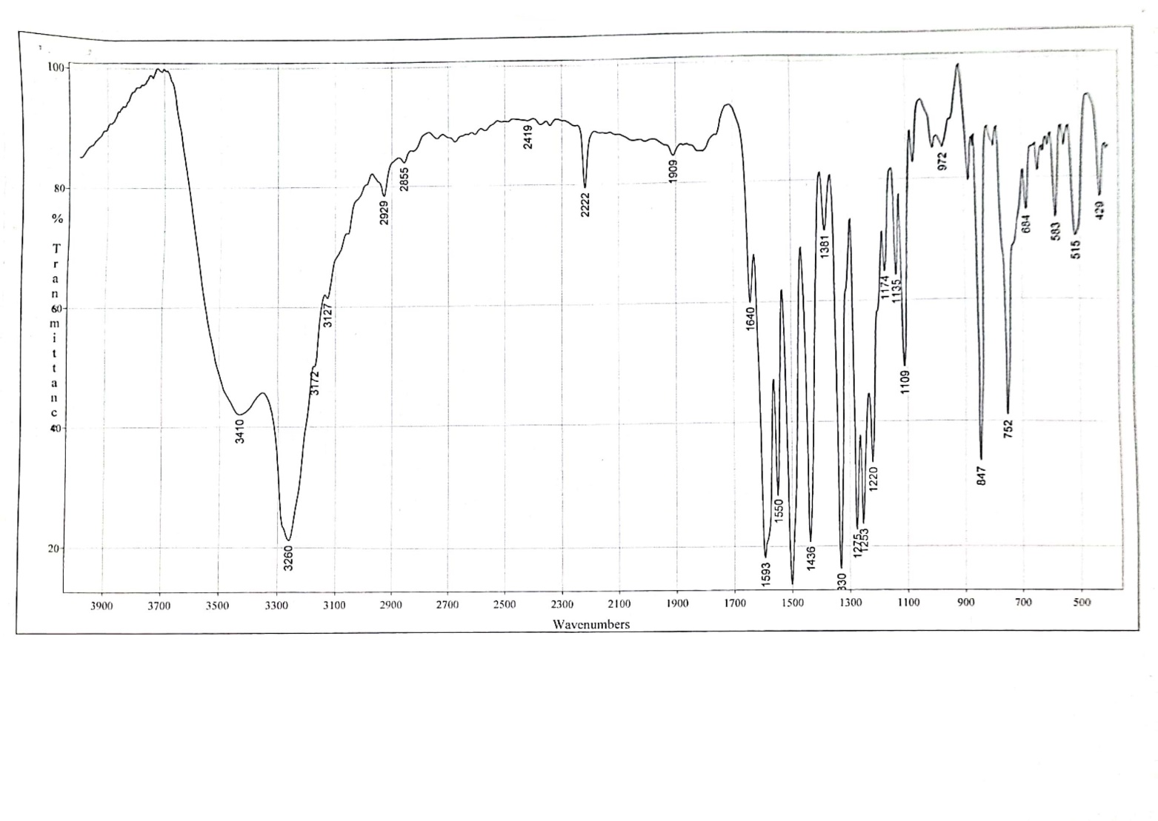

**Figure 46:** IR of compound **7**

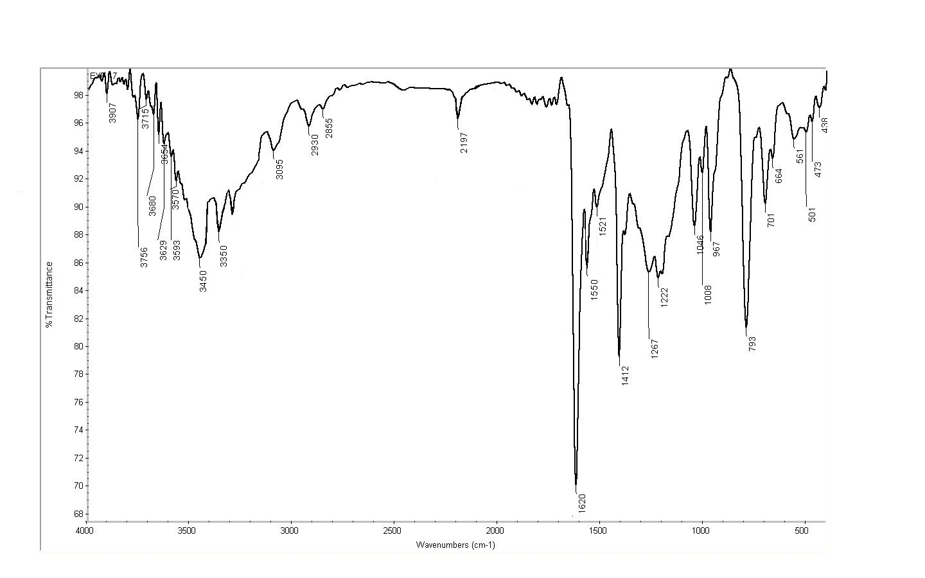

**Figure 47:** IR of compound **14**

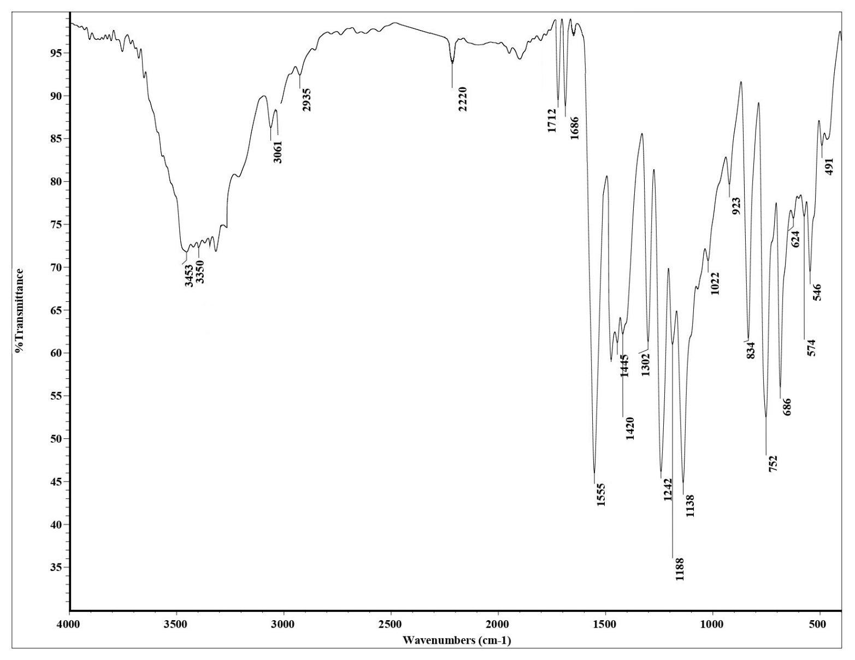

**Figure 48:** IR of compound **19**

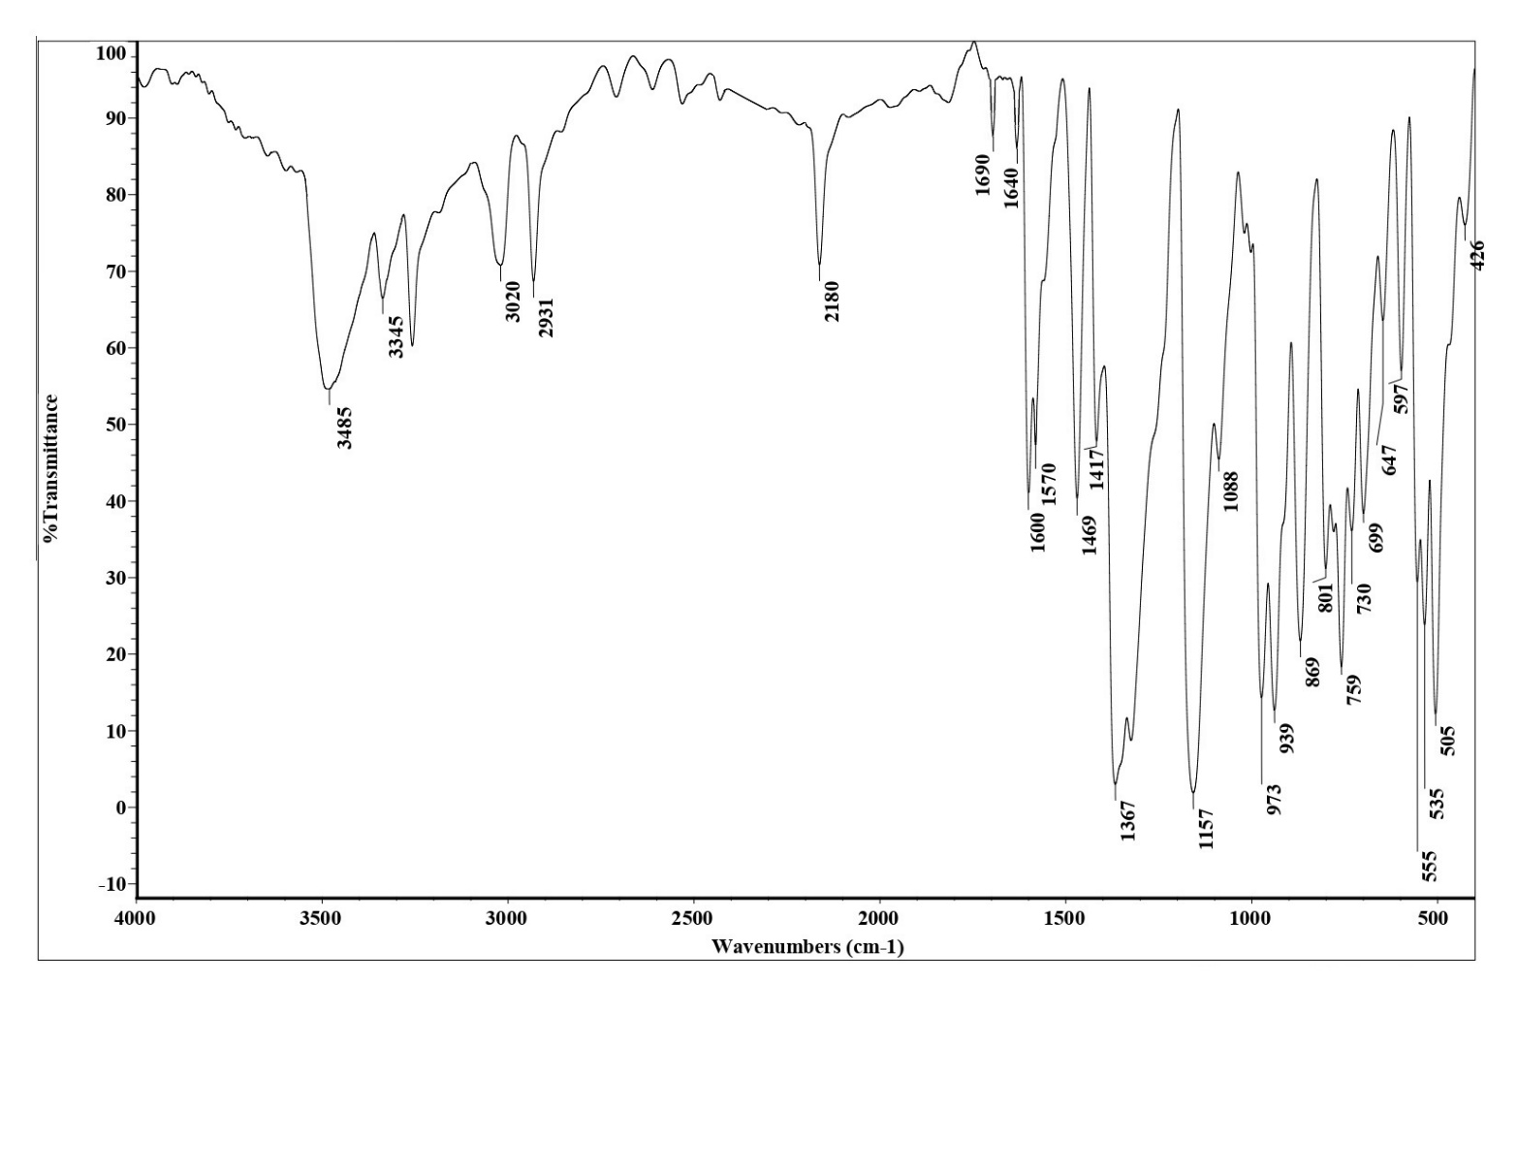

**Figure 49:** IR of compound **21**

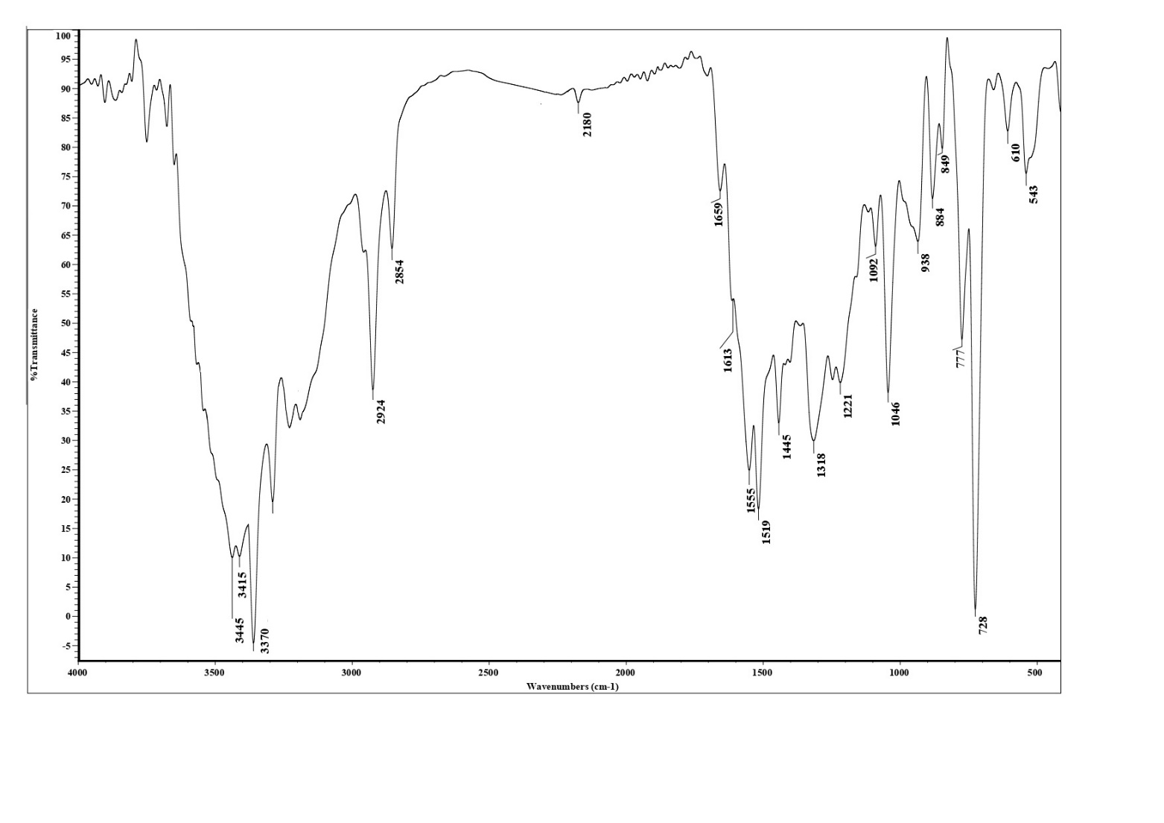

**Figure 50:** IR of compound **23**



**Figure 51:** Mass Fragmentation of compound **3**



**Figure 52:** Mass Fragmentation of compound **9**



**Figure 53:** Mass Fragmentation of compound **11**





**Figure 54:** Mass Fragmentation of compound **14**