Supporting Information
Acylhydrazone-modified guar gum material for the highly effective removal of oily sewage
Junchi Ma^{[1,2]}, Yanru Gu^{[1,2]}, Depeng Ma^{[1,2]}, Weizhao Lu^{[1,2]}, Jianfeng Qiu*^{[1,2]}
- Translational Medicine Research Centre, The First Affiliated Hospital of Shandong First Medical University & Shandong Provincial Qianfoshan Hospital, Jinan , Shandong, China.
- School of Radiology, Shandong First Medical University & Shandong Academy of Medical Sciences, Jinan, Shandong , China.
Figure S1 The preparation procedure of GG-SH
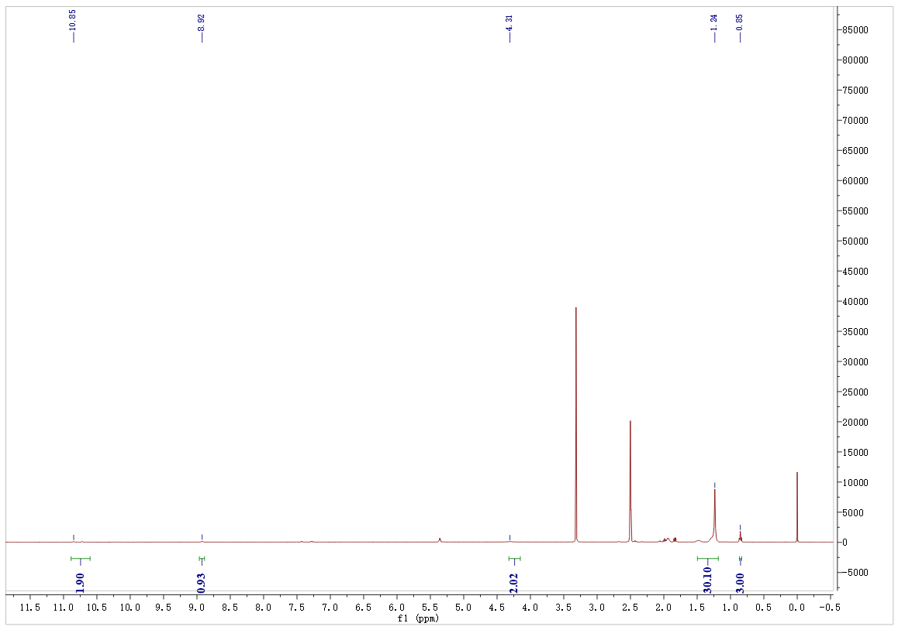
Figure S2 ¹H NMR spectra of stearyl hydrazide

Figure S3 FTIR spectra of stearyl hydrazide

Table S1 Parameters and the correlation coefficients of the three equilibrium isotherm models for adsorption of oily sewage by GG-SH
 | Parameter
Langmuir | q_{m}(exp) | 2157.3
Langmuir | q_{m} | 2019.6
Langmuir | K₁ | 0.012
Langmuir | R² | 0.993
Freundlich | K₂ | 10.810
Freundlich | n | 0.708
Freundlich | R² | 0.983
Temkin | K₃ | 487.621
Temkin | B | 0.018
Temkin | R² | 0.892
Table S2 Thermodynamic parameters for the adsorption of oil onto GG-SH
temperature（K） | ΔH^{θ}(kJ/mol) | ΔS^{θ}(J/(mol·K)) | ΔG^{θ}(kJ/mol)
298.15 | 4.64 | 19.83 | -1.27
313.15 | 4.64 | 19.83 | -1.57
328.15 | 4.64 | 19.83 | -1.86

Table S3 Kinetic fitting results and related parameters of adsorbent for oily sewage.
 | Pseudo-first-order |  |  | Pseudo-second-order
q_{e}(exp) | q_{e}(cal) | k₁ | R² | q_{e}(cal) | k₂ | R²
2157.3 | 2120.1 | 0.065 | 0.903 | 2165.4 | 4.618×10⁻⁴ | 0.997

Figure S4 Nitrogen adsorption isotherms of GG-SH before and after the adsorption of oil.
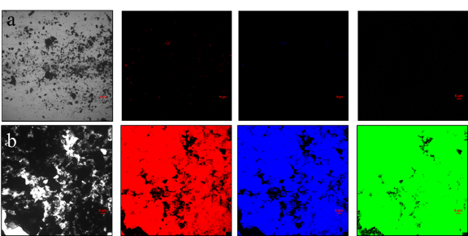
Figure S5 Confocal fluorescence microscopy of GG-SH adsorbent (a)before and (b)after treating process

