**Smartphone colorimetric determination of glucose in food samples based on the intrinsic peroxidase-like activity of carbon dots from locust**

Ke Su, Guoqiang Xiang*, Chen Cui, Xiuming Jiang, Yaming Sun, Wenjie Zhao, Lijun He

School of chemistry and chemical engineering, Henan University of Technology, Zhengzhou, 450001, China

* Email: [xianggq@126.com](mailto:xianggq@126.com)

1. **Synthesis of N-CDs**

The fabrication of N-CDs was based on a self-exothermic reaction between nitric acid and diethylenetriamine (DETA) using locust powder as a carbon source and completed within 10.0 min. The preparation procedure was as follows. Locust powder (1.0 g) was placed into a round-bottom flask (100 mL). To this, 5.0 mL of water and 5.0 mL of DETA were added. After homogeneous mixing, nitric acid (10.0 mL) was added to the resulting mixture dropwise. A violent self-exothermic reaction occurred due to the reaction between nitric acid and DETA, with excessive bubbling and substantial heat release. The temperature of the reaction mixture reached 100.0 oC within 1.0 min. After natural cooling, 50.0 mL of deionized water was added to the mixture to dissolve the formed N-CDs completely, and the solid insoluble matter was removed by [centrifugation](javascript:;). Then 2.5 g of [activated](javascript:;) [carbon](javascript:;) was added into the obtained brown solution of N-CDs, and the mixture was magnetically stirred for 30.0 minutes. The purified N-CDs aqueous solution was obtained by removing the [activated](javascript:;) [carbon](javascript:;) powder by centrifugation. 7.8 g of [Claybank](javascript:;) N-CDs powder was obtained through freeze-drying the purified N-CDs solution. The N-CDs powder was dispersed in water (10.0 mg mL-1) for further characterization and analytical application.

1. **Characterization of N-CDs**

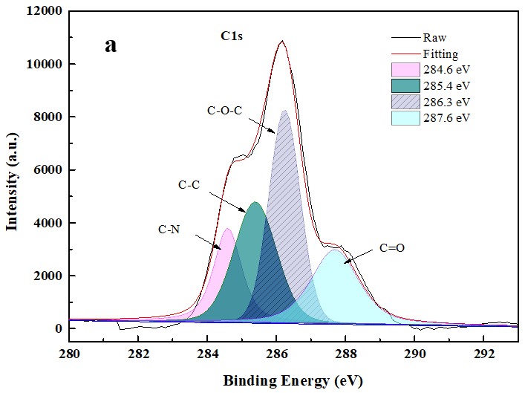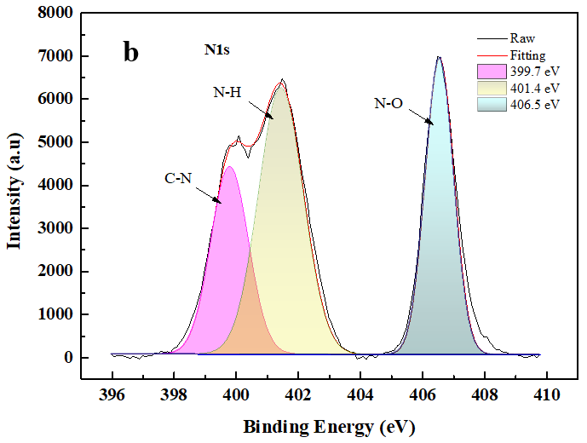

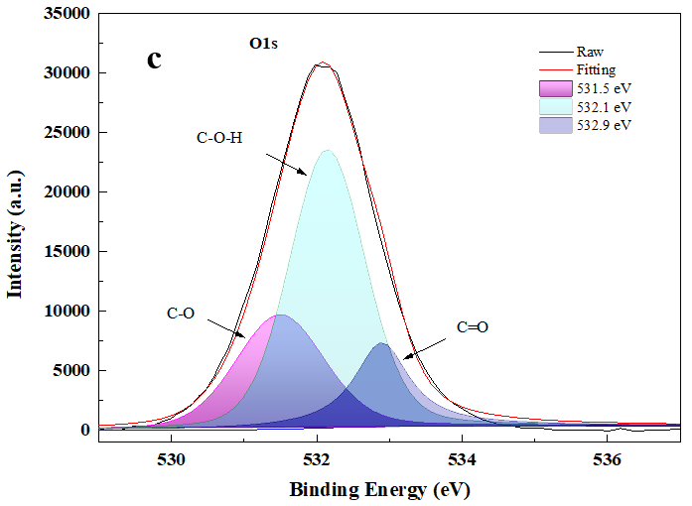 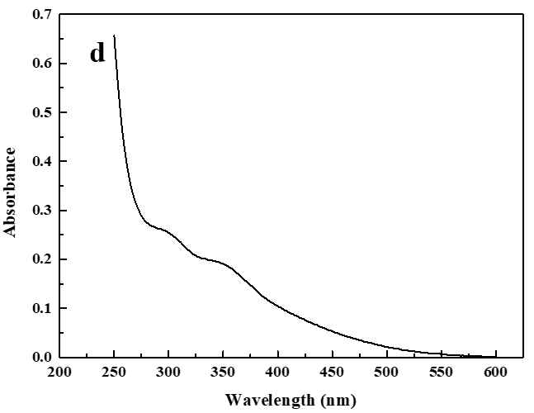

**Fig. S1** Characterization of N-CDs. High-resolution XPS spectrum of C1s (a), N1s (b), and O1s (c). UV-Vis absorbance spectra of N-CDs (d). Optical properties of N-CDs.

1. **ESR spectra of ·OH in the system of N-CDs+DMPO+H2O2**



**Fig. S2** ESR spectra of ·OH in the system of N-CDs+DMPO+H2O2

1. **Analytical performance of other reported method for Glu using CDs based peroxidase mimics**

**Table S1** Comparison of determination of glucose using different peroxidase mimics

|  |  |  |  |  |  |
| --- | --- | --- | --- | --- | --- |
| Probes | Preparation | Samples | Detection limit  (μM) | Linear range  (μM) | Ref |
| CDs from soot | Heating reflux | Urine | 5.10 | 25-400 | (Zhong et al., 2018) |
| CDs from candle soot | Heating reflux | Human serum | 0.4 | 1.0-500 | (Shi et al., 2011) |
| Fe, N-doped CDs | Hydrothermal | Not given | 5-60,60-100 | 3.0 | (Li et al., 2020) |
| Co, N-doped CDs | Hydrothermal | Human serum | 1.16 | 2.0-100 | (Zhang et al., 2021) |
| Reduced CDs | Heating reflux | Human serum | 2.0 | 10-400 | (Long et al., 2016) |
| CDs from litchi rind | Heating reflux | Human serum | 3.0 | 10-2000 | (Zhong et al., 2019) |
| GQDs | Electrochemical oxidation | Human serum | 6.0 | 10-600 | (Nirala et al., 2017) |
| N-doped GQDs | Hydrothermal | Human serum, fruit juices | 16 | 25-375 | (Lin et al., 2015) |
| GQDs | Heating reflux |  | 0.5 |  | (Zheng et al., 2013) |
| N-CDs | Self-exothermic reaction | Food samples | 1.09/0.20 | 5-100 | this work |

1. **Analytical results of Glu in food samples**

**Table S2** Determination of Glu in food samples by smartphone-based method (mean ± SD, n=3)

|  |  |
| --- | --- |
| Food samples | Found (mg·g-1) |
| Red bean | Not detected |
| Black soya bean | Not detected |
| Tomato | 2.34±0.12 |
| Hami melon | 9.70±0.58 |
| Kumquat | 5.88±0.065 |
| Apple | 29.06±0.71 |
| Sweet potato | 3.99±0.12 |

Li, Y., Weng, Y., Lu, S., Xue, M., Yao, B., Weng, W., Zheng, T., 2020. One-Step Hydrothermal Synthesis of N, Fe-Codoped Carbon Dots as Mimic Peroxidase and Application on Hydrogen Peroxide and Glucose Detection. J Nanomater. 2020, 1-11. <http://doi.org/10.1155/2020/1363212>.

Lin, L., Song, X., Chen, Y., Rong, M., Zhao, T., Wang, Y., Jiang, Y., Chen, X., 2015. Intrinsic peroxidase-like catalytic activity of nitrogen-doped graphene quantum dots and their application in the colorimetric detection of H2O2 and glucose. Anal Chim Acta. 869, 89-95. <http://doi.org/10.1016/j.aca.2015.02.024>.

Long, Y., Wang, X., Shen, D., Zheng, H., 2016. Detection of glucose based on the peroxidase-like activity of reduced state carbon dots. Talanta. 159, 122-126. <http://doi.org/10.1016/j.talanta.2016.06.012>.

Nirala, N.R., Khandelwal, G., Kumar, B., Vinita, Prakash, R., Kumar, V., 2017. One step electro-oxidative preparation of graphene quantum dots from wood charcoal as a peroxidase mimetic. Talanta. 173, 36-43. <http://doi.org/10.1016/j.talanta.2017.05.061>.

Shi, W., Wang, Q., Long, Y., Cheng, Z., Chen, S., Zheng, H., Huang, Y., 2011. Carbon nanodots as peroxidase mimetics and their applications to glucose detection. Chem Commun (Camb). 47(23), 6695-6697. <http://doi.org/10.1039/c1cc11943e>.

Zhang, G.Q., Li, Y.S., Liu, W.P., Gao, X.F., 2021. A fluorimetric and colorimetric dual-signal sensor for hydrogen peroxide and glucose based on the intrinsic peroxidase-like activity of cobalt and nitrogen co-doped carbon dots and inner filter effect. Anal Methods. 13(28), 3196-3204.

Zheng, A.X., Cong, Z.X., Wang, J.R., Li, J., Yang, H.H., Chen, G.N., 2013. Highly-efficient peroxidase-like catalytic activity of graphene dots for biosensing. Biosens Bioelectron. 49, 519-524. <http://doi.org/10.1016/j.bios.2013.05.038>.

Zhong, Q., Chen, Y., Qin, X., Wang, Y., Yuan, C., Xu, Y., 2019. Colorimetric enzymatic determination of glucose based on etching of gold nanorods by iodine and using carbon quantum dots as peroxidase mimics. Mikrochim Acta. 186(3), 161. <http://doi.org/10.1007/s00604-019-3291-2>.

Zhong Q., Huang X., Tan Q., Su A., Chen Y., Liu X., Wang Y., 2018. Glucose determination method using carbon quantum dots as peroxidase-mimicking enzymes. Chinese J Anal Chem. 46(7), 1062-1068.