**Supplementary Material**

**for**

**Kinetic Parameters Underlying Hematite-assisted Decomposition of Tribromophenol**

Labeeb Ali,a Mohamed Shafi Kuttiyathil,a

Mohammad Al-Harahsheh,b Mohammednoor Altarawneha*

1United Arab Emirates University, Department of Chemical and Petroleum Engineering, Sheikh Khalifa bin Zayed Street, Al-Ain 15551,

United Arab Emirates

2Chemical Engineering Department, Jordan University of Science and Technology, Irbid 22110, Jordan

*Corresponding author’s email: **mn.altarawneh@uaeu.ac.ae**

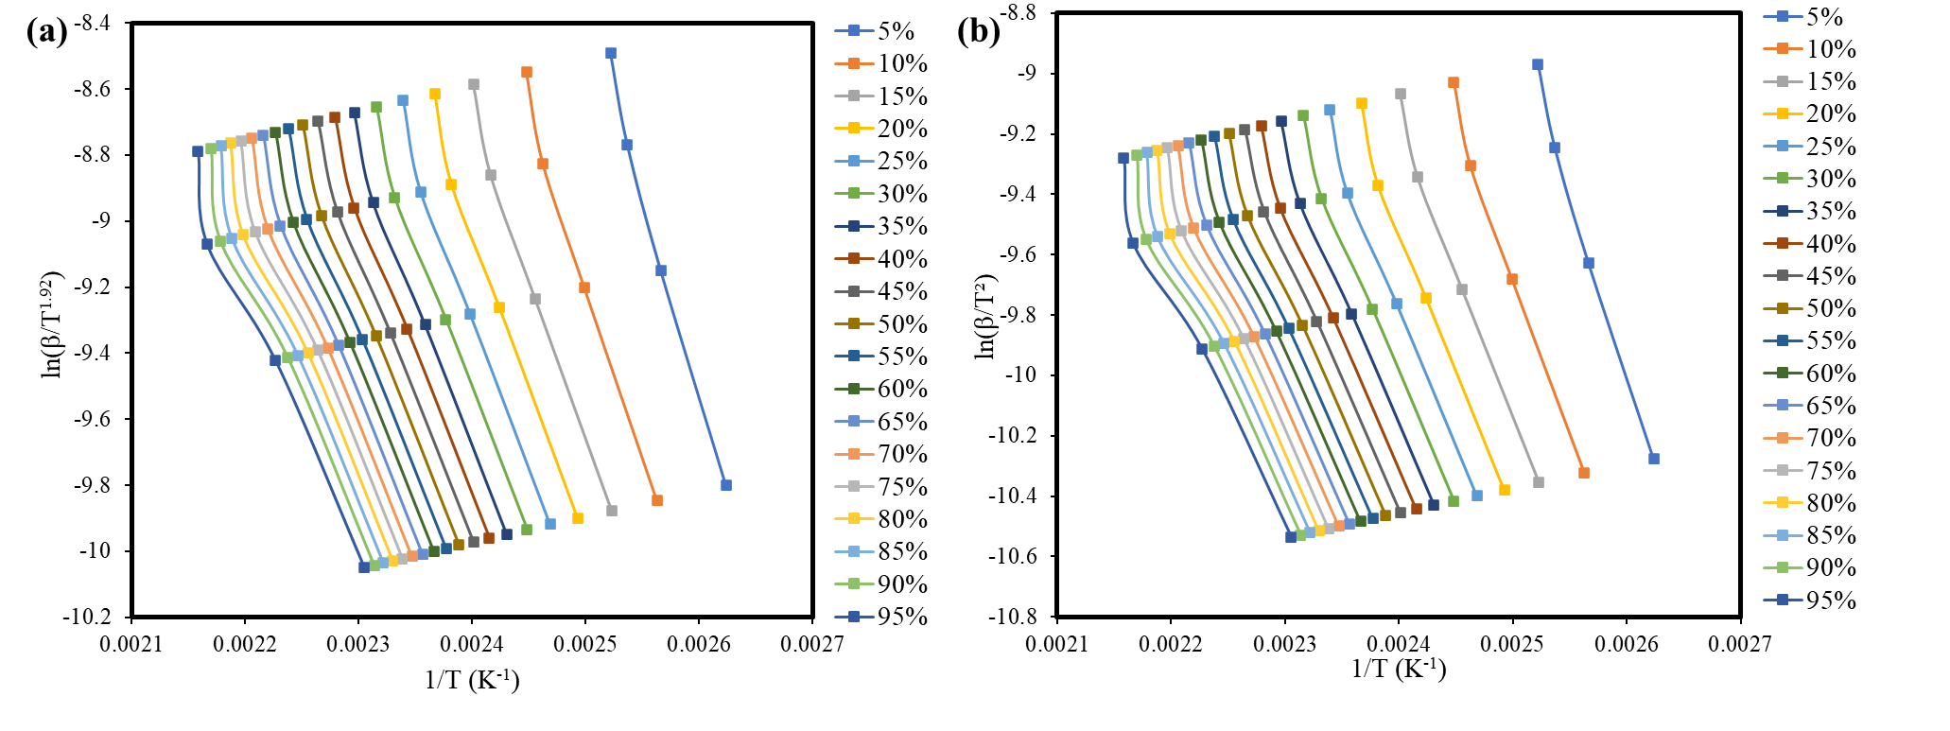

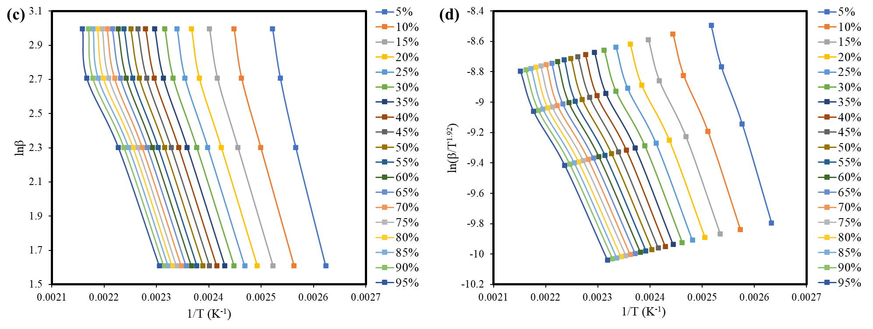

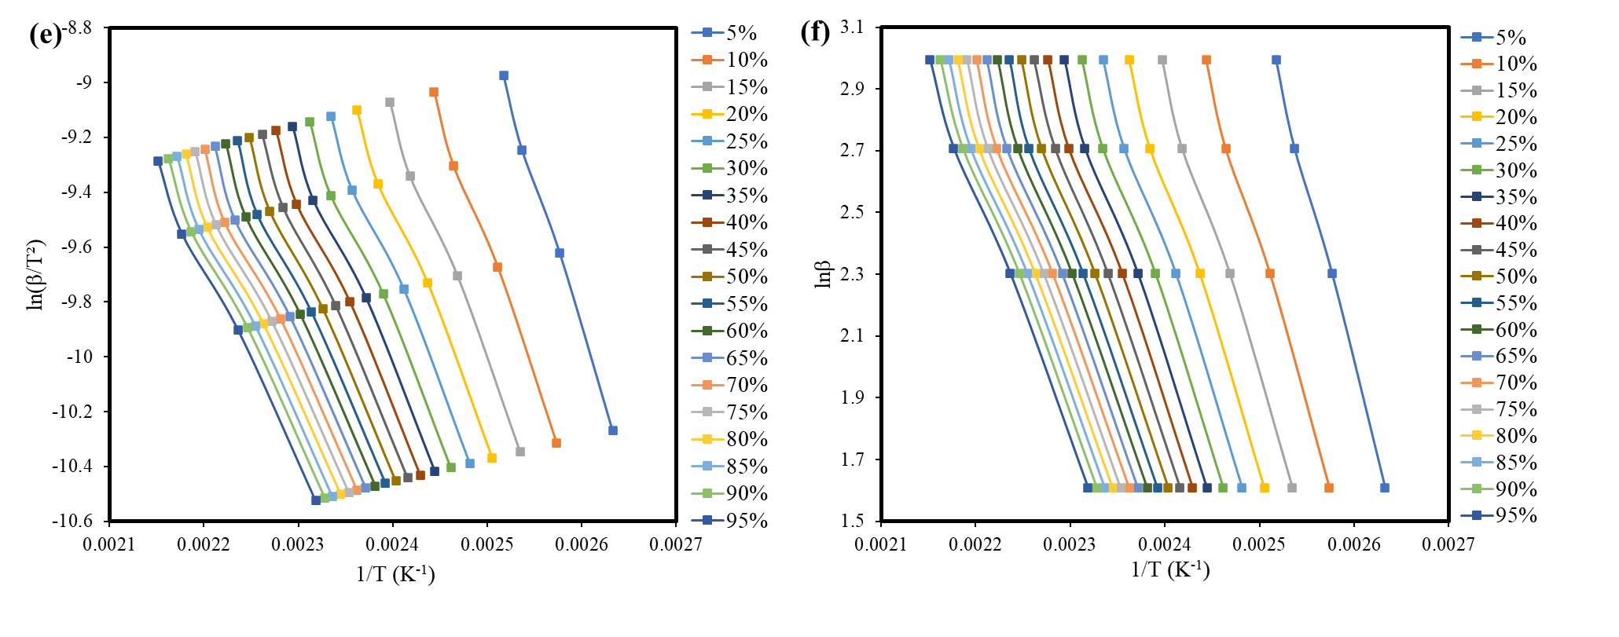

**Fig. S.1.** Linear regression lines generated for different isoconversional models in combustion of TBP (a) Starink, (b) KAS, (c) FWO, and pyrolysis of TBP (d) Starink, (e) KAS, (f) FWO.

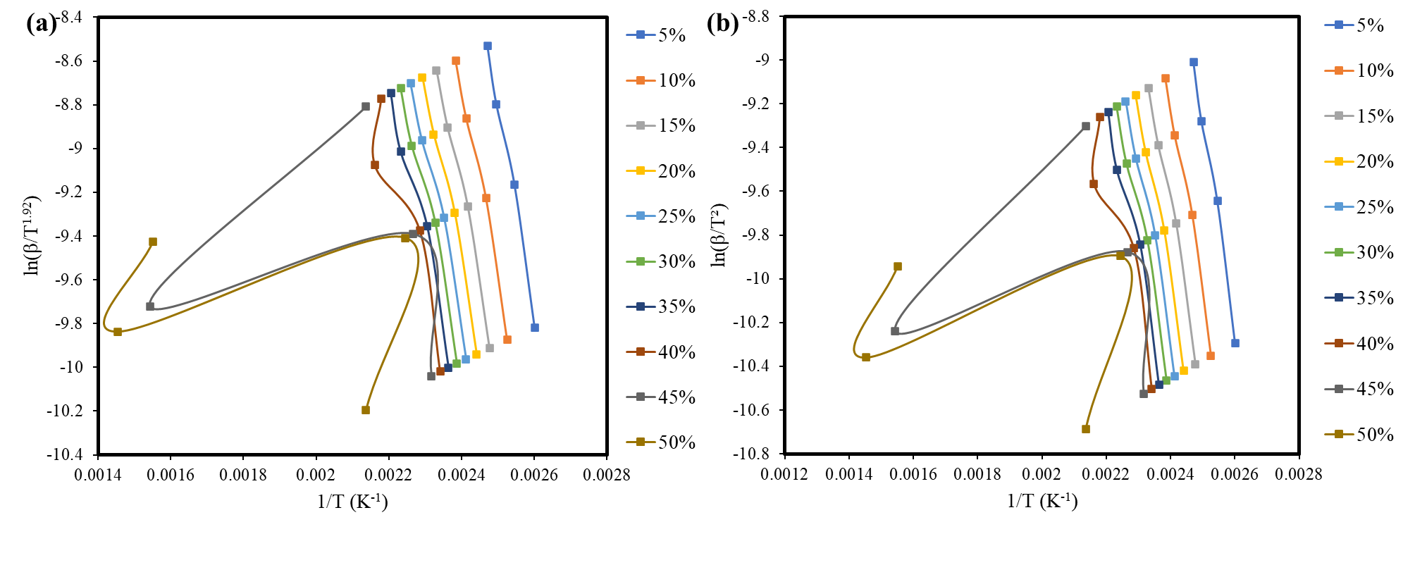

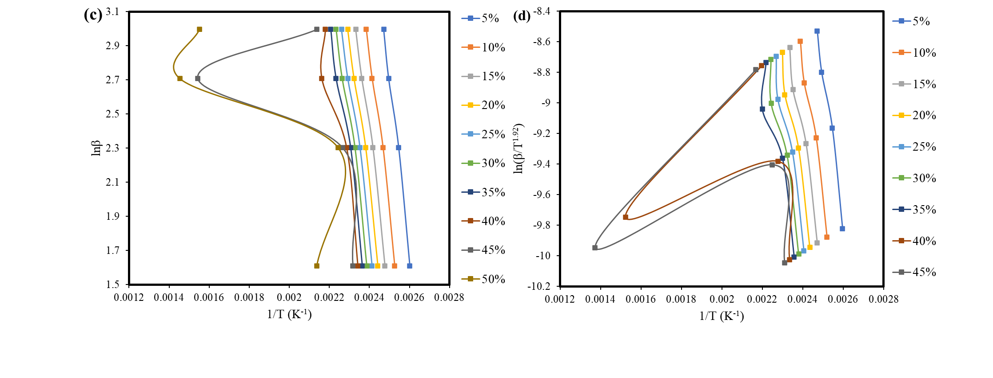

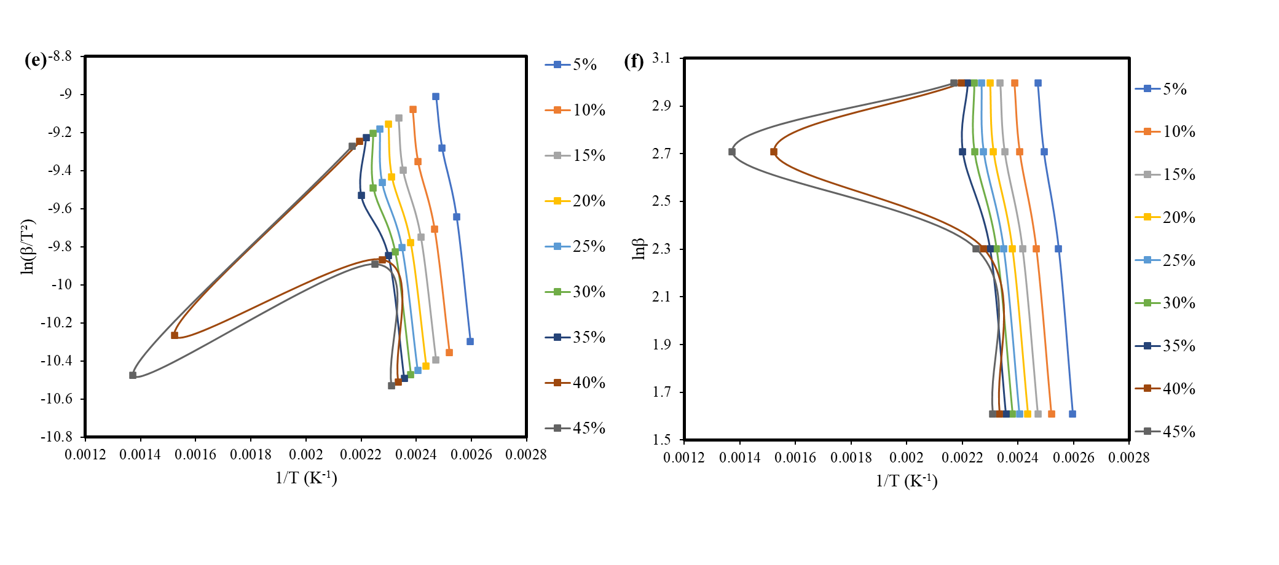

**Fig. S.2**. Linear regression lines generated for different isoconversional models in the combustion of TBP with Fe2O3 (a) Starink, (b) KAS, (c) FWO, and pyrolysis of TBP (d) Starink, (e) KAS, (f) FWO.

**Table S.1.** *E*a and *A* values calculated for TBP for the combustion reaction using model-free

methods at different conversions

|  |  |  |  |  |  |  |  |  |  |  |  |  |
| --- | --- | --- | --- | --- | --- | --- | --- | --- | --- | --- | --- | --- |
| Conversion  (%) | Straink Model | | | | KAS Model | | | | FWO model | | | |
| R2 | Ea (kJ/mol) | A (min-1) | MSE | R2 | Ea (kJ/mol) | A (min-1) | MSE | R2 | Ea (kJ/mol) | A (min-1) | MSE |
|  |
| 0.05 | 0.99 | 104.28 | 2.73E+13 | 0.0018 | 0.99 | 104.11 | 2.60E+13 | 0.0018 | 0.99 | 105.09 | 3.42E+13 | 0.0018 |  |
| 0.1 | 0.99 | 90.90 | 6.50E+11 | 0.0021 | 0.99 | 90.71 | 6.15E+11 | 0.0021 | 0.99 | 92.53 | 1.02E+12 | 0.0021 |  |
| 0.15 | 0.99 | 85.13 | 1.29E+11 | 0.0021 | 0.99 | 84.92 | 1.21E+11 | 0.0021 | 0.99 | 87.14 | 2.26E+11 | 0.0021 |  |
| 0.2 | 0.99 | 81.82 | 5.08E+10 | 0.0023 | 0.99 | 81.61 | 4.79E+10 | 0.0023 | 0.99 | 84.08 | 9.60E+10 | 0.0023 |  |
| 0.25 | 0.99 | 79.25 | 2.47E+10 | 0.0023 | 0.99 | 79.04 | 2.33E+10 | 0.0023 | 0.99 | 81.71 | 4.93E+10 | 0.0023 |  |
| 0.3 | 0.99 | 77.33 | 1.44E+10 | 0.0021 | 0.99 | 77.11 | 1.35E+10 | 0.0021 | 0.99 | 79.93 | 2.99E+10 | 0.0021 |  |
| 0.35 | 0.99 | 76.18 | 1.04E+10 | 0.0019 | 0.99 | 75.96 | 9.75E+09 | 0.0019 | 0.99 | 78.89 | 2.23E+10 | 0.0020 |  |
| 0.4 | 0.99 | 74.86 | 7.16E+09 | 0.0019 | 0.99 | 74.64 | 6.72E+09 | 0.0019 | 0.99 | 77.68 | 1.59E+10 | 0.0020 |  |
| 0.45 | 0.99 | 74.50 | 6.46E+09 | 0.0019 | 0.99 | 74.27 | 6.06E+09 | 0.0019 | 0.99 | 77.37 | 1.45E+10 | 0.0019 |  |
| 0.5 | 0.99 | 73.65 | 5.08E+09 | 0.0021 | 0.99 | 73.42 | 4.77E+09 | 0.0021 | 0.99 | 76.60 | 1.17E+10 | 0.0021 |  |
| 0.55 | 0.99 | 72.82 | 4.02E+09 | 0.0022 | 0.99 | 72.59 | 3.77E+09 | 0.0022 | 0.99 | 75.85 | 9.46E+09 | 0.0022 |  |
| 0.6 | 0.99 | 72.13 | 3.31E+09 | 0.0024 | 0.99 | 71.90 | 3.10E+09 | 0.0024 | 0.99 | 75.22 | 7.93E+09 | 0.0024 |  |
| 0.65 | 0.99 | 71.44 | 2.72E+09 | 0.0026 | 0.99 | 71.21 | 2.55E+09 | 0.0026 | 0.99 | 74.60 | 6.65E+09 | 0.0026 |  |
| 0.7 | 0.99 | 70.63 | 2.16E+09 | 0.0031 | 0.99 | 70.40 | 2.02E+09 | 0.0031 | 0.99 | 73.86 | 5.39E+09 | 0.0031 |  |
| 0.75 | 0.98 | 69.72 | 1.67E+09 | 0.0037 | 0.98 | 69.48 | 1.56E+09 | 0.0037 | 0.99 | 73.02 | 4.25E+09 | 0.0037 |  |
| 0.8 | 0.98 | 68.96 | 1.35E+09 | 0.0044 | 0.98 | 68.72 | 1.26E+09 | 0.0044 | 0.98 | 72.33 | 3.50E+09 | 0.0044 |  |
| 0.85 | 0.98 | 68.13 | 1.07E+09 | 0.0051 | 0.98 | 67.89 | 9.96E+08 | 0.0051 | 0.98 | 71.56 | 2.82E+09 | 0.0051 |  |
| 0.9 | 0.97 | 67.32 | 8.46E+08 | 0.0058 | 0.97 | 67.07 | 7.89E+08 | 0.0058 | 0.98 | 70.81 | 2.28E+09 | 0.0058 |  |
| 0.95 | 0.97 | 65.57 | 5.15E+08 | 0.0060 | 0.97 | 65.33 | 4.80E+08 | 0.0060 | 0.98 | 69.18 | 1.44E+09 | 0.0060 |  |

Table S.2. Ea and A values calculated for TBP for the pyrolysis reaction using model-free methods at different conversions

|  |  |  |  |  |  |  |  |  |  |  |  |  |
| --- | --- | --- | --- | --- | --- | --- | --- | --- | --- | --- | --- | --- |
| Conversion  (%) | Straink Model | | | | KAS Model | | | | FWO model | | | |
| R2 | Ea (kJ/mol) | A (min-1) | MSE | R2 | Ea (kJ/mol) | A (min-1) | MSE | R2 | Ea (kJ/mol) | A (min-1) | MSE |
|  |
| 0.05 | 0.99 | 91.75 | 8.61E+11 | 0.0006 | 0.99 | 91.56 | 8.18E+11 | 0.0006 | 0.99 | 93.17 | 1.28E+12 | 0.0006 |  |
| 0.1 | 0.99 | 80.24 | 3.39E+10 | 0.0010 | 0.99 | 80.03 | 3.20E+10 | 0.0010 | 0.99 | 82.38 | 6.20E+10 | 0.0010 |  |
| 0.15 | 0.99 | 74.93 | 7.58E+09 | 0.0013 | 0.99 | 74.72 | 7.14E+09 | 0.0013 | 0.99 | 77.44 | 1.54E+10 | 0.0013 |  |
| 0.2 | 0.99 | 71.71 | 3.05E+09 | 0.0013 | 0.99 | 71.50 | 2.86E+09 | 0.0013 | 0.99 | 74.45 | 6.62E+09 | 0.0013 |  |
| 0.25 | 0.99 | 69.55 | 1.65E+09 | 0.0014 | 0.99 | 69.33 | 1.55E+09 | 0.0014 | 0.99 | 72.46 | 3.77E+09 | 0.0014 |  |
| 0.3 | 0.99 | 68.09 | 1.09E+09 | 0.0015 | 0.99 | 67.87 | 1.02E+09 | 0.0015 | 0.99 | 71.13 | 2.58E+09 | 0.0014 |  |
| 0.35 | 0.99 | 67.22 | 8.51E+08 | 0.0015 | 0.99 | 66.99 | 7.98E+08 | 0.0015 | 0.99 | 70.35 | 2.07E+09 | 0.0015 |  |
| 0.4 | 0.99 | 66.18 | 6.34E+08 | 0.0015 | 0.99 | 65.95 | 5.93E+08 | 0.0015 | 0.99 | 69.41 | 1.59E+09 | 0.0015 |  |
| 0.45 | 0.99 | 65.79 | 5.67E+08 | 0.0013 | 0.99 | 65.56 | 5.30E+08 | 0.0013 | 0.99 | 69.07 | 1.44E+09 | 0.0013 |  |
| 0.5 | 0.99 | 64.98 | 4.50E+08 | 0.0015 | 0.99 | 64.74 | 4.21E+08 | 0.0015 | 0.99 | 68.34 | 1.17E+09 | 0.0015 |  |
| 0.55 | 0.99 | 64.25 | 3.65E+08 | 0.0017 | 0.99 | 64.01 | 3.41E+08 | 0.0017 | 0.99 | 67.68 | 9.69E+08 | 0.0017 |  |
| 0.6 | 0.99 | 63.51 | 2.96E+08 | 0.0016 | 0.99 | 63.27 | 2.77E+08 | 0.0016 | 0.99 | 67.01 | 8.02E+08 | 0.0016 |  |
| 0.65 | 0.99 | 62.72 | 2.36E+08 | 0.0017 | 0.99 | 62.48 | 2.20E+08 | 0.0017 | 0.99 | 66.28 | 6.52E+08 | 0.0017 |  |
| 0.7 | 0.99 | 62.11 | 1.99E+08 | 0.0017 | 0.99 | 61.87 | 1.85E+08 | 0.0017 | 0.99 | 65.74 | 5.58E+08 | 0.0017 |  |
| 0.75 | 0.99 | 61.47 | 1.65E+08 | 0.0016 | 0.99 | 61.23 | 1.54E+08 | 0.0016 | 0.99 | 65.16 | 4.73E+08 | 0.0016 |  |
| 0.8 | 0.99 | 61.16 | 1.51E+08 | 0.0015 | 0.99 | 60.92 | 1.41E+08 | 0.0015 | 0.99 | 64.89 | 4.39E+08 | 0.0015 |  |
| 0.85 | 0.99 | 60.75 | 1.35E+08 | 0.0015 | 0.99 | 60.51 | 1.26E+08 | 0.0015 | 0.99 | 64.53 | 3.96E+08 | 0.0015 |  |
| 0.9 | 0.99 | 60.39 | 1.22E+08 | 0.0013 | 0.99 | 60.15 | 1.13E+08 | 0.0013 | 0.99 | 64.21 | 3.62E+08 | 0.0013 |  |
| 0.95 | 0.99 | 59.98 | 1.08E+08 | 0.0011 | 0.99 | 59.73 | 1.01E+08 | 0.0011 | 0.99 | 63.85 | 3.26E+08 | 0.0011 |  |

Table S.3. Thermodynamic parameters for pyrolysis of TBP

|  |  |  |  |  |  |  |  |  |  |
| --- | --- | --- | --- | --- | --- | --- | --- | --- | --- |
| Coversion (%) | Straink Model | | | KAS Model | | | FWO model | | |
| ΔH (kJ/mol) | ΔG (kJ/mol) | ΔS (kJ/mol) | ΔH (kJ/mol) | ΔG (kJ/mol) | ΔS (kJ/mol) | ΔH (kJ/mol) | ΔG (kJ/mol) | ΔS (kJ/mol) |
| 0.5 | 88.33 | 100.58 | -0.03 | 88.15 | 100.59 | -0.03 | 89.75 | 83.43 | 0.01 |
| 0.1 | 76.82 | 101.08 | -0.05 | 76.62 | 101.09 | -0.05 | 78.97 | 83.89 | -0.01 |
| 0.15 | 71.52 | 101.33 | -0.07 | 71.31 | 101.34 | -0.07 | 74.02 | 84.12 | -0.02 |
| 0.2 | 68.30 | 101.49 | -0.07 | 68.08 | 101.50 | -0.07 | 71.04 | 84.26 | -0.03 |
| 0.25 | 66.13 | 101.61 | -0.08 | 65.91 | 101.62 | -0.08 | 69.05 | 84.36 | -0.03 |
| 0.3 | 64.68 | 101.69 | -0.08 | 64.45 | 101.70 | -0.08 | 67.72 | 84.43 | -0.04 |
| 0.35 | 63.81 | 101.73 | -0.08 | 63.58 | 101.75 | -0.09 | 66.94 | 84.47 | -0.04 |
| 0.4 | 62.77 | 101.79 | -0.09 | 62.54 | 101.80 | -0.09 | 66.00 | 84.52 | -0.04 |
| 0.45 | 62.38 | 101.81 | -0.09 | 62.14 | 101.83 | -0.09 | 65.66 | 84.54 | -0.04 |
| 0.5 | 61.56 | 101.86 | -0.09 | 61.33 | 101.87 | -0.09 | 64.92 | 84.58 | -0.04 |
| 0.55 | 60.83 | 101.90 | -0.09 | 60.60 | 101.92 | -0.09 | 64.26 | 84.62 | -0.05 |
| 0.6 | 60.10 | 101.94 | -0.09 | 59.86 | 101.96 | -0.09 | 63.59 | 84.65 | -0.05 |
| 0.65 | 59.30 | 101.99 | -0.10 | 59.06 | 102.01 | -0.10 | 62.87 | 84.69 | -0.05 |
| 0.7 | 58.70 | 102.03 | -0.10 | 58.46 | 102.04 | -0.10 | 62.32 | 84.72 | -0.05 |
| 0.75 | 58.06 | 102.07 | -0.10 | 57.81 | 102.08 | -0.10 | 61.74 | 84.76 | -0.05 |
| 0.8 | 57.75 | 102.08 | -0.10 | 57.50 | 102.10 | -0.10 | 61.48 | 84.77 | -0.05 |
| 0.85 | 57.34 | 102.11 | -0.10 | 57.09 | 102.12 | -0.10 | 61.11 | 84.79 | -0.05 |
| 0.9 | 56.98 | 102.13 | -0.10 | 56.73 | 102.15 | -0.10 | 60.80 | 84.81 | -0.05 |
| 0.95 | 56.57 | 102.16 | -0.10 | 56.32 | 102.17 | -0.10 | 60.44 | 84.83 | -0.05 |

Table S.4. Thermodynamic parameters for catalytic combustion of TBP using Fe2O3

|  |  |  |  |  |  |  |  |  |  |
| --- | --- | --- | --- | --- | --- | --- | --- | --- | --- |
| Coversion (%) | Straink Model | | | KAS Model | | | FWO model | | |
| ΔH (kJ/mol) | ΔG (kJ/mol) | ΔS (kJ/mol) | ΔH (kJ/mol) | ΔG (kJ/mol) | ΔS (kJ/mol) | ΔH (kJ/mol) | ΔG (kJ/mol) | ΔS (kJ/mol) |
| 0.05 | 75.78 | 99.44 | -0.05 | 75.58 | 99.45 | -0.05 | 77.85 | 82.51 | -0.01 |
| 0.1 | 68.71 | 99.78 | -0.07 | 68.50 | 99.79 | -0.07 | 71.33 | 82.81 | -0.03 |
| 0.15 | 66.04 | 99.92 | -0.08 | 65.82 | 99.93 | -0.08 | 68.92 | 82.93 | -0.03 |
| 0.2 | 64.19 | 100.01 | -0.08 | 63.96 | 100.02 | -0.08 | 67.26 | 83.01 | -0.04 |
| 0.25 | 62.36 | 100.11 | -0.09 | 62.13 | 100.12 | -0.09 | 65.60 | 83.10 | -0.04 |
| 0.3 | 60.48 | 100.22 | -0.09 | 60.25 | 100.23 | -0.09 | 63.89 | 83.19 | -0.04 |
| 0.35 | 57.43 | 100.39 | -0.10 | 57.19 | 100.41 | -0.10 | 61.06 | 83.34 | -0.05 |
| 0.4 | 42.73 | 101.38 | -0.13 | 42.47 | 101.40 | -0.13 | 47.18 | 84.21 | -0.08 |
| 0.45 | -3.36 | 115.02 | -0.27 | -3.01 | 114.03 | -0.27 | 2.47 | 91.54 | -0.20 |
| 0.5 | -3.54 | 115.66 | -0.27 | -3.91 | 117.42 | -0.28 | 4.73 | 90.51 | -0.19 |

Table S.5. Thermodynamic parameters for catalytic pyrolysis of TBP using Fe2O3

|  |  |  |  |  |  |  |  |  |  |
| --- | --- | --- | --- | --- | --- | --- | --- | --- | --- |
| Coversion (%) | Straink Model | | | KAS Model | | | FWO model | | |
| ΔH (kJ/mol) | ΔG (kJ/mol) | ΔS (kJ/mol) | ΔH (kJ/mol) | ΔG (kJ/mol) | ΔS (kJ/mol) | ΔH (kJ/mol) | ΔG (kJ/mol) | ΔS (kJ/mol) |
| 0.05 | 77.65 | 99.41 | -0.05 | 77.45 | 99.42 | -0.05 | 79.63 | 82.47 | -0.01 |
| 0.1 | 70.82 | 99.73 | -0.07 | 70.61 | 99.74 | -0.07 | 73.33 | 82.75 | -0.02 |
| 0.15 | 67.82 | 99.87 | -0.07 | 67.60 | 99.89 | -0.07 | 70.61 | 82.88 | -0.03 |
| 0.2 | 65.95 | 99.97 | -0.08 | 65.73 | 99.98 | -0.08 | 68.93 | 82.97 | -0.03 |
| 0.25 | 66.05 | 99.97 | -0.08 | 64.03 | 100.07 | -0.08 | 66.98 | 83.07 | -0.04 |
| 0.3 | 61.13 | 100.23 | -0.09 | 60.89 | 100.24 | -0.09 | 64.50 | 83.19 | -0.04 |
| 0.35 | 53.00 | 100.71 | -0.11 | 52.76 | 100.73 | -0.11 | 56.86 | 83.62 | -0.06 |
| 0.4 | -2.53 | 112.66 | -0.26 | -2.18 | 112.11 | -0.26 | 1.24 | 92.16 | -0.21 |
| 0.45 | -0.99 | 110.72 | -0.25 | -0.61 | 110.37 | -0.25 | 0.22 | 92.84 | -0.21 |

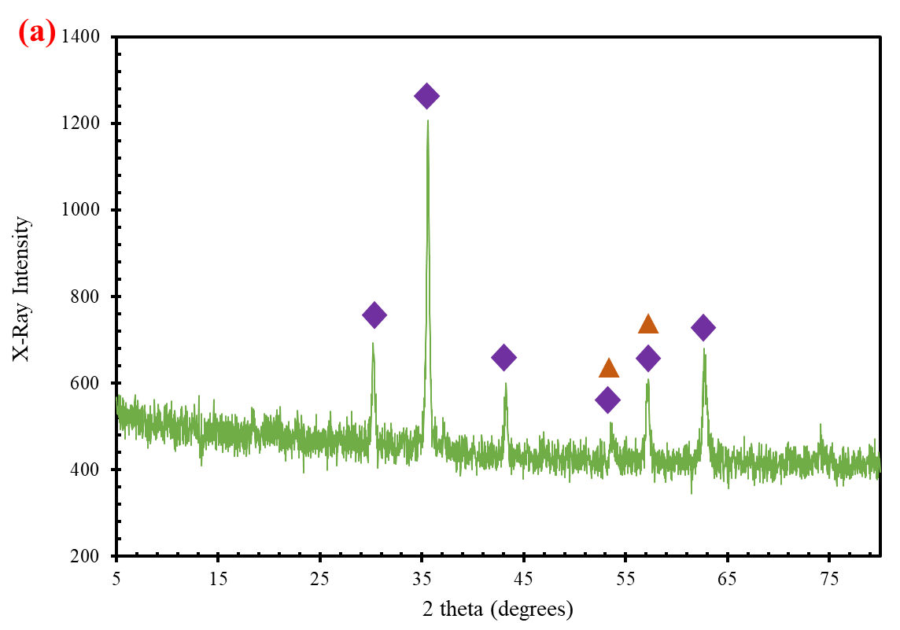

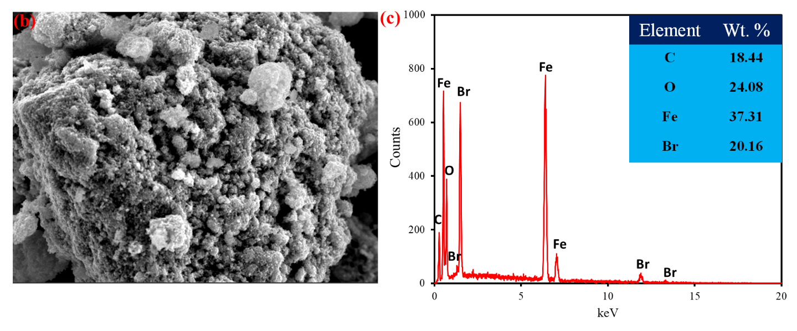

**Fig. S.3.** XRD pattern for the co-pyrolyzed mixture of TBP:Fe2O3 (a), SEM-EDX analysis of (b) co-pyrolyzed TBP: Fe2O3, (b) Elemental composition of the sample.