**Supplementary Information**

**An unexpectedly stable Y2B5 compound with the fractional stoichiometry under ambient pressure**

Yuanyuan Jina, Wenjie Huanga, Jinquan Zhang a, Song Lia, Shubo Chenga, Weiguo Sunb, Meng Juc, Chuanzhao Zhanga,*

a*Department of Physics and Optoelectronic Engineering, Yangtze University, Jingzhou 434023, China*

b*College of Physics and Electronic Information, Luoyang Normal University, Luoyang 471022, China*

c*School of Physical Science and Technology, Southwest University, Chongqing 400715, China*

* Corresponding author.

E-mail address: [zcz19870517@163.com](mailto:zcz19870517@163.com) (Chuanzhao Zhang).

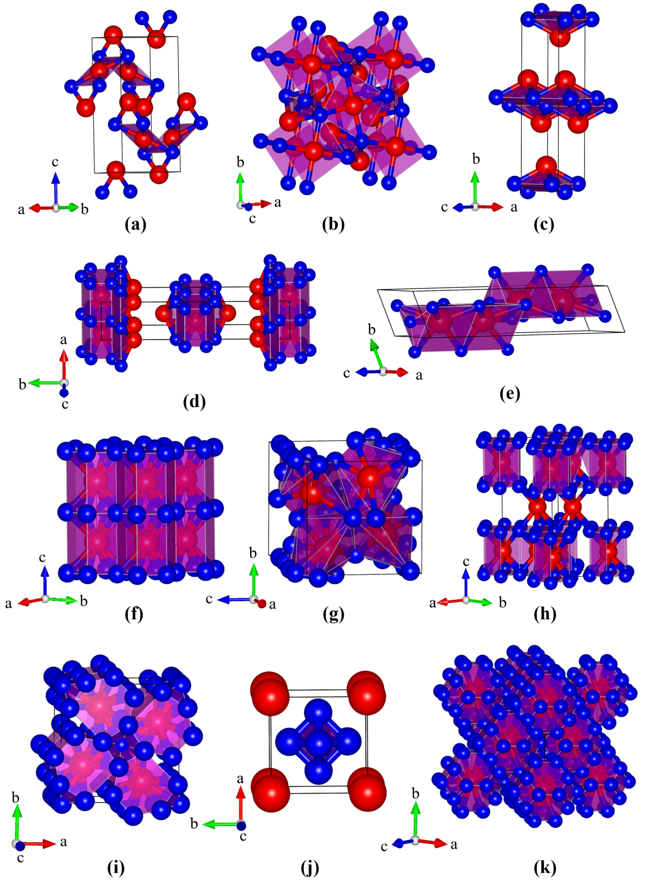

**Fig. S1** Crystal structures of the lowest enthalpy phases of each components in the YB system. (a) *Pnma*Y2B, (b) *P*4*/mbm*Y3B2, (c) *Cmcm*YB, (d) *Immm*Y3B4, (e) *P*63/*mmc*Y2B3, (f) *P*6/*mmm*YB2, (g) *P*121/*c*1Y2B5, (h) *R*-3*m*YB3, (i)*P*4/*mbm*YB4, (j) *Pm*3*m*YB6 and (k) *Fm*3*m*YB12. The red and blue spheres represent Y and B atoms, respectively.

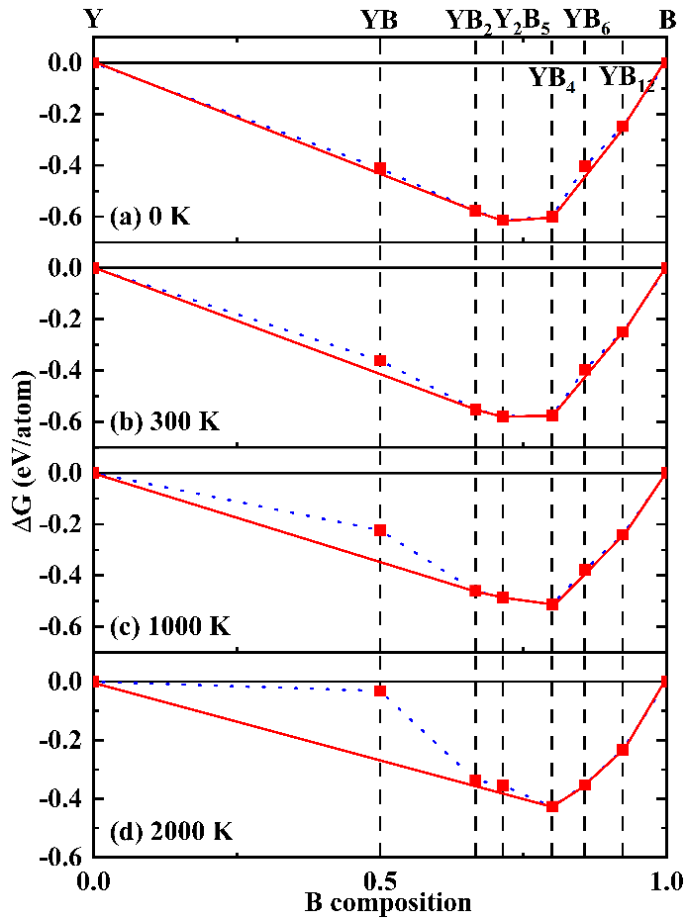

**Fig. S2** Predicted Gibbs free energies of various Y-B compounds under ambient pressure with respect to *α*-Y and *α*-B at the temperatures of (a) 0, (b) 300, (c) 1000 and (d) 2000 K. Dashed lines connect data points, and solid lines represent the convex hull.

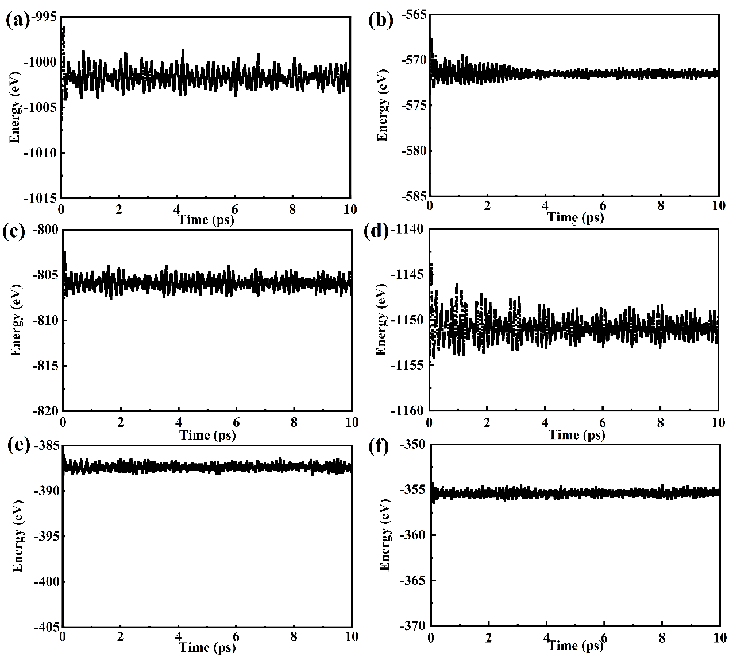

**Fig. S3** Free energy as a function of MD time at the temperature of 300 K for (a) *Cmcm*-YB, (b) *P*6/*mmm*-YB2, (c) *P*21/*c*-Y2B5, (d) *P*4/*mbm*-YB4, (e) *Pm*-3*m*-YB6 and (f) *Fm*-3*m*-YB12.

**Table S1** The lattice constants *a*, *b* and *c*Å and the occupied positions of the lowest enthalpy phases of each components in the YB system.

|  |  |  |  |  |  |  |  |  |  |  |
| --- | --- | --- | --- | --- | --- | --- | --- | --- | --- | --- |
|  | Structure | Lattice parameters (Å) | Positions | | | | | | | |
| Atom | *x* | | *y* | | *z* | | |
| Y2B | *Pnma*  (62) | *a* = 6.358, *b* = 3.697,  *c* = 11.424 | Y1(4*c*) | 0.99995 | | 0.25000 | | 0.75003 | | |
| Y2(4*c*) | 0.24994 | | 0.25000 | | 0.48100 | | |
| B1(4*c*) | 0.25011 | | 0.25000 | | 0.14246 | | |
|  |  |  |  |  | |  | |  | | |
| Y3B2 | *P*4*/mbm* (127) | *a* = 6.778, *b* = 6.778,  *c* = 4.191 | Y1(2*a*) | 0.00000 | | 0.00000 | | 0.00000 | | |
| Y2(4*h*) | 0.17265 | | 0.672658 | | 0.50000 | | |
| B1(4*g*) | 0.41109 | | 0.91109 | | 0.00000 | | |
|  |  |  |  |  | |  | |  | | |
| YB | *Cmcm*  (63) | *a* = 3.550, b = 12.962,  *c* = 3.192 | Y1(4*c*) | 0.00000 | | 0.37554 | | 0.25000 | | |
| B1(4*c*) | 0.00000 | | 0.02315 | | 0.25000 | | |
|  |  |  |  |  | |  | |  | | |
| Y3B4 | *Immm*  (71) | *a* = 3.784, *b* = 17.308,  *c* = 3.261 | Y1(2*c*) | 0.50000 | | 0.50000 | | 0.00000 | | |
| Y2(4*g*) | 0.00000 | | 0.16862 | | 0.00000 | | |
| B1(4*g*) | 0.00000 | | 0.39619 | | 0.00000 | | |
| B2(4*h*) | 0.00000 | | 0.44347 | | 0.50000 | | |
|  |  |  |  |  | |  | |  | | |
| Y2B3 | *P*63*/mmc*  (194) | *a* = 3.293, *b* = 3.293,  *c* = 16.476 | Y1(4*f*) | 0.33333 | | 0.66667 | | 0.13898 | | |
| B1(4*f*) | 0.33333 | | 0.66667 | | 0.51116 | | |
| B2(2*d*) | 0.33333 | | 0.66667 | | 0.75000 | | |
|  |  |  |  |  | |  | |  | | |
| YB2 | *P*6*/mmm*  (194) | *a* = 3.296, *b* = 3.296,  *c* = 3.858 | Y1(1*a*) | 0.00000 | | 0.00000 | | 0.00000 | | |
| B1(2*d*) | 0.33333 | | 0.66667 | | 0.50000 | | |
|  |  |  |  |  | |  | |  | | |
| Y2B5 | *P*121*/c*1  (14) | *a* = 7.136, *b*=7.159,  *c* = 7.183 | Y1(4*e*) | 0.23226 | | 0.19256 | | 0.62620 | | |
| Y2(4*e*) | 0.24228 | | 0.81458 | | 1.25293 | | |
| B1(4*e*) | 0.50341 | | 0.67373 | | 0.53959 | | |
| B2(4*e*) | 0.50109 | | 0.08926 | | 1.41081 | | |
| B3(4*e*) | 0.50347 | | 0.03824 | | 1.17433 | | |
| B4(4*e*) | 0.07411 | | 0.99012 | | 0.92498 | | |
| B5(4*e*) | 0.68603 | | 0.00197 | | 1.04120 | | |
|  |  |  |  |  | |  | |  | | |
| YB3 | *R-*3*m*  (166) | *a* = 5.404, *b* = 5.404,  *c* = 11.886 | Y1(6*c*) | 0.00000 | | 0.00000 | | 0.16558 | | |
| B1(2*e*) | 0.32933 | | 0.00402 | | 0.33333 | | |
|  |  |  |  |  | |  | |  | | |
| YB4 | *P*4*/mbm* (127) | *a* = 7.104, *b* = 7.104,  *c* = 4.022 | Y1(4*g*) | 0.31772 | | 0.81772 | | 0.00000 | | |
| B1(4*e*) | 0.00000 | | 0.00000 | | 0.20297 | | |
| B2(4*h*) | 0.91312 | | 0.41312 | | 0.50000 | | |
| B3(8*j*) | 0.17611 | | 0.03843 | | 0.50000 | | |
|  |  |  |  |  | |  | |  | | |
| YB6 | *Pm-*3*m*  (221) | *a* = 4.098, *b* = 4.098,  *c* = 4.098 | Y1(1*a*) | 0.00000 | | 0.00000 | | 0.00000 | | |
| B1(6*f*) | 0.50000 | | 0.50000 | | 0.19895 | | |
|  |  |  |  |  | |  | |  | | |
| YB12 | *Fm-*3*m*  (225) | *a* =7.495, *b* = 7.495,  *c* = 7.495 | Y1(4*a*) | 0.00000 | | 0.00000 | | 0.00000 | | |
| B1(48*i*) | | 0.50000 | | 0.16879 | | 0.16879 |

**Table S2** Calculated lattice parameters, *a*, *b* and *c* Å cell volume per formula unit V(Å3), total enthalpies per formula unit *H* eV and formation enthalpies per atom ∆*H* (eV) for the lowest formation enthalpy of each compositions of the Y−B binary system, compared with previous results.

|  |  |  |  |  |  |  |  |
| --- | --- | --- | --- | --- | --- | --- | --- |
|  | Space group | *a* (Å) | *b* (Å) | *c* (Å) | *V* (Å3) | *H* (eV) | ∆*H* (eV) |
| Y2B | *Pnma* | 6.358 | 3.697 | 11.424 | 67.13 | 19.62 | 0.01 |
| Y3B2 | *P*4*/mbm* | 6.778 | 6.778 | 4.191 | 96.28 | 33.40 | 0.14 |
| YB | *Cmcm* | 3.550 | 12.962 | 3.192 | 146.87 | 27.95 | 0.41 |
| Y3B4 | *Immm* | 3.784 | 17.308 | 3.261 | 106.78 | 49.19 | 0.43 |
| Y2B3 | *P*63*/mmc* | 3.294 | 3.294 | 16.476 | 77.41 | 31.20 | 0.36 |
| YB2 | *P*6*/mmm* | 3.296 | 3.296 | 3.858 | 36.29 | 21.58 | 0.58 |
| 3.298*a* | 3.298*a* | 3.843*a* |  |  |  |
| 3.288*b* | 3.288*b* | 3.836*b* |  |  |  |
| Y2B5 | *P*121*/c*1 | 7.093 | 7.103 | 7.125 | 87.35 |  | 0.61 |
| YB3 | *R-*3*m* | 5.404 | 5.404 | 11.886 | 150.28 | 27.11 | 0.14 |
| YB4 | *P*4*/mbm* | 7.104 | 7.104 | 4.022 | 50.74 | 36.26 | 0.60 |
| 7.111*a* | 7.111*a* | 4.017*a* |  |  |  |
| 7.106*b* | 7.106*b* | 4.020*b* |  |  |  |
| 7.107*c* | 7.107*c* | 4.018*c* |  |  |  |
| YB6 | *Pm-*3*m* | 4.098 | 4.098 | 4.098 | 68.82 | 49.50 | 0.41 |
| 4.113*a* | 4.113*a* | 4.113*a* |  |  |  |
| 4.102*b* | 4.102*b* | 4.102*b* |  |  |  |
| 4.110*d* | 4.110*d* | 4.110*d* |  |  |  |
| YB12 | *Fm-*3*m* | 7.495 | 7.495 | 7.495 | 105.25 | 90.16 | 0.25 |
| 7.501*a* | 7.501*a* | 7.501*a* |  |  |  |
| 7.501*b* | 7.501*b* | 7.501*b* |  |  |  |
| *a*Reference 1. *b*Reference 2. *c*Reference 3. *d*Reference 4. | | | | | | | |

**References**

1. P.K. Liao, K.E. Spear, The B−Y(boron−yttrium) system, J. Phase Equilib. 16 (6) (1995) 521−524.

2. C. Colinet, J.C. Tedenac, Enthalpies of formation of rare-earth borides from first principles. Comparison with experimental values, Calphad 62 (2018) 4960.

3. J.A. Zaykoski, M.M. Opeka, L.H. Smith, I.G. Talmy, Synthesis and characterization of YB4 ceramics, J. Am. Ceram. Soc. 94 (11) (2011) 4059–4065.

4. M. Romero, A. Benitez-Rico, E.P. Arévalo-López, R.W. Gómez, M.L. Marquina, J.L. Rosas, R. Escamilla, First-principles calculations of the structural, elastic, vibrational and electronic properties of YB6 compound under pressure, Eur. Phys. J. B 92 (2019) 159.