## **[Synthesis of new 1,2,3-triazole linked benzimidazolidinone : single crystal X-ray structure, biological activities evaluation](https://www.sciencedirect.com/science/article/pii/S0022286021003203) and molecular docking studies**

Hanan Al-GHULIKAH[1], Ameni Ghabi[2], Amel haouas[3], Hasan Mtiraoui[2], Erwann JEANNEAU[4], Moncef Msaddek[2]

1 Department of Chemistry, College of Sciences, Princess Nourah bint Abdulrahman University, P.O. Box 84428, Riyadh 11671, Saudi Arabia

2 Laboratory of Heterocyclic Chemistry Natural Products and Reactivity/CHPNR, Department of Chemistry, Faculty of Science of Monastir, University of Monastir, 5000 Monastir, Tunisia

3 Department of Chemistry, Faculty of Science and Arts, Northern Border University, Arar, Saudi Arabia.

4 Université Lyon1, Institut de Chimie de Lyon, Centre de Diffractométrie Henri Longchambon 69622 Villeurbanne

* Corresponding Author:

E-mail 1: [haalghulikah@pnu.edu.sa](mailto:haalghulikah@pnu.edu.sa)

**Table of Contents**

**NMR Spectra**

1H and 13C NMR of **3 S2-S8**

RX data tables **S**9**-S13**

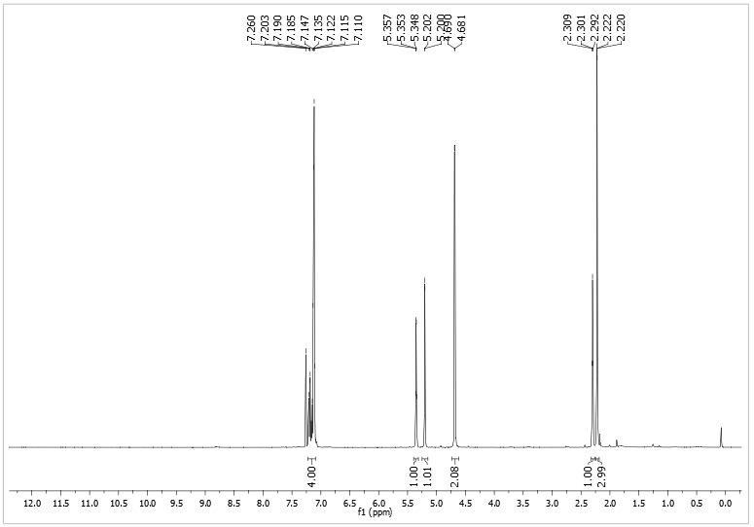



1H NMR of compound (**3**) in CDCl3 at 400 MHz

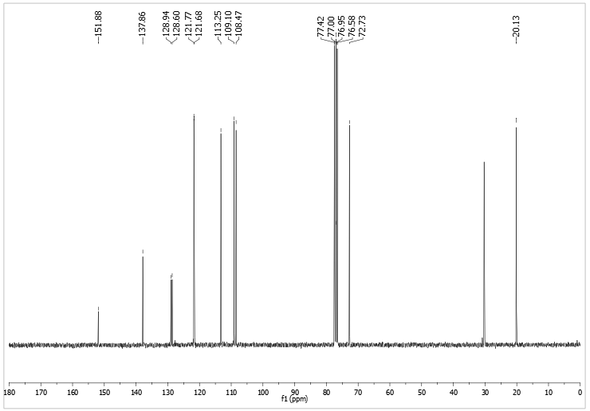



13C NMR of compound (**3**) in CDCl3 at 100 MHz

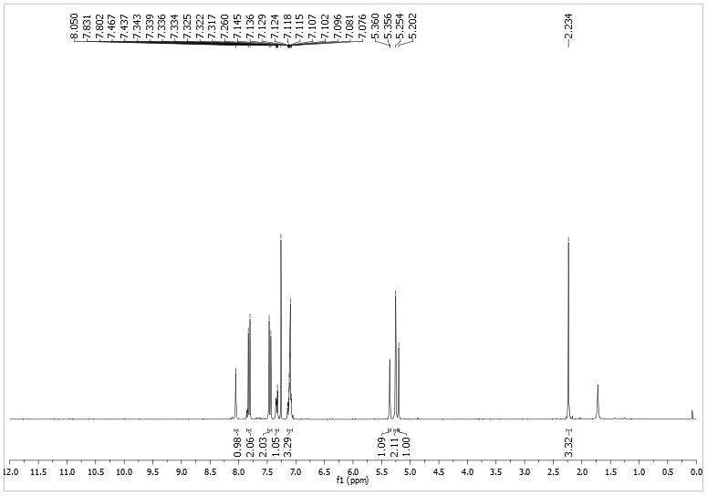



1H NMR of compound (**5a**) in CDCl3 at 400 MHz 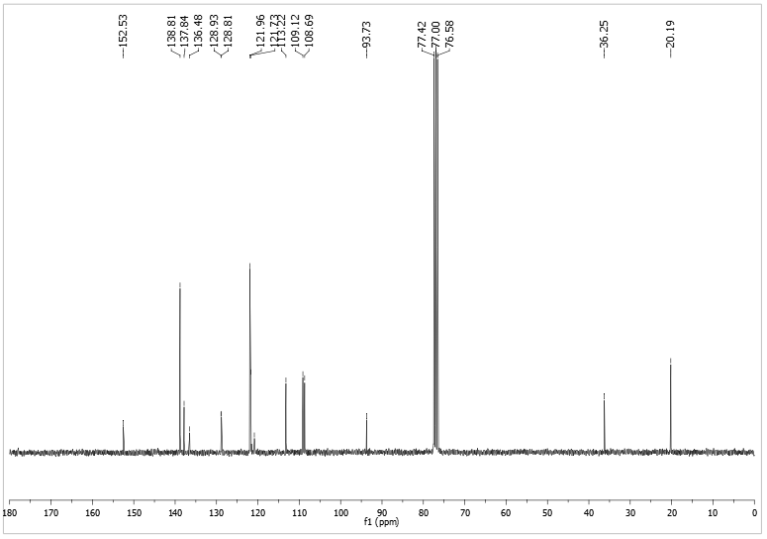



13C NMR of compound (**5a**) in CDCl3 at 100 MHz

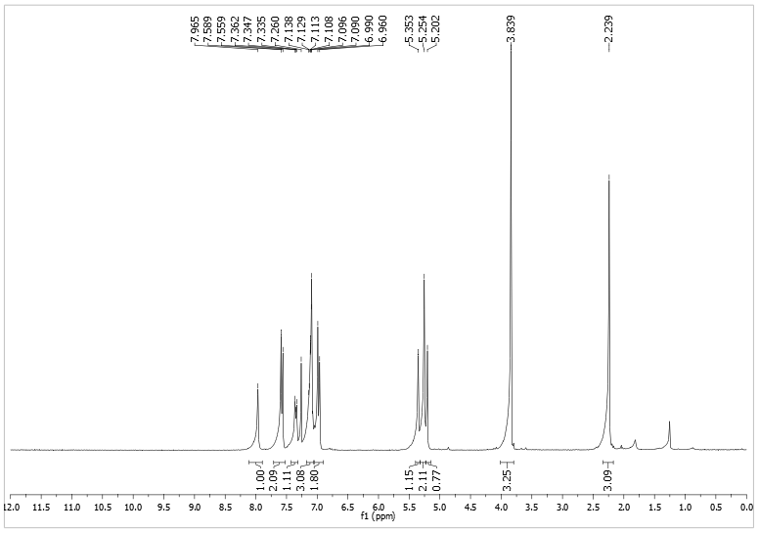



1H NMR of compound (**5b**) in CDCl3 at 400 MHz

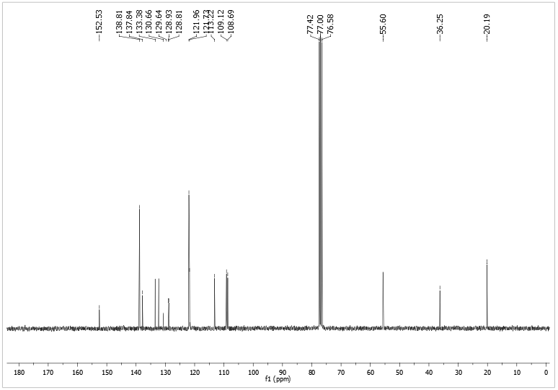



13C NMR of compound (**5b**) in CDCl3 at 100 MHz

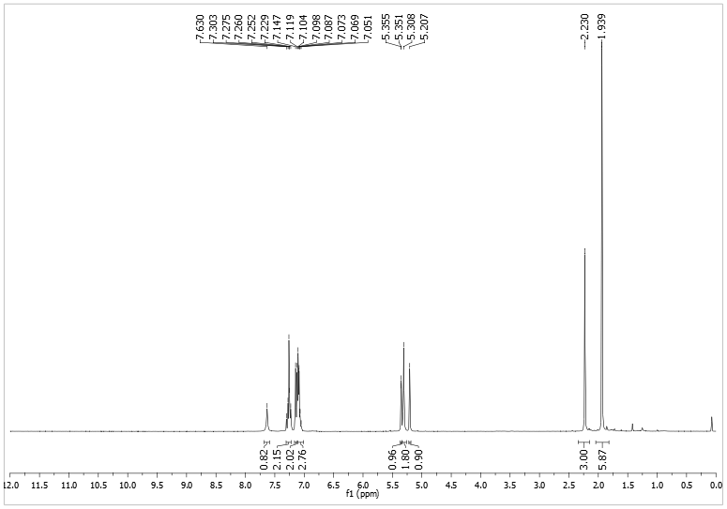



1H NMR of compound (**5c**) in CDCl3 at 400 MHz

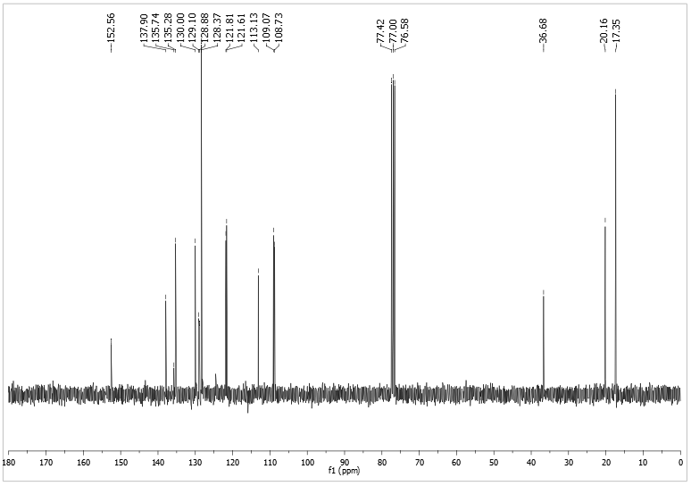



13C NMR of compound (**5c**) in CDCl3 at 100 MHz

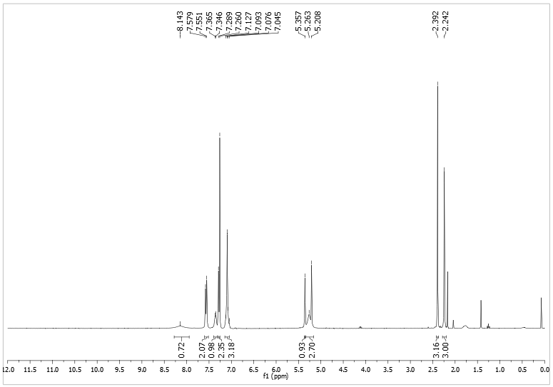



1H NMR of compound (**5d**) in CDCl3 at 400 MHz

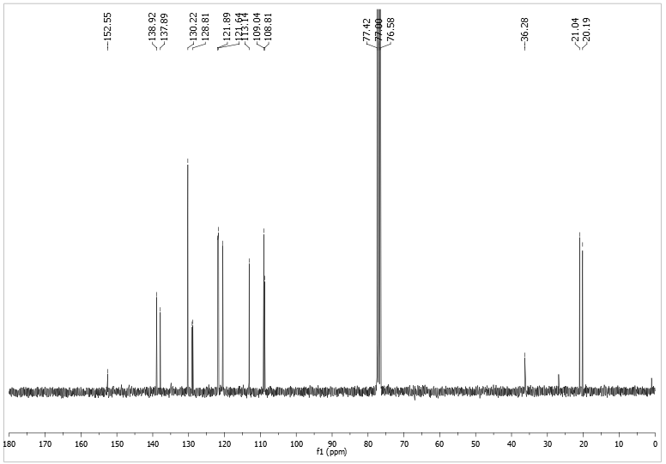



13C NMR of compound (**5d**) in CDCl3 at 100 MHz

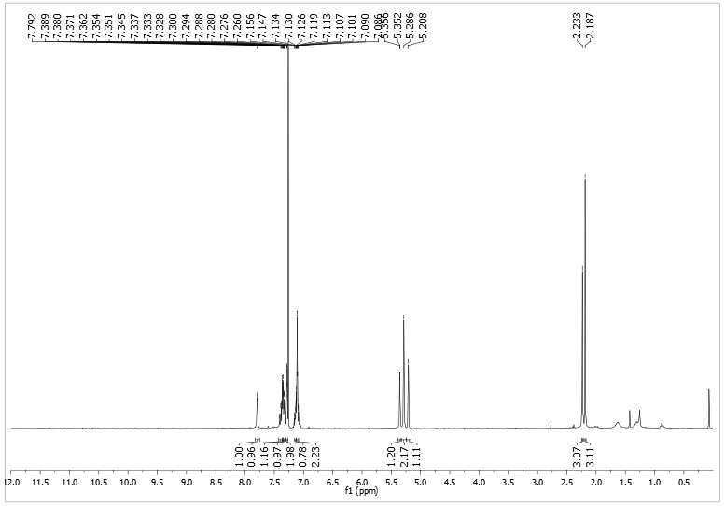



1H NMR of compound (**5e**) in CDCl3 at 400 MHz

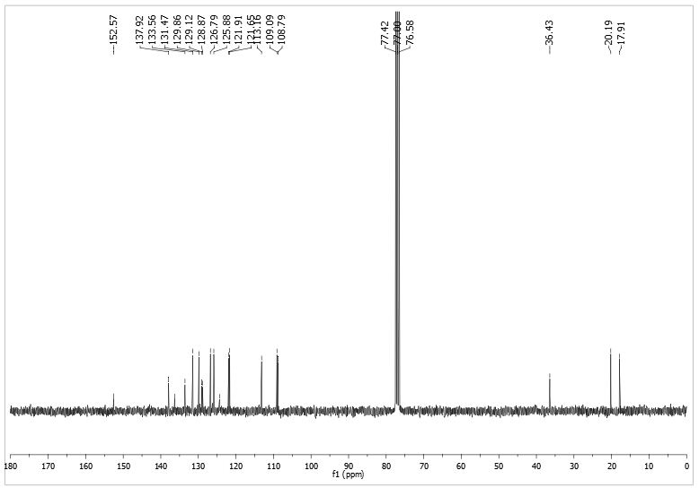



13C NMR of compound (**5e**) in CDCl3 at 100 MHz

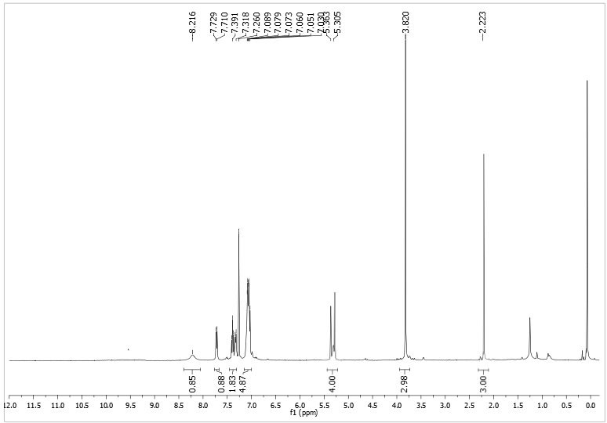



1H NMR of compound (**5f**) in CDCl3 at 400 MHz

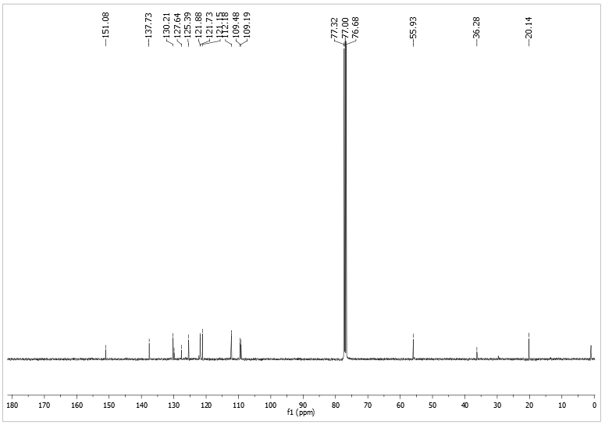13C NMR of compound (**5f**) in CDCl3 at 100 MHz



**Table 1**: Fractional Atomic Coordinates (×104) and Equivalent Isotropic Displacement Parameters (Å2×103) for **AG003_2**. *Ueq* is defined as 1/3 of the trace of the orthogonalised *Uij*.

| **Atom** | **x** | **y** | **z** | ***Ueq*** |
| --- | --- | --- | --- | --- |
| O1 | 4839.7(8) | 3436(2) | 8464.0(3) | 43.3(3) |
| O2 | 3883.6(8) | 1598(3) | 5943.1(4) | 49.7(4) |
| N1 | 3331.4(8) | 3423(2) | 7191.6(4) | 29.6(3) |
| N2 | 2625.9(10) | 5132(3) | 6783.3(4) | 43.5(4) |
| N3 | 2940.3(10) | 5567(3) | 7084.8(4) | 42.3(4) |
| N4 | 3215.2(8) | 4951(3) | 5658.3(3) | 33.7(4) |
| N5 | 2657.9(9) | 3317(3) | 6091.8(4) | 35.6(4) |
| C1 | 3728.9(9) | 3349(3) | 7516.7(4) | 28.4(4) |
| C2 | 2116.9(15) | 8262(5) | 5521.2(6) | 64.6(7) |
| C3 | 2530.0(12) | 1621(3) | 6366.5(5) | 39.1(4) |
| C4 | 4500.6(10) | 3291(3) | 8147.9(4) | 33.2(4) |
| C5 | 3947(3) | 3112(8) | 5197.1(10) | 49.4(11) |
| C6 | 2821.1(10) | 2720(3) | 6694.6(4) | 33.1(4) |
| C7 | 5453.2(12) | 1633(4) | 8567.3(5) | 45.2(5) |
| C8 | 4294.0(10) | 1467(3) | 7603.1(5) | 32.6(4) |
| C9 | 4552(2) | 6085(8) | 5489.7(10) | 45.0(10) |
| C10 | 2137.9(10) | 5222(3) | 5967.0(4) | 32.2(4) |
| C11 | 1396.5(10) | 6067(4) | 6065.3(5) | 39.8(4) |
| C12 | 4681.0(10) | 1428(3) | 7919.4(5) | 34.1(4) |
| C13 | 3755.9(11) | 5293(4) | 5397.4(4) | 39.5(4) |
| C14 | 3544.3(10) | 5208(3) | 7745.1(5) | 33.8(4) |
| C15 | 1015.7(13) | 8029(5) | 5887.2(6) | 54.7(6) |
| C16 | 3271.9(11) | 1630(3) | 6952.1(5) | 34.9(4) |
| C17 | 1373.0(17) | 9120(6) | 5622.5(6) | 74.3(8) |
| C18 | 3321.0(10) | 3113(3) | 5902.3(4) | 34.3(4) |
| C19 | 4122(2) | 7669(9) | 5368.6(10) | 49.5(11) |
| C20 | 3933.6(11) | 5178(3) | 8056.4(4) | 35.2(4) |
| C21 | 3409(3) | 4830(9) | 5082.6(10) | 50.3(11) |
| C22 | 2487.9(11) | 6279(4) | 5696.0(4) | 38.0(4) |

**Table 2**: Anisotropic Displacement Parameters (×104) for **AG003_2**. The anisotropic displacement factor exponent takes the form: *-22[h2a*2 × U11+ ... +2hka* × b* × U12]*

| **Atom** | ***U11*** | ***U22*** | ***U33*** | ***U23*** | ***U13*** | ***U12*** |
| --- | --- | --- | --- | --- | --- | --- |
| O1 | 46.0(7) | 46.0(8) | 38.0(7) | 1.1(6) | 2.9(6) | 10.9(6) |
| O2 | 37.8(7) | 57.3(9) | 54.3(8) | 11.2(7) | 5.6(6) | 15.5(6) |
| N1 | 26.9(7) | 21.8(7) | 40.7(8) | 1.0(6) | 7.5(6) | 1.3(5) |
| N2 | 49.9(9) | 37.1(9) | 43.2(9) | -1.4(7) | 0.1(7) | 11.8(7) |
| N3 | 51.1(9) | 31.3(8) | 44.0(9) | -0.3(7) | -0.4(7) | 13.5(7) |
| N4 | 29.5(7) | 39.1(8) | 32.7(8) | -0.3(6) | 3.2(6) | 5.5(6) |
| N5 | 30.9(7) | 37.3(8) | 38.9(8) | 2.2(6) | 4.7(6) | 1.5(6) |
| C1 | 23.7(8) | 23.3(8) | 38.9(9) | 3.4(6) | 7.4(6) | -1.6(6) |
| C2 | 68.3(14) | 73.6(16) | 54.6(13) | 23.5(12) | 24.1(11) | 36.4(13) |
| C3 | 40.8(10) | 33.5(9) | 43.3(10) | 2.0(8) | 5.0(8) | -5.6(8) |
| C4 | 29.8(8) | 31.7(9) | 39.0(9) | 3.9(7) | 8.7(7) | -0.5(7) |
| C5 | 46(2) | 59(3) | 43(2) | -14.6(19) | 11.1(17) | 5(2) |
| C6 | 30.5(8) | 28.2(8) | 41.4(10) | 0.7(7) | 8.1(7) | -3.1(7) |
| C7 | 39.3(10) | 50.6(12) | 45.6(11) | 7.2(9) | 1.9(8) | 9.0(9) |
| C8 | 28.6(8) | 24.7(8) | 45.2(10) | -0.8(7) | 8.3(7) | 2.3(7) |
| C9 | 33.2(19) | 54(2) | 49(2) | 1.2(19) | 8.4(16) | -2.4(18) |
| C10 | 27.3(8) | 32.1(9) | 36.5(9) | -6.9(7) | -2.7(7) | -1.2(7) |
| C11 | 30.5(9) | 44.5(10) | 44.4(10) | -8.9(8) | 3.5(7) | -1.7(8) |
| C12 | 28.7(8) | 28.2(8) | 45.9(10) | 4.8(7) | 7.2(7) | 3.8(7) |
| C13 | 38.9(9) | 45.8(11) | 34.5(9) | 1.5(8) | 7.9(7) | 9.0(8) |
| C14 | 32.2(8) | 25.1(8) | 45.3(10) | 3.2(7) | 10.0(7) | 5.8(7) |
| C15 | 41.9(11) | 68.5(14) | 54.4(13) | -3.2(11) | 7.3(9) | 22.1(10) |
| C16 | 35.8(9) | 24.3(8) | 44.8(10) | -1.6(7) | 5.1(7) | 0.5(7) |
| C17 | 75.0(17) | 87.8(19) | 62.1(15) | 22.2(13) | 18.0(13) | 52.0(15) |
| C18 | 27.8(8) | 36.7(9) | 37.8(9) | -2.5(7) | -0.9(7) | 1.2(7) |
| C19 | 48(2) | 56(3) | 46(2) | -3(2) | 16.9(18) | 3(2) |
| C20 | 38.5(9) | 28.8(9) | 39.5(10) | 0.3(7) | 10.7(7) | 4.2(7) |
| C21 | 41(2) | 72(3) | 37(2) | 8.9(19) | 1.8(16) | 5(2) |
| C22 | 36.4(9) | 42.1(10) | 36.0(9) | -2.2(8) | 5.2(7) | 8.1(8) |

**Table 3**: Bond Lengths in Å for **AG003_2**.

| **Atom** | **Atom** | **Length/Å** |
| --- | --- | --- |
| O1 | C4 | 1.360(2) |
| O1 | C7 | 1.421(2) |
| O2 | C18 | 1.220(2) |
| N1 | N3 | 1.349(2) |
| N1 | C1 | 1.427(2) |
| N1 | C16 | 1.346(2) |
| N2 | N3 | 1.310(2) |
| N2 | C6 | 1.356(2) |
| N4 | C13 | 1.436(2) |
| N4 | C18 | 1.380(2) |
| N4 | C22 | 1.399(2) |
| N5 | C3 | 1.448(2) |
| N5 | C10 | 1.384(2) |
| N5 | C18 | 1.378(2) |
| C1 | C8 | 1.381(2) |
| C1 | C14 | 1.388(2) |
| C2 | C17 | 1.389(3) |
| C2 | C22 | 1.373(3) |
| C3 | C6 | 1.493(3) |
| C4 | C12 | 1.388(2) |
| C4 | C20 | 1.390(2) |
| C5 | C13 | 1.446(4) |
| C6 | C16 | 1.360(3) |
| C8 | C12 | 1.388(3) |
| C9 | C13 | 1.397(4) |
| C10 | C11 | 1.379(2) |
| C10 | C22 | 1.387(3) |
| C11 | C15 | 1.378(3) |
| C13 | C19 | 1.389(5) |
| C13 | C21 | 1.379(4) |
| C14 | C20 | 1.371(3) |
| C15 | C17 | 1.379(4) |

**Table 4**: Bond Angles in ° for **AG003_2**.

| **Atom** | **Atom** | **Atom** | **Angle/°** |
| --- | --- | --- | --- |
| C4 | O1 | C7 | 118.33(14) |
| N3 | N1 | C1 | 119.64(13) |
| C16 | N1 | N3 | 109.87(14) |
| C16 | N1 | C1 | 130.48(14) |
| N3 | N2 | C6 | 108.83(15) |
| N2 | N3 | N1 | 107.53(14) |
| C18 | N4 | C13 | 123.90(14) |
| C18 | N4 | C22 | 109.53(14) |
| C22 | N4 | C13 | 126.46(15) |
| C10 | N5 | C3 | 126.99(15) |
| C18 | N5 | C3 | 122.74(15) |
| C18 | N5 | C10 | 110.16(14) |
| C8 | C1 | N1 | 120.57(15) |
| C8 | C1 | C14 | 120.33(16) |
| C14 | C1 | N1 | 119.10(14) |
| C22 | C2 | C17 | 117.4(2) |
| N5 | C3 | C6 | 112.98(15) |
| O1 | C4 | C12 | 124.86(15) |
| O1 | C4 | C20 | 115.69(15) |
| C12 | C4 | C20 | 119.45(17) |
| N2 | C6 | C3 | 121.75(16) |
| N2 | C6 | C16 | 108.30(16) |
| C16 | C6 | C3 | 129.92(16) |
| C1 | C8 | C12 | 120.01(16) |
| N5 | C10 | C22 | 107.20(14) |
| C11 | C10 | N5 | 131.32(17) |
| C11 | C10 | C22 | 121.47(17) |
| C15 | C11 | C10 | 117.76(19) |
| C8 | C12 | C4 | 119.80(16) |
| N4 | C13 | C5 | 118.8(2) |
| C9 | C13 | N4 | 117.1(2) |
| C19 | C13 | N4 | 117.8(2) |
| C19 | C13 | C5 | 123.1(3) |
| C21 | C13 | N4 | 114.7(2) |
| C21 | C13 | C9 | 128.1(3) |
| C20 | C14 | C1 | 119.51(15) |
| C11 | C15 | C17 | 120.73(19) |
| N1 | C16 | C6 | 105.46(15) |
| C15 | C17 | C2 | 121.7(2) |
| O2 | C18 | N4 | 127.31(17) |
| O2 | C18 | N5 | 126.56(17) |
| N5 | C18 | N4 | 106.13(14) |
| C14 | C20 | C4 | 120.89(16) |
| C2 | C22 | N4 | 132.10(18) |
| C2 | C22 | C10 | 120.94(17) |
| C10 | C22 | N4 | 106.97(15) |

**Table 5**: Torsion Angles in ° for **AG003_2**.

| **Atom** | **Atom** | **Atom** | **Atom** | **Angle/°** |
| --- | --- | --- | --- | --- |
| O1 | C4 | C12 | C8 | 179.81(15) |
| O1 | C4 | C20 | C14 | -179.19(16) |
| N1 | C1 | C8 | C12 | 179.51(14) |
| N1 | C1 | C14 | C20 | -178.90(15) |
| N2 | C6 | C16 | N1 | 0.44(19) |
| N3 | N1 | C1 | C8 | -163.93(15) |
| N3 | N1 | C1 | C14 | 15.6(2) |
| N3 | N1 | C16 | C6 | -0.83(19) |
| N3 | N2 | C6 | C3 | 178.22(16) |
| N3 | N2 | C6 | C16 | 0.1(2) |
| N5 | C3 | C6 | N2 | 48.1(2) |
| N5 | C3 | C6 | C16 | -134.27(19) |
| N5 | C10 | C11 | C15 | -179.66(19) |
| N5 | C10 | C22 | N4 | 0.93(19) |
| N5 | C10 | C22 | C2 | -179.0(2) |
| C1 | N1 | N3 | N2 | -179.50(14) |
| C1 | N1 | C16 | C6 | 179.65(15) |
| C1 | C8 | C12 | C4 | -0.2(2) |
| C1 | C14 | C20 | C4 | -1.0(3) |
| C3 | N5 | C10 | C11 | 1.6(3) |
| C3 | N5 | C10 | C22 | -177.38(17) |
| C3 | N5 | C18 | O2 | -2.4(3) |
| C3 | N5 | C18 | N4 | 177.29(15) |
| C3 | C6 | C16 | N1 | -177.46(16) |
| C6 | N2 | N3 | N1 | -0.6(2) |
| C7 | O1 | C4 | C12 | 3.1(2) |
| C7 | O1 | C4 | C20 | -176.97(15) |
| C8 | C1 | C14 | C20 | 0.7(2) |
| C10 | N5 | C3 | C6 | -87.1(2) |
| C10 | N5 | C18 | O2 | -178.87(17) |
| C10 | N5 | C18 | N4 | 0.84(19) |
| C10 | C11 | C15 | C17 | -0.8(3) |
| C11 | C10 | C22 | N4 | -178.20(16) |
| C11 | C10 | C22 | C2 | 1.8(3) |
| C11 | C15 | C17 | C2 | 1.3(4) |
| C12 | C4 | C20 | C14 | 0.7(3) |
| C13 | N4 | C18 | O2 | 2.9(3) |
| C13 | N4 | C18 | N5 | -176.82(15) |
| C13 | N4 | C22 | C2 | -4.0(3) |
| C13 | N4 | C22 | C10 | 176.04(16) |
| C14 | C1 | C8 | C12 | -0.1(2) |
| C16 | N1 | N3 | N2 | 0.9(2) |
| C16 | N1 | C1 | C8 | 15.5(2) |
| C16 | N1 | C1 | C14 | -164.87(17) |
| C17 | C2 | C22 | N4 | 178.7(2) |
| C17 | C2 | C22 | C10 | -1.3(4) |
| C18 | N4 | C13 | C5 | 52.8(3) |
| C18 | N4 | C13 | C9 | -65.4(3) |
| C18 | N4 | C13 | C19 | -122.0(3) |
| C18 | N4 | C13 | C21 | 115.7(3) |
| C18 | N4 | C22 | C2 | 179.5(2) |
| C18 | N4 | C22 | C10 | -0.4(2) |
| C18 | N5 | C3 | C6 | 97.1(2) |
| C18 | N5 | C10 | C11 | 177.90(18) |
| C18 | N5 | C10 | C22 | -1.12(19) |
| C20 | C4 | C12 | C8 | -0.1(2) |
| C22 | N4 | C13 | C5 | -123.2(3) |
| C22 | N4 | C13 | C9 | 118.6(3) |
| C22 | N4 | C13 | C19 | 62.0(3) |
| C22 | N4 | C13 | C21 | -60.3(3) |
| C22 | N4 | C18 | O2 | 179.47(18) |
| C22 | N4 | C18 | N5 | -0.24(19) |
| C22 | C2 | C17 | C15 | -0.2(5) |
| C22 | C10 | C11 | C15 | -0.8(3) |

**Table 6**: Hydrogen Fractional Atomic Coordinates (×104) and Equivalent Isotropic Displacement Parameters (Å2×103) for **AG003_2**. *Ueq* is defined as 1/3 of the trace of the orthogonalised *Uij*.

| **Atom** | **x** | **y** | **z** | ***Ueq*** |
| --- | --- | --- | --- | --- |
| H2 | 2354.22 | 9000.83 | 5342.03 | 77 |
| H3A | 2814.39 | 25.18 | 6333.69 | 47 |
| H3B | 1952.21 | 1240.78 | 6368.35 | 47 |
| H5A | 4287.03 | 1946.53 | 5327.81 | 74 |
| H5B | 4229.66 | 3676.06 | 5010.24 | 74 |
| H5C | 3450.86 | 2264.28 | 5120.23 | 74 |
| H7A | 5892.67 | 1732.68 | 8423.04 | 68 |
| H7B | 5225.52 | -57.9 | 8557.93 | 68 |
| H7C | 5655.88 | 2006.92 | 8790.54 | 68 |
| H8 | 4415.07 | 225.17 | 7449.28 | 39 |
| H9A | 4536.45 | 7678.51 | 5607.1 | 67 |
| H9B | 4847.27 | 6305.27 | 5294.9 | 67 |
| H9C | 4818.5 | 4817.03 | 5630.6 | 67 |
| H11 | 1161.49 | 5337.69 | 6245.68 | 48 |
| H12 | 5060.04 | 157.35 | 7978.2 | 41 |
| H14 | 3159.55 | 6463.83 | 7687.34 | 41 |
| H15 | 512.18 | 8623.8 | 5946.24 | 66 |
| H16 | 3492.6 | -7.82 | 6960.89 | 42 |
| H17 | 1109.49 | 10463.65 | 5508.88 | 89 |
| H19A | 4014.24 | 8973.82 | 5515.57 | 59 |
| H19B | 4475.92 | 7954.09 | 5202.35 | 59 |
| H20 | 3816.53 | 6438.49 | 8208.35 | 42 |
| H21A | 3716.25 | 5042.64 | 4899.75 | 60 |
| H21B | 2867.77 | 4305.61 | 5053.2 | 60 |

**Table 7**: Atomic Occupancies for all atoms that are not fully occupied in **AG003_2**.

| **Atom** | **Occupancy** |
| --- | --- |
| C5 | 0.499(3) |
| H5A | 0.499(3) |
| H5B | 0.499(3) |
| H5C | 0.499(3) |
| C9 | 0.501(3) |
| H9A | 0.501(3) |
| H9B | 0.501(3) |
| H9C | 0.501(3) |
| C19 | 0.501(3) |
| H19A | 0.501(3) |
| H19B | 0.501(3) |
| C21 | 0.499(3) |
| H21A | 0.499(3) |
| H21B | 0.499(3) |