**Supporting Materials**

**Experimental Analysis and Thermodynamic Modelling of Nitroxynil Solubility in pure solvent and binary solvent**

Yang Chena,[1], Nanxin Lia,1, Jinping Lana,1, Xiaojuan Lia, Wei Zhanga, Funeng Xua, Haohuan Lia, Gang Shua, Juchun Lina, Guangneng Penga, Huaqiao Tanga, Ling Zhaoa, Hualin Fua[2]*

a Department of Pharmacy, College of Veterinary Medicine, Sichuan Agricultural University, Chengdu, Sichuan 611130, People's Republic of China

* Corresponding author: Hualin Fu

1. mail:fuhl2005@sohu.com

**Table S1.** Main reagents and their sources

|  |  |  |  |
| --- | --- | --- | --- |
| Materials | Provenance | Mass fraction purity | CAS NO. |
| Nitroxinil | Huana Chemicals Co., Ltd. (China) | ≥99.5% | 1689-89-0 |
| methanol | Chron Chemicals Co.,Ltd. (China) | ≥99.9% | 67-56-1 |
| ethanol | Chron Chemicals Co.,Ltd. (China) | ≥99.7% | 64-17-5 |
| 1,2-propanediolethyl | Chron Chemicals Co.,Ltd. (China) | ≥99.0% | 57-55-6 |
| isopropanol | Chron Chemicals Co.,Ltd. (China) | ≥99.7% | 67-63-0 |
| ethyl acetate | Chron Chemicals Co.,Ltd. (China) | ≥99.5% | 141-78-6 |
| acetonitrile | Chron Chemicals Co.,Ltd. (China) | ≥99.0% | 109-60-4 |
| n-butanol | Chron Chemicals Co.,Ltd. (China) | ≥99.5% | 71-36-3 |
| phemethylol | Chron Chemicals Co.,Ltd. (China) | ≥99.0% | 100-51-6 |

**Table S2.** Calculation of Hansen solubility parameters for Nitroxynil in terms of the Hoftyzer–van Krevelen method.a

|  |  |  |  |  |  |
| --- | --- | --- | --- | --- | --- |
| 方程式(1) | | | | |  |
| Group | Frequency | *F*di (J1/2·cm3/2· mol−1) | *F*pi (J1/2·cm3/2· mol−1) | *E*hi  (J·mol-1) | *V*i  (cm3/mol) |
|  | 1 | 1270 | 110 | 0 | 52.4 |
| -OH | 1 | 210 | 500 | 20000 | 10.47 |
| -CN | 1 | 430 | 1100 | 2500 | 22.4 |
| -NO2 | 1 | 500 | 1070 | 360 | 24 |
| -I | 1 | 655 | 665 | 0 | 32.2 |
|  |  | 21.67 (J·cm-3)1/2 | | |  |
|  |  | 12.36 (J·cm-3)1/2 | | |  |
|  |  | 12.71 (J·cm-3)1/2 | | |  |
|  |  | 28.00 (J·cm-3)1/2 | | |  |
|  |  | 24.94 (J·cm-3)1/2 | | |  |

a Taken from ref. [1][2]

**Table S3.** Values of Hansen solubility parameters of Nitroxynil and selected solvents.a

|  |  |  |  |  |  |  |  |  |  |  |  |
| --- | --- | --- | --- | --- | --- | --- | --- | --- | --- | --- | --- |
| *xj0* | *δ*d | *δ*p | *δ*h | *δ*t | *δ*v | Δ*δ*d | Δ*δ*p | Δ*δ*h | Δ*δ*t | Δ*δ* | Ra |
| (J·cm-3)1/2 | (J·cm-3)1/2 | (J·cm-3)1/2 | (J·cm-3)1/2 | (J·cm-3)1/2 | (J·cm-3)1/2 | (J·cm-3)1/2 | (J·cm-3)1/2 | (J·cm-3)1/2 | (J·cm-3)1/2 | (J·cm-3)1/2 |
| Ethanol(1)+phemethylol(2) | | | | | | | | | | | |
| 0 | 18.40 | 6.30 | 13.70 | 23.79 | 19.45 | 3.27 | 6.06 | 0.99 | 4.21 | 6.95 | 11.17 |
| 0.1000 | 18.12 | 6.60 | 14.05 | 23.86 | 19.28 | 3.55 | 5.76 | 1.34 | 4.14 | 6.89 | 11.63 |
| 0.2000 | 17.84 | 6.90 | 14.40 | 23.94 | 19.13 | 3.83 | 5.46 | 1.69 | 4.05 | 6.88 | 12.11 |
| 0.3000 | 17.56 | 7.20 | 14.75 | 24.04 | 18.98 | 4.11 | 5.16 | 2.04 | 3.96 | 6.90 | 12.61 |
| 0.4000 | 17.28 | 7.50 | 15.10 | 24.14 | 18.84 | 4.39 | 4.86 | 2.39 | 3.85 | 6.97 | 13.11 |
| 0.5000 | 17.00 | 7.80 | 15.45 | 24.26 | 18.70 | 4.67 | 4.56 | 2.74 | 3.74 | 7.08 | 13.63 |
| 0.6000 | 16.72 | 8.10 | 15.80 | 24.39 | 18.58 | 4.95 | 4.26 | 3.09 | 3.61 | 7.22 | 14.15 |
| 0.7000 | 16.44 | 8.40 | 16.15 | 24.53 | 18.46 | 5.23 | 3.96 | 3.44 | 3.47 | 7.40 | 14.67 |
| 0.8000 | 16.16 | 8.70 | 16.50 | 24.68 | 18.35 | 5.51 | 3.66 | 3.79 | 3.32 | 7.62 | 15.20 |
| 0.9000 | 15.88 | 9.00 | 16.85 | 24.84 | 18.25 | 5.79 | 3.36 | 4.14 | 3.15 | 7.87 | 15.73 |
| 1 | 15.60 | 9.30 | 17.20 | 25.01 | 18.16 | 6.07 | 3.06 | 4.49 | 2.98 | 8.14 | 16.26 |
| Ethanol(1)+acetonitrile(2) | | | | | | | | | | | |
| 0 | 15.30 | 13.70 | 6.10 | 21.42 | 20.54 | 6.37 | 1.34 | 6.61 | 6.57 | 9.28 | 15.89 |
| 0.1000 | 15.33 | 13.26 | 7.21 | 21.51 | 20.27 | 6.34 | 0.90 | 5.50 | 6.48 | 8.44 | 14.44 |
| 0.2000 | 15.36 | 12.82 | 8.32 | 21.67 | 20.01 | 6.31 | 0.46 | 4.39 | 6.33 | 7.70 | 13.21 |
| 0.3000 | 15.39 | 12.38 | 9.43 | 21.89 | 19.75 | 6.28 | 0.02 | 3.28 | 6.11 | 7.08 | 12.28 |
| 0.4000 | 15.42 | 11.94 | 10.54 | 22.17 | 19.50 | 6.25 | 0.42 | 2.17 | 5.83 | 6.63 | 11.72 |
| 0.5000 | 15.45 | 11.50 | 11.65 | 22.51 | 19.26 | 6.22 | 0.86 | 1.06 | 5.49 | 6.36 | 11.56 |
| 0.6000 | 15.48 | 11.06 | 12.76 | 22.91 | 19.03 | 6.19 | 1.30 | 0.05 | 5.09 | 6.32 | 11.84 |
| 0.7000 | 15.51 | 10.62 | 13.87 | 23.36 | 18.80 | 6.16 | 1.74 | 1.16 | 4.63 | 6.50 | 12.51 |
| 0.8000 | 15.54 | 10.18 | 14.98 | 23.86 | 18.58 | 6.13 | 2.18 | 2.27 | 4.13 | 6.89 | 13.52 |
| 0.9000 | 15.57 | 9.74 | 16.09 | 24.42 | 18.37 | 6.10 | 2.62 | 3.38 | 3.58 | 7.45 | 14.79 |
| 1 | 15.60 | 9.30 | 17.20 | 25.01 | 18.16 | 6.07 | 3.06 | 4.49 | 2.98 | 8.14 | 16.26 |
| Nitroxynil | 21.67 | 12.36 | 12.71 | 28.00 | 24.94 | - | - | - | - | - | - |

**Table S4.** Hansen solubility parameter and solvent polarity of Nitroxynil in in nine

solventsa.

|  |  |  |  |  |  |  |  |  |  |
| --- | --- | --- | --- | --- | --- | --- | --- | --- | --- |
| material | CAS No. | *δ*d  (MPa)0.5 | *δ*p  (MPa)0.5 | *δ*h  (MPa)0.5 | *δ*t  (MPa)0.5 | *δ*v  (MPa)0.5 | Δ*δ*t  (MPa)0.5 | Δ*δ*  (MPa)0.5 | *Ra*(*v*)  (MPa)0.5 |
| Nitroxynil | 1689-89-0 | 21.67 | 12.36 | 12.71 | 28.00 | 24.94 | - | - | - |
| methanol | 67-56-1 | 15.14 | 12.27 | 22.30 | 29.62 | 19.49 | 1.62 | 11.60 | 22.06 |
| ethanol | 64-17-5 | 15.75 | 8.80 | 19.43 | 26.51 | 18.04 | 1.48 | 9.63 | 19.26 |
| 1,2-propanediolethyl | 57-55-6 | 17.30 | 10.20 | 22.10 | 29.86 | 20.08 | 1.87 | 10.58 | 21.14 |
| isopropanol | 67-63-0 | 15.80 | 6.10 | 16.40 | 23.58 | 16.94 | 4.42 | 9.34 | 17.63 |
| ethyl acetate | 141-78-6 | 15.80 | 5.30 | 7.20 | 18.15 | 16.67 | 9.84 | 10.71 | 19.89 |
| acetonitrile | 109-60-4 | 15.30 | 13.70 | 6.10 | 21.42 | 20.54 | 6.57 | 9.28 | 15.89 |
| n-butanol | 71-36-3 | 16.00 | 5.70 | 15.80 | 23.20 | 16.98 | 4.80 | 9.27 | 17.07 |
| phemethylol | 100-51-6 | 18.40 | 6.30 | 13.70 | 23.79 | 19.45 | 4.21 | 6.95 | 11.17 |
| water | 7732-18-5 | 15.50 | 16.00 | 42.30 | 47.81 | 22.28 | 19.81 | 30.44 | 59.42 |

a Taken from ref. [3][4][5][6]

[1] C. Li, H. Wang, W. Huang, T. Wen, J. Xu, J. Ouyang, C. Zhang, Solubility measurement, modeling and Hansen solubility parameters of 8-Chloro-11-(4-methyl-1-piperazinyl)-5H-dibenzo[b,e][1,4]diazepine in four binary solvents, J. Mol. Liq. 339 (2021) 116733. https://doi.org/https://doi.org/10.1016/j.molliq.2021.116733.

[2] F. Shen, T. Zhang, Y. Li, Determination and correlation of solubility of an explosive in different pure solvents, J. Mol. Liq. 340 (2021) 117169. https://doi.org/https://doi.org/10.1016/j.molliq.2021.117169.

[3] W. Huang, H. Wang, C. Li, T. Wen, J. Xu, J. Ouyang, C. Zhang, Measurement and correlation of solubility, Hansen solubility parameters and thermodynamic behavior of Clozapine in eleven mono-solvents, J. Mol. Liq. 333 (2021) 115894. https://doi.org/https://doi.org/10.1016/j.molliq.2021.115894.

[4] J. Sha, K. Hu, T. Li, Z. Cao, Y. Wan, R. Sun, H. He, G. Jiang, Y. Li, T. Li, B. Ren, Solubility determination, model correlation, solvent effect, molecular simulation and thermodynamic properties of flutamide in eleven pure solvents at different temperatures, J. Mol. Liq. 336 (2021). https://doi.org/10.1016/j.molliq.2021.115559.

[5] Z. Cao, R. Zhang, X. Hu, J. Sha, G. Jiang, Y. Li, T. Li, B. Ren, Thermodynamic modelling, Hansen solubility parameter and solvent effect of oxaprozin in thirteen pure solvents at different temperatures, J. Chem. Thermodyn. 151 (2020) 106239. https://doi.org/https://doi.org/10.1016/j.jct.2020.106239.

[6] H. Brett, Opening the Gateway: St. Louis Union Station, Civ. Eng. Mag. 77 (2007) 32–33. https://doi.org/10.1061/ciegag.0000795.

**Table S5.** The activity coefficient(γi) of NIT in nine mono-solvent systems from from 278.15 K to 323.15 K (p = 101.3 kpa).a

|  |  |  |  |  |  |  |  |  |  |
| --- | --- | --- | --- | --- | --- | --- | --- | --- | --- |
| T/K | Water | Methanol | Ethanol | 1,2-Propanediolethyl | Isopropanol | Ethyl acetate | Acetonitrile | n-Butanol | Phemethylol |
| 278.15 | 13.4642 | 0.9354 | 1.1880 | 1.2954 | 1.7188 | 0.1120 | 0.1624 | 1.1080 | 0.1137 |
| 283.15 | 15.0768 | 1.0198 | 1.3740 | 1.4976 | 1.8320 | 0.1299 | 0.1533 | 1.1894 | 0.1323 |
| 288.15 | 18.1192 | 1.2502 | 1.4748 | 1.6223 | 2.0427 | 0.1408 | 0.1624 | 1.4093 | 0.1258 |
| 293.15 | 19.7499 | 1.4459 | 1.7191 | 1.9683 | 2.3112 | 0.1463 | 0.1607 | 1.5286 | 0.1387 |
| 298.15 | 22.4688 | 1.4907 | 1.9663 | 2.1126 | 2.7443 | 0.1515 | 0.1802 | 1.7325 | 0.1340 |
| 303.15 | 26.1514 | 1.6059 | 2.1882 | 2.4338 | 3.1456 | 0.1643 | 0.1957 | 1.8706 | 0.1339 |
| 308.15 | 29.0906 | 1.6122 | 2.3314 | 2.6617 | 3.4065 | 0.1830 | 0.2031 | 1.9971 | 0.1453 |
| 313.15 | 33.6452 | 1.9695 | 2.7188 | 2.7902 | 3.6505 | 0.2050 | 0.2009 | 2.1419 | 0.1414 |
| 318.15 | 35.5591 | 1.9716 | 2.8703 | 3.1786 | 3.8227 | 0.2203 | 0.2022 | 2.2046 | 0.1557 |
| 323.15 | 39.9464 | 2.2382 | 3.1351 | 3.3983 | 4.3178 | 0.2404 | 0.2122 | 2.3851 | 0.1600 |

a The relative standard deviation of the solubility measurement u(x) =0.001, u

1. = 0.05 K, u(P) = 2 KPa.

**Table S6.** The activity coefficient(γi) of NIT in binary mixed solvents of ethanol+phemethylol with different ratio within a temperature range from 278.15 K to 323.15 K (p = 101.3 kpa).a,b

|  |  |  |  |  |  |  |  |  |  |  |  |
| --- | --- | --- | --- | --- | --- | --- | --- | --- | --- | --- | --- |
| T/K | xj0=0.00 | xj0=0.10 | xj0=0.20 | xj0=0.30 | xj0=0.40 | xj0=0.50 | xj0=0.60 | xj0=0.70 | xj0=0.80 | xj0=0.90 | xj0=1.00 |
| 278.15 | 0.1137 | 0.1384 | 0.1568 | 0.1697 | 0.2150 | 0.2296 | 0.2748 | 0.3313 | 0.3735 | 0.5392 | 1.1880 |
| 283.15 | 0.1323 | 0.1448 | 0.1467 | 0.1721 | 0.2260 | 0.2529 | 0.3040 | 0.3691 | 0.4443 | 0.6113 | 1.3740 |
| 288.15 | 0.1258 | 0.1318 | 0.1494 | 0.1938 | 0.2374 | 0.2908 | 0.3457 | 0.4264 | 0.5103 | 0.7133 | 1.4748 |
| 293.15 | 0.1387 | 0.1566 | 0.1756 | 0.2167 | 0.2492 | 0.2999 | 0.3986 | 0.4923 | 0.5659 | 0.8300 | 1.7191 |
| 298.15 | 0.1340 | 0.1625 | 0.1974 | 0.2274 | 0.2613 | 0.2911 | 0.4598 | 0.5255 | 0.6655 | 0.8775 | 1.9663 |
| 303.15 | 0.1339 | 0.1648 | 0.1881 | 0.2372 | 0.2738 | 0.3467 | 0.5044 | 0.5744 | 0.7795 | 0.9757 | 2.1882 |
| 308.15 | 0.1453 | 0.1664 | 0.2040 | 0.2555 | 0.2866 | 0.3971 | 0.5515 | 0.6313 | 0.8950 | 1.1001 | 2.3314 |
| 313.15 | 0.1414 | 0.1763 | 0.2068 | 0.2817 | 0.2999 | 0.4300 | 0.5910 | 0.6754 | 1.0263 | 1.2209 | 2.7188 |
| 318.15 | 0.1557 | 0.1708 | 0.1999 | 0.2692 | 0.3135 | 0.4366 | 0.6300 | 0.7101 | 1.1608 | 1.3219 | 2.8703 |
| 323.15 | 0.1600 | 0.1992 | 0.2137 | 0.2942 | 0.3276 | 0.4255 | 0.6680 | 0.7299 | 1.2358 | 1.4334 | 3.1351 |

a xj0 represents the initial mole fraction of ethanol in (ethanol+phemethylol) binary solvent system.

b The relative standard deviation of the solubility measurement u(x) =0.001, u

(T)= 0.05 K, u(P) = 2 KPa.

**Table S7.** The activity coefficient(γi) of NIT in binary mixed solvents of ethanol+acetonitrile with different ratio within a temperature range from 278.15 K to 323.15 K (p = 101.3 kpa).a,b

|  |  |  |  |  |  |  |  |  |  |  |  |
| --- | --- | --- | --- | --- | --- | --- | --- | --- | --- | --- | --- |
| T/K | xj0=0.00 | xj0=0.10 | xj0=0.20 | xj0=0.30 | xj0=0.40 | xj0=0.50 | xj0=0.60 | xj0=0.70 | xj0=0.80 | xj0=0.90 | xj0=1.00 |
| 278.15 | 0.1624 | 0.1761 | 0.1918 | 0.2148 | 0.2148 | 0.3132 | 0.3450 | 0.4581 | 0.7109 | 0.9628 | 1.1880 |
| 283.15 | 0.1533 | 0.1698 | 0.1995 | 0.2450 | 0.2450 | 0.3179 | 0.3656 | 0.5132 | 0.7647 | 1.0069 | 1.3740 |
| 288.15 | 0.1624 | 0.1815 | 0.2147 | 0.2487 | 0.2487 | 0.3688 | 0.4315 | 0.6079 | 0.7834 | 1.1464 | 1.4748 |
| 293.15 | 0.1607 | 0.1976 | 0.2296 | 0.2592 | 0.2592 | 0.3819 | 0.4792 | 0.6616 | 0.9171 | 1.3578 | 1.7191 |
| 298.15 | 0.1802 | 0.1975 | 0.2521 | 0.2867 | 0.2867 | 0.3946 | 0.4957 | 0.7555 | 1.0175 | 1.4979 | 1.9663 |
| 303.15 | 0.1957 | 0.2241 | 0.2445 | 0.3026 | 0.3026 | 0.3621 | 0.5099 | 0.8519 | 1.0959 | 1.6235 | 2.1882 |
| 308.15 | 0.2031 | 0.2347 | 0.2661 | 0.2966 | 0.2966 | 0.4181 | 0.4925 | 0.7585 | 1.1347 | 1.8323 | 2.3314 |
| 313.15 | 0.2009 | 0.2397 | 0.2819 | 0.3078 | 0.3078 | 0.4433 | 0.5885 | 0.8363 | 1.1529 | 1.8529 | 2.7188 |
| 318.15 | 0.2022 | 0.2435 | 0.2928 | 0.3315 | 0.3315 | 0.4624 | 0.5981 | 0.8811 | 1.2109 | 2.0891 | 2.8703 |
| 323.15 | 0.2122 | 0.2336 | 0.2666 | 0.3343 | 0.3343 | 0.5012 | 0.6138 | 0.9277 | 1.2922 | 2.2095 | 3.1351 |

a xj0 represents the initial mole fraction of ethanol in (ethanol+acetonitrile) binary solvent system.

b The relative standard deviation of the solubility measurement u(x) =0.001, u

1. = 0.05 K, u(P) = 2 KPa.

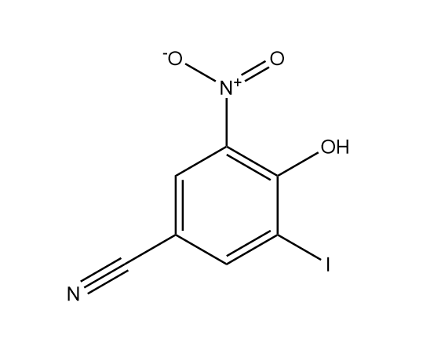

**Figure S1.** Molecular structure of NIT.

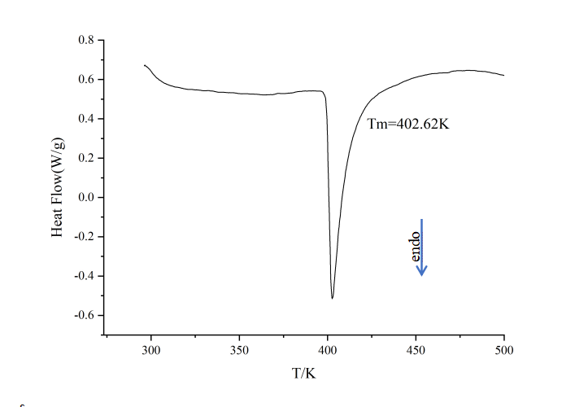

**Figure S2.** DSC thermogram of NIT as original sample.

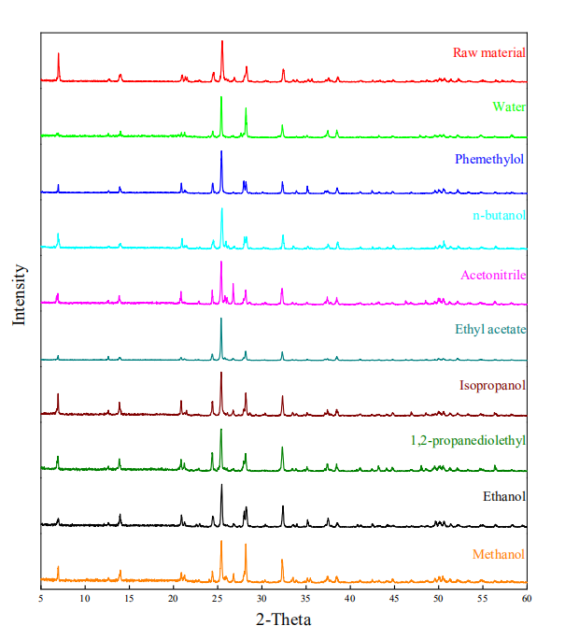

**Figure S3.** PXRD pattern of NIT after the solubility experiments at 323.15 K.

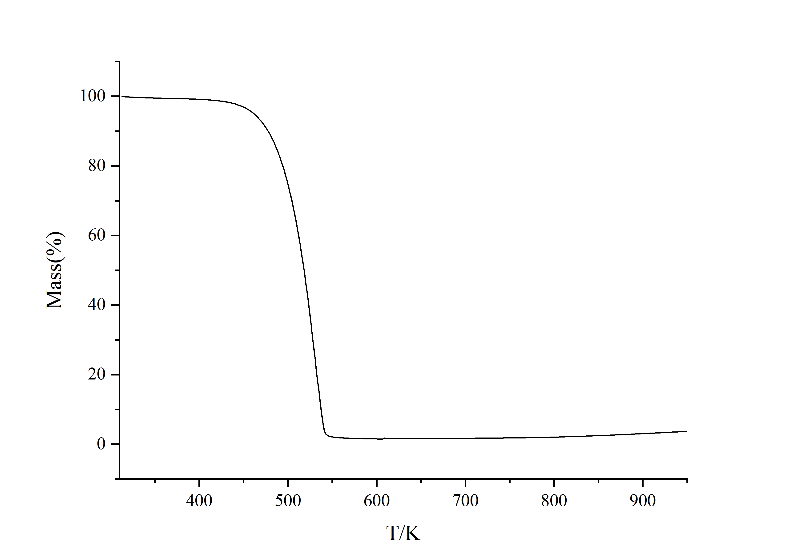

**Figure S4.**Thermogravimetric analysis of NIT.

1. These authors contributed equally to this work.
2. * Corresponding author

   *E-mail addresses*: fuhl2005@sohu.com