**Supplementary Materials**

**Ascorbic acid supported Carboxymethyl cellulose stabilized silver nanoparticles as optical nanoprobe for Au3+ detection in environmental sample**

**Titilope John Jayeoyea*, Chamaiporn Supachettapunb, Nongnuj Muangsina,c\***

*a Department of Chemistry, Faculty of Science, Chulalongkorn University, Bangkok 10330, Thailand*

*b Program of Petrochemistry and polymer science, Faculty of Science, Chulalongkorn University, Bangkok 10330, Thailand*

*c Nanotec-CU Center of Excellence on Food and Agriculture, Department of Chemistry, Faculty of Science, Chulalongkorn University, Bangkok 10330, Thailand*

**Corresponding authors,**

* N. Muangsin ([nongnuj.j@chula.ac.th](mailto:nongnuj.j@chula.ac.th); [nongnuj.ms@gmail.com](mailto:nongnuj.ms@gmail.com))
* T.J. Jayeoye ([titilope12@gmail.com](mailto:titilope12@gmail.com); jayeoye.t@chula.ac.th)

Department of Chemistry, Faculty of Science, Chulalongkorn University, Bangkok 10330, Thailand

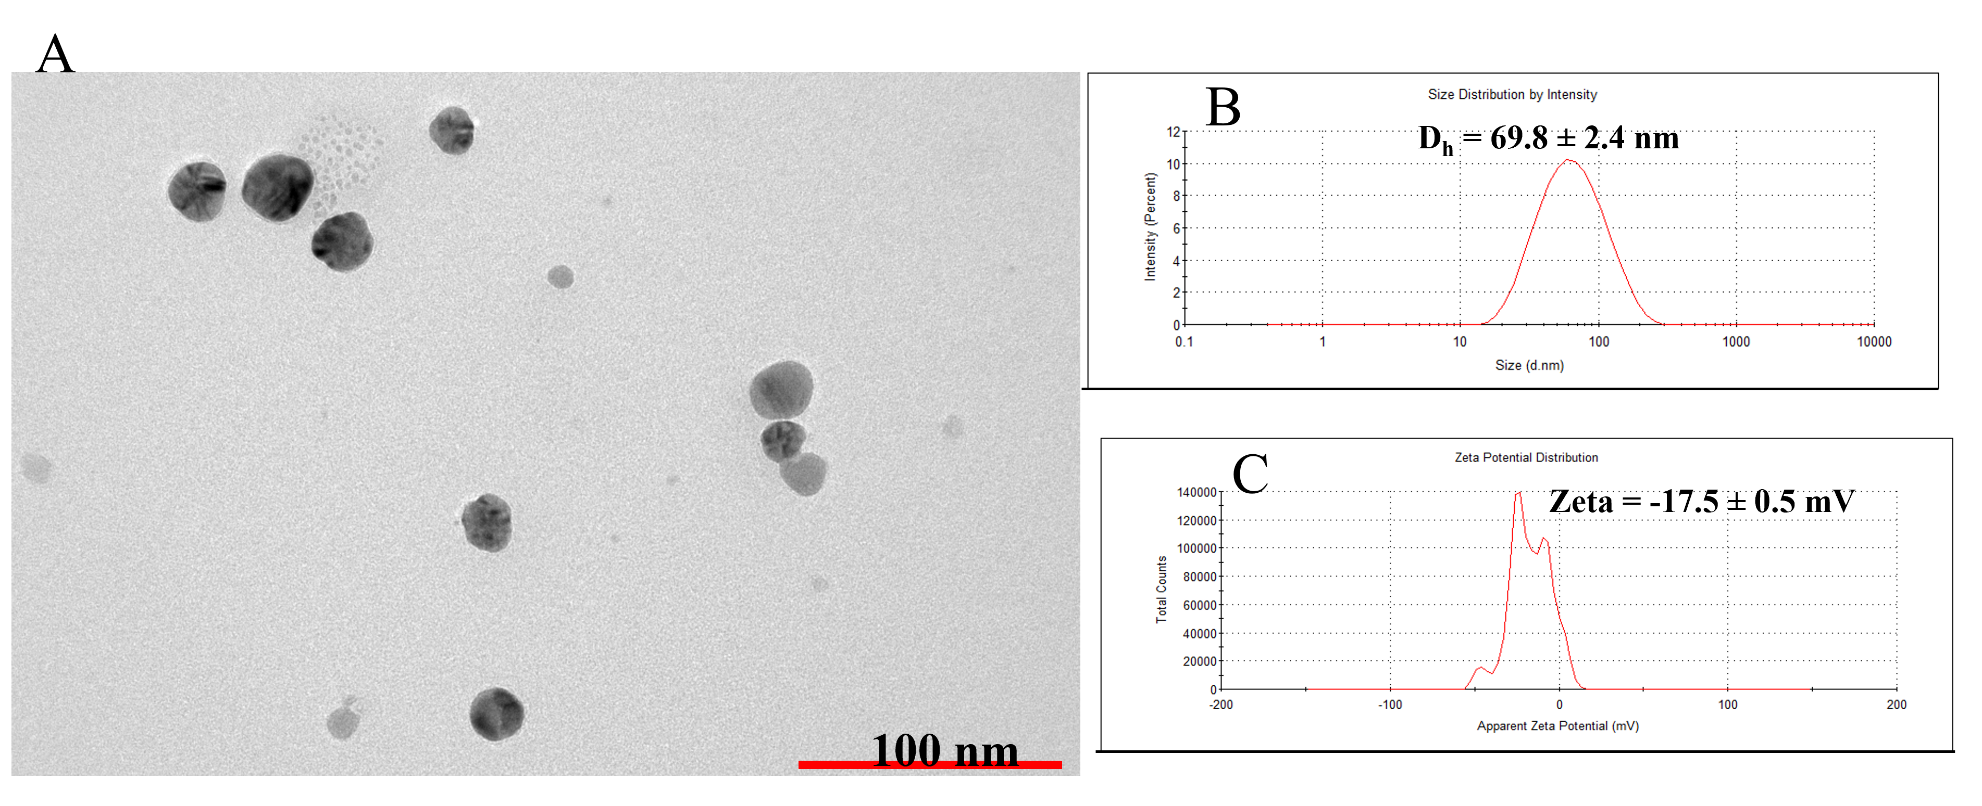

**Fig.S1.** (A) TEM images (B) Hydrodynamic diameter from DLS machine (C) Zeta potential of CMC-AgNPS.

**Fig.S2.** EDS Spectra of CMC-AgNPs, inset shows the percent elemental composition

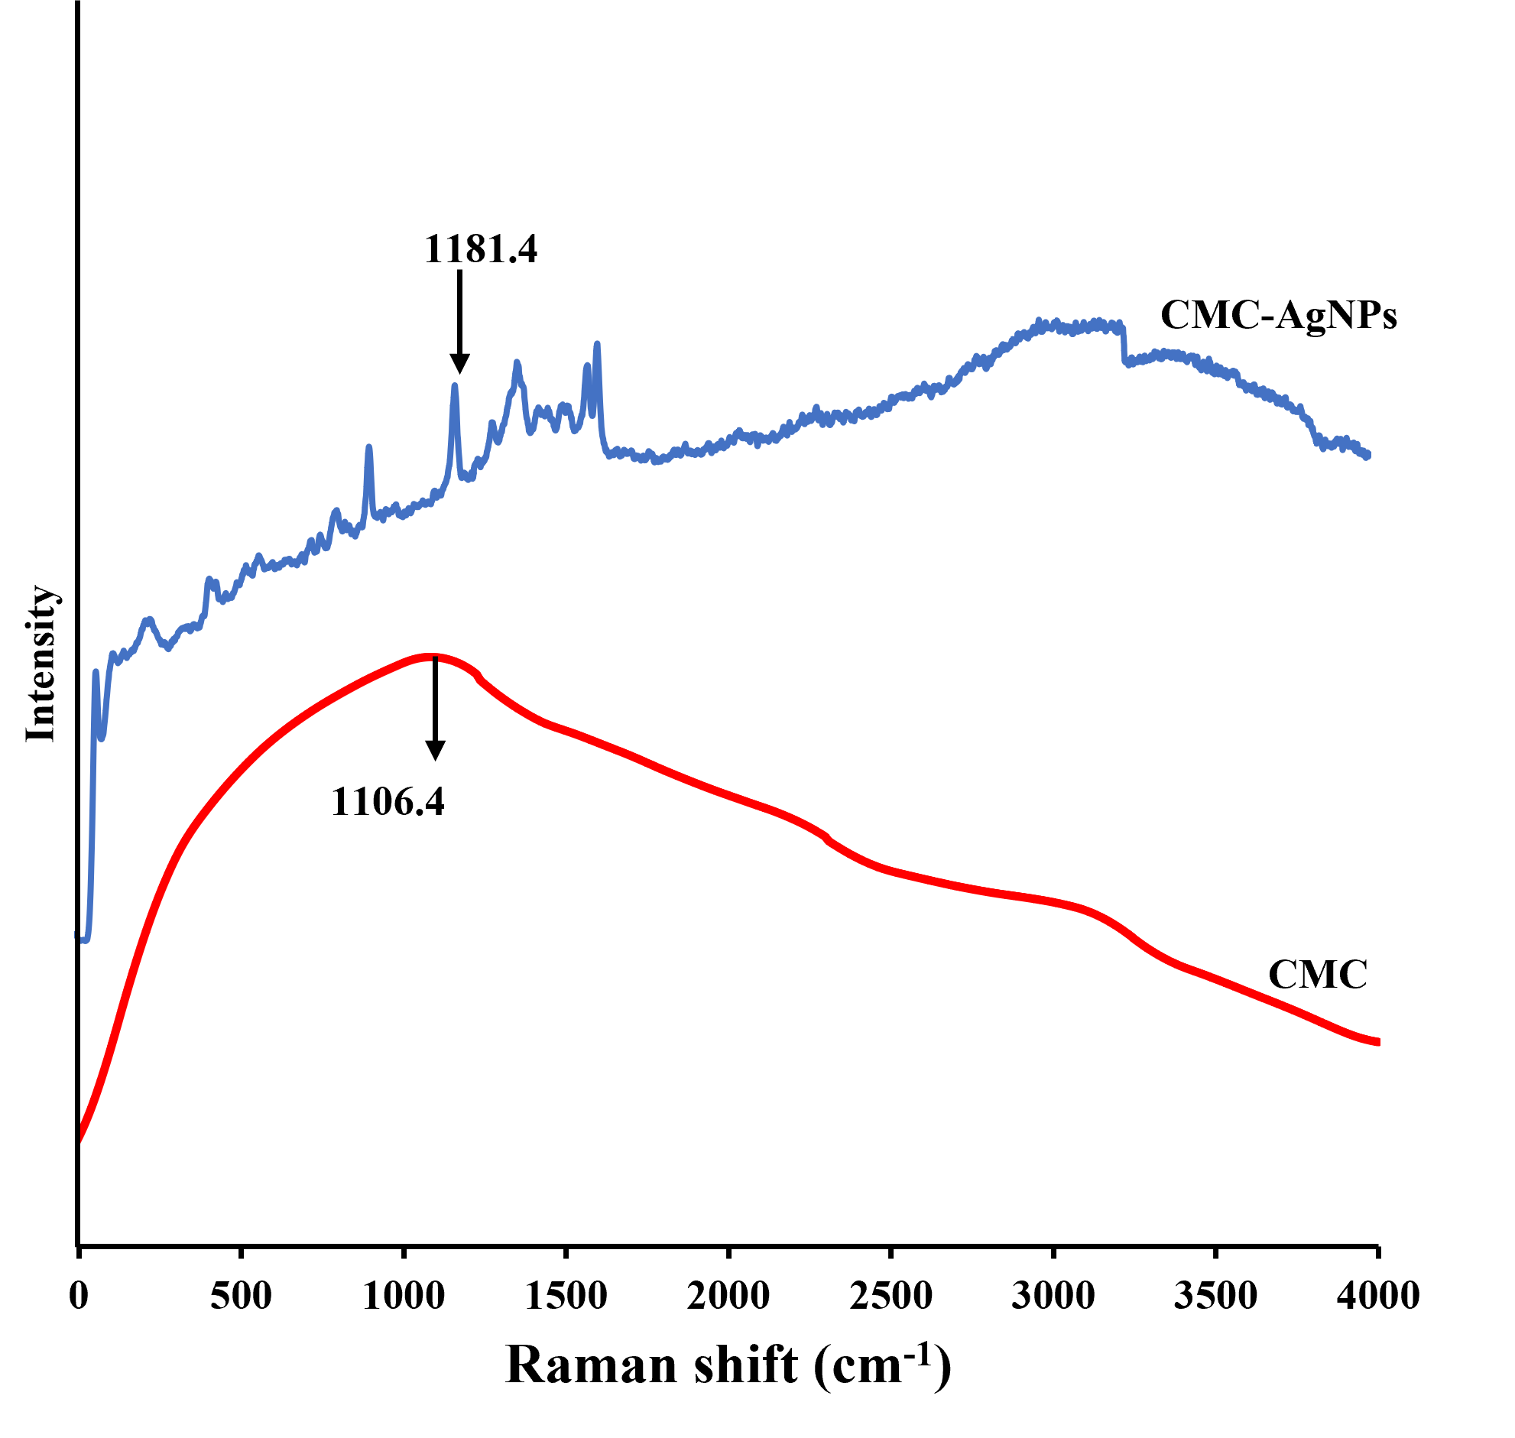

**Fig.S3.** Raman spectra of CMC (red) and CMC-AgNPs (blue)

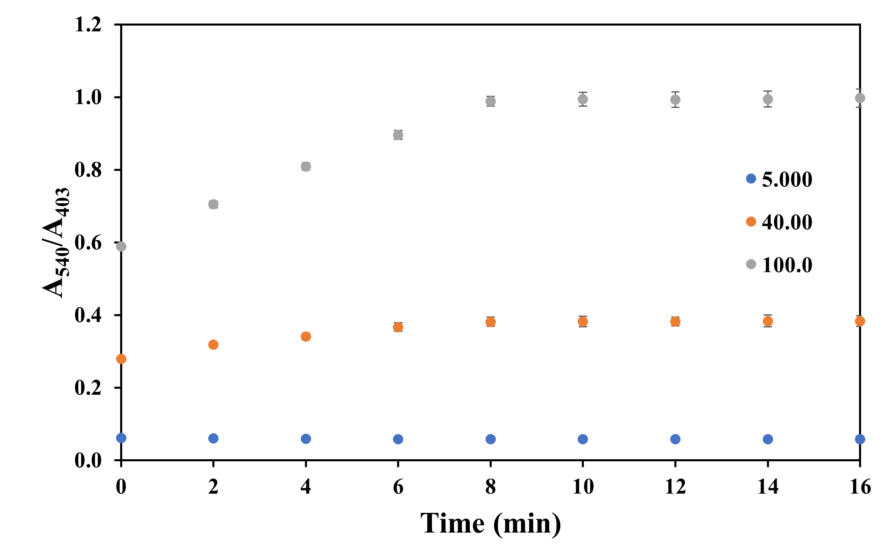

**Fig.S4.** Plot of A540/A403 against time at 2 min interval

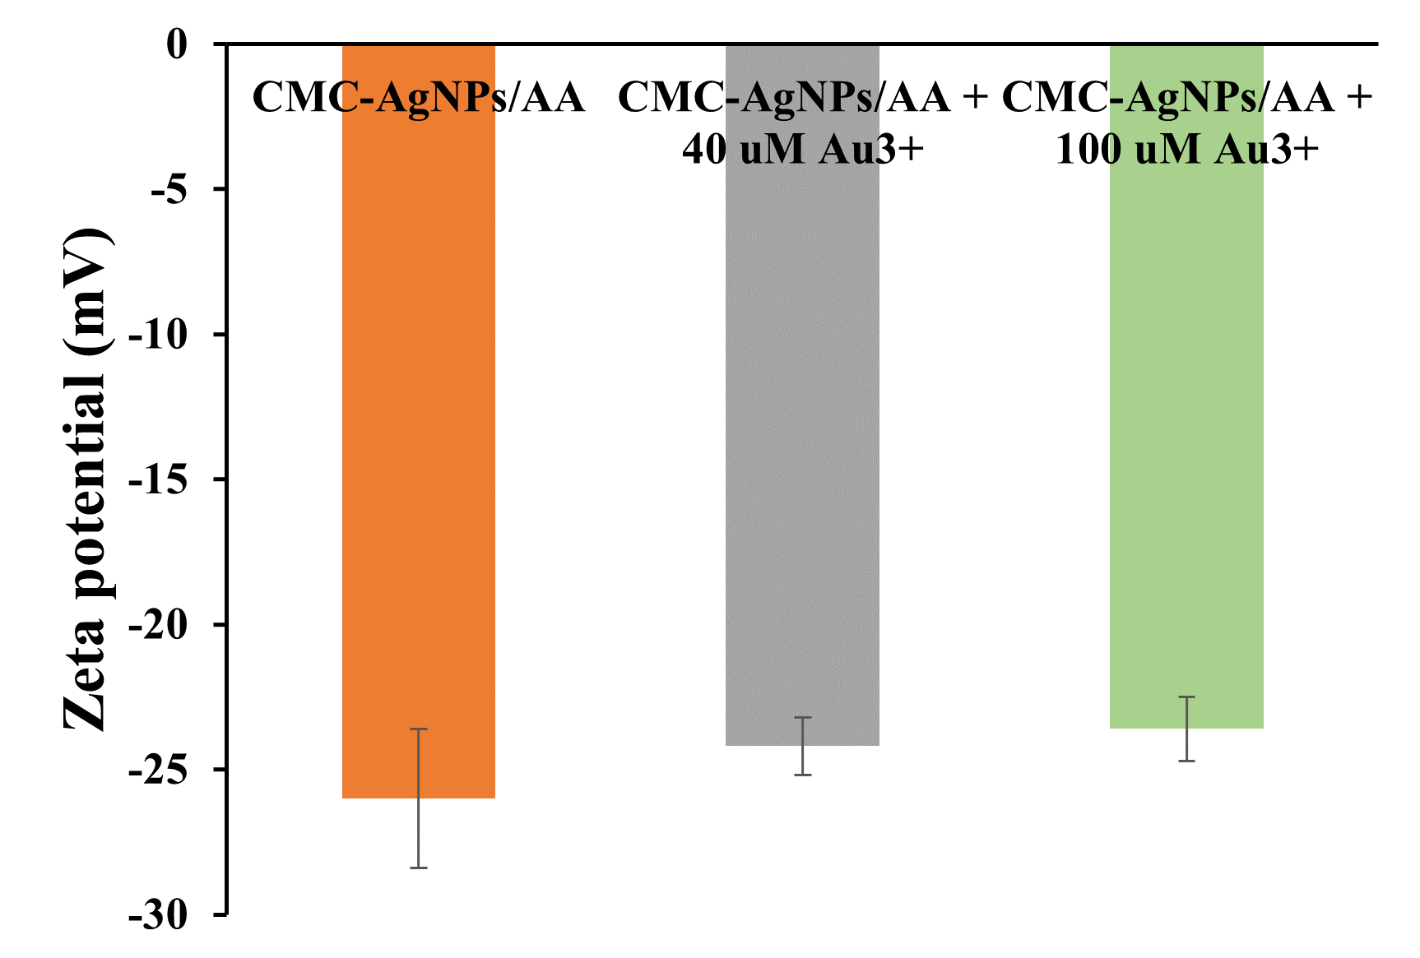

**Fig.S5.** Zeta potential of CMC-AgNPs under Au3+ injection at 0.00, 40.0 and 100.0 µM.

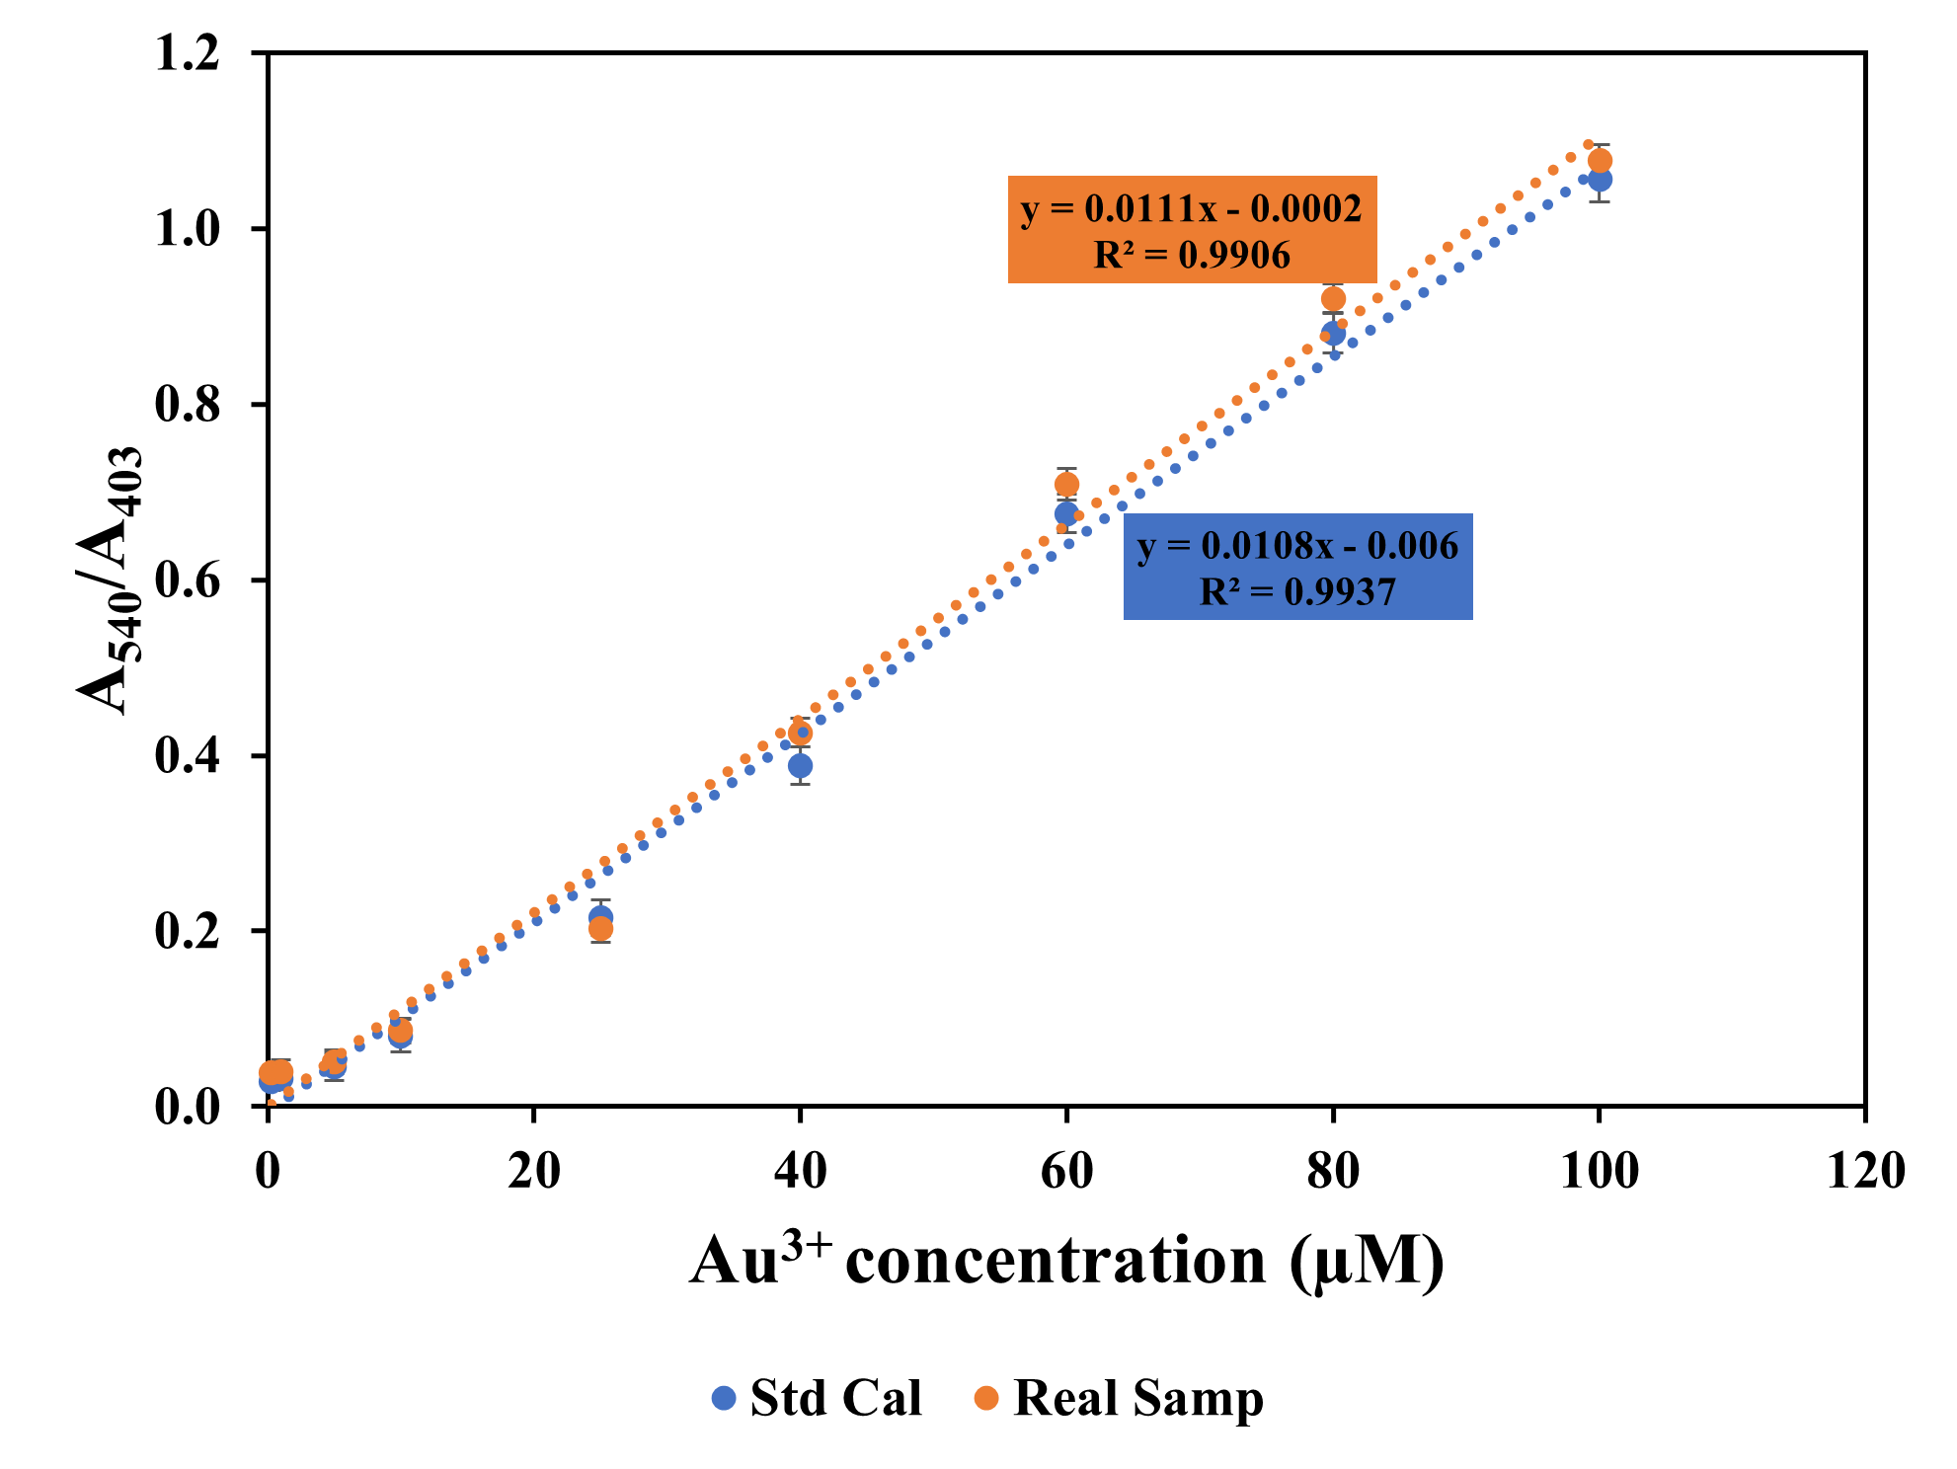

**Fig.S6.** Plot of A540/A403 vs Au3+ concentrations from 0.25 to 100.0 µM, comparing response for the calibration plot and in wastewater sample.