**Supplementary material**

**Supplementary method**

**EP20 hepatotoxicity verification**

Male C57BL/6 mice were continuously administrated with EP20 (50 mg/kg) or the same volume of 0.5% CMC-Na intragastrically for 7 days. After 1 week of treatment, mice were euthanized with CO2, and blood was collected and centrifuged to obtain serum. Two hepatotoxicity indexes, Alanine Aminotransferase (ALT), and Aspartate Aminotransferase (AST) were detected. ALT and AST were detected using kits from Jiangcheng Biotech (Nanjing, China).

**Supplementary result**

The hepatotoxicity of EP20 in mice was assessed, according to our prediction. EP20 at a dosage of 50mg/kg caused elevated alanine aminotransferase in serum, suggesting that EP20 possesses significant hepatotoxicity.(Sup Fig 2)

**Supplementary Fig 1 Total ion chromatogram**

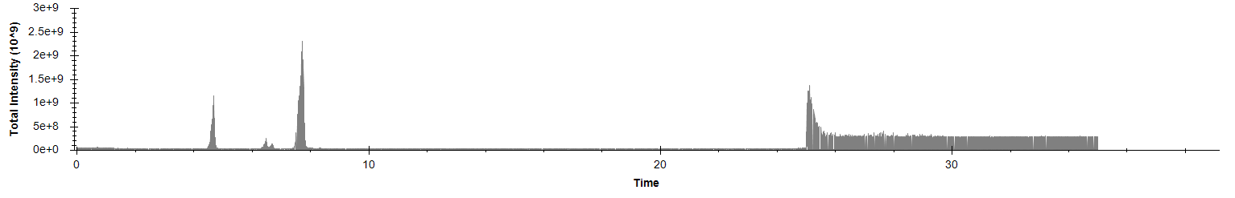

**Supplementary Fig 1** EP20 showed obvious hepatotoxicity. (A) EP20 caused elevated ALT in serum. (B) EP20 caused elevated AST in serum.

