Five undescribed plant-derived bisphenols from Artemisia capillaris aerial parts: Structure elucidation, anti-hepatoma activities and plausible biogenetic pathway

Lanlan Ge ^{a,b}, Qiujie Xie ª, Xiaofang Wei ª, Yangfang Li ª, Wanying Shen ^{a,c}, Yunguang Hu ^{d}, Jie Yao ª, Shuling Wang ^{e}, Xiao Du ^{e,f}**, and Xiaobin Zeng ^{a,b,g,}*

ª Center Lab of Longhua Branch and Department of Infectious Disease, Shenzhen People’s Hospital (The Second Clinical Medical College, Jinan University; The First Affiliated Hospital, So uthern University of Science and Technology), Shenzhen 518020, Guangdong Province, PR China.
^{b} Department of pathology (Longhua Branch), Shenzhen People’s Hospital (The Second Clinical Medical College, Jinan University; The First Affiliated Hospital, Southern University of Science and Technology), Shenzhen 518120, Guangdong Province, PR China.
^{c} College of pharmacy, Gansu University of Chinese Medicine, Lanzhou 73000, Gansu Province, PR China.
^{d} Guangdong Yifang Pharmaceutical Co., Ltd., Foshan 528241, Guangdong Province, PR China.
^{e} College of Pharmacy, School of Medicine, Hangzhou Normal University, Hangzhou 311121, Zhejiang Province, PR China.
^{f} China Resources Sanjiu Medical & Pharmaceutical Co., Ltd., Shenzhen 518110, Guangdong Province, PR China.
^{g} Guangdong Provincial Key Laboratory of Regional Immunity and Diseases, Medicine School of Shenzhen University, Shenzhen 518037, Guangdong Province, PR China.

* Corresponding authors: Dr. X. Du, du9111024@163.com; Prof. X. Zeng, zeng.xiaobin@szhospital.com
Contents
No. | Items | Page
1 | Figure S1a-h ¹H-NMR, ¹³C-NMR, 2D-NMR, MS and IR spectrum of 13 | 1-8
2 | Figure S2a-g ¹H-NMR, ¹³C-NMR, 2D-NMR, MS and IR spectrum of 15 | 9-16
3 | Figure S2a-g ¹H-NMR, ¹³C-NMR, 2D-NMR, MS and IRspectrum of 25 | 17-24
4 | Figure S2a-g ¹H-NMR, ¹³C-NMR, 2D-NMR, MS and IR spectrum of 29 | 25-32
5 | Figure S2a-g ¹H-NMR, ¹³C-NMR, 2D-NMR, MS and IR spectrum of 31 | 33-40
6 | Figure S2a-g ¹H-NMR, ¹³C-NMR, 2D-NMR, MS and IR spectrum of 32 | 41-48

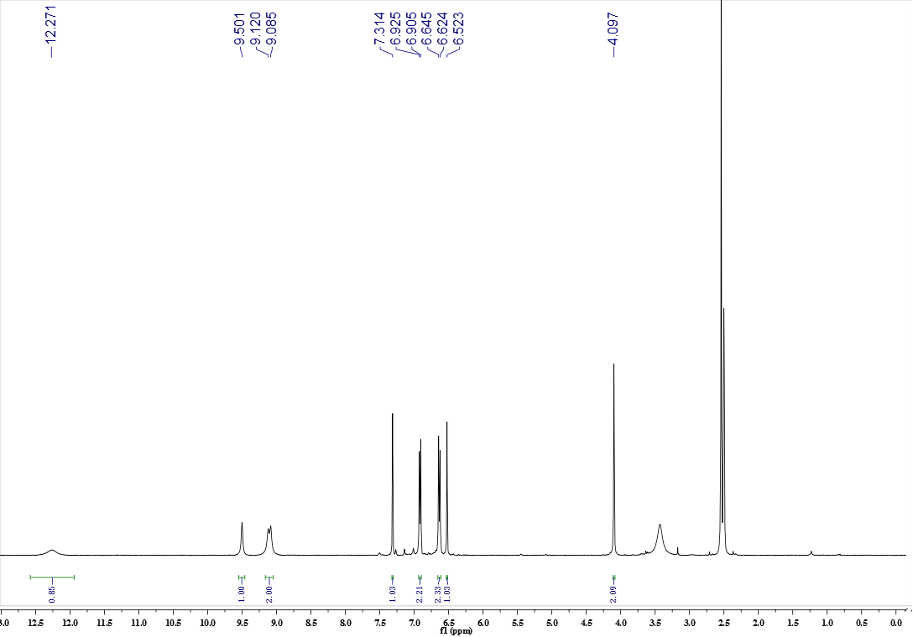
Figure S1a ¹H-NMR spectrum of compound 13
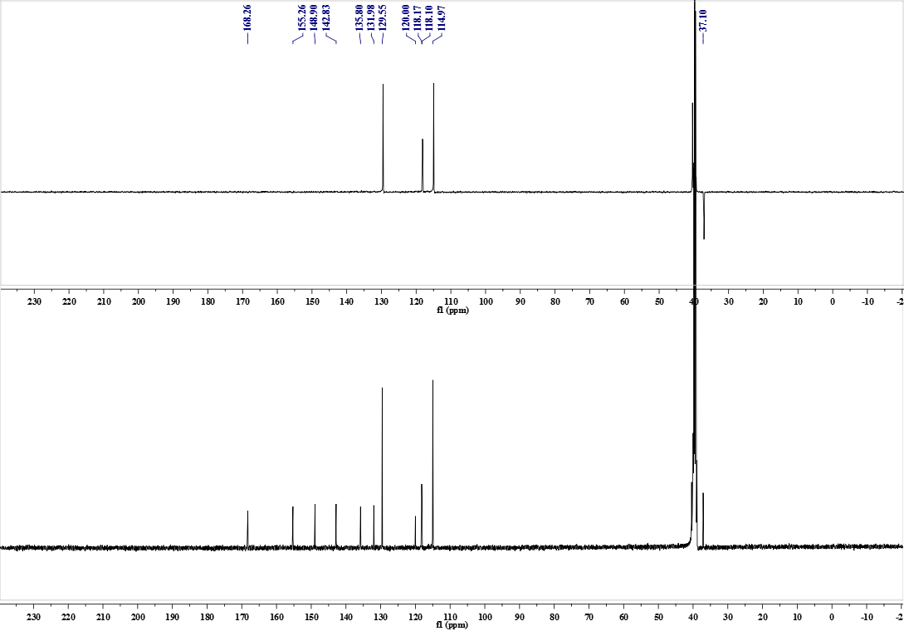
Figure S1b ¹³C-NMR and DEPT spectrum of compound 13
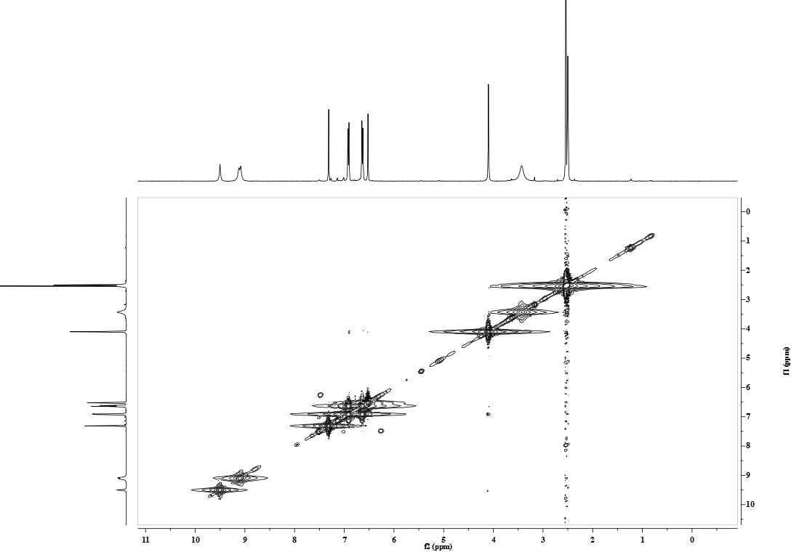
Figure S1c ¹H-¹H COSY spectrum of compound 13
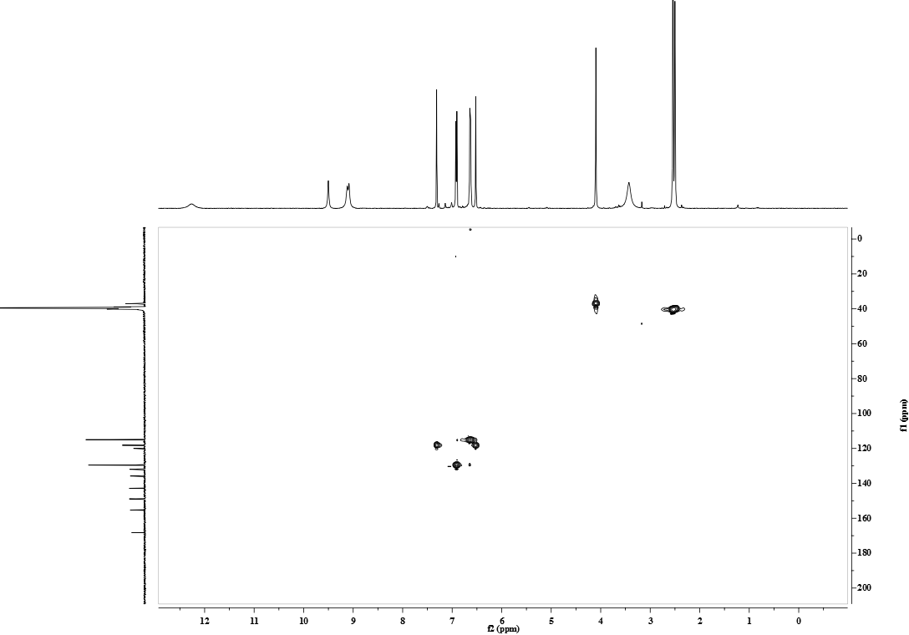
Figure S1d HSQC spectrum of compound 13
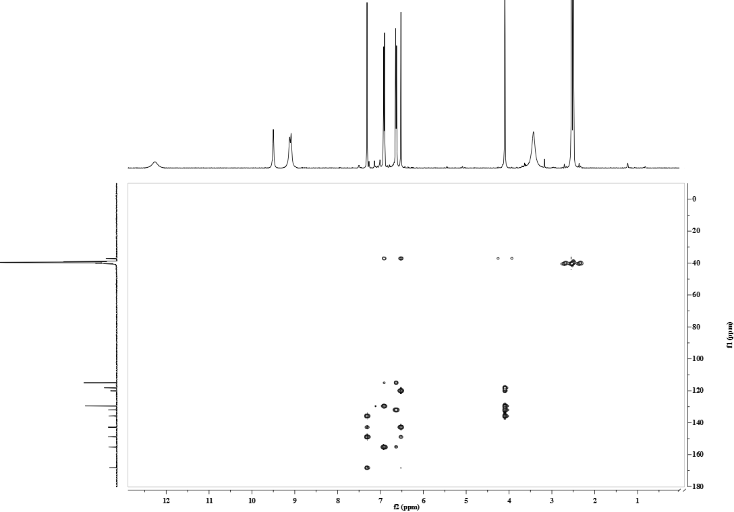
Figure S1e HMBC spectrum of compound 13
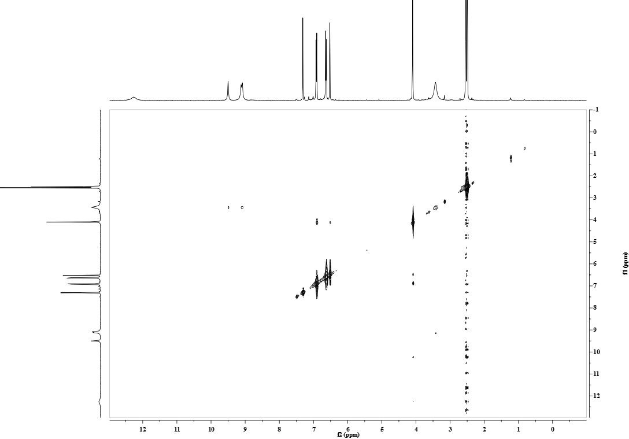
Figure S1f NOESY spectrum of compound 13
Figure S1g HR-ESI-TOF-MS spectrum of compound 13

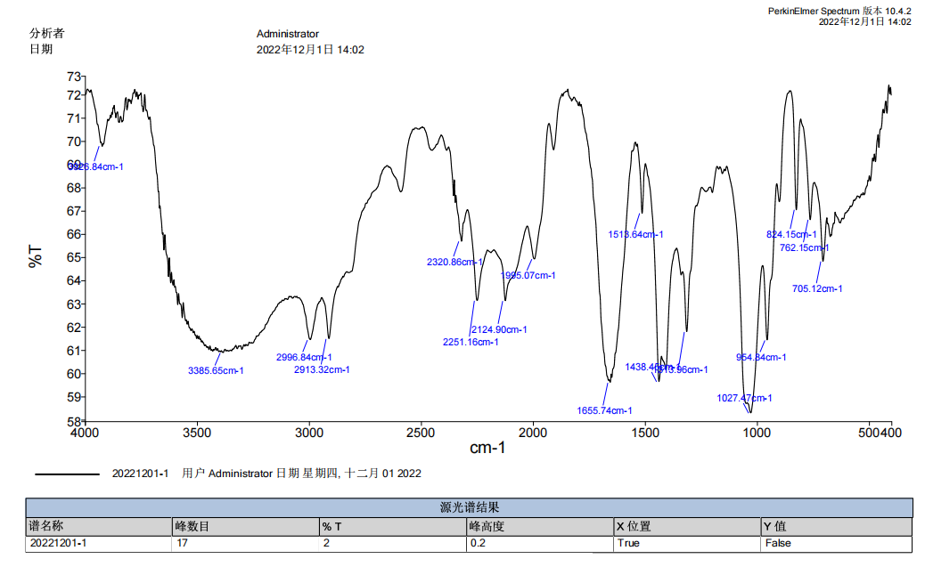
Figure S1h IR spectrum of compound 13
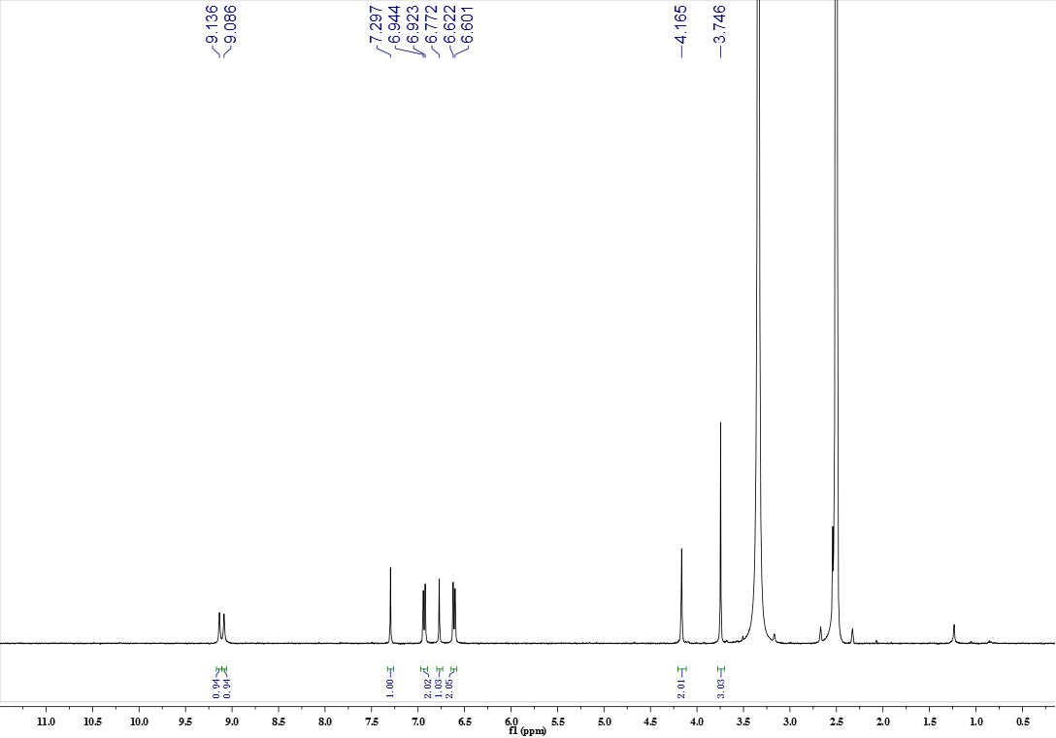
Figure S2a ¹H-NMR spectrum of compound 15
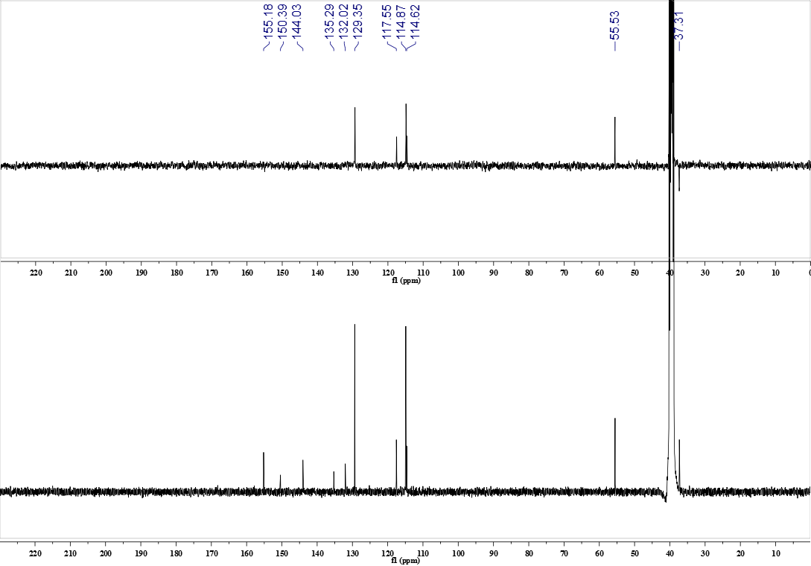
Figure S2b ¹³C-NMR and DEPT spectrum of compound 15
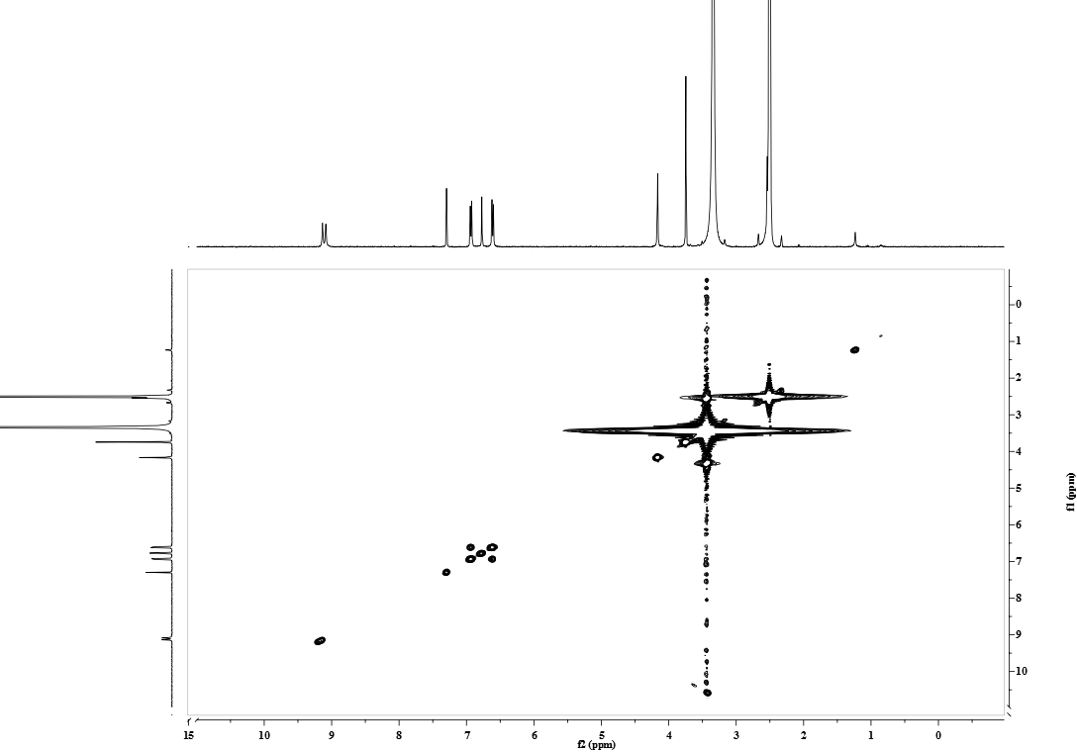
Figure S2c ¹H-¹H COSY spectrum of compound 15
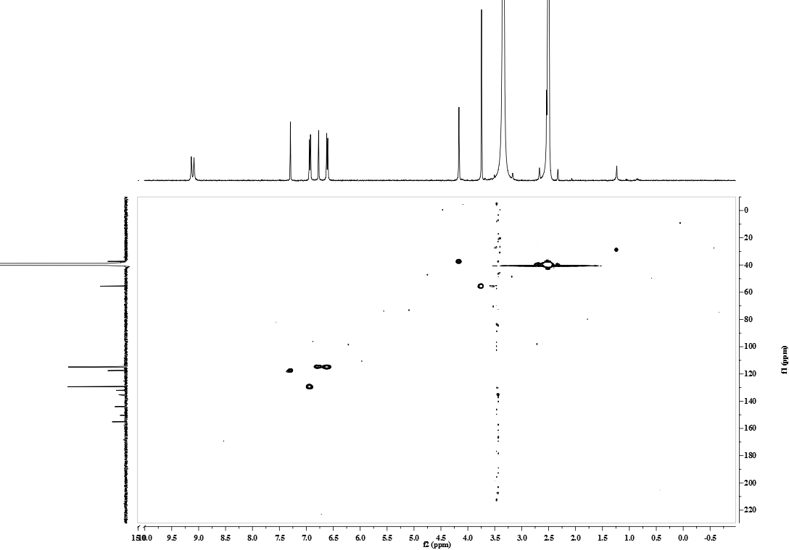
Figure S2d HSQC spectrum of compound 15
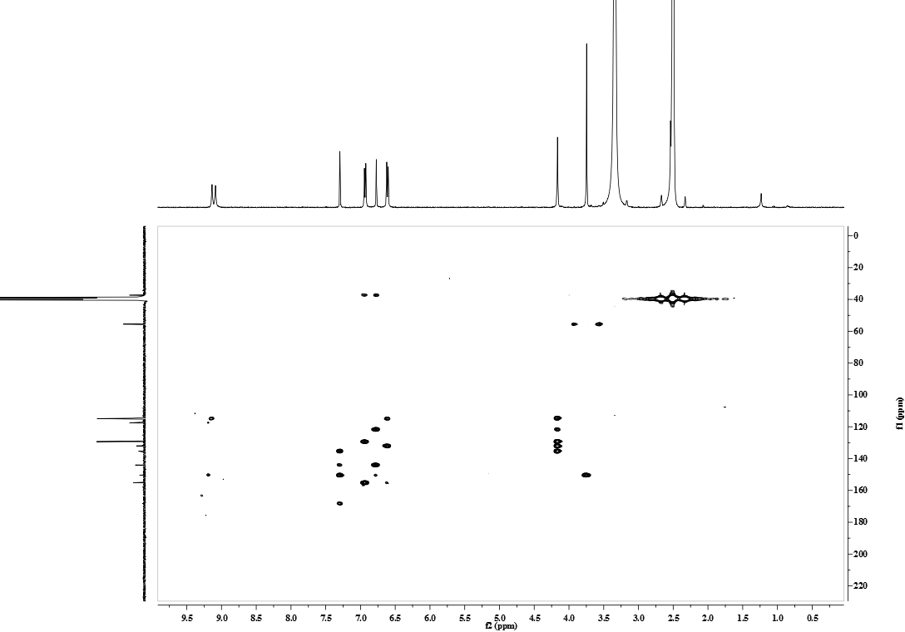
Figure S2e HMBC spectrum of compound 15
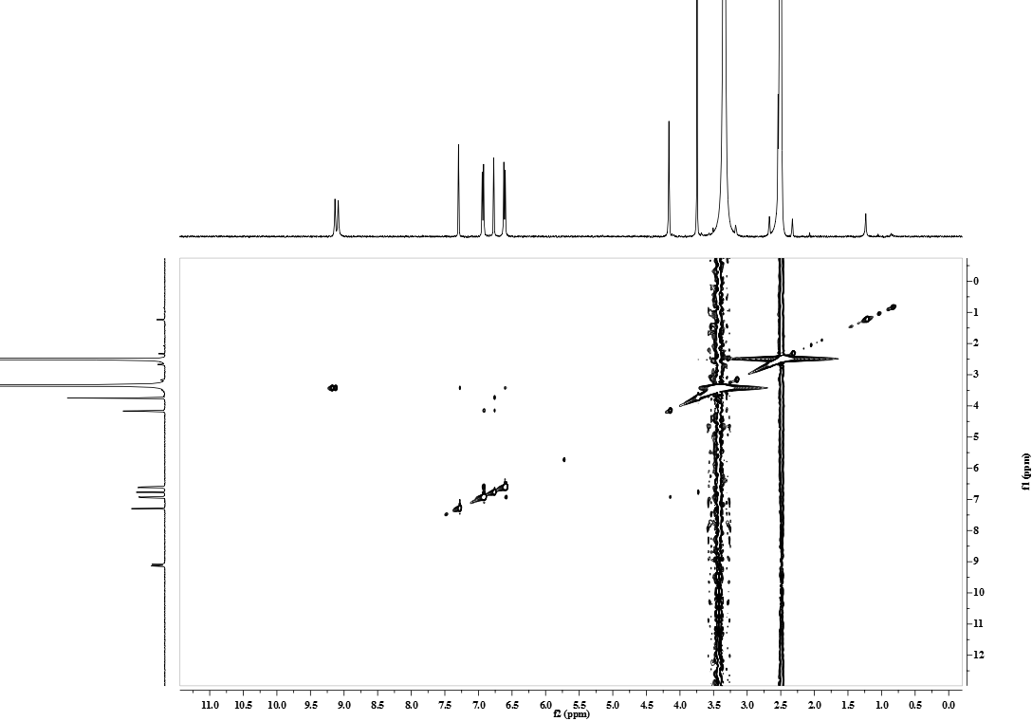
Figure S2f NOESY spectrum of compound 15
Figure S2g HR-ESI-TOF-MS spectrum of compound 15
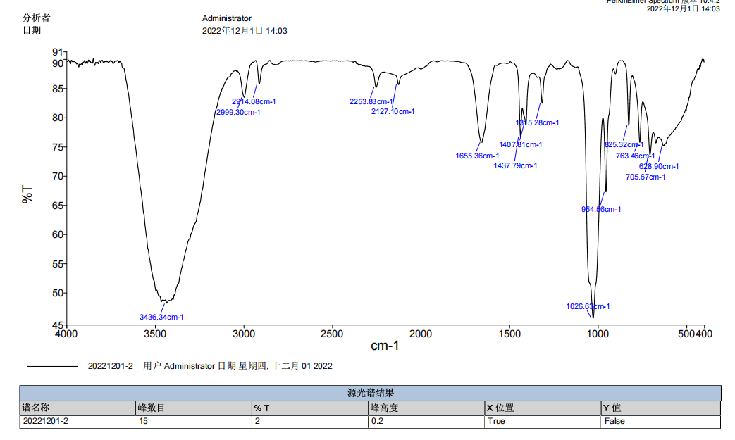
Figure S2h IR spectrum of compound 15
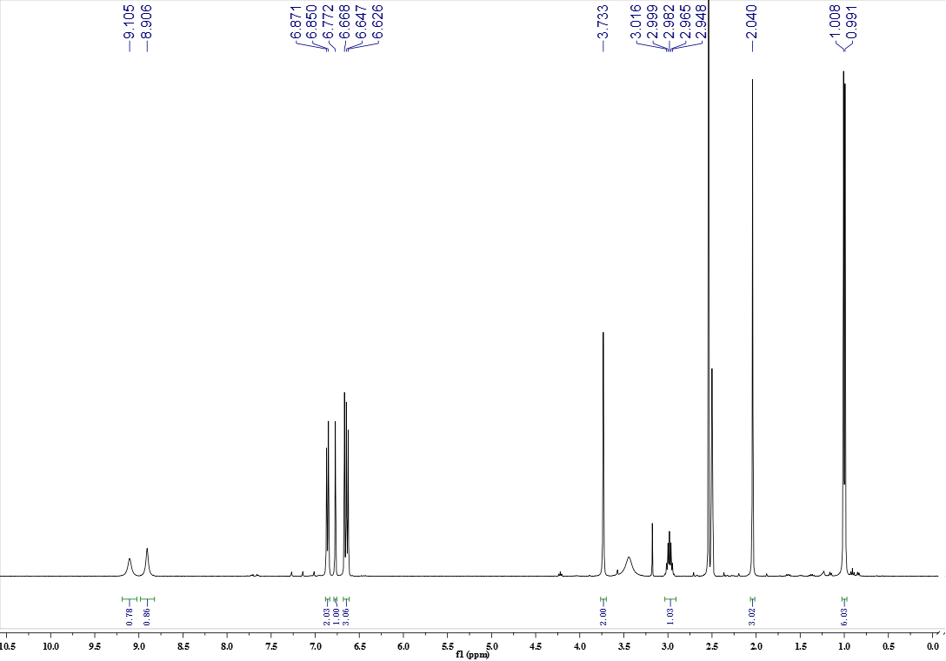
Figure S3a ¹H-NMR spectrum of compound 25
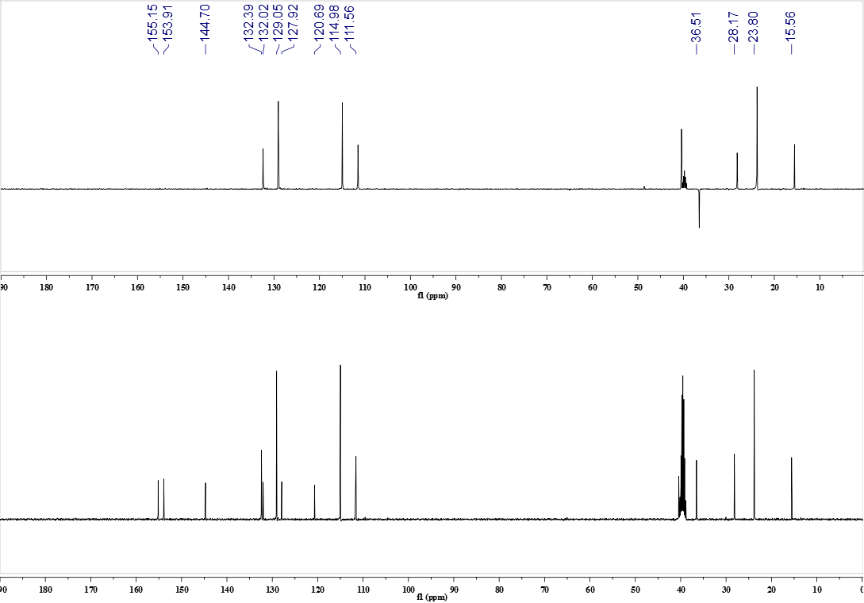
Figure S3b ¹³C-NMR and DEPT spectrum of compound 25
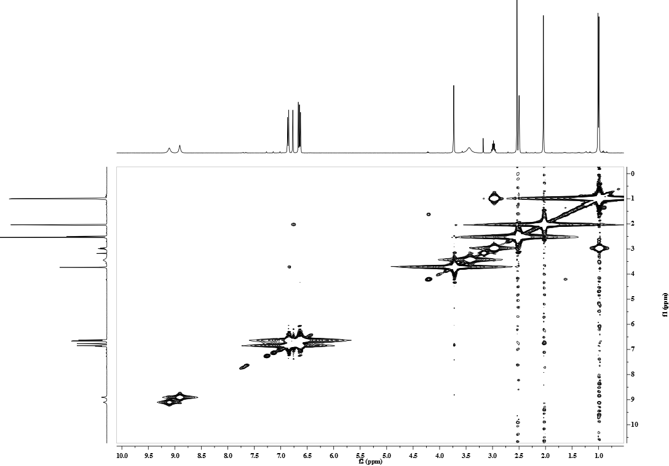
Figure S3c ¹H-¹H COSY spectrum of compound 25
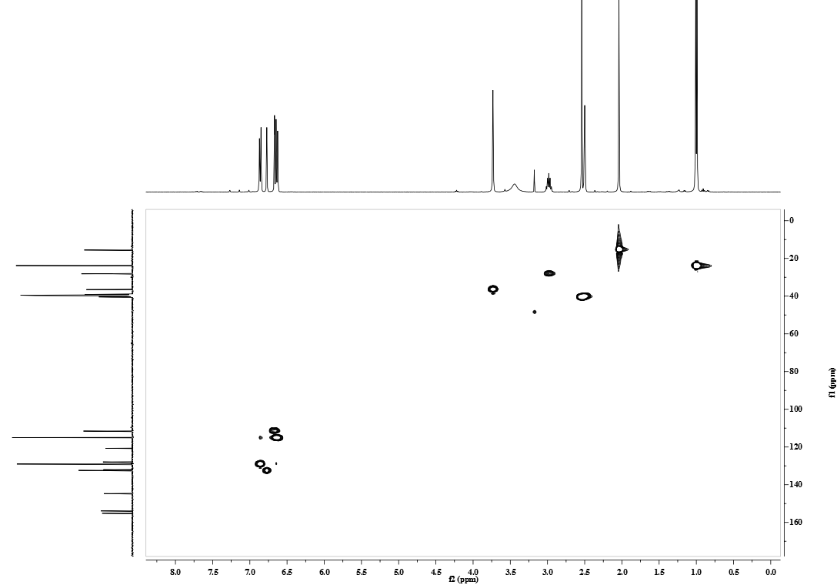
Figure S3d HSQC spectrum of compound 25
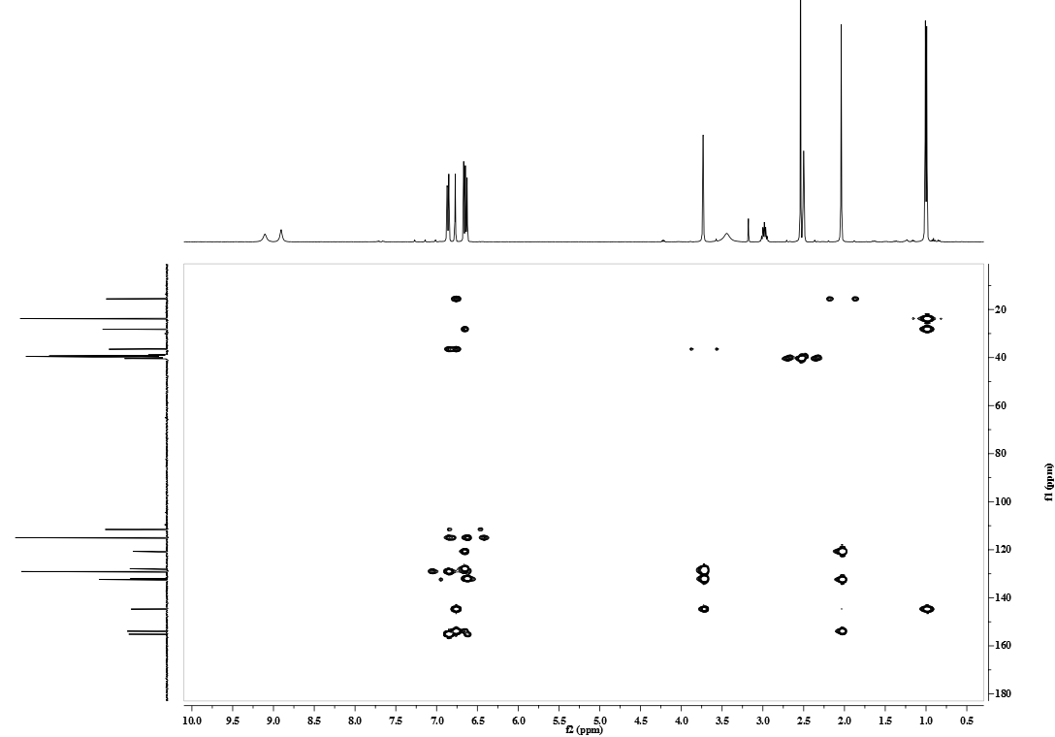
Figure S3e HMBC spectrum of compound 25
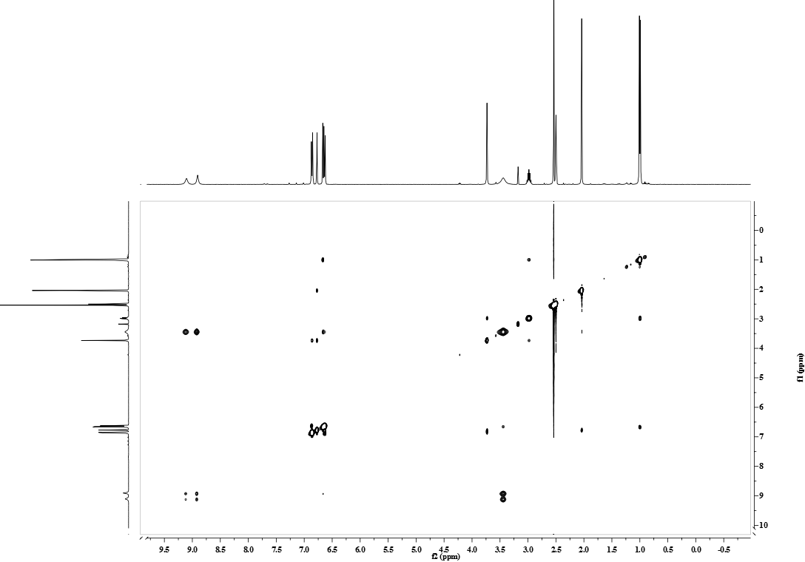
Figure S3f NOESY spectrum of compound 25
Figure S3g HR-ESI-TOF-MS spectrum of compound 25
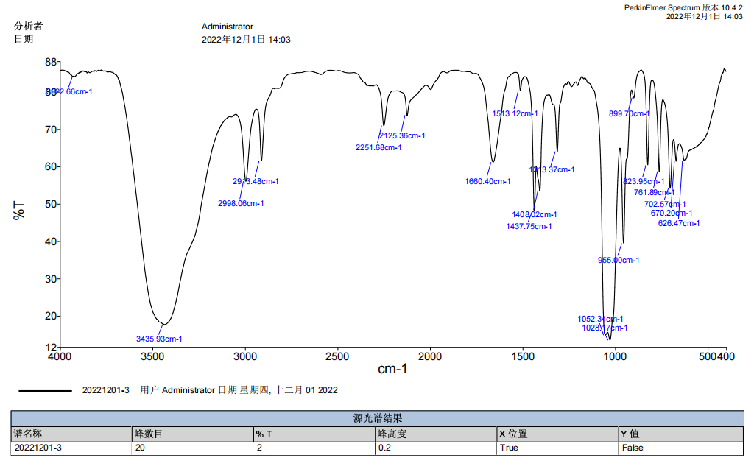
Figure S3h IR spectrum of compound 25
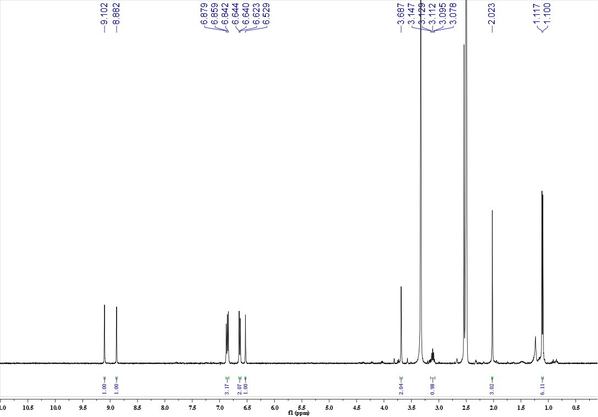
Figure S4a ¹H-NMR spectrum of compound 29
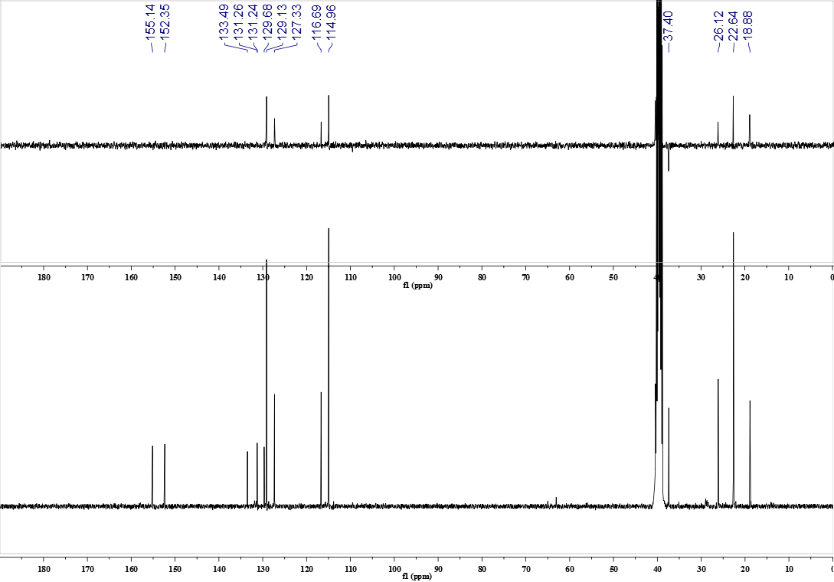
Figure S4b ¹³C-NMR and DEPT spectrum of compound 29
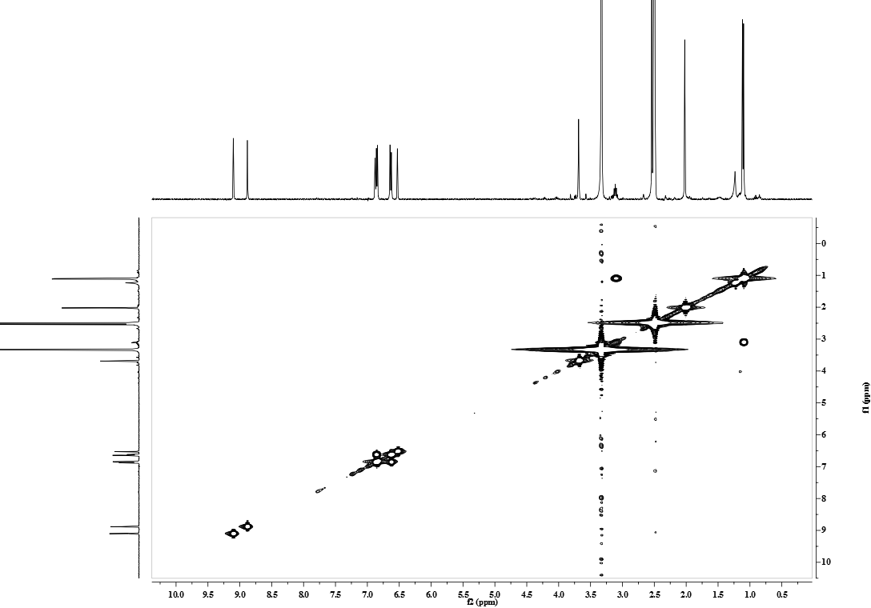
Figure S4c ¹H-¹H COSY spectrum of compound 29
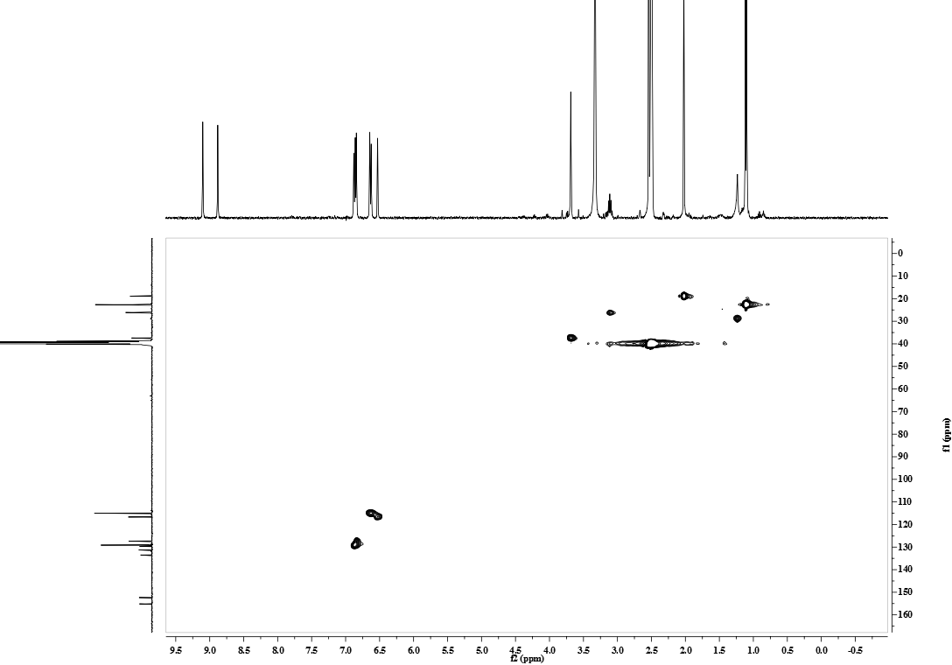
Figure S4d HSQC spectrum of compound 29
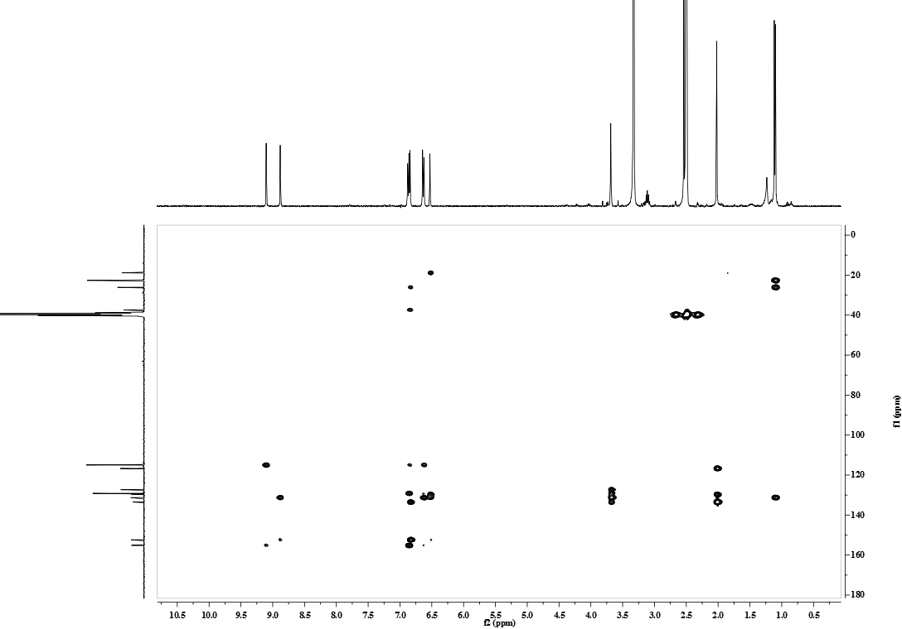
Figure S4e HMBC spectrum of compound 29
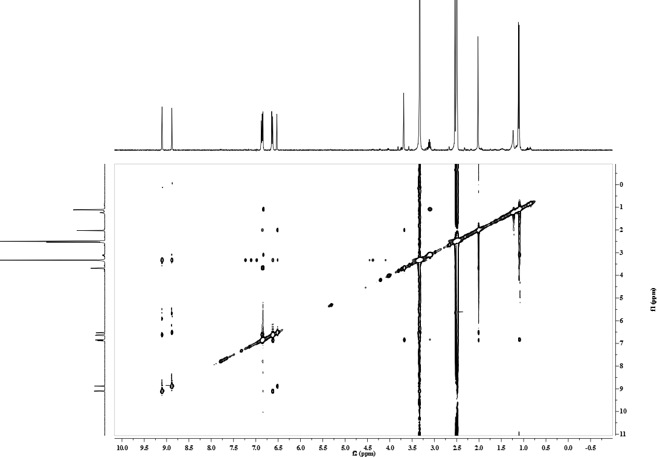
Figure S4f NOESY spectrum of compound 29
Figure S4g HR-ESI-TOF-MS spectrum of compound 29
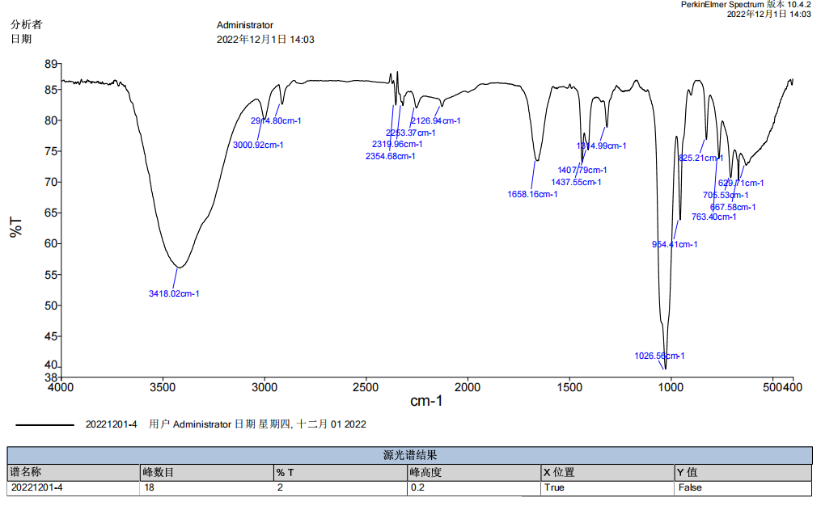
Figure S4h IR spectrum of compound 29
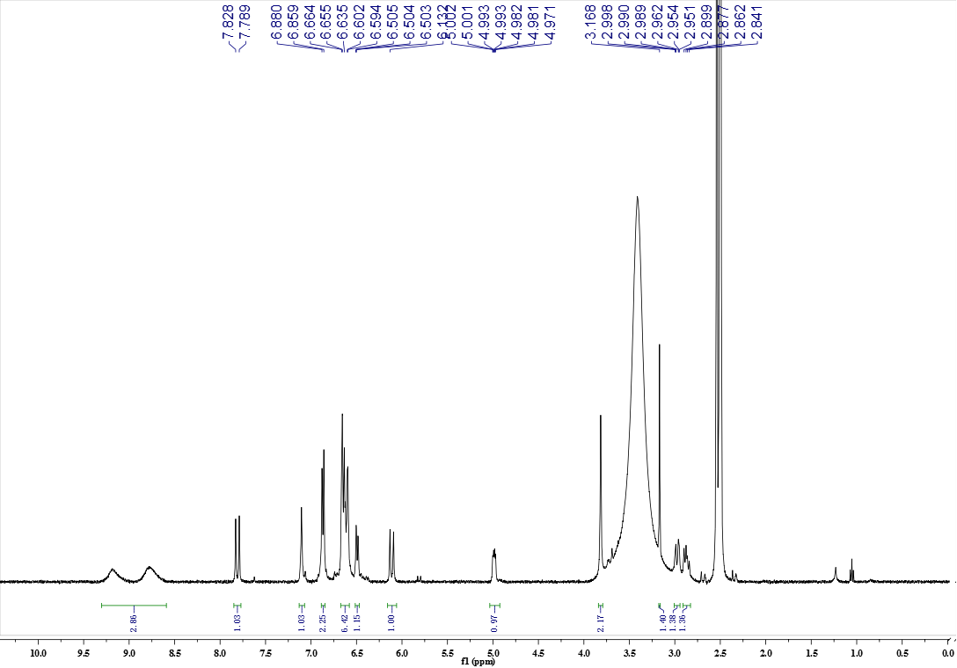
Figure S5a ¹H-NMR spectrum of compound 31
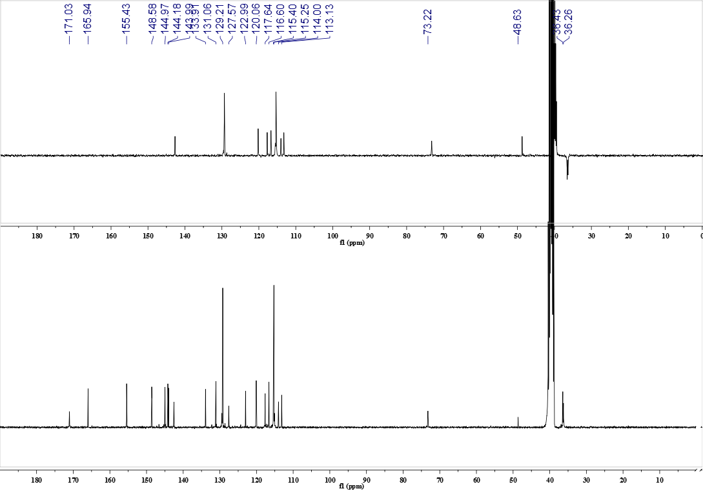
Figure S5b ¹³C-NMR and DEPT spectrum of compound 31
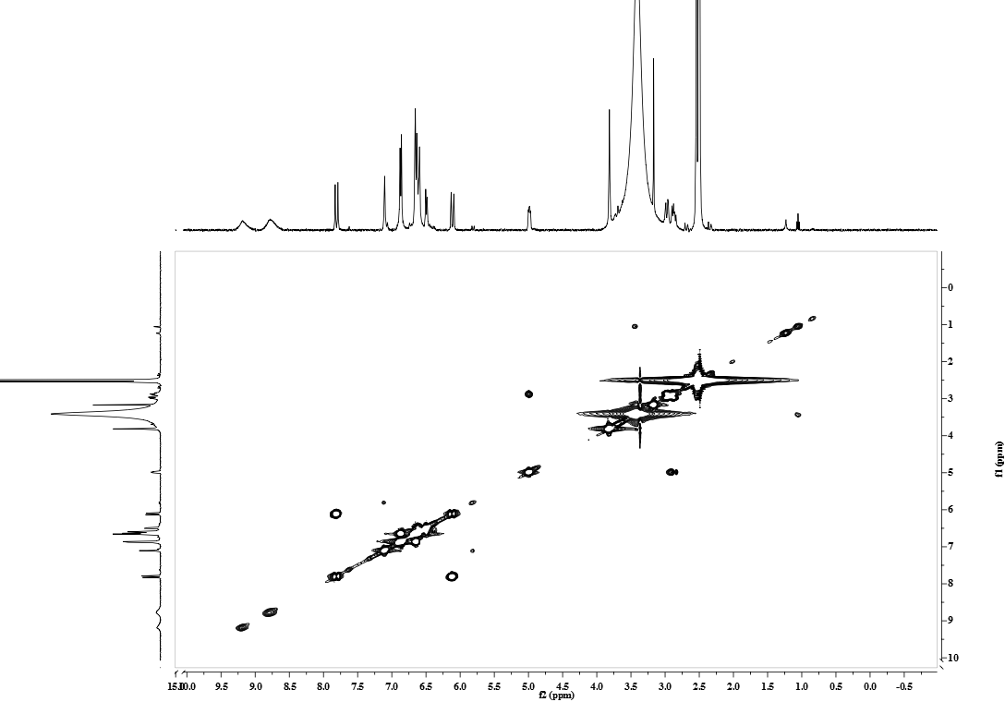
Figure S5c ¹H-¹H COSY spectrum of compound 31
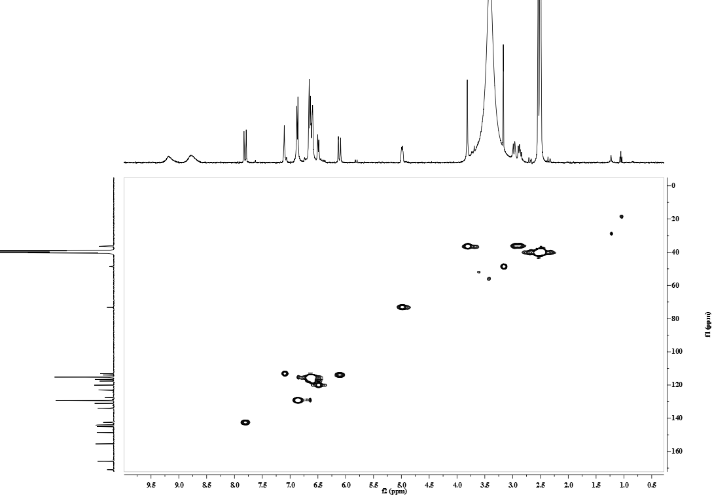
Figure S5d HSQC spectrum of compound 31
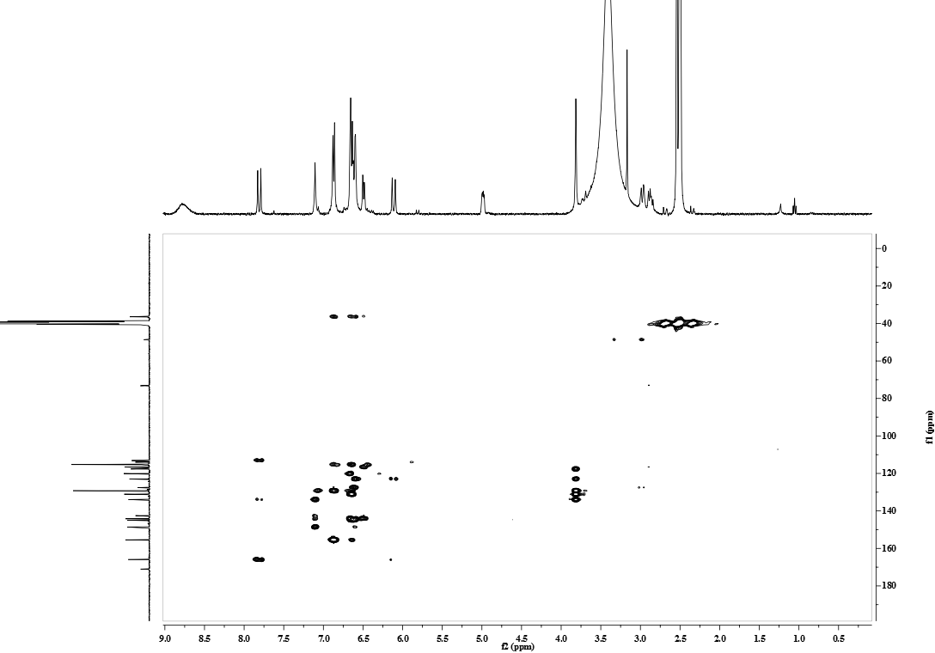
Figure S5e HMBC spectrum of compound 31
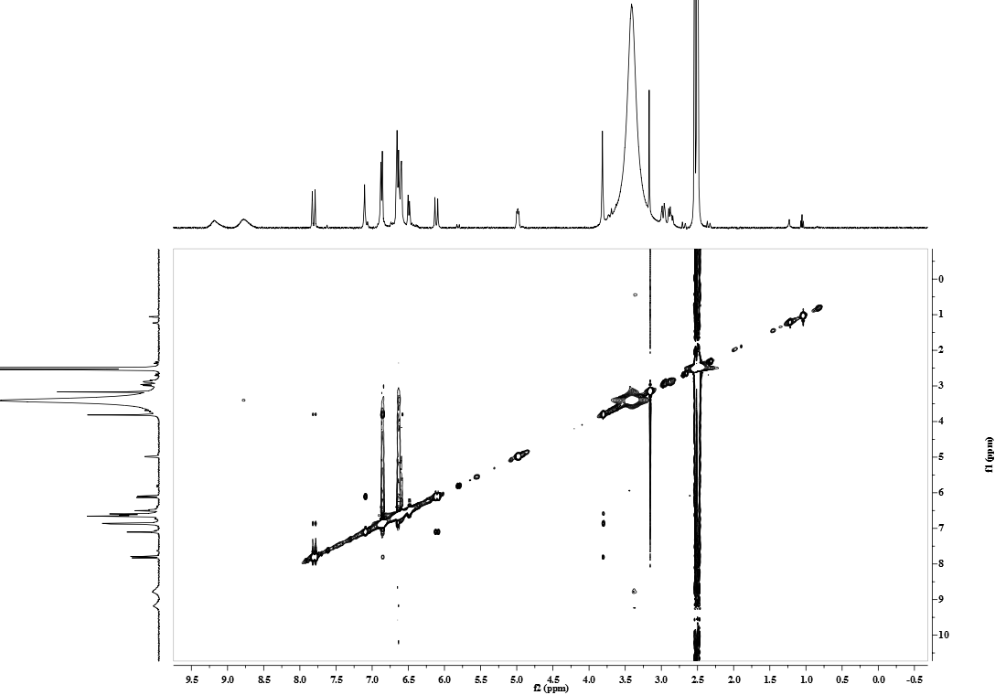
Figure S5f NOESY spectrum of compound 31
Figure S5g HR-ESI-TOF-MS spectrum of compound 31
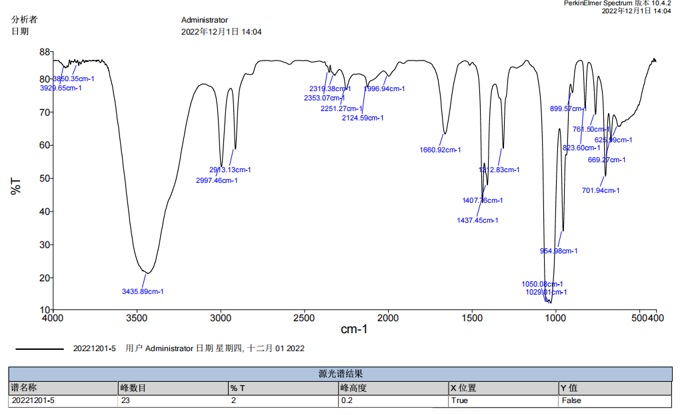
Figure S5h IR spectrum of compound 31
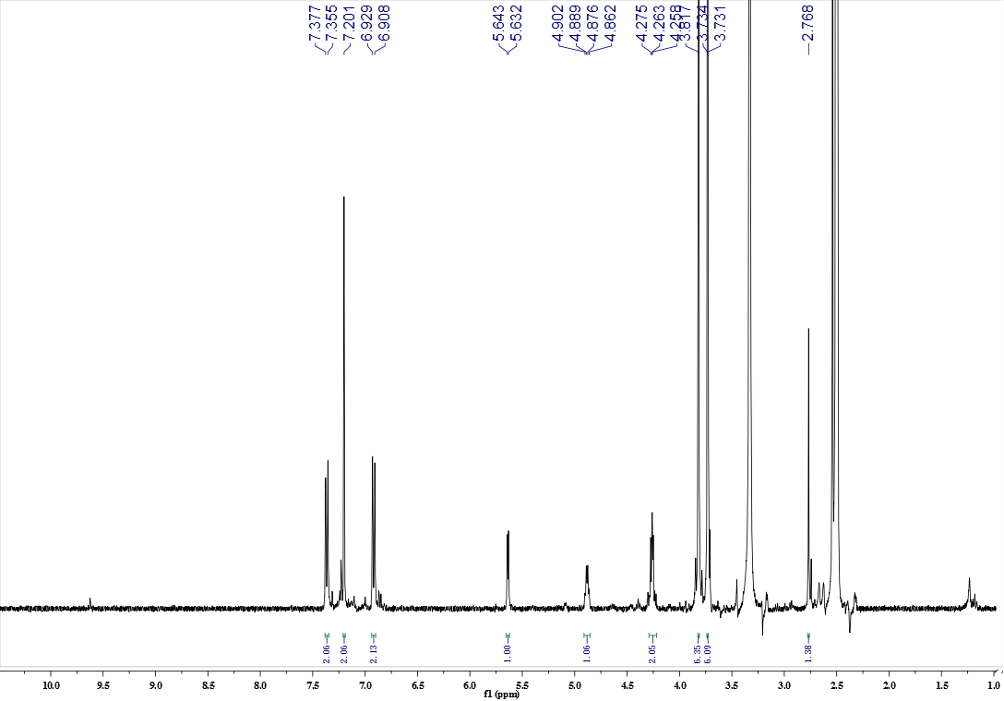
Figure S6a ¹H-NMR spectrum of compound 32
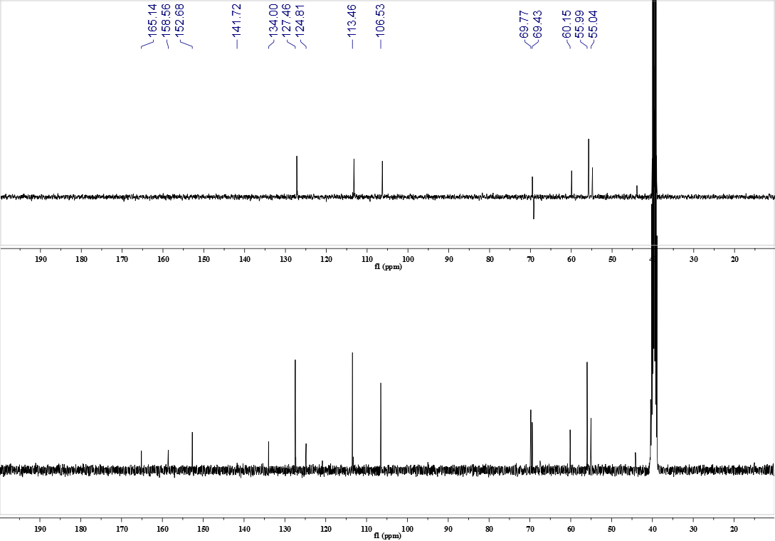
Figure S6b ¹³C-NMR and DEPT spectrum of compound 32
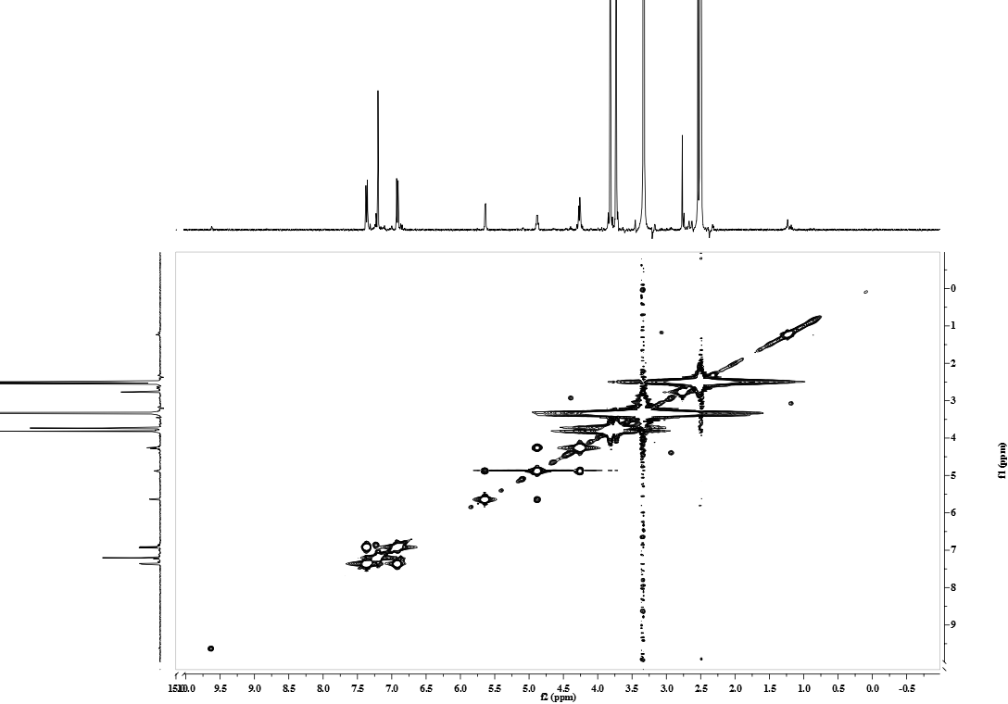
Figure S6c ¹H-¹H COSY spectrum of compound 32
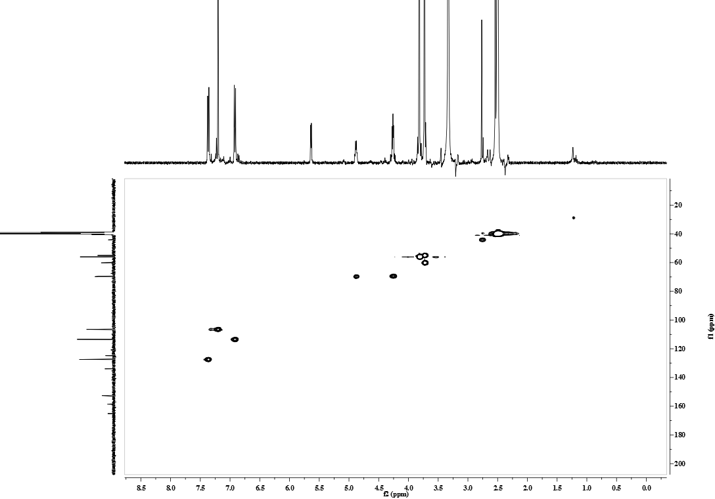
Figure S6d HSQC spectrum of compound 32
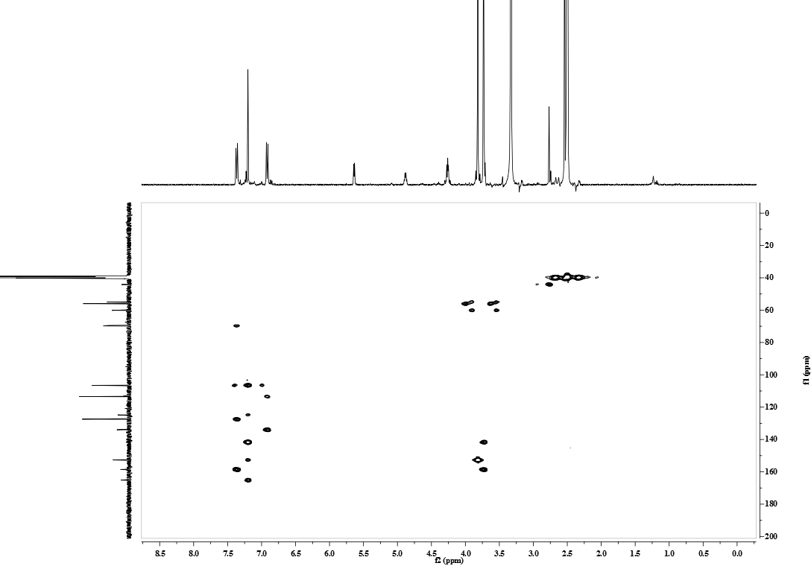
Figure S6e HMBC spectrum of compound 32
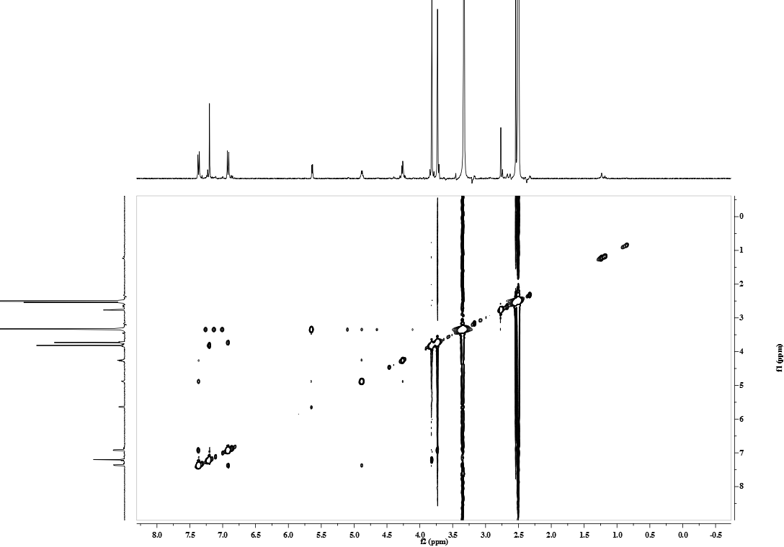
Figure S6f NOESY spectrum of compound 32
Figure S6g HR-ESI-TOF-MS spectrum of compound 32
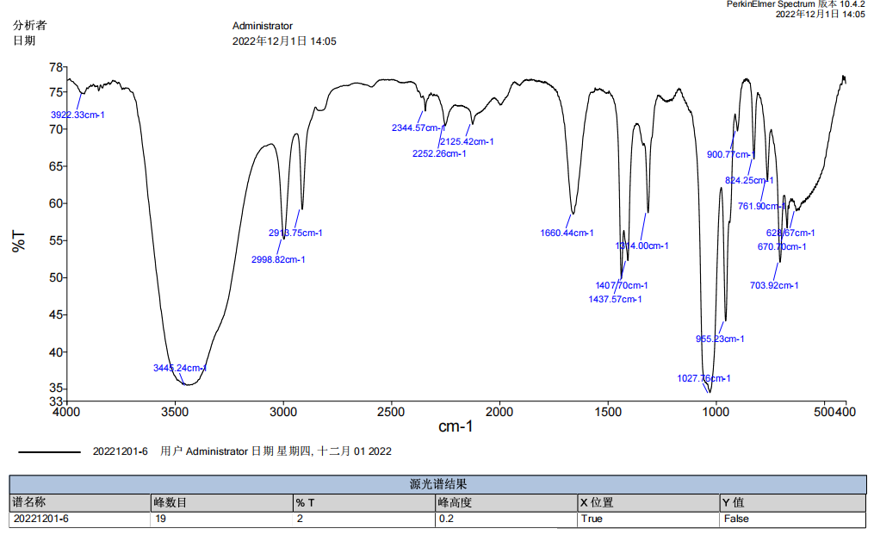
Figure S6h IR spectrum of compound 32

