**Supplementary material**

**ssDNA-QDs/GO multicolor fluorescence system for synchronous screening of hepatitis virus DNA**

# Junping Guo1, Huan Zhang1, Jiajia Yang[1]*, Ying Zhang, Jiekai Wang, Guiqin Yan

*Shanxi Normal University,* Taiyuan, 030031, China

**Fig. S1**



**Fig. S1.** (**A**)-(**C**) HRTEM images of QDs(525), QDs(585), and QDs(632). (**D**)-(**F**) Hydrodynamic size distribution of QDs(525), QDs(585), and QDs(632).

**Fig. S2**



**Fig. 2** (**A**)-(**C**) The UV-vis absorption spectrum of pure QDs and QDs@CHAV-DNA, QDs@CHBV-DNA and QDs@CHCV-DNA.

**E**E

**Fig. S3.**

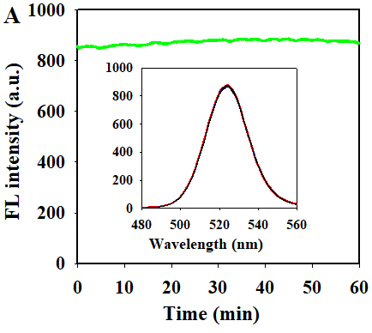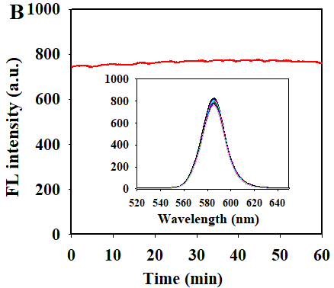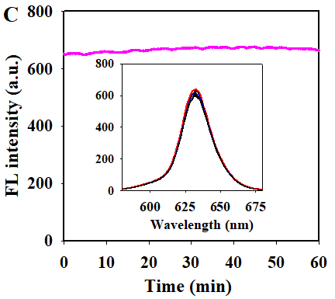

**Fig. S3.** (**A**)-(**C**) Fluorescence kinetics curves of QDs@CHAV-DNA, QDs@CHBV-DNA, and QDs@CHCV-DNA. within 60 min. Insert: The change of fluorescence emission spectra of QDs@CHAV-DNA, QDs@CHBV-DNA, and QDs@CHCV-DNA within 60 min.

**Fig. S4**



**Fig. S4.** HR-TEM image of GO.

**Fig. S5**



**Fig. S5. (A)**Fluorescence emission spectra of QDs@CDNA/GO with different concentrations of HBV-DNA (1.0 nM and 128 nM). **(B)**Fluorescence emission spectra of QDs@CDNA/GO with different concentrations of HCV-DNA (1.0 nM and 128 nM). **(C)** Fluorescence emission spectra of QDs@CDNA/GO with different concentrations of HAV-DNA, HBV-DNA and HCV-DNA (1.0 nM and 128 nM).

**Fig. S6**

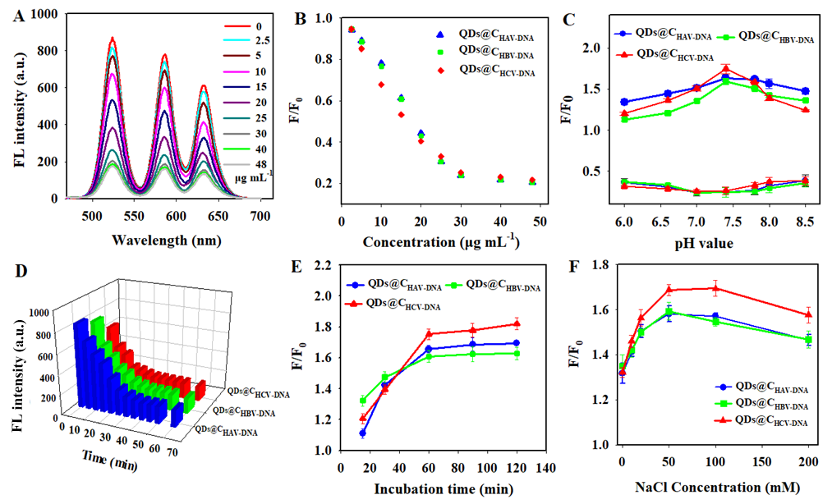

**Fig. S6.** (**A**)Effect of GO concentration on the fluorescence intensity of QDs@CDNA. (**B**)Effect of GO concentration (0-48 μg mL-1) on the F/F0 of QDs@CDNA. (**C**) Effect of pH value on the F/F0 of QDs@CDNA and GO system. (**D**) Effect of incubation time on the change of fluorescence intensity (F/F0) of QDs@CDNA in the presence of GO. (**E**) Effect of hybridization time on the change of fluorescence intensity (F/F0) of QDs@CDNA/GO system in the presence of HAV-DNA, HBV-DNA, and HCV-DNA, respectively. (**F**) Effect of NaCl concentration on the F/F0 of QDs@CDNA and GO system. The error bars showed the standard deviation of three replicate detection.C-F: the concentration of GO is 30 μg mL-1. The concentration of HAV-NDA, HBV-DNA, HCV-DNA is 32 nM.

**Table S1**

Detailed information of DNA sequences

|  |  |  |
| --- | --- | --- |
| **Name** | **Sequence (5′ to 3′)** | **Ref.** |
| HAV DNA | TTAGAGTTGCATGGATTAACTCCTCTTTCT | Zhao et al., 2014 |
| HBV DNA | TTGGCTTTCAGTTATATGGATGATGTGGTA | Zhao et al., 2014 |
| HCV DNA | GGCGACGCGGGATCCGACGTT | Jie et al., 2017 |
| CHAV DNA | NH2-TTTAGAAAGAGGAGTTAATCCATGCAACTCTAA |  |
| CHBV DNA | NH2-TTTTACCACATCATCCATATAACTGAAAGCCAA |  |
| CHCV DNA | NH2-TTTAACGTCGGATCCCGCGTCGCC |  |
| Single-base mismatched HAV-DNA | TTAGAGTTGCATGGTTTAACTCCTCTTTCT |  |
| Double -base mismatched HAV-DNA | TTAGAGTTACATGGATTAAATCCTCTTTCT |  |
| Triple -base mismatched HAV DNA | TTAGAGTTACATGGTTTAAATCCTCTTTCT |  |
| Single-base mismatched HBV-DNA | TTGGCTTTCAGTTATAAGGATGATGTGGTA |  |
| Double-base mismatched HBV DNA | TTGGCTTTAAGTTATATGGATCATGTGGTA |  |
| Triple-base mismatched HBV DNA | TTGGCTTTAAGTTATTTGGATCATGTGGTA |  |
| Single-base mismatched HCV-DNA | GGCGACGCGCGATCCGACGTT |  |
| Double-base mismatched HCV-DNA | GGCGAGGCGGGATCCCACGTT |  |
| Triple-base mismatched HCV-DNA | GGCGAGGCGCGATCCCACGTT |  |

Zhao, B., Shen, J. L., Chen, S. X., Wang, D. F., Fan, L., Mathur, S., Song, S. P., Fan, C. H. 2014. Gold nanostructures encoded by non-fluorescent small molecules in polyA-mediated nanogaps as universal SERS nanotags for recognizing various bioactive molecules. *Chemical Science*, **5**, 4460-4466.

Jie, G. F., Zhao, Y., Wang, X. C. Ding, C. F. 2017. Multiplexed fluorescence detection of microRNAs based on novel distinguishable quantum dot signal probes by cycle amplification strategy*. Sensor and Actuators B-Chemical*, **252**, 1026-1034.2017

**Table S2.**

The effect of coexistent substances in the biological fluids on the detection of hepatitis virus DNA (100 nM).

|  |  |  |  |
| --- | --- | --- | --- |
| **Coexistent substances** | [**Concentration**](https://fanyi.so.com/?src=onebox#concentration) **(μM)** | **Detection Target** | **Variation of the calculated value (%)** |
| Na+ | 400 | HAV-DNA | -2.73 |
| HBV-DNA | -3.05 |
| HCV-DNA | +1.97 |
| K+ | 400 | HAV-DNA | -2.31 |
| HBV-DNA | -2.82 |
| HCV-DNA | -1.93 |
| Ca2+ | 400 | HAV-DNA | -2.91 |
| HBV-DNA | +2.48 |
| HCV-DNA | +3.14 |
| Glucose | 400 | HAV-DNA | -2.59 |
| HBV-DNA | -2.15 |
| HCV-DNA | -3.03 |
| L-Cys | 200 | HAV-DNA | +2.93 |
| HBV-DNA | +3.17 |
| HCV-DNA | +3.01 |
| L-Gly | 200 | HAV-DNA | +2.7 |
| HBV-DNA | +3.11 |
| HCV-DNA | +3.26 |
| ATP | 200 | HAV-DNA | -3.08 |
| HBV-DNA | +3.45 |
| HCV-DNA | -2.48 |
| BSA | 200 | HAV-DNA | -3.14 |
| HBV-DNA | -3.31 |
| HCV-DNA | -4.03 |

1. 1 These authors contributed equally and share first name co-authorship.

   *Corresponding author. Fax: (86) Fax: (86) 0351-2051196. E-mail: jjyang2009@126.com.