**Appendix A Supplementary Date**

**Design, synthesis, bioactivity and mechanism of action of novel myricetin derivatives containing amide and hydrazide**

Xiao Cao, Fang Liu, Bangcan He, Li Xing, Yuanquan Zhang, Nian Zhang, and Wei Xue*

State Key Laboratory Breeding Base of Green Pesticide and Agricultural Bioengineering; Key Laboratory of Green Pesticide and Agricultural Bioengineering, Ministry of Education; Research and Development Center for Fine Chemicals, Guizhou University, Guiyang 550025, P.R. China.

*Corresponding author: Tel.: 0086-851-88292090, Fax: 0086-851-88292090, E-mail: [wxue@gzu.edu.cn](mailto:wxue@gzu.edu.cn) (Wei Xue)

1. **Spectra data of target compounds G1-G22**



***N*-(2-(2-(2-((5,7-dimethoxy-4-oxo-2-(3,4,5-trimethoxyphenyl)-4*H*-chromen-3-yl)oxy)acetyl)hydrazineyl)-2-oxoethyl)benzamide (G1).**

White solid, m.p. 135.7-137.4 °C, yield 38%; 1H NMR (500 MHz, DMSO-*d*6) δ 10.20(s, 1H, -CH2CONHNHCO-), 9.99(s, 1H, -CH2CONHNHCO-), 8.76 (t, *J* = 6.0 Hz, 1H, -CH2NHCO-), 7.85 (d, *J* = 6.9 Hz, 2H, Ph-H), 7.49 (d, *J* = 7.2 Hz, 1H, Ph-H), 7.44 (d, *J* = 7.8 Hz, 2H, Ph-H), 7.43 (s, 2H, Ph-H), 6.83 (d, *J* = 2.3 Hz, 1H, Ph-H), 6.47 (d, *J* = 2.2 Hz, 1H, Ph-H), 4.52(s, 2H, -O-CH2CO-), 3.93 (d, *J* = 6.0 Hz, 2H, -COCH2NHCO-), 3.86(s, 3H, Ph-OCH3), 3.83(s, 6H, Ph-OCH3), 3.81(s, 3H, Ph-OCH3), 3.71(s, 3H, Ph-OCH3); 13C NMR (126 MHz, DMSO-*D*6) δ 172.70, 168.46, 167.03, 164.53, 160.83, 158.69, 153.31, 152.26, 140.12, 139.68, 134.46, 131.89, 128.80, 127.88, 125.65, 108.72, 106.44, 96.63, 93.69, 69.49, 60.70, 56.74, 56.69, 56.63, 41.56; HRMS (ESI) calcd for C31H31N3O11 [M+H]+: 622.20314, found 622.20294.



***N*-(2-(2-(2-((5,7-dimethoxy-4-oxo-2-(3,4,5-trimethoxyphenyl)-4*H*-chromen-3-yl)oxy)acetyl)hydrazineyl)-2-oxoethyl)-4-methylbenzamide (G2).**

White solid, m.p. 139.4-141.2 °C, yield 31%; 1H NMR (500 MHz, DMSO-*d*6) δ 10.19(s, 1H, -CH2CONHNHCO-), 9.99(s, 1H, -CH2CONHNHCO-), 8.69 (t, *J* = 5.0 Hz, 1H, -CH2NHCO-), 7.74 (d, *J* = 6.1 Hz, 2H, Ph-H), 7.43 (s, 2H, Ph-H), 7.23 (d, *J* = 6.1 Hz, 2H, Ph-H), 6.84 (d, *J* = 3.0 Hz, 1H, Ph-H), 6.47 (d, *J* = 2.9 Hz, 1H, Ph-H), 4.52(s, 2H, -O-CH2CO-), 3.91 (t, *J* = 4.7 Hz, 2H, -COCH2NHCO-), 3.86(s, 3H, Ph-OCH3), 3.83(s, 6H, Ph-OCH3), 3.80(s, 3H, Ph-OCH3), 3.70(s, 3H, Ph-OCH3), 2.31 (s, 3H, Ph-CH3); 13C NMR (126 MHz, DMSO-*D*6) δ 172.70, 168.55, 167.02, 166.91, 164.53, 160.81, 158.69, 153.30, 152.25, 141.77, 140.09, 139.67, 131.69, 129.33, 127.90, 125.66, 108.71, 106.40, 96.62, 93.68, 69.47, 60.70, 56.73, 56.68, 56.63, 41.50, 21.49; HRMS (ESI) calcd for C32H33N3O11 [M+H]+:636.21879, found 636.21954.



**4-chloro-*N*-(2-(2-(2-((5,7-dimethoxy-4-oxo-2-(3,4,5-trimethoxyphenyl)-4*H*-chromen-3-yl)oxy)acetyl)hydrazineyl)-2-oxoethyl)benzamide (G3).**

White solid, m.p. 223.4-224.7 °C, yield 51%; 1H NMR (400 MHz, DMSO-*d*6) δ 10.26 (s, 1H, -CH2CONHNHCO-), 10.06 (s, 1H, -CH2CONHNHCO-), 8.93 (t, *J* = 6.0 Hz, 1H, -CH2NHCO-), 7.93 – 7.89 (m, 2H, Ph-H), 7.56 (d, *J* = 8.6 Hz, 2H, Ph-H), 7.47 (s, 2H, Ph-H), 6.88 (d, *J* = 2.3 Hz, 1H, Ph-H), 6.51 (d, *J* = 2.3 Hz, 1H, Ph-H), 4.57 (s, 2H, -O-CH2CO-), 3.97 (d, *J* = 6.0 Hz, 2H, -COCH2NHCO-), 3.91 (s, 3H, Ph-OCH3), 3.88 (s, 6H, Ph-OCH3), 3.85 (s, 3H, Ph-OCH3), 3.75 (s, 3H , Ph-OCH3); 13C NMR (101 MHz, DMSO) δ 172.64, 168.28, 166.99, 165.98, 164.47, 160.75, 158.64, 153.24, 152.20, 140.01, 139.60, 136.67, 133.15, 129.78, 128.86, 125.60, 108.64, 106.32, 96.56, 93.62, 69.40, 60.63, 56.66, 56.62, 56.57, 41.53; HRMS (ESI) calcd for C31H30ClN3O11 [M+H]+:656.16416, found 656.16504.



***N*-(2-(2-(2-((5,7-dimethoxy-4-oxo-2-(3,4,5-trimethoxyphenyl)-4*H*-chromen-3-yl)oxy)acetyl)hydrazineyl)-2-oxoethyl)-4-fluorobenzamide (G4)**.

White solid, m.p. 128.9-130.3 °C, yield 66%; 1H NMR (500 MHz, DMSO-*d*6) δ 10.21(s, 1H, -CH2CONHNHCO-), 10.00(s, 1H, -CH2CONHNHCO-), 8.83 (t, *J* = 6.3 Hz, 1H, -CH2NHCO-), 7.91 (d, *J* = 8.8 Hz, 2H, Ph-H), 7.43(s, 2H, Ph-H), 7.28, (s, 2H, Ph-H), 6.84 (d, *J* = 2.3 Hz, 1H, Ph-H), 6.47 (d, *J* = 2.4 Hz, 1H, Ph-H), 4.52(s, 2H, -O-CH2CO-), 3.92 (d, *J* = 5.9 Hz, 2H, -COCH2NHCO-), 3.86(s, 3H, Ph-OCH3), 3.83(s, 6H, Ph-OCH3), 3.81(s, 3H, Ph-OCH3), 3.70(s, 3H, Ph-OCH3); 13C NMR (126 MHz, DMSO-*D*6) δ 172.68, 168.41, 167.03, 165.98, 165.46, 164.52, 163.49, 160.81, 158.70, 153.30, 152.25, 140.07, 139.66, 130.97, 130.60, 130.53, 125.66, 115.83, 115.66, 108.71, 106.39, 96.64, 93.69, 69.46, 60.69, 56.72, 56.69, 56.64, 41.58; HRMS (ESI) calcd for C31H30FN3O11 [M+H]+:640.19371, found 640.19421.



***N*-(2-(2-(2-((5,7-dimethoxy-4-oxo-2-(3,4,5-trimethoxyphenyl)-4*H*-chromen-3-yl)oxy)acetyl)hydrazineyl)-2-oxoethyl)-3,5-dimethylbenzamide (G5)**.

White solid, m.p. 135.7-137.7 °C, yield 46%; 1H NMR (400 MHz, DMSO-*d*6) δ 10.25 (s, 1H, -CH2CONHNHCO-), 10.02 (s, 1H, -CH2CONHNHCO-), 8.70 (t, *J* = 6.0 Hz, 1H, -COCH2NHCO-), 7.50 (s, 2H, Ph-H), 7.48 (s, 2H, Ph-H), 7.17 (s, 1H, Ph-H), 6.89 (d, *J* = 2.3 Hz, 1H, Ph-H), 6.52 (d, *J* = 2.3 Hz, 1H, Ph-H), 4.56 (s, 2H, -O-CH2CO-), 3.94 (d, *J* = 5.9 Hz, 2H, -COCH2NHCO-), 3.91 (s, 3H, Ph-OCH3), 3.88 (s, 6H, Ph-OCH3), 3.86 (s, 3H, Ph-OCH3), 3.75 (s, 3H, Ph-OCH3), 2.32 (s, 6H, Ph-CH3); 13C NMR (101 MHz, DMSO) δ 172.64, 168.45, 167.20, 166.97, 164.48, 160.75, 158.64, 153.24, 152.21, 140.01, 139.61, 137.82, 134.43, 133.05, 125.60, 108.65, 106.33, 96.57, 93.63, 69.40, 60.64, 56.67, 56.63, 56.58, 41.43, 21.32; HRMS (ESI) calcd for C33H35N3O11 [M+H]+:650.23444, found 650.23535.



**2,4-dichloro-*N*-(2-(2-(2-((5,7-dimethoxy-4-oxo-2-(3,4,5-trimethoxyphenyl)-4*H*-chromen-3-yl)oxy)acetyl)hydrazineyl)-2-oxoethyl)benzamide (G6)**.

White solid, m.p. 238.1-239.7 °C, yield 33%; 1H NMR (400 MHz, DMSO-*d*6) δ 10.30 (s, 1H, -CH2CONHNHCO-), 10.06 (s, 1H, -CH2CONHNHCO-), 8.83 (t, *J* = 6.0 Hz, 1H, -CH2NHCO-), 7.69 (s, 1H, Ph-H), 7.53 (s, 2H, Ph-H), 7.48 (s, 2H, Ph-H), 6.89 (d, *J* = 2.3 Hz, 1H, Ph-H), 6.52 (d, *J* = 2.3 Hz, 1H, Ph-H), 4.57 (s, 2H, -O-CH2CO-), 3.95 (d, *J* = 6.0 Hz, 2H, -COCH2NHCO-), 3.91 (s, 3H, Ph-OCH3), 3.88 (s, 6H, Ph-OCH3), 3.86 (s, 3H, Ph-OCH3), 3.76 (s, 3H, Ph-OCH3); 13C NMR (101 MHz, DMSO) δ 172.64, 167.79, 167.00, 166.31, 164.48, 160.76, 158.64, 153.25, 152.22, 140.02, 139.58, 135.54, 135.17, 131.80, 131.03, 129.70, 127.73, 125.60, 108.65, 106.33, 96.58, 93.63, 69.39, 60.64, 56.67, 56.63, 56.59, 46.20, 41.11; HRMS (ESI) calcd for C31H29Cl2N3O11 [M+H]+:690.12519, found 690.12555.



***N*-(2-(2-(2-((5,7-dimethoxy-4-oxo-2-(3,4,5-trimethoxyphenyl)-4*H*-chromen-3-yl)oxy)acetyl)hydrazineyl)-2-oxoethyl)furan-2-carboxamide (G7)**.

White solid, m.p. 153.1-154.9 °C, yield 25%; 1H NMR (400 MHz, DMSO-*d*6) δ 10.25 (s, 1H, -CH2CONHNHCO-), 10.03 (s, 1H, -CH2CONHNHCO-), 8.61 (t, *J* = 6.1 Hz, 1H, -CH2NHCO-), 7.86 (s, 1H, Furan-H), 7.47 (s, 2H, Ph-H), 7.14 (dd, *J* = 3.5, 0.9 Hz, 1H, Furan-H), 6.89 (d, *J* = 2.3 Hz, 1H, Ph-H), 6.64 (dd, *J* = 3.5, 1.8 Hz, 1H, Furan -H), 6.52 (d, *J* = 2.3 Hz, 1H, Ph-H), 4.56 (s, 2H, -O-CH2CO-), 3.91 (s, 5H, -COCH2NHCO-, Ph-OCH3), 3.88 (s, 6H, Ph-OCH3), 3.86 (s, 3H, Ph-OCH3), 3.75 (s, 3H, Ph-OCH3); 13C NMR (101 MHz, DMSO) δ 172.63, 168.16, 166.95, 164.48, 160.77, 158.64, 158.47, 153.25, 152.21, 148.09, 145.62, 140.04, 139.60, 125.60, 114.18, 112.35, 108.66, 106.35, 96.58, 93.64, 69.40, 60.64, 56.68, 56.64, 56.58; HRMS (ESI) calcd for C29H29N3O12 [M+H]+: 612.18240, found 612.18201.



***N*-(2-(2-(2-((5,7-dimethoxy-4-oxo-2-(3,4,5-trimethoxyphenyl)-4*H*-chromen-3-yl)oxy)acetyl)hydrazineyl)-2-oxoethyl)-3,5-bis(trifluoromethyl)benzamide (G8)**.

White solid, m.p. 196.2-197.7 °C, yield 28%; 1H NMR (400 MHz, DMSO-*d*6) δ 10.26 (s, 1H, -CH2CONHNHCO-), 10.09 (s, 1H, -CH2CONHNHCO-), 9.43 (t, *J* = 5.9 Hz, 1H, -CH2NHCO-), 8.54 (s, 2H, Ph-H), 8.36 (s, 1H, Ph-H), 7.48 (s, 2H, Ph-H), 6.89 (d, *J* = 2.4 Hz, 1H, Ph-H), 6.52 (d, *J* = 2.3 Hz, 1H, Ph-H), 4.57 (s, 2H, -O-CH2-CO-), 4.04 (d, *J* = 5.9 Hz, 2H, -COCH2NH-), 3.91 (s, 3H, Ph-OCH3), 3.88 (s, 6H, Ph-OCH3), 3.86 (s, 3H, Ph-OCH3), 3.75 (s, 3H, Ph-OCH3); 13C NMR (101 MHz, DMSO) δ 172.63, 167.05, 164.48, 164.24, 160.77, 158.65, 153.25, 152.22, 140.04, 136.62, 131.08, 130.75, 128.76, 125.60, 108.66, 106.37, 96.59, 93.65, 69.41, 60.63, 56.67, 56.64, 56.59, 41.80; 19F NMR (376 MHz, DMSO-*d*6) δ -61.31; HRMS (ESI) calcd for C33H29F6N3O11 [M+H]+: 758.17790, found 758.17743.



***N*-(2-(2-(2-((5,7-dimethoxy-4-oxo-2-(3,4,5-trimethoxyphenyl)-4*H*-chromen-3-yl)oxy)acetyl)hydrazineyl)-2-oxoethyl)-4-(trifluoromethyl)benzamide (G9)**.

White solid, m.p. 208.2-209.6°C, yield 37%; 1H NMR (400 MHz, DMSO-*d*6) δ 10.27 (s, 1H, -CH2CONHNHCO-), 10.08 (s, 1H, -CH2CONHNHCO-), 9.10 (t, *J* = 6.0 Hz, 1H, -CH2NHCO-), 8.09 (d, *J* = 8.1 Hz, 2H, Ph-H), 7.88 (d, *J* = 8.1 Hz, 2H, Ph-H), 7.48 (s, 2H, Ph-H), 6.89 (d, *J* = 2.3 Hz, 1H, Ph-H), 6.52 (d, *J* = 2.3 Hz, 1H, Ph-H), 4.57 (s, 2H, -O-CH2CO-), 4.00 (d, *J* = 6.0 Hz, 2H, -COCH2NHCO-), 3.91 (s, 3H, Ph-OCH3), 3.88 (s, 6H, Ph-OCH3), 3.85 (s, 3H, Ph-OCH3), 3.75 (s, 3H, Ph-OCH3); 13C NMR (101 MHz, DMSO) δ 172.64, 168.15, 167.01, 165.88, 164.48, 160.75, 158.64, 153.24, 152.21, 140.02, 139.59, 138.17, 131.86, 131.55, 128.76, 128.64, 125.84, 125.80, 125.77, 125.60, 123.06, 108.65, 106.33, 96.57, 93.63, 69.40, 60.63, 56.66, 56.62, 56.58, 41.58; 19F NMR (376 MHz, DMSO) δ -61.30; HRMS (ESI) calcd for C32H30F3N3O11 [M+H]+:690.19052, found 690.19153.



***N*-(2-(2-(4-((5,7-dimethoxy-4-oxo-2-(3,4,5-trimethoxyphenyl)-4*H*-chromen-3-yl)oxy)butanoyl)hydrazineyl)-2-oxoethyl)benzamide (G10)**.

White solid, m.p. 186.1-187.6 °C, yield 78%; 1H NMR (500 MHz, DMSO-*d*6) δ 9.86(s, 1H, -CH2CONHNHCO-), 9.77(s, 1H, -CH2CONHNHCO-), 8.74(t, *J* = 6.0 Hz, 1H, -CH2NHCO-), 7.83 (d, *J* = 6.2 Hz, 2H, Ph-H), 7.48 (d, *J* = 8.7 Hz, 1H, Ph-H), 7.42 (s, 2H, Ph-H), 7.35 (s, 2H, Ph-H), 6.79 (d, *J* = 3.3 Hz, 1H, Ph-H), 6.43 (d, *J* = 3.2 Hz, 1H, Ph-H), 3.90 (d, *J* = 13.7 Hz, 4H, -O-CH2CH2CH2-, -COCH2NH-), 3.84 (d, *J* = 6.9 Hz, 9H, Ph-OCH3), 3.79(s, 3H, Ph-OCH3), 3.71(s, 3H, Ph-OCH3), 2.23 (d, *J* = 7.8 Hz, 2H, -O-CH2CH2CH2-), 1.87 (t, *J* = 7.5 Hz, 2H, -O-CH2CH2CH2-); 13C NMR (126 MHz, DMSO-*D*6) δ 172.73, 171.15, 168.46, 167.00, 164.30, 160.78, 158.66, 153.24, 151.92, 140.43, 139.91, 134.46, 131.87, 128.78, 127.87, 126.07, 108.91, 106.10, 96.45, 93.61, 71.67, 60.73, 56.61, 56.56, 41.58, 30.21, 26.38; HRMS (ESI) calcd for C33H35N3O11 [M+H]+: 650.23444, found 650.23389.



***N*-(2-(2-(4-((5,7-dimethoxy-4-oxo-2-(3,4,5-trimethoxyphenyl)-4*H*-chromen-3-yl)oxy)butanoyl)hydrazineyl)-2-oxoethyl)-4-methylbenzamide (G11)**.

White solid, m.p. 213.1-215.0 ℃, yield 76%; 1H NMR (500 MHz, DMSO-*d*6) δ 9.83 (s, 1H, -CH2CONHNHCO-), 9.75(s, 1H, -CH2CONHNHCO-), 8.64 (t, *J* = 6.0 Hz, 1H, -CH2NHCO-), 7.73 (d, *J* = 8.3 Hz, 2H, Ph-H), 7.35 (s, 2H, Ph-H), 7.23 (d, *J* = 8.0 Hz, 2H, Ph-H), 6.80 (d, *J* = 2.1 Hz, 1H, Ph-H), 6.44 (d, *J* = 2.1 Hz, 1H, Ph-H), 3.91 (t, *J* = 6.8 Hz, 2H, -O-CH2CH2CH2CO-), 3.87–3.85 (m, 5H, -COCH2NHCO-, Ph-OCH3), 3.83 (s, 6H, Ph-OCH3), 3.80 (s, 3H, Ph-OCH3), 3.71 (s, 3H, Ph-OCH3), 2.31 (s, 3H, Ph-CH3), 2.22 (t, *J* = 7.5 Hz, 2H, -O-CH2CH2CH2-), 1.88 (p, *J* = 7.2 Hz, 2H, -O-CH2CH2CH2-); 13C NMR (126 MHz, DMSO-*D*6) δ 172.74, 171.14, 168.54, 166.89, 164.32, 160.81, 158.68, 153.26, 151.94, 141.73, 140.45, 139.96, 131.73, 129.31, 127.90, 126.09, 108.94, 106.15, 96.47, 93.64, 71.69, 60.74, 56.64, 56.58, 41.54, 30.22, 26.38, 21.49; HRMS (ESI) calcd for C34H37N3O11 [M+H]+: 664.25009, found 664.24976.



**4-chloro-*N*-(2-(2-(4-((5,7-dimethoxy-4-oxo-2-(3,4,5-trimethoxyphenyl)-4*H*-chromen-3-yl)oxy)butanoyl)hydrazineyl)-2-oxoethyl)benzamide (G12).**

White solid, m.p. 224.6-226.2 ℃, yield 70%; 1H NMR (400 MHz, DMSO-*d*6) δ 9.92 (s, 1H, -CH2CONHNHCO-), 9.81 (s, 1H, -CH2CONHNHCO-), 8.90 (t, *J* = 6.0 Hz, 1H, -CH2NHCO-), 7.89 (d, *J* = 8.6 Hz, 2H, Ph-H), 7.55 (d, *J* = 8.6 Hz, 2H, Ph-H), 7.40 (s, 2H, Ph-H), 6.85 (d, *J* = 2.2 Hz, 1H, Ph-H), 6.48 (d, *J* = 2.3 Hz, 1H, Ph-H), 3.96 (d, *J* = 6.7 Hz, 2H, -O-CH2CH2CH2-), 3.92 (d, *J* = 6.0 Hz, 2H, -COCH2NH-), 3.90 (s, 3H, Ph-OCH3), 3.87 (s, 6H, Ph-OCH3), 3.84 (s, 3H, Ph-OCH3), 3.75 (s, 3H, Ph-OCH3), 2.27 (t, *J* = 7.6 Hz, 2H, -O-CH2CH2CH2-), 1.92 (t, *J* = 7.3 Hz, 2H, -O-CH2CH2CH2-); 13C NMR (101 MHz, DMSO) δ 172.68, 171.11, 168.27, 165.96, 164.25, 160.71, 158.61, 153.18, 151.87, 140.37, 139.83, 136.63, 133.16, 129.77, 129.64, 128.83, 126.01, 108.84, 106.03, 96.39, 93.56, 71.61, 60.67, 56.54, 56.51, 41.55, 30.14, 26.31; HRMS (ESI) calcd for C33H34ClN3O11 [M+H]+:684.19546, found 684.19604.



***N*-(2-(2-(4-((5,7-dimethoxy-4-oxo-2-(3,4,5-trimethoxyphenyl)-4*H*-chromen-3-yl)oxy)butanoyl)hydrazineyl)-2-oxoethyl)-4-fluorobenzamide (G13).**

White solid, m.p. 222.1-223.2 ℃, yield 80%; 1H NMR (500 MHz, DMSO-*d*6) δ 9.85(s, 1H, -CH2CONHNHCO-), 9.75(s, 1H, -CH2CONHNHCO-), 8.77 (t, *J* = 6.0 Hz, 1H, -CH2NHCO-), 7.90 (t, *J* = 7.2 Hz, 2H, Ph-H), 7.35 (s, 2H, Ph-H), 7.25 (t, *J* = 8.8 Hz, 2H, Ph-H), 6.79 (d, *J* = 2.5 Hz, 1H, Ph-H), 6.44 (d, *J* = 2.5 Hz, 1H, Ph-H), 3.92(t, *J* = 6.8 Hz, 2H, -O-CH2CH2CH2CO-), 3.87(d, 2H, -COCH2NHCO-), 3.85(s, 3H, Ph-OCH3), 3.83(s, 6H, Ph-OCH3), 3.80(s, 3H, Ph-OCH3), 3.71(s, 3H, Ph-OCH3), 2.22 (t, *J* = 7.5 Hz, 2H, -O-CH2CH2CH2-), 1.88 (dd, *J* = 14.2, 7.4 Hz, , 2H, -O-CH2CH2CH2-); 13C NMR (126 MHz, DMSO-*D*6) δ 172.73, 171.16, 168.40, 165.99, 165.45, 164.30, 163.47, 160.79, 158.66, 153.24, 151.93, 140.43, 139.95, 130.98, 130.57, 130.50, 126.07, 115.79, 115.62, 108.93, 106.14, 96.45, 93.63, 71.68, 60.73, 56.62, 56.56, 41.62, 30.22, 26.37; 19F NMR (471 MHz, DMSO-*D*6) δ -109.18; HRMS (ESI) calcd for C33H34FN3O11 [M+H]+:668.22501, found 668.22498.



***N*-(2-(2-(4-((5,7-dimethoxy-4-oxo-2-(3,4,5-trimethoxyphenyl)-4*H*-chromen-3-yl)oxy)butanoyl)hydrazineyl)-2-oxoethyl)-4-methoxybenzamide (G14).**

White solid, m.p. 193.1-194.7 °C, yield 47%; 1H NMR (400 MHz, DMSO-d6) δ 9.87 (s, 1H, -CH2CONHNHCO-), 9.79 (s, 1H, -CH2CONHNHCO-), 8.63 (t, *J* = 6.0 Hz, 1H, -CH2NHCO-), 7.86 (d, *J* = 8.9 Hz, 2H, Ph-H), 7.40 (s, 2H, Ph-H), 7.00 (d, *J* = 8.9 Hz, 2H, Ph-H), 6.85 (d, *J* = 2.3 Hz, 1H, Ph-H), 6.49 (d, *J* = 2.3 Hz, 1H, Ph-H), 3.96 (t, *J* = 6.8 Hz, 2H, -O-CH2CH2CH2-), 3.88 (s, 11H, -CH2-, Ph-OCH3), 3.84 (s, 3H, Ph-OCH3), 3.81 (s, 3H, PH-CH3), 3.76 (s, 3H, Ph-OCH3), 2.27 (t, *J* = 7.5 Hz, 2H, -O-CH2CH2CH2-), 1.95–1.89 (m, 2H, -O-CH2CH2CH2-); 13C NMR (101 MHz, DMSO) δ 172.67, 171.07, 168.57, 166.43, 164.25, 162.10, 160.74, 158.61, 153.19, 151.88, 140.38, 139.87, 129.67, 126.67, 126.02, 113.91, 108.87, 106.08, 96.41, 93.58, 71.63, 60.68, 56.57, 56.52, 55.80, 41.47, 30.15, 26.32；HRMS (ESI) calcd for C34H37N3O12 [M+H]+: 680.24500, found 680.24432.



***N*-(2-(2-(4-((5,7-dimethoxy-4-oxo-2-(3,4,5-trimethoxyphenyl)-4*H*-chromen-3-yl)oxy)butanoyl)hydrazineyl)-2-oxoethyl)-3,5-dimethylbenzamide (G15)**.

White solid, m.p. 202.1-203.8 °C, yield 67%; 1H NMR (400 MHz, DMSO-*d*6) δ 9.88 (s, 1H, -CH2CONHNHCO-), 9.81 (s, 1H, -CH2CONHNHCO-), 8.66 (t, *J* = 6.0 Hz, 1H, -CH2NHCO-), 7.48 (s, 2H, Ph-H), 7.40 (s, 2H, Ph-H), 7.16 (s, 1H, Ph-H), 6.85 (d, *J* = 2.3 Hz, 1H, Ph-H), 6.49 (d, *J* = 2.3 Hz, 1H, Ph-H), 3.96 (t, *J* = 6.7 Hz, 2H, -O-CH2CH2CH2-), 3.90 (d, *J* = 2.8 Hz, 5H, -COCH2NH-, Ph-OCH3), 3.88 (s, 6H, Ph-OCH3), 3.84 (s, 3H, Ph-OCH3), 3.75 (s, 3H, Ph-OCH3), 2.31 (s, 6H, Ph-CH3), 2.27 – 2.22 (m, 2H, -O-CH2CH2CH2-), 1.92 (t, *J* = 7.3 Hz, 2H, -O-CH2CH2CH2-); 13C NMR (101 MHz, DMSO-*d*6) δ 172.68, 171.10, 168.44, 167.18, 164.25, 160.72, 158.61, 153.18, 151.88, 140.37, 139.84, 137.80, 134.44, 133.02, 126.02, 125.58, 108.85, 106.04, 96.40, 93.56, 71.62, 60.67, 56.55, 56.52, 41.46, 30.15, 26.31, 21.31; HRMS (ESI) calcd for C35H39N3O11 [M+H]+: 678.26574, found 678.26672.



***N*-(2-(2-(4-((5,7-dimethoxy-4-oxo-2-(3,4,5-trimethoxyphenyl)-4*H*-chromen-3-yl)oxy)butanoyl)hydrazineyl)-2-oxoethyl)-2-fluorobenzamide** **(G16)**.

White solid, m.p. 179.1-180.6 °C, yield 36%; 1H NMR (400 MHz, DMSO-*d*6) δ 9.92 (s, 1H, -CH2CONHNHCO-), 9.84 (s, 1H, -CH2CONHNHCO-), 8.48 (q, *J* = 5.8 Hz, 1H, -CH2NHCO-), 7.73 – 7.69 (m, 1H, Ph-H), 7.55 (d, *J* = 8.2 Hz, 1H, Ph-H), 7.40 (s, 2H, Ph-H), 7.31 (d, *J* = 7.4 Hz, 2H, Ph-H), 6.85 (d, *J* = 2.3 Hz, 1H, Ph-H), 6.49 (d, *J* = 2.3 Hz, 1H, Ph-H), 3.97 – 3.93 (m, 4H, -O-CH2CH2CH2-, -COCH2NH-), 3.90 (s, 9H, Ph-OCH3), 3.84 (s, 3H, Ph-OCH3), 3.76 (s, 3H, Ph-OCH3), 2.28 (t, *J* = 7.5 Hz, 2H, -O-CH2CH2CH2-), 1.94 (q, *J* = 7.2 Hz, 2H, -O-CH2CH2CH2-); 13C NMR (101 MHz, DMSO-*d*6) δ 172.67, 171.09, 167.96, 164.25, 164.18, 161.14, 160.74, 158.66, 158.61, 153.19, 151.88, 140.38, 139.87, 133.35, 133.27, 130.91, 130.89, 126.02, 124.96, 124.93, 123.49, 123.36, 116.76, 116.54, 108.87, 106.07, 96.40, 93.58, 71.62, 60.68, 56.57, 56.52, 41.50, 30.14, 26.31;  19F NMR (376 MHz, DMSO-*d*6) δ -113.50; HRMS (ESI) calcd for C33H34FN3O11 [M+H]+: 668.22501, found 668.22479.



***N*-(2-(2-(4-((5,7-dimethoxy-4-oxo-2-(3,4,5-trimethoxyphenyl)-4*H*-chromen-3-yl)oxy)butanoyl)hydrazineyl)-2-oxoethyl)-4-(trifluoromethyl)benzamide (G17)**.

White solid, m.p. 180.1-181.7 °C, yield 56%; 1H NMR (400 MHz, DMSO-*d*6) δ 9.94 (s, 1H, -CH2CONHNHCO-), 9.83 (s, 1H, -CH2CONHNHCO-), 9.06 (t, *J* = 6.0 Hz, 1H, -CH2NHCO-), 8.07 (d, *J* = 8.1 Hz, 2H, Ph-H), 7.87 (d, *J* = 8.2 Hz, 2H, Ph-H), 7.40 (s, 2H, Ph-H), 6.85 (d, *J* = 2.2 Hz, 1H, Ph-H), 6.49 (d, *J* = 2.3 Hz, 1H, Ph-H), 3.95 (d, *J* = 5.4 Hz, 4H, -O-CH2CH2CH2-, -COCH2NH- ), 3.90 (s, 3H, Ph-OCH3), 3.88 (s, 6H, Ph-OCH3), 3.84 (s, 3H, Ph-OCH3), 3.75(s, 3H, Ph-OCH3), 2.27 (t, *J* = 7.6 Hz, 2H, -O-CH2CH2CH2-), 1.92 (t, *J* = 7.3 Hz, 2H, -O-CH2CH2CH2-); 13C NMR (101 MHz, DMSO) δ 172.69, 171.14, 168.14, 165.86, 164.26, 160.72, 158.61, 153.18, 151.88, 140.37, 139.84, 138.17, 131.84, 131.52, 128.75, 126.02, 125.81, 125.77, 108.84, 106.04, 96.40, 93.57, 71.61, 60.67, 56.55, 56.52, 41.61, 30.14, 26.31; 19F NMR (376 MHz, DMSO) δ -61.30; HRMS (ESI) calcd for C34H34F3N3O11 [M+H]+: 718.22182, found 718.22241.



***N*-(2-(2-(4-((5,7-dimethoxy-4-oxo-2-(3,4,5-trimethoxyphenyl)-4*H*-chromen-3-yl)oxy)butanoyl)hydrazineyl)-2-oxoethyl)-3,5-bis(trifluoromethyl)benzamide (G18)**.

White solid, m.p. 176.4-178.2 °C, yield 31%; 1H NMR (400 MHz, DMSO-*d*6) δ 9.97 (s, 1H, -CH2CONHNHCO-), 9.83 (s, 1H, -CH2CONHNHCO-), 9.42 (t, *J* = 5.9 Hz, 1H, -CH2NHCO-), 8.54 (s, 2H, Ph-H), 8.35 (s, 1H, Ph-H), 7.40 (s, 2H, Ph-H), 6.85 (d, *J* = 2.3 Hz, 1H, Ph-H), 6.49 (d, *J* = 2.3 Hz, 1H, Ph-H), 3.98 (s, 2H, -O-CH2CH2CH2CO-), 3.95 (d, *J* = 6.9 Hz, 2H, -COCH2NHCO-), 3.90 (s, 3H, Ph-OCH3), 3.87 (s, 6H, Ph-OCH3), 3.84 (s, 3H, Ph-OCH3), 3.75 (s, 3H, Ph-OCH3), 2.27 (t, *J* = 7.6 Hz, 2H, -O-CH2CH2CH2-), 1.92 (t, *J* = 7.3 Hz, 2H, -O-CH2CH2CH2-); 13C NMR (101 MHz, DMSO) δ 172.69, 171.19, 167.94, 164.26, 164.22, 160.71, 158.61, 153.18, 151.89, 140.36, 139.84, 136.61, 131.05, 130.71, 128.75, 126.01, 125.48, 124.96, 122.24, 108.84, 106.04, 96.40, 93.58, 71.61, 60.66, 56.55, 56.52, 41.84, 30.16, 26.30; 19F NMR (376 MHz, DMSO) δ -61.32; HRMS (ESI) calcd for C35H33F6N3O11 [M+H]+:786.20920, found 786.20984.



**3-bromo-*N*-(2-(2-(4-((5,7-dimethoxy-4-oxo-2-(3,4,5-trimethoxyphenyl)-4*H*-chromen-3-yl)oxy)butanoyl)hydrazineyl)-2-oxoethyl)benzamide (G19)**.

White solid, m.p. 186.0-187.4 °C, yield 67%; 1H NMR (500 MHz, DMSO-*d*6) δ 9.86(s, 1H, -CH2CONHNHCO-), 9.76(s, 1H, -CH2CONHNHCO-), 8.90 (t, *J* = 5.9 Hz, 1H, -CH2NHCO-), 8.02 (t, *J* = 1.8 Hz, 1H, Ph-H), 7.82 (d, *J* = 7.9 Hz, 1H, Ph-H), 7.70 (d, *J* = 7.0 Hz, 1H, Ph-H), 7.41 (t, *J* = 7.9 Hz, 1H, Ph-H), 7.35(d, 2H, Ph-H), 6.80 (d, *J* = 2.2 Hz, 1H, Ph-H), 6.45 (d, *J* = 2.3 Hz, 1H, Ph-H), 3.91 (t, *J* = 6.8 Hz, 2H, -O-CH2CH2CH2CO-), 3.88 (d, *J* = 6.0 Hz, 2H, -COCH2NHCO-), 3.85(s, 3H, Ph-OCH3), 3.83(s, 6H, Ph-OCH3), 3.80(s, 3H, Ph-OCH3), 3.71(s, 3H, Ph-OCH3), 2.22 (t, *J* = 7.6 Hz, -O-CH2CH2CH2-), 1.92 – 1.83 (m, 2H, -O-CH2CH2CH2-); 13C NMR (126 MHz, DMSO-*D*6) δ 172.72, 171.14, 168.21, 165.58, 160.81, 158.67, 153.26, 151.94, 140.45, 139.98, 136.70, 134.58, 131.08, 130.66, 127.03, 126.08, 122.14, 108.95, 106.20, 96.48, 93.66, 71.69, 60.74, 56.65, 41.70, 30.24, 26.39; HRMS (ESI) calcd for C33H34BrN3O11 [M+H]+:728.14495, found 728.14569.



***N*-(2-(2-(4-((5,7-dimethoxy-4-oxo-2-(3,4,5-trimethoxyphenyl)-4*H*-chromen-3-yl)oxy)butanoyl)hydrazineyl)-2-oxoethyl)-3-methylbenzamide (G20)**.

White solid, m.p. 187.1-188.3 °C, yield 64%; 1H NMR (500 MHz, DMSO-*d*6) δ 9.85(s, 1H, -CH2CONHNHCO-), 9.77(s, 1H, -CH2CONHNHCO-), 8.69 (t, *J* = 6.0 Hz, 1H, -CH2NHCO-), 7.64 (d, *J* = 18.1 Hz, 1H, Ph-H), 7.35(d, 2H, Ph-H), 7.31 (dd, *J* = 5.2, 1.0 Hz, 2H, Ph-H), 6.80 (d, *J* = 2.3 Hz, 1H, Ph-H), 6.44 (d, *J* = 2.4 Hz, 1H, Ph-H), 3.91 (t, *J* = 6.9 Hz, 2H, -O-CH2CH2CH2CO-), 3.86 (d, *J* = 3.3 Hz, 5H, -COCH2NHCO-, Ph-OCH3), 3.83(s, 6H, Ph-OCH3), 3.80(s, 3H, Ph-OCH3), 3.71(s, 3H, Ph-OCH3), 2.31(s, 3H, Ph-CH3), 2.22 (t, *J* = 7.6 Hz, -O-CH2CH2CH2-), 1.90 – 1.85 (m, 2H, -O-CH2CH2CH2-); 13C NMR (126 MHz, DMSO-*D*6) δ 172.72, 171.12, 168.47, 167.09, 164.30, 160.78, 158.67, 153.24, 151.92, 140.44, 139.89, 138.01, 134.48, 132.40, 128.67, 128.46, 126.08, 125.00, 108.92, 106.09, 96.47, 93.62, 71.67, 60.73, 56.61, 56.58, 41.55, 30.21, 26.38, 21.48; HRMS (ESI) calcd for C34H37N3O11 [M+H]+:664.25009 found 664.25085.



***N*-(2-(2-(4-((5,7-dimethoxy-4-oxo-2-(3,4,5-trimethoxyphenyl)-4*H*-chromen-3-yl)oxy)butanoyl)hydrazineyl)-2-oxoethyl)furan-2-carboxamide (G21)**.

White solid, m.p. 210.1-211.2 °C, yield 54%; 1H NMR (400 MHz, DMSO-*d*6) δ 9.89 (s, 1H, -CH2CONHNHCO-), 9.81 (s, 1H, -CH2CONHNHCO-), 8.57 (t, *J* = 6.1 Hz, 1H, -CH2NHCO-), 7.85 (s, 1H, Furan-H), 7.40 (s, 2H, PH-H), 7.13 (d, *J* = 2.6 Hz, 1H, PH-H), 6.85 (d, *J* = 2.3 Hz, 1H, Ph-H), 6.63 (dd, *J* = 3.5, 1.8 Hz, 1H, Furan -H), 6.49 (d, *J* = 2.3 Hz, 1H, Furan-H), 3.96 (t, *J* = 6.8 Hz, 2H, -O-CH2CH2CH2CO-), 3.90 (s, 2H, -COCH2NHCO-), 3.88 (s, 9H, Ph-OCH3), 3.84 (s, 3H, Ph-OCH3), 3.76 (s, 3H, Ph-OCH3), 2.27 (t, *J* = 7.6 Hz, 2H, -O-CH2CH2CH2-), 1.92 (t, *J* = 7.3 Hz, 2H, -O-CH2CH2CH2-); 13C NMR (101 MHz, DMSO) δ 172.67, 171.05, 168.14, 164.25, 160.73, 158.61, 158.45, 153.19, 151.86, 148.11, 145.59, 140.37, 139.86, 126.02, 114.14, 112.33, 108.86, 106.06, 96.40, 93.57, 71.61, 60.68, 56.56, 56.51, 46.21, 30.14, 26.31; HRMS (ESI) calcd for C31H33N3O12 [M+H]+:640.21370, found 640.21326.



***N*-(2-(2-(4-((5,7-dimethoxy-4-oxo-2-(3,4,5-trimethoxyphenyl)-4*H*-chromen-3-yl)oxy)butanoyl)hydrazineyl)-2-oxoethyl)cyclohexanecarboxamide (G22)**.

White solid, m.p. 212.1-213.8 °C, yield 49%; 1H NMR (400 MHz, DMSO-*d*6) δ 9.77 (s, 2H, -CH2CONHNHCO-), 7.96 (t, *J* = 5.9 Hz, 1H, -CH2NHCO-), 7.40 (s, 2H, Ph-H), 6.85 (d, *J* = 2.3 Hz, 1H, Ph-H), 6.49 (d, *J* = 2.3 Hz, 1H, Ph-H), 3.96 (t, *J* = 6.8 Hz, 2H, -O-CH2CH2CH2CO- ), 3.90 (s, 3H, Ph-OCH3), 3.88 (s, 6H, Ph-OCH3), 3.84 (s, 3H, Ph-OCH3), 3.76 (s, 3H, Ph-OCH3), 3.70 (d, *J* = 5.8 Hz, 2H, -COCH2NHCO-), 2.26 (t, *J* = 7.5 Hz, 2H, -O-CH2CH2CH2-), 2.16 (t, *J* = 11.5 Hz, 1H, -COCHCH2CH2CH2CH2CH2-), 1.91 (t, *J* = 7.4 Hz, 2H, -O-CH2CH2CH2-), 1.69 (d, *J* = 11.1 Hz, 4H, -COCHCH2CH2CH2CH2CH2-), 1.34 – 1.11 (m, 6H, -COCHCH2CH2CH2CH2CH2-); 13C NMR (101 MHz, DMSO) δ 176.02, 172.67, 171.08, 168.51, 164.26, 160.73, 158.61, 153.19, 151.87, 140.38, 139.85, 126.02, 108.86, 106.05, 96.41, 93.57, 71.61, 60.67, 56.56, 56.52, 44.13, 30.12, 29.57, 26.30, 25.94, 25.70; HRMS (ESI) calcd for C33H41N3O11 [M+H]+:656.28139, found 656.28094.

1. **Spectra of target compounds G1-G22**

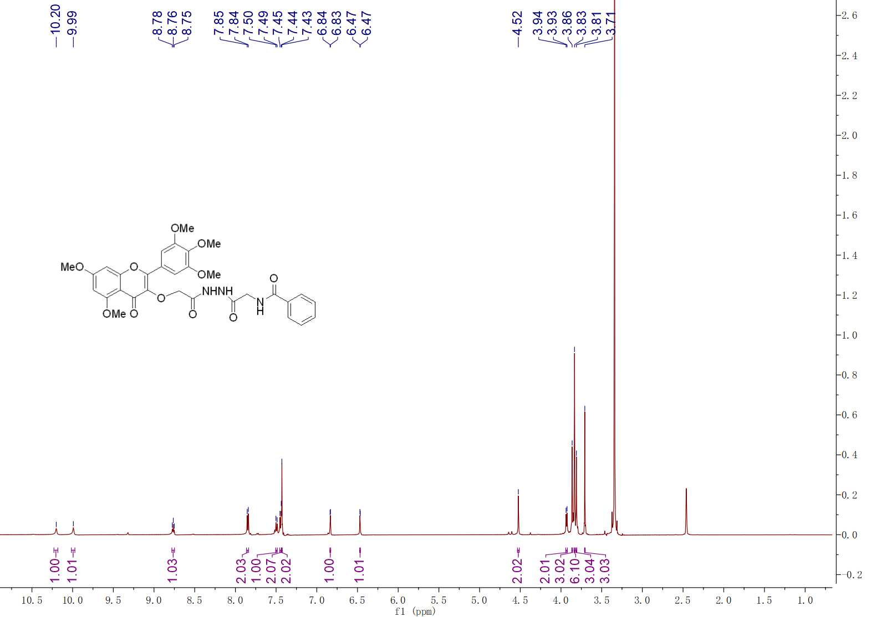

**Fig. S1 1H NMR spectra of compound G1**

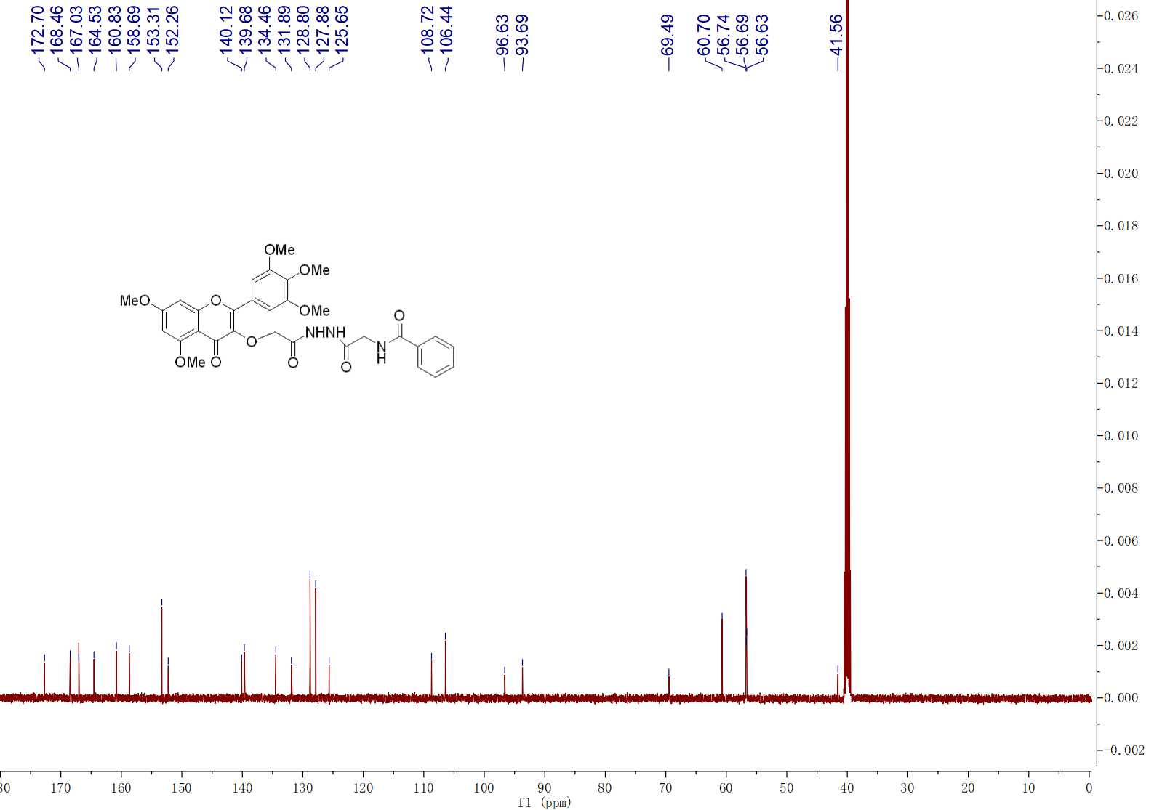

**Fig. S1 13C NMR spectra of compound G1**

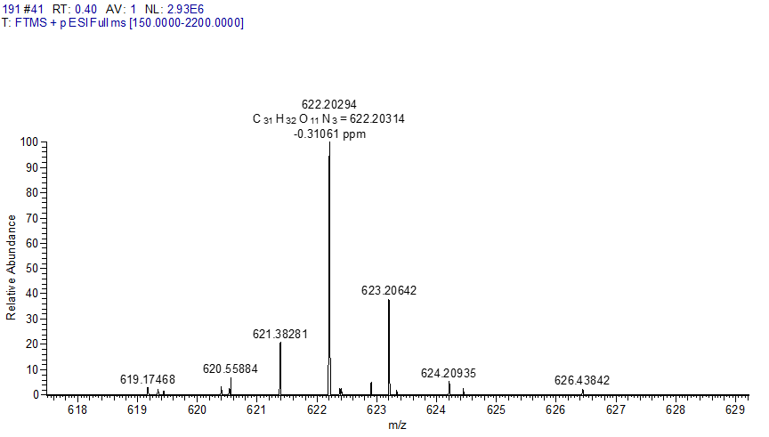 **Fig. S1 HRMS spectra of compound G1**

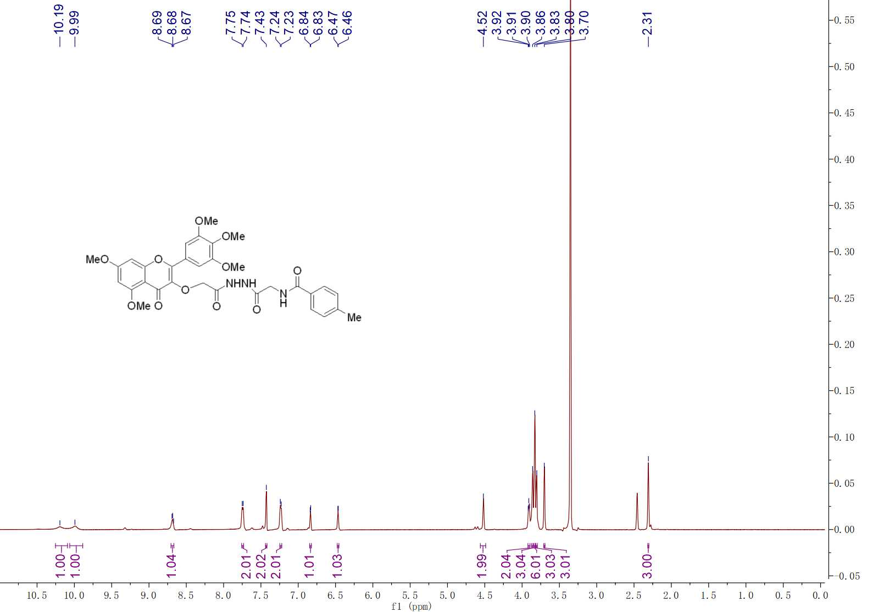

**Fig. S2 1H NMR spectra of compound G2**

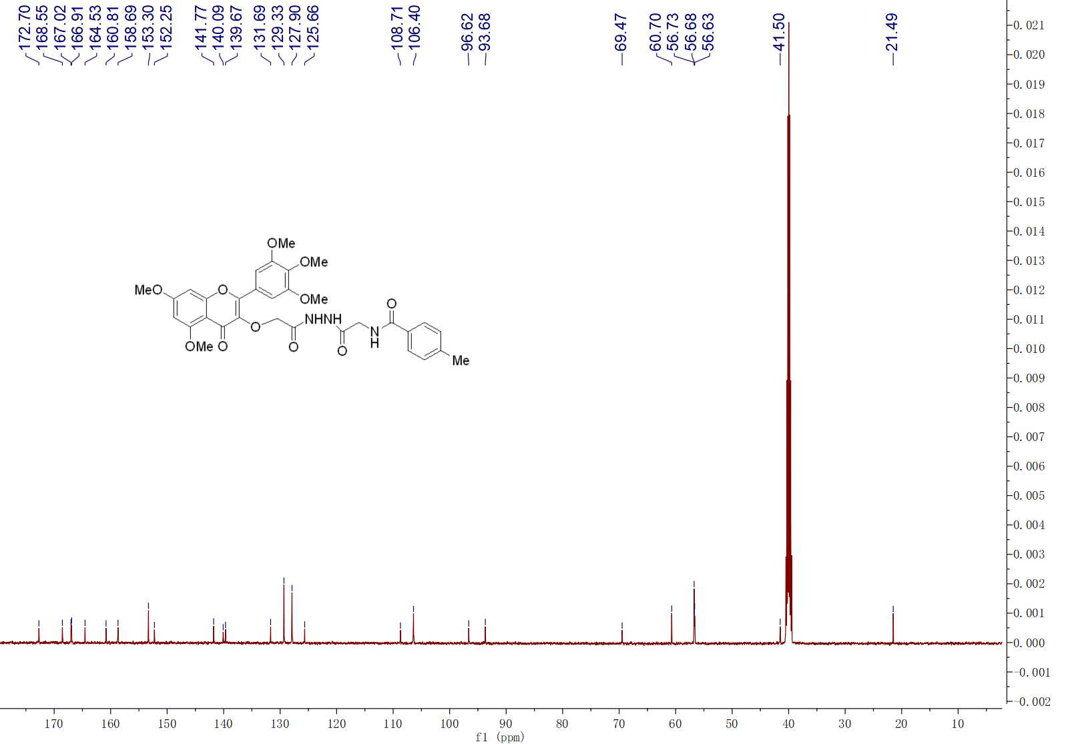

**Fig. S2 13C NMR spectra of compound G2**



**Fig. S2 HRMS spectra of compound G2**

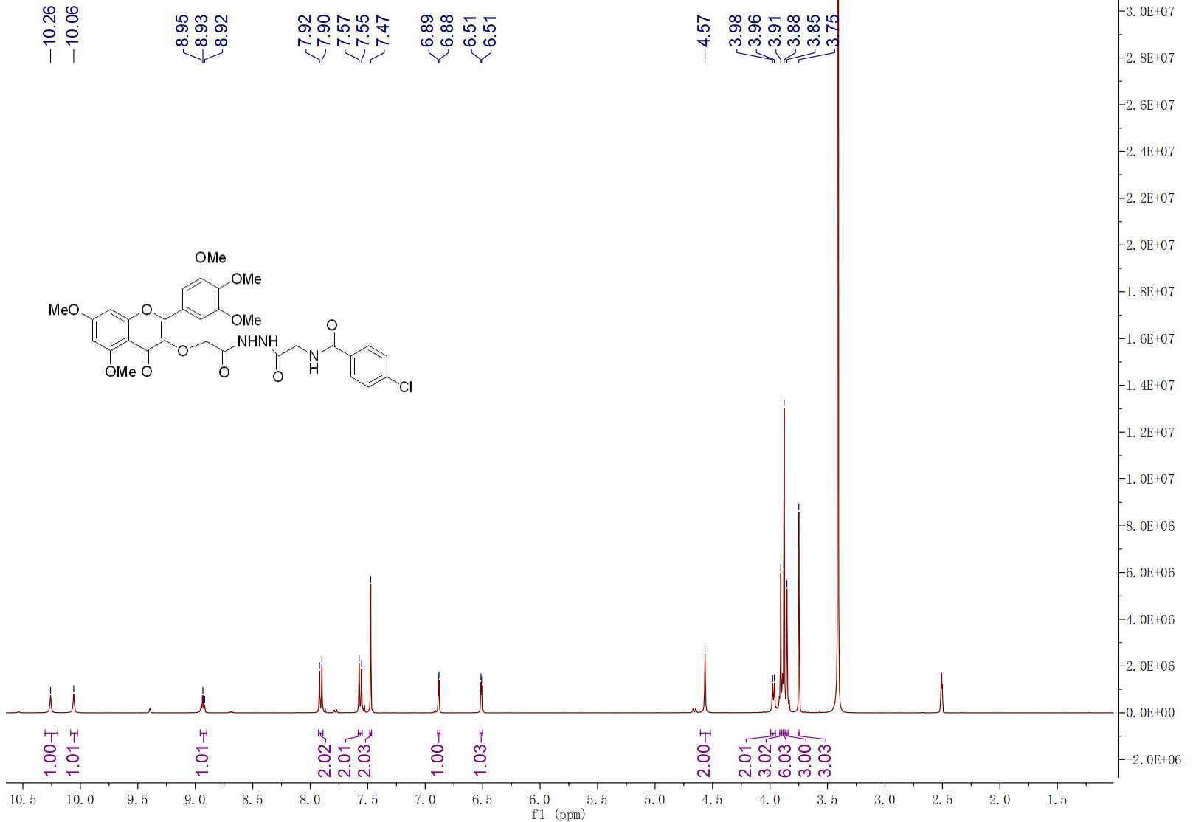

**Fig. S3 1H NMR spectra of compound G3**

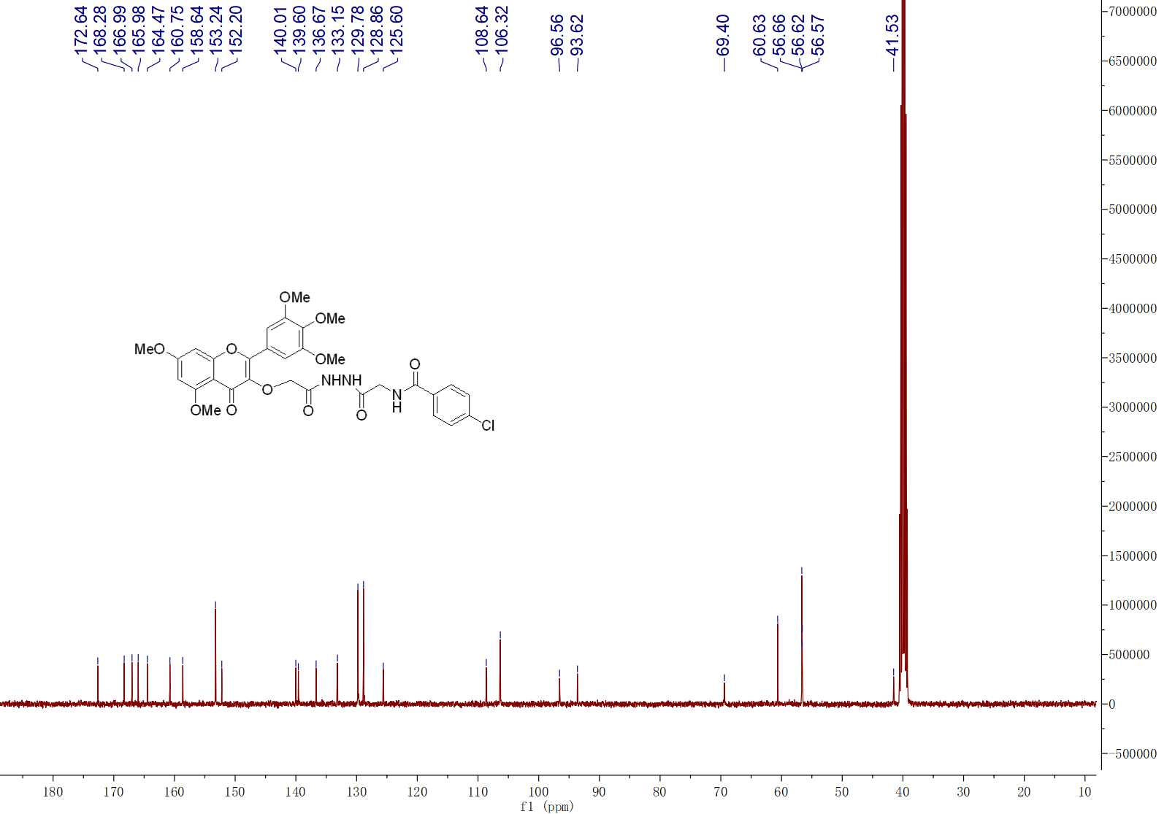

**Fig. S3 13C NMR spectra of compound G3**



**Fig. S3 HRMS spectra of compound G3**

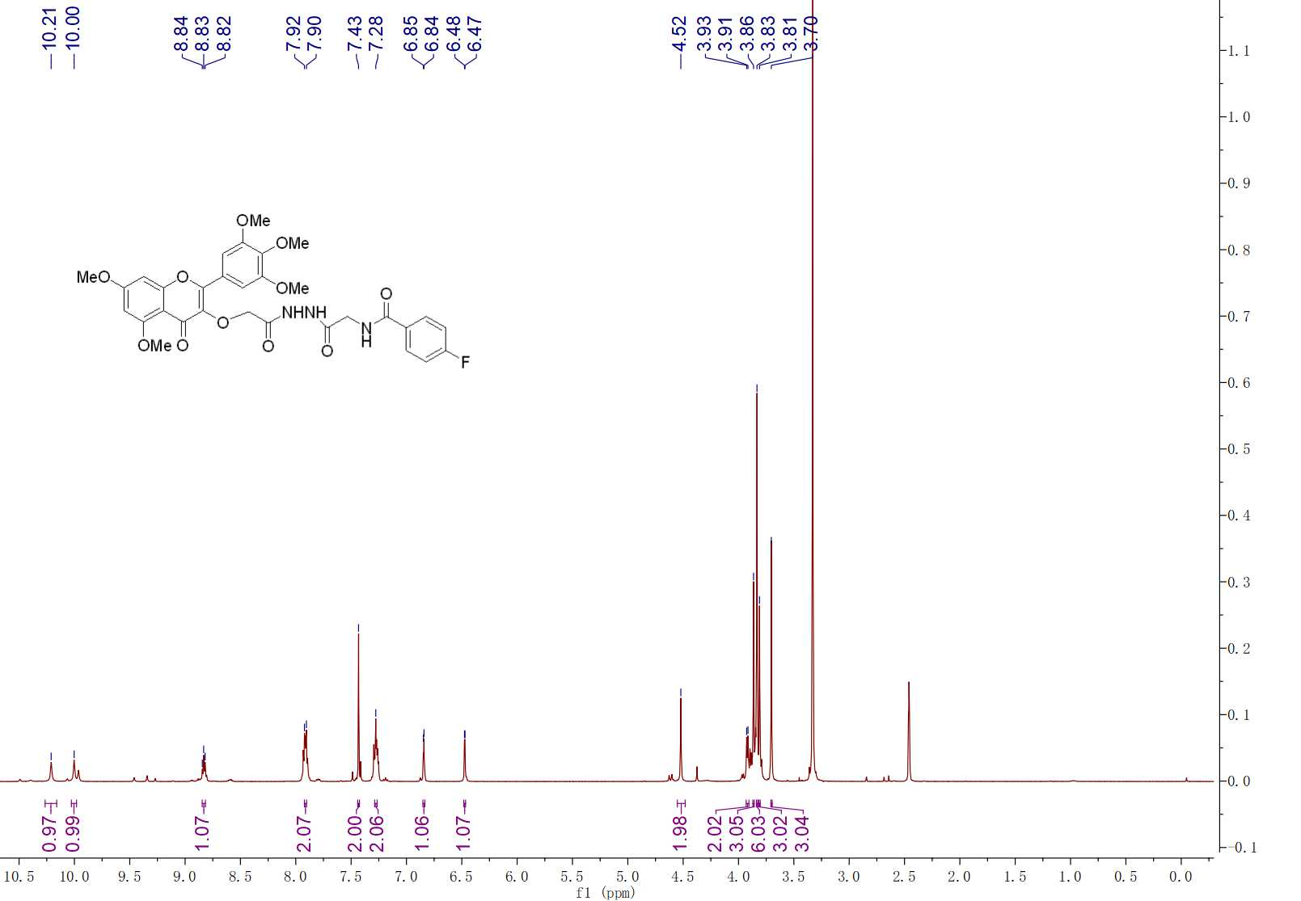

**Fig. S4 1H NMR spectra of compound G4**

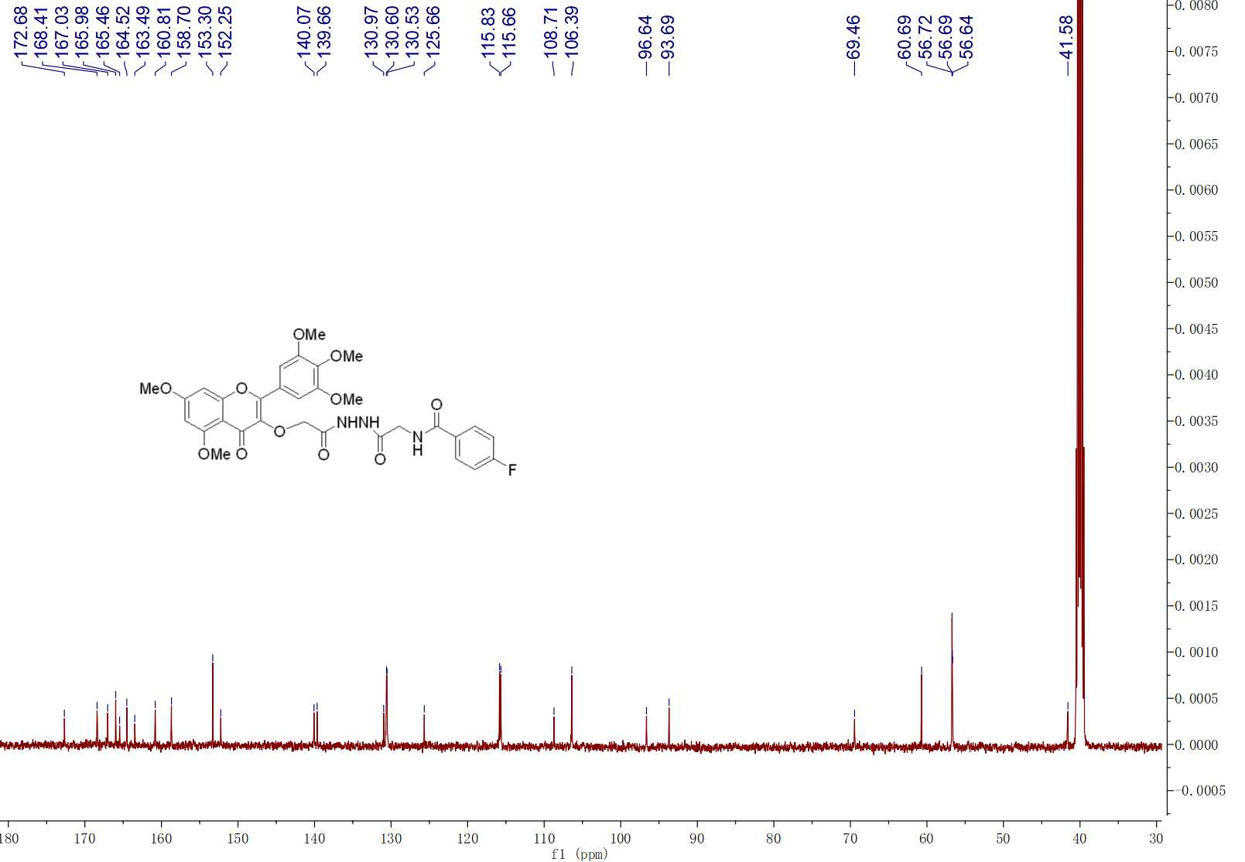

**Fig. S4 13C NMR spectra of compound G4**

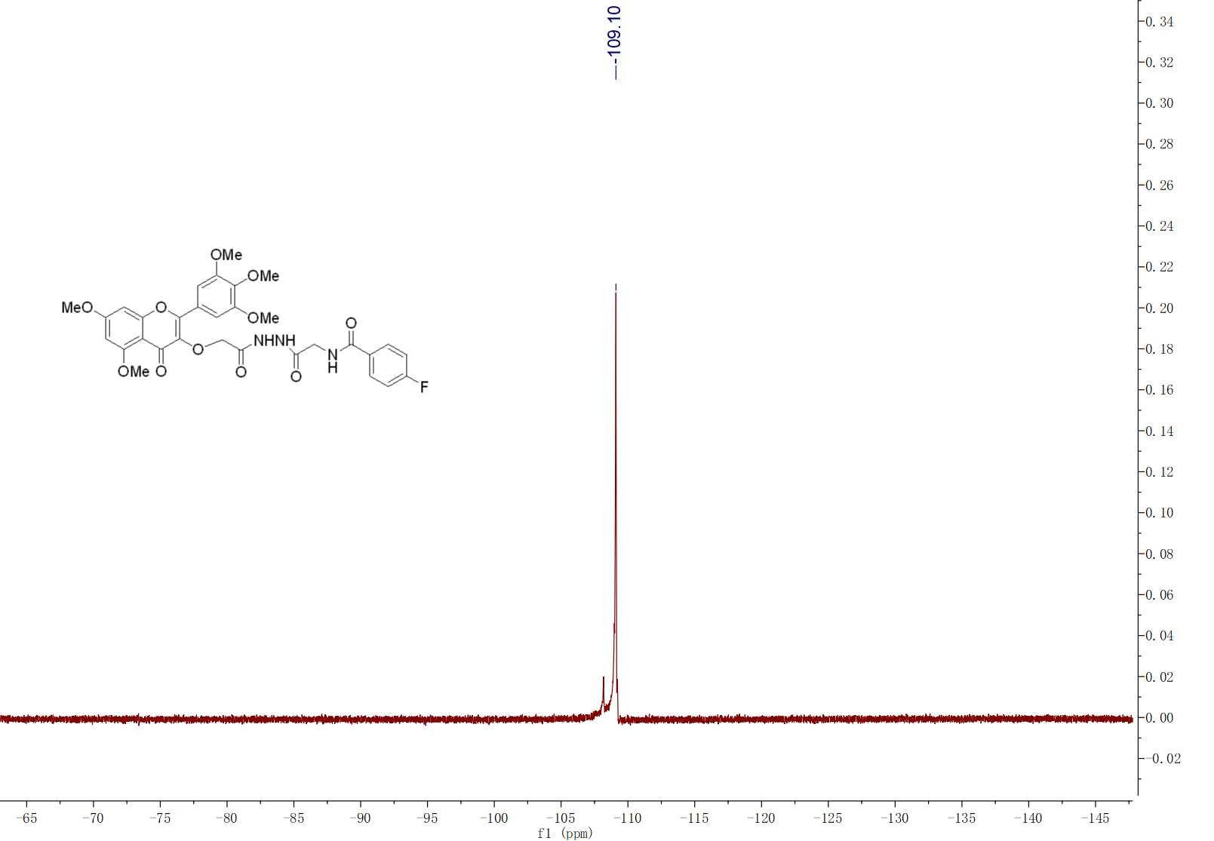

**Fig. S4 19F NMR spectra of compound G4**



**Fig. S4 HRMS spectra of compound G4**

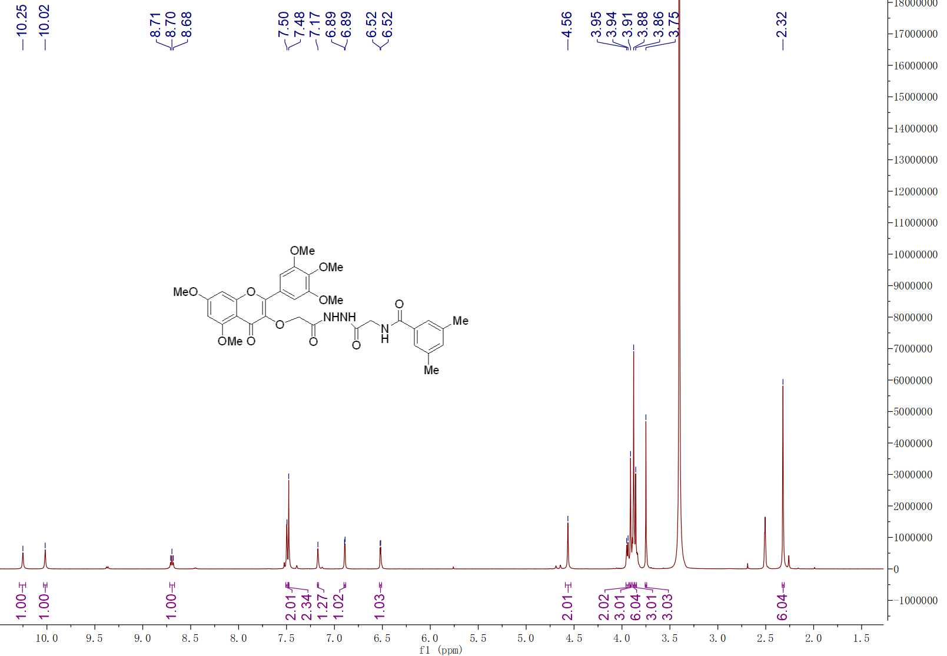

**Fig. S5 1H NMR spectra of compound G5**

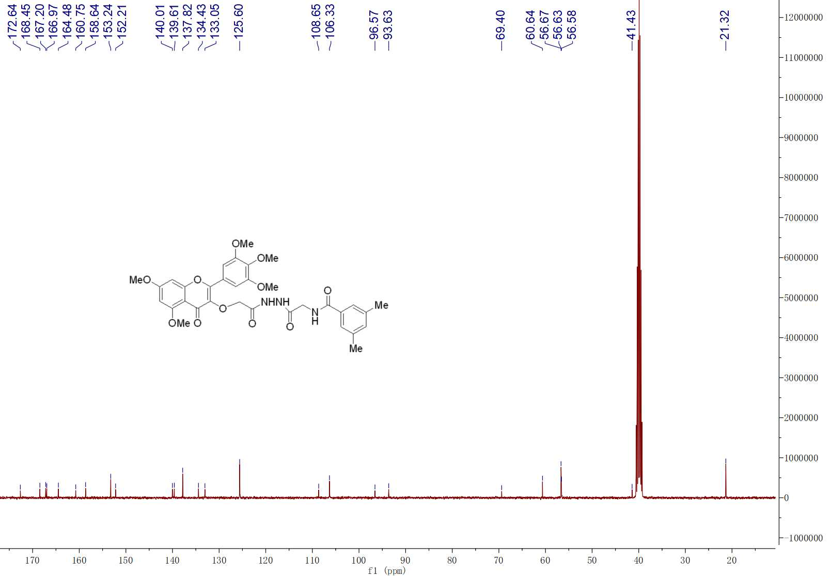

**Fig. S5 13C NMR spectra of compound G5**



**Fig. S5 HRMS spectra of compound G5**

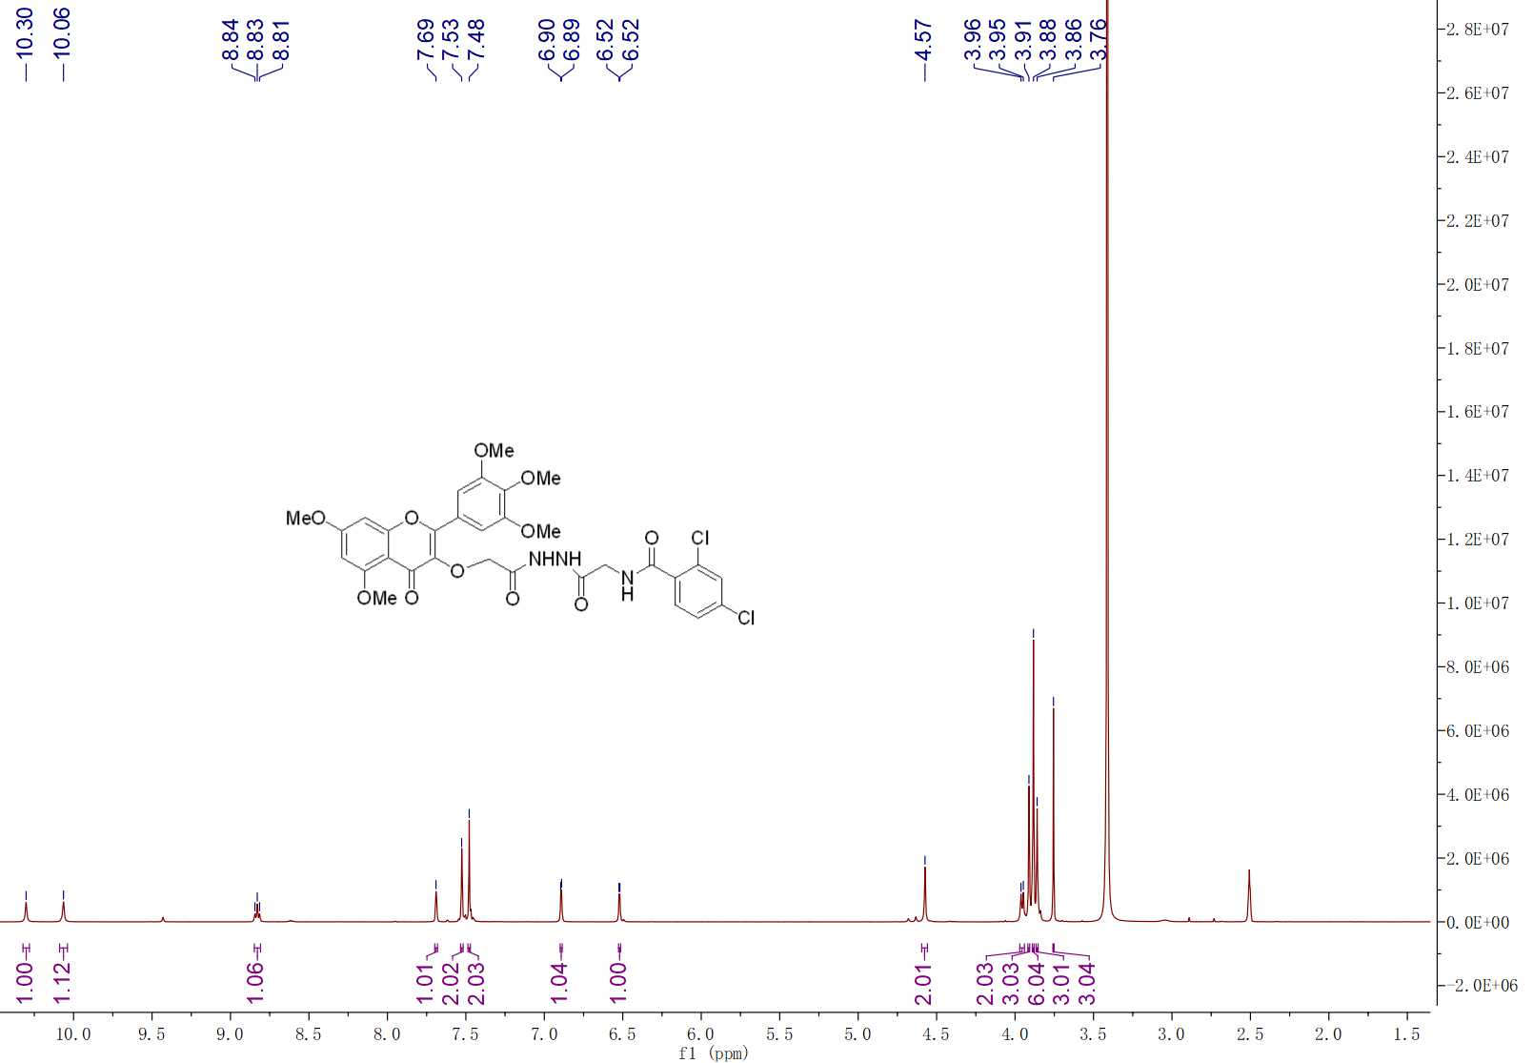

**Fig. S6 1H NMR spectra of compound G6**

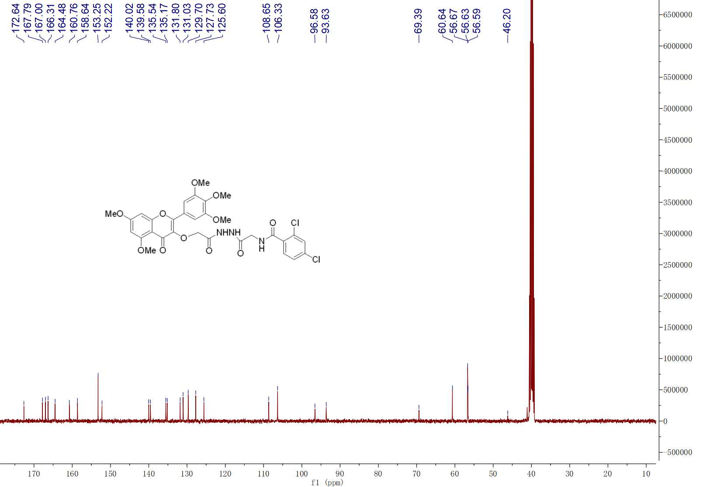

**Fig. S6 13C NMR spectra of compound G6**



**Fig. S6 HRMS spectra of compound G6**

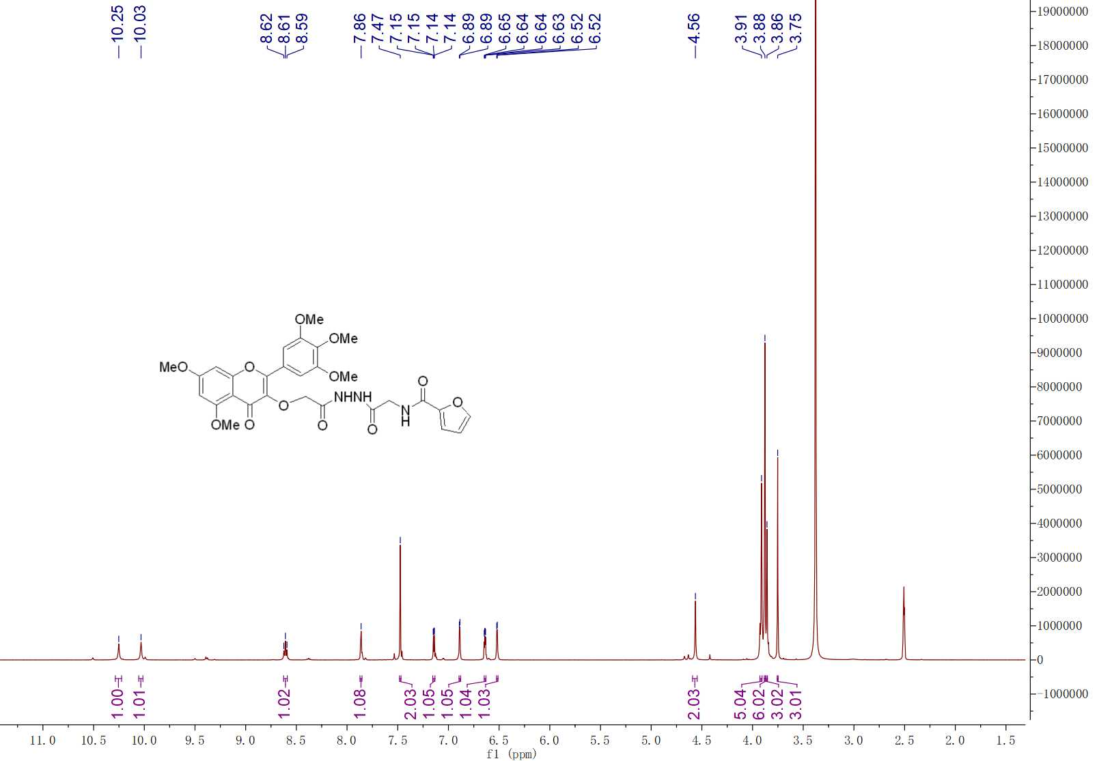

**Fig. S7 1H NMR spectra of compound G7**

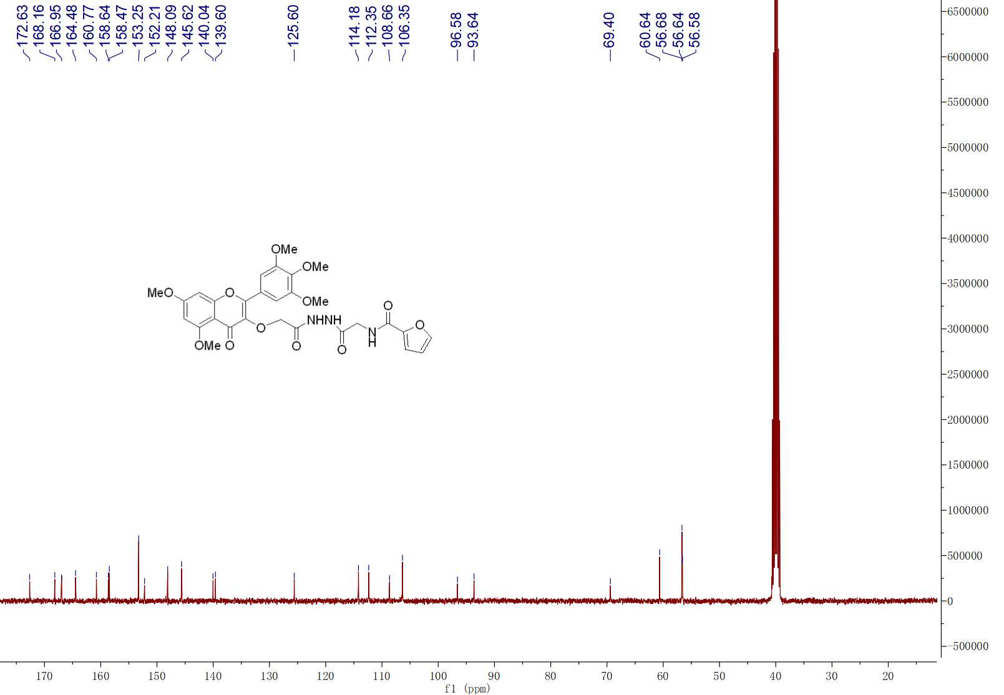

**Fig. S7 13C NMR spectra of compound G7**



**Fig. S7 HRMS spectra of compound G7**

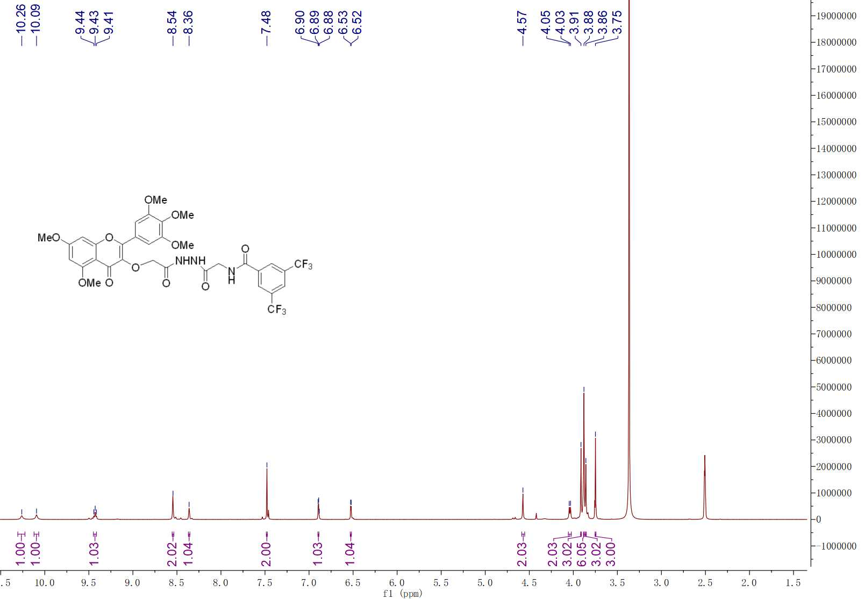

**Fig. S8 1H NMR spectra of compound G8**

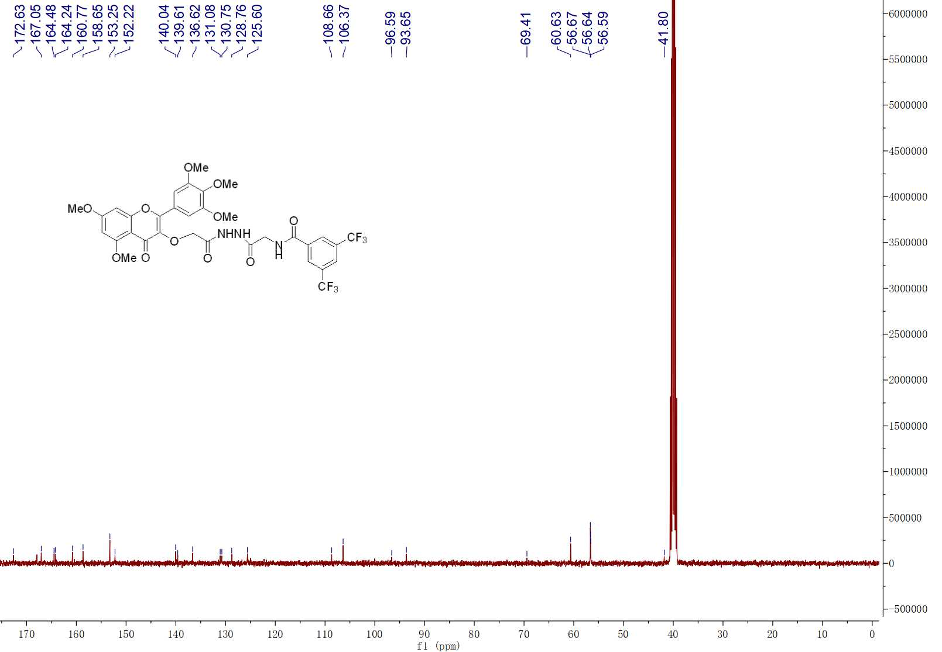

**Fig. S8 13C NMR spectra of compound G8**

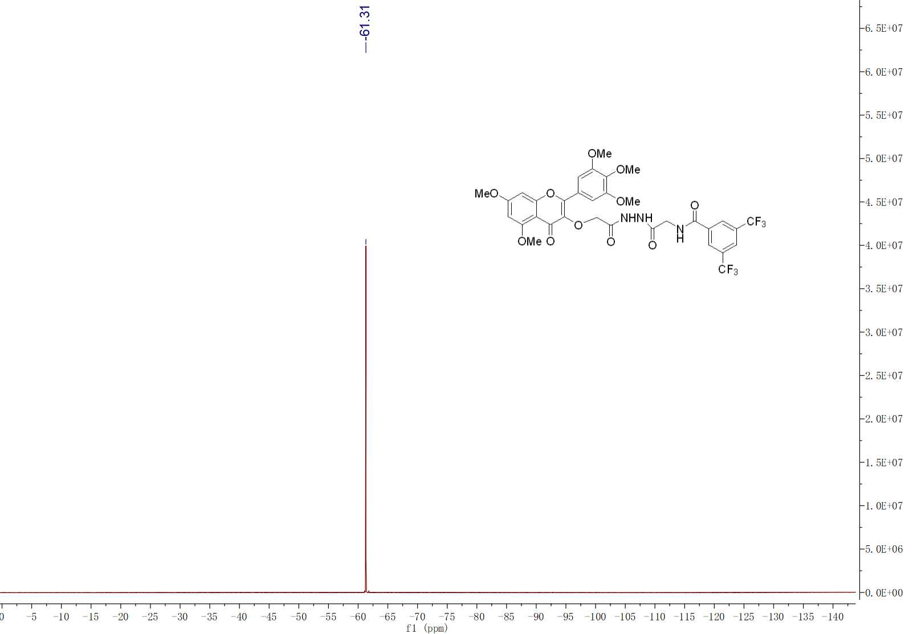

**Fig. S8 19F NMR spectra of compound G8**



**Fig. S8 HRMS spectra of compound G8**

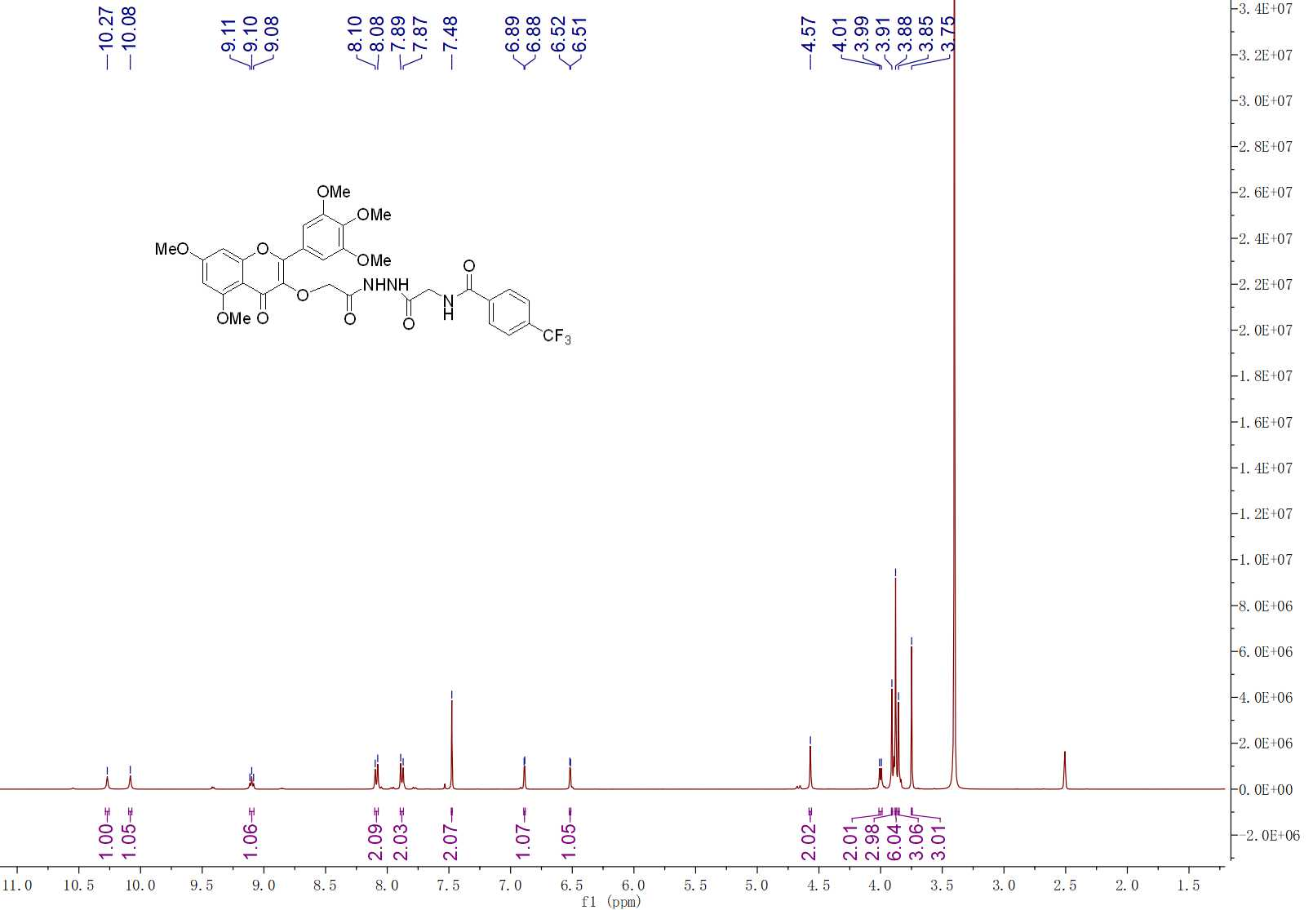

**Fig. S9 1H NMR spectra of compound G9**

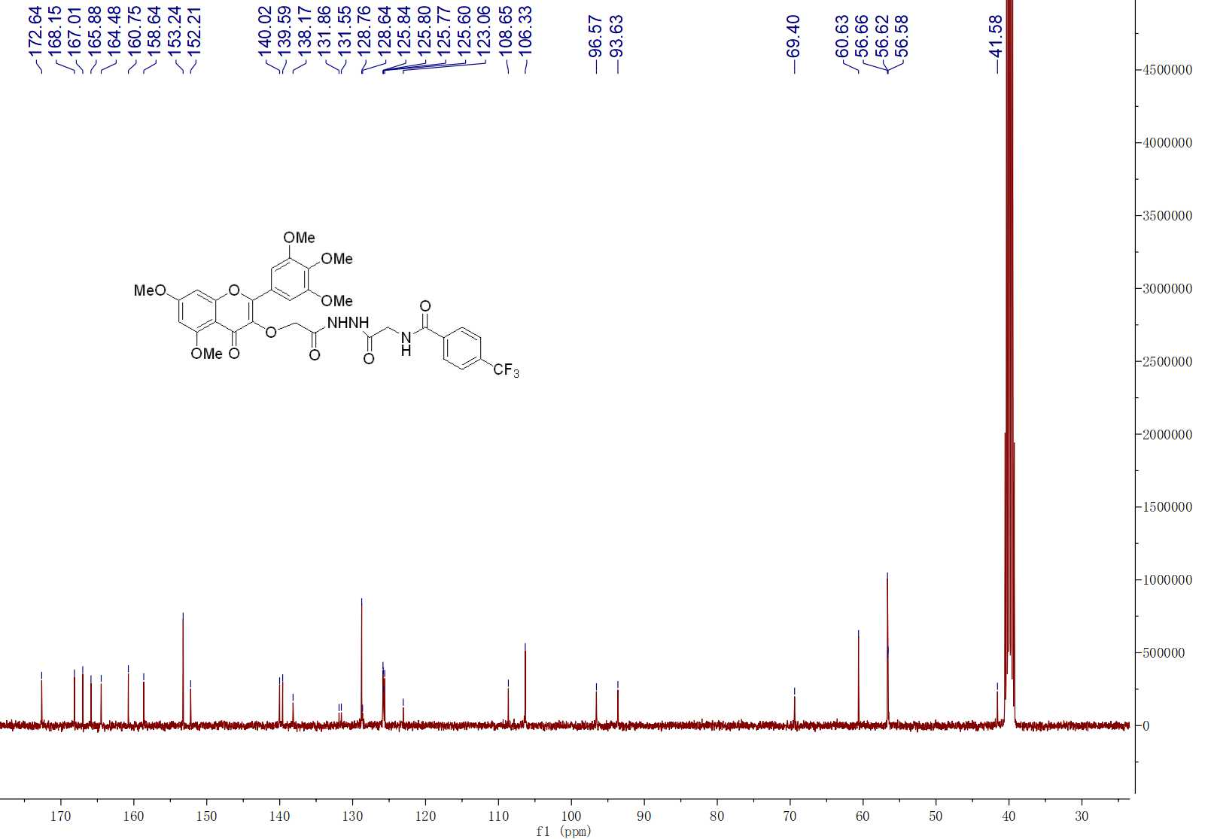

**Fig. S9 13C NMR spectra of compound G9**

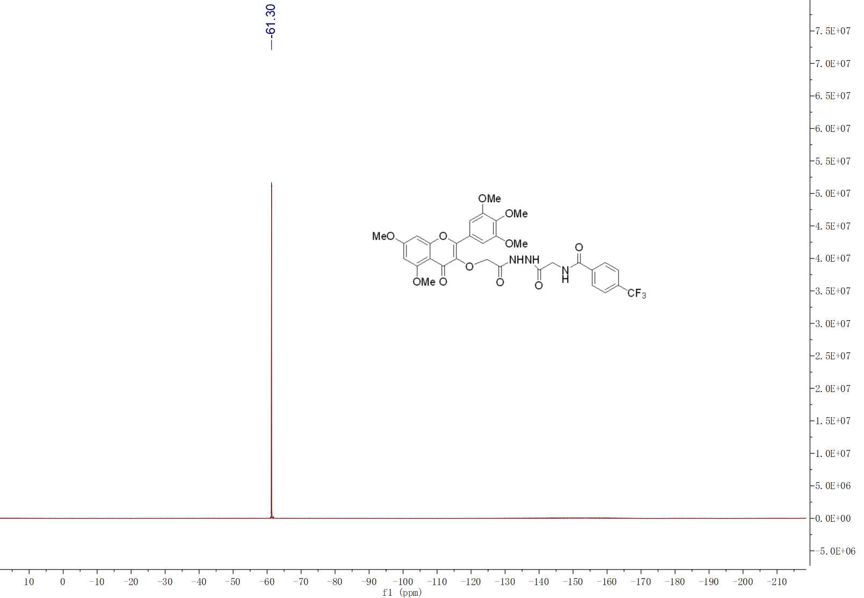

**Fig. S9 19F NMR spectra of compound G9**



**Fig. S9 HRMS spectra of compound G9**

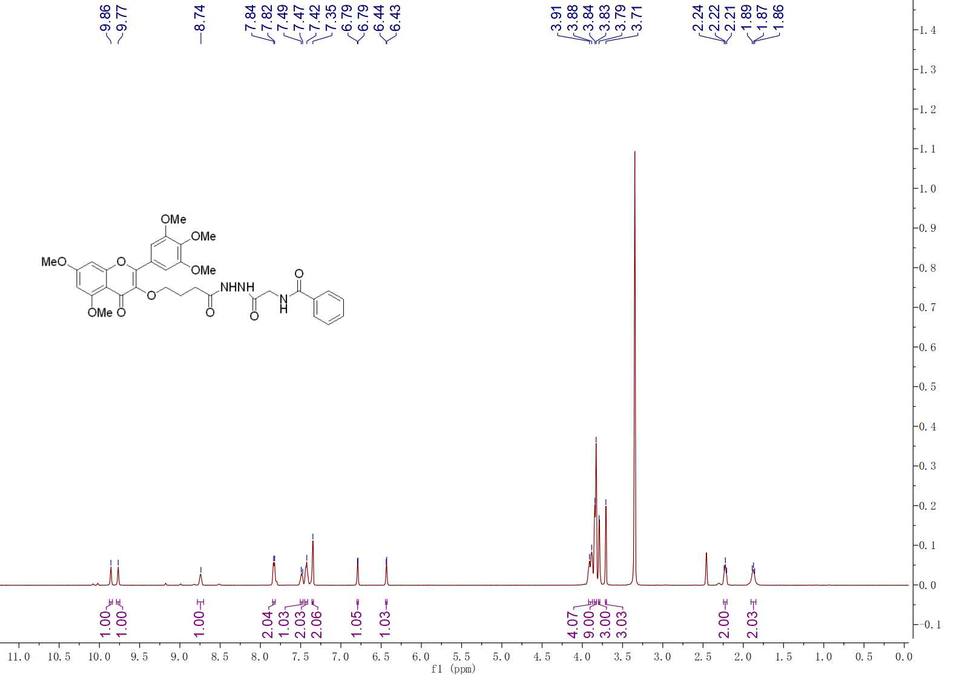

**Fig. S10 1H NMR spectra of compound G10**

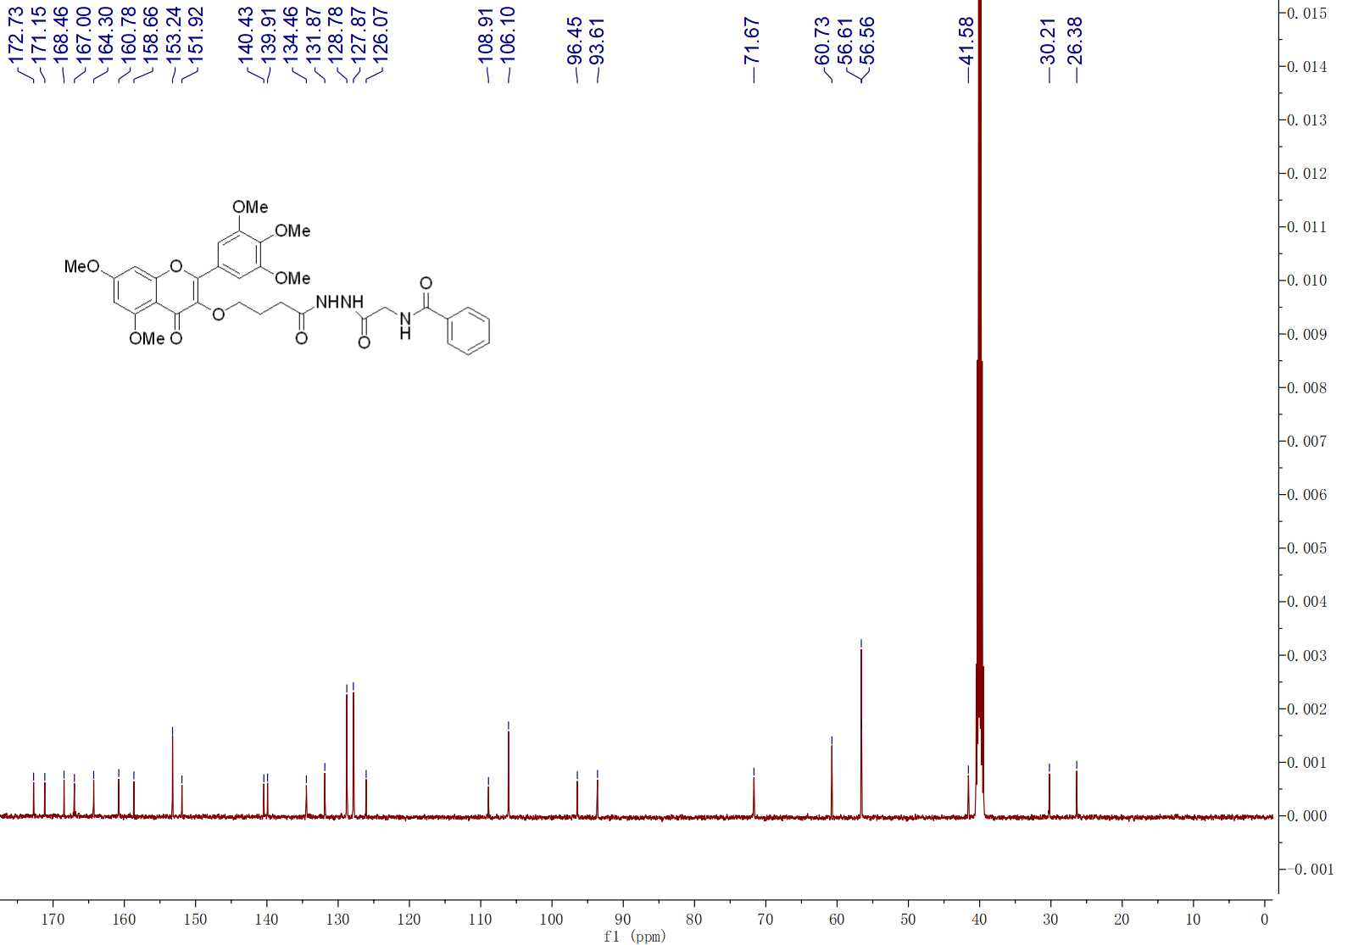

**Fig. S10 13C NMR spectra of compound G10**



**Fig. S10 HRMS spectra of compound G10**

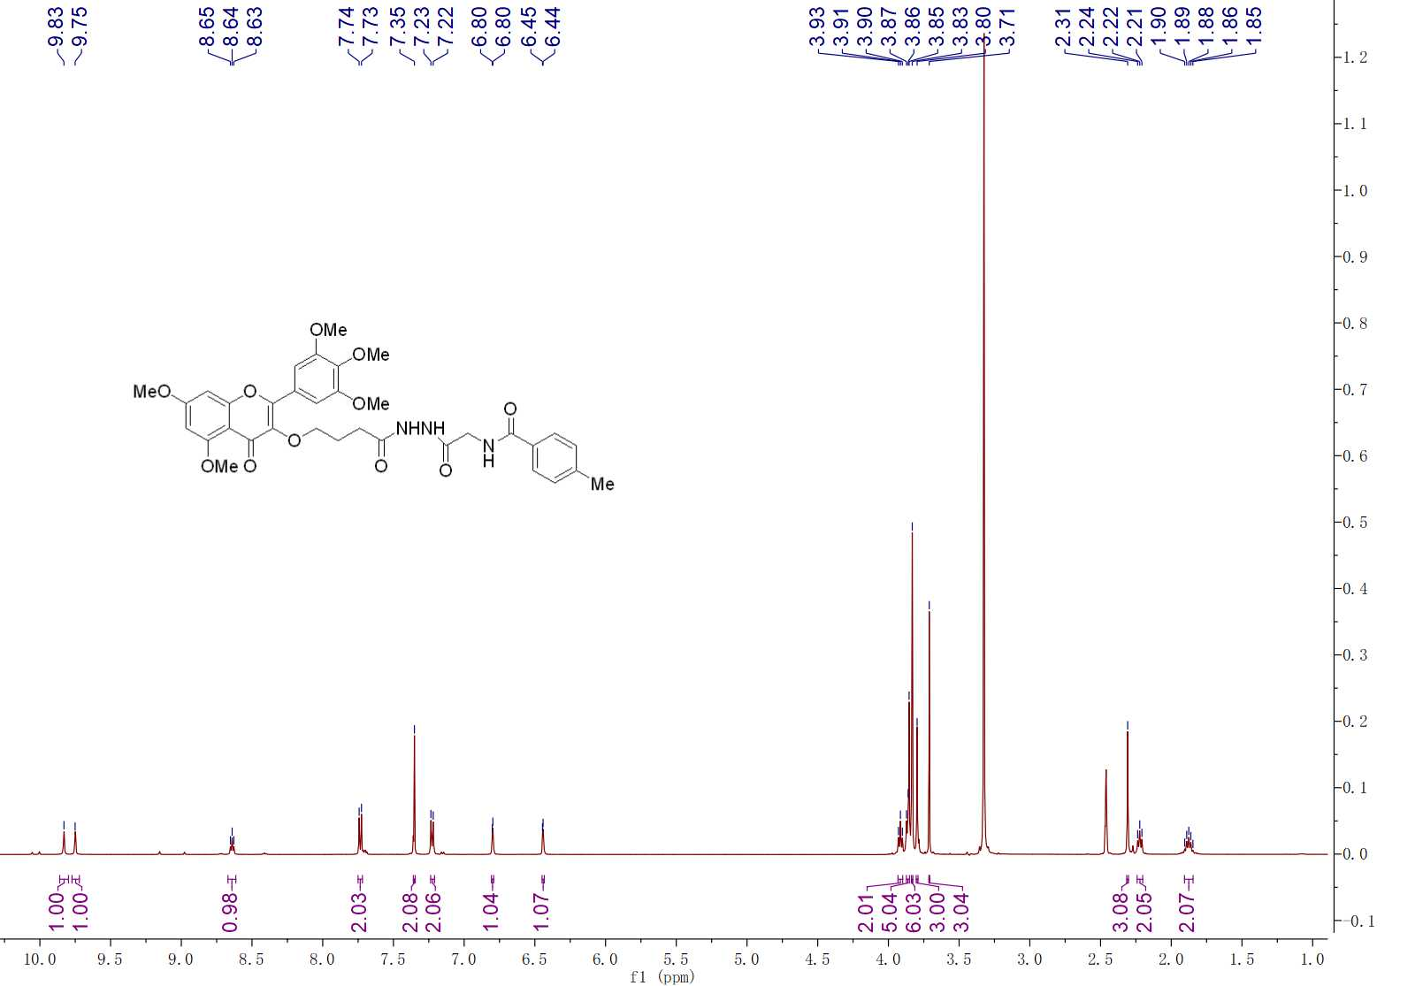

**Fig. S11 1H NMR spectra of compound G11**

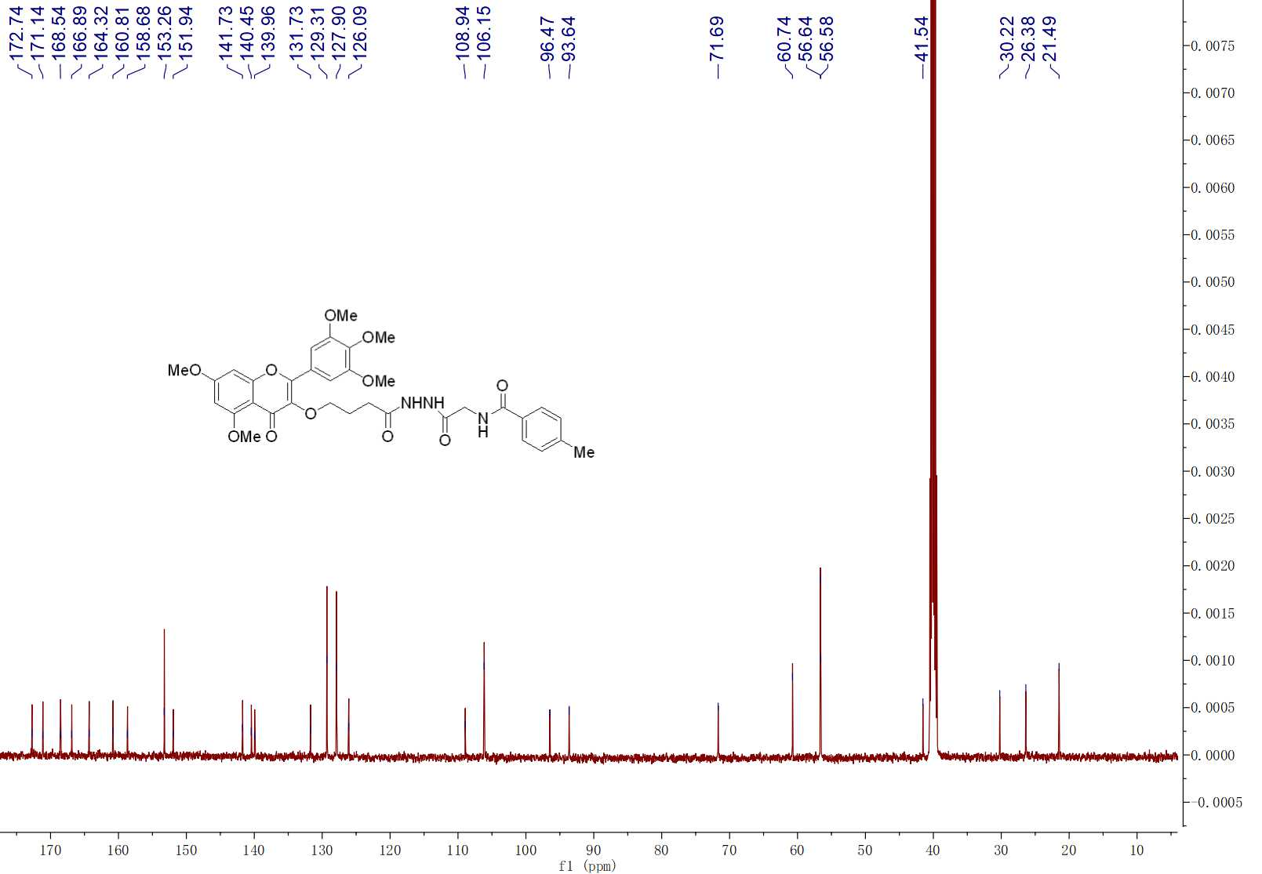

**Fig. S11 13C NMR spectra of compound G11**



**Fig. S11 HRMS spectra of compound G11**

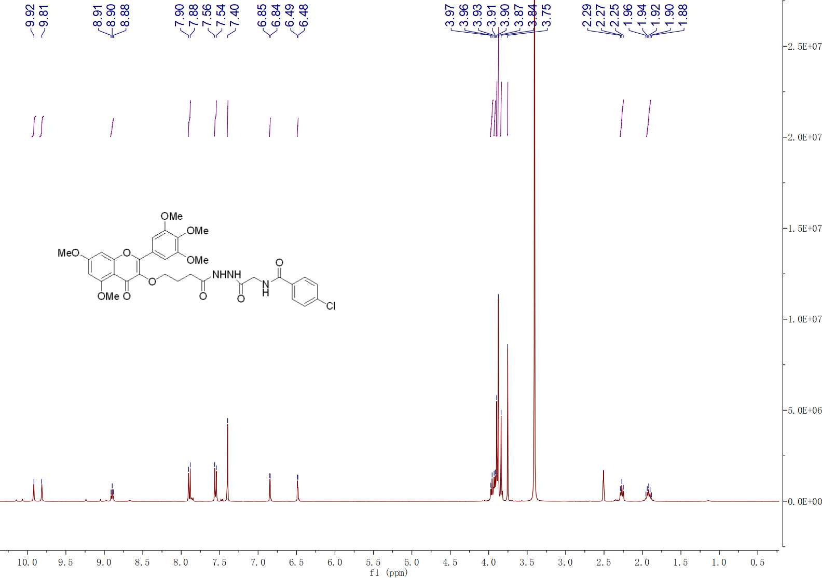

**Fig. S12 1H NMR spectra of compound G12**

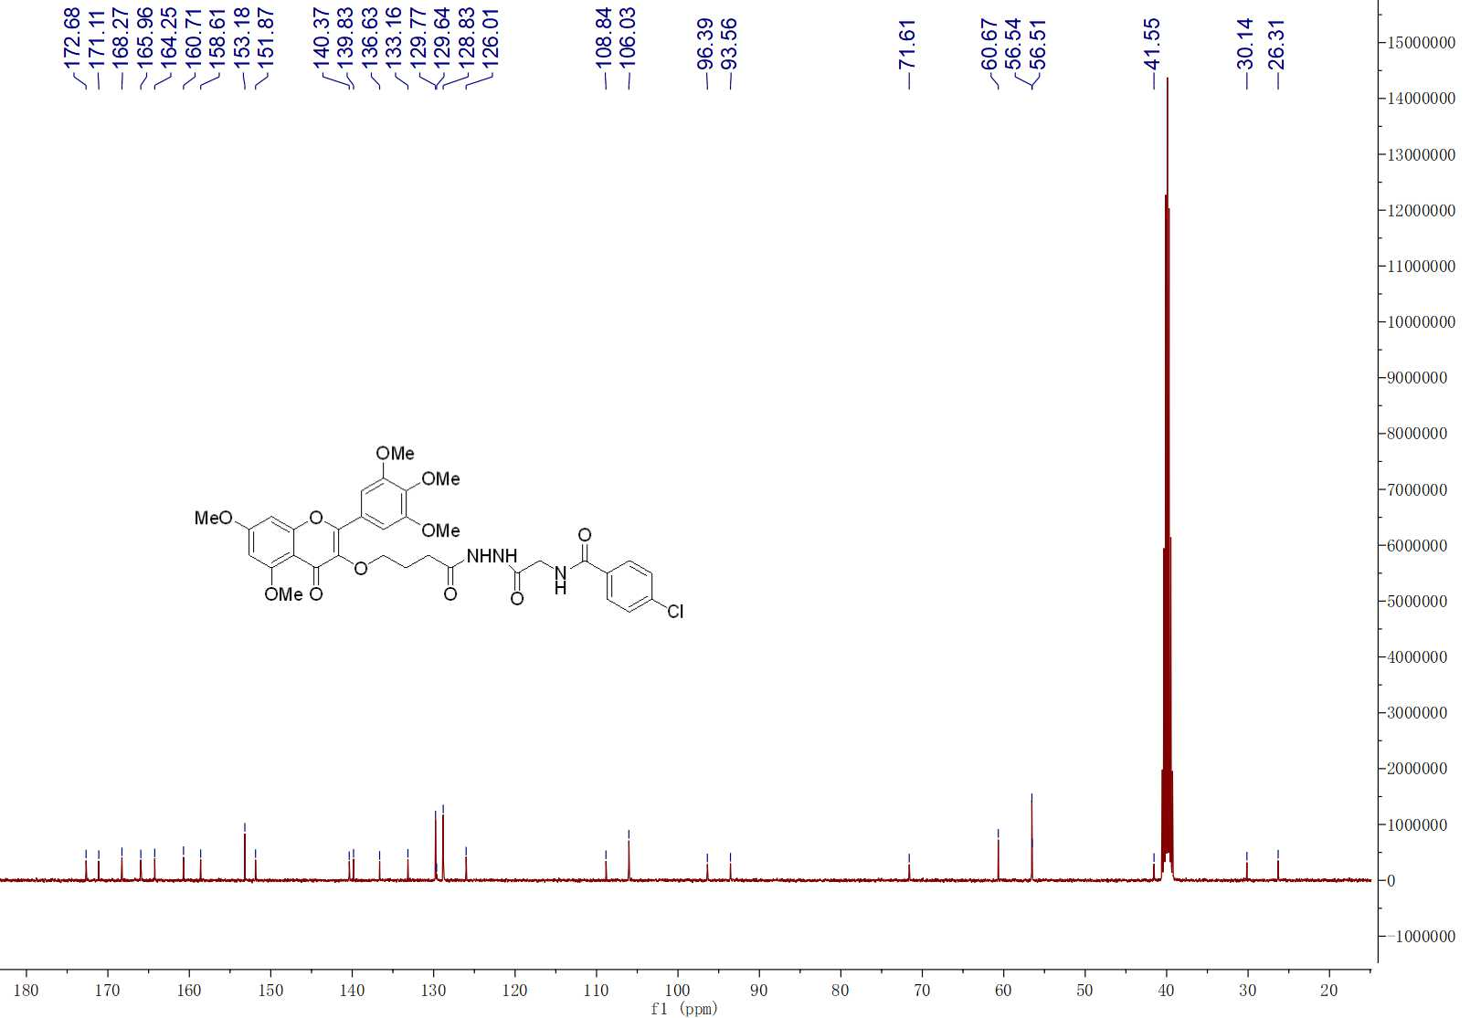

**Fig. S12 13C NMR spectra of compound G12**



**Fig. S12 HRMS spectra of compound G12**

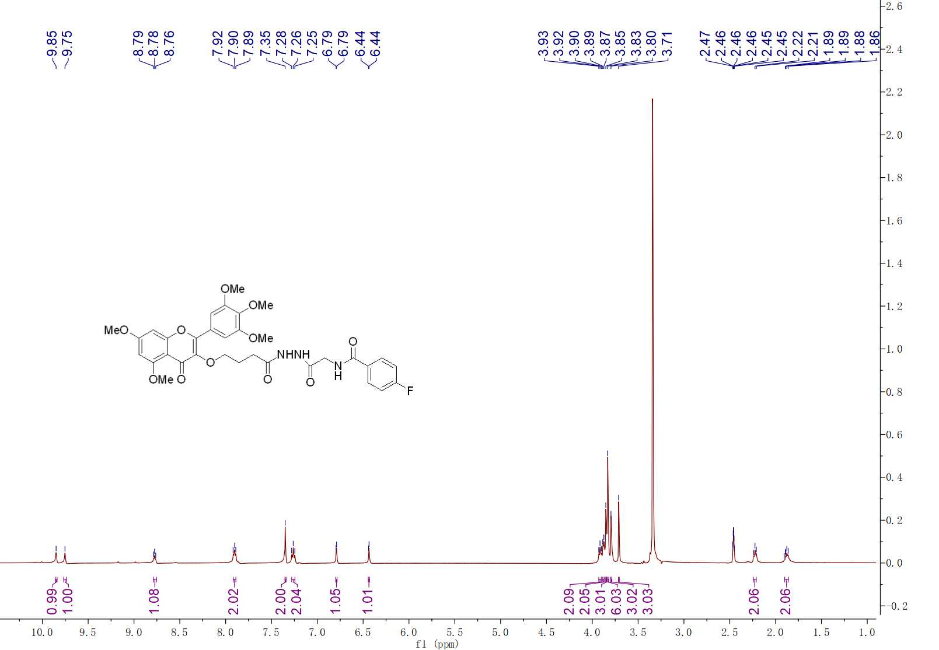

**Fig. S13 1H NMR spectra of compound G13**

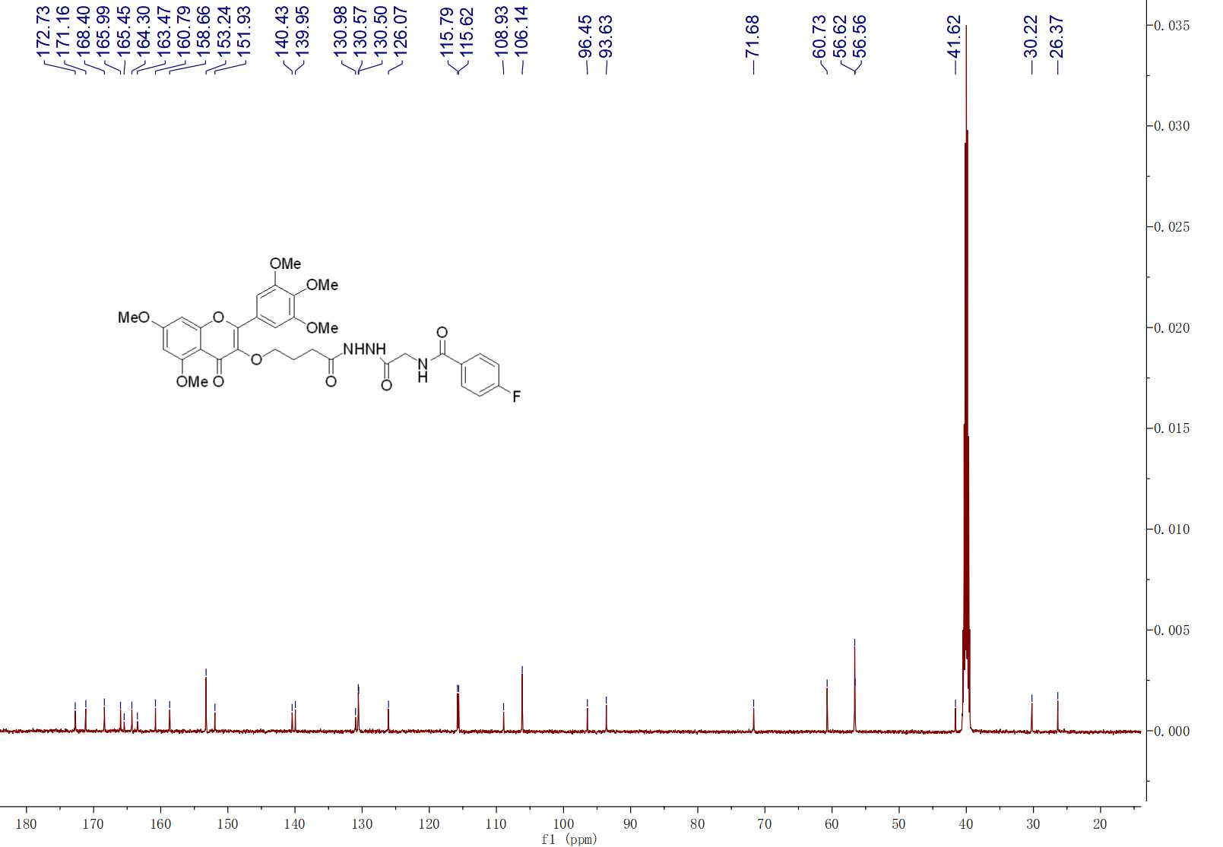

**Fig. S13 13C NMR spectra of compound G13**

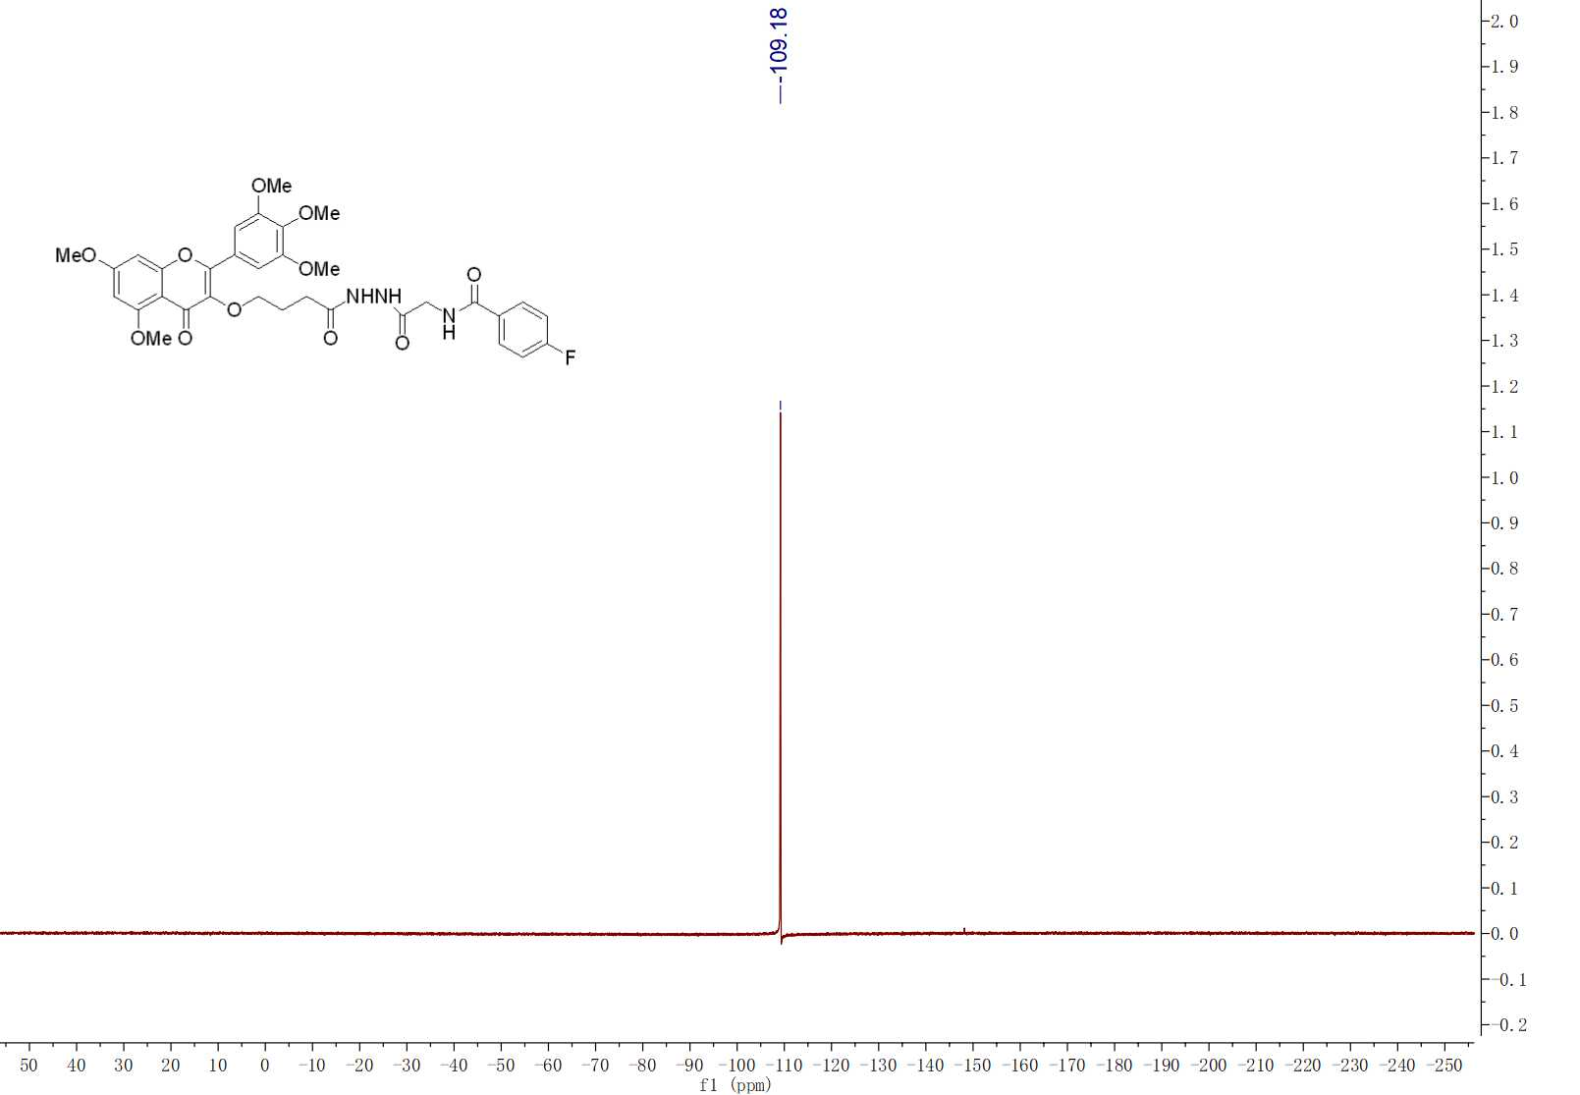

**Fig. S13 19F NMR spectra of compound G13**



**Fig. S13 HRMS spectra of compound G13**

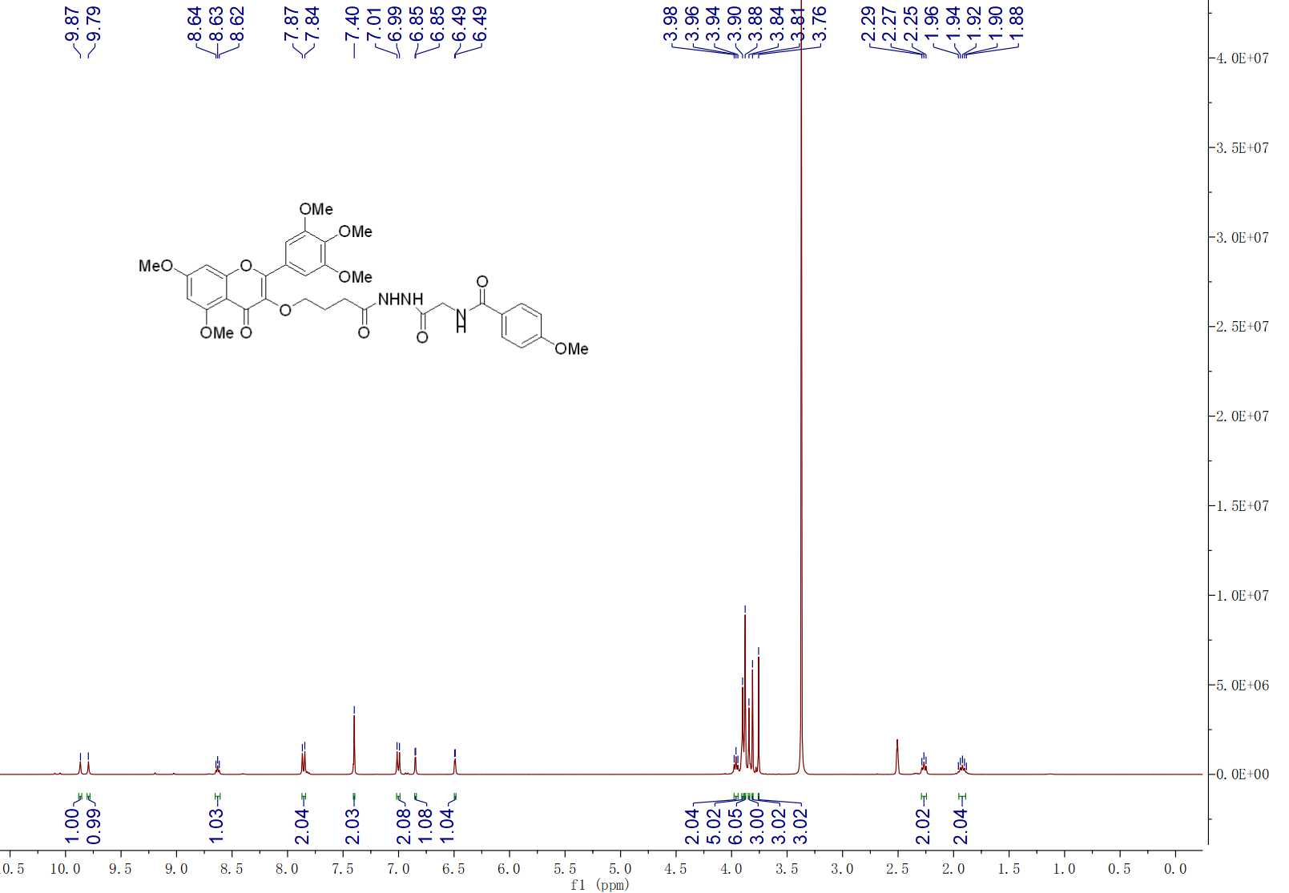

**Fig. S14 1H NMR spectra of compound G14**

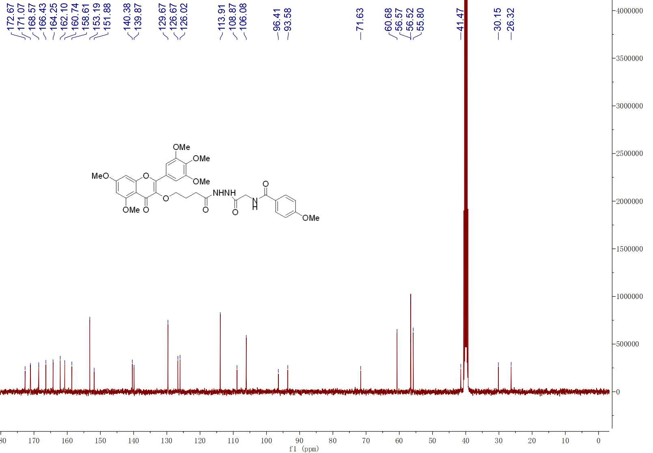

**Fig. S14 13C NMR spectra of compound G14**



**Fig. S14 HRMS spectra of compound G14**

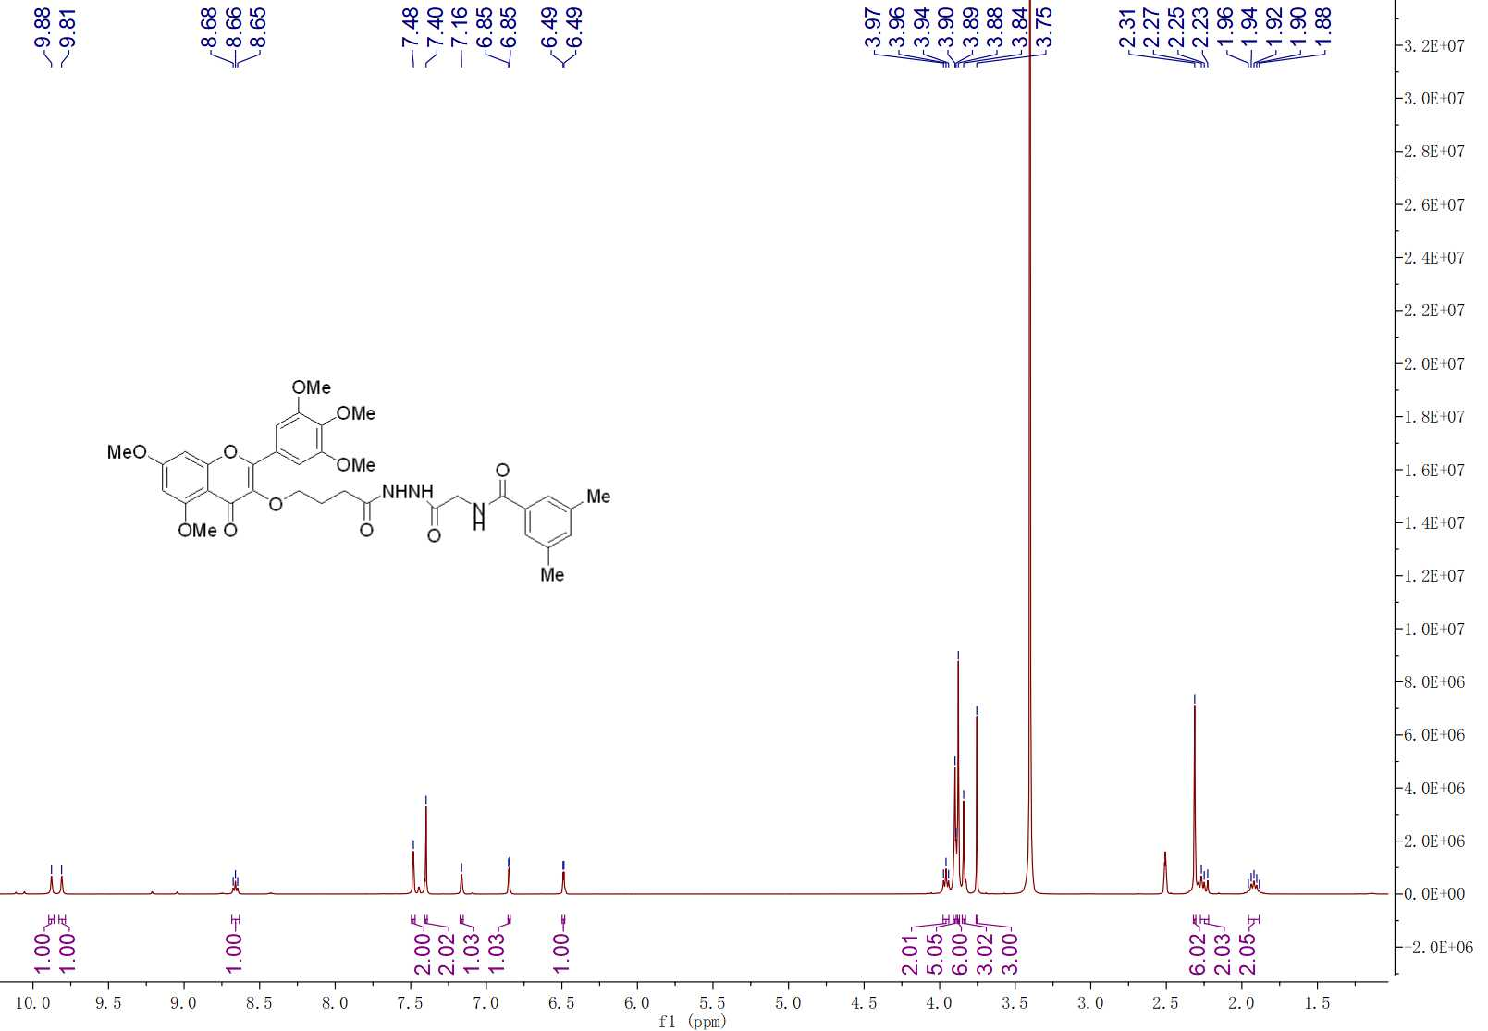

**Fig. S15 1H NMR spectra of compound G15**

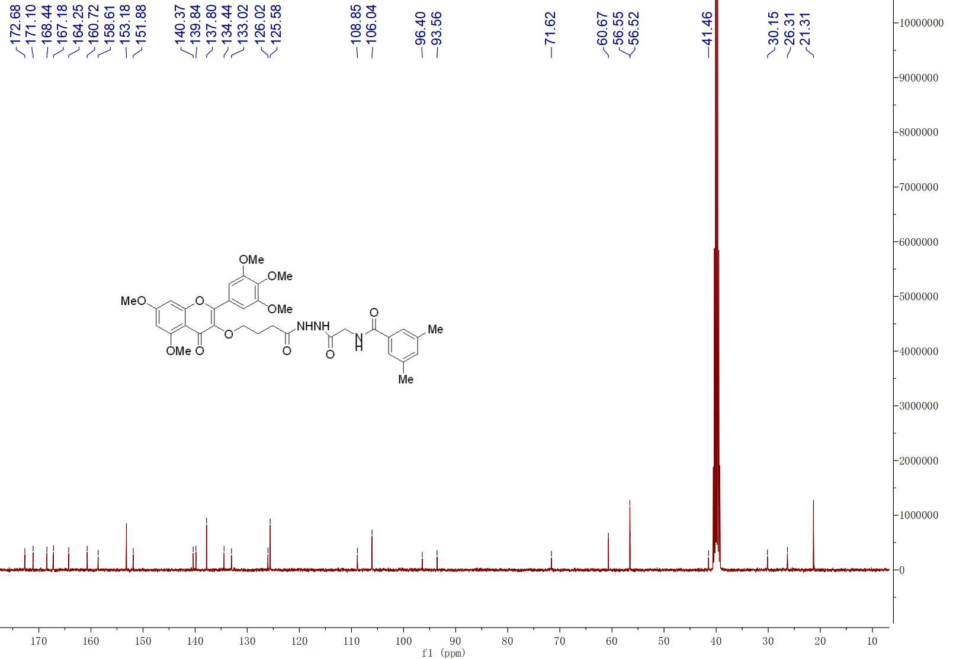

**Fig. S15 13C NMR spectra of compound G15**



**Fig. S15 HRMS spectra of compound G15**

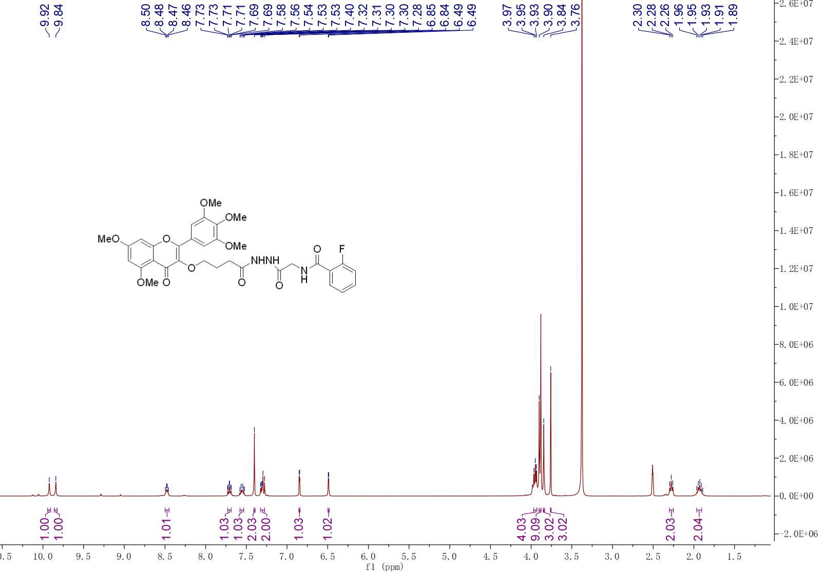

**Fig. S16 1H NMR spectra of compound G16**

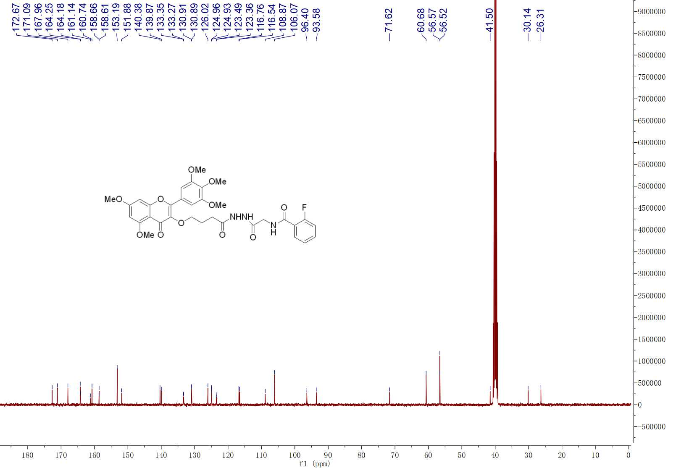

**Fig. S16 13C NMR spectra of compound G16**

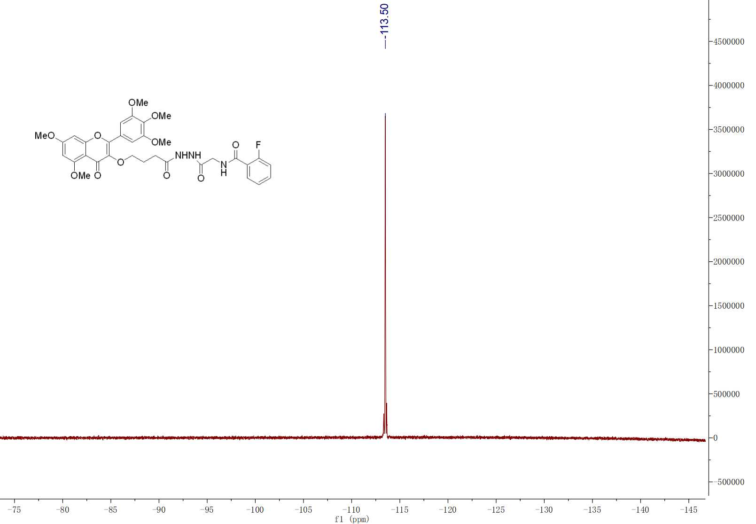

**Fig. S16 19F NMR spectra of compound G16**



**Fig. S16 HRMS spectra of compound G16**

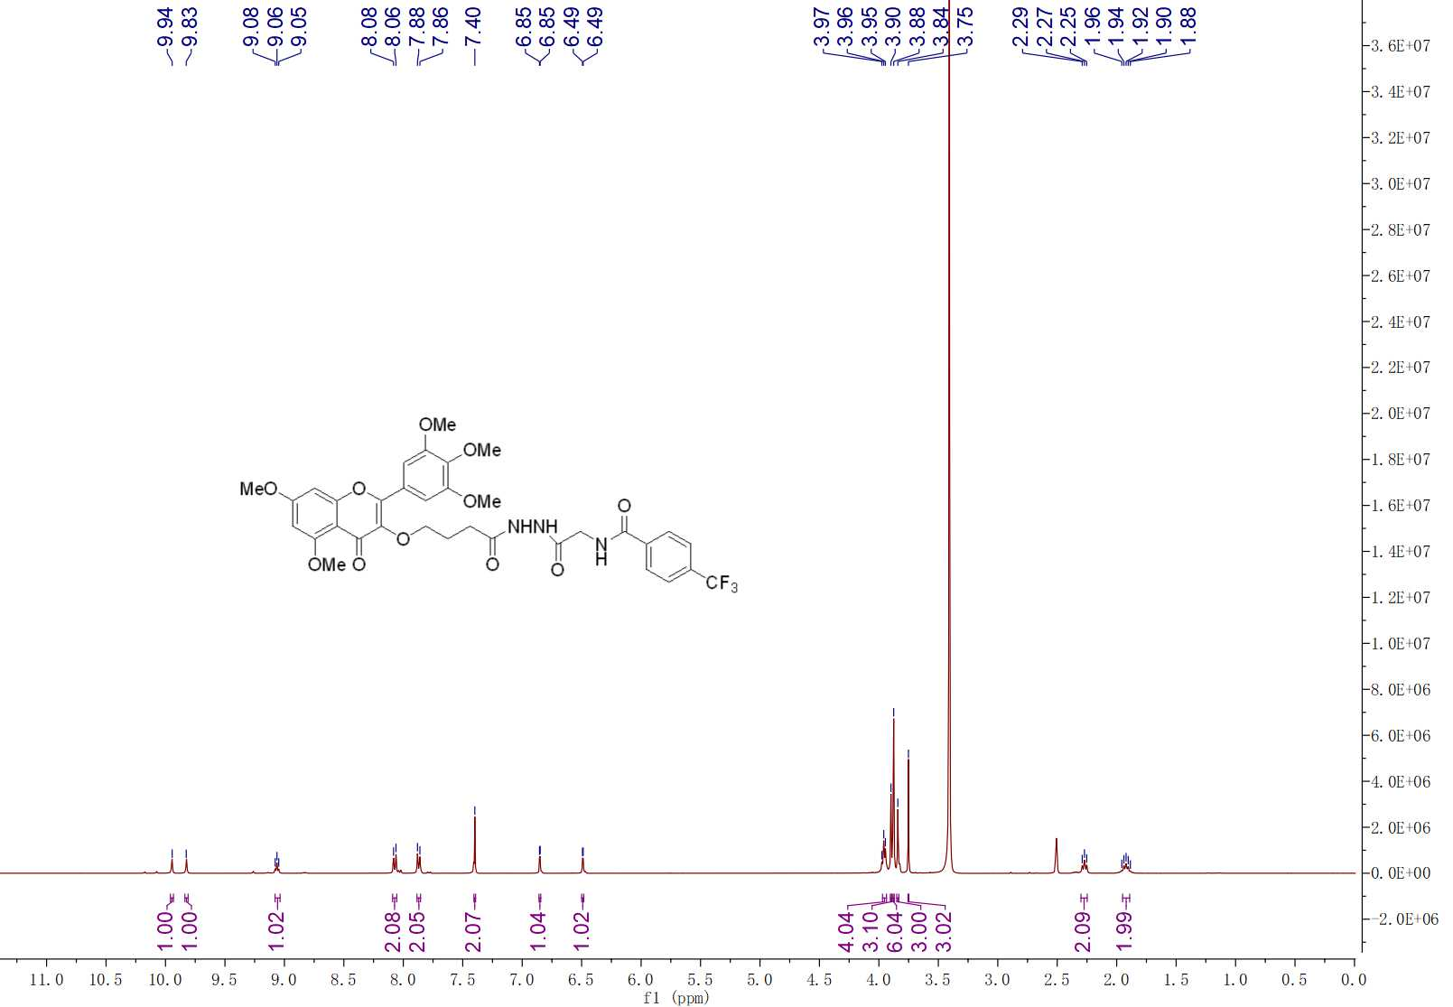

**Fig. S17 1H NMR spectra of compound G17**

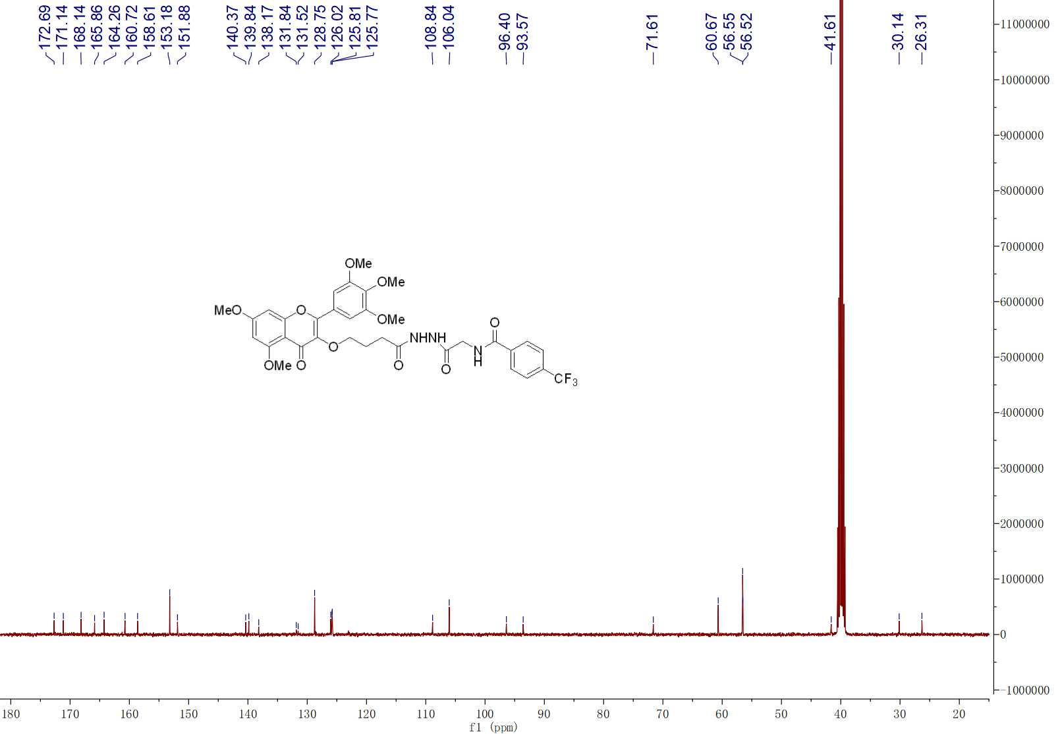

**Fig. S17 13C NMR spectra of compound G17**

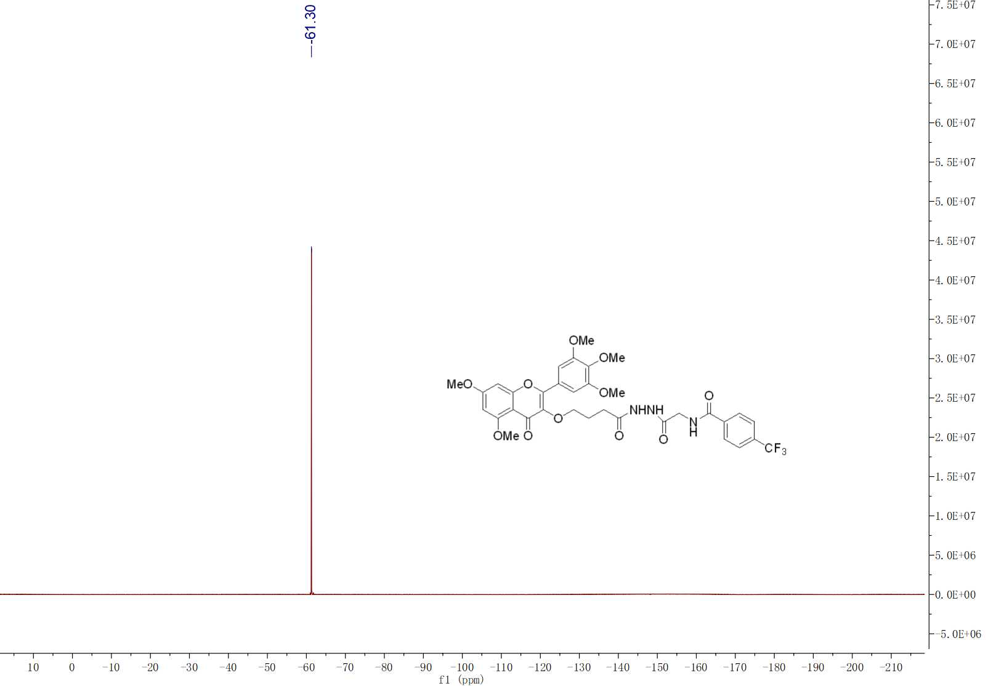

**Fig. S17 19F NMR spectra of compound G17**



**Fig. S17 HRMS spectra of compound G17**

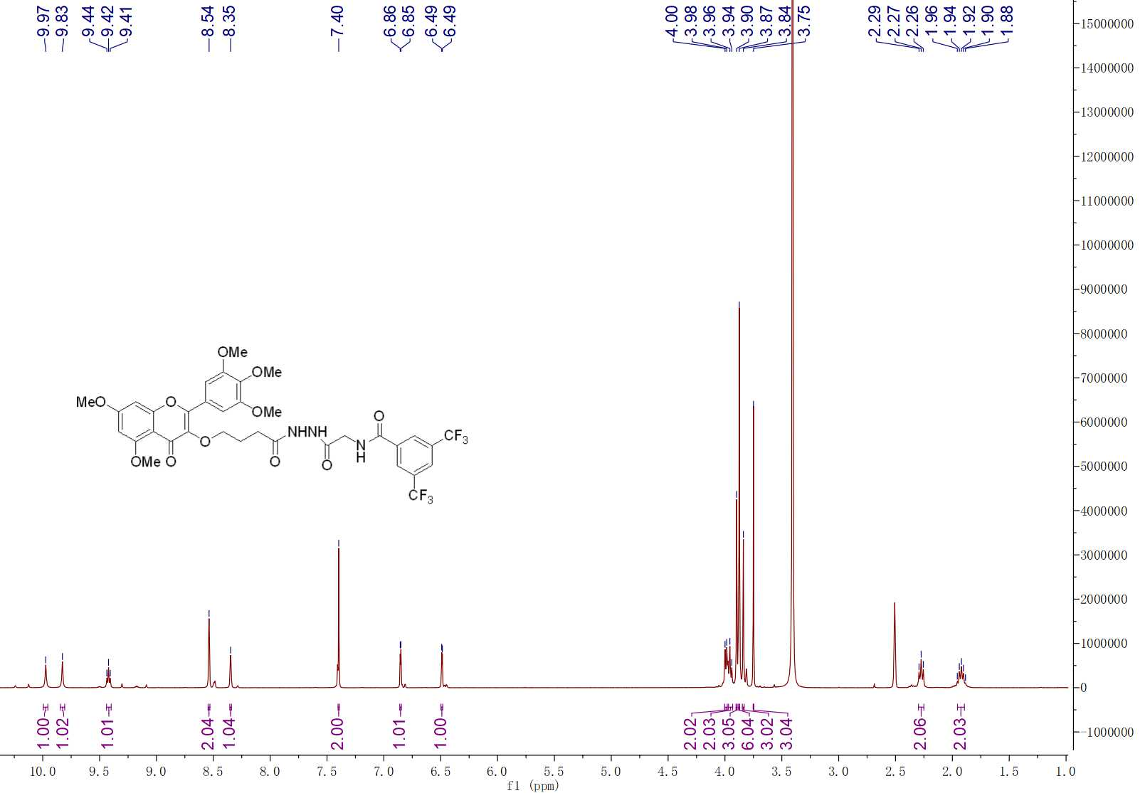

**Fig. S18 1H NMR spectra of compound G18**

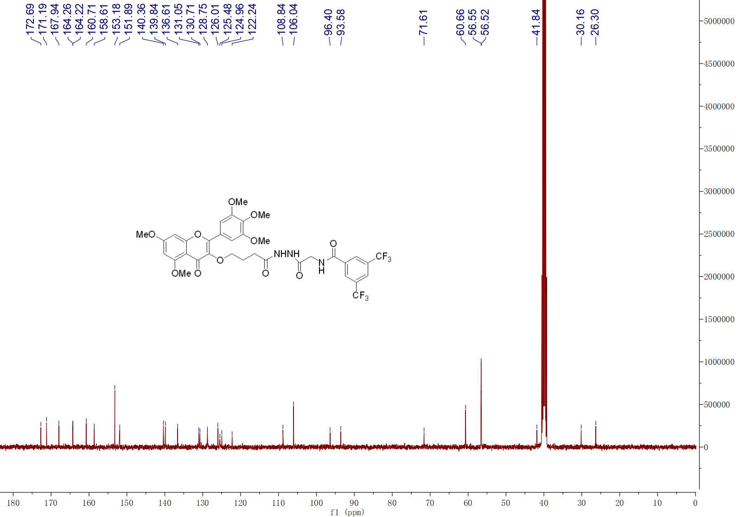

**Fig. S18 13C NMR spectra of compound G18**

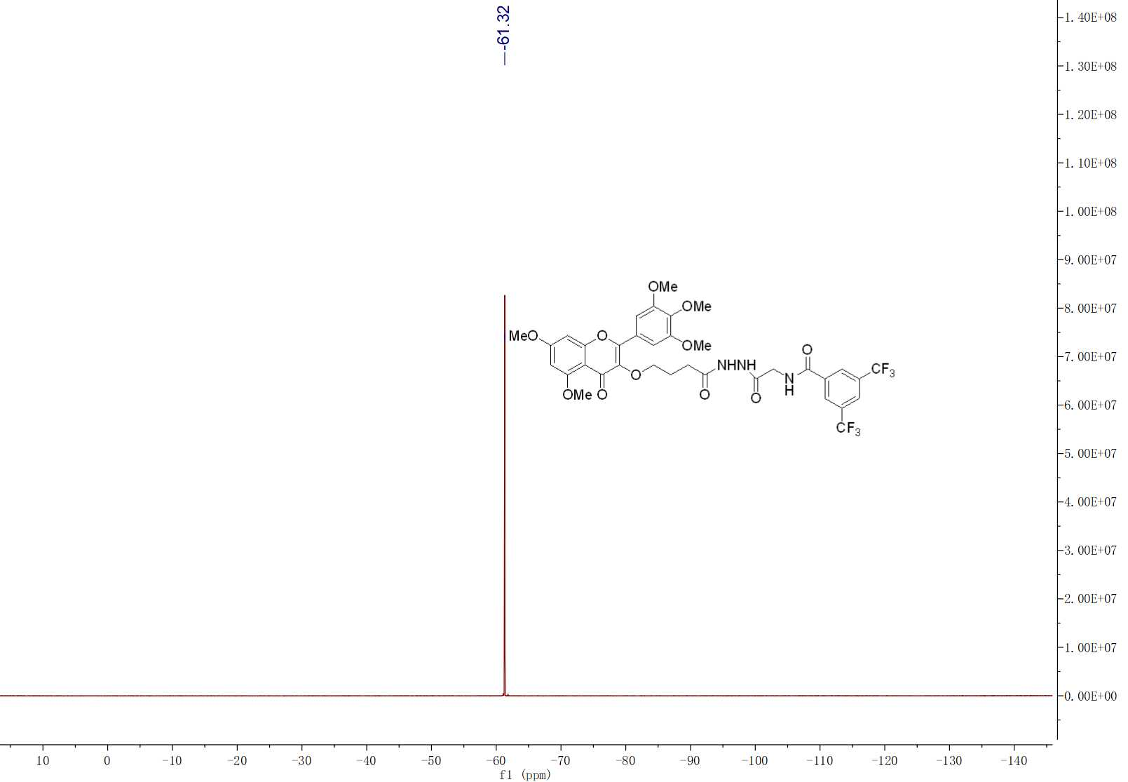

**Fig. S18 19F NMR spectra of compound G18**



**Fig. S18 HRMS spectra of compound G18**

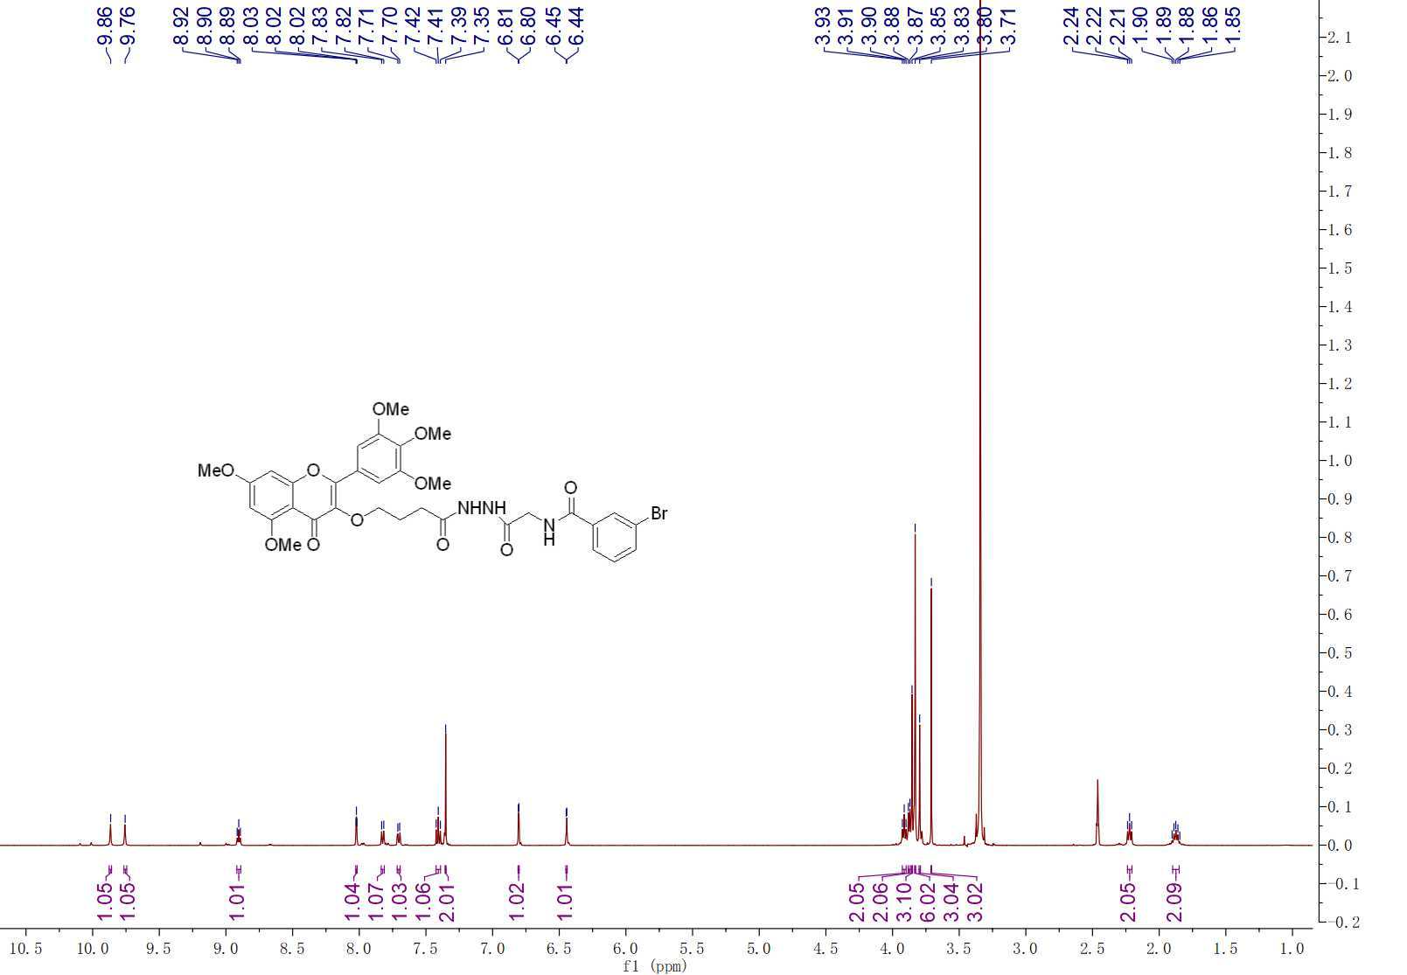

**Fig. S19 1H NMR spectra of compound G19**

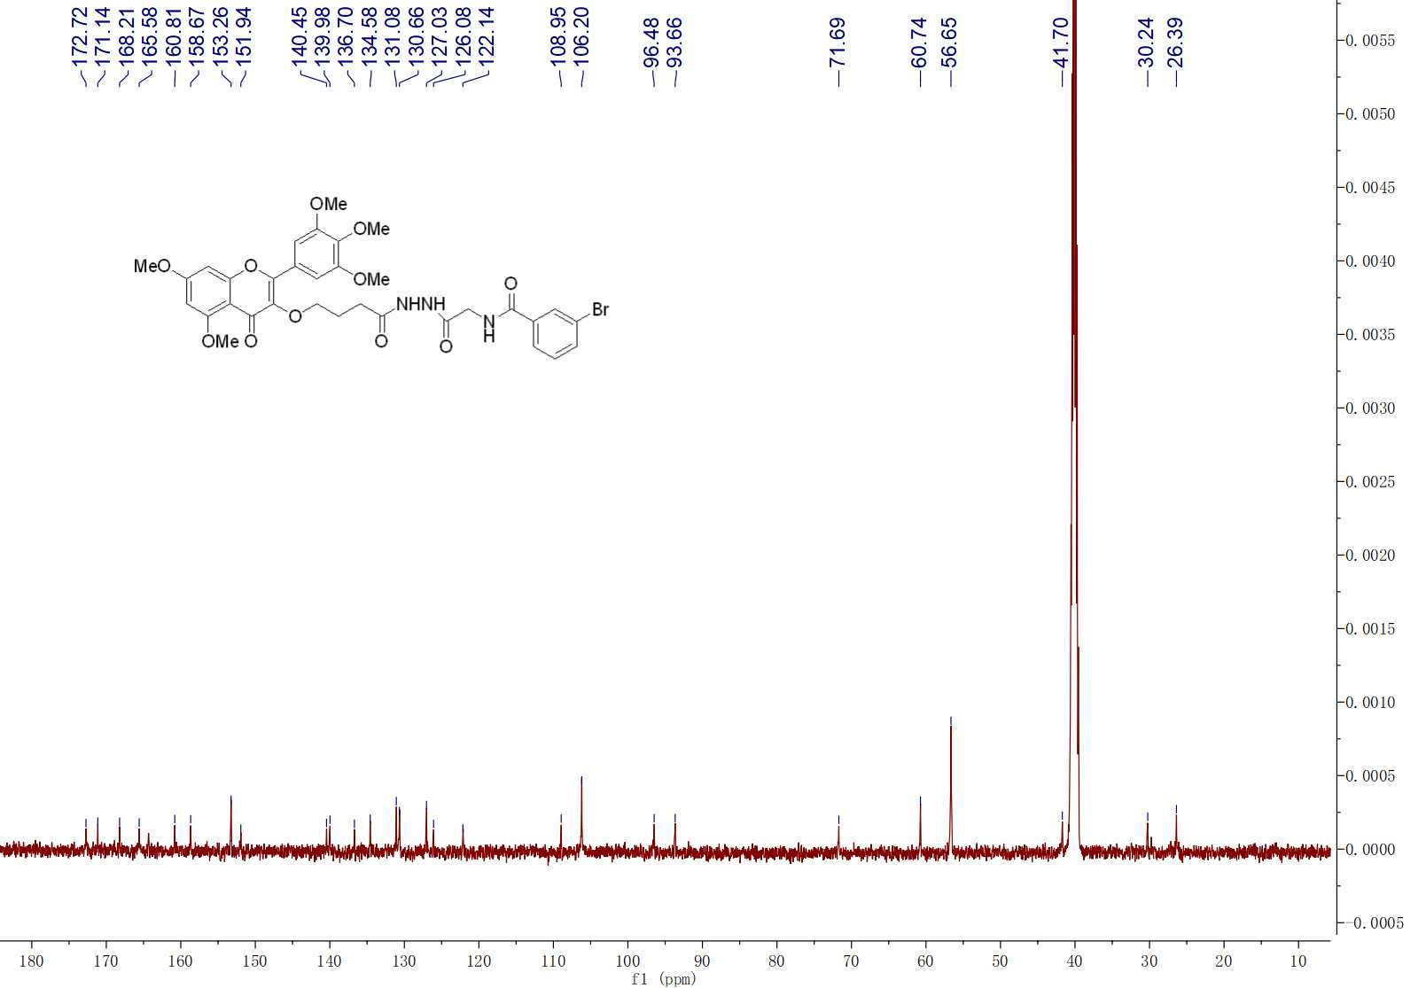 **Fig. S19 13C NMR spectra of compound G19**



**Fig. S19 HRMS spectra of compound G19**

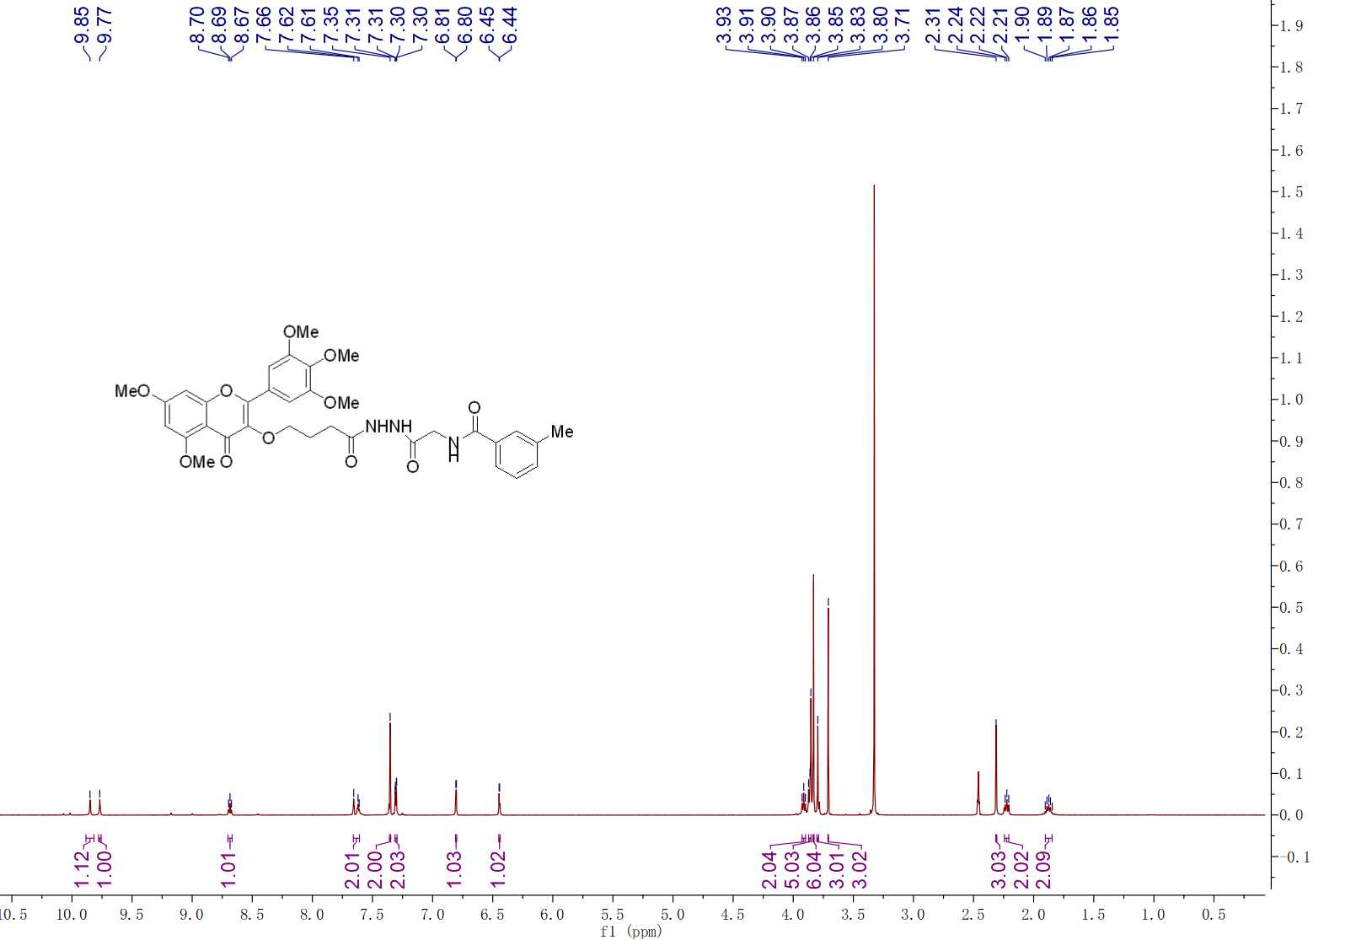

**Fig. S20 1H NMR spectra of compound G20**

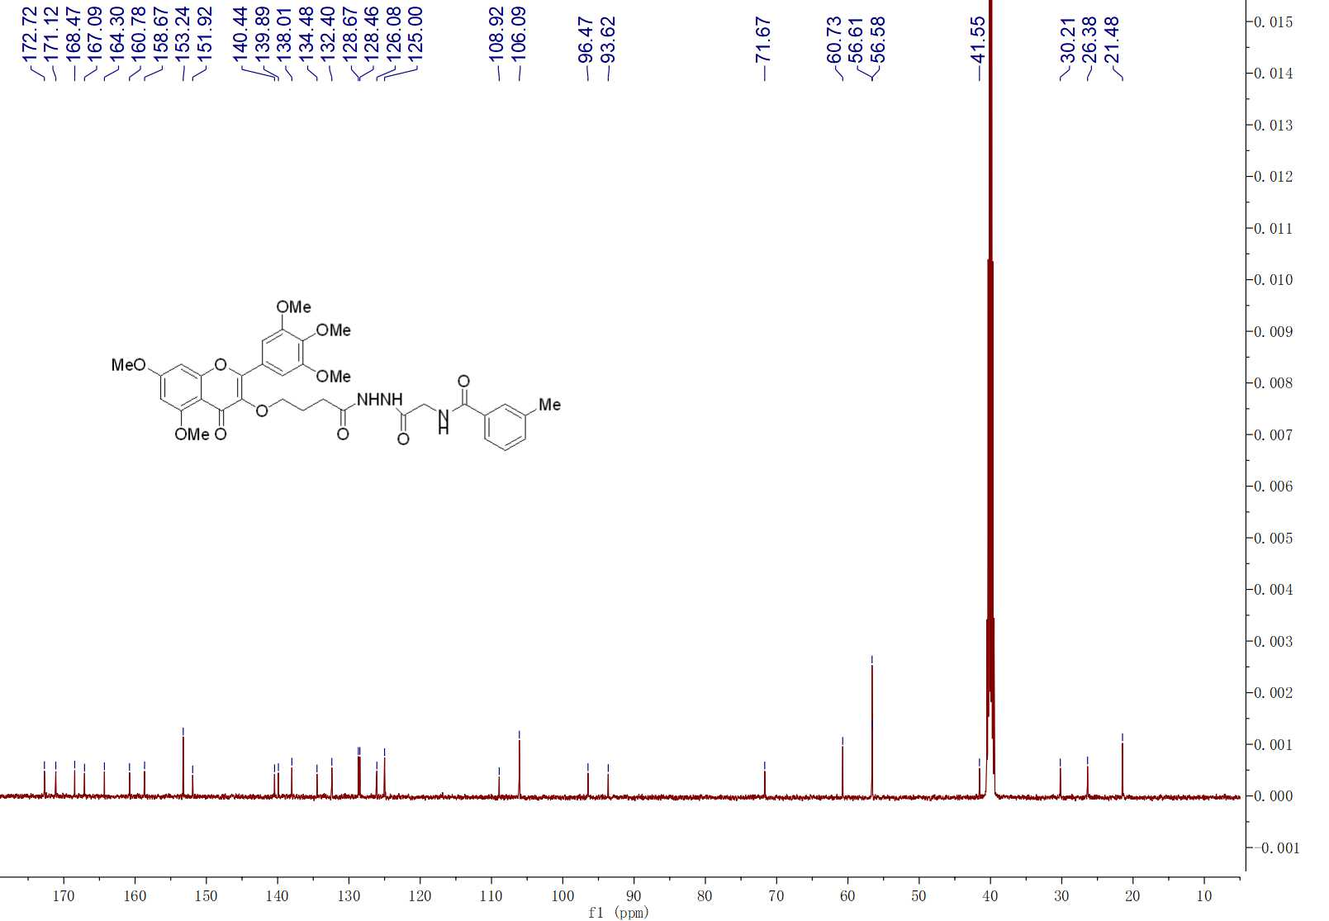

**Fig. S20 13C NMR spectra of compound G20**



**Fig. S20 HRMS spectra of compound G20**

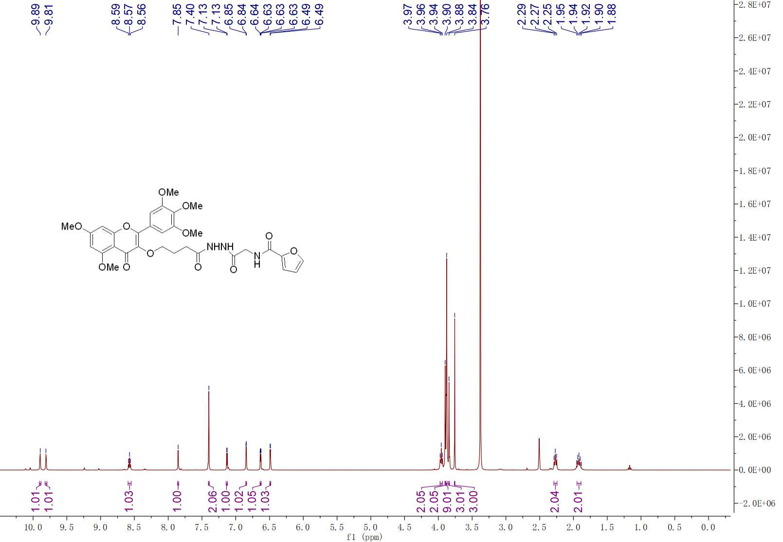

**Fig. S21 1H NMR spectra of compound G21**

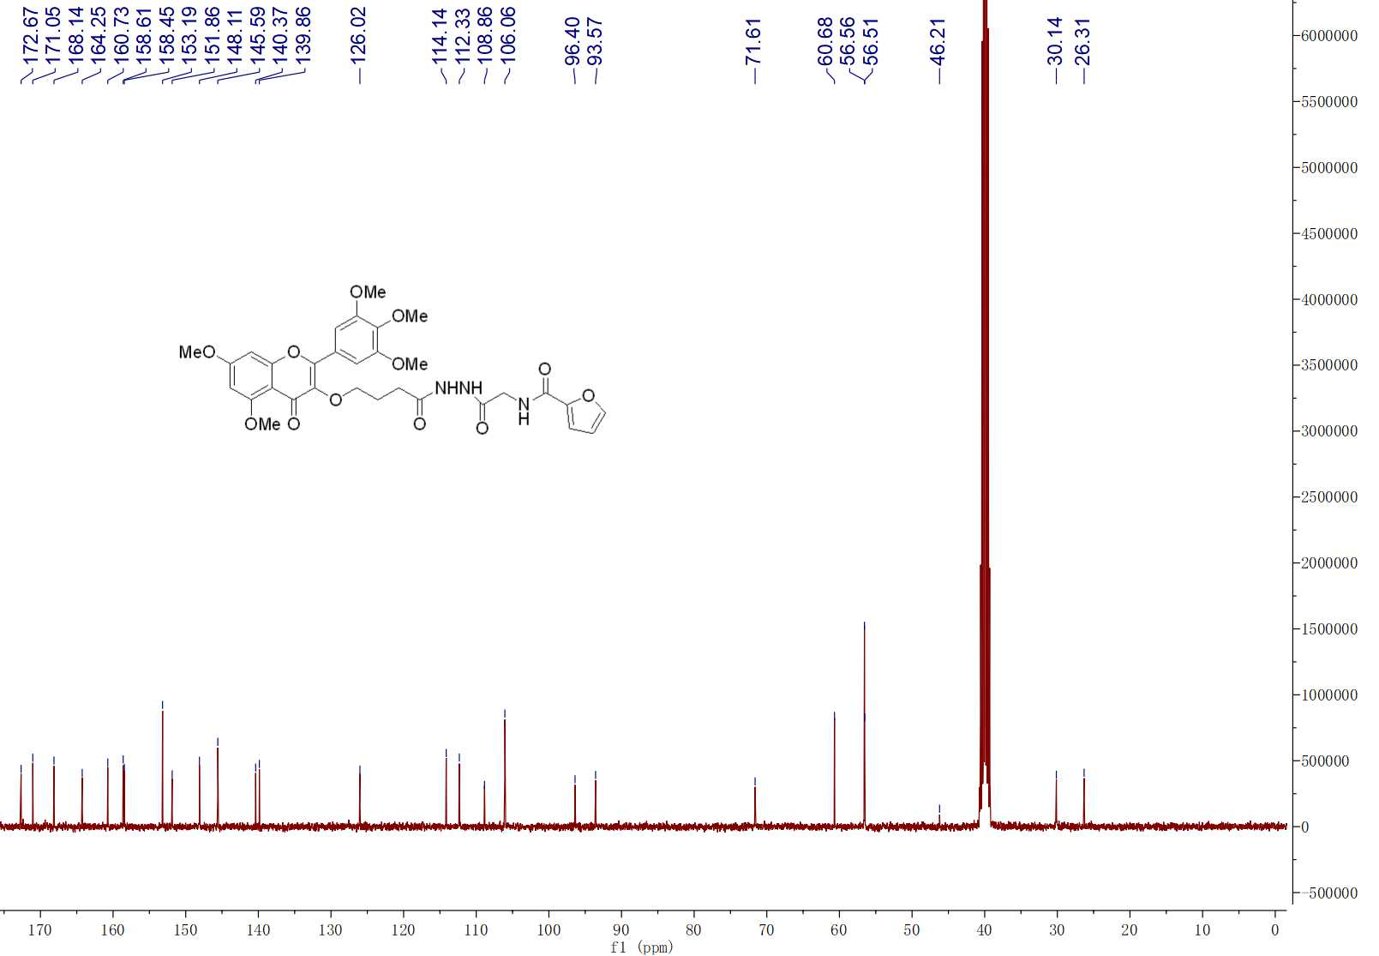

**Fig. S21 13C NMR spectra of compound G21**



**Fig. S21 HRMS spectra of compound G21**

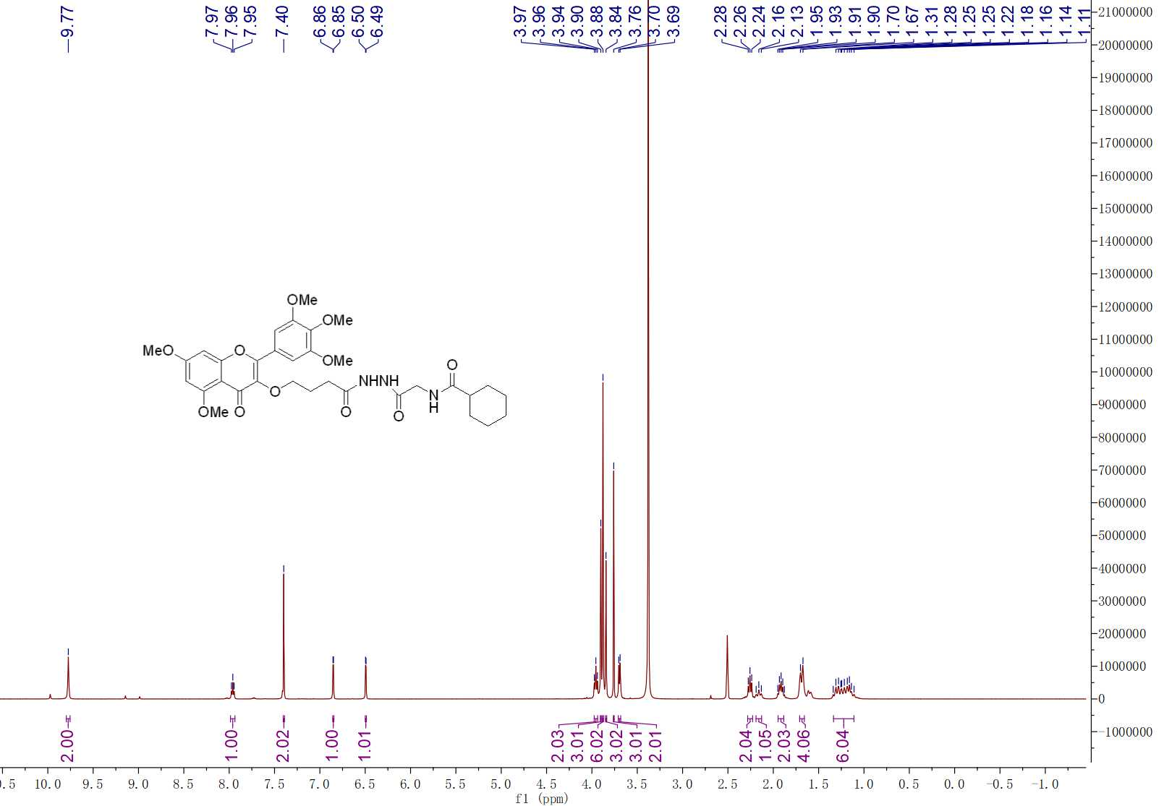

**Fig. S22 1H NMR spectra of compound G22**

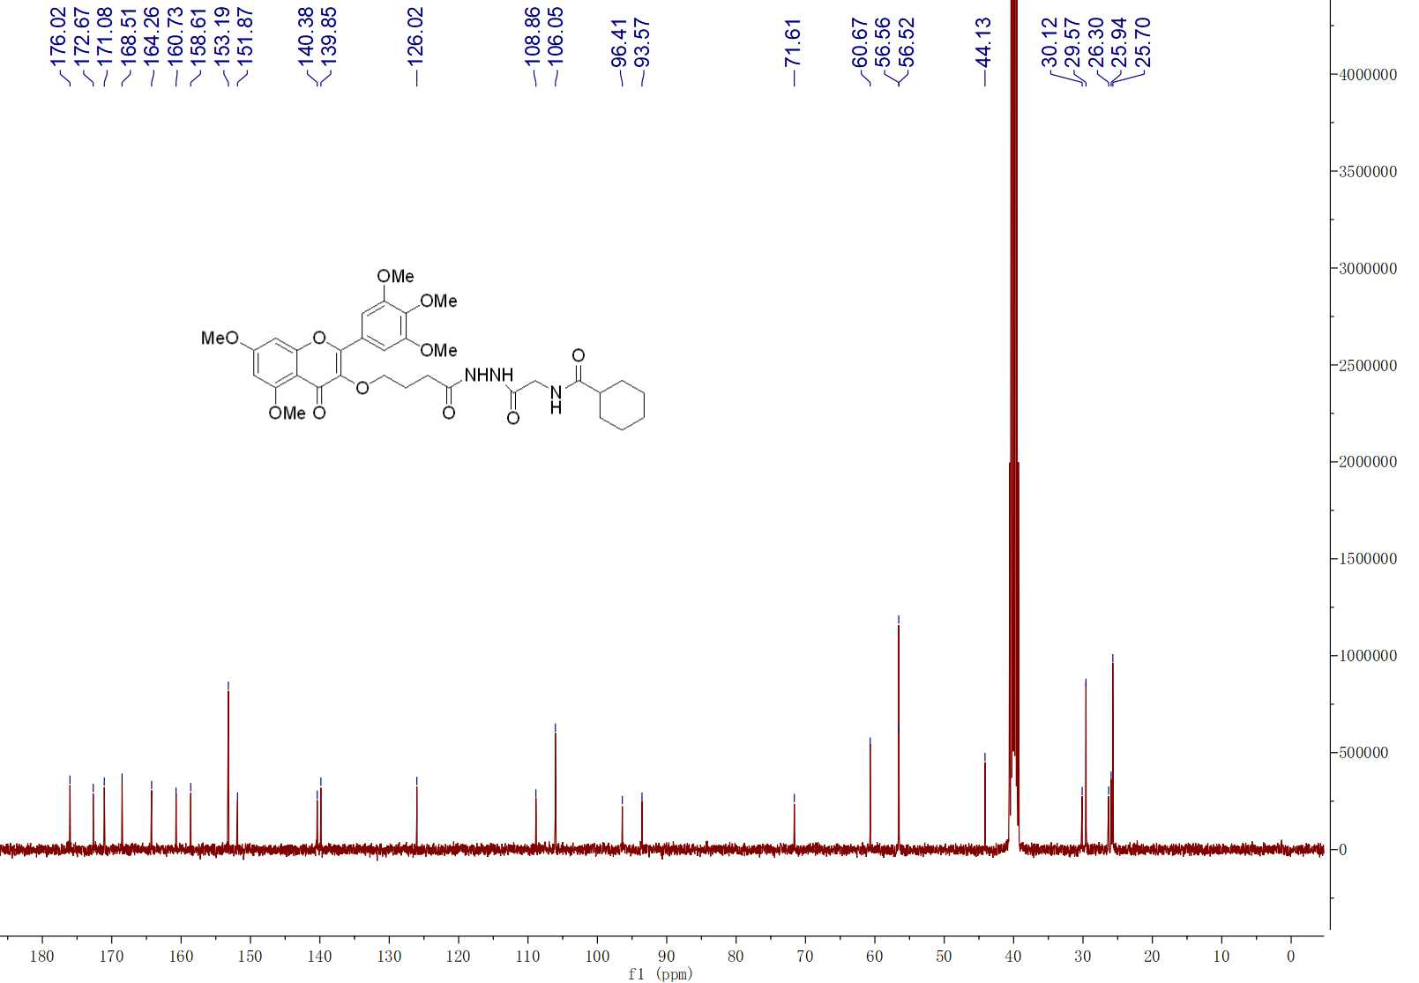

**Fig. S22 13C NMR spectra of compound G22**



**Fig. S22 HRMS spectra of compound G22**