**Supporting Information**

**Construction of a QCM sensor for detecting** **diethylstilbestrol in water based on the computational design of molecularly imprinted polymers**

**Xuhong Cai** **a, Junbo Liu a,*, Dadong Liang a, Shanshan Tang** **b,*, Bao Xu** **c**

**a** *College of Resource and Environment*, *Jilin Agricultural University*, *Changchun, Jilin 130118*, *China*

**b** *College of Life*, *Key Laboratory of Straw Comprehensive Utilization and Black Soil Conservation*, *The Ministry of Education*, *Jilin Agricultural University*, *Changchun*, *Jilin 130118*, *China*

**c** *Institute of Mathematica*, *Jilin Normal University*, *Siping*, *Jilin 136000, China*

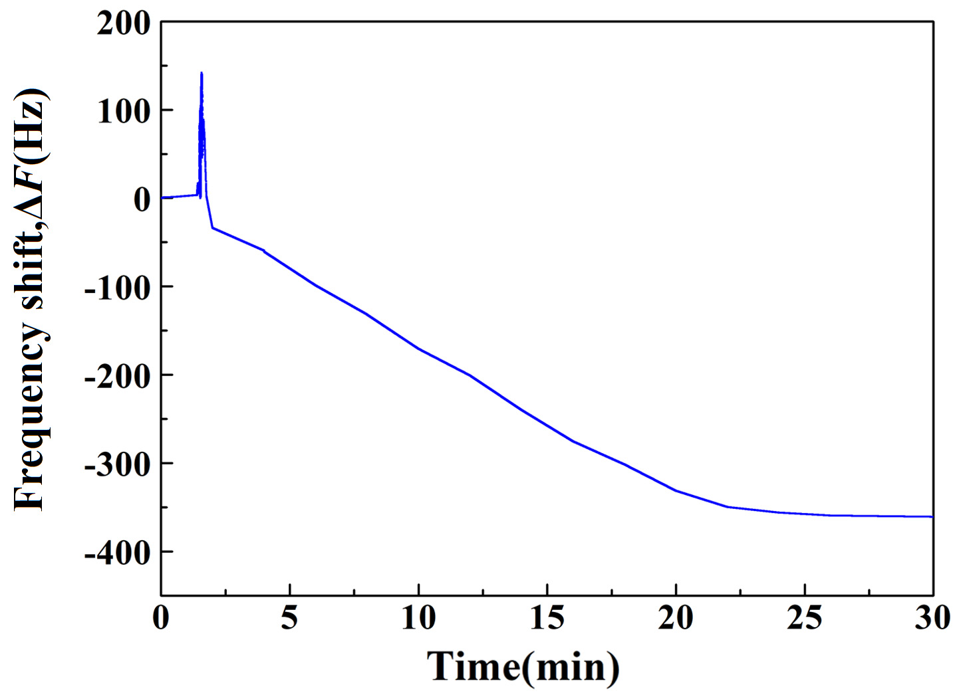

Fig. S1 Response time of the QCM sensor tested in DES standard solutions (200 ng/mL).

Table S1 Cycling performance of the sensor tested in the water samples (50 ng/mL).

|  |  |  |  |
| --- | --- | --- | --- |
| Times | Response values (Hz) | Concentrations (ng/mL) | Recovery rates (%) |
| 1 | -101.54 | 48.47 | 96.94 |
| 2 | -100.64 | 47.96 | 95.92 |
| 3 | -99.58 | 47.36 | 94.72 |
| 4 | -98.56 | 46.78 | 93.57 |
| 5 | -97.56 | 46.22 | 92.43 |
| 6 | -96.18 | 45.44 | 90.87 |
| 7 | -95.37 | 44.98 | 89.96 |