Supporting Information

**A dual-functional chemosensor based on acylhydrazone derivative for rapid detection of Zn(II) and Mg(II): spectral properties, recognition mechanism and application studies**

Yongjie Ding,a,c Chunxiang Zhao,*a Pengcheng Zhang,a Yahong Chen,*b Jianping Xie,a Weiwu Song,b Zengchen Liu,c Guanglu Liu c and Xinyu Zheng a

a College of Chemistry and Chemical Engineering, Zhoukou Normal University, Zhoukou, Henan 466001, P. R. China

b Zhoukou Key Laboratory of Small Molecule Drug Development and Application, Zhoukou 466001, China

c Institute of Medicinal Development and Application for Aquatic Disease Control, Zhoukou Normal University, Zhoukou 466001, China

**\*** Correspondence: [zcx@zknu.edu.cn](mailto:zcx@zknu.edu.cn) (C. Zhao); [20041023@](mailto:chen-yh75@163.com)zknu.edu.cn (Y. Chen)



**Fig. S1.** FT-IR spectrum of compound **QN62**.

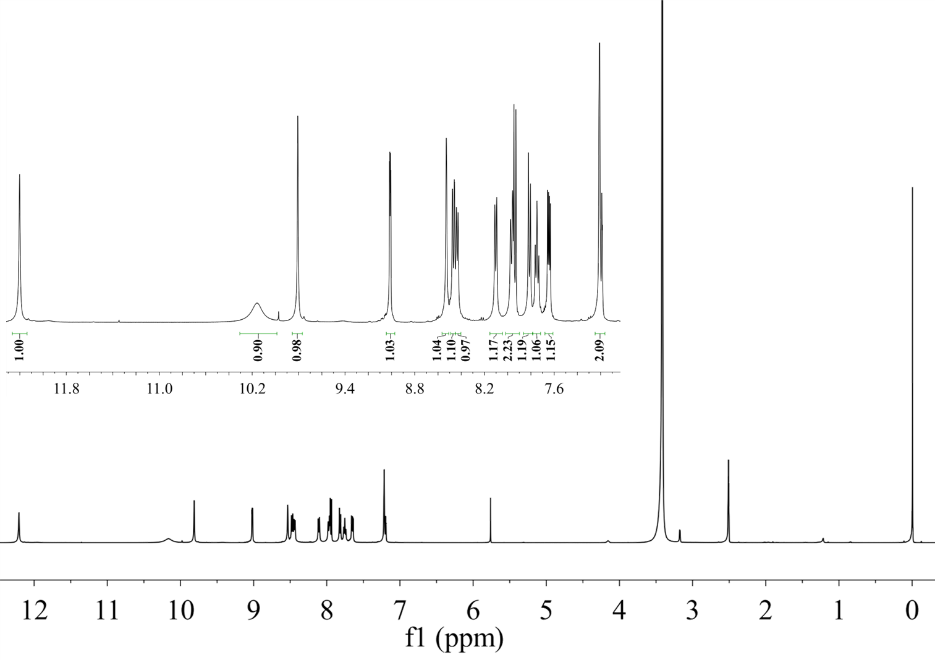

**Fig. S2.** 1H NMR spectra of compound **QN62** in DMSO.

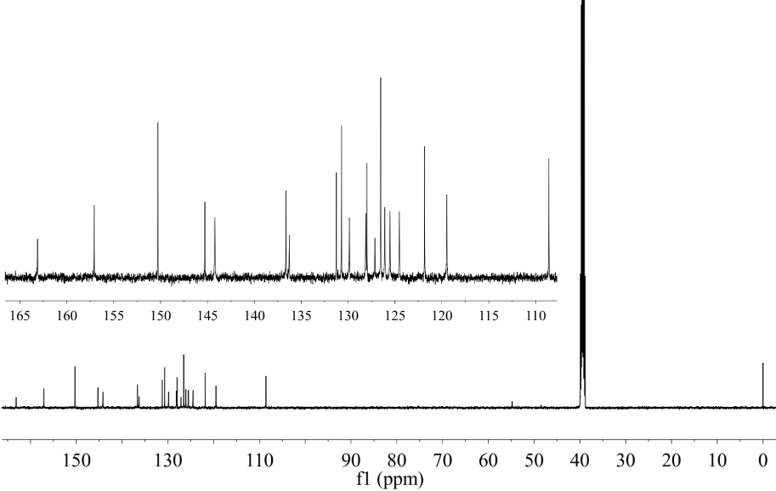

**Fig. S3.** 13C NMR spectra of compound **QN62** in DMSO.

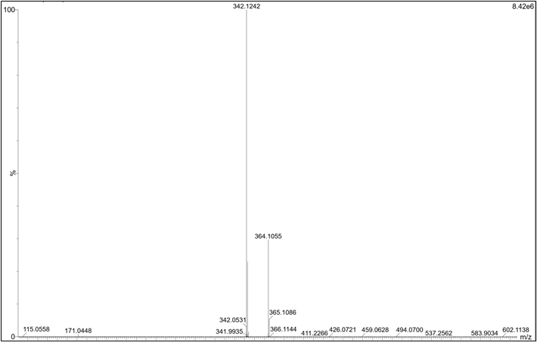

**Fig. S4.** HR-MS spectrum of compound **QN62**. The peaks at m/z = 342.1242 could be assigned to [**QN62** + H]+



**Fig. S5.** Fluorescence spectra of **QN62** (20 μM) in different solvents.



**Fig. S6.** Time-dependent fluorescence intensity of **QN62** in the presence of 1.0 equiv. amount of (a) Zn2+ in DMSO-H2O (4:1, v/v) and (b) Mg2+ in ethanol-H2O (9:1, v/v).



**Fig. S7**. pH effect on emission intensity of compound **QN62** (20 μM) to (a) Zn2+ in DMSO-H2O (4:1, v/v) solution and (b) Mg2+ ion in ethanol-H2O (9:1, v/v).



**Fig. S8.** (a) Linear fit between the fluorescence intensity and Zn2+ concentration: 0-20 μM in DMSO-H2O (4:1, v/v). (b) Linear fit between the fluorescence intensity and Mg2+ concentration: 0-20 μM in ethanol-H2O (9:1, v/v).



**Fig. S9.** Benesi-Hildebrand plot of **QN62** (20 μM) and Zn2+/Mg2+. (a) Zn2+ in DMSO-H2O (4:1, v/v), (b) Mg2+ in ethanol-H2O (9:1, v/v).

  

**Fig. S10.** (a) Fluorescence response of **QN62** (20 μM) towards Zn2+ (1.0 equiv.) in DMSO-H2O (4:1, v/v) upon the addition of various metal ions (1.0 equiv.). (b) Fluorescence response of **QN62** (20 μM) towards Mg2+ (1.0 equiv.) in ethanol-H2O (9:1, v/v) upon the addition of various metal ions (1.0 equiv.). (c) Fluorescence response of **QN62** (20 μM) towards Zn2+ (1.0 equiv.) in DMSO-H2O (4:1, v/v) upon the addition of various metal ions (0.2 to 0.35 equiv.). (d) Fluorescence response of **QN62** (20 μM) towards Mg2+ (1.0 equiv.) in ethanol-H2O (9:1, v/v) upon the addition of various metal ions (0.5 to 0.75 equiv.).



**Fig. S11.** Job’s plot of (a) **QN62**-Zn2+ complex at 538 nm in DMSO-H2O (4:1, v/v) and (b) **QN62**-Mg2+ complex at 527 nm in ethanol-H2O (9:1, v/v) solution.

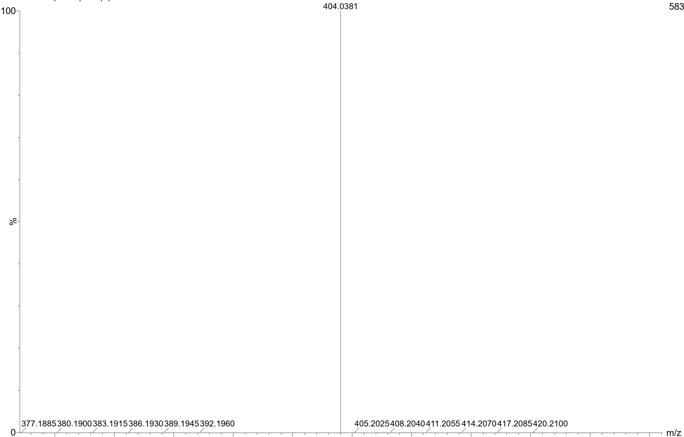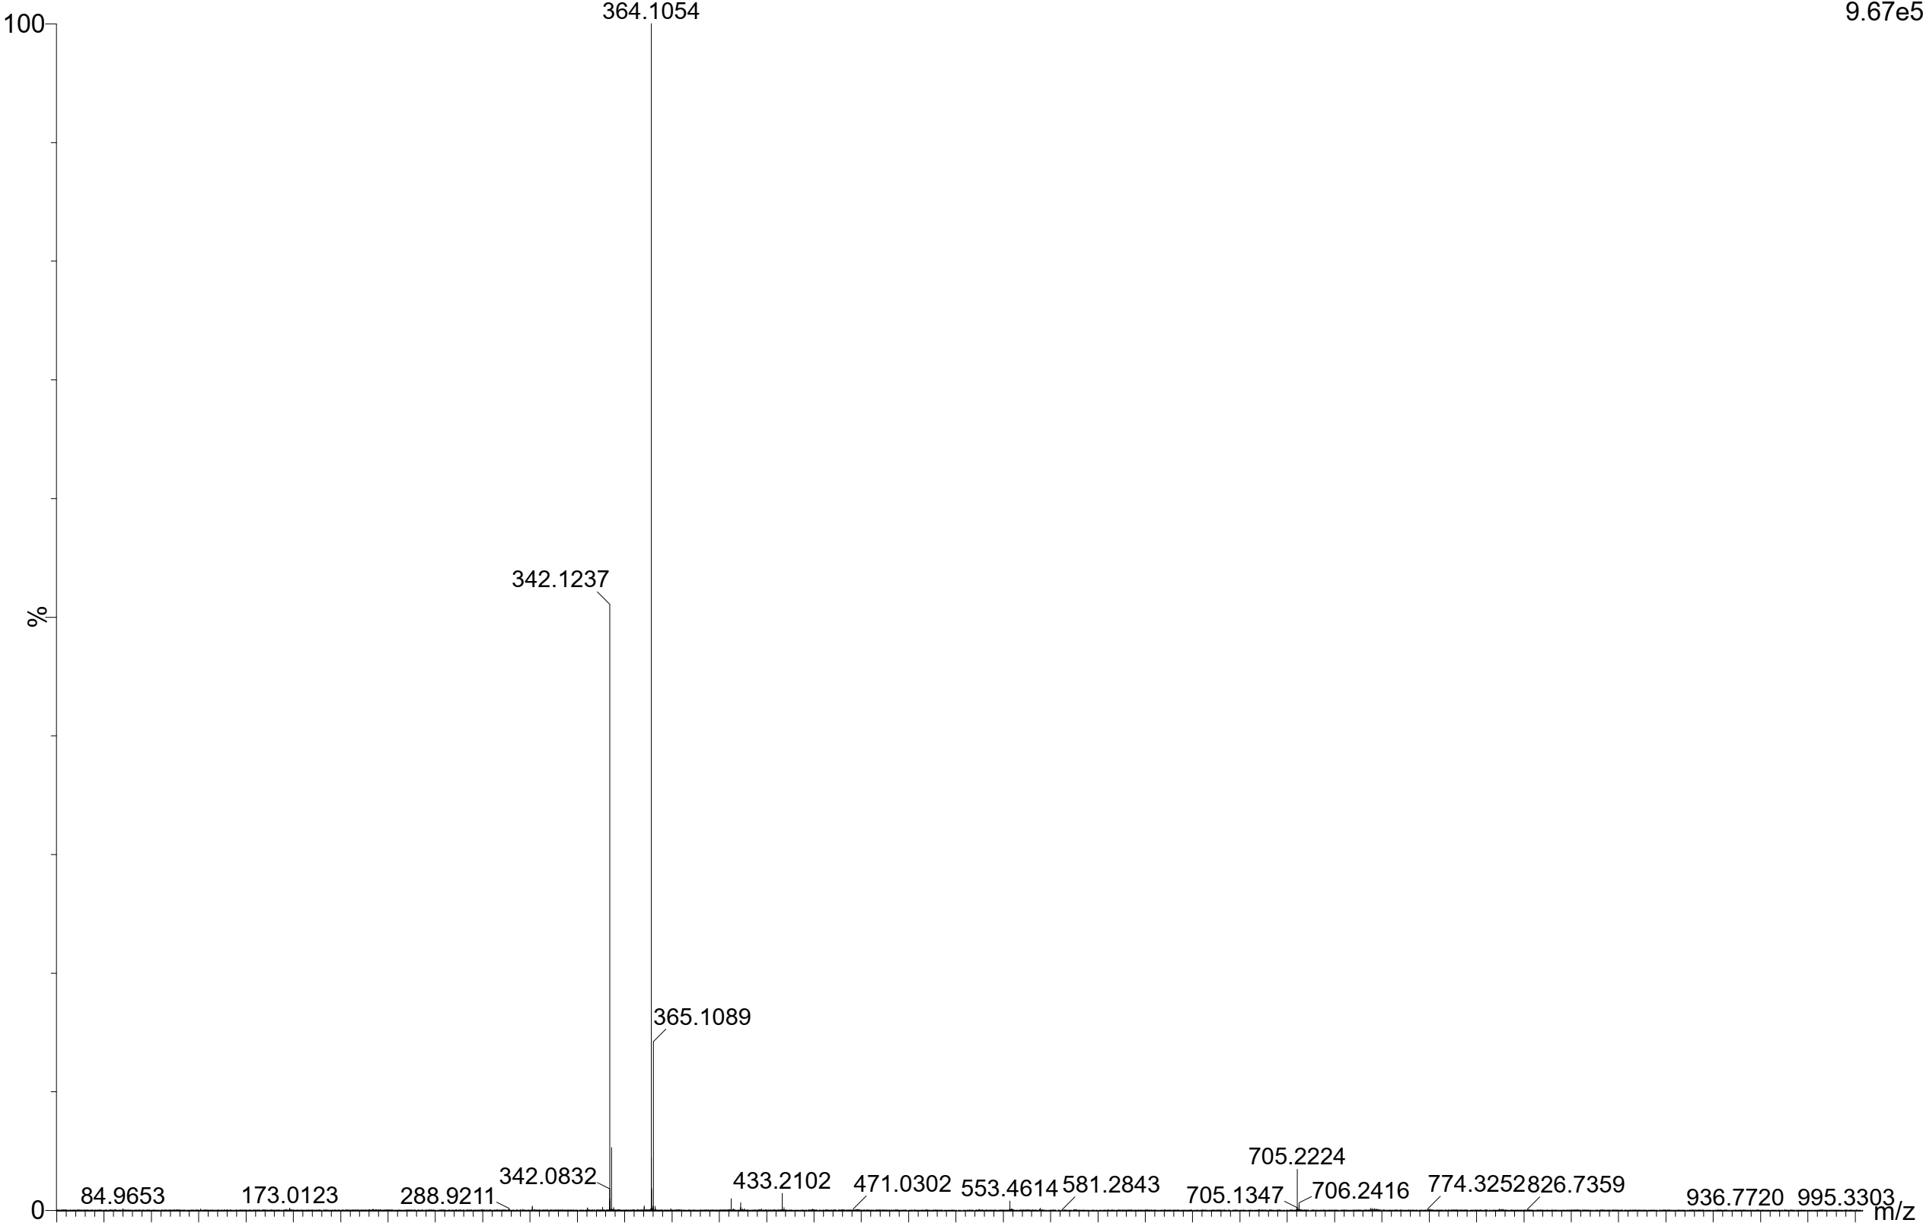

**Fig. S12.** HR-MS spectrum of complexes **QN62**-Zn2+ and **QN62**-Mg2+. The peaks at m/z = 404.0381 could be assigned to [**QN62** + Zn2+- H]+ , the peaks at m/z = 364.1054 could be assigned to [**QN62**

+ Mg2+ - H]+.

**Table S1.** Crystallographic data of compound **QN62**

|  |  |
| --- | --- |
| Formula | C22H17N3O2Cl2 |
| *M*r | 426.28 |
| Crystal system | monoclinic |
| Space group | P21/n |
| Crystal color | Yellow |
| *a*, Å | 14.611(5) |
| *b*, Å | 7.401(2) |
| *c*, Å | 17.818(6) |
| *α*, deg | 90 |
| *β*, deg | 99.523(5) |
| *γ*,deg | 90 |
| *V*, Å3 | 1900.2(10) |
| *Z* | 4 |
| *D*calcd, g cm–3 | 1.490 |
| *F*(000), e | 880.0 |
| Param. refined | 290 |
| *R*(*F*)/*wR*(*F*2)a (all refl.) | 0.0964/0.1917 |
| *μ*(Mo*Kα*), mm–1 | 0.367 |
| GoF (*F*2)b | 1.140 |

**Table S2.** Bond Distances (Angstrom) of compound **QN62**

|  |  |  |  |
| --- | --- | --- | --- |
| **Bond Distances (Angstrom)** | | | |
| O1-C11 | 1.231(5) | C15-C14 | 1.423(6) |
| O2-C17 | 1.364(4) | C17-C16 | 1.377(6) |
| N3-N2 | 1.379(4) | C17-C18 | 1.407(6) |
| N3-C11 | 1.352(5) | C13-C14 | 1.364(5) |
| N2-C10 | 1.279(5) | C8-C7 | 1.377(6) |
| N1-C9 | 1.362(5) | C19-C18 | 1.371(5) |
| N1-C1 | 1.313(5) | C7-C6 | 1.397(6) |
| C21-C12 | 1.375(5) | C1-C2 | 1.403(6) |
| C21-C20 | 1.416(5) | C4-C5 | 1.410(6) |
| C9-C8 | 1.431(5) | C4-C3 | 1.413(6) |
| C9-C4 | 1.418(5) | C2-C3 | 1.354(6) |
| C12-C11 | 1.485(5) | C5-C6 | 1.368(6) |
| C12-C13 | 1.415(5) | Cl1-C22 | 1.745(10) |
| C20-C19 | 1.428(6) | Cl1A-C22A | 1.750(11) |
| C20-C16 | 1.415(6) | Cl2A-C22A | 1.751(14) |
| C10 | 1.461(5) | Cl2-C22 | 1.770(11) |
| C15 | 1.406(5) |  |  |

**Table S3.** Bond Angles (Degrees) of compound **QN62**.

|  |  |  |  |
| --- | --- | --- | --- |
| **Bond Angles (Degrees)** | | | |
| C11-N3-N2 | 121.1(3) | O2-C17-C18 | 121.2(4) |
| C10-N2-N3 | 114.1(3) | C16-C17-C18 | 120.8(3) |
| C1-N1-C9 | 117.4(3) | C14-C13-C12 | 120.8(4) |
| C12-C21-C20 | 121.0(4) | C9-C8-C10 | 119.5(3) |
| N1-C9-C8 | 119.1(3) | C7-C8-C9 | 119.5(3) |
| N1-C9-C4 | 122.2(3) | C7-C8-C10 | 120.9(3) |
| C4-C9-C8 | 118.7(4) | C17-C16-C15 | 120.3(4) |
| C21-C12-C11 | 123.3(4) | C18-C19-C20 | 121.1(4) |
| C21-C12-C13 | 119.7(3) | C19-C18-C17 | 119.9(4) |
| C13-C12-C11 | 117.0(3) | C13-C14-C15 | 120.8(4) |
| C21-C20-C15 | 119.1(4) | C8-C7-C6 | 121.4(4) |
| C19-C20-C21 | 122.5(4) | N1-C1-C2 | 124.7(4) |
| C19-C20-C15 | 118.5(3) | C5-C4-C9 | 119.6(4) |
| O1-C11-N3 | 123.5(3) | C5-C4-C3 | 122.9(4) |
| O1-C11-C12 | 122.0(3) | C3-C4-C9 | 117.5(4) |
| N3-C11-C12 | 114.6(3) | C3-C2-C1 | 118.5(4) |
| N2-C10-C8 | 120.8(3) | C6-C5-C4 | 120.7(4) |
| C16-C15-C20 | 119.5(4) | C2-C3-C4 | 119.6(4) |
| C16-C15-C14 | 122.0(4) | C5-C6-C7 | 120.1(4) |
| C14-C15-C20 | 118.5(3) | Cl1-C22-Cl2 | 111.0(6) |
| O2-C17-C16 | 118.0(4) | Cl1A-C22A-Cl2A | 112.6(7) |